Original Research Article

Scientometric Mapping of Indian Scientific Research Footprint on Artificial Intelligence Application in Cancer

Abstract
This study maps the Indian research landscape of AI in cancer through a scientometric analysis of publications indexed in the Web of Science Core Collection from 2021 to 2025. Over a total of 1424 records (articles, review papers, conference proceedings) were analyzed by the use of the tools: Biblioshiny, VOSviewer and SciMAT. The analysis shows an annual growth rate of 73.73% and explains 97.64% of the variability in the number of publications based on the year of publication. Laba Suca, Vellore Institute of Technology and Scientific Reports as the most productive authors, institutions, and journals, respectively, in the Indian AI cancer research landscape. The Collaboration analysis shows that there are many strong international collaboration projects, including with the United States, Saudi Arabia, the United Kingdom and China. Institutions like Vellore Institute of Technology, Manipal Academy of Higher Education and the IIT family made significant contributions. Deep learning, explainable AI, medical imaging, precision medicine, biomarkers and tumor detection were dominant research areas identified by the thematic and conceptual mapping. Citation and co-citation analyses also showed a shift in the intellectual landscape of the field, emphasizing interdisciplinary and review-based studies. In conclusion, this study highlights Indian AI-cancer research's trajectory toward global scientific recognition, clinically aligned innovation, and collaborative efforts.
Keywords: Artificial Intelligence, Cancer Research, Scientometric Analysis, Biblioshiny, VOSviewer, SciMAT
1. Introduction
The adoption of artificial intelligence in cancer research has sparked a ground breaking enthusiasm among researchers worldwide. Deep learning architectures, in particular, convolutional neural networks (CNNs), have shown extraordinary ability to process complex biomedical data, from radiological imaging to digital pathology slides, from genomic sequences to profiles of liquid biopsies, and to a significant degree, have increased the power of clinical decisions that can be made without their involvement (Bi et al., 2019; Shen et al., 2021). Numerous scientific and literature studies, known as bibliometric and scientometric studies, have, however, systematically recorded this exponential growth curve in various cancer fields. Overall, China published the highest number of papers on AI in liver cancer (2,922) and showed the highest citation impact, with the United States following, whereas other countries lagged significantly behind in both number of papers and in their citation impact. The important research hotspots mentioned in the literature were AI classification, diagnosis, survival prediction, imaging methods like computed tomography and magnetic resonance imaging. AI's infiltration into specific cancer types has also been shed light upon with singular detail in domain-specific analyses of the literature. In the case of breast cancer research, Lakhtaryna (2023) found a strong increase in the number of publications related to AI in the last five years in the databases Scopus, Web of Science, PubMed and Google Scholar, with the identification of three thematic clusters: dominant AI methodologies, imaging-based diagnostics and pathomorphological analysis, and pointed out the convergence of disciplines of medicine, computer science, engineering, and mathematical sciences. Using the tools of Biblioshiny and VOSviewer, Peduk, S. (2025) studied 1,293 well-crafted studies on breast cancer AI between 2012 and 2025, and found that while there was a marked increase after 2020, the shift had also seen a transition from rule-based AI to more sophisticated deep learning-oriented models, with a lack of transparency, data privacy and algorithmic bias among the unaddressed issues. In the breast cancer imaging field, deep learning and radiomics have also been highlighted as prevailing methodological approaches, with the former gaining significantly in the realm of imaging data acquisition and the latter becoming increasingly prominent in the analysis of imaging features, as summarized by Wu et al. (2025).
Huang et al. (2024) reviewed 770 publications between 1996 and 2024 for cervical cancer, finding that almost 86% of them were published in the last five years and that the most common techniques were machine learning and deep learning. When looking at the full body of literature in prostate cancer diagnosis spanning 35 years of published papers on Scopus, Denysenko et al. (2022) found three themes of prostate cancer diagnostics development, which gradually evolved from traditional to AI-assisted morphological diagnostics. In the study of tumor pathology, Shen et al. (2021) analyzed 2,753 papers from 1999 to 2021, and found that, among the institutions, Harvard Medical School and among the individuals, Madabhushi Anant had the greatest impact, while convolutional neural networks and breast cancer histopathology were the central research areas. In a more global overview, Caraka et al. (2025) have used Correspondence Analysis and Multiple Correspondence Analysis on 19,627 peer-reviewed articles published between 2022 and 2025, and found that there were dominant themes such as multimodal learning, radiogenomics, transformer-based architectures, federated learning, and explainable AI, while also noting that structural barriers to the equitable generation of knowledge were low and middle-income countries and the lack of standardized datasets. Zeng et al. (2023) mapped 5,210 AI-lung disease publications, confirming the explosive growth after 2017, with deep learning, convolutional neural networks and radiomics being the most frequently used methodological approaches, and lung cancer being the most frequent disease being discussed. With this background the current study performs a detailed scientometric examination of Indian scientific production in AI-cancer research, systematically detailing growth in publications, citation impact, author networks, institutional productivity, collaborative networks, thematic evolution and patterns of intellectual knowledge structures
2. Objectives of the Study
This study's main Objective is to map the Indian research landscape of artificial intelligence in cancer by examining publication growth, citation impact, and overall scientific output. The Specific Objectives of this study are as follows:
- To examine the year-wise distribution and growth pattern of Indian research literature on AI application in Cancer.
- To identify the most productive authors, journals, institutions and highly cited research articles in Indian context.
- To investigate the International collaborative network of Indian research output with other countries.
- To analyse interlink among documents based on Co-Authorship, Co-Citation and Bibliographic Coupling analysis.
- To assess the intellectual structure of Indian research using keyword co-occurrence, thematic mapping, conceptual structure, and strategic network analysis.
3. Research Methodology
The study is a descriptive analysis using various scientometric techniques applied to the Indian research literature on artificial intelligence applications in cancer. The search string of (TS="artificial intelligence") AND (TS=cancer OR TS=tumor OR TS=carcinoma OR TS=neoplasm OR TS=sarcoma OR TS=malignancy OR TS=oncology) was used to retrieve bibliographic records from the Web of Science Core Collection, done on 22 April 2026. The search returned 31,067 records, which was subsequently refined to a list of 1,726 publications based on year of publication (2021-2025), Country (India) and language (English). Lastly, the document types were restricted to articles, review articles and proceedings papers for a final sample dataset of 1424 publications. The records were exported in plain text format and then further processed in MS-Excel, VOSviewer, Biblioshiny and SciMAT software.

4. Analysis and Discussion
4.1 Quantitative Aspects of Dataset
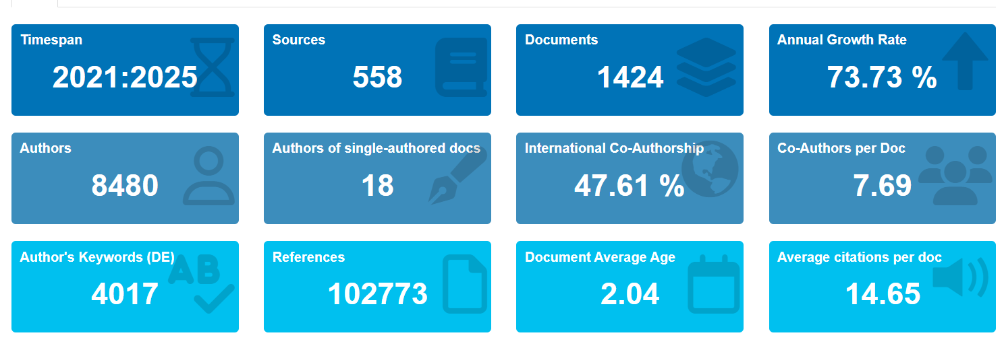
Fig 1: Dashboard of basic dataset characteristics
Fig. 1. demonstrates the dashboard of the sample dataset for the timespan 2021-25, which includes 1424 publications from 558 sources. The annual growth of 73.73% is a noticeable increase in research activity with a strong level of collaboration among authors. The data shows that out of 8480 total authors the average of 7.69 co-authors per document and 47.61% international co-authorship. The average citations per document (14.65) indicates high academic exposure and growing global impact of Indian research on artificial intelligence application in cancer.
4.2 Annual and Cumulative Growth Trend
As shown in Fig 2, there is a significant increase in the number of Indian research publications in the field of AI for Cancer from 2021 to 2025. There have been 73 publications in 2021, and 665 publications in 2025, and over 1,424 publications in total over the years, showing the field is expanding quickly. The strong and steady growth trend is further supported by the polynomial trendline (R² = 0.9764), which explains 97.64% of variability in the number of publications based on the year of publication.

Fig 2: Annual and Cumulative Growth Trend with polynomial trendline
4.3 Year-wise Scientific production and Citation Impact
Table 1: Annual production and Citation Impact Metrics
Year | Mean TC per Article | NP | Mean TC per Year | Citable Years
2021 | 35.15 | 73 | 5.86 | 6
2022 | 32.8 | 151 | 6.56 | 5
2023 | 21.96 | 201 | 5.49 | 4
2024 | 16.25 | 334 | 5.42 | 3
2025 | 5.26 | 665 | 2.63 | 2
Note. TC = total citations; NP = number of publications; Mean TC per Article = total citations divided by number of publications; Mean TC per Year = total citations divided by citable years; Citable Years = number of years the publication cohort has been available for citation.

As shown in Table-1, the number of citations given to earlier publications is higher than to later publications. The articles published in 2021 had the highest mean citations per article (35.15) which was due to longer exposure of the articles, followed by 2022 with mean citations per article (32.8). The mean citation rate steadily decreased over time despite the rise in publications from 73 in 2021 to 665 in 2025. The mean number of citations per year was relatively constant from 2021 to 2024, but dropped in 2025 because of the number of years which were citable. Based on the findings, it is observed that the older publications are still having higher influence over the recent research outputs.
4.4 Most Productive Authors including co-authors
Table-2 points out the top contributors in the field of cancer research who are closely related to the AI-driven research in India. Luca Saba had the most publications (14) and most citations (11,843) and h-index (56), showing high research visibility in the world. Jasjit S. Suri was the most prolific contributor from India, having published 13 articles, indicating a high level of engagement in medical imaging research with AI tools. Other authors like Yogesh Kumar and T.R. Mahesh also showed remarkable scholarly impact with their increased citation performance. The involvement of the internationally affiliated researchers among the top contributors reflects the global and collaborative nature of the India-based AI-cancer research.
Table 2: Top 10 Authors based on number of publications
Rank | Author | Affiliation | NP | h-index | Total Citation
1 | Saba, Luca | University of Cagliari, Dept. of Radiology, Cagliari, Italy | 14 | 56 | 11,843
2 | Suri, Jasjit S. | A.V.C. College of Engineering, Tamil Nadu, India | 13 | 8 | 211
3 | Kumar, Yogesh | Deendayal Petroleum University | 11 | 21 | 1,684
4 | Mahesh, T. R. | R. Jain (Deemed to be University) | 10 | 21 | 1,264
5 | Kaushik, Ajeet | Florida Polytechnic University | 8 | 74 | 17,785
6 | Chaudhary, Vishal | Mahidol University, Thailand | 8 | 40 | 4,279
7 | Kalra, Mannudee Pk. | Massachusetts General Hospital, Jordan University of Science & Technology | 7 | 62 | 15,956
8 | Johri, Amer M. | Queen's University, Kingston, Canada | 7 | 40 | 4,210
9 | Kumar, Neeraj | Thapar Institute of Engineering & Technology, India | 7 | 7 | 361
10 | Naik, Nithesh | Manipal Academy of Higher Education, India | 6 | 44 | 7,741
Note. NP = number of publications; h-index = author h-index (as provided); Total citations = cumulative citations.
4.5 Most productive institutions in Indian research on AI application in Cancer
Table 3: Top 10 Most Productive Authors
Rank | Institutions | NP | Country
1 | Vellore Institute of Technology (VIT) | 125 | India
2 | Manipal Academy of Higher Education (MAHE) | 104 | India
3 | Indian Institute of Technology system (IIT system) | 103 | India
4 | Tata Memorial Centre (TMC) | 99 | India
5 | Saveetha Institute of Medical and Technical Science | 98 | India
6 | All India Institute of Medical Sciences (AIIMS) New Delhi | 75 | India
7 | Homi Bhabha National Institute | 74 | India
8 | Chitkara University, Punjab | 67 | India
9 | Tata Memorial Hospital | 66 | India
10 | National Institute of Technology system (IIT system) | 65 | India
Table-3 shows that Vellore Institute of Technology (VIT) is the top contributor with 125 publications, Manipal Academy of Higher Education (104) and the IIT System (103). The dominance of premier technical and medical institutions reflects the interdisciplinary nature of AI-cancer research in India. The specialized healthcare institutes like Tata Memorial Centre and AIIMS New Delhi also showed significant research output, showcasing the increasing role of AI in oncology care and diagnostic research. The findings showed that there is a strong collaboration among institutions like engineering, medical, and research institutions across the country which are contributing to the growing research output in India regarding the study of cancer using AI tools.
4.6 Highly Influential Publications in Indian AI-Cancer Research
Table 4: Most Highly Cited Publications in Indian AI-Cancer Research
Rank | Title | Journal | Author | TC | TCPY
1 | Artificial Intelligence (AI) and Internet of Medical Things (IoMT) Assisted Biomedical Systems for Intelligent Healthcare | Biosensors | Pandiaraj Manickam et al. | 334 | 66.8
2 | A review of Explainable Artificial Intelligence in healthcare | Computers and Electrical Engineering | Zahra Sadeghi et al. | 247 | 82.33
3 | Improved Breast Cancer Classification Through Combining Graph Convolutional Network and Convolutional Neural Network | Information processing and management | Zhang Yudong et al. | 235 | 39.17
4 | Anticancer Drug Discovery Based on Natural Products: From Computational Approaches to Clinical Studies | Biomedicines | Pritee Chunarkar-Patil et al. | 228 | 76
5 | The 2019 Genitourinary Pathology Society (GUPS) White Paper on Contemporary Grading of Prostate Cancer | Archives | Jonathan I. Epstein | 214 | 35.67
6 | Economics of Artificial Intelligence in Healthcare: Diagnosis vs. Treatment | Healthcare | Narendra N. Khanna et al. | 210 | 42
7 | Recent Advances in Optical Biosensors for Sensing Applications: a Review | Spinger | Arun Uniyal et al. | 202 | 50.5
8 | Breast cancer detection using deep learning: Datasets, methods, and challenges ahead | Computers in Biology and Medicine | Nusrat Mohi ud din et al. | 201 | 40.2
9 | DeepXplainer: An interpretable deep learning based approach for lung cancer detection using explainable artificial intelligence | Computer methods and programs in biomedicine | Niyaz Ahmad Wani et al. | 170 | 56.67
10 | Deep Transfer Learning Approaches in Performance Analysis of Brain Tumor Classification Using MRI Images | Journal of healthcare engineering | Chetana Srinivas et al. | 152 | 30.4
Note. TC = total citations; TCPY = total citations per year.
The top 10 publications with highest citations in the Indian research on AI application in Cancer domain are shown in Table 4. Pandiaraj Manickam et al. received the highest number of total citations (334), indicating that there was a great deal of scholarly interest in AI-enhanced intelligent healthcare systems. The review on Explainable Artificial Intelligence by Zahra Sadeghi et al. also had the highest citations per year (82.33) showing its current relevance. Research papers that were highly cited were mainly those in deep learning, explainable AI, biosensors, medical imaging, and cancer diagnostics. The high prevalence of review articles and interdisciplinary publications indicates a growing conceptual and methodological shift in the formation of the intellectual environment of cancer research with the help of artificial intelligence.
4.7 Most productive source journals
Table 5: Top 10 Most Productive Source Journals
Rank | Journal | ISSN | Publisher | Country | NP | SJR | Quartiles
1 | Scientific Reports | 2045-2322 | Nature Research | United Kingdom | 67 | 0.893 | Q1
2 | IEEE Access | 2169-3536 | IEEE | United States | 45 | 0.884 | Q1
3 | Diagnostics | 2075-4418 | MDPI | Switzerland | 42 | 0.848 | Q2
4 | Cancers | 2072-6694 | MDPI | Switzerland | 31 | 1.41 | Q1
5 | South African Journal of Botany | 0254-6299 | Elsevier | Netherlands | 27 | 0.596 | Q2
6 | Seminars in Oncology | 1532-8708 | W.B. Saunders | United States | 25 | 1.536 | Q1
7 | Biomedical Signal Processing and Control | 1746-8094 | Elsevier | United Kingdom | 22 | 1.336 | Q1
8 | Archives of Computational Methods in Engineering | 1134-3060 | Springer Nature | Netherlands | 19 | 2.415 | Q1
9 | Computers in Biology and Medicine | 0010-4825 | Elsevier | United Kingdom | 18 | 1.375 | Q1
10 | Journal of Stomatology, Oral and Maxillofacial Surgery | 2468-7855 | Elsevier | France | 17 | 0.656 | Q1
Note. NP = number of publications; SJR = SCImago Journal Rank; Quartile = SJR quartile.
Table 5 shows that Scientific Reports was the most preferred publication outlet (67 articles) followed by IEEE Access (45) and Diagnostics (42). The majority of productive journals fell into the two highest impact categories (Q1 and Q2) showing that the Indian research on AI application in Canceris gaining momentum and being spread through the highest impact international journals. High interdisciplinary integration of oncology, biomedical engineering and computational sciences is evident in the dominant presence of publishers like Nature Research, IEEE, Elsevier, and MDPI. The increasing academic rigor and international recognition of Indian research in cancer-related fields, as evidenced by higher SJR in journals such as Archives of Computational Methods in Engineering and Seminars in Oncology, emphasizes the expanding role of AI in Indian cancer research.
4.8 Thematic Linkages among Authors, Keywords, and Sources
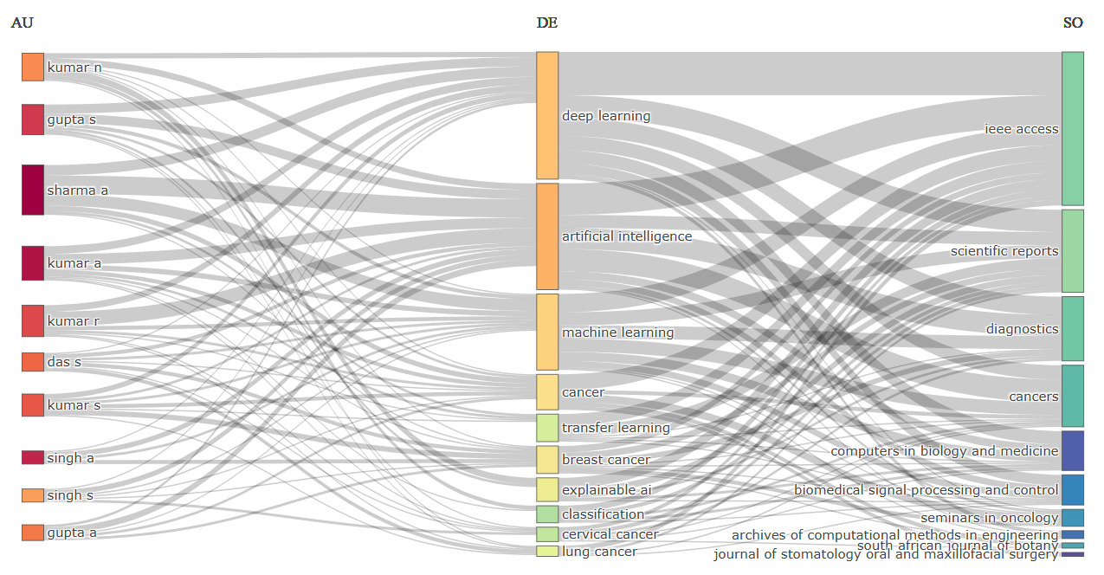Fig 3: Three-Field Plot of Authors, Keywords, and Sources in Indian AI-Cancer Research
As shown in Fig 3, there exists an intellectual linkage between the productive authors and the dominating research themes and major publications sources. Authors like Sharma A., Gupta S., and Kumar A. had a high linkage with “deep learning,” “artificial intelligence,” and “machine learning,” suggesting their focus on AI-based cancer diagnostics and classification. The emerging specialized themes were keywords associated with the concepts of “breast cancer” and “explainable AI”. The thematic areas were mainly linked to journals such as IEEE Access, Scientific Reports and Diagnostics, which are among the most prominent interdisciplinary ones for sharing research on AI-based oncology.
4.9 Thematic Map of Indian research on AI application in Cancer
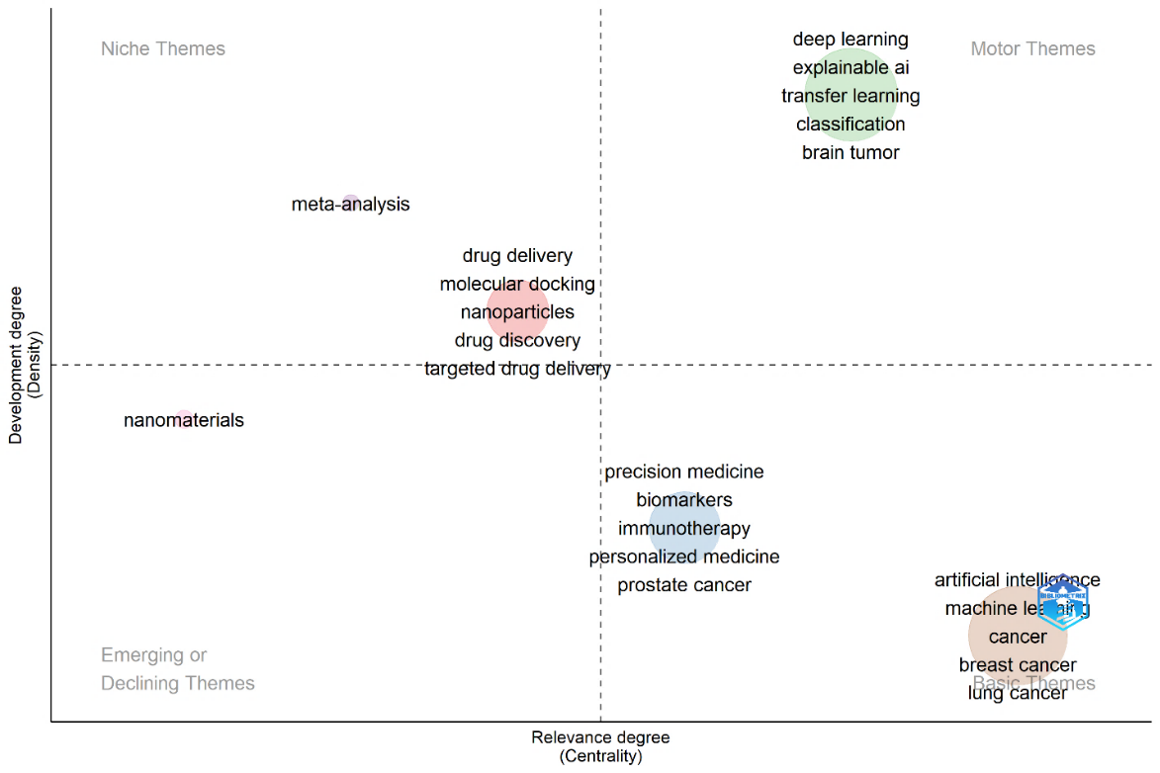
Fig 4: Thematic Map of AI-Driven Cancer Research in India
The motor-related topics like deep learning, explainable AI, transfer learning and classification of brain tumors are well concentrated in Fig 4 giving the impression of their high centrality and developmental maturity in the domain of AI powered oncology research in India. The topics of artificial intelligence, machine learning, breast cancer and lung cancer seem to be very much at the centre, but not very well developed, indicating that there is wide relevance, but little conceptual development. Precision medicine, biomarkers and immunotherapy are transitional technologies, in which the integration of different disciplines is emerging. On the other hand, nanomaterials and meta-analysis are with low connectivity with mainstream AI-cancer research in India, and are peripheral.

4.10 Co-occurrence Analysis of Author Keywords
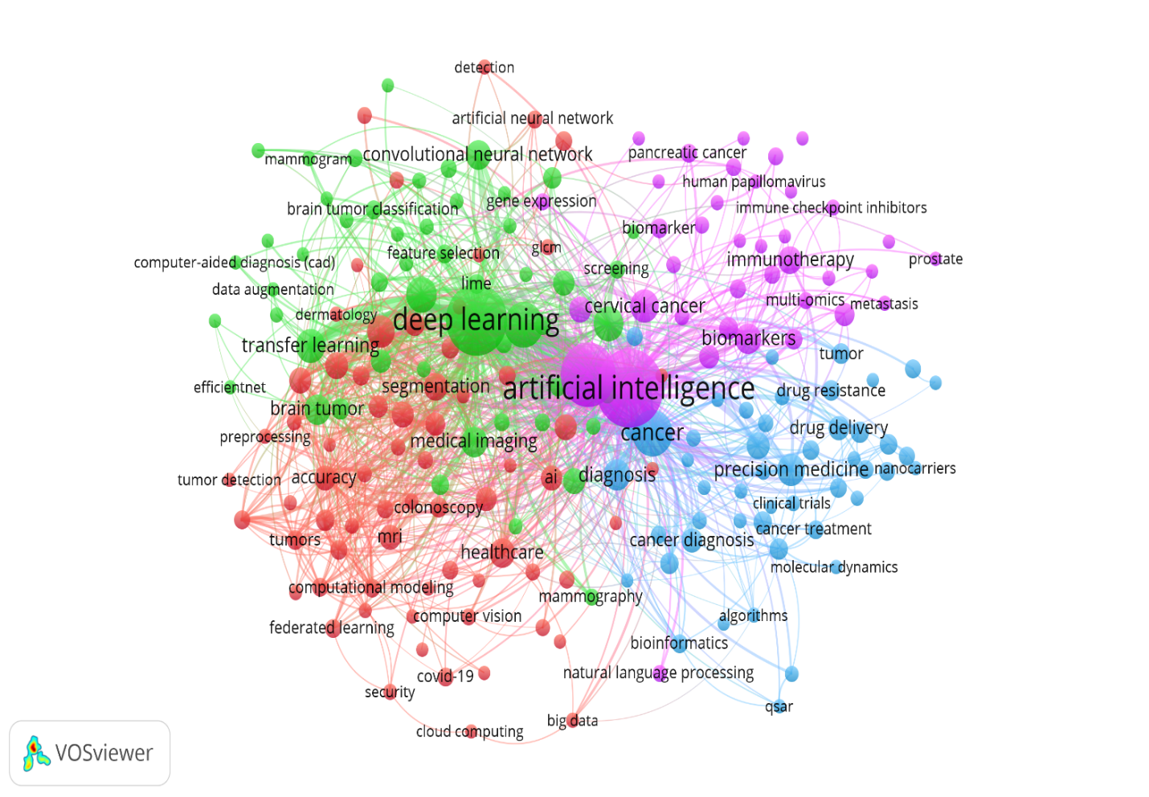
Fig 5: Network visualization of Co- Occurrence keyword
The total number of keywords in Fig 5 is 207, four thematic clusters, 2,658 interlinkages and the total link strength is 5,360, reflecting a very interconnected intellectual structure in Indian AI-cancer research. The predominant color of the green cluster is deep learning, convolutional neural network, feature extraction, and transfer learning, which focus on computational modelling and on cancer analysis based on images. The red cluster is built around diagnosis, detection, segmentation and accuracy of tumors, indicating that there are considerable clinical imaging applications. The blue cluster is focused on precision medicine, drug delivery, bioinformatics and cancer diagnosis, reflecting the translational and therapeutic research axis. The purple cluster, in turn, focuses on biomarkers, immunotherapy, cervical cancer, and multi-omics, signifying a tendency toward personalized oncology and molecular-level investigations of cancer.

4.11 Conceptual Structure: Multiple Correspondence Analysis
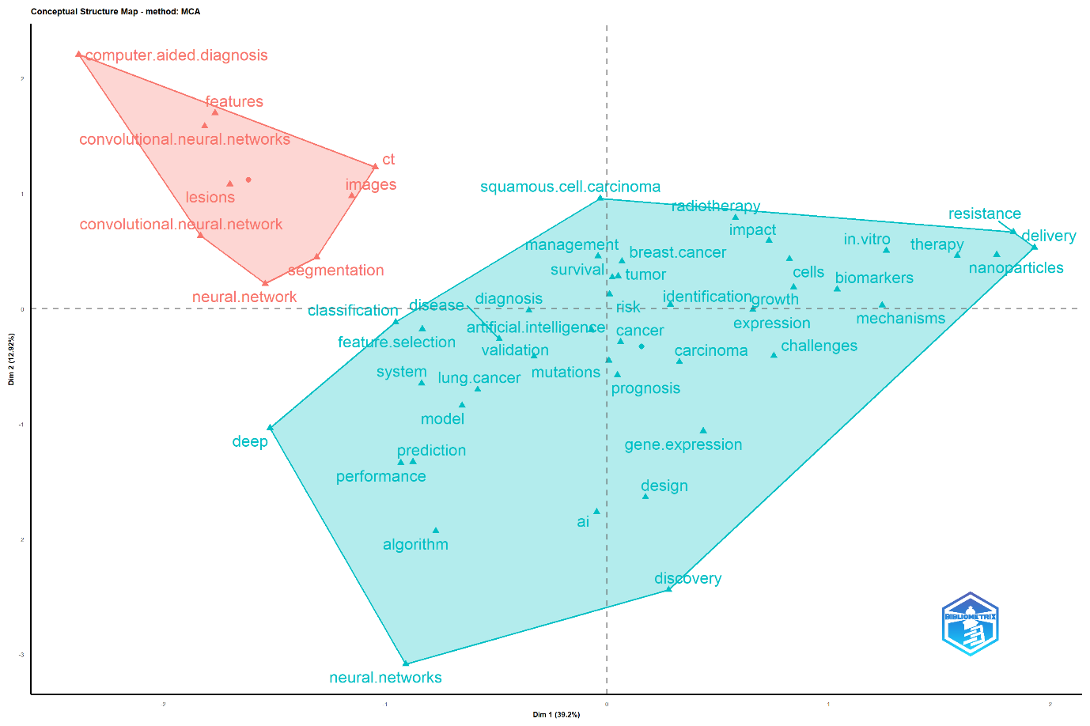
Fig 6: Factorial Correspondence Analysis
Multiple Correspondence Analysis (MCA) was used to create Fig 6, which depicts two key thematic clusters, corresponding to the intellectual structure of AI-driven cancer research in India. The primary themes of the red cluster appear to be computer-aided diagnosis, convolutional neural networks, lesion detection, segmentation, and imaging, suggesting a focus on medical image analysis and automated diagnostic systems. The blue cluster, on the other hand, is related to fields such as artificial intelligence, biomarkers, radiotherapy, gene expression, precision medicine, nanoparticle-based delivery, and prognosis, to which oncology has been increasingly interwoven with other fields. The spatial dispersion also indicates possible diversification of methodology and orientation towards translation research in the field.

4.12 Strategic Thematic Network Structure of AI in Cancer Research in India
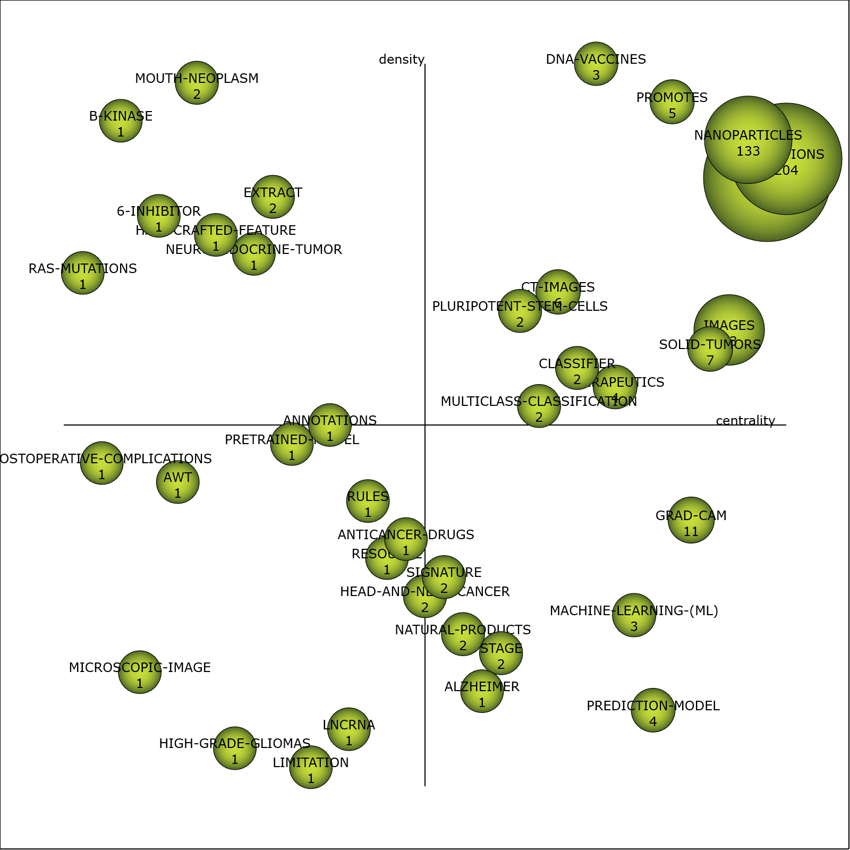
Fig 7: Scimat Strategic Thematic Network Structure
Fig 7 shows high theme diversification of AI use in cancer research in India with 35 thematic nodes distributed based on centrality and density metrics. Highly connected and developmentally mature are dominant themes such as MUTATIONS (centrality 385.56), DISEASES (367.66) and NANOPARTICLES (341.70), which are viewed as important and strategic to the research landscape. Medical imaging and explainable AI in oncology continue to gain importance through the use of large thematic nodes pertaining to IMAGES, SOLID-TUMORS and GRAD-CAM. Specialized, but internally developed domains are highly dense, but less central themes, such as DNA-VACCINES and MOUTH-NEOPLASM. The trends of MACHINE-LEARNING, PREDICTION-MODEL, LNCRNA, and PRETRAINED-MODEL signify evolving methodological advances and a growing level of translational integration in AI-cancer research in India.

4.13 Co-authorship Network Among Authors
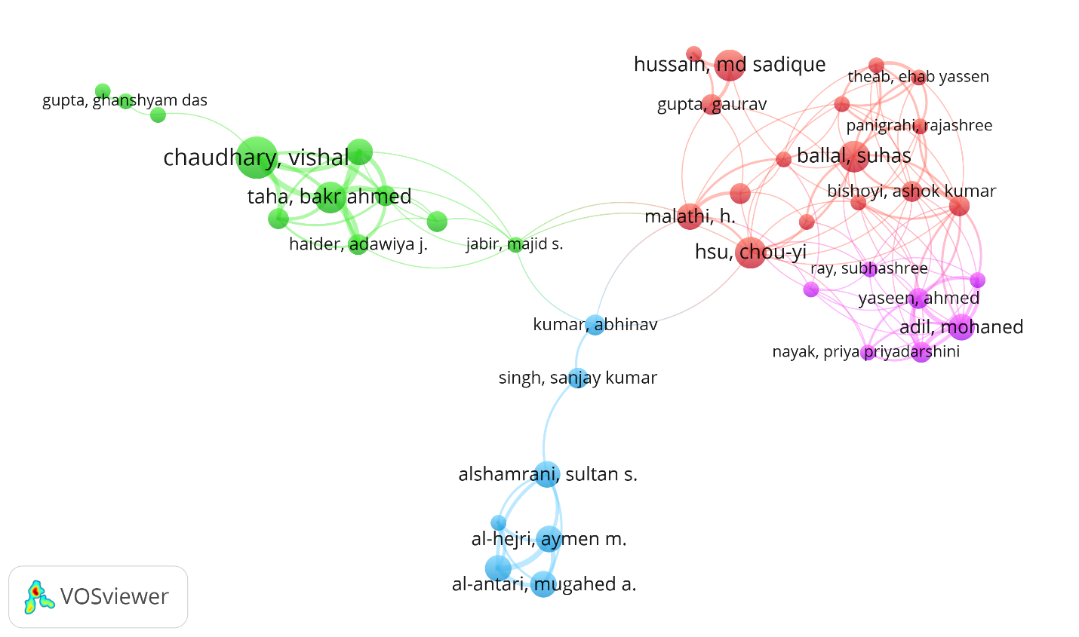
Fig 8: Network Visualization of Co authorship among author
Fig 8 displays the four clusters of collaboration, consisting of 41 authors and 138 links, resulting in a moderate level of interconnectedness among authors' research collaborations (249 links). Vishal Chaudhary, Bakr Ahmed Taha and associates dominate the green cluster, and close working together and constant scholarly exchange are clearly evident. The red cluster reflects the most densely connected group, including authors like Chou-Yi Hsu, Suhas Ballal, and Ashok Kumar Bishoyi, which suggests strong research connections and significant academic collaborations. The blue cluster is a relatively small group of specialized collaboration, around Sultan S. Alshamrani and co-authors, while the purple cluster, comprising of Ahmed Yaseen and Mohaned Adil, indicates an emerging domain of collaboration with developing research ties. Authors in the center of the network have higher degree of collaborative influence and integration across thematic research groups.

4.14 Collaboration among Countries in Indian research on AI application in Cancer

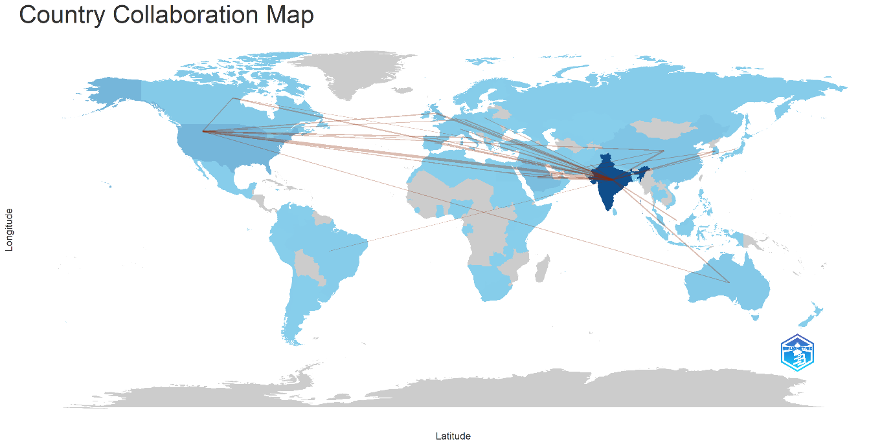
Fig 9: Country Collaboration Map
Fig 9, Country Collaboration Map for India illustrates the orientation of the country towards research collaboration with international partners, which is overwhelmingly Western leaning, with USA having the highest co-authorship linkage (n=247) with close to 1.46 times more than the second highest partner, Saudi Arabia (n=169). The tertiary level of collaboration includes the United Kingdom (n=99) and China (n=93), and emerging partnerships include Korea (n=71), Italy (n=59), Australia (n=49), Canada (n=46), and Malaysia (n=46). The collaboration map visualises these asymmetries by highlighting the density of lines flowing out of India, with transatlantic and Indo-Pacific knowledge corridors as the structurally important pathways for India's oncological AI research ecosystem.

4.15 Bibliographic Coupling Analysis among Documents
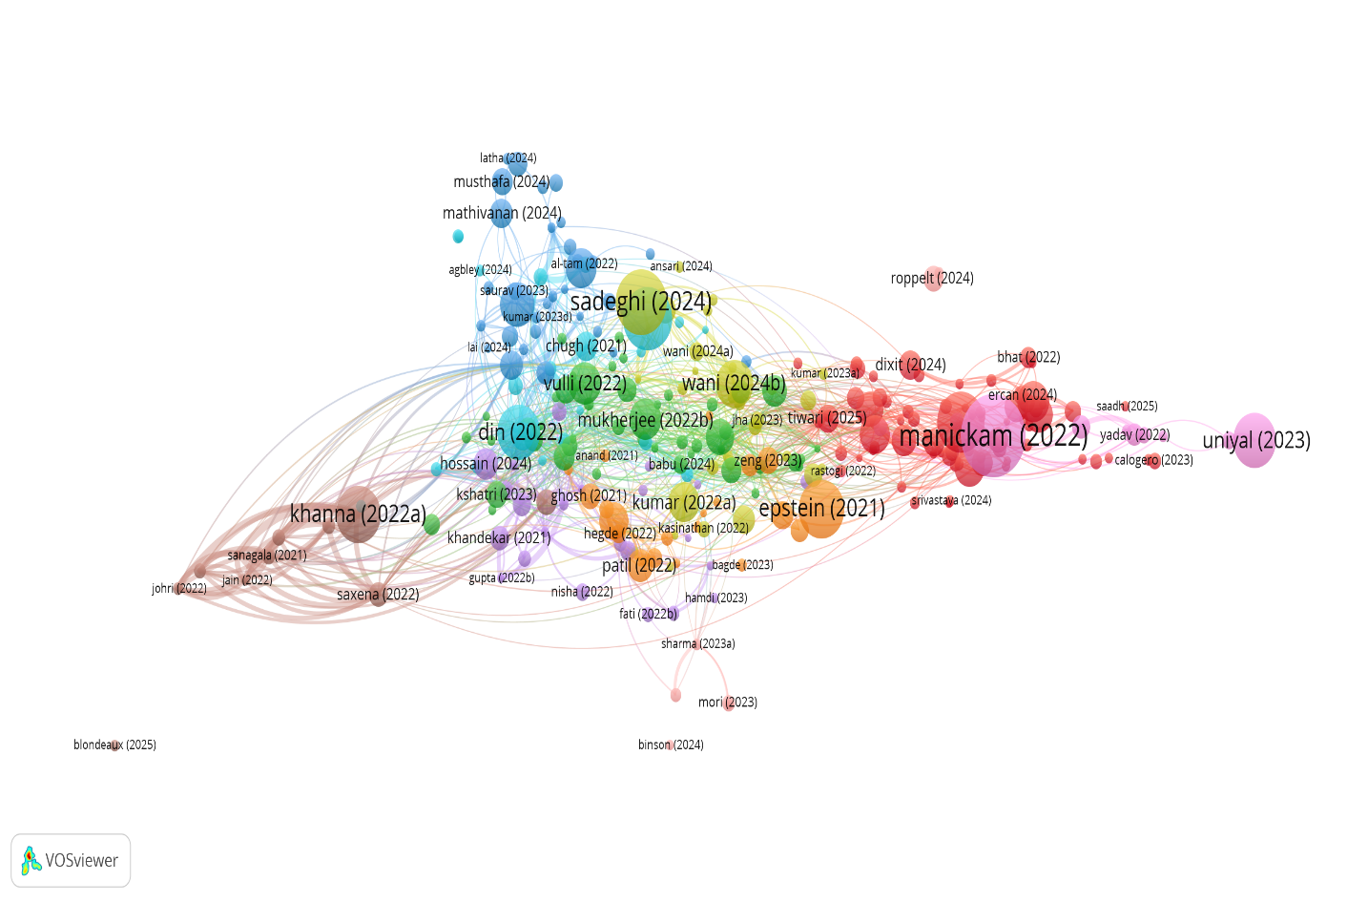
Fig 10: Network Visualization of Bibliographic coupling
The documents in the figure Fig 10 contain 4,166 links, a minimum citation of 21, and are distributed across 10 different thematic clusters, with 284 documents. The green cluster represents the intellectual heart with three papers, including Sadeghi (2024), Wani (2024b) and Din (2022), with the latter having the highest citations (126). The red cluster is led by Manickam (2022) and is considered high impact emerging frontiers. The highest link strength (143) is in the brown cluster around Khanna (2022b), which represents core collaborative structures. The blue cluster (Mathivanan, 2024) represents contributions at their earliest stage, and the purple cluster (Uniyal, 2023) shows a niche specialization. The bridging nodes that connect clusters are essential and they are Yellow and Orange.

4.16 Co-citation Analysis of Cited References

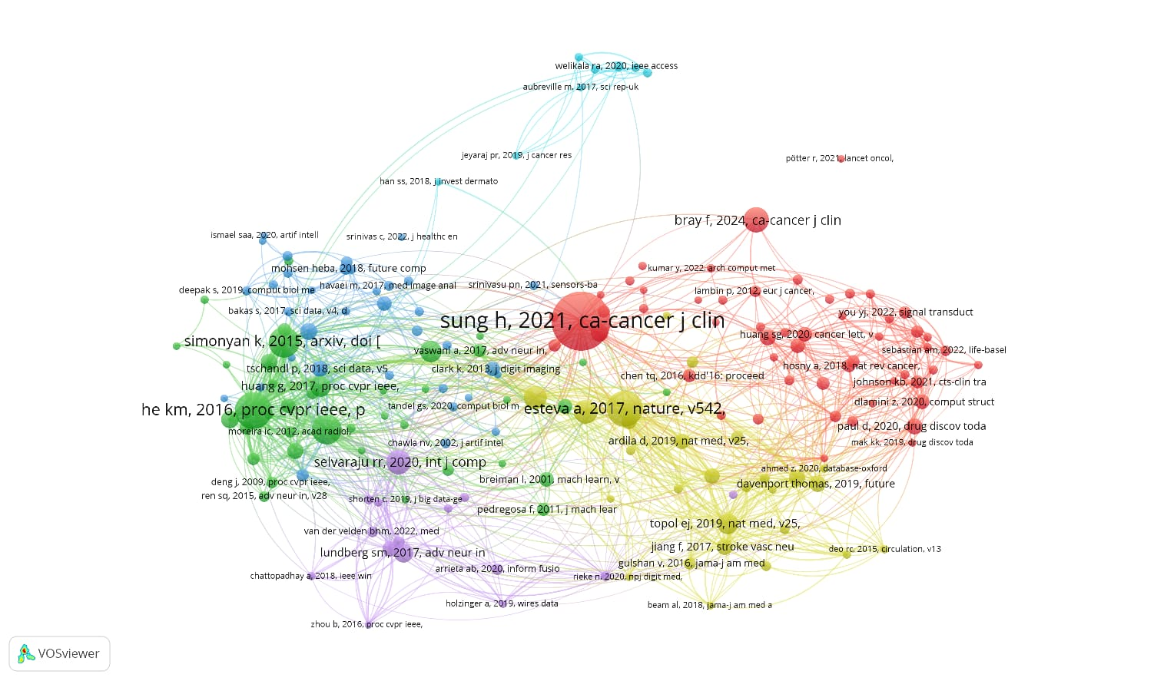
Fig 11: Network Visualization of Co-citation of cited References
A minimum citation threshold of 10 was used to create the links between the references and generate the thematic clusters, with 179 references cited in at least 10 other documents in the sample, distributed across 6 thematic clusters and 5,079 links, having a total link strength of 8,895.Fig 11 shows the distribution of the 179 references cited in 10 or more other documents in the sample across at least 6 thematic clusters, connected by 5,079 links with a total link strength of 8,895, using a threshold for citations of 10. Led by (Sung 2021) the red cluster is a cornerstone of global cancer epidemiology and clinical AI translation. The network's technological backbone is the green cluster that is made up of (He 2016) and Simonyan (2015). The yellow cluster (Esteva, 2017) represents a connection between AI diagnostics and dermatological oncology. Two clusters of related concepts are highlighted in blue, namely explainability frameworks, and purple and light-blue clusters, which relate to machine learning methodologies and foundational AI theory, respectively, and both of which collectively scaffold clinical applications.
5. Conclusion
The present scientometric study shows that AI research in cancer in India has spiraled quickly from 2021 to 2025, which represents the increasing intersection of computational intelligence, medical imaging, and medical oncology. Overall, the significant increase in publications, the nature of collaborations with international partners and the growing representation in high-impact journals are reflective of India's growing influence on the global AI-oncology research landscape. Finally, the thematic analyses identify deep learning, explainable AI, tumor detection, precision medicine, biomarkers, and radiomics as the key intellectual pillars of the field, with other emerging areas, such as multi-omics, pretrained models, and nanoparticle-assisted therapies, indicating research trajectories of the future.
Additionally, the study sheds light on the critical importance of interdisciplinary institutions and collaborative author networks in the research and development of AI-driven diagnostics and treatment of cancer. The citation average of recent publications shows a lower citation average, but this is not because of limited citation windows, but rather because of a lower number of cited publications. The overall citation impact, on the other hand, demonstrates the increased academic visibility and scientific relevance. The results collectively suggest that Indian research on AI application in Cancer is moving from exploratory experiments to clinically focused, data-driven, and translational research. This study offers a comprehensive knowledge map that can guide researchers, policymakers, healthcare institutions and funding agencies in prioritizing research and development in the field of oncology and the role of AI.
REFERENCE
- Bi, W. L., Hosny, A., Schabath, M. B., Giger, M. L., Birkbak, N. J., Mehrtash, A., Allison, T., Arnaout, O., Abbosh, C., Dunn, I. F., Mak, R. H., Tamimi, R. M., Tempany, C. M., Swanton, C., Hoffmann, U., Schwartz, L. H., Gillies, R. J., Huang, R. Y., & Aerts, H. J. W. L. (2019). Artificial intelligence in cancer imaging: Clinical challenges and applications. CA: A Cancer Journal for Clinicians, 69(2), 127–157. https://doi.org/10.3322/caac.21552
- Cobo, M. J., López‐Herrera, A. G., Herrera‐Viedma, E., & Herrera, F. (2012). SciMAT: A new science mapping analysis software tool. Journal of the American Society for Information Science and Technology, 63(8), 1609–1630. https://doi.org/10.1002/asi.22688
- Denysenko, A., Savchenko, T., Dovbysh, A., Romaniuk, A., & Moskalenko, R. (2022). Artificial Intelligence Approach in Prostate Cancer Diagnosis: Bibliometric Analysis. Galician Medical Journal, 29(2), E202225. https://doi.org/10.21802/gmj.2022.2.5
- Huang, Q., Su, W., Li, S., Lin, Y., Cheng, Z., Chen, Y., & Mo, Y. (2025). A bibliometric analysis of artificial intelligence applied to cervical cancer. Frontiers in Medicine, 12, 1562818. https://doi.org/10.3389/fmed.2025.1562818
- Koçak, M., & Akçalı, Z. (2024). Development trends and knowledge framework of artificial intelligence (AI) applications in oncology by years: A bibliometric analysis from 1992 to 2022. Discover Oncology, 15(1), 566. https://doi.org/10.1007/s12672-024-01415-0
- Liubarets, S. F., & Liubarets, T. F. (2024). THE ROLE OF INDICATORS OF MINERAL METABOLISM IN THE DEVELOPMENT OF COMPLICATIONS OF TOOTH FORMATION DISORDERS IN CHILDREN. Bulletin of Problems Biology and Medicine, 1(4), 54. https://doi.org/10.29254/2077-4214-2024-4-175-54-63
- Monroy Rodríguez, S., Thiel-Ellul, D., & Fernández-Ardavín, A. (2025). Exploring willingness to pay for sustainability in tourism: A co-word analysis of the literature review. Journal of Business and Tourism Management (JBTM), 1(2), 1–18. https://doi.org/10.64976/jbtm.8
- Pedük, Ş. (2025). Mapping the future of early breast cancer diagnosis: A bibliometric analysis of AI innovations. Discover Oncology, 16(1), 1870. https://doi.org/10.1007/s12672-025-03495-y
- Seri̇Ndere, M. (2023). Bibliometric analysis of the 50 most cited articles on artificial intelligence for lung cancer imaging. Journal of Health Sciences and Medicine, 6(3), 686–692. https://doi.org/10.32322/jhsm.1294551
- Shen, Z., Hu, J., Wu, H., Chen, Z., Wu, W., Lin, J., Xu, Z., Kong, J., & Lin, T. (2022). Global research trends and foci of artificial intelligence-based tumor pathology: A scientometric study. Journal of Translational Medicine, 20(1), 409. https://doi.org/10.1186/s12967-022-03615-0
- Shimizu, H., & Nakayama, K. I. (2020). Artificial intelligence in oncology. Cancer Science, 111(5), 1452–1460. https://doi.org/10.1111/cas.14377
- Tiwari, A., Mishra, S., & Kuo, T.-R. (2025). Current AI technologies in cancer diagnostics and treatment. Molecular Cancer, 24(1), 159. https://doi.org/10.1186/s12943-025-02369-9
- Wu, X., Xia, Y., Lou, X., Huang, K., Wu, L., & Gao, C. (2025). Decoding breast cancer imaging trends: The role of AI and radiomics through bibliometric insights. Breast Cancer Research, 27(1), 29. https://doi.org/10.1186/s13058-025-01983-1
- Yi, P., Liu, S., Liao, W., Zhang, X., Pan, Z., He, Z., Zeng, F., & Liu, S. (2024). Applications of Artificial Intelligence in Lung Carcinoma: Bibliometric Analysis for Knowledge Mapping and Emerging Trends (2000-2023). SSRN. https://doi.org/10.2139/ssrn.4860806
- Zeng, M., Wang, X., & Chen, W. (2024). Worldwide research landscape of artificial intelligence in lung disease: A scientometric study. Heliyon, 10(10), e31129. https://doi.org/10.1016/j.heliyon.2024.e31129
- Zhang, T., Zheng, Y., Zhang, C., Li, W., Wang, Z., Du, K., & Wang, Z. (2026). AI research trends in liver cancer bibliometric analysis. Medicine, 105(1), e46891. https://doi.org/10.1097/MD.0000000000046891

