Original Research Article

Remote Sensing and Geophysical Targeting of Rare-Metal Pegmatites and Orogenic Gold in the Borgu Basement Terrain, Northwestern Nigeria

Abstract
This study presents an integrated approach combining airborne geophysical data and satellite remote sensing imagery to evaluate the mineral prospectivity of the Borgu Local Government Area in Niger State, northwestern Nigeria, for rare-metal pegmatites (lithium, beryl, tourmaline) and orogenic gold. The study area lies within the Nigerian Basement Complex of the Pan-African mobile belt, predominantly underlain by granite gneiss. Aeromagnetic data interpretation revealed significant NE-SW trending structural features including faults, fractures, and lithological contacts that may control mineralization. The Total Magnetic Intensity map indicates relatively low magnetic signatures, suggesting the presence of magnetite-poor felsic rocks typical of LCT (Lithium-Cesium-Tantalum) pegmatite host environments. Source Parameter Imaging indicates magnetic sources at depths of 120-180 m. Radiometric data analysis shows zones of potassium and thorium enrichment reflecting evolved granitic systems. Remote sensing analysis using Landsat imagery identified alteration indicators including iron oxide, clay, hydrothermal alteration, and quartz signatures. Integration of these datasets within a GIS environment enabled delineation of ten priority exploration targets. The results demonstrate that the Borgu basement terrain possesses favorable geological and structural conditions for pegmatite-related rare-metal mineralization and structurally controlled gold deposits, warranting follow-up field investigations including detailed geological mapping, geochemical sampling, and ground geophysical surveys.

Keywords: Remote sensing; Aeromagnetic; Pegmatite; Lithium; Gold; Borgu; Nigerian Basement Complex; Mineral exploration

1. Introduction
Nigeria hosts significant solid mineral resources, including critical metals and gemstones such as lithium, beryl, tourmaline, and gold, which are increasingly important for modern technology, renewable energy systems, and the jewelry industry (Goodenough et al., 2014; Küster, 1990). Lithium is particularly important for rechargeable battery technologies, while gold commonly occurs in quartz veins and structurally controlled hydrothermal systems within crystalline basement terrains (Groves et al., 1998; Goldfarb et al., 2001).
Lithium-bearing pegmatites are widely distributed within the Nigerian Basement Complex, particularly in Nasarawa, Kogi, Oyo, Kwara, and Niger States, where they are spatially associated with Pan-African granitoids and schist belts. Similarly, gold mineralization is well documented within the Nigerian schist belts of northwestern and north-central Nigeria, where structural features such as faults and shear zones play critical roles in ore localization. These occurrences highlight the strong influence of tectonic structures, magmatism, and hydrothermal processes on mineralization within the Basement Complex.
Geologically, the Nigerian Basement Complex forms part of the Pan-African Mobile Belt and was extensively reworked during the Pan-African Orogeny (~600 ± 150 Ma). The terrain is dominated by Precambrian migmatites, gneisses, schists, and granitoids that have undergone multiple phases of deformation, metamorphism, and magmatic intrusion (Akingboye and Osazua, 2016; Ekeleme et al., 2024). These tectonic events resulted in the development of faults, fractures, folds, and shear zones that act as conduits for mineralizing fluids and therefore serve as important controls on mineral deposition.
The Borgu area, located in northwestern Niger State within the North-Central Nigerian Basement Complex, is characterized by metamorphic and igneous rocks including gneisses, schists, and granitic intrusions. The occurrence of pegmatite bodies, quartz veins, and hydrothermal alteration zones suggests favorable conditions for rare-metal pegmatite and orogenic gold mineralization (NGSA, 2022). However, despite this mineral potential, integrated exploration studies combining remote sensing and geophysical techniques for systematic mineral targeting in the area remain limited.
This study therefore applies an integrated exploration approach combining remote sensing analysis and geophysical data interpretation to improve mineral targeting. The methodology involves lithological and structural mapping, lineament extraction, hydrothermal alteration mapping, and subsurface structural analysis to delineate prospective zones for rare-metal pegmatites and orogenic gold mineralization in the Borgu Basement terrain.
2. Study Area

2.1 Location and Accessibility
The study area lies within Exploration License EL-054003 in Borgu Local Government Area of Niger State, northwestern Nigeria (Figure 1). It covers parts of New Bussa, Lemu, Kainji, and nearby settlements, and is located between longitudes 4°16′–4°18′E and latitudes 10°03′–10°04′N.
The area is reasonably accessible through a network of major and minor roads linking the settlements, while several earth roads, farm tracks, and footpaths provide access to the interior parts of the license area for field investigations. The terrain is generally undulating with gentle slopes and isolated hills, which allows relatively easy movement for field mapping and exploration activities.
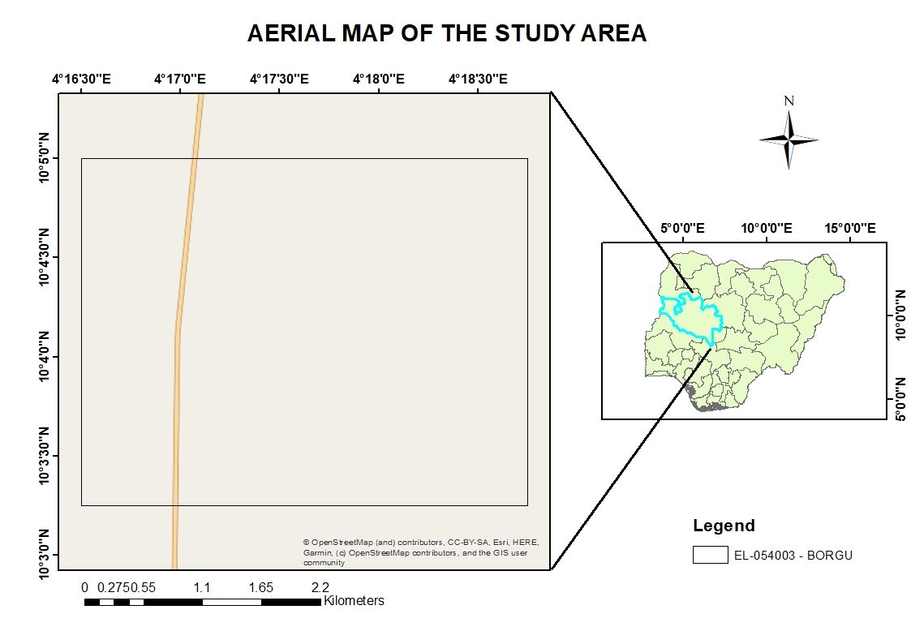
Figure 1: Aerial Map of the Study Area

2.2 Climate and Vegetation
The study area lies within the Guinea Savannah ecological zone of northwestern Nigeria and is characterized by a tropical climate with distinct wet and dry seasons (Figure 2). The wet season occurs between May and October, while the dry season lasts from November to April and is influenced by Harmattan winds. Average annual temperatures range between 25 °C and 35 °C.
Vegetation in the area consists mainly of savannah grasses, shrubs, and scattered trees, with some cultivated farmlands producing crops such as maize, millet, sorghum, and yam. Seasonal streams and patches of woodland also occur within the area. The vegetation pattern and seasonal variations influence field accessibility, outcrop exposure, and remote sensing interpretation.

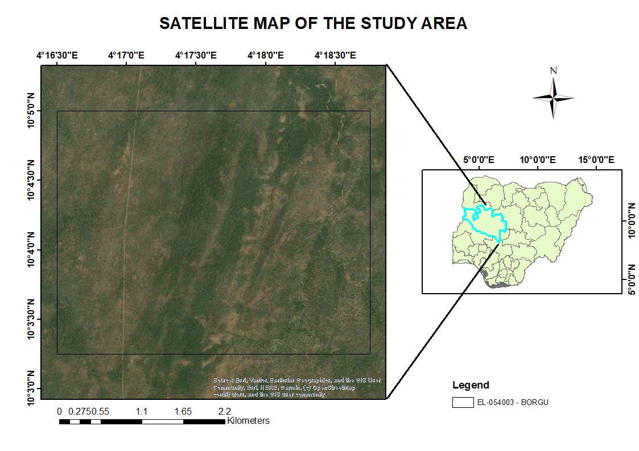
Figure 2: Satellite Map of the Study Area

2.3 Topography and Drainage
The study area is characterized by a gently undulating terrain consisting of low hills, gentle slopes, and shallow valleys, which allow relatively easy access for field investigations (Figure 3). The terrain lacks major escarpments or rugged topographic features, making it suitable for both remote sensing analysis and ground exploration activities.
Digital Elevation Model (DEM) analysis indicates elevation values ranging from about 224 m to 232 m above sea level, confirming the generally low-relief nature of the area. Lower elevations occur mainly in the northern and northeastern parts, which may serve as drainage channels and possible zones for secondary mineral concentration, while slightly higher elevations in the southern and southwestern parts may represent bedrock exposures favorable for primary mineralization.
Drainage in the area is mainly controlled by seasonal streams forming a dendritic pattern and largely dependent on rainfall. The general south-to-north slope of the terrain influences surface runoff, erosion, and sediment redistribution within the license area.
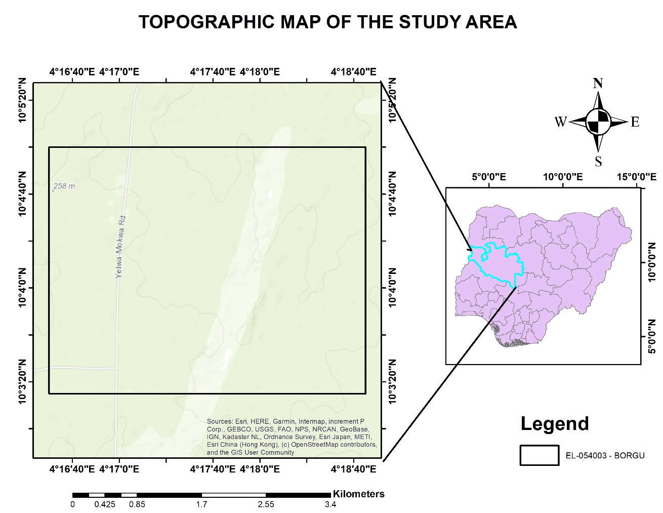
Figure 3: Topographic Map of the Study Area

3. Geological Setting

3.1 Regional Geology
The study area is located within Borgu Local Government Area of Niger State, Nigeria, and forms part of the Nigerian Basement Complex of the Pan-African Mobile Belt (Figure 4). This terrain was extensively reworked during the Pan-African Orogeny (~600 ± 150 Ma) and is dominated by Precambrian crystalline rocks such as migmatites, gneisses, schists, and granitoids that experienced multiple phases of deformation, metamorphism, and magmatic intrusion (Akingboye and Osazua, 2016; Ekeleme et al., 2024).
The Nigerian Basement Complex is broadly subdivided into the Migmatite-Gneiss Complex, the Schist Belts, and the Pan-African Older Granite suite (Oyawoye, 1972; Rahaman, 1988). These units record several tectono-metamorphic events and are associated with granitoid and pegmatitic intrusions that control the distribution of economically important mineralization.
Regionally, the Borgu area is dominated by migmatite-gneiss complexes and Pan-African granitoids intruded by pegmatite and quartz veins. These pegmatites are significant hosts for rare-metal mineralization including lithium-bearing minerals, beryl, and tourmaline (Küster, 1990; Chukwu and Obiora, 2021).

3.2 Local Geology
The local geology of the study area is dominated by granite gneiss (Figure 4), a high-grade metamorphic rock of granitic origin characterized by well-developed gneissic foliation defined by alternating quartz-feldspar rich and ferromagnesian mineral bands.
The granite gneiss forms the basement host for later pegmatite and quartz vein intrusions, which are important targets for rare-metal mineralization such as lithium, beryl, and tourmaline. Structural features such as fractures, joints, and shear zones within the gneiss also provide pathways for hydrothermal fluids responsible for quartz vein-hosted gold mineralization.

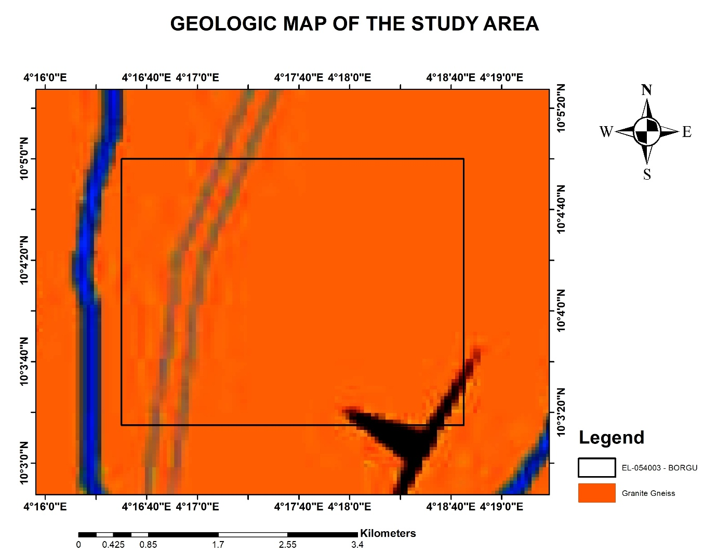
Figure 4: Geologic map of the study area showing the dominant Granite Genesis.

3.3 Mineralization Controls
Mineralization within the study area is largely controlled by structural features and magmatic processes. Rare-metal pegmatites are typically emplaced along fractures, joints, and shear zones that act as conduits for mineralizing fluids (Cerny and Ercit, 2005; London, 2008). Similarly, gold mineralization in basement terrains is structurally controlled and commonly occurs within quartz veins and deformation-related fracture systems (Groves et al., 1998; Goldfarb et al., 2001).
These geological conditions suggest significant potential for rare-metal pegmatite and structurally controlled gold mineralization in the Borgu area. The Lithium–Cesium–Tantalum (LCT) pegmatite family, which hosts lithium, beryl, and tourmaline, is commonly associated with evolved S-type granites and typically exhibits low magnetic signatures due to magnetite depletion (Cerny and Ercit, 2005).

4. Methodology

4.1 Data Acquisition
This study adopted a desktop-based exploration approach using existing geoscientific datasets to evaluate the mineral potential of the exploration license area in Borgu LGA, Niger State. The datasets used include airborne geophysical data (aeromagnetic and radiometric), Landsat satellite imagery, Digital Elevation Model (DEM) data, and regional geological maps supported by published literature.

4.2 Aeromagnetic Data Processing
The aeromagnetic data were processed using several enhancement techniques to extract geological and structural information. Total Magnetic Intensity (TMI) was used to identify variations in subsurface magnetic properties and delineate lithological boundaries and intrusive bodies (Figure 5). The First Vertical Derivative (1VD) enhanced shallow magnetic features and structural contacts (Figure 6), while the Second Vertical Derivative (2VD) highlighted near-surface fractures and localized structures (Figure 7).
Source Parameter Imaging (SPI) was used to estimate the depth to magnetic sources (Figure 8). The Analytical Signal (AS) helped delineate magnetic source edges irrespective of magnetization direction (Figure 10), while the Tilt Derivative (TDR) was used to enhance structural features and fault geometries (Figure 11).

4.3 Remote Sensing Analysis
Landsat imagery was processed using image enhancement and band ratio techniques to identify lithological variations and hydrothermal alteration zones. The indices computed include Iron Oxide Index (Band 4/Band 2) for ferric minerals (Figure 13), Clay Index (Band 6/Band 7) for hydroxyl-bearing minerals (Figure 14), Ferric Iron Index for oxidation intensity (Figure 15), Ferrous Index (Band 6/Band 5) for ferrous minerals, Quartz Index for silicification zones (Figure 14), and NDVI to assess vegetation influence on spectral responses (Figure 18).

4.4 GIS Integration and Target Delineation
The results obtained from aeromagnetic interpretation, remote sensing analysis, and DEM evaluation were integrated within a Geographic Information System (GIS) environment. This integrated approach allowed for overlay and comparison of different datasets, including geological structures, lineaments, elevation data, and alteration indicators, to identify areas where these features coincide. Zones exhibiting favorable geological and structural characteristics were identified as potential exploration targets.

5. Results

5.1 Aeromagnetic Interpretation

5.1.1 Total Magnetic Intensity (TMI)
The Total Magnetic Intensity map (Figure 5) of the study area shows relatively low magnetic relief within the license area compared to high-intensity clusters to the northwest and southeast. This suggests the exploration license is underlain by a suite of non-magnetic rocks, likely metasediments (schists or phyllites) or highly fractionated, magnetite-poor S-type granites. These are the classic host environments for LCT pegmatites (Lithium-Cesium-Tantalum) because these melts are typically depleted in iron and magnetite. From an orogenic gold perspective, the EL sits in a magnetic low trough, a high-priority exploration signature as these lows often represent major crustal-scale shear zones where hydrothermal fluids have washed out the magnetite (magnetite destruction).

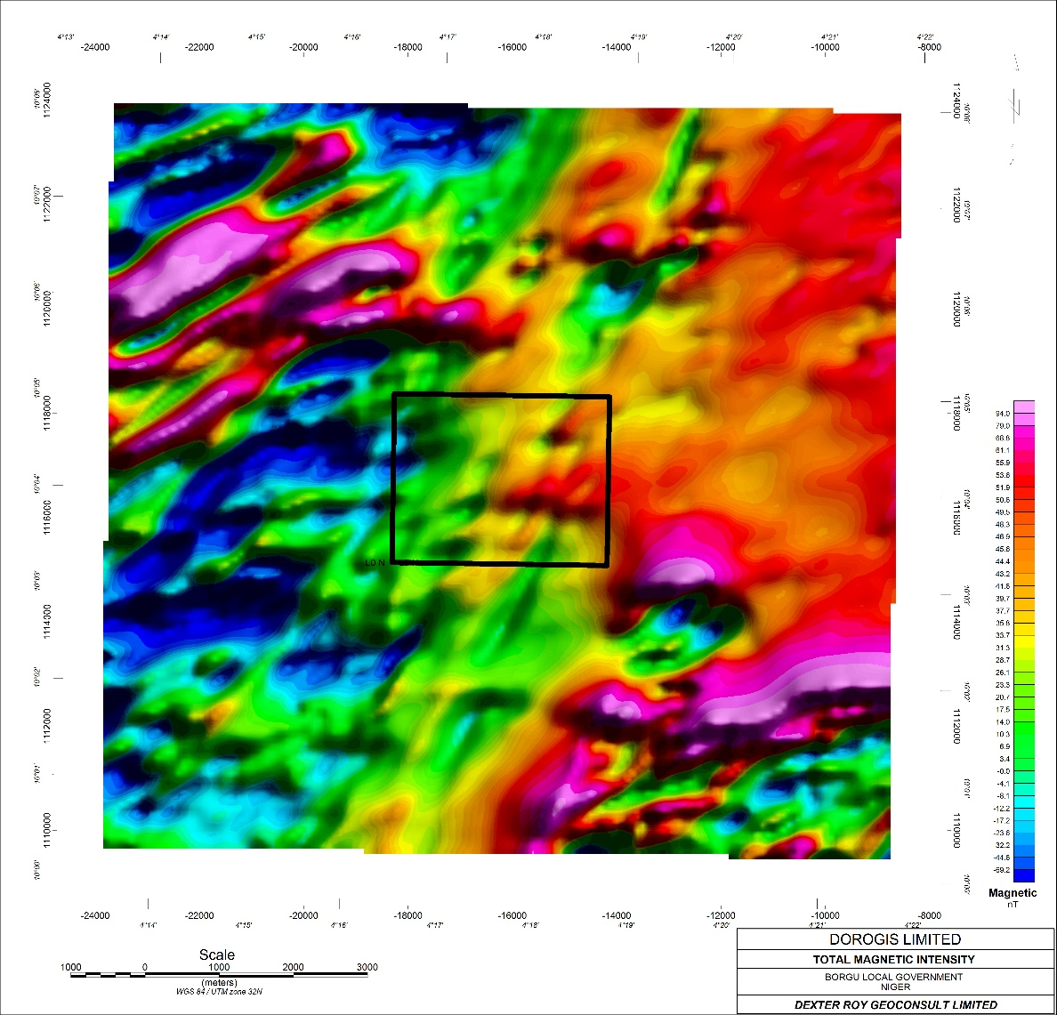
Figure 5: Total Magnetic Intensity

5.1.2 Vertical Derivative Analysis
The First Vertical Derivative (1VD) map (Figure 6) reveals a series of distinct NE-SW trending linear features that represent the primary lithological contacts and major fault planes defining the architecture of the basement rocks. These 1VD lineaments are important indicators for pegmatite exploration as pegmatitic melts typically follow these regional structural grains. The Second Vertical Derivative (2VD) map (Figure 7) shows that the major NE-SW corridor is composed of multiple, closely spaced parallel fractures and small-scale shears. This high level of structural lining is a classic signature for orogenic gold mineralization, with secondary and tertiary fractures providing the necessary surface area for hydrothermal fluid reactions.

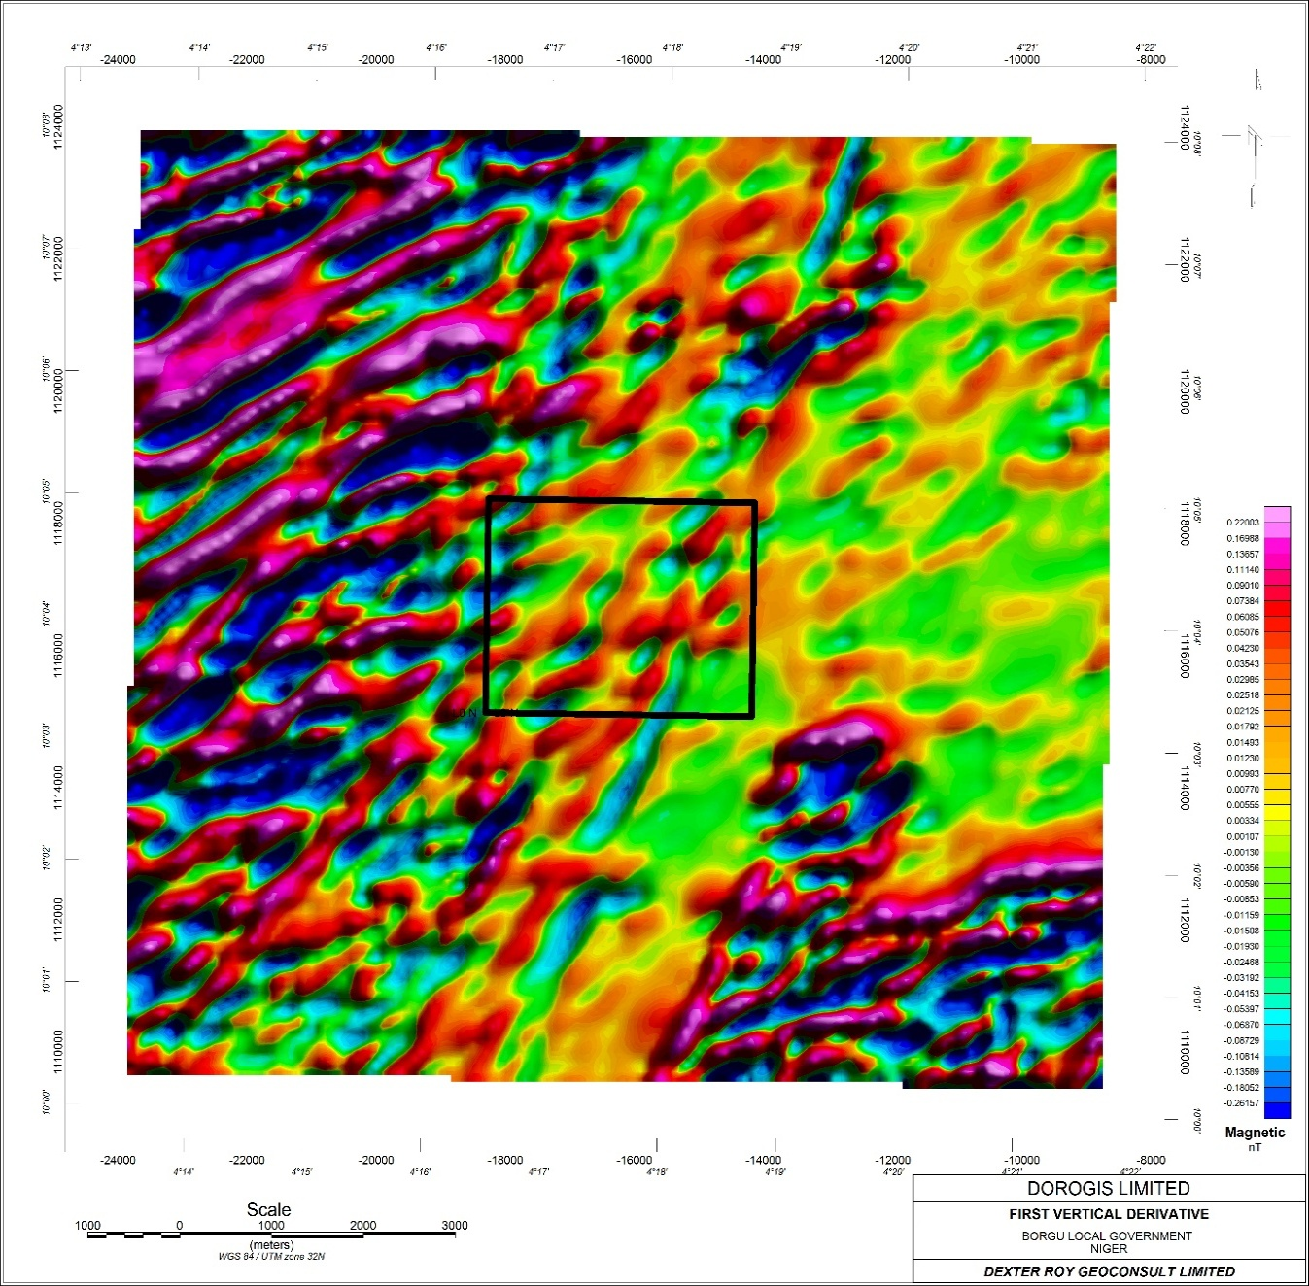
Figure 6: First Vertical Derivatives

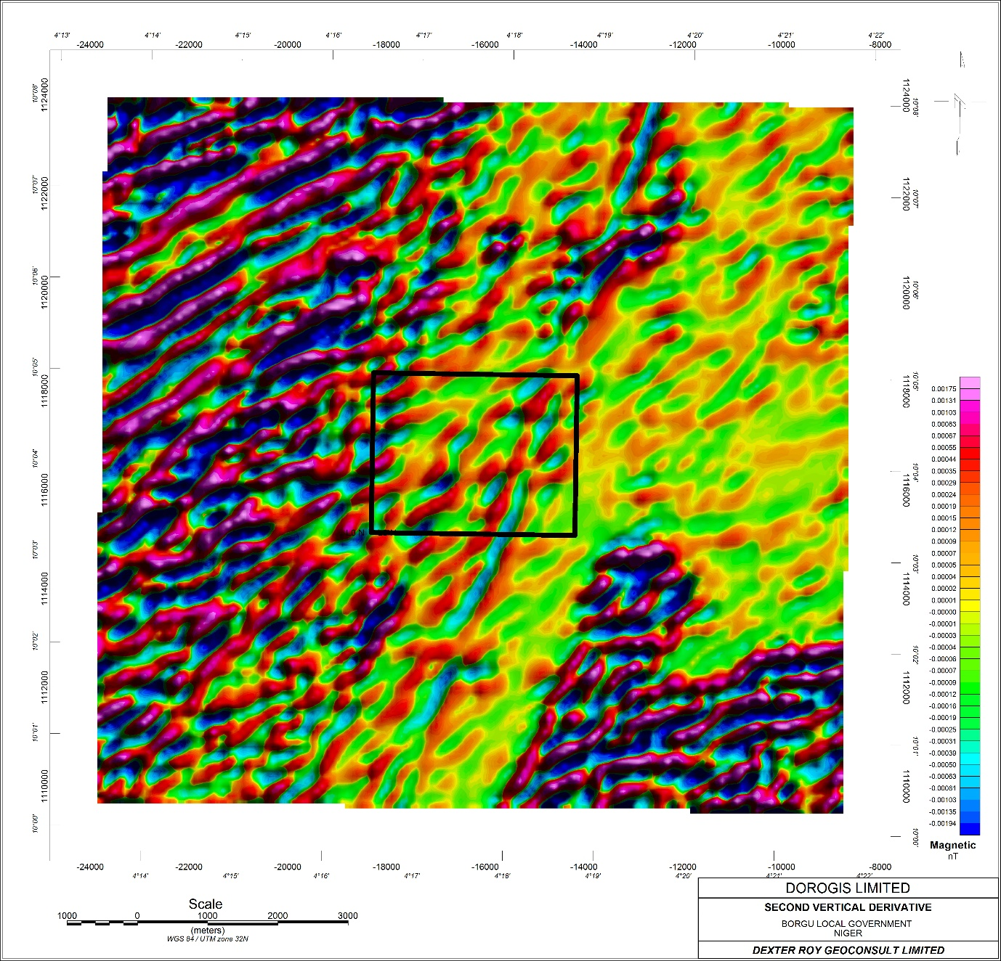
Figure 7: Second Vertical Derivatives

5.1.3 Source Parameter Imaging (SPI)
The Source Parameter Imaging (SPI) map (Figure 8) provides critical depth-to-source estimates for magnetic features within the study area. It indicates that the magnetic basement is relatively shallow, ranging between 120 m and 180 m. This is an encouraging depth as it suggests that any mineralization associated with the basement-cover interface or shallow intrusive bodies is within reach of standard drilling. The shallowest signatures are concentrated on the western flank of the license, representing priority areas for trenching or pitting where cover material is likely thinnest.

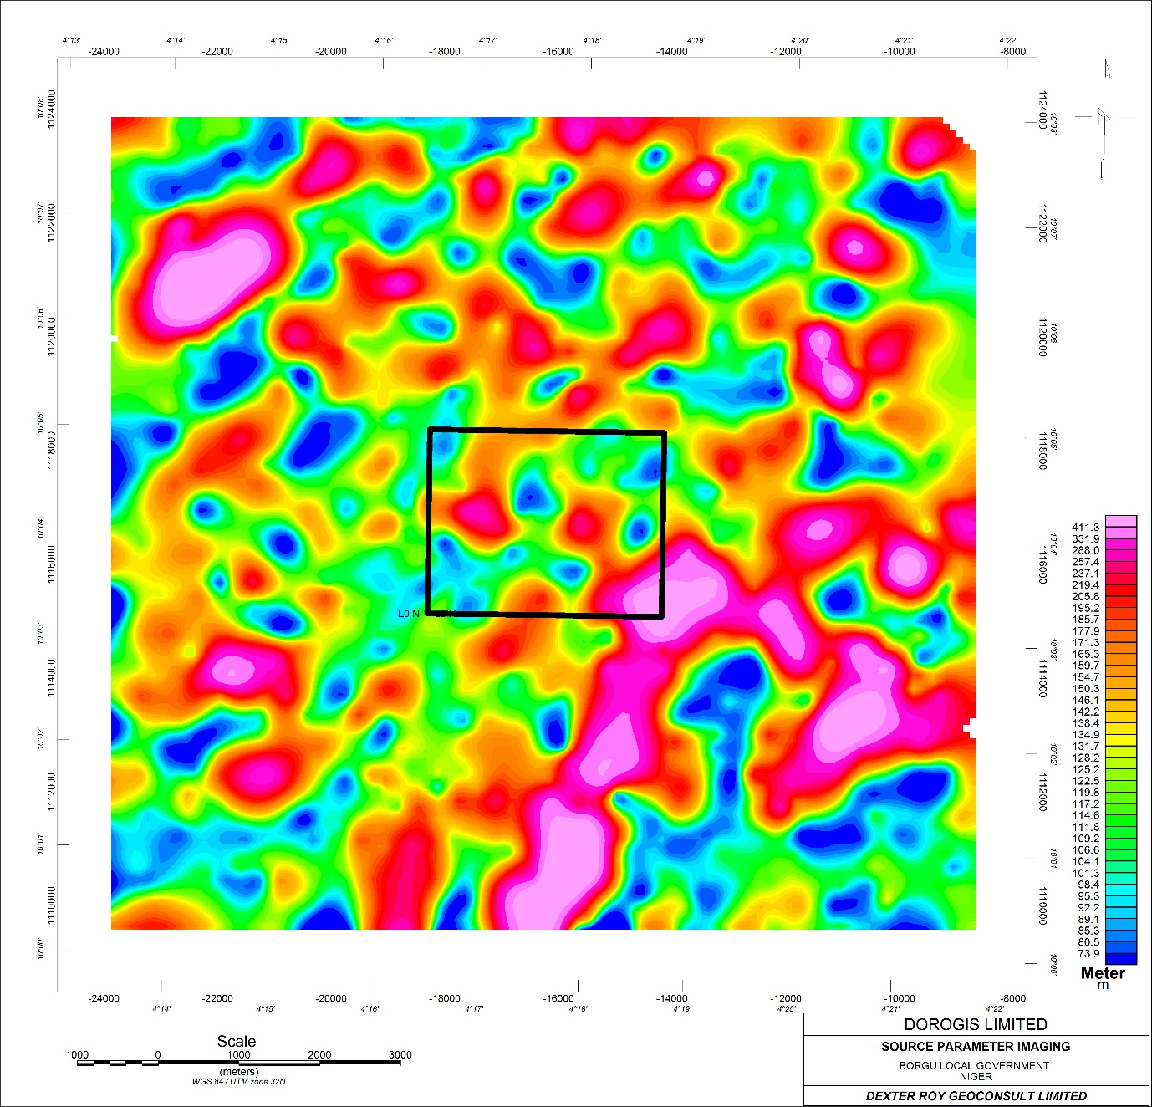
Figure 8: Source Parameter Imaging

5.1.4 Radiometric Data
The radiometric signature within the license area provides compelling evidence for lithium and beryl prospecting. The area is dominated by a cyan-to-white color on the K-Th-U ternary map (Figure 9), indicating strong enrichment in Potassium (K) and Thorium (Th). In the Nigerian Basement Complex, this specific ternary signature typically identifies evolved granitic facies or pegmatitic swarms that have intruded the metasedimentary host rock. The white zones represent areas where K, Th, and U are all elevated simultaneously, a key indicator for highly fractionated pegmatites.

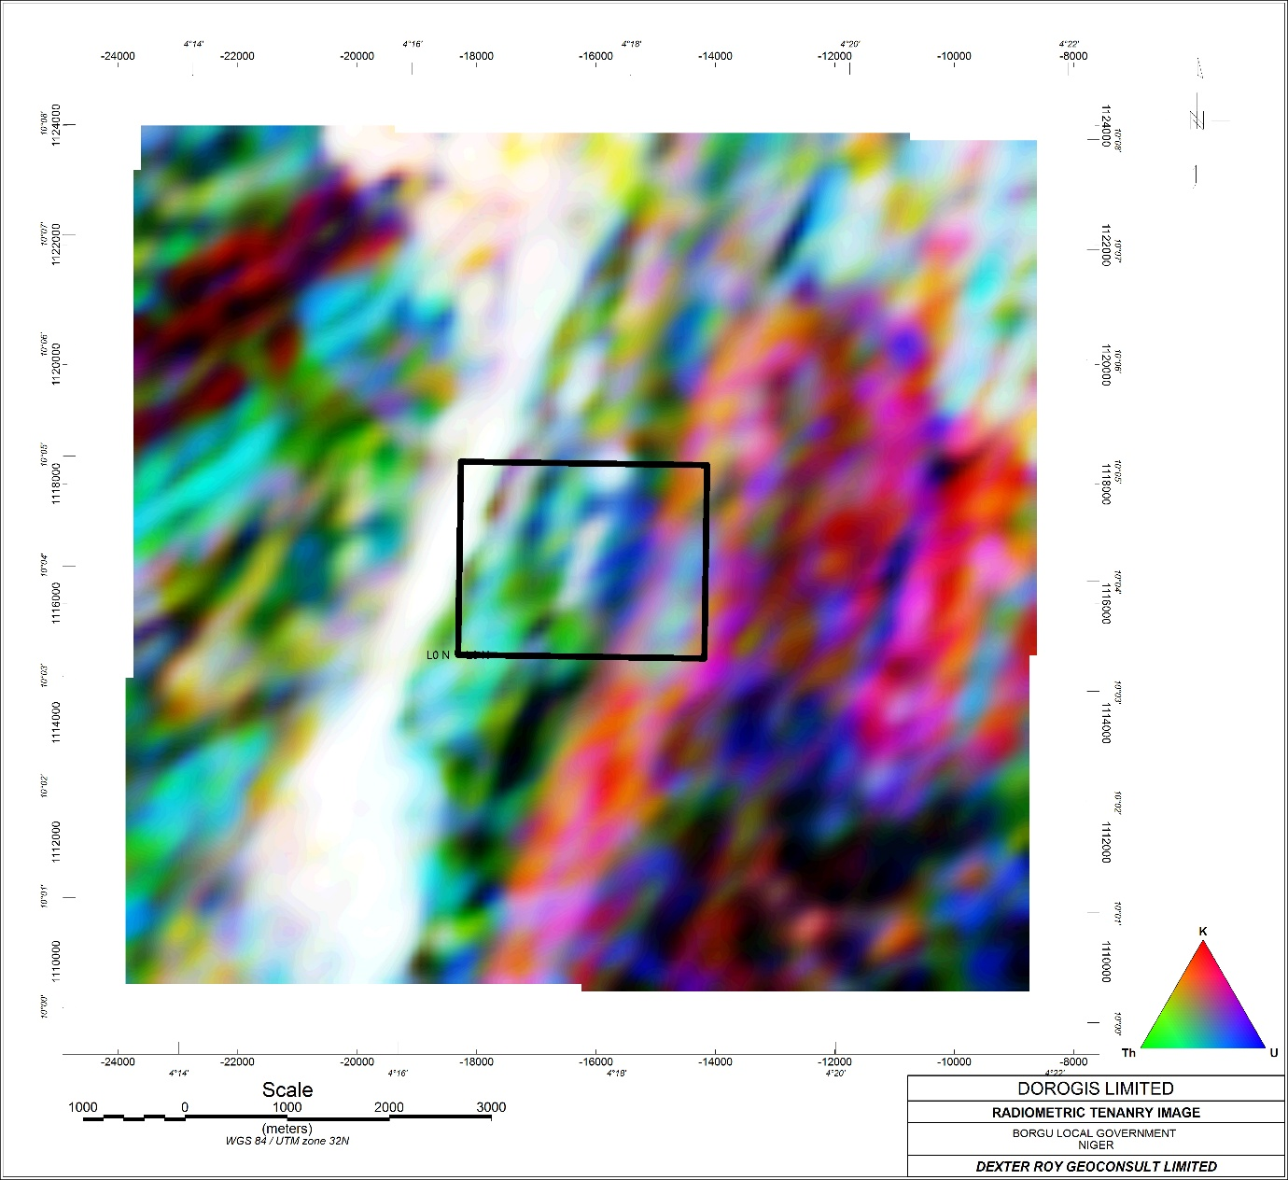
Figure 9: Radiometric Tenanry Image

5.1.5 Analytical Signal (AS) Map
The Analytical Signal map (Figure 10) confirms that the license area is a magnetic low zone, showing very low amplitudes compared to the surrounding basement. This is a positive sign for LCT pegmatite exploration, as it confirms the absence of massive mafic or magnetic intrusions within the license. However, the AS map does show very subtle, isolated highs along the western edge of the license area. These likely represent deeper magnetic basement features or small, buried mafic dykes. These features are important because they create rheological contrasts - harder rocks next to softer schists - which often provide the structural trap needed for gold mineralization.

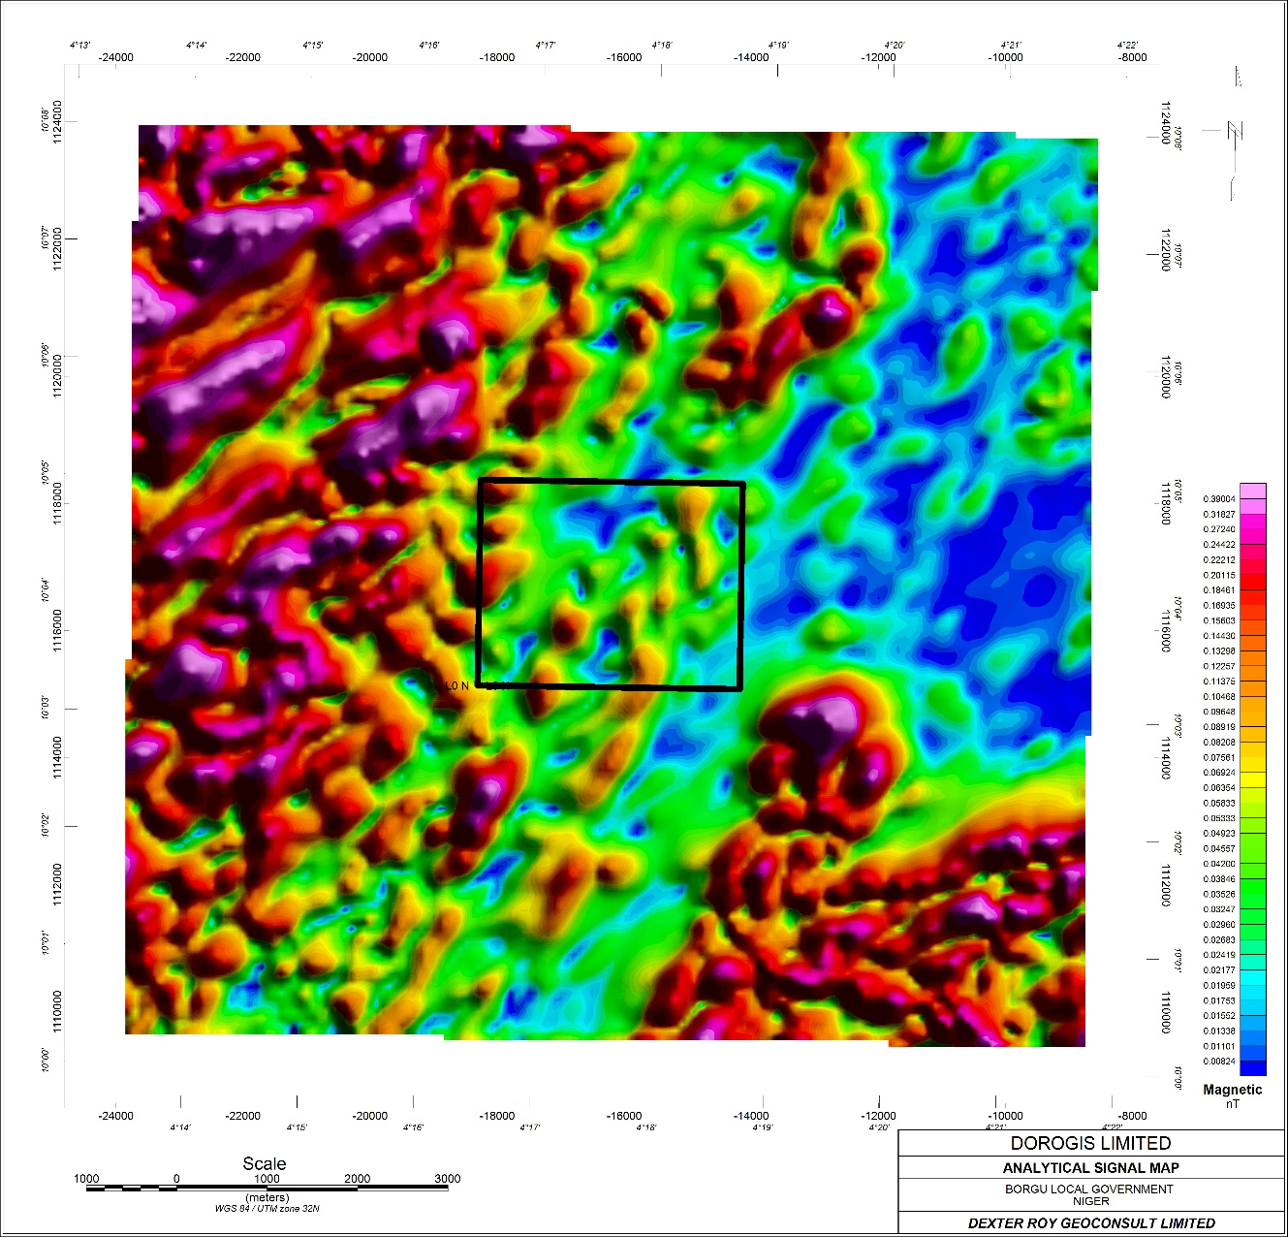
Figure 10: Analytical Signal Map

5.1.6 Tilt Derivative (TDR) Map
The Tilt Derivative equalizes the signal from both shallow and deep sources, revealing a structural kink or bend in the center of the license (Figure 11). This geometric anomaly suggests a localized zone of dilation where the NE-SW faults have been slightly rotated or offset. In orogenic gold systems, these are the primary targets because they represent low-pressure sites where mineral-bearing fluids are sucked in, causing gold and tourmaline to precipitate. This structural intersection in the middle of the license is a good target for ground-truth mapping and initial soil sampling.

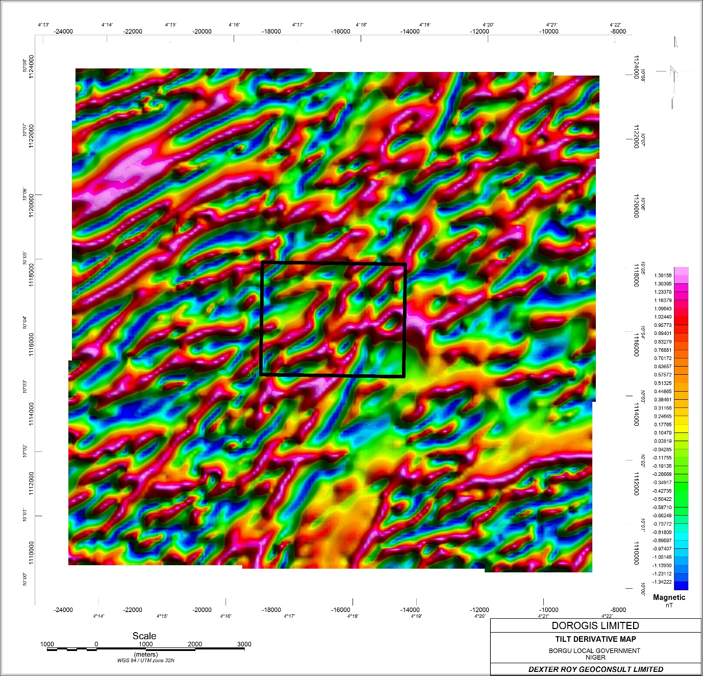
Figure 11: TILT Derivatives Map

5.1.7 Lineament Map
The Lineament Map of the study area highlights a prominent NE-SW structural grain (Figure 12). While the rocks inside the license area have low magnetic contrast, by cross-referencing this with the 1VD and TDR, the structures can be confirmed to continue through the license. This confirms that the license sits directly within a major structural corridor. The fact that the lineaments appear to converge or pinch as they enter the license area from the south suggests a high-strain environment. This is an ideal setting for gold mineralization, as high strain typically leads to the development of extensive fracture networks required for large-scale fluid flow.
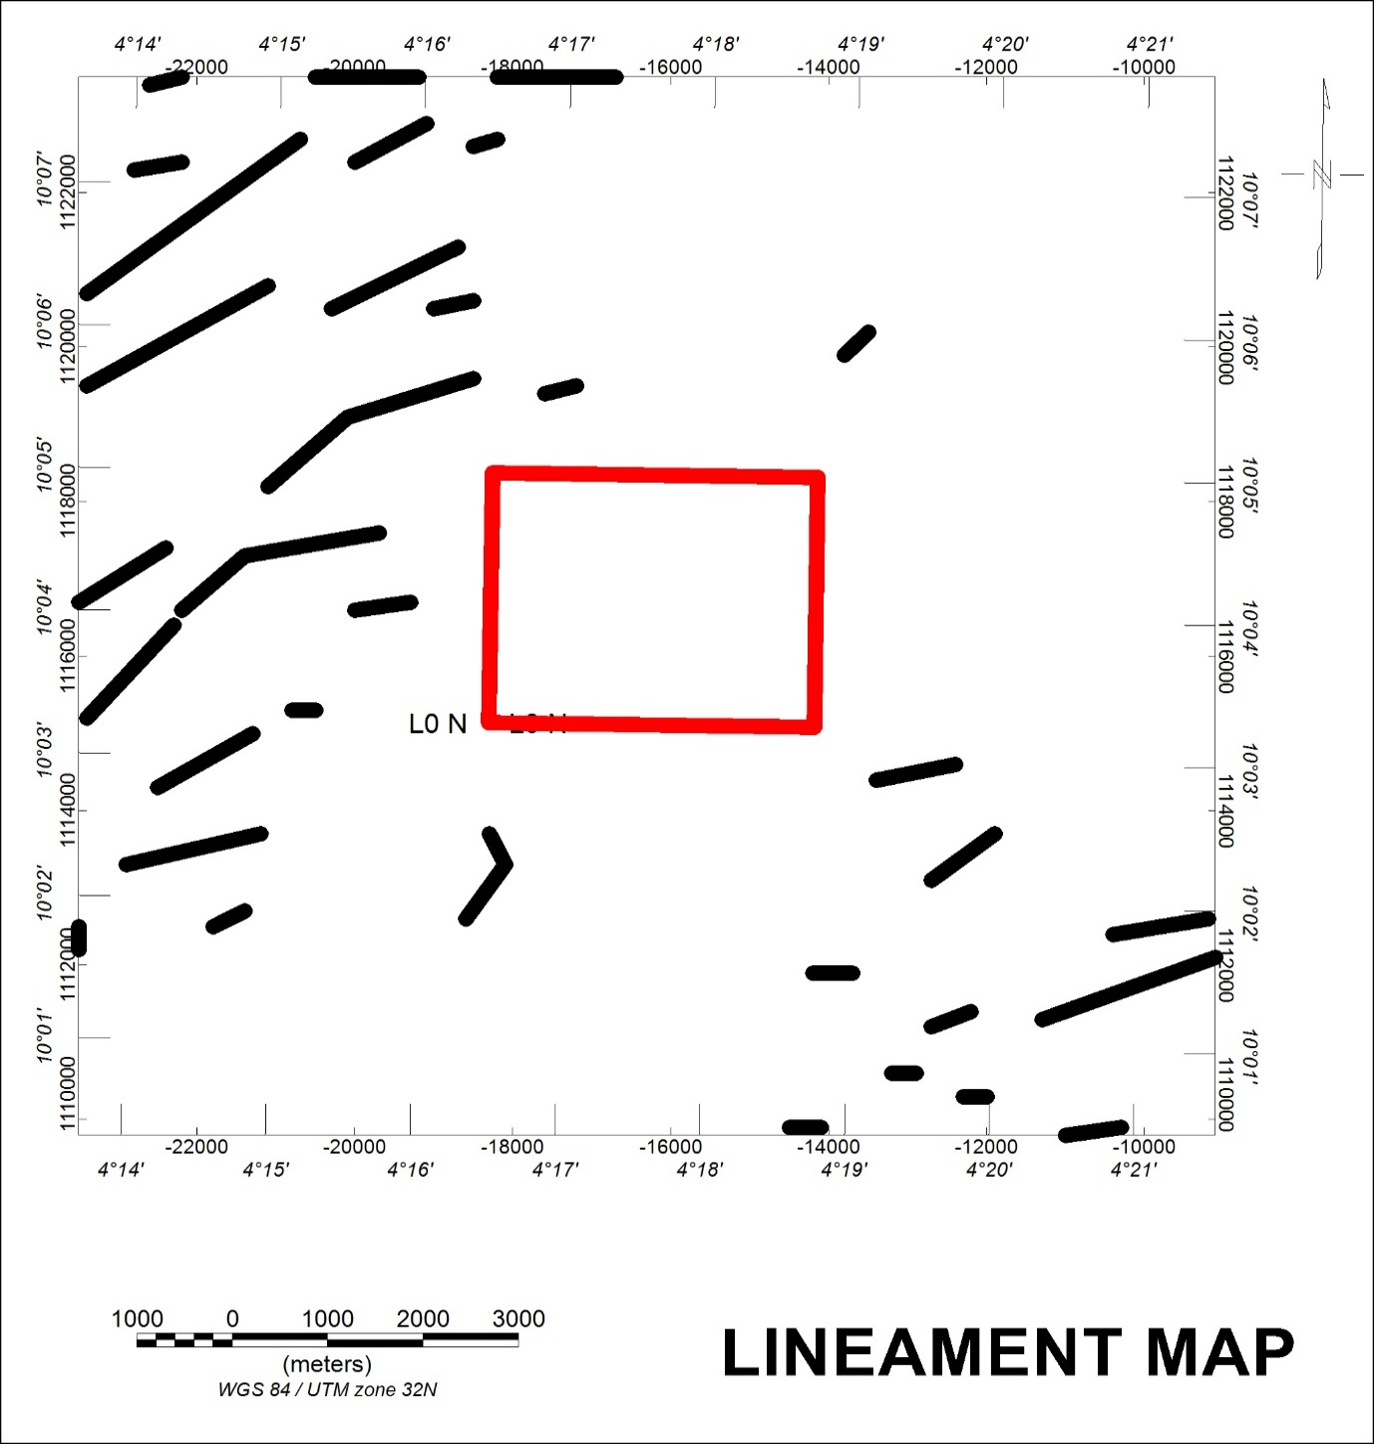
Figure 12: Lineament Map

5.2 Remote Sensing Results

5.2.1 Alteration Indices
Remote sensing analysis using Landsat imagery identified significant alteration indicators across the study area.
The Iron Oxide Index (Ratio 4/2) identifies the presence of ferric iron minerals like hematite and goethite (Figure 13), which often form gossans or ferruginous caps over mineralized zones. High values in this index may point to the oxidation of sulfide minerals (pyrite/arsenopyrite) commonly associated with gold mineralization. These iron-stained zones are high-priority targets for ground-truthing as they often coincide with the margins of hydrothermal systems.
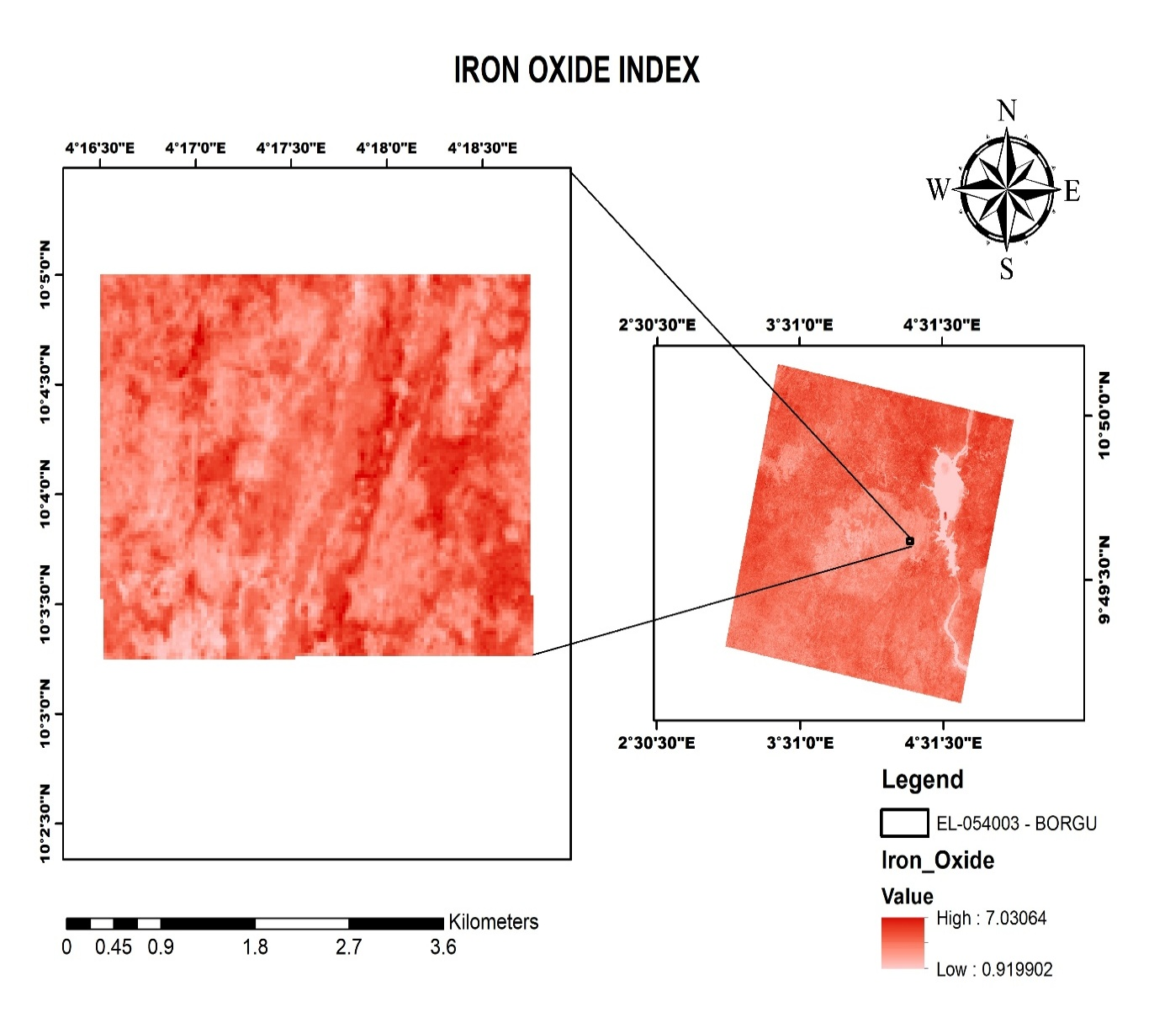
Figure 13: Iron Oxide Index

The Clay Index (Ratio 6/7) targets the hydroxyl absorption features characteristic of minerals like kaolinite, illite, and muscovite (Figure 14). In the context of lithium and gold prospecting, high clay anomalies often represent hydrothermal alteration zones. For gold, this suggests argillic alteration around quartz veins. For lithium, these anomalies may highlight the weathered caps of pegmatite bodies or the presence of muscovite/lepidolite, which are key indicators of highly fractionated granitic systems.

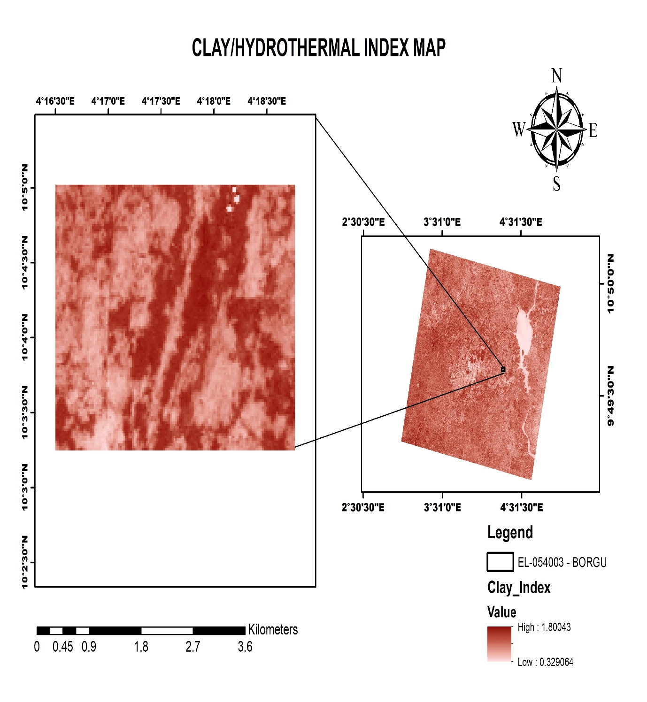
Figure 14: Clay Index
The Ferric Iron Index delineates (Figure 15) highly oxidized surface materials and lateritic weathering crusts, while the Ferrous Index (Ratio 6/5) identifies FeO bearing minerals like chlorite and biotite. A high ferrous response in the metasedimentary units may indicate propylitic alteration, which typically forms the distal envelope of gold mineralization. The spatial transition from ferrous-rich to ferric-rich zones helps in mapping the intensity of the paleo-weathering profile.
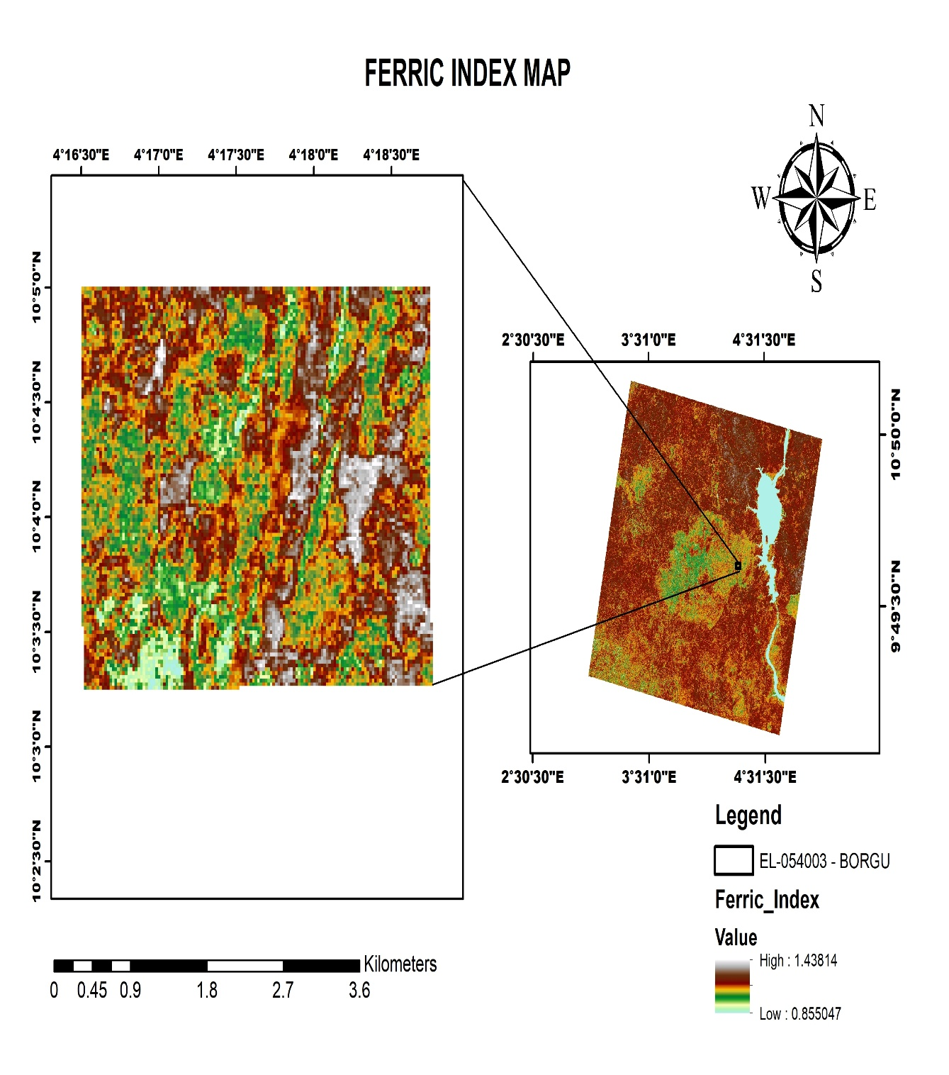
Figure 15: Ferric Iron Index

5.2.2 Quartz Index and False Color Composite
The Quartz Index map (Figure 16), utilizing SWIR ratios to isolate the silicate response, identifies zones of silicification and quartz-vein proliferation. Given that both LCT pegmatites and orogenic gold deposits are silica-saturated systems, the bright anomalies on this map are critical exploration targets. The NNE-trending linear quartz anomalies are interpreted as prospective auriferous reef zones or large-scale pegmatitic bodies within the schist-gneiss contact zones.
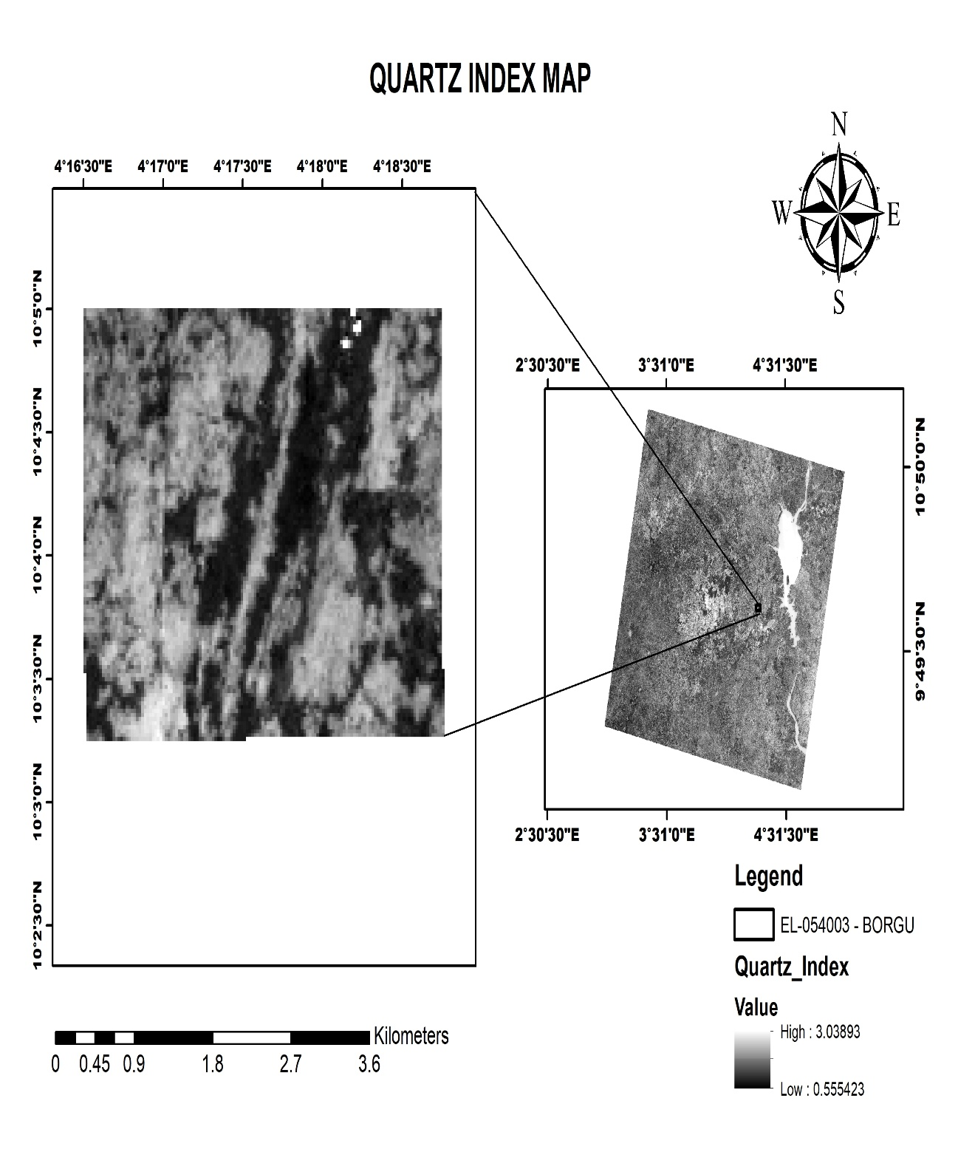
Figure 16: Quartz Index
The False Color Composite (FCC) Map (Figure 17) serves as the foundational litho-structural layer for the study area. By assigning Short-Wave Infrared (SWIR) and Near-Infrared (NIR) bands to the RGB channels, this composite enhances the contrast between metasedimentary sequences and igneous intrusions. The map reveals a dominant NNE-SSW to NE-SW structural grain, typical of the Nigerian schist belts. Tonal variations in the cyan-to-brown spectrum distinguish the more resistive granitic and gneissic bodies from the low-lying schistose units, while the linear features identified are interpreted as shear zones or brittle-ductile faults that likely governed the emplacement of mineralized pegmatites and quartz veins.
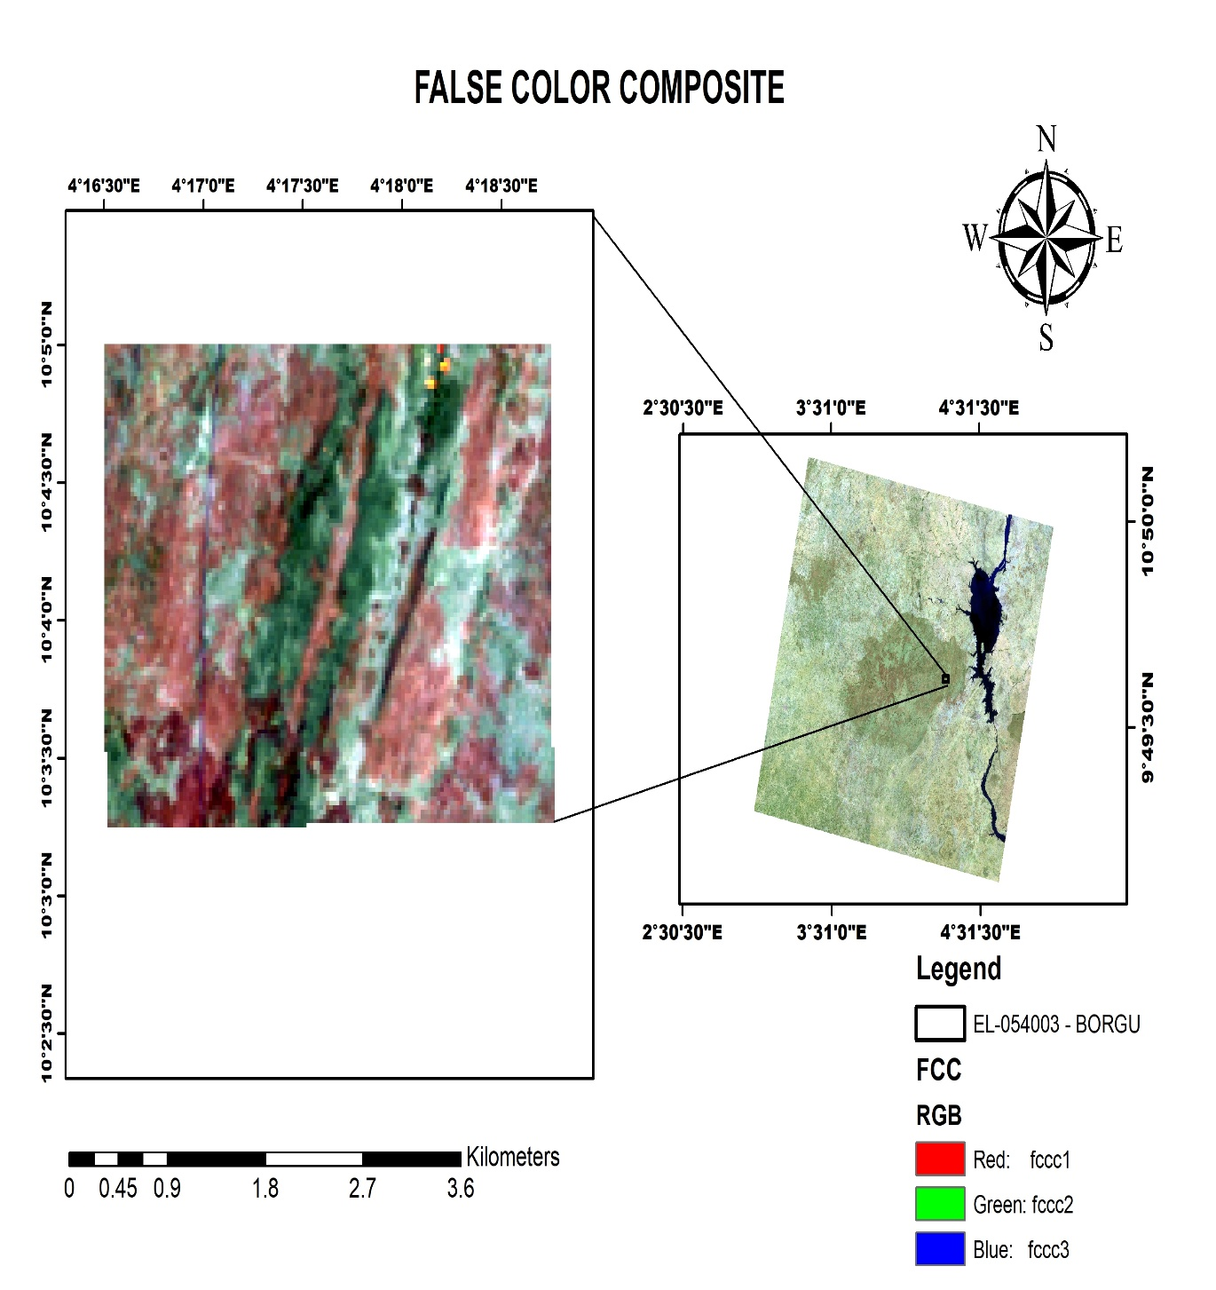
Figure 17: False Color Composite

5.2.3 NDVI Analysis
The Normalized Differential Vegetation Index (NDVI) was utilized as a spectral constraint to assess the validity of the lithological indices. The map (Figure 18) shows low-to-moderate index values across the central and western portions of the license, indicating areas of exposed rock and thin regolith suitable for direct spectral analysis. Areas of high NDVI coincide with riparian vegetation along drainage channels; these zones require cautious interpretation as the biomass may mask the underlying rock signatures. For prospecting, the low-NDVI anomalies represent primary targets for surface geochemical sampling.
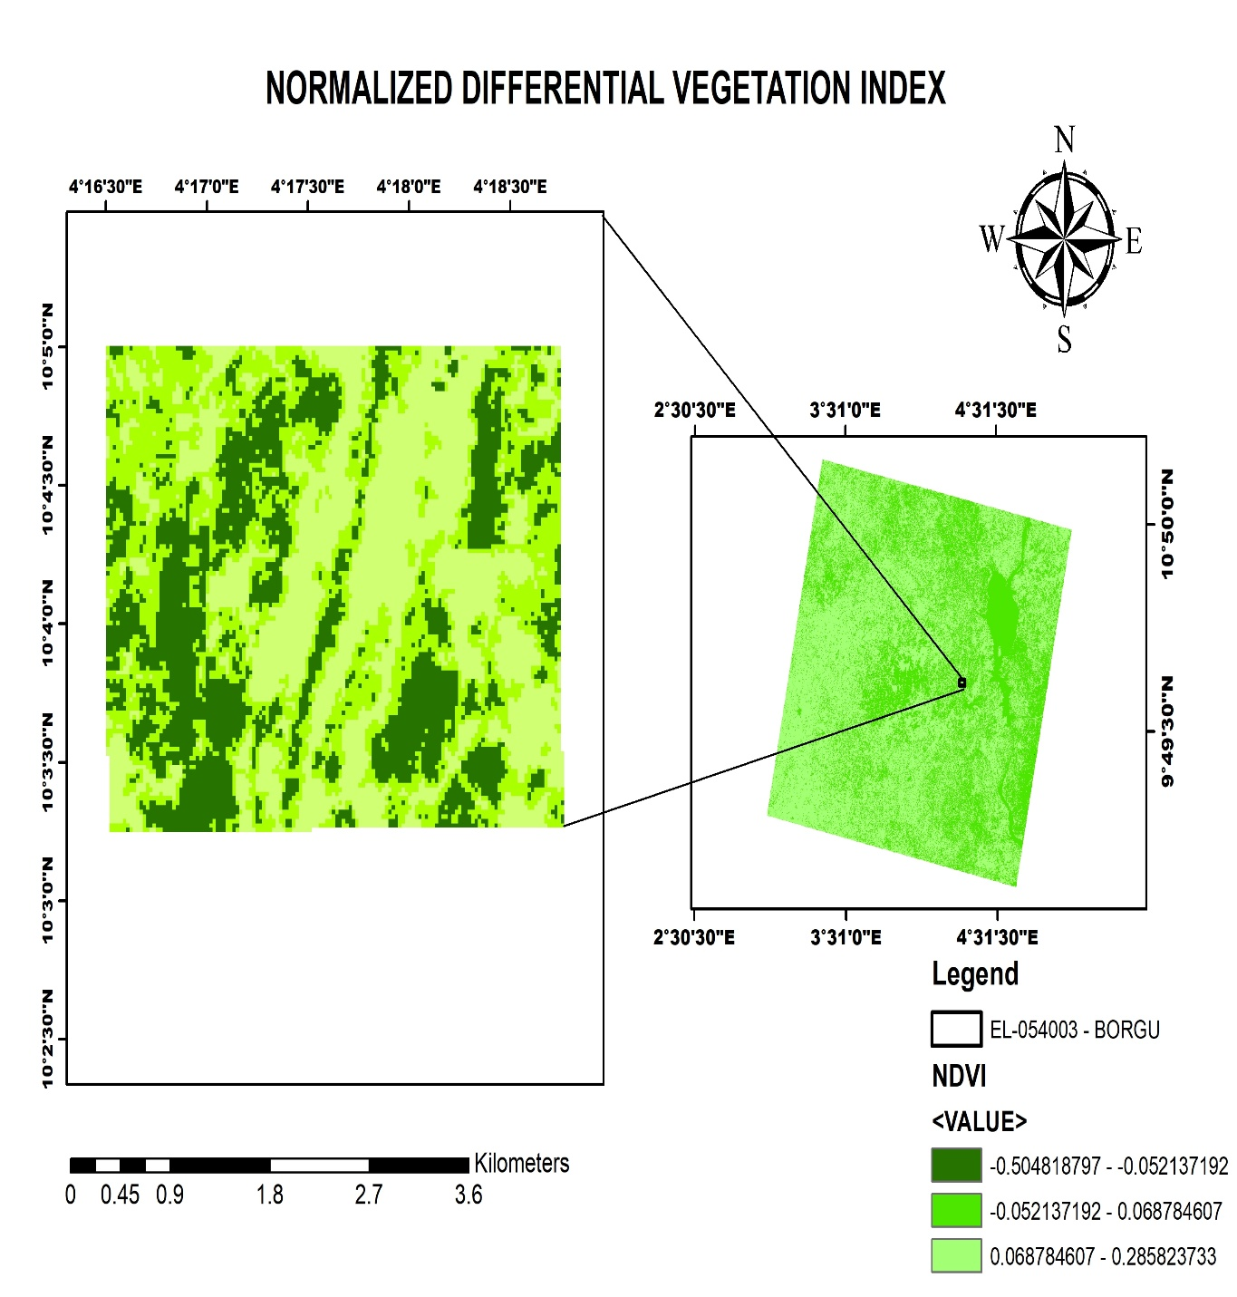
Figure 18: Normalized Differential Vegetation Index

5.3 Prospectivity Mapping
Integration of all datasets enabled the generation of mineral-specific prospectivity maps.
The gold prospectivity map (Figure 19) was generated through weighted overlay of Clay Index, Iron Oxide Index, Ferric Iron Index, and NDVI. Areas of high prospectivity correspond to zones where elevated clay alteration, iron oxide concentration, and ferric iron responses coincide with relatively low vegetation cover.
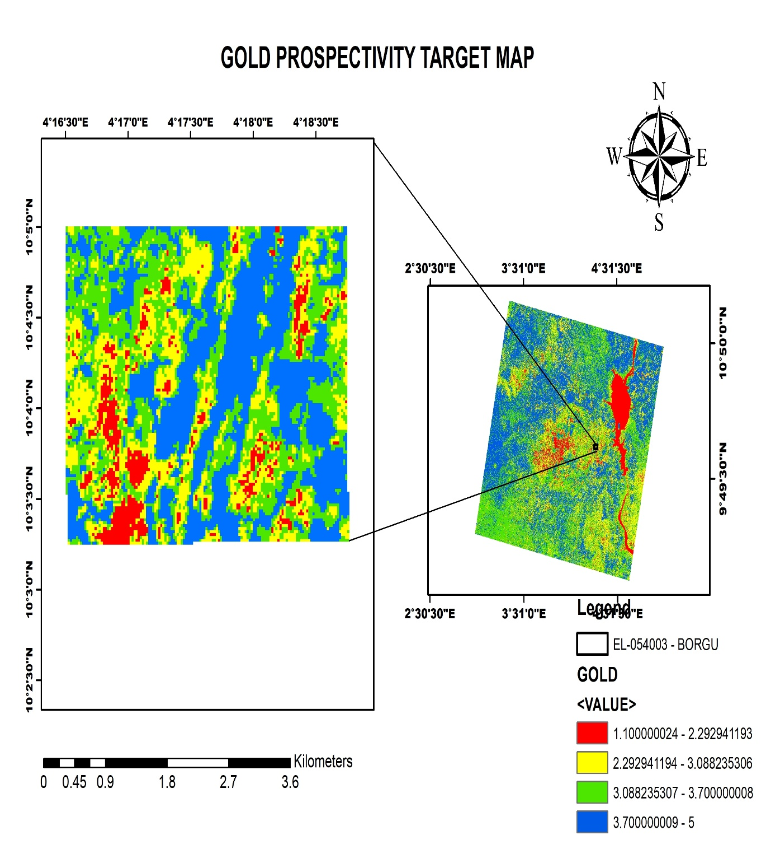
Figure 19: Gold prospectivity map
The beryl prospectivity map (Figure 20) was produced by combining Silica Index, Clay Index, Ferrous Mineral Index, and NDVI. Areas of elevated prospectivity correspond to locations where strong spectral responses from silica, clay, and ferrous mineral indices overlap in areas with relatively low vegetation cover.
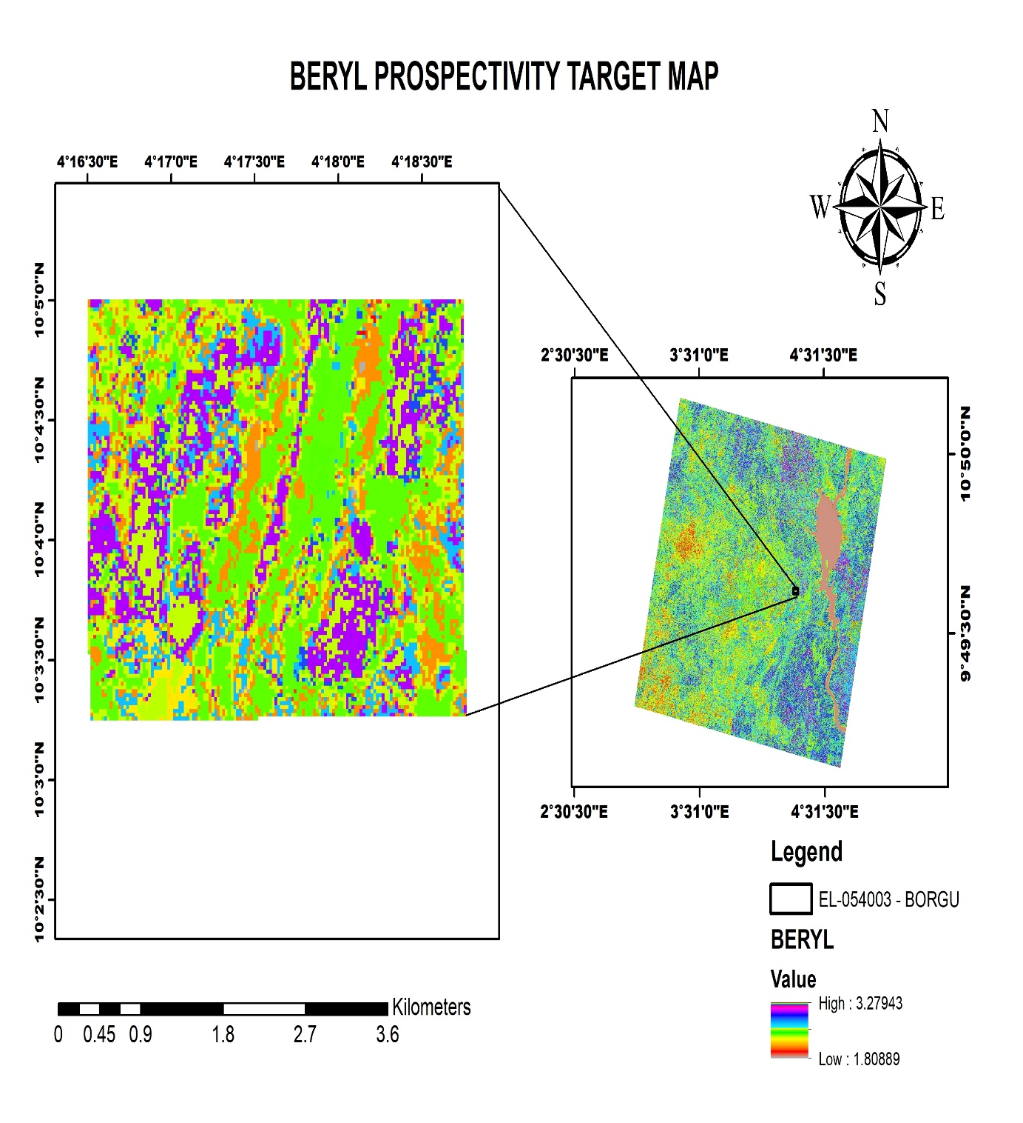
Figure 20: Beryl prospectivity map

The tourmaline prospectivity map (Figure 21) was generated through a weighted combination of Silica Index, Clay Index, Iron Oxide Index, Ferrous Mineral Index, and NDVI. Areas of highest prospectivity correspond to locations where strong silica enrichment coincides with clay alteration and elevated iron oxide responses in areas with relatively low vegetation cover.
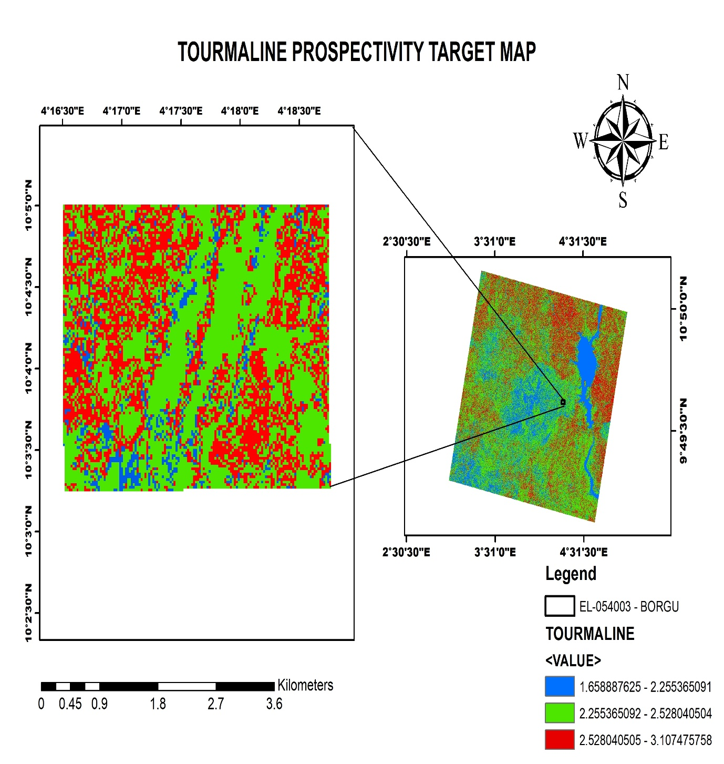

Figure 21: Tourmaline prospectivity map

The lithium prospectivity map (Figure 22) reveals high-value anomalies concentrated in the southwestern and eastern parts of the mapped area, with values ranging from 2.05 to 3.65. These clusters suggest potential lithium mineralization zones likely associated with pegmatitic bodies or structurally controlled mineralization. The moderate lithium zones appear as scattered areas surrounding the high-value anomalies and may represent geochemical dispersion halos around the main mineralized zones.
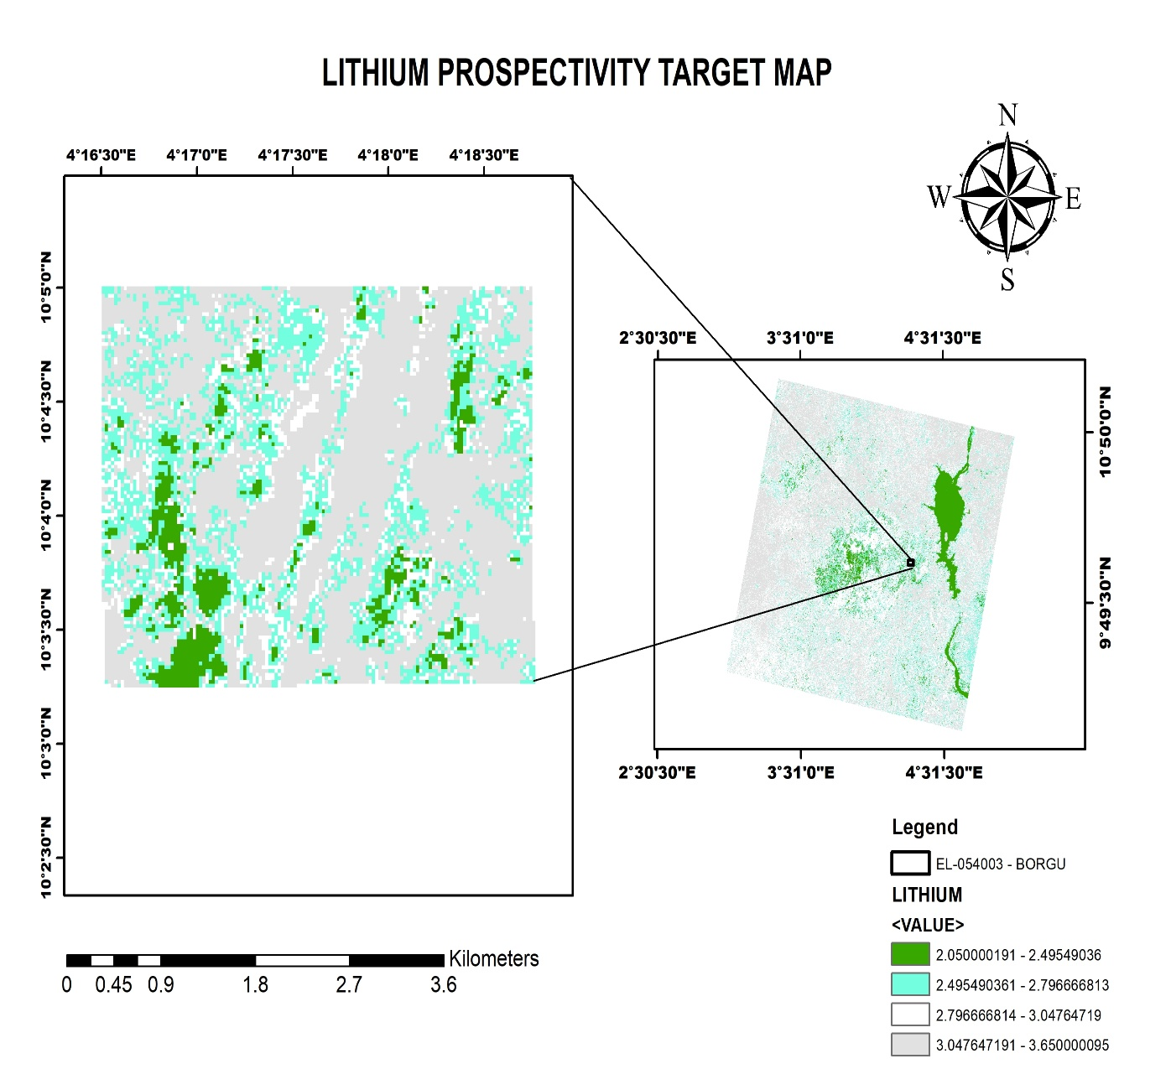

Figure 22: Lithium prospectivity map

Target ID | Longitude | Latitude | Primary Target
1 | 4° 16' 45" | 10° 04' 00" | Gold
2 | 4° 17' 15" | 10° 03' 45" | Gold
3 | 4° 17' 00" | 10° 03' 15" | Gold
4 | 4° 17' 30" | 10° 04' 30" | Beryl
5 | 4° 18' 00" | 10° 03' 30" | Beryl
6 | 4° 17' 12" | 10° 04' 00" | Beryl
7 | 4° 17' 00" | 10° 03' 30" | Tourmaline
8 | 4° 16' 30" | 10° 03' 30" | Lithium/Tourmaline
9 | 4° 18' 00" | 10° 03' 45" | Lithium
10 | 4° 17' 00" | 10° 03' 25" | Lithium
Table 1: Summary of identified exploration targets

6. Discussion

6.1 Structural Controls on Mineralization
The dominant NE–SW structural trend identified in this study is consistent with the regional tectonic framework of the Nigerian Basement Complex and the Pan-African Mobile Belt (Feybesse and Milési, 1994; Perrouty et al., 2012). These structures are interpreted as products of Pan-African transpressional deformation and are widely recognized as major controls on mineralization across West Africa. The intersections of NE–SW and NW–SE structures identified from the 2VD analysis are particularly prospective for gold mineralization, as such structural intersections commonly form dilatational zones that enhance fluid migration and gold deposition (Robert and Poulsen, 2001).
The magnetic low signatures observed in the TMI data are typical of LCT-type pegmatite environments and are comparable to signatures reported from pegmatite fields in Namibia, Senegal, and other parts of the West African Craton (Miller et al., 2009; Lambert-Smith et al., 2016). Their spatial association with radiometric potassium and thorium anomalies further supports the presence of evolved granitic systems favorable for rare-metal mineralization.

6.2 Comparison with Regional Studies
The results obtained in this study agree with previous investigations of mineralization within the Nigerian Basement Complex. Similar structural controls have been reported by Ekeleme et al. (2024) for Pb–Zn–Fe–Au mineralization in north-central Nigeria, where mineralization is associated with pegmatized migmatites and shear zones. The radiometric characteristics observed in Borgu also compare well with signatures from other Nigerian pegmatite terrains (Akoh et al., 2015; Chukwu and Obiora, 2021).
Furthermore, the inferred orogenic gold potential corresponds with established models of gold mineralization within the West African Craton. The mesothermal conditions typical of orogenic gold systems (Groves et al., 1998) are compatible with the metamorphic conditions of the Nigerian Basement Complex. The structural architecture observed in Borgu, characterized by major shear zones, subsidiary fractures, and competent host rocks, is comparable to the geological settings of major gold deposits in Mali and Burkina Faso.

6.3 Implications for Exploration
The integration of aeromagnetic, radiometric, and remote sensing datasets demonstrates a reliable and cost-effective approach for mineral targeting within the Borgu Basement terrain. The shallow depth to magnetic sources (120–180 m) derived from SPI analysis suggests that potential mineralized zones may be accessible through preliminary exploration methods such as trenching and pitting before drilling.
The ten priority targets delineated in this study provide a practical framework for follow-up exploration. Areas showing coincident lithium prospectivity, favorable structures, and hydrothermal alteration signatures particularly in the southwestern and eastern parts of the study area should be prioritized for field validation. Similarly, structurally controlled gold targets located at lineament intersections with strong alteration responses represent key areas for detailed geochemical investigation.

7. Conclusions and Recommendations

7.1 Conclusions
This study demonstrates the effectiveness of integrating airborne geophysical datasets with satellite remote sensing techniques for mineral prospectivity evaluation within the Borgu Basement terrain, northwestern Nigeria. The geological setting, dominated by granite gneiss of the Nigerian Basement Complex, provides a favorable environment for rare-metal pegmatite mineralization and structurally controlled orogenic gold systems.
Aeromagnetic data interpretation revealed dominant NE–SW structural trends which likely acted as major conduits for mineralizing fluids and controlled the emplacement of pegmatitic intrusions. The occurrence of magnetic low zones further suggests favorable host environments for LCT-type pegmatites. Radiometric analysis showing potassium and thorium enrichment indicates evolved felsic magmatic systems commonly associated with rare-metal mineralization. In addition, remote sensing analysis identified hydrothermal alteration signatures characterized by iron oxide, clay, and silica enrichment, further supporting the mineral potential of the area.
The integration of structural, radiometric, and alteration datasets enabled the delineation of ten priority exploration targets. The estimated shallow depth to magnetic sources (120–180 m) suggests that the identified mineralization zones may be accessible for further exploration and possible economic evaluation. Overall, the study highlights the strong control of lithology, structural architecture, and hydrothermal processes on mineralization within the Borgu area.

7.2 Recommendations
To further validate the mineral potential identified in this study, detailed field-based geological investigations are necessary to confirm lithological relationships, structural controls, and pegmatite occurrences within the priority target zones. Ground verification of remotely sensed alteration anomalies should also be undertaken to establish their relationship with mineralization.
In addition, systematic geochemical surveys involving soil, stream sediment, and rock sampling should be conducted, particularly along the major structural corridors identified from the aeromagnetic data. Detailed mapping and petrographic analysis of pegmatite bodies are also recommended to properly characterize their mineral assemblages and rare-metal potential.
Follow-up ground geophysical investigations, including detailed magnetic surveys, electrical resistivity tomography, and induced polarization methods, are necessary to improve the resolution of subsurface structural and mineralization models. Where coincident geochemical, structural, and radiometric anomalies occur, shallow trenching or pitting is recommended to expose mineralized zones.
Finally, where integrated results continue to indicate significant mineralization potential, a phased exploratory drilling programme should be implemented to evaluate the vertical continuity, grade distribution, and economic viability of the identified targets.

Declarations
Conflicts of Interest Interests: The author declares that there are no known competing financial or personal interests that could have influenced the work reported in this study.
Ethical Approval: Not applicable.
Consent to Participate: Not applicable.
Consent for Publication: All authors has read and approved the final manuscript and agrees to its submission for publication.
Data Availability: The datasets used in this study were obtained from Dexter Roy GeoConsult Limited and are not publicly available due to data confidentiality restrictions but may be made available from the author upon reasonable request and with permission from the company.

COMPETING INTERESTS DISCLAIMER:
Authors have declared that they have no known competing financial interests OR non-financial interests OR personal relationships that could have appeared to influence the work reported in this paper.

References
Adams, C., Melcher, F., Gutzmer, J., & Gilbert, S. (2023). Nb-Ta oxide mineralogy of the Winneba pegmatite, Ghana. Ore Geology Reviews, 154, 105299.
Ahmed, A.H., Attourabi, A.A., El Amrani, E., & El Atrchi, F. (2023). The Dibilo lithium pegmatite field, Liptako, Niger: Geology, mineralogy and geochemistry. Ore Geology Reviews, 157, 105388.
Akoh, J.U., Ogala, J.E., & Garba, I. (2015). Geochemical characterization of pegmatites from Angwan Doka area, north-central Nigeria. Journal of Mining and Geology, 51(1), 1-12.
Akingboye, A.S., & Osazua, I.M. (2016). The location of the Precambrian basement complex of Nigeria between the West African craton, the Congo craton and the southern part of the Tuareg shield. Nigerian Journal of Mining and Geology, 46(1), 23-35.
Attourabi, A.A., Ahmed, A.H., El Amrani, E., & El Atrchi, F. (2024). Petrogenesis and metallogenesis of the Dibilo lithium pegmatite field, Niger. Economic Geology, 119(2), 387-410.
Cerny, P., & Ercit, T.S. (2005). The classification of granitic pegmatites revisited. The Canadian Mineralogist, 43(6), 2005-2026.
Chukwu, E., & Obiora, S.C. (2021). Rare metal pegmatites of Nigeria: A review. Journal of African Earth Sciences, 178, 104184.
Delor, C., Lahondere, D., Egal, E., & Goujou, J.C. (2010). Notice explicative de la carte geologique et des ressources minerales de la Republique du Senegal a 1/500 000. Direction des Mines et de la Geologie, Senegal.
Ekeleme, I.A., Haruna, A.I., Olorunyomi, A.E., Chollom, J.G., & Ochiba, I.E. (2024). Geology and petrography of the basement complex rocks and associated skarn mineralization in Tsauni area, north-central Nigeria. International Journal of Geological and Environmental Sciences, 10(1), 41-58.
Feybesse, J.L., & Milési, J.P. (1994). The Archaean and Proterozoic basement of West Africa: A review. In: Proterozoic Crustal Evolution (ed. K.C. Condie). Elsevier, Amsterdam, pp. 107-138.
Goldfarb, R.J., Groves, D.I., & Gardoll, S. (2001). Orogenic gold and geologic time: A global synthesis. Ore Geology Reviews, 18(1-2), 1-75.
Goodenough, K.M., Schofield, D.I., Thomas, R.J., De Waele, B., Key, R.M., & Bauer, W. (2014). Episodic granitic magmatism in the western part of the Pan-African Lufilian Arc, Central Africa. Precambrian Research, 242, 30-45.
Groves, D.I., Goldfarb, R.J., Gebre-Mariam, M., Hagemann, S.G., & Robert, F. (1998). Orogenic gold deposits: A proposed classification in the context of their crustal distribution and relationship to other gold deposit types. Ore Geology Reviews, 13(1-5), 7-27.
Hagemann, S.G., Lisitsin, V.A., & Huston, D.L. (2016). Mineral system analysis: Quo vadis. Ore Geology Reviews, 76, 504-522.
Küster, D. (1990). Rare-metal pegmatites of the Ijebu-Jesa area, southwestern Nigeria. Journal of African Earth Sciences, 10(3), 549-560.
Lambert-Smith, J.S., Thomas, R.J., Treloar, P.J., & Antwi, E.K. (2016). The Kédougou-Kenieba inlier, eastern Senegal, West Africa: Geology and ore deposits. Ore Geology Reviews, 78, 447-463.
Ledru, P., Johan, V., Milesi, J.P., & Tegyey, M. (1991). Markers of the last stages of the Paleoproterozoic collision in the Ubendian belt (Tanzania, Malawi, Mozambique). Precambrian Research, 51(1-4), 179-194.
London, D. (2008). Pegmatites. The Canadian Mineralogist, Special Publication 10, 347 pp.
Miller, A., Röding, C., & Röller, K. (2009). The significance of lithium pegmatites in the Damara Orogen, Namibia. Journal of African Earth Sciences, 53(4-5), 115-126.
Nigerian Geological Survey Agency (2022). Mineral resources of Nigeria. Ministry of Mines and Steel Development, Abuja, Nigeria.
Oyawoye, M.O. (1972). The basement complex of Nigeria. In: African Geology (eds. T.F.J. Dessauvagie & A.J. Whiteman). University of Ibadan Press, pp. 67-98.
Perrouty, S., Aillères, L., Jessell, M.W., Baratoux, L., Bourassa, Y., & Crawford, B. (2012). Revised Eburnean geodynamic evolution of the Man-Leo shield, with reference to the Paleoproterozoic evolution of the Birimian belt. Precambrian Research, 214-215, 102-122.
Rahaman, M.A. (1988). Recent advances in the study of the basement complex of Nigeria. In: Precambrian Geology of Nigeria (ed. M.A. Rahaman). Geological Survey of Nigeria, pp. 11-43.
Robert, F., & Poulsen, K.H. (2001). Vein formation and deformation in greenstone gold deposits. Reviews in Economic Geology, 14, 111-155.
Thébaud, N., Hollis, S.P., & Fiorentini, M.L. (2020). The Houndé gold camp, Burkina Faso: A review. Minerals, 10(12), 1089.

