Short Research Article

Phytotoxicity evaluation of silver nanoparticles used in agriculture: stimulatory and inhibitory effects on growth of microalgae and lettuce seeds

.

ABSTRACT

Silver nanoparticles (AgNP) have optical, electrical, thermal and antimicrobial properties that have been applied in several sectors, such as chemical / biological sensors and surgical materials. In the agricultural sector, formulations based on AgNP help to prevent plant pathogens through seed disinfection and control of plant diseases caused by bacteria. Therefore the consumption of products containing AgNP can lead to the release of these metallic nanoparticles in the environmental compartments. The purpose of the present work is to evaluate the effect of the nanomaterial in the bioindicator organisms Pseudokirchneriella subcapitata (unicellular microalgae) and Lactuca sativa (lettuce seed), the latter as a bioindicator of humid areas. At low concentrations of AgNP (0.1 to 1.0 mg L⁻¹), biostimulation was associated with an increase in percentage of algae growth and with the elongation of root in L. sativa at 0,01 mg L⁻¹. A dose-effect relationship was determined for both organisms by calculating the Mean Effective Concentration (EC50) associated with the inhibition of the growth rate. This was equivalent to 3.67 mg L⁻¹ (EC50-168h) and 35.31 mg L⁻¹ (EC50-96h), respectively for P. subcapitata and Lactuca sativa. The determination of the No Observed Effect Concentration (NOEC) values (0.58 and 1.45 mg L⁻¹, respectively for P. subcapitata and L. sativa) is useful for the establishment of maximum permissible levels of the nanocomposite in the aquatic system and in adjacent areas to these compartments.

Keywords: Nanosilver; Pseudokirchneriella subcapitata; Lactuca sativa; Ecotoxicology; Nanomaterial

1. INTRODUCTION

Silver nanoparticles (AgNPs) have unique optical, electrical, and thermal properties and are being incorporated into products ranging from photovoltaics to biological and chemical sensors. An increasingly common application is the use of silver nanoparticles for antimicrobial coatings, fabrics, and biomedical devices, among others. Thus, these nanoparticles continuously release a low level of silver ions to provide protection against bacteria (Yin et al., 2020).

In the agricultural sector, AgNP-based solutions help prevent plant pathogens, in addition to reducing the use of agrochemicals in plant protection (Zhang et al., 2023). According to Castro-Restrepo (2017), AgNPs constitute an alternative for the disinfection of seeds and propagation materials such as bulbs and cuttings, and in the control of plant diseases caused by bacteria. Park et al. (2006) developed a product based on AgNP and silica which inhibits the growth of fungi such as Pythium ultimum, Magnaporthe grisea, Colletotrichum gloeosporioides, Botrytis cinerea and Rhizoctonia solani, finding 100% inhibition using 100 ppm of the product. However, increased consumption of products containing AgNPs may lead to the release of these metallic nanoparticles into environmental compartments.

The limited knowledge about the behavior of AgNPs in the environment makes it necessary to carry out assessments in different aquatic species (Ribeiro et al., 2014). Therefore, due to the increasing prevalence of silver nanoparticles in consumer products, there is a large international effort underway to verify their safety and understand their toxic properties in different bioindicator organisms.

Some organism can serve as useful bioindicators. The microalga Pseudokirchneriella subcapitata is a planktonic colonial chlorophyceae, consisting of lunate cells with pointed apices. It has been widely used as a bioindicator in ecotoxicity studies of environmental pollutants and recommended for the registration of chemical agents and biopesticides by national and international agencies (Miashiro et al., 2012). Lettuce seed (L. sativa) is a bioindicator organism for contamination of wetlands in the transition zone between the aquatic and soil compartments. It has been used in risk assessment and biomonitoring studies of degraded areas (Sobrero and Ronco, 2004).

The No Observed Effect Concentration (NOEC) is the highest concentration of a material in a toxicity test that has not statistically significant adverse effect on the exposed test-organism population as compared to the control. It is an important toxicological parameter to be determined and used for establishing maximum permissible concentrations in the aquatic environment (Rand and Petrocelli, 1985; May et al, 2025).

Thus, based on the above, this work evaluated the behavior of growth of P. subcapita and L. sativa in response to the exposition to different concentrations of AgNP. The NOEC values were determined for both organisms arising from these effects.

2. material and methods

2.1 Test Material

The silver nanoparticles (AgNP) were provided by the National Nanotechnology Laboratory for Agribusiness of Embrapa Instrumentation. They were synthesized based on the method of Berni Neto et al. (2008) by dissolving 1.8 g of polyvinyl alcohol (PVA) in 80 mL of deionized water, under heating (approximately 60°C). Then, 720 mg of silver nitrate was added and placed in an ice bath under agitation for 30 minutes. Subsequently, 40 mL of sodium borohydride solution (316 mg in 40 mL) was added dropwise (1 drop per second) until a yellow solution was obtained. The obtained AgNP demonstrated an average AgNP size of 82.8 nm and average zeta potential of −3.61.

2.2 Microalgae Assay

Algae (P. subcapitata) were obtained from cultures in medium prepared according to OECD (2006). They were exposed for 168 h at 20±2°C under continuous illumination (~1300 lux) in 96-well polystyrene plates. The initial concentration was approximately 10⁶ cells/mL with a total test suspension volume of 300 μL per well. A total of 12 replicates were prepared for each test concentration (0.0–100 mg L⁻¹). Algal growth was monitored by absorbance readings (750 nm, microplate reader; Sunrise Tecan Group) every 24h or 48h for 168h. The specific growth rate was calculated according to OECD (2006), and the Effective Concentration that inhibited 50% of the specific growth rate (EC50-168h) was determined as a function of the logarithm of the concentration of the test material according to the adjusted regression model.

2.3 Lettuce Seed Assay

Lactuca sativa seeds were obtained commercially and the assays were performed in the dark for 96 hours at 20±1°C in 12-well polystyrene plates, according to Bautista et al. (2013). A total of 24 seeds were exposed for each test concentration, placed individually in each well on a Whatman No. 2 filter paper disc, to which 400 μL of test solution with a concentration of 0.0-100.0 mg L⁻¹ was added. The seeds were observed and photographed every 24 hours using a camera (Optika 4083B3) coupled to a stereomicroscope. Root size was measured using Optika View software, Ver 7.1.1.5, to determine the percentage of germination and the root growth rate at the end of the exposure period. Growth rates were calculated using the slope coefficients of the "root size versus time" regression (Basu and Pal, 2011).

2.4 Determination of Toxicological Parameters

The Mean Effective Concentration that causes an effect on 50% of organisms during a given period (EC50) within a 95% confidence interval was determined using the "Simple Regression" module of the Statgraphics Centurion XVII program, Version 1.17.04 (StatPoint Technologies). The No-Observed-Effect Concentration (NOEC) was determined by calculating the Effective Inhibition Concentration of 10% of the growth of the test organism. The upper limit of the 95% confidence interval of EC10 was taken as equivalent to NOEC (Hoekstra and Van Ewijk, 1993). Seed germination rates were compared using the "One Way ANOVA" module of the Statgraphics Centurion XVII program, as were growth curves.

3. results and discussion

3.1 Effect on Microalgae

The growth curves of P. subcapitata under different concentrations of AgNP during a period of 168h are presented in Figure 1A. At the end of the exposure, an algal growth increase was observed compared to the control at concentrations of 0.1 and 1.0 mg L⁻¹, suggesting that a biostimulating effect by silver ions occurred. The same effect was verified by our previous studies made with another batch of AgNP that demonstrated a biostimulatory effect at concentrations of 0.015 and 0.0015 mg L⁻¹ (Becaro et al., 2015). The same trend of behaviour was observed by Schmittschmitt et al. (1996) in exposures of the same microalga (previously named Selenastrum capricornutum) to silver at concentrations of 20 and 40 μg L⁻¹ in the form of AgNO₃ and Ag₂SO_{4,} respectively. Biostimulation was also verified by Sibi et al. (2017) after exposure of microalgae to metal nanoparticles, including heavy metals such as lead, in which the authors reported a significant increase in protein and lipid content.

On the other hand, there was a decrease in the percentage of growth in the 10 and 100 mg L⁻¹ exposures.

The curves allowed the calculation of specific growth rates, which were compared using the Kruskal-Wallis test. Only the highest concentration (100 mg L⁻¹) growth rate was significantly different (P ≤ .05) from that of the control. A negative dose-effect correlation was found between the specific growth rate and the logarithm of the AgNP concentration (Figure 1B), which allowed the determination of toxicity parameter values. Thus, the EC50-168h (with confidence interval in parentheses) and the EC10-168h were 3.67 (2.46 -5.31) and 0.23 mg L⁻¹, respectively. The NOEC value was equivalent to 0.58 mg L⁻¹.

The EC50-168h value was much higher than that the EC50-48h determined by Sorensen and Baun (2015) in the same algae, for silver in the form of AgNO3 (4.9 μg L⁻¹), possibly implying lower toxicity when the metal is in nanoparticle form. The value of this toxicity parameter was very close to that reported by McLaughlin and Bonzongo (2012) for silver nanoparticles (EC50 = 1.6 mg L⁻¹) in P. subcapitata.

3.2 Effect on Lettuce Seeds

The germination rates of L. sativa seeds after 96 hours of exposure to AgNP were determined. The germination percentage for all treatments remained on average between 88 and 100%. After analyzing the data using the Kruskal-Wallis test, no significant differences were found between seeds free of the test material and those exposed to AgNP.

The root growth of L. sativa seeds during 96 hours of exposure to various concentration levels of nanoparticles is shown in Figure 2A. The data show that at exposures of 10 and 100 mg L⁻¹, root growth was lower compared to the control.

As observed in algae exposed to low concentrations of AgNP, biostimulation of root growth may have occurred, compared to the control, after 96h of exposure. This phenomenon may be associated with the claims of Juárez-Maldonado et al. (2019), in which silver nanoparticles improved germination response because of the ability to increase metabolism in seed reserves and water transport in internal tissues.

In analogy to our results, Guzmán-Báez et al. (2021) reported that silver nanoparticles increase nitrogen, phosphorus, and potassium concentrations in leaves and stimulate root length and number of roots in tomato seedlings.

The percentage of seed germination and root length decreased at concentrations of 10 mg L⁻¹ of AgNP in Hordeum vulagare and Linum usitatissimum (Mishra et al., 2019). Absence of effect on seed germination of L. sativa and also on root elongation was reported by Barrena et al. (2009).

Applying the Kruskal-Wallis test to the growth rates, it was found that, similarly to what was observed with P. subcapitata, only the highest concentration showed a significant difference from the control. These rates, when plotted as a function of the logarithm of the concentration, generated a curve with a negative correlation (Figure 2B) that allowed the calculation of an EC50-96h equivalent to 35.31 (18.50 – 10.75) mg L⁻¹. The 10% inhibition of growth (EC10-96h) was equivalent to 0.62 mg L⁻¹, while 1.45 mg L⁻¹ was the value corresponding to the NOEC.

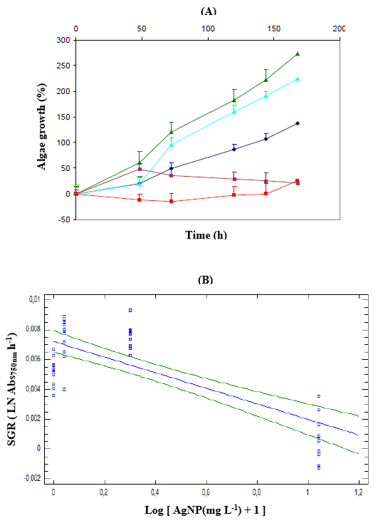

Fig. 1. (A) Growth curves of Pseudokirchneriella subcapitata exposed to different concentrations of AgNP: -♦- 0.0 mg L⁻¹; -▲- 0.1 mg L⁻¹; -▲- 1.0 mg L⁻¹; -■- 10.0 mg L⁻¹; -■- 10.0 mg L⁻¹. (B) Concentration-effect curve of AgNP on the specific growth rate (SGR) of Pseudokirchneriella subcapitata exposed for 168 hours to the test material. Regression curve ( ̶ ); 95% confidence interval ( ̶ ) .

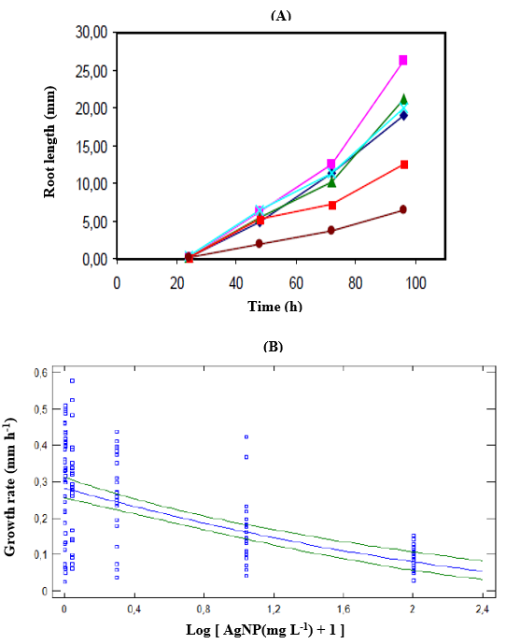

Fig. 2. (A) Growth curves of Lactuca sativa exposed to different concentrations of AgNP: -♦- 0.0 mg L⁻¹; -■- 0.01 mg L⁻¹; -▲- 0.1 mg L⁻¹; -x- 1.0 mg L⁻¹; -■- 10.0 mg L⁻¹; --●- 100,0 mg L⁻¹. (B) Concentration-effect curve of AgNP on the specific growth rate (SGR) of Lactuca sativa exposed for 168 hours to the test material. Regression curve ( ̶ ); 95% confidence interval ( ̶ ) .

4. Conclusion

The results of this study demonstrated that, although the heavy metal nanoparticles under study show a negative effect on biomass production and root growth in the test organisms, a biostimulation occurs at low concentrations. This last effect was confirmed in this study by the comparison with previous results obtained with another batch of the nanomaterial.
Based on the EC50 values, the phytotoxic action of AgNP on the microalgae growth rate is approximately 10 times greater than for lettuce seeds. These values ​​also indicate that the test material would be classified as "moderately toxic" and "slightly toxic" for the bioindicator organisms P. subcapitata and L. sativa, respectively. These characteristics help justify the various uses of products based on this nanocomposite.
Together with results from studies on other test organisms, the EC50 values ​​generated by the dose-effect curves constitute an important tool for establishing maximum permissible limits in water bodies and adjacent areas.

DISCLAIMER (ARTIFICIAL INTELLIGENCE)

Author(s) hereby declare that NO generative AI technologies such as Large Language Models (ChatGPT, COPILOT, etc.) and text-to-image generators have been used during writing or editing of this manuscript.

COMPETING INTERESTS DISCLAIMER:
Authors have declared that they have no known competing financial interests OR non-financial interests OR personal relationships that could have appeared to influence the work reported in this paper.

References

Barrena, R., Casals, E., Colon, J., Font, X., Sanchez, A., & Puntes, V. (2009). Evaluation of the ecotoxicity of model nanoparticles. Chemosphere, 75, 850–857.

Basu P., & Pal, A. (2011). Spatio-temporal analysis of development of basal roots of common bean (Phaseolus vulgaris L.). Plant Signaling & Behavior, 6(7), 982-985.

Bautista, O. V., Fischer, G., & Cardenas, J. F. (2013). Cadmium and chromium effects on seed germination and root elongation in lettuce, spinach and Swiss chard. Agronomía Colombiana, 31(1), 48-57.

Berni Neto, E., Ribeiro, C., & Zucolotto, V. (2008). Síntese de nanopartículas de prata para aplicação na sanitização de embalagens. Embrapa Instrumentação Agropecuária. Comunicado Técnico, 99, 1-4. https://www.infoteca.cnptia.embrapa.br/bitstream/doc/31734/1/CT992008.pdf

Castro-Restrepo, D. (2017). Nanotechnology in agriculture. Bionatura, 2(3), 384-389.

Guzmán-Báez, G. A., Trejo-Téllez , L. I., Ramirez Olvera, S. M., Salinas-Ruiz, J., Bello-Bello, J. J., Alcántar-González, G. et al. (2021). Silver nanoparticles increase nitrogen, phosphorus, and potassium concentrations in leaves and stimulate root length and number of roots in tomato seedlings in a hormetic manner. Dose Response, 19(4), 15593258211044576.

Hoekstra, J. A., & Van Ewijk, P. H. (1993). The bounded effect concentration as an alternative to the NOEC. Science of the Total Environment, 134(1), 705- 711.

Juárez-Maldonado, A., Ortega-Ortiz, H., Moralez-Diaz, A. B., Gonzalez-Morales, S., Morelos-Moreno, A., Cabrera-De La Fuente, M. et al. (2019). Nanoparticles and nanomaterials as plant biostimulants. International Journal of Molecular Science, 20(1),162. https//:doi.org/10.3390/ijms20010162

May, A., Assalin, M. R., Halfeld-Vieira, B. A., Nechet, K. L., Batista, E. R., Quevedo, H. D. et al. β-Caryophyllene and graphene oxide: A novel approach for managing Fusarium wilt in Cyclamen spp. (2025). ACS Omega, 10(41), 48563–48572.

McLaughlin, J., & Bonzongo, J. C. (2012). Effects of natural water chemistry on nanosilver behavior and toxicity to Ceriodaphnia dubia and Pseudokirchneriella subcapitata. Environmental Toxicology and Chemistry, 31(1), 168–175.

Miashiro, l., Lombardi, J. V., & Mercante, C. T. J. (2012). Ecotoxicity assessment in aquaculture system using the test organism Pseudokirchneriella subcapitata (Chlorophyceae). Acta Scientiarum Biological Sciences, 34(4), 373-379 .

Mishra, V. K., Husen, A., Rahman, Q. I., Iqbal, M., Sohrab, S. S., & Yassi, M. O. (2019). Plant-based fabrication of silver nanoparticles and their application. In: A. Husen & M. Iqbal (Eds.). Nanomaterials and plant potential (pp. 135-175). Berlin: Springer Nature.

OECD (2006). Freshwater alga and cyanobacteria, growth inhibition test. OECD Guidelines for the Testing of Chemicals, Section 2, 201. https://www.oecd.org/content/dam/oecd/en/publications/reports/2011/07/test-no-201-freshwater-alga-and-cyanobacteria-growth-inhibition-test_g1gh28f1/9789264069923-en.pdf

Park, H. J., Kim, S. H., Kim, H. J., & Choi, S.H. (2006). A new composition of nanosized silica-silver for control of various plant diseases. The Plant Pathology Journal, 22(3), 295-302.

Rand, G. M., & Petrocelli, S. R. (Eds.). (1985). Fundamentals of aquatic toxicology, New York: Hemisphere Publishing Corporation.

Ribeiro, F., Gallego-Urrea, J. A., Jurkschat, K., Crossley, A., Hassellov, M., Taylor, C. et al. (2014). Silver nanoparticles and silver nitrate induce high toxicity to Pseudokirchneriella subcapitata, Daphnia magna and Danio rerio. Science of the Total Environment, 466, 232–241.

Schmittschmitt, J. P., Shaw, J. R., & Birge, W. J. (1996). The effects of silver on green algae and prospects for trophic transfer. In: The 4th international Conference Proceedings: Transport, Fate and Effects of Silver in the Environment, 4 (pp. 245-249). Madison: University of Wisconsin System. https://repository.library.noaa.gov/view/noaa/45683

Sibi, G., Kumar, D. A., Gopal, T., Harinath, K., Banupriya, S., & Chaitra, S. (2017). Metal nanoparticle triggered growth and lipid production in Chlorella vulgaris. International Journal of Science Research in Environmental Science and Toxicology, 2(1), 1-8.

Sorensen, S. N. & Baun, A. (2015). Controlling silver nanoparticle exposure in algal toxicity testing – A matter of timing. Nanotoxicology, 9(2), 201–209.

Sobrero, M. C., & Ronco, A. (2004). Acute toxicity test with lettuce seeds (Lactuca sativa L.) .In: G. Castillo Morales (Ed.). Toxicological tests and water quality assessment methods: standardization , intercalibration , results and applications (pp. 71-79). Jiutepec: IMTA.

Yin, I.X., Zhang, J., Zhao, I.S., Mei, M.L., Li, Q., & Chu, C.H. (2020). The antibacterial mechanism of silver nanoparticles and its application in dentistry. International Journal of Nanomedicine, 15, 2555–2562.

Zhang, N, Sun, J., Yin, L., Liu, J., & Chen, C. (2023). Silver nanoparticles: From in vitro green synthesis to in vivo biological effects in plants. Advanced Agrochem, 2(4), 313-323.

