Development and Implementation of a Need-Based Digital Literacy Training Program for Rural Women: Evidence from Haryana

Abstract

Digital literacy has emerged as a key competency required for participation in the modern digital economy. Despite rapid technological advancements, rural women continue to face barriers such as limited access to digital devices, lack of training opportunities and low confidence in using digital technologies. The present study aimed to design and implement a need-based digital literacy training module for rural women. The study was conducted in Hisar district of Haryana. A purposive sample of 50 rural women was selected based on their willingness to participate in digital literacy training and their access to smartphones. A structured training module was developed in consultation with subject experts. The module was designed according to the specific learning needs identified during the baseline survey and followed the SMART approach in training design. The training program was conducted for ten days and included sessions on Smartphone basics, communication platforms, digital payment applications, e-commerce platforms, educational apps and cyber safety practices using participatory methods such as demonstrations and hands-on practice. The findings indicated high participation levels, with hands-on practice receiving the highest engagement (Mean = 2.82), followed by demonstration (Mean = 2.70), reflecting effective implementation of the training module. The training module emphasized practical skill development so that participants could apply digital knowledge in their daily lives. The implementation of the training program enabled rural women to gain familiarity with different digital applications and increased their confidence in using smartphones beyond basic communication functions. The study highlights the importance of context-specific and need-based digital literacy programs in promoting digital inclusion and strengthening socio-economic participation among rural women.

Keywords: Digital literacy, rural women, training module, digital inclusion

Introduction
The increasing penetration of smartphones and internet services has changed everyday life by influencing communication, access to information and delivery of services across rural and urban communities. In recent years, the Government of India has launched several initiatives such as Digital India and Pradhan Mantri Gramin Digital Saksharta Abhiyan to promote digital inclusion among citizens. However, the benefits of digital technology have not been equally distributed across different sections of society. Rural populations, particularly women, often remain excluded from the digital ecosystem due to limited access to digital devices, inadequate digital skills and socio-cultural barriers.
Digital literacy is defined as the ability to access, understand and use digital technologies effectively for communication, information retrieval and participation in socio-economic activities (UNESCO, 2019). Studies have emphasized that digital literacy plays a crucial role in empowering women by enhancing their access to education, health services and financial resources (Sharma & Sharma, 2021). Furthermore, access to information and communication technologies (ICTs) has been found to improve women’s decision-making ability and participation in economic activities (Agrawal et al., 2025). Despite the growing importance of digital technology, many rural women lack the knowledge and confidence required to use digital tools effectively. Their interaction with smartphones is often limited to basic functions such as making calls or receiving messages. Advanced digital applications such as digital payment platforms, e-commerce services and educational applications remain underutilized. One of the major reasons for this gap is the lack of structured training programs that address the specific needs and learning capacities of rural women.
Need-based training programs are considered effective because they are designed according to the learning requirements and socio-economic context of the target group. Such programs focus on practical skills that are relevant to the daily lives of participants. By identifying the specific learning needs of rural women and developing training modules accordingly, it is possible to enhance their digital literacy and encourage meaningful participation in the digital environment. Malakar and Deka (2021) reported that ICT training programs designed according to the needs of rural women significantly improve their knowledge and practical skills. Similarly, Gogoi et al. (2022) emphasized that participatory training approaches enhance learning outcomes and build confidence among participants. The present study was therefore undertaken to design and implement a need-based digital literacy training module for rural women. The training program focused on practical digital skills that could help participants use smartphones and digital applications effectively in their everyday activities. Although several studies have highlighted the importance of digital literacy among rural women, limited attention has been given to the development of structured need-based digital literacy training modules specifically designed according to the learning needs of rural women in Haryana. Therefore, the present study focused on designing and implementing a context-specific digital literacy training program for rural women.

Objectives
- To develop and implement a need-based digital literacy training program for rural women
- To assess the participation and perception of respondents towards the training

Methodology-

Locale of the Study
The study was conducted in Hisar district of Haryana state. Two blocks namely Agroha and Barwala were randomly selected for the study. Villages from both blocks were selected for implementation of the training Program.

Selection of Respondents
A purposive sample of 50 rural women was selected based on their willingness to participate in digital literacy training and availability of smartphones. Rural women who had basic access to a smartphone, willing to learn digital skills, possessed basic literacy skills in 3R’s- reading, writing and arithmetic, currently or formerly using any form of internet-based application were considered suitable participants for the training program.
Research Design
The study followed an experimental research design with participatory training approach.

Development of Training Module
The digital literacy training module was developed based on the learning needs identified during the baseline assessment conducted in the first phase of the study. The module was designed in consultation with subject experts. The training program followed the SMART approach, ensuring that the objectives were specific, measurable, achievable, relevant and time-bound. The module aimed to introduce rural women to practical digital applications that could be used in their daily lives. The training content included basic smartphone operations, social media communication tools, digital payment applications, e-commerce platforms, educational resources
and cyber safety practices.
Data Collection
Data regarding participation and perception of respondents towards the training program were collected using a structured schedule. Participation and perception levels were measured using a three-point rating scale. The collected data were analyzed using mean scores and ranking techniques.

Duration of Training
The training program was conducted for ten days. Each session focused on a specific aspect of digital literacy and included practical demonstrations and guided practice.

Implementation of Training Program
The training program was conducted in community settings within the selected villages. Participants were encouraged to bring their smartphones to the sessions so that they could practice digital activities during the training. Each session included demonstrations by the trainer followed by hands-on practice by participants. Visual aids such as charts, posters and printed guides were used to simplify the learning process. Trainers provided step-by-step instructions to ensure that participants understood the functioning of different digital applications. Participants were also encouraged to ask questions and share their experiences during the sessions. Interactive teaching strategies helped create a supportive learning environment where rural women felt comfortable experimenting with new technologies. Peer learning also played an important role, as participants often helped each other during practice sessions.
Statistical Analysis
The collected data were analyzed using frequency, percentage, mean scores and ranking techniques to assess respondents’ participation and perception towards the training program.

RESULTS AND DISCUSSION

Table 1: Structure of the Training Module
Day | Topic | Major Digital Skills
Day 1 | Introduction to smartphones | Power on/off, making calls, SMS
Day 2 | Basic smartphone functions | Camera, gallery, internet browsing
Day 3 | Communication platforms | WhatsApp, YouTube, Facebook
Day 4 | Digital payments | Google Pay, PhonePe, Paytm, BHIM UPI
Day 5 | Online shopping platforms | Amazon, Flipkart, Myntra
Day 6 | Health and fitness apps | Google Fit
Day 7 | Entertainment applications | JioTV, Spotify
Day 8 | Food delivery applications | Zomato, Swiggy
Day 9 | Educational applications | BYJU'S, learning platforms
Day 10 | Government apps and cyber safety | DIKSHA, NCERT ePathshala
Table 1 outlines the day-wise structure of the need-based digital literacy training module developed for rural women. The module was designed in a progressive and practical manner, moving from basic to advanced digital skills over a period of ten days. The training began with basic smartphone operations (calling, SMS), followed by essential functions such as camera use and internet browsing. It then introduced communication platforms like WhatsApp and YouTube and later covered digital payments through applications such as Google Pay and PhonePe. Subsequent sessions focused on practical applications, including online shopping, health, entertainment and food services, along with educational platforms and government applications like DIKSHA. Overall, the module was practical, need-based and aimed at enhancing participants’ confidence in using digital tools in their daily lives.

Table 2: Level of participation of respondents in different training methods (N=50)
S. No. | Training Method | Mean Score | Rank
1. | Hands-on practice | 2.82 | I
2. | Practical exercises | 2.65 | III
3. | Demonstration | 2.70 | II
4. | Visual aids | 2.58 | IV
5. | Group discussion | 2.45 | V

Ranks were assigned on the basis of mean scores.

Table 2 presents the level of participation of respondents in different training methods. The findings indicated that hands-on practice received the highest participation (Mean = 2.82) and was ranked first, showing that respondents were most actively engaged in practical learning activities. This was followed by demonstration (Mean = 2.70) and practical exercises (Mean = 2.65), indicating a strong preference for learning by doing and observing. Visual aids (Mean = 2.58) and group discussion (Mean = 2.45) were ranked lower, suggesting comparatively less participation in these methods. Overall, the results showed that activity-based and practical training methods were more effective in engaging rural women during the training program.

Table 3: Topic-wise participation of respondents during training (N=50)
S. No. | Training Topic | Mean Score | Rank
1. | Communication platforms | 2.85 | I
2. | Online services | 2.72 | III
3. | Digital payment applications | 2.78 | II
4. | Cyber safety practices | 2.65 | IV
5. | E-commerce platforms | 2.60 | V

Table 3 shows the topic-wise participation of respondents during the training program. The findings revealed that communication platforms received the highest participation (Mean = 2.85) and were ranked first, indicating high engagement in communication tools. This may be due to the familiarity and direct usefulness of communication applications in maintaining social connections and accessing information. This was followed by digital payment applications (Mean = 2.78) and online services (Mean = 2.72), showing considerable interest in practical and utility-based digital skills. Cyber safety practices (Mean = 2.65) and e-commerce platforms (Mean = 2.60) were ranked lower, reflecting comparatively lesser participation. Overall, the results indicated that respondents were more actively engaged in communication and financial-related digital activities during the training program.

Table 4: Perception of respondents towards training program (N=50)
S. No. | Statement | Mean Score | Rank
1. | The training program was easy to understand | 2.80 | I
2. | Hands-on practice helped in learning better | 2.72 | III
3. | Training duration was sufficient | 2.65 | IV
4. | The trainer explained each step clearly | 2.75 | II
5. | Training materials were useful | 2.60 | V

Table 4 presents the respondents perception of the training program. The findings indicated that respondents found the training program easy to understand (Mean = 2.80), which was ranked first. This was followed by the statement that the trainer explained each step clearly (Mean = 2.75) and that hands-on practice helped in better learning (Mean = 2.72), reflecting effective teaching methods. Training duration (Mean = 2.65) and training materials (Mean = 2.60) were ranked lower, indicating relatively lesser satisfaction with these aspects. Overall, the results suggested that respondents had a positive perception of the training process, particularly appreciating the clarity of instruction and practical learning approach.

The findings indicate that structured training programs tailored to the needs of rural women can significantly facilitate exposure to digital tools and encourage them to use digital technologies for communication, information access and financial transactions. The high participation in hands-on sessions suggests that experiential learning plays a crucial role in skill development. Similar findings were reported by Malakar and Deka (2021), who observed that practical training improves ICT skills among rural women. The positive feedback regarding training effectiveness indicates that the module was relevant and easy to understand. The use of participatory methods helped reduce technological fear and increased confidence among respondents. Previous studies have also emphasized that training programs designed according to local needs and delivered through interactive methods yield better learning outcomes (Gogoi et al., 2022).

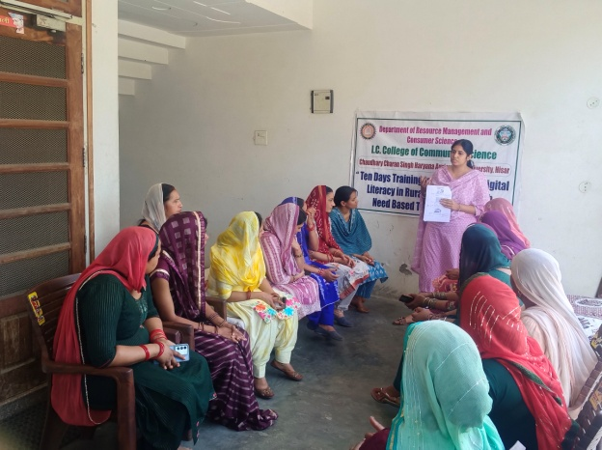
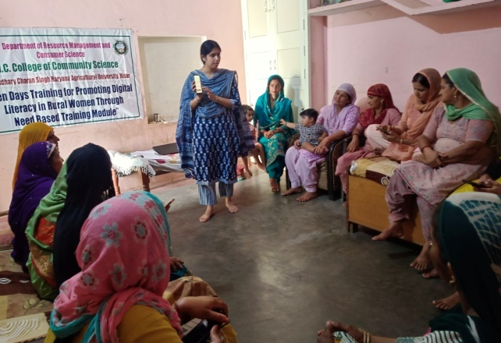

Plate1. Rural women participating in the digital literacy training session

Summary and Conclusion
The development of the need-based training module played a crucial role in ensuring the effectiveness of the training program. Since the content was designed according to the specific learning needs of rural women, the participants were able to relate the training to their everyday activities. Applications related to communication, digital payments and online services were particularly useful for participants. The use of hands-on practice sessions significantly improved participants' confidence in using smartphones and digital platforms. Visual demonstrations and simple explanations helped overcome technological barriers and reduced the fear associated with using digital devices. The training also created awareness about safe digital practices, which is essential in preventing cyber fraud and misuse of digital information. The study demonstrated that designing and implementing a need-based digital literacy training module can significantly contribute to enhancing digital awareness among rural women. By focusing on real-life applications and providing hands-on training, the program successfully introduced rural women to the digital ecosystem. The training program demonstrated that rural women were more comfortable learning digital skills when examples and applications were connected with their day-to-day activities such as online payments, communication and accessing government services. Expanding such training programs through educational institutions, self-help groups and government initiatives can further strengthen the digital empowerment of rural women.

Implications

Need-based digital literacy programs should be promoted through educational institutions, self-help groups and government initiatives. Community-based training centers can play a key role in delivering such programs in rural areas. Integrating digital literacy training with existing rural development schemes may further strengthen women's participation in the digital economy.

References
- Agrawal, N., Upadhyay, M., Verma, S. P., & Prashant. (2025). Empowerment of Rural Women through ICT: A Sociological Study of Kanpur District of Uttar Pradesh. International Research Journal of Multidisciplinary Scope, 6(4), 882–901. https://doi.org/10.47857/irjms.2025.v06i04.05982
- Gogoi, A., Manoranjini, M., & Gupta, M. (2022). Design and implementation of digital literacy training Programs in rural areas. International Journal of Extension Education, 18(1), 45–52.
- Malakar, P., & Deka, M. B. (2021). Enhancing ICT literacy among rural women through need-based interventions. Indian Research Journal of Extension Education, 21(3), 90–95.
- Sharma, K. A., & Sharma, B. S. (2021). Digital literacy and women empowerment in rural India. Journal of Community Mobilization and Sustainable Development, 16(2), 312–318.
- UNESCO. (2019). A global framework of reference on digital literacy skills for indicator 4.4.2. Paris: UNESCO.

