Original Research Article

Multifunctional Nb–Er Co-Doped TiO₂: A Structure–Property–Function Correlation Study for Energy and Educational Applications

Abstract
Titanium dioxide (TiO₂) is widely used in energy and dielectric applications; however, its wide bandgap and rapid charge recombination limit practical performance. In this study, (Nb₀.₅Er₀.₅)xTi₁₋xO₂ (x = 0.01–0.10) was synthesized via a solid-state route to investigate the effect of Nb–Er co-doping on structure–property relationships. X-ray diffraction confirms the stabilization of the rutile phase with dopant-induced lattice distortion and crystallite refinement. Scanning electron microscopy reveals a transition from uniform grains to agglomerated structures with increasing dopant concentration.
Dielectric analysis shows strong frequency dispersion governed by Maxwell–Wagner interfacial polarization, while impedance and modulus studies indicate non-Debye relaxation behavior. The AC conductivity follows Jonscher’s power law, confirming a hopping conduction mechanism mediated by defect states and oxygen vacancies. An optimal composition (x ≈ 0.04–0.06) exhibits enhanced dielectric constant, reduced loss, and improved conductivity due to synergistic interactions between Nb donor states and Er-induced defect levels [1, 2].
These findings highlight the potential of Nb–Er co-doped TiO₂ for low-power solar energy systems and multifunctional applications, including compact educational devices demonstrating real-time energy conversion.

Keywords: Nb–Er co-doping; Titanium dioxide (TiO₂); Dielectric properties; Impedance spectroscopy; Non-Debye relaxation; AC conductivity; Defect engineering; Maxwell–Wagner polarization; Hopping conduction; Solar energy materials

1. Introduction
Titanium dioxide (TiO₂) is one of the most extensively studied semiconductor oxides due to its remarkable chemical stability, low cost, non-toxicity, and versatile functionality in applications ranging from photocatalysis to energy conversion and dielectric devices [3,4]. In particular, TiO₂ has been widely employed in dye-sensitized and emerging photovoltaic systems owing to its favorable band alignment and electron transport properties. However, its relatively wide bandgap (~3.0–3.2 eV) restricts optical absorption primarily to the ultraviolet region, while rapid recombination of photogenerated charge carriers significantly limits its overall efficiency in practical applications [5].
To address these limitations, doping strategies have been extensively explored to tailor the electronic structure and enhance the functional properties of TiO₂. Transition metal doping has been shown to improve electrical conductivity by introducing donor levels, while rare-earth doping can create localized energy states that facilitate visible-light absorption and modify polarization behavior [6,7]. Among various dopants, niobium (Nb⁵⁺) is particularly effective as an n-type dopant, substituting Ti⁴⁺ and contributing free electrons to the conduction band, thereby enhancing electrical conductivity and charge transport [8]. On the other hand, erbium (Er³⁺), a rare-earth ion, is known for its unique optical transitions and ability to introduce defect levels within the bandgap, enabling upconversion and extended light absorption [9].
While single-dopant systems have been widely investigated, co-doping has emerged as a promising approach to achieve synergistic effects by combining the advantages of different dopant species. In Nb–Er co-doped TiO₂, Nb⁵⁺ can enhance carrier concentration, whereas Er³⁺ introduces localized states and defect dipoles, potentially leading to improved dielectric response and modified charge transport behavior. However, despite several studies on doped TiO₂ systems, a comprehensive understanding of the correlation between structural modifications, microstructural evolution, dielectric behavior, and electrical transport mechanisms in Nb–Er co-doped TiO₂ remains limited.
In particular, the role of defect chemistry—such as oxygen vacancies and dopant-induced lattice distortion—in governing non-Debye relaxation behavior and hopping conduction mechanisms has not been systematically explored in this system. Furthermore, the relationship between microstructural features, such as grain size and grain boundary density, and their influence on dielectric polarization and impedance response requires detailed investigation.
In this context, the present study aims to establish a direct structure–property–function correlation in (Nb₀.₅Er₀.₅)xTi₁₋xO₂ (x = 0.01–0.10) synthesized via a solid-state reaction route. A comprehensive characterization is carried out using X-ray diffraction (XRD), scanning electron microscopy (SEM), dielectric spectroscopy, and impedance analysis to elucidate the effects of Nb–Er co-doping on structural, microstructural, and electrical properties.
Beyond conventional material characterization, this work also explores the functional implications of the observed properties in the context of low-power energy systems. The combination of enhanced dielectric response, improved charge transport, and stable electrical behavior suggests that Nb–Er co-doped TiO₂ can serve as a promising candidate for solar energy applications. Additionally, the ability to integrate such materials into compact and efficient systems opens avenues for their use in educational devices that demonstrate fundamental principles of energy conversion and material science in an interactive manner.
Thus, this study not only advances the understanding of defect-engineered TiO₂ systems but also highlights the broader applicability of such materials in interdisciplinary domains that bridge advanced materials research with practical and educational applications.
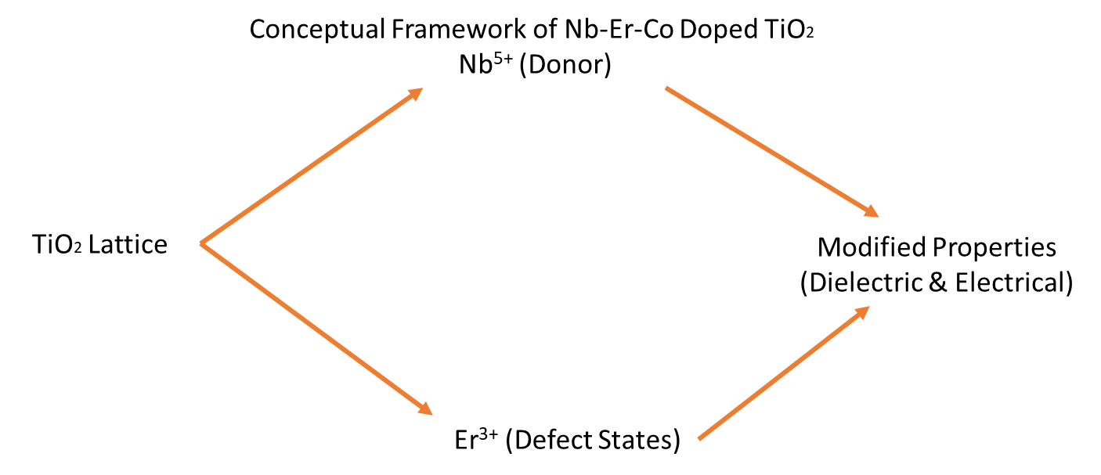
Figure 1. Schematic illustrating the role of Nb⁵⁺ and Er³⁺ dopants in modifying the TiO₂ lattice, introducing defect states, and influencing dielectric and electrical properties.

2. Experimental Procedure
2.1 Materials
High-purity precursor materials were used for the synthesis of (Nb₀.₅Er₀.₅)xTi₁₋xO₂ (x = 0.01, 0.02, 0.04, 0.06, 0.10). Titanium dioxide (TiO₂, 99.99%), niobium pentoxide (Nb₂O₅, 99.99%), and erbium oxide (Er₂O₃, 99.99%) were procured from Sigma-Aldrich and used without further purification. The selection of high-purity oxides ensures minimal impurity-driven defects, allowing controlled investigation of dopant-induced effects on structural and electrical properties [10].

2.2 Synthesis of Nb–Er Co-Doped TiO₂
The samples were synthesized using a conventional solid-state reaction method, which is widely employed for preparing homogeneous oxide ceramics with controlled stoichiometry and high crystallinity [11]. Appropriate stoichiometric amounts of TiO₂, Nb₂O₅, and Er₂O₃ were weighed according to the desired composition and thoroughly mixed using an agate mortar and pestle to ensure uniform distribution of dopants.
The mixed powders were ground for several hours to achieve fine particle size and homogeneity. The homogenized powders were then subjected to calcination at elevated temperature (typically in the range of 800–1000 °C) in air to facilitate solid-state diffusion and phase formation. The calcined powders were reground and pressed into pellets using a hydraulic press under uniform pressure.
The pellets were sintered at high temperature to achieve densification and improved grain connectivity. The solid-state route enables effective incorporation of Nb⁵⁺ and Er³⁺ ions into the TiO₂ lattice, leading to defect formation and microstructural evolution [12].

2.3 Structural Characterization
The phase formation and crystal structure of the synthesized samples were analyzed using X-ray diffraction (XRD) with Cu Kα radiation (λ = 1.5406 Å). The diffraction patterns were recorded over an appropriate 2θ range with a fixed step size and scanning rate.
Phase identification was carried out by comparing the obtained diffraction patterns with standard JCPDS data. The crystallite size was estimated using the Scherrer equation:
$$D=\frac{Kλ}{βcos⁡θ}$$
where $D$is the crystallite size, $K$is the shape factor, $β$is the full width at half maximum (FWHM), and $θ$is the Bragg angle [13].

2.4 Microstructural Analysis
The surface morphology and grain structure of the sintered samples were examined using scanning electron microscopy (SEM). The samples were properly polished and coated (if required) to ensure good conductivity and image clarity.
SEM analysis provides information on grain size, grain boundary distribution, porosity, and agglomeration, which are critical for understanding the relationship between microstructure and electrical properties [14].

2.5 Dielectric Measurements
The dielectric properties were measured using an LCR meter over a wide frequency range. Silver paste was applied on both sides of the pellet samples to form good electrical contacts.
The dielectric constant ($ε^{'}$) and dielectric loss ($ε^{''}$) were calculated from the measured capacitance using:
$$ε^{'}=\frac{C_{p}d}{ε_{0}A}$$
where $C_{p}$is the capacitance, $d$is the thickness of the sample, $A$is the electrode area, and $ε_{0}$is the permittivity of free space.
The dielectric loss tangent is given by:
$$tan⁡δ=\frac{ε^{''}}{ε^{'}}$$
These measurements provide insight into polarization mechanisms and energy dissipation within the material [15].
2.6 Electrical and Impedance Measurements
The electrical properties were analyzed using impedance spectroscopy over a broad frequency range. The complex impedance $Z^{*}$was obtained, from which the real ($Z^{'}$) and imaginary ($Z^{''}$) components were extracted.
The AC conductivity was calculated using:
$$σ_{ac}=ωε_{0}ε^{''}$$
where $ω=2πf$is the angular frequency. Impedance and modulus formalisms were used to investigate relaxation behavior, grain and grain boundary contributions, and charge transport mechanisms [16].

2.7 Data Analysis
The experimental data were analyzed using standard models such as:
- Maxwell–Wagner interfacial polarization
- Koop’s phenomenological model
- Jonscher’s universal power law
These models provide a theoretical framework for understanding dielectric dispersion, conduction mechanisms, and relaxation behavior in doped oxide systems.
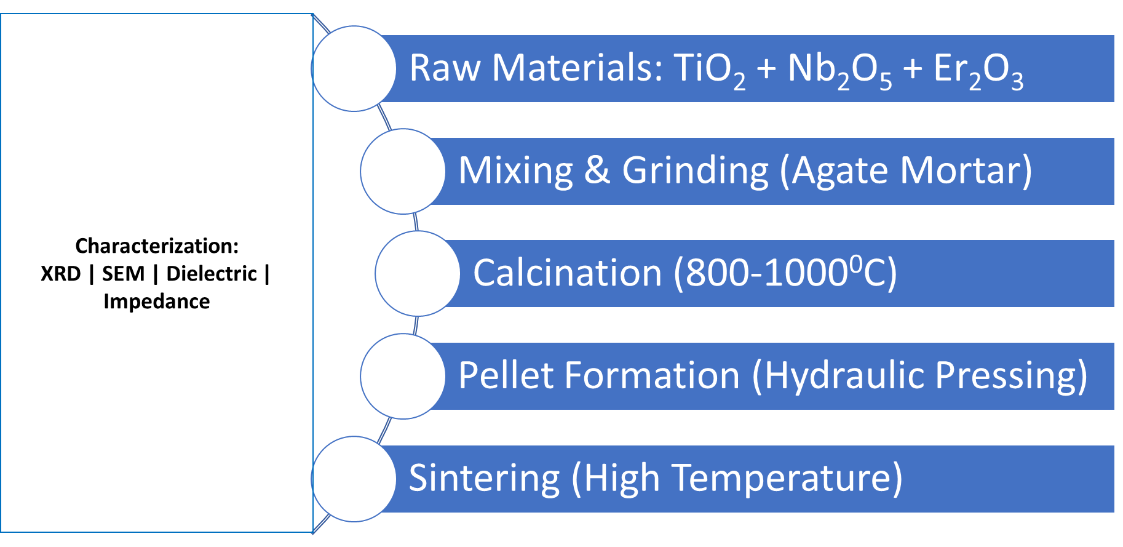
Figure 2. Schematic representation of the synthesis route, pellet preparation, and characterization techniques including XRD, SEM, dielectric, and impedance measurements.

3. Results and Discussion
3.1 Structural Analysis
The X-ray diffraction patterns of (Nb₀.₅Er₀.₅)_{x}Ti₁₋_{x}O₂ (x = 0.01–0.10) confirm the formation of the rutile TiO₂ phase for all compositions, with no detectable secondary phases within the resolution limit. The characteristic reflections corresponding to the (110), (101), and (211) planes are consistent with standard rutile TiO₂, indicating successful incorporation of Nb⁵⁺ and Er³⁺ ions into the host lattice.
A systematic broadening of diffraction peaks is observed with increasing dopant concentration, suggesting a reduction in crystallite size and an increase in lattice strain. The crystallite size (D), estimated using the Scherrer relation,
$$D=\frac{Kλ}{βcos⁡θ}$$decreases with doping, indicating that the introduction of aliovalent ions inhibits grain growth during sintering. Additionally, a slight shift in peak positions is observed, reflecting lattice distortion arising from the substitution of Ti⁴⁺ (0.605 Å) by Nb⁵⁺ and Er³⁺ ions of larger ionic radii [17]. The observed diffraction peaks at 2θ ≈ 27.4°, 36.1°, 41.2°, 54.3°, and 56.6° are indexed to the (110), (101), (111), (211), and (220) planes of rutile TiO₂.
Figure 3. X-ray diffraction patterns showing phase stability and peak broadening with increasing dopant concentration.
The X-ray diffraction patterns of (Nb₀.₅Er₀.₅)_{x}Ti₁₋_{x}O₂ confirm the formation of the rutile TiO₂ phase across all compositions without the appearance of secondary phases, indicating successful incorporation of Nb⁵⁺ and Er³⁺ ions into the TiO₂ lattice. The characteristic diffraction peaks observed at 2θ ≈ 27.4°, 36.1°, 41.2°, 54.3°, and 56.6° correspond to the (110), (101), (111), (211), and (220) planes of rutile TiO₂.
A gradual shift of diffraction peaks toward lower 2θ values with increasing dopant concentration suggests lattice expansion due to substitution of Ti⁴⁺ ions by larger Nb⁵⁺ and Er³⁺ ions. Furthermore, systematic peak broadening is observed with increasing x, indicating a reduction in crystallite size and an increase in lattice strain.
The crystallite size, estimated using the Scherrer equation, decreases from approximately 38 nm for x = 0.01 to 23 nm for x = 0.10. This reduction can be attributed to the inhibition of grain growth caused by dopant-induced lattice distortion and defect formation.
These results confirm that Nb–Er co-doping significantly influences the structural properties of TiO₂ by introducing strain and defects, which are expected to play a crucial role in governing the dielectric and electrical behavior of the material.

3.2 Microstructural Evolution
SEM analysis reveals a clear evolution of microstructure with dopant concentration. At low doping levels, the samples exhibit relatively uniform and fine grains with moderate agglomeration. With increasing dopant content, the microstructure becomes denser and more interconnected, indicating enhanced diffusion and grain boundary mobility during sintering.
At higher doping levels (x ≥ 0.06), grain coalescence and agglomeration become prominent, leading to non-uniform grain distribution. This behavior reflects the competing effects of dopant-induced lattice strain and thermally activated grain growth, which govern the final microstructure of oxide ceramics [18].
The observed discrepancy between decreasing crystallite size (XRD) and increasing grain size (SEM) arises from the distinction between coherent scattering domains and agglomerated grains, highlighting the complex interplay between defect chemistry and sintering dynamics.

Figure 4. (a) SEM micrographs of (Nb₀.₅Er₀.₅)xTi₁₋xO₂ for dopant concentrations x= 0.01

Figure 4 (b) SEM micrographs of (Nb₀.₅Er₀.₅)xTi₁₋xO₂ for dopant concentrations x= 0.02
Figure 4 (c) SEM micrographs of (Nb₀.₅Er₀.₅)xTi₁₋xO₂ for dopant concentrations x= 0.06
Figure 4 (d) SEM micrographs of (Nb₀.₅Er₀.₅)xTi₁₋xO₂ for dopant concentrations x= 0.1

3.3 Dielectric Behavior
The frequency dependence of the dielectric constant (ε′) for (Nb₀.₅Er₀.₅)xTi₁₋xO₂ exhibits a characteristic dispersion behavior, with relatively high values at low frequencies followed by a gradual decrease and eventual stabilization at higher frequencies. This behavior is consistent with the Maxwell–Wagner interfacial polarization model, which describes dielectric response in heterogeneous systems comprising conducting grains separated by insulating grain boundaries [19].
At lower frequencies, charge carriers accumulate at the grain boundaries, leading to the formation of space charge regions and enhanced interfacial polarization. This results in elevated dielectric constant values. As the frequency increases, the applied electric field alternates more rapidly, and the charge carriers are unable to follow the field variations, thereby reducing the contribution of interfacial polarization and causing a decrease in the dielectric constant.
The dielectric loss (tanδ) exhibits a similar frequency-dependent trend, decreasing significantly with increasing frequency. This reduction in dielectric loss indicates diminished energy dissipation and improved dielectric stability at higher frequencies, which is desirable for practical applications. The absence of pronounced loss peaks suggests a broad distribution of relaxation times, indicative of non-ideal dielectric behavior.
Figure 5: Frequency dependence of dielectric constant showing Maxwell–Wagner interfacial polarization and reduced dispersion at higher frequencies.

Notably, compositions in the intermediate doping range (x ≈ 0.04–0.06) exhibit enhanced dielectric performance, characterized by relatively higher dielectric constant and lower loss. This behavior can be attributed to an optimal balance between grain boundary density and defect-induced polarization mechanisms, as supported by microstructural observations. The presence of dopant-induced defects and oxygen vacancies contributes to polarization processes, while excessive doping leads to defect clustering and reduced dielectric efficiency.

3.4 Electrical Conductivity
The AC conductivity (σ_ac) shows a strong frequency dependence, increasing with frequency for all compositions. This behavior follows Jonscher’s universal power law,
$$σ_{ac}=σ_{dc}+Aω^{s}$$indicating that charge transport occurs via hopping of localized charge carriers [20].
At low frequencies, conductivity is dominated by grain boundary resistance, while at higher frequencies, the hopping of charge carriers between localized states becomes the dominant mechanism. The enhanced conductivity at intermediate doping levels is attributed to increased electron concentration from Nb⁵⁺ donor states and improved grain connectivity.
Figure 6: AC conductivity as a function of frequency indicating hopping conduction mechanism following Jonscher’s power law.

3.5 Impedance and Relaxation Behavior
Impedance spectroscopy provides further insight into the electrical response of the material. The real part of impedance (Z′) decreases with increasing frequency, indicating enhanced conductivity and reduced resistive barriers. The Nyquist plots exhibit depressed semicircular arcs, suggesting non-Debye relaxation behavior characterized by a distribution of relaxation times.
The absence of a well-defined relaxation peak in both impedance and modulus spectra indicates that relaxation processes are broadly distributed, reflecting structural disorder and defect heterogeneity. Such behavior is consistent with hopping conduction mechanisms in disordered oxide systems [21].
Figure 7: Nyquist plot (Z″ vs Z′) showing depressed semicircle indicative of non-Debye relaxation behavior.
3.6 Structure–Property Correlation
The combined results establish a clear correlation between structural, microstructural, and electrical properties. The incorporation of Nb⁵⁺ and Er³⁺ ions introduces defect states and oxygen vacancies, which play a crucial role in determining charge transport and polarization behavior.
At intermediate doping levels, the material exhibits:
- Reduced crystallite size
- Optimized grain boundary density
- Enhanced dielectric constant
- Improved electrical conductivity
These features collectively contribute to superior functional performance. In contrast, excessive doping leads to defect clustering and microstructural inhomogeneity, which adversely affect dielectric and electrical properties.

3.7 Functional Implications
The improved dielectric stability and enhanced electrical conductivity suggest that Nb–Er co-doped TiO₂ is a promising candidate for low-power energy applications. Efficient charge transport and reduced dielectric loss are critical for improving the performance of solar energy systems.
Furthermore, the tunable microstructure and defect chemistry provide opportunities for integrating these materials into compact devices, including energy-harvesting systems and multifunctional platforms. The observed structure–property–function relationship highlights the importance of controlled doping and microstructural engineering in designing advanced oxide materials.

4. Conclusion
In this study, (Nb₀.₅Er₀.₅)xTi₁₋xO₂ (x = 0.01–0.10) was successfully synthesized via a solid-state route to investigate the effect of Nb–Er co-doping on the structural, microstructural, dielectric, and electrical properties of TiO₂. X-ray diffraction confirmed the stabilization of the rutile phase across all compositions, with systematic peak broadening and slight shifts indicating dopant-induced lattice distortion and reduced crystallite size. Microstructural analysis revealed a transition from relatively uniform grains at low doping levels to dense, interconnected structures at intermediate compositions, followed by agglomeration at higher dopant concentrations.
The dielectric response exhibited pronounced frequency dispersion consistent with Maxwell–Wagner interfacial polarization, while impedance and modulus analyses indicated non-Debye relaxation behavior associated with a distribution of relaxation times. The AC conductivity followed Jonscher’s power law, confirming a hopping conduction mechanism mediated by defect states and oxygen vacancies introduced through Nb⁵⁺ and Er³⁺ substitution.
A clear structure–property correlation was established, identifying intermediate compositions (x ≈ 0.04–0.06) as optimal, where enhanced dielectric constant, reduced loss, and improved electrical conductivity are achieved due to the synergistic interaction between donor-induced charge carriers and defect-driven polarization mechanisms. These findings demonstrate that controlled co-doping and microstructural tuning can effectively enhance the functional performance of TiO₂.
From an application perspective, the improved charge transport and dielectric stability suggest strong potential for low-power energy systems, particularly in solar-related applications. Additionally, the multifunctional nature of the material offers opportunities for integration into compact, energy-aware devices, including platforms designed for interactive and educational demonstrations of energy conversion processes. Overall, this work provides a coherent framework for the rational design of defect-engineered oxide materials with tunable electrical properties and multifunctional applicability.

References
[1] Chen, X., Liu, L., Yu, P. Y., & Mao, S. S. (2011). Increasing solar absorption for photocatalysis with black hydrogenated titanium dioxide nanocrystals. Science, 331(6018), 746–750. https://doi.org/10.1126/science.1200448
[2] Grätzel, M. (2001). Photoelectrochemical cells. Nature, 414, 338–344.
https://doi.org/10.1038/35104607
[3] Chen, X., & Mao, S. S. (2007). Titanium dioxide nanomaterials: synthesis, properties, modifications, and applications. Chemical Reviews, 107(7), 2891–2959.
https://doi.org/10.1021/cr0500535
[4] Fujishima, A., Zhang, X., & Tryk, D. A. (2008). TiO₂ photocatalysis and related surface phenomena. Surface Science Reports, 63(12), 515–582.
https://doi.org/10.1016/j.surfrep.2008.10.001
[5] Diebold, U. (2003). The surface science of titanium dioxide. Surface Science Reports, 48(5–8), 53–229. https://doi.org/10.1016/S0167-5729(02)00100-0
[6] Choi, W., Termin, A., & Hoffmann, M. R. (1994). The role of metal ion dopants in quantum-sized TiO₂. Journal of Physical Chemistry, 98(51), 13669–13679. https://doi.org/10.1021/j100102a038
[7] Zhang, J., et al. (2010). Role of rare-earth doping in TiO₂. Journal of Physical Chemistry C, 114, 18300–18305. https://doi.org/10.1021/jp105164p
[8] Furubayashi, Y., et al. (2005). Transparent conducting Nb-doped TiO₂. Applied Physics Letters, 86, 252101. https://doi.org/10.1063/1.1949728
[9] Auzel, F. (2004). Upconversion and anti-Stokes processes with f and d ions. Chemical Reviews, 104(1), 139–174. https://doi.org/10.1021/cr020357g
[10] West, A. R. (2014). Solid State Chemistry and Its Applications. Wiley.
[11] German, R. M. (1996). Sintering Theory and Practice. Wiley.
[12] Chiang, Y. M., Birnie, D., & Kingery, W. D. (1997). Physical Ceramics. Wiley.
[13] Cullity, B. D., & Stock, S. R. (2001). Elements of X-Ray Diffraction. Prentice Hall.
[14] Goldstein, J., et al. (2017). Scanning Electron Microscopy and X-ray Microanalysis. Springer. https://doi.org/10.1007/978-1-4939-6676-9
[15] Barsoum, M. W. (2002). Fundamentals of Ceramics. Taylor & Francis.
[16] Barsoukov, E., & Macdonald, J. R. (2005). Impedance Spectroscopy: Theory, Experiment, and Applications. Wiley. https://doi.org/10.1002/0471716243
[17] Shannon, R. D. (1976). Revised effective ionic radii. Acta Crystallographica A, 32(5), 751–767. https://doi.org/10.1107/S0567739476001551
[18] Kingery, W. D., Bowen, H. K., & Uhlmann, D. R. (1976). Introduction to Ceramics. Wiley.
[19] Wagner, K. W. (1914). Explanation of dielectric relaxation. Archiv für Elektrotechnik, 2, 371–387.
[20] Jonscher, A. K. (1977). The universal dielectric response. Nature, 267, 673–679.
https://doi.org/10.1038/267673a0
[21] Elliott, S. R. (1987). A.C. conduction in disordered materials. Advances in Physics, 36(2), 135–217. https://doi.org/10.1080/00018738700101971

