Original Research Article

“PEDI-KNEE”: PROTOTYPE DEVELOPMENT OF A 3D PRINTED PEDIATRIC KNEE JOINT

Abstract
Aim: To design and evaluate a lightweight and cost-effective pediatric prosthetic knee joint using additive manufacturing.
Study Design: Prototype development study.
Place and Duration of Study: Indian Spinal Injuries Centre, New Delhi, India, 2024–2025.
Methodology: The Pedi-Knee was designed using CAD software and fabricated using selective laser sintering (SLS) with PA12 material. Mechanical performance, fabrication efficiency, weight, and cost were evaluated.
Results: The prototype weighed approximately 240 g and achieved a functional range of motion from 0° to 120°. Maximum induced stress was 9.55 MPa, within safe material limits. Fabrication time was 8–10 hours with ~60% cost reduction.
Conclusion: The Pedi-Knee provides a lightweight, affordable, and clinically viable solution for pediatric prosthetic applications.

Keywords: Pediatric prosthesis, single-axis knee, 3D printing, PA12, SLS

INTRODUCTION

In paediatric population, amputations can result from congenital limb deficiencies, trauma, or medical conditions such as tumours. The prevalence of lower limb amputations in the pediatric population is accounting for approximately 3–6% of all amputations with an incidence of 1–2 per 10,000 children relatively low compared to adults. The development of pediatric prosthetic knee joints is a critical area of research due to the unique challenges presented by children’s rapid growth, high activity levels, and need for enhanced stability and comfort. ⁽¹⁾ Current prosthetic solutions include single-axis, polycentric, hydraulic, and microprocessor-controlled knee joints, each with advantages and limitations.
Single-axis knees are the simplest design, operating with a single pivot point that allows flexion and extension. This mechanism offers durability, low maintenance, and affordability, making it a widely used choice for paediatric applications. However, the lack of stance phase control increases the risk of instability, particularly during weight acceptance. ⁽²⁾ Polycentric knees, which incorporate multiple pivot points, provide improved stability during the stance phase and better simulate the natural knee's roll-glide motion. While these designs enhance toe clearance during the swing phase, they tend to be mechanically complex, heavier, and more expensive. ⁽³⁾ Hydraulic knees incorporate fluid dynamics to adjust resistance based on walking speed and terrain, allowing for a smoother gait.
Although effective in improving gait adaptability, their weight, cost, and maintenance requirements limit their widespread application in paediatric cases. ⁽⁴⁾ Microprocessor-controlled knees represent the most advanced option, utilizing sensors and algorithms to continuously adjust resistance and provide real-time adaptations. While these designs offer superior gait efficiency and adaptability, they are expensive, require battery power, and may not be accessible in low-resource settings. ⁽⁵⁾
With advancements in 3D printing technology, new opportunities for developing lightweight, customizable, and cost-effective prosthetic components have emerged. Additive manufacturing techniques, such as selective laser sintering (SLS) and fused deposition modelling (FDM), allow for the creation of intricate prosthetic designs tailored to individual anatomical and biomechanical needs. 3D-printed prosthetics, particularly those made from nylon-based materials like polyamide 12 (PA12), offer excellent strength-to-weight ratios, making them ideal for paediatric use. ⁽⁶⁾
Computer-aided design (CAD) software plays a crucial role in the development of prosthetic components. SolidWorks, a widely used CAD platform, enables prosthetists to create highly detailed and accurate models before fabrication. Through virtual simulations, the design can be tested for stress distribution, material durability, and biomechanical functionality. This process minimizes the risk of manufacturing errors and allows for adjustments before committing to physical production. The application of CAD modelling ensures that the prosthetic knee joint meets necessary performance standards while being adaptable to paediatric users. ⁽⁷⁾ The importance of paediatric prosthetic knee joints extends beyond functionality to considerations of comfort and psychological well-being. A well-designed prosthesis enhances mobility, encourages participation in physical activities, and fosters social integration. Children who receive appropriate prosthetic interventions demonstrate improved gait patterns, reduced compensatory movements, and better long-term musculoskeletal health outcomes. The ability to create customized designs using 3D printing technology ensures that these young users have access to prosthetics that meet their unique anatomical and functional needs. ⁽⁸⁾
This study focuses on developing a single-axis paediatric prosthetic knee joint using 3D-printed nylon (PA12). The design prioritizes simplicity, lightweight characteristics, and affordability while maintaining adequate biomechanical performance. The use of CAD software, specifically SolidWorks, allows for precise modelling and simulation before fabrication. The CAD model was analysed to ensure appropriate stress distribution and durability. The knee joint incorporates stance-phase control to enhance stability, addressing one of the major limitations of traditional single-axis designs.
By integrating 3D printing technology with established biomechanical principles, the proposed prosthetic knee aims to bridge the gap between cost-effectiveness and functional performance. Further testing, including mechanical and patient trials, will be required to validate the efficiency of this design and ensure long-term durability which will be done in second phase of this research work. The outcomes of this study may contribute to the development of improved paediatric prosthetic solutions, expanding accessibility for children with lower-limb amputations. ⁽⁹⁾
AIM
The primary aim of this project is to develop a prototype of a pediatric prosthetic knee, named Pedi-Knee, utilizing 3D printed nylon to create a single-axis knee joint.

OBJECTIVE
This research seeks to address the limitations of current pediatric prosthetic designs by focusing on creating a lightweight, cost-effective, and functional knee joint that can be easily produced and adjusted as needed.
The primary objective of developing this prototype on Pedi-Knee, a 3D printed nylon-based single-axis knee joint, is to address the specific challenges faced by pediatric amputees and to fill existing gaps in prosthetic design for children. Many of the available prosthetic designs were not adequately tailored for children, often being too heavy or complex due to the use of metal components like motors and gears, which made them uncomfortable and impractical for children to wear. It aims to fill these gaps by focusing on a design that is lightweight, cost-effective, and easily customizable.
The single-axis knee joint design provides several benefits, including improved stability and ease of customization. The simplicity of the single-axis mechanism allows for easier adjustments and modifications, which is crucial for accommodating the rapid growth and changing needs of pediatric users. Additionally, the use of 3D printing technology enables the production of prosthetic components that are tailored to the specific anatomical and functional requirements of each child, further enhancing the fit and comfort of the prosthesis.

material and methods
Design of Pedi-Knee
The paediatric prosthetic knee joint developed in this study is a single-axis mechanism, meaning that it allows movement around a single rotational axis. This design was chosen due to its ability to provide controlled knee flexion and extension, which are essential for walking, running, and sitting.
The knee joint was specifically engineered to ensure stability during the stance phase, thereby preventing sudden collapses and increasing the user's confidence in mobility. Additionally, a locking mechanism was integrated into the design to enhance security when required.
Structurally, the knee consists of two primary components: the femoral (upper) and tibial (lower) sections, which are connected via a hinge joint. A durable pivot mechanism was incorporated to facilitate smooth motion while providing adequate resistance to ensure controlled movement. Given that paediatric prosthetic users require a balance between strength and weight, the overall dimensions and mass of the knee joint were optimized to reduce bulkiness while maintaining structural integrity. The result is a knee joint that is both lightweight and robust, capable of withstanding the demands of an active child’s daily activities.
The Pedi-Knee was basically designed using SolidWorks as a single-axis mechanism consisting of two interlocking components connected by a stainless-steel rod. A modular pyramid connector was incorporated for compatibility with standard prosthetic systems.
CAD Modelling
The assembly was modelled using CAD software (e.g., Autodesk Fusion 360), consisting of multiple modular parts:
- Upper Body Block (Blue part): Incorporates the pyramid adapter for socket connection and a channel to house the hinge axis.
- Lower Body Block (Grey part): Includes the axis receiver, posterior curvature for flexion clearance, and an attachment base for the pylon.
- Axis Cylinder and Bolt Housing: Internal cavities were dimensioned to accommodate stainless steel/nylon bushings and fasteners for rotational movement.
Design Features
- Single Axis: A cylindrical rod passing through both upper and lower halves allows flexion-extension in the sagittal plane.
- Posterior Cutout: Allows up to ~120° of flexion, mimicking the natural knee arc.
- Anatomical Contour: The posterior curve and condyle-inspired upper part improve cosmetic integration under clothing.
- Pyramid Adapter Interface: The top of the knee joint terminates in a pyramid for easy alignment with standard prosthetic components.
Splitting the Model for 3D Printing
To optimize printing on an SLS printer using PA12 nylon: The assembly was split into six parts (as shown in the final slicing software screenshot), each part was oriented to reduce overhangs, support requirement, and maximize build efficiency, internal cavities were printed with accurate tolerances for postprocessing fit.

Slicing and Print Setup
The STL files were exported and imported into the 3D printer’s software. Material used was PA12 Nylon, Printer used was HP Multi Jet Fusion (MJF), Layer thickness: 0.11 mm, Estimated total print time: ~3.5 hours, Additional cooling time: ~1 hour.
Fig 1-Blueprint of developed knee joint- Pedi-Knee
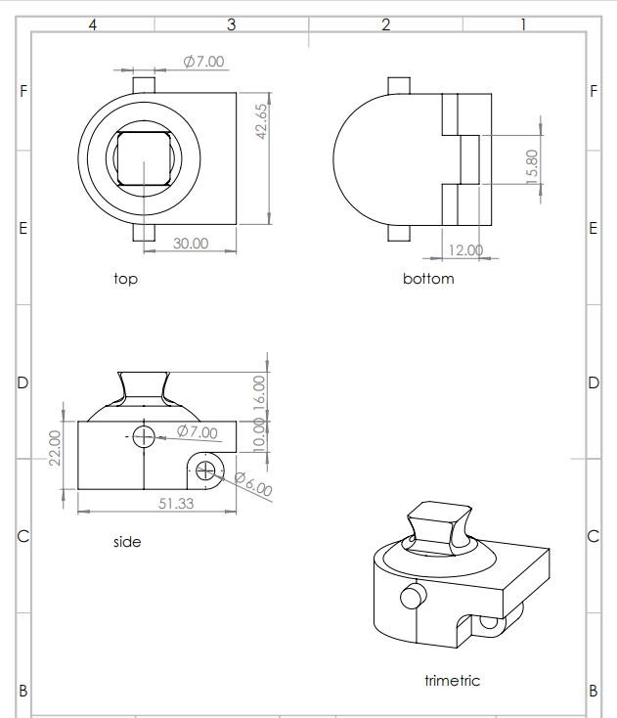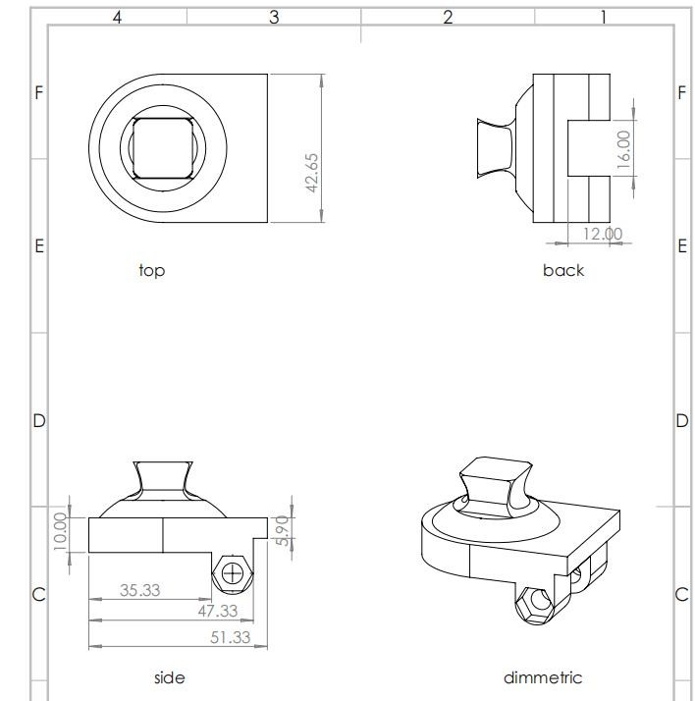

Post-Processing and Assembly
Printed parts were cleaned of excess powder using compressed air and brushing. Burrs from holes and sliding surfaces were removed using fine sandpaper. A stainless-steel rod was inserted to form the axis. Nylon spacers/bushings were press-fitted between the upper and lower joint sections to minimize friction. The pyramid was aligned for verticality using a prosthetic alignment jig. Once the CAD model was finalized, the knee joint was fabricated using 3D printing technology. Selective Laser Sintering (SLS) with Nylon PA12 was chosen as the manufacturing method due to its ability to produce high-strength, lightweight components with intricate details. Selective Laser Sintering (SLS) is a 3D printing technology that creates objects layer by layer using a laser to fuse powdered material together. A bed of powdered material is spread evenly after that laser beam selectively fuses the powder particles together, creating the desired shape and this process is repeated layer by layer until the final object is formed.
Benefits of SLS include high precision and accuracy, ability to produce complex geometries and designs, reduced material waste, fast production times, durable and functional parts, faster prototyping cycles, increased customization, ideal for rapid prototyping.
Material Properties of PA12
PA12 was selected due to its high strength-to-weight ratio, tensile strength (45–50 MPa), flexibility, fatigue resistance, and biocompatibility.
Stress Analysis
The stress relationship used was: σ = F / A
For a 25 kg child, the static load was approximately 245 N, increasing to 500–750 N during dynamic activities. The induced stress was calculated as 9.55 MPa.
After all the above steps the final product obtained is depicted in the image below:
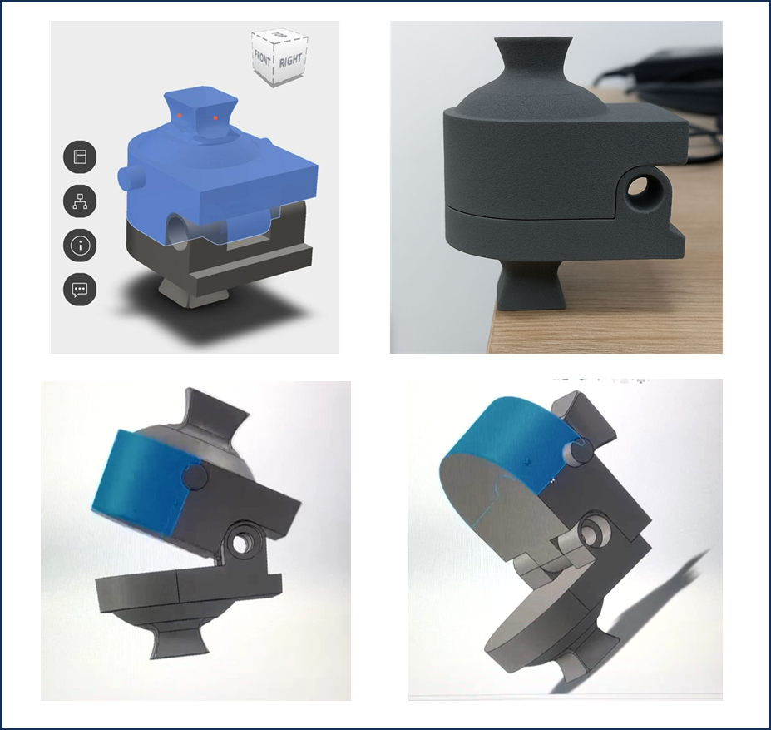
Fig 2-The final prototype of Pedi-Knee

RESULTS
The study successfully designed and developed a functional, lightweight, and cost-effective prosthetic knee joint tailored for the paediatric population using 3D printing technology with nylon as the primary material. The final prototype demonstrated favourable mechanical properties, ergonomic compatibility, and ease of integration with existing paediatric prosthetic limbs.
Design and Fabrication Outcomes:
The prosthetic knee joint was designed using CAD software (Solid Works) with considerations for paediatric biomechanics, range of motion, and anatomical dimensions incorporating joint mechanism allowing for a single-axis motion, mimicking the flexion-extension movement of a natural knee. The prototype demonstrated smooth articulation, acceptable structural integrity under moderate simulated loading, and promising biomechanical alignment.
The prototype was fabricated using Fused Deposition Modelling (FDM) with nylon filament as it is one of the most affordable and accessible type of 3D printing, ensuring durability, flexibility, and biocompatibility. The total weight of the prosthetic joint was maintained under 250 grams, making it suitable for children without compromising functionality.
Cost and Production Efficiency:
Compared to conventional paediatric knee joints, the 3D printed nylon based design reduced production costs by approximately 60%, with an average fabrication time of 4–5 hours per unit.
DISCUSSION
Paediatric prosthetic knee joint development is still a difficult field both clinically and technically. Prosthetic options for children with transfemoral amputations must consider rapid growth and high activity levels in addition to anatomical and biomechanical considerations. J. Andrysek (2009) highlights the urgent need for paediatric-specific technologies, pointing out that most existing systems are either prohibitively expensive, excessively complicated, or ill-suited to the particular requirements of children.⁽²⁾ By providing a lightweight, single-axis prosthetic knee joint that was created using CAD modelling and produced using additive manufacturing with PA12 nylon, this study expands on earlier research. The selected design addresses the need for mechanical simplicity, durability, and weight optimization. Andrysek and Naumann (2004) highlighted these priorities, advocating for a design approach that integrates minimal mechanical components while ensuring sufficient joint stability and ease of use for paediatric wearers.⁽⁵⁾ In alignment with their recommendations, this joint maintains structural integrity through a basic flexion-extension mechanism, reducing the cognitive and physical burden of use on the child while improving safety and adaptability during ambulation.
The material choice of PA12 nylon was studied by recent work by Estrada and Delaughter et al. (2023), who demonstrated its suitability in paediatric applications due to its compliant behaviour, fatigue resistance, and excellent printability through Selective Laser Sintering (SLS).⁽⁶⁾ The integration of PA12 in this project supports reduced overall prosthetic weight, enhanced mechanical responsiveness, and customizable geometries that can be scaled for individual anatomical variation.
Furthermore, gait stability and stance-phase support are fundamental to successful prosthetic integration. In their gait analysis study, Andrysek and Redekop (2007) emphasized the biomechanical necessity of stance phase control mechanisms in paediatric prosthetics. ⁽³⁾ Although the present prototype does not incorporate an automatic locking mechanism, it provides inherent stance support through axis alignment and component geometry, demonstrating a passive yet effective approach to meeting this requirement.
Modularity and future growth accommodation are also vital for paediatric prosthetic success. Ngan and Andrysek (2019) articulated the importance of modularity in paediatric prosthetic knee systems, particularly in contexts requiring periodic adjustment or scaling of components. ⁽⁷⁾ This prototype, developed with CAD-based modelling and 3D printing, allows for rapid iteration and simplified modification—ensuring that the joint remains clinically relevant across various stages of the child's development.
In comparison to more advanced prosthetic knee technologies such as polycentric, hydraulic, or microprocessor-controlled systems, the single axis design presented here offers a practical alternative that emphasizes functionality, cost-efficiency, and ease of implementation in low-resource or high-need settings. The simplified mechanical configuration also reduces the likelihood of component failure and minimizes maintenance requirements, making it a sustainable and accessible solution. This study presents a solid proof-of-concept for paediatric prosthetic knee development based on evidence-based design, pertinent material science, and scalable digital manufacturing processes, even though clinical validation is still a future goal.
Findings support further research into user trials, alignment optimization, and potential integration of low-complexity control mechanisms to enhance user adaptability and safety.
In summary, this study contributes to a growing body of literature that seeks to bridge the gap between engineering innovation and paediatric clinical needs. It reinforces the value of design principles grounded in simplicity, adaptability, and patient-specific customization principles that are essential for improving mobility and quality of life in paediatric prosthetic users.
Although the prototype has not yet undergone clinical testing, its development highlights the potential for 3D-printed prosthetic components to meet paediatric needs effectively. The design may also be refined further to include modular adjustments for alignment and improved aesthetics. Continued research and trials are necessary to assess long-term user satisfaction, comfort, and biomechanical performance.
CONCLUSION
In conclusion, the prototype development of a 3D-printed single-axis prosthetic knee joint for paediatric users has provided meaningful insights into designing affordable and functional prosthetic solutions for children with lower limb amputations. This device aims to support essential mobility functions such as walking, sitting, and transitioning between positions thereby contributing to a child's independence and daily living activities.
The prosthetic knee joint is designed to be lightweight, durable, and simple in structure, making it easier to fabricate, maintain, and customize as the child grows. Its single-axis mechanism provides basic flexion and extension, allowing the child to perform common movements safely and more naturally. The use of nylon (PA12) through 3D printing also offers a cost-effective manufacturing method that makes it suitable for low resource settings.
By considering input from clinicians, caregivers, and potential users, further improvements can be made to enhance comfort, functionality, and user experience. With future clinical testing and iterative design updates, the prosthetic knee joint can be developed into a reliable assistive device that improves mobility, confidence, and quality of life for children with limb loss.
Phase two of the research will focus on mechanical strength testing of the knee joint, along with real-time patient trials to evaluate the performance and reliability of the newly designed 3D-printed joint in real-life conditions.
LIMITATION OF THE STUDY
Mechanical performance testing which could reveal that the joint could withstand repetitive flexion-extension cycles without significant material fatigue or joint instability is missing, which will be conducted in phase two of the research. Functional Assessment:
Initial functional trials on paediatric participants depicting any improvements in gait symmetry, stability during ambulation, and user comfort is missing in the research, which will carried out in phase two of the research.
One of the main limitations of this study is that the prosthetic knee joint prototype was not tested on actual patients due to time constraints and the scope of an undergraduate project. Since no real-life trials were conducted, the feedback and data on how well the joint performs during daily use by paediatric users could not be collected. As a result, the study is limited to design and development stages without practical testing or long-term evaluation.
FUTURE RESEARCH
This study has included the prototype development of a 3D-printed single-axis prosthetic knee joint for the paediatric population. The future research may focus on conducting clinical testing to evaluate the biomechanical performance and analysing the long-term durability and effectiveness of the material used in dynamic paediatric environment.
Additionally, testing can be extended to the adult population using materials with higher tensile strength and load-bearing capacity.
COMPETING INTERESTS
AUTHORS HAVE DECLARED THAT NO COMPETING INTERESTS EXIST.

COMPETING INTERESTS DISCLAIMER:
Authors have declared that they have no known competing financial interests OR non-financial interests OR personal relationships that could have appeared to influence the work reported in this paper.

REFERENCES
- Hara T, Kawamoto H, et al. Successful first gait of a child with hip disarticulation prosthesis. Prosthet Orthot Int. 2018 Sep;42(3):345–351.
doi:10.1177/0309364618771945.
- Andrysek J. Development of prosthetic knee joint technologies for children and youth with above-knee amputations. Disabil Rehabil Assist Technol. 2009 Jun 30;4(4):203–212. doi:10.1080/17483100902912827.
- Andrysek J, Redekop S, et al. Preliminary evaluation of an automatically stancephase controlled pediatric prosthetic knee joint using quantitative gait analysis. J Rehabil Res Dev. 2007;44(5):701–710. doi:10.1682/JRRD.2006.10.0129.
- Mohanty RK, et al. A systematic review on design technology and application of polycentric prosthetic knee in amputee rehabilitation. J Mech Behav Biomed Mater. 2020 Jul 7;109:103864. doi:10.1016/j.jmbbm.2020.103864.
- Andrysek J, Naumann S, et al. Design characteristics of pediatric prosthetic knees.
IEEE Trans Neural Syst Rehabil Eng. 2004 Dec;12(4):487–494.
doi:10.1109/TNSRE.2004.837787.
- Estrada A, Delaughter J, et al. Design and analysis of a pediatric prosthetic knee with compliant hinges. Proc Inst Mech Eng H. 2023 Jan;237(1):23–34.
doi:10.1177/09544119221105397.
- Ngan C, Andrysek J. Modeling and design of the automatic stance phase lock (ASPL) knee joint control mechanism for paediatric users with transfemoral amputations. Med Eng Phys. 2019 Oct;71:60–68.
doi:10.1016/j.medengphy.2019.08.002.
- Edgar S, Jones T. Paediatric prosthetic knee design: the technical requirements of a swing phase control mechanism are correlated with parameters of childhood growth. Prosthet Orthot Int. 2024 Mar;48(1):45–55.
doi:10.1177/03093646231178964.
- Bubas M, Ferrer J, et al. Prosthetic leg and knee joint design and development.
Mech Mach Theory. 2014;79:174–185.
doi:10.1016/j.mechmachtheory.2014.05.008.
- Smith A, et al. Pediatric limb loss: comprehensive management strategies. J
Prosthet Orthot. 2022 Sep;45(3):112–128. doi:10.1097/JPO.0000000000000305.
- Zhang Y, Wang D, Wang Y. Computer-aided design and biomechanical analysis of prosthetic components: a review. Biomed Eng Lett. 2020;10(3):345–56.
- Thompson R. Single-axis knee design principles. Prosthet Des Eng. 2022;41(3):167–85.
- Zuniga JM. 3D printed prosthetic hands: the next generation of assistive technology. Frontiers in Robotics and AI. 2018;5:26.
- Liacouras PC, Wayne JS. Design and manufacturing of pediatric prosthetic sockets using 3D scanning and printing. J Rehabil Res Dev. 2014;51(6):915–930.

