Original Research Article

Region-Specific Poverty Allevation Model: A Qualitative Inquiry in Gunungkidul
Regency, Indonesia

.
ABSTRACT

Many developing countries struggle with poverty due to unstable and unsustainable development patterns. It is typically defined by income levels and the inability to meet basic human needs. Within modern governance, the success of a government, whether central or regional, is often judged by its ability to lower poverty figures. Because of this, poverty alleviation is consistently prioritized as a Key Performance Indicator (KPI) across all development planning stages. Moving to a more detailed analysis, the Gunungkidul Regency area is known as a barren area and always suffers from a lack of water to meet domestic needs. Meanwhile, the population is dominated by the productive age, which is 15-64 years, which is 497.35 thousand people. This means that the population in Gunungkidul Regency in 2023, the productive age population dominates. Then the location of poverty alleviation priorities in Gunungkidul Regency from 2022 to 2026 is determined based on the Circular Letter of the Deputy Governor of Yogyakarta number 401/0161 dated January 5, 2022, concerning the submission of 15 subdistrict Locus for Poverty Alleviation. In this study, 7 samples were taken, namely Nglipar, Tepus, Playen, Ponjong, Karangmojo, Saptosari, and Gedangsari. In this study, it is to find out the causative factors, existing conditions, and specific poverty management in Gunungkidul district. The qualitative analysis used was field condition analysis, social and cultural analysis, and descriptive statistical analysis. Overall, the conclusion of this finding is that poverty in Gunungkidul Regency is basically a type of natural poverty where due to natural and geographical conditions, some areas are the Gunungsewu Karst area, which is a conservation land, some areas need infrastructure to empower the community. The latest findings in this study are that there are several sample locations that are close to tourism zones, but poverty in these areas is still high due to geographical problems, and many more.

Keywords: Poverty, Social Analysis, Cultural Analysis, Allevation Model

1. INTRODUCTION
Poverty is a pervasive global problem and has long hampered many people's efforts to achieve a better life by creating hardships, such as disease, violence, and hunger (Bin-feng et al., 2023). Regardless of how poverty reduction is positioned in development in general, poverty is a situation in which individuals or households experience an inability to meet basic needs such as food, shelter, education and health. To measure the poverty level in Indonesia, there are two commonly used approaches, namely micro poverty and macro poverty. Significant changes in the macroeconomic system tend to have microeconomic effects (Connolly et al., 2024).
Macro poverty is a measurement method that focuses on poverty levels in aggregate, usually at the national level. This approach uses the concept of "basic needs" and monetary approach. The poverty rate in this approach is based on the food poverty line, which is the amount of food needed per capita per day. Macro poverty data is usually obtained from the results of sample surveys such as “Susenas”. This approach is suitable for poverty planning that has a geographic target but does not provide detailed information about who is poor and where they are. Macro poverty rates are used as a guide in the formulation of economic and social policies. Building social capital is an important factor because it is generally considered a resource embedded in social networks (Lawson & Uddin, 2026).
Micro-poverty refers to the economic inability to fulfill essential food and non-food requirements. This perspective utilizes a multidimensional, non-monetary framework for assessment, shifting away from purely income-based metrics. By employing in the Integrated Poverty Parameter (PMT), which evaluates specific household characteristics, this approach generates granular data to accurately categorize populations into “very poor”, “poor”, and “vulnerably poor” groups. Micro-poverty data is used directly to determine the goals of social assistance programs such as BLT, PKH (Family Hope Program) and others. Micro poverty also uses various variables such as floor area per capita, floor type, defecation facilities, clean water sources, lighting, etc. From a sustainable development perspective, relatively poor groups struggle to share equitably in harnessing economic growth and lack access to high-quality resources, thus hindering progress towards shared prosperity (Mao et al., 2025).
Moreover, extreme poverty itself is understood as a multidimensional structural phenomenon that is still a major challenge in Indonesia, especially related to limited basic services, low food security, and vulnerability to climate change. According to the results of previous research, village funds have an impact not only on increasing access to basic services, but also on strengthening social capital and household economic resilience, which are often overlooked in formal macro indicators (Smas et al., 2025).
According to the Kuznets Curve of the Environment, economic growth in the early stages of development is often achieved at the expense of environmental quality, which implies a trade-off between economic growth and economic protection. However, this is very risky because poor people are often the most vulnerable to pollution and resource depletion under the strategy of polluting first and then cleaning up (Wu et al., 2026).
Furthermore, case study in China In 2014, the Chinese government launched the ECC (E-commerce to Rural Areas) project to capitalize on the rapid development of e-commerce and promote TPA (Third-Party Assistance). In the subsequent year, the ECC initiative was recognized as one of China’s top ten landfill projects. Moreover, the rigorous execution of ECC guidelines has evolved into a widely adopted strategy for digital rural advancement across the country. This project aims to encourage the development of rural e-commerce in poor districts to create a national economic effect (Duan et al., 2024).
Gunungkidul district has a poverty rate that is still relatively high when compared to the poverty level in D.I Yogyakarta and the National. The poverty rate in Gunungkidul fluctuated during the period 2018 – 2023. The poverty rate in 2018 was 17.12 and in 2019 it was 16.61. However, the Covid-19 pandemic in 2020 caused an increase in the poverty rate by 0.46% to 17.07. In 2021 it will be 17.69 and in 2022 it will be 15.86 while in 2023 it will be 15.60.
Table 1. D.I. Yogyakarta Poverty Line in 2023
Regency/City | Poverty Line  (Rp/Hood/month) | Number of poor people (000) | Percentage
Kulon Progo | 416.870 | 70.74 | 15.64
Bantul | 488.340 | 128.51 | 11.96
Gunungkidul | 382.249 | 122.24 | 15.60
Sleman | 491.652 | 97.50 | 7.52
Yogyakarta | 662.267 | 28.48 | 6.49
D.I Yogyakarta | 573.022 | 448.47 | 11.04
National | 550.458 | 25.896,55 | 9.36
Source: BPS, 2023
The causes of poverty are very diverse, not only related to the inability to meet basic material needs but there are several other causative factors such as a high population growth rate, an increasing unemployed community, low education, natural disasters, and unequal distribution of income. Vulnerability is a physical, social, financial, and environmental component or process that increases the sensitivity of individuals, community assets, or systems to the impact of a disaster (Amin et al., 2025). So, the purpose of this study is to answer the causes of poverty, find out the conditions of poverty in Gunung Kidul Regency, and get the best model to reduce specific poverty in our sample area.

2. material and methods
The study used primary data and some secondary data as corroboration. Primary data is data taken from respondents directly, while secondary data is data taken from various sources, both publicly published and unpublished, such as data stored by stakeholders for special purposes.
The primary data that will be used in this study consists of several types and sources, including:
- Stakeholder perception data related to poverty management in Gunungkidul Regency, both at the Provincial level, Regency level, Subdistrict, and (Village) level.
- Data on the perception of poor households
- Information and data collected from the results of the discussion.
- Information and data from observations related to matters related to poverty in Gunungkidul Regency, both directly and indirectly.
Meanwhile, the secondary data to be analyzed consist of, among others:
- Publication data of the Central Statistics Agency, related to poverty data and other macro performance data. Poverty data consists of the number of poor people, the percentage of the poor population and the definition and methodology used by BPS in calculating poverty.
- Data from the Ministry of Social Affairs, in the form of Integrated Social Welfare Data, which is managed by the Social Service. Social welfare data is integrated data used to determine the beneficiaries of various social assistance schemes carried out by the Government.
- Information and data on regulations related to poverty alleviation regulations, both at the National, Provincial levels, Regency levels, and village levels.
- Information and data about programs, program implementations and evaluation results related to poverty alleviation, both at the National, Provincial levels, Regency levels, and Village levels.
- Data from publications, literature, and previous research results related to poverty.
Poverty (Poverty) is a problem faced by all countries, especially in developing and underdeveloped countries which is one of the oldest and most challenging social problems ever (Onsay & Rabajante, 2025). The problem of poverty is multidimensional caused by many factors that are not only the domain of the economic field, but also political, social, cultural and other social systems.

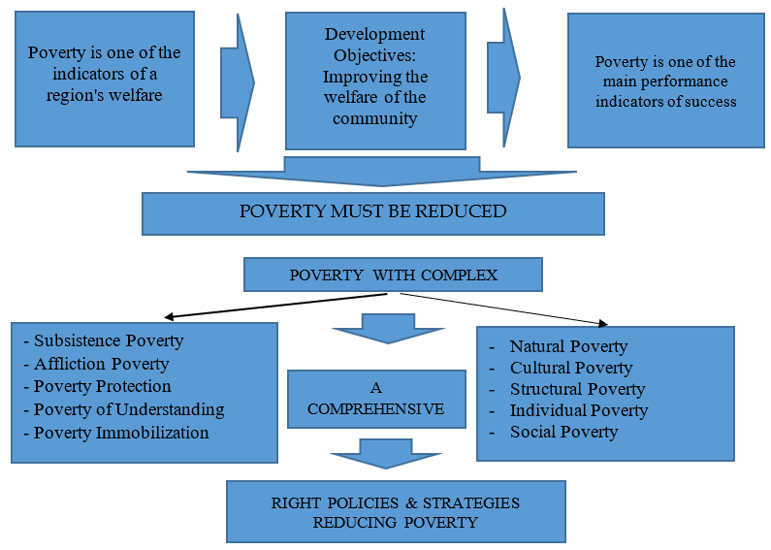
Figure 1. Conceptual Framework of Research

First, on a micro level, poverty stems from unequal patterns of resource ownership, which lead to disparate income distribution. The impoverished typically possess only limited resources, often of suboptimal quality. Second, poverty is driven by disparities in the quality of human resources. Low-quality human capital, resulting from limited education, unfavorable circumstances, discrimination, or hereditary factors, lead to ow productivity, which subsequently results in depressed wages. Third, poverty arises from restricted access to capital. This factor culminates in the vicious circle of poverty theory. According to (García & Sánchez, 2017), this theory is based on a casual relationship where underdevelopment, market instability, and capital flight lead to low productivity.
- Market Imperfections
- Retardation
- Dependency
Low Investment
Low Productivity
Low Savings
Low Income

Source: Nurkse (in Kuncoro, 1997:132)
Figure 2. The Vicious Circle of Poverty

2.1. International poverty measurement
World Bank (World Bank) is changing the standard of the new poverty line that refers to the rules purchasing power parities (PPP) 2017. On the basis of this change, the World Bank set the extreme poverty line at US$2.15 or Rp32,757.4 (with a reference exchange rate of Rp15,236 per US dollar) per person per day in the 2017 PPP (Mejia, 2025). This standard is up when compared to the 2011 PPP, which is US$1.90 or worth Rp28,948.4 per person per day.

  - Measuring Indonesian Poverty
According to BPS, poverty is defined as an economic incapacity to satisfy essential food and non-food requirements, as determined by individual spending patterns. Under this framework, a population is deemed poor when their average monthly expenditure per capita remains below the Poverty Line (PL), a metric derived from the combination of the Food Poverty Line (FPL) and the Non-Food Poverty Line (NFPL). To assess the scale of this issue in Indonesia, BPS and Bappenas utilize a standardized methodology that focuses on three primary indicators.:
- Poverty Rate (P0)
The poverty level is carried out by looking at the proportion of the population who spend per capita income below the poverty line or called PL. Meanwhile, PL reflects the value of the minimum expenditure needed by a person, such as food needs and non-food. Food needs are seen from a person's needs which are equivalent to 2,100 kilo calories per capita. This refers to essential non-food requirements, including housing, clothing, education, and healthcare, which are monitored through 51 specific commodities in urban regions and 47 in rural settings.
- Depth of Poverty (P1)
The depth of poverty is shown by the code P1 by looking at the average difference between the difference in expenditure per capita of the poor population and the poverty line that occurs in the community. If the P1 is higher, then the population poverty rate is also further away from the average per capita population expenditure. On the other hand, the smaller the index value, the closer it is to the poverty line.
- Severity of Poverty (P2)
The Poverty Severity Index, designated as P2 is calculated by averaging the squares of the gaps between the poverty line and the per capita expenditure of the poor, thereby providing a clear representation of expenditure inequality within the impoverished population. The higher the index value, the higher the inequality of expenditure among the poor.
Therefore, livelihood strategies are very important to reduce poverty because they significantly affect overall household well-being, sustainability, and resilience (Agustina et al., 2026).

  - Local poverty measurement
The Governor of the Special Region of Yogyakarta Regulation Number 81 of 2023 concerning the Poverty Alleviation Plan for the Special Region of Yogyakarta for 2023–2027 determines the location of the poverty priority subdistrict using these 8 (eight) which are the identification of multidimensional poverty, namely: (1). Decile 1 and 2 Households Integrated Social Welfare Data 2020, (2). Human Development Index 2018, (3). 2020 Development Village Index, (4). Food Prone Villages 2020, (5). Uninhabitable Households in terms of Floor, Walls and Roofs, from Social Welfare Data 2020 (6). Houses Without Proper Sanitation, from Social Welfare Data 2020 (7). Households with Decent Water Sources from Social Welfare Data 2020, and (8). Households Without Electricity from Social Welfare Data 2020. Then related to the geographical context in Yogyakarta can limit the generalization of findings to other regions with different socio-economic conditions and infrastructure (Cahyo et al., 2025).

  - Sociological and Cultural Approaches
Sociologically, understanding the roots of poverty cannot be read in isolation, meaning that it is impossible to only blame the problem of equitable development of regions. In other words, cultural aspects and mental attitudes are important points that cannot be separated. From a sociological perspective, efforts to alleviate or overcome poverty are to anticipate every factor that causes the emergence of poverty as described above. In the context of modern society as it is today, the context of poverty is more caused by ignorance, lack of technical skills, a dull work ethic, and low job opportunities. In addition, the phenomenon of poverty in Indonesia is also caused by the existence of a consumptive lifestyle of the community, but it is not accompanied by a work ethic to find a better income. By understanding the fundamentals of the poverty problem, a cross-sectoral approach is needed that is not only focused on poverty alleviation programs, but also a sociological approach by prioritizing awareness efforts and encouraging community empowerment through strengthening solidarity and social capital. Rural sociology is increasingly becoming an important field of study, especially in the transformations that affect rural areas. Driven by globalization, technological innovation, and evolving socio-political dynamics, this transformation exerts a profound influence on rural communities and the trajectory of regional development (Rizwan & Hannoun, 2026).
The cultural approach in the context of poverty is not only an economic phenomenon but also provides a more holistic and in-depth perspective on how poverty affects and is influenced by people's cultures. Culture encompasses values, norms, beliefs, and practices that can influence the way individuals and communities deal with poverty. This approach involves understanding how culture influences:
1. Perceptions and attitudes towards poverty: How society sees and responds to poverty.
2. Survival strategies: The ways used by communities to overcome and adapt to poverty.
3. Access to resources: How social relationships and cultural norms affect distribution and access to resources.
The systematic measurement of poverty involves a sequence of methodological choices, ranging from selecting appropriate welfare indicators and defining clear thresholds to differentiate the poor from the non-poor, to integrating data for the derivation of poverty metrics (Mysikov, 2026).

  - Aspects of Poverty Alleviation Regulations and Policies in Indonesia
There are several laws and regulations that can be used as a basis for formulating Poverty Alleviation policies, including the following:
- Government Regulation No. 39 of 2012 concerning the Implementation of Social Welfare (Statute Book of the Republic of Indonesia No. 68 of 2012, Supplement to Statute Book of the Republic of Indonesia No. 5294);
- Presidential Regulation No. 15 of 2010 concerning the Acceleration of Poverty Alleviation as amended by Presidential Regulation No. 96 of 2015 concerning Amendments to Presidential Regulation No. 15 of 2010 concerning the Acceleration of Poverty Alleviation (State Gazette of the Republic of Indonesia No. 199 of 2015);
- Presidential Regulation No. 166 of 2014 concerning the Poverty Alleviation Acceleration Program (Statute Book of the Republic of Indonesia No. 341 of 2014);
- Presidential Instruction of the Republic of Indonesia Number 7 of 2014 concerning the Implementation of the Prosperous Family Savings Program, Smart Indonesia Program, and Healthy Indonesia Program to Build Productive Families

Growth Poverty and Inequality
Kuznet Curve: Inequality may increase in the middle of development but then decrease.

Resources for redistribution
Poverty Inequality
Business Employment Opportunities

Growth
Asymmetric Growth in Various Sectors

Inequality
Depending on the Source of Growth

Poverty Inequality, Growth
Signs of Meritocratic Factors Paying Their MPs
Inseparability in Investments, Interest Rates
Poverty Trap, Underutilization
Institutions, Inefficient Institutional Policies
Civil Conflict
Inequality
Growth
Inequality,
Poverty
Growth
Trust, Collective Action

Distorted Taxation

Source: IMF Working Paper, 2021.

Figure 3. The Main Channel in the Relationship Between Growth, Poverty, and Inequality

3. results and discussion
3.1. Primary Data Analysis
The analysis of primary data at the Household (RT) level was obtained based on a survey conducted on a sample of poor households in 6 (six) Districts in 3 (three) Districts, namely subdistrict Playen (Plembutan and Banaran Districts), Districts of Gedangsari (Districts of Hargomulyo and Serut, and Districts of Saptosari (Districts of Krambil Sawit and Jetis).
3.1.1. Household Level Analysis
Respondent profiles comprise their professional roles and total household size. The findings of the analysis are presented below:
Table 2. Respondent Position
No. | Position in the Family | Quantity | Presses
1. | Head of Household | 24 | 80
2. | Housewives | 6 | 20
3. | Family members | 0 | 0
4. | Other: Follow your child | 0 | 0
Quantity |  | 30 | 100
Source: Survey Data, 2024
Most of the respondents surveyed were 24 (twenty-four) heads of families (80%) and 6 (six) housewives (20%). The number of respondents' family members was mostly less than 3 (three) as much as 56.67%.
Table 3. Number of Respondents' Family Members
No. | Number of Family Members | Quantity | Presses
1. | <3 | 17 | 56,67
2. | 4-5 | 4 | 13,33
3. | >5 | 2 | 6,67
4. | Others:  - Alone | 7 | 23,33
Quantity |  | 30 | 100
Source: Survey Data, 2024
The perception of poor household respondents consisted of the length of time they received assistance, the type of assistance obtained, the benefits of the assistance, improvements that need to be made to the assistance provided by the government, the income and expenses of the respondents, problems, and proposals for improvements to the poverty alleviation assistance program in Gunungkidul Regency.
Table 4. Long Received Government Assistance
No. | Period of Assistance | Quantity | Presses
1. | < 3 years | 5 | 16.67
2. | 4-5 years | 8 | 26.67
3. | > 5 years | 3 | 10.00
4. | Others:  - Once got, now not anymore because the data doesn't show up  - Once got it but was returned because it was unable to provide a complement (Uninhabitable House)  - Have received PKH in 2021 only once | 14 | 46.67
Quantity |  | 30 | 100
Source: Survey Data, 2024
According to table 4, the largest segment of respondents (46.67%) reported receiving assistance at irregular or unpredictable times, meaning that some of the recipients of assistance had received but then did not get it again and had received assistance but were returned (Uninhabitable House) because they were unable to provide accompanying funds. As many as 26.67% received assistance between 4-5 years and as many as 16.67% received assistance for less than 3 years, only 10% of respondents received assistance for more than 5 (five) years. The types of poverty alleviation assistance received by poor Household respondents are shown by table 5 as follows:
Table 5. Types of Government Assistance Respondents Receive
No. | Types of Assistance | Quantity | Presses
1. | PKH | 23 | 22.55
2. | Cash social assistance | 15 | 14.71
3. | Non-cash social assistance | 16 | 15.69
4. | Health insurance | 23 | 22.55
5. | Education Guarantee | 3 | 2.94
6. | Habitable houses | 9 | 8.82
 | Others:  - CPP  - Baznas | 13 | 12.75
Quantity |  | 102 | 100
Source: Survey Data, 2024
The distribution of assistance is inseparable from the problem, the respondent's perception of the problems felt by the respondents in the distribution of poverty alleviation assistance is shown by table 6 as follows:
Table 6. Problems in Aid Distribution According to Respondent Perception
No. | Problem | Quantity | Presses
1. | Data | 6 | 20.00
2. | Companion Funds | 0 | 0
3. | Ambiguity | 3 | 10.00
4. | None | 5 | 16.67
5 | Don't Understand | 16 | 53.33
Quantity |  | 30 | 100
Source: Survey Data, 2024
Table 6 can be seen that as many as 16 respondents (53.33%) stated that they did not understand the problems in the distribution of aid, as many as 5 respondents (16.67%) stated that there were data problems (who got it) and 3 respondents (10.00%) stated that there was an unclear in the distribution of aid.
3.2. Social and Cultural Analysis
As evidenced by data derived from direct observation in the field, documentation and interviews with several related speakers, if viewed from the social and cultural aspects, the causes, consequences and measures to overcome or solve poverty in Gunungkidul Regency can be described as follows:
3.2.1. Causes of Poverty
A primary driver of poverty is the lack of education and vocational skills, largely stemming from restricted access to educational opportunities. The poor population in Gunugkidul is on average poorly educated. As a result, they do not get a decent job, so their income is low.
Furthermore, regarding unemployment where the poor population in Gunungkidul, of the 30 samples studied, most (30%) do not have a permanent job or can be categorized as unemployed, who work only as farm laborers (23%), those who also do not have a side job (42%). This is the reason why they do not have a fixed source of income, so they fall into poverty.
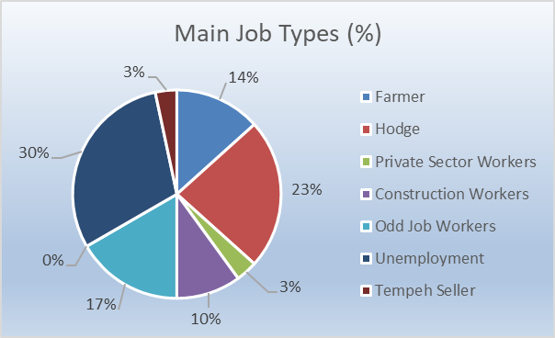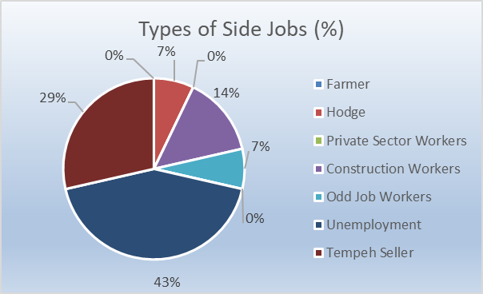
Source: Survey Data, 2024.
Figure 4. Types of Basic and Side Jobs
An unsupportive social environment where most of the population is also poor can form the mindset that poverty is normal and inevitable.
Dependence on Social Assistance that is not accompanied by skills training or further education can create dependency that hinders independent efforts to get out of poverty. Most of the assistance received by the poor in Gunungkidul is charity assistance or financial assistance, so it does not encourage them to work productively, and even makes the poor people only depend on receiving assistance.

Source: Survey Data, 2024.
Figure 5. Types of Assistance Received
Considerable expenditure for social needs is mainly intended to give "donations" to neighbors or relatives who are having a celebration. Most of the respondents stated that the amount of donations given will be recorded by those who have the celebration, and one day it will be returned according to the amount of donations that have been given. For families who have celebrations, they also have dependents to give rice gifts to people who have helped, so that the costs incurred are also large/wasteful.

Source: Survey Data, 2024.
Figure 6. Respondent Spending Types
4. Conclusion
Poverty in Gunungkidul Regency is fundamentally natural poverty, arising from its specific environmental and geographical constraints. Other forms, such as cultural poverty, are essentially secondary consequences of these natural conditions. Since a significant portion of the region belongs to the Gunung Sewu Karst conservation area, there is limited potential for land utilization outside the agricultural sector, particularly for investment. Consequently, the region’s natural tourism potential fails to generate a multiplier effect for poverty reduction without strategic investment. Furthermore, the demographic profile of poor households is characterized by elderly individuals in poor health who require intensive care The social system in Gunungkidul Regency does allow these poor elderly to be in the community, but care still needs to be improved. Social security programs for very poor households need companions, so that they can access and take advantage of the social security programs provided by the Government. The existence of cadres is very helpful and helpful, especially to overcome the literacy of the data collection system for obtaining assistance.
Technological engineering is needed to increase dryland productivity, through the expansion of water distribution networks and the technical design of additional production infrastructure. In addition, it is necessary to develop various activities to increase alternative income. As a conservation area with high poverty conditions, it is necessary to receive a special program, considering the lack of freedom in utilizing space to invite investment which can have an impact on improving people's welfare and reducing poverty.

Consent
As per international standards or university standards, respondents’ written consent has been collected and preserved by the author(s).

Disclaimer (Artificial intelligence)
Author(s) hereby declare that NO generative AI technologies such as Large Language Models (ChatGPT, COPILOT, etc.) and text-to-image generators have been used during the writing or editing of this manuscript.

References
Agustina, L., Rum, S., & Sudrajat, S. (2026). Environmental and Sustainability Indicators Breaking down poverty : Livelihood assets ' impact on Indonesian livelihood strategies. Environmental and Sustainability Indicators, 30(May 2025), 101225. https://doi.org/10.1016/j.indic.2026.101225
Amin, C., Tyas, W., Jumadi, J., Novita, D., & Samson, M. G. M. (2025). Social Sciences & Humanities Open Navigating urban poverty : The role of livelihood capital in the livelihood strategies of urban beggars in Indonesia. Social Sciences & Humanities Open, 11(December 2024), 101298. https://doi.org/10.1016/j.ssaho.2025.101298
Bin-feng, C., Zhe, L., Sikandar, S., & Safdar, R. (2023). Heliyon Targeted poverty alleviation initiatives and corporate sustainable value creation : Determining the role of corporate internal governance control in China. Heliyon, 9(7), e17686. https://doi.org/10.1016/j.heliyon.2023.e17686
Cahyo, N., Harisa, W., & Raharti, R. (2025). Case Studies on Transport Policy Modeling motorcycles dependency for commuting among low-income communities in Yogyakarta , Indonesia : The perspective of the theory of planned behavior. Case Studies on Transport Policy, 20(November 2022), 101404. https://doi.org/10.1016/j.cstp.2025.101404
Connolly, K., Eiser, D., Kumar, A., Mcgregor, P. G., & Roy, G. (2024). A micro-macro-economic modelling approach to major welfare system reforms : The case of a Universal Basic Income for Scotland. Structural Change and Economic Dynamics, 68(October 2023), 259–268. https://doi.org/10.1016/j.strueco.2023.10.005
Duan, W., Jiang, M., & Qi, J. (2024). Journal of Environmental Economics Poverty or pollution : The environmental cost of E-commerce for poverty reduction in China ☆. Journal of Environmental Economics and Management, 127(June), 103029. https://doi.org/10.1016/j.jeem.2024.103029
García, A. O., & Sánchez, P. M. (2017). Analysis of the vicious circle of poverty and social exclusion of the gypsy woman in the neighborhood of Los Rosales , Murcia. Social and Behavioral Sciences, 237 (June 2016), 618–625. https://doi.org/10.1016/j.sbspro.2017.02.023
Lawson, D., & Uddin, M. (2026). Social Science & Medicine The double-edged sword of social capital : Impacts on women's health in extreme poverty. Social Science & Medicine, 398(January), 119109. https://doi.org/10.1016/j.socscimed.2026.119109
Mao, H., Fu, Y., & Zhu, Z. (2025). The information technology and relative poverty : An analysis based on the micro data of China family panel studies. Cities, 163(May), 106029. https://doi.org/10.1016/j.cities.2025.106029
Mejia, S. A. (2025). The effects of world society on international poverty , 1990 – 2018. Social Science Research, 125(October 2024), 103090. https://doi.org/10.1016/j.ssresearch.2024.103090
Mysikov, M. (2026). Reassessing poverty measurement in Europe using a cash-flow-informed residual-income framework Tom a s Zelinský. Economics Letters, 259(June 2025). https://doi.org/10.1016/j.econlet.2025.112786
Onsay, E. A., & Rabajante, J. F. (2025). From data to decision : Alleviating poverty and promoting development through measuring the unmeasurable economic numbers. Societal Impacts, 6(February 2024), 100138. https://doi.org/10.1016/j.socimp.2025.100138
Rizwan, M., & Hannoun, O. (2026). Social Sciences & Humanities Open Topic modelling and thematic analysis of research gaps and methodological innovations in rural sociology : A systematic review. Social Science & Humanities Open, 13(February 2025).
Smas, M. H., Mokay, M. M., & Nurhayati, E. (2025). Overcoming extreme poverty through the utilisation of Village Funds : A case study in Indonesia. Societal Impacts, 6(May), 100128. https://doi.org/10.1016/j.socimp.2025.100128
Wu, Y., Hu, J., Cai, M., Irfan, M., & Wu, K. (2026). Beyond the Trade-Off: The Environmental and Economic Co-Benefits of China's Targeted Poverty Alleviation. Quarterly Review of Economics and Finance, 102144. https://doi.org/10.1016/j.qref.2026.102144

