Original Research Article

Role of Digital Payment Practices in Green Finance Orientation: A Study Among Millennials in Kerala

.
ABSTRACT
Aims: In a digitally oriented sustainable financial ecosystem, this study emphasizes the relationship of green finance orientation and usage of digital payment practices among the Millennials in Kerala. The objectives set for the study are to identify the factors influencing usage of digital payment options in a sustainability-focused world, to analyze the level of awareness about Green financial behaviour and digital payments and to evaluate the role of Green finance-oriented payment options in promoting environmentally responsible financial behavior.
Study design: Descriptive and Analytical Research Design is undertaken by collecting data from Millennial users of Fintech payment practices, within the Geographical boundary of Kerala.
Place and Duration of Study: The study is conducted in Kerala among Millennial category during the year 2025.
Methodology: The sample size of the study is 206 (97 men, 109 women; age range 29-44 years). Various analysis tools (Descriptives, Kruskal–Wallis H Test, Dwass-Steel-Critchlow-Fligner Pairwise Comparisons, Spearman’s Rank-Order Correlation, Multiple Linear Regression Analysis, Pearson’s Product–Moment Correlation Coefficients And Linear Regression Analysis) used in the study to draw necessary interpretations with the help of statistical software package Jamovi.
Results: Descriptives reveal a high level of awareness regarding the digital payment mechanism and correlation (level of awareness to influencing factors of digital payment usage: Spearman's rho 0.807***, p-value<.001) explains existence of internal consistency among the variables, while the regression model based on demographic factors (Level of awareness about Green financial behaviour and digital payments: p-value<0.666, R 0.0159, F 0.645) is not statistically significant, which means more behavioural, attitudinal and environmental factors beyond the demographic factors need to be explored. The study recommends for further research that more enhanced awareness level and behavioural factors can lead to more efficient sustainable financial practices.
Conclusion: The digital payment adoption by Millennials can positively contribute towards an environment-friendly financial system. This study leads insights to Government, Policy makers, Education system, Fintech service providers etc. which help them to formulate measures which can encourage the financial practices in a more sustainable manner.

Keywords: Sustainable Financial Ecosystem, Digital Payment Practices, Millennial, Green (Environmental) Finance, Responsible Financial Behaviour, Fintech Digital Transformation.

1. INTRODUCTION

The process where the Environmental Social Governance (ESG) factors are integrated with Capital- Financial Decisions for the benefit of the society and the universe as a whole gave birth to the theme sustainable finance. The early phase of this era was during pre- 1990s when the 1992 Rio Earth Summit which discussed the ethical investing as a main stream with climate emergency and regulatory pressure. Even the strong basement was built during 1990s-2000 with the launch of the UN Principles for Responsible Investment (UNPRI- 2006).
The main stream acceleration was seen since 2010 as increased focus is given to climate change, social responsibility, inequalities etc. This growth gave a huge role for the Green- Social- Sustainability concept in the area of products and services. A simplified scheme for understanding broad terms on sustainable finance along with green (environmental) finance and climate finance (fig.1 UNEP, 2016).
The technologically empowered consumer emphasized study in EU regarding the policy formulation in digital payments explains the role of socio-technical advancements. The policy formulation always prioritized the interests of the industry over the consumer risks. The study suggestions are focusing on necessities on the part of the policymakers for critical assessment of the externalities of platform- based payment infrastructure. (Ferrari, 2022)
With the pressure of sustainability finance and the rapid change in the field of Information technology the traditional financial services had been replaced by a wide range of Fintech services which was an explosion like movement in the field concerned. Fintech is a term which is a combination of Finance and Technology, where softwares, digital tools etc. are used to implant innovation and automated services in the field of finance. Such services resulted in faster, efficient and more convenient way for financial transactions and services. These directions of changes were move forwarded through the traditional computer systems, networks, internet facilities, internet banking, mobile banking, digital payment mechanisms etc. and now reaching to the top of AI. The Fintech contribute to sustainability by reducing the usage of reduced infrastructure, paperless transactions, low carbon emissions, and make transactions more transparent and traceable. UIDAI Authentication and other related systems have empowered paperless financial services and proceeded to financial inclusion. In India, the mobile wallets such as Phone Pe, Google pay and Paytm have converted Peer-to-Peer and merchant transactions.(Srinivasan et al.2024)
The early foundations for the Fintech were during 1970s, and then during the period of 2008-2014 the Mobile Wallets started their ride. The smart phone and internet boom during 2010-2016 and UPI revolution along with digital transformation thereafter have paved strong foundations for a landscape shift to Artificial Intelligence, block chain based systems and Centra Bank Digital Currencies (CBDCs). (Yadav et al., 2024)
The Fintech based payment mechanisms, in other words digital payment tools are replacing traditional financial practices by the measures of Mobile Wallets & Contactless Payments, Peer-to-Peer (P2P) Transfers, Cross-Border Payments, Payment Gateways, Buy Now, Pay Later (BNPL), Account-to-Account (A2A) Payments etc. The mobile Wallets, QR Codes, block chain etc. make cheaper, faster and more secure financial transactions than the traditional banking systems.
The adoption of Fintech Peer to peer payment applications are also hurried by the pandemic Covid-19, this growth is featured by fast-flexible and location-independent transactions. The prolonged usage of the P2P application platforms is subject to the expected benefits, perceived usefulness, social influence and user trust. The sustained adoption of Fintech is the sum total of privacy, transparency, facilitating social interaction, value creation and security which results in developing trust. ( Savitha et al., 2022)

Fig.1. A simplified scheme for understanding broad terms on sustainable finance
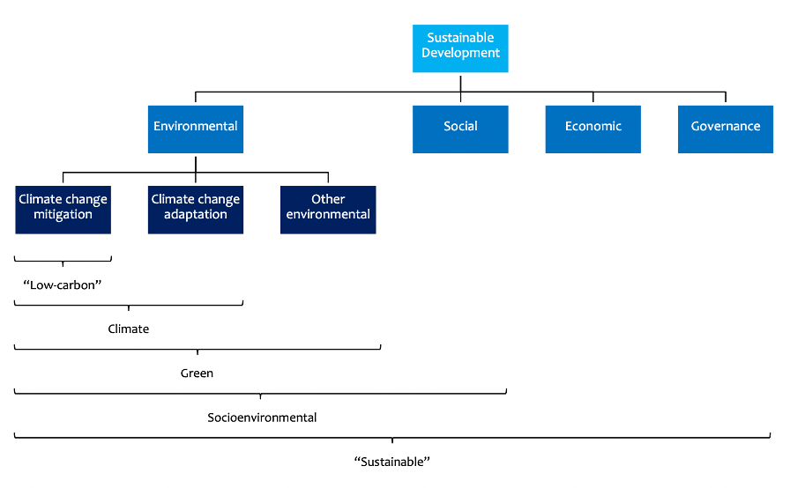
Source: Definitions and Concepts: Background Note, UNEP, 2016.

In recent years we can see growing emphasis on sustainability and rapid consumption. This gives smoother environment for Fintech adoption. Among all demographic groups Millennials (people born between 1981 and 1996) are most active adaptors of Fintech. Their digital literacy, technology preferences, value for convenience, instant processing, cost effectiveness etc. made them ideal users of Fintech payment practices. The financial transactions are showing a rapid shift in their pattern and manner with the application of innovative technological advancements in payment mechanisms especially in an environment friendly perspective. These changes altogether results in sustainable financial practices.
The Covid-19 pandemic impact accelerated the Fintech adoption. The Fintech payment services are more efficient in transactions and also more accessible to the users. The Fintech payment platforms create major impact on users with their service quality and technological advancements. Now a days, the budget-friendly smart phones and digital payment mechanisms like Banking apps, Mobile Wallets and UPI are expanded financial inclusion of the marginalized population in India. The high quality in services improves customer satisfaction, perceived usefulness, loyalty and competitive advantage which can enhance financial inclusion and digital payment leadership. (Sharma et al., 2024) The Fintech industry is growing as a major claimant of the accelerated developments of digital transformation adoption by the global markets which has most importantly gave pace to the demand for information goods. (Wu et al., 2024) It is indispensable to explore the impact of financial technologies on sustainable environmental performance. (Tu, 2024).
The usage of digital payment practices in a sustainable perspective can give a base for green financial orientation. Millennials are more socially and environmentally aware group, who choose Fintech as convenient, responsible and environment- friendly alternative for the conventional system of financial services. The reflections of technological advancements in their daily financial engagements especially in digital payment practices is noticeable. Thus the study focuses on how the usage of digital payment practices leads to green financial orientation among Millenials in Kerala.
The objectives set for the study are :
- To identify the factors influencing usage of digital payment options in a sustainability-focused world.
- To analyze the level of awareness about Green financial behaviour and digital payments.
- To evaluate the role of Green finance-oriented payment options in promoting environmentally responsible financial behavior.

The research questions focused in the study are as follows:

Q1. What is the level of awareness of green finance and digital payment options among Millennials?

Q2. Is there a significant relationship between factors influencing green finance orientation in a sustainability- focused world and digital payment usage options among Millennials?

Q3. Do demographic factors significantly influence green financial payment behavior among Millennials?

Q4. How do digital payment practices contribute to green financial behavior in a technology-driven financial environment?

This study is about the digital paymet practices in a sustainable financial perspective. More precisely it is a study regarding the influence of digital payment practices on green financial orientation. The respondent category of the study is belonging to the age group of 29 to 44, which is the Millenials. The geographical area of the study is limited to the state of Kerala in India.
  - Literature Review
A bibliometric analysis to inspect the trends of research in fraudulent and criminal activities in digital and online payment mechanisms emphasized the innovative aspects of risk management and information security. Most of the studies in this area are from the countries of China, India, US, Korea, and UK which are particularly during the period 2021 to 2023. The study demonstrates the relevance of advanced technological adoption, measures of Compliances, awareness drives to upgrade the digital payment security, customer satisfaction and trust. (Laxman et al., 2025) An investigation study based on the factors influencing the payment apps in Saudi Arabia which are usage and loyalty where the data collection was conducted among 290 respondents , while the demographic factors such as age , and education are found to be not at all significant. In the study the relevance of seamless functionality, robust security and user-friendly design are focused on a Technology Acceptance Framework. The major findings are providing practical base policymakers and Fintech developers the purpose of improving digital payment adoption in emerging markets. (Bajwa et al., 2025)
The Multi-Sector Endogenous Growth Model and empirical data based study from 246 prefecture-level cities in China explains the way of Fintech driven technological innovation and regional economic development. The R& D investment and economic growth show more improved especially in developed cities, while in the case of underdeveloped areas the impact is lower. In order to emphasize the Fintech development promotion, talent cultivation, digital infrastructure and differentiated regional strategies lead towards co-ordinated growth and inclusive innovation. The further research suggestions are spatial effects, knowledge spillovers. the interaction between Fintech, human capital, and regional economic development. (Huang et al., 2025)
A study based on Nigerian financial system gives that there exist a rapid financial innovation over the last three decades with the adoption of Fintech payment mechanisms like mobile banking, online transactions, POS systems and ATMs, even then the instability and unpredictability in money demand are there with enhanced transaction speed and convenience. These innovations forced the regulatory mechanisms and traditional monetary patterns to make sufficient arrangements for reviewing the conventional systems in a digitally supported platform. (Oyadeyi, 2025)
A study regarding the evolution of digital payment systems in India reviews the progression of early EFTs to digital payment platforms like mobile wallets, UPI and digital rupee. The Government- regulatory- infrastructural initiatives have sped up Fintech adoption and promotion of financial inclusion. There are major challenges of cyber security risks, digital literacy gaps and limitations of infrastructure. The study suggests that the robust policy support, sustained innovation, and awareness campaigns are unavoidable pre-requisites to inclusion, secure digital payment ecosystem and long-term accessibility. (Katrak, 2024)
In a study about Mobile Banking adoption in Kenya it was seen a steep hike which include in transactions (54%), in agents (19.56%) and in accounts (14.56%). The features such as supporting payments ,micro-loans, peer-to-peer transfers and bill payments has made the mobile banking as a dominant part of the financial system. Minoritized and low-income groups are facilitated with this to build credit profiles. The Fintech adoption has been sped up by the Covid-19 Pandemic explosion. As a part of this the government agencies also framed regulations for Fintech. The study suggests that the Fintech based investments can improve economic resilience in growth economies. (Tut, 2023) The study among rural women conducted in Kerala reveals the factors influencing the use of TAM (Technology Acceptance Model) are namely Perceived Usefulness, Ease of Use etc. which positively shape attitudes. The findings direct that the prominent factors which can stimulate the mobile payment adoption and advanced digital financial inclusion are reducing costs, building trust, enhancing usability and providing localized support. (M R & Sasankan, 2024.)
A study based on the social adoption of CBDC (central bank digital currency ), potential benefits, risks, importance of education, phased implementation and awareness. More cautious risk management, collaboration with strategies and external experts are essential requirements for successful CBDC deployment. To have more improved social acceptance, safe and efficient use research –system design included introduction and targeted education oriented scaling is inevitable. (Horváth, 2023)
The study based on China about the mobile payment adoption during the Covid-19 pandemic examines through the Unified Theory of Acceptance and use of Technology (UTAUT) framework. The data collection from 593 online respondents analyses the factors of perceived security, performance expectancy, trust and social influence are the major drives in the field of mobile payment adoption. Here the role of emergency situations in rapidly directing trend of digital payment adoption and focuses the practical side of encouraging the contactless payment solutions for safety and economic stability. The study lashes light on the necessity for optimizing the strategies for user adoption under crisis on the part of governments and Fintech. (Sleiman et al., 2023)
In another study the RACE framework (Reach, Act, Convert, Engage) details the competition level in digital transformation between the mobile payment market and traditional banks. RACE encomposes strategic alliances, customers, technology resources and ecosystems, and both of them together support safeguarding assets from risks and intense growth of markets. The model emphasis on the initiating of co-operation and ecosystem building with the existence of dynamic capabilities and multilateral alliances. The conventional Banks can carry innovation and competitiveness in Fintech enabled payment markets with the help of effective resource orchestration .(Shang & Chiu, 2023)
The study on green digital financing discusses the SDG funding gaps in developing economies which explains the matter in the base of COVID-19, even then there exist the barriers of data scarcity and high perceived risk. The policy –regulatory gaps, digital divides and cybersecurity risks etc. are barriers exist there as challenges . Even then the digital tools like crowdfunding, blockchain, AI risk assessment provides low cost green lending.(Devidze, 2022) A study on Fintech innovation explains that the innovative measures empowers the development of emerging markets which are facing structural challenges. The green finance market development is enhancing by efficiency, fund access, risk management and transparency. (Chien et al., 2025) The study on the impact of sustainable performance in Saudi Banks ensures the positive relationship of Fintech adoption in enhancing the sustainablility effect. Here the moderating role of Fintech strengthens the Digital transformation in which the sustainability outcomes are maximizing in digitally transitioning economies. (Zaid et al., 2025)

1.2. Theoretical Framework
The important factors which influence green finance implementation procedure are green economy, renewable energy and sustainable development. The harmonised policy framework, product innovation, transparent ESG goals are playing an inevitable role in transforming of sustainable economy. (Hussain M et al., 2024) In India it is evident that the growth of fintech and green finance is highlighted by the support of environment sustainability. The expansion of Fintech will result in carbon emmissions and the protection investments. In order to achieve sustainable goals, the institutions and policy makers have to integrated Fintech and promote green finance products.(Sreenu Nenavath. 2022)
There is great importance in the case of growing eco-friendly financial systems. A dynamic rassociation can be witnessed among financial development, green finance, and environmental sustainability. At the same time it is apparently available that, the developing countries experience structural ana policy challenges in implementing green finance initiatives effectively. (Yaying Z et al., 2025)
The Indian Banking system has been strengthening through the contributions of digital payment mechanism like convenience, efficiency and round- the -clock access to financial services. The emphasized faster change in the field of information and communication technology with the support of universal internet and mobile adoption result in rapid growth of cash based transactions into digital transactions. The growth of Fintech firms gave a better base for secure and instant payment mechanisms, even then the customer considerations such as perception and service quality are still decisive elements for the sustained digital payment regarding the youth purchasing behavior. (Nidhi & Kamaladevi, 2025)

Fig. 2. RBI & Government Initiatives
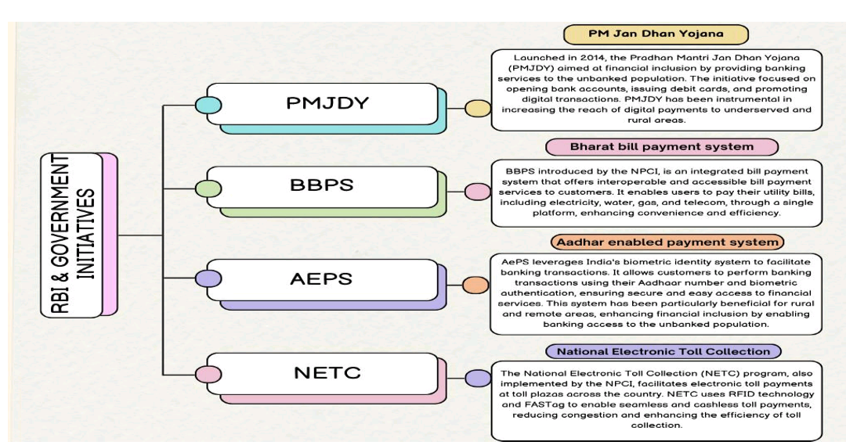
Source: (Pankaj Yadav et al., 2024)
The major drives of the evolution of cash- based transactions to the digital platforms are regulatory reforms, technological innovations and changing consumer preferences and the major miles stones in that way are extending from EFT and ECS to UPI and mobile payment applications. Now a days an economy-wide up gradation can be seen in the digital payment systems in the transactions with more efficiency and convenience. Even the challenges like cyber security and regulatory compliances exist there, the upcoming advancements to integrate with the advanced technologies like block chain and artificial intelligence.(Yadav et al., 2024)
The PayTech usage of individuals are significantly influenced by the familiar feature of employment, education level and income among them the higher education and income are the major factors which strongly promote P2P payments. The social interactions play a vital role in digital financial inclusion and thereby this is apparently clear that the Fintech companies can focus on social proof strategies in order to strengthen the Fintech adoption. The future research can be based on cultural- regional factors along with mediating factors like trust, financial literacy and perceived security. (Nyakurukwa, Seetharam, & Chipeta, 2025)

Fig. 3. Historical Developments of Payment System
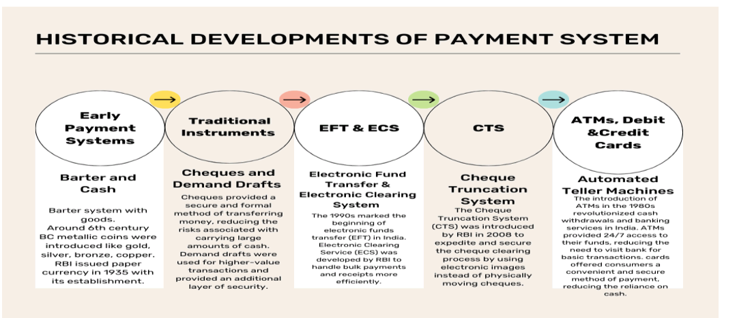
Source: (Pankaj Yadav et al., 2024)

Mobile payment service adoption based study on Hungarian Generation X during the period of Covid-19 investigates the influencing factors, which are subjective norms, pandemic-related risk and perceived usefulness (mediating variable) which significantly shaped behavioral intentions. The relevance of health crises in accelerating digital payment option is the major matter of investigation in the study.(Daragmeh et al., 2021)

Fig. 4. Overall Analysis of UPI

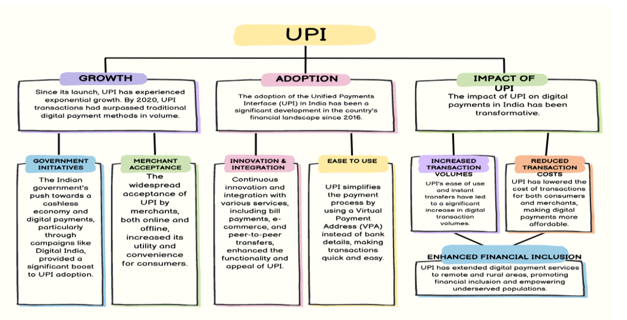
Source: (Pankaj Yadav et al., 2024)

Fig. 5. Digital Payment Trends 2024
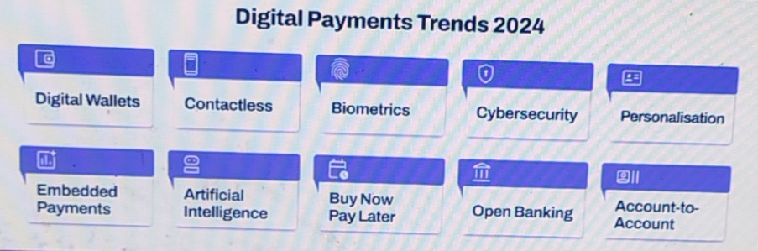
Source: (Jekaterina Drozdovica, 2024)
The Fig.5. shows the Digital Payment Trends during the year 2024 and hints the future also.

- material and methods

The study on usage of Digital payment practices among Millennials in a Green Financial Orientation basis is focused here. The descriptive and analytical research design is used in the study. The purposive sampling Method is choosen for data collection purpose. The population is the users of Digital Payment practices which is limited to millennial categories in Kerala and 206 samples are collected using structured questionnaire.

The analysis tools used in the study include: Reliability Analysis is conducted using Cronbach's Alpha, Descriptives, Kruskal–Wallis H Test, Dwass-Steel-Critchlow-Fligner Pairwise Comparisons, Spearman’s Rank-Order Correlation, Multiple Linear Regression Analysis, Pearson’s Product–Moment Correlation Coefficients And Linear Regression Analysis. And also Demographic Profile of respondents is analysed using Percentage Analysis with the help of graphical representation. The Multiple Linear Regression Analysis is included here to test the significance of variables considered for the study.

A text based Conceptual Model is used to define the Variables (Independent Variables, Independent Variables, Moderating Variables and Mediating Variables).
The Variables based Conceptual model is shown below in Fig.6.

Fig. 6. Four Types of Variables in the Conceptual Model

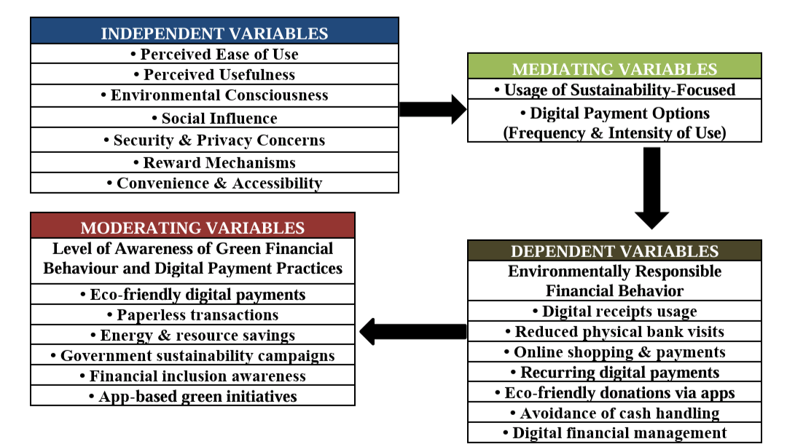

Source: Author
- results and discussion

The data collected from 206 respondents belonging to millennial category. The collected data has been classified and tabulated in order to apply necessary analysis tools. Reliability Analysis is conducted using Cronbach's Alpha, Descriptives are calculated in order to find out means and standard deviations of constructs, Kruskal–Wallis H test was conducted to examine significant differences in the level of awareness about about Green financial behaviour and digital payments among various demographic groups, Dwass-Steel-Critchlow-Fligner pairwise comparisons to identify which specific groups differ from each other regarding the awareness level, A Spearman’s rank-order correlation was conducted to examine the relationship between factors influencing usage of digital payment options in a sustainability-focused world and awareness level, A multiple linear regression analysis was conducted to examine whether age, gender, education level, employment status, and monthly income significantly predict awareness level, Pearson’s product–moment correlation coefficients were computed to examine the relationships among the seven variables of role of Green finance-oriented payment options in promoting environmentally responsible financial behavior, A linear regression analysis was conducted to examine whether age, gender, education level, employment status, and monthly income predict wareness level. Statistical Software Jamovi is used for Data Analysis purpose.

The topic of study Digital payment practices among Millennials in Kerala in a Green Financial Perspective is growing through the use a set of analysis tools with the help of the statistical analysis software Jamovi. The interpretations drawn are discussed below with the help of tabulation and graphical representation.

Fig.7. Demographic Profile

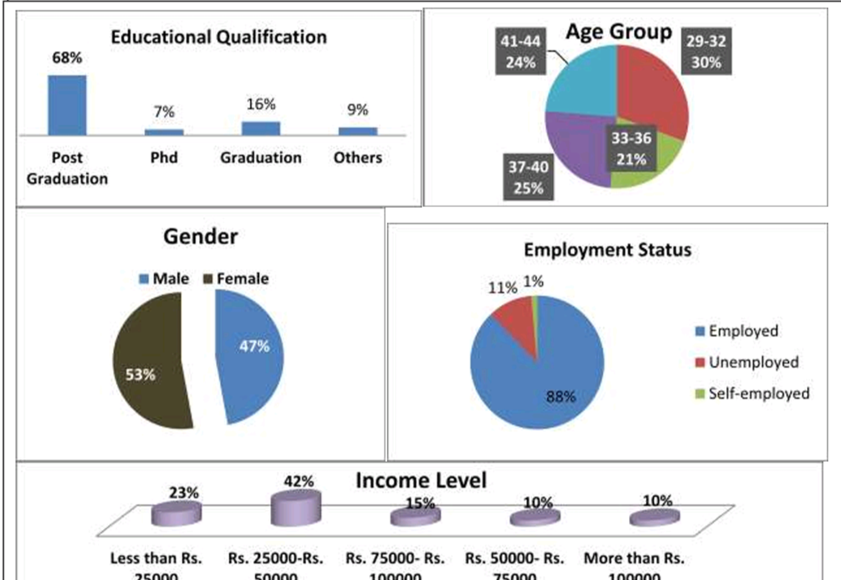

Source: Primary Data

The Demographic Profile of the respondents reveals that out of 206 individuals responded 24% are belonging to 29-32 age group, 33-36 age group, 25% - 37-40 age group and 41-44 age group. And also the male – female proportion of the respondents is 53% and 47 % respectively. The Income level of respondents gives that 23 % of them falls in below Rs. 25000, 42 % in Rs. 25000-Rs. 50000, 15 % in Rs. 50000 – Rs. 75000, 10% in Rs. 75000-100000 and 10% in Rs. 100000 above. While discussing Education Qualification, Most of the respondents (68%) are post graduates, 16 % are graduates, 7 % are PhD holders and 9 % are belonging to other educational qualifications. Employment status of respondents shows that 88% are employed, 1% self- employed and 11% are unemployed.

Table.1. Reliability Analysis

Scale Reliability Statistics
 | Cronbach's α
Factors influencing in a sustainability-focused world usage of Fintech payment options |  | 0.893
The level of awareness about sustainable Fintech based payment practices |  | 0.886
the role of Fintech based payment options in promoting environmentally responsible financial behavior |  | 0.888

Source: Primary Data, Jamovi

A reliability analysis was conducted for the scale measuring [the factors influencing usage of digital payment options in a sustainability-focused world , Level of awareness about Green financial behaviour and digital payments, and Role of Green finance-oriented payment options in promoting environmentally responsible financial behavior]. The scale demonstrated a high degree internal consistency, with Cronbach’s α values of 0.893, 0.886 and 0.888 respectively.

Table. 2. Descriptives

Descriptive Statistics
 | Factors influencing usage of digital payment options in a sustainability-focused world | Level of awareness about Green financial behaviour and digital payments | Role of Green finance-oriented payment options in promoting environmentally responsible financial behavior
N | 206 | 206 | 206
Missing | 0 | 0 | 0
Mean | 3.55 | 3.58 | 3.46
Median | 3.71 | 3.83 | 3.57
Standard deviation | 0.859 | 0.854 | 0.846
Minimum | 1 | 1 | 1
Maximum | 5 | 5 | 5

Source: Primary Data, Jamovi

Descriptive Analysis conducted to analyse summarise the variables with Mean, Median and Standard Deviation. The obtained Mean and Median values indicate a moderately high level of agreement across all three variables. In case of Standard Deviation a moderate level of variability can be seen there, which show that the responses are reasonably consistent.

Table. 3. Kruskal-Wallis Test (Non-parametric)
( Education - Grouping Variable)
 | χ² | df | p | ε²
Level of awareness about Green financial behaviour and digital payments | 8.92 | 3 | 0.03 | 0.0435

Source: Primary Data, Jamovi

A Kruskal-Wallis H test was conducted to examine differences in awareness level across different 4 education levels. A statistically significant difference was found, χ²(3) = 8.92, p = 0.030, indicating that the education level slightly influences the Level of awareness about Green financial behaviour and digital payments.

Table. 4. Dwass-Steel-Critchlow-Fligner pairwise comparisons
Pairwise comparisons - Level of awareness about Green financial behaviour and digital payments ( Education Level - Grouping Variable)
 |  | W | p
1 | 2 | -0.661 | 0.966
1 | 3 | 1.956 | 0.51
1 | 4 | -1.065 | 0.876
2 | 3 | 3.735 | 0.041
2 | 4 | -0.499 | 0.985
3 | 4 | -7.52 | < .001

Source: Primary Data, Jamovi

In a continuation to the A Kruskal-Wallis H test Post-hoc pairwise comparisons using the Dwass-Steel-Critchlow-Fligner test revealed significant differences in Level of awareness about Green financial behaviour and digital payments between Education (Group 2) and Group 3 (W = 3.735, p = 0.041) and between Group 3 and Group 4 (W = −7.520, p < .001). No significant differences were observed among the other groups.

Table.5. Kruskal-Wallis Test (Non-parametric)
( Age - Grouping Variable)
 | χ² | df | p
Level of awareness about Green financial behaviour and digital payments | 3.57 | 3 | 0.312

Source: Primary Data, Jamovi

A Kruskal-Wallis H test was conducted to determine if there were statistically significant differences in the awareness level across four age groups. The result shows that there was no significant difference, (χ²(3) = 3.57, p = 0.312).

Table. 6. Correlation Matrix

Correlation Matrix
 |  | Level of awareness about Green financial behaviour and digital payments | Factors influencing usage of digital payment options in a sustainability-focused world
Level of awareness about Green financial behaviour and digital payments | Spearman's rho | —
 | df | —
 | p-value | —
Factors influencing usage of digital payment options in a sustainability-focused world | Spearman's rho | 0.807*** | —
 | df | 204 | —
 | p-value | < .001 | —
Note. * p < .05, ** p < .01, *** p < .001

Source: Primary Data, Jamovi

The Spearman’s rank Correlation Coefficient is calculated to test the relationship between the variables : Level of awareness about Green Financial Brhaviour and Factors influencing digital payment adoption in a sustainability-focused world. The result gives that there is a strong, positive, and statistically significant correlation.

Table.7. Multiple Linear Regression
Model Fit Measures
 |  |  |  |  |  | Overall Model Test
Model |  | R |  | R² |  | F |  |  |  | df1 |  | df2 |  |  |  | p
1 |  | 0.126 |  | 0.0159 |  | 0.645 |  |  |  | 5 |  | 200 |  |  |  | 0.666
Model Coefficients- Level of awareness about Green financial behaviour and digital payments
Predictor |  |  |  |  |  |  |  | Estimate |  |  |  |  |  | SE |  |  |  |  |  | t |  | p
Intercept |  |  |  |  |  |  |  | 4.0136 |  |  |  |  |  | 0.4072 |  |  |  |  |  | 9.856 |  | < .001
Age: |  |  |  |  |  |  |  | -0.0307 |  |  |  |  |  | 0.0610 |  |  |  |  |  | -.503 |  | 0.615
Gender: |  |  |  |  |  |  |  | -0.1445 |  |  |  |  |  | 0.1275 |  |  |  |  |  | -.134 |  | 0.258
Education Level: |  |  |  |  |  |  |  | 0.0419 |  |  |  |  |  | 0.0841 |  |  |  |  |  | 0.499 |  | 0.618
Employment Status: |  |  |  |  |  |  |  | -0.1080 |  |  |  |  |  | 0.1674 |  |  |  |  |  | -.645 |  | 0.520
Monthly Income: |  |  |  |  |  |  |  | -0.0431 |  |  |  |  |  | 0.0569 |  |  |  |  |  | -.757 |  | 0.450

Source: Primary Data, Jamovi

The multiple Linear Regression analysis is conducted to examine whether the demographic factors (age, gender, education level, employment status, and monthly income ) significantly predict the Level of awareness about Green financial behaviour and digital payments. Here the results ( df=5, R = 0.126, R² = 0.0159, F(5, 200) = 0.645, p = 0.666) explain that the demographic factors have a lower influence on the variable (Variance=1.6%), which is not statistically significant. Here it is clear that the demographic variables are not predicting the outcome of the sample, which means beyond the demographic factors more behavioural, attitudinal and environmental factors need to be explored in order to demonstrate unavoidable prediction in the context of Level of awareness about Green financial behaviour and digital payments.

Table. 8. Correlation Matrix

Correlation Matrix
 |  | Use of digital receipts instead of paper | Reduction in physical bank visits | Switch to online shopping and payments | Frequency of using Paytm for recurring payments | Engagement in eco-friendly donations or campaigns via app | Avoidance of cash handling | Digital financial management
Use of digital receipts instead of paper | Pearson's r | —
 | df | —
 | p-value | —
Reduction in physical bank visits | Pearson's r | 0.748 | —
 | df | 204 | —
 | p-value | < .001 | —
Switch to online shopping and payments | Pearson's r | 0.718 | 0.859 | —
 | df | 204 | 204 | —
 | p-value | < .001 | < .001 | —
Frequency of using Paytm for recurring payments | Pearson's r | 0.508 | 0.319 | 0.325 | —
 | df | 204 | 204 | 204 | —
 | p-value | < .001 | < .001 | < .001 | —
Engagement in eco-friendly donations or campaigns via app | Pearson's r | 0.34 | 0.189 | 0.111 | 0.766 | —
 | df | 204 | 204 | 204 | 204 | —
 | p-value | < .001 | 0.006 | 0.113 | < .001 | —
Avoidance of cash handling | Pearson's r | 0.539 | 0.384 | 0.437 | 0.727 | 0.576 | —
 | df | 204 | 204 | 204 | 204 | 204 | —
 | p-value | < .001 | < .001 | < .001 | < .001 | < .001 | —
Digital financial management | Pearson's r | 0.609 | 0.495 | 0.474 | 0.784 | 0.667 | 0.671 | —
 | df | 204 | 204 | 204 | 204 | 204 | 204 | —
 | p-value | < .001 | < .001 | < .001 | < .001 | < .001 | < .001 | —

Source: Primary Data, Jamovi

The Karl Pearson’s Moment- Correlation Coefficient studies the relationship between the seven variables of the construct Role of Green finance-oriented payment options in promoting environmentally responsible financial behavior. The relationship here indicates that most of the variables are correlated. The magnitude of correlation ranges from small to very strong. Very high degree positive association can be seen in between Use of digital receipts instead of paper, Reduction in physical bank visits and Switch to online shopping and payments; and strong correlation is there between Frequency of using Paytm for recurring payments, Engagement in eco-friendly donations or campaigns via app and Digital financial management. Moderate positive correlation exist between Use of digital receipts instead of paper and Frequency of using Paytm for recurring payments; and between Avoidance of cash handling and Digital financial management. The variables switch to online shopping and payments and Engagement in eco-friendly donations or campaigns via app indicate small significant correlation. The correlation results give that there exist internal consistency among most of the variables of Role of Fintech in promoting environmentally responsible financial behaviour.

Table. 9. Linear Regression
Model Fit Measures
 |  |  |  |  |  |  |  | Overall Model Test
Model |  | R |  | R² |  |  |  | F |  |  |  | df1 |  |  | df2 |  |  | p
1 |  | 0.138 |  | 0.0191 |  |  |  | 0.777 |  |  |  | 5 |  |  | 200 |  |  | 0.567
Model Coefficients - Role of Green finance-oriented payment options in promoting environmentally responsible financial behavior
Predictor |  |  |  |  |  | Estimate |  |  |  | SE |  |  |  |  |  | t |  |  |  | p
Intercept |  |  |  |  |  | 3.8514 |  |  |  | 0.4025 |  |  |  |  |  | 9.568 |  |  |  | < .001
Age: |  |  |  |  |  | 0.0775 |  |  |  | 0.0602 |  |  |  |  |  | -1.287 |  |  |  | 0.200
Gender: |  |  |  |  |  | 0.1226 |  |  |  | 0.1260 |  |  |  |  |  | -0.973 |  |  |  | 0.332
Education Level: |  |  |  |  |  | 0.0539 |  |  |  | 0.0831 |  |  |  |  |  | -0.648 |  |  |  | 0.518
Employment Status: |  |  |  |  |  | -.0238 |  |  |  | 0.1655 |  |  |  |  |  | -0.144 |  |  |  | 0.886
Monthly Income: |  |  |  |  |  | 0.0511 |  |  |  | 0.0562 |  |  |  |  |  | 0.908 |  |  |  | 0.365

Source: Primary Data, Jamovi

The linear regression analysis is conducted to test whether the demographic factors (whether age, gender, education level, employment status, and monthly income) predict Role of Green finance-oriented payment options in promoting environmentally responsible financial behavior. The test results indicate that none of the demographic factors are shown to be statistically significant, that means a weak model fit with a lower influence on the variable.

The study gives a strong basis for sustainable financial behaviour. This brings light to the fund allocation of investors into various financial investment instruments such as ESG fund platforms, green bonds, other eco-friendly financial instruments. This also result in usage of digital payment practices which will help to have reduced paper usage with a strengthened sustainable behaviour from the part of youngsters. These all are can be viewed like an outcome of financial literacy based on sustainable finance, accelerated application of ESG platforms etc. The green finance orientation can help in transforming the daily financial transactions in a environmentally responsible manner.

Based on analysis results the study suggests a number of future research orientations. As the variables studied shows internal consistency, they can be refined for further studies, which may give better results. The demographic factors focussed in the study are not significantly predicting any of the variables studied; hence the further studies may consider some more factors for future research such as behavioural, psychological, or technology-related factors. Also the results suggest more longitudinal studies in digital payment and sustainability for future which may examine causal relationship. More attitudinal, behavioural and environmental factors need to be studied beyond the demographic factors, in order to draw a significant prediction on level of awareness on about Green financial behaviour and digital payments. The use of more diverse and large samples for further studies may be suitable for advanced analytical models and that may facilitate to prove indirect effects of the variables.

4. Conclusion

In a fast changing financial ecosystem, Fintech or digital payment mechanisms play a vital role. While considering this, the study within the geographical boundary of Kerala- the southern state of India among Millennials on a sustainability perspective is highly relevant. The variables studied here are highly associated with each other. The adoption of digital payment mechanism by the Millennials surely support sustainability based financial results such as green finance orientation. The higher awareness level, more favourable attitude of Millennials and more consistency in usage towards the digital payment aspects will lead to environment friendly and efficient financial results. The financial technology innovations provides a brightest hope of easiness in sustainability-green finance practices through the enhanced digital transformation.

COMPETING INTERESTS DISCLAIMER:
Authors have declared that they have no known competing financial interests OR non-financial interests OR personal relationships that could have appeared to influence the work reported in this paper.
Disclaimer (Artificial intelligence)

Author(s) hereby declare that NO generative AI technologies such as Large Language Models (ChatGPT, COPILOT, etc.) and text-to-image generators have been used during the writing or editing of this manuscript.

Disclaimer (Ethics)
This study followed ethical guidelines. Informed consent obtained; responses anonymized and confidential.

References

- Abrahim Sleiman, K. A., Juanli, L., Lei, H. Z., Rong, W., Yubo, W., Li, S., Cheng, J., & Amin, F. (2023).
- Factors that impacted mobile-payment adoption in China during the COVID-19 pandemic. Heliyon, 9(5), e16197. https://doi.org/10.1016/j.heliyon.2023.e16197
- Bajwa, F. A., Fu, J., Bajwa, I. A., Ahmad, S., & Mahmood, F. (2025). Factors influencing usage and loyalty for payment app customers in Saudi Arabia. Acta Psychologica, 255, 104961. https://doi.org/10.1016/j.actpsy.2025.104961
- Bank für Internationalen Zahlungsausgleich & Weltbank (Eds.). (2020). Payment aspects of financial inclusion in the fintech era. Bank for International Settlements.
- Bui, C., Scheule, H., & Wu, E. (2017). The value of bank capital buffers in maintaining financial systemresilience. Journal of Financial Stability, 33, 23–40. https://doi.org/10.1016/j.jfs.2017.10.006
- Caldarelli, A., Fiondella, C., Maffei, M., & Zagaria, C. (2016). Managing risk in credit cooperative banks: Lessons from a case study. Management Accounting Research, 32, 1–15. https://doi.org/10.1016/j.mar.2015.10.002
- Chien, F., Zhang, Y., & Sadiq, M. (2025). Fintech innovation in green finance: A disruptive force or a complementary tool? International Review of Economics & Finance. Advance online publication. https://doi.org/10.1016/j.iref.2025.104658
- Daragmeh, A., Lentner, C., & Sági, J. (2021). FinTech payments in the era of COVID-19: Factors influencing behavioral intentions of “Generation X” in Hungary to use mobile payment. Journal of Behavioral and Experimental Finance, 32, 100574. https://doi.org/10.1016/j.jbef.2021.100574
- Devidze, N. (2022). Current state of green digital financing and the associated challenges. In Green digital finance and sustainable development goals (pp. 29–50). Springer. https://doi.org/10.1007/978-981-19-2662-4_2
- Ferrari, M. V. (2022). The platformisation of digital payments: The fabrication of consumer interest in the EU FinTech agenda. Computer Law & Security Review, 45, 105687. https://doi.org/10.1016 /j.clsr.2022.105687
- Horváth, D. (2023). Money in the digital age: Exploring the potential of central bank digital currency with a focus on social adaptation and education. Sustainable Futures, 6, 100136. https://doi.org/10.1016/j.sftr.2023.100136
- Huang, X., Dong, J., & Li, X. (2025). Fintech, technological innovation and regional economic growth:Theoretical modeling and empirical evidence. China Economic Review, 91, 102397. https://doi.org/10.1016/j.chieco.2025.102397
- Hussain Mohi ud Din Qadri , Hassnian Ali , Zain ul Abideen , Ahmad Jafar. 2024. “Mapping the Evolution of Green Finance Research and Development in Emerging Green Economies” https://doi.org/10.1016/j.resourpol.2024.104943
- Jin, J. Y., Kanagaretnam, K., Lobo, G. J., & Mathieu, R. (2017). Social capital and bank stability. Journal of Financial Stability, 32, 99–114. https://doi.org/10.101 6/j.jfs.201 7.08.001
- Katrak, M. Z. K. (n.d.). The Evolution of Digital Payment Systems in India: A Review.
- Laxman, V., Ramesh, N., Jaya Prakash, S. K., & Aluvala, R. (2024). Emerging threats in digital payment and financial crime: A bibliometric review. Journal of Digital Economy, 3, 205–222. https://doi.org/10.1016 /j.jdec.2025.04.002
- M R, M., & Sasankan, S. (2024). Unveiling the Drivers of Mobile Payment Adoption Among Rural Women in Kerala. Commerce & Business Researcher, 16(1), 103–124. https://doi.org/10.59640/cbr.v16i1.103-124
- Nyakurukwa, K., Seetharam, Y., & Chipeta, C. (2025). The role of acquaintances’ characteristics in shaping digital payment technology. Finance Research Letters, 76, 106976. https://doi.org/10.1016/j.frl.2025.106976
- Nidhi, S., & Kamaladevi, M. (2025). A study on awareness of digital payment system among youngsters in Kerala. International Journal for Multidisciplinary Research, 7(5). https://www.ijfmr.com
- Oyadeyi, O. O. (2025). Financial innovation and money demand in Nigeria: Exploring the impact of banking innovations, fintech developments and digital payment channels on the money demand. Social Sciences & Humanities Open, 12, 102057. https://doi.org/10.1016/j.ssaho.2025.102057
- Panetta, I. C., Leo, S., & Delle Foglie, A. (2023). The development of digital payments – Past, present, and future – From the literature. Research in International Business and Finance, 64, 101855. https://doi.org /10.1016/j.ribaf.2022.101855
- Pankaj Yadav, Vaniki Joshi Lohani, Sakshi Sharma, & Sonia Choudhary. (2024). Transforming Transactions: The Evolution of Fintech in Indian Banking Sector. International Research Journal on Advanced Engineering and Management (IRJAEM), 6(07), 2179–2194. https://doi.org/10.47392/IRJAEM.2024.0319
- Rahman, P., & Mehnaz, S. (2024). International Journal for Multidisciplinary Research (IJFMR). SSRN Electronic Journal. https://doi.org/10.2139/ssrn.5054029
- Savitha, B., Hawaldar, I. T., & Kumar K, N. (2022). Continuance intentions to use FinTech peer-to-peer payments apps in India. Heliyon, 8(11), e11654. https:// doi.org /10.1016/j.heliyon.2022.e11654
- Shang, S. S. C., & Chiu, L. S. L. (2023). A RACE pathway for inventing and sustaining mobile payment innovation—A case study of a leading Bank in Taiwan. Asia Pacific Management Review, 28(4),401–409. https://doi.org/10.1016/j.apmrv.2022.12.007
- Sharma, V., Jangir, K., Gupta, M., & Rupeika-Apoga, R. (2024). Does service quality matter in FinTech payment services? An integrated SERVQUAL and TAM approach. International Journal of Information Management Data Insights, 4(2), 100252. https://doi.org/10.1016/j.jjimei.2024.100252
- Sreenu Nenavath. 2022. “Impact of fintech and green finance on environmental quality protection in India: By applying the semi-parametric difference-indifferences (SDID)” https://doi.org/10.1016/j.renene.2022.05.020
- Srinivasan, R., Diatha, K. S., & Singh, S. (2024). Adoption of cashless payment systems in the bottom-of-the-pyramid retail supply chains in India: A technology–organization–environment framework perspective. Electronic Commerce Research, 24, 1–38. https://doi.org/10.1007/S10660-023-09803-4
- Tu, Y.-T. (2024). Drivers of Environmental Performance in Asian economies: Do natural resources, green innovation and Fintech really matter? Resources Policy, 90, 104832. https://doi.org/10.1016/j.resourpol.2024.104832
- Tut, D. (2023). FinTech and the COVID-19 pandemic: Evidence from electronic payment systems. Emerging Markets Review, 54, 100999. https:// doi.org /10.1016 /j.ememar .2023.100999
- Zaid, M. A. K., Khan, M. F., Al-Mekhlafi, A.-W. A.-G. S., Al Koliby, I. S., Saoula, O., Saeed, H. A. E. M., & Mohammad, R. A. (2025). The future of green finance: How digital transformation and FinTech drive sustainability. Discover Sustainability, 6, 480. https://doi.org/10.1007/s43621-025-01356-w
- Zedda, S., Modina, M., & Gallucci, C. (2024). Cooperative credit banks and sustainability: Towards a social credit scoring. Research in International Business and Finance, 68, 102186. https://doi.org/10.1016/j.ribaf.2023.102186
- Yadav, P., Lohani, V. J., Sharma, S., & Choudhary, S. (2024). Transforming transactions: The evolution of FinTech in Indian banking sector. International Research Journal of Advanced Engineering and Management, 5(3). https://doi.org /10.47392 /IRJAEM.2024.0319
- Yaying Zhou ,Ibrahim Alnafrah , Abd Alwahed Dagestani . 2025. “Leveraging AI and green finance for cleaner energy production: A sustainability framework for ESG integration and climate action” https://doi.org/10.1016/j.jclepro.2025.146595

APPENDIX

Questionnaire

Sir/ Madam,

The following Questionnaire is regarding a research study on “Role of Digital Payment Practices in Green Finance Orientation; A Study Among Millennials in Kerala”. The collected responses will be kept confidential.

- Age: 29-32, 33-36, 37-40, 41-44

- Gender: Male, Female

- Education: Graduation, Post-Graduation, PhD, Others

- Employment status: Employed, Unemployed, Self-Employed

- Monthly Income: Below Rs.25000, Rs. 25000- Rs. 50000, Rs. 50000- Rs. 75000, Rs. 75000-Rs. 100000, Above Rs. 100000

- Opinion on "factors influencing Fintech adoption in a sustainability-focused world"
(Mark your agreement on the following: Using a 5-Point Likert Scale: 1 = Strongly Disagree, 2 = Disagree, 3 = Neutral, 4 = Agree, 5 = Strongly Agree)

OPTIONS | SA | A | N | DA | SDA
· Perceived ease of use
· Perceived usefulness
· Environmental consciousness
· Social influence
· Security and privacy concerns
· Reward mechanisms
· Convenience and accessibility

- Opinion on "level of awareness about sustainable fintech based payment practices "
(mark your agreement on the following: using a 5-point likert scale: 1 = strongly disagree, 2 = disagree, 3 = neutral, 4 = agree, 5 = strongly agree)
OPTIONS | SA | A | N | DA | SDA
· Awareness of eco-friendly digital payments
· Knowledge of paperless transactions
· Understanding of energy/resource savings
· Familiarity with government-led digital sustainability campaigns
· Understanding of financial inclusion through digital platforms
· Awareness of app-based green initiatives

- Opinion on "role of Fintech in promoting environmentally responsible financial behavior"
(Mark your agreement on the following: Using a 5-Point Likert Scale: 1 = Strongly Disagree, 2 = Disagree, 3 = Neutral, 4 = Agree, 5 = Strongly Agree)
OPTIONS | SA | A | N | DA | SDA
· Use of digital receipts instead of paper
· Reduction in physical bank visits
· Switch to online shopping and payments
· Frequency of using Paytm for recurring payments
· Engagement in eco-friendly donations or campaigns via app
· Avoidance of cash handling
· Digital financial management

