Original Research Article

Valorization of wheat bran for PHBV Copolymer Production by Bacillus subtilis SMI3: Optimization, Structural Characterization, and Biodegradability

ABSTRACT
Background: Selecting an appropriate microbial host is as critical as choosing a suitable feedstock. Gram-negative bacteria such as Cupriavidus necator are known for their high polyhydroxybutyrate (PHB) yields; however, the presence of lipopolysaccharide endotoxins complicates downstream purification, particularly for applications in food and medicine.
Aims: The present study evaluates the potential of wheat bran, an abundant agricultural by-product, as a low-cost substrate for polyhydroxyalkanoate (PHA) production using a newly isolated Bacillus subtilis strain SMI3, and to optimize fermentation conditions, characterize the polymer, and assess its biodegradability.
Study design: Laboratory-scale experimental study for bioprocess optimization and polymer characterization.
Place and Duration of Study: Department of Microbiology, Faculty of Life Sciences, Bayero University, Kano, Nigeria; between March 2024 and February 2025.
Methodology: Bacillus subtilis SMI3 was isolated from fadama soil, screened for intracellular PHA accumulation using Sudan Black B and Nile Blue A, and identified by 16S rRNA gene sequencing. Wheat bran was hydrolyzed by dilute acid (5% H₂SO₄, 121°C, 30 min) to obtain fermentable sugars. One-factor-at-a-time (OFAT) screening evaluated incubation time (24–120 h), pH (6.5–8.5), temperature (25–45°C), substrate concentration (1–5% w/v), and inoculum size (0.5–4 McFarland). Response surface methodology (RSM) with a four-factor central composite design (CCD) was then applied. The polymer was extracted and characterized by Fourier transform infrared (FTIR) spectroscopy and gas chromatography–mass spectrometry (GC-MS). Biodegradability was tested by soil burial over 60 days.
Results: OFAT identified baseline conditions: 72 h, pH 7.0, 35°C, 3 g/L wheat bran, and 3.0 McFarland inoculum. The RSM model was highly significant (R² = 0.9706, p < 0.0001), predicting a maximum yield of 660.00 mg/L, which was experimentally validated. Substrate concentration and inoculum size showed the strongest interactive effect (p = 0.0037). FTIR spectroscopy confirmed the PHA ester carbonyl peak at 1737 cm⁻¹, characteristic of the polyhydroxyalkanoate backbone. GC-MS revealed a PHBV copolymer containing 28.18% 3-hydroxybutyrate and 19.66% 3-hydroxyvalerate – produced without adding any precursor. Soil burial caused 72.5% weight loss after 60 days.
Conclusion: Wheat bran hydrolysate is an effective, low-cost feedstock for PHBV production by Bacillus subtilis SMI3. The high yield, novel precursor-free 3HV incorporation, and rapid biodegradability make this process a promising sustainable route for bioplastics within a circular bioeconomy.
Keywords: Polyhydroxyalkanoates (PHA); Bacillus subtilis; wheat bran; response surface methodology (RSM); PHBV copolymer; biodegradability.

1. INTRODUCTION
The widespread reliance on petrochemical-based plastics has created serious environmental concerns, largely because these materials are not biodegradable and contribute significantly to carbon dioxide emissions throughout their lifecycle. Although such synthetic polymers are relatively inexpensive to produce, their long-term effects on aquatic ecosystems and plant life are considerable (Kumari et al., 2020; Shrimali et al., 2024). In addition, rising petroleum costs and growing demand for environmentally sustainable alternatives underscore the pressing need to develop biodegradable polymers that can effectively replace conventional plastics ((Patil et al., 2024; Vigneswari et al., 2021).
Polyhydroxybutyrate (PHB) is a biodegradable polyester synthesized by various bacteria as intracellular carbon and energy reserves under nutrient-limited conditions (Reddy et al., 2003; Reddy et al., 2022). PHB has attracted attention because it degrades completely to carbon dioxide and water, leaving no toxic residues, and its physical properties resemble those of polypropylene (Narayanasamy et al., 2024; Tao et al., 2025). However, the major limiting factor for its commercial success is production costs. Pure sugars such as glucose or fructose can account for up to 50% of total production costs, with the carbon source alone representing 70–80% of raw material expenses (Sivaraagini et al., 2026; Vicente et al., 2023). The urgency to replace these costly traditional processes is compounded by the environmental impact of petrochemical plastics, which contribute significantly to global greenhouse gas emissions and long-term ecological pollution (R. Kumar et al., 2026; Verma et al., 2025).
To reduce these costs, several efforts have focused on finding renewable and inexpensive carbon sources (Sivaraagini et al., 2026). Agricultural residues are potentially attractive feedstocks because they are abundant, cheap, and do not compete with food production (Shrimali et al., 2024). Wheat bran, a major byproduct of the cereal industry, is produced in large quantities worldwide. It consists of non-starch polysaccharides (cellulose, arabinoxylans), starch, protein, and lignin (Shrimali et al., 2024). A recent comprehensive review by Poudel et al. (2026) highlights that wheat bran contains 15–21% protein and 26–34% hemicellulose, making it a versatile substrate for biorefinery applications. Utilizing such residues aligns with the biorefinery concept, which seeks to mitigate the environmental burden of unconsumed food waste estimated to account for 8–10% of global GHG emissions while simultaneously generating high-value biopolymers (Sirohi,et al., 2021a; Sirohi et al., 2021b).
Selecting an appropriate microbial host is as critical as choosing a suitable feedstock. Gram-negative bacteria such as Cupriavidus necator are known for their high polyhydroxybutyrate (PHB) yields; however, the presence of lipopolysaccharide endotoxins complicates downstream purification, particularly for applications in food and medicine (Shahid et al., 2021). In contrast, Bacillus subtilis is classified as Generally Recognized as Safe, exhibits rapid growth, and produces a range of enzymes capable of degrading plant-derived polysaccharides, which is especially beneficial when wheat bran is used as the carbon source (de Jesús Franco-León et al., 2021; Ramana & Batra, 2015). Additionally, certain Bacillus strains possess class IV PHA synthases that enable the production of copolymers with enhanced material flexibility (Adamu & Salisu, 2024; Iftikhar, 2024). On this basis, B. subtilis was selected for the present study. Nonetheless, despite the advantages of this microbial system, the utilization of wheat bran as a substrate remains complex and requires careful optimization.
Despite these advantages, using wheat bran as a feedstock is not straightforward. Its complex lignocellulosic structure limits microbial access to fermentable sugars, and physical or chemical pretreatment is usually required (Khamkong & Mongkolthanaruk, 2025; Khamkong et al., 2022; Sztupecki et al., 2023). Furthermore, the efficiency of PHB accumulation is highly sensitive to the interaction between nitrogen availability and carbon concentration. Since no universal set of conditions can adequately describe all species, determining the exact metabolic threshold for a newly isolated organism requires advanced statistical modeling. Therefore, statistical optimization methods such as response surface methodology (RSM) are needed to identify the optimal combination.
In the present study, we investigated a new isolate, Bacillus subtilis SMI3, with NCBI GeneBank accession number PX567902, obtained from fadama soil in Kano, Nigeria. A two-stage optimization approach was employed: one-factor-at-a-time (OFAT) screening followed by central composite design (CCD) under response surface methodology (RSM) using wheat bran hydrolysate as the carbon source. The polymer was characterized by FTIR spectroscopy, and its biodegradability was assessed through soil burial tests.

2. material and methods
2.1 Substrate Collection and Preparation
2.1.1 Sample Acquisition and Botanical Identification
The primary feedstock for this study consisted of wheat bran (Triticum aestivum), a nutrient-dense byproduct of the cereal milling industry. Five hundred grams (500g) of the substrate were procured from the Naibawa Yan Lemo market in Kano, Nigeria (11º59'N, 8º31'E). The samples were verified and authenticated by a taxonomist within the Department of Plant Biology at Bayero University, Kano. A voucher specimen was deposited in the university herbarium and assigned the reference number BUKHAN-0563. The collected bran was stored in sterile, moisture-proof containers at room temperature prior to thermo-chemical pretreatment.
2.1.2 Thermo-Chemical Hydrolysis of Wheat Bran
To liberate fermentable sugars from the wheat bran matrix, a controlled dilute-acid pretreatment was employed. The pulverized bran was suspended in a 5% (v/v) sulfuric acid (H₂SO₄) solution at a solid-to-liquid ratio of 1:10 (w/v). The mixture was subjected to thermal hydrolysis in an autoclave at 121°C (15 psi) for 30 minutes, a process designed to disrupt the aleurone and hyaline layers of the grain. Following thermal treatment, the slurry was cooled to ambient temperature and filtered through a double-layered muslin cloth to separate the unhydrolyzed residue. The resulting liquid hydrolysate was adjusted to pH 7.0 using 6N NaOH. To ensure the removal of all suspended solids and precipitated salts, the neutralized fraction was centrifuged at 8,000 rpm for 10 minutes. After centrifugation, the clear supernatant was collected. The total reducing sugar concentration was determined by the dinitrosalicylic acid (DNS) method using a glucose standard curve (0.2–1.4 mg/mL, R² = 0.995). The hydrolysate supernatant was diluted 10-fold with distilled water prior to the assay. Based on the absorbance at 620 nm (1.1703±0.125), the original hydrolysate contained 12.5 ± 1.28 g/L of reducing sugars (glucose equivalents). This supernatant was then used as the primary carbon source for Bacillus subtilis SMI3 fermentation.
2.2 Soil Sample Collection and Isolation of Bacteria
Dumpsite Soil samples were collected from three locations in Kano State, Nigeria: Bayero University Kano (BUK) New Site, BUK Old Site, and the Naibawa area. Samples were obtained from a depth of 1–5 inches, sieved through a 2 mm mesh to remove debris, and transferred into sterile polythene bags. The samples were transported to the Microbiology Laboratory of Bayero University Kano, for immediate analysis.
For bacterial isolation, 1 g of each soil sample was suspended in 9 mL of sterile distilled water to obtain a stock suspension. Serial dilutions were prepared using sterile 0.85% NaCl solution. Aliquots (0.1 mL) from the 10⁻⁴ and 10⁻⁵ dilutions were spread onto Nutrient Agar plates and incubated at 35°C for 48 hours. Distinct colonies were selected based on morphological differences and purified through repeated streaking to obtain pure cultures. The isolates were maintained on Nutrient Agar slants at 4°C for subsequent analyses (Adamu & Bukar, 2022).

2.2.1 Screening and Selection of PHA-Producing Bacillus subtilis
Purified Bacillus subtilis isolates obtained from soil samples were screened for their ability to accumulate polyhydroxybutyrate (PHB), the most common type of polyhydroxyalkanoate (PHA). Screening was carried out in two stages to ensure accurate identification of high-yield PHB producers.
2.2.1.1 Sudan Black B Staining
Preliminary detection of intracellular PHB granules was performed using Sudan Black B, a lipophilic dye that stains lipid inclusions within bacterial cells. Bacterial colonies were exposed to a 0.02% alcoholic Sudan Black B solution and left for 30 minutes. Excess stain was removed by rinsing with absolute ethanol. Colonies exhibiting bluish-black coloration were considered PHB-positive, while non-producing colonies remained white (Fadipe et al., 2021; Oyewole et al., 2024).

2.2.1.2 Nile Blue A Staining
Sudan Black B-positive B. subtilis isolates were further confirmed using Nile Blue A staining, which specifically detects polyhydroxyalkanoic acids. A concentration of 0.0005 g of Nile Blue A dye was incorporated into a carbon-rich nutrient agar medium. Following incubation, colonies capable of accumulating PHB exhibited bright orange fluorescence under ultraviolet (UV) light. The intensity of fluorescence was positively correlated with intracellular polymer content, enabling the selection of the most productive B. subtilis strains (Aragosa et al., 2021). Based on the combined results of Sudan Black B and Nile Blue A screening, Bacillus subtilis isolates demonstrating the strongest staining and fluorescence was selected for further molecular characterization, PHB production, and optimization studies.
2.3 Molecular Identification
2.3.1 Extraction of Genomic DNA and PCR Amplification
Genomic DNA was extracted from selected bacterial isolates using the GenElute™ Bacterial Genomic DNA Isolation Kit (Sigma-Aldrich®, Shanghai, China) according to the manufacturer’s instructions. The purity and concentration of the extracted DNA were determined spectrophotometrically at 260 and 280 nm using a UV–Visible spectrophotometer, following the method described by Maniatis & Fritsch, (1982). DNA integrity was further confirmed by electrophoresis on 0.8% agarose gel.
PCR amplification of the 16S rRNA gene was carried out using universal primers 27F (5′-AGAGTTTGATCCTGGCTCAG-3′) and 1492R (5′-GGTTACCTTGTTACGACTT-3′). The reaction mixture (20 µL) consisted of 1× ReadyMix™ Taq PCR Master Mix (Sigma®, Bangalore, India), 10 pmol of each primer, approximately 10 ng of template DNA, and nuclease-free water. PCR amplification was performed using the following conditions: initial denaturation at 95°C for 5 minutes, followed by 30 cycles of denaturation at 95°C for 1 minute, annealing at 55°C for 1 minute, and extension at 72°C for 1 minute, with a final extension step at 72°C for 10 minutes (Abdullahi et al., 2021; Shehu et al., 2023). The amplified PCR products were visualized on a 1% agarose gel stained with ethidium bromide and documented using a Bio-Rad® gel documentation system.
2.3.2 Sequencing and Phylogenetic Analysis
PCR products were purified using the GenElute™ PCR Clean-Up Kit and sequenced by Eurofins Genomics India Pvt. Ltd. (Bangalore, India). The obtained sequences were analyzed using Sequencing Analysis Software v5.4 (Applied Biosystems®, USA) and BioEdit v7.2.5. The resulting sequences were compared with reference sequences available in the NCBI database using the BLAST algorithm to determine the closest phylogenetic relatives. Representative sequences were deposited in the GenBank database under the accession number PX567902. Phylogenetic analysis was performed using the neighbour-joining method based on the Maximum Composite Likelihood model in MEGA version 11.0 to confirm the taxonomic placement of the isolate as Bacillus subtilis (Kumar et al., 2024; Tamura et al., 2007).
2.4 Statistical Optimization (OFAT and RSM)
Process optimization was carried out using a systematic, two-tier statistical framework. Initially, a One-Factor-At-a-Time (OFAT) screening was conducted in triplicate to delineate the significant operational ranges for five critical independent variables: incubation temperature (25–45°C), initial pH (6.5–8.5), substrate concentration (1–5% v/v), inoculum size (0.5–4 % v/v), and incubation time (24–120 h). Agitation was maintained at a constant 150 rpm to ensure adequate oxygen mass transfer, a prerequisite for aerobic PHB synthesis in Bacillus species (Adamu & Bukar, 2022).
The basal mineral salt medium (MSM) used for PHBV production contained (per litre of deionised water): KH₂PO₄ 1.5 g, Na₂HPO₄ 3.5 g, MgSO₄·7H₂O 0.2 g, CaCl₂·2H₂O 0.02 g, FeSO₄·7H₂O 0.01 g, and 1 mL of a trace element solution (ZnSO₄·7H₂O 0.1 mg, MnCl₂·4H₂O 0.03 mg, H₃BO₃ 0.3 mg, CoCl₂·6H₂O 0.2 mg, NiCl₂·6H₂O 0.02 mg, Na₂MoO₄·2H₂O 0.03 mg per litre). Ammonium sulfate ((NH₄)₂SO₄) was added as the nitrogen source at a final concentration of 1.0 g/L, giving an initial C/N ratio (based on total reducing sugars from wheat bran hydrolysate) of approximately 12:1. The wheat bran hydrolysate provided 12.5 g/L reducing sugars, giving an initial C/N ratio of approximately 6:1. All components except the hydrolysate and trace elements were sterilised together; the hydrolysate and trace elements were filter-sterilised and added aseptically after autoclaving.
Inoculum was prepared by suspending fresh colonies in sterile saline to a density of approximately 9 × 10⁸ CFU/mL. This suspension was then added to the fermentation medium at 2% (v/v). This suspension was then added to the fermentation medium at 2% (v/v). Subsequently, a five-level, four-factor Central Composite Design (CCD) was employed to optimize the interactions. A total of 30 experimental runs were performed in triplicate. The relationship between the independent variables and the PHB yield (Y) was modeled using a second-order polynomial equation. Experimental data were analyzed using Design-Expert v.13 to generate 3D response surface plots (Hamdy et al., 2022).
2.5 Extraction and Characterization
Biomass was harvested via centrifugation (10,000 rpm, 15 min, 4°C), washed twice with deionized water, and lyophilized to determine the Dry Cell Weight (DCW). The intracellular PHB was extracted using a modified sodium hypochlorite-chloroform method. The dried biomass was treated with a 3.6% (v/v) NaOCl solution and chloroform (1:1 ratio) at 30°C for 1 hour to facilitate cell lysis and polymer solubilization. The organic phase was recovered, and the polymer was precipitated with ten volumes of ice-cold methanol (Adamu & Salisu, 2024).
Chemical characterization was performed using Fourier Transform Infrared (FTIR) spectroscopy (4000–400 cm⁻¹) to identify characteristic ester linkages. The monomeric composition was elucidated via Gas Chromatography-Mass Spectrometry (GC-MS) following acidic methanolysis. Methanolysis was performed by heating a mixture containing 2 mL chloroform, 0.3 mL of 98% sulfuric acid, and 1.7 mls methanol at 100 °C for 140 minutes, which converted the PHA constituents to their corresponding methyl esters. After cooling the reaction mixture to room temperature, 1 ml of water was added to induce phase separation. The lower chloroform layer containing the methyl esters was recovered and subjected to GC–MS analysis (Adamu & Salisu, 2024; Mandragutti et al., 2024).
2.6 Biodegradability Analysis
The degradation kinetics of the produced PHB were assessed via a soil burial assay in fadama soil (pH 6.8). PHB films of uniform thickness (approx. 0.5 mm) were weighed (W₁) and buried at a depth of 10 cm. Over 60 days, samples were periodically retrieved, washed with distilled water, dried, and re-weighed (W_2). The percentage weight loss was calculated as:
$$Weight Loss \left(\%\right)= \frac{W_{1}-W_{2}}{W_{1}}×100$$
Surface morphology changes during degradation were monitored to confirm microbial depolymerase activity (Park et al., 2021).
3. results
3.1 Isolation, Screening Characteristics, and Identification of Bacillus subtilis
Bacterial isolates recovered from fadama soil samples were initially evaluated based on colony morphology, microscopic characteristics, and their ability to accumulate intracellular polymer granules. During the screening process, isolate SMI3 exhibited distinctive colony features on Nutrient Agar, including smooth, circular colonies with well-defined margins and a creamy-white appearance. Microscopic examination further revealed Gram-positive rod-shaped cells consistent with members of the genus Bacillus. The isolate also demonstrated strong intracellular granule formation during the screening stage, as observed on stained plates (plate 1), suggesting its potential for polyhydroxybutyrate (PHB) accumulation. Detailed screening and biochemical characterization results have been reported previously and are therefore not presented in this study.
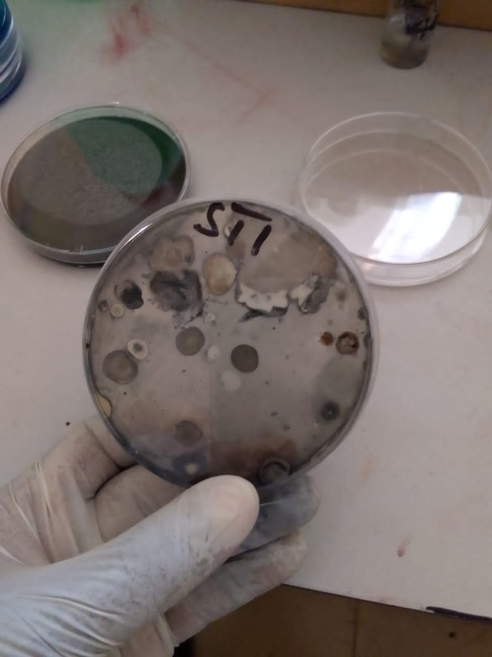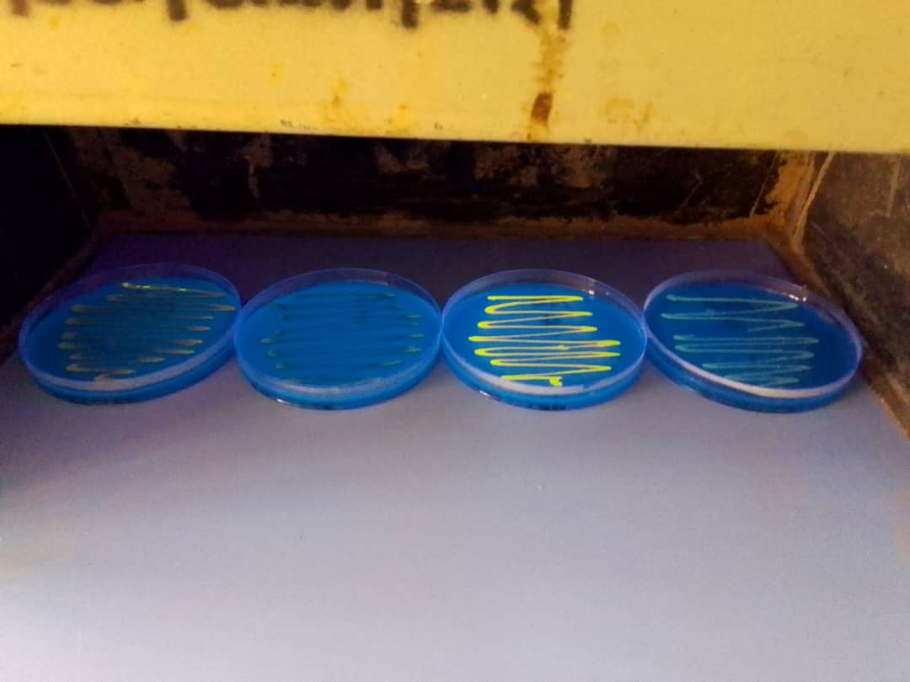
Plate 1: Sudan Black B and Nile Blue A staining showing intracellular PHA accumulation in Bacillus subtilis isolate SMI3.

To confirm its taxonomic identity, molecular characterization was performed using 16S rRNA gene sequence analysis. The obtained sequence showed a high similarity (98.2%) with Bacillus subtilis strain AaR113 in the NCBI GenBank database. Phylogenetic analysis further supported this identification, with isolate SMI3 clustering firmly within the Bacillus subtilis clade and exhibiting strong bootstrap support values exceeding 95%.
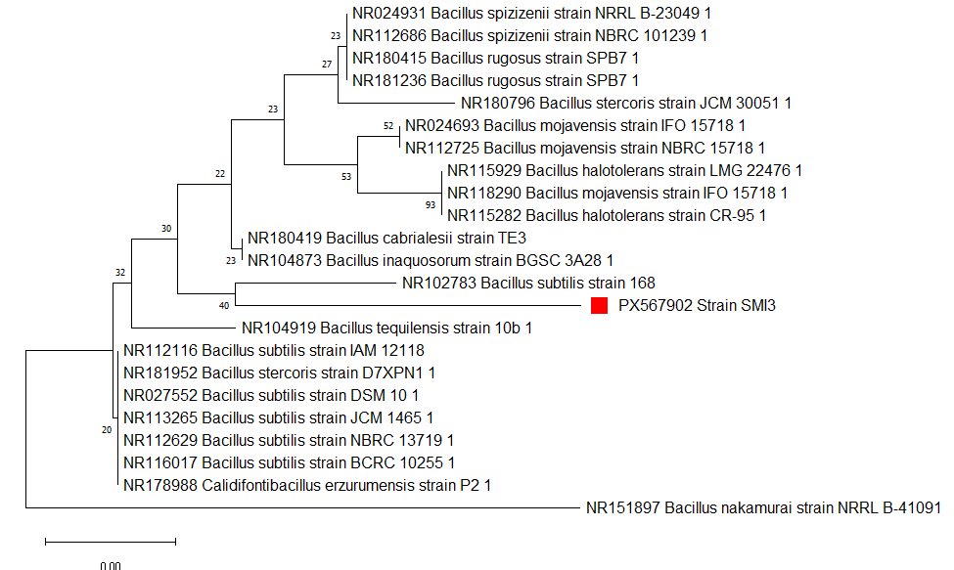
Figure 1: Phylogram (neighbour-joining tree) indicating the genetic relationship between strain SMI3 and related microorganisms based on the 16S rRNA gene sequence analysis. Accession numbers are accompanied by the species name of their 16S rRNA sequences.
3.2 Optimization of PHB Production
3.2.1 OFAT Optimization
Wheat bran hydrolysate supported PHB production by Bacillus subtilis SMI3, but yields varied considerably depending on the culture conditions. PHB accumulation increased steadily during the first 72 hours, reaching a peak of 328 mg/L (Figure 2). After 72 hours, the yield decreased significantly (p < 0.05), suggesting that the bacteria began utilizing the stored polymer as an internal carbon source when the substrate became limiting. PHB production was highest at pH 7.0 (360 mg/L), while yields were lower under acidic conditions and declined further as the pH became alkaline (Figure 3). The effect of substrate concentration followed a "rise and fall" pattern (Figure 4); the yield increased with wheat bran concentration up to 3 g/L (320 mg/L), then dropped sharply at 5 g/L, suggesting that higher concentrations may have caused osmotic stress or the accumulation of inhibitory compounds. In terms of inoculum size, the yield increased with cell density, peaking at 504 mg/L with a 3.0 McFarland standard, but higher densities did not improve the yield further (Figure 5). Temperature had the strongest effect on PHB production (Figure 6). The yield rose from 240 mg/L at 25°C to a maximum of 576 mg/L at 35°C, then fell sharply to 168 mg/L at 45°C, confirming that the isolate is mesophilic.

Figure 2: Effect of incubation time on PHB Production by Bacillus subtilis (SMI3). Data are presented as mean ± SD from three independent replicates

Figure 3: Effect of Initial pH on PHB Production by Bacillus subtilis (SMI3). Data are mean ± SD (n=3).

Figure 4: Effect of Inoculum Size on PHB Production by Bacillus subtilis (SMI3). Data are mean ± SD (n=3).

Figure 5: Effect of wheat bran concentration on PHB production by Bacillus subtilis (SMI3) (SMI3). Data are mean ± SD (n=3).

Figure 6: Effect of Temperature on PHB Production by Bacillus subtilis (SMI3). Data are mean ± SD (n=3).

3.2.2 Statistical Optimization using Response Surface Methodology (RSM)
Central Composite Design (CCD) and Model Fit
To investigate the synergistic interactions between the selected process variables on wheat bran (WB) bioconversion, a four-factor Central Composite Design (CCD) was employed. The experimental PHB yields by the isolate across the 30-run matrix are presented in Table 1. The polymer concentrations ranged from 356.39 mg/L to a maximum of 660.00 mg/L (Run 1). This substantial increase in yield compared to the univariate trials underscores the necessity of optimizing the interplay between nutritional and physical parameters to maximize the metabolic flux toward polyester storage.
Regression Model and Interactive Effects
The relationship between the coded independent variables—Incubation Time (A), Substrate Concentration (B), Inoculum Size (C), and pH (D)—and the PHB yield (Y) was expressed through the following second-order polynomial equation:
$$PHA Yield = + 541.15 + 9.04A + 41.52B + 34.79C + 26.12D - 3.13A2 - 22.95B2 - 15.42C2 - 4.12D2 + 4.27AB + 3.94AC + 1.66 AD + 13.26BC + 20.32BD + 5.72CD$$
The positive linear coefficients for variables A, B, C, and D indicate that within the design space, these factors directly promote PHB accumulation. Notably, substrate concentration (B) and inoculum size (C) exhibited the strongest linear influence. The negative quadratic terms (B^2 and C²) imply that while these factors are essential, their levels must be precisely controlled to avoid substrate inhibition or metabolic saturation. Significant synergistic interactions were particularly evident between substrate concentration and pH (B × C) and substrate concentration and inoculum size (B × D) (Figure 7).

Model Validation and ANOVA
The statistical significance of the quadratic model was evaluated using Analysis of Variance (ANOVA), as detailed in Table 2. The model exhibited a highly significant F-value of 35.41 (p < 0.0001), suggesting that the model is extremely robust. The coefficient of determination (R² = 0.9706) indicates that the model can account for 97.06% of the variability in PHB yield, while the Adjusted R² of 0.9432 further confirms the high degree of correlation between the experimental and predicted values. Statistical diagnostics further validated the model's predictive power. The Adequate Precision value of 26.579, far exceeding the desirable threshold of 4 demonstrates an excellent signal-to-noise ratio. Furthermore, the Lack of Fit p-value of 0.1758 was non-significant, confirming that the quadratic model is an adequate tool for predicting PHB production using wheat bran hydrolysate. The high predicted R² of 0.8529 suggests that this model can be effectively utilized for industrial scaling and process control.
Table 1. Central Composite Design matrix of four process parameters showing the actual and predicted yield for PHA production by Bacillus subtilis using Wheat bran.
Run | Factor A | Factor B | Factor D | Factor C | Predicted value (mg/L) | Experimental value (mg/L)
 | Incubation time (h) | Substrate Conc. (g) | Inoculum size (µL) | pH | Predicted value (mg/L) | Experimental value (mg/L)
 | 72 | 5 | 3 | 8 | 656.17 | 660
 | 60 | 4 | 2.5 | 7.5 | 541.15 | 552.4
 | 48 | 3 | 2 | 7 | 433.24 | 421.73
 | 48 | 5 | 3 | 7 | 518.69 | 498.23
 | 60 | 4 | 2.5 | 7.5 | 541.15 | 524.66
 | 60 | 4 | 2.5 | 7.5 | 541.15 | 538.56
 | 72 | 3 | 3 | 8 | 497.42 | 501.36
 | 72 | 5 | 2 | 8 | 548.52 | 541.78
 | 72 | 3 | 2 | 7 | 431.57 | 426.78
 | 84 | 4 | 2.5 | 7.5 | 546.72 | 540.43
 | 72 | 3 | 3 | 7 | 435.03 | 439.28
 | 36 | 4 | 2.5 | 7.5 | 510.57 | 507.4
 | 60 | 4 | 3.5 | 7.5 | 576.9 | 569.05
 | 60 | 6 | 2.5 | 7.5 | 532.37 | 532.82
 | 60 | 4 | 2.5 | 7.5 | 541.15 | 538.95
 | 72 | 3 | 2 | 8 | 471.07 | 483.85
 | 48 | 3 | 3 | 8 | 476.69 | 462.39
 | 72 | 5 | 2 | 7 | 455.99 | 462.62
 | 48 | 3 | 3 | 7 | 430.07 | 453.93
 | 60 | 4 | 1.5 | 7.5 | 472.42 | 470.82
 | 72 | 5 | 3 | 7 | 540.74 | 542.85
 | 48 | 3 | 2 | 8 | 456.97 | 471.99
 | 48 | 5 | 3 | 8 | 618.35 | 640.26
 | 48 | 5 | 2 | 7 | 440.57 | 453.76
 | 48 | 5 | 2 | 8 | 517.33 | 505.4
 | 60 | 4 | 2.5 | 6.5 | 409.89 | 407.97
 | 60 | 4 | 2.5 | 8.5 | 549.04 | 541.51
 | 60 | 2 | 2.5 | 7.5 | 366.29 | 356.39
 | 60 | 4 | 2.5 | 7.5 | 541.15 | 537.21
 | 60 | 4 | 2.5 | 7.5 | 541.15 | 555.1

Table 2: Quadratic Model Analysis of variance for PHA produced by Bacillus subtilis using Wheat Bran
Source | Sum of Squares | Mean Square | F- Value | Prob > F
Model | 1.18E+05 | 8424.62 | 35.41 | < 0.0001 | significant
A | 1960.05 | 1960.05 | 8.24 | 0.0117
B | 41371.36 | 41371.36 | 173.91 | < 0.0001
C | 29046.17 | 29046.17 | 122.1 | < 0.0001
D | 16372.54 | 16372.54 | 68.82 | < 0.0001
A2 | 268.09 | 268.09 | 1.13 | 0.3052
B2 | 14451.55 | 14451.55 | 60.75 | < 0.0001
C2 | 6521.96 | 6521.96 | 27.42 | 0.0001
D2 | 465.89 | 465.89 | 1.96 | 0.182
AB | 292.15 | 292.15 | 1.23 | 0.2852
AC | 248.61 | 248.61 | 1.05 | 0.3228
AD | 43.99 | 43.99 | 0.18 | 0.6733
BC | 2811.92 | 2811.92 | 11.82 | 0.0037
BD | 6608.47 | 6608.47 | 27.78 | < 0.0001
CD | 524.3 | 524.3 | 2.2 | 0.1584
Residual | 3568.3 | 237.89
Lack of Fit | 2948.15 | 294.81 | 2.38 | 0.1758 | not significant
Pure Error | 620.16 | 124.03
Cor Total | 1.22E+05
Std. Dev. | 15.42 | R-Squared | 0.9706
Mean | 504.65 | Adj R-Squared | 0.9432
C.V. | 3.06 | Pred R-Squared | 0.8529
PRESS | 17874.35 | Adeq Precision | 26.579

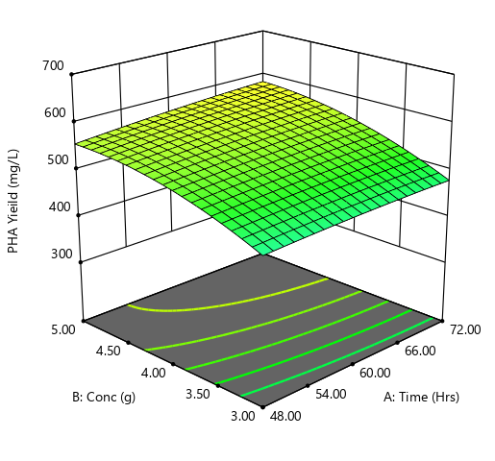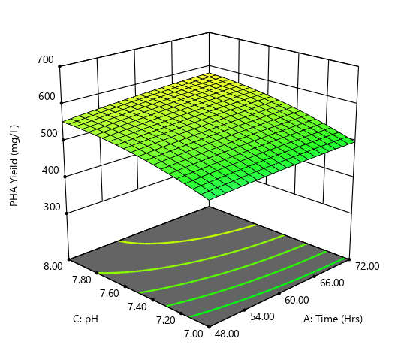
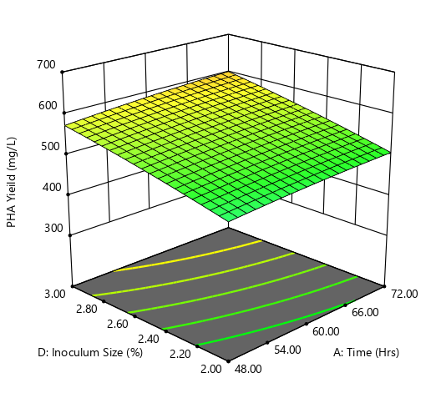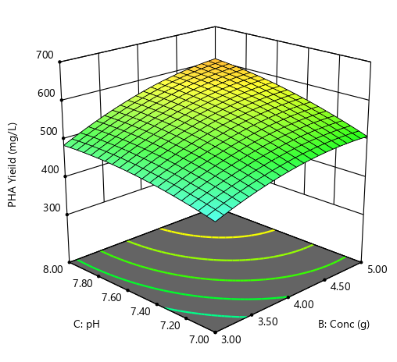
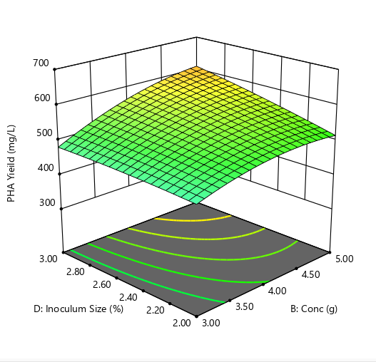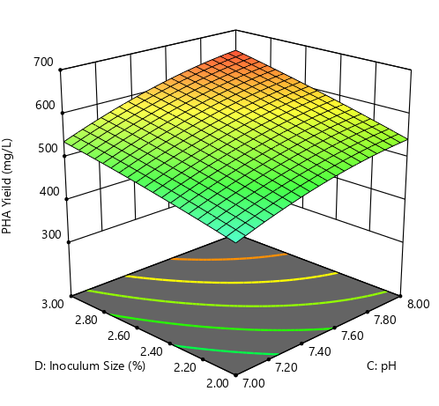
Figure 7: Response surface 3D plots showing the interactive effects of (a) Substrate concentration and Inoculum size, (b) pH and Incubation time on the PHA yield by Bacillus subtilis (SMI3) using wheat bran hydrolysate.

3.3 Structural Characterization of PHB produced
3.3.1 FTIR Spectroscopic Analysis
The FTIR spectrum of the extracted polymer (Figure 8) showed a strong absorption band at 1737 cm⁻¹, which corresponds to the ester carbonyl (C=O) stretching vibration and is the characteristic marker of the polyhydroxyalkanoate backbone. An additional, less intense peak at 1586 cm⁻¹ was also observed; this is attributed to Amide II vibrations, indicating the presence of residual protein or peptidoglycan associated with the polymer granules – a common finding in PHA extracted from Gram-positive bacteria. Bands at 1424 cm⁻¹ and 1374 cm⁻¹ were assigned to –CH₃ and –CH₂ bending, respectively, and peaks in the 1000–1200 cm⁻¹ region confirmed C–O–C stretching typical of a polyester structure.

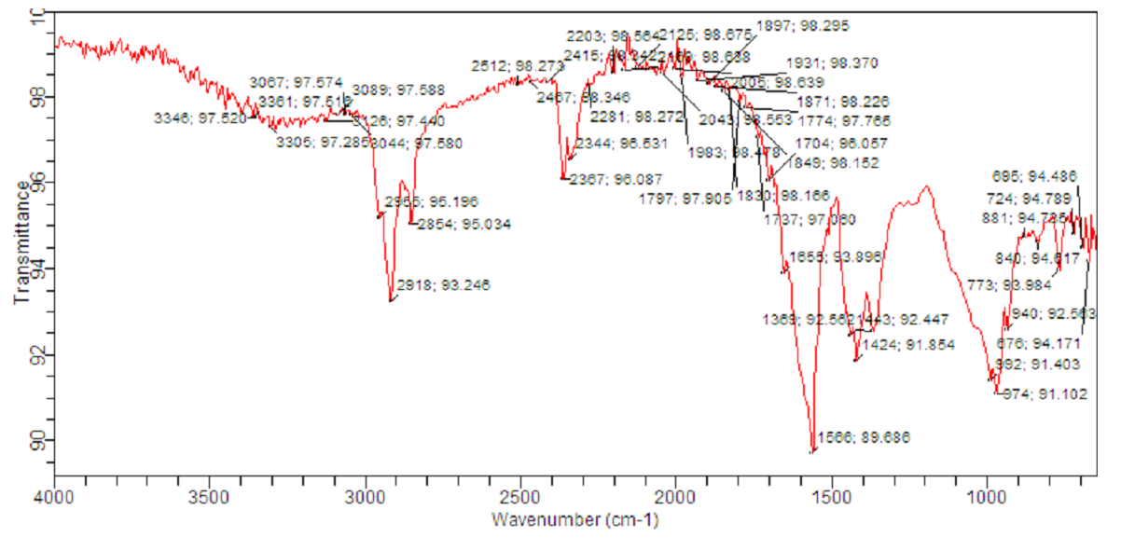
Figure 8: FTIR Spectroscopy of PHB Produced by Bacillus subtilis

3.3.2 GC-MS characterization
The monomeric composition of the polymer was analyzed by GC-MS (Figure 8). The chromatogram showed two major peaks. The first peak, with retention time of 6.858 minutes, was identified as 3-hydroxybutyrate (3HB) based on diagnostic fragment ions at m/z 103, 88, and 59. The second peak at 6.951 minutes corresponded to 3-hydroxyvalerate (3HV), confirmed by ions at m/z 129, 143, and 101. Peak area integration showed that 3HB accounted for 28.18% and 3HV for 19.66% of the total monomer fraction. This confirms that B. subtilis SMI3 produced a PHBV copolymer rather than pure PHB when grown on wheat bran hydrolysate.
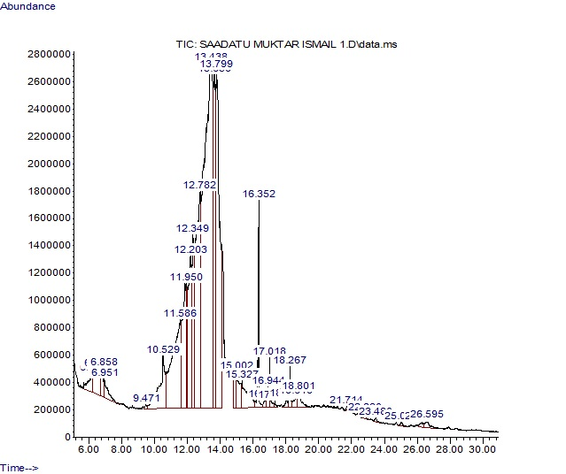
Figure 9: Gas chromatography analysis of derivatives of PHB obtained from Bacillus subtilis

4. Discussion
The successful production of biopolymers at an industrial scale begins with the selection of a robust microbial chassis. In this study, 35 bacterial isolates were recovered from fadama soil in Kano State, Nigeria. Primary screening with Sudan Black B identified 11 isolates capable of accumulating intracellular PHA granules, and subsequent confirmatory staining with Nile Blue A (which fluoresces under UV light when bound to PHA) validated isolate SMI3 as the most promising candidate. This two‑tiered strategy reduces false positives and is widely used for reliable PHA detection (Fadipe et al., 2021; Oyewole et al., 2024). Fadama soils, with their seasonal flooding and high organic matter, impose periodic nutrient stress that may naturally select for bacteria with efficient carbon‑reserve mechanisms. Similarly, George et al., (2023) isolated PHA‑producing Lysinibacillus fusiformis and Metabacillus indicus from contaminated soil, supporting the idea that stressed environments harbour such bacteria.
Molecular identification via 16S rRNA gene sequencing confirmed isolate SMI3 as Bacillus subtilis with 98.2% similarity to strain AaR113, and phylogenetic analysis placed it firmly within the B. subtilis clade (bootstrap >95%). The sequence was deposited in GenBank (accession PX567902). Bacillus subtilis is Generally Recognised as Safe (GRAS), which offers a significant advantage over Gram‑negative producers like Cupriavidus necator that contain lipopolysaccharide endotoxins, complicating purification for food or medical applications (Adamu & Salisu, 2024; Shahid et al., 2021).
Wheat bran was chosen as a low‑cost, abundant agricultural by‑product that does not compete with food production. Using wheat bran hydrolysate, B. subtilis SMI3 achieved a maximum PHBV yield of 660 mg/L a value competitive with other reports using Bacillus species on similar residues (Hassan et al., 2019; Sanna Rose et al., 2026). The nutritional complexity of wheat bran (sugars, proteins, B‑vitamins) supports robust growth without expensive supplements, directly addressing the major cost barrier in PHA production (Shrimali et al., 2024).
The time course of fermentation followed a classic “rise and fall” pattern. PHBV accumulation increased steadily to 328 mg/L at 72 h, then declined significantly (p < 0.05). The peak corresponds to the transition from late‑exponential to early‑stationary phase, where nutrient (most likely nitrogen) depletion triggers the polymerisation of excess carbon into intracellular granules (Iftikhar, 2024). The subsequent decline is due to activation of intracellular PHA depolymerases when the exogenous carbon becomes limiting; the bacteria metabolise the stored polymer for survival (Paloyan et al., 2025; Patil et al., 2024).
This finding agrees with Yadav & Patra, (2025), who reported optimum PHB production for a Bacillus species at 72 h with a decline thereafter. Thus, harvest timing is critical – extending fermentation beyond 72 h leads to net product loss.
Environmental and nutritional factors strongly influenced PHBV yield. The optimum pH was 7.0 (yield 360 mg/L); yields decreased under acidic or alkaline conditions, likely because pH affects the activity and structural integrity of PHA synthase (Reddy et al., 2003). The isolate exhibited a mesophilic preference, with an optimum temperature of 35 °C (yield: 576 mg/L), which dropped sharply to 168 mg/L at 45 °C. This decline can be explained by thermal stress redirecting acetyl‑CoA from polymer synthesis into the TCA cycle to meet maintenance demands (T. Khamkong et al., 2022), and by high temperatures disrupting the cell membrane, leading to leakage of cellular contents.
Substrate concentration showed a non‑linear effect: PHBV production increased up to 3 g/L wheat bran (320 mg/L) but decreased at 5 g/L, indicating substrate inhibition. This is likely due to osmotic stress or accumulation of inhibitory compounds (e.g., furfural) formed during dilute‑acid hydrolysis. Similar observations have been reported for other agro‑residues (Attapong et al., 2023; Khamberk et al., 2024). Inoculum size also positively correlated with yield, peaking at 504 mg/L with an inoculum density of approximately 9×10⁸ CFU/mL (added at 2% v/v). A sufficiently high initial cell density shortens the lag phase and increases final titer, but an excessively high inoculum can deplete nutrients prematurely.
The transition from one‑factor‑at‑a‑time (OFAT) screening to response surface methodology (RSM) using a central composite design was pivotal for maximising yield. The quadratic model was highly significant (F = 35.41, p < 0.0001) with an R² of 0.9706, meaning the model explained 97 % of the variability – superior to many similar studies (Adamu & Bukar, 2022; Shrimali et al., 2024). The adjusted R² (0.9432) and predicted R² (0.8529) were in good agreement, and the lack‑of‑fit p‑value (0.1758) was non‑significant, confirming the model’s adequacy. The most significant interaction was between substrate concentration and inoculum size (p = 0.0037), highlighting the importance of an optimal cell‑to‑carbon ratio. The interaction between substrate concentration and pH (p < 0.0001) also underscores the need for pH control in high‑density cultures. The model predicted a maximum yield of 660 mg/L, which was successfully validated experimentally. The maximum PHBV yield of 660 mg/L (0.66 g/L) is modest compared to industrial benchmarks but compares favourably with other screening-level studies using agro-residues. Iftikhar et al. (2024) reported 476 mg/L for Bacillus subtilis on molasses and 288 mg/L on banana peel hydrolysate. Naseem et al. (2024) obtained only 20 mg/L from rice bran and 11 mg/L from sugarcane molasses. Umesh et al., (2018) achieved 5.09 g/L, but with beef-extract supplementation. Kumar Sachan et al. (2024) obtained 647 mg/L for a novel Bacillus paranthracis before full optimisation, later reaching 4.52 g/L. Thus, our yield is typical for an unsupplemented wheat bran hydrolysate. Future improvements could include fed-batch fermentation, detoxification of the hydrolysate, and optimisation of the C/N ratio. Alternative pretreatments, such as ethanol–NaOH (which achieves >85% sugar recovery without inhibitor formation) or ionic-liquid pretreatment (95.3% xylose recovery), could be explored in future work to improve sugar yields from wheat bran
FTIR spectroscopy confirmed the polymer as a PHA-type polyester. The spectrum exhibited a characteristic peak at 1737 cm⁻¹ (ester carbonyl C=O stretching), a definitive marker of the PHA backbone. The prominent peak at 1586 cm⁻¹ is attributed to Amide II vibrations, indicating residual cellular proteins or peptidoglycans associated with the polymer granules – a common occurrence in Bacillus-derived PHAs (Iftikhar, 2024; Manousi & Zachariadis, 2020). Additional bands at 1424 cm⁻¹ and 1383 cm⁻¹ correspond to –CH₃ and –CH₂ bending, and peaks in the 1000–1200 cm⁻¹ range (C-O-C stretching) further confirm the polyester nature. Our FTIR peaks are consistent with those reported by (Iftikhar, 2024) for (1697–1750 cm⁻¹) and by Naseem et al. (2024) for various Bacillus strains.
GC-MS analysis revealed that the polymer was a PHBV copolymer containing 28.18% 3-hydroxybutyrate (3HB) and 19.66% 3-hydroxyvalerate (3HV). The production of PHBV by Bacillus subtilis SMI3 without adding propionic or valeric acid is novel and economically significant, as 3HV incorporation typically requires these expensive and potentially toxic precursors. The ability to synthesise PHBV directly from wheat bran hydrolysate is likely facilitated by the catabolism of branched-chain amino acids and threonine, which are abundant in the protein fraction of wheat bran (approx. 9.6–18.6%); (Shrimali et al., 2024). The protein content of wheat bran (15–21%) is well documented Poudel et al., (2026), and catabolism of its amino acids – particularly threonine and branched-chain amino acids – is the likely source of propionyl-CoA for 3HV synthesis. In Bacillus species, threonine degradation via threonine dehydratase yields 2-ketobutyrate, which is decarboxylated to propionyl-CoA (Chanasit & Bunkaew, 2023; Sivashankari et al., 2023). Propionyl-CoA then condenses with acetyl-CoA via β-ketothiolase to form 3-ketovaleryl-CoA, the direct precursor of 3HV monomers (Das et al., 2022). This precursor-free route to a PHBV copolymer with a high 3HV fraction is a highly desirable industrial trait because PHBV has reduced crystallinity and improved flexibility compared to the brittle PHB homopolymer, while also lowering raw material costs (Sinaei et al., 2021; Sirohi et al., 2021). The exact pathway in SMI3 remains to be fully elucidated, but the evidence strongly points to endogenous propionyl-CoA generation from amino acid catabolism (Jin et al., 2023; Park et al., 2021).
A critical requirement for any sustainable plastic alternative is rapid environmental degradation. Soil burial tests showed that the PHBV film lost 72.5 % of its initial weight after 60 days in fadama soil, confirming high susceptibility to microbial depolymerisation. This rate is consistent with previous reports, such as Boonmee et al., (2022), who found complete PHBV degradation over 60 days in landfill soil under thermophilic conditions. The rich microbial diversity of dumpsite fadama soil, due to its high organic matter, provides an ideal environment for PHBV‑degrading microorganisms that secrete extracellular depolymerases, breaking the polymer into water‑soluble intermediates that are mineralised to CO₂ and water (Jin et al., 2023; Yadav & Patra, 2025).
Several limitations should be acknowledged. First, a complete mass balance (residual sugars, nitrogen consumption) was not performed, so the carbon-to-polymer conversion efficiency could not be calculated. Second, the polymer yield was determined gravimetrically without further purification, so some non-PHA biomass may be included. Third, the exact mechanism of 3HV incorporation without a precursor remains speculative; we did not analyse the PHA synthase genes. Fourth, the yield (660 mg/L) is not yet industrially competitive, but as shown by Sachan et al. (2024), a 13-fold increase is achievable through further optimisation. Future studies should address these gaps.

4. Conclusion
In conclusion, Bacillus subtilis SMI3, isolated from dumpsite fadama soil, effectively converts wheat bran hydrolysate into a PHBV copolymer containing 28% 3-hydroxybutyrate and 19% 3-hydroxyvalerate without precursor supplementation. Under statistically optimised conditions (72 h, pH 7.0, 35 °C, 3 g/L wheat bran, and an inoculum of 2% v/v), the strain produced 660 mg/L of polymer, with the RSM model explaining 97% of the yield variability. The produced PHBV film lost 72.5% of its weight after 60 days in soil, confirming rapid biodegradability. While the current yield is modest compared to industrial benchmarks, the use of an inexpensive, abundant feedstock and the intrinsic ability to form a flexible copolymer without costly precursors make this process a viable starting point for sustainable bioplastic production. Future strain engineering and bioprocess intensification are expected to substantially improve productivity

Competing interests
The authors declare that they have no known competing financial or personal interests that could have appeared to influence the work reported in this paper.

DISCLAIMER (ARTIFICIAL INTELLIGENCE)
The authors declare that no generative AI tools were used for content generation. However, AI-assisted tools such as Grammarly and Google Gemini were used solely for grammar checking and language editing of the manuscript.

References

Abdullahi, S., Muhammed, Y. G., Muhammad, A., Ahmed, J. M., & Shehu, D. (2021). Isolation and Characterization of Bacillus Spp. for Plant Growth Promoting Properties. Acta Biologica Marisiensis, 5(2), 47–58. https://doi.org/10.2478/abmj-2022-0009
Adamu, K. S., & Bukar, A. (2022). Production of biodegradeable plastic by Bacillus sp. using sugarcane baggase. Bayero Journal of Pure and Applied Sciences, 13(1), 180–186.
Adamu, K. S., & Salisu, I. (2024). Optimization of Polyhydroxybutyrate Production by Bacillus Species Isolated from Dump Site Soil Using Multiple Linear Regression Analysis. UMYU Scientifica, 3(4), 355–368.
Aragosa, A., Specchia, V., & Frigione, M. (2021). Isolation of two bacterial species from argan soil in morocco associated with polyhydroxybutyrate (PHB) accumulation: Current potential and future prospects for the bio-based polymer production. Polymers, 13(11), 1870.
Attapong, M., Chatgasem, C., Siripornadulsil, W., & Siripornadulsil, S. (2023). Ability of converting sugarcane bagasse hydrolysate into polyhydroxybutyrate (PHB) by bacteria isolated from stressed environmental soils. Biocatalysis and Agricultural Biotechnology, 50, 102676.
Boonmee, C., Kositanont, C., & Leejarkpai, T. (2022). Degradation behavior of biodegradable plastics in thermophilic landfill soil and wastewater sludge conditions. Environmental Research, Engineering and Management, 78(1), 57–69.
Chanasit, W., & Bunkaew, K. (2023). Inexpensive Production of Poly (3‑hydroxybutyrate‑co‑3‑hydroxyvalerate) from Bacillus megaterium PP-10 Using Pineapple Peel Waste. ASEAN Journal of Scientific and Technological Reports, 26(3), 36–44.
Das, R., Pal, A., & Paul, A. K. (2022). Enhanced production of poly (3-hydroxybutyrate-co-3-hydroxyvalerate) copolymer by endophytic Bacillus cereus RCL 02 utilizing sugarcane molasses as sole source of carbon: a statistical optimization approach. Biotechnologia, 103(3), 283.
de Jesús Franco-León, J., Arriola-Guevara, E., Suárez-Hernández, L. A., Toriz, G., Guatemala-Morales, G., & Corona-González, R. I. (2021). Influence of supplemented nutrients in tequila vinasses for hydrogen and polyhydroxybutyrate production by photofermentation with Rhodopseudomonas pseudopalustris. Bioresource Technology, 329, 124865.
Fadipe, T. O., Jamil, N., & Lawal, A. K. (2021). Biosynthesis and characterization of poly-(3)-hydroxyalkanoic acid by Bacillus megaterium SF4 using different carbohydrates. In Microbial Polymers: Applications and Ecological Perspectives (pp. 109–129). Springer.
George, A. E., Antia, U. E., Adeleke, A. J., & Fatunla, O. K. (2023). Optimisation of polyhydroxy butyrate production by Lysinibacillus fusiformis and Metabacillus indicus isolated from spent engine-oil contaminated soil. UMYU Journal of Microbiology Research, 8(2), 30–39.
Hamdy, S. M., Danial, A. W., Gad El-Rab, S. M. F., Shoreit, A. A. M., & Hesham, A. E.-L. (2022). Production and optimization of bioplastic (Polyhydroxybutyrate) from Bacillus cereus strain SH-02 using response surface methodology. BMC Microbiology, 22(1), 183.
Hassan, M. A., Bakhiet, E. K., Hussein, H. R., & Ali, S. G. (2019). Statistical optimization studies for polyhydroxybutyrate (PHB) production by novel Bacillus subtilis using agricultural and industrial wastes. International Journal of Environmental Science and Technology, 16(7), 3497–3512.
Iftikhar, N. (2024). Production of Polyhydroxyalkanoates ( pha ) by bacillus and pseudomonas on Cheap Carbon Substrates. 67, 1–13.
Jin, A., del Valle, L. J., & Puiggalí, J. (2023). Copolymers and Blends Based on 3-Hydroxybutyrate and 3-Hydroxyvalerate Units. International Journal of Molecular Sciences, 24(24). https://doi.org/10.3390/ijms242417250
Khamberk, S., Thammasittirong, S. N.-R., & Thammasittirong, A. (2024). Valorization of sugarcane bagasse for Co-production of poly (3-hydroxybutyrate) and bacteriocin using Bacillus cereus strain S356. Polymers, 16(14), 2015.
Khamkong, P., & Mongkolthanaruk, W. (2025). Production and Characterization of Laccase from Streptomyces salinarius and its Immobilization on Magnetite Nanoparticles. KKU Science Journal, 53(2), 149–161.
Khamkong, T., Penkhrue, W., & Lumyong, S. (2022). Optimization of production of polyhydroxyalkanoates (PHAs) from newly isolated Ensifer sp. strain HD34 by response surface methodology. Processes, 10(8), 1632.
Kumar, R., Singh, B., Dogra, A., Kumar, A., Ali, S., Das, A. P., & Bala, K. (2026). Biodegradable Polymers: A Green Solution to Environmental Plastic Pollution. In Advances in Organic Waste Conversion Through Industrial Biotechnology (pp. 49–73). Springer.
Kumar, S., Stecher, G., Suleski, M., Sanderford, M., Sharma, S., & Tamura, K. (2024). MEGA12: Molecular Evolutionary Genetic Analysis version 12 for adaptive and green computing. Molecular Biology and Evolution, 41(12), msae263.
Kumari, D., Jaipuriar, D. S., Kanchana, P., Varma, S. M., & Gurja, S. (2020). Biodegradable plastic (phb) from bacteria collected from gopalpur beach, bhubaneswar. International Journal of Current Pharmaceutical Research, 41–44.
Mandragutti, T., Jarso, T. S., Godi, S., Begum, S. S., & K, B. (2024). Physicochemical characterization of polyhydroxybutyrate (PHB) produced by the rare halophile Brachybacterium paraconglomeratum MTCC 13074. Microbial Cell Factories, 23(1), 59.
Maniatis, T., & Fritsch, E. F. (1982). Sambrook J (1982) Molecular cloning: a laboratory manual. Cold Spring Harbord Laboratory, Cold Spring Harbor, NY.
Manousi, N., & Zachariadis, G. A. (2020). Recent Advances in the Extraction of Polycyclic Aromatic Hydrocarbons from Environmental Samples. 1–29.
Narayanasamy, A., Patel, S. K. S., Singh, N., Rohit, M. V, & Lee, J.-K. (2024). Valorization of algal biomass to produce microbial polyhydroxyalkanoates: recent updates, challenges, and perspectives. Polymers, 16(15), 2227.
Naseem, A., Rasul, I., Raza, Z. A., Muneer, F., ur Rehman, A., & Nadeem, H. (2024). Bacterial production of polyhydroxyalkanoates (PHAs) using various waste carbon sources. PeerJ, 12, e17936.
Oyewole, O. A., Abdulmalik, S. U., Abubakar, A. O., Chimbekujwo, K. I., Obafemi, Y. D., Oyegbile, B., Abioye, O. P., Adeniyi, O. D., & Egwim, E. C. (2024). Production of polyhydroxyalkanoate (pha) by pseudomonas aeruginosa (ol405443) using agrowastes as carbon source. Cleaner Materials, 11, 100217.
Paloyan, A., Tadevosyan, M., Ghevondyan, D., Khoyetsyan, L., Karapetyan, M., Margaryan, A., Antranikian, G., & Panosyan, H. (2025). Biodegradation of polyhydroxyalkanoates: current state and future prospects. Frontiers in Microbiology, 16, 1542468.
Park, S. L., Cho, J. Y., Choi, T.-R., Song, H.-S., Bhatia, S. K., Gurav, R., Park, S.-H., Park, K., Joo, J. C., & Hwang, S. Y. (2021). Improvement of polyhydroxybutyrate (PHB) plate-based screening method for PHB degrading bacteria using cell-grown amorphous PHB and recovered by sodium dodecyl sulfate (SDS). International Journal of Biological Macromolecules, 177, 413–421.
Patil, T. D., Ghosh, S., Agarwal, A., Patel, S. K. S., Tripathi, A. D., Mahato, D. K., Kumar, P., Slama, P., Pavlik, A., & Haque, S. (2024). Production, optimization, scale up and characterization of polyhydoxyalkanoates copolymers utilizing dairy processing waste. Scientific Reports, 14(1), 1620.
Poudel, A., Zhang, M., Jia, L., Arvelli, S., Lee, J., Qi, J., Arabi, N., Babaei, S., Peng, H., & Zhao, J. (2026). Bioconversion of Wheat Bran into High-Value Products: A Review of Pretreatment Methods and Microbial Applications. ACS Food Science & Technology.
Ramana, K. V., & Batra, H. V. (2015). Polyhydroxyalkanoates: Composites. In Encyclopedia of Biomedical Polymers and Polymeric Biomaterials, 11 Volume Set (pp. 6614–6624). CRC Press.
Reddy, C. S. K., Ghai, R., & Kalia, V. (2003). Polyhydroxyalkanoates: an overview. Bioresource Technology, 87(2), 137–146.
Reddy, V. U. N., Ramanaiah, S. V, Reddy, M. V., & Chang, Y.-C. (2022). Review of the developments of bacterial medium-chain-length polyhydroxyalkanoates (mcl-PHAs). Bioengineering, 9(5), 225.
Sachan, R. S. K., Devgon, I., Al-Tawaha, A. R. M. S., & Karnwal, A. (2024). Optimizing Polyhydroxyalkanoate production using a novel Bacillus paranthracis isolate: a response surface methodology approach. Heliyon, 10(15).
Sanna Rose, D., Rameshbabu, D., & Immanuel, G. (2026). Production of Biopolymer from Bacillus cereus and Its Antibacterial Ability against Clinical Pathogens. Biology Bulletin, 53(1), 4.
Shahid, S., Corroler, D., Mosrati, R., Amiel, C., & Gaillard, J.-L. (2021). New model development for qualitative and quantitative analysis of microbial polyhydroxyalkanoates: A comparison of Fourier Transform Infrared Spectroscopy with Gas Chromatography. Journal of Biotechnology, 329, 38–48.
Shehu, D., Gimba Muhammed, Y., Abdullahi, S., Ya’u, M., Ibrahim, S., Babandi, A., Muhammad Yakasai, H., Babagana, K., & Muhammad, A. (2023). Isolation and Molecular Characterisation of Polycyclic Aromatic Hydrocarbons (PAHs) Degrading Bacteria from Petrochemical Contaminated Soil. Malaysian Journal of Applied Sciences, 8(2), 1–12. https://doi.org/10.37231/myjas.2023.8.2.349
Shrimali, G., Gangawane, A., Rami, E., Shah, H., Thummar, K., Sahoo, D. K., Patel, A., & Schmidt, J. E. (2024). Optimized Polyhydroxybutyrate Production by Neobacillus Niacini GS1 Utilizing Corn Flour, Wheat Bran, and Peptone: A Sustainable Approach. Biomass, 4(4), 1164–1177.
Sinaei, N., Zare, D., & Azin, M. (2021). Production and characterization of poly 3-hydroxybutyrate-co-3-hydroxyvalerate in wheat starch wastewater and its potential for nanoparticle synthesis. Brazilian Journal of Microbiology, 52(2), 561–573.
Sirohi, R., Gaur, V. K., Pandey, A. K., Sim, S. J., & Kumar, S. (2021). Harnessing fruit waste for poly-3-hydroxybutyrate production: a review. Bioresource Technology, 326, 124734.
Sirohi, R., Pandey, J. P., Tarafdar, A., Agarwal, A., Chaudhuri, S. K., & Sindhu, R. (2021). An environmentally sustainable green process for the utilization of damaged wheat grains for poly-3-hydroxybutyrate production. Environmental Technology & Innovation, 21, 101271.
Sivaraagini, M. B. P., Ashok, K., Rayalu, K., & Shiva, K. (2026). Comparative Evaluation Of Bioplastic Production From Agricultural Wastes And Agro-Products : A Comprehensive Review With Statistical Interpretation. 14(3), 316–321.
Sivashankari, R. M., Mierzati, M., Miyahara, Y., Mizuno, S., Nomura, C. T., Taguchi, S., Abe, H., & Tsuge, T. (2023). Exploring Class I polyhydroxyalkanoate synthases with broad substrate specificity for polymerization of structurally diverse monomer units. Frontiers in Bioengineering and Biotechnology, 11, 1114946.
Sztupecki, W., Rhazi, L., Depeint, F., & Aussenac, T. (2023). Functional and nutritional characteristics of natural or modified wheat bran non-starch polysaccharides: a literature review. Foods, 12(14), 2693.
Tamura, K., Dudley, J., Nei, M., & Kumar, S. (2007). MEGA4: molecular evolutionary genetics analysis (MEGA) software version 4.0. Molecular Biology and Evolution, 24(8), 1596–1599.
Tao, X., Liu, S., Lv, L., Sun, L., Zhang, G., Liang, J., & Zou, W. (2025). Recent advances in polyhydroxyalkanoate production from volatile fatty acids derived from food waste fermentation. Frontiers in Microbiology, Volume 16. https://www.frontiersin.org/journals/microbiology/articles/10.3389/fmicb.2025.1693596
Umesh, M., Mani, V. M., Thazeem, B., & Preethi, K. (2018). Statistical optimization of process parameters for bioplastic (PHA) production by Bacillus subtilis NCDC0671 using orange peel-based medium. Iranian Journal of Science and Technology, Transactions A: Science, 42(4), 1947–1955.
Verma, K., Balbudhe, S., Dhodapkar, R., & Khan, D. (2025). Towards a greener future: Exploring bioplastics environmental impact and biodegradability. Waste and Biomass Valorization, 1–21.
Vicente, D., Proença, D. N., & Morais, P. V. (2023). The role of bacterial polyhydroalkanoate (PHA) in a sustainable future: a review on the biological diversity. International Journal of Environmental Research and Public Health, 20(4), 2959.
Vigneswari, S., Noor, M. S. M., Amelia, T. S. M., Balakrishnan, K., Adnan, A., Bhubalan, K., Amirul, A.-A. A., & Ramakrishna, S. (2021). Recent advances in the biosynthesis of polyhydroxyalkanoates from lignocellulosic feedstocks. Life, 11(8), 807.
Yadav, J., & Patra, N. (2025). Enhanced production of Poly (3-hydroxybutyrate) using fed-batch studies and optimized separation process. Brazilian Journal of Chemical Engineering, 1–13.

