Evidence of Dengue and Chikungunya Virus Co-circulation in field collected Aedes Mosquito Populations across Delhi, India

Pooja Prasadª*, Priya Singhª, Sunita Patelª, Ashna Bhasinª, Arti Bahlª, Shaukat Kamalª, Tanzin Dikidª, Ranjan Dasª

ªNational Centre for Disease Control, 22-Sham Nath Marg, Delhi-110054, India

.

ABSTRACT

Aims: Vector surveillance provides early warning of arboviral transmission prior to the outbreaks. Delhi the capital of India, experiences frequent Dengue and Chikungunya cases. The study aimed to determine the prevalence and distribution of Dengue and Chikungunya virus in Aedes mosquitoes collected across different areas of Delhi.
Study design: Field & Lab based study on Aedes mosquito collected from different zones of MCD Delhi.
Place and Duration of Study: Centre for Medical Entomology and Vector Management, VAD Laboratory, National Centre for Disease Control, Delhi from May 2025 to October 2025
Methodology: Adult Aedes mosquitoes were collected from 54 localities across Delhi in collaboration with the Municipal Corporation of Delhi. Specimens from residential and peri-domestic sites, were morphologically identified, and pooled (≤10 mosquitoes per pool). Viral RNA was extracted using TRIzol followed by column purification. Detection of dengue virus (DENV) and chikungunya virus (CHIKV) was performed using Real-time RT-PCR targeting the C-prM and E1 genes, respectively. Samples with Ct ≤40 were considered positive. The minimum infection rate (MIR) was calculated per 1,000 mosquitoes. Sampling and screening were conducted weekly or fortnightly.
Results: A total of 133 mosquito pools were screened for dengue virus (DENV) and chikungunya virus (CHIKV) using real-time polymerase chain reaction (Real Time -qPCR). Positive mosquito pools were detected in multiple zones of Delhi. Out of total tested pool (133 Pools), 8.27 % were positive for DENV alone while 3.76% showed co-positivity for both DENV and CHIKV viruses.
Conclusion: This study provides entomological evidence of concurrent circulation of DENV and CHIKV in Aedes populations in Delhi. Detection of both viruses in mosquito pools indicates the potential risk of dual outbreak and possible trans-ovarian transmission and emphasizing the need for strengthened integrated vector surveillance for timely outbreak preparedness and control

Keywords: DENV, CHIKV, Aedes, mosquito pool, arbovirus co-circulation, vector surveillance

1. INTRODUCTION
Dengue and chikungunya are two of the most significant arboviral diseases affecting tropical and subtropical regions worldwide. The day-biting female mosquito, Aedes aegypti, is primarily responsible for the transmission of both viruses. Dengue virus (DENV), a member of the Flaviviridae family, and chikungunya virus (CHIKV), belong to the Togaviridae family; pose a considerable global public health burden, with over 5.6 billion people at risk of arboviral infections [1].
In India, the co-circulation of DENV and CHIKV has become increasingly common due to rapid urbanization, inadequate water supply and insufficient vector control measures, which create favorable conditions for mosquito proliferation [2]. Delhi, in particular, has experienced recurrent dengue outbreaks over the past two decades, along with the periodic re-emergence of chikungunya after years of low incidence [2] due to climate change, urbanization, frequent international travel, inadequate water management, and favorable climatic conditions (3,4). The overlapping transmission seasons of these viruses increase the possibility of simultaneous infections in both humans and mosquitoes, complicating clinical diagnosis and patient management [5].
Aedes aegypti breeds primarily in stagnant water containers, such as flower pots, water storage tanks, and discarded tires [6]. Mosquito density typically peaks during the monsoon season, coinciding with the increased availability of breeding sites. Furthermore, Aedes mosquitoes have adapted to unfavorable environmental conditions by producing desiccation-resistant eggs capable of surviving several months; these hatch once water becomes available [7].
Detection of natural viral infections in field-collected Aedes mosquitoes provides a vital tool for assessing the risk of arboviral transmission. Vector-based surveillance supports public health authorities to identify high-risk zones, obtain early warning signals, and implement timely, targeted interventions to prevent outbreaks. This approach is particularly important in densely populated urban centers like Delhi, where abundant breeding habitats can facilitate rapid virus amplification. Previous studies have highlighted the widespread distribution and ecological adaptability of Aedes aegypti and Aedes albopictus, which play a crucial role in the transmission dynamics of dengue and chikungunya viruses across diverse urban settings [8]. Furthermore, evidence of the simultaneous circulation of multiple arboviruses within Aedes aegypti populations, along with their potential for vertical (trans-ovarial) transmission, has been documented, indicating a mechanism for virus persistence even in the absence of active human infections [9]. Ongoing climatic changes have created favorable conditions for the breeding and survival of arboviral vectors, particularly Aedes mosquitoes, thereby increasing the risk of disease transmission, hence continuous surveillance studies are critical for early detection, monitoring vector dynamics, and implementing timely control measures to prevent potential outbreaks
In this context, the present study aimed to investigate the prevalence and distribution of DENV and CHIKV in field-collected Aedes mosquito populations across multiple zones of Delhi. The detection of these viruses in field-collected mosquito populations provides early warning signals for future outbreaks and enhances the effectiveness of vector surveillance systems. This study provides important evidence of DENV and CHIKV co-circulation in Aedes mosquitoes, contributing valuable data for strengthening integrated vector management and improving public health preparedness in endemic urban settings.

2. material and methods

2.1 Study area
Delhi has a warm climate and monsoon season providing favorable conditions for Aedes mosquito breeding. Factors such as intermittent water supply, water storage practices, poor sanitation, dense urban settlements, and lack of awareness further increase the risk of Aedes-borne disease. This study was conducted in 54 localities of Delhi in collaboration with the Municipal Corporation of Delhi (MCD) from May to October 2025, during the peak season of mosquito activity. Sampling sites were selected based on reported dengue cases to cover high-risk areas. Mosquitoes were collected weekly or fortnightly to monitor changes in infection over time (Figure 1).
Delhi : In India, recurrent dengue outbreaks have been documented in Delhi over the past two decades, with significant case burdens reported in 2006 (3,366 cases), 2010 (6,259 cases), 2013 (5,574 cases), and 2015 (15,867 cases) according to the MIS Cell, Vector-Borne Diseases report [10]. NVBDCP data, dengue incidence in India has declined in 2025 compared with recent peak years Delhi continues to represent a high-risk setting for arboviral circulation and entomological surveillance.
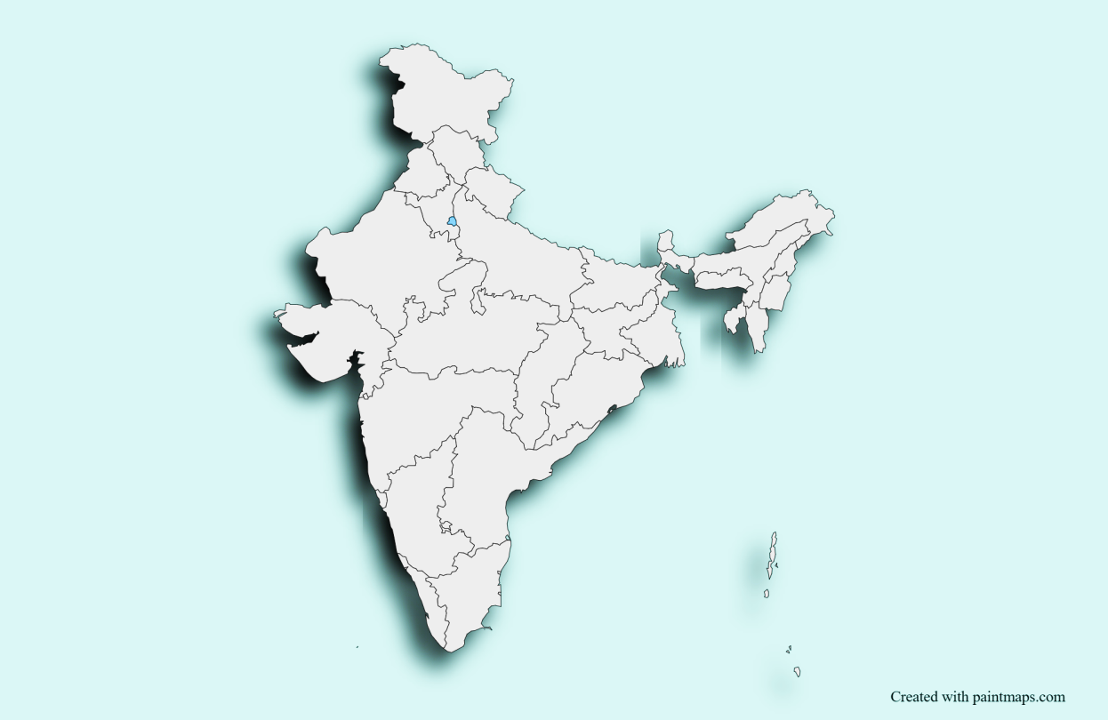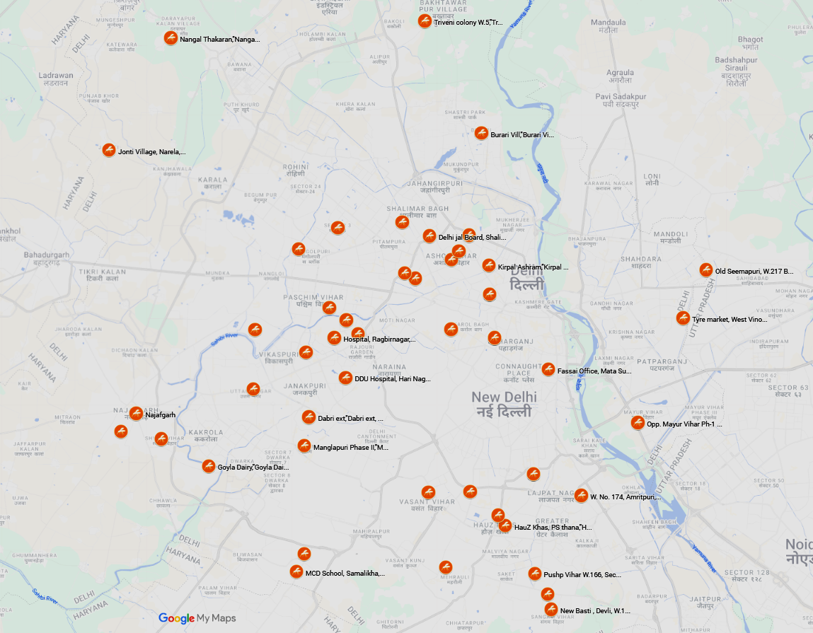

Fig 1: Location map for surveyed localities within Delhi.
2.2 Mosquito collection and identification:
Adult Aedes mosquitoes were collected by trained MCD personnel using oral aspirators from residential premises, peri-domestic areas. Collected specimens were transported to VAD Lab of Centre for Medical Entomology and Vector Management (CME&VM), National Centre for Disease Control (NCDC), Delhi. The mosquito sampled was stunned (by keeping in a freezer for 20 minutes or by hand tapping) and morphologically identified to species level using standard taxonomic keys [11]. The mosquitoes were sorted by species, sex, and pooled (≤10 mosquitoes per pool) (Figure 2). When the number of mosquitoes exceeded ten per locality, additional pools were created to ensure balanced representation. All samples were stored at −20°C prior to RNA extraction.

Species | Adult body | Thorax | Leg
Ae. aegypti | 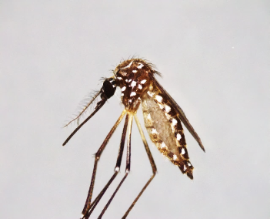 | 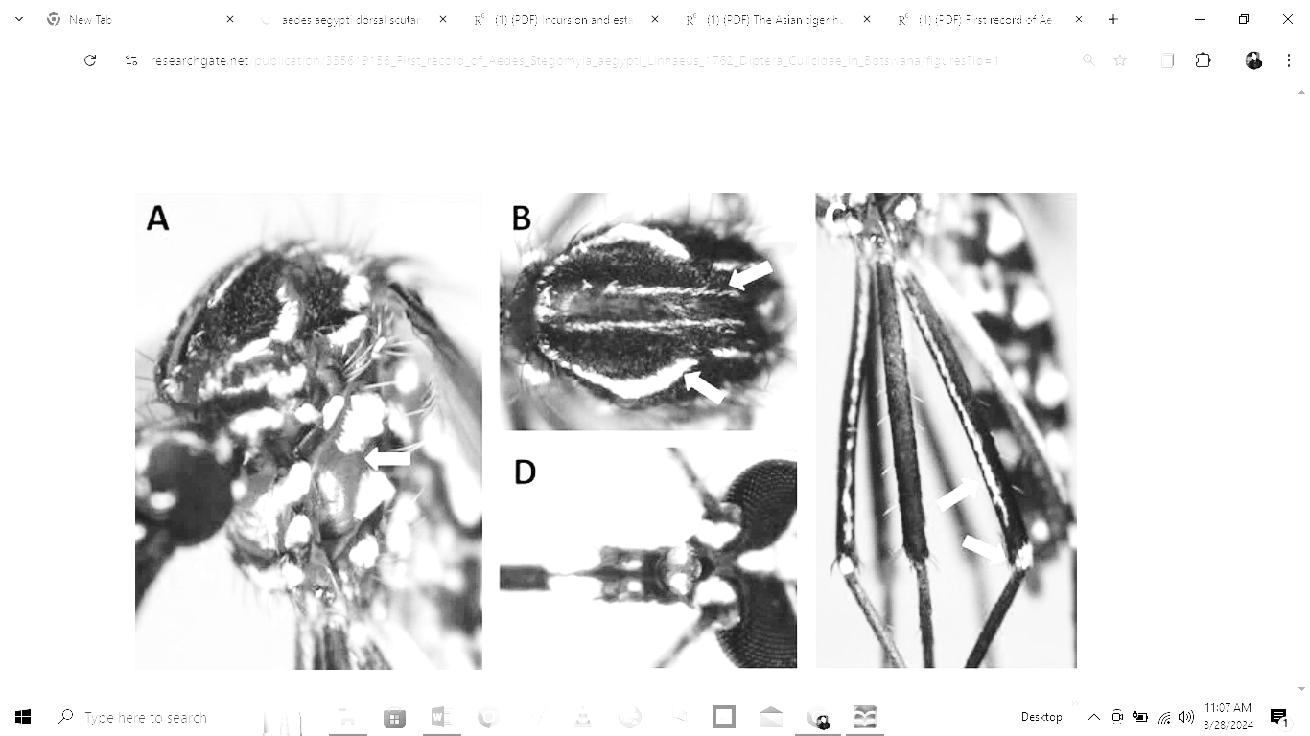 | 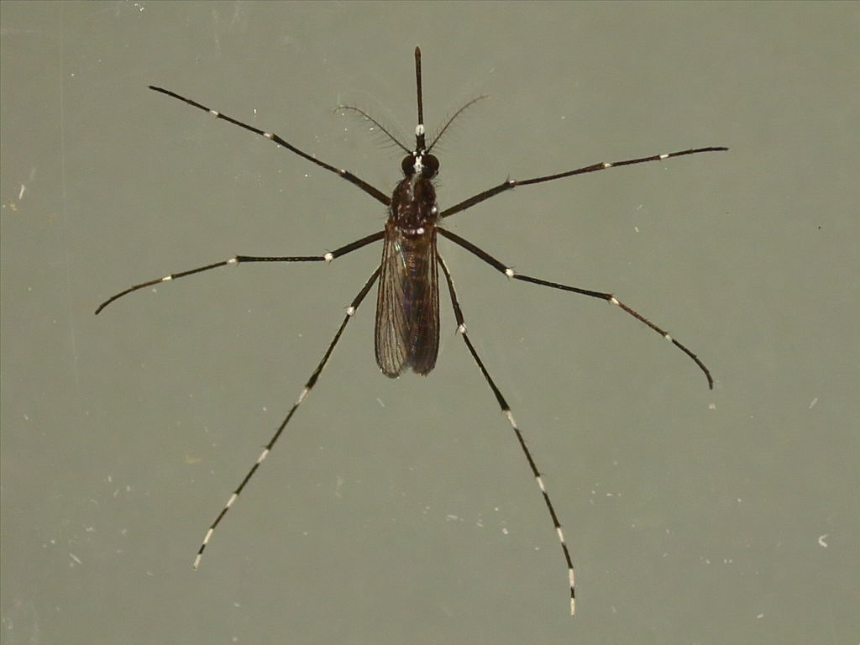
Ae. aegypti | A. | B. | C.
Ae. albopictus | 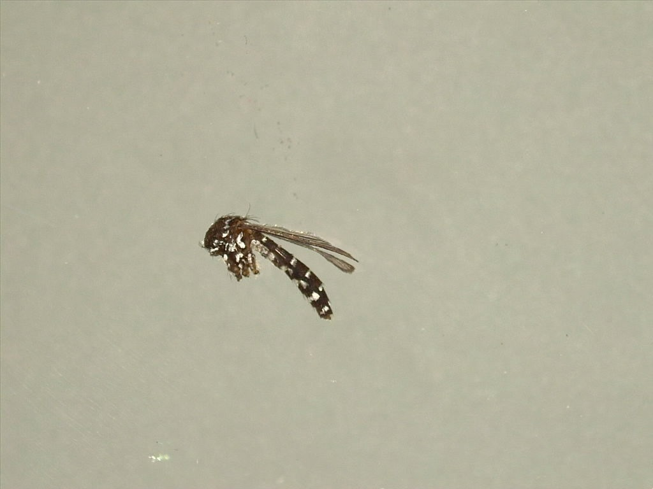 | 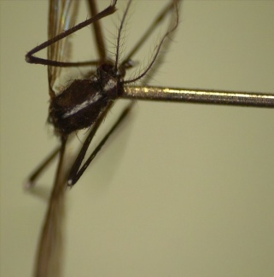
Ae. albopictus | D. | E. | F.
Ae. vittatus | 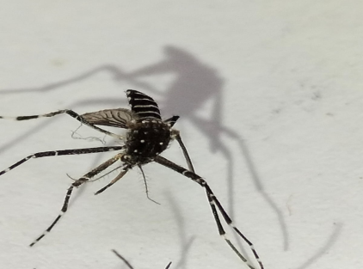 | 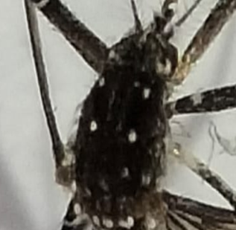 | 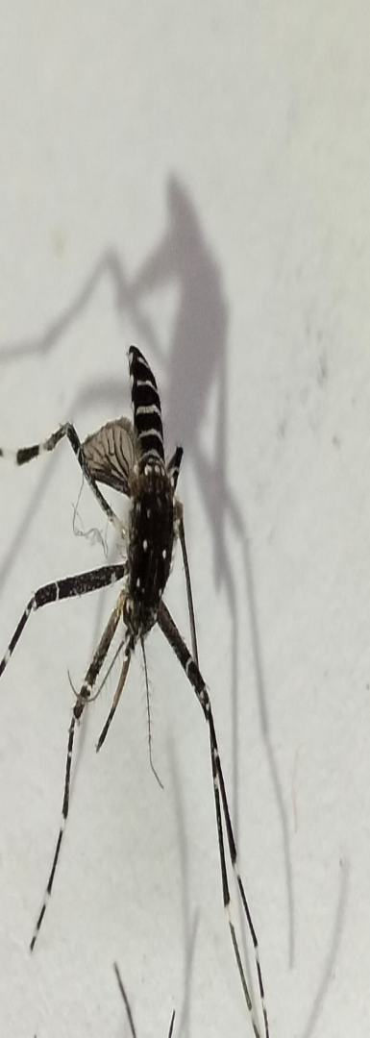
Ae. vittatus | G. | H. | I.

Fig 2. Morphological identification of Aedes species under light microscopy.
(A–C) Aedes aegypti: adult body (A), thoracic scaling pattern (B), and legs (C);
(D–F) Aedes albopictus: adult body (D), thoracic scaling pattern (E), and legs (F);
(G–I) Aedes vittatus: adult body (G), thoracic scaling pattern (H), and legs (I).

2.3 RNA extraction
RNA extraction from Aedes mosquitoes was done by following standardized protocols. Adult Aedes mosquito (pool size ≤10 mosquitoes) were homogenized using TRIzol by bench top mechanical homogenizer and centrifuged and transferred the supernatant part to another micro centrifuge tube. Chloroform was added to each sample mixed by pulse vortexing for phase separation. Further, samples were transferred to the column tube for the separation of RNA from impurities (Nucleic acid extraction kit), and the final product (viral) RNA was eluted in a final volume of 50 μl (as per manufactures protocol).
However, in Pooled mosquitoes, if the number of collected mosquitoes exceeded more than ten from one locality, then one more pool was added to that locality, and mosquitoes were divided equally in each tube. Therefore, the number of mosquitoes in each pool may vary.
2.4 Molecular detection
Real-time RT-PCR assays targeting conserved regions of the dengue virus (DENV) and chikungunya virus (CHIKV) genomes were performed using a commercially validated diagnostic kit strictly following the manufacturer’s protocol. The assay targeted the C-prM gene region for DENV and the E1 gene region for CHIKV, with an internal control included in each reaction to monitor extraction and amplification efficiency.

The pool from all the surveyed locality were processed with real-time qPCR for DENV/CHKV. Each Reaction of 25 µl (15 µl master mix + 10 µl extracted RNA sample) were set up in 96 well plates. Amplification was carried out in 96-well plates under the following cycling conditions: reverse transcription at 53°C for 5 minutes, initial denaturation at 95°C for 15 minutes, followed by 10 cycles (90°C for 30 s, 54°C for 30 s, 60°C for 30 s) and 35 cycles (90°C for 30 s, 56°C for 30 s, 60°C for 1 min). Fluorescent dyes (FAM, HEX, and Texas Red) were used for detection of target genes and internal controls. Positive and negative controls were included in each run. Samples with cycle threshold (Ct) values ≤40 were considered positive, as per kit guidelines.

2.5 Data analysis
Minimum infection rate (MIR) estimation
The minimum infection rate (MIR) for adult mosquitoes collected during the survey was determined using the formula:-

$$MIR =\frac{Number of collected positive mosquitoes}{number of total mosquitoes tested}x 1000$$
which assumes that a positive pool contains at least 1 infected mosquito [12, 13].

3. results and discussion

ResulT

Entomological surveillance was undertaken in collaboration with the Municipal Corporation of Delhi (MCD) across 54 localities across 12 zones of Delhi. A total of 649 mosquitoes was collected (133 pools) from 54 localities. Further, these mosquitos were screened for DENV and CHIKV (Table 1). Male mosquito found positive indicates transovarian transmission of DENV in both species in Delhi. Detection of DENV in male mosquitoes suggests vertical transmission, which may contribute to virus persistence during non-outbreak periods. Although CHIKV mono-infection was not detected, its presence in co-infected pools indicates silent circulation within vector populations.

Table 1: Zone-wise Aedes species prevalence.
Zones | Ae. aegypti | Ae. albopictus | Ae. vittatus
Najafgarh | 204 | 60 | 0
Narela | 17 | 7 | 2
Keshav puram | 67 | 46 | 11
West Zone | 12 | 15 | 0
South Zone | 49 | 32 | 0
Rohini | 24 | 3 | 5
Shahadara North | 10 | 0 | 7
Karol Bagh Zone | 12 | 0 | 0
City SP Zone | 0 | 15 | 0
Civil lines Zine | 5 | 0 | 0
Central Zone | 29 | 2 | 0
Shahadara South zone | 15 | 0 | 0
Total | 444 | 180 | 25

Figure 3: Percent prevalence of Aedes mosquito in MCD zones

The study shows a high density of Aedes aegypti in Delhi, especially in Najafgarh and Keshav Puram, marking them as key dengue risk areas. The presence of Aedes albopictus in several zones indicates a secondary vector role. The limited detection of Aedes vittatus suggests localized occurrence and adaptation to specific habitats. These findings highlight the need for zone-focused mosquito surveillance and targeted control measures to reduce the risk of arboviral transmission in Delhi (Table 1 & Figure 3).

The map illustrates the geographical distribution of Aedes mosquito pools that tested positive for dengue virus (DENV) and chikungunya virus (CHIKV) across different districts and sub-districts of Delhi. Red dots indicate localities where viral RNA was detected in pooled mosquito samples, confirming the presence of active arboviral circulation in these areas (Figure 4).

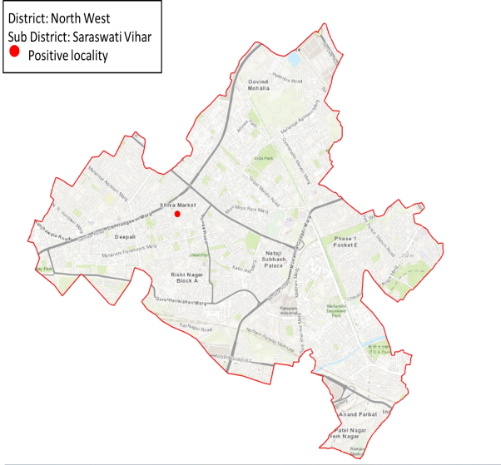 | 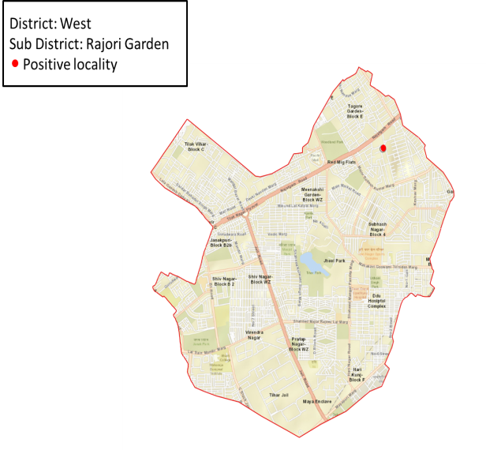
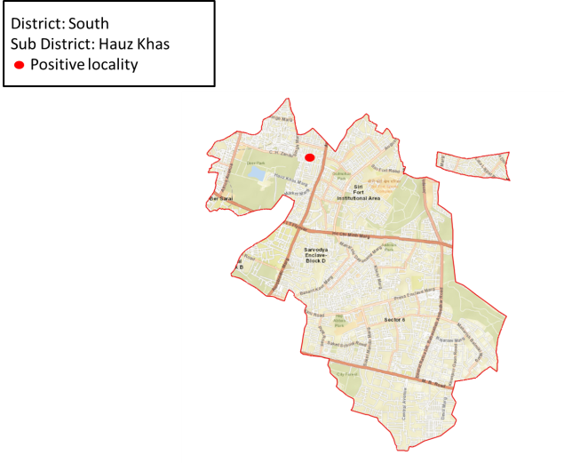 | 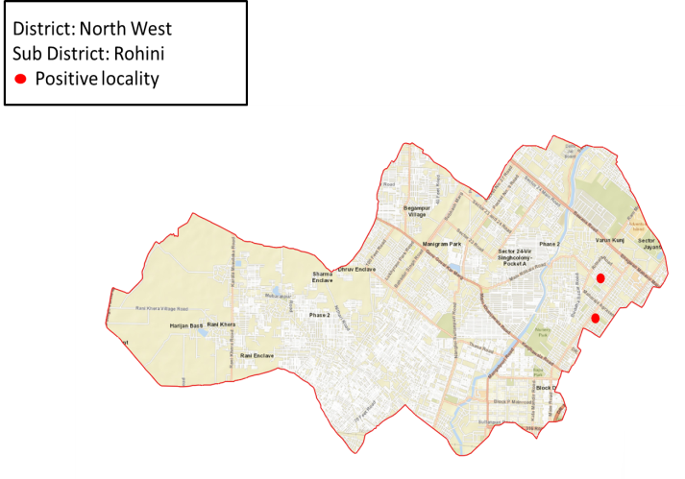
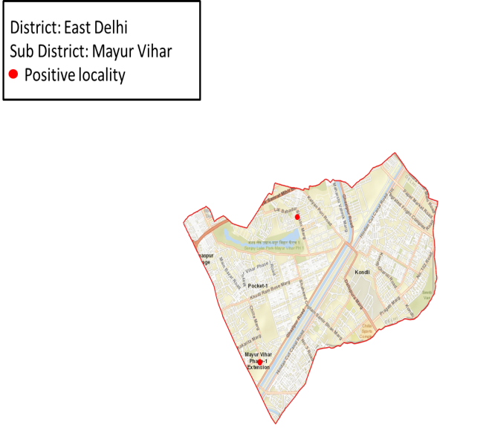 | 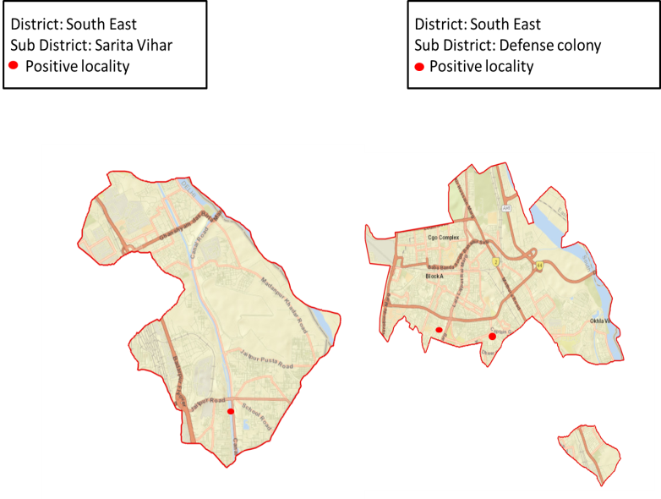
Fig 4: Pools positive for dengue virus (DENV) and chikungunya virus (CHIKV) across selected sub-districts of Delhi.
Positive mosquito pools were identified in multiple districts, including North West (Saraswati Vihar and Rohini), West (Rajori Garden), South (Hauz Khas), East (Mayur Vihar), South East (Defence Colony), and South West (Sarita Vihar) zones. The detection of DENV and CHIKV in vectors highlights ongoing transmission risk and reflects the potential for human infections in these localities.

Table 2. Details of surveyed localities in 12 zones of Delhi,
No. of Localities | No. of Mosquitoes | No. of Mosquito Pools | DENV |  | CHIKV |  | DENV &  CHIKV
No. of Localities | No. of Mosquitoes | No. of Mosquito Pools | Pools Positive | % of Pools Positive | Pools Positive | % of Pools Positive | Pools Positive | % of Pools Positive
54 | 649 | 133 | 11 | 8.27 | 0 | 0 | 5 | 3.76

Dengue (DENV) is the dominant circulating arbovirus, detected in over 8% of mosquito pools. No alone CHIKV pools were found positive, suggesting no active chikungunya transmission during the survey period. Co-infection (DENV & CHIKV) presence (3.76%) indicates some overlapping viral circulation or mixed infection potential in vectors With an overall 12% pool positivity, this indicates moderate vector infection levels, suggesting ongoing transmission risk (Table 2).
Species wise MIR for Dengue and chikungunya virus was also calculated. MIR for Ae. aegypyti was found to be 27.027 (444), Ae. albopictus 16 (180) and for Ae. vittatus 40 (25). During the period of study the sample size for Ae. vittatus was small henceforth for accurate ratio of MIR more study needs to be conducted and large sample size may be included.
Among the vector species analyzed, Aedes aegypti displayed the highest infection rate, reaffirming its status as the principal urban vector responsible for sustaining dengue transmission and contributing to increased epidemic potential in densely populated areas. These findings underscore the necessity for continuous entomological and virological surveillance to detect early signs of arboviral activity and to implement timely, evidence-based vector control interventions aimed at preventing future outbreaks.

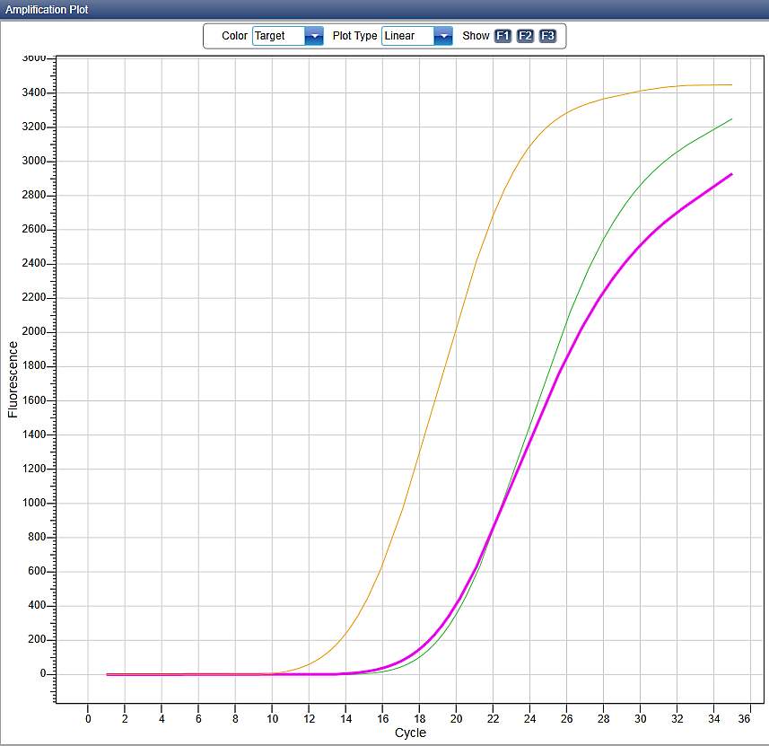

CHIK-HEX
IC-TexRed
DENGUE-FAM

Figure 5: Real-time PCR amplification curves showing fluorescence (RFU) versus cycle number. Early Ct values indicate high target concentration, intermediate Ct values moderate abundance, and late Ct values low target levels. No amplification was observed in negative controls, confirming the absence of non-specific amplification or contamination.

The findings of this study provide evidence for the co-circulation and transovarian transmission of dengue virus (DENV) and chikungunya virus (CHIKV) in Aedes mosquito populations across different zones of Delhi (Figure 5). Detection of both viruses in field-collected mosquitoes, including instances of co-infected pools, highlights the persistent risk of simultaneous arboviral transmission to humans in urban settings. This observation is consistent with previous studies from endemic regions, which have reported concurrent circulation of DENV and CHIKV within Aedes populations due to overlapping ecological niches and transmission cycles. Although the prevalence of co-infected mosquitoes was relatively low, even a small proportion can contribute to the occurrence of concurrent infections in humans, especially in densely populated areas with high mosquito abundance [14, 15] .
In the present research, the density of collected mosquitos was high from Najafgarh zone Delhi, followed by Keshav puram. The high mosquito collection from Najafgarh Delhi may be because the teams regularly conducted surveys in those locations. In Delhi, September and October are considered monsoon (July–September) and post-monsoon (September–October) seasons. We found the highest positivity rate for DENV during the transmission season, i.e., September–October.
Viruses in mosquito populations have important public health implications. It increases the risk of human co-infections, which can make clinical diagnosis difficult due to similar symptoms like fever, body aches, rash, and joint pain. Co-infected mosquitoes may also show changes in their ability to transmit viruses because one virus can affect the replication or transmission of the other [14]. Although the exact mechanisms are not fully understood, studying these interactions is essential for predicting outbreaks and planning control strategies.
Detecting infection in male mosquitoes suggests transovarian (vertical) transmission. Infections in unfed or gravid females indicate the species’ role in transmitting the virus, while infections in fully fed females suggest they acquired the virus from infected humans, reflecting active viraemia in the population. [13].
The co-circulation of DENV and CHIKV in Delhi also emphasizes the need for integrated vector management (IVM) strategies. Interventions such as source reduction, larvicidal treatments, community engagement, and public awareness campaigns should be prioritized in areas with high viral prevalence. In addition, molecular monitoring of mosquito populations should be combined with epidemiological data on human infections to better understand transmission networks and the risk of co-infections.
Our findings underscore the importance of entomological surveillance as an early warning system for arboviral outbreaks. Monitoring virus circulation in Aedes populations allows public health authorities to detect potential hotspots, implement targeted vector control measures, and reduce the risk of human infections. Furthermore, regular surveillance is essential to track the emergence of novel viral strains, shifts in dominant serotypes, and the introduction of arboviruses into new areas, which may alter transmission dynamics over time [16].

Conclusion
This study provides a baseline for future research on vector-virus interactions. The overlapping clinical features of these viruses complicate diagnosis and management, underscoring the importance of continuous vector surveillance for timely public health interventions. The detection of co-infections in Aedes aegypti highlights the potential risk of simultaneous transmission of multiple arboviruses, further strengthening the need for integrated surveillance and control strategies. Additionally, the possibility of transovarian (vertical) transmission in Aedes mosquitoes suggests that these viruses can be maintained in vector populations, serving as a natural reservoir for future outbreaks. Sustained vector management through source reduction, community participation, and complementary preventive measures remains the cornerstone for mitigating the risk of arboviral spread. Importantly, these findings have implications beyond Delhi, as similar co-circulation, co-infection, and vertical transmission patterns reported globally reinforce the urgent need for strengthened entomological surveillance and coordinated vector control programs in arbovirus-endemic regions worldwide.

Consent (where ever applicable)

No Consent is needed as the study deals with mosquito.

Ethical approval (where ever applicable)

The study has been approved by Institutional Ethics Committee of NCDC (file no: 35/2023/CME&VM/NCDC/PCR; 8732827).

Disclaimer (Artificial intelligence)

Author(s) hereby declare that NO generative AI technologies such as Large Language Models (ChatGPT, COPILOT, etc.) and text-to-image generators have been used during the writing or editing of this manuscript.

References

World Health Organization (2025). New WHO guidelines for clinical management of arboviral diseases: dengue, chikungunya, Zika and yellow fever. Geneva: WHO. Arboviral infections transmitted by Aedes mosquitoes are a growing public health threat, placing over 5.6 billion people at risk globally. Available at: https://www.who.int/news/item/10-07-2025-new-who-guidelines-for-clinical management-of-arboviral-diseases--dengue--chikungunya--zika-and-yellow-fever.
- Hisamuddin M, Tazeen A, Abdullah M, Islamuddin M, Parveen N, Islam A, Faizan MI, Hamza A, Naqvi IH, Verma HN, Malik A. Co-circulation of Chikungunya and Dengue viruses in Dengue endemic region of New Delhi, India during 2016. Epidemiology & Infection. 2018 Oct;146(13):1642-53.

- Telle O, Nikolay B, Kumar V, Benkimoun S, Pal R, Nagpal B, et al. (2021) Social and environmental risk factors for dengue in Delhi city: A retrospective study. PLoS Negl Trop Dis 15(2): e0009024. https://doi.org/10.1371/journal.pntd.0009024

- Kolimenakis A, Heinz S, Wilson ML, Winkler V, Yakob L, Michaelakis A, Papachristos D, Richardson C, Horstick O. The role of urbanisation in the spread of Aedes mosquitoes and the diseases they transmit—A systematic review. PLoS neglected tropical diseases. 2021 Sep 9;15(9):e0009631.

- Kaur P, Chu JJ. Chikungunya virus: an update on antiviral development and challenges. Drug discovery today. 2013 Oct 1;18(19-20):969-83.

- Gubler DJ. Dengue and dengue hemorrhagic fever. Clinical microbiology reviews. 1998 Jul 1;11(3):480-96.

- Nature Education. (2021). The biology of mosquitoes: Life cycle and ecological adaptations. Nature Education Knowledge. Available from: https://www.nature.com/scitable/knowledge/library/the-biology-of-mosquitoes-13227811/

- Kamgang, B., Happi, J. Y., Boisier, P., Njiokou, F., Hervé, J. P., Simard, F., & Paupy, C. (2010). Geographic and ecological distribution of the dengue and chikungunya virus vectors Aedes aegypti and Aedes albopictus in three major Cameroonian towns. Medical and veterinary entomology, 24(2), 132-141.

- Teixeira, A. F., de Brito, B. B., Correia, T. M. L., Viana, A. I. S., Carvalho, J. C., da Silva, F. A. F., ... & de Melo, F. F. (2021). Simultaneous circulation of Zika, Dengue, and Chikungunya viruses and their vertical co-transmission among Aedes aegypti. Acta Tropica, 215, 105819.

- MIS Cell, Vector Borne Diseases Report. (2022). Dengue surveillance data for Delhi – outbreak case counts (2006, 2010, 2013, 2015). National Capital Territory of Delhi, India. Data source: National Vector Borne Disease Control Programme (cases for Delhi outbreaks).
- Barraud PJ. The fauna of British India, including Ceylon and Burma, Diptera V, family culicidae. Tribes Megarhinini and Culicinii. 1934.

- Gu W, Lampman R, Novak RJ. Assessment of arbovirus vector infection rates using variable size pooling. Medical and veterinary entomology. 2004 Jun;18(2):200-4.

- Vikram K, Nagpal BN, Pande V, Srivastava A, Saxena R, Singh H, Gupta SK, Tuli NR, Yadav NK, Olivier T, Richard P. Detection of dengue virus in individual Aedes aegypti mosquitoes in Delhi, India. Journal of vector borne diseases. 2015 Apr 1;52(2):129-33.

- Mishra A, et al. Dengue-chikungunya co-infections in India: A review. Virus Res. 2019; 273:197770.

- Kittayapong, P., Baimai, V., & O’Neill, S. L. (2019). Effects of dual infection of dengue and chikungunya viruses in Aedes mosquitoes on viral replication and transmission. PLoS Neglected Tropical Diseases, 13(5), e0007361. https://doi.org/10.1371/journal.pntd.0007361.

- Patel K, et al. Arbovirus co-circulation and human co-infections: Evidence from India.

PLoS Negl Trop Dis. 2021; 15:e0009002

