Impact of Tortuosity on Species Transport in PEMFCs Gas Diffusion Layers

.
ABSTRACT

Proton exchange membrane fuel cells (PEMFCs) are electrochemical systems that directly convert the chemical energy of hydrogen into electricity, offering high energy efficiency and low environmental impact. Within these systems, the gas diffusion layer (GDL) plays a critical role in ensuring efficient reactant transport and uniform current distribution.
This study examines the influence of GDL tortuosity on PEMFC performance. A numerical model, incorporating the Maxwell-Stefan transport laws for multi-species diffusion, the Butler-Volmer equation for electrochemical kinetics, and Darcy’s law for flow in porous media, was developed using COMSOL Multiphysics. The main originality of this work lies in the explicit analysis of anisotropic tortuosity, contrasted with the isotropic case, in order to evaluate its effects on species transport and current density distribution.
The results show that increasing tortuosity significantly limits reactant diffusion, leading to a reduction in cell performance of up to 20-80 % at low current densities. Polarization curve analysis indicates a decrease in cell efficiency as tortuosity increases. In addition, anisotropic tortuosity induces spatial heterogeneities in diffusion pathways, resulting in non-uniform current density distribution and further performance losses. These findings highlight the critical role of GDL microstructure in PEMFC operation and provide practical insights for the design and optimization of GDL materials. Specifically, controlling tortuosity and its anisotropy can improve reactant transport, enhance efficiency, and increase the durability of fuel cells under realistic operating conditions.

Keywords: PEMFC fuel cells, GDL, COMSOL Multiphysics, Tortuosity, Cell performance

NOMENCLATURES

« a »: | Anode
« c »: | Cathode
$R_{agg}$ : | Radius of the Agglomerate
$j_{agg,a}$ and $j_{agg,c}$ : | Current Densities Given
$ε_{mac}$ : | Porosity
$D_{agg}$ : | Gas diffusivity
$n_{e}$ : | Number of «Charge Transfers »
S: | Specific Surface Area
F: | Faraday Constant
$c_{i,ref}$ : | Reference Concentrations of the Species
$c_{i,agg}$: | Corresponding Concentrations in the Surface of the Cluster
$i_{0a} and i_{0c}$ : | Exchange Current Densities
R: | Gas Constant
T: | Temperature
$k_{p}$ : | Electrode Permeability
ղ : | Gas Viscosity
$D_{ij}$ : | Binary Maxwell-Stefan Diffusion
$τ_{g}$ :  $$λ_{e}:$$ | Tortuosity  describes the equilibrium between electrochemical kinetics and mass transport.

1. INTRODUCTION

Proton exchange membrane (PEM) fuel cells are electrochemical devices that convert hydrogen into electricity with high efficiency and low environmental impact. Due to their relatively low operating temperature (60–80°C), high efficiency (40–60%), and highpower density, PEMFCs are considered promising candidates for automotive, portable, and stationary applications (Alaswad et al., 2021; Yang et al., 2022). Within these systems, the gas diffusion layer (GDL) plays a critical role in ensuring reactant transport, water management, and uniform current distribution.
Indeed, the GDL, consisting of a porous microfibrous substrate combined with a micro-nanoporous layer, improves gas distribution (Shu et al., 2021). GDLs are manufactured from porous materials with good electrical conductivity and an anisotropic porous microstructure (Xiao et al., 2022). Its primary function is to effectively remove water from fuel cells during operation (Santamaria et al., 2014). It also facilitates the diffusion of reactants and the removal of reaction products while ensuring uniform current distribution (Zhang et al., 2021; Ozden et al., 2019). Experimental studies by Molaeimanesh et al., 2017 demonstrated the significant effect of GDL structural parameters and material characteristics on species transport.
Numerous studies have investigated the influence of GDL microstructure on transport phenomena in PEMFCs. In particular, tortuosity has been identified as a key parameter affecting gas diffusion and water transport (Tayarani-Yoosefabadi et al., 2016; Arvay et al., 2012). High tortuosity increases transport resistance and limits reactant access to catalytic sites (Yu et al., 2012), while anisotropic tortuosity can lead to heterogeneous species distribution (Ramaswamy et al., 2020). This means that the performance of PEM fuel cells can be better or worse depending on the orientation of the GDL relative to the gas flow.
Due to its fibrous structure, GDL exhibits high anisotropy, which results in distinct transport mechanisms for gaseous species, electrons, heat, and water (Majlan et al., 2018). For example, Nabovat et al. (2014) demonstrated that tortuosity affects the path of protons in the catalytic layer and that of electrons in the carbon fibers of the GDL.
(Wang et al., 2017, Zhao et al., 2018, Jing et al., 2024) have shown that tortuosity affects the diffusion of reactants such as oxygen and hydrogen, which has an impact on cell efficiency. In the case of anisotropic tortuosity, i.e. Anisotropy induced by tortuosity can lead to differences in gas diffusion, affecting the distribution of reactants on the catalytic surface (Pant et al., 2011, Niblett et al., 2019). This leads to areas that are underfed with oxygen, creating ‘hot spots’ where the electrochemical reaction is less efficient.
Despite these advances, the role of tortuosity, particularly its anisotropic nature, remains insufficiently characterized in many existing models, which often rely on simplified or isotropic assumptions. This limits the accurate prediction of species transport and performance under realistic operating conditions.
This study aims to investigate the impact of isotropic and anisotropic tortuosity on species transport in GDLs using a numerical model developed in COMSOL Multiphysics. The model incorporates mass transport, pressure losses, and structural parameters to provide a comprehensive analysis of PEMFC performance. The remainder of this paper is organized as follows: Section 2 presents the model formulation, Section 3 discusses the results, and Section 4 concludes the study.

2. methodology

2.1. PEMFC prototype serving as voltage and current measurements
Figure 1 presents the experimental setup consisting of a 50 W proton exchange membrane fuel cell (PEMFC) system used for voltage and current measurements. The system is composed of three main units: (i) an electrolysis unit, (ii) an electronic control unit, and (iii) a fuel cell stack.
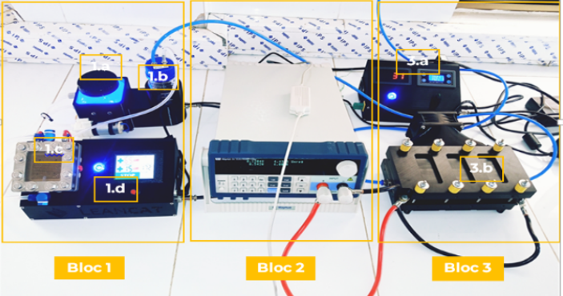
Fig 1. Voltage and current measuring equipment (Leode et al., 2024)

Demineralized water is supplied to the proton exchange membrane electrolyzer, where it is decomposed into hydrogen and oxygen. The generated hydrogen is directed toward the fuel cell stack, while oxygen and excess water are recirculated. Within the fuel cell, hydrogen is oxidized at the anode, producing protons and electrons. The protons migrate through the Nafion 115 membrane, whereas electrons flow through the external circuit, generating electrical current.
At the cathode, oxygen reacts with protons and electrons to form water according to the following electrochemical reactions (yang et al., 2021; Pradeep et al., 2025):
Anode:
H₂ → 2H⁺ + 2e⁻ (1)
Cathode:
O₂ + 4H⁺ + 4e⁻ → 2H₂O + heat (2)
The bipolar plates ensure uniform gas distribution, electrical conduction, and separation of reactants. The system enables controlled measurement of current density and voltage under various operating conditions.
2.2. Description of the Model
The modeled domain of the proton exchange membrane fuel cell (PEMFC) consists of three main regions: the anode (Ωₐ), the proton exchange membrane (Ωₘ), and the cathode (Ω𝑐), as illustrated in Figure 2. Each electrode is connected to a gas distribution system including an inlet channel, a current collector, and an outlet channel.
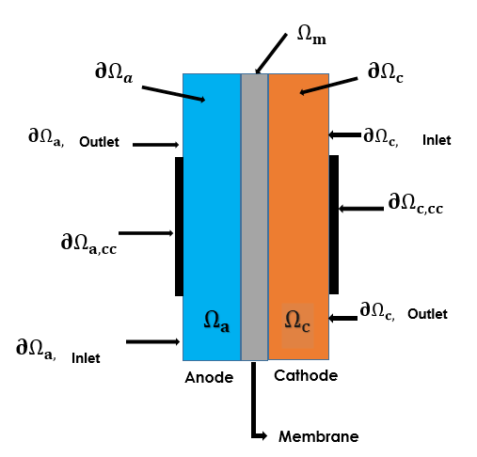
Fig 2. Model geometry with domain and boundary labels (Nazemian et al., 2020).

The reactant gases (humidified hydrogen at the anode and humidified air at the cathode) are treated as ideal gases. Their transport within the porous electrodes is governed by coupled diffusion and convection mechanisms. The electrodes are modeled as homogeneous porous media with uniform structural properties such as porosity and permeability.
Gas flow within the porous structure is described using Darcy’s law, assuming a continuous fluid phase. Electrochemical reactions occurring in the catalyst layers are represented using an agglomerate model, where catalyst particles and carbon are embedded in a polymer electrolyte matrix. This approach is based on the analytical solution of a diffusion–reaction problem in a spherical porous particle.The model integrates mass transport, momentum conservation, and electrochemical kinetics to describe the multiphysics behavior of the PEMFC. The governing equations and associated sub-models used in the simulations are detailed in the following sections
2.3. Governing Equations and Transport Model
This section presents the governing equations used to describe mass, momentum, and charge transport within the gas diffusion layers (GDL), catalyst layers, and membrane of the PEM fuel cell.
2.3.1. Mass and Momentum Conservation (Darcy’s Law)

Gas transport in the porous electrodes is described using Darcy’s law, assuming steady-state flow and a continuous gas phase (Ruan et al., 2025):
∇·(ρu) = 0; u = −(kₚ / μ) ∇p (3)
where u is the velocity vector (m/s), kₚ is the permeability (m²), μ is the dynamic viscosity (Pa·s), and p is the pressure (Pa).
The gas density is expressed as:
ρ = (p / RT) ∑ Mᵢ xᵢ (4)
where R is the universal gas constant, T is the temperature, Mᵢ is the molar mass, and xᵢ is the molar fraction of species i.
2.3.2. Charge Equilibrium Charge Conservation and Transport

The hydrogen fuel cell interface is used to model the potential distributions in the three domains, which local current density expressions, for the anode and cathode are given by the following equation (Zhang et al., 2025):
$i_{e}=\frac{R_{agg}}{3}j_{agg,e}$ (5)
Where the subscript e represents « a » (anode) or « c » (cathode), $R_{agg}$is the radius of the agglomerate in m and $j_{agg,a}$ and $j_{agg,c}$ (in A/m³) are the current densities given by the agglomerate model, $ε_{mac}$ is porosity (the macroscopic porosity) The specific surface area of the fine gas diffusion electrode (in 1/m) can be calculated by the following formula:
${ a}_{υ}=\frac{3}{R_{agg}}\left(1-ε_{mac}\right)$ (6)
2.3.3. Charge Conservation and Transport
Charge transport in the solid phase is governed by Ohm’s law: (Igari et al., 2026)
iₛ = −σₛ ∇ϕₛ (7)
where iₛ is the current density (A/m²), σₛ is the electrical conductivity (S/m), and ϕₛ is the electric potential (V).
2.3.4. Agglomerate Reaction Model
Electrochemical reactions in the catalyst layers are described using an agglomerate model, which accounts for diffusion–reaction processes within spherical porous particles. The local current density is expressed as (Pant et al., 2017):
$j_{agg,e}=6n_{e}F\left(\frac{D_{agg}}{R_{agg}^{2}}\right)\left(1-λ_{e}cothλ_{e}\right)β_{e}$ (8)
where $D_{agg}$ is the effective diffusivity (m²/s), $R_{agg}$ is the agglomerate radius (m), nₑ is the number of electrons transferred, F is Faraday’s constant and $λ_{e}$describes the equilibrium between electrochemical kinetics and mass transport.
.
2.3.5. Multicomponent Mass Transport (Maxwell–Stefan)
Species transport is modeled using the Maxwell–Stefan equations for multicomponent diffusion (Farsi et al., 2025; Berger et al., 2025):
∇·Jᵢ = 0 (9)
where the flux Jᵢ includes diffusion and convection contributions.
In porous media, the effective diffusion coefficient is corrected as:
$D_{ij,eff}=ε_{g}τ_{g}^{-1}D_{ij }$ (10)
where ε is the porosity and $τ_{g}$ is the tortuosity.
To account for the structural anisotropy of the GDL, tortuosity is no longer treated as a scalar but as a second-order diagonal symmetric tensor in order to account for anisotropic transport:
$τ_{g}=\left[\begin{matrix}τ_{g},xx & 0 \\ 0 & τ_{g},yy\end{matrix}\right]$ (11)
Where $τ_{g},xx$ et $τ_{g},yy$ represent the tortuosity factors in the transverse (across the thickness of the GDL) and planar (along the GDL) directions, respectively.
This representation allows us to distinguish the resistance to diffusion along two principal orthogonal directions. Thanks to this tensor formulation, the model can reproduce phenomena such as the preferential lateral diffusion of reactants or the accumulation of water in certain regions, which the isotropic approach cannot capture. It is precisely this ability to describe directional transport heterogeneities that forms the basis of our analysis of anisotropic tortuosity as a novel aspect of the study.
2.3.6. Membrane Transport
Water transport in the membrane includes both diffusion and electro-osmotic drag (Nie et al., 2024):
$N_{H_{2}O}^{m}=n_{d}\frac{-σ_{m}∇∅_{m}}{F}- D_{H_{2}O}^{m} ∇C_{H_{2}O}$ (12)
where $n_{d}$is the electro-osmotic drag coefficient, σₘ is the membrane conductivity, and $C_{H_{2}O}$ is the water concentration.
2.3.7. Electrochemical Kinetics
The electrochemical reactions are described using the Butler–Volmer equation (Wang et al., 2024):
$j=j_{ref}\left(\frac{C}{C_{ref}}\right)\left[exp\left(\frac{α_{a}Fn_{act}}{RT}\right)-exp\left(\frac{-α_{c}Fn_{act}}{RT}\right)\right]$ (13)
where $j_{ref}$ is the exchange current density, α is the charge transfer coefficient, and η is the activation overpotential.

2.3.8. Boundary Conditions
Boundary conditions are defined on all external boundaries of the calculation domain in order to describe the behaviour of the fluid and chemical species.
At the channel inlet, a Dirichlet condition is applied: it directly sets the values of the main variables, such as velocity, pressure and species concentrations. This means that the characteristics of the gas mixture are known at the inlet.
At the outlet of the channels, a Neumann condition is used. This assumes that the velocity, pressure and concentration gradients in the direction of flow are zero. In other words, the variables no longer vary when they leave the domain, which corresponds to a free outlet of the fluid. Finally, on the channel walls and at the ends of the MEA, the conditions applied to pressure, velocities and concentrations are also Neumann-type. This reflects the absence of material flow and pressure variation across these surfaces, which are considered impermeable.
The table below provides information on the boundary conditions used in this study.
Table 1. Conditions at the Anode Boundaries.
Velocity Field (Described by Darcy's Law) | $$∂Ω_{collecteur}^{out}, Ω_{GDL}^{sys}:nu=0;$$  $∂Ω_{GDL}^{in}:P=p_{a,in};$  $∂Ω_{GDL}^{out}:P=p_{ref};$  $∂Ω_{mem-GDL}^{a}: -nu=\frac{i_{a}}{ρF}\left(\frac{M_{H2}}{2}+ λ_{H2O}M_{H2O}\right)$
Mass transit | $dΩ_{collecteur}^{a}, dΩ_{GDL}^{a, sys}: --n_{a}\left(-ρw_{H2}D_{H2-H2O}\left[∇x_{H20}+\left(x_{H20}-w_{H20}\right).\frac{∇P}{P}\right]+ρw_{H2}u\right)=0; dΩ_{GDL}^{a, in}: w_{O2}= w_{O2, in};$  $dΩ_{GDL}^{a, out}: ∇.\left(-ρw_{H2}D_{H2-H2O}\left[∇x_{H20}+\left(x_{H20}-w_{H20}\right).\frac{∇P}{P}\right]\right)=0$;  $dΩ_{mem-GDL}^{a, }:-n.N_{H2}=\frac{i_{0}}{2F} M_{H2}$
Freight transport | $${∂Ω}_{collecteur}^{out}, ∂Ω_{GDL}^{in}: -ni=0;$$  $$∂Ω_{GDL}^{out}: ∅_{s}=0$$

Table 2. Boundary conditions at the membrane.
Velocity Field (Described by Darcy's Law) | $$-$$
Mass transit | $$-$$
Freight transport | $∂dΩ_{mem}^{, sys}: n∇∅_{m}=0;$  $$dΩ_{GDL-mem}^{a}: = -n\left(σ_{m}∇∅_{m}\right)=i_{a};$$  $dΩ_{GDL-mem}^{c}: -n\left(σ_{m}∇∅_{m}\right)=i_{c}$
Table 3. Conditions at the Cathode Boundaries
Velocity Field (Described by Darcy's Law) | $$∂Ω_{collecteur}^{out}, Ω_{GDL}^{sys}:nu=0;$$  $∂Ω_{GDL}^{in}:P=p_{c,in};$  $∂Ω_{GDL}^{out}:P=p_{ref};$  $∂Ω_{mem-GDL}^{c}:$  $-nu=\frac{i_{c}}{ρF}\left(\frac{M_{H2}}{4}+ \left(\frac{1}{2}+ λ_{H2O}\right)M_{H2O}\right)$
Mass transit | $∇.\left(-ρw_{O2\sum_{j}{D_{O2,j}}}\left[∇x_{j}+\left(x_{j}-w_{j}\right).\frac{∇P}{P}\right]+ρw_{O2}u\right)$=0;  $∇.\left(-ρw_{H2O\sum_{j}{D_{H2O,j}}}\left[∇x_{j}+\left(x_{j}-w_{j}\right).\frac{∇P}{P}\right]+ρw_{H2O}u\right)$=0;  $w_{O2}+ w_{H2}+ w_{N2}=0$
Freight transport | $$∂dΩ_{GDL}^{c, sys}, dΩ_{GDL}^{a, in}, dΩ_{GDL}^{c, out}: -n.i=0;$$  $dΩ_{collecteur: }^{c}∅_{s}=V_{cell}$

3. results

The present study investigates the effects of gas diffusion layer (GDL) microstructure, particularly tortuosity, and operational parameters on the performance of a proton exchange membrane fuel cell (PEMFC). The analysis includes four tortuosity configurations-low isotropic (τₓ = 1.1, τᵧ = 1.1), high isotropic (τₓ = 2.8, τᵧ = 2.8), and two anisotropic cases (τₓ = 1.1, τᵧ = 2.8; τₓ = 2.8, τᵧ = 1.1) as well as variations in porosity, electronic conductivity, gas pressure, and relative humidity.

3.1. Impact of GDL Tortuosity
The influence of tortuosity on the distribution of current density and reactant species is illustrated in Figures 3 to 8.
Figure 3 shows that low isotropic tortuosity produces a uniform current density throughout the anode, promoting efficient utilization of reactants. In contrast, high isotropic tortuosity results in localized reductions in current density due to hindered transport, while anisotropic tortuosity generates directional asymmetry, with higher current along the axis of lower tortuosity and lower current along the axis of higher tortuosity.
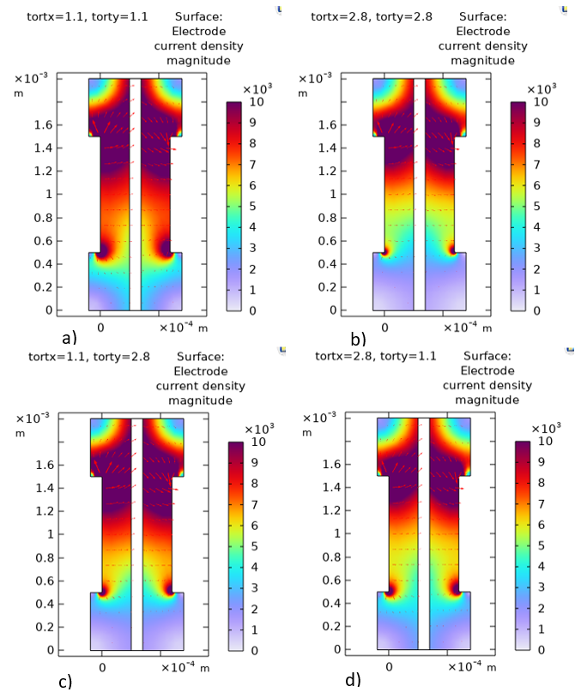
Fig 3. Effect of GDL Tortuosity on Current Density Distribution in the x- and y- Directions:a) tortx=1.1, torty=1.1; b) tortx=2.8, torty=2.8; c) tortx=1.1, torty=2.8; d) tortx=2.8, torty=1.1.
Figures 4 through 6 further reveal the impact of tortuosity on hydrogen and oxygen mass fractions. In the low isotropic case, reactants are distributed homogeneously, ensuring efficient electrochemical reactions. However, high or anisotropic tortuosity induces marked concentration gradients, leading to underutilized zones and limiting reactant accessibility.
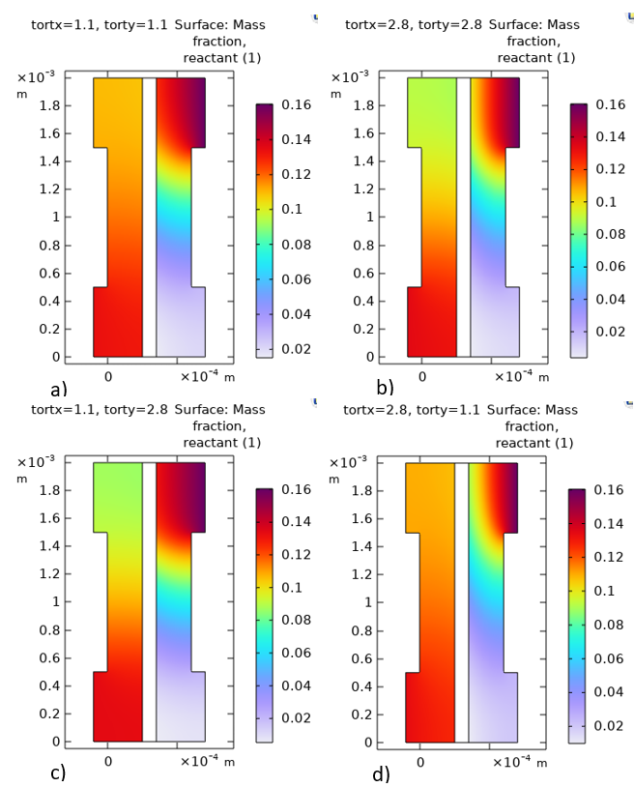
Fig 4. Effect of GDL Tortuosity on Reactant Mass Fractions Distribution in the x- and y- Directions: a) tortx=1.1, torty=1.1; b) tortx=2.8, torty=2.8; c) tortx=1.1, torty=2.8; d) tortx=2.8, torty=1.1.
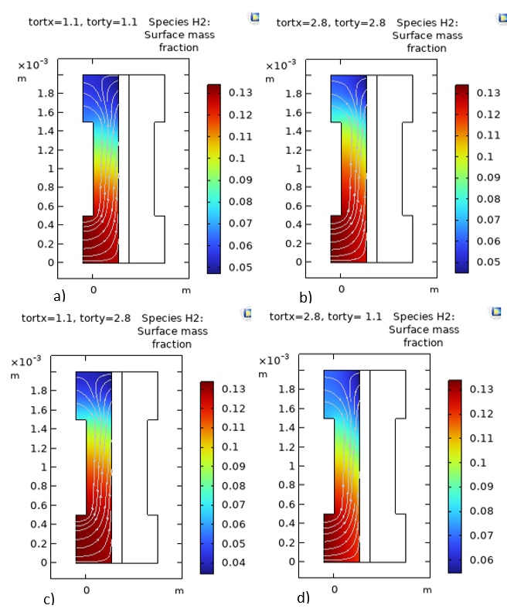
Fig 5. Effect of GDL Tortuosity on Hydrogen Mass Fraction Distribution in the x- and y- Directions: a) tortx=1.1, torty=1.1; b) tortx=2.8, torty=2.8; c) tortx=1.1, torty=2.8; d) tortx=2.8, torty=1.1
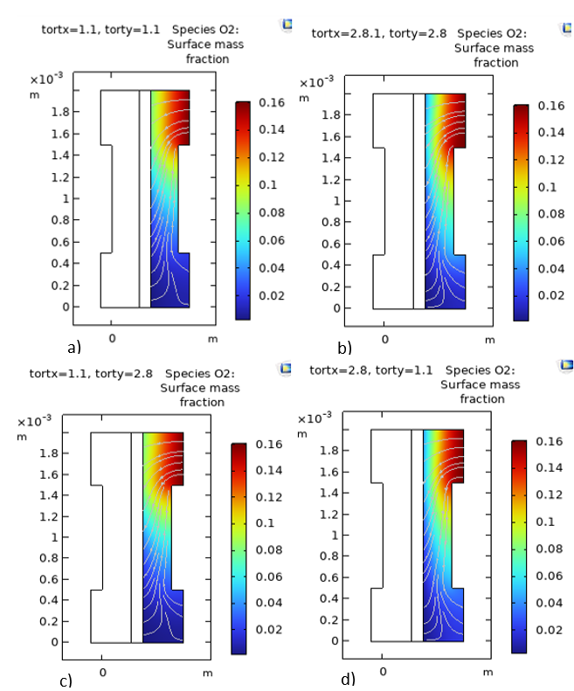
Fig 6. Effect of GDL Tortuosity on Oxygen Mass Fraction Distribution: a) tortx=1.1, torty=1.1; b) tortx=2.8, torty=2.8; c) tortx=1.1, torty=2.8; d) tortx=2.8, torty=1.1.
Similarly, Figure 7 shows that relative humidity is strongly affected by GDL microstructure: low isotropic tortuosity ensures uniform water transport and optimal membrane hydration, while high or anisotropic configurations create dry or flooded regions, reducing proton conductivity and overall cell performance.

Collectively, these results indicate that GDL tortuosity is a critical geometric parameter, with low isotropic tortuosity providing the most favorable conditions for uniform current density, reactant distribution, and water management.
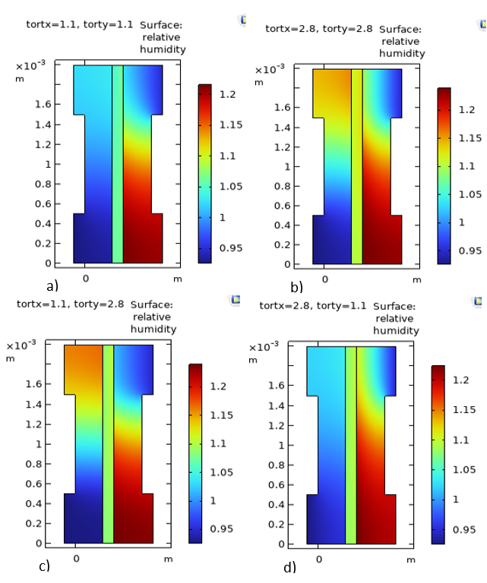
Fig 7. Effect of Tortuosity on Relative Humidity Distribution in the PEM Fuel Cell: a) tortx=1.1, torty=1.1; b) tortx=2.8, torty=2.8; c) tortx=1.1, torty=2.8; d) tortx=2.8, torty=1.1

3.2. Effect of Operating Parameters

Beyond microstructural effects, several operational parameters significantly influence PEMFC performance.
Figure 8 illustrates the variation of current density within the anode active layer as a function of cell height (i.e. Vertical position). Here, the cell height represents the spatial coordinate used to examine the distribution of different tortuosity configurations on this distribution.
In this figure, an uneven distribution of current density across the layer is observed for both configurations. Despite these variations, the curves for each configuration follow a similar general trend, with the current density exhibiting significant variations in the x and y directions due to tortuosity effects. A comparison between the two types of tortuosity reveals marked differences. The highest current density is achieved when tortuosity is low and isotropic, whereas it is lower in the configuration with isotropic tortuosity. Thus, low tortuosity, particularly when isotropic, promotes optimal anode performance by facilitating mass transport and ensuring a more homogeneous current distribution.
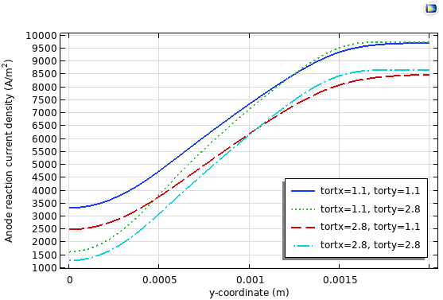
Fig 8. Current Density Distribution in the Anode Catalyst Layer for Two GDL Tortuosity Configurations.
Figure 9 illustrates the effect of gas diffusion layer (GDL) tortuosity on the polarization curve of the proton exchange membrane fuel cell (PEMFC). The different curves, corresponding to various tortuosity configurations, exhibit similar general shapes and can be divided into three characteristic performance regions: activation losses, ohmic losses, and mass transport (concentration) losses.
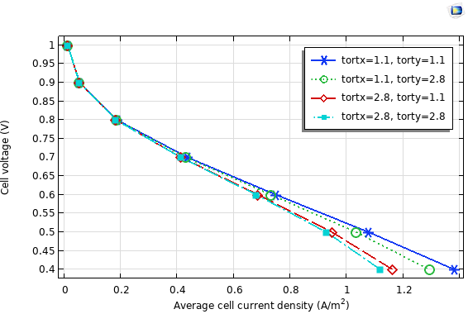
Fig 9. Polarization Curves of the PEM Fuel Cell for Different GDL Tortuosity Conditions.
Activation zone (0-0.2 A/m²): a sharp drop in voltage is observed at low current density. This phenomenon is linked to the activation potential, which reflects the kinetics of electrochemical reactions at the anodic and cathodic interfaces.
Ohmic zone (0.2-0.8 A/m²): Linear decrease in voltage with increasing current density, reflecting ohmic losses due to resistance to proton transport across the membrane and electron conduction through the electrodes and interconnections.
Mass transport zone (0.8-1.4 A/m²): The cell voltage drops rapidly with increasing current density.
This figure also shows that an increase in tortuosity significantly limits the diffusion of reagents, leading to a reduction in cell efficiency of up to 20–80% at low current densities. Analysis of the polarisation curves reveals a decrease in cell efficiency as tortuosity increases.

This results from mass transport limitations, where depletion of reactants (mainly oxygen) at the catalytic sites hinders the electrochemical reaction, leading to concentration. These different results imply that the best performance is achieved for low isotropic tortuosity, where reactant transport is most efficient and voltage losses are minimized.

3.3. Assessment of the Model’s Performance Compared to Experimental Data
To validate the model qualitatively, simulated polarization curves were compared with experimental data from the laboratory PEMFC stack (Figure 10). The model successfully reproduces the three characteristic regions of PEMFC operation:
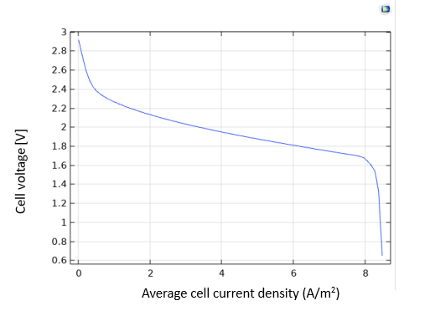
Fig 10. Experimental voltage curve.
(a) Activation region: Rapid voltage drop at low current density due to electrochemical reaction kinetics.
(b) Ohmic region: Linear voltage decrease at intermediate currents reflecting ionic and electronic resistance.
(c) Mass transport region: Sharp voltage drop at high currents due to reactant depletion in the diffusion and catalytic layers.
Although minor deviations exist due to parameter approximations, the model captures the essential trends of the experimental data, confirming its capability to represent key electrochemical phenomena.
3.4. Other Parameters Affecting PEMFC Performance
Beyond microstructural effects, several operational parameters significantly influence PEMFC performance.
Electrical conductivity of the GDL strongly affects ohmic losses. Figure 11 shows that increasing conductivity from 20 S/m to 1000 S/m markedly enhances cell voltage by facilitating electron transport. Conductivities above 1000 S/m show negligible additional improvement, indicating an optimal range for practical applications.
Porosity influences mass transport and water management, as shown in Figure 12. Moderate porosity (~0.6) improves oxygen diffusion to the cathode and water removal, resulting in higher voltage at a given current density. Further increases in porosity above 0.8 yield limited benefits and may compromise mechanical stability.
Gas pressure also plays a key role. As illustrated in Figure 13, increasing anode and cathode pressures from 1 to 4 atm raises cell voltage by approximately 6% at 1 A/cm², due to higher partial pressures of hydrogen and oxygen. However, pressures above 4 atm provide marginal improvements and introduce risks such as membrane drying and mechanical stress.
Relative humidity (RH) affects both proton conductivity and water management. Figure 14 demonstrates that optimal performance is achieved at RH between 60% and 80%. At low RH (40%), membrane dehydration reduces proton conductivity, whereas high RH (>80%) can cause flooding in porous layers, limiting gas transport and reducing efficiency.

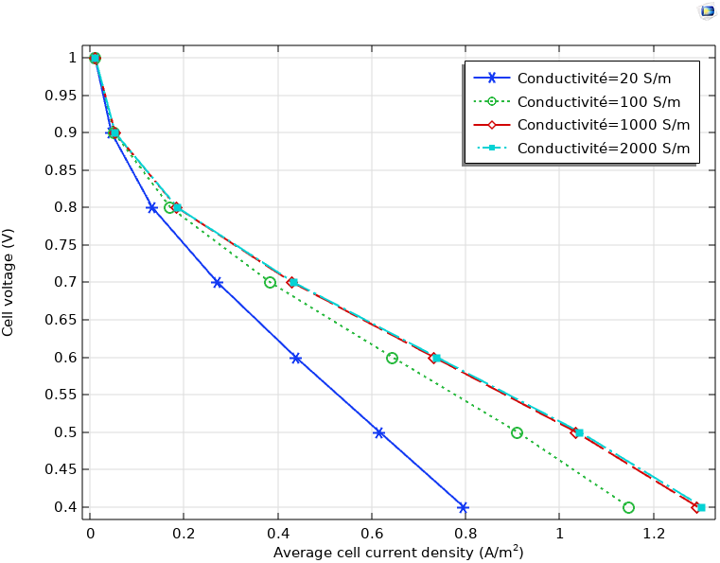
Fig 11. Effect of electrical conductivity on PEM Fuel Cell Performance.
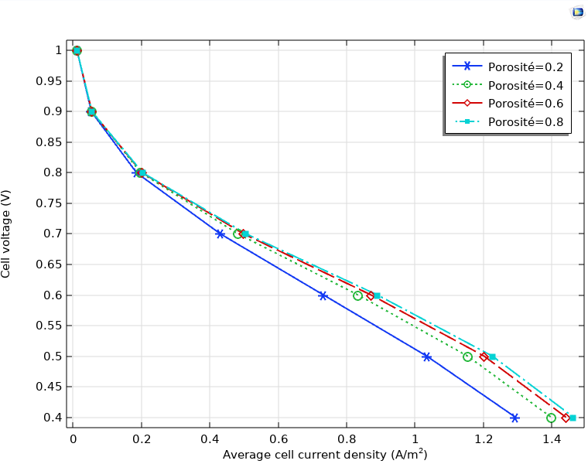
Fig 12. Effect of Porosity on PEM Fuel Cell Performance.
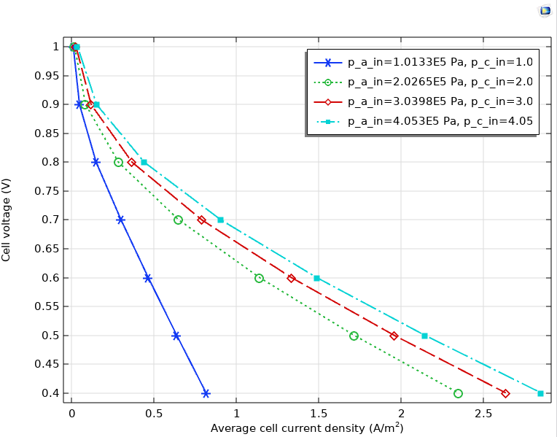
Fig 13. Effect of Anode and Cathode Gas Pressure on PEM Fuel Cell Performance.

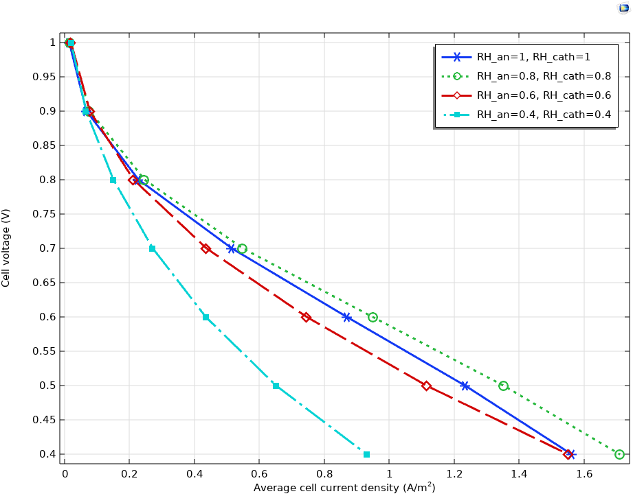
Fig 14. Effect of Relative Humidity on PEM fuel cell Performance.
3-5- Discussion
The combined analysis of microstructural and operational parameters highlights their strong interdependence in determining PEMFC performance. As demonstrated in Figures 3-8, low isotropic tortuosity ensures homogeneous distributions of current density, reactants, and relative humidity, thereby enhancing electrochemical efficiency. Conversely, high or anisotropic tortuosity introduces spatial heterogeneities, leading to increased concentration gradients and reduced reactant accessibility.
In addition to tortuosity, other parameters such as porosity, electrical conductivity, gas pressure, and relative humidity significantly influence cell behavior (Figures 11-14). Moderate porosity improves mass transport and water management, while increased conductivity reduces ohmic losses. Similarly, optimized pressure and humidity conditions enhance reactant availability and membrane hydration, although extreme values may negatively affect durability. The results show that increasing tortuosity significantly limits reactant diffusion, leading to a reduction in cell performance of up to 20 – 80 % at low current densities (Chen et al., 2025).
These findings are consistent with previous studies (Ceballos et al., 2022; Ullah et al., 2026), which emphasize the importance of coupling microstructural design with operating conditions to achieve optimal performance.
However, several limitations of the present study should be acknowledged. First, the GDL is modeled as a homogeneous porous medium with uniform properties, which may not fully capture the complex and heterogeneous microstructure observed in real materials. Second, the simulations are based on a two-dimensional representation, which limits the accurate description of three-dimensional transport phenomena. Third, some simplifying assumptions were adopted, such as steady-state conditions and ideal gas behavior, which may not fully reflect transient or non-ideal operating conditions encountered in practical systems. Finally, the validation of the model remains qualitative, as a fully quantitative comparison with experimental data was not performed.
Despite these limitations, the model successfully captures the main physical and electrochemical trends governing PEMFC operation. Future work should focus on incorporating three-dimensional reconstructed microstructures, transient modeling, and more detailed experimental validation to further improve predictive accuracy.
4. CONCLUSION
This study, based on COMSOL Multiphysics modeling of species transport in PEM fuel cells, highlights the critical role of the gas diffusion layer (GDL) microstructure, particularly tortuosity, on cell performance. Low isotropic tortuosity promotes homogeneous distributions of reactants, water, and current density, leading to improved electrochemical efficiency. Conversely, high or anisotropic tortuosity introduces concentration gradients and diffusion losses, reducing performance. Operating parameters such as porosity, gas pressure, relative humidity, and electrical conductivity further modulate these effects, acting synergistically with the GDL microstructure.
The results show that increasing tortuosity significantly limits reactant diffusion, leading to a reduction in cell performance of up to 20 – 80 % at low current densities.
Although the model captures the main physical trends, some limitations should be noted. The GDL was considered homogeneous, the simulations were two-dimensional, and steady-state conditions with ideal gas assumptions were used. Moreover, experimental validation was qualitative rather than quantitative. These limitations suggest that future work should focus on three-dimensional modeling, transient behavior, and more detailed experimental comparisons to refine predictive accuracy.
Ultimately, the integration of strategies that combine the microstructural design of GDLs with adaptive control of operating parameters appears to be the most promising approach for achieving both high performance and increased durability of PEMFCs in practical applications.

Disclaimer (Artificial intelligence)

Author(s) hereby declare that NO generative AI technologies such as Large Language Models (ChatGPT, COPILOT, etc.) and text-to-image generators have been used during the writing or editing of this manuscript.

References

Alaswad, A., Omran, A., Sodre, J. R., Wilberforce, T., Pignatelli, G., Dassisti, M., Baroutaji, ., &
Olabi, A. G. (2021). Technical and Commercial Challenges of Proton-Exchange
Membrane (PEM) Fuel Cells. Energies, 14(1), 144. https://doi.org/10.3390/en14010144
Arvay, A., Yli-Rantala, E., Liu, C. H., Peng, X. H., Koski, P., Cindrella, L.,... & Kannan, A. M.
(2012). Characterization techniques for gas diffusion layers for proton exchange membrane fuel cells–A review. Journal of Power Sources, 213, 317-337. https://doi.org/10.1016/j.jpowsour.2012.04.026
Berger, A., Striednig, M., Simon, C., & Gasteiger, H. A. (2025). Determination of the τ/ε-Ratio
for gas diffusion substrates and microporous layers in a proton exchange membrane fuel cell. Journal of The Electrochemical Society, 172(1), 014508. https://doi.org/10.1149/1945-7111/ada63e

Ceballos, J. O., Ordoñez, L. C., & Sierra, J. M. (2022). Numerical simulation of a PEM fuel
cell: Effect of tortuosity parameters on the construction of polarization curves. International Journal of Hydrogen Energy, 47(70), 30291-30302. https://doi.org/10.1002/cctc.202401286

Chen, J., Gao, W., Ning, T., Meng, L., Yin, Y., Ouyang, H., & Wang, C. (2025). Effect of GDL
compression on PEMFC performance: A comprehensive cross-scale study. Chemical Engineering Journal, 503, 158542. https://doi.org/10.1016/j.cej.2024.158542

Farsi, A., Zhu, L., Seip, T., & Bazylak, A. (2025). Predicting Liquid Organic Hydrogen Carrier
Saturation in ehydrogenation Cell Gas Diffusion Layers for Hydrogen Storage. ChemCatChem, 17(16),e202401286. https://doi.org/10.1002/cctc.202401286
Igari, R., Edmundson, D. D., Dichiara, A. B., & Takana, H. (2026). Power generation
mechanism by ion transport in electrically conductive papers. Energy Conversion and Management: X, 101739. https://doi.org/10.1016/j.ecmx.2026.101739
Jing, S. Y., Sun, Z. Y., Yang, L., & Wang, Y. (2024). Effects of porosity and porosity
distribution in gas diffusion layer on the performances of proton exchange membrane fuel cell. Journal of Power Sources, 613, 234957. https://doi.org/10.1016/j.jpowsour.2024.234957
Léodé, A. E., & Agnimonhan, F. H. Review on the Proton Exchange M. Fuel Cells
(PAFC), 14, 15. www.isca.in
Majlan, E. H., Rohendi, D., Daud, W. R. W., Husaini, T., & Haque, M. A. (2018). Electrode
for proton exchange membrane fuel cells: A review. Renewable and Sustainable Energy Reviews, 89, 117-134. https://doi.org/10.1016/j.rser.2018.03.007
Molaeimanesh, G. R., & Nazemian, M. (2017). Investigation of GDL compression effects on
the performance of a PEM fuel cell cathode by lattice Boltzmann method. Journal of Power Sources, 359, 494-506. https://doi.org/10.1016/j.jpowsour.2017.05.078
Nabovati, A., Hinebaugh, J., Bazylak, A., & Amon, C. H. (2014). Effect of porosity
heterogeneity on the permeability and tortuosity of gas diffusion layers in polymer electrolyte membrane fuel cells. Journal of Power Sources, 248, 83-90. https://doi.org/10.1016/j.jpowsour.2013.09.061
Nazemian, M., & Molaeimanesh, G. R. (2020). Impact of carbon paper structural parameters
on the performance of a polymer electrolyte fuel cell cathode via lattice Boltzmann method. Acta Mechanica Sinica, 36(2), 367-380. https://doi.org/10.1007/s10409-019-00919-1
Niblett, D., Niasar, V., & Holmes, S. (2019). Enhancing the performance of fuel cell gas
diffusion layers using ordered microstructural design. Journal of The Electrochemical Society, 167(1), 013520. https://doi.org/10.1149/2.0202001JES
Nie, Y., Sun, Z., & Chen, Z. (2024, July). Simulation of Water Transport in Proton Exchange
Membrane Fuel Cell Using a One-dimension Model. In 2024 IEEE 25th China Conference on System Simulation Technology and its Application (CCSSTA) (pp. 1-5). IEEE. https://doi.org/10.1109/CCSSTA62096.2024.10691739.
Ozden, A., Shahgaldi, S., Li, X., & Hamdullahpur, F. (2019). A review of gas diffusion layers
for proton exchange membrane fuel cells—With a focus on characteristics, characterization techniques, materials and designs. Progress in Energy and Combustion Science, 74, 50-102. https://doi.org/10.1016/j.pecs.2019.05.002
Pant, L. M., Mitra, S. K., & Secanell, M. (2011, January). Mass transport measurements in
porous transport layers of a PEM fuel cell. In International Conference on Nanochannels, Microchannels, and Minichannels (Vol. 44632, pp. 257-262). https://doi.org/10.1115/ICNMM2011-58181
Pant, L. M., & Weber, A. Z. (2017). Communication—Modeling polymer-electrolyte fuel-cell
agglomerates with double-trap kinetics. Journal of The Electrochemical Society, 164(11), E3102-E3104. ). https://doi.org/10.1149/2.0111711jes
Pradeep, K., Jeffery, A. A., Sundaresan, A. P., Gunaseelan, R., Rajendran, S., Karthik, P.
E., ... & Selvam, N. C. S. (2025). Impact of catalyst engineering on the durability performance of self-supported catalysts in anion exchange membrane water electrolyzers: recent advances and perspectives. Journal of Materials Chemistry A, 13(20), 14510-14539. https://doi.org/10.1039/D5TA00208G
Ramaswamy, N., Gu, W., Ziegelbauer, J. M., & Kumaraguru, S. (2020). Carbon support
microstructure impact on high current density transport resistances in PEMFC cathode. Journal of The Electrochemical Society, 167(6), 064515. https://doi.org/10.1149/1945-7111/ab819c
Ruan, L., Rybak, I. A Hybrid-Dimensional Stokes–Brinkman–Darcy Model for Arbitrary Flows
to the Fluid–Porous Interface. Transp Porous Med 152, 75 (2025). https://doi.org/10.1007/s11242-025-02220-1

Santamaria, A. D., Das, P. K., MacDonald, J. C., & Weber, A. Z. (2014). Liquid-water
interactions with gas-diffusion-layer surfaces. Journal of The Electrochemical Society, 161(12), F1184. https://doi.org/10.1149/2.0321412jes
Shu, Q. Z., Xia, Z. X., Wei, W., Xu, X. L., Wang, S. L., Zhao, H., & Sun, G. Q. (2021). A
novel gas diffusion layer and its application to direct methanol fuel cells. New Carbon Materials, 36(2), 409-419. https://doi.org/10.1016/s1872-5805(21)60017-3
Tayarani-Yoosefabadi, Z., Harvey, D., Bellerive, J., & Kjeang, E. (2016). Stochastic
microstructural modeling of fuel cell gas diffusion layers and numerical determination of transport properties in different liquid water saturation levels. Journal of Power Sources, 303, 208-221. https://doi.org/10.1016/j.jpowsour.2015.11.005
Ullah, A., Ahmad, S., Ali, T., Samreen, A., Saher, S., Arif, M. Z., & Kannan, A. M. (2026).
Advanced fabrication strategies for Durable, High-Efficiency, and scalable solid oxide fuel cells. Fuel, 407, 137515. https://doi.org/10.1016/j.fuel.2025.137515
Wang, C. Y. (2004). Fundamental models for fuel cell engineering. Chemical Reviews, 104(10), 4727-
4766. https://doi.org/10.1021/cr020718s
Wang, Y., & Wang, S. (2017). Evaluation and modeling of PEM fuel cells with the
Bruggeman correlation under various tortuosity factors. International Journal of Heat and Mass Transfer, 105, 18-23. https://doi.org/10.1016/j.ijheatmasstransfer.2016.09.030
Wang, L. S., & Haile, S. M. (2024). From Fundamental Interfacial Reaction Kinetics to
Macroscopic Current–Voltage Characteristics: Case Study of Solid Acid Fuel Cell Limitations and Possibilities. Advanced Materials Interfaces, 11(20), 2400119. https://doi.org/10.1002/admi.202400119

Xiao, L., Bian, M., Zhu, L., Duan, K., Leng, W., Zeis, R.,... & Zhang, H. (2022). High-density
and low-density gas diffusion layers for proton exchange membrane fuel cells: Comparison of mechanical and transport properties. International Journal of Hydrogen Energy, 47(53), 22532-22544. https://doi.org/10.1016/j.ijhydene.2022.05.092
Yang, W., Zhu, L., Wang, S., Yin, Z., Xiao, L., Shao, Q.,... & Sui, P. C. (2022). Investigation
of fabrication of gas diffusion substrate for proton exchange membrane fuel cells. International Journal of Hydrogen Energy, 47(83), 35423-35436. https://doi.org/10.1016/j.ijhydene.2022.08.094
Yang, H., Driess, M., & Menezes, P. W. (2021). Self‐supported electrocatalysts for practical
water electrolysis. Advanced energy materials, 11(39), 2102074. https://doi.org/10.1002/aenm.202102074Digital Object Identifier (DOI)

Yu, Z., Carter, R. N., & Zhang, J. (2012). Measurements of pore size distribution, porosity,
effective oxygen diffusivity, and tortuosity of PEM fuel cell electrodes. Fuel Cells, 12(4), 557-565. https://doi.org/10.1002/fuce.201200017
Zhang, H., Rahman, M. A., Mojica, F., Sui, P. C., & Chuang, P. Y. A. (2021). A
comprehensive two-phase proton exchange membrane fuel cell model coupled with anisotropic properties and mechanical deformation of the gas diffusion layer. Electrochimica Acta, 382, 138273. https://doi.org/10.1016/j.electacta.2021.138273
Zhang, W., Lu, X., Bück, A., He, Z., Tsotsas, E., & Jiang, Z. (2025). Pore network simulation
of HT-PEMFC GDL using radical Voronoi tessellation: Analysis of oxygen, phosphoric acid solution, and charge transport. International Journal of Heat and Mass Transfer, 246, 127025. https://doi.org/10.1016/j.ijheatmasstransfer.2025.127025

