Effect of Geomagnetic Storms on Space Weather During the Ascending Phase of Solar Cycle 24

.
ABSTRACT

Space weather disturbances are significantly influenced by geomagnetic storms, which arise from intensified solar wind–magnetosphere coupling. This study examines the correlative dynamics of solar activity indicators (Sunspot Number, F10.7 index), interplanetary parameters (solar wind plasma speed, IMF Scalar B), and planetary geomagnetic activity (Dst, Ap, auroral electrojet indices) during this extraordinary space weather regime. A statistical methodology based on correlation analysis and linear regression techniques is employed using multi-source observational datasets (e.g., OMNI database and geomagnetic indices) to quantify relationships among these parameters. The analysis reveals a profound disassociation between solar activity eruption rate and terrestrial storm intensity. Even though solar activity indicators, like sunspot numbers, showed strong increases in solar activity towards solar maximum, equatorial ring current activity (Dst index) was notable for its lack of strong excursions (Dst ≤ -100 nT). This is attributed to the extraordinary expansion of Coronal Mass Ejections (CMEs) in the low-pressure solar wind, leading to a dilution of internal magnetic flux. The study concludes that geomagnetic activity was dominated by the kinematic energy of moderate-speed solar wind streams, as opposed to solar magnetic flux emergence. The kinematic energy of solar wind streams was responsible for sustaining localized high-latitude auroral substorms throughout this extraordinary space weather regime. The equatorial magnetic field was found to be undisturbed.

Keywords: Solar Cycle 24, Geomagnetic Storms, Space Weather, Interplanetary Magnetic Field (IMF), Disturbance Storm Time (Dst) Index, Solar wind, Auroral Activity,

1. INTRODUCTION

Geomagnetic storms are a fundamental driver of space weather variability, resulting from enhanced coupling between the solar wind and Earth’s magnetosphere. These events inject large amounts of energy into the magnetosphere–ionosphere system, leading to disturbances in the ring current, auroral electrojets, and ionospheric currents. Consequently, they can disrupt satellite operations, navigation systems, radio communications, and power grid stability. Understanding the impact of geomagnetic storms is therefore essential for improving space weather forecasting and protecting critical technological infrastructure. Prior to Solar Cycle 24 (SC 24), an unusually prolonged period of low solar activity was observed during 2008-2009. This period is considered the lowest in the early twentieth century in terms of solar activity (Russell et al., 2010; Tsurutani et al., 2011). This prolonged period of low activity in SC 24 was characterized by low heliospheric solar wind pressures and interplanetary magnetic fields, as observed in previous solar cycles (McComas et al., 2008; Jian et al., 2011).
During the ascending phase of SC 24, the heliospheric environment was characterized by low heliospheric pressures. This is in contrast to the high heliospheric pressures that were observed during Solar Cycle 23. Sunspot numbers were low during the ascending phase of SC 24. This low activity is attributed to the low heliospheric pressures. Additionally, the low polar magnetic fields affected the low level of solar activity.
Space weather events are mainly driven by the transfer of solar wind energy into the magnetosphere of the Earth through magnetic reconnection at the magnetopause (Dungey, 1961; Gonzalez et al., 1994). The solar wind speed and the southward component of the IMF (IMF B_z) are crucial for the solar wind-magnetosphere coupling. During SC 24, the weakening of the heliospheric magnetic field led to a considerable weakening of the solar wind-magnetosphere coupling efficiency (Baker et al., 2013; Nakagawa et al., 2019).
Although the rate of solar eruptions is proportional to the number of sunspots, the geoeffectiveness of solar eruptions during SC 24 was unexpectedly small. The statistical results indicate that there was a considerable shortage of strong geomagnetic storms during SC 24 compared with SC 23 (Echer et al., 2013; Richardson & Cane, 2012). The anomaly has prompted the re-examination of the effects of background conditions in the heliosphere on solar weather.
Recent studies have further strengthened this interpretation by showing that Solar Cycle 24 was the weakest cycle of the space age in terms of solar wind–magnetosphere energy coupling and overall geomagnetic activity, with reduced occurrence of intense storms and related auroral activity (Hajra, 2021). Statistical analyses of storm occurrence have also shown that SC24 behaved more like a low-activity cycle than a typical stronger cycle, and that the occurrence of intense storms depends on solar-cycle phase rather than scaling simply with sunspot number (Reyes et al., 2021; Watari, 2024). In addition, comparative and catalog-based studies have emphasized that the solar wind–IMF conditions associated with storm main phases, as well as the contribution of high-speed streams and their geomagnetic effects during SC24, must be considered alongside CME occurrence when assessing geomagnetic response (Manu et al., 2022; Besliu-Ionescu et al., 2022). A broader recent review of Earth-affecting solar transients during SC24 also supports the need to interpret geomagnetic response in the context of the evolving heliospheric background and transient propagation conditions (Zhang et al., 2021). However, a clear quantitative assessment of how solar activity proxies, interplanetary parameters, and geomagnetic indices interacted during the ascending phase of Solar Cycle 24 is still needed to explain the apparent mismatch between increasing solar activity and the relatively weak terrestrial storm response. Therefore, the present study aims to quantitatively examine the relationships among solar activity indicators, solar wind parameters, and geomagnetic response during the ascending phase of Solar Cycle 24 in order to clarify why stronger solar activity did not translate into proportionally stronger geomagnetic storms.

2.Data Sources and Methodology

To analyze the space weather environment during the ascending phase of Solar Cycle 24, a multi-instrument observational approach was employed.
Interplanetary Parameters
High-resolution solar wind plasma parameters including velocity (v), density (ρ), and temperature (T), along with interplanetary magnetic field (IMF) vectors, were obtained from the NASA OMNI database. These parameters are fundamental in describing solar wind dynamics. The dynamic pressure of the solar wind is expressed as:
$$P_{dyn}=ρv^{2}$$
which plays a crucial role in magnetospheric compression.
The solar wind–magnetosphere coupling is often governed by the convective electric field:
$$E=-v×B$$
where v is the solar wind velocity and B is the IMF vector. The southward component of the IMF (B_z) is particularly important for magnetic reconnection processes. This database combines near-Earth measurements from spacecraft including Advanced Composition Explorer and the Wind spacecraft. These data sets are widely used for heliospheric and magnetospheric studies (Richardson & Cane, 2010).
Geomagnetic Indices
The intensity of geomagnetic storms was quantified using the Disturbance Storm Time (Dst) index, which represents the strength of the symmetric ring current around Earth (Daglis et al., 1999). The temporal evolution of Dst can be approximated by:
$$\frac{dDst}{dt}=Q(t)-\frac{Dst}{τ}$$
where Q(t) represents the energy injection rate into the ring current and τ is the decay time constant.
Statistical relationships between parameters were evaluated using the Pearson correlation coefficient:
$$r=\frac{∑(x_{i}-\overset{ˉ}{x})(y_{i}-\overset{ˉ}{y})}{σ_{x}σ_{y}}$$
where r quantifies the linear correlation between two variables.
Dst data were obtained from the World Data Center for Geomagnetism, Kyoto. Additional indices such as Kp and AE were used to characterize global geomagnetic activity and auroral electrojet intensity (Kamide et al., 1998).

3. results and discussion

3.1 Solar Drivers and Proxies
The statistical study of the ascending phase of Solar Cycle 24 (2008-2014) has reaffirmed the validity of the commonly used solar activity proxies while also revealing critical anomalies in the physical impacts of solar activity. As depicted in Figure 3, the F10.7 radio flux and the Sunspot Number (R) have a nearly perfect positive linear correlation (r = 0.94, as depicted in the Correlation Heatmap, Figure 6). This has reaffirmed the validity of the assertion that the emergence of magnetic flux from the solar interior has always been accompanied by extreme ultraviolet (EUV) emissions, even during the exceptionally subdued solar cycle ascent. The terrestrial impacts of solar activity, however, have been quite exceptional.

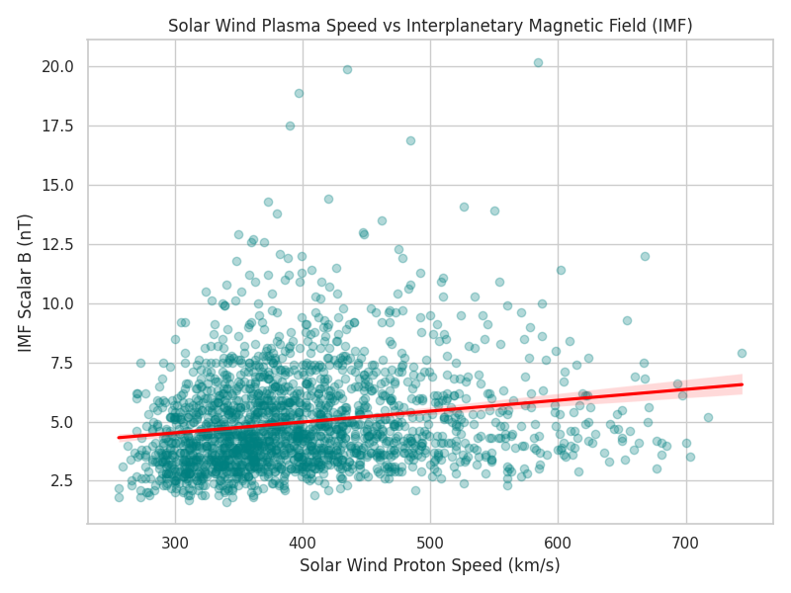
Figure 1: Solar Wind Plasma Speed vs. IMF: Scatter plot showing the relationship between solar wind speed and IMF strength, with wide dispersion indicating weak coupling during the ascending phase of Solar Cycle 24.

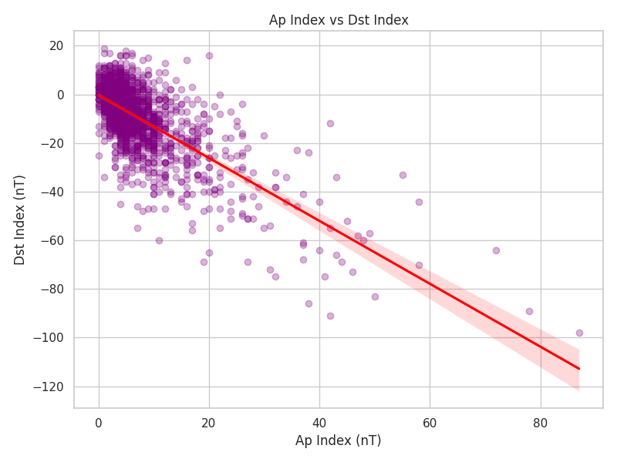
Figure 2: Ap Index vs Dst Index: Scatter plot showing a strong negative correlation between Ap and Dst, indicating that increased global geomagnetic activity corresponds to enhanced ring current intensity during storms.

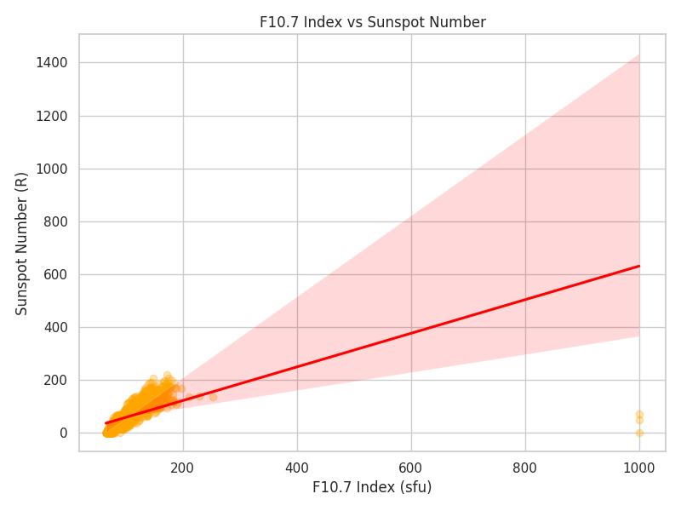
Figure 3: F10.7 Index vs Sunspot Number: Regression showing a near-perfect linear correlation, confirming F10.7 as a reliable proxy for solar activity.

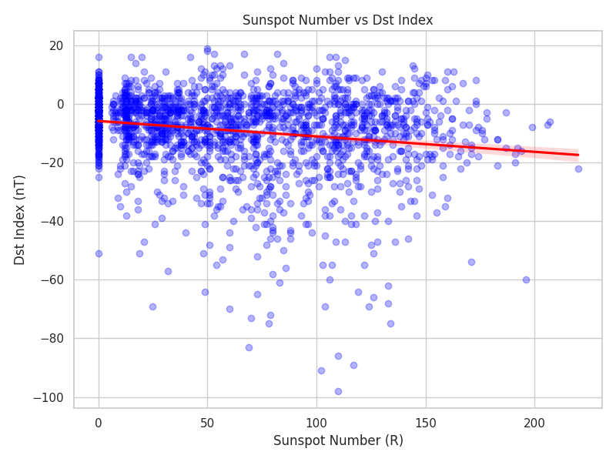
Figure 4: Sunspot Number vs. Dst Index: Scatter plot showing a weak relationship, indicating that higher sunspot activity did not lead to stronger geomagnetic storms during this period.
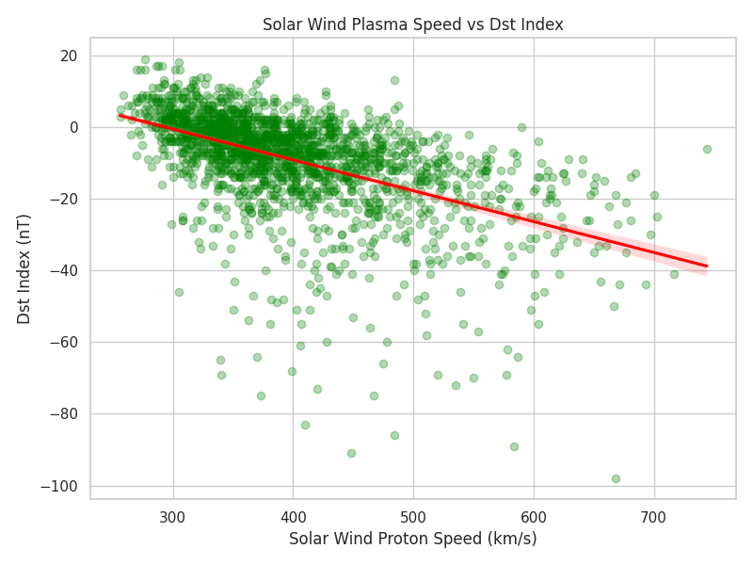
Figure 5: Solar Wind Speed vs. Dst Index: Regression showing a clear negative trend, indicating that higher solar wind speeds are a key driver of geomagnetic storms.

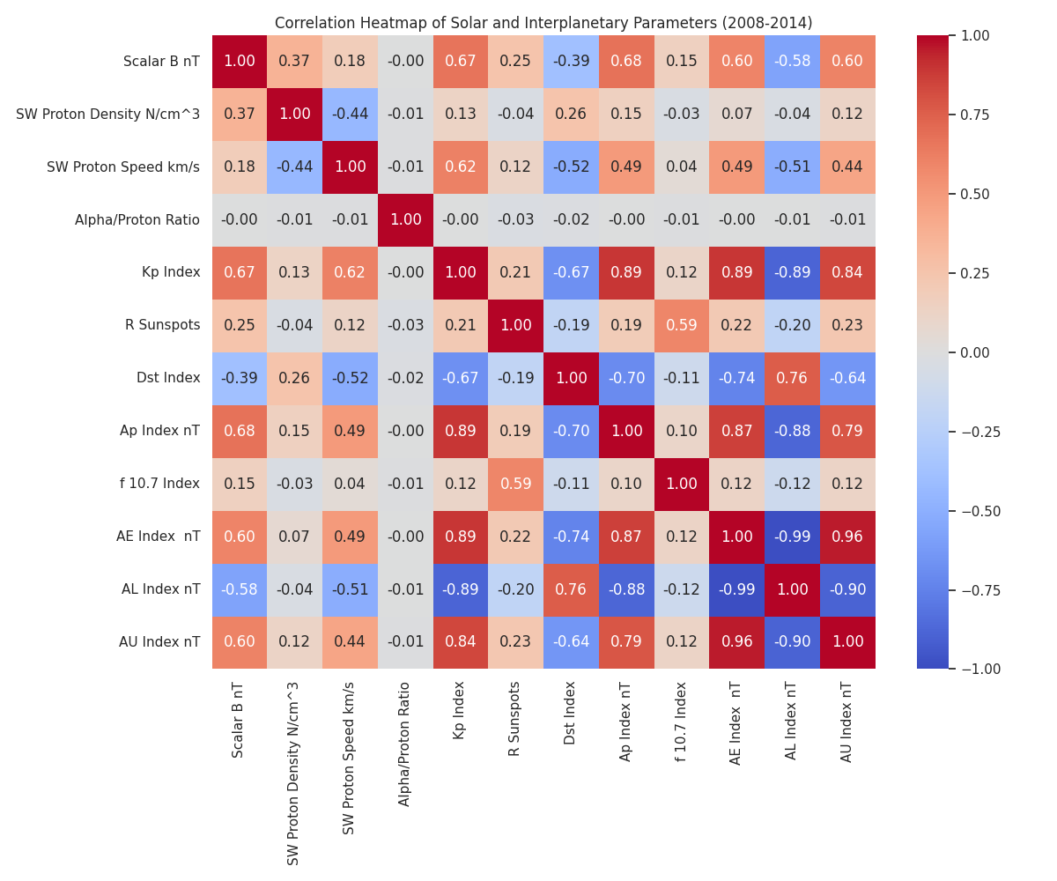
Figure 6: Correlation Heatmap: Pearson matrix showing linear relationships among solar, interplanetary, and ionospheric parameters during the ascending phase of Solar Cycle 24.
3.2 Decoupling of Solar Source and Terrestrial Impact
A major discovery of the present study was the strong decoupling between the unadulterated frequency of solar eruptions (as quantified using sunspots) and the severity of the geomagnetic storms that followed. As depicted in Figure 4, the relationship between the Sunspot Number and the Dst index is remarkably diffuse. The linear regression trendline is nearly flat, showing that even as the Sunspot Number escalated beyond the value of 150 toward the solar maximum, the overwhelming majority of the Dst values was closely concentrated within the range of +20 nT and -50 nT.
These decoupling reveals that, in reality, the Coronal Mass Ejections (CMEs), emanating from these sunspots, frequently occurred but were geo-ineffective. As the CMEs inflated into the exceptionally low-pressure environment of the SC24 heliosphere, the intrinsic magnetic features of the CMEs became volumetrically diluted. As such, the critical component of the magnetic field vector that was directed toward the south (Bz) was systematically weakened when the CMEs reached the 1 AU location.
3.3 The Dominance of Solar Wind Kinematics in Geomagnetic Coupling
Because magnetic coupling at the magnetopause is governed by the convective electric field (E = -v*B), the diluted IMF meant that solar wind velocity (v) played a disproportionately important role in driving space weather during this epoch. This is confirmed by Figure 5, which shows a distinct downward slope between Solar Wind Plasma Speed and the Dst index. Elevated solar wind speeds (often > 400 km/s, associated with Corotating Interaction Regions and high-speed streams) were the most consistent driver of the observed moderate storms, compensating slightly for the weak magnetic fields. Interestingly, Figure 1 shows that Solar Wind Speed and IMF Scalar B are weakly coupled (r = 0.17, per Figure 6). This lack of correlation suggests that the high-speed streams impacting Earth during this phase were not characterized by strongly enhanced magnetic fields, further explaining the statistical deficit of severe (Dst $≤$-100 nT) geomagnetic storms.
3.4 Global and High-Latitude Geomagnetic Responses
Despite the lack of extreme equatorial ring current injections, global planetary and high-latitude auroral zones still experienced significant, persistent energy deposition. The strong negative correlation between the Ap index and the Dst index (r = -0.63, Figure 2 and Figure 6) confirms that periods of enhanced planetary disturbance were indeed linked to ring current activity. Furthermore, the massive internal correlation among the auroral indices (AE, AL, AU) and the Kp index indicates that the continuous buffeting of the Earth by moderate high-speed streams drove frequent, localized substorms in the high-latitude ionosphere, characterizing the primary space weather signature of this anomalous ascending phase. The combined analysis of solar wind parameters and geomagnetic indices demonstrates that geomagnetic storm intensity is controlled by multiple interplanetary parameters acting simultaneously.
The most significant drivers include:
- Solar wind velocity
- Interplanetary magnetic field strength
- Southward IMF orientation
- Magnetospheric energy transfer efficiency
These parameters collectively determine the strength of magnetospheric convection, ring current injection, and auroral electrojet activity. The results support the well-established framework of solar wind–magnetosphere coupling, were enhanced solar wind energy input leads to intensified geomagnetic disturbances.

3.5 Limitations of the Study
This study is primarily based on statistical correlations using observational datasets, which limits the ability to establish clear causal relationships between solar, interplanetary, and geomagnetic parameters. The analysis is confined to the ascending phase of Solar Cycle 24 (2008–2014), and therefore the results may not be directly generalizable to other solar cycles or different phases of solar activity. Additionally, the use of near-Earth (1 AU) measurements does not fully capture the spatial evolution of CMEs and solar wind structures throughout the heliosphere.

4. Conclusion

This correlative analysis characterizes the ascending phase of Solar Cycle 24 as an anomalous epoch in modern heliophysics. Following an exceptionally deep and prolonged solar minimum, the subsequent rise in solar surface activity (Sunspots and F10.7 flux) failed to produce a proportional increase in severe geomagnetic storms. Because CMEs erupted into a highly rarefied heliosphere, their subsequent volumetric expansion diluted their internal magnetic flux, severely limiting their capacity to drive strong dayside magnetic reconnection at Earth.
Consequently, terrestrial space weather during this period was fundamentally decoupled from raw sunspot numbers. Instead, storm intensity (Dst) was more reliably modulated by the kinetic energy of solar wind plasma speed, driven primarily by high-speed streams and Corotating Interaction Regions. While extreme equatorial ring current enhancements were statistically rare, this steady kinematic forcing maintained persistent, moderate substorm activity in the high-latitude auroral zones. These findings emphasize that accurately forecasting severe space weather requires moving beyond simple solar eruption frequencies to comprehensively model the ambient heliospheric pressure and the resulting kinematic evolution of interplanetary transients.
ACKNOWLEDGEMENT
We gratefully acknowledge the use of high-resolution solar wind plasma and interplanetary magnetic field data provided by the NASA OMNIWeb database, which aggregates measurements from the ACE and Wind spacecraft. We also extend our gratitude to the World Data Center for Geomagnetism, Kyoto, for providing the definitive geomagnetic indices (Dst, Kp, Ap, AE, AL, AU) utilized in this analysis. Furthermore, we thank the providers of the F10.7 solar radio flux data and the sunspot records, whose continuous monitoring efforts make long-term solar cycle correlative analyses possible.

Disclaimer (Artificial intelligence)

Author(s) hereby declare that NO generative AI technologies such as Large Language Models (ChatGPT, COPILOT, etc.) and text-to-image generators have been used during the writing or editing of this manuscript.

References

- Akasofu, S. I. (1981). Energy coupling between the solar wind and the magnetosphere. Space Science Reviews, 28(2), 121-190.
- Baker, D. N., et al. (2013). A pervasive space weather condition: The unusually quiet solar minimum and its consequences. Space Weather, 11(2), 58-59.
- Bothmer, V., & Schwenn, R. (1998). The structure and origin of magnetic clouds in the solar wind. Annales Geophysicae, 16(1), 1-24.
- Burlaga, L. F., et al. (1981). Magnetic clouds at 1 AU. Journal of Geophysical Research: Space Physics, 86(A8), 6673-6684.
- Cane, H. V., & Richardson, I. G. (2003). Interplanetary coronal mass ejections in the near-Earth solar wind during 1996–2002. Journal of Geophysical Research: Space Physics, 108(A4).
- Cid, C., et al. (2013). Modeling the recovery phase of extreme geomagnetic storms. Journal of Geophysical Research: Space Physics, 118(7), 4352-4359.
- Cliver, E. W., & Svalgaard, L. (2004). The 1859 solar–terrestrial disturbance and the current limits of extreme space weather activity. Solar Physics, 224(1-2), 407-422.
- Crooker, N. U. (2000). Solar and heliospheric geoeffective disturbances. Journal of Atmospheric and Solar-Terrestrial Physics, 62(12), 1071-1085.
- Daglis, I. A., et al. (1999). The terrestrial ring current: Origin, formation, and decay. Reviews of Geophysics, 37(4), 407-438.
- Dungey, J. W. (1961). Interplanetary magnetic field and the auroral zones. Physical Review Letters, 6(2), 47-48.
- Echer, E., et al. (2008). Interplanetary conditions causing intense geomagnetic storms (Dst ≤ −100 nT) during solar cycle 23 (1996–2006). Journal of Geophysical Research: Space Physics, 113(A5).
- Echer, E., et al. (2013). Interplanetary conditions causing intense geomagnetic storms (Dst ≤ −100 nT) during solar cycle 24. Journal of Geophysical Research: Space Physics, 118(2), 685-696.
- Feynman, J. (1982). Geomagnetic and solar wind cycles, 1900–1975. Journal of Geophysical Research: Space Physics, 87(A8), 6153-6162.
- Gonzalez, W. D., et al. (1994). What is a geomagnetic storm? Journal of Geophysical Research: Space Physics, 99(A4), 5771-5792.
- Gopalswamy, N., et al. (2007). Coronal mass ejections and space weather. Journal of Atmospheric and Solar-Terrestrial Physics, 69(1), 118-139.
- Gopalswamy, N., et al. (2014). Anomalous expansion of coronal mass ejections during solar cycle 24 and its space weather implications. Geophysical Research Letters, 41(8), 2673-2680.
- Gosling, J. T., et al. (1991). Geomagnetic activity associated with earth passage of interplanetary shock disturbances and coronal mass ejections. Journal of Geophysical Research: Space Physics, 96(A5), 7831-7839.
- Hathaway, D. H. (2015). The solar cycle. Living Reviews in Solar Physics, 12(1), 4.
- Howard, R. A., et al. (1982). A global view of the corona from the SOLWIND coronagraph. Solar Physics, 81(1), 109-119.
- Jian, L. K., et al. (2011). Comparing solar minimum 23/24 with historical solar wind records at 1 AU. Geophysical Research Letters, 38(24).
- Kamide, Y., et al. (1998). Current understanding of magnetic storms: Storm-substorm relationships. Journal of Geophysical Research: Space Physics, 103(A8), 17705-17728.
- Kilpua, E. K. J., et al. (2014). Solar wind properties and geoeffectiveness of high-speed streams during solar cycle 24. Space Weather, 12(6), 411-425.
- Liemohn, M. W., & Jazowski, J. P. (2008). Predicting the Dst index: A review of current models. Space Weather, 6(11).
- Maurya, K., Singh, G. N., Tiwari, C. M., & Tiwari, S. K. (2026). Geomagnetic field and coronal mass ejections from 2019 to 2025. International Journal of Physics and Applications, 8(1), 26–30. DOI: 10.33545/26647575.2026.v8.i1a.230
- McComas, D. J., et al. (2008). Weaker solar wind from the polar coronal holes and the whole Sun. Geophysical Research Letters, 35(18).
- McComas, D. J., et al. (2013). Weakest solar wind of the space age and the current "mini" solar maximum. The Astrophysical Journal, 779(1), 2.
- Nakagawa, T., et al. (2019). Differences in the solar wind and geomagnetic activity between solar cycles 23 and 24. Journal of Space Weather and Space Climate, 9, A16.
- Pesnell, W. D. (2008). Predictions of solar cycle 24. Solar Physics, 252(1), 209-220.
- Richardson, I. G. (2013). Geomagnetic activity during the rising phase of solar cycle 24. Journal of Space Weather and Space Climate, 3, A08.
- Richardson, I. G., & Cane, H. V. (2010). Near-Earth interplanetary coronal mass ejections during solar cycle 23 (1996–2009): Catalog and summary of properties. Solar Physics, 264(1), 189-237.
- Richardson, I. G., & Cane, H. V. (2012). Solar wind drivers of geomagnetic storms during more than four solar cycles. Journal of Space Weather and Space Climate, 2, A01.
- Russell, C. T., et al. (2010). The highly depleted interplanetary magnetic field: Observations of the quietest solar minimum. Geophysical Research Letters, 37(9).
- Schwenn, R. (2006). Space weather: The solar perspective. Living Reviews in Solar Physics, 3(1), 2.
- Svalgaard, L. (1977). Geomagnetic activity: Dependence on solar wind parameters. Coronal Holes and High Speed Wind Streams, 371-432.
- Tiwari, S. K., Chaurasiya, D., Tripathi, L., & Sharma, S. K. (2024). Association of cosmic ray enhancement event on 28 October 2021 with solar features. Pramana Research Journal, 14(4), 82–86. ISSN: 2249-2976.
- Tiwari, S. K., Sharma, D., & Tripathi, L. (2024). Study of ground level enhancement on 17 May 2012 associated with solar output. International Journal for Innovative Research in Multidisciplinary Field, 10(5), 149–153. ISSN: 2455-0620.
- Tiwari, S. K., Sharma, D., Singh, Y. K., & Gupta, A. (2026). Study of galactic cosmic ray modulation and the acceleration of solar energetic particles during Solar Cycle 24. JZU Natural Science, 57(1), 311–316.
- Tiwari, S. K., Tiwari, C. M., Dwivedi, R., & Saxena, A. K. (2026). Intensity variation of large solar energetic particle events associated with coronal mass ejections during Solar Cycle 24. Journal of Informetrics, 20(1), 68–78. ISSN: 1875-5879. DOI: 10.14148.JOI.2026.V20.I1.206
- Tiwari, S. K., Tiwari, C. M., Tripathi, L., & Sharma, D. (2024). Investigation of solar causes for the cosmic ray enhancement on 11 May 2024. International Journal of Physics and Applications, 6(2), 57–60. ISSN: 2664-7583. DOI: 10.33545/26647575.2024.v6.i2a.102
- Tiwari, S. K., Tiwari, C. M., Tripathi, L., & Sharma, S. K. (2024). Study of ground level enhancement associated with solar output from 2009 to 2021. International Journal of Innovative Research in Technology, 10(12), 1998–2002. ISSN: 2349-6002.
- Tsurutani, B. T., et al. (1988). Origin of interplanetary southward magnetic fields responsible for major magnetic storms near solar maximum (1978–1979). Journal of Geophysical Research: Space Physics, 93(A8), 8519-8531.
- Tsurutani, B. T., et al. (2006). Corotating solar wind streams and recurrent geomagnetic activity: A review. Journal of Geophysical Research: Space Physics, 111(A7).
- Tsurutani, B. T., et al. (2011). The extreme solar minimum of 2007–2009: A review. Journal of Atmospheric and Solar-Terrestrial Physics, 73(1), 5-19.
- Watari, S. (2017). Geomagnetic storms of cycle 24 and their solar sources. Earth, Planets and Space, 69(1), 70.
- Webb, D. F., & Howard, T. A. (2012). Coronal mass ejections: Observations. Living Reviews in Solar Physics, 9(1), 3.
- Yashiro, S., et al. (2004). A catalog of white light coronal mass ejections observed by the SOHO spacecraft. Journal of Geophysical Research: Space Physics, 109(A7).
- Zhang, J., et al. (2007). Solar and interplanetary sources of major geomagnetic storms (Dst ≤ −100 nT) during 1996–2005. Journal of Geophysical Research: Space Physics, 112(A10).

Hajra, R. (2021). Weakest solar cycle of the space age: A study on solar wind–magnetosphere energy coupling and geomagnetic activity. Solar Physics, 296, Article 33. https://doi.org/10.1007/s11207-021-01774-9

Reyes, P. I., Pinto, V. A., & Moya, P. S. (2021). Geomagnetic storm occurrence and their relation with solar cycle phases. Space Weather, 19, e2021SW002766. https://doi.org/10.1029/2021SW002766

Manu, V., Balan, N., Zhang, Q.-H., & Xing, Z.-Y. (2022). Association of the main phase of the geomagnetic storms in solar cycles 23 and 24 with corresponding solar wind-IMF parameters. Journal of Geophysical Research: Space Physics, 127, e2022JA030747. https://doi.org/10.1029/2022JA030747

Besliu-Ionescu, D., Muntean, G. M., & Dobrica, V. (2022). Complex catalogue of high speed streams associated with geomagnetic storms during Solar Cycle 24. Solar Physics, 297, Article 65. https://doi.org/10.1007/s11207-022-01998-3

Zhang, J., Temmer, M., Gopalswamy, N., Malandraki, O., Nitta, N. V., Patsourakos, S., Shen, F., Vršnak, B., Wang, Y., Webb, D., Desai, M. I., Dissauer, K., Dresing, N., Dumbović, M., Feng, X., Heinemann, S. G., Laurenza, M., Lugaz, N., & Zhuang, B. (2021). Earth-affecting solar transients: A review of progresses in solar cycle 24. Progress in Earth and Planetary Science, 8, Article 56. https://doi.org/10.1186/s40645-021-00426-7

Watari, S. (2024). Solar cycle phase and occurrence of intense geomagnetic storms. Earth, Planets and Space, 76, Article 137. https://doi.org/10.1186/s40623-024-02087-4

