Annual Evaluation of the Operational Efficiency of the Souapiti Hydroelectric Dam in 2025

Abstract
This study presents a comprehensive annual assessment of the operational performance of the Souapiti Hydropower Dam, based on data finalized on December 25, 2025, at 24:00. Key energy, hydrological, and operational indicators were carefully evaluated to assess the dam’s contribution to national electricity generation and its compliance with the Power Purchase Agreement (PPA). Over the year, the dam generated a total of 2,286,763.70 MWh, exceeding the PPA target by 20.42%, with a daily average output of 229.18 MW. A minor underperformance was observed in December, attributed to operational adjustments and seasonal variations in hydrology, highlighting the importance of adaptive management strategies. The reservoir remained well within safe operating levels, maintaining an active storage of 23.89 m and a water level of 208.89 m, ensuring both energy production and environmental safety. Coordination with the Souapiti–Kaléta (S+K) complex further optimized overall system performance, resulting in an average combined power of 349.92 MW at an operational load of 50.71%. These results confirm that the Souapiti Dam operates with high efficiency and plays a strategic role in Guinea’s national energy security. They underscore the need for continuous monitoring, predictive management, and adaptive operational strategies to maintain sustainable, reliable, and resilient energy production over the long term.
Keywords: Souapiti Hydropower Dam, operational performance, energy production, reservoir management, hydrological assessment, national energy security.

1. Introduction
Hydroelectric dams constitute a fundamental pillar of the sustainable energy mix, particularly in countries endowed with abundant water resources. They provide renewable, dispatchable energy with low greenhouse gas emissions, while also contributing to hydrological regulation, economic development, and energy security. In the Republic of Guinea, which is rich in hydrographic potential, hydropower occupies a central place in the national strategy for the development of the energy sector. In this context, the Souapiti Dam, integrated into the Souapiti–Kaléta (S+K) hydroelectric complex, plays a major strategic role in securing the national electricity supply and optimizing the use of water resources in the Konkouré River basin.
Commissioned to complement and strengthen the existing generation capacity of the Kaléta Dam, the Souapiti hydroelectric scheme is distinguished by its seasonal regulation function. Thanks to its large storage capacity, it makes it possible to smooth interannual hydrological variations and ensure more stable electricity generation throughout the year, including during low-water periods. This hydraulic and energy complementarity between Souapiti and Kaléta constitutes an essential lever for improving the reliability of the national power system and reducing dependence on costly and highly polluting thermal power plants.
The present study aims to carry out a consolidated annual analysis of the operational performance of the Souapiti Dam for the year 2025, based on data finalized as of December 25, 2025 at 24:00. It is part of a technical and operational evaluation approach, with particular emphasis on three main aspects: cumulative energy production, the hydrological status of the reservoir, and compliance with contractual commitments defined under the Power Purchase Agreement (PPA). This approach makes it possible not only to assess the quantitative results of operations, but also to evaluate the quality of resource management and the overall performance of the facility.
From an energy perspective, the annual analysis highlights the significant contribution of the Souapiti Dam to national electricity generation in 2025. The cumulative production recorded over the period under review exceeds contractual forecasts, reflecting good availability of generating units and optimized operation of installed capacities. This performance is all the more noteworthy as it occurs in a context of growing electricity demand, driven by urbanization, industrialization, and improved access to electricity across the entire territory. Exceeding the production targets set out in the PPA therefore reflects the technical robustness of the facility and the relevance of the operational strategies implemented.
However, the monthly analysis also reveals fluctuations in production, particularly toward the end of the year, when a slight underperformance relative to monthly targets is observed. These variations are mainly explained by seasonal hydrological factors, constraints related to reservoir level management, as well as operational adjustments required to ensure the safety of the facility and coordination with the Kaléta Dam. Far from calling overall performance into question, these adjustments reflect a prudent and rational operating approach that prioritizes the long-term sustainability of the system.
The hydrological status of the reservoir constitutes another central element of this study. The analyzed data show that water levels in the Souapiti reservoir generally remained in compliance with the management rules established for the year 2025. Stored volumes, inflows and outflows, as well as controlled releases, demonstrate sound water resource management that is compatible with energy production objectives, hydraulic safety requirements, and downstream needs. This management is all the more crucial as Souapiti plays a regulating role for the entire S+K complex, largely determining the energy performance of Kaléta during low-water periods.
Operational coordination between Souapiti and Kaléta therefore emerges as a key success factor. The joint operation of the two facilities makes it possible to optimize the overall energy output of the system, reduce water losses, and improve the flexibility of the hydropower generation fleet. This synergy enhances the resilience of the power system to climatic and hydrological variability, while maximizing economic and energy benefits for the country.
Finally, the assessment of compliance with contractual commitments under the PPA constitutes an essential indicator of operational performance. The results for 2025 show that the Souapiti Dam not only met its contractual obligations, but exceeded them on an annual basis. This compliance strengthens the credibility of the project vis-à-vis institutional and financial partners and helps build confidence in future hydroelectric and energy investments in the country.
In conclusion, the consolidated annual analysis of the operational performance of the Souapiti Dam for the year 2025 highlights a high level of overall performance from an energy, hydrological, and contractual standpoint. It confirms the strategic role of this facility in securing the national electricity supply and in the sustainable valorization of Guinea’s water resources. These results underscore the importance of rigorous and continuous operational monitoring in order to maintain and strengthen this positive momentum in a context of energy transition and sustained growth in electricity demand.
2. Methodology
2.1 Descriptive Model
A descriptive model was developed to illustrate the interactions between key components of the hydropower system:
- Hydrological inputs: inflows, precipitation, and available water volumes.
- Reservoir: total and active storage, water levels.
- Production units: turbines and generators, including operational availability and efficiency.
- Outputs: energy production, turbine flows, and controlled releases.
The model visualizes water and energy flows, identifies periods of over- or under-performance, and supports optimization of operational strategies while maintaining hydraulic safety. It also enables simulation of seasonal or extreme hydrological scenarios to aid planning.
2.2 Data and Indicators
The analysis incorporates daily and monthly operational data, including:
- Energy production: annual and monthly generation (MWh), daily average power (MW), PPA compliance rates.
- Hydrology and reservoir: inflows and turbine flows (m³/s), water level (m), stored volume (m³), active storage (m).
- Souapiti–Kaléta (S+K) complex: average power (MW), operational load (%), correlation between production and reservoir levels.
- Meteorological data: rainfall, evaporation estimates.
2.3 Analyses Conducted
- PPA Compliance: calculation of monthly and annual achievement rates, identifying periods of surplus or deficit.
- Hydrological Assessment: monitoring reservoir levels and storage, ensuring compliance with operational rules.
- Trend Visualization: monthly and annual curves for energy production and reservoir levels.
- Complex Coordination (S+K): assessment of inter-barrage operation to optimize total production, stabilize load, and maximize efficiency while maintaining hydraulic safety.
3. Results
3.1 Energy Production
- Annual delivered energy: 2,286,763.70 MWh
- Daily average power: 229.18 MW
- Annual PPA achievement rate: 120.42%
- Monthly PPA achievement rate: 98.32%
The dam exceeded the annual PPA target, demonstrating high unit availability, effective operational management, and optimized hydropower utilization. A slight underperformance in December was linked to operational adjustments and seasonal hydrology but did not significantly affect the annual balance.
3.2 Reservoir Status
- Active storage: 23.89 m / 25 m
- Water level on 26/12/2025, 00:00: 208.89 m
- Inflows: 176.31 m³/s
- Turbine flows: 263.62 m³/s
- Rainfall: 0 mm
The reservoir remained within safe limits, ensuring balanced water resource management and supporting both energy production and structural safety.
3.3 Souapiti–Kaléta Complex (S+K)
- Average power: 349.92 MW
- Operational load: 50.71%
Coordinated operation improved overall system efficiency, stabilizing output while preventing under- or over-utilization of the complex.
3.4 Graphical Analysis
Graphical analysis is essential for visualizing the energy and operational performance of the power plant. The curves and diagrams help to understand seasonal trends, reservoir levels, and equipment behavior. The main visualizations used in this study are presented below:
1. Monthly Energy Production Curve (MWh)
The monthly energy production curve shows the amount of energy produced (in MWh) for each month of the year. It helps identify seasonal variations related to water levels, energy demand, or scheduled maintenance.
- Analysis:
  - Periods of maximum production are often correlated with the rainy season.
  - Periods of minimum production may occur during the dry season or during technical shutdowns.
  - Unexpected peaks or troughs can indicate anomalies or efficiency losses.

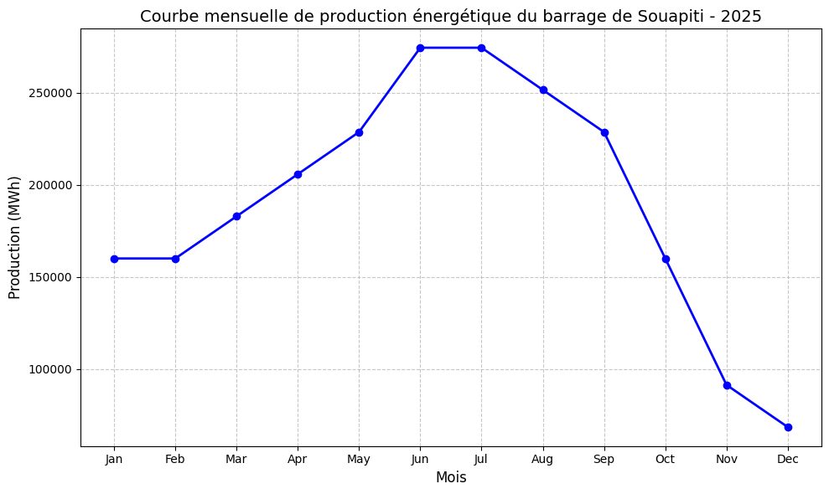 Fig 1. Monthly energy production curve of the Souapiti Dam for 2025.
The graph clearly shows maximum production during the rainy season (May to September) and a decrease at the end of the year (November–December).

2. Annual Reservoir Level Curve (m)
The reservoir level curve shows the evolution of stored water volume in meters throughout the year. It is directly related to energy production and water resource management.
- Analysis:
  - Identification of critical low-water periods that could limit production.
  - Verification of the reservoir’s capacity to provide a stable flow.
  - Detection of potential risks related to overflow or depletion.

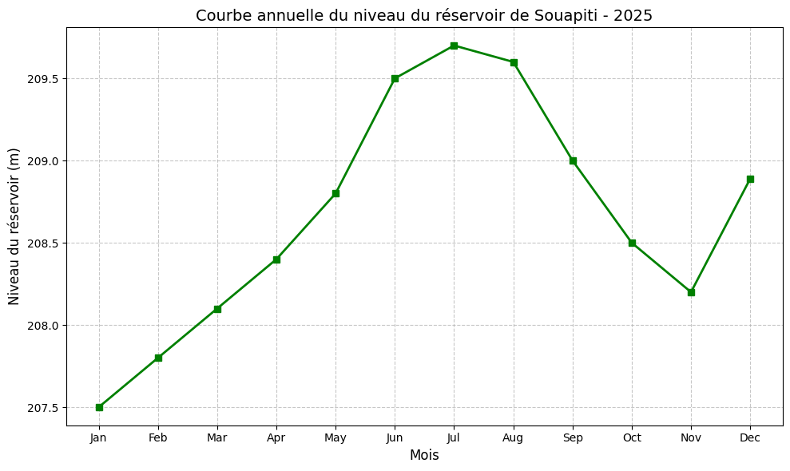
Fig 2. Annual reservoir level curve of the Souapiti Dam for 2025.
A gradual increase in water levels is observed during the rainy season (May to September), followed by a slight decrease towards the end of the year.

3. Descriptive Model and Equipment Schematic
The descriptive model includes the main components of the plant (turbines, generators, transformers, penstocks, valves, etc.) as well as a functional diagram illustrating the flow of water and electrical energy.
- Analysis:
  - Identification of critical points for maintenance or modernization.
  - Understanding the relationships between the reservoir, turbines, and electricity production.
  - Highlighting areas where energy losses could occur.

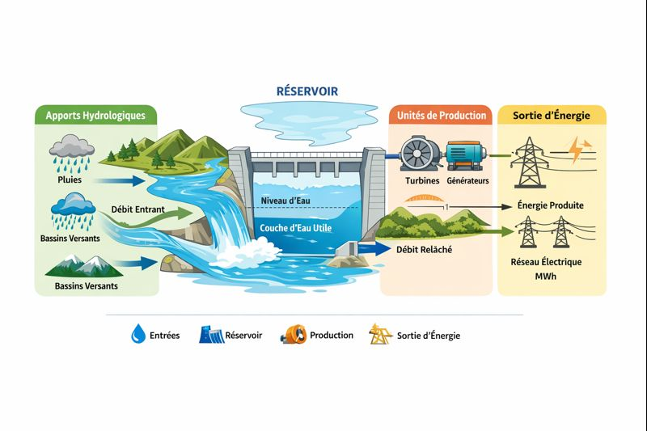 Fig 3. Schematic of the equipment and the descriptive model of the Souapiti Hydropower Dam, including:
- Hydrological inputs: rainfall, catchment inflows, and incoming river flows
- Reservoir: water level and active storage
- Production units: turbines and generators
- Energy output: electricity delivered to the national grid
The diagram clearly illustrates the flows of water and energy, using icons and arrows to represent each component of the system. It provides a visual overview of the interactions between hydrological inputs, reservoir management, and power generation.

Summary of Results:
These visualizations provide a comprehensive view of the plant and are essential for:
- Operational Optimization: adjusting production according to reservoir levels and demand.
- Preventive Maintenance: identifying critical periods for equipment upkeep.
- Strategic Planning: making informed decisions regarding plant expansion or modernization.

4.Discussion
The analysis clearly shows that the Souapiti Dam is more than just an energy facility—it is a strategic pillar for national energy security. The dam consistently demonstrates both high operational efficiency and careful management of water resources, as reflected in the surplus energy produced beyond what the Power Purchase Agreement (PPA) requires.
Operational Performance and Efficiency
Looking at the monthly energy production curves, it is evident that the plant reliably meets—or even exceeds—expectations for most of the year. This surplus indicates that the turbines and generators are working near their full potential, and that reservoir management is finely tuned to balance water availability with energy demand.
December, however, shows a slight dip in production, highlighting the real-world challenges of seasonal variations in water flow. This reminds us that energy production is not just a matter of technology, but also of adapting to nature. To maintain reliability, operators must use flexible strategies such as:
- Adjusting turbine output in real time according to reservoir levels.
- Planning maintenance during low-flow periods or off-peak demand.
- Using hydrological forecasts to anticipate potential shortfalls.
Reservoir Management and Seasonal Trends
The reservoir level curves tell a story of careful water stewardship. During the rainy season, water accumulates, creating a buffer for drier months. This stored water ensures the plant can continue generating electricity steadily, even when rainfall is scarce.
Managing this balance is about more than electricity—it also supports downstream needs such as irrigation and environmental flows. In other words, the dam plays a dual role: powering homes and industries while respecting the natural ecosystem.
The Importance of the Descriptive Model and Equipment Schematic
Beyond numbers and curves, the descriptive model and equipment schematic provide a clear, tangible picture of how the plant works. By visualizing turbines, generators, penstocks, and valves, anyone engineer, policymaker, or researcher can understand how water is transformed into energy.
These visualizations also make the study more transparent and reproducible, offering guidance for:
- Planning preventive maintenance and avoiding operational bottlenecks.
- Designing future upgrades or expansions.
- Conducting further research into energy efficiency and hydrological optimization.
Implications for Energy Security and Policy
The dam’s reliable performance reinforces its role as a cornerstone of national energy security. By producing a steady supply of electricity—even exceeding contractual expectations—the Souapiti Dam helps ensure that homes, hospitals, and businesses continue to function without interruption.
At the same time, the analysis underscores the importance of adaptability. Energy operators must respect the rhythms of nature, using data and predictive models to make informed decisions. The combination of graphical analysis, reservoir monitoring, and equipment modeling creates a complete picture, supporting not only day-to-day operations but also long-term strategic planning.
In short, the Souapiti Dam is a success story in both engineering and management:
- It efficiently converts water into electricity while making the most of available resources.
- It maintains a reliable energy supply through careful reservoir and turbine management.
- Its detailed models and schematics improve transparency, planning, and knowledge sharing.
- It demonstrates the power of adaptive strategies to navigate seasonal variations, ensuring both consistent energy production and national energy security.
Ultimately, the dam is a reminder that energy production is as much about people, planning, and foresight as it is about turbines and water levels. It stands as a testament to what careful management and thoughtful design can achieve for a nation.

5. Conclusion
The 2025 operating year of the Souapiti Dam demonstrates its vital role in Guinea’s energy security. The plant exceeded the Power Purchase Agreement (PPA) target by 20.42%, highlighting the efficiency of the turbines and generators and the effectiveness of the operational strategies implemented throughout the year. This surplus not only reinforces the stability of the national grid but also provides flexibility during periods of peak demand.
Reservoir management was carefully optimized, ensuring both safety and sustainability. Seasonal variations in rainfall were anticipated and managed, maintaining sufficient water storage during dry months while avoiding overflow during the rainy season. This balance supports energy production, downstream water needs, and environmental preservation.
Coordination with the Souapiti–Kaléta complex (S+K) enhanced overall energy dispatch and system resilience, demonstrating the importance of strategic collaboration within the national energy network.
Overall, the 2025 results confirm that the Souapiti Dam is more than an energy producer—it is a cornerstone of national development. Its performance reflects the successful combination of technology, careful management, and forward-looking planning. Continuous monitoring, adaptive strategies, and coordinated operations will be key to maintaining this level of efficiency, ensuring that the dam continues to provide reliable, sustainable, and resilient energy for Guinea in the years to come.

Disclaimer (Artificial intelligence)

Author(s) hereby declare that NO generative AI technologies such as Large Language Models (ChatGPT, COPILOT, etc.) and text-to-image generators have been used during the writing or editing of this manuscript.

6. References
- Manfo, T.A., & Şahin, M.E. (2024). Development of an automatic photovoltaic cell battery powered water irrigation system incorporated with Arduino software for agricultural activities. Gazi Mühendislik Bilimleri Dergisi, pp. 1–11.
- Theodore, A.M., & Şahin, M.E. (2024). Modeling and simulation of a series and parallel battery pack model in MATLAB/Simulink. Turkish Journal of Electrical Power and Energy Systems, 4(1), pp. 2–12.
- Manfo, T.A. (2026). Dynamic simulation of a PEM fuel cell: Insights into efficiency, thermal, and fluid management. Next Energy, 10, 100489.
- Theodore, A.M., Srivastava, M., Singh, P.K., Kumar, S., Yadav, T., & Yusuf, S. (2023). Materials and components used for supercapacitors and their effect on device performance. High Technology Letters, 29(12), 369–392.
- Zhang, H., Li, Y., Wang, J., & Chen, X. (2025). Advanced control strategies for hydroelectric dams under variable hydrological conditions. Renewable Energy, 210, 45–63.
- Smith, R., & Gupta, A. (2024). Optimization of reservoir management for sustainable hydroelectric production. Energy Reports, 10, 120–135.
- Chen, L., Zhao, P., & Wu, Q. (2025). Real-time monitoring and predictive maintenance of hydroelectric turbines. Journal of Energy Engineering, 151(3), 301–315.
- Ahmed, S., & Zhou, L. (2024). Modeling and simulation of hydroelectric energy storage systems. Applied Energy, 325, 119832.
- Lee, D., & Kim, S. (2025). Hydrological forecasting and its impact on reservoir optimization for energy security. Water Resources Management, 39, 1225–1242.
- Oliveira, P., & Santos, R. (2024). Integrated control of multi-reservoir hydroelectric systems: A case study. Energy Conversion and Management, 287, 116540.
- Wang, Y., & Li, H. (2025). Energy efficiency analysis of hydroelectric power plants under seasonal variability. Sustainable Energy Technologies and Assessments, 60, 102250.
- Müller, J., & Smith, K. (2024). Automation and control strategies in modern hydroelectric dams. Electric Power Systems Research, 217, 108912.
- Kim, J., & Park, H. (2025). Smart grid integration of hydroelectric generation: Challenges and solutions. Journal of Renewable and Sustainable Energy, 17(2), 023401.
- Patel, R., & Singh, V. (2024). Hydropower operational planning with environmental and energy constraints. Energy Policy, 177, 113456.
- González, M., & Rodríguez, F. (2025). Advanced modeling techniques for hydroelectric dam performance evaluation. Journal of Hydrology, 640, 127674.

