Potential Role of Ocular Demodex Infestation in Eyelid Eczema
ABSTRACT
Background: Eyelid eczema includes a heterogeneous group of inflammatory dermatologic conditions affecting the periocular region. Although these disorders often present with similar clinical features, their etiologies are distinct.
Aim: We aimed to establish demodex infestation as a cause of eye lid eczema.
Methodology: Patients diagnosed with eyelid eczema were enrolled in the study from April 2024 to December 2024. An age and gender matched control group was formed from healthy volunteers. Each patient had a detailed ophthalmic evaluation, and two lashes were removed from each eye, then eyelashes were examined directly under light microscopy for the presence of Demodex mites.
Results: A total of 58 patients with eyelid eczema and 46 healty controls were enrolled the study. Demographics were similar between groups. Demodex infestation was found more prevalent in patients with eyelid eczema compared to the control group (31% in the eczema group, 13% in the control group, p-value= 0.03 Participants with demodex infestation had a threefold higher likelihood of having eyelid eczema compared to the control group.
Conclusion: When evaluating eyelid eczema, Demodex infestation should not be overlooked.
Keywords: Demodex, eczema, periorbital dermatitis, ocular demodicosis, blepharitis.

Introduction
The skin of the eyelids is considerably thinner than that of other body regions, rendering it more susceptible to irritation from environmental and cosmetic exposures. Inflammatory conditions affecting this region are commonly referred to as eyelid dermatitis or eczema. Both terms broadly denote irritation or inflammation of the epidermis, the outermost layer of the skin. Eyelid eczema is characterised by inflammation of the eyelid skin, with patients typically presenting with scaly, erythematous, and oedematous changes. These manifestations are often accompanied by wrinkled or crepey skin texture. Common symptoms include redness, pruritus, and a burning sensation affecting the eyelids.
The predisposition of the eyelids to dermatitis is largely attributable to their minimal thickness—approximately 0.55 mm, compared with around 2.0 mm in other facial regions—which facilitates the penetration of both contact and airborne allergens. Consequently, even when allergens come into contact with multiple body sites, clinical manifestations may be confined to the eyelids (Ayala, 2003). Eyelid eczema is typically a chronic condition characterised by alternating periods of remission and exacerbation. In the absence of appropriate management, it may lead to persistent structural alterations, including induration, thickening of the eyelid tissue, and other undesirable cutaneous changes (Feser, 2008).
Diagnosis is primarily established through a detailed patient history and clinical examination, including careful inspection of the eyelids and ocular surface using biomicroscopy. However, identifying the precise aetiology of pruritic and inflamed eyelid skin can be challenging, which may complicate the selection of appropriate therapeutic interventions. Eyelid eczema encompasses a heterogeneous group of conditions with similar clinical presentations but diverse underlying causes. It may arise as a manifestation of endogenous disorders, such as atopic dermatitis or seborrhoeic dermatitis, or as a consequence of exogenous factors, including environmental or contact exposures. Demodex mites are saprophytic ectoparasites commonly found on human skin, particularly in facial and eyelid regions. The two principal species, Demodex folliculorum and Demodex brevis, occupy distinct anatomical niches: the former predominantly inhabits hair follicles, whereas the latter resides mainly within sebaceous glands. These mites are generally considered part of the normal ocular surface fauna, existing in a commensal relationship with the host. However, under conditions of overpopulation associated with alterations in the local microenvironment, they may become pathogenic (Cheng, 2015).
An increased density of Demodex mites is associated with various dermatological disorders, which are collectively classified under the term demodicosis. These conditions include pityriasis folliculorum, perioral dermatitis, pustular folliculitis, seborrheic dermatitis, blepharitis, and rosacea (Huang W, 2024 and Paichitrojjana A, 2024).^{4,5}
Demodex infestation is associated with both anterior and posterior blepharitis contributes to dery eye and can clinically mimic sebaceous gland carcinoma (Sharma N, 2023).⁶
Blepharitis is a chronic inflammatory condition affecting the eyelid margins and common in ophthalmology clinics. De Venecia et al. (2011) reported the prevalence of Demodex mites in blepharitis was 73% in their study.⁷
By occluding follicular ostia and sebaceous ducts, demodex mites in the eyelash follicles can induce follicular expansion, epithelial hyperplasia, and hyperkeratosis. An inflammatory foreign body reaction caused by Demodex mites and their metabolic byproducts contributes significantly to the pathogenesis of ocular involvement (Sharma N, 2023).⁶ Demodex mites also inhabit the pilosebaceous unit where they contribute to inflammation and trigger immune reactions (Karincaoglu Y, 2009).⁸
In this study, we aimed to investigate the frequency of ocular demodex infestation in patients with eyelid eczema without signs of blepharitis.
Material and methods
A case-control study was reviewed and approved by the local ethics committee and all participants gave written informed consent. The study was carried out according to the principles expressed in the Declaration of Helsinki.
A total of 104 individuals were included in the study: 46 healthy participants were enrolled in the control group, and 58 patients with eyelid eczema were enrolled in the eyelid eczema group.
Patients diagnosed with eyelid eczema at our clinic between April and December 2024 were enrolled in this study. Diagnosis of the disease was made after a detailed anamnesis and ocular examination. Patients without clinically significant signs of blepharitis (such as crusting, lash debris, hyperemia of eyelid margin) included in the study. Eyelid eczema was diagnosed when patients had itchy, red, edematous and scaly eyelid skin (Figure 1). The patients who did not have any known dermatological, systemic, and ocular diseases were included in the control group.
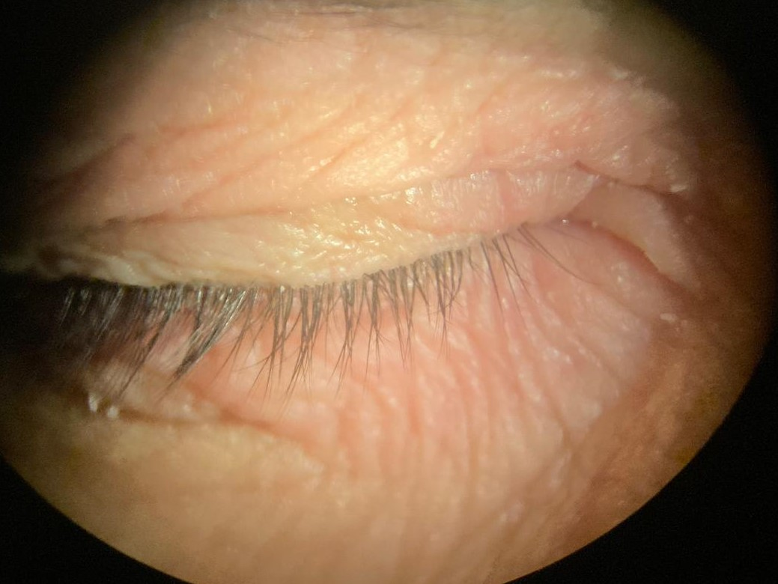
Figure 1. A patient’s picture taken by biomicroscope showing erythematous, edematous and scaly lesions on the upper and lower eyelids.
The patients were asked about a history of atopy (defined as a personal or family history of eczema, asthma, or hay fever ), and those with a negative atopy history were included in the study.
Comprehensive ocular examinations were conducted for all participants by a single ophthalmologist using biomicroscopy to ensure consistency. Two eyelashes were randomly selected from each eye and carefully epilated using sterile forceps. The extracted specimens were subsequently mounted on glass slides with glycerin and examined under light microscopy at magnifications of ×40 and ×100. The presence of one or more Demodex mites upon microscopic evaluation was defined as a positive finding (Figure 2).
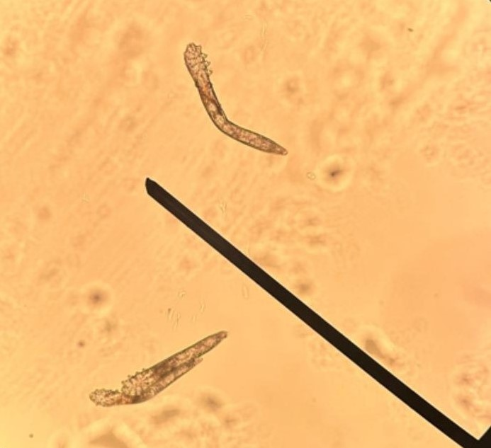
Figure 2. Demodex mites under light microscope.
Statistical analyses were performed using the SPSS software version 15. Presence of demodex and other categorical variables (sex, age groups) were compared between eyelid eczema and control groups by Chi-square test, and p value of <.05 was considered for statistical significance. We calculated odds ratios for the presence of demodex in each group and we compared them.
Results
The results of the present study demonstrate that the mean age was 49.44 ±13.85 in eyelid eczema group (49 women, 9 men). The mean age was 49.43 ±12.83 in control group (39 women, 7 men).
Age groups and sex of patients were not different between the eyelid eczema and control groups (Table 1).

Table 1. Comparison of sex and age groups between the patients with eyelid eczema and controls.
Variables |  | Groups |  | Pª
 |  | Eczema  N (%) | Control  N (%) | Pª
Sex | women | 49 (84.5) | 39 (84.8) | 0.96
 | men | 9 (15.5) | 7 (15.2) | 0.96
Age groups | 21-30 | 5 (8.6) | 3 (6.5) | 0.98
 | 3140 | 10 (17.2) | 8 (17.4) | 0.98
 | 41-50 | 14 (24.1) | 12 (26.1) | 0.98
 | 51-60 | 11 (19.0) | 8 (17.4) | 0.98
 | 61-70 | 14 (24.1) | 13 (28.3) | 0.98
 | 71-80 | 4 (6.9) | 2 (4.3) | 0.98

ª Chi-square test.

Eighteen out of fiftyeight patients in the eyelid eczema group (31%; with 95% confidence interval between 20 % and 42 %) were found to be infested with Demodex. And 6 out of 46 of the controls (13%; with 95% confidence interval between 4% and 22 %) were found to have Demodex infestation.
When we compared the eyelid eczema and the control group by ocular demodicosis, we found a significant difference (Chi-square; p=0.03) between the groups (Table 2).

Table 2. Comparison of eyelid eczema and control groups by the presence of demodex.

Groups | Demodex |  | Pª
Groups | Absent  N (%) | Present  N (%) | Pª
Eyelid Eczema | 40 (69) | 18 (31) | 0.03*
Control | 40 (87) | 6 (13) | 0.03*

*statistically significant difference
ª Chi-square test

Odds of the presence of demodex among the eyelid eczema group was 0.45; and odds of the presence of demodex within the control group was 0.15. Therefore the odds ratio of the presence of demodex between the eyelid eczema and control groups was 3.0, which means that the presence of ocular demodicosis was three times higher in the eyelid eczema group than in the control group.

Discussion
This study aimed to determine the frequency of ocular demodicosis in the eyelid eczema patients and to draw the attention of the clinicians on the subject.
To the best of our knowledge, this is the the first study to investigate ocular demodicosis and eyelid eczema together.
Eyelid eczemas are clinically and therapeutically clearly delineated entity with different causes. The eyelid eczema can cause substantial suffering because of the disturbing symptoms and high aesthetic significance of this region. The tendency to recur, and resistance to therapy they pose is a considerable diagnostic and therapeutic challenge to dermatologists and ophthalmologists. Patients with eyelid eczema often undergoes repeated therapies with topical corticosteroids, which tend to fail to accomplish lasting improvement and can also include steroid-induced side effects such as skin atrophy and telangiectasias (Murrell DF,2007).⁹
Generally differentiating the cause of itching, red, edematous eyelids is often difficult in eyelid eczema.
Contact allergy is the leading cause of periocular eczema, reported in 54% of cases (44% from direct contact and 10.2% from airborne contact dermatitis). Other contributors to eczematous lesions around the eyes include atopic dermatitis (25%), irritant contact dermatitis (9.1%), and secondary eczematous conditions such as periorbital rosacea (4.5%) and allergic conjunctivitis (2.1%) (Feser A, 2008).²
Studies on the epidemiology of periocular dermatitis indicate that the condition is significantly more common in women (80.3%–84.9%). Being aged 40 years or older has also been recognized as a risk factor (Feser A, 2008).²
Similary, in our study, 84.5 % of eyelid eczema patients were female, and 74.1% were 40 years old or older, which is consistent with findings in the literature.
High proportion of eyelid eczema patients aged 40 years or older may reflect age-dependent variations in stratum corneum thickness and hydration in the eyelid area (Gao YY, 2005).¹⁰
Ocular demodicosis, defined by infestation of the eyelids with Demodex mites, remains frequently underdiagnosed in routine clinical practice. The threshold mite density required to elicit clinical manifestations has yet to be clearly established. Notably, Demodex mites are commonly detected on the eyelids of asymptomatic elderly individuals, indicating that their mere presence does not necessarily confer pathogenicity. Indeed, the occurrence of Demodex in otherwise healthy individuals has been widely documented in the literature.
In the present study, a colonisation rate of 31% was observed in the eczema group, compared with 13% in the control group. These findings are consistent with previous reports, such as that of Gao et al., who identified Demodex infestation in 22% of patients with clinically clean eyelashes. Reported prevalence rates of eyelid Demodex infestation vary considerably across studies and populations, ranging from 4% to 47% (Borzova, 2024). The clinical manifestations of ocular demodicosis include blepharitis, eyelash abnormalities (e.g. trichiasis), meibomian gland dysfunction, and recurrent chalazion formation—conditions frequently encountered in ophthalmic practice (Luo, 2017). However, no significant correlation has been established between mite density and the severity of ocular symptoms (Wesołowska, 2014).
From a pathogenic perspective, Demodex mites invade epithelial structures, particularly keratinocytes lining the pilosebaceous units, and feed on sebum and cellular proteins through the action of proteolytic and lipolytic enzymes. This enzymatic activity contributes to degradation of the follicular epithelium, potentially resulting in perifollicular inflammation. Although the life cycle of Demodex mites remains incompletely understood, their migration across adjacent skin areas—particularly during nocturnal periods—has been suggested. In addition to direct tissue damage, Demodex mites may mechanically obstruct follicular openings. Extrafollicular mites have also been implicated in inducing granulomatous foreign body reactions, attributed to their chitinous exoskeleton. Furthermore, the disintegration of mites may provoke delayed hypersensitivity reactions through the release of antigenic waste products and exoskeletal components (Sharma, 2023; Akçınar, 2018). Demodex infestation has also been associated with the modulation of inflammatory cytokines, including interleukin-8 (IL-8) and tumour necrosis factor-alpha (TNF-α) (Koller, 2011; Taylor, 2006).
The immunological activation, inflammatory responses, and follicular alterations induced by Demodex mites may contribute to the development of conditions such as eyelid eczema, which may be conceptualised as a form of protein contact dermatitis. This entity represents an allergic cutaneous reaction to exogenous protein antigens, typically derived from plant or animal sources, with delayed onset following exposure. Clinically, it manifests as chronic dermatitis, with a pathogenesis involving immunoglobulin E (IgE)-mediated mechanisms, antigen presentation by Langerhans cells, and T-lymphocyte infiltration (Levin, 2008). Demodicosis exhibits a broad clinical spectrum and may mimic other dermatological conditions, leading to diagnostic challenges. Presentations can range from non-specific facial dermatitis to more severe phenotypes, influenced by host factors such as genetic predisposition, immune status, and mite density. In many cases, the condition manifests as non-specific dermatitis, contributing to underdiagnosis or misdiagnosis, and thereby an apparent underestimation of its true incidence despite widespread infestation (Paichitrojjana, 2022; Zhao, 2012).
While earlier studies have primarily associated eyelash demodicosis with blepharitis, Udomwech et al. (2021) identified additional suggestive clinical features, including eyelid erythema and telangiectasia. Their findings demonstrated a significant association between these eyelid margin changes and Demodex infestation.
The present study further contributes to this body of evidence by identifying additional suggestive signs, namely erythematous, oedematous, and scaly eyelid skin consistent with eyelid eczema or dermatitis, even in the absence of clinical blepharitis. Approximately one-third (31%) of the study population exhibited mite colonisation, while 13% of control subjects demonstrated asymptomatic colonisation. These findings underscore the importance of considering Demodex infestation in the differential diagnosis of patients presenting with eyelid eczema.
Therapeutic strategies for ocular demodicosis are directed towards both eradication of Demodex mites and alleviation of associated symptoms. However, standardised treatment guidelines remain lacking. Current evidence supports the efficacy of agents such as tea tree oil or its active component, terpinen-4-ol, as well as ivermectin, in reducing mite burden and improving clinical outcomes (Navel, 2019; Choi, 2022).
Conclusion
About one-third (31 %) of the eyelid eczema group had ocular demodicosis in our study. Demodex infestation should therefore always be on the list of possible etiologies when treating patients with eyelid eczema or periorbital dermatitis. These results should be supported by future studies with larger sample sizes.
Limitation
This study limited to small sample size as this is a preliminary study, we will work with bigger sample size in future to establish the main findings.

CONSENT
All participants gave written informed consent.
ETHICAL APPROVAL
The study was carried out according to the principles expressed in the Declaration of Helsinki, and approved by the local ethics committee.

Disclaimer (Artificial intelligence)

Author(s) hereby declare that NO generative AI technologies such as Large Language Models (ChatGPT, COPILOT, etc.) and text-to-image generators have been used during the writing or editing of this manuscript.

REFERENCES
- Ayala F, Fabbrocini G, Bacchilega R et al. (2003). Eyelid dermatitis: an evaluation of 447 patients. Am J Contact Dermat, 14: 69-74.
- Feser A, Plaza T, Vogelgsang and Mahler V. (2008). Periorbital dermatitis-a recalcitrant disease: causes and differential diagnosis. British J Dermatology. 159:858-863.
- Cheng AM, Sheha H, Tseng SC. (2015). Recent advances on ocular Demodex infestation. Curr Opin Ophthalmol. 26(4):295–300
- Huang W, Huang C, Chu C, Hu F. (2024). Comorbidity of ocular and facial Demodicosis. Am J Ophthalmol. 257:201-211.
- Paichitrojjana A, Chalermchai T. The association between Acne Vulgaris,Acne Vulgaris with nonspecific facial dermatitis and Demodex mite presence. (2024). Clinical, Cosmetic and Investigational Dermatology. 17:137-146
- Sharma N, Martin E, Pearce EI, Hagan S, Purslow C. (2023). Demodex blepharitis: A survey-based approach to investigate knowledge, attitudes, and practices among optometrists in India. Clin Optom 55–64.
- deVenecia AB, Lim Bon Siong R. (2011). Demodex sp. infestation in anterior blepharitis, meibomian-gland dysfunction and mixed blepharitis. Philipp J Ophthalmol. 36(1): 15-22.
- Karincaoglu Y, Tepe B, Kalayci B, Atambay M, Seyhan M. (2009). Is Demodex folliculorum an aetiological factor in seborrhoeic dermatitis? Clin Exp Dermatol. 34:e516-20.
- Murrell DF, Calvieri S, Ortonne JP, et al. (2007). A randomized controlled trial of pimecrolimus cream 1 % in adolescents and adults with head and neck atopic dermatitis and intolerant of, or dependent on, topical corticosteroids. Br J Dermatol 157: 954–9.
- Gao YY, Di Pascuale MA, Li W, et al. (2005). High prevalence of Demodex in eyelashes with cylindrical dandruff. Invest Ophthalmol Vis Sci. 46(9):3089–3094. doi: 10.1167/iovs.05-0275
- Borzova E, Snarskaya E, Brotkovskaya A. (2024). Eyelid dermatitis in patch-tested adult patients: a systemic review with a meta-analysis. Sci Reports 13;14(1)18791.
- Luo X, Li J, Chen C, Tseng S, Liang L. (2017). Ocular demodicosis as a potential cause of ocular surface inflammation. Cornea. 36(Suppl 1):S9–S14.
- Wesolowska M, Knysz B, Reich A, et al. (2014). Prevalence of Demodex spp. in eyelash follicles in different populations. Arch Med Sci. 10(2):319–324.
- Akçınar UG, Ünal E, Doğruman AF. (2018). Demodex spp. as a possible aetiopathogenic factor of acne and relation with acne severity and type. Postepy Dermatol Alergol. 35(2):174–181. doi:10.5114/ada.2018.75239
- Koller B, Muller Wiefel AS, Rupec R, Korting HC, Ruzicka T. (2011). Chitin modulates innate immune responses of keratinocytes. PLoS ONE. 6:e16594.
- Taylor RC, Richmond P, Upham JW. (2006). Toll-like receptor 2 ligands inhibit TH2 responses to mite allergen. J Allergy Clin Immunol. 117:1148-54.
- Levin C, Warshaw E. (2008). Protein contact dermatitis: allergens, pathogenesis, and management. Dermatitis 19: 241–51.
- Paichitrojjana A. (2022). Demodex: the worst enemies are the ones that used to be friends. Dermat Rep. 14(3):9339.
- Zhao YE, Hu L, Wu LP, et al. (2012). A meta-analysis of association between acne vulgaris and Demodex infestation. J Zhejiang Univ Sci B. 13 (3):192–202.
- Udomwech L, Phasuk N. (2021). Multiple eyelid signs are suggestive of Demodex infestation. Clin Ophthalmol 15:671-678.
- Navel V, Mulliez A, Benoist d’Azy C, et al. (2019). Efficacy of treatments for Demodex blepharitis: a systematic review and meta– analysis. Ocul Surf. 17(4):655–669.
- Choi Y, Eom Y, Yoon EG, et al. (2022) Efficacy of Topical Ivermectin 1% in the Treatment of Demodex Blepharitis. Cornea. 41(4):427-434.

