Original Research Article

Minimally Age-Dependent Gut Microbial Signatures in Pancreatic Neoplasia Identified by qPCR Targeting the but Gene

ABSTRACT

Aims: Age-related variation in the gut microbiota complicates biomarker discovery for pancreatic cancer. This study aimed to identify microbial taxa with minimal age dependence that are associated with pancreatic neoplasia and to develop a practical quantitative PCR (qPCR)-based assay targeting a shared gene involved in butyrate production.
Study design: Cross-sectional study.
Place and Duration of Study: Department of Gastroenterology and Hepatology, Fujita Health University, Toyoake, Japan, between October 2022 and July 2025.
Methodology: Fecal samples from 64 individuals with precursor lesions considered to be at high risk for pancreatic cancer (HR) and 22 patients with pancreatic cancer (PC) were compared with those from healthy controls aged <50 years (Young; n = 71) and ≥50 years (Old; n = 65). Microbiota composition was analyzed by 16S rRNA gene sequencing. A qPCR primer set targeting the but gene, which encodes butyryl-CoA:acetate CoA-transferase, was designed to evaluate the shared genetic potential of the identified minimally age-dependent taxa, namely the Anaerostipes hadrus group and Agathobacter rectalis.
Results: The A. hadrus group and A. rectalis showed disease-associated depletion with minimal age dependency. The qPCR assay showed no difference in but gene levels between the Young and Old groups (P = 0.3301). but gene levels in the HR group were comparable to those in the Old group (P > 0.9999), whereas levels in the PC group were significantly lower than those in the Old group (P = 0.0020) and the HR group (P = 0.0136).
Conclusion: Targeting the but gene provides a practical approach to assessing the shared butyrate-producing potential of this minimally age-dependent microbial cluster. Within this cross-sectional cohort, but gene levels were preserved in HR individuals, whereas levels in the PC group were reduced, suggesting its potential utility as a non-invasive adjunct for future evaluation in longitudinal monitoring or risk assessment after prospective validation.

Keywords: ageing; but gene; butyrate; gut microbiota; IPMN; microbial gene marker; pancreatic cancer; quantitative PCR.

1. INTRODUCTION

Pancreatic cancer (PC) remains one of the most lethal malignancies, largely because effective strategies for early detection remain limited. In recent years, accumulating evidence has suggested that the gut microbiota plays important roles in the development and progression of several cancers (Fujii et al., 2024a; Fujii et al., 2024b; Tanaka et al., 2025). In PC and precursor lesions considered high risk for PC (HR), such as intraductal papillary mucinous neoplasms (IPMNs), fecal microbial alterations have also been reported. Previous studies have described enrichment of oral-associated taxa, including Streptococcus species, together with depletion of beneficial taxa such as the Faecalibacterium prausnitzii group in PC (Nagata et al., 2022; Bastos et al., 2023).
Given the anatomical and functional connection between the gastrointestinal tract and the pancreas, fecal microbiota profiling has emerged as a promising non-invasive approach for risk assessment in pancreatic neoplasia. In our previous work, we proposed that specific microbial gene markers in the gut are promising biomarker candidates because their abundances serve as a genetic proxy for the metabolic potential across diverse microbial taxa linked to intestinal disease states. We also showed that these gene targets can be quantified efficiently and economically by quantitative PCR (qPCR), providing a practical alternative to next-generation sequencing (NGS) for routine clinical use (Fujii et al., 2024a; Nagasaka et al., 2024). In the context of PC, the development of microbiota-based diagnostics from non-invasive samples could improve clinical strategies for early detection, postoperative surveillance, and the monitoring of HR individuals with precursor lesions such as IPMNs, pancreatic cysts, or chronic pancreatitis.
One of the most critical considerations in developing such diagnostic systems is that the composition of the gut microbiota is strongly influenced by ageing (Odamaki et al., 2016; Gyriki et al., 2025), which complicates biomarker discovery in older populations. This is especially relevant because the incidence of PC rises markedly with age. There is therefore a need to identify minimally age-dependent microbial signatures that can distinguish pancreatic neoplasia from healthy states in older adults. Although previous studies have described gut microbiota changes associated with PC and HR lesions, few have systematically evaluated how these disease-related alterations relate to age-associated shifts in microbial composition. This gap is important because some microbial taxa may appear altered in cancer primarily because of their natural variation with age, potentially confounding biomarker discovery. Identifying microbial signatures that reflect disease status rather than age is thus essential for developing robust, non-invasive tools for early detection and risk stratification in pancreatic neoplasia.
In this study, we aimed to identify gut microbial taxa associated with pancreatic neoplasia while exhibiting minimal age dependency. To this end, we profiled the fecal microbiota of healthy individuals stratified by age, individuals with HR lesions, and patients with PC, and evaluated age-related microbial changes within the healthy cohort. By explicitly incorporating age stability into marker selection, this study addresses an important source of confounding that has received limited attention in previous microbiome studies of pancreatic neoplasia. We then selected candidate taxa that were consistently altered across disease stages but showed a weak correlation with age. To translate these findings into a practical assay, we targeted the but gene, which encodes butyryl-CoA:acetate CoA-transferase, a key enzyme in microbial butyrate biosynthesis (Louis and Flint, 2007; Vital et al., 2014), and established a qPCR-based system to evaluate the shared genetic potential for butyrate production within this minimally age-dependent microbial cluster. This strategy aims to contribute to the development of non-invasive, rapid, and cost-effective approaches for evaluating microbiota-related alterations in pancreatic neoplasia. By reducing age-related confounding, such biomarkers may provide a useful basis for future studies of disease monitoring and risk assessment. Ultimately, this non-invasive method may serve as a complementary tool for future evaluation in longitudinal monitoring of HR cohorts.

2. METHODOLOGY

2.1 Patients and sample collection
This cross-sectional study compared gut microbiota profiles among healthy individuals stratified by age, HR individuals with precursor lesions, and patients with PC at a single time point. Between October 2022 and July 2025, individuals with one or more established risk factors for PC who consented to participate in surveillance studies were enrolled. HR individuals with precursor lesions were defined according to previously reported criteria and included those with pancreatic cysts (particularly IPMN), chronic pancreatitis, or a family history of PC (Bogdanski et al., 2025; Sagami et al., 2023; Dbouk et al., 2021). To exclude overt PC at enrolment, all HR individuals underwent contrast-enhanced CT, magnetic resonance cholangiopancreatography (MRCP), and/or endoscopic ultrasonography (EUS). Patients with PC were treated at our department during the study period and had pathologically confirmed pancreatic ductal adenocarcinoma (PDAC) based on surgical resection or EUS-guided tissue acquisition. Fecal samples were collected using an FS-0015 collection kit (TechnoSuruga Laboratory, Shizuoka, Japan).

2.2 Healthy control individuals and sample collection
Fecal samples were obtained from healthy individuals stratified by age: <50 years (n = 71) and ≥50 years (n = 65). The ≥50-year group consisted entirely of samples analysed in our earlier study (Nakano et al., 2025). All participants had no history of gastrointestinal disease and had not used antibiotics within 1 week before sample collection. Sample collection was performed according to the procedure described in Section 2.1.

2.3 16S rRNA gene next-generation sequencing of fecal DNA samples
The 16S rRNA gene next-generation sequencing (NGS) of fecal DNA samples was performed according to a previously described protocol (Fujii et al., 2024b). Briefly, DNA was extracted from fecal samples using the QIAamp PowerFecal Pro DNA Kit (QIAGEN, Venlo, The Netherlands) following the manufacturer’s instructions. A primer set comprising Pro341F and Pro805R, targeting the V3–V4 region of the bacterial 16S rRNA gene, was used for PCR (Takahashi et al., 2014). Sequencing was conducted at TechnoSuruga Laboratory. Paired-end sequencing (2 × 300 bp) was performed on the MiSeq platform (Illumina, San Diego, CA, USA). The resulting reads were processed, analysed, and visualised using the EzBioCloud 16S database and microbiome pipeline provided by ChunLab Inc. (available at EZBioCloud) (Yoon et al., 2017). Alpha diversity was assessed using Chao1 and Shannon indices. Beta diversity was estimated using Bray–Curtis distances and visualised by principal coordinate analysis (PCoA). Group differences in beta diversity were tested using permutational multivariate analysis of variance (PERMANOVA) with 999 permutations. Potential biomarkers distinguishing each group were identified using the linear discriminant analysis effect size (LEfSe) algorithm with thresholds of P < 0.05 and |LDA effect size| > 3.6.

2.4 Primer design
To develop a primer set capable of collectively quantifying the but gene encoding butyryl-CoA:acetate CoA-transferase in both the Anaerostipes hadrus group and Agathobacter rectalis, we first identified homologous sequences using BLASTp. The query sequence was the butyryl-CoA:acetate CoA-transferase protein from A. hadrus ATCC 29173 (GenBank accession no. EKY19441.1), and the search was conducted on the NCBI website (accessed on June 18, 2025). Ten homologous amino acid sequences were retrieved, including five from various A. hadrus strains and five from A. rectalis. The corresponding nucleotide sequences were collected from NCBI and subjected to multiple sequence alignment using MAFFT (available at GenomeNet; accessed on June 18, 2025). Based on conserved regions identified across A. hadrus group strains and A. rectalis, we designed a primer set specific for the but gene (Supplementary Figure 1). The primers were designed to target regions approximately at positions 733–758 bp and 793–816 bp within the but gene sequence of A. hadrus ATCC 29173. The forward primer (hadrus_rectalis_but_F) and reverse primer (hadrus_rectalis_but_R) are listed in Supplementary Table 1.

2.5 qPCR analysis
The abundances of the but gene and total bacterial 16S rRNA genes were quantified by qPCR using the QuantStudio 3 system (Thermo Fisher Scientific, Waltham, MA, USA). Reaction mixtures were prepared using PowerTrack SYBR Green Master Mix (Thermo Fisher Scientific) according to the manufacturer’s instructions. Gene-specific primer sets were used as detailed in Supplementary Table 1: hadrus_rectalis_but_F and hadrus_rectalis_but_R for the but gene, and F_Bact 1369 and R_Prok 1492 for the total bacterial 16S rRNA gene (Furet et al., 2009). The qPCR protocol consisted of an initial denaturation at 95°C for 2 min, followed by 40 cycles of denaturation at 95°C for 10 s, annealing at gene-specific temperatures (Supplementary Table 1) for 15 s, and extension at 72°C for 15 s. A final extension step at 72°C for 1 min was included in all reactions. but gene levels were calculated by normalising but copy number to total 16S rRNA gene copy number, thereby enabling accurate quantification across samples.
Absolute quantification was performed using standard curves generated from serial dilutions of DNA templates. For the but gene, PCR fragments from A. hadrus JCM 17467 were used as the standard. The amplification efficiency, slope, coefficient of determination (R²), and linear dynamic range for each primer set were validated. The targeted primer sets exhibited high linearity (R² > 0.99) and appropriate amplification efficiencies (Supplementary Table 1).

2.6 NGS analysis of amplified but gene fragments
NGS analysis was performed on amplified but gene fragments initially identified by qPCR from a randomly selected subset of four healthy control subjects. The amplified fragments were purified using the Wizard SV Gel and PCR Clean-Up System (Promega, Madison, WI, USA) and eluted in 30 µL of the supplied elution buffer. The purified DNA was then used as the template for a secondary PCR incorporating adapter sequences required for Illumina sequencing. The primer set comprised the forward primer but_forNGS_F (5′-ACACTCTTTCCCTACACGACGCTCTTCCGATCTGARATGTAYGTTGAYGCDTTYGTTGA-3′) and the reverse primer but_forNGS_R (5′-GTGACTGGAGTTCAGACGTGTGCTCTTCCGATCTCTGACGRTAACGRTCRATGTTYTT-3′). Within these primer sequences, the segments corresponding to the previously described primers hadrus_rectalis_but_F and hadrus_rectalis_but_R are underlined, whereas the flanking regions represent Illumina adapter sequences. This secondary PCR was performed using Quick Taq HS DyeMix (Toyobo, Osaka, Japan) at a final primer concentration of 3.2 pM. The amplification program consisted of an initial denaturation at 94°C for 2 minutes, followed by one cycle at 55°C for 15 seconds and 72°C for 15 seconds, then 22 cycles of denaturation at 95°C for 5 seconds, annealing at 68°C for 15 seconds, and extension at 72°C for 15 seconds. A final extension step at 72°C for 1 minute completed the PCR protocol. After confirmation of amplification, DNA was again purified using the Wizard SV Gel and PCR Clean-Up System and eluted in 50 µL of elution buffer. The purified PCR products were then subjected to NGS by Bioengineering Lab Co., Ltd. (Kanagawa, Japan) using paired-end sequencing (2 × 300 bp) on the MiSeq platform.

2.7 Statistical analysis
Continuous variables, including age, the relative abundances of candidate taxa, and qPCR-derived but gene levels, were compared across groups using the Kruskal–Wallis test followed by Dunn’s multiple-comparisons test. Differences in sex distribution among groups were evaluated using the chi-square test. Global differences in alpha diversity across groups were assessed using the Kruskal–Wallis test, and differences in beta diversity were assessed using PERMANOVA with 999 permutations. Potential biomarkers distinguishing each group were identified using the linear discriminant analysis effect size (LEfSe) algorithm within the EzBioCloud pipeline, in which adjusted Q-values (i.e., false discovery rate-adjusted P-values) were used together with |LDA effect size| > 3.6. Statistical analyses were conducted using GraphPad Prism version 10.3.1 (GraphPad Software, San Diego, CA, USA), except for PERMANOVA and LEfSe analyses, which were performed within the EzBioCloud pipeline. A P-value < 0.05 was considered statistically significant. The sample size was determined on the basis of feasibility and participant availability during the study period; therefore, no formal sample size calculation was performed. No missing data were present for the variables analyzed.

3. RESULTS

3.1 Characteristics of individuals
The study included 136 healthy controls and 86 individuals with pancreatic neoplasia. The healthy controls were stratified into two age groups: the Young group (<50 years, n = 71; mean age, 35 years) and the Old group (≥50 years, n = 65; mean age, 67 years). The pancreatic neoplasia cohort consisted of 64 individuals with HR lesions (mean age, 66 years) and 22 patients with PC (mean age, 74 years).
As expected, the Young group was significantly younger than all other groups (P < 0.0001) (Fig. 1). No significant age differences were observed between the Old group and either the HR or PC groups (P > 0.9999 and P = 0.4467, respectively). No significant differences in sex distribution were observed among the groups (P = 0.2310).
The characteristics and clinical staging information of individuals with pancreatic neoplasia are summarized in Supplementary Table 2. Based on disease stage, individuals were categorized into the PC or HR groups as follows: patients with stage 2 or stage 3 disease were classified as the PC group, whereas those with stage 0 or stage 1 disease (including low-grade branch-duct IPMN, pancreatic cysts, chronic pancreatitis, and IPMN with high-risk stigmata or worrisome features) were assigned to the HR group. The HR group was therefore clinically heterogeneous and included individuals with low-grade branch-duct IPMN, pancreatic cysts, chronic pancreatitis, and IPMN with high-risk stigmata or worrisome features, all of which may differ in their biological background and risk profile.
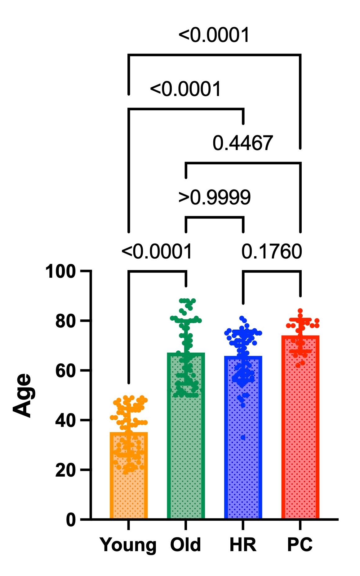
Fig. 1. Comparison of age distributions across study groups: healthy controls aged <50 years (Young), healthy controls aged ≥50 years (Old), individuals with precursor lesions considered high risk for pancreatic cancer (HR), and patients with pancreatic cancer (PC). Each dot represents an individual participant; bars indicate the mean, and error bars indicate the standard deviation. Statistical significance was assessed using the Kruskal–Wallis test followed by Dunn’s post hoc tests, with significant intergroup P-values indicated above each bar.

3.2 Microbial diversity among study groups
Fecal microbiota composition was compared among four groups: healthy control individuals aged <50 years (Young group), healthy control individuals aged ≥50 years (Old group), individuals with precursor lesions considered to be at high risk for pancreatic cancer (HR group), and patients with PC (PC group). Supplementary Figure 2 shows the species-level composition of the fecal microbiota across these groups.
Alpha diversity, assessed using the Shannon and Chao1 indices, did not differ significantly among the groups. In contrast, principal coordinate analysis (PCoA) based on Bray–Curtis distances revealed partial separation, indicating differences in beta diversity (Fig. 2). These differences were further supported by PERMANOVA, which demonstrated significant dissimilarities between the Young group and the Old, HR, and PC groups (all P ≤ 0.001), and between the Old group and both the HR (P ≤ 0.001) and PC (P = 0.006) groups. By contrast, no significant difference was observed between the HR and PC groups (P = 0.054) (Supplementary Table 3).
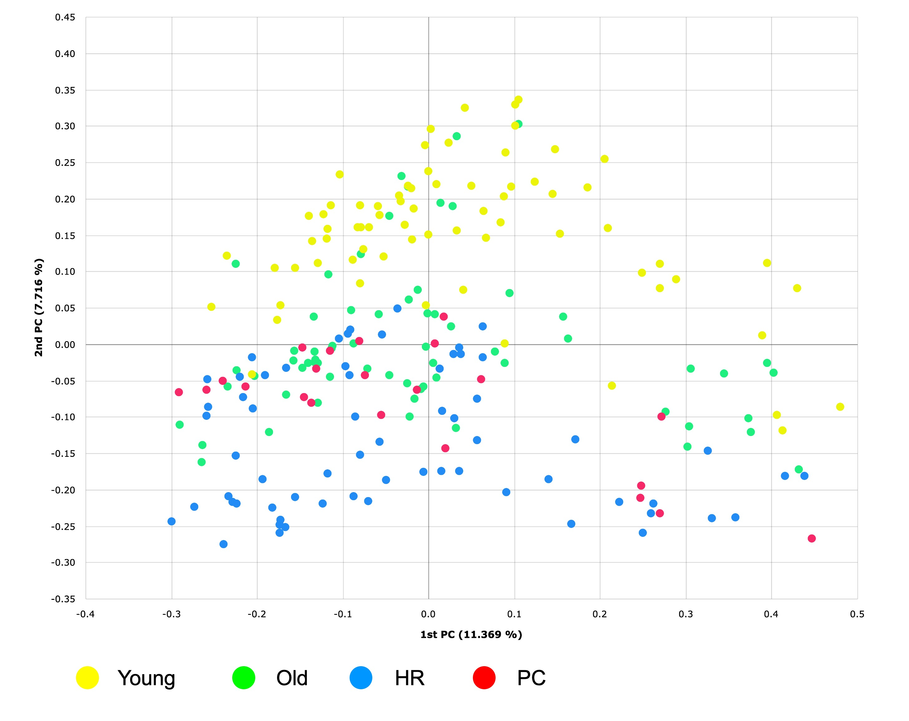
Fig. 2. Principal coordinate analysis (PCoA) plots based on Bray–Curtis distances, highlighting differences in fecal microbiota composition among the following groups: healthy controls aged <50 years (Young), healthy controls aged ≥50 years (Old), individuals with precursor lesions considered high-risk for pancreatic cancer (HR), and patients with pancreatic cancer (PC). Each dot represents an individual participant.

3.3 Differentially abundant taxa across the control, HR, and PC groups
LEfSe analysis identified four candidate taxa—F. prausnitzii group, Fusicatenibacter saccharivorans, Anaerostipes hadrus group, and Agathobacter rectalis—as being differentially abundant among the Old, HR, and PC groups (Fig. 3). Pairwise comparisons showed that the F. prausnitzii group, F. saccharivorans, and A. hadrus group were significantly less abundant in both the HR and PC groups compared with the Old group, whereas A. rectalis showed a significant decrease only in the PC group (P < 0.05 for all; Fig. 4).
An additional LEfSe analysis across the four groups (Young, Old, HR, and PC) identified one additional candidate taxon, the Streptococcus salivarius group. Subsequent statistical comparisons showed that the S. salivarius group was significantly less abundant in the Young group than in the PC group (P = 0.0340), but did not differ significantly between the Old and PC groups (P = 0.8468). This trend is illustrated in Supplementary Figure 3.

Fig. 3. Linear discriminant analysis effect size (LEfSe) results identifying species-level differences in fecal microbiota composition among healthy controls aged ≥50 years (Old), individuals with precursor lesions considered high risk for pancreatic cancer (HR), and patients with pancreatic cancer (PC). The analysis employed an |LDA effect size| threshold of >3.6. Blue bars represent the magnitude of the LDA effect size, while red bars show the relative abundance of each taxon. Taxa are listed in ascending order by P-value.

3.4 Identification of minimally age-dependent taxa
To determine whether the disease-associated changes observed in the Old, HR, and PC groups were influenced by age, we further compared the relative abundances of the candidate taxa between the Young and Old groups. The F. prausnitzii group showed a non-significant trend toward lower abundance in the Old group than in the Young group (P = 0.1205), whereas F. saccharivorans did not differ between these groups (P = 0.8676) (Fig. 4a,b). In contrast, the relative abundances of the A. hadrus group and A. rectalis were nearly identical between the Young and Old groups (P > 0.9999). Importantly, the A. hadrus group was significantly less abundant in the HR (P = 0.0374) and PC (P = 0.0031) groups than in the Old group, whereas A. rectalis was significantly decreased only in the PC group (P = 0.0095) and not in the HR group (P = 0.9624) (Fig. 4c,d). These findings identified the A. hadrus group and A. rectalis as minimally age-dependent taxa associated with pancreatic neoplasia.
Furthermore, when the relative abundances of the A. hadrus group and A. rectalis were combined, the depletion in the PC group compared with the Old group became more pronounced (P = 0.0007), and a significant difference also emerged between the HR and PC groups (P = 0.0409). Meanwhile, the combined values remained virtually indistinguishable between the Young and Old groups (P > 0.9999) (Fig. 4e).

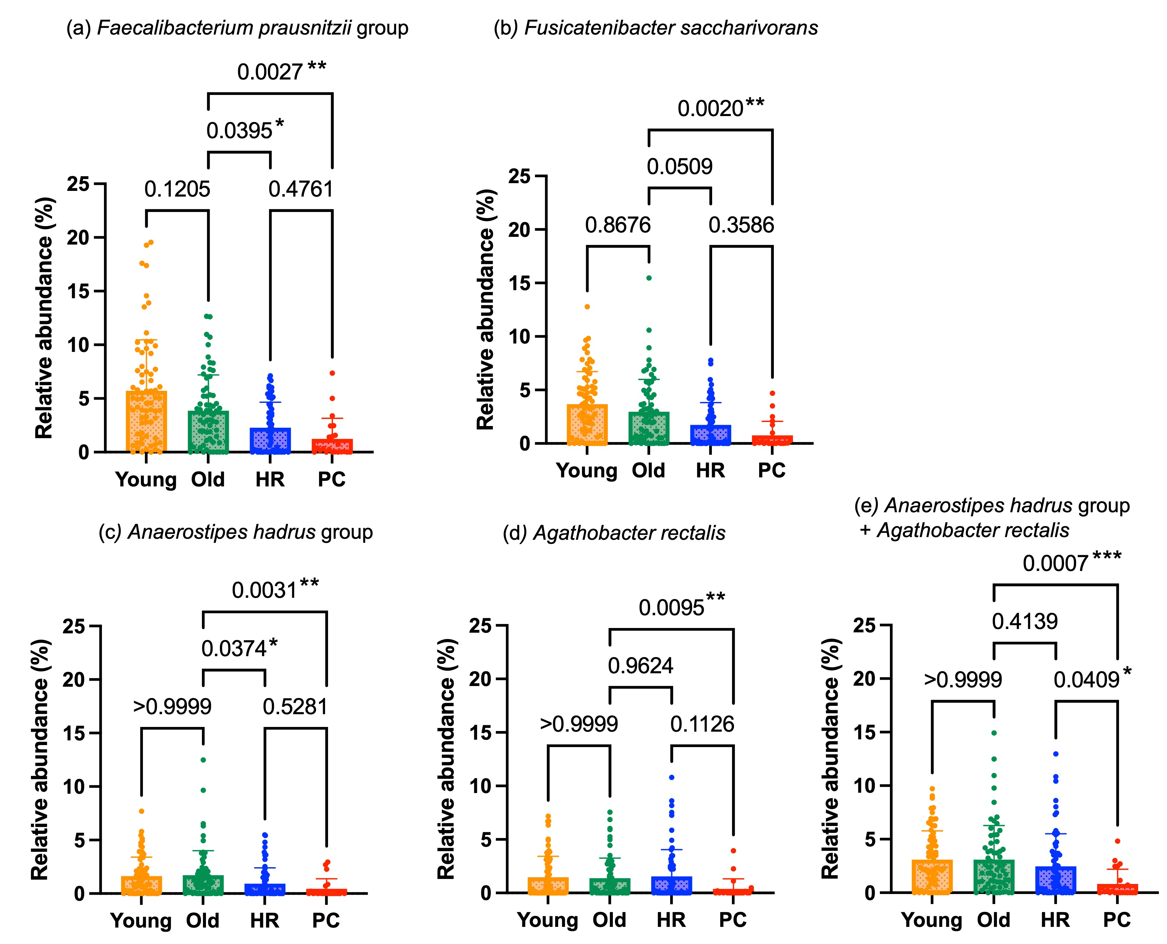
Fig. 4. Comparison of the relative abundance of Faecalibacterium prausnitzii group (a), Fusicatenibacter saccharivorans (b), Anaerostipes hadrus group (c), and Agathobacter rectalis (d) across the four study groups: healthy controls aged <50 years (Young), healthy controls aged ≥50 years (Old), individuals with precursor lesions considered high risk for pancreatic cancer (HR), and patients with pancreatic cancer (PC). Each dot represents an individual participant; bars indicate the mean, and error bars indicate the standard deviation. Statistical differences were assessed using the Kruskal–Wallis test followed by Dunn’s post hoc comparisons. Significant P-values for intergroup comparisons are indicated above the bars. Statistically significant differences are indicated as follows: P < 0.05 (*), P < 0.01 (**), P < 0.001 (***).

3.5 qPCR-based quantification of the butyrate synthesis gene in minimally age-dependent taxa
Given the age stability and disease association of the A. hadrus group and A. rectalis, we next quantified their shared butyrate-related genetic marker using a qPCR assay targeting the but gene. but gene levels did not differ between the Young and Old groups (P = 0.3301). Levels in the HR group were comparable to those in the Old group (P > 0.9999), whereas levels in the PC group were significantly lower than those in the Old group (P = 0.0020) and the HR group (P = 0.0136) (Fig. 5). These results indicate that but gene levels were reduced in PC, but not in HR, within this cross-sectional cohort.

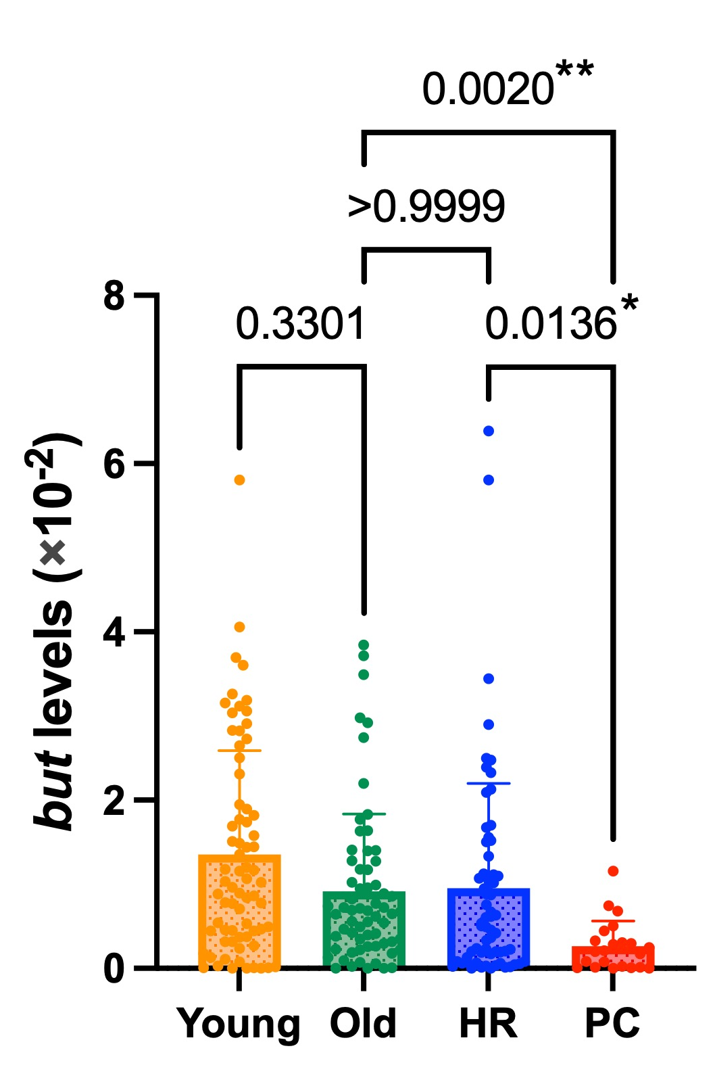

Fig. 5. Comparison of but gene levels derived from both the Anaerostipes hadrus group and Agathobacter rectalis across the four study groups: healthy controls aged <50 years (Young), healthy controls aged ≥50 years (Old), individuals with precursor lesions considered high risk for pancreatic cancer (HR), and patients with pancreatic cancer (PC). Each dot represents an individual participant; bars indicate the mean, and error bars indicate the standard deviation. Statistical differences were assessed using the Kruskal–Wallis test followed by Dunn’s post hoc comparisons. Significant P-values for intergroup comparisons are indicated above the bars. Statistically significant differences are indicated as follows: P < 0.05 (*), P < 0.01 (**).

3.6 NGS analysis of amplified but gene fragments
To verify the specificity of the primer set targeting the but gene, NGS analysis was conducted on amplified but gene fragments initially identified by qPCR analysis from a randomly selected subset of four healthy control subjects. A total of 219,176 reads corresponding to these amplified fragments were obtained. Supplementary Table 4 summarizes the characteristics of major Amplicon Sequence Variants (ASVs) that exhibited more than 200 reads. Among the total reads described in this table, ASVs perfectly matching the but gene sequence of A. hadrus accounted for 71.5%, while those perfectly matching the sequence of A. rectalis represented 18.9%. The next most abundant ASVs (9.2%) matched the but gene sequence of Roseburia species, which belong to the Lachnospiraceae family and are closely related to the Anaerostipes and Agathobacter genera as major butyrate producers.

4. DISCUSSION

This cross-sectional study sought to identify gut microbial signatures associated with pancreatic neoplasia while distinguishing those strongly influenced by ageing from those that remain comparatively stable across healthy age groups. The principal findings were that, among several disease-associated taxa, the A. hadrus group and A. rectalis showed the clearest depletion with minimal age dependency, and that a but gene-targeted qPCR assay captured reduced butyrate-producing potential in the PC group. Because the assay is non-invasive and less resource-intensive than NGS, it may be better viewed as a candidate adjunct for future evaluation in surveillance or risk assessment, rather than as a stand-alone diagnostic test.
Among the taxa examined, the relative abundance of the A. hadrus group was significantly lower in the HR and PC groups, and A. rectalis was significantly reduced in the PC group compared with healthy controls aged ≥50 years. Importantly, these differences were not observed between younger and older healthy individuals, suggesting that the observed disease-associated changes are less likely to reflect physiological ageing alone. This age stability supports their potential relevance as microbial markers of pancreatic neoplasia.
The F. prausnitzii group and F. saccharivorans were also identified as disease-associated taxa in the sequencing analysis. However, they were not regarded as the principal markers with minimal age dependence in the present study. In particular, the F. prausnitzii group showed a modest age-related trend in the healthy cohorts, suggesting that candidate taxa differ in the extent to which their abundances are influenced by ageing and other host-related factors. This distinction is important for biomarker development, because taxa that are biologically informative at the discovery stage are not always the most suitable targets for direct qPCR measurement in robust longitudinal risk assessment.
The observed reduction of the A. hadrus group and A. rectalis in PC is biologically plausible because both taxa are well-characterized producers of short-chain fatty acids (SCFAs), particularly butyrate. SCFAs play essential roles in maintaining intestinal barrier integrity, modulating immune responses, and exerting anti-inflammatory effects within the gut microenvironment (Yang et al., 2025). Accordingly, depletion of these taxa may be associated with a pro-inflammatory microbial milieu relevant to pancreatic tumor biology. Previous studies have reported reductions in butyrate-producing taxa, including A. hadrus, in the gut microbiota of patients with pancreatic cancer (Wang et al., 2022). To our knowledge, no prior studies have specifically emphasized the association between A. rectalis and pancreatic neoplasia.
Our findings also provide important context for interpreting previous studies. For example, increased abundance of Streptococcus species and depletion of beneficial taxa such as the F. prausnitzii group have previously been reported in patients with PC (Nagata et al., 2022; Bastos et al., 2023). However, in our age-stratified analysis, the S. salivarius group showed no significant difference between the Old and PC groups, but it was significantly less abundant in younger individuals than in patients with cancer. Similarly, the F. prausnitzii group, while reduced in the HR and PC groups, also showed higher abundance in younger individuals, suggesting that its apparent depletion in disease states may be influenced partly by age. These observations highlight the importance of age-controlled analyses in microbiome research and suggest that both oral-associated taxa and beneficial commensal taxa, although biologically informative at the discovery stage, may be more appropriately incorporated into broader multi-marker panels rather than used as stand-alone indicators.
Notably, the HR and PC groups were not significantly separated in beta diversity, indicating that community-wide compositional differences between these groups were limited in this cohort. This finding tempers the interpretation of progression-related changes at the global microbiota level and suggests that any disease-stage differences may be better reflected by selected taxa or targeted functional markers than by overall beta diversity.
Consistent with our rationale that microbial functional genes reflect metabolic potential across diverse taxa linked to intestinal disease states, we further evaluated the specificity of this approach by sequencing but gene amplicons from representative fecal samples. Most reads were assigned to A. hadrus (71.5%) and A. rectalis (18.9%), with an additional 9.2% corresponding to Roseburia species—closely related Lachnospiraceae members and known butyrate producers. Accordingly, the assay should be interpreted as a marker of a broader butyrate-producing functional cluster rather than as a taxon-specific measure of A. hadrus and A. rectalis. These findings provide preliminary support for the biological relevance of the but-targeted qPCR assay as a functional readout of shared butyrate-producing potential. However, the amplicon-sequencing analysis was performed in only four healthy control samples and should therefore be regarded as limited. In addition, although the newly designed primers showed high linearity and appropriate amplification efficiencies using pure DNA templates, validation in complex fecal matrices remains incomplete and has not yet undergone full Minimum Information for Publication of Quantitative Real-Time PCR Experiments (MIQE)-compliant evaluation. Accordingly, further analytical and clinical validation will be required before broader clinical implementation. The limited variation in but gene sequences observed by NGS may be due to the short (34-bp) amplicon length; nevertheless, this region likely captures diverse but genes associated with butyrate production across multiple bacterial groups.
Taken together, our findings underscore the value of identifying microbial signatures with minimal age dependence when developing non-invasive biomarkers for pancreatic neoplasia. To facilitate clinical translation, rather than relying on strict taxonomic quantification of the A. hadrus group and A. rectalis, we targeted their shared functional core through the but gene. In the present cohort, but gene levels in the HR group were similar to those in the Old group, whereas those in the PC group were significantly lower. This pattern suggests that reduced butyrate-producing potential may be more closely associated with established cancer than with the HR state itself, although prospective longitudinal studies are required to determine when this change emerges during malignant progression.
In the clinical management of HR individuals—such as those with IPMNs or chronic pancreatitis—identifying clinically meaningful interval change between routine imaging examinations remains challenging. If validated prospectively, this qPCR-based assay could serve as a practical adjunct for longitudinal monitoring because it can be performed rapidly and at relatively low cost. Serial within-person assessment may help identify individuals who warrant earlier imaging or endoscopic reassessment, but this application remains hypothetical until it is tested in prospective surveillance cohorts.
Compared with NGS-based taxonomic profiling, the qPCR assay also offers practical advantages because it directly quantifies a targeted functional gene and can be implemented more simply in repeated testing. In this study, both the combined taxonomic measure and the but gene assay distinguished the PC group from non-PC groups, whereas the qPCR approach may be more scalable for surveillance-oriented applications. These features may be especially relevant if future studies confirm its value in serial sampling.
This study has several important limitations that should be explicitly acknowledged. First, the cross-sectional design limits causal inference and precludes conclusions regarding temporal sequence; therefore, the observed reduction in but gene levels should be interpreted as stage-associated rather than progression-associated. Second, although age was explicitly considered, the conclusion of relative age stability was based on between-group comparisons rather than formal regression-based modeling of age effects; therefore, age dependence should be interpreted cautiously. Third, the sample size, particularly in the PC group (n = 22), was modest, which may have limited statistical power to detect smaller differences between groups. Accordingly, these findings should be interpreted as preliminary and require validation in larger cohorts. Fourth, the HR group was clinically heterogeneous, encompassing multiple conditions with potentially distinct biological backgrounds and risk profiles. Fifth, the ≥50-year healthy control cohort was derived from a previously analyzed dataset, and residual cohort or batch effects therefore cannot be excluded. Sixth, no additional global false discovery rate correction was applied across all subsequent pairwise comparisons; therefore, these analyses should be interpreted as supportive and exploratory. Seventh, NGS-based characterization of the but gene amplicons was performed in only a small subset of samples, and primer validation in complex fecal matrices remains limited and not yet fully MIQE-compliant. Accordingly, further analytical and clinical validation is required before clinical implementation. Finally, our cohort was geographically and ethnically homogeneous, which may limit generalizability.

5. CONCLUSION

This study provides new insights into gut microbial alterations associated with pancreatic neoplasia by distinguishing broadly disease-associated taxa from a more specific butyrate-related signature with relative age stability. By targeting the but gene, we developed a practical qPCR assay that evaluates the shared butyrate-producing potential of this biologically coherent microbial cluster. Within the present cohort, this assay showed that but gene levels were preserved in HR individuals, whereas those in the PC group were lower. Future prospective studies are warranted to validate these findings in larger and more diverse populations and to determine the potential clinical utility of this assay in longitudinal monitoring or risk assessment.

Consent (wherever applicable)
Written informed consent was obtained from all participants before sample collection. A copy of the written consent documentation is available for review by the Editorial Office upon reasonable request.

Ethical approval
The study protocol was approved by the Institutional Review Board of Fujita Health University (approval numbers: HM22-272 and HM23-078) and the Ethics Committee of Nagoya University of Arts and Sciences (approval number: 802), and the study was conducted in accordance with the Declaration of Helsinki.

Availability of data and materials
The 16S rRNA gene sequencing datasets generated from fecal DNA samples of healthy control individuals aged <50 years, healthy control individuals aged ≥50 years, and individuals with pancreatic neoplasia have been deposited in the NCBI Sequence Read Archive (SRA) under accession numbers PRJNA1286111, PRJNA1286097, and PRJNA1290828, respectively. Additional supporting data, primer information, and amplicon-sequencing summaries are provided in the Supplementary Material.

Authors’ contributions
This work was carried out in collaboration among all authors. Author EO collected the clinical samples. Author TF prepared the initial draft of the manuscript. All authors read and approved the final manuscript.

ABBREVIATIONS
A. hadrus: Anaerostipes hadrus; A. rectalis: Agathobacter rectalis; HR: high risk; IPMN: intraductal papillary mucinous neoplasm; LEfSe: linear discriminant analysis effect size; MIQE: Minimum Information for Publication of Quantitative Real-Time PCR Experiments; NGS: next-generation sequencing; PC: pancreatic cancer; PCoA: principal coordinate analysis; PDAC: pancreatic ductal adenocarcinoma; PERMANOVA: permutational multivariate analysis of variance; qPCR: quantitative polymerase chain reaction.

Disclaimer (Artificial intelligence)

During the preparation of this work, the authors used ChatGPT (GPT-5.2; OpenAI, San Francisco, CA, USA) in order to assist in translating certain sections from Japanese to English. After using this tool, the authors reviewed and edited the content as needed and take full responsibility for the content of the published article.

References
Bastos, A. R., Pereira-Marques, J., Ferreira, R. M., & Figueiredo, C. (2023). Harnessing the microbiome to reduce pancreatic cancer burden. Cancers (Basel), 15(9), 2629. https://doi.org/10.3390/cancers15092629
Bogdanski, A. M., Acedo, P., Wallace, M. B., van Leerdam, M. E., & Klatte, D. C. F. (2025). Recommendations, evidence and sustainability of screening for pancreatic cancer in high-risk individuals. Best Pract Res Clin Gastroenterol, 74, 101974. https://doi.org/10.1016/j.bpg.2025.101974
Bustin, S. A., Benes, V., Garson, J. A., Hellemans, J., Huggett, J., Kubista, M., et al. (2009). The MIQE guidelines: minimum information for publication of quantitative real-time PCR experiments. Clin Chem, 55(4), 611-622. https://doi.org/10.1373/clinchem.2008.112797
Dbouk, M., Brewer Gutierrez, O. I., Lennon, A. M., Chuidian, M., Shin, E. J., Kamel, I. R., et al. (2021). Guidelines on management of pancreatic cysts detected in high-risk individuals: An evaluation of the 2017 Fukuoka guidelines and the 2020 International Cancer of the Pancreas Screening (CAPS) consortium statements. Pancreatology, 21(3), 613-621. https://doi.org/10.1016/j.pan.2021.01.017
Fujii, T., Kuzuya, T., Kondo, N., Funasaka, K., Ohno, E., Hirooka, Y., et al. (2024). Altered intestinal Streptococcus anginosus and 5α-reductase gene levels in patients with hepatocellular carcinoma and elevated Bacteroides stercoris in atezolizumab/bevacizumab non-responders. J Med Microbiol, 73(9), 001878. https://doi.org/10.1099/jmm.0.001878
Fujii, T., Nakagawa, Y., Funasaka, K., Hirooka, Y., & Tochio, T. (2024). Levels of 5α-reductase gene in intestinal lavage fluid decrease with progression of colorectal cancer. J Med Microbiol, 73(6), 001834. https://doi.org/10.1099/jmm.0.001834
Furet, J. P., Firmesse, O., Gourmelon, M., Bridonneau, C., Tap, J., Mondot, S., et al. (2009). Comparative assessment of human and farm animal faecal microbiota using real-time quantitative PCR. FEMS Microbiol Ecol, 68(3), 351-362. https://doi.org/10.1111/j.1574-6941.2009.00671.x
Gyriki, D., Nikolaidis, C. G., Bezirtzoglou, E., Voidarou, C., Stavropoulou, E., & Tsigalou, C. (2025). The gut microbiota and aging: interactions, implications, and interventions. Front Aging, 6, 1452917. https://doi.org/10.3389/fragi.2025.1452917
Louis, P., & Flint, H. J. (2007). Development of a semiquantitative degenerate real-time PCR-based assay for estimation of numbers of butyryl-coenzyme A (CoA) CoA transferase genes in complex bacterial samples. Appl Environ Microbiol, 73(6), 2009-2012. https://doi.org/10.1128/AEM.02561-06
Nagasaka, M., Fujii, T., Kamano, T., Tochio, T., Takahashi, H., Hirooka, Y., et al. (2024). Assessment of risk for immune and psychiatric disorders using qPCR-based monitoring of the nan gene in gut microbiota: A non-invasive approach. Microbiol Res J Int, 34(11), 107-119. https://doi.org/10.9734/mrji/2024/v34i111503
Nagata, N., Nishijima, S., Kojima, Y., Hisada, Y., Imbe, K., Miyoshi-Akiyama, T., et al. (2022). Metagenomic identification of microbial signatures predicting pancreatic cancer from a multinational study. Gastroenterology, 163(1), 222-238. https://doi.org/10.1053/j.gastro.2022.03.054
Nakano, N., Fujii, T., Takahashi, H., Fujiki, K., Funasaka, K., Ohno, E., et al. (2026). Fecal and salivary microbial gene markers for the non-invasive detection of colorectal cancer progression. Microbiol Res J Int, (In press).
Nakaoka, K., Ohno, E., Kuramitsu, K., Kuzuya, T., Funasaka, K., Tochio, T., et al. (2024). Efficacy of 1-kestose supplementation in patients with pancreatic ductal adenocarcinoma: A randomized controlled pilot study. Nutrients, 16(17), 2889. https://doi.org/10.3390/nu16172889
Odamaki, T., Kato, K., Sugahara, H., Hashikura, N., Takahashi, S., Xiao, J. Z., et al. (2016). Age-related changes in gut microbiota composition from newborn to centenarian: A cross-sectional study. BMC Microbiol, 16, 90. https://doi.org/10.1186/s12866-016-0708-5
Sagami, R., Hayasaka, K., Ujihara, T., Iwaki, T., Okada, R., Yamada, M., et al. (2023). Role of EUS combined with a newly modified scoring system to detect pancreatic high-grade precancerous lesions. Endosc Ultrasound, 12(1), 111-119. https://doi.org/10.4103/EUS-D-21-00187
Takahashi, S., Tomita, J., Nishioka, K., Hisada, T., & Nishijima, M. (2014). Development of a prokaryotic universal primer for simultaneous analysis of bacteria and archaea using next-generation sequencing. PLoS One, 9(8), e105592. https://doi.org/10.1371/journal.pone.0105592
Tanaka, T., Fujii, T., Takahashi, H., Kuramitsu, K., Funasaka, K., Ohno, E., et al. (2025). Association between microbiome dysbiosis and postoperative disorders before and after gastrectomy. Digestion, 106(5), 437-449. https://doi.org/10.1159/000545678
Vital, M., Howe, A. C., & Tiedje, J. M. (2014). Revealing the bacterial butyrate synthesis pathways by analyzing (meta)genomic data. mBio, 5(2), e00889-14. https://doi.org/10.1128/mBio.00889-14
Wang, X. Y., Sun, Z. X., Makale, E. C., Rezaeifar, M., Xia, J., Chen, Y., et al. (2022). Gut microbial profile in patients with pancreatic cancer. Jundishapur J Microbiol, 15(4), e122386. https://doi.org/10.5812/jjm-122386
Yang, S. F., Chen, X. C., & Pan, Y. J. (2025). Microbiota-derived metabolites in tumorigenesis: Mechanistic insights and therapeutic implications. Front Pharmacol, 16, 1598009. https://doi.org/10.3389/fphar.2025.1598009
Yoon, S. H., Ha, S. M., Kwon, S., Lim, J., Kim, Y., Seo, H., et al. (2017). Introducing EzBioCloud: A taxonomically united database of 16S rRNA gene sequences and whole-genome assemblies. Int J Syst Evol Microbiol, 67(5), 1613-1617. https://doi.org/10.1099/ijsem.0.001755

