Exploring the impact of cooler zones to enhance seed support for Muga (Antheraea assamensis Helfer) cultivation

.
ABSTRACT

To ensure a continuous supply of Disease Free Layings (DFLs) of Muga silk and meet the annual demand of approximately 325-350 lakh DFLs, a seed linkage program has been initiated in the cooler regions of Kalimpong, West Bengal. This initiative aims to provide basic Muga seeds for the traditional rearing regions of the North-East during challenging climatic conditions, particularly during the Aherua (June-July) and Bhodia (August-September) seasons. The rearing and grainage performance in Kalimpong has been analysed based on key economic factors such as DFL to cocoon ratio, hatching percentage, larval weight, cocoon weight, shell weight, and silk ratio. This study indicates that rearing of Antheraea assamensis Helfer in the cooler zones of Kalimpong showcases improved performance, particularly during unfavourable seasons. As reported by Guha et al. (2019), climate change has led to increased temperature gradients that adversely affect muga silkworm rearing. Additionally, significant fluctuations in relative humidity (above 86%) and temperatures exceeding 32-37°C have consistently resulted in crop losses, particularly between June and September, which is crucial for basic seed production (t=13.74, P<0.00001). The findings of the present study highlight the essential role of cooler zones in supporting muga silk cultivation and stabilising seed production systems. Given the strong dependence of muga silkworm biology on environmental parameters, the integration of cooler regions such as Kalimpong into the seed linkage network emerges as a viable climate-adaptive strategy for ensuring the resilience and continuity of muga sericulture.

Keywords: Cooler zone, Seed support, Muga cultivation, Antheraea assamensis, Climate mitigation strategies, climate resilient sericulture.

1. INTRODUCTION

Muga silk, a cultural heritage of India, is cherished for its distinctive natural golden yellow colour. The Muga silkworm (Antheraea assamensis Helfer) is native to Assam and the neighboring regions of North-Eastern India. However, the production of Muga raw silk remains lower compared to other commercial silks in the country, primarily due to the scarcity of high-quality Muga Dfls during the key rearing seasons.
A significant challenge facing the Muga silk industry is the inconsistency in seed cocoon production during the Aherua, Bhodia, and Late Bhodia cropping seasons. These pre-seed and seed crops are often reared under adverse climatic conditions, which result in low productivity, crop losses, and a subsequent shortage of seeds. This shortage ultimately impacts the production of Kotia commercial crop seeds, which are crucial for ensuring a stable supply of Muga raw silk.
Additionally, in recent years, regions in Meghalaya such as Mendipathar, Rompara, Adokgre, Tura and other plain areas of Assam have experienced significant temperature rise, reaching as high as 39-41°C during the Aherua and Bhodia seasons. These extreme temperatures are extremely detrimental to Muga rearing and grainage, further complicating the production of Kotia commercial Dfls. This situation underscores the need for improved practices and strategies to mitigate the adverse effects of climate change on Muga silk production in India.
Choudhury et al. (2010) reported that unprecedented climatic changes causing loss of silkworms due to diseases, pests, predators and natural vagaries has been raking havoc in the entire seed multiplication programs of muga culture. The change in the abiotic factors also leads to poor cocoon yield, pupal mortality and emergence of high percentage of crippled moths, male sterility leading low hatching of dfls and reduced coupling aptitude. It was also reported by different authors that the abiotic and biotic factors of the environment during different seasons greatly influenced the growth and development of muga silkworm in the form of cocoon weight, pupal weight, shell percentage, potential fecundity (Chiang, 1985; Yadav and Goswami, 1989; Yadav, 2000; Rahmathulla, 2012).
The recurring meteorological challenges in the traditional muga growing area over the past five years due to biotic and abiotic factors have significantly impacted the production of DFLs for commercial crops such as Kotia and Jethua. These environmental conditions have rendered many traditional seed crop rearing zones in Assam ineffective. To address the demand for Muga DFLs, estimated between 325 to 350 lakh annually, a seed linkage program is proposed, which would involve conducting Muga rearing in cooler zones during unfavorable weather conditions.
The Muga Eri Silkworm Seed Organization (MESSO), in collaboration with the Central Silk Board in Guwahati, has identified special seed zones in the Kalimpong District of West Bengal, where the climate is more conducive for Muga rearing, with temperatures ranging from 20°C to 27°C during summer. Efforts are ongoing to find additional summer seed zone areas suitable for Muga cultivation in various regions including Bomdila, Aalo, Ziro, Kiang in Arunachal Pradesh, South Garo Hills Meghalaya, Imphal West Manipur, Kolasib, Kanpui and Lunglei in Mizoram, Mokokchung and Wokha in Nagaland, as well as non-traditional areas such as Kurseong, Sittong, Kolbong, Relling, Bijanbari, and Naxalbari under the Darjeeling District of West Bengal, along with other locations like Panchmari in Madhya Pradesh, Dehradun in Uttarakhand, and Koraput in Odisha.

2. material and methods
Cooler Zone Identifications:
Kalimpong: The town centre is on a ridge connecting two hills, Deolo Hill and Durpin Hill, at an elevation of 1,247 m (4,091 ft). Deolo, the highest point in Kalimpong, has an altitude of 1,704 m (5,591 ft) and Durpin Hill is at an elevation of 1,372 m (4,501 ft).RSRS Kalimpong Muga farm is situated at Durpin hill.
Kalimpong has a temperate, monsoon-influenced subtropical highland climate (Köppen: Cwb). It has five distinct seasons: spring, summer, autumn, winter and the monsoons. The annual temperature is 18 °C (64 °F). Summers are mild, with an average maximum temperature of 25.5 °C (77.9 °F) in August.(Source: https://kalimpong.gov.in/climate)

List 1. Weather details of Kalimpong
 | May | June | July | August | September | October
Avg. Temperature °C (°F) | 20.8 °C  (69.4) °F | 22 °C  (71.5) °F | 21.9 °C  (71.4) °F | 22 °C  (71.6) °F | 21.3 °C  (70.3) °F | 18.8 °C  (65.9) °F
Min. Temperature °C (°F) | 17.2 °C  (62.9) °F | 19.8 °C  (67.6) °F | 20.3 °C  (68.5) °F | 20.1 °C  (68.2) °F | 19.1 °C  (66.3) °F | 15.3 °C  (59.6) °F
Max. Temperature °C (°F) | 24.6 °C  (76.3) °F | 24.9 °C  (76.9) °F | 24.4 °C  (75.9) °F | 24.8 °C  (76.6) °F | 24.3 °C  (75.7) °F | 22.7 °C  (72.9) °F
Precipitation / Rainfall mm (in) | 187  (7) | 519  (20) | 861  (33) | 617  (24) | 360  (14) | 114  (4)
Humidity(%) | 78% | 89% | 93% | 91% | 89% | 82%
Rainy days (d) | 16 | 20 | 21 | 20 | 18 | 10
Avg. Sun hours (hours) | 8.9 | 6.5 | 5.2 | 6.1 | 6.6 | 8.4

Studies were conducted during Aherua and Bhodia crop for two consecutive years during 2023 and 2024 in four different locations viz. Kalimpong (27.0594⁰ N, 88.4695⁰ E) (Non-traditional belt), Mendipathar (25.9158⁰ N, 90.6441⁰ E) , Rompara (25.8787⁰ N, 90.6097⁰ E) & AGIA (26.1639⁰ N, 90.6253⁰ E) (All are traditional belt) to understand the present scenario of Muga cultivation during summer seasons.
200 gm muga dfls each in 3 replications were reared in these four locations to evaluate the rearing performance. Pre-brushing care were taken to avoid pest and predators during rearing by removing dry leaves & twigs of the som plants and ant nests, cleaning of plots, and erection of nylon nets. Prophylactic measures were also taken to avoid disease incidence through dusting of lime & bleaching powder (9:1) in the field, spraying of Sodium hypochlorite in the food plants before initiation of rearing. The rearing performance has been assessed by the following parameters viz. dfl: cocoon ratio, fecundity, hatching (%,) larval weight (g) cocoon weight (g), shell Weight (g), silk ratio (%). The abiotic factors were correlated with different economic parameters and the effect of the change in the climate on muga rearing was established.

3. results and discussion

The rearing performance data for Aherua and Bhodia crops in the Kalimpong area, compared with Mendipathar, Rompara, and Agia, highlights significant variances influenced by environmental conditions. In Kalimpong, cocoon yields were impressive, with averages of 52, 49, 58, and 54 cocoons per dfls, contrasting sharply with the low yields in the other locations, which struggled to meet the standard seed cocoon norms with cocoon yield of below the Dfls: Seed Cocoon=1:30.
Fecundity rates during the Bhodia season were notable in Kalimpong, with averages reaching up to 190 eggs per moth. In stark contrast, the other areas recorded lower fecundity rates, averaging between 130 to 154 eggs, likely due to adverse temperature conditions. While Kalimpong maintained an optimal temperature range of 17-25°C, Mendipathar, Rompara, and Agia experienced much higher temperatures of 39-41°C, negatively impacting the fecundity and overall economic viability of Muga rearing. The fourth and fifth stage female worms when exposed to high temperature during the rearing period affects the rate of ovulation and the fecundity gets affected. (Chaudhuri, 2003)
Hatching success in the other locations was also dismal, with rates of only 12-24% for Aherua and 15-39% for Bhodia, whereas Kalimpong hatching percentage was recorded up to 88-92%. The higher temperatures in Mendipathar, Rompara, and Agia disrupted mating behaviours and resulted in increased embryonic mortality rates, contributing to the poor hatching outcomes, which may be cause a lesser transfer of sperms resulting in increase of unfertilized eggs. (Gandara & Drummond, 2023)
Additionally, larval development times in Kalimpong were longer (22-31 days), indicating a negative impact on growth rates despite favourable temperatures. In contrast, larvae in warmer regions completed development more quickly, suggesting that while temperatures influence growth, they also harm overall health and weight, as evidenced by average larval weights of 5-6 gm for males and 9-10 gm for females, compared with 7-11 gm in Kalimpong. Guha et al. (2024) reported that under warmer temperatures, larval stages developed more quickly and had higher growth rates but reached a smaller body size, a phenomenon known as the Temperature-Size Rule (TSR). Under a short photoperiod, both growth and development were slower, especially at the two lower temperatures (<15°C and <10°C), but the body size resulting from slow growth over a longer developmental period did not vary significantly with the photoperiod. Chanotra et al. (2024) found a correlation between crop success in muga rearing and the studied period, temperature, and relative humidity. Tripathi & Singh (2017) and Borah and Goswami (2026) have reported that elevated air temperatures, particularly during the 4th and 5th larval instars, pose a significant climatic challenge that can adversely affect matured silkworms and cocoon production and harvest. During the present study, the performance of grainages indicates that farm rearing in Mendipathar, Rompara (Meghalaya), and Agia (Assam) has yielded a very poor seed cocoon dfl ratio, achieving only 1 dfl from 10-11 cocoons. In contrast, Kalimpong demonstrated significantly better outcomes, with a yield of 1 dfl from about 3 cocoons, which aligns well with the expected norms for dfl recovery. Additionally, heavy crippled moth emergence, low mating tendencies, reduced fecundity, and poor hatching rates have been consistently observed over the past three years in Mendipathar, Rompara, and Agia. Kumar et al, (2025) has also demonstrated the impact of seasonal variations on economic grainage traits of Muga silkworm in Garo Hills, Meghalaya.. The present findings provide a foundation for future studies in Antherearea assamensis to investigate the cellular and molecular mechanisms underlying sperm elimination and the inability of sperm to support the early embryo when males are chronically exposed to high temperatures. Moreover, these findings highlight the importance of microclimatic conditions in strengthening sustainable sericulture practices, and the role of cooler zones that significantly improve seed quality, larval survival and overall productivity in Muga cultivation.

Table 1-Details of Study area with Climatic conditions:

NAME OF THE PLACE | DISTRICT | STATE | LATITUDE | LONGI TUDE | ALTI TUDE | MUGA REARING  IN PLAINS/ HILLS AREA | WEATHER DURING JUNE TO SEPTEMBER 2023-2024 |  |  |  | REMARKS
 |  |  |  |  |  |  | AVG. TEMPERATURE ⁰C |  | AVG. RH (%) |  | REMARKS
 |  |  |  |  |  |  | MIN | MAX | MIN | MAX | REMARKS
KALIMPONG | KALIMPONG | WEST BENGAL | 27.0594⁰N | 88.4695⁰E | 1247M | HILLY | 17 | 25 | 78 | 93
MENDIPATHAR | NORTH GARO HILLS | MEGHALAYA | 25.9158⁰N | 90.6441⁰E | 62M-916M | PLAINS | 26 | 39 | 58 | 92
ROMPARA | NORTH GARO HILLS | MEGHALAYA | 25.8787⁰N | 90.6097⁰E | 26M-997M | PLAINS | 27 | 39 | 57 | 93
AGIA | GOALPARA | ASSAM | 25.6743⁰N | 90.3278⁰E | 500M-900M | PLAINS | 28 | 41 | 62 | 90

Table.2 Comparative Performance of Muga silkworm rearings and grainage during Aherua & Bhodia Crop in different study locations -2023

Sl. | Parameters | KALIMPONG |  | MENDIPATHAR |  | ROMPARA |  | AGIA
No.
 |  | Aherua | Bhodia | Aherua | Bhodia | Aherua | Bhodia | Aherua | Bhodia
1 | Larval Duration (days) | 22 | 32 | 19 | 20 | 20 | 21 | 19 | 20
2 | Dfl: Cocoon | 1:52 | 1:49 | 1:16 | 1:23 | 1:17 | 1:21 | 1:12 | 1:14
3 | Larval Wt. (M) IN G | 6.11 | 7.32 | 5.14 | 6.24 | 5.37 | 6.12 | 5.12 | 5.98
4 | Larval Wt. (F) IN G | 11.73 | 11.89 | 9.49 | 10.48 | 10.83 | 10.67 | 10.1 | 10.23
5 | Cocoon Wt. (M) IN G | 5.98 | 6.9 | 4.39 | 5.78 | 4.29 | 5.41 | 4.46 | 4.81
6 | Cocoon Wt. (F) IN G | 8.98 | 9.12 | 8.24 | 9.16 | 9.48 | 8.89 | 7.48 | 7.11
7 | Pupal Wt. (M) IN G | 5.42 | 6.26 | 3.92 | 5.15 | 3.82 | 4.92 | 3.95 | 4.28
8 | Pupal Wt. (F) IN G | 8.27 | 8.35 | 7.55 | 8.45 | 8.81 | 8.2 | 6.76 | 6.35
9 | Shell Wt. (M) IN G | 0.56 | 0.64 | 0.47 | 0.63 | 0.47 | 0.49 | 0.51 | 0.53
10 | Shell Wt. (F) IN G | 0.71 | 0.77 | 0.69 | 0.71 | 0.67 | 0.69 | 0.72 | 0.76
11 | Silk Ratio (M) IN G | 9.36 | 9.28 | 10.71 | 10.90 | 10.96 | 9.06 | 11.43 | 11.02
12 | Silk Ratio (F) IN G | 7.91 | 8.44 | 8.37 | 7.75 | 7.07 | 7.76 | 9.63 | 10.69
13 | Seed Cocoon : Dfl | 3.5:1 | 3:1 | 4:1 | 4:1 | 4.5:1 | 4:1 | 5:1 | 4.5:1
14 | Fecundity (NO) | 182 | 188 | 156 | 149 | 139 | 138 | 142 | 146
15 | Hatching % | 90 | 91 | 24 | 39 | 22 | 38 | 12 | 15

Table.3 Comparative Performance of Muga silkworm rearings and grainage during Aherua & Bhodia Crop in different study locations- 2024

Sl. | Parameters | KALIMPONG |  | MENDIPATHAR |  | ROMPARA |  | AGIA
No.
 |  | Aherua | Bhodia | Aherua | Bhodia | Aherua | Bhodia | Aherua | Bhodia
1 | Larval Duration (days) | 24 | 31 | 18 | 19 | 19 | 19 | 18 | 19
2 | Dfl: Cocoon | 1:58 | 1:54 | 1:20 | 1:16 | 1:21 | 1:11 | 1:07 | 1:08
3 | Larval Wt. (M) IN G | 6.47 | 7.12 | 5.63 | 6.14 | 5.47 | 6.22 | 5.97 | 6.24
4 | Larval Wt. (F) IN G | 11.8 | 11 | 9.21 | 10.13 | 10.15 | 10 | 9.67 | 10.27
5 | Cocoon Wt. (M) IN G | 6.13 | 6.68 | 5.18 | 5.41 | 4.97 | 5.23 | 5.1 | 5.49
6 | Cocoon Wt. (F) IN G | 8.41 | 8.46 | 7.68 | 8.1 | 7.1 | 7.89 | 6.98 | 7.23
7 | Pupal Wt. (M) IN G | 5.54 | 6.07 | 4.64 | 4.85 | 4.47 | 4.69 | 4.62 | 4.98
8 | Pupal Wt. (F) IN G | 7.72 | 7.69 | 6.99 | 7.39 | 6.43 | 7.2 | 6.26 | 6.47
9 | Shell Wt. (M) IN G | 0.59 | 0.61 | 0.54 | 0.56 | 0.5 | 0.54 | 0.48 | 0.51
10 | Shell Wt. (F) IN G | 0.69 | 0.77 | 0.69 | 0.71 | 0.67 | 0.69 | 0.72 | 0.76
11 | Silk Ratio (M) IN G | 9.62 | 9.13 | 10.42 | 10.35 | 10.06 | 10.33 | 9.41 | 9.29
12 | Silk Ratio (F) IN G | 8.20 | 9.10 | 8.98 | 8.77 | 9.44 | 8.75 | 10.32 | 10.51
13 | Seed Cocoon : Dfl | 3:1 | 3:1 | 4.5:1 | 4:1 | 5:1 | 4:1 | 5.5:1 | 5:1
14 | Fecundity (NO) | 180 | 190 | 153 | 146 | 148 | 154 | 135 | 140
15 | Hatching % | 88 | 92 | 20 | 37 | 21 | 36 | 14 | 19

Table: 4 Muga P-4 Basic Seed production through Replenishment stock maintenance-2023-2025 at Kalimpong region .(Source- Technical report,,MESSO,CSB Guwahati)

2023 | 2024 | 2025
2395 g | 9723 g | 7500 g

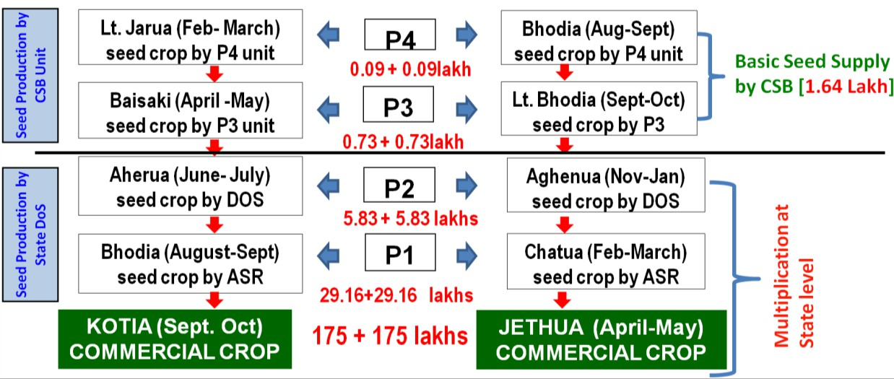
Fig 1.:Muga seed production steps and seed sharing patterns as per projected
Raw silk target (2025-26) (Source: Technical report MESSO,CSB, GUWAHATI)

Table: 5 Types of Muga seed requirement and sharing patterns as per projected raw silk target for (2025-26). (Source: MESSO,CSB, GUWAHATI)

Seed Production/  Organization | DFLs production  Units/Agency | Type of seeds | Requirement of  Dfls
MESSO,CSB-Unit | CSB P4Units(2) | P4 Dfls (Lakh) | 0.18
MESSO,CSB-Unit | CSB P3Units(8) | P3 Dfls(Lakh) | 1.46
State Sericulture Departments/Pvt.graineur/ ASR/ RSP | DoS Farms | P2 Dfls (Lakh) | 11.67
State Sericulture Departments/Pvt.graineur/ ASR/ RSP | DoS farmers | P1 Dfls (Lakh) | 58.33
State Sericulture Departments/Pvt.graineur/ ASR/ RSP | Commercial farmers | Commercial (Lakh) | 350
 |  | Raw Silk (MT) | 350

Figure.2 Min and Max Temperature during Aherua & Bhodia Crop in 2023-2024

Figure.3 Min and Max Relative Humidity during Aherua & Bhodia Crop in 2023-2024

The data regarding the rearing and grainage performance of the Aherua and Bhodia crops in various locations is laid out in Tables 2 and 3. Table 1 provides an overview of the minimum and maximum temperatures along with the minimum and maximum relative humidity recorded during both seasons across these locations. From the information in Tables 2 and 3, it is evident that the DFLs to cocoon ratio, along with other performance metrics, was highest in every recorded year (2023-2024) when rearing was conducted in the Kalimpong area for both Aherua and Bhodia crops.

In the plains, fluctuations in temperature and humidity have been identified as significant factors contributing to the spread of bacterial and viral diseases among Muga silkworms, leading to a low DFLs to cocoon ratio and a reduced hatching percentage. Land elevation also plays a critical role in the performance of Muga rearing during the rainy season. In the plains, stagnant rainwater in rearing fields can result in various diseases affecting Muga silkworms. Conversely, the hilly terrain mitigates this issue due to its sloped land, which prevents water from pooling.

To achieve the target of producing 350 MT of raw Muga silk by the 2025-2026 period, a specific quantity of basic DFLs at the P-4 level is required. For the 2024-2025 period, Kalimpong alone produced a certain amount of P-4 DFLs and supplied them to P-3 units. To fulfill the target, it is planned to produce an additional 5,500 to 6,000 grams of DFLs at the Mendipathar and Tura P-4 units, which is considered easily achievable (refer to Fig-1 and Table 5).

Subharani and Jayaprakash (2015) reported that large scale muga silkworm rearings in cooler zones viz. Nagaland and Mizoram has been taken up for the first time by Muga Silkworm Seed Organisation, Central Silk Board, Guwahati to combat muga crop failures during summer seed crop rearings in Assam and bridge the gap of seed shortage during commercial crop rearings in Assam. The results of this study showed that the rearing performances during the seed crops in the cooler pockets of Mizoram and Nagaland revealed significantly better results than the rearings of Narayanpur, Assam where there prevails adverse climatic conditions during seed crops rearings. Similarly, Kakati (2012) & Pachau et al. (2012) reported that Nagaland and Mizoram ensure favourable climatic conditions for muga seed crop rearings and can be prospective seed zone for meeting the dfls demand during succeeding commercial crops in Assam. The cocoon yields and all the other economic parameters of cooler zones rearings were remarkably higher than the farm rearings of Narayanpur, Assam. The findings corroborate the report of Sekharappa and Gururaj (1989) who reported that temperature and humidity directly affect the biological activities of the silkworm. Dependence of muga cocoon yields on environment was also reported by Chaudhuri (2003). Since, muga silkworm being indispensible to outdoor rearing, the fluctuations in abiotic factors during different seasons greatly influence the development and survivability (Zamal et al., 2010). Das and Roy (2013) in their study on temperature trends in Assam also observed that majority of the trends, both annual and seasonal, showed increasing tendency in temperature during the period 1981-2010. Hence, as an alternative, systematic planning for conduction of summer seed crop rearings in cooler areas to meet the dfls demand for commercial crop in Assam should be worked out. The study provides valuable field-based comparative data between traditional and non-traditional rearing zones, highlighting the adaptive potential of cooler regions such as Kalimpong.by offering a practical strategy for stabilising Disease-Free Layings (DFLs) supply as in traditional regions, as climate change is posing a significant threat to muga silk production during summer seasons in Assam and Meghalaya.
4. Conclusion

The results demonstrate that rearing performances during seed crops in the cooler regions of Kalimpong significantly surpassed those in the plains areas of Mendipathar, Rompara (Meghalaya), and Agia (Assam), which are subject to adverse climatic conditions during the Aherua, Bhodia, and late Bhodia (June to October) seed crop rearings. The relationship between altitude and temperature is notable; as elevation increases, environmental temperatures decrease due to the thinning of air and its reduced capacity to retain heat. Under standard atmospheric conditions, temperature typically decreases by approximately 1 degree Celsius for every 165 meters of ascent in the troposphere, a phenomenon known as the normal lapse rate. Therefore, systematic planning of summer seed crop rearings in cooler areas at the P-2 level (130-acre plantations for the Aherua crop) and P-1 level (6480-acre plantations for the Bhodia crop) is essential to meet the demand for commercial crops such as Jethua throughout the North-East. Furthermore, collaborative initiatives, including training programs, Krishi Mela, and various extension activities, have been conducted in partnership with organizations such as the Central Silk Board’s MESSO-Guwahati, RSRS-Kalimpong, and the Department of Sericulture, West Bengal. These initiatives are designed to support Muga (Antheraea assamensis Helfer) cultivation, improve technical expertise in Muga farming practices, and strengthen seed production to ensure the success of commercial crops in the Muga sector.
Cultivation in cooler zones significantly enhances seed quality, larval survival, and overall productivity in Muga production. These findings underscore the critical role of microclimatic conditions in promoting sustainable muga sericulture practices.

Disclaimer (Artificial intelligence)
Author(s) hereby declare that NO generative AI technologies such as Large Language Models (ChatGPT, COPILOT, etc.) and text-to-image generators have been used during the writing or editing of this manuscript.

References
Borah, P. and Goswami, R. (2026). Changing Climatic Patterns and Their Implications for Muga Sericulture in Jorhat, Assam, India. International Journal of Environment and Climate Change.16(4): 422-429.
Chanotra S., Kumara, R. R., Saicharan, D., Guha, L. M., & Hemachandran, H. (2024). Variation in season wise performance of Muga silkworm (Antheraea assamensis Helfer) aimed to climate change trends: A descriptive study. International Journal of Zoology and Applied Biosciences, 9(6). https://elibrary.ru/item.asp?id=8012289.
Chaudhuri, M. (2003) Evaluation of impact of weather on cocoon shell weight of muga silkworm, Anthereae assamensis, Westwood). Sericologia, 39(4): 577 591.
Chiang, H.C. 1985. Insects and their environment, Fundamentals of applied Entomology, Macmillan Publishing Company, New York. Pp. 128-161.
Choudhury, B., Bhattacharya, A., Singh, B.K., Prabhakar, C.J. (2010). Effect of global warming in the rearing performance of muga silkworm, Anthereae assama Helfer. J. Assam Sci. Soc., 51(1): 134 140.
Das, Kishore K., Tanushree Deb Roy, (2013) Temperature trends at four stations of Assam during the period 1981-2010. Int. J. Sci. Res. Publ., 3(6).
Das, P., Saikia, M., & Neog, D. (2023). Effect of climate change on Eri and Muga cultivation and the resultant impact on rural income and employment in Assam. Journal of Livestock Science, 14. https://doi.org/10.33259/JLivestSci.2023.135-147
Gandara ACP, Drummond-Barbosa D. (2023) Chronic exposure to warm temperature causes low sperm abundance and quality in Drosophila melanogaster. Sci Rep. Jul 30;13(1):12331. doi: 10.1038/s41598-023-39360-7. PMID: 37518578; PMCID: PMC10387475.
Guha, Lopamudra, Hridya, H., Das, B., Sarkar, B.N., Bhuyan, N. B., Choudhury, B. (2019). Analysing the Impact of Climatic Changes on Rearing Performance of Antheraea assamensis (Muga Silk Worm): Study of a Decade, Proceedings of The 25th International Congress on Sericulture and Silk Industry,2019, NM P 03,84pp
Guha, Lopamudra, Hridya, H.,Majumdar, M, Singh, A, Chutia, M., Sarkar, B.N., Neog K. (2024). Influence of Photoperiod and Temperature on Oviposition Activity in Antheraea assamensis Helfer. Silkworm Seed Con 2024: International Conference on Silkworm Seed Industry: Opportunities and Future Prospects, Bangalore. 30-31 Jan, 2024.
Gowda, B. N., & Reddy, N. M. (2007). Influence of different environmental conditions on cocoon parameters and their effects on reeling performance of bivoltine hybrids of silkworm, Bombyx mori. International Journal of Industrial Entomology, 14. https://koreascience.or.kr/journal/IJIEB.page
Kakati, L.N. (2012). Mokokchung district of Nagaland-Prospective seed Zone for muga silk Industry. Compendium of Seminar Papers. National Seminar on Recent trenda in Research and Development in Muga Culture- Ideas to action, Guwahati, 3-4th May. 87pp.
Kumar, V., Singh, A., Majumdar, M., Kumar, N., & Bhatia, N. K. (2025). Impact of seasonal variations on economic grainage traits of Muga silkworm (Antheraea assamensis) in Garo Hills, India. Archives of Current Research International, 25(4). https://doi.org/10.9734/acri/2025/v25i41146
Pachuau, L., Chowdhury, B.N., Tikader, A. (2012) Status of Muga culture in Mizoram. Compendium of seminar papers. National Seminar on Recent trenda in Research and Development in Muga Culture- Ideas to action, Guwahati, 3 4th May. 88pp.
Ram, R. L., Maji, C., & Bindroo, B. B. (2016). Impact of climate change on sustainable sericultural development in India. International Journal of Agriculture Innovations and Research, 4(6). https://www.ijair.org/administrator/components/com_jresearch/files/publications/IJAIR_1473_Final.pdf
Rahmathulla, V.K. (2012). Management of Climatic factors for successful silkworm (Bombyx mori L.) crop and higher silk production: A review. Psyche, 1 12 Pp.
Sekarappa, B.M., Gururaj, T.J. (1989). Management of silkworm rearing during summer, Indian Silk, 27(12): 6.
Subharani , S., Jayaprakash, P. (2015) High Altitude Seed Zones: A Ray of Hope for Muga Silk Industry Int.J.Curr.Microbiol.App.Sci (2015) 4(6): 436-442.
Tripathi, A. K., & Singh, P. (2017). The effect of climate change on the mulberry insect fauna in India’s temperate and subtropical regions. Novateur Publications JournalNX- A Multidisciplinary Peer-Reviewed Journal 3,(11):58-66. https://www.neliti.com/publications/438880/the-effects-of-climate-change-on-the-mulberry-insect-fauna-in-india-s-temperate
Yadav, (2000). Studies on the association between cocoon weight and silk of muga silkworm (Anthereae assama (Westwood) during different broods. Int. J. Wild Silk Moths Silk, 5: 221 225.
Yadav, G.S., Goswami, B.C. (1989). Correlation and Regression analysis between cocoon weight and shell weight in muga silkworm on two different types of food plants. Sericologia, 29(2): 219 224.
Zamal, T., Sarmah, B., Hemchandra, O., Kalita, J.(2010). Global warming and its impact on the productivity of Muga Silkworm (Anthereae assamensis Helfer.) Bioscan., 1: 199 209.

Definitions, Acronyms, Abbreviations
Here is the Definitions section. This is an optional section.
Term: Definition for the term

APPENDIX

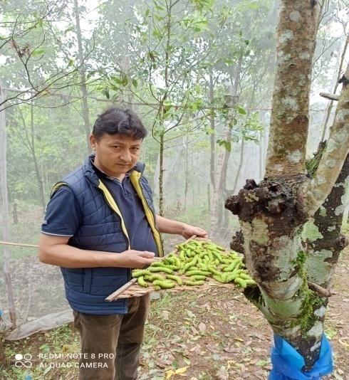
PLATE:- MUGA REARING DURING AHERUA CROP AT RSRS KALIMPONG IN 2023 (W.B)

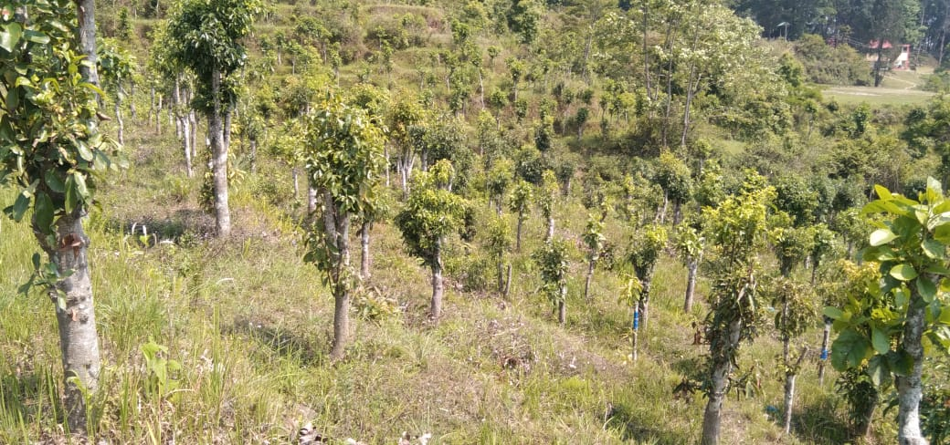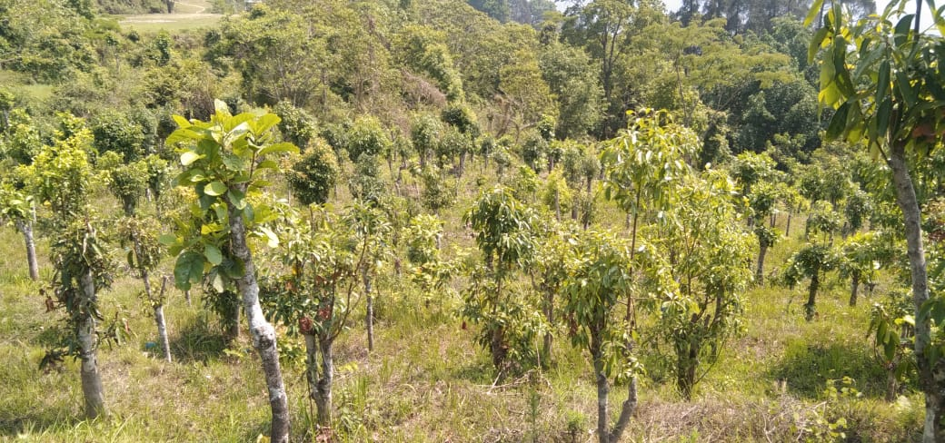
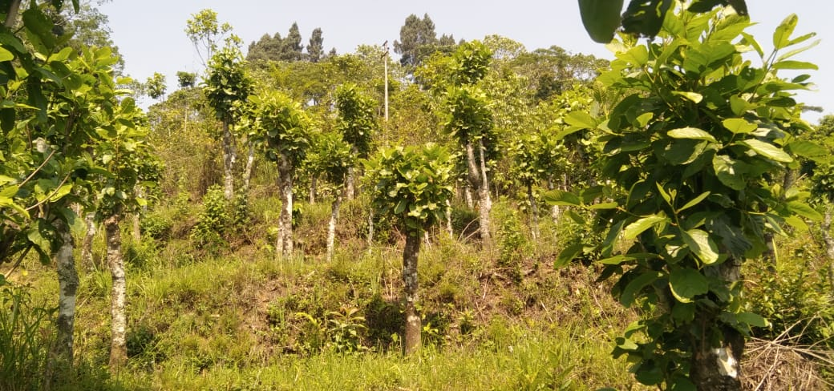
PLATE-SYSTEMATIC POLLARDING CONDUCTED AT RSRS KALIMPONG FIELD DURING 2022-2023

PLATE:- MUGA GRAINAGE DURING BHODIA CROP AT RSRS KALIMPONG IN 2023 (W.B)
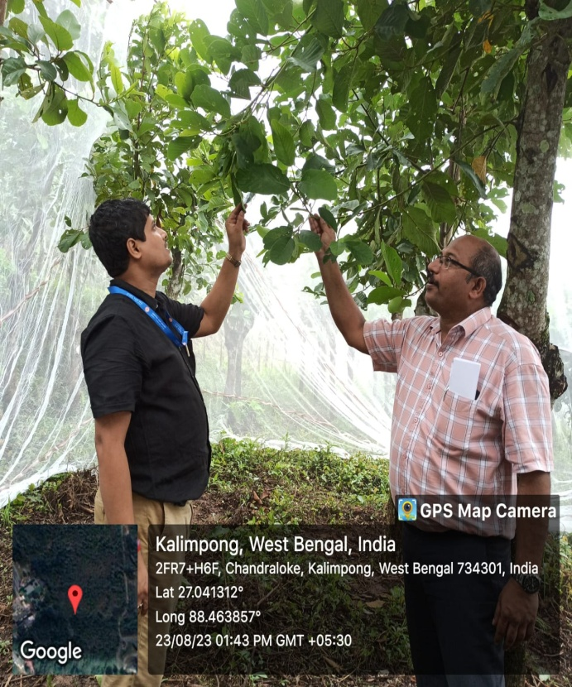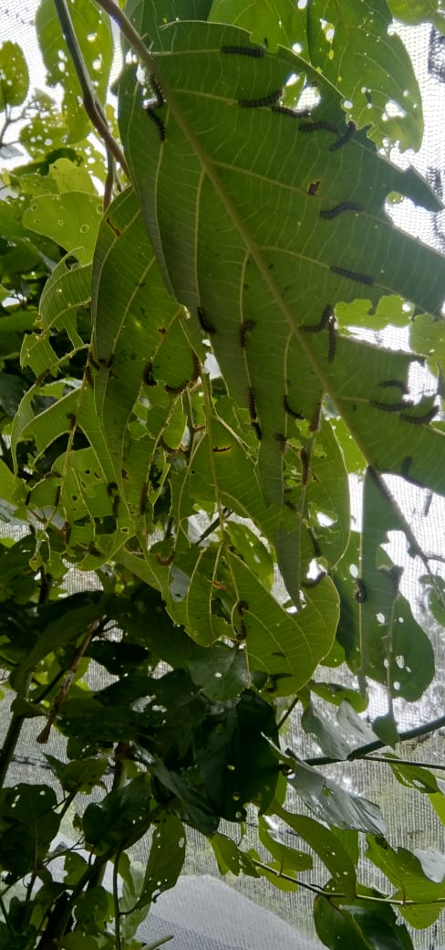
PLATE:- MUGA REARING DURING BHODIA CROP AT RSRS KALIMPONG IN 2023 (W.B)
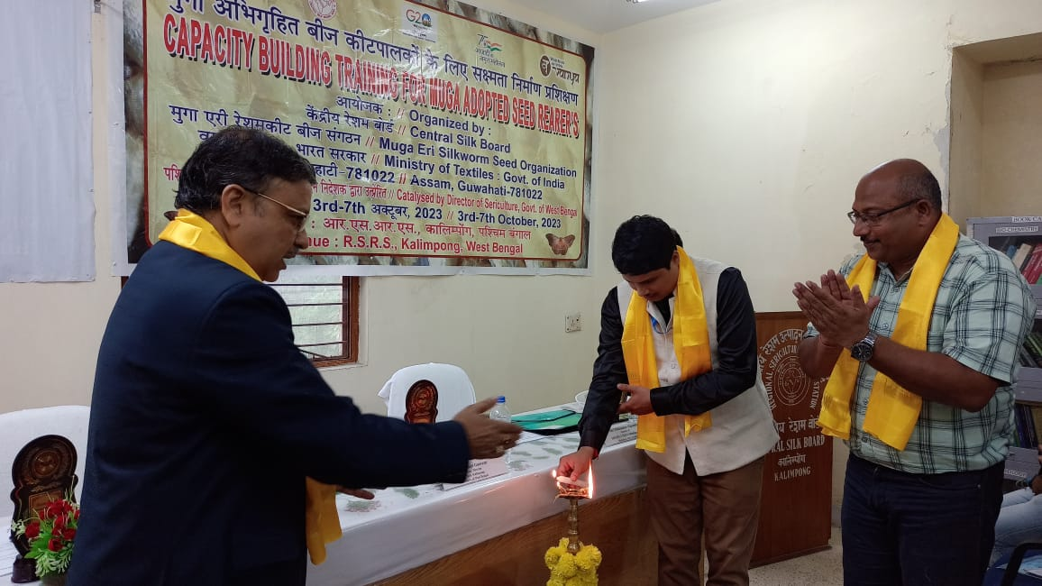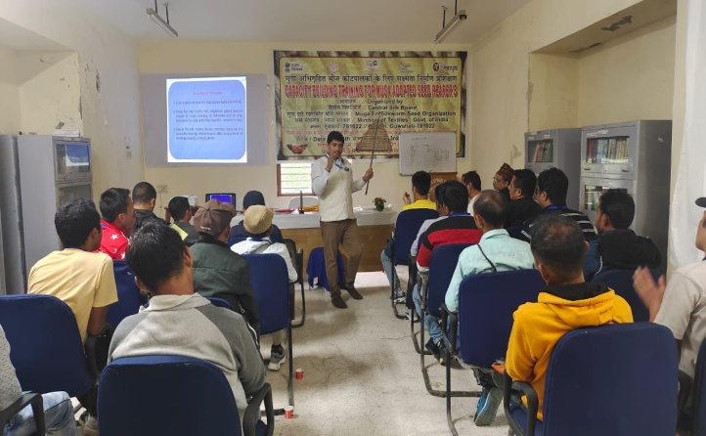
PLATE- CBT FOR MUGA ASR AT RSRS KALIMPONG WITH DOS WEST BENGAL IN 2023

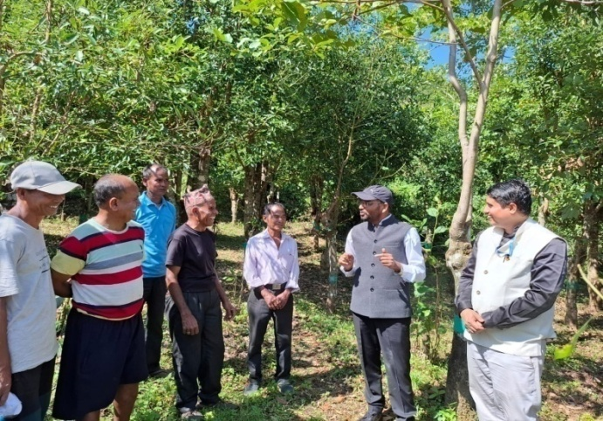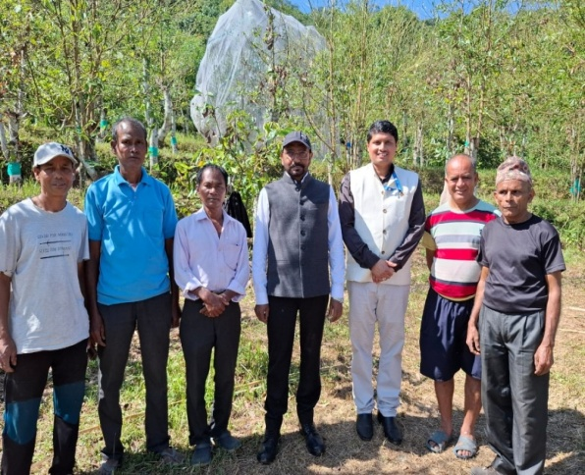
PLATE:- DIRECTOR MESSO, VISITED THE RSRS KALIMPONG FIELD DURING MUGA LATE BHODIA REARING IN 2024 (W.B)
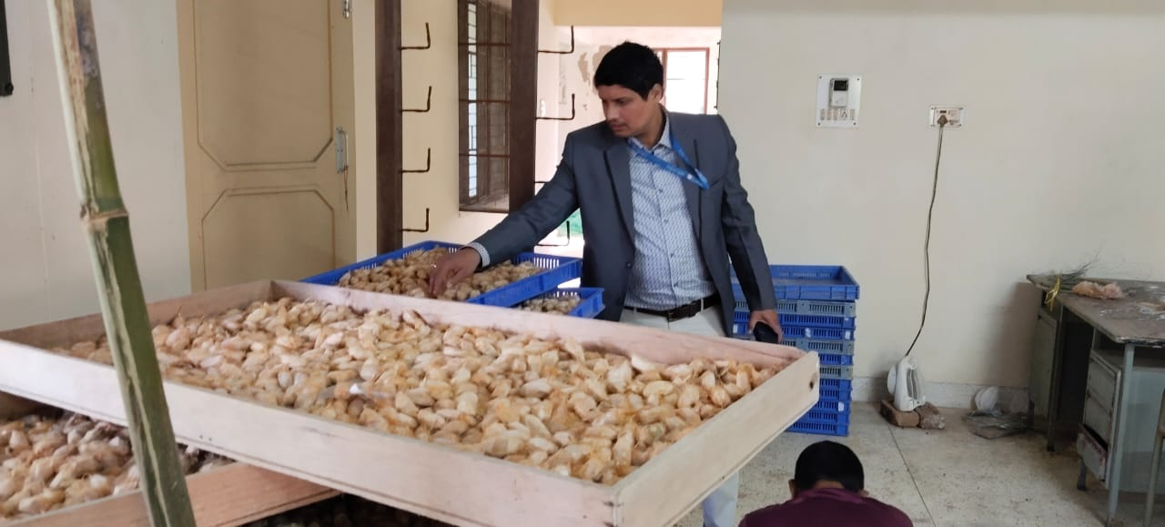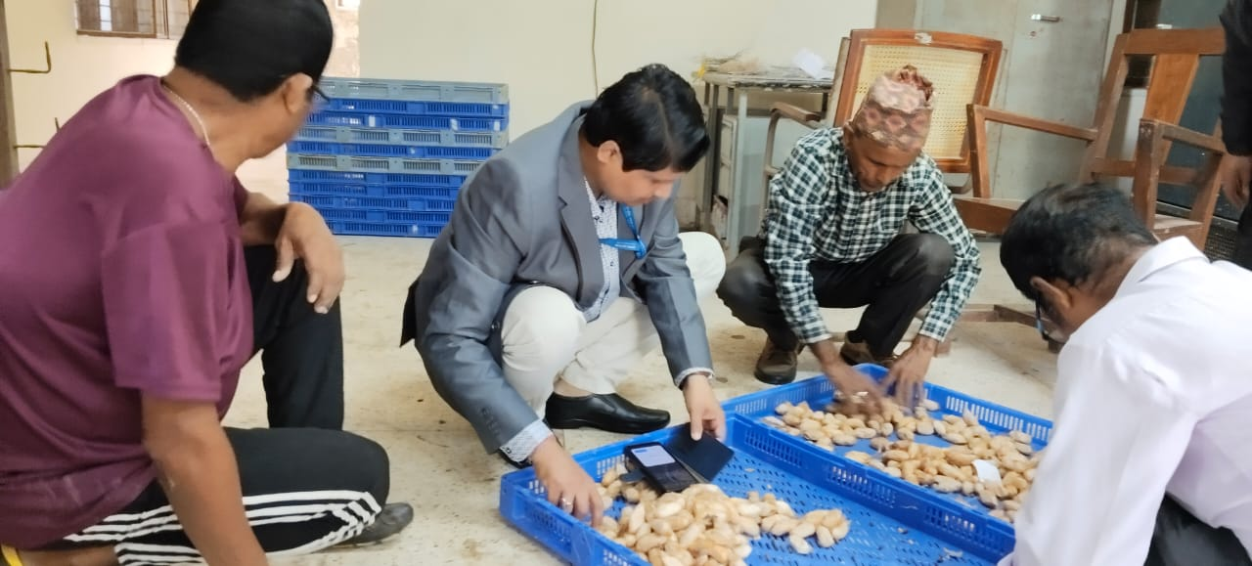
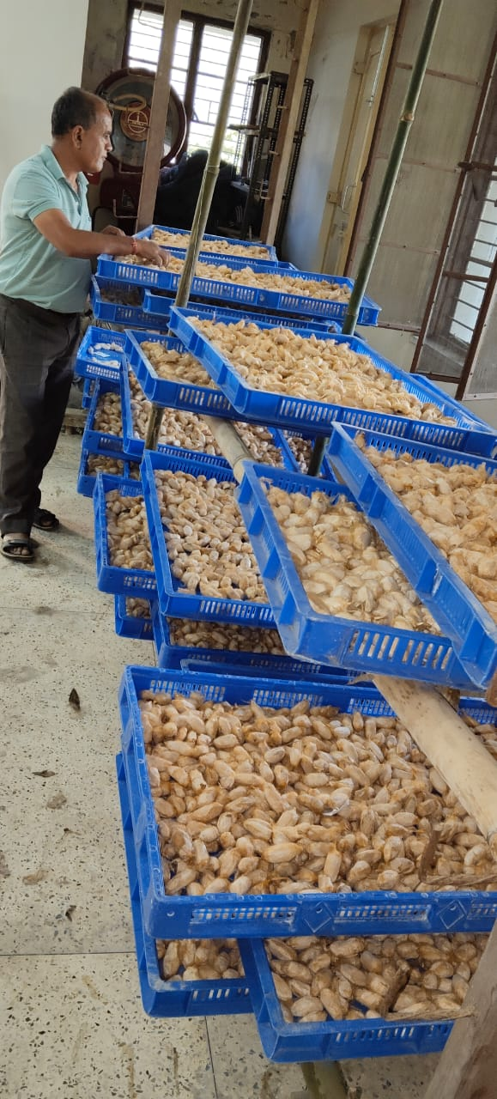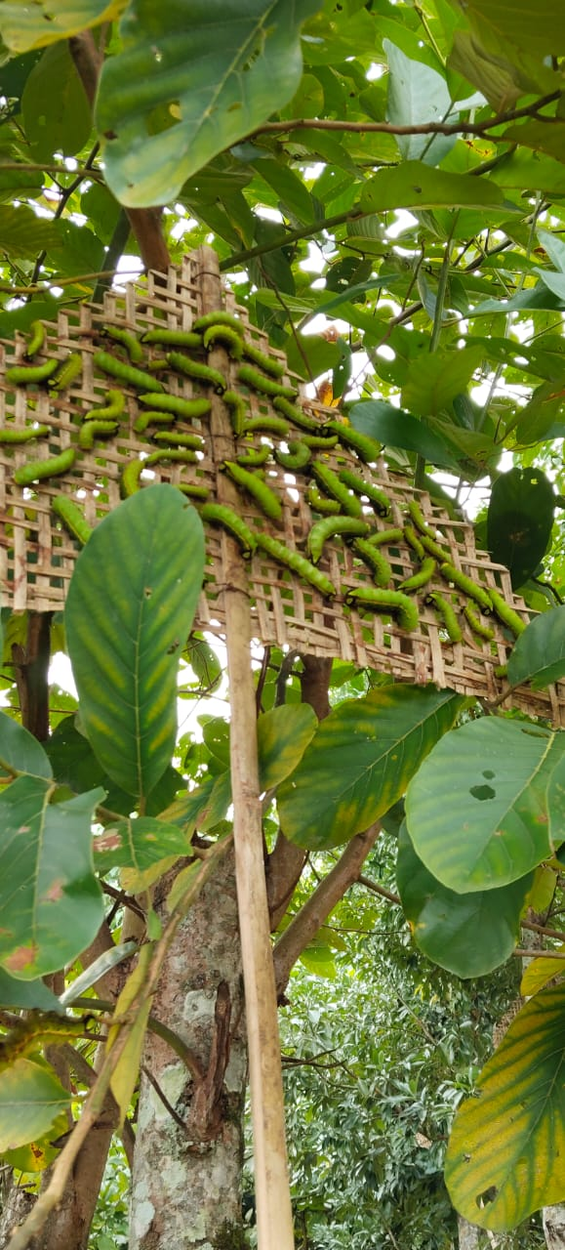
PLATE:- ASSESSMENT OF MUGA SEED COCOON AND REARING DURING LATE BHODIA CROP AT RSRS KALIMPONG IN 2024 (W.B)
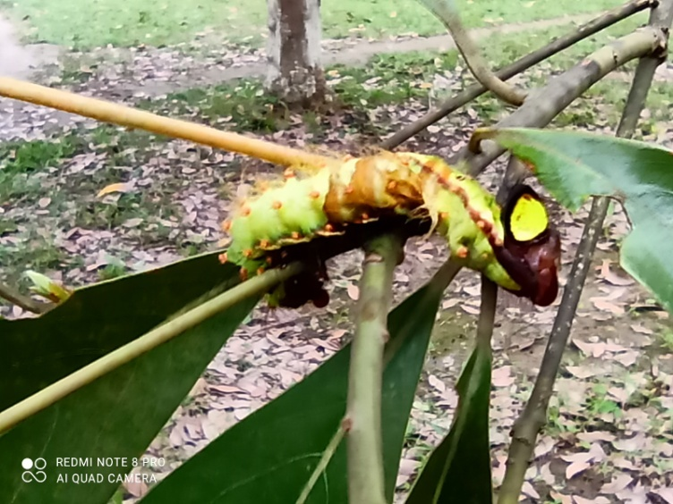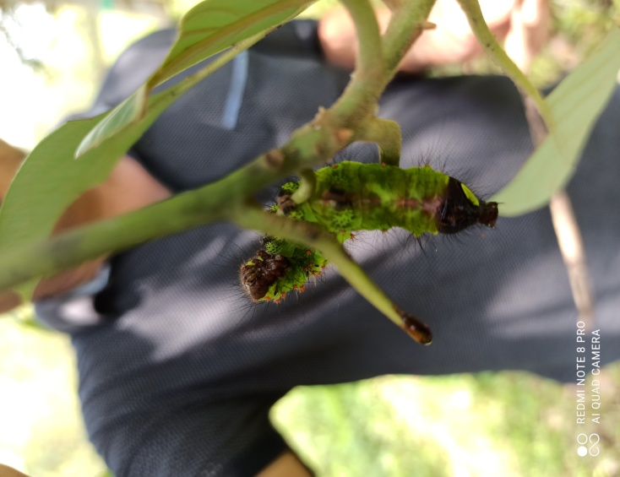

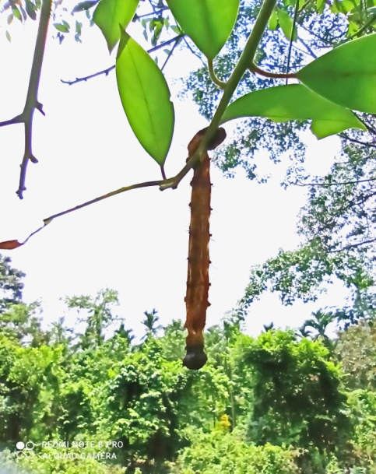

PLATE:- MUGA DISEASE DURING AHERUA & BHODIA CROP AT MENDIPATHAR , ROMPARA , AGIA AREA

