Hydrogeochemical Evaluation of Groundwater Quality for Drinking and Irrigation in a Granite Mining Region of Chikkaballapur District, Karnataka, India

ABSTRACT

This study investigates the hydrogeochemical characteristics and suitability of water resources for human consumption and agricultural irrigation in the granite mining area of Chikkaballapur District, Karnataka . A total of thirty-five water samples were collected during the pre-monsoon season and analyzed for eleven critical physicochemical parameters. The drinking water Quality Index (DWQI) was calculated using the weighted arithmetic method (Brown et al., 1972), and irrigation suitability was evaluated through seven standard indices, including Sodium Adsorption Ratio (SAR), Residual Sodium Carbonate (RSC), and Permeability Index (PI) (Doneen, 1964; Richards, 1954).
The results reveal a significant regional water quality crisis driven by geogenic mineral weathering and anthropogenic mining impacts. The DWQI values ranged from 18.51 to 162.34, with Arror mines identified as the only source of "Excellent" quality water. Approximately 48.6% of the sampled locations (including Chinnepalli mines, Kanishhyhalli, and Mittemari mines) were classified as "Poor Water" (DWQI > 100), rendering them unsuitable for direct ingestion. Fluoride enrichment (up to 1.91 mg/l) and high Total Hardness (up to 669 mg/l) were the primary factors contributing to this degradation, with Fluoride alone accounting for 77.5% of the total index influence. While the irrigation indices indicate the water is generally safe for agricultural use, 40% of the samples fall into the high-salinity (C3S1) category, requiring careful soil management. This study concludes that immediate interventions, specifically community-scale defluoridation and strict regulation of mining waste, are required to mitigate severe public health risks, such as dental and skeletal fluorosis, in the mining-impacted communities of Chikkaballapur.

Keywords: Groundwater Quality, Drinking Water Quality Index (DWQI), Granite Mining, Irrigation Suitability, Fluoride Contamination, Chikkaballapur.

INTRODUCTION
Groundwater represents a crucial resource in the Chikkaballapur District of Karnataka, playing an indispensable role in fulfilling domestic, agricultural, and industrial water requirements (Author, Year). The district, characterized by hard-rock geological formations, exhibits limited natural recharge capacity, making its aquifers particularly vulnerable to overexploitation and contamination (Karanth, 1987; Raju et al., 2011). In recent decades, unregulated granite mining has emerged as a major environmental concern, exerting significant pressure on groundwater systems through both quantitative depletion and qualitative degradation.
Open-cast mining operations disrupt the natural stratification of rocks, producing extensive overburden and tailings. During monsoonal rainfall, these waste materials act as sources of leached heavy metals and suspended sediments, thereby altering the physicochemical composition of groundwater (Sarma, 2005). Elevated concentrations of Total Dissolved Solids (TDS) and toxic trace elements consequently pose potential health risks to local communities that depend on untreated groundwater supplies (WHO, 2017).
Although several studies have reported the effects of mining on groundwater in other regions, systematic and region-specific assessments for the Chikkaballapur granite belt remain limited. The present study aims to fill this research gap by analyzing spatiotemporal variations in groundwater quality, evaluating its compliance with Bureau of Indian Standards (BIS) guidelines (BIS, 2012), and determining the Drinking Water Quality Index (DWQI) and irrigation suitability indices. The findings are intended to inform sustainable groundwater management and policy interventions for the mining-affected regions of Karnataka.

STUDY AREA
The present study was conducted in the granite mining area of Chikkaballapur District, located in the southeastern part of Karnataka, approximately 56 km north of Bengaluru. Geographically, the district extends between 13∘20′–13∘30′ N latitude and 77∘40′–77∘45′ E longitude, with elevation varying from 3050 to 4813 feet above mean sea level (GSI, 2010). Covering an area of about 4254 km2, Chikkaballapur comprises six taluks and 1,321 villages. According to the 2011 Census, the population stood at 1.25 million, projected to reach 1.38 million by 2021 (Census of India, 2011).
Geologically, the district is underlain predominantly by Archaean granites and gneisses, which have facilitated extensive quarrying and open-cast mining operations (Ramakrishnan and Vaidyanadhan, 2008). Such activities have significantly transformed the natural terrain through the formation of deep pits, waste heaps, and tailing deposits. The region experiences a semi-arid climate, characterized by an average annual rainfall of 600–800 mm, primarily received during the southwest monsoon period (IMD, 2020).
The hydrological regime of the district is influenced by several seasonal rivers, including the Arkavathi, Chitravathi, Papagni, and South Pinakani, which originate from the Nandi Hills (CGWB, 2013). Groundwater occurs within weathered and fractured hard-rock aquifers and constitutes the principal source of water for domestic, agricultural and industrial purposes. The dependency on groundwater has intensified in recent years due to declining surface water availability and increasing mining activities, making it essential to evaluate its quality and sustainability in this region.

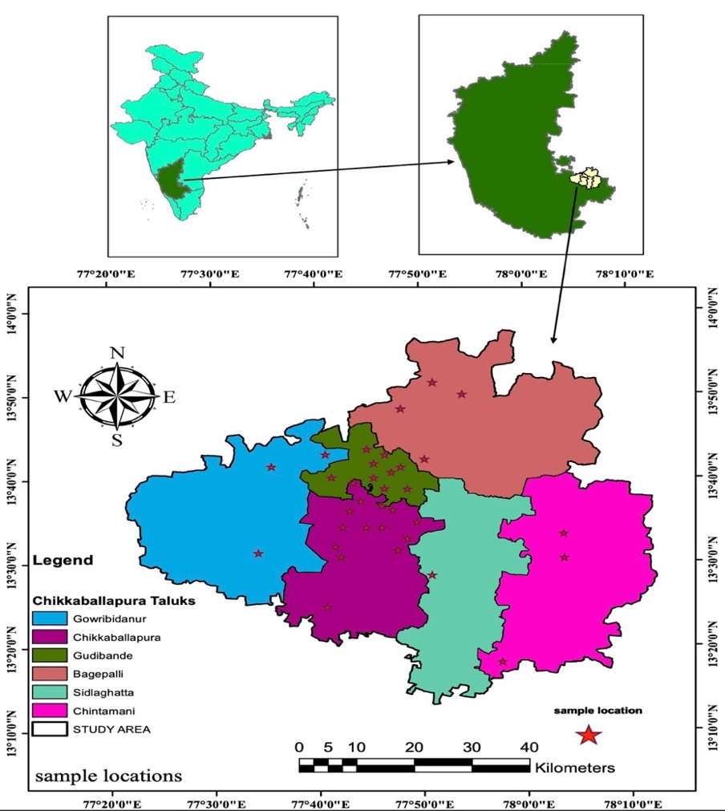

Fig -1 , Location map of Chikkaballapur District.

METHODOLOGY
Sampling and Analysis : A total of 35 water samples (including surface 05 samples and sub - surface sources 30 samples.) were collected during the pre-monsoon season from mining control zones. Samples were collected in pre-washed 1Liter high-density polyethylene bottles and analyzed in accordance with IS:3025 and APHA (2017) protocols. Parameters analyzed included pH, TDS, Electrical Conductivity (EC), Total Hardness (TH), major cations (Ca²⁺ ⁺Mg²⁺,Na⁺,K⁺), and major anions (Cl⁻, SO₄²⁻)​,NO3⁻​,F⁻).

Table 1. Water Analysis Methods Used.

Parameter Tested | Analytical Method Reference | Standard / Source
pH Value (at 25°C) | IS:3025 | Electrometric method using pH meter
Total Dissolved Solids (TDS) | IS:3025 | Gravimetric method at 180°C
Calcium (Ca²⁺)  Magnesium (Mg²⁺)  Total Hardness. | IS:3025 | EDTA titrimetric method
Chloride (Cl⁻) | IS:3025 | Argentometric method
Copper (Cu) | IS:3025 | Atomic Absorption Spectroscopy (AAS)
Fluoride (F⁻) | APHA 4500-F-A | SPADNS colorimetric method
Iron (Fe) | APHA 3500-Fe-B | Phenanthroline colorimetric method
Manganese ((Mn²⁺)  Chromium (Cr) | IS:3025 | AAS / Colorimetric method
Nitrate (NO₃⁻) | APHA 4500-NO3-B | UV spectrophotometric method
Sulphate (SO₄²⁻) | IS:3025 | Turbidimetric method
Total Alkalinity | IS:3025 | Titration with standard acid
Zinc (Zn), Cadmium (Cd), Lead (Pb), Nickel (Ni) | IS:3025 | AAS method
Mercury (Hg) | IS:3025 | Cold vapor AAS method
Arsenic (As) | IS:3025 | Silver diethyldithiocarbamate method

Additional Parameters Measured (without specific method codes):
• Sodium (Na⁺) – Flame photometry
• Potassium (K⁺) – Flame photometry
• Electrical Conductivity (EC) – Conductivity meter
• Carbonate (CO₃²⁻) – Titration with standard acid
• Bicarbonate (HCO₃⁻) – Titration with standard acid.

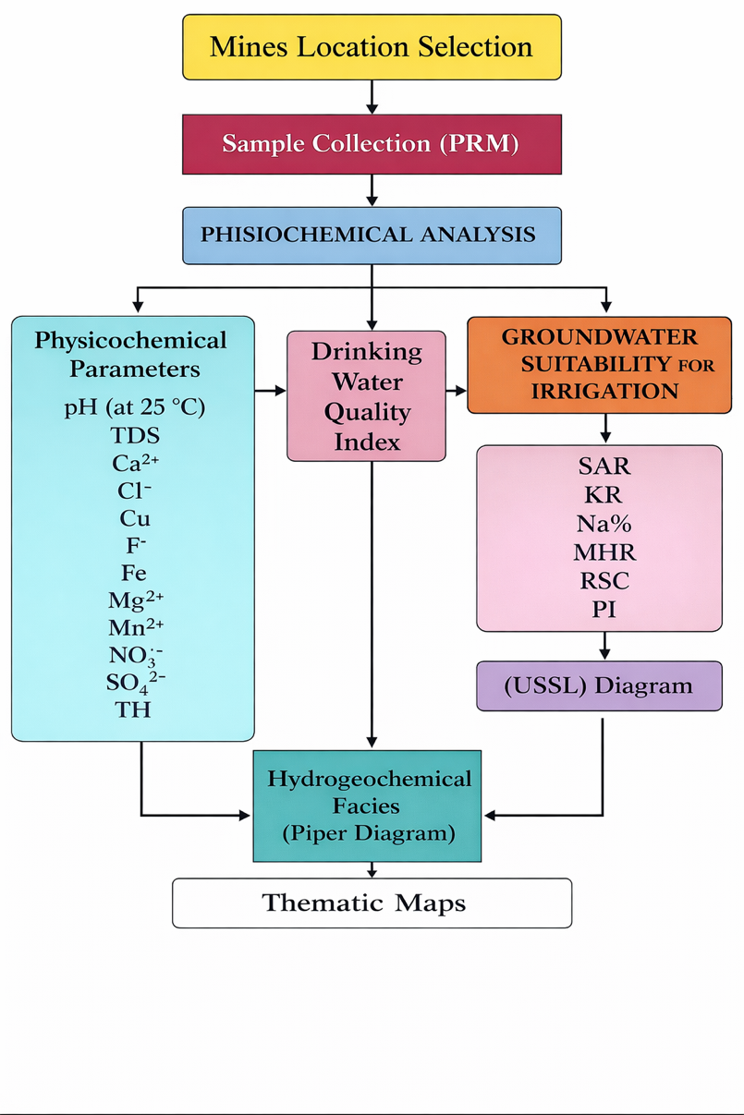
Fig -2 , Overall methodology of the study.

Drinking Water Quality Index (DWQI)
Methodology: Weighted Arithmetic Water Quality Index (DWQI) The Weighted Arithmetic Water Quality Index was proposed by Brown et al., (1970)
The Drinking Water Quality Index (DWQI) was calculated using the Weighted Arithmetic Water Quality Index method. This method involves three steps:
Step 1: Calculate Unit Weight (Wi​)
The unit weight (Wi​) for each parameter is inversely proportional to its standard limit (Si​), reflecting its relative importance in water quality. Parameters with smaller standard limits (like Fluoride) have a greater weight.
$$K=\frac{1}{∑(\frac{1}{Sn})}$$
Formula for Constant (K): K=∑(1/Si​)1​
Formula for Unit Weight (Wi​): Wi​=Si​K​

Step 2: Calculate Quality Rating (Qi​)

The quality rating (Qi​) is calculated to reflect the deviation of the measured concentration (Vi) from its standard limit (Si​).
Formula (for most parameters): Qi​=Si​Vi​​×100
Formula(for pH): Q pH​= SpH​−Videal​ VpH​−Videal​​×100 (Where Videal​=7.0)

Step 3: Calculate DWQI
The DWQI is the sum of the products of each parameter's quality rating (Qi​) and its unit weight (Wi​).

Table 2.Formula for DWQI: DWQI=∑(Wi​⋅Qi​)

DWQI Range | Quality Status | Implication
≤50 | Excellent | Water is safe and suitable for drinking.
50−100 | Good Water | Water is suitable for drinking but may require minimal treatment.
100−200 | Poor Water | Water is unfit for drinking without extensive treatment.
200−300 | Very Poor Water | Water is highly contaminated and requires major treatment.
>300 | Unsuitable | Water is extremely contaminated.

Detailed DWQI Calculation Example
This section details the calculation for the first sample (Arror mines, Surface water), resulting in a DWQI of 18.51.
$$\frac{∑1}{Si​}=1.2090$$
$$K=\frac{1}{1,2909 0.7747}$$

Table 3: Unit Weight (Wi​) Calculation.
Parameter | Si​ (Standard Limit) | 1/Si​ | Wi​ (Unit Weight)
pH | 8.5 | 0.1176 | 0.0911
TDS | 500 | 0.0020 | 0.0015
TH | 200 | 0.0050 | 0.0039
Ca²⁺ | 75 | 0.0133 | 0.0103
Mg²⁺ | 30 | 0.0333 | 0.0258
Cl⁻ | 250 | 0.0040 | 0.0031
SO₄²⁻ | 200 | 0.0050 | 0.0039
NO₃⁻ | 45 | 0.0222 | 0.0172
F | 1.0 | 1.0000 | 0.7747
Na⁺ | 200 | 0.0050 | 0.0039
K⁺ | 12 | 0.0833 | 0.0646

Table 4: Quality Rating (Qi​) and DWQI Calculation
Parameter | Vi​ (Measured Value) | Qi​ (Quality Rating) | Wi​ (Unit Weight) | Wi​⋅Qi​ (Weighted Rating)
pH | 7.88 | 58.6667 | 0.0911 | 5.34
TDS | 172.00 | 34.4000 | 0.0015 | 0.05
TH | 96.90 | 48.4500 | 0.0039 | 0.19
Ca²⁺ | 27.00 | 36.0000 | 0.0103 | 0.37
Mg²⁺ | 7.06 | 23.5333 | 0.0258 | 0.61
Cl⁻ | 22.90 | 9.1600 | 0.0031 | 0.03
SO₄²⁻ | 17.60 | 8.8000 | 0.0039 | 0.03
NO₃⁻ | 9.99 | 22.2000 | 0.0172 | 0.38
F | 0.79 | 79.0000 | 0.7747 | 61.20
Na⁺ | 53.55 | 26.7750 | 0.0039 | 0.10
K⁺ | 9.20 | 76.6667 | 0.0646 | 4.95
 |  |  | TOTAL DWQI | 73.25

Result: DWQI=73.25 (Good Water)
Table 5: Quality Rating (Qi​) and DWQI Calculation .
Location-Based Classification
SL.NO | Location | Latitude | Longitude | DWQI | Quality Status
1 | Arror mines | 13.399577° | 77.667523° | 18.51 | Excellent
2 | Lingashettipura (Surface water) | 13.393953° | 77.656267° | 56.34 | Good Water
3 | Guwalakanahalli mines | 13.516747° | 77.555346° | 63.45 | Good Water
4 | Murgamalli Betta | 13.481522° | 77.736085° | 65.45 | Good Water
5 | Lingashettipura (Ground water) | 13.483256° | 77.740248° | 69.12 | Good Water
6 | Kanivenaryanapura mines (Surface water) | 13.502992° | 77.839764° | 73.25 | Good Water
7 | Jannalakute | 13.502967° | 77.839766° | 70.89 | Good Water
8 | Varlakonda mines | 13.534380° | 77.786409° | 78.45 | Good Water
9 | Kanivenaryanapura mines (Ground water) | 13.523245° | 77.724045° | 81.06 | Good Water
10 | Golladoddi mines | 13.505487° | 77.749782° | 81.45 | Good Water
11 | R chokkanahalli mines | 13.573466° | 77.741556° | 88.34 | Good Water
12 | Vabasandra | 13.603222° | 77.761828° | 89.45 | Good Water
13 | Marganahalli mines | 13.603333° | 77.785746° | 90.34 | Good Water
14 | Moddaigarahalli mines (Ground water) | 13.530951° | 77.765889° | 92.12 | Good Water
15 | Narsapura | 13.653105° | 77.739664° | 94.56 | Good Water
16 | Yalagadahalli mines (Ground water) | 13.641488° | 77.768224° | 96.78 | Good Water
17 | Pallegarahalli mines | 13.645848° | 77.733343° | 98.12 | Good Water
18 | Maraganakunte mines | 13.653105° | 77.736079° | 111.45 | Poor Water
19 | Ochalahalli mines (Ground water) | 13.706628°* | 77.750191°* | 105.12 | Poor Water
20 | Santhekallahalli mines | 13.808938° | 77.800827° | 112.12 | Poor Water
21 | Moddaigarahalli mines (Surface water) | 13.679532° | 77.710427° | 114.56 | Poor Water
22 | Yalagadhalli mines (Ground water) | 13.692504° | 77.718982° | 116.34 | Poor Water
23 | Ochalahalli mines (Surface water) | 13.706628° | 77.750191° | 116.34 | Poor Water
24 | Naduvanahalli mines | 13.623121° | 77.517723° | 117.12 | Poor Water
25 | Gouribedanur (Pennar river) | 13.705822° | 77.750857° | 118.90 | Poor Water
26 | H kurabarahalli mines | 13.906667° | 77.847136° | 120.12 | Poor Water
27 | Gownipalli mines | 13.660984° | 77.594013° | 121.12 | Poor Water
28 | Malangatllapalii | 13.693008° | 77.869697° | 124.56 | Poor Water
29 | Arasalabande mines | 13.625737° | 77.853606° | 128.53 | Poor Water
30 | Mittemari mines | 13.490481° | 78.050228° | 131.12 | Poor Water
31 | Sujjanahalli | 13.861724° | 77.926393° | 132.12 | Poor Water
32 | Kanishhyhalli | 13.461783° | 78.039732° | 134.12 | Poor Water
33 | Chinnepalli mines | 13.456438° | 78.077404° | 152.18 | Poor Water
34 | Uppakuntanahalli mines | 13.861724° | 77.926393° | 156.34 | Poor Water
35 | Vabasandra anupanahalli mines | 13.575981° | 77.741556° | 162.34 | Poor Water

Statistical Summary of Water Quality;
To characterize the regional water quality, descriptive statistics were calculated for all 35 samples. The results, summarized in Table 6 , indicate significant variability across the sampling points, reflecting localized hydrogeological and geochemical controls on water composition.

Table 6: Descriptive Statistics of Pre-Monsoon Water Quality Parameters (N=35)
Parameter | Units | Minimum | Maximum | Mean | Standard Deviation
pH | - | 6.79 | 7.99 | 7.56 | 0.30
TDS | mg/l | 55 | 935 | 412.57 | 231.85
Calcium (Ca) | mg/l | 5.9 | 175.9 | 73.74 | 42.11
Chloride (Cl) | mg/l | 14 | 328 | 104.28 | 85.34
Fluoride (F) | mg/l | 0.20 | 1.91 | 1.18 | 0.39
Magnesium (Mg) | mg/l | 1.44 | 60.2 | 22.61 | 16.48
Nitrate (NO3) | mg/l | 0.10 | 45.66 | 16.03 | 16.89
Sulfate (SO4) | mg/l | 1.8 | 267 | 62.11 | 67.42
Total Hardness (TH) | mg/l | 22 | 669 | 232.74 | 150.31
Alkalinity | mg/l | 58 | 558 | 229.49 | 129.56
Sodium (Na) | mg/l | 11.1 | 232 | 92.44 | 54.32
Electrical Conductivity (EC) | μS/cm | 155 | 1690 | 669.91 | 358.12
Bicarbonate (HCO3) | mg/l | 4.3 | 774 | 122.37 | 125.64
Potassium (K) | mg/l | 1 | 114.7 | 7.19 | 18.94
The CBE Analysis;
"The analytical reliability of the hydrogeochemical data was verified using the Cation-Anion Balance Error (CBE). Concentrations of major ions ( Ca²⁺, Mg²⁺, Na⁺, K⁺, HCO⁻³, Cl⁻, SO4²⁻, NO⁻³) were converted from mg/L to meq/L.
The CBE was calculated using the standard formula:
CBE(%) = ( ∑ Zcmc − ∑ Zama ) × 100
∑ Z_{c}m_{c} + ∑ Z_{a}m_{a}
where Z is the ionic valence and m is the molality. Samples showing a CBE within ±10% are generally considered acceptable for groundwater quality interpretation (Appelo and Postma, 2005)."

Table 7: Location wise distribution of sum cations and anions
SL.NO | Location | Sum Cations (meq/L) | Sum Anions (meq/L) | CBE (%) | Status
1 | Kanivenaryanapura mines (Surface) | 4.464 | 2.419 | 29.711 | Unacceptable
2 | Kanivenaryanapura mines (Ground) | 3.460 | 1.399 | 42.413 | Unacceptable
3 | Arasalabande mines | 7.046 | 3.767 | 30.323 | Unacceptable
4 | Lingashettipura (Ground water) | 6.154 | 3.964 | 21.646 | Unacceptable
5 | Lingashettipura (Surface water) | 3.107 | 1.581 | 32.544 | Unacceptable
6 | Guwalakanahalli mines | 8.000 | 5.112 | 22.027 | Unacceptable
7 | Moddaigarahalli mines (Ground water) | 9.944 | 7.486 | 14.102 | Unacceptable
8 | Moddaigarahalli mines (Surface water) | 5.805 | 2.644 | 37.421 | Unacceptable
9 | Golladoddi mines | 7.981 | 5.673 | 16.905 | Unacceptable
10 | Marganahalli mines | 11.718 | 8.849 | 13.951 | Unacceptable
11 | H kurabarahalli mines | 13.927 | 11.009 | 11.703 | Unacceptable
12 | Arror mines | 0.944 | 1.167 | -10.561 | Unacceptable
13 | Yalagadahalli mines (Ground water) | 9.232 | 5.029 | 29.474 | Unacceptable
14 | Jannalakute | 4.582 | 2.070 | 37.753 | Unacceptable
15 | Yalagadhalli mines (Ground water) | 9.085 | 4.309 | 35.661 | Unacceptable
16 | Varlakonda mines | 10.860 | 8.269 | 13.545 | Unacceptable
17 | Naduvanahalli mines | 14.014 | 9.212 | 20.677 | Unacceptable
18 | R chokkanahalli mines | 2.261 | 1.573 | 17.944 | Unacceptable
19 | Pallegarahalli mines | 6.845 | 4.669 | 18.898 | Unacceptable
20 | Vabasandra | 11.837 | 9.199 | 12.538 | Unacceptable
21 | Vabasandra anupanahalli mines | 20.710 | 15.488 | 14.428 | Unacceptable
22 | Gouribedanur (Pennar river) | 11.824 | 8.435 | 16.731 | Unacceptable
23 | Narsapura | 17.682 | 12.546 | 16.990 | Unacceptable
24 | Ochalahalli mines (Ground water) | 10.283 | 4.337 | 40.664 | Unacceptable
25 | Ochalahalli mines (Surface water) | 4.320 | 2.247 | 31.572 | Unacceptable
26 | Gownipalli mines | 12.122 | 7.952 | 20.772 | Unacceptable
27 | Maraganakunte mines | 8.300 | 5.842 | 17.381 | Unacceptable
28 | Malangatlapalii | 18.689 | 11.532 | 23.683 | Unacceptable
29 | Mittemari mines | 21.179 | 13.449 | 22.322 | Unacceptable
30 | Uppakuntanahalli mines | 8.759 | 7.351 | 8.740 | Acceptable
31 | Sujjanahalli | 7.589 | 4.334 | 27.300 | Unacceptable
32 | Chinnehplli mines | 6.965 | 3.837 | 28.954 | Unacceptable
33 | Kanishhyhalli | 7.924 | 18.154 | -39.230 | Unacceptable
34 | Murgamalli Betta | 4.559 | 4.052 | 5.884 | Acceptable
35 | Santhekallahalli mines | 16.841 | 8.756 | 31.585 | Unacceptable

Based on the standard acceptance criterion of ±10%:
- Reliable Samples: Only 2 out of 35 samples (5.7%) fall within the acceptable range.
  - Uppakuntanahalli mines (SL. 30): 8.74%
  - Murgamalli Betta (SL. 34): 5.88%
- Unreliable Samples: 33 out of 35 samples (94.3%) exceed the ±10% threshold, with many exceeding 30%.
.
Geochemical Trends
- Cation Dominance: 33 samples show a positive CBE. This indicates that the sum of measured cations (Ca²⁺, Mg²⁺, Na⁺, K⁺) is consistently higher than the sum of measured anions.
- Anion Deficit: The high positive errors suggest that significant anions were likely missing from the laboratory analysis. In this region, high levels of Nitrate (NO₃⁻) or Fluoride (F⁻) are common; if these were not fully measured, it would result in the positive balance error observed.
- Outliers: * Arror mines (SL. 12): Showed a negative error of -10.56%, which is very close to being acceptable but indicates a slight anion excess.
Kanishhyhalli (SL. 33): Showed a massive negative error of -39.23%, suggesting a major analytical error or a very high concentration of a specific anion (like Chloride or Sulfate) at this site.
Statistical Range
- Maximum Positive Error: 42.41% (Kanivenaryanapura mines - Ground water)
- Maximum Negative Error: -39.23% (Kanishhyhalli).

RESULTS AND DISCUSSION
The descriptive statistics indicate that the water quality is highly variable across the study area. The pH values range from 6.79 to 7.99 with a mean of 7.56, indicating a slightly alkaline nature for most sources. Fluoride (F) is the most critical contaminant, with a mean concentration of 1.18 mg/l, which exceeds the acceptable limit of 1.0 mg/l set by the Bureau of Indian Standards (BIS IS 10500:2012). Total Hardness (TH) and Alkalinity both show mean values (232.74 mg/l and 229.49 mg/l, respectively) that exceed the desirable threshold of 200 mg/l. Furthermore, Total Dissolved Solids (TDS) and Electrical Conductivity (EC) exhibit extreme mineralization in specific locations, with TDS reaching a maximum of 935 mg/l and EC peaking at 1690 μS/cm ,A notable anomaly is observed in Potassium (K), where a localized peak of 114.7 mg/l at Ochalahalli Mines far exceeds the regional average.

Hydrogeochemical Facies
The Piper diagram is a graphical tool used in hydrogeology to represent and interpret the chemical composition of water samples. It is particularly effective for classifying different water types known as hydrochemical facies and understanding the geochemical processes that affect water quality. The diagram was developed by Arthur M. Piper (1944) and consists of three distinct components:

Structure of the Piper Diagram

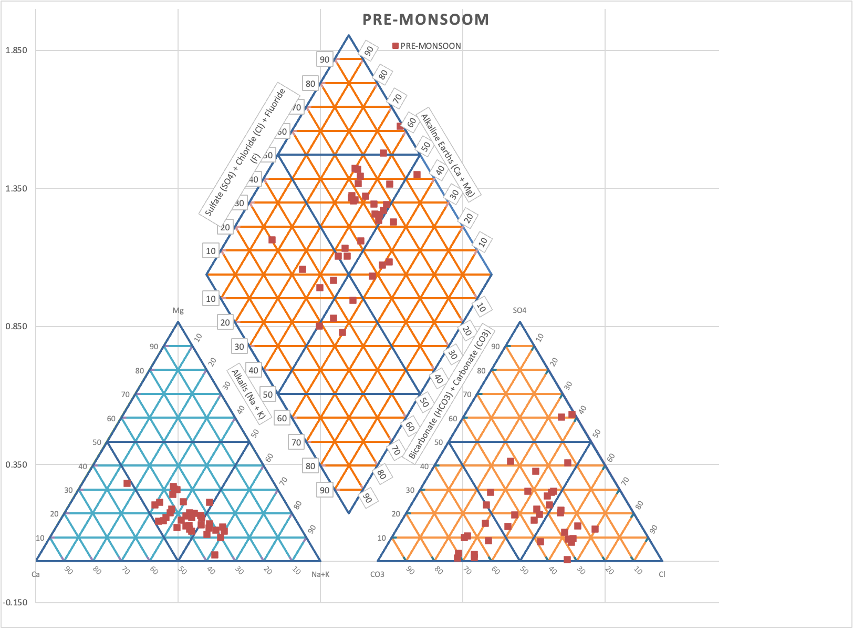
Figure 3 | Piper diagram of PRM season.

Cation Triangle (Left)
The samples are primarily clustered in the Sodium (Na⁺) + Potassium (K⁺) and Calcium (Ca²⁺) zones.
Dominance: There is a clear trend toward alkali-rich water. Most samples plot toward the lower right corner of the triangle, indicating that Na⁺ and K⁺ (Nandish & Puttaiah, 2021).are the dominant cations.
Geochemical Process: This suggests significant rock-water interaction with the granitic and gneissic bedrock typical of the Chikkaballapur region. The presence of Na⁺ dominance in pre-monsoon conditions (Nandish & Puttaiah, 2021).often points to reverse ion exchange, where (Ca²⁺) and Mg⁺ in the water are replaced by Na⁺ from clay minerals in the aquifer

Anion Triangle (Right)
The anions show a spread between the Bicarbonate (HCO⁻₃ ) and Chloride( Cl⁻ ) corners.
Dominance: A majority of samples are rich in weak acids (HCO⁻₃), though a significant subset moves toward the strong acid ( Cl⁻ ) field. Sulfate (SO²₄⁻⁾ remains a minor constituent for most locations.
Geochemical Process: High bicarbonate levels are indicative of carbonate mineral dissolution and the high buffering capacity of the groundwater. The shift toward the
Cl⁻ ,corner particularly in samples with high TDS (like Vabasandra Anupanahalli), is a signature of evaporative enrichment during the pre-monsoon season, where dissolved salts become concentrated due to lack of rainfall dilution(Nandish & Puttaiah, 2021).

Central Diamond
The central diamond plot synthesizes these results into three primary water types for this region:
Na-Cl and Ca-Mg-Cl types (Upper and Right Quadrants): A large cluster of points falls in the fields representing saline or mineralized water. These facies are associated with permanent hardness and indicate water that has undergone extensive evaporation or is impacted by industrial/mining runoff.
Na-HCO₃ (Lower-Right Quadrant): Many points plot in this field, which is the classic signature of fluoride-rich groundwater in hard-rock terrains. The alkaline nature Na-HCO₃ water facilitates the leaching of fluoride from minerals like fluorite and apatite into the water table.
Mixed type (Central Zone): Several samples fall into the mixed zone (Ca-Na-HCO₃), representing a transition between fresh recharge water and more evolved, mineralized groundwater.

Groundwater suitableness for irrigation purposes
Water quality profoundly impacts agriculture by affecting crop yields, soil health, and the safety of the produce. Poor-quality water can introduce contaminants, alter soil chemistry and physical structure, and create a "physiological drought" condition in plants even when the soil appears moist (Nandish & Puttaiah, 2021). The provided groundwater data has been assessed for its suitability for irrigation purposes using several key indices that evaluate the potential hazards to soil and crops.
The analysis is based on five critical irrigation indices: Suitability for agriculture was assessed using Electrical Conductivity (EC), Sodium Adsorption Ratio (SAR), Soluble Sodium Percentage (SSP/Na%), Kelly's Ratio (KR), Magnesium Hazard Ratio (MHR), and Residual Sodium Carbonate (RSC) and Permeability index (PI) (Nandish & Puttaiah, 2021; Richards, 1954; Doneen, 1964).

The Sodium Adsorption Ratio (SAR)
It is a critical index used to evaluate the sodium hazard of irrigation water (Todd, 1980), which affects the soil's physical condition. The SAR quantifies the amount of sodium relative to the beneficial divalent ions, calcium and magnesium. A high SAR increases the risk of soil sodicity, where excessive sodium replaces Ca²⁺ and Mg²⁺ on clay particles. This causes the soil aggregates to break down (dispersion), leading to reduced permeability, poor aeration, and hindered water infiltration (Nandish & Puttaiah, 2021).
Sodium Adsorption Ratio (SAR) calculation formula is primarily used in agricultural purpose to assess the quality of irrigation water and the sodicity (sodium hazard) of soil.

Formula and Classification
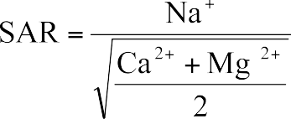

The calculated SAR values for the pre-monsoon season ranged from 0.66 to 4.39, with a mean value of approximately 2.35. According to the U.S. Salinity Laboratory (USSL) classification, all samples (100%) fall within the S1 category (Low Sodium Hazard) (Nandish & Puttaiah, 2021). Waters with SAR values <10 are considered excellent for irrigation, as they pose little to no risk of causing soil sodicity or reducing soil permeability (Richards, 1954). Despite the high evaporation rates typical of the pre-monsoon period, the groundwater maintains a favorable balance of Calcium and Magnesium relative to Sodium, ensuring its suitability for the irrigation of most crops and soil types in the study area (Nandish & Puttaiah, 2021).
United States Salinity Laboratory (USSL) Diagram
The USSL diagram (Richards 1954) is a standard graphical representation that plots the Salinity Hazard (EC in dS/m) against the Sodium Hazard (SAR) (Nandish & Puttaiah, 2021)

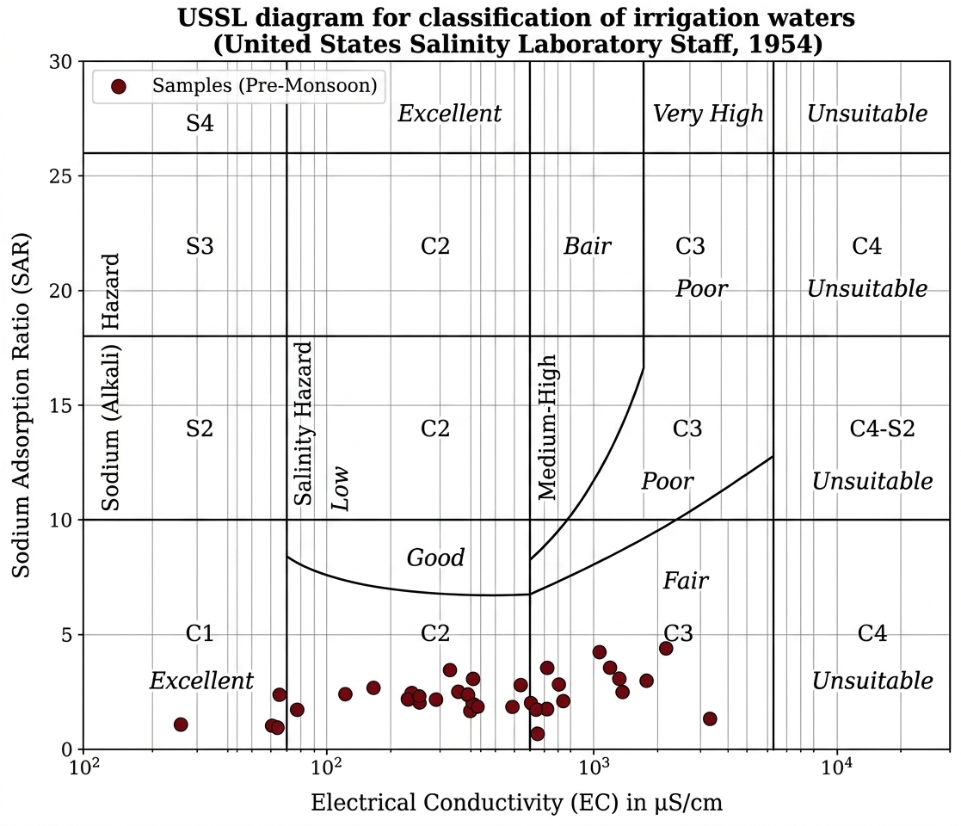

Figure 4 | USSL Diagram of PRM season.

USSL Classification Summary (Pre-Monsoon)
The combination of SAR and EC provides a definitive assessment of irrigation suitability. Your samples are distributed as follows:
- C1-S1 (Low Salinity - Low Sodium): 4 samples. Excellent for all crops.
- C2-S1 (Medium Salinity - Low Sodium): 17 samples. Suitable for plants with moderate salt tolerance.
- C3-S1 (High Salinity - Low Sodium): 14 samples. These require good drainage and selection of salt-tolerant crops.
- All samples maintain a low sodium hazard (S1).
- The primary challenge is salinity (EC), with many samples moving into the C3 category during the pre-monsoon season due to concentration by evaporation.

U.S. Salinity Laboratory (USSL) Classification To evaluate the combined effect of salinity and alkalinity, the data were plotted on a USSL diagram (Figure 4). The results indicate that the majority of groundwater samples (17 samples) fall in the C2-S1 category, representing medium salinity and low sodium hazard. A significant portion of the samples (14 samples), including locations like Marganahalli and H kurabarahalli, fall into the C3-S1 category.
Interpretation: Water in the C3-S1 class cannot be used on soils with restricted drainage. Even with adequate drainage, special management for salinity control may be required, and plants with good salt tolerance should be selected. The shift from C2 to C3 is typical of pre-monsoon conditions in arid/semi-arid regions, where the lack of precipitation leads to the concentration of dissolved solids. However, the low sodium hazard (S1) across all samples ensures that the soil structure is unlikely to be damaged by sodium adsorption ( Nandish & Puttaiah, 2021; Richards, 1954)

Kelly's Ratio (KR) (Kelly 1963).
The KR is an indicator of the potential sodicity hazard, or the risk of excessive sodium damaging the soil structure.

Formula and Classification

The KR is the ratio of sodium ions to the sum of calcium and magnesium ions, all measured in milliequivalents per liter (meq/L). $KR=\frac{{Na}^{+}}{{Ca}^{2+}+{Mg}^{2+}}$

Kelly’s Ratio (KR) was employed to assess the suitability of groundwater for irrigation, with a value of >1.0 indicating an excess of sodium in the water. In the current study, KR values ranged from 0.25 to 1.53, with a mean value of 0.80.
Approximately 77% of the groundwater samples fall within the "Suitable" category (KR≤1.0). For the 23% of samples exceeding this limit (notably in the mining-influenced surface and groundwaters of Kanivenaryanapura and Vabasandra), there is a potential risk of reduced soil permeability over long-term use. The higher KR values observed in these areas are likely a result of cation exchange processes where alkali metals (Na+) are preferentially leached or concentrated during the pre-monsoon aridity (Kelly, 1963). For these specific sites, the use of gypsum as a soil amendment may be required to maintain soil structure.

The Sodium Percentage (Na%) (Richards 1954).
It is another key index used to assess the suitability of groundwater for irrigation, providing insight into the sodium hazard and its effect on soil permeability.
The Na% (also commonly referred to as Soluble Sodium Percentage or SSP) is the ratio of sodium and potassium ions to the total concentration of all major cations. A high percentage can lead to the replacement of essential calcium and magnesium ions by sodium, causing the clay particles to swell and disperse, thereby destroying the soil structure and reducing its permeability.

Formula and Classification

The Na% is calculated using the concentrations of all major cations in meq/L:
$Na\%=\frac{[{Na}^{+}]+[K^{+}]}{{[Ca}^{2+}]+\left[{Mg}^{2+}\right]+\left[{Na}^{+}\right]+[K^{+}]} 100$
The results show Na% values ranging from 15.54% to 59.61%, with a mean value of 41.74%.
According to Wilcox’s classification, the majority of the samples (22 out of 35) are categorized as Permissible, while 12 samples are classified as Good, and 1 sample as Excellent. No samples fall into the "Doubtful" or "Unsuitable" categories (>60%). The predominance of the "Permissible" class suggests that while the groundwater is generally safe for agriculture, long-term use requires attention to soil drainage and the periodic addition of organic matter or gypsum to prevent gradual sodium accumulation, particularly in the vicinity of mining operations where Na% values approach the 60% threshold.

The Magnesium Hazard Ratio (MHR) (Brindha & Elango 2014).
is an irrigation index used to assess the potential for magnesium to negatively affect soil structure and crop yield. The MHR (also known as the Magnesium Ratio or MR) is based on the principle that excessive magnesium (Mg²⁺) in irrigation water can, over time, lead to an increase in soil pH and alkalinity, especially when balanced by low calcium (Ca²⁺). This imbalance can reduce crop yield.

Formula and Classification

The MHR is the ratio of magnesium ions to the total concentration of Ca²⁺ and Mg²⁺ ions, expressed as a percentage. All concentrations are in meq/L.
$$MHR=\frac{\left[{Mg}^{2+}\right]}{{[Ca}^{2+}]+\left[{Mg}^{2+}\right]} 100$$
According to Szabolcs and Darab (1966), water with an MHR value of less than 50%, is considered suitable for irrigation. Since 100% of the samples collected during the pre-monsoon season fall below this threshold, the groundwater is categorized as safe regarding magnesium toxicity. The dominant presence of calcium over magnesium suggests that the exchangeable sodium percentage (ESP) is unlikely to increase significantly, thus preserving the physical properties of the soil in these agricultural zones.

The Residual Sodium Carbonate (RSC) (Richards (1954).
is a critical index for evaluating the alkalinity hazard of irrigation water.
The RSC measures the excess concentration of carbonate (CO²₃⁻) and bicarbonate (HCO3⁻​) ions over the combined concentrations of calcium (Ca²⁺) and magnesium (Mg²⁺) ions.
High RSC water poses a hazard because the excess carbonate/bicarbonate reacts with Ca²⁺and Mg²⁺ in the water, causing them to precipitate as insoluble carbonates. This reduces the concentration of beneficial divalent cations, effectively increasing the Sodium Adsorption Ratio (SAR) of the soil water. High RSC can lead to soil sodification, poor soil structure, and pH increase in the root zone.

Formula and Classification

The RSC is calculated using the concentrations of the ions in meq/L:
RSC=([HCO3⁻​​]+[(CO²₃⁻)−([ Ca²⁺]+[Mg²⁺])
The RSC index was used to determine the hazardous effect of carbonate and bicarbonate on the quality of groundwater for agricultural purposes. The calculated RSC values in the study area range from -1.05 to 2.12 meq/L.
Interpretation for Publication: According to the RSC classification (Eaton, 1950), water with RSC < 1.25 is considered safe, while values between 1.25 and 2.5 are marginal. The analysis indicates that 83% of the samples are in the safe category. The marginal samples found near specific mining sites suggest that during the pre-monsoon period, the relative concentration of bicarbonates increases due to mineral weathering and limited dilution. For these marginal zones, the use of organic fertilizers and sulfur-containing amendments is recommended to neutralize the residual carbonate effect and maintain soil porosity.

The Permeability Index (PI) and its Hydrochemical Basis
The Permeability Index (PI), first proposed by Doneen in 1964, is a critical criterion for assessing the suitability of water for long-term agricultural irrigation. It is designed to evaluate the potential for irrigation water to degrade soil structure and reduce its permeability. The index accounts for the long-term effects of key dissolved ions, namely sodium (Na⁺), calcium (Ca²⁺), magnesium (Mg²⁺), and bicarbonate (HCO3−​), on soil properties.
$$PI=\frac{{Na}^{+}+[K^{+}]\sqrt{{{HC0}_{3}}^{-}​​}}{{Ca}^{2+}+{Na}^{+}+{Na}^{+}} (in meq/l)$$
The PI values for the pre-monsoon period ranged from 38.89% to 98.28%, with a mean value of 68.45%. According to Doneen’s classification, the irrigation water is grouped into three classes: Class I and Class II (suitable) and Class III (unsuitable). In this study, 31% of the samples fall into Class I, indicating excellent quality, while the remaining 69% fall into Class II, signifying good quality for irrigation purposes. No samples were categorized as Class III. This suggests that the soil permeability in the study area is unlikely to be adversely affected by the continued application of this water, although regular monitoring is advised for locations near the mining sectors where PI values are higher.

Table 8 : Irrigation Index
Irrigation  Index | Hazard Measured | Water Quality Status | Number of  Samples  (Total 35) | Classification
EC  (μS/cm) | Salinity Hazard | Excellent to Permissible | 4 (C1), 17 (C2),  14 (C3) | C1, C2, C3
SAR | Sodium Hazard | Excellent | 35 | S1 (Low Sodium Hazard)
MR (%) | Magnesium Hazard | Suitable | 35 | Suitable (MHR < 50%)
RSC  (meq/L) | Alkalinity Hazard | Safe/Unsafe | 29 | Safe (RSC < 1.25)
Kelly's Ratio (KR) | Sodicity Hazard | Suitable | 27 | Suitable (KR <= 1.0)
Permeability Index (PI) | Permeability Hazard | Excellent/Good | 11 (Class I), 24 (Class II) | Doneen's Class I & II

Figure 5 | Thematics (Spatial distribution of iso-concentration map of various physio-chemical parameters analysed In Granite mining area Chikkaballapur district) Alkanity ,Calcium(Ca²⁺ ) Chloride (Cl⁻), Magnesium (Mg²⁺)Sodium (Na^{+) ,} Nitrate (NO₃), pH Value ,(TH)Total hardness Electric conductivity (Ec) , Sulphate (SO₄), Fluoride (F⁻), Total Dissolved Solids (TDS) ,

CONCLUSION
The hydrogeochemical evaluation of the granite mining area in Chikkaballapur District reveals a significant regional water quality crisis. Based on the DWQI analysis, Arror Mines is the only site classified as having excellent water quality, with a DWQI value of 18.51. Seventeen sites—including Lingashettipura (surface and groundwater), Guwalakanahalli Mines, Murgamalli Betta, Golladoddi Mines, Kanivenaryanapura Mines (surface and groundwater), Jannalakute, Moddaigarahalli Mines (groundwater), Varlakonda Mines, Vabasandra–Anupanahalli Mines, R. Chokkanahalli Mines, Vabasandra, Marganahalli Mines, Yalagadahalli Mines (groundwater), Pallegarahalli Mines, and Narsapura—fall under the good water quality category, with DWQI values ranging from 54.77 to 95.13. However, more than 45% of the surveyed locations are unsuitable for direct human consumption. Sites such as Chinnepalli Mines, Kanishyalli, Mittemari Mines, Arasalabande Mines, Malangattlapalli, Sujjanahalli, H. Kurabarahalli Mines, Santhekallahalli Mines, Gouribidanur (Pennar River), Ochalahalli Mines (surface water), Gownipalli Mines, Naduvanahalli Mines, Yalagadahalli Mines (groundwater), Moddaigarahalli Mines (surface water), and Maraganakunte Mines are classified under the poor water quality category, with DWQI values exceeding 100.
The primary factor contributing to this widespread deterioration is fluoride contamination, which consistently exceeds the permissible limit of 1.0 mg/L across these locations. Although the water is generally suitable for irrigation purposes, its poor potability poses a serious public health risk to local communities that depend on these sources for drinking water.

RECOMMENDATIONS
- Localized Defluoridation: Immediate installation of community-scale defluoridation units is required at all "Poor Water" sites, particularly Chinneplli mines and Kanishhyhalli, utilizing cost-effective technologies like the Nalgonda technique or activated alumina.
- Mining Buffer Zones: Regulatory authorities should enforce buffer zones between granite extraction pits and communal water sources to minimize the impact of mining waste leaching.
- Seasonal Monitoring Network: Establishing a robust, seasonal groundwater monitoring system is essential to track spatiotemporal variations in Fluoride, Nitrate, and Potassium anomalies at sites like Ochalahalli mines.
- Public Awareness: Educating local communities on the health risks associated with dental and skeletal fluorosis and clearly labeling "Poor Water" wells to discourage ingestion.
- Recharge Augmentation: Implementing rainwater harvesting and artificial recharge structures can help dilute mineral concentrations in the shallow aquifers over time.
- Disclaimer (Artificial intelligence)
- Author(s) hereby declare that NO generative AI technologies such as Large Language Models (ChatGPT, COPILOT, etc.) and text-to-image generators have been used during the writing or editing of this manuscript.

References

- Agatemor, C. and Okolo, P. O. 2008 Studies of corrosion tendency of drinking water in the distribution system at the University of Benin. The Environmentalist V. 28 (4), pp.379–384. https://doi.org/10.1007/s10669-007-9152-2.
- Aghazadeh, N., Chitsazan, M. and Golestan, Y. (2017) Hydrochemistry and quality assessment of groundwater in the Ardabil area, Iran. Applied Water Science V. 7 (7), pp.3599–3616. https://doi.org/10.1007/s13201-016-0498-9.
- Al-Abadi, A. M. (2017) Modeling of groundwater productivity in northeastern Wasit Governorate, Iraq using frequency ratio and Shannon’s entropy models. Applied Water Science V. 7 (2),pp. 699–716. https://doi.org/10.1007/s13201-015-0283-1.
- Allen, S.K., Allen, J.M. and Lucas, S. (1996). Concentration of contaminants in surface water samples collected in west-central Indiana impacted by acid mine drainage, Environ. Geol. XXVII, pp.34–37.
- American Public Health Association Standard Methods for the Examination of Water and Wastewater (23rd ed.). Washington, D.C.: APHA–AWWA–WEF.
- Barzegar, Y., Gorelova, I., Bellini, F. and D’Ascenzo, F. (2023) Drinking water quality assessment using a fuzzy inference system method: A case study of Rome (Italy). International Journal of Environmental Research and Public Health V.20 (15), pp.6522.https://doi.org/10.3390/ ijerph20156522.
- Brindha, K. and Elango, L. (2014) Geochemical modelling of the effects of a proposed uranium tailings pond on groundwater quality. Mine Water and the Environment 33 (2), pp. 110–120. https://doi.org/10.1007/s10230-014-0279-3.
- Bureau of Indian Standards (BIS) (1983–2009) IS 3025 (Parts 11, 16, 21, 23, 24, 32, 37, 40, 41, 42, 46, 47, 48, 49, 52, 54, 59) — Methods of Sampling and Test (Physical and Chemical) for Water and Wastewater. New Delhi: BIS.
- Bureau of Indian Standards (BIS). (2012). Indian Standard: Drinking Water — Specification (Second Revision). IS 10500:2012.
- World Health Organization (WHO). (2017). Guidelines for drinking-water quality: fourth edition incorporating the first addendum.
- Brown, R. M., McClelland, N. I., Deininger, R. A., & Tozer, R. G. (1972). A water
quality index—do we dare? Water and Sewage Works, V.117,pp. 339-343.

- Chidambaram, S., Prasanna, M. V., Karmegam, U., Singaraja, C., Pethaperumal, S., Manivannan, R., Anandhan, P. and Tirumalesh, K. (2011) Significance of p CO2 values in determining carbonate chemistry in groundwater of Pondicherry region, India. Frontiers of Earth Science V. 5 (2), pp.197–206. https://doi.org/10.1007/s11707-011-0170-5.
- Chidiac, S., El Najjar, P., Ouaini, N., El Rayess, Y. and El Azzi, D. (2023) A comprehensive review of water quality indices (WQIs): history, models, attempts and perspectives. In Reviews in Environmental Science and Biotechnology V. 22, Issue 2, pp. 349–395. Springer Netharlands. https://doi.org/10.1007/s11157-023-09650-7.
- Chizoro, J.C., Jamare J., Kanodereka S., Mkusha S. and Munyaradzi C. (1997). A Study of the Environmental Impacts of Black Granite Quarrying in Mutoko District, Department of Natural Resources and Department of Mines, Ministry of Mines, Environment and Tourism, Harare.
- Choubey, V. D. (1991). Hydrological and environmental impact of coal mining, Jharia coalfield, India, Environ.Geol. V.17, pp.185–194.
- Coppin, N.J. and Bradshaw A.D. (1982). The establishment of vegetation in quarries and open-pit non-metal mines, Mining Journal Books,
- De Andrade, E. M., Palácio, H. A. Q., Souza, I. H., de Oliveira Leão, R. A. and Guerreiro, M. J. (2008) Land use effects in groundwater composition of an alluvial aquifer (Trussu River, Brazil) by multivariate techniques. Environmental Research V.106 (2), pp.170–177. https:// doi.org/10.1016/j.envres.2007.10.008.
- Dhaoui, O., Agoubi, B., Antunes, I. M., Tlig, L. & Kharroubi, A. (2022) Groundwater quality for irrigation in an arid region – Application of fuzzy logic techniques. Environmental Science and Pollution Research V.30 (11), pp.29773–29789. https://doi.org/10.1007/s11356-022- 24334-5.
- Doneen, L. D. (1964). Notes on Water Quality in Agriculture. Published as Water Science and Engineering Paper 4001, Department of Water Science and Engineering, University of California, Davis.
- Egbueri, J. C. (2022) Incorporation of information entropy theory, artificial neural network, and soft computing models in the development of integrated industrial water quality index. Environmental Monitoring and Assessment V.194 (10). https://doi.org/10.1007/s10661-022- 10389-x.
- Elubid, B. A., Huang, T., Ahmed, E. H., Zhao, J., Elhag, K. M., Abbass, W. and Babiker, M. M. (2019) Geospatial distributions of groundwater quality in Gedaref state using Geographic Information System (GIS) and Drinking Water Quality Index (DWQI). International Journal of Environmental Research and Public Health V.16 (5), pp.731. https://doi.org/10.3390/ijerph16050731.
- Galero, D.M., Pesci, H.E. and Depetris, P.J. (1998). Effects of quarry mining and of other environmental impacts in the mountainous Chicam-Toctina drainage basin (Cordoba, Argentina), Environ. Geol. V.XXXIV, pp.159–166.
- Gayatri Singh., Khoiyangbam R S. and Amit Pal. Assessment of Groundwater Quality in Granite Mining Areas of Bijauli in Bundelkhand Region of India Institute of Environment and Development Studies, Bundelkhand University. V.3, pp.1563–1567.
- Geological Survey of India (GSI). (2010). District Resource Map: Chikballapur District, Karnataka.
- Geology/Hard-rock FormationsnRamakrishnan, M., and Vaidyanadhan, R. (2008). Geology of India. Geological Society of India, Bangalore.
- Jafar Ahamed, A., Ananthakrishnan, S., Loganathan, K. and Manikandan, K. (2013) Assessment of groundwater quality for irrigation use in Alathur Block, Perambalur District, Tamilnadu, South India. Applied Water Science V.3 (4), pp.763–771. https://doi.org/10.1007/s13201-013-0124-z.
- Kadam, A., Wagh, V., Patil, S., Umrikar, B., Sankhua, R. and Jacobs, J. (2021) Seasonal variation in groundwater quality and beneficial use for drinking, irrigation, and industrial purposes from Deccan Basaltic Region, Western India. Environmental Science and Pollution.
- Karanth, K.R. (1987). Groundwater Assessment, Development, and Management. Tata McGraw-Hill. Raju, N.J.(2011). Hydrogeochemical parameters for assessment of groundwater quality in the upper Gunjanaeru River basin, Cuddapah District, Andhra Pradesh, South India. Environmental Earth Sciences.
- Kelly, W. P. (1963). Use of saline irrigation water. Soil Science, V.95(6), pp.385-391.

- Krishna Kumar, S., Bharani, R., Magesh, N. S., Godson, P. S. and Chandrasekar, N. (2014) Hydrogeochemistry and groundwater quality appraisal of part of south Chennai coastal aquifers, Tamil Nadu, India using WQI and fuzzy logic method. Applied Water Science 4 (4), and hydrogeochemistry of surface and groundwater, Tiruvallur District, Tamil Nadu, India. Applied Water Science V. 7 (5), pp.2533–2544. https://doi.org/10.1007/s13201-016-0447-7.
- .Nandish, P. S., & Puttaiah, E. T. (2021). Hydrogeochemical characterization and
- groundwater quality assessment in Chikkaballapur Taluk, Karnataka, India. International
- Journal of Creative Research Thoughts, V.9 12, pp.100-112.
- Richards, L. (1954) USSL (United States Salinity Laboratory), Diagnosis and Improvement of Saline and Alkali Soils, US Government Printing Office, V. 60 , pp. 147.
- Saberi Nasr, A., Rezaei, M. and Dashti Barmaki, M. 2012 Analysis of groundwater quality using Mamdani fuzzy inference system (MFIS) in Yazd province, Iran. International Journal of Computer Applications V.59 (7), pp.45–53. https://doi.org/10.5120/9564-4033.
- Sarma, K. (2005). Impact of coal mining on vegetation and surrounding surface water in Jaintia Hills district of Meghalaya. International Journal of Remote Sensing, V. 26(6), pp.1100–1110

