Value Economics of Groundnut Deoiled Cake Flour

Abstract
The global agri-food system faces the dual challenge of ensuring nutritional security while minimizing environmental waste. Oilseed processing generates nutrient-rich by-products such as groundnut deoiled cake, which are often underutilized and primarily used as animal feed despite their high potential for human nutrition. The present study investigated the value addition potential of Groundnut Deoiled Cake Flour (GDCF) obtained from traditional cold-pressed oil mills (Telghana) for the development of shelf-stable food products, thereby supporting circular bio-economy principles. GDCF was incorporated into various traditional and convenience foods including sweetened bars, groundnut chikki, sesame chikki, crackers, chutneys, cookies, cupcakes, toffee, extruded snacks, and chocolate balls at substitution levels ranging from 30% to 50%, with certain formulations utilizing 100% GDCF. Product formulations were optimized through sensory evaluation conducted by a seven-member trained panel using a 9-point hedonic scale. The results demonstrated good sensory acceptability across most products, with overall acceptability scores ranging from 7 to 8.8. A 50% incorporation of GDCF was found optimal for traditional sweets such as chikkis and chutneys, whereas 30% incorporation yielded the best sensory scores for bakery and extruded products including crackers, cookies, cupcakes, and chocolate balls. Economic analysis revealed substantial profitability and value addition, as the utilization of GDCF reduced production costs while significantly increasing market value. The highest value addition was observed in cookies (4882.5%), followed by groundnut chikki (2922.2%), sesame chikki (2694.8%), and chocolate balls (2302.4%). Overall, the study highlights the strong potential of groundnut deoiled cake as a functional ingredient for the development of nutritious and economically viable food products. The utilization of such agro-industrial by-products not only enhances resource efficiency but also creates opportunities for rural entrepreneurship while contributing to sustainable strategies for addressing protein-energy malnutrition.
Keywords: Groundnut deoiled cake Flour; Value addition; Circular bio-economy; Sensory evaluation; Protein-energy malnutrition.
1. Introduction
1.1 The Dual Challenge in the Agri-Food System The global agri-food system currently faces a significant dual challenge: it must ensure nutritional security while simultaneously minimizing environmental waste (Ligarda-Samanez et al., 2025). During the processing of oilseeds such as groundnut, coconut, sesame, and almond nutrient-rich residues, commonly referred to as oil cakes, are generated (Ranjan et al., 2020; Preeti et al., 2025). Historically, these valuable byproducts have been overlooked and are frequently underutilized, primarily being relegated to use as animal feed (Kalpana et al., 2013) (Fekria et al., 2012). Oilseed cakes refer to the solid residues remaining from the extraction process of oils in the edible oil industry. Cakes derived from oil-bearing seeds in the edible oil industry are termed edible oil cakes when they are utilized to fulfil nutritional needs in animal feed or human consumption (like soybean, groundnut, rapeseed, sunflower, safflower, coconut, linseed, cottonseed) (Vichare & Morya, 2024). The oilseed cake remains as a source of bioactive polyphenols and antioxidants, which are known to play an important role in preventing various diseases. Despite the rich profile of it, its direct adoption for human consumption is limited due to the presence of anti-nutrients, including polyphenols, tannins, phytic acid, cyanogenic glucosides, glucosinolates, chlorogenic acid, and sinapic acid (Talwar et al., 2026).
1.2 Nutritional Potential and the Circular Bio-Economy Despite their underutilization, these byproducts possess immense potential for human nutrition. Oil cakes are rich in essential nutrients, characterized by their high levels of plant protein, dietary fiber, and essential minerals (Arya et al., 2016; Sarkar et al., 2021). Transforming these residues from agricultural waste into a valuable "resource" is a critical step in advancing the principles of a circular bio-economy. Furthermore, utilizing these byproducts creates lucrative opportunities for rural entrepreneurship through the development of value-added commodities (Arya et al., 2016) (Khamaised et. al.,2024).These cakes retain approximately 40–50% of the seed’s original proteins, fibers, minerals, and bioactive compounds, making them promising sources of functional ingredients such as antioxidants, enzymes, and protein isolates. Such components not only contribute to nutritional improvement but also offer significant economic value in the context of waste valorization, with recovery rates depending on the extraction method employed (Grahovac et al., 2025).
1.3 Rationale and Significance of the Study Considering the profound nutritional importance of defatted groundnut cake (DGC), there is a strong justification for its incorporation into both traditional and convenience food products. The deliberate value addition and popularization of DGC can go a long way in tackling protein-energy malnutrition within the country (Kalpana et al., 2013). Consequently, this study explores potential approaches toward the value addition of groundnut oil cake. Ultimately, this research signifies the critical need for adopting safe processing methods and policies to ensure the availability of safe, hygienically prepared groundnut deoiled cake flour (GDCF) for both household and commercial consumption.
2. Materials and Methods
2.1 Raw Material Sourcing and Preparation The research utilized byproducts from traditional cold-pressed oil mills (Telghana) to develop shelf-stable traditional foods (Bochare et al., 2022). Freshly pressed raw materials—including groundnut, sesame, coconut, and almond—were sourced immediately following the oil extraction phase to ensure optimal quality and minimize the risk of lipid oxidation in the residual oils. The traditional extraction process yields significant volumes of byproduct; for instance, the extraction of 1 liter of oil required approximately 2.5 kg of whole groundnuts, leaving behind a nutrient-dense residual cake.
Upon collection, the solid oil cakes were visually inspected to remove any physical impurities and broken down into smaller fragments. To prevent microbial growth and extend shelf life, the fragments were subjected to a controlled drying process, reducing the moisture content to a safe threshold. The dried cakes were subsequently mechanically ground and passed through a standardized sieve (e.g., 60-mesh) to achieve a fine, uniform particle size. The resulting Groundnut Deoiled Cake Flour (GDCF)—alongside the flours derived from sesame, coconut, and almond—was packaged in airtight, moisture-proof containers and stored under refrigerated conditions until it was utilized as the core ingredient for product development.
2.2 Product Formulation and Standardization Initial trials involved the standardization of recipes for control samples without the inclusion of GDCF. Following successful standardization, traditional recipes were modified by substituting the main standard ingredients with GDCF in varying proportions, predominantly ranging from 30% to 50%. A wide variety of value-added food products were formulated, including sweetened bars, groundnut chikki, sesame chikki, crackers, groundnut chutney, mixed chutney, cake, cupcake, cookies, toffee, extruded snacks, noodles, and chocolate laddoos. Additionally, trials were conducted using GDCF in spices and flour; however, this resulted in a softened product consistency that was less desirable than the control food product. Finally, the developed products were subjected to Food Safety certification and standardized for weights and measures (Purohit and Rajyalakshmi, 2011).
Traditional recipes were standardized for control samples, after which the primary ingredient (e.g., refined wheat flour, groundnut, or sesame) was systematically substituted with Groundnut Deoiled Cake Flour (GDCF) or Mixed Deoiled Cake Flour to create varying trial formulations. The base ingredients and specific substitution ratios for all product trials are detailed in Table 1.
Table 1: Base Ingredients and Trial Proportions for Value-Added Food Products
Food Product | Base/Constant Ingredients | Ingredient Substituted | Trial Proportions (Substituted Ingredient %: GDCF %)
Sweetened Bar | Ghee (5g), Honey (10g) | Jaggery | T1 (40:60), T2 (50:50), T3 (60:40) Note: Ratio is Jaggery to GDCF
Groundnut Chikki | Jaggery (40g), Ghee (5g), Honey (10g) | Groundnut | T1 (30:70), T2 (50:50), T3 (70:30)
Sesame Chikki | Jaggery (40g), Ghee (5g), Honey (10g) | Sesame | T1 (30:70), T2 (50:50), T3 (70:30)
Crackers | Poha powder (50g), Oil (400ml), Spices (16g) | Maida (Refined wheat flour) | T1 (30:70), T2 (50:50), T3 (70:30)
Groundnut Chutney | Chilli powder (10g), Garlic (5g), Salt (5g), Cumin (5g) | Groundnut | T1 (70:30), T2 (50:50)
Mixed Chutney | Chilli powder (10g), Garlic (5g), Salt (5g), Cumin (5g) | Groundnut | T1 (70:30), T2 (50:50) Note: Substitution is Mixed Deoiled Cakes
Toffee | Honey (30g), Ginger juice (10ml), Salt (0.5g) | Groundnut flour | T1 (100:0), T2 (0:100)
Cookies | Sugar (25g), Oil/butter (18g), Milk (15ml), Baking Powder (0.75g), Ammonium Bicarbonate (0.75g) | Maida (Refined flour) | T1 (50:50), T2 (60:40), T3 (70:30)
Cup Cake | Sugar (25g), Oil (15g), Egg (60g), Milk (2ml), Cocoa powder (2g), Baking powder (2g) | Maida (Refined flour) | T1 (50:50), T2 (60:40), T3 (70:30)
Extruded Snacks | Spices (10g), Oil (5ml), Salt (5g) | Mixed dry flour (Rice, chickpea, rice flakes, green gram) | T1 (50:50), T2 (70:30)
Chocolate Balls | Jaggery (45g), Cocoa powder (7g), Cardamom (2g), Coconut shreds (5g) | Groundnut | T1 (50:50), T2 (70:30)

2.3 Sensory Evaluation To finalize the formulations, extensive sensory evaluations were conducted to optimize the GDCF ratio for the highest overall acceptability. A sensory panel comprising 7 expert members was selected after familiarization and testing using threshold methods. The panel evaluated the product trials based on a 9-point hedonic scale, which ranged from 9 ("Like extremely") down to 1 ("Dislike extremely") as given in Table 2. The parameters evaluated by the panellists included appearance, taste, colour, flavour, texture, and overall acceptability.
Sensory evaluation scores were expressed as mean ± standard deviation. The data were subjected to one-way analysis of variance (ANOVA) to determine significant differences among treatments. Mean comparisons were performed using Duncan’s Multiple Range Test (DMRT) at a significance level of p ≤ 0.05 (Gomez & Gomez, 1984) (Laokuldilok et al., 2021; Roni et al., 2021). Statistical analyses were carried out using OPSTAT/SPSS software.
Table 2: 9 Point Headonic Scale
9 | Like extremely
8 | Like very much
7 | Like moderately
6 | Like slightly
5 | Neither like nor dislike
4 | Dislike slightly
3 | Dislike moderately
2 | Dislike very much
1 | Dislike extremely

2.4 Economic and Value Addition Analysis The economic viability of incorporating GDCF was assessed through a detailed cost-benefit analysis. The production costs for the value-added foods were calculated by accounting for the cost of raw ingredients, packaging and labelling costs (approximately 3% to 4.5% depending on the product), and processing costs, which included labour and electricity, estimated at 15%. Value addition was determined by calculating the net benefit (market value minus manufacturing cost) and computing the percentage of value added to the deoiled cake per kilogram over its base base value.
3. Results and Discussion
3.1 Sensory Evaluation and Product Optimization The sensory acceptability of the formulated products was evaluated using a 9-point hedonic scale, assessing attributes such as appearance, taste, color, flavor, and texture. The incorporation of Groundnut Deoiled Cake Flour (GDCF) yielded varying optimal substitution levels depending on the product category.
Table 3: Sensory Evaluation and Overall Acceptability of Optimized Value-Added Products
Sr. No. | Food Product | Optimal Trial | GDCF Incorporation Ratio | Overall Acceptability (Out of 9)
1 | Sweetened Bar | T2 | 50:50 (Jaggery: GDCF) | 6.9
2 | Groundnut Chikki | T2 | 50:50 (Groundnut: GDCF) | 6.9
3 | Sesame Chikki | T2 | 50:50 (Sesame: GDCF) | 7.0
4 | Crackers | T3 | 70:30 (Maida: GDCF) | 7.4
5 | Groundnut Chutney | T2 | 50:50 (Groundnut: GDCF) | 8.3
6 | Mixed Chutney | T2 | 50:50 (Mixed DOC: Groundnut) | 7.9
7 | Toffee | T2 | 100% GDCF | 8.3
8 | Cookies | T3 | 70:30 (Maida: GDCF) | 8.2
9 | Cup Cake | T3 | 70:30 (Maida: GDCF) | 8.8
10 | Extruded Snacks | T2 | 70:30 (Dry ingredients: GDCF) | 8.8
11 | Chocolate Balls | T2 | 70:30 (Groundnut: GDCF) | 7.3

- Traditional Sweets and Chikkis: For the sweetened bars, groundnut chikki, and sesame chikki, the formulations incorporating 50% GDCF (Trial T2) achieved the highest overall acceptability ratings from the sensory panel. Specifically, a 50% incorporation in chikki was favored over a 30% incorporation because it significantly improved the texture of the final product. It was observed, however, that GDCF addition can impart hardness to the product over the storage period; this was successfully mitigated through the addition of honey and the use of specific packaging.
- Bakery and Extruded Products: In contrast to the sweets, bakery items (crackers, cookies, and cupcakes) and extruded snacks exhibited optimal sensory acceptability at a lower GDCF incorporation rate of 30%. Increasing the proportion of GDCF beyond 30% in crackers introduced bitterness, which consequently reduced the overall acceptability of the product. Similarly, a 30% incorporation was deemed optimal for chocolate balls, as higher quantities of GDCF contributed to undesirable hardness (Warra & Prasad, 2024).
- Chutneys and Confectioneries: The groundnut chutney achieved its highest rating with a 50:50 ratio of GDCF to groundnut, offering a preferred, lower-fat alternative for meals. Notably, replacing pure GDCF with a mixed deoiled cake flour (groundnut, sesame, and coconut) in the mixed chutney further increased acceptability by imparting a highly specific and desirable flavour profile. In the development of toffee, utilizing 100% GDCF in place of standard groundnut flour enhanced the texture and provided a highly acceptable hard and tangy flavour.
3.2 Economic Impact and Value Addition A critical component of this study was assessing the economic viability of utilizing agricultural byproducts. The extensive economic analysis revealed that the incorporation of GDCF not only added significant market value but also actively reduced the overall cost of production across the various food products.
Table 4: Comprehensive Economic and Value-Addition Analysis
Sr. No. | Food Product | Quantity Prepared from 1 kg DOC (g) | Manufacturing Cost (Rs.) | Market Value (Rs.) | Net Benefit (Rs.) | Over Base Value (% Value Added)
1 | Sweetened Bar | 2500 | 549.5 | 1000 | 450.5 | 1187.1%
2 | Groundnut Chikki | 4300 | 662.2 | 1720 | 1057.8 | 2922.2%
3 | Sesame Chikki | 4300 | 741.8 | 1720 | 978.2 | 2694.8%
4 | Crackers | 3060 | 376 | 765 | 389 | 1011.4%
5 | Groundnut Chutney | 2666.6 | 176 | 798 | 622 | 1677.1%
6 | Mixed Chutney | 2666.6 | 176 | 910 | 734 | 1997.1%
7 | Toffee | 2640 | 1072.4 | 1267.2 | 194.8 | 456.5%
8 | Cookies | 7333.3 | 1176 | 2920 | 1744 | 4882.5%
9 | Cup Cake | 6240 | 1048 | 1248 | 200 | 471.4%
10 | Extruded Snacks | 4166 | 783 | 1040 | 257 | 724.2%
11 | Chocolate Balls | 8600 | 1309.1 | 2150 | 840.84 | 2302.4%

The percentage of value added over the base value of the deoiled cake was exceptionally high across multiple categories. The most substantial value addition was observed in cookies at 4882.5%, followed by groundnut chikki at 2922.2%, sesame chikki at 2694.8%, and chocolate balls at 2302.4%. Even formulations with comparatively lower margins such as extruded snacks (724.2%), cupcakes (471.42%), and toffees (456.57%) demonstrated remarkable economic feasibility.

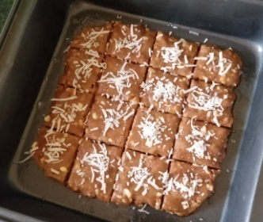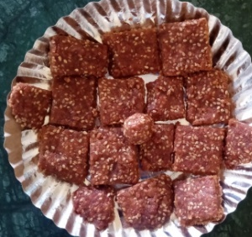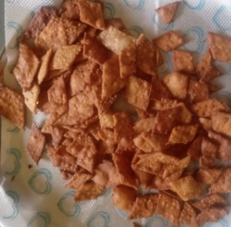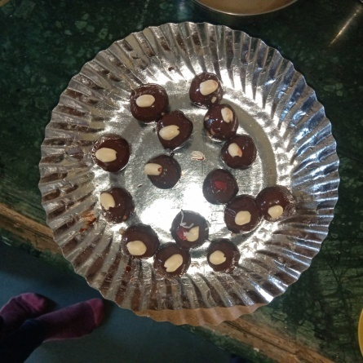
Plate 3: crackers
Plate 1: groundnut chikki
Plate 2: sesame chikki
Plate 4: Chocolate balls
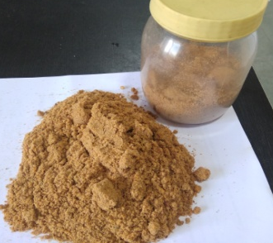
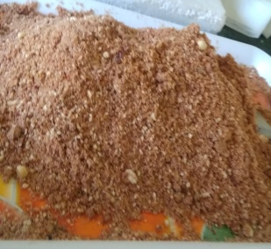
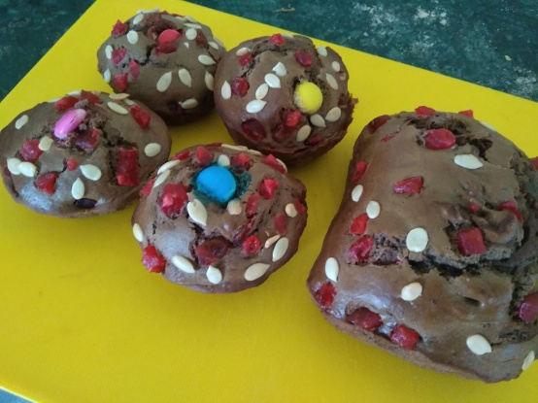
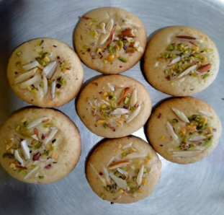
Plate 7: Cup Cake
Plate 8: cookies
Plate 6: groundnut chutney
Plate 5: mixed chutney

3.3 Implications for Nutritional Security and Bio-Economy The results signify that defatted groundnut cake (DGC) is highly suitable for incorporation into both traditional and convenience foods. By transforming this nutrient-rich, underutilized residue into shelf-stable, high-value commercial products, this approach directly supports the principles of a circular bio-economy. Furthermore, the popularization and value addition of DGC presents a viable strategy for tackling protein-energy malnutrition while simultaneously generating lucrative rural entrepreneurship opportunities.

4. Conclusion
The present study successfully demonstrated the viability of utilizing groundnut deoiled cake flour (GDCF) to develop a variety of value-added traditional and convenience food products. Sensory evaluations revealed high acceptability across different formulations, with specific products like Chikki showing that a 50% incorporation of GDCF is highly acceptable and even improves the texture of the final product compared to lower substitution levels. Considering the substantial nutritional importance of defatted groundnut cake, the purposeful value addition and popularization of these byproducts can go a long way in tackling protein-energy malnutrition within the country. Furthermore, the impressive economic margins achieved through this approach present a strong case for circular bio-economy practices and rural entrepreneurship (Thakare, 2025; Bochare et al., 2022). Ultimately, this study signifies the critical need for the adoption of safe processing methods and supportive policies to ensure the broad availability of safe, hygienically prepared GDCF for both household and commercial consumption.
Disclaimer (Artificial intelligence)
Author(s) hereby declare that NO generative AI technologies such as Large Language Models (ChatGPT, COPILOT, etc.) and text-to-image generators have been used during the writing or editing of this manuscript.

REFERENCES

Al-Khamaised, A. M., & Saleh, M. I. (2024). Impact of Sesame (Sesamum indicum L.) Oil cake on pasta physicochemical properties. Polish Journal of Food and Nutrition Sciences, 74(3).
Arya, S. S., Salve, A. R., & Chauhan, S. (2016). Peanuts as functional food: a review. Journal of food science and technology, 53(1), 31-41.
Fekria, A. M., Isam, A. M. A., Suha, O. A., & Elfadil, E. B. (2012). Nutritional and functional characterization of defatted seed cake flour of two Sudanese groundnut (Arachis hypogaea) cultivars. International Food Research Journal, 19(2), 629.
Gomez, K. A., & Gomez, A. A. (1984). Statistical procedures for agricultural research. John wiley & sons.
Kalpana Devi, B., Vidhya, R., & Jaganmohan, R. (2013). Determination and isolation of protein from different fractions of defatted groundnut oil cake. African Journal of Plant Science, 7(8), 394-400.
Laokuldilok, N., Surin, S., & Damrongwattanakool, N. (2021). Effect of using riceberry flour and xanthan gum on physical properties and estimated glycemic index of steamed rice cakes: optimization by D-optimal mixture design approach. Journal of Food Science and Technology, 59, 724–734. https://doi.org/10.1007/s13197-021-05067-8 Cited by: 11
Ligarda-Samanez, C. A., Huamán-Carrión, M. L., Calsina-Ponce, W. C., Cruz, G. D. L., Calderón Huamaní, D. F., Cabel-Moscoso, D. J., ... & Jilaja-Carita, E. E. (2025). Technological innovations and circular economy in the valorization of agri-food by-products: advances, challenges and perspectives. Foods, 14(11), 1950.
Lim, J. (2011). Hedonic scaling: A review of methods and theory. Food Quality and Preference. https://doi.org/10.1016/j.foodqual.2011.05.008 Cited by: 822
Peryam, D. R., & Pilgrim, F. J. (1957). Hedonic scale method of measuring food preferences. Food technology.
Purohit, C., & Rajyalakshmi, P. (2011). Quality of products containing defatted groundnut cake flour. Journal of food science and technology, 48(1), 26-35.
Roni, R. A., Sani, M. N. H., Munira, S., Wazed, M. A., & Siddiquee, S. (2021). Nutritional Composition and Sensory Evaluation of Cake Fortified with Moringa oleifera Leaf Powder and Ripe Banana Flour. Applied Sciences, 11, 8474. https://doi.org/10.3390/app11188474 Cited by: 37
Suchitra Bochare, Dr. Umesh Thakre, Shubhankar Mukharjee. Cost economics and economic viability of cold press oil extraction unit. Int J Hortic Food Sci 2022;4(2):140-142. DOI: 10.33545/26631067.2022.v4.i2b.123
UG Thakare. (2025). Evaluation of major training programmes conducted by KVK, Akola. International Journal of Agriculture Extension Social Development, 8(9), 176–181. https://doi.org/10.33545/26180723.2025.v8.i9c.2395
Warra, A. A., & Prasad, M. N. (2024). Industrial Crops: Bioresources to Biotechnology. CRC Press.
Talwar, B., Chopra, R., & Chaudhary, S. (2026). Sustainable valorization of oilseed cake using solid-state fermentation for enhanced nutritional profile. Discover Food.
Vichare, S. A., & Morya, S. (2024). Exploring waste utilization potential: nutritional, functional and medicinal properties of oilseed cakes. Frontiers in Food Science and Technology, 4. https://doi.org/10.3389/frfst.2024.1441029
Sarkar, N., Chakraborty, D., Dutta, R., Agrahari, P., Sundaram, D., Singh, A., & Jacob, S. (2021). A comprehensive review on oilseed cakes and their potential as a feedstock for integrated biorefinery. Journal of Advanced Biotechnology and Experimental Therapeutics, 4(3), 376. https://doi.org/10.5455/jabet.2021.d137
Grahovac, N., Aleksić, M., Trajkovska, B., Marjanović Jeromela, A., & Nakov, G. (2025). Extraction and Valorization of Oilseed Cakes for Value-Added Food Components—A Review for a Sustainable Foodstuff Production in a Case Process Approach. Foods, 14(13), 2244. https://doi.org/10.3390/foods14132244
Preeti, K. T., R., Nidoni, U., Mathad, P. F., Shirawal, S., & Swapna. (2025). Physico Chemical Properties of Groundnut (Arachis hypogaea L.) and Defatted Groundnut Cake. Journal of Scientific Research and Reports, 31(3), 1–11. https://doi.org/10.9734/jsrr/2025/v31i32872
Ranjan, A., Denis, D. M., Singh, I., & Lal, K. (2020). Technology for production of edible grade de- oiled cake from groundnut and its diversified use in baked, 1392–1397.
‌

‌

‌

