Experimental comparation of the performance of cabinet solar dryer in natural and force convection condition
Abstract: Solar energy offers an effective and sustainable approach for preserving agricultural products, particularly in regions with high solar availability. The present study experimentally investigated the performance of a cabinet-type solar dryer operating under natural and forced convection modes for drying potato slices. The system was fabricated using locally available materials and tested under actual climatic conditions in Prayagraj, India. Performance evaluation was carried out based on temperature variation, moisture removal, drying rate, and overall drying efficiency. The results indicated that forced convection significantly enhanced the drying process due to improved airflow and heat transfer within the drying chamber. The cabinet temperature reached approximately 75°C under forced convection, resulting in faster moisture removal. The drying efficiency increased to 55% compared to 33% under natural convection. The drying process exhibited an initial rapid moisture removal phase followed by a falling rate period. The findings demonstrate that forced convection solar drying is an efficient and reliable method for agricultural drying without reliance on conventional fuels
Keywords: cabinet solar dryer, convection, infrared thermometer, chamber temperature
1. Introduction
Out in fields where harvests often spoil fast, sunlight now plays a bigger role in keeping crops usable - without needing complex power systems. Lying under open sky, food can pick up dust, dry unevenly, while rain or clouds slow things down without warning. But when stacked inside box-like solar units, produce stays clean, dries faster even on hazy days, protected from sudden weather turns. These enclosed setups trap heat just right so fruits, grains, herbs keep better color, taste, texture than they do out in the wild sun. Instead of hoping for perfect skies, farmers gain steadier results using designs built around basic materials and natural airflow patterns.
Sunlight passes through a clear cover into a well-insulated box, warming whatever sits inside. Heat builds up within the space, helping pull moisture out via airflow that can be passive or powered. Built simply, these units run without high costs, fitting operations of modest size. Dust, bugs, and wet weather stay outside thanks to sealed walls, shielding what dries within. Fruit and veggies often go here when needing dehydration under clean conditions.
Dried potatoes travel far as snacks, yet it takes removing water first - sun-powered boxes handle this without burning coal. These solar units heat up slowly under daylight, leaving behind crispness needed before any oil enters the picture. Research confirms they drop wetness enough in just several hours, holding onto look and bite people expect [4]. Air moves through the chamber at steady rates, keeping conditions even across layers. When temperatures stay predictable inside, every slice dries like its neighbor. Quality stays intact when light does the work instead of gas flames.
Nowadays solar cabinet dryers use stronger airflow setups, fans run by sunlight power, also materials that save heat like phase change substances. These updates deal with uneven sun availability while boosting how fast things dry plus keeping results steady [5]. Take hybrid models with built-in fans - they move warmth and moisture more effectively, cutting down drying duration along with lifting output standards [4]. In much the same way, adding phase change material holds extra heat when sunlight is strong, then gives it back when light fades, so drying keeps going [6].
Not only do solar cabinet dryers cut down on fossil fuel use, they shrink greenhouse gases too. Because of cleaner operation, villages see lower power bills while growers earn more by improving crop quality before selling. With gains like these, places now lean toward using the tech for moisture-heavy foods - think dried potatoes ready for storage.
2. Literature review
One way to group solar dryers involves how they move heat and air - this leads to three main types: direct, indirect, and mixed-mode. Work long ago by Ekechukwu OV and Norton B [3] laid out clear categories for these systems, pointing out benefits when compared to standard drying techniques. Instead of exposing material to sunlight straight away, some models warm air using a dedicated collector; this defines the indirect kind. Cabinet-style units fall under the direct category, where sunshine reaches the item being dried without delay. Efficiency gains appear when both heating strategies operate at once - a feature found in mixed setups. Though different in design, each version relies on sun-based energy flow to reduce moisture.
One key finding among multiple reviews points to solar drying’s role in cutting down energy needs alongside better preservation of food traits. Drying duration sees marked reduction according to work by Fudholi et al. [4], along with El-Sebaii and Shalaby [5], without sacrificing output standards. Developments in system design, as highlighted by Kumar et al. [6], contribute toward greater heat utilization - expanding use into diverse crop types.
A box-like structure, built with insulation and topped by a clear lid, forms the core of the solar cabinet dryer. Inside, shelves hold materials meant for drying under sunlight. Light passes through the glass surface, striking both contents and inner walls, transforming into thermal energy. This warmth raises air temperature within the enclosure. Moisture escapes more readily when warmed airflow moves across the substance, either on its own or pushed by mechanical means.
Early research led by Sharma together with Pangavhane showed how cabinet dryers could successfully remove moisture from farm-grown crops. From that point onward, key elements like air movement speed, shelf layout, and heat retention needs began taking shape. Work later expanded when Goyal alongside Tiwari introduced surface collectors laid flat while refining how air moves through the system. Efficiency during dehydration saw measurable gains because of these adjustments reported across several reviews [1–2].
Easy to build, needing little money, cabinet dryers fit well in countryside settings. Still, how well they work depends on sunlight strength, air warmth, dampness levels, alongside how fast air moves through. Because of that, studies aim at adjusting such elements for better results when removing moisture. What happens during drying greatly affects how fast crops lose water and what condition they end up in. Research has looked into how farming goods respond while losing moisture using sun-powered methods.
Beginning with Tripathy and Kumar, experiments on potato slice dehydration led to predictive mathematical frameworks. Moisture movement, observed during diminishing rate phases, emerged as the core process. Not far from their approach, Akpinar examined mint leaf behavior under heat exposure. Temperature levels, along with air motion, shaped how quickly water left the material. These elements together defined the speed pattern noted in later analysis.
Analysis by Dissa and colleagues examined how convection drying behaves, showing that speed depends on traits like material thickness, pore structure, space between particles, and starting water levels. Of note in their work is the impact of slice dimension - especially seen in potato-based snacks - a factor directly tied to duration of drying and resulting texture or appearance. Commonly eaten across regions, these crisps require careful removal of internal moisture prior to oil exposure during manufacturing. An option using sunlight instead of standard thermal systems offers lower power demand, making it a less resource-heavy approach [19].
Working on solar energy applications, Eltawik et al. [9] designed a mixed-mode drying unit powered by photovoltaics for processing potato chips. Under their observation, moisture dropped to secure thresholds rapidly, without compromising the output standard. With sunlight driving the ventilation mechanism, air movement increased, aiding thermal and moisture exchange more effectively. As a result, duration needed for drying diminished noticeably.
Beyond traditional methods, Boulemtafes et al. [10] explored how sunlight powers the drying of potato slices while tracking both energy use and cost. Instead of relying on standard systems, their findings showed lower energy demands alongside decreased operational expenses when using solar technology. Environmental gains emerged too - emissions tied to warming climates dropped noticeably under this approach. While efficiency stood out, so did long-term resource conservation through cleaner processes.
Even with progress, problems persist in ensuring even drying and steady output quality. Differences in heat and air movement inside the chamber often result in inconsistent moisture removal, altering chip structure and look. Because standard solar cabinet models fall short, studies have tested improved methods - such as fan-driven airflow, combined heating sources, or stored thermal capacity - to boost efficiency.
Improvement in drying efficiency emerges when airflow gains support through mechanical means, according to Mohanraj and Chandrasekar [15]. Their work on forced convection solar dryers highlights how fans contribute to faster moisture removal. In a related manner, findings from Forson et al. [13] align with those of Simate [14], both examining mixed-mode systems. Enhanced drying speeds appear alongside superior output characteristics within these setups. Air movement, when actively managed, tends to influence outcomes more than passive designs.
Still, hybrid solar dryers emerged using both sunlight and backup heat to keep operations steady when skies change. Work by Goodyear et al. [22] looked into new steps taken in solar drying methods - where mix-mode setups stood out due to steadier output despite outdoor shifts.
From Kabeel and Abdelgaied’s work [21], heat storage using PCM helps improve drying when sunlight varies, due to energy retention in high-intensity phases followed by gradual release later. Stability in temperature emerges alongside prolonged operational windows under diminished irradiance. Evidence across recent articles in Solar Energy and Renewable Energy supports enhanced thermal behavior along with consistent moisture removal linked to PCM use [10,21]. Still, questions persist around ideal material choice, positioning within systems, and economic feasibility.
In a study referenced as [25], Iranmaneh and team used computational fluid dynamics to examine how air moves and heat spreads inside solar-powered drying units. It was observed that when airflow paths are well planned, the consistency and speed of drying increase notably. In another case, work labeled [12] by Akbulut with Durmus focused on energy usage and quality loss within these systems, aiming to pinpoint where changes could enhance function. From reference [10], Boulemtafes together with others indicated reductions in energy demand and expenses during operation through such technologies. At point [23], findings shared by Venkateswarlu along with Reddy brought attention to added social impact - fewer crops spoiled after harvest, goods gained worth, especially within country regions.
3. Materials and Methods
3.1 Setup and construction
The fabrication and experiment set was held in the department of Renewable Energy Engineering, SHUATS, Prayagraj, Uttar Pradesh. The Coordinates of the setup place was 25.4137° N and 81.8491° E. The meteorological conditions of the experiment place were Warm and Humid.
Built around a rigid structure, the cabinet solar dryer uses galvanized iron square tubes measuring 0.04 by 0.04 meters. Connected to the drying compartment is a flat plate solar collector, sized at 0.55 by 1.02 meters. That compartment measures 0.76 by 0.56 by 0.56 meters, sealed tightly with 18-gauge sheet metal panels to reduce thermal escape. Over the collector lies a clear glass panel, designed so sunlight enters efficiently while heat remains trapped inside. Within the enclosure, multiple trays - constructed from angle iron frames and 22-gauge perforated sheets - are placed evenly; each contains numerous 5 mm holes occupying ninety percent of surface area. Air movement begins when a small fan powered by a DC motor pulls outside airflow through the intake near the collector base. Once warmed within that section, the rising hot air migrates naturally toward the upper chamber where goods undergo dehydration. From there, humid air exits via a chimney that holds an exhaust fan, maintaining steady movement while pulling out dampness. Power comes from a battery, paired with a device to adjust flow rate - this balance supports consistent results when drying farm items such as cut potatoes.
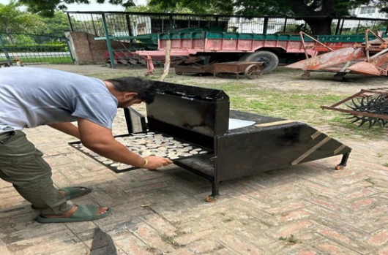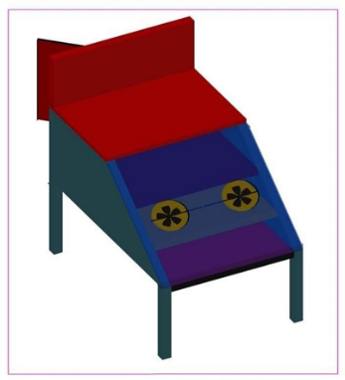
Figure 1(a) Cabinet solar dryer Figure 1 (b) Design of cabinet solar dryer
3.2 Experimental Procedure
- Fresh potatoes were washed, peeled, and cut into uniform slices.
- The initial moisture content of the potato slices was determined using standard oven-drying method.
- The slices were uniformly spread on perforated trays inside the drying chamber.
- The solar dryer was operated under sunny conditions.
- Airflow was maintained using DC fans powered by a battery.
- Temperature at collector outlet and drying chamber, as well as ambient temperature, were recorded at regular intervals.
- Weight of the samples was measured periodically to determine moisture loss.
- Drying continued until the desired moisture content was achieved.
Table 1 Instruments used for the measurement of essential values
S. No. | Characteristics | Instrument | Specifications
 | Solar insolation | Solarimeter | Range- 0-1999 W/m²
 | Surface temperatures | Infrared thermometer | Range- 28 to 80 ˚C
 | Wind velocity | Digital thermo- anemometer. | Range- 0-30 m/s
 | Ambient temperature | Mercury thermometer | Range- 10 to110 ˚C
3.3 Performance evaluation
The experiment was conducted on 25th March 2026 to evaluate the performance of the solar cabinet dryer under prevailing climatic conditions. The drying experiment was carried out during peak sunshine hours from 11:00 AM to 5:00 PM, ensuring adequate solar energy availability. During the experimental period, the average solar radiation was observed to be approximately 750 W/m², with maximum intensity recorded around midday. Solar radiation was measured using a solarimeter, ensuring accurate monitoring of incident solar energy on the collector surface. Temperature measurements, including ambient and cabinet temperatures, were recorded using both a mercury thermometer and an infrared thermometer to ensure reliability and precision. The thermal energy required for moisture evaporation was evaluated using the standard value of latent heat of vaporization of water (approximately 2257 kJ/kg), which represents the energy needed to convert water from liquid to vapor during the drying process. This parameter is essential for calculating drying efficiency and understanding the heat utilization characteristics of the solar dryer. Overall, the selected time duration and measurement instruments ensured accurate assessment of solar radiation and thermal performance during the experiment.
The performance of cabinet solar dryer was evaluated with the following equations
Moisture Content (Wet Basis) [24-25]
The moisture content on a wet basis represents the percentage of water present in the material relative to its initial total mass. This parameter is used to quantify the extent of moisture removal during the drying process. A higher value of moisture content indicates greater water removal from the product. It is widely used in drying studies due to its simplicity and direct relation to the initial weight of the sample.
${MC}_{wb}=\frac{W_{i}​-W_{f}}{W_{i}​} ×100$ (1)
Where ${MC}_{wb}$ is the moisture content in wet basis, $w_{i}$ is the initial weight in kg and $w_{f}$is the final weight in kg
Drying Rate (DR) [26]
The drying rate defines the rate at which moisture is removed from the material over a specific time period. It provides insight into the kinetics of the drying process and helps identify different drying phases, such as the constant rate and falling rate periods. A higher drying rate indicates faster moisture removal, which is influenced by temperature, airflow, and solar radiation intensity.
$DR= \frac{W_{i}​-W_{f}}{t​} ×100$ (2)
Where t represents the time in hr
Drying Efficiency (%) [27-28]
Drying efficiency represents the effectiveness of the solar dryer in utilizing the available solar energy for moisture evaporation. It is defined as the ratio of useful energy used to evaporate moisture to the total solar energy incident on the collector. Higher efficiency values indicate better energy utilization and improved system performance. This parameter is crucial for comparing the effectiveness of different drying systems and operating conditions.
$η_{d}=\frac{m_{w} ​× L}{I × A × t}$ (3)
Where $m_{w}$ is the mass of the moisture removed in kg, L is the latent heat of vaporisation in kJ/kg, I is the solar radiation in w/m², A is the area of solar collector in m².

4. Results and discussion
Different evaluating parameters has been calculated using equation 1, 2 and 3 and is been discussed in this section
Table 2 Different evaluating parameters for natural convection solar cabinet solar dryer
Time (hr) | Initial Weight (kg) | Final Weight (kg) | Moisture Content (%) | Moisture Content | Drying Rate (kg/hr) | Dryer Efficiency (%)
0 | 2.00 | 2.00 | 0.00 | 0.00 | 0.00 | –
1 | 2.00 | 1.75 | 12.50 | 0.143 | 0.25 | 18
2 | 2.00 | 1.55 | 22.50 | 0.290 | 0.225 | 22
3 | 2.00 | 1.38 | 31.00 | 0.449 | 0.207 | 26
4 | 2.00 | 1.25 | 37.50 | 0.600 | 0.187 | 29
5 | 2.00 | 1.15 | 42.50 | 0.739 | 0.170 | 31
6 | 2.00 | 1.08 | 46.00 | 0.852 | 0.153 | 33

Table 3 Different evaluating parameters for force convection solar cabinet solar dryer
Time (hr) | Initial Weight (kg) | Final Weight (kg) | Moisture Content (%) | Moisture Content | Drying Rate (kg/hr) | Dryer Efficiency (%)
0 | 2.00 | 2.00 | 0.00 | 0.00 | 0.00 | –
1 | 2.00 | 1.65 | 17.50 | 0.212 | 0.35 | 28
2 | 2.00 | 1.40 | 30.00 | 0.429 | 0.300 | 35
3 | 2.00 | 1.20 | 40.00 | 0.667 | 0.267 | 42
4 | 2.00 | 1.05 | 47.50 | 0.905 | 0.237 | 48
5 | 2.00 | 0.95 | 52.50 | 1.105 | 0.210 | 52
6 | 2.00 | 0.88 | 56.00 | 1.273 | 0.187 | 55
Starting at 2.00 kg, the sample lost mass steadily, ending at 1.08 kg after six hours inside the solar cabinet dryer - proof of consistent dehydration. Though initial moisture stood high, it dropped to 46% on wet-weight terms by the end. Drying began quickly, pulling water at 0.25 kg per hour, yet slowed later toward 0.153 kg/h, revealing dominance of the falling-rate phase. Heat use climbed during operation; efficiency rose from 18% up to 33%. Because air movement relied solely on buoyancy effects, full potential stayed out of reach. Despite solid function under passive airflow conditions, speed lagged behind models using fans or blowers.
Starting at 2.00 kg, the sample dropped to 0.88 kg after six hours inside the forced convection solar cabinet dryer. Table 2 reveals this method outperformed natural convection clearly. Moisture levels fell sharply, landing at 56% by the end of drying. During the initial hour, water loss peaked at 0.35 kg/h before slowing - by the sixth hour, the rate had dipped to 0.187 kg/h - a pattern typical of falling rate periods. Efficiency climbed, beginning at 28% and ending at 55%, thanks to uninterrupted air movement improving both heat and moisture exchange. Because airflow remained steady, results were faster, more consistent across samples, and overall stronger than passive systems. For potato slices, this design proved superior under tested conditions.
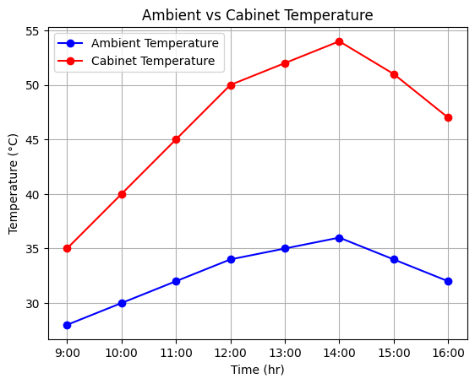
Figure 2. Ambient and cabinet temperature for natural convection solar dryer

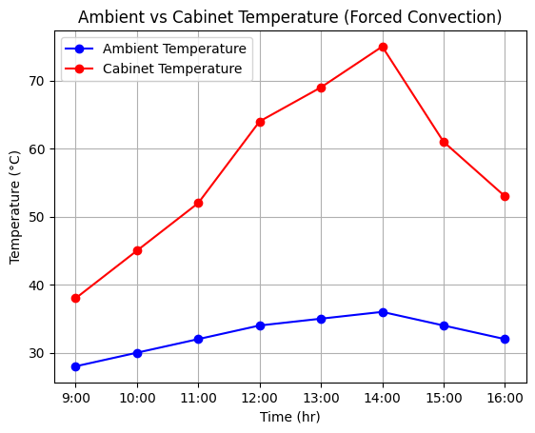
Figure 3. Ambient and cabinet temperature for force convection solar dryer
Figure 2 shows the graph which shows that cabinet temperature in forced convection is significantly higher than ambient temperature throughout the day, indicating efficient heat transfer and solar energy utilization. Both temperatures increase from morning and peak around 14:00 due to maximum solar radiation. The cabinet temperature reaches up to 75°C, much higher than ambient (36°C), enhancing drying efficiency. After peak hours, temperatures decline gradually, reflecting reduced solar intensity and heat availability.

5. Conclusion
Despite similar setups, results shifted noticeably when airflow was powered rather than passive. Higher temperatures inside the chamber - peaking at 75°C - emerged clearly during fan-assisted trials. Moisture left crops quicker when air moved by force, not just warmth alone. Efficiency climbed to 55%, nearly doubling the 33% seen without mechanical aid. Throughout testing, internal heat stayed well above outside levels, especially with active airflow. Graphs tracing temperature changes revealed steadier, more consistent drying under forced conditions. Heat worked more thoroughly where fans pushed it through. Drying times shortened meaningfully when convection wasn’t left to chance. For items such as sliced potatoes, this design handled water removal far better overall.
6. Limitation of the research
Even though the findings shed light on how natural and forced convection solar dryers work, some gaps stayed. Testing happened over a short time, during particular weather patterns, meaning outcomes might shift across seasons. Potato slices alone were used, yet other crops with distinct traits could behave differently when dried. The setup ran at a reduced size; moving to larger versions might bring issues like uneven air movement or temperature spread. Changes in sunlight intensity and surrounding conditions got little attention, even though they can alter drying reliability.

COMPETING INTERESTS DISCLAIMER:
Authors have declared that they have no known competing financial interests OR non-financial interests OR personal relationships that could have appeared to influence the work reported in this paper.
Disclaimer (Artificial intelligence)
Author(s) hereby declare that NO generative AI technologies such as Large Language Models (ChatGPT, COPILOT, etc.) and text-to-image generators have been used during the writing or editing of this manuscript.

References
- Sharma VK, Colangelo A, Spagna G. Experimental investigation of different solar dryers. Energy Convers Manage. 1990;31:377–385.
- Pangavhane DR, Sawhney RL, Sarsavadia PN. Design, development and performance testing of a new natural convection solar dryer. Energy. 2002;27:579–590.
- Ekechukwu OV, Norton B. Review of solar-energy drying systems II: an overview. Energy Convers Manage. 1999;40:615–655.
- Fudholi A, Sopian K, Ruslan MH, et al. Review of solar dryers for agricultural products. Renew Sustain Energy Rev. 2010;14:1–30.
- El-Sebaii AA, Shalaby SM. Solar drying of agricultural products: A review. Renew Sustain Energy Rev. 2012;16:37–43.
- Kumar M, Sansaniwal SK, Khatak P. Progress in solar dryers for drying various commodities. Renew Sustain Energy Rev. 2016;55:346–360.
- Tiwari S, Tiwari GN, Al-Helal IM. Development and recent trends in greenhouse dryers: A review. Renew Sustain Energy Rev. 2016;65:1048–1064.
- Prakash O, Kumar A. Historical review and recent trends in solar drying systems. Int J Green Energy. 2013;10:690–738.
- Eltawil MA, Azam MM, Alghannam AO. Solar PV powered mixed-mode tunnel dryer for drying potato chips. Renew Energy. 2018;116:594–605.
- Boulemtafes A, et al. Energy, economic and environmental analysis of solar drying of potato slices. Renew Energy. 2022;200:48–58.
- Akpinar EK. Drying of mint leaves in a solar dryer: modeling and performance analyses. Energy Convers Manage. 2010;51:2407–2418.
- Akbulut A, Durmus A. Energy and exergy analyses of thin layer drying of mulberry. Energy. 2010;35:1754–1763.
- Forson FK, Nazha MAA, Rajakaruna H, et al. Design of mixed-mode natural convection solar crop dryers. Renew Energy. 2007;32:2306–2319.
- Simate IN. Optimization of mixed-mode solar dryers. Renew Energy. 2003;28:435–453.
- Mohanraj M, Chandrasekar P. Performance of forced convection solar dryer. Renew Energy. 2009;34:192–198.
- Goyal RK, Tiwari GN. Parametric study of a reverse flat plate absorber cabinet dryer. Solar Energy. 1997;60:41–48.
- Goyal RK, Tiwari GN. Performance of a cabinet dryer: new concept. Energy Convers Manage. 1999;40:41–48.
- Tripathy PP, Kumar S. Determination of drying parameters for potato slices during solar drying. Energy Convers Manage. 2008;49:2941–2948.
- Dissa AO, Desmorieux H, Savadogo PW, et al. Convective drying characteristics of agricultural products. Renew Energy. 2009;34:1897–1905.
- Sarsilmaz C, et al. Drying of apricots using solar dryer. Renew Energy. 2000;20:117–127.
- Kabeel AE, Abdelgaied M. Solar dryer with PCM for enhanced drying. Solar Energy. 2016;142:209–217.
- Goodyear JK, et al. Solar dryers for food applications: concepts and advances. Solar Energy. 2020;208:321–344.
- Venkateswarlu K, Reddy SV. Recent trends in solar dryers. Sustain Energy Technol Assess. 2023;58:103298
- Fudholi A, Sopian K, Ruslan MH, et al. Review of solar dryers for agricultural products. Renew Sustain Energy Rev. 2010;14:1–30
- El-Sebaii AA, Shalaby SM. Solar drying of agricultural products. Renew Sustain Energy Rev. 2012;16:37–43.
- Akpinar EK. Drying of agricultural products: modeling and analysis. Energy Convers Manage. 2010;51:2407–2418
- Eltawil MA, Azam MM, Alghannam AO. Solar dryer for potato chips. Renew Energy. 2018;116:594–605.
- Boulemtafes A, et al. Solar drying energy analysis. Renew Energy. 2022;200:48–58

