Mitigation of button shedding in coconut through nutritional and hormonal interventions

ABSTRACT
Background: Coconut is a vital perennial tropical crop with major global and socio-economic importance, but its productivity is affected by climatic stress, nutritional deficiencies, and severe button shedding that significantly reduces yield. Button shedding varies from year to year within a variety and it is greater in dwarf palms compared to tall palms. Shedding of buttons and immature nuts may be due to nutritional and hormonal deficiency, pests and diseases, unfavorable environmental conditions, lack of drainage, pollination, and genetic conditions.
Aim: The aim of this study was to evaluate the efficiency of growth regulators and nutrients for the management of button shedding in coconut.
Study design: The experiment was conducted in a Randomized Complete Block Design.
Place and Duration of Study: The study was conducted at the Coconut Research Station, Balaramapuram, Kerala, India.
Methodology: A survey was conducted to select the West Coast Tall (WCT) palms with uniform age showing significant button shedding. The respective solutions as per different treatments fixed for the study were prepared and administered to the palms through root feeding technique. After imparting different treatments via root feeding, the number of buttons retained in the newly opened inflorescence, biochemical, physiological and yield parameters were observed and recorded for a period of first six months. This was the first report of using Hoagland solution (2X) for the management of button shedding in coconut.
Results: Among the seven treatments, T2 (Hoagland Solution - 2X) showed the lowest button shedding percentage which was followed by T6 (Salicylic Acid - 200 ppm) and T5 (Borax (0.5 g) + 2, 4-D (50 ppm) during the first four months after root feeding. T2 treated palms exhibited the highest photosynthetic and transpiration rates over the six-month period, indicating enhanced physiological performance. Both T2 and T6 treatments maintained higher carbohydrate levels than the control throughout the study. In addition, macronutrient (N, K, Ca, Mg, S) and micronutrient (Fe, Zn, Cu, B, Mn) contents were consistently greater in T2-treated palms, reflecting improved nutritional status and better nut retention following root feeding.
Conclusion: The reduction in button shedding observed in treatments T2, T6, and T5 was closely associated with increased carbohydrate accumulation and enhanced macro- and micronutrient contents in the leaves following root feeding. These improvements indicate that better nutritional status and elevated physiological activity contributed to improved button retention. Overall, the results demonstrate that root feeding with balanced nutrients and growth regulators enhances photosynthetic efficiency, nutrient uptake, and metabolic activity in coconut palms, thereby minimizing early nut drop. This study highlights the effectiveness of Hoagland solution and salicylic acid as practical interventions to improve palm health and reduce button shedding, ultimately supporting higher nut retention and productivity.
Keywords: Button shedding, Growth regulators, Hoagland Solution, Physiological traits, Root feeding, coconut palms.

Graphical Abstract
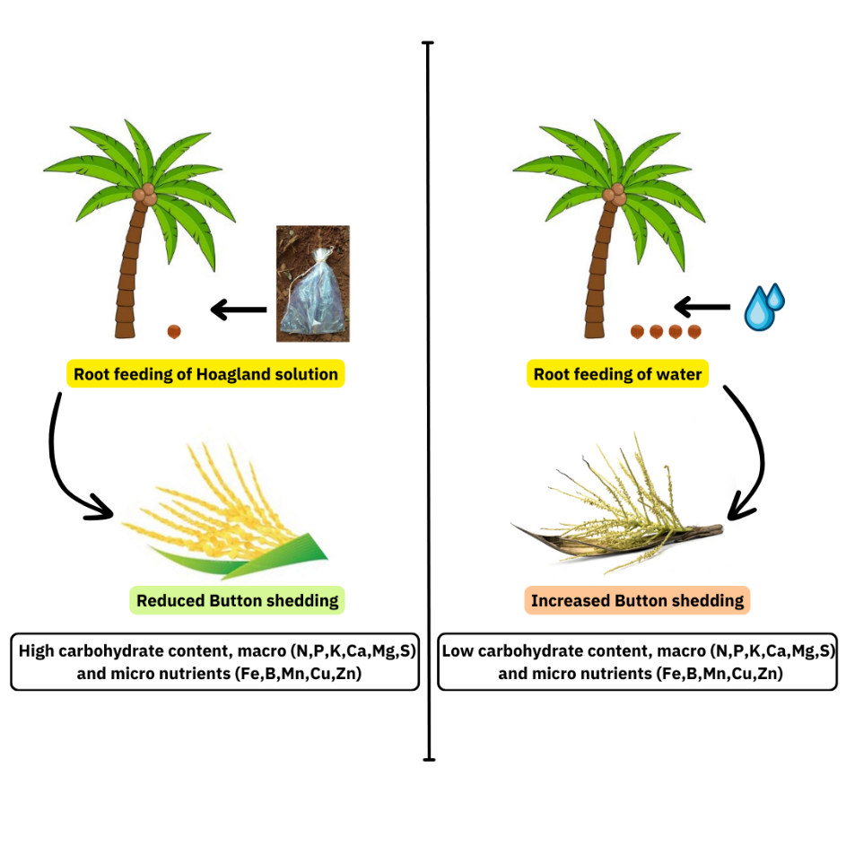
- INTRODUCTION

Coconut (Cocos nucifera L.) is one of the important perennial crops having multipurpose uses as every part of the tree is useful to humankind. It is grown in humid tropics between 23º north and 23º south of the equator and up to altitudes of about 600 m from the mean sea level for nut production (Kumar and Aggarwal, 2013). Humans have used coconuts for thousands of years. The palm may have originated in the lands around the western Pacific and was probably distributed from there to east and westwards by humans. The socio-economic life of most Indian small and marginal farmers is interlinked with coconut cultivation. Coconut farming improves the economy of several countries in Asian and Pacific regions and also provides food security to millions of people across the world.
The worldwide coconut production in 2021 was estimated at 63,683,595 metric tonnes, showing a 2.1% increase from the previous year. The Philippines, Indonesia, and India collectively account for approximately 70 % of the world's total copra production (FAOSTAT, 2023). The overall coconut production of India in 2021-2022 was 19,309 million nuts in an area of 2.15 million hectares with a productivity of 8,966 nuts/hectare (Coconut Development Board, 2024). Among the Indian states, Kerala, Tamil Nadu, and Karnataka have emerged as leading states, collectively accounting for more than two-thirds of the country's total coconut area and production. Since the 1990s, coconut production has undergone a continuous increase with some fluctuations in Tamil Nadu and Karnataka, and a moderate increase in Kerala (Maruthi and Peter, 2019). These positive trends could stem from a variety of factors, including expanded cultivation areas, technological advancements, price fluctuations, changes in agricultural practices, or a combination of these factors (Thamban et al., 2016).
In coconut plantation, the nut yield is affected by both abiotic and biotic factors. The climatic changes in the environment affect the coconut plantation through increased CO₂ concentration, high temperature, precipitation changes, pests and diseases, increased weeds, and increased susceptibility to organic carbon pools. Simulation modelling indicates that, under projected climate change scenarios, coconut productivity may increase by approximately 16% by 2050 and 36% by 2080 compared with current yield levels. Due to the climate-changing scenario, the yield is predicted to decrease in 2050 and 2080 by about 8% and 31% respectively over the current yields in East Coast zones. However, yield is estimated to decline in Andhra Pradesh, Orissa and Gujarat while yield is predicted to increase in Kerala, Tamil Nadu, Karnataka, and Maharashtra (Hebbar et al., 2013).
Nutritional deficiencies in coconut trees commonly lead to problems such as button shedding, premature nut fall, husk splitting, shrivelled nuts, fragile fronds, and reduced yield (Sudhalakshmi, 2021). Button shedding and immature nut fall are the important factors determining coconut palm's final yield. Button shedding varies from year to year within a variety and it is greater in dwarf palms compared to tall palms (Peiris et al., 1995). The yield loss due to button shedding ranges from 55 to 95 % depending on the conditions prevailing and on the variety of the coconut. Shedding of buttons and immature nuts may be due to nutritional and hormonal deficiency, pests and diseases, unfavorable environmental conditions, lack of drainage, pollination, and genetic conditions (Rajapakse et al.,1995; Malarvannan, 2012).
Coconut palms are sensitive to high-temperature stress, particularly during their seedling and reproductive stages. Fruit setting and abortion rates within the first three months of inflorescence opening are key factors affecting coconut yield fluctuations (Ranasinghe et al., 2022). Elevated temperatures frequently lead to the shedding of young female flowers, or buttons, which significantly impacts coconut yield. The temperature conditions during the fruit (nut) setting period greatly influence the number of nuts that set per inflorescence (Hebbar et al., 2020). Therefore, it is crucial to identify the optimal combination of nutrients and growth regulators to mitigate the effects of these climatic changes.
The external application of growth regulators reduces the percentage of pre-harvest fruit drop, increasing the total number of fruits per plant. Applying plant growth regulators like auxins and gibberellins enhances the internal physiology of developing fruits, improving fruit set, reducing premature fruit drop, and addressing various physiological disorders to enhance quality and yield (Bons and Kaur, 2019). Several studies have been conducted to control the button shedding in coconut using growth regulators and nutrients. The current study was conducted to find out the efficiency of growth regulators and nutrients in checking button shedding in the coconut palms which was given through the root feeding method. This approach provides a practical and precise strategy to influence physiological and biochemical processes associated with button retention.
- MATERIALS AND METHODS

Initially, a survey was conducted to select the palms with uniform age showing significant button shedding. The research was conducted at Coconut Research Station, Balaramapuram, Kerala, India located at 8°23 ′N 77°5 ′E. The experiment was designed in Randomized Complete Block Design (RCBD) with 7 treatments and 5 replications. A total of 35 button-shedding palms (West Coast Tall) were used in the experiment. The treatments included in the study were prepared and administered to the palms through the root feeding method. The treatments used were T1 [C]: Control (200 ml of distilled water); T2 [HS]: Hoagland Solution (2X); T3 [HS+2, 4-D]: Hoagland Solution (2X) + 2, 4-D (50 ppm); T4 [B]: Borax (0.5 g palm⁻¹); T5 [B+2, 4-D]: Borax (0.5 g palm⁻¹) + 2, 4-D (50 ppm); T6 [SA]: Salicylic acid (200 ppm); T7 [SA+2, 4-D]: Salicylic acid (200 ppm) + 2, 4-D (50 ppm). The root feeding was administered in February (winter), and observations were recorded from February to July over six months.
A pit measuring 60×40 cm was excavated three feet away from the coconut trunk to locate a single fresh, pencil-thick root of pink or red colour. The root was then exposed at a 45ᵒ angle to reveal the vessels. A thick polybag of 45×30 cm containing 200 mL of the respective treatment solution was taken and the cut root was inserted in the polybag, thereby ensuring contact with the respective solution and tied airtight with a thread. The side roots were sheared to prevent the piercing of the polybag. Below the bag, the soil was excavated to seat the bag, so that the roots were fully immersed in the solution. The absorption of solution within 4-24 hours was considered as the right selection of root for the study. There was no repetition of root feeding for the next growth cycle.
2.1 Preparation of solution
- Hoagland Solution (2X): To prepare 2X concentration, the volume of stock solution per litre of final solution taken was doubled and made up to 1000 mL using distilled water. The cost of Hoagland No.2 basal salt mixture of 1 litre is about Rs.2165/-.
- Hoagland Solution (2X) + 2, 4-D (50 ppm): It is prepared by adding 100 mL of Hoagland Solution in 100 mL of 2, 4-D solution.
- Borax (0.5 g palm⁻¹): It is prepared by mixing 0.5 g of Borax in 200 mL of water
- Borax (0.5 g palm⁻¹) + 2, 4-D (50 ppm): It is prepared by adding 100 mL of Borax solution in 100 mL of 2,4-D solution
- Salicylic acid (200 ppm): 200 mg of Salicylic acid dissolved in small amount of 70 % ethanol and made up to 1000 mL using distilled water
- Salicylic acid (200 ppm) + 2, 4-D (50 ppm): It is prepared by adding 100 mL of Salicylic acid in 100 mL of 2, 4-D solution

2.2 Analysis of yield, physiological and biochemical parameters

The yield parameters such as the number of female flowers, the number of buttons retained and the percentage of button shedded were recorded for six months. The physiological parameters such as transpiration rate (mmol H₂O m⁻² sec⁻¹) and photosynthetic rate (µmol CO₂ m⁻²sec⁻¹) were estimated using Portable Photosynthetic System (CIRAS-3 SW, PP System International, MA, USA) in the 4th leaflet from top of the frond. Also, total carbohydrate content was estimated by anthrone method as described by Khandare et al. (2021). The macronutrients such as Nitrogen (N) was estimated using micro - Kjeldhal assembly as described by Gallaher et al. (1976), Phosphorous (P) by spectrophotometrically as vanado - molybdophosphate yellow colour complex in HNO₃ medium (Nishanth and Biswas, 2008), Potassium (K) by flame photometer (Nishanth and Biswas, 2008), Magnesium (Mg) and Calcium (Ca) by titrimetry (Charles et al., 2011), Sulphur (S) by turbidimetry (Tabatabai and Bremner, 1970), Iron (Fe), Zinc (Zn), Copper (Cu), Boron (B) and Manganese (Mn) by Atomic Absorption Spectrophotometry (Shimadzu AAS, Aa-6880f) (Allan, 1959; Elango et al., 2021; Charles et al., 2011).

2.3 Data analysis
The yield parameter such as the percentage of button shedding, physiological parameters such as transpiration rate, photosynthetic rate, and biochemical parameters such as total carbohydrate content and nutrient content were statistically analysed using the GRAPES web application (Gopinath et al., 2021) and the statistical software package OPSTAT (Sheoran et al., 1998). GRAPES version 1.0.0 web application is developed based on the R software. The standard error (Mean) was statistically analysed using Least Square Difference (LSD) method at the Critical Difference (0.05) and graphically represented with error bars. The correlation was analysed using the GRAPES version 1.0.0 web application. PCA analysis was carried out using the FactoMine R package in R 4.3.1. (R Core Team, 2023). The Box plot was formed using the psych package in R 4.3.1.

- RESULTS AND DISCUSSION

3.1 Effect of root feeding with plant growth regulators and nutrients on yield parameters
A coconut bunch typically contains around 16 female flowers. During the first two months of development, approximately 23.8% of the nuts are dropped, followed by a 40.1% drop in the next two months and a 1.9% drop in the subsequent two months. After this period, the shedding of buttons causes negligible nut losses (Abeywardena and Mathes, 1971). The effect of root feeding treatments on button shedding percentage was showed in Fig.1. The button shedding percentage showed significant variation for the first four months and showed non- significant variation during 5th and 6th month. The highest button shedding percentage was recorded during the 4th month and has declined in the 5th and 6th month in all the treatments compared to the control. T2 [HS] recorded the lowest percentage of button shedding (22.9%, 24.2%, 28.4% and 31.1% respectively) for the first four months followed by T6 [SA]. T1 [C] recorded the highest percentage of button shedding (32.88%, 37.21%, 44.24% and 50% respectively) for the first four months.
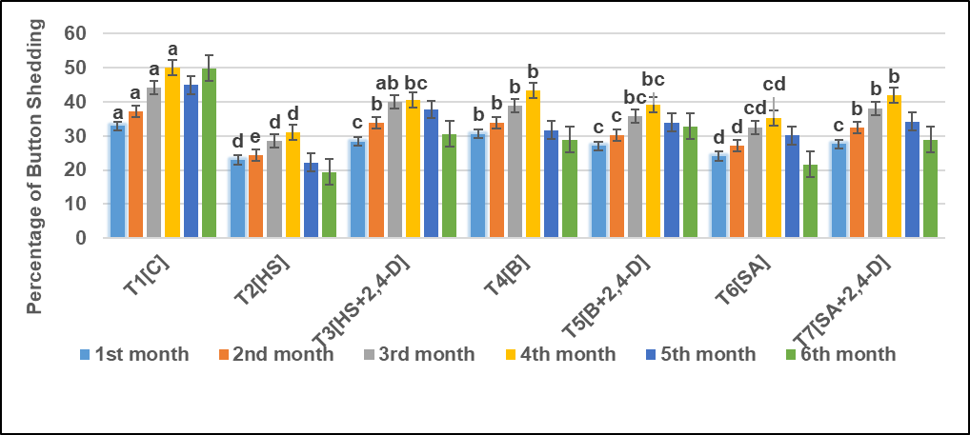
Fig.1. Effect of root feeding treatments on button shedding percentage of coconut
Ngullie et al. (2014) reported that salicylic acid might interfere with the ethylene hormone production, thereby inhibiting the abscission process. In the present study, salicylic acid (200 ppm) was also found to show the lowest button shedding percentage which is similar with the findings of Subhaktian et al. (2025), where the combination of SA at 2 mM and NAA at 0.5 ml L⁻¹, effectively reduced button shedding without adversely affecting fruit development.The root feeding of Salicylic acid may hinder the ethylene biosynthesis, thereby reducing the button shedding. The effect of root feeding with different nutrients and growth regulators shows a quick response in coconut health. For instance, TNAU coconut tonic was recommended once in six months to ensure the restoration of plant nutrients. Thus, it indicates the root feeding of TNAU coconut tonic shows a visible improvement in plant health within six months (Alagarswamy et al., 2024).

3.2 Effect on physiological parameters
T2 [HS] exhibited the highest photosynthetic rate (10.9, 11.1, 12.4,12, 12.4, 13.3 µmol CO₂ m⁻²sec⁻¹) (Fig. 2) and transpiration rate (3.63, 3.7, 4.13, 4, 4.13, 4.43 mmol H₂O m⁻² sec⁻¹) (Figure 3) respectively for the first six months. T1 [C] palms showed the lowest transpiration and photosynthetic rate compared to all the treatments during the entire six months of the study. Under many environmental conditions, increases in irradiance or stomatal opening elevate both photosynthetic and transpiration rates, confirming their coordinated response (Mao et al., 2023). The rate of apparent photosynthesis (A) in coconut palms varies between 2-15 µmol CO₂ m⁻²sec⁻¹ which changes according to leaf age, nutritional status, and climatic factors (Jayasekera et al., 1996). In our study, the photosynthetic rate ranges between 1-14 µmol CO₂ m⁻²sec⁻¹ that may be due to climatic conditions and nutritional status of the leaf after root feeding of the treatments. The transpiration rate was highest in treatment T2 [HS] palms compared to other treatments for the first four months and decreased during the 5th and 6th months (Fig.3). Nath et al. (2012) showed that graded nitrogen application up to 500 g per palm increased nut yield and copra content in coconut. Higher levels of phosphorus (500 g) and potassium (2000 g) also enhanced yield. The yield improvement under high potassium was attributed to greater K uptake in leaves, which enhanced photosynthetic efficiency and promoted better carbohydrate synthesis and translocation. Similarly, in our study, the increased nitrogen, potassium content in T2 treated palms increased the photosynthetic efficiency of the palms.
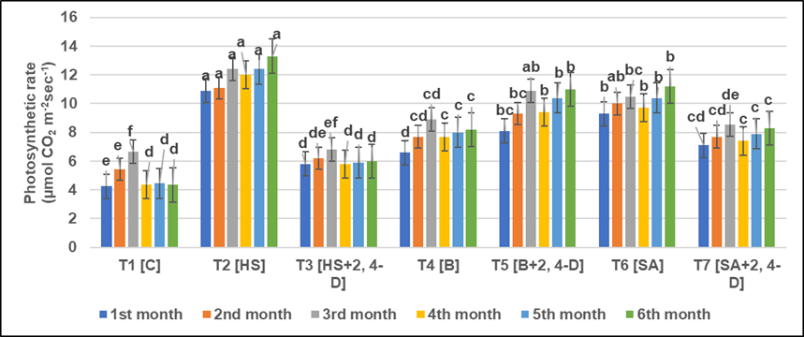

Fig. 2. Effect of root feeding treatments on the photosynthetic rate (µmol CO₂ m⁻²sec⁻¹) of coconut

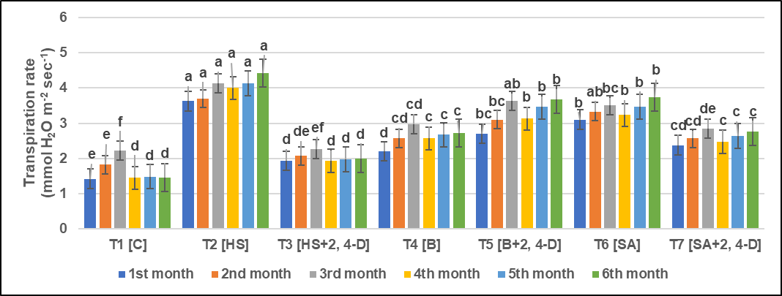

Fig. 3. Effect of root feeding treatments on transpiration rate (mmol H₂O m⁻² sec⁻¹) of coconut
3.3 Effect on biochemical parameters
The biochemical parameter such as carbohydrate content was found maximum in the T2 [HS] treated palms (21.84, 43.50, 79.65, 77.42, 84.33, 96.66 mg g⁻¹) respectively during the first six months except 2nd month (Table 1). T1 [C] revealed the lowest carbohydrate content (9.53, 27.21, 41.33, 29.33, 32.66, 30.33 mg g⁻¹) respectively for the first six months. The increased carbohydrate content in T2 treated palms might be due to the presence of major and minor mineral elements which enhanced the photosynthetic process that leads to increased production of carbohydrate content (Larcher, 2003). Salicylic acid (200 ppm) also increased the carbohydrate content in the coconut leaf as reported by Kassem et al. (2012); El-Shazly et al. (2013) where salicylic acid may enhance photosynthetic process which indirectly results in increased carbohydrate content.

Table 1. Total Carbohydrate content (mg g⁻¹ fresh weight)
Treatments | Months after root feeding
Treatments | 1st month | 2nd month | 3rd month | 4th month | 5th month | 6th month
T1[C] | (9.53)^{d} | 27.21 | (41.33)^{e} | (29.33)^{e} | (32.66)^{e} | (30.33)^{d}
T2 [HS] | (21.84)ª | 43.50 | (79.65)ª | (77.42)ª | (84.33)ª | (96.66)ª
T3 [HS+2, 4-D] | (14.01)^{c} | 32.98 | (44.91)^{de} | (36.33)^{de} | (40.66)^{de} | (48)^{c}
T4 [B] | (11.73)^{cd} | 29.64 | (47.47)^{de} | (40)^{cd} | (45.66)^{cd} | (52.66)^{c}
T5 [B+2, 4-D] | (15.18)^{bc} | 41.56 | (62.03)^{bc} | (52.33)^{b} | (58.33)^{b} | (66.66)^{b}
T6 [SA] | (18.37)^{ab} | 42.50 | (74.96)^{ab} | (70.74)ª | (78.33)ª | (88)ª
T7 [SA + 2,4- D] | (12.58)^{cd} | 33.42 | (57.62)^{cd} | (47.44)^{bc} | (55.33)^{bc} | (63.33)^{b}
SE(M) | 1.26 | 3.92 | 4.30 | 2.513 | 3.205 | 3.279
C.D (0.05) | 3.95 | NS* | 13.42 | 7.830 | 9.984 | 10.214
*NS – Non - significant
Selvamani and Duraisami (2018) reported that the nitrogen content is important and necessary for the growth and metabolism of the palms. It enhances the nut production per year by increasing the setting of buttons. In the present study, T2 [HS] recorded the maximum nitrogen content (2.07, 2.26, 2.5, 2.37, 2.41, and 2.54 % respectively) during the observation of six months period which enhanced the nut production. T1 [C] recorded the lowest nitrogen content (1.61, 1.61, 1.63, 1.56, 1.58 and 1.52% respectively) during the observation of first six months period (Fig. 4A). T7 [SA+2, 4-D] recorded the maximum phosphorus content (0.13, 0.14, 0.18, 0.08, 0.15, and 0.22 % respectively) during the observation of six months period. T1[C] revealed the lowest phosphorus content (0.01, 0.03, 0.05, 0.03, 0.04 and 0.05% respectively) during the observation of six months (Fig. 4B). Nitrogen and Potassium are the most important for the coconut yield. Potassium plays a significant role in the production of nuts, inflorescences, fruit setting and the number of female flowers (Ollivier, 1993). T2 [HS] and T1 [C] recorded the maximum (1.27, 1.46, 1.7, 1.65, 1.87 and 2.14% respectively) potassium content and minimum potassium content (0.08, 0.27, 0.4, 0.26, 0.32 and 0.3 % respectively) during the observation of six months (Fig. 4C). The macronutrients such as N, K were found higher in T2 treated palms for the first six months where they play a major role in the reduction of button shedding.
During the six months, T2 [HS] recorded the highest calcium content (0.57, 0.88, 1.05, 0.88, 1.08 and 1.16% respectively). T1 [C] recorded the lowest calcium content (0.39, 0.5, 0.54, 0.5, 0.52 and 0.6 % respectively) (Fig. 4D). T2 [HS] recorded the highest magnesium content (1.56, 1.74, 1.95, 1.6, 1.78, and 1.89 % respectively) during the observation of six months. T1 [C] recorded the lowest magnesium content (0.13, 0.36, 0.45, 0.39, 0.49, and 0.45% respectively) (Fig. 4E). The treatment T2 recorded the highest Mg content that might have influenced the button retention which is supported by the findings of Singh et al. (1982) and Ca, S (Fig.4F) were found higher during the first six months. T2 [HS] and T1[C] recorded the highest sulphur content (0.57, 0.75, 1.06, 0.86, 1.01 and 1.19% respectively) and lowest sulphur content (0.3, 0.35, 0.43, 0.33, 0.41 and 0.5 %) respectively during the six months period.

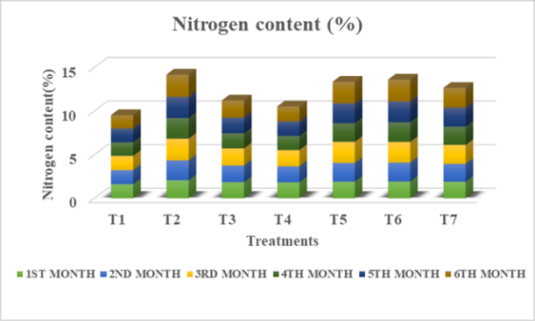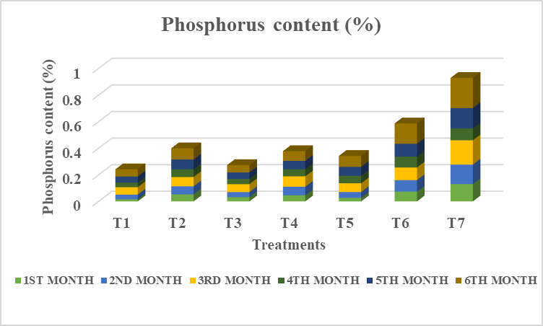

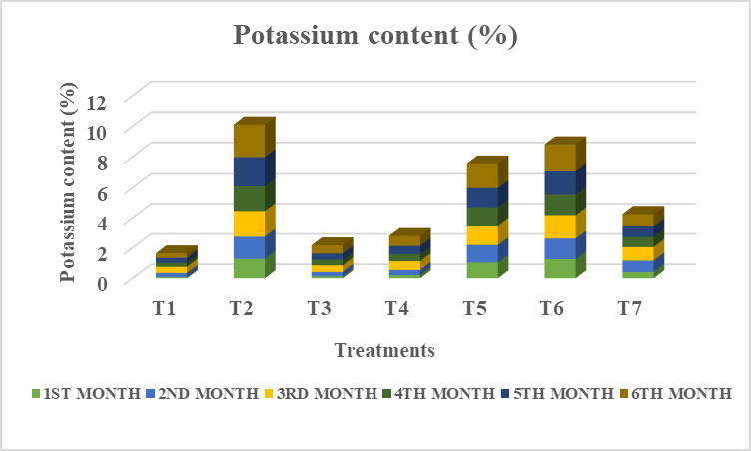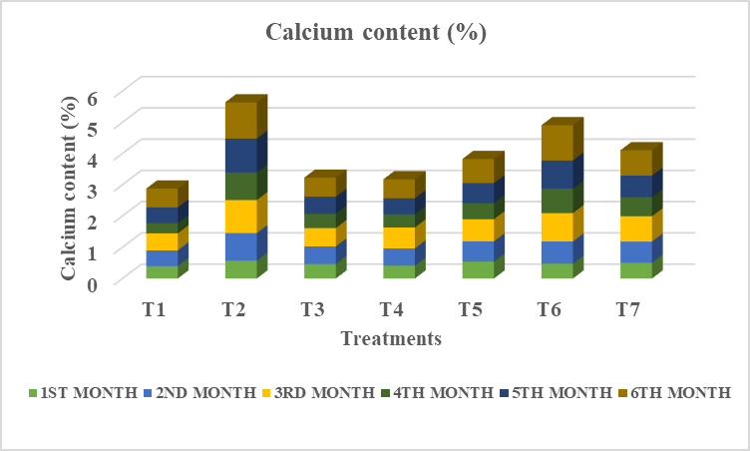

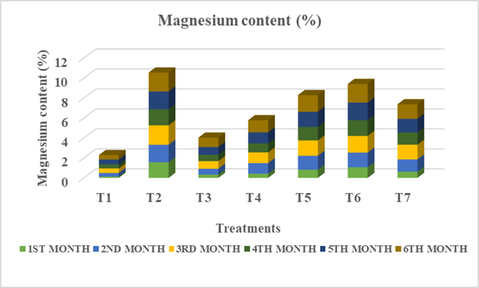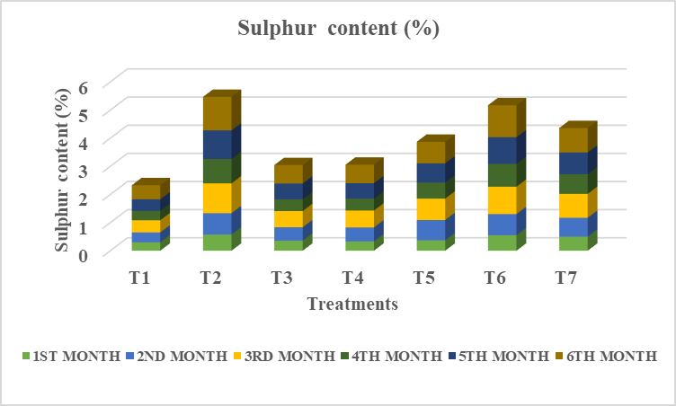
Figure 4. Macronutrient content in the leaves after root feeding – Nitrogen (4A), Phosphorus(4B), Potassium (4C),Calcium (4D), Magnesium (4E), Sulphur (4F)
For better plant growth, the adequate quantity of micronutrients leads to higher yield because of the increase in growth, better flowering and higher fruit set (Ram and Bose, 2000). Micronutrients such as Fe, B, Mn were also higher in the T2 treated palms for first six months which in involved in reduced button shedding. T2[HS] revealed the highest iron content (158.5, 175.45, 240, 234, 258.33 and 275.66 ppm respectively) (Fig.5A) and T1[C] revealed the lowest iron content (80.68, 98.41, 121.83, 101.66, 123 and 132 ppm respectively) during the observation of six months. T5 [B+2, 4-D] recorded the highest Zinc content (42.33, 43.9, 55.34, 46.43, 53.32 and 62.06 ppm respectively) (Fig.5B). T1 [C] recorded the lowest Zinc content (21, 22.41, 23.85, 20.9, 22.44 and 24.41 ppm respectively) during the observation of six months. T2 [HS] showed highest copper content (54, 67.66, 61.66, 71 and 81.33 ppm respectively) (Fig.5C) during the observation of six months except 1st month. T1 [C] showed lowest copper content (29, 41, 36.66, 42.33 and 48.33 ppm respectively). T2 [HS] showed highest boron content (15.06, 19.16, 26.93, 20.33, 25.33 and 31.33 ppm respectively) during the six months period (Fig.5D). T1 [C] showed lowest boron content (3, 4.13, 7.76, 7.23, 7.83 and 7.2 ppm respectively) during the observation of six months. T2 [HS] recorded the highest manganese content (169.55, 179.66, 188.66, 181.92, 186.66 and 195.33 ppm respectively) (Fig.5E). T1 [C] recorded the lowest manganese content (150.44, 163.53, 174.62, 168.81, 171.66 and 168.66 ppm respectively) during the observation of six months.

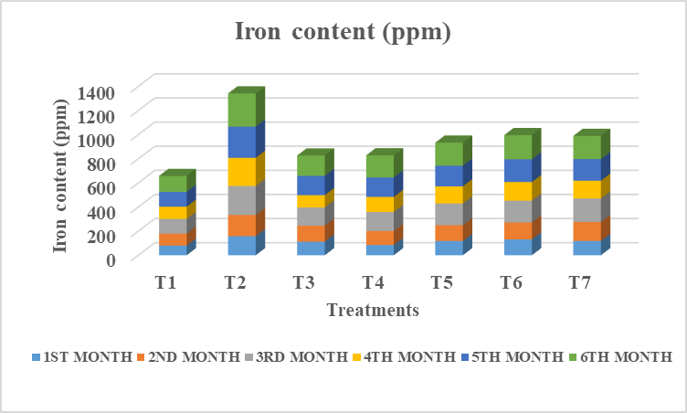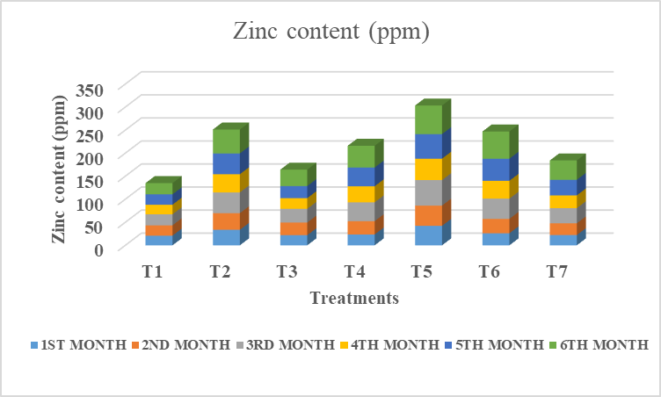

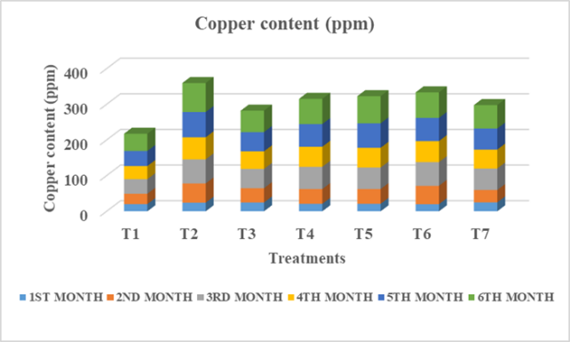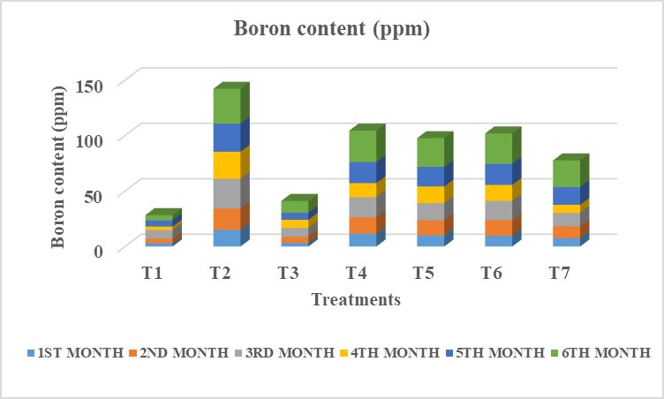

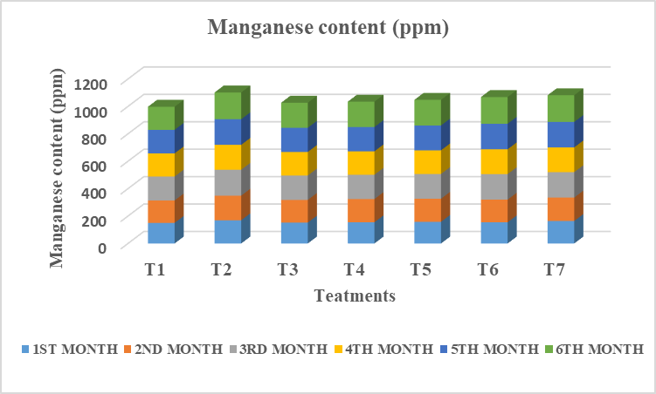
Figure 5. Micronutrient content in the leaves after root feeding – Iron (5A), Zinc (5B),
Copper(5C), Boron (5D), Manganese (5E)

3.4. Correlation analysis
Correlation analysis revealed the association between physiological and biochemical variables and button retention under treatments T2, T5, and T6 during the first four months after treatment. The button shedding percentage (BSP) showed a strong positive correlation with leaf Zn content (r = 0.71), Cu content (r = 0.60), and total carbohydrate content (TC) (r = 0.60), indicating that higher accumulation of these constituents was strongly associated with reduced button shedding and improved button retention. A moderate positive correlation was observed with Mn (r = 0.42) and N content (r = 0.40), suggesting a meaningful contribution of these nutrients to button retention, though to a lesser extent than Zn, Cu, and carbohydrates. Other variables such as K (r = 0.31), S (r = 0.22), Mg (r = 0.10), Fe (r = 0.09), B (r = 0.08), P (r = 0.08), Ca (r = 0.05), photosynthetic rate (r = 0.05), and transpiration rate (r = 0.02) exhibited weak positive correlations, indicating only a minor supportive role in reducing BSP. Overall, the correlation pattern suggests that micronutrients, particularly Zn and Cu, along with enhanced carbohydrate status, are the primary factors associated with improved button retention in coconut palms under the studied treatments.

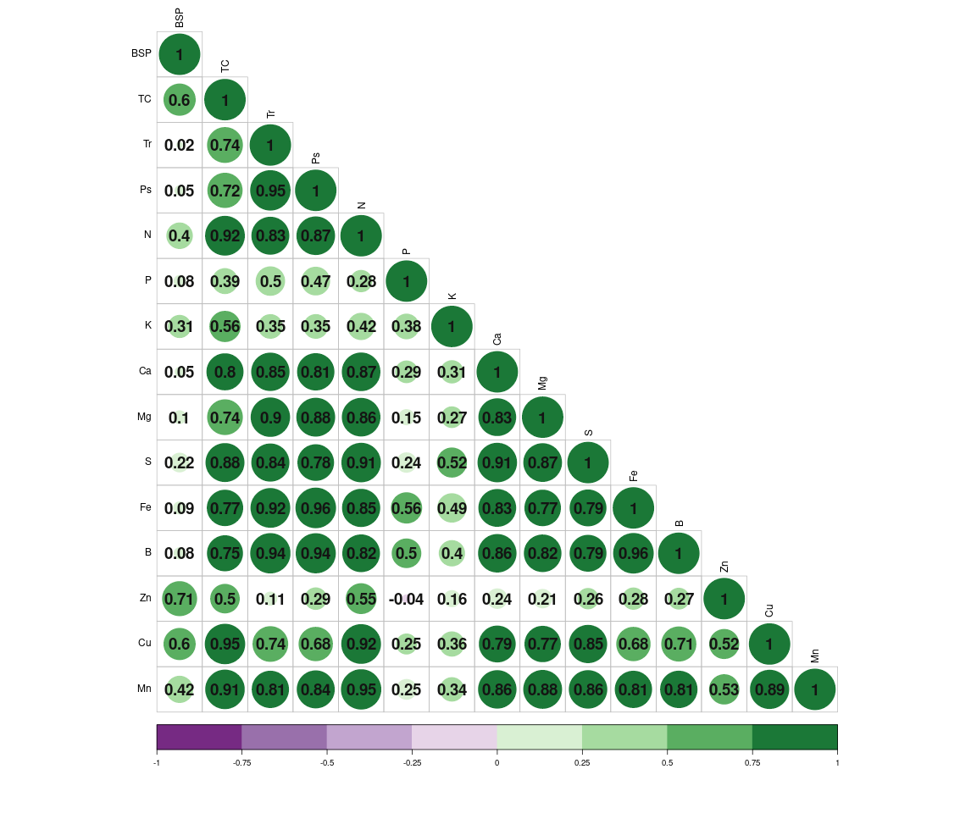
Fig. 6. Correlation analysis between button shedding percentage, physiological parameters and biochemical parameters in T2, T5 and T6 treated palms [BSP – Button Shedding Percentage; TC- Total Carbohydrate content; Tr- Transpiration rate; Ps- Photosynthetic rate]
3.5 Principal Component Analysis
Correlation analysis reveals direct relationships, whereas PCA aids in understanding the underlying structure and variance within the data. Among the 11 dimensions, Dim.1, Dim.2 & Dim.3 were taken into account as they consist of eigen value >1. The dimension 1 accounted for a maximum variability of 70.8 % with the highest Eigenvalue of 9.915 followed by dimension 2 of about 10.2 % & dimension 3 with 7.7 % (Table 2). The scree plot depicts the percentage of explained variance by the dimensions (Fig.7A). Dim.1, Dim.2 & Dim.3 accounted for 88.7 % of the cumulative variance. In Dimension 1, all the parameters are positively associated with each other. The variation was highly contributed by N (9.39 %), Mn (8.93%), Tr (8.7 %), Fe (8.65%), B (8.65 %) and S (8.6%). The treatments (T2.2, T6.3) are closely associated with the variables that facilitated in the reduction of button shedding (Fig.7B &Table3).
Table 2: Eigenvalues of Dimensions
Dimension | Eigenvalue | Percentage of variance | Cumulative percentage of variance
Dim.1 | 9.915 | 70.818 | 70.818
Dim.2 | 1.433 | 10.233 | 81.051
Dim.3 | 1.079 | 7.705 | 88.756
Dim.4 | 0.726 | 5.186 | 93.942
Dim.5 | 0.407 | 2.906 | 96.848
Dim.6 | 0.197 | 1.404 | 98.251
Dim.7 | 0.092 | 0.659 | 98.91
Dim.8 | 0.076 | 0.543 | 99.454
Dim.9 | 0.047 | 0.337 | 99.79
Dim.10 | 0.023 | 0.162 | 99.953
Dim.11 | 0.007 | 0.047 | 100
B
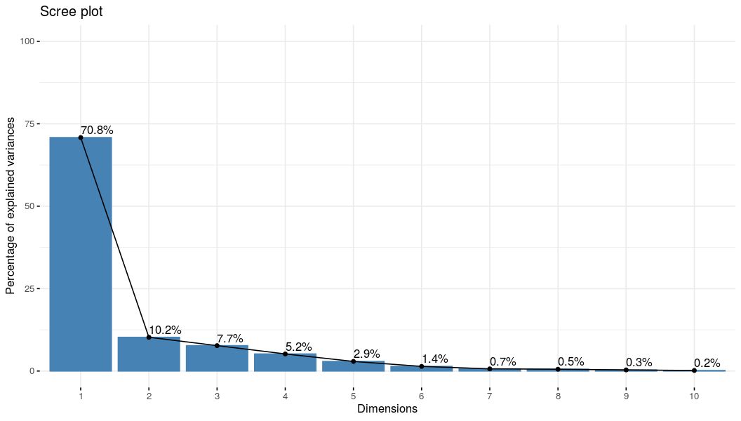
Fig.7A Scree plot explaining the percent of variation contributed by each dimension

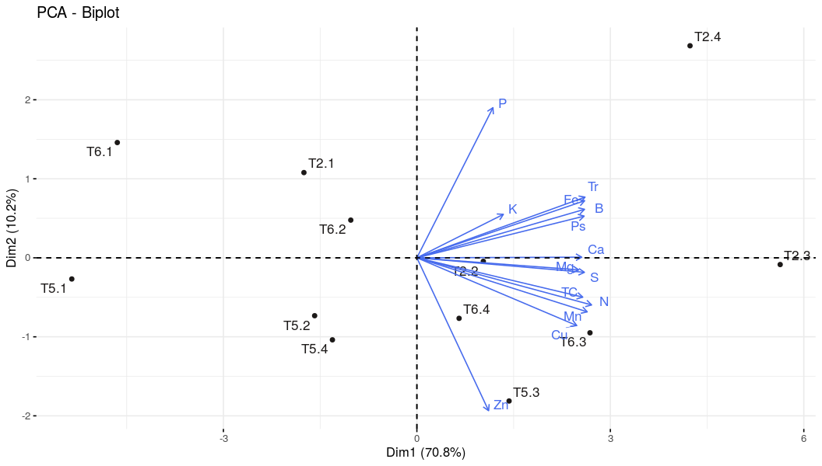
Fig.7B A biplot graph illustrating the contribution of variables for T2, T5, and T6 during the first four months following root feeding.
T2.1, T2.2, T2.3, T2.4 – Variables recorded during the 1st, 2nd, 3rd and 4th month repsectively after the root feeding of T2 [HS]; T5.1, T5.2, T5.3, T5.4 – Variables recorded during the 1st, 2nd, 3rd and 4th month repsectively after the root feeding of T5 [Borax+2,4-D]; T6.1, T6.2, T6.3, T6.4 – Variables recorded during the 1st, 2nd, 3rd and 4th month respectively after the root feeding of T6 [SA]
Table 3: Percentage contribution of variables on dimension
Variables | Dim.1 | Dim.2 | Dim.3 | Dim.4
TC | 8.85 | 2.68 | 2.08 | 2
Tr | 8.40 | 8.02 | 1.49 | 0.07
Ps | 6.91 | 14.12 | 3.69 | 2.56
N | 9.43 | 3.93 | 0.02 | 0.03
P | 1.70 | 10.31 | 39.82 | 21.29
K | 2.63 | 1.28 | 28.10 | 51.22
Ca | 8.77 | 0.08 | 3.02 | 1.17
Mg | 8.29 | 0.01 | 10.17 | 0.08
S | 9.29 | 0.004 | 1.43 | 5.77
Fe | 8.65 | 1.16 | 2.67 | 5.08
B | 8.60 | 0.79 | 0.37 | 9.022
Zn | 1.20 | 47.94 | 6.22 | 0.94
Cu | 8.15 | 5.63 | 0.07 | 0.17
Mn | 9.06 | 3.99 | 0.77 | 0.52

CONCLUSION
Root feeding with nutrients and growth regulators proved to be an effective approach for enhancing vegetative vigour, strengthening plant health, improving fruit set, and increasing overall productivity in coconut palms. The findings revealed that root feeding with double-strength Hoagland solution (2X) significantly reduced button shedding by 43–60% during the first four months of observation. This reduction in button shedding under treatment T2 was associated with increased leaf nutrient status and carbohydrate accumulation following root feeding. Further large-scale validation is recommended to assess the economic viability and environmental sustainability of this practice for improving coconut production.
ACKNOWLEDGMENTS
The authors are grateful to the Kerala Agricultural University and Indian Council of Agricultural Research for providing National Talent Scholarship for conducting the PG research work and also thankful to Coconut Research Station, Balaramapuram for providing facilities.
COMPETING INTERESTS: The authors report there are no competing interests to declare.
AUTHORS’ CONTRIBUTIONS: D Shanmugapriya – This work is part of my M.Sc. Research work; Roy Stephen – Complete guidance and support on my entire research work; M.M. Viji – provided facilities and support in the department, corrected the manuscript; K. Prathapan - provided facilities and guidance in CRS, Balaramapuram; K.N.Anith – guidance and provided facilities for the research; R.V. Manju- guidance during the research work; R. Beena – guidance during the research work; M. Siva – assisted in graphical and statistical analysis.

FUNDING: All Author Acknowledge Kerala Agricultural University and Indian Council of Agricultural Research for the funding of the study
Disclaimer (Artificial intelligence)
Author(s) hereby declare that NO generative AI technologies such as Large Language Models (ChatGPT, COPILOT, etc.) and text-to-image generators have been used during the writing or editing of this manuscript.
REFERENCES
Abeywardena, V., and Mathes, T.D. (1971). Crop losses through button shedding and immature nutfall. Ceylon Coconut Planters’ Review, 6, 97–106.
Alagarswamy, S., Karuppasami, K.M., Djanaguiraman, M., Venugopal, P.B., Natarajan, S., Rathinavelu, S., Dhashnamurthi, V., Veerasamy, R., & Parasuraman, B. (2024). Sustaining the yield of maize, blackgram, greengram, groundnut, cotton, sugarcane, and coconut through the application of nutrients and plant growth regulator mixture. Plants, 13, 1549.
Allan, J.E. (1959). The determination of iron and manganese by atomic absorption. Spectrochimica Acta, 15, 800–806.
Bons, H.K., & Kaur, M. (2019). Role of plant growth regulators in improving fruit set, quality and yield of fruit crops: A review. Journal of Horticultural Science and Biotechnology, 1–10.
Charles, A., Joseph, M., Ramani, V.A., Joseph, S., & Nadu, T. (2011). Quantitative estimation of primary and secondary metabolites on flowers of Caryota urens L. International Journal of Applied Biology and Pharmaceutical Technology, 3, 431–435.
Coconut Development Board (CDB). (2024). All India final estimates of area and production of coconut. Retrieved February 13, 2024, from http://coconutboard.nic.in/Statistics.aspx
Elango, D., Kanatti, A., Wang, W., Devi, A.R., Ramachandran, M., & Jabeen, A. (2021). Analytical methods for iron and zinc quantification in plant samples. Communications in Soil Science and Plant Analysis, 52, 1069–1075.
El-Shazly, S.M., Moatamed, A.M.H.E., & Kotb, H.R.M. (2013). Effect of some agrochemicals preharvest foliar application on yield and fruit quality of ‘Swelling’ peach trees. Alexandria Journal of Agricultural Research, 58, 219–229.
FAOSTAT. (2023). FAO corporate statistical database. Retrieved August 4, 2023, from www.fao.org
Gallaher, R.N., Weldon, C.O., & Boswell, F.C. (1976). A semiautomated procedure for total nitrogen in plant and soil samples. Soil Science Society of America Journal, 40, 887–889.
Gopinath, P.P., Parsad, R., Joseph, B., & Adarsh, V.S. (2021). GRAPES: General R Shiny based analysis platform empowered by software. Journal of Open Source Software, 6, 3437.
Hansch, R., & Mendel, R.R. (2009). Physiological functions of mineral micronutrients (Cu, Zn, Mn, Fe, Ni, Mo, B, Cl). Current Opinion in Plant Biology, 12, 259–266.
Hebbar, K.B., Balasimha, D., & Thomas, G.V. (2013). Plantation crops response to climate change: Coconut perspective. In H.P. Singh, J.P. Singh, & S.S. Lal (Eds.), Climate-resilient horticulture: Adaptation and mitigation strategies (pp. 177–187). New Delhi: Springer.
Hebbar, K.B., Neethu, P., Sukumar, P.A., Sujithra, M., Santosh, A., Ramesh, S.V., Niral, V., Hareesh, G.S., Nameer, P.O., & Prasad, P.V.V. (2020). Understanding physiology and impacts of high temperature stress on the progamic phase of coconut (Cocos nucifera L.). Plants, 9, 1651.
Jayasekera, C., Nainayake, N.P.A.D., & Jayasekera, K.S. (1996). Photosynthetic characteristics and productivity of the coconut palm. COCOS, 11, 7–20.
Kassem, H.A., Al-Obeed, R.S., & Ahmed, M.A. (2012). Effect of bio-regulators preharvest application on date palm fruit productivity, ripening and quality. African Journal of Agricultural Research, 7, 6565–6572.
Khandare, R.V., Watharkar, A.D., Pawar, P.K., Jagtap, A.A., & Desai, N.S. (2021). Hydrophytic plants Canna indica, Epipremnum aureum, Cyperus alternifolius and Cyperus rotundus for phytoremediation of fluoride from water. Environmental Technology and Innovation, 21, 1–29.
Kumar, S.N., & Aggarwal, P.K. (2013). Climate change and coconut plantations in India: Impacts and potential adaptation gains. Agricultural Systems, 117, 45–54.
Larcher, W. (2003). Physiological plant ecology. Berlin: Springer.
Maathuis, F.J. (2009). Physiological functions of mineral macronutrients. Current Opinion in Plant Biology, 12, 250–258.
Malarvannan, S. (2012). Button shedding in coconut.
Mao, J., Luo, Y., Jin, C., Xu, M., Li, X., & Tian, Y. (2023). Response of leaf photosynthesis–transpiration coupling to biotic and abiotic factors in the typical desert shrub Artemisia ordosica. Sustainability, 15(13), 10216.
Maruthi, I., & Peter, P. (2019). A comprehensive study on the issue of coconut production in Karnataka. Retrieved July 12, 2020, from http://www.isec.ac.in/Final%20report%20coconut.pdf
Ngullie, C.R., Tank, R.V., & Bhanderi, D.R. (2014). Effect of salicylic acid and humic acid on flowering, fruiting, yield and quality of mango (Mangifera indica L.) cv. Kesar. Advances in Research on Crop Improvement, 5, 136–139.
Nishanth, D., & Biswas, D.R. (2008). Kinetics of phosphorus and potassium release from rock phosphate and waste mica enriched compost and their effect on yield and nutrient uptake by wheat (Triticum aestivum). Bioresource Technology, 99, 3342–3353.
Ollivier, J. (1993). Potassium deficiency symptoms in coconut. Oleagineux, 48, 483–486.
Peiris, T.S.G., Thattil, R.O., & Mahindapala, R. (1995). An analysis of the effect of climate and weather on coconut (Cocos nucifera). Experimental Agriculture, 31, 451–460.
Ram, R.A., & Bose, T.K. (2000). Effect of foliar application of magnesium and micronutrients on growth, yield and fruit quality of mandarin orange (Citrus reticulata Blanco). Indian Journal of Horticulture, 57, 215–220.
Ranasinghe, C.S., Silva, L.R.S., & Premasiri, R.D.N. (2022). Major determinants of fruit set and yield fluctuation in coconut (Cocos nucifera L.). Journal of Manuscript Studies, 12, 15–27.
Rajapakse, C.N.K., Wijesekara, H.T.R., & Norman, A.H. (1995). A preliminary study on immature nutfall of coconut with reference to pest damage. COCOS, 10, 53–54.
R Core Team. (2023). R: A language and environment for statistical computing. Vienna: R Foundation for Statistical Computing. Retrieved from https://www.R-project.org/
Selvamani, V., & Duraisami, V.P. (2018). Evaluating the primary yield limiting leaf nutrient deficiency of coconut (Cocos nucifera Linn.) in a major coconut growing zone of Tamil Nadu. Journal of Plantation Crops, 46, 112–117.
Sheoran, O.P., Tonk, D.S., Kaushik, L.S., Hasija, R.C., & Pannu, R.S. (1998). Statistical software package for agricultural research workers. In D.S. Hooda & R.C. Hasija (Eds.), Recent advances in information theory, statistics and computer applications. Hisar: CCS HAU.
Singh, S.P., Singh, B.P., & Moti, R. (1982). Effect of magnesium and season on growth, flowering, fruiting and yield of guava (Psidium guajava L.) cv. Allahabad Safeda. Haryana Journal of Horticultural Sciences, 11, 188–191.
Subhaktian, D., Evizal, R., Novpriansyah, H., & Karyanto, A. (2025). The Effect of Salicylic Acid and Naphthalene Acetic Acid on Reducing Button Shedding in Dwarf Coconut (Cocos nucifera L.). In IOP Conference Series: Earth and Environmental Science (Vol. 1572, No. 1, p. 012027). IOP Publishing.
Sudhalakshmi, C. (2021). Identifying soil fertility constraints and evolving management strategies for pencil point disorder in coconut. Journal of Crop and Weed, 17, 70–75.
Tabatabai, M.A., & Bremner, J.M. (1970). A simple turbidimetric method of determining total sulfur in plant materials. Agronomy Journal, 62, 805–806.
Thamban, C., Jayasekhar, S., Chandran, K.P., & Jagnathan, D. (2016). Coconut production in Kerala: Trends, challenges and opportunities. Indian Coconut Journal, 49, 10–15.

Nath, J.C., Arulraj, S. and Maheswarappa, H.P. 2012. Integrated nutrient management in COD x WCT hybrid coconut under alluvial clay-loam soil of Assam. J. Plant. Crops 40(2): 105-110.

