Original Research Article
Constraints Faced by Farmers in the Adoption of ICT in Kota District of Rajasthan

ABSTRACT
Information and Communication technology (ICT) has emerged as a key catalyst for the growth and modernization of agriculture through making it more practical, engaging and effective. ICT-based extension system plays an important role in redefining agricultural practices and improving farmers lives by enhancing access to timely information and promoting the exchange of knowledge.
Objective: “To determine the constraints faced by the farmers towards ICT”
Methodology: The present study was conducted during the academic year 2021-2022 in Kota district of Rajasthan. Multistage sampling technique was used in the present study. In first stage, Kota district was selected purposively for the study. Out of total five blocks in Kota district, Ladpura block was chosen, followed by six villages from ladpura block were randomly selected for the study based on their good ICT connectivity and well- established linkages to government and non-government institutions. Lastly, a proportionate random sample of ICT-using cultivator farmers was selected from each village, with a total sample of 399 farmers. Statistical tools such as frequency, percentage, arithmetic mean, standard deviation and correlation are used.
Key findings: The findings of the present study revealed that majority of farmers identified as insufficient regional specific information as most important constraint with a mean score of 4.73 followed by difficulty in understanding the language of ICT gadgets ranked second with a mean score of 4.61, insufficient servicing centres of ICTs in villages ranked third with a mean score of 4.39, high cost of servicing charges of ICT gadget ranked fourth with a mean score of 4.31, inadequate facilitator’s knowledge and insufficient training and practical exposure towards ICTs ranked fifth with a mean score of 4.06 and so on.
Conclusion: The findings of the present study will be highly valuable for researchers, academicians and policy makers with suitable modifications may also be applied beyond the specific field of study.
KEYWORDS: Digital literacy, Information and Communication Technology (ICT), Constraints, Access to information, Digital divide, Barriers, Adoption.
INTRODUCTION
Information and Communication technology (ICT) in agriculture, often referred to as e-agriculture, is an important area of agricultural technology aimed at improving how information is processed, shared and used. More specifically, e-agriculture focuses on using digital tools and communication technologies to support farmers and rural communities. Information and Communication Technology (ICT) has significant potential to bridge knowledge gaps by providing access to essential agricultural information such as weather forecasts, market prices, pest management practices and improved farming techniques (Choruma, 2024; Domguia, 2025). It involves the planning, design, development, evaluation and practical application of innovative Information and communication technology solutions to address real world challenges in agriculture, with the ultimate objective of making farming practices more informed, efficient and sustainable.

Across the globe, many ICT- based or e-agriculture initiatives have been developed and tested to support farmers in improving their livelihoods. These interventions may also help agriculturists to boost their farm productivity and income, while reducing the risks related to weather, markets and production. Information and communication technology (ICT) includes a wide range of tools, networks and services used to share and manage information. This includes modern internet-based technologies, mobile phones, applications and sensors as well as more traditional tools such as telephones, televisions, radios and satellites are continued to play an important role in information delivery.
Global systems are changing rapidly, and modern information and communication technologies are playing an important role in this transformation. ICT in agriculture is a growing field which aims to strengthen agricultural and rural development by bringing advance digital tools in rural areas. Through the use of ICT, farmers can easily gain access to reliable, timely and relevant information and services making help them to make better decisions and improve the profitability of their farming activities. However, the availability and effectiveness of ICT vary widely across different regions due to differences in information access, communication infrastructure and the level of involvement from individuals as well as public or private organizations. Therefore, the outcomes of ICT initiatives are different across contexts. (Mahant et al., 2012).
Information and communication technology (ICT) plays a vital role in the growth and development of human society. It encompasses a wide range of technologies, including computer programs, databases, communication networks, system design and analysis tools, programming languages, artificial intelligence (AI), and knowledge bases. ICT enables the electronic storage, retrieval, modification and dissemination of information. ICT has also changed traditional systems like libraries, making information easier to access and manage. At present, ICT includes both hardware and software which enables the electronic collection, analysis, display and transmission of information. (Singh, 2021).
Information and Communication Technology (ICT) and agriculture together focuses on various technologies to address the challenges in the agriculture sector, with a particular emphasis on issues faced by resource-poor persons and marginalized rural population. Traditionally, agricultural extension systems have adopted a ‘lab-to-land’ approach, where the scientific knowledge produced by the researchers are transmitted to farmers through extension agencies. (Swaminathan et al., 2018).
In many developing countries, including India, extension services play an important role in helping farmers to address the key challenges such as efficient resource management, better access to markets and adaptation to climate change. ICT also plays an important role in information dissemination systems which are mentioned below (Singh, 2017).
Kisan Call Centers (KCCs): Kisan Call Centers is an initiative of Ministry of agriculture launched on January 21, 2004. KCCs allows farmers to get answers to their agricultural queries over the phone, in their own local language or dialect. KCCs operates in 22 languages through a single nationwide toll-free number for KCCs is 1800 180 1551.
e-Sagu: e-Sagu is a personalized online agricultural advisory system designed to support farmers with expert guidance. Rather than conducting field visits agricultural scientists review crop condition data such as digital images and related information and offer personalized advice to each farm on a regular basis, usually every one to two weeks.
m-Kisan: m-Kisan or mobile Kisan enable farmers to receive agricultural advisories directly on their mobile phones through SMS. Agricultural experts can register on the m-Kisan portal and send timely recommendations to the farmers.
Digital Green: Digital Green is an international organization which works with rural communities to improve their livelihoods through the use of digital platforms. It works in partnership with progressive farmers and professionals to make simple, engaging and easy to understand videos for farmers. These videos are shown to farmers either individually or in groups to enhance learning. The content is systematically designed to meet the needs, interests and overall well-being of rural communities.
Information and Communication Technology (ICT) plays a vital role in modern society by driving innovation, improving efficiency and strengthening global connectivity. ICT plays a crucial role across key sectors such as education, healthcare, business and governance as it facilitates real-time communication, efficient operations, and easy access to wide range of information. ICT supports innovations like remote learning, e-commerce, telemedicine and digital inclusion, thereby making a strong contribution to economic and social development. However, the use of ICT also brings several challenges such as unequal access to technology, often referred to as the digital divide and limits the opportunities for disadvantaged communities. Additionally, cyber security risks, data privacy issues and fast technological changes creates serious concerns. Addressing these challenges requires inclusive access to technology, robust security measures and sustainable practices to ensure that the benefits of ICT are fully realized while its negative impacts are minimized. (Nehra et al., 2018; Sharma et al., 2019; Sharma et al., 2017). Major challenges such as limited digital infrastructure, low levels of digital literacy, language and educational limitations and economic hardships significantly hinder farmers ability to effectively utilize agricultural information systems (Nxumalo, 2025; Smidt & Jokonyo, 2022; Oki & Abyengi, 2024).
Limitations of the study:
- The study is limited to selected farmers of Kota district, which may restrict the generalization of findings.
- The findings were based on farmers self-reported responses, which may be influenced by recall bias and personal perceptions.
- The study has considered only selected ICT tools available during the study period, so new or emerging technologies may not be included.
- Limited time and resources may restrict the sample size and coverage area.

MATERIALS AND METHODS
The study was conducted in Kota district of Rajasthan, India, during the academic year 2021-2022 to examine how the farmers utilize different ICT tools for accessing the agricultural information. A multistage sampling technique was adopted for the present study. In the first stage, Kota district was selected purposively because of the successful adoption of agricultural development programs and relatively higher adoption of ICT-based extension services. In the second stage, Ladpura block was chosen purposively out of five blocks of the district – Itawa, Sangod, Ladpura, Digod, and khairabad owning to its diverse farming practices, better digital infrastructure, and strong linkages with agricultural research and extension agencies. In the third stage, six villages from Ladpura block, namely Rasulpur, Bhimpura, Aarampura, Bhojpura, Jakhora, and Mawasa were selected randomly. Farmers from these villages make regular use of different ICT-based platforms for agricultural information, benefits from good digital connectivity and maintain linkages with both government and non-government institutions. In the final stage, farmers who were actively using ICT tools were selected for the study as they showed greater interest in seeking farm information and adopting advanced farming technologies. A proportionate number of farmers 78 from Rasulpur, 137 from Bhimpura, 62 from Aarampura, 22 from Bhojpura, 44 from Jakhora and 56 from Mawasa were randomly selected. Thus, a total sample of 399 farmers was obtained. A proportionate random sampling was applied using the formula suggested by Taro Yamane (1967).

𝐍
𝐧 = 𝟏 + 𝐍(𝐞)^{𝟐}

Where;
n = sample size
N = population size
e = margin of error (5 % or .05) at 95 % confidence level
The data were collected through personal interviews using a pre-tested structured interview schedule and appropriate statistical tools were used wherever required such as frequency, percentage, mean, standard deviation, chi-square test etc.
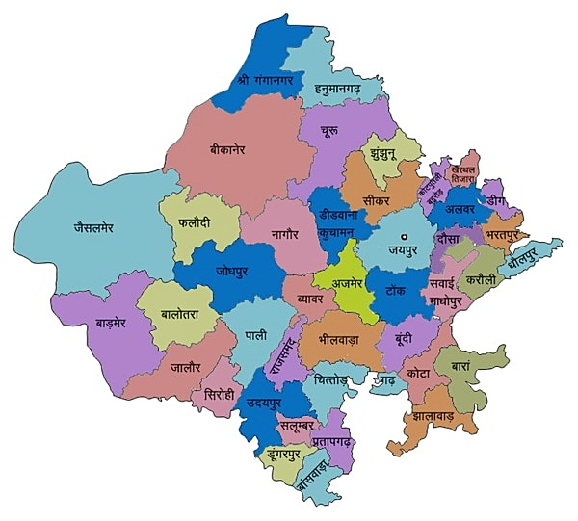
Rajasthan

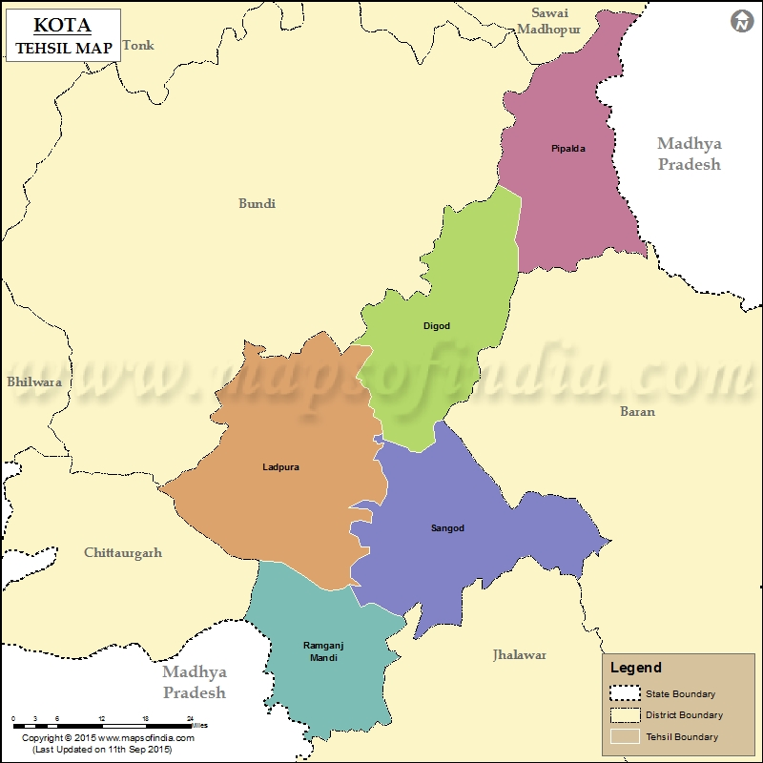

Figure 1. Study Area

RESULTS AND DISCUSSION
The constraints refer to as the difficulties faced by farmers in accessing and using agricultural information through ICTs. In the present study, the constraints were operationally defined as the problems experienced by ICT users during its utilization. Since, the use of ICT tools and services in agriculture and its allied sector as well as rural development is still at a developing stage where farmers encounter several challenges. An effort was made to identify these constraints, and the findings are presented in table 1. The constraints were ranked based on the mean scores calculated from the total scores obtained for each statement as expressed by the respondent farmers.
Table 1. Constraints faced by the farmers in utilization of ICT tools
S. No. | Constraints | Mean Score | Rank
1. | Insufficient regional specific information. | 4.73 | I
2. | High cost of ICT gadgets like smart phones, computers etc. | 2.26 | XII
3. | Lack of sufficient skills in usage of ICT tools by rural communities. | 1.81 | XV
4. | Low level of education. | 3.38 | VII
5. | Inadequate internet facilities. | 2.22 | XIII
6. | Lack of technical guidance. | 2.55 | X
7 | Inadequate facilitator’s knowledge. | 4.06 | V
8. | Insufficient training and practical exposure towards ICTs. | 4.03 | VI
9. | Lack of awareness of benefits of ICTs. | 3.30 | VIII
10 | Insufficient servicing centers of ICTs in villages. | 4.39 | III
11. | High cost of servicing charges of ICT gadget. | 4.31 | IV
12. | Difficulty in understanding the language of ICT gadgets. | 4.61 | II
13. | Non availability of ICT gadgets and spare parts in local markets. | 2.38 | XI
14. | Poor economic condition of rural people. | 2.76 | IX
15. | Lack of subsidies on ICT gadgets. | 2.03 | XIV
16. | Lack of financial resources. | 1.65 | XVI

It is observed from the Table 1. that among the various constraint faced by the respondent farmers in the extent of use of ICT tools, “insufficient regional specific information” was emerged as the most serious challenge for respondent farmers with the highest mean score of 4.73 and ranked first. The majority of farmers reported that most knowledge centers provide information in English only, which makes it difficult for them to understand and use the information effectively. The findings are in line with Dhaka and Chayal (2010), who were also identified insufficient region-specific information as a major constraint in the use of ICT tools and services. The second most important constraint perceived by the farmers was “difficulty in understanding of the language used in ICT gadgets”, with a mean score of 4.61. Because of the limited education and familiarity, many farmers found it difficult to understand the information, as most of ICT tools deliver services in English. Similar findings were also indicated by Singh et al. (2017), who observed that the farmers using the KRISHINET portal faced difficulties with language and technical terminology due to lack of inadequate support mechanisms.
The respondents highlighted the third major constraint as “insufficient services centers of ICTs in villages”, with a mean score of 4.39. Due to poor infrastructure, limited technological literacy, high cost of ICT devices and inadequate technical skills are the main causes hindering the establishment of ICT service centres in rural areas. “High cost of servicing charges of ICT gadgets” was ranked fourth among the major constraints faced by the respondent farmers with a mean score of 4.31. Farmers reported that hidden costs such as maintenance cost, start-up costs, and high price of hardware and software made ICT use more expensive over time. Similar findings were reported by Naik (2018), who observed that the high cost of ICT gadgets as a major constraint among farmers in Anantapur district of Andhra Pradesh. Similarly, Warthi and Bhanotra (2017) found that the high cost of mobile phones and internet services was a major constraint perceived by dairy entrepreneurs.
As listed in the above mention table the fifth major constraint indicated by the respondent farmers was “inadequate facilitator’s knowledge” with a mean score of 4.06. Due to poor subject matter knowledge among facilitators, limited skills in operating ICT gadgets, lack of proper training and weak communication skills related to ICT services. The respondents identified the sixth major constraint as “insufficient training and practical exposure to ICTs, with a mean score of 4.03. The lack of infrastructure facilities and training resources in rural areas often results in trainers being inadequately prepared, leading to poor performance and higher work-related stress.
It was also observed that a “low level of education” emerged as a constraint, with a mean score of 3.38 and ranked seventh. Poor economic conditions and inadequate educational and sanitation facilities limits farmers opportunities and reduce their ability to fully utilize ICT services for accessing information. “Lack of awareness of benefits of ICTs” was ranked eighth among constraints, with a mean score of 3.30. This was mainly due to limited exposure to new technologies, inadequate infrastructure and insufficient extension programs in rural areas.
The findings further revealed that “poor economic conditions of rural people” were also identified as constraint with a mean score of 2.76 and ranked ninth. Farmers’ financial constraints directly affects the extent of use of ICT tools. “Lack of technical guidance” was also highlighted by the respondent farmers as a constraint, with a mean score of 2.55 and ranked tenth.
The constraint “Non-availability of ICT gadgets and spare parts” was ranked eleventh by the respondent farmers, with a mean score of 2.38, mainly due to poor marketing facilities and the underdeveloped condition of the area. In today’s context, rapid technological development and increasing demand has driven ICT gadgets toward advanced features, making them more expensive. As a result, the constraint “high cost of ICT gadgets such as smartphones and computers” ranked twelfth, with a mean score of 2.26.
“Inadequate internet facilities”, such as poor connectivity, unstable power supply, limited network availability and costly internet data, were identified as a constraint by the respondents and ranked thirteenth, with a mean score of 2.22. The results further indicated that “lack of subsidies on ICT gadgets” was also identified as a difficulty by the respondents, and placed in fourteenth rank, with a mean score of 2.03.
The respondents reported that a major problem in effectively using ICT tools and services for agriculture and rural development was “lack of sufficient skills among rural communities” as a constraint and ranked fifteenth, with a mean score of 1.81. Lastly, the sixteenth constraint faced by the respondent farmers was “lack of financial resources” with a mean score of 1.65. This constraint was mainly due to fragmented landholdings, price fluctuations, high transportation costs and limited awareness about government sponsored credit facilities.
The findings were consistent with the results observed in earlier investigations such as Das et al. (2020), Nikam et al. (2020), Kumar (2019), Naik (2018), Kumar and Sharma (2017), Rajoria et al. (2017).
CONCLUSION
The study highlights that farmer in Kota district of Rajasthan face numerous challenges in the effective use of Information and Communication Technology (ICT) for agricultural purposes. The major challenges were insufficient information, high cost of ICT gadgets, low education levels, limited digital literacy and inadequate financial resources. Poor access to reliable internet connectivity and electricity further restricts the regular use of ICT tools, especially in rural areas. Additionally lack of awareness of benefits of ICTs and insufficient service centers reduces the practical relevance of ICT platform for farmers. These constraints collectively reduce the potential benefits of ICT enabled extension services. Therefore, strengthening the education through capacity building, affordable access to ICT tools, developing relevant content and improving basic infrastructure is crucial for encouraging greater adoption among farmers in the study area.
Disclaimer (Artificial intelligence)
Author(s) hereby declare that NO generative AI technologies such as Large Language Models (ChatGPT, COPILOT, etc.) and text-to-image generators have been used during the writing or editing of this manuscript.

REFERENCES:
"World Bank's e-sourcebook ICT in agriculture – connecting smallholder farmers to knowledge, networks and institutions (2011)".
Choruma, D.J., Dirwai, T.L., Mutenje, M.J., Mustafa, M., Chimonyo, V.G.P., Jacobs-Mata, I. and Mabhaudhi, T. 2024. Digitalisation in agriculture: A scoping review of technologies in practice, challenges, and opportunities for smallholder farmers in sub-Saharan Africa. J. Agric. Food Res, 18: p.101286.
Das, U., Goswamy, P., and Kameswari, V. L. V. (2020). Farmers’ perception on use of mobile phones for agricultural information.
Dhaka, B. L. and Chayal, K. (2010). Farmers experience with ICTs on transfer of technology in changing agri-rural environment. Indian Research Journal Extension Education. 10(3): 114-118.
DOMGUIA, E.N. & ASONGU, S.A., 2021. ICT and agriculture in Sub-Saharan Africa: Effects and transmission channels. Info Develop. http://dx.doi.org/10.1177/02666669251333759
e-Agriculture Community of Practice
Improvement for Sustainability. (2018); 2:538-555.
Kumar and Sharma, S. (2017). Survey analysis on the usages and impact of whatsapp messenger. Global Journal of Enterprise Information System. 8(3): 52-57.
Kumar, S. (2019). Study of utilization of Information and Communication Technology tools by paddy growers in Motigarpur block of Sultanpur district. M.Sc. (Ag.) (Unpub.) Thesis, NDUAT, Narendra Nagar, Ayodhya.
Mahant, M., Shukla, A., Dixit, S., and Patel, D. (2012). Uses of ICT in Agriculture. International Journal of Advanced Computer Research, 2(1), 46.
Maitrayee Dutta and Ketan Anand (2023). Role of Information Communication Technology in Agriculture. International Journal of Novel Research and Development, 8(10), a863-a870. https://ijnrd.org/papers/IJNRD2310097.pdf
Naik, B. J. (2018). A study on ICT tools usage by the farmers in Anantapur district of Andhra Pradesh. M. Sc. (Ag.) (Unpub.) Thesis. Acharya N.G. Ranga Agricultural University Lam, Guntur (ANGRAU), Hyderabad (India).
Nehra KS, Jangra MR, Jangra S, Kumar R. (2018). Role of information technology in agriculture. Crop improvement for sustainability. 537-555.
Nikam, V., Kumar, S., Kingsly, I. M., and Roy, M. (2020). Farmers mobile use pattern, information sources and perception about mobile app for grapes. Indian Journal of Extension Education. 56(1): 77-83.
Nxumalo, G.S. and Chauke, H., 2025. Challenges and opportunities in smallholder agriculture digitization in South Africa. Front. Sustain. Food Syst, 9: 1583224.
Oki, O. and Agbeyangi, A., 2024. Impact and necessity of ICT adoption in agriculture: Insights from regression analysis. Available from http://dx.doi.org/10.54364/AAIML.2024.44164
Prahlad P Bhat, Rahul Prasad R, Anil K, Abhishek Jadhav, Manohar K N, Rajesh C M, and Shashank L Reddy. (2024). “The Role of Information and Communication Technology in Enhancing the Effectiveness of Agricultural Extension Programs Worldwide: A Review”. Journal of Scientific Research and Reports 30 (7):963–976.
Rajoria, S., Rewani, S. K., Singh, V., Singodia, M., Saini, G. R., and Kumar, R. (2017). Constraints Perceived by Livestock Farmers in Use of ICTs in Jaipur District of Rajasthan, India. International Journal of Current Microbiology and Applied Sciences. 6(12): 1834-1839.
Sharma K, Sharma R, Devi N. (2019). Non-Timber Forest Products (NTFPs) and livelihood security: An economic study of High Hill Temperate Zone households of Himachal Pradesh. Econ Affairs. 64(2):305-315.
Sharma K, Sharma R, Singh KP, Dev K. (2017). Income and Employment pattern of rural households: A case study of High Hill Temperate Zone Households of Himachal Pradesh. J Agric Dev Policy. 27(2):29-36.
Singh, M., Khare, N.K., and Pande, A.K. (2017). Constraints perceived by the farmers of Jabalpur district of Madhya Pradesh in use of KRISHINET portal. Journal of Current Microbiology and applied sciences. 6(12): 1834-1839.
Singh, R. (2021). Information Communication Technology.
Singh, S., Ahlawat, S., and Sanwal, S. (2017). Role of ICT in Agriculture: Policy implications. Oriental Journal of Computer Science and Technology, 10(3), 691-697.
Smidt, H.J. and Jokonya, O., 2022. Factors affecting digital technology adoption by small- scale farmers in agriculture value chains (AVCs) in South Africa. Inf. Technol. Dev, 28(3): 558-584.
Swaminathan, M., and Swaminathan, M. S. (2018). ICT and agriculture. CSI Transactions on ICT, 6(3), 227-229.
Tomar, V.; Raghuwanshi, S.; Agarwal, S. and Dangi, A. (2025). Empowering Sugarcane Growers: Exploring ICT Utilization for Sustainable Agriculture in Madhya Pradesh. Indian Res. J. Ext. Edu., 25 (4): 70-74.
Warthi, M., and Bhanotra, A. (2017). Benefits and constraints of mobile phone use as an ICT tool by dairy entrepreneurs. Journal of Animal Research. 7(6): 1089-1092.

