Pathogenicity and Integrated Management of Colletotrichum capsici [Syd. (Butler and Bisby)] Causing Anthracnose of Betelvine (Piper betle L.)

.
ABSTRACT

Disease development is largely governed by physiological and nutritional factors that influence fungal growth, sporulation, and pathogenicity. Excessive dependence on fungicides has raised concerns regarding environmental safety and resistance. Therefore, understanding pathogen biology along with evaluation of botanicals and fungicides is essential for developing sustainable disease management strategies. An in vitro study was conducted to evaluate the efficacy of botanicals and fungicides against Colletotrichum capsici, the causal agent of anthracnose of betelvine, using the poisoned food technique. Seven botanicals were tested at 2.5, 5 and 10 per cent concentrations. All botanicals significantly inhibited mycelial growth over the control, with datura showing maximum inhibition of 15.70, 30.09 and 37.17 per cent at 2.5, 5, and 10 per cent concentrations, respectively. At 10 per cent, bryophyllum, neem, tulsi, and garlic recorded 30.75, 22.57, 20.79 and 16.59 per cent inhibition respectively. Seven fungicides were evaluated at 100–1000 ppm. Propiconazole 25% EC caused 100 per cent inhibition at all concentrations. At 100 ppm, copper oxychloride, tebuconazole + trifloxystrobin, and carbendazim + mancozeb showed 87.17, 73.89, and 72.34 per cent inhibition, respectively, while Mancozeb 75% WP recorded 85.61 per cent inhibition at 1000 ppm. Among fungicides, propiconazole 25% EC caused complete inhibition at all concentrations, whereas copper oxychloride and combination fungicides were also highly effective at higher doses. The results support the integration of eco-friendly botanicals with effective fungicides for sustainable management of anthracnose of betelvine.

Keywords: Betelvine, Anthracnose, Colletotrichum capsici, Botanicals, Fungicides

1. INTRODUCTION

Betelvine (Piper betle L.) is an important perennial cash crop cultivated widely in India under artificially created microclimatic structures known as bareja (Lewis et al., 2004). These systems provide shade, high humidity, and moderate temperature essential for quality leaf production (Guha and Jain, 1997; Anwar et al., 2017). However, the same conditions favor the development of fungal diseases (Delai et al., 2024).
Anthracnose caused by Colletotrichum capsici is one of the most destructive diseases of betelvine, affecting leaves and stems and causing necrotic lesions, cracking, defoliation, and sometimes complete plant mortality (Chattopadhyay and Maity, 1990). Yield losses ranging from 25 to 90 per cent have been reported depending on environmental conditions and disease severity (Maity and Sen, 1982; Singh and Joshi, 1971;, Sanogo & Ji, 2012; De Silva et al., 2021).
Disease development is largely governed by physiological and nutritional factors that influence fungal growth, sporulation, and pathogenicity (Khandebharad, 1974; Naik et al., 1988; Handiso & Alemu, 2017). Excessive dependence on fungicides has raised concerns regarding environmental safety and resistance. Therefore, understanding pathogen biology along with evaluation of botanicals and fungicides is essential for developing sustainable disease management strategies.

2. MATERIAL AND METHODS
2.1 Pathogenicity
2.1.1 Attached leaves
To prove the pathogenicity of the test fungus on standing betelvine crop, a potted plant was inoculated using a pure fungal culture. Two leaves were injured with a sterilized needle; one was inoculated with a 5 mm mycelial disc, while the other was sprayed with 1×10⁶ spores/ml spore suspension. Similarly, two uninjured healthy leaves were also inoculated in the same manner. Control plants were sprayed with sterile water. After inoculation, all vines were covered with polythene bags to maintain high humidity for infection. Proper watering was ensured.
2.1.2. Detached leaves
Fresh, healthy betelvine leaves were disinfected with 0.1% sodium hypochlorite and washed with sterile water. Two leaves were injured and inoculated with 5mm mycelial disc and 1×10⁸ conidia/ml spore suspension, while two uninjured leaves were similarly inoculated. Control leaves received only sterile water. All samples were kept in humid conditions. After incubation, disease symptoms developed mainly on injured, inoculated leaves, similar to natural infection, confirming pathogen involvement

2.2 Evaluation of botanicals
Seven botanicals like- Calotropis gigantean(Aak), Azadirachta indica(Neem), Ocimum sanctum(Tulsi), Datura stramonium(Datura), Allium sativa(Onion), Allium cepa(Garlic),and Kalanchoe pinnata(Bryophyllum) leaf extracts were evaluated against the test fungus using the poisoned food technique. One hundred grammes of plant leaves were taken, surface sterilised with1% sodium hypochlorite, washed with sterile water 2-3 times and allowed to dry at room temperature (25°C). Each botanical’s 100 g of leaves was crushed separately with 100 ml of sterile water prior to extraction. After crushing the extract was first filtered through muslin cloth and then through Whatman No. 1 filter paper, later the extract was passed through Seitz filter to free them from bacterial contamination. Each plant extract was assessed with three concentrations (2.5%, 5% and 10%). A 5 mm mycelial disc from a 7-day-old culture of the fungus was placed at the centre of each plate and incubated at 25 ± 2°C for six days.

2.3 Evaluation of fungicides
Seven fungicides viz. Mancozeb (75%), and Copper oxychloride (50%) as contact fungicides, Propiconazole (25%), Hexaconazole (5%), and Carbendazim (50%)as systemic fungicides; Tebuconazole (50%) +Trifloxystrobin (25%), and Carbendazim (12%) + Mancozeb (63%) as combi-products were used. The effectiveness of the fungicides mentioned above was examined at 100ppm, 200ppm, 500ppm and 1000ppmconcentrations, using the Poisoned Food Technique. The quantity of fungicide required was calculated based on active ingredient using the formula:

$Amount of$ Fungicide required$=\frac{Conc. of fungicide \left(ppm\right) ×vol. of potato dextrose agar }{{10}^{6}} xCF$
Where, CF= Correction Factor
$CF=\frac{100}{ai}$Where, a.i.- Active ingredient

Poisoned food technique
In the 250 ml conical flasks containing 50 ml of warm sterilized PDA medium were amended with different fungicides, which were weighed according to the appropriate concentration and properly mixed under aseptic conditions. The homogenous liquid was poured into three sterilised Petri plate and let to settle down. A 5 mm mycelial disc was placed in the middle of each plate and incubated at 25±2°C; while the fungicide-free plates were amended with distilled water acts as control. After 6 days of inoculation, observations on mycelial growth was measured and per cent inhibition was calculated following Vincent (1947)formula:
Per cent inhibition=C−T/C×100
Where, C is mycelial growth in the control and T is mycelial growth in the treatment.

2.4 Statistical Analysis
All experiments were conducted in a completely randomized design with three replications. The data were subjected to statistical analysis, and critical differences were calculated at the 5% level of significance.

3. results and discussion
3.1 Pathogenicity
3.1.1. Attached leaves
Spore suspension method:-
In the spore suspension method, minute spots appeared within three days after inoculation when the pin-prick technique was used, and the lesions were fully developed after six days. In contrast, in the un-prickled (undamaged) method, initial spots appeared after four days, and lesions were observed on the eighth day after inoculation.
Mycelial disc method:-
In the damaged (pin-pricked) leaves, minute spots developed within four days after inoculation, and the lesions were fully developed by the seventh day. In contrast, in the unprickled (undamaged) leaves, initial spots appeared within five days, and lesions were observed on the eighth day after inoculation. No signs of disease development were observed in the control plants
3.1.2. Detached leaf technique:
Spore Suspension method:-
In the pin-pricked method, spots appeared within 2 days and lesions fully developed by 6 days. In the unprickled method, spots appeared after 3 days and lesions by 7 days.
Mycelial disc method:-
Pin-prickled leaves showed symptoms faster, with spots in 2 days and full lesions by 8 days, while unprickled leaves developed spots in 6 days and lesions by 9 days; no disease appeared in the control.
In the present investigation pin-prickled inoculation method found superior over unpin-prickled spore inoculation method to prove pathogenicity as reported by Roy et al., (1997), Ravanappa (2003) and Gawande et al., (2006).
Table1. Efficacy of different methods of testing the pathogenicity of C. capsici on betelvine
S.No. | Method of inoculation |  | Symptoms expressed on leaves (after no. of days)
S.No. |  |  | Attached leaves |  | Detached leaves
S.No. |  |  | Initiation of spot | Full  Development of spot | Initiation of spot | Full  Development of spot
S.No. |  |  | 3 | 6 | 2 | 6
S.No. | Spore suspension | Pin-prickled leaves
1.
1. | Spore suspension | Unpin-prickled leaves | 4 | 8 | 3 | 7
2. | Mycelial disc | Pin-prickled leaves | 4 | 7 | 2 | 8
2. | Mycelial disc | Unpin-pricked leaves | 5 | 8 | 6 | 9
3. | Control | Pin-prickled leaves | - | - | - | -
3. | Control | Unpin-pricked leaves | - | - | - | -

3.2 Efficacy of botanicals on mycelial growth inhibition of C. capsici (in vitro)
The effect of seven botanicals, namely aak, neem, tulsi, datura, onion, garlic, and bryophyllum, was evaluated at 2.5, 5 and 10 per cent concentrations for inhibition of mycelial growth of C. capsici using the poisoned food technique (Nene and Thapliyal, 1982). Results were presented in Table 2 and Fig 1.
All the botanicals significantly inhibited mycelial growth as compared to the control. Among the botanicals tested, datura was found to be significantly superior at all concentrations, showing maximum inhibition of mycelial growth. At 2.5 per cent concentration, datura, garlic, bryophyllum and tulsi recorded 15.70, 7.07, 6.63, and 6.19 per cent inhibition of mycelial growth, respectively.
At 5 per cent concentration, datura again exhibited the highest inhibition (30.09%), followed by bryophyllum (15.04%), tulsi (13.94%), garlic (13.71%), and neem (13.27%). Similarly, at 10 per cent concentration, datura showed maximum inhibition (37.17%), followed by bryophyllum (30.75%), neem (22.57%), tulsi (20.79%), and garlic (16.59%). The results clearly indicated that inhibition of mycelial growth increased with increasing concentration of botanicals, with maximum inhibition observed at 10 per cent concentration.
Botanicals are the most economical, environmentally friendly approach to manage C.capsici on betelvine. Among the botanicals tested, datura was found best against C.capsici under in vitro conditions. In the current investigation, best result for percent inhibition of mycelial growth was exhibited 15.70, 30.09, and 37.17% by datura at all three-concentration tested followed by 6.63, 15.04, and 30.75 % for bryophyllum and 7.07, 13.71, and 22.57% for garlic. These outcomes were supported the result reported by Bagri et al., (2004). 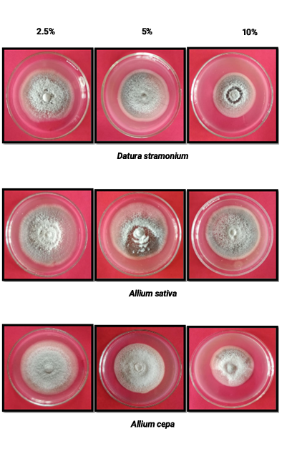

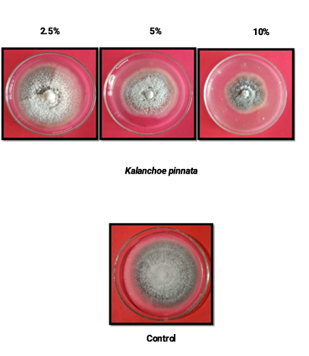
Plate.1 Efficacy of botanicals on mycelial growth inhibition of C. capsici (in vitro)

Table 2. Efficacy of botanicals on mycelial growth inhibition of C. capsici (in vitro)

S. No. | Botanicals |  | Concentration |  |  |  |  |  |  | Mean A
S. No. |  |  | 2.5% |  | 5% |  |  | 10% |  | Mean A
S. No. |  |  | Mycelial growth (mm) | % Inhibition | Mycelial growth (mm) | % Inhibition |  | Mycelial growth (mm) | % Inhibition | Mean A
T1 | AAK |  | 74.00 | 1.77 | 70.67 | 6.20 |  | 67.67 | 10.18 | 6.05
T2 | NEEM |  | 71.33 | 5.30 | 65.33 | 13.27 |  | 59.67 | 20.79 | 13.12
T3 | TULSI |  | 70.67 | 6.19 | 64.83 | 13.94 |  | 62.83 | 16.59 | 12.24
T4 | DATURA |  | 63.50 | 15.70 | 52.67 | 30.09 |  | 47.33 | 37.17 | 27.65
T5 | ONION |  | 74.67 | 0.89 | 71.00 | 5.75 |  | 67.33 | 10.62 | 5.75
T6 | GARLIC |  | 70.00 | 7.07 | 65.00 | 13.71 |  | 58.33 | 22.57 | 14.45
T7 | BRYOPHYLLUM |  | 70.33 | 6.63 | 64.00 | 15.04 |  | 52.17 | 30.75 | 17.47
T8 | Control |  | 76.00 | 0.00 | 75.00 | 0.00 |  | 75.00 | 0.00 | 75.33
Mean B |  |  |  | 14.86 |  | 21.67 |  |  | 28.00
Factors |  | C.D at 5% |  |  |  |  | SE(m)±
Factor (A) Fungicide |  | 1.23 |  |  |  |  | 0.43
Factor (B) Concentration |  | 0.75 |  |  |  |  | 0.26
Factors (AXB) |  | 2.14 |  |  |  |  | 0.75
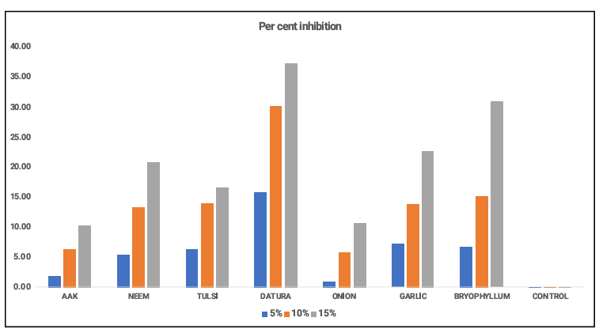
Fig. 1. Efficacy of botanicals on mycelial growth inhibition of C. capsici (in vitro)

3.2. Efficacy of fungicides on mycelial growth inhibition of C. capsici (in vitro)
Seven fungicides (single and combination) viz., Mancozeb 75% WP, Copper oxychloride 75% WP, Propiconazole 25% EC, Hexaconazole 5% SC, Carbendazim 50% WP, Tebuconazole 50% + Trifloxystrobin 25% WG and Carbendazim 12% + Mancozeb 63% WP, were evaluated at 100, 200, 500 and 1000 ppm concentrations for inhibition of mycelial growth of C. capsici using the poisoned food technique (Nene and Thapliyal, 1982). The results are depicted in Table 3 and Fig. 2.
All the fungicides significantly inhibited mycelial growth compared to the control. Among the fungicides tested, Propiconazole 25% EC was found to be significantly superior at all concentrations, exhibiting complete (100%) inhibition of mycelial growth. At 100 ppm concentration, copper oxychloride, tebuconazole 50% + trifloxystrobin 25% WG and carbendazim 12% + mancozeb 63% WP recorded 87.17, 73.89, and 72.34 per cent inhibition of mycelial growth, respectively.
At 200 ppm concentration, copper oxychloride (88.72%), carbendazim 12% + mancozeb 63% WP (78.98%), and tebuconazole 50% + trifloxystrobin 25% WG (75.89%) showed higher inhibition. At 500 ppm concentration, copper oxychloride, carbendazim 12% + mancozeb 63% WP, and tebuconazole 50% + trifloxystrobin 25% WG exhibited complete (100%) inhibition of mycelial growth. At 1000 ppm concentration, all fungicides showed 100 per cent inhibition except Mancozeb 75% WP, which recorded 85.61 per cent inhibition.
Fungicides are crucial for reduction of growth of fungi:- it is one of the quick alternates for disease management. It was discovered that propiconazole 25%EC performed better than the other fungicides at all four concentrations, with a maximum inhibition (100%) of mycelial growth. At 500 ppm concentrations, Copper oxychloride 50%WP, Tebuconazole 50%+ Trifloxystrobin 25%WG, and Carbendazim 12%+Mancozeb 63%WP showed 100% inhibition, whereas Mancozeb 75% WP showed the worst performance at 1000 ppm with 85.61% inhibition. Similarly, under in vitro conditions, Propiconazole 25%EC was found to be the most effective fungicide against C. capsici (Gawande et al. 2006; Gopinath et al., 2006; Ahmed et al., 2014 and Hembram and Baskey (2015).

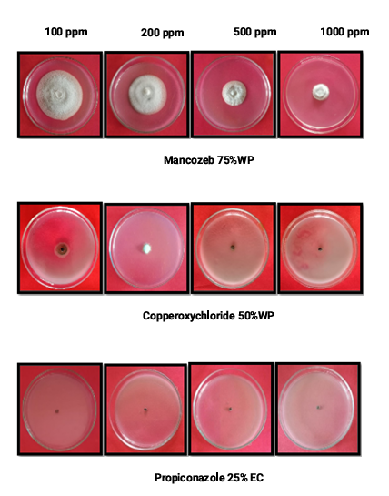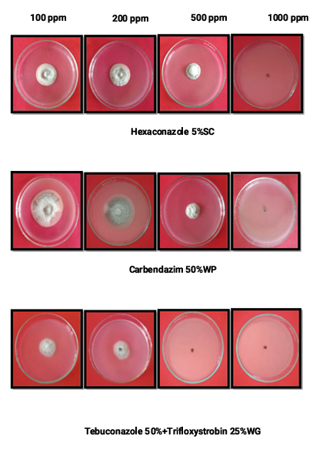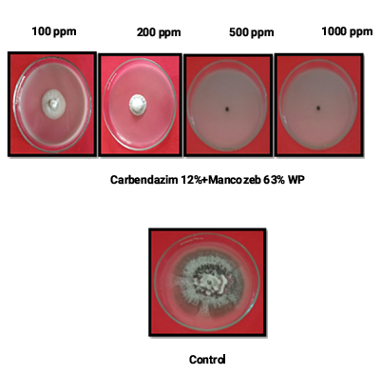
Plate.2 Petri plate showing efficacy of fungicides on mycelial growth inhibition of C. capsici (in vitro)

Table 3 Variation in fungicides concentration on mycelial growth inhibition of C. capsici (in vitro)

S. No. | Fungicides | Concentration |  |  |  |  |  |  |  |  |  |  | Mean A
S. No. | Fungicides | 100 ppm |  |  | 200 ppm |  | 500 ppm |  |  | 1000 ppm |  |  | Mean A
S. No. | Fungicides | Mycelial growth (mm) |  | % Inhibition | Mycelial growth (mm) | % Inhibition | Mycelial growth (mm) |  | % Inhibition | Mycelial growth (mm) |  | % Inhibition | Mean A
T1 | Mancozeb 75% WP | 59.00 |  | 14.57 | 45.67 | 39.37 | 25.83 |  | 65.70 | 10.83 |  | 85.61 | 51.31
T2 | Copperoxychloride 75% WP | 9.67 |  | 87.17 | 8.50 | 88.72 | 0.00 |  | 100.00 | 0.00 |  | 100.00 | 93.97
T3 | Propiconazole 25% EC | 0.00 |  | 100.00 | 0.00 | 100.00 | 0.00 |  | 100.00 | 0.00 |  | 100.00 | 100
T4 | Hexaconazole 5% SC | 31.17 |  | 58.63 | 27.17 | 63.94 | 24.17 |  | 67.91 | 0.00 |  | 100.00 | 72.62
T5 | Carbendazim 50% WP | 51.00 |  | 10.44 | 33.66 | 18.44 | 22.67 |  | 69.90 | 0.00 |  | 100.00 | 49.69
T6 | Tebuconazole 50% + Trifloxystrobin 25% WG | 19.67 |  | 73.89 | 18.17 | 75.89 | 0.00 |  | 100.00 | 0.00 |  | 100.00 | 87.47
T7 | Carbendazim 12% + Mancozeb 63% WP | 20.83 |  | 72.34 | 15.83 | 78.98 | 0.00 |  | 100.00 | 0.00 |  | 100.00 | 87.82
T8 | Control | 75.33 |  | 0.00 | 75.33 | 0.00 | 75.33 |  | 0.00 | 75.33 |  | 0.00 | 0.00
Mean B |  |  |  | 52.13 |  | 58.17 |  |  | 75.44
Factors |  |  | C.D at 5% |  |  |  |  | SE(m)±
Factor (A) Fungicide |  |  | 5.63 |  |  |  |  | 1.98
Factor (B) Concentration |  |  | 3.98 |  |  |  |  | 1.40
Factors (AXB) |  |  | 11.26 |  |  |  |  | 3.97

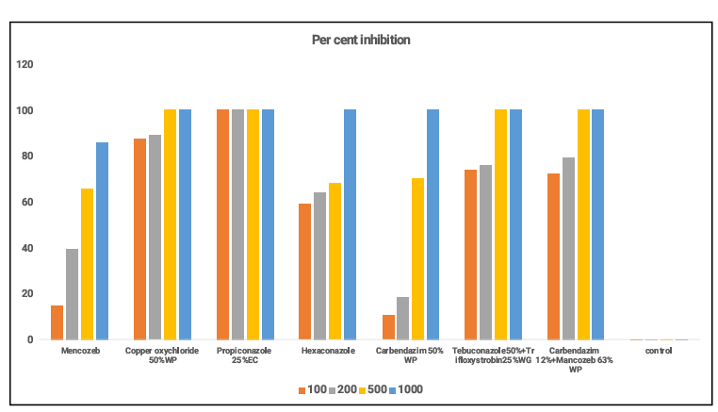
Fig. 2. Efficacy of fungicides on mycelial growth inhibition of C. capsici (in vitro)

4. Conclusion
The study demonstrated that both botanicals and fungicides were effective in suppressing the mycelial growth of C. capsici under in vitro conditions. Datura leaf extract exhibited the highest antifungal activity among botanicals, showing increased inhibition with rising concentrations, while other botanicals showed moderate effects. Among fungicides, propiconazole 25% EC caused complete inhibition at all concentrations, whereas copper oxychloride and combination fungicides were also highly effective at higher doses. The results support the integration of eco-friendly botanicals with effective fungicides for sustainable management of anthracnose of betelvine.

AcknowledgEments

The authors sincerely thank the Department of Plant Pathology, College of Agriculture, Jawaharlal Nehru Krishi Vishwa Vidyalaya, Jabalpur, for providing laboratory and field facilities.

References
Bagri, R. K., Jain, K. L., & Sharma, S. K. (2004). Evaluation of plant extracts against Colletotrichum species under in vitro conditions. Indian Phytopathology, 57, 176–179.

Chattopadhyay, C., & Maity, S. (1990). Incidence of anthracnose disease of betelvine. Plant DiseaseResearch,5,87–91.

Gawande, V. L., Giri, G. K., & Dey, U. (2006). Evaluation of fungicides against anthracnose pathogen. Indian Journal of Plant Protection, 34, 123–126.

Gopinath, K., Ramasamy, S., & Balasubramanian, P. (2006). Fungicidal management of anthracnose disease caused by Colletotrichum spp. Plant Disease Research, 21, 98–101.

Guha, P., & Jain, R. (1997). Status and prospects of betelvine cultivation in India. Agricultural Review, 18,211–219.
Gawande AD, Asalmol MN and Raut SP. 2006. Management of Colletotrichum spp. on Piper longum (L.). Annals of Plant Protection Sciences 14(2): 411-414.

Hembram, S., & Baskey, S. (2015). Evaluation of fungicides against Colletotrichum spp. causing anthracnose. Journal of Mycology and Plant Pathology, 45, 312–316.

Khandebharad, R. (1974). Physiological studies on Colletotrichum spp. Indian Phytopathology,27,142–146.

Maity, S., & Sen, B. (1982). Loss assessment due to anthracnose of betelvine. Indian JournalofPlantPathology,15,45–49.

Naik, M. K., Hiremath, R. V., & Hegde, R. K. (1988). Influence of nutritional factors on growth of Colletotrichum spp. Indian Journal of Mycology and Plant Pathology, 18, 42–46.

Singh, R., & Joshi, L. (1971). Losses due to anthracnose in betelvine. Indian Journal of Agricultural Sciences, 41, 879–883.

Vincent J.M. 1947. The esters of 4‐hydroxybenzoic acid and related compounds. Part I. Methods for the study of their fungistatic properties. Journal of the Society of Chemical Industry,66,149–155.

Delai, C., Muhae-Ud-Din, G., Abid, R., Tian, T., Liu, R., Xiong, Y., ... & Ghorbani, A. (2024). A comprehensive review of integrated management strategies for damping-off disease in chili. Frontiers in Microbiology, 15, 1479957.

Sanogo, S., & Ji, P. (2012). Integrated management of Phytophthora capsici on solanaceous and cucurbitaceous crops: current status, gaps in knowledge and research needs. Canadian Journal of Plant Pathology, 34(4), 479-492.

Anwar, A., Bhat, M., Masoodi, L., Mughal, N., Ambardar, V. K., & Hassan, M. G. (2017). Integrated management of Colletotrichum capsici incitant of dieback and fruit rot of chilli under temperate conditions of Kashmir, India. Journal of Pharmacognosy and Phytochemistry, 6(4), 1509-1513.

Handiso, S., & Alemu, T. (2017). Integrated Management of Anthracnose (Colletotrichum capsici (Syd.)): Implications to disease reactions, quality and growth parameters of three genotypes of Chili. American Scientific Research Journal for Engineering, Technology, and Sciences (ASRJETS), 32(1), 303-315.

De Silva, D. D., Ades, P. K., & Taylor, P. W. (2021). Pathogenicity of Colletotrichum species causing anthracnose of Capsicum in Asia. Plant Pathology, 70(4), 875-884.

Lewis Ivey, M. L., Nava-Diaz, C., & Miller, S. A. (2004). Identification and management of Colletotrichum acutatum on immature bell peppers. Plant disease, 88(11), 1198-1204.

