Review Article

Morphological Characterisation of Desi and Kabuli Chickpea Genotypes Using DUS Descriptors for Improved Breeding and Genetic Conservation

ABSTRACT
Chickpea (Cicer arietinum L.) is one of the most important pulse crops grown in India and plays a key role in human nutrition. Studying morphological characters is a simple and effective way to understand visible differences among chickpea plants. This review focuses on the morphological characterisation of Desi and Kabuli chickpea types using the DUS (Distinctness, Uniformity, and Stability) descriptors developed by the Protection of Plant Varieties and Farmers’ Rights Authority (PPV&FRA), Government of India. Morphological traits such as plant growth habit, leaf type, flower colour, and seed characteristics help in identifying and differentiating chickpea genotypes. These traits can be influenced by environmental factors like temperature, light, humidity, and soil nutrients. The availability of diverse morphological traits in chickpea germplasm provides useful options for plant breeders to select better varieties. Morphological characterisation using DUS descriptors is a valuable approach for identifying and differentiating chickpea genotypes, supporting breeding programs and the development of improved varieties. Overall, morphological characterisation remains a cost-effective first-tier tool but should ideally be combined with molecular approaches for robust variety registration and breeding.
Keywords: Environments, DUS (Distinctness, Uniformity, and Stability), Genotypes, chickpeas

Introduction
The chickpea (Cicer arietinum L.; Family: Fabaceae) is a cool-season, diploid (2n=16), self-pollinating pulse crop with a genome size of about 738 Mb and an estimated 28 269 genes. (Varshney et al., 2013). Known by many different names, such as Gram, Chana, Egyptian pea, Bengal gram, and Garbanzo bean, chickpeas (Cicer arietinum L.) are an annual legume crop cultivated during the Rabi season ( Asati R et al.,2022). It is a winter-season legume crop that thrives at temperatures between 20 and 25°C during the day and 15–20°C at night, thereby performing well in drier weather conditions (Singh et al., 2022). In the last two decades (1995–2016), the global chickpea area has expanded by 8%, grain yield by 27%, and overall production by 40% (Food and Agriculture Organisation, 2020). India, being the world's largest producer of chickpea, accounts for ~70% of total annual pulse production of ~12 million tons, which was harvested from ~11 million ha, which is far less than its true potential when compared to other major crops (Singh et al., 2022). Given that they include a higher proportion of fat and protein than grains, pulses are the most important component of a vegetarian diet. These are crucial for diets since they contain a lot of vitamins and minerals that produce energy. They are known as "poor man's meat" and "rich man's vegetable" due to their high protein content and various essential amino acids, especially lysine. They provide livestock with good nutritious feed as well. They balance out the majority of vegetarians' diet, which consists mostly of cereals. Most of it is grown in semi-arid nations, with Ethiopia being the secondary origin region and southwest Asia and the Mediterranean region being the primary origin regions. (Vavilov NI.1926).
Chickpeas, or chana, are commonly referred to as the "King of pulses" in India. It is commonly employed for making dal, chickpea flour, and many other foods. Through symbiotic nitrogen fixation, which transforms atmospheric nitrogen into a form that plants can use, it also demonstrates the capacity to improve soil fertility. ( Yadav RK et al., 2023). With a composition of 29–35.2% carbohydrate and 22–25% protein, the chickpea (Cicer arietinum L.), an essential healthful legume in the Fabaceae family, provides high nutritional value (Schutyser et al., 2015). With 10.74 million hectares under production and an average yield of 1171.6 kg/ha, India is the world’s top producer of chickpeas, followed by Ethiopia, Pakistan, Turkey, and Australia (FAOSTAT 2023).
In India, the growth of modified chickpea varieties has lagged behind those that affect basic crops like rice and wheat (Bimbraw 2016). The limited genetic foundation of existing cultivars is an important factor in stagnated productivity, emphasising the need to continue genetic research and genetic variety exploration (Singh et al., 2022). The effort to promote successful future breeding projects, it also aims at finding a core part of chickpea accessions that preserve the greatest quantity of genetic variation using the Principal Component Score (PCS) technique.
Morphological characterisation is a valuable approach used to examine observable traits in crop plants, enabling the identification, classification, and understanding of genetic variations within diverse genotypes. This supports breeders in selecting desirable traits and improving breeding programs (Behera et al., 2023). It can be used to identify and classify various genotypes based on their morphological traits, thereby aiding in the identification of different chickpea varieties and detecting genetic variations or mutations within a population (Asati et al., 2023). The comparison of amounts for morphological and biological factors of deviation provides an understanding of the level of variation throughout a group, as the evaluation of such parameters, in addition to the heritability and projected genetic development, is critical for yield. The values mentioned above have been determined to ascertain the possibility to better the yield of chickpea varieties. (Mohan and Thiyagarajan, 2019). After crop harvesting, the growth rate of the chickpea crop is dependent on its development conditions. At various phases of development of plants, environmental variables such as water content of the soil, seeding time, soil fertility, humidity, and even day duration have an important effect (Tilahun et al., 2015).
The breeder picks both parents according to morphological variation, and identifying the genetic variation of the parents in relation to the qualities which need to be improved is crucial to effective breeding (Shedge et al., 2019). Allow identify particular chickpea varieties and identify genetic modifications or changes within a population by classifying and defining different genotypes based on their exterior characteristics. Plant the morphological features have long been understood to be critical descriptors for performing Distinctness, Uniformity, and Stability (DUS) testing and identifying crop varieties.(Joshi MA et al., 2018). The present review aims to evaluate the morphological characteristics of Desi and Kabuli chickpea types using DUS descriptors and identify elite genotypes for breeding programs and improved variety development.

Centre of Diversity
The primary centre of diversity is in the Fertile Crescent, which is where the crop was cultivated. As chickpeas spread globally, secondary centres of diversity formed, some of that dating from over two thousand years to the Mediterranean area of Europe, the Indian subcontinent, and Africa's northern region, and some subsequently to Mexico and Chile after the spreading of Columbus to those countries. (Vander Maesen 1972). The biological environment is inherently complex. No two individuals are completely identical; not even paternal triplets. Diversity is the variation in a single or multiple elements of an individual.
It is inaccurate to assume that variation in DNA and variation in genetics are comparable. On the contrary, genetic variability is an umbrella term that covers all of the variation that happens between genotypes when speaking of the general genetic breakdown of genotypes that belong to only one species or among two groups. Differences in the structure of bodily structure, physiologic conduct or biochemical traits are illustrations of how changes in inheritance features can develop. Diversification at multiple genetic loci within a person can be defined as chromosomal heterogeneity. Among agricultural employees, genetic variation attracted much fascination. (HR Bhandari et al., 2017).

Fig 1 : Hierarchical relationship among ecological, species, genetic, and genomic diversity

Genetic Diversity in Chickpea:
In order to identify different parental combinations and produce segregated progenies with maximal genetic variability, genetic diversity research aids in assessing and establishing the genetic relationship in germplasm collections. Genetic distance and similarity analyses, which both indicate that there are genetic differences or parallels, are frequently utilised for assessing genetic diversity.
Genetic Variation in Chickpea: Changes in a population's members' genetic composition (DNA) are referred to as genetic variability. Selection by nature and plant breeding are based on genetic variation in chickpeas.
Mutations: Mutation breeding has effectively created chickpea genotypes resistant to Ascochyta blight and Fusarium wilt (Kaiser et al., 2007).
Genetic Recombination: The method improves the diversity of genes and makes it possible to pick better genotypes in breeding programs by producing new allele combinations in offspring (Tullu et al., 2008).
Gene Flow: Limited natural outcrossing may produce novel alleles, improving diversity for yield and tolerance for stress traits, even though chickpeas are primarily self-pollinating (Tanksley & McCouch, 1997).
Polyploidy: According to Kumar et al. (2010), polyploidy promotes variation in genetics and may enhance resistance to environmental stressors.
Phenotypic Variation in Chickpea: The term “phenotypic variation” indicates discernible variability in the characteristics of plants produced by the relationship between genotype and environment.
Genetic Factors: Phenotypic expression is significantly affected by differences in genes driving growth regulators, developing systems, and seed development (Chaudhary et al., 2011).
Environmental Factors: Environmental factors that have an important effect on trait expression, including temperature, rainfall, soil fertility, and photoperiod. For instance, lowered plant height and seed size are common in chickpeas cultivated under moisture stress (Singh et al., 2013).
Genotype × Environment Interaction: According to Akhter et al. (2015), drought-tolerant chickpea genotypes perform superior in rainfed environments but do not demonstrate the same improvement in irrigated conditions.
Environmental Variation in Chickpea: Changes in external developmental factors that impact plant development without modifying the genetic composition are referred to as environmental variation. These differences have an important effect on the stability and cultivation of chickpeas in various locales.
Availability of Water: Though chickpeas are resistant to heat and drought, excessive humidity stress affects the production of biomass, pod development, and seed density (Singh et al., 2014)
Temperature: Considerable losses in crop yield arise from pollen inefficiency, flower reduction and a low set of seeds resulting from severe temperatures throughout development and pod development (Saxena et al., 2010)
Fertility and Type of Soil: The soils with excellent drainage are good for growing chickpeas. Growth, digestion of nutrients, and development are hampered by humidity, a food shortage, and a pH imbalance of the soil (Ahmad et al., 2012)
Intensity of Light: The process of photosynthesis and the formation of carbon dioxide are dependent on enough sunlight. Although chickpeas possess an average resistance to shade, their lower light quality affects growing and seed production (Blum, 2009)

Methods of diversity analysis in chickpea:
Morphological, physiological, biological, chemical, and molecular identification are all utilised for variation assessment. For expansion of analysis, markers of morphology were initially used and are now utilised. They are organic modifications of a certain type of plant. With the development of genetic techniques, molecular identification developed as the most common means to analyse genetic variation. Eventually, biological and biochemical variation identified in a species' genotypes started to be utilised during this process.

Table: 1. Overview of Diversity Analysis Methods and Their Applications in Genetic Studies
Method of Diversity Analysis | Traits / Data Used | Statistical Tools | Important Results | References
Morphological diversity analysis | Plant height, pods/plant, days to flowering, seed weight, yield | ANOVA, cluster analysis | Observed substantial genetic variation between genotypes of chickpeas. | Singh et al., 2016; Upadhyaya et al., 2017
Mahalanobis D² statistics | Quantitative yield traits | D² analysis, Tocher method | Increased genetic variation has been demonstrated by an elevated crossover distance. | Kumar et al., 2018; Meena et al., 2025
Principal Component Analysis (PCA) | Yield and yield attributes | PCA, biplot analysis | The most significant variability in chickpea communities is caused by only a few of features. | Srikanth et al., 2024; Rajpoot et al., 2025
Cluster analysis (UPGMA/Ward’s) | Agro-morphological traits | Euclidean distance | Classified genetics into separate categories so as to select parents | Pragati et al., 2024
SSR marker-based diversity | DNA polymorphism | Jaccard similarity, UPGMA | High diversity and exact genetic variation forecast | Yadav et al., 2019; Tripathi et al., 2023; Rajpoot et al., 2025
SNP marker analysis | Genome-wide variation | STRUCTURE, PCA | highlighted genetic links and demographic makeup | Roorkiwal et al., 2018; Varshney et al., 2021
ISSR and RAPD markers | DNA banding pattern | Similarity matrix, dendrogram | High polymorphism can be helpful for the initial study on diversity | Ghaffari et al., 2017; Ahmad et al., 2020
Biochemical markers | Seed storage proteins | SDS-PAGE | Low variability but beneficial for varietal classification | Malik et al., 2016
Combined agro-morphological + molecular analysis | Field traits + SSR/SNP | Multivariate analysis | promoting reliable choice of parents for breeding projects | Varshney et al., 2021; Shrivastava et al., 2025

The major objectives of Chickpea Breeding programs:
Breeding for higher yield: Due to its unknown growth habit, hypersensitivity to light, temperature sensitivity, and poor transpiration partitioning, chickpeas have relatively small harvest index values. Breeding cultivars responsive to irrigation and fertiliser can boost yield potential.
Breeding for extended adaptation of chickpea in space and time: This goal covers how to develop cultivars that work for multiple crops in the irrigated parts of the Indian subcontinent and winter growing in the Mediterranean.
Breeding for resistance to biotic stress: Chickpea yield may be stabilised by breeding for biotic stress resistance. The chickpeas are exposed to an assortment of environmental stresses which limit their crop production. Biotic stress comprises the bacteria Ascochyta disease, wilt and root rot (diseases), pod moth and leaf borer (pests), cystic root knots, root disease nematodes (soil microorganisms), and others.
Breeding for abiotic stress immunity: Because these result in substantial yield instability, selection for resistance or tolerance to abiotic stress is a key aim. High humidity, cold, and frost are the primary environmental stressors.
Identifying the steady type of male infertility: Male sterility is essential for heterosexual reproduction, which is a problematic process in chickpeas. The development of permanent and effective male fertility become a crucial goal due to the dearth of permanent male sterility.
Morphological Diversity: The division of the Kabuli big-seeded and Desi small-seeded gene pools, each with matching patterns of characteristics, is an important indication of variation in grown chickpeas. The Desi cultivars are defined by little leaves or leaflets and short pods with between one and three pointed or pointed seeds. The seeds they produce generally weigh between 10 and 25 grams per 100 seeds. (Van der Masen 1973)
Morphological Characterisation in Chickpea: To help to accurately identify and characterise plant materials, morphological identification is an essential first step. In addition, a thorough knowledge of these external characteristics is an important tool in creating fresh communities, identifying important characteristics, and helping the spread of helpful genes. Several morphological features specified in the DUS suggestions are implemented for identifying the genotypes. (PPV & FRA., 2018).

Table 2: List of Morphological Characteristics for DUS Testing of Chickpea (Cicer arietinum) as per PPV&FR Standards
S.No. | Characteristics | States | Note | Stage of observation
 | Stem: Anthocyanin colouration | Absent  Present | 1  9 | Before flowering
 | Stem: Height at initiation of first flower | Low (<8 nodes)  Medium (8-15 nodes)  High (>15 nodes) | 3  5  7 | First flowering
 | Time of flowering (50% of the plants with at least one open flower) | Extra early (<40 days)  Early (40-60 days)  Medium (61-80 days)  Late (>80 days) | 1  3  5  7 | First flowering
 | Plant: Growth habit | Erect  Semi-erect  Spreading | 3  5  7 | 50% Fiowering
 | Plant: Colour of foliage | Light green  Medium green  Dark green  Greenish green | 1  2  3  4 | 50% Fiowering
 | Leaflet: Size(length) | Small (<10mm)  Medium (10-15mm)  Large(>15mm) | 3  5  7 | 50% Fiowering
 | Leaf: Pattern | Simple  Compound  Pinnate | 1  2  3 | 50% Fiowering
 | Flower: Number per peduncle | Single  Twin | 1  2 | 50% Fiowering
 | Flower: Color | White  Pink  Blue | 1  2  3 | 50% Fiowering
 | Flower: Stripes on standard | Absent  Present | 1  9 | 50% Fiowering
 | Peduncle: Length | Short (<5mm)  Medium (5-10mm)  Long (>10mm) | 3  5  7 | Pod development
 | Plant: Height | Short (<45cm)  Medium (45-60cm)  Tall (>65cm) | 3  5  7 | Fully developed green pod
 | Pod: Size(length) | Small (<15mm)  Medium (15-20mm)  Large (>20mm) | 3  5  7
 | Pod: Number of seeds | One  More than one | 1  3
 | Seed: Colour | Beige (Kabuli)  Creamy beige  Green  Yellow  Orange  Brown  Dark brown  Grey  Black | 1  2  3  4  5  6  7  8  9 | 30 days after harvest
 | Seed: Size | Very small (<20g)  Small (20-25g)  Medium (26-35g)  Laege (36-45g)  Very large (>45g) | 1  3  5  7  9 | 30 days after harvest
 | Seed: Shape | Pea-shaped  Owls head  Angular | 1  2  3 | 30 days after harvest
 | Seed: Testa | Rough  Smooth  Tuberculated | 1  2  3 | 30 days after harvest
 | Seed: Ribbing | Absent  Present | 1  9 | 30 days after harvest
 | Seed: Type | Desi  Kabuli | 1  3 | 30 days after harvest

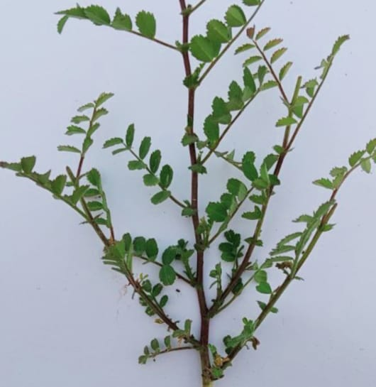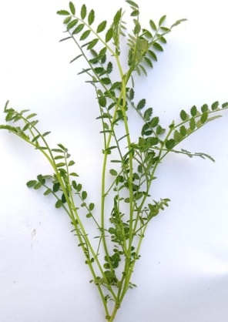
Plate 1 : Anthocyanin coloration

Present (A) Absent (B)

Plate 2: Colour of foliage

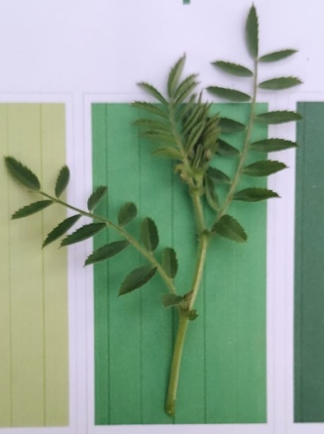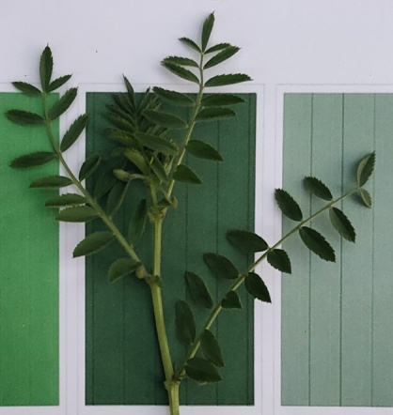
Medium Green (A) Dark Green(B)

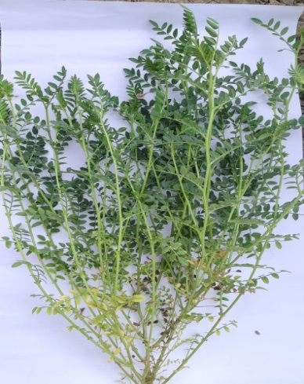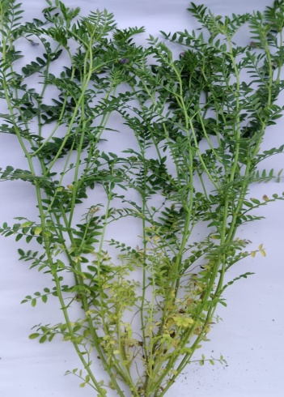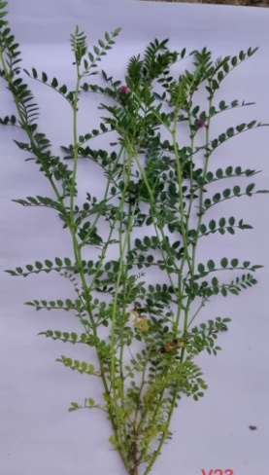
Plate 3 : Growth habit
Spreading(A) Semi erect (B) Erect (C)

Plate 4 Leaflet size (mm)

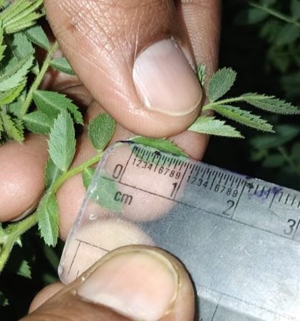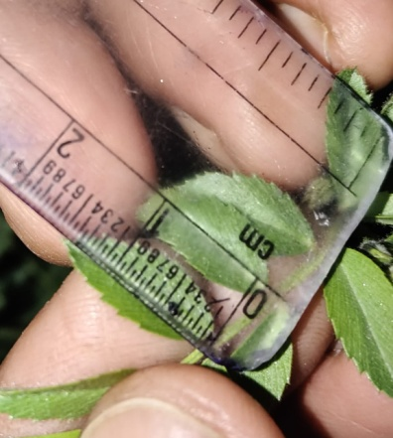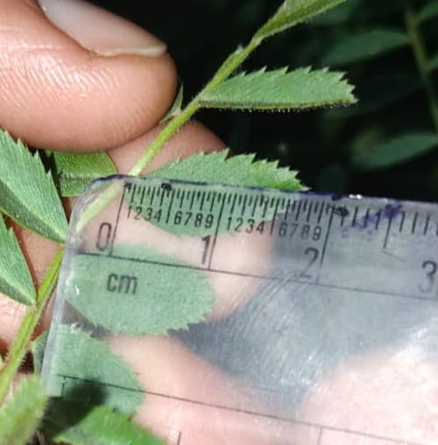
Small (A) Medium(B) Large(C)
Plate 5bLeaf Pattern
Plate 5a : Flower color

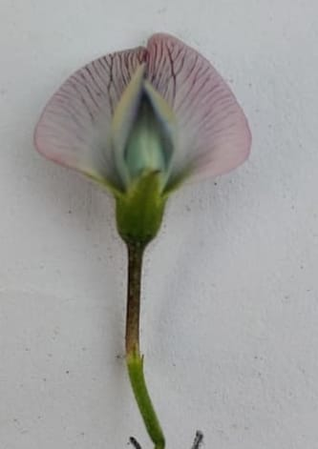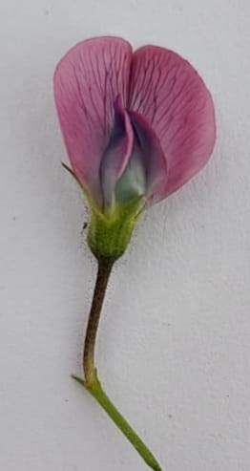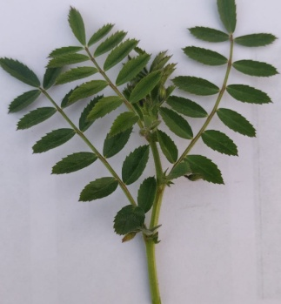
White Blue Pink
Pinnate

Plate 6 : Stripe on standard
Present (A) Absent(B)

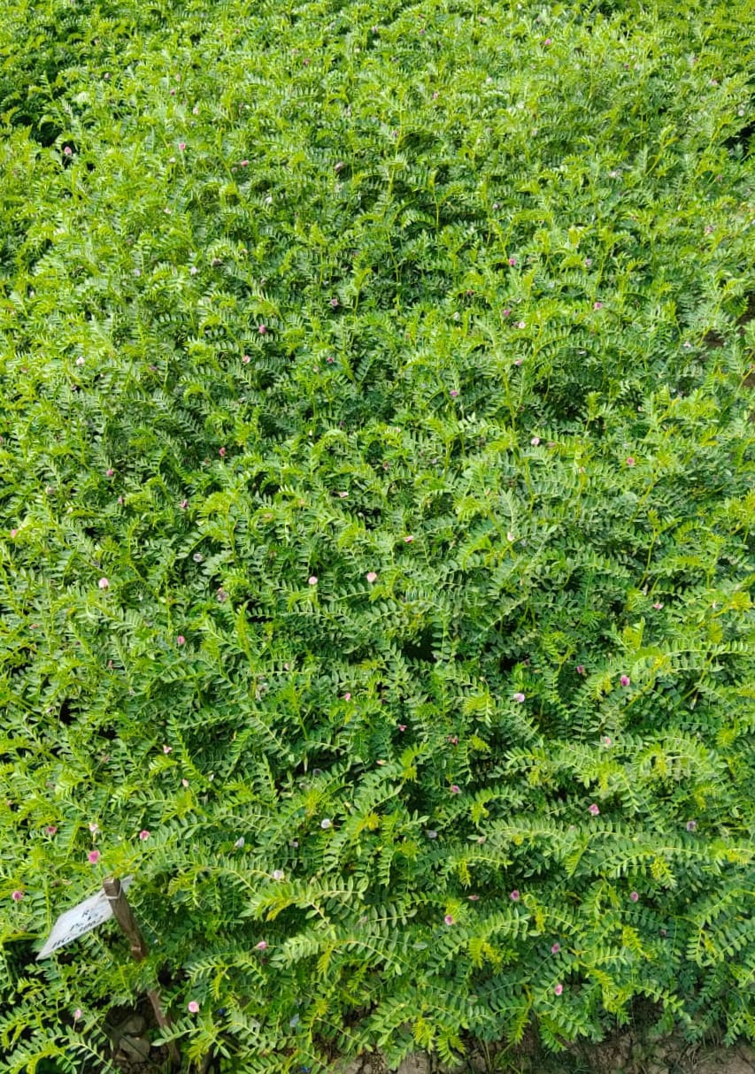

Plate 8 : Flower: Number per peduncle
Plate 7 : Time of 50% flowering


Twin (A) Single(B)

Breeding Methods in Chickpea: In the early stages of developing chickpeas, native or purchased genetic choices. They helped in the development of modifications to the hybridisation process, which generated almost all of the most recent classifications. According to the breeding program's ultimate target, only one, multiple, or numerous crosses are used. Backcross hybridisation is often used to add one or a few characteristics obtained from an uncultivated species or a genetic line to a successful variation. Segregating descendants can be accomplished by using pedigree, bulk, or a variety of these processes. (Gaur et al., 2007). For higher and faster genetic advancements, the precision and efficacy of choices in the separating stages need to be addressed. Screening in regulated conditions or at stressful sites may improve the accuracy of selecting for tolerance or resistance to hazards.
Table :3. Breeding Tools in Chickpea
S. No. | Breeding Tool | Description | Achievements in chickpea | References
 | Conventional breeding | Pedigree, Bulk and Backcross breeding methods | Development of high-yielding and disease-resistant varieties | Gaur et al., 2016, Varshney et al 2016
 | Hybridization | Crossing diverse parents to create variability | Improvement in seed yield, size and adaptability | Thudi et al., 2017
 | Mutation breeding | Use of physical and chemical mutagens | Development of early maturing and bold-seeded types | Lal et al., 2018
 | Marker-Assisted Selection | Selection using DNA markers linked to traits | Fusarium wilt and Ascochyta blight resistance | Varshny et al., 2018, Kumar et al., 2019
 | Marker-Assisted Backcrossing | Introgression of target genes into elite varieties | Rapid development of disease-resistant cultivars | Bharadwaj et al., 2020
 | QTL Mapping | Identification of genomic regions controlling traits | QTL for drought tolerance and yield | Jaganathan et al., 2020
 | Genome-Wide Association Studies | Marker trait association at while genome level | Identification of yield and stress elated genes | Roorkiwal et al., 2021
 | Genomic Selection | Prediction of breeding values using genome-wide markers | Improved selection efficiency for complex traits | Crossa et al., 2017, Roorkiwal et al., 2022
 | Genomics-Assisted Breeding | Integration of genomics with conventional breeding | Accelerated varietal development | Varshney et al., 2021
 | Speed breeding | Manipulation of light and temperature to shorten the generation time | 3-4 generations per year in chickpea | Watson et al., 2018, Samineni et al., 2024
 | High-Throughput phenotyping | Sensor and image-based phenotyping | Accurate screening for drought and heat tolerance | Tardieu et al., 2017, Mir et al., 2022
 | Omics approaches | Genomics transcritomics proteomics and metabolomics | Identification of stress-responsive genes | Kudapa et al., 2018
 | Bioinformatics tools | Data analysis and gene discovery platform | Candidate gene identification | Thudi et al., 2021
 | Cas genome editing | Precise gene modification | Functional validation of yield and stress genes | Badhan et al., 2021;
 | AI & Machine learning | Prediction of genotype-phenotype relationships | Improved genomic prediction accuracy | Montesinos Lopez et al., 2022, Pandey et al., 2024

Challenges and Limitations:
The Impact of the Environment on Chickpea Morphological Characteristics: Although the chickpea (Cicer arietinum L) is a cool-season, drought-resistant crop, the external environment has an important effect on its morphological features, including the height of the plant, growth habit, leaf size, pod quantity, and seed size. Among genetically identical plants, these environmental factors can lead to diversity in field experiments. Temperature, Availability of water, Soil fertility, etc.
Genetic Diversity in Chickpea Breeding:
Limited genetic basis: Particularly in cultivated varieties, chickpeas have an extremely restricted genetic base, which limits the potential of adding novel characteristics. Given this, it can be difficult to substantially improve production, tolerance for stress, or disease resistance through just conventional breeding.

Conclusion
A straightforward, dependable, and useful technique for examining variation in chickpeas is morphological characterisation. Desi and Kabuli chickpea genotypes can be easily identified and distinguished using the DUS descriptors supplied by PPV&FRA based on outward characteristics such as plant type, leaves, blooms, and seeds. Even though environmental factors may have an impact on these characteristics, they nevertheless offer important insights into the genetic diversity seen in chickpea germplasm. The large range of morphological diversity accessible affords considerable chances for plant breeders to identify suitable and superior genotypes. Overall, morphological characterisation plays a significant role in variety identification, protection, and improvement, and it strongly supports chickpea breeding programs, field evaluation, and quality seed production for producing improved chickpea varieties.

Disclaimer (Artificial intelligence)
Author(s) hereby declare that NO generative AI technologies such as Large Language Models (ChatGPT, COPILOT, etc.) and text-to-image generators have been used during the writing or editing of this manuscript.

References:

- Ahmad, F., Atta, B. M., Hussain, M., & Shah, T. M. (2020). Assessment of genetic diversity in chickpea (Cicer arietinum L.) using RAPD and ISSR molecular markers. Pakistan Journal of Botany, 52(2), 589–596.
- Ahmad, S. M., Ashraf, M., & Akram, N. A. (2012). Growth, yield and physiological responses of chickpea (Cicer arietinum L.) to soil salinity. Agricultural Water Management, 104, 87–94.
- Akhter, M. S., Uddin, M. N., Hossain, M. A., & Rahman, M. M. (2015). Genetic improvement of chickpea (Cicer arietinum L.) under drought conditions: Evaluation of yield and physiological traits. Field Crops Research, 173, 73–85.
- Asati R, Tripathi MK, Tiwari S, Yadav RK, Tripathi N 2022. Molecular breeding and drought tolerance in chickpea. Life.; 12:1846.
- Badhan, S., Ball, A. S., & Mantri, N. (2021). First report of CRISPR/Cas9-mediated DNA-free editing of 4CL and RVE7 genes in chickpea protoplasts. International Journal of Molecular Sciences, 22(1), 396.
- Bharadwaj, C., Tripathi, S., Soren, K. R., Thudi, M., Singh, R. K., Sheoran, S., Roorkiwal, M., Gaur, P. M., & Varshney, R. K. (2020). Introgression of Fusarium wilt resistance into elite chickpea cultivars using marker-assisted backcrossing. Legume Research, 43(3), 321–328.
- Bimbraw, A. S. (2016). Use of conservation technology for the improvement in production of chickpea in comparison to wheat. Current Agriculture Research, 4(1), 01-15.
- Blum, A. (2009). Drought resistance and tolerance in plants. Springer Science Business Media.
- Chaudhary, D. A., Khan, M. A., & Ahmad, S. (2011). Molecular markers in chickpea (Cicer arietinum L.): Advances and challenges. Plant Breeding, 130(4), 438–452.
- Crossa, J., Pérez-Rodríguez, P., Cuevas, J., Montesinos-López, O. A., Jarquín, D., de los Campos, G., Burgueño, J., González-Camacho, J. M., Pérez-Elizalde, S., Singh, R., Zhang, X., Gowda, M., Rutkoski, J., & Varshney, R. K. (2021). Genomic selection in plant breeding: Methods, models, and perspectives. Trends in Plant Science, 26(9), 888–903.
- FAO (2023) Food and Agricultural Organization of the United Nations. https://www.fao.org/faostat/en (Accessed May 15, 2025).
- Gaur, P. M., Jukanti, A. K., & Varshney, R. K. (2016). Chickpea breeding and management.Wallingford, UK: CAB International. ISBN: 978-1-78064-399-6
- Gaur, P.M.; Gowda, C.L.L.; Knights, E.J.; Warkentin, T.O.; Acikgoz, N.; Yadav, S.S.; Redden, B., Chen, W., Sharma, B., Kumar, J. 2007 Breeding Achievements. In Chickpea Breeding and Management; Eds.; CABI: Wallingford, UK,; pp. 391–416
- Ghaffari, P., Talebi, R., & Keshavarzi, F. (2017). Genetic diversity and population structure of chickpea (Cicer arietinum L.) landraces based on ISSR markers. Biochemical Systematics and Ecology, 72, 42–48.
- HR Bhandari, A Nishant Bhanu, K Srivastava, MN Singh, Shreya, A Hemantaranjan 2017. Assessment of genetic diversity in crop plants - an overview. Advances in Plants & Agriculture Research; 7(3):279‒286.
- Jaganathan, D., Thudi, M., Kale, S., Azam, S., Roorkiwal, M., Gaur, P. M., Kishor, P. B. K., Nguyen, H. T., Sutton, T., & Varshney, R. K. (2020). Genotyping-by-sequencing based QTL mapping for drought tolerance traits in chickpea. Frontiers in Plant Science, 11, 570.
- Joshi MA, Aggarwal D, Sanyal A. 2018. Cultivar Identification and diversity analysis based on morphological descriptors and image Analysis in chickpea (Cicer arietanum L.). Legume Research-An International Journal. 41(5):647-655.
- Kaiser, W. J., Rubio, J., & Muehlbauer, F. J. (2007). Genetics of resistance to Ascochyta blight in chickpea (Cicer arietinum L.). Plant Pathology, 56(4), 531–540.
- Kudapa, H., Song, Q. J., Chitikineni, A., Thudi, M., Lee, R., Wang, D., … & Varshney, R. K. (2018). Multi-omics approaches for chickpea improvement: From genotype to phenotype. Functional Plant Biology, 45, 893–911.
- Kumar, J., Abbo, S., & Udupa, S. M. (2019). Marker-assisted selection for Fusarium wilt resistance in chickpea (Cicer arietinum L.). Euphytica, 215, 1–14.
- Kumar, J., Choudhary, P., Solanki, R. K., & Patel, J. B. (2018). Genetic divergence analysis in chickpea (Cicer arietinum L.) using Mahalanobis D² statistics. International Journal of Current Microbiology and Applied Sciences, 7(2), 1345–1352.
- Kumar, S., Choudhary, A. K., Rana, K. S., & Sarker, A. (2010). Genetic resources and polyploidy in Cicer species: Implications for chickpea improvement. Euphytica, 175(1), 1–14.
- Lal, D., & Ravikumar, R. L. (2018). Development of genetic linkage map and identification of QTLs in chickpea (Cicer arietinum L.). International Journal of Current Microbiology and Applied Sciences, 7(6), 1234–1245.
- Malik, S. R., Bakhsh, A., Asif, M. A., Iqbal, U., & Iqbal, S. M. (2016). Assessment of genetic diversity in chickpea using seed storage protein profiling. Pakistan Journal of Agricultural Sciences, 53(2), 379–385.
- Meena, V. K., Verma, P., Jajoriya, R., & Sharma, R. (2025). Genetic diversity analysis in chickpea genotypes of south-eastern Rajasthan. Journal of Experimental Agriculture International, 47(4), 16–22.
- Mir, R. R., Zaman-Allahir, R., Singh, V. K., Kumar, S., & Kumar, A. (2022). High-throughput phenotyping for drought and heat stress in chickpea. Frontiers in Plant Science, 13, 906234.
- Mohan, Shanmugam and Thiyagarajan, Kalaimagal (2019). Genetic Variability, Correlation and Path Coefficient Analysis in Chickpea (Cicer arietinum L.) for Yield and its Component Traits. Int.J.Curr.Microbiol.App.Sci.8(5): 1801-1808
- Montesinos-López, O. A., Herr, A. W., Crossa, J., Crespo-Herrera, L., Dreisigacker, S., Gerard, G. & Vitale, P. (2024). Enhancing genomic prediction with integrated genomics and phenomics data. BMC Genomics, 25, 544.
- Pandey, M. K., Tiwari, S., Azam, S., Roorkiwal, M., Rathore, A., Singh, V. K., & Varshney, R. K. (2024). Artificial intelligence and machine learning approaches for legume crop improvement. Trends in Plant Science, 29(3), 245–258.
- PPV & FRA 2018. Guidelines for the Conduct of Test for Distinctness, Uniformity and Stability on Chickpea (Cicer arietanum L.).
- Pragati, K., Verma, S. K., Panwar, R. K., & Singh, M. (2024). Estimating genetic diversity in chickpea lines using cluster analysis and yield traits. International Journal of Plant & Soil Science, 36(9), 150–157.
- Rajpoot, S. S., Tripathi, M. K., Payasi, D. K., & Tiwari, S. (2025). Delineation of genetic diversity in chickpea employing multivariate techniques. Journal of Experimental Agriculture International, 47(9), 460–478.
- Rajpoot, S. S., Tripathi, M. K., Tiwari, S., & Payasi, D. K. (2025). Estimation of genetic diversity in desi chickpea genotypes employing microsatellite markers. Plant Cell Biotechnology and Molecular Biology, 26(9–10), 48–60.
- Roorkiwal, M., Bharadwaj, C., Barmukh, R., Dixit, G. P., Thudi, M., Gaur, P. M., Chaturvedi, S. K., Fikre, A., Hamwieh, A., Kumar, S., & Varshney, R. K. (2021). Genome-wide association mapping for yield and agronomic traits in chickpea. Scientific Reports, 11, 12345.
- Roorkiwal, M., Jain, A., Kale, S. M., Doddamani, D., Chitikineni, A., Thudi, M., & Varshney, R. K. (2018). Genome-wide association mapping for yield traits in chickpea. Plant Biotechnology Journal, 16(3), 676–688.
- Roorkiwal, M., Rathore, A., Das, R. R., Singh, M. K., Jain, A., Srinivasan, S., Gaur, P. M., & Varshney, R. K. (2022). Genomic selection for accelerated genetic gains in chickpea breeding. The Plant Genome, 15(2), e20218.
- Samineni, S., Saxena, K. B., Gaur, P. M., Sameerkumar, C. V., Varshney, R. K., & Rathore, A. (2024). Speed breeding in chickpea: Accelerating generation turnover for crop improvement. Frontiers in Sustainable Food Systems, 8, 1383302.
- Saxena, N. P., Krishnamurthy, L., & Johansen, C. (2010). High temperature stress during flowering reduces yield of chickpea (Cicer arietinum L.). Journal of Agronomy and Crop Science, 196(1), 69–78.
- Schutyser, M. A., Pelgram, P. M., van der Linck, A. J., Bom Tannin, K. F., & Wilkie, C. R. M. (2015). Dry fractionation for Sustainable production of functional legume protein concentrates. Trends in Food Science and Technology, 45(2), 327–335.
- Shedge,P.J., Patil, D.K. and Dawane, J.K. (2019) Correlation and Path Coefficient Analysis of Yield and Yield Components in Chickpea (Cicer arietinum L.). Int.J. Curr.Microbiol.App.Sci. 8(7): 1326-1333.
- Shrivastava, A., Babbar, A., Prakash, V., Tripathi, M. K., & Tiwari, S. (2025). Genetic and molecular diversity analysis of chickpea genotypes grown under rice-fallow conditions. Journal of Food Legumes, 38(2), 125–132.
- Singh, K. B., Malhotra, R. S., Halila, M. H., Knights, E. J., & Verma, M. M. (2013). Environmental effects on productivity and yield stability of chickpea (Cicer arietinum L.). Crop Science, 53(1), 211–220.
- Singh, M., Kumar, J., Singh, V. P., & Prasad, S. K. (2014). Water stress effects on growth, yield and water-use efficiency of chickpea (Cicer arietinum L.). Agricultural Water Management, 142, 1–10.
- Singh, M., Kumar, R., Singh, B., & Sharma, S. (2016). Genetic variability and divergence studies in chickpea (Cicer arietinum L.). Legume Research, 39(2), 235–240.
- Singh, R. K., Singh, C., Ambika, Chandana, B. S., Mahto, R. K., Patial, R. (2022). Exploring chickpea germplasm diversity for Broadening the genetic base utilizing genomic resources. Frontiers in Genetics, 13, 905771.
- Srikanth, B., Yadav, S. K., Kumar, A., & Meena, R. K. (2024). Assessment of genetic variability and divergence in chickpea under late sown conditions. International Journal of Advanced Biochemistry Research, 8(3), 599–604.
- Tanksley, S. D., & McCouch, S. R. (1997). Seed banks and gene flow in crop improvement. Science, 277, 1063–1066.
- Tardieu, F., Cabrera-Bosquet, L., Pridmore, T., & Bennett, M. (2017). Plant phenomics, from sensors to knowledge. Current Biology, 27(15), R770–R783.
- Thudi, M., Chitikineni, A., Liu, X., He, W., Roorkiwal, M., Yang, W., Jian, J., Doddamani, D., Gaur, P. M., Rathore, A., & Varshney, R. K. (2017). Recent advances in genomics-assisted breeding in chickpea. Plant Biotechnology Journal, 15(8), 997–1010.
- Thudi, M., Datta, S., Varshney, R. K., & Gaur, P. M. (2021). Genomics and breeding innovations in legumes: Progress and prospects. Functional Plant Biology, 48, 1018–1034.
- Tilahun, G., Mekbib, F., Fikre, A.and Eshete, M. (2015) Genotype x environment interaction and stability analysis for yield and yield related traits of Kabuli type chickpea (Cicer arietinum L.) in Ethiopia. AJB 14(18): 1564-1575.
- Tripathi, M. K., Mishra, N., Tiwari, S., Gupta, N., & Ahuja, A. (2023). Identification of polymorphic SSR markers and genetic diversity analysis in desi chickpea genotypes. Biological Forum – An International Journal, 15(3), 45–51.
- Tullu, A., Kaiser, W. J., Kraft, J. M., & Muehlbauer, F. J. (2008). Genetic recombination and breeding strategies for resistance to Ascochyta blight in chickpea (Cicer arietinum L.). Theoretical and Applied Genetics, 116(5), 687–698.
- Upadhyaya, H. D., Bajaj, D., Das, S., Kumar, V., Gowda, C. L. L., Sharma, S., & Varshney, R. K. (2017). Genetic structure, diversity, and allelic richness in global chickpea germplasm. Crop Science, 57(1), 1–12.
- Vander Maesen, L.J.G. (1972). The wild species of Cicer and the origin of the cultivated chickpea. Euphytica, 21(1): 1–19.
- Varshney, R. K., Bohra, A., Yu, J., Graner, A., Zhang, Q., & Sorrells, M. E. (2021). Designing future crops: Genomics-assisted breeding comes of age. Nature Reviews Genetics, 22, 561–580.
- Varshney, R. K., Roorkiwal, M., Sun, S., Bajaj, P., Chitikineni, A., Thudi, M., & Singh, N. P. (2021). Genomics-assisted breeding for chickpea improvement. Theoretical and Applied Genetics, 134, 1–24.
- Varshney, R. K., Singh, V. K., Kumar, A., Powell, W., Sorrells, M. E., & Zhang, Q. (2015). Genomics-assisted breeding for crop improvement. Trends in Plant Science, 20(8), 522–530.
- Varshney, R. K., Thudi, M., Roorkiwal, M., He, W., Upadhyaya, H. D., Yang, W., Bajaj, P., Cubry, P., Rathore, A., Jian, J., & Doddamani, D. (2018). Integrated physical, genetic and genome map of chickpea for crop improvement. Theoretical and Applied Genetics, 131, 561–575.
- Varshney, R.K., Song, C., Saxena, R.K., Azam, S., Yu, S., Sharpe, A.G., Cannon, S., Baek, J., Rosen, B.D., Tar’an, B., Millan, T., Zhang, X., Ramsay, L.D., Iwata, A., Wang, Y., Nelson, W., Farmer, A.D., Gaur, P.M., Soderlund, C., Penmetsa, R.V., Xu, C., Bharti, A.K., He, W., Winter, P., Zhao, S., Hane, J.K., Carrasquilla-Garcia, N., Condie, J.A., Upadhyaya, H.D., Luo, M.-C., Thudi, M., Gowda, C.L.L., Singh, N.P., Lichtenzveig, J., Gali, K.K., Rubio, J., Nadarajan, N., Dolezel, J., Bansal, K.C., Xu, X., Edwards, D., Zhang, G., Kahl, G., Gil, J., Singh, K.B., Datta, S.K., Jackson, S.A., Wang, J., & Cook, D.R. (2013). Draft genome sequence of chickpea (Cicer arietinum L) provides a resource for trait improvement. Nature Biotechnology, 31(3), 240–246.
- Vavilov NI. Studies on the origin of cultivated plants. Leningrad: Inst Applied Botony Plant Breeding; 1926.
- Watson, A., Ghosh, S., Williams, M. J., Cuddy, W. S., Simmonds, J., Rey, M.-D., & Hickey, L. T. (2018). Speed breeding is a powerful tool to accelerate crop research and breeding. Nature Plants, 4, 23–29.
- Yadav RK, Tripathi MK, Tiwari S, Tripathi N, Asati R, Patel V, Sikarwar RS, Payasi DK 2023a. Breeding and genomic approaches towards development of Fusarium wilt resistance in chickpea. Life; 13:988.
- Yadav, S., Shah, V., & Mod, B. (2019). Genetic diversity analysis between different varieties of chickpea using SSR markers. International Journal of Applied Sciences and Biotechnology, 7(2), 236–242
- Behera , K., Babbar , A., Vyshnavi , R. G., Patel , T., & Prajapati , S. S. (2023). Exploring the Chickpea Genotypes through Morphological Characterization for Improved Breeding. International Journal of Plant & Soil Science, 35(18), 551–563. https://doi.org/10.9734/ijpss/2023/v35i183320
- Asati, R., Tripathi, M. K., Yadav, R. K., Tiwari, S., Chauhan, S., Tripathi, N., ... & Yasin, M. (2023). Morphological description of chickpea (Cicer arietanum L) genotypes using DUS characterization. International Journal of Environment and Climate Change, 13(9), 1321-1341.
- Food Agriculture Organization (2020). FAOSTAT Statistical database of the United Nations Food and Agriculture Organization. Rome: FAO. Available online at: http://faostat.fao.org (accessed September 14, 2021).
- Singh, M., Kumar, T., Sood, S., Malhotra, N., Rani, U., Singh, S., ... & Kumar, S. (2022). Identification of promising chickpea interspecific derivatives for agro-morphological and major biotic traits. Frontiers in Plant Science, 13, 941372.

