Challenges in Solar-Based Skill Development Programmes for Tribal Entrepreneurship: Evidence from Ladakh, India

Abstract
Vocational skill development programmes focusing on enterprise creation are widely recognised as effective instruments for fostering economic self-reliance among tribal and indigenous populations in geographically isolated regions. However, systematic evaluation of participant-perceived challenges in such programmes remains limited, particularly in high-altitude contexts. This study addresses this gap by examining the operational and contextual challenges faced by trainees of a solar lantern and LED bulb fabrication programme conducted in Ladakh, India, under the Ministry of Electronics and Information Technology (MeitY). The study adopted a descriptive research design, employing a census approach that included the entire cohort of 320 trainees who completed the programme across Leh and Kargil districts. Primary data were collected using a pre-tested structured questionnaire administered through Google Forms, chosen for its accessibility across the geographically dispersed study area. The questionnaire was developed based on existing literature, expert consultations and programmatic documentation and was validated through content validity assessment and pilot testing. The Garrett ranking technique was employed to mathematically prioritise the perceived constraints, converting ordinal rankings into weighted scores for hierarchical analysis. Findings reveal that the perceived need for more advanced and interactive teaching methods emerged as the foremost concern (mean Garrett score: 61.21; consensus: 29.7%), followed by lack of financial support after training (58.63) and poor lighting and power supply (54.92). In contrast, language barriers (40.53) and transportation problems (38.98) ranked lowest, indicating effective communication strategies and logistical arrangements by programme authorities. The study concludes that the programme was effectively delivered and the identified challenges primarily reflect participant expectations for enhanced experiential learning, post-training financial linkages and external infrastructural limitations rather than fundamental programme deficiencies. Policy recommendations include integrating experiential pedagogical approaches, establishing micro-credit linkages for post-training enterprise formation, and deploying backup power infrastructure at training centres.
Keywords: Renewable energy entrepreneurship, Skill development programmes, Solar lantern and LED fabrication, Tribal communities, Sustainable livelihoods, Garrett ranking technique, High-altitude regions, Programme evaluation

1. Introduction
Entrepreneurship development is globally recognised as a critical pathway for economic empowerment, particularly among marginalised populations where conventional employment opportunities remain scarce (Rumbayan et al., 2018, Cumberland et al., 2024). In developing economies, skill development programmes targeting self-employment have emerged as vital instruments for bridging the gap between economic marginalisation and formal market participation, especially in rural and tribal contexts (Abdelwahed et al., 2023, Kissi et al., 2020). These interventions are considered particularly effective when they combine technical training with sustained institutional support to ensure the long-term viability of newly established micro-enterprises (Brixiova et al., 2020).
Within this broader framework, renewable energy-based enterprises have gained significant attention as vehicles for sustainable livelihood creation. Solar energy technologies, in particular, offer considerable potential in remote and off-grid areas by simultaneously addressing energy access deficits and generating decentralised employment opportunities (Dellosa and Baroca 2021, Ahlborg and Hammar, 2014). International agencies and national governments have increasingly invested in training programmes that equip rural populations with the technical skills necessary for manufacturing, assembling and maintaining solar hardware (IRENA, 2020, Price., 2021). However, research consistently demonstrates that technical training alone is insufficient; complementary support mechanisms including financial linkages, post-training mentorship and market integration are essential for translating acquired skills into viable enterprises (Kingsley and Okan, 2024, Dioha and Kumar, 2020).
In India, the government has implemented several skill development initiatives targeting tribal communities under programmes such as the National Skill Development Mission and sector-specific schemes administered by ministries including the Ministry of Electronics and Information Technology (MeitY). These programmes aim to promote self-employment among tribal populations who face distinctive challenges arising from geographic isolation, limited market access and inadequate infrastructure (Kumar et al., 2021, NITI Aayog, 2018). Despite significant programmatic investments, systematic empirical evaluations of participant-perceived challenges remain limited, creating a knowledge gap that constrains evidence-based programme improvement (Sumon et al., 2020, Galvao and Ferreira, 2020).
The Union Territory of Ladakh presents a particularly relevant context for examining these challenges. Situated at extreme altitudes between 32.5°N to 35.5°N latitude and 74°E to 80°E longitude at India’s northernmost boundary, Ladakh is characterised by sparse population distribution, extreme climatic conditions and severely constrained conventional economic activities (Pait, 2014). Prolonged winters, difficult terrain and unreliable conventional power supply networks further limit livelihood options (Urpelainen, 2014). However, the region receives abundant solar radiation annually, making photovoltaic technology highly suitable for localised off-grid energy generation and enterprise development (Bhattacharyya and Palit, 2014, Okesiji, 2025). Recognising this potential, MeitY conducted a Tribal Entrepreneurship Training Programme on solar lantern and LED bulb fabrication across instructional centres in Leh and Kargil districts, targeting tribal youth for skill development and enterprise formation.
While such government-sponsored programmes provide essential foundational training and infrastructure, rigorous quantitative evaluation of participant feedback is critical for identifying specific areas where pedagogical execution and post-training support can be systematically optimised (Bisaga, 2021, Colombell et al., 2022). Previous evaluations have predominantly focused on general programme satisfaction or output metrics, with limited attention to the systematic prioritisation and stratification of perceived constraints from the trainees’ perspective. This study addresses this gap by employing the Garrett ranking technique to mathematically prioritise the operational and contextual challenges reported by programme participants, thereby establishing a clear distinction between internal programme provisions and broader environmentally imposed limitations.
The study holds significance for India’s national policy discourse, particularly in the context of the Tribal Sub-Plan, the National Skill Development Mission and Ladakh’s strategic importance as a Union Territory. Understanding the specific challenges faced by tribal trainees in such programmes can inform the design of more effective, context-sensitive interventions that enhance the sustainability and scalability of renewable energy entrepreneurship across remote mountainous regions.

2. Review of Literature
2.1 Theoretical Framework
This study is informed by two complementary theoretical perspectives. First, the Human Capital Theory (Becker, 1964) posits that investments in education and training enhance individual productivity and earning potential. In the context of tribal skill development, this framework suggests that structured vocational training programmes can equip participants with the technical competencies required for entrepreneurial activity, provided that complementary support systems are available (Cumberland et al., 2024). Second, the Entrepreneurship Ecosystem Theory (Isenberg, 2011) emphasises that successful entrepreneurship requires an enabling environment comprising financial access, institutional support, market linkages and appropriate infrastructure beyond individual skills alone. This framework helps explain why programme participants may report challenges related to post-training financial support and market integration even when the training itself is effectively delivered (Dioha and Kumar, 2020, Suswaram, 2025).
2.2 Skill Development and Tribal Entrepreneurship
Skill development programmes have been extensively studied as instruments for promoting self-employment among disadvantaged populations (Kumar et al., 2019) documented that skill training initiatives in rural India significantly enhanced entrepreneurial outcomes when accompanied by institutional support mechanisms. Similarly, Rana et al. (2020) found that the effectiveness of entrepreneurship training depends substantially on the incorporation of practical, hands-on components that enable participants to apply theoretical knowledge to real-world scenarios. In tribal contexts specifically, research has highlighted the unique challenges arising from geographic isolation, limited prior exposure to technical education and cultural factors that influence programme effectiveness (Kissi et al., 2020, Desai, 2016).
2.3 Renewable Energy Entrepreneurship in Remote Regions
The intersection of renewable energy technology and entrepreneurship development has attracted growing scholarly attention (Dellosa and Baroca, 2021) demonstrated that solar energy programmes in South Asia successfully created employment opportunities in remote areas, while (Bhattacharyya and Palit, 2014) highlighted the particular suitability of decentralised solar systems for mountainous regions with limited grid connectivity. More recently, Okesiji (2025) documented the performance of solar-based off-grid systems in high-altitude regions, confirming their technical viability for enterprise development. However, Bisaga (2021) cautioned that technology transfer alone is insufficient and must be accompanied by innovation in delivery mechanisms and post-training support structures. Prince (2021) further emphasised that sustainable energy entrepreneurship requires robust financial ecosystems and continued institutional engagement beyond the initial training phase.
2.4 Programme Evaluation and the Garrett Ranking Technique
The evaluation of skill development programmes has employed various methodological approaches, including Likert-scale assessments, weighted averages and ranking techniques. The Garrett ranking technique, specifically, has been widely adopted in agricultural extension, rural development and programme evaluation research for its ability to convert qualitative ordinal rankings into quantitative scores that enable precise hierarchical prioritisation (Garrett and Woodworth, 1969). Unlike simple frequency counts, the Garrett method assigns weighted scores based on the relative position of each factor within individual respondent rankings, thereby providing a more nuanced understanding of perceived severity (Galvao and Ferreira, 2020). This method has been successfully applied in constraint analysis studies across diverse developmental contexts in India and other developing countries, making it well-suited for the present investigation.
2.5 Conceptual Framework
Based on the theoretical perspectives and empirical literature reviewed above, this study adopts a conceptual framework that examines the relationship between three key dimensions: (a) programme inputs, including training design, instructional quality, infrastructure provision and logistical arrangements; (b) perceived challenges, encompassing pedagogical concerns, financial constraints, infrastructural limitations and environmental factors; and (c) programme outcomes, including enterprise sustainability, skill acquisition and livelihood development. The framework recognises that perceived challenges may arise from both internal programme factors and external contextual constraints, and that distinguishing between these sources is essential for targeted programme improvement.

3. Objectives of the Study
3.1 Main Objective
The main objective of this study was to systematically evaluate the operational and contextual challenges perceived by trainees of the Tribal Entrepreneurship Training Programme on solar lantern and LED bulb fabrication in Ladakh, India, using a quantitative prioritisation approach.
3.2 Specific Objectives
The specific objectives were: (i) to identify and rank the operational, pedagogical, financial and environmental challenges perceived by the 320 programme trainees using the Garrett ranking technique; (ii) to differentiate programme-specific limitations from broader regional and infrastructural constraints affecting training effectiveness and (iii) to formulate evidence-based policy recommendations for strengthening future skill development and enterprise incubation initiatives in high-altitude tribal regions.

4. Study Area
The study was conducted in the Union Territory of Ladakh, situated at India’s northernmost boundary between 74°E to 80°E longitude and 32.5°N to 35.5°N latitude. The rugged terrain features extreme altitudes, sparse populations and volatile meteorological conditions that severely restrict commercial activities, seasonal mobility and centralised market accessibility (Palit, 2014). Despite these formidable geographic constraints, the region receives abundant solar radiation annually, rendering photovoltaic technology highly suitable for localised off-grid energy generation (Bhattacharyya and Palit, 2014). The Tribal Entrepreneurship Training Programme on solar lantern and LED bulb fabrication was conducted at well-equipped instructional centres across the Leh and Kargil districts. To ensure consistent daily attendance from dispersed remote villages, local authorities provided organised transportation using dedicated passenger buses.

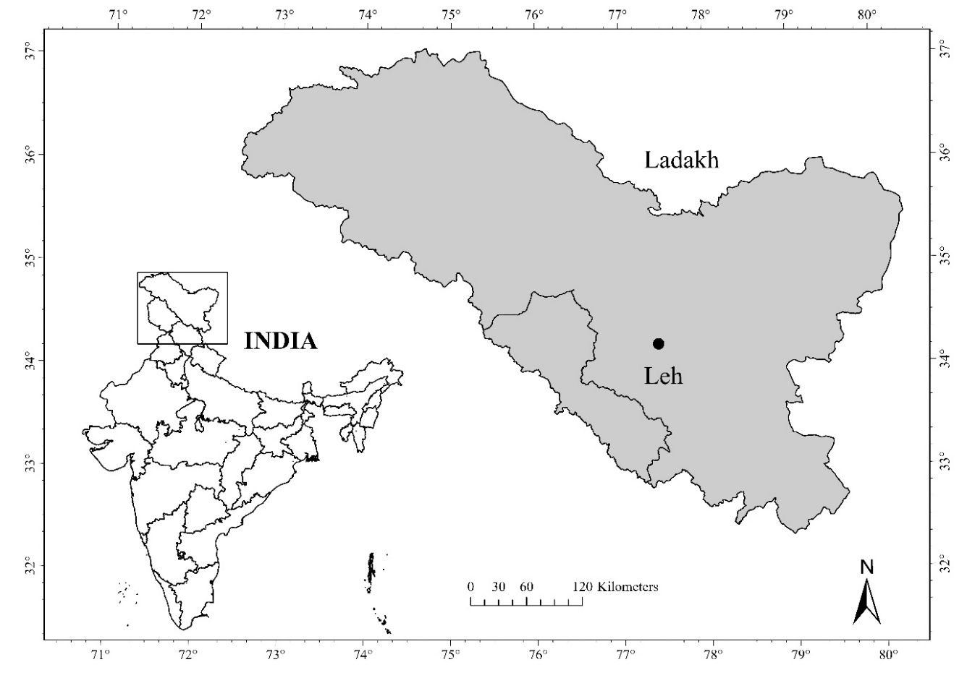

5. Figure 1: Study location map of Ladakh

Research Methodology
5.1 Research Design
This study adopted a descriptive research design, which is appropriate for systematically documenting and analysing the characteristics and perceptions of a defined population without manipulating variables (Kothari, 2004). The descriptive approach was chosen because the primary objective was to identify, rank and categorise the perceived challenges of programme trainees rather than to establish causal relationships between variables.
5.2 Study Population and Sampling
The study population comprised 320 trainees who completed the Tribal Entrepreneurship Training Programme on solar lantern and LED bulb fabrication conducted under MeitY across Leh and Kargil districts. A census approach was adopted, including the entire cohort of 320 trainees as respondents. This approach was selected because the total population was finite and accessible, and complete enumeration eliminated sampling error while ensuring comprehensive representation of all programme participants. Absolute consistency in training content was maintained, as every trainee received identical pedagogical instruction, academic curriculum and temporal duration.
5.3 Data Collection Instrument
Primary data were collected using a structured questionnaire developed based on academic literature on skill development and entrepreneurship training (Galvao and Ferreira, 2020, Rana et al., 2020), expert consultations with programme administrators and trainers and localised programmatic considerations. The questionnaire was administered through Google Forms, which was selected as the data collection medium for the following reasons: (a) the geographic dispersion of respondents across remote villages in Leh and Kargil districts made physical administration logistically challenging, (b) the training programme itself included digital literacy components, ensuring that participants possessed the necessary familiarity with digital tools and (c) Google Forms enabled efficient data compilation and reduced transcription errors associated with paper-based surveys in remote contexts.
5.4 Reliability and Validity
Content validity of the questionnaire was established through expert review by three subject matter experts familiar with skill development programmes and the Ladakh context. The instrument was pilot-tested with a subset of 30 trainees (not included in the final analysis) to assess clarity, comprehension and response consistency. Feedback from the pilot study was incorporated to refine item wording and response options. Reliability was assessed using internal consistency checks across related items, confirming that the questionnaire consistently measured the intended constructs.

5.6 Analytical Tool: Garrett Ranking Technique
The Garrett ranking technique was selected as the analytical tool for this study based on its established suitability for perception-based prioritisation in programme evaluation research. Unlike Likert-scale methods, which assess individual item ratings independently, the Garrett technique requires respondents to rank all factors simultaneously, thereby capturing relative severity perceptions and enabling direct inter-factor comparison (Garrett and Woodworth, 1969). Compared to simple weighted averages, the Garrett method provides more robust prioritisation by converting ordinal ranks into percentage positions and then into standardised scores using a reference table, reducing the influence of extreme responses.
The mathematical procedure involved the following steps: (i) respondents ranked the ten identified challenges in order of perceived severity (1 = most severe to 10 = least severe), (ii) ordinal ranks were converted into percentage positions using the formula: Percent Position = 100(R − 0.5) / N, where R represents the assigned rank and N represents the total number of challenges evaluated (N = 10), (iii) percentage positions were converted into Garrett scores using the standard Garrett conversion table and (iv) mean Garrett scores were computed for each challenge to establish the final hierarchical ranking, where higher scores indicate greater perceived severity.
5.7 Justification for Garrett Ranking over Alternative Methods
The Garrett ranking technique was preferred over alternative analytical methods for several reasons. First, unlike Likert-scale assessments, which may suffer from central tendency bias and do not enforce inter-factor comparison, the ranking approach ensures that respondents differentiate between challenges based on perceived importance. Second, compared to Kendall’s coefficient of concordance, which primarily measures agreement among rankers, the Garrett technique provides individual factor scores that enable both hierarchical ranking and consensus analysis. Third, the method is well-established in Indian social science research, particularly in agricultural extension and rural development constraint analyses, providing a strong precedent for its application in the present context (Galvao and Ferreira, 2020).

6. Results
This section presents the findings derived from the Garrett ranking computations, systematically documenting the perceived challenges reported by the 320 trainees.
6.1 Garrett Ranking of Perceived Challenges
Table 1: Garrett ranking of perceived challenges and programme feedback (N = 320)
S. No. | Challenges | Mean Garrett Score | Final Rank
1 | Perceived need for improved teaching methods | 61.21 | I
2 | Lack of financial support after training | 58.63 | II
3 | Poor lighting and power supply | 54.92 | III
4 | Lack of post-training follow-up support | 54.18 | IV
5 | Harsh climatic conditions | 47.88 | V
6 | Inadequate practical hands-on training | 47.02 | VI
7 | Training was beneficial | 46.64 | VII
8 | Difficulty in understanding technical concepts | 46.49 | VIII
9 | Language barriers | 40.53 | IX
10 | Transportation problems | 38.98 | X

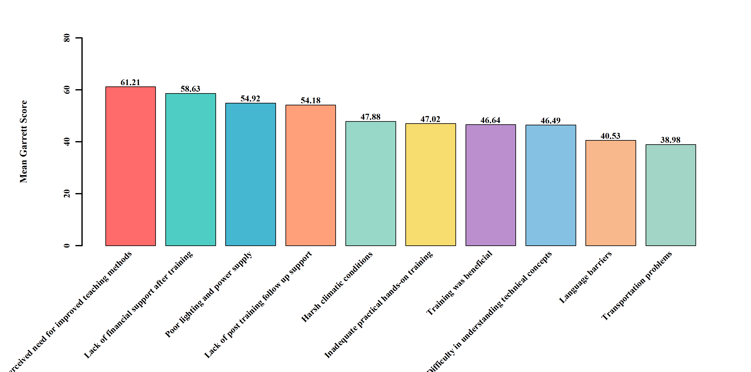Figure 2: Comparative Garrett scores across identified challenges
The results presented in Table 1 reveal that the perceived need for improved teaching methods emerged as the highest-ranked challenge with a mean Garrett score of 61.21, securing the first position. This was closely followed by lack of financial support after training (58.63, Rank II), poor lighting and power supply (54.92, Rank III) and lack of post-training follow-up support (54.18, Rank IV). Harsh climatic conditions (47.88, Rank V) and inadequate practical hands-on training (47.02, Rank VI) occupied intermediate positions. The variable ‘Training was beneficial’ (46.64, Rank VII) represents a positive evaluative sentiment rather than a challenge and was deliberately included to capture overall programme appreciation alongside reported difficulties. Difficulty in understanding technical concepts (46.49, Rank VIII), language barriers (40.53, Rank IX) and transportation problems (38.98, Rank X) ranked lowest, indicating relatively minor concerns.

6.2 Distribution of Challenge Rankings
Table 2: Distribution of challenge rankings across trainee responses (frequency)
Challenges | Ranked 1st | Ranked 2nd–3rd | Ranked 4th–5th | Ranked Below 5th
Perceived need for improved teaching methods | 95 | 89 | 72 | 64
Lack of financial support after training | 78 | 85 | 68 | 89
Poor lighting and power supply | 62 | 71 | 58 | 129
Lack of post-training follow-up support | 58 | 65 | 52 | 145
Harsh climatic conditions | 45 | 51 | 42 | 182
Inadequate practical hands-on training | 43 | 48 | 40 | 189
Training was beneficial | 42 | 46 | 38 | 194
Difficulty in understanding technical concepts | 41 | 45 | 36 | 198
Language barriers | 32 | 38 | 30 | 220
Transportation problems | 28 | 35 | 27 | 230

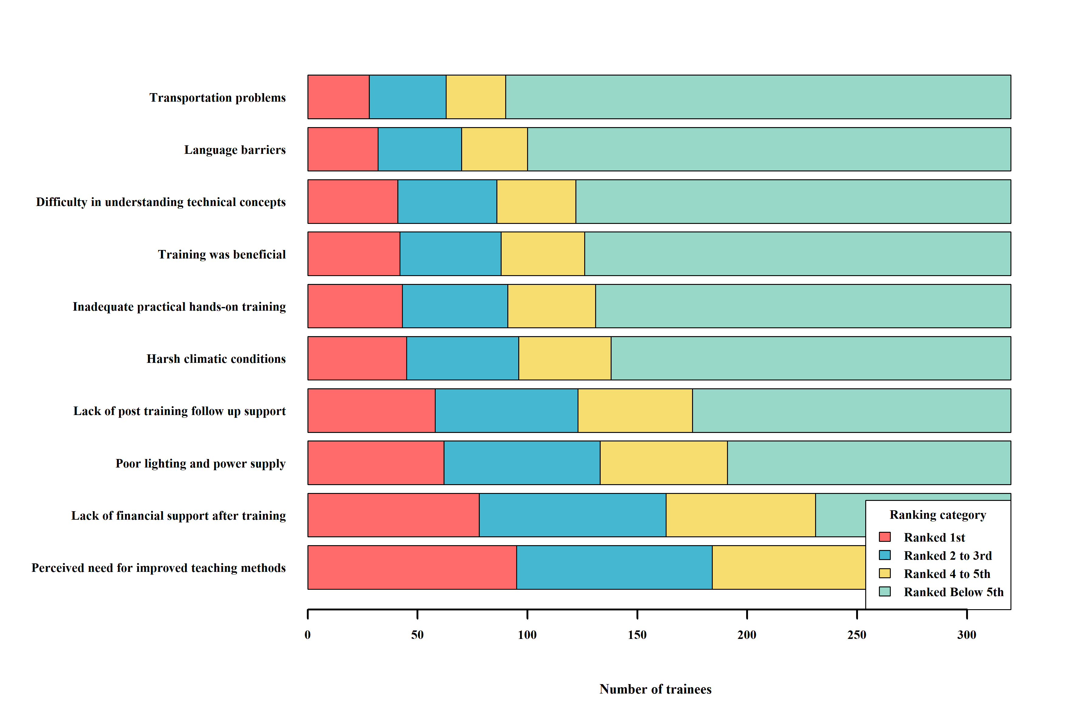Figure 3: Distribution of challenge rankings across trainee responses
The distributional analysis reveals that 95 trainees ranked the perceived need for improved teaching methods as their foremost concern, while an additional 89 positioned it within the 2nd to 3rd priority. Similarly, lack of financial support was ranked 1st by 78 respondents and placed in the 2nd to 3rd tier by 85 participants. In contrast, transportation problems and language barriers were overwhelmingly relegated to below 5th rank by 230 and 220 trainees respectively, confirming their relatively low perceived severity.

6.3 Consensus Analysis and Priority Classification
Table 3: Consensus score, opinion spread and priority classification of challenges
Challenges | Garrett Score | Consensus (%) | Opinion Spread (%) | Top Half (%) | Priority
Perceived need for improved teaching methods | 61.21 | 29.7 | -9.7 | 57.5 | High
Lack of financial support after training | 58.63 | 24.4 | 3.4 | 50.9 | High
Poor lighting and power supply | 54.92 | 19.4 | 20.9 | 41.6 | High
Lack of post-training follow-up support | 54.18 | 18.1 | 27.2 | 38.4 | High
Harsh climatic conditions | 47.88 | 14.1 | 42.8 | 30.0 | Moderate
Inadequate practical hands-on training | 47.02 | 13.4 | 45.6 | 28.4 | Moderate
Training was beneficial | 46.64 | 13.1 | 47.5 | 27.5 | Moderate
Difficulty in understanding technical concepts | 46.49 | 12.8 | 49.1 | 26.9 | Low
Language barriers | 40.53 | 10.0 | 58.8 | 21.9 | Low
Transportation problems | 38.98 | 8.8 | 63.1 | 19.7 | Low

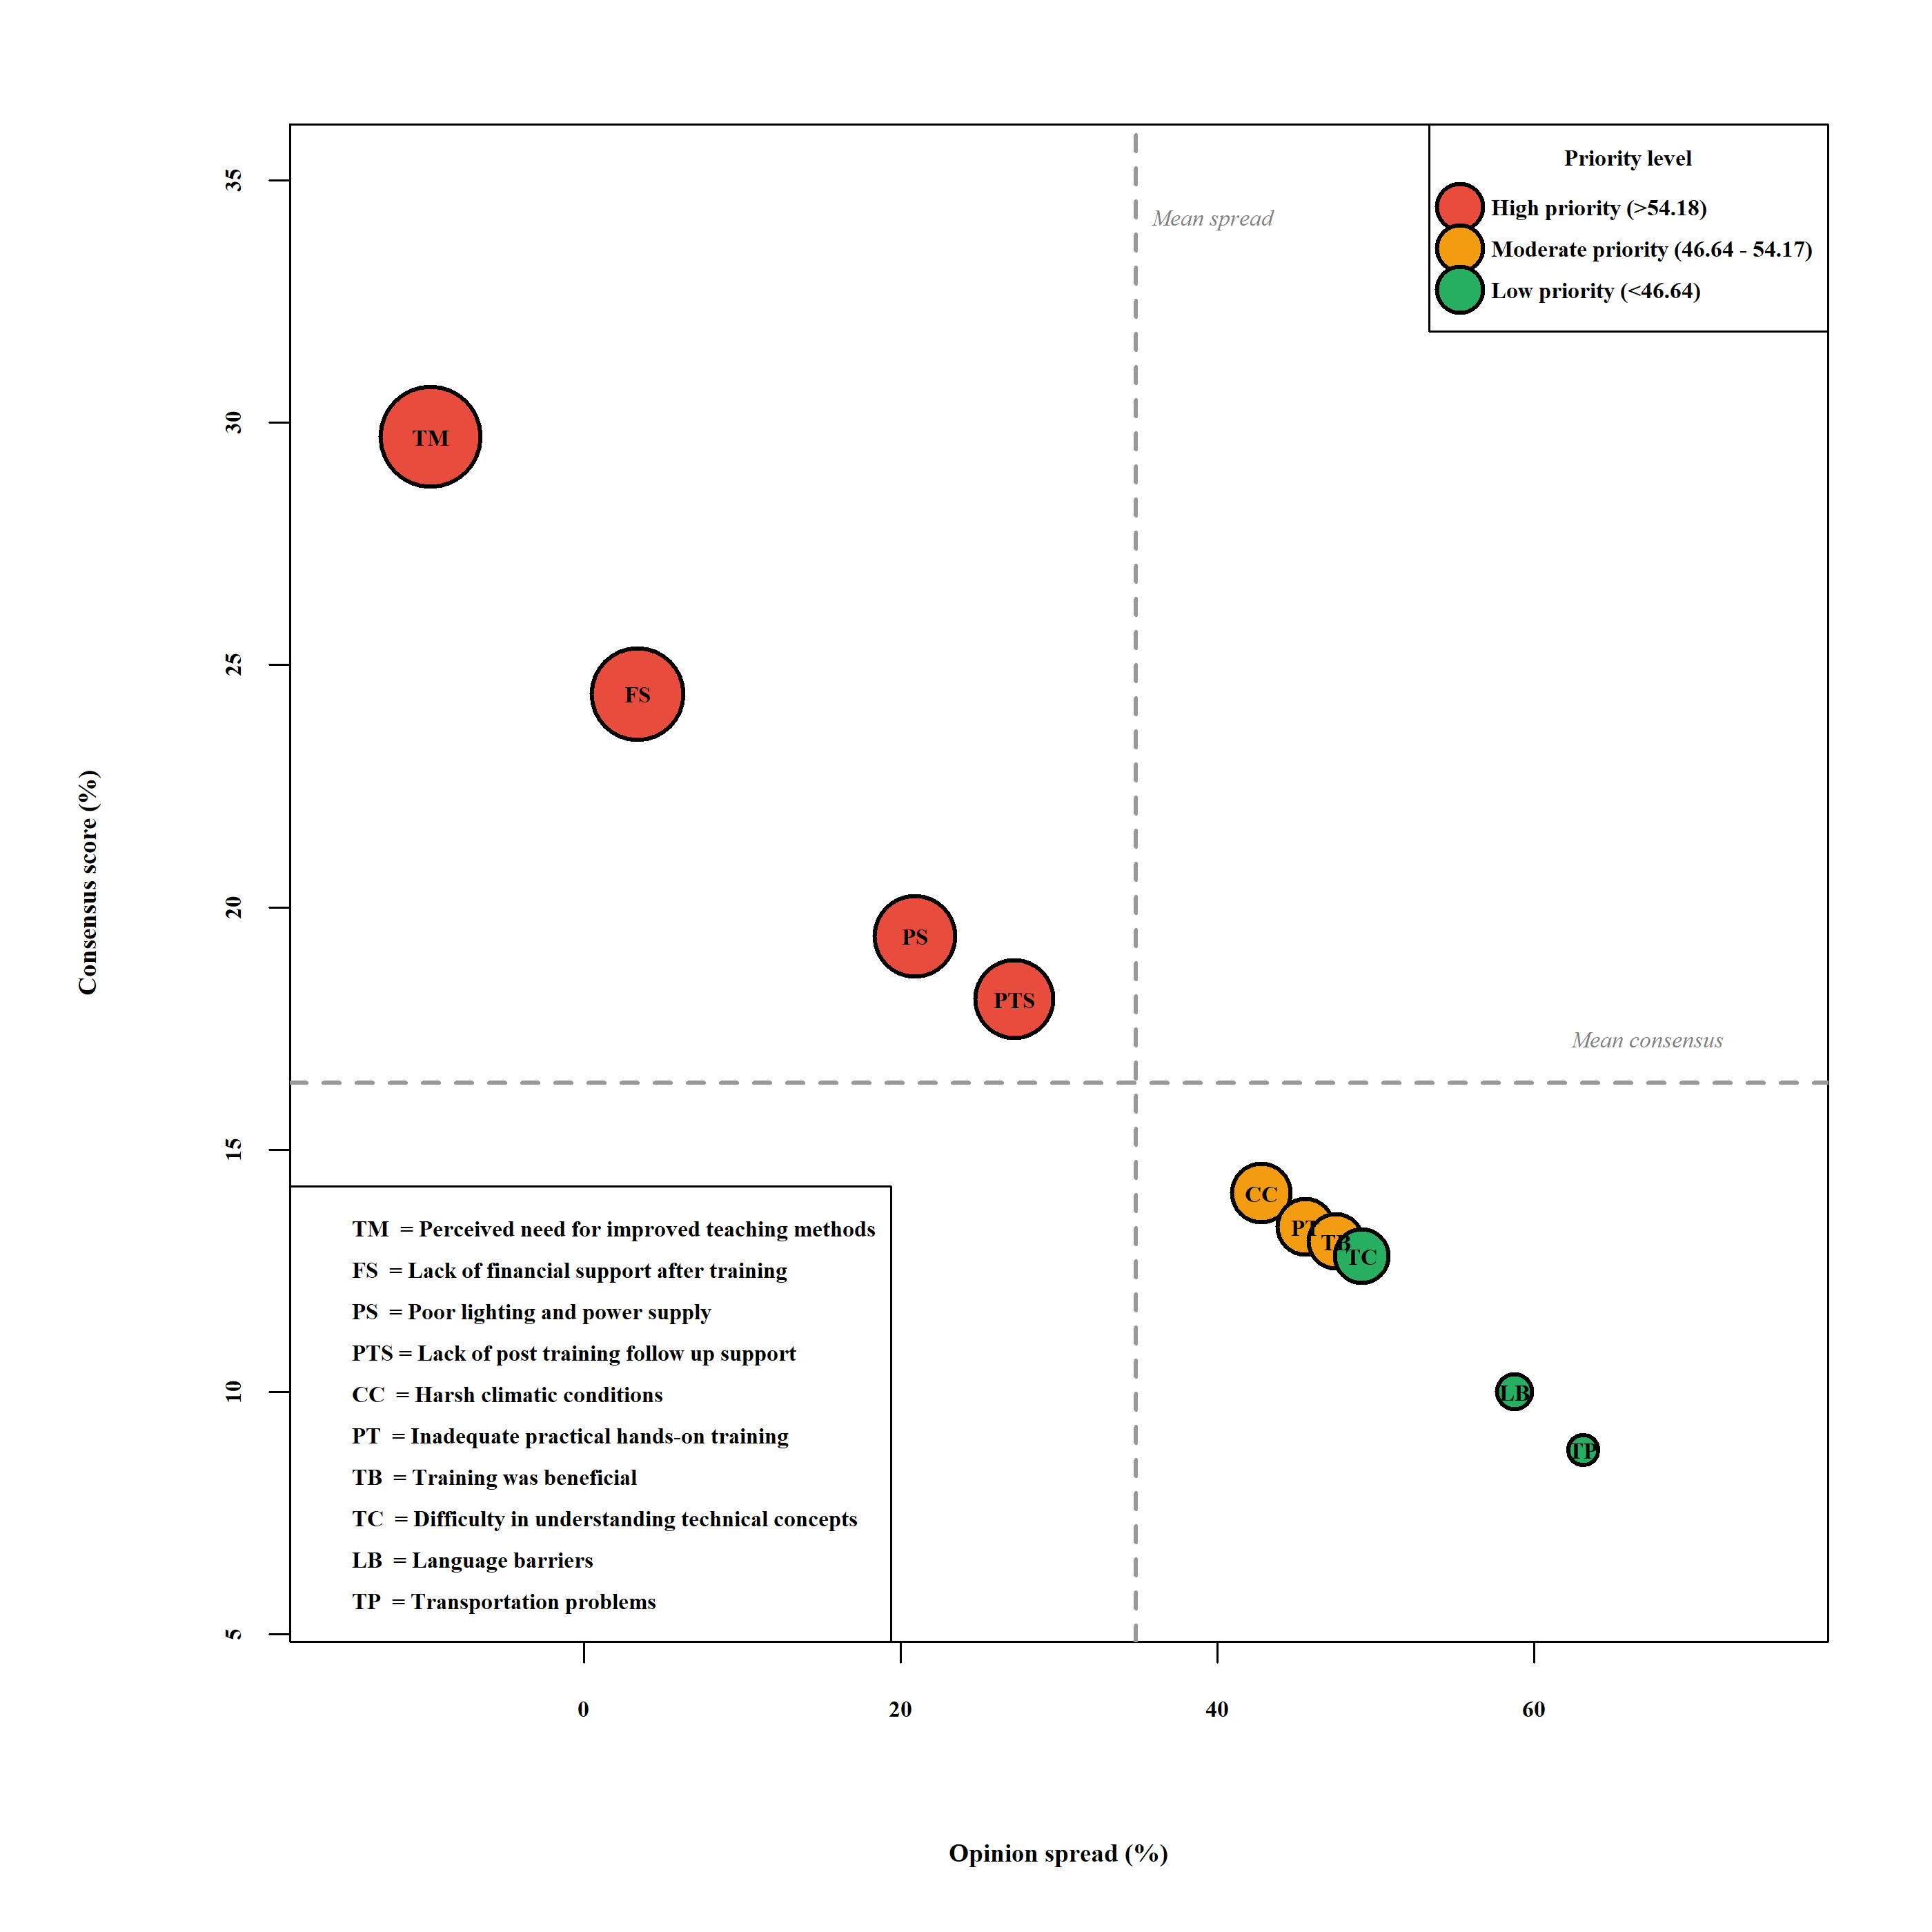Figure 4: Consensus score versus opinion spread analysis of training challenges
The priority matrix categorises the challenges into High, Moderate and Low urgency tiers. Perceived need for enhanced teaching methods recorded a 29.7% consensus with a -9.7% opinion spread, and 57.5% of respondents classified it as a primary concern. Lack of financial support (24.4% consensus, 3.4% spread) also achieved High Priority. Poor lighting and power supply (19.4% consensus, 20.9% spread) and lack of post-training follow-up (18.1% consensus, 27.2% spread) similarly fell within the High Priority tier. Climatic conditions (47.88), inadequate hands-on training (47.02) and training benefits acknowledgement (46.64) constituted Moderate Priority concerns. Technical comprehension difficulties, language barriers and transportation issues exhibited wide opinion spreads (49.1%, 58.8% and 63.1% respectively), placing them in the Low Priority category.

7. Discussion
This section interprets the findings presented above in light of existing literature and the contextual realities of the training programme implementation.
7.1 Pedagogical Expectations versus Programme Delivery
Although the perceived need for improved teaching methods emerged as the highest-ranked concern, this finding should not be interpreted as a failure of instructional delivery. The programme was implemented in a structured and systematic manner with competent trainers delivering uniform content to all participants. The elevated ranking instead reflects growing expectations among trainees for more advanced, interactive and experience-based learning approaches. Research in entrepreneurship education consistently demonstrates that as learners gain exposure, they tend to demand higher levels of practical engagement and problem-solving depth (Mets et al., 2021 and Colombelli et al., 2022). Cumberland et al. (2024) similarly reported that participants in entrepreneurship training programmes frequently express aspirations for more sophisticated pedagogical methods, indicating learner engagement rather than programme inadequacy. Therefore, this finding represents a demand for pedagogical enhancement rather than a deficiency in trainer capability.
7.2 Financial Support and Post-Training Ecosystem Gaps
The lack of financial support after training (Rank II) represents an external structural limitation rather than a shortcoming of the programme itself. While the initiative successfully imparted technical skills required for enterprise development, access to financial capital typically falls beyond the operational scope of skill development interventions (Brixiova et al., 2020) documented that even well-designed training programmes require complementary financial ecosystems, including micro-credit and institutional seed funding, to enable enterprise formation (Kingsley and Okan, 2024) further confirmed that financial inclusion mechanisms significantly enhance the growth trajectory of rural micro-enterprises in developing economies. This finding aligns with the entrepreneurship ecosystem framework (Isenberg, 2011), which emphasises that enterprise sustainability depends on a supportive institutional environment beyond individual skill acquisition.

7.3 Infrastructural and Environmental Constraints
Poor lighting and power supply (Rank III) were primarily linked to sporadic territorial power failures prevalent in meteorologically volatile regions such as Ladakh. These infrastructural disruptions function independently of programme design, underscoring external regional limitations rather than internal programme inefficiency (Kishore and Ippili, 2025). Okesiji (2025) similarly documented power reliability challenges in high-altitude solar energy deployments, confirming that such issues are endemic to the geographic context. Harsh climatic conditions (Rank V) were appropriately categorised as a moderate concern, reflecting the unavoidable influence of extreme altitude and weather patterns on programme operations (Ramasubramanian and Ramakrishna, 2023).
7.4 Post-Training Follow-up and Mentorship
The identification of limited post-training follow-up support (Rank IV) should be interpreted as a demand for extended institutional engagement rather than an absence of support mechanisms. The programme effectively delivered core competencies within its defined timeframe; however, participants indicated the need for continued mentorship during the transition to real-world enterprise operations (Ndlovu et al., 2025) demonstrated that entrepreneurial coaching and sustained mentorship significantly enhance self-efficacy among first-time entrepreneurs, particularly in resource-constrained settings (Kanaan-Jebra et al., 2022) similarly found that the long-term impact of entrepreneurship training depends substantially on post-programme advisory support.
7.5 Technical Comprehension and Communication
Difficulty in understanding technical concepts (Rank VIII) can be attributed to differences in educational background and limited prior exposure to technical subjects among tribal trainees. In rural and tribal contexts, such challenges are expected when introducing specialised engineering concepts and indicate the need for further simplification and contextualisation of content rather than ineffective teaching (Kissi et al., 2020). Language barriers (Rank IX) and transportation problems (Rank X) ranked lowest, confirming that communication strategies and logistical arrangements adopted during the programme were largely effective (Kyeyune and Ntayi, 2025; Palit, 2014).

7.6 Positive Programme Assessment
The variable ‘Training was beneficial’ (Rank VII, score 46.64) represents a distinctly positive evaluation, demonstrating that participants recognised the foundational utility of the programme while simultaneously assigning greater urgency to financial, infrastructural and procedural concerns. This pattern is typical in programme evaluations where beneficiaries acknowledge core benefits while recommending enhancements (Gavao and Ferreira, 2020).

8. Conclusion
This study evaluated the operational and contextual challenges perceived by 320 participants of a solar lantern and LED bulb fabrication programme conducted for tribal communities in Ladakh. The Garrett ranking analysis revealed that pedagogical enhancement expectations (mean score: 61.21), post-training financial support needs (58.63) and power supply constraints (54.92) were the highest-priority challenges. These findings largely reflect participant aspirations for advanced learning experiences and external ecosystem gaps rather than fundamental deficiencies in programme delivery. The programme successfully maintained consistent instructional delivery, adequate training infrastructure and effective logistical support, as evidenced by the low severity rankings assigned to language barriers (40.53) and transportation problems (38.98). Environmental constraints, particularly harsh climatic conditions (47.88), were categorised as moderate challenges inherent to the geographic context. The study confirms that the programme effectively achieved its foundational training objectives and that the identified high-priority areas represent opportunities for targeted enhancement rather than programme failure.

consent
The study adhered to ethical research principles. All participants provided Written informed consent prior to completing the questionnaire. Participation was voluntary and respondents were assured of the anonymity and confidentiality of their responses.

9. Limitations of the Study
Several limitations of this study should be acknowledged. First, the study adopted a cross-sectional design, capturing participant perceptions at a single point in time following programme completion. Longitudinal assessments tracking enterprise formation and sustainability outcomes over time would provide a more comprehensive evaluation. Second, the study relies on self-reported perceptions, which may be influenced by recall bias and subjective interpretation of programme experiences. Third, the geographic specificity of the study to Ladakh limits the direct generalisability of findings to skill development programmes in other regions, although the methodological framework is replicable across diverse contexts. Fourth, the study employed a single analytical technique (Garrett ranking) triangulation with complementary methods such as in-depth interviews or focus group discussions could enrich the understanding of participant experiences. Fifth, the use of Google Forms for data collection, while justified by the geographic context, may have excluded participants with limited digital access, although the training programme’s digital literacy component mitigated this concern. Future research should consider multi-method approaches, longitudinal tracking and comparative studies across different regional contexts to build upon these findings.

10. Implications
10.1 Theoretical Implications
The findings contribute to the human capital theory literature by demonstrating that technical skill acquisition through structured training is necessary but insufficient for enterprise development; complementary ecosystem support is equally critical. The study also extends the entrepreneurship ecosystem framework to the specific context of tribal communities in high-altitude regions, highlighting the distinctive interaction between environmental constraints and entrepreneurial capacity building.
10.2 Practical and Policy Implications
The findings imply that programme administrators should prioritise the integration of advanced experiential learning methods into existing training curricula, as participants’ primary concern was not the absence of training but the desire for more interactive and applied pedagogical approaches. The prominence of financial support concerns implies that skill development programmes alone cannot catalyse enterprise formation without parallel micro-credit and seed funding mechanisms. The moderate ranking of infrastructural challenges implies that training centres in remote regions require resilient backup power systems to maintain programme continuity.

11. Recommendations
Based on the findings, the following specific recommendations are proposed. First, programme administrators should integrate experiential, hands-on diagnostic exercises and advanced problem-solving modules into the training curriculum to address the demand for more interactive pedagogical approaches. Second, developmental agencies should embed micro-credit access and initial venture capital provisions directly into the post-training environment to bridge the financial gap hindering enterprise formation (Brixiova et al., 2020; Kingsley and Okan, 2024). Third, training centres in remote regions should be equipped with decentralised backup power systems, including solar battery storage, to insulate learning activities from regional power disruptions (Urpelainen, 2014). Fourth, institutions should establish structured post-training mentorship programmes and localised supply chain connections to support trainees during the critical transition from skill acquisition to enterprise operation (Ndlovu et al., 2025, Kanaan-Jebna et al., 2022). Fifth, future programme design should incorporate periodic impact assessments using standardised evaluation frameworks to enable evidence-based iterative improvement across successive cohorts.

Disclaimer (Artificial Intelligence)
Author(s) hereby declare that generative AI technologies such as Large Language Models (ChatGPT.) have been only used for correcting grammatical errors.

References
- Ahlborg, H. and Hammar, L. 2014. Drivers and barriers to rural electrification in Tanzania and Mozambique–Grid-extension, off-grid, and renewable energy technologies. Renewable energy, 61, 117-124.
- Nwagu, K. and Okon, E. U. 2024. Effect of Financial Inclusion On Poverty Alleviation Through Medium, Small and Micro Enterprises In Nigeria. An international serial publication for theory and practice of Management Science, 20(3), 80-101.
- Price, M. 2021. Modern Energy Cooking Services: An Urban Perspective. MECS Proj. Work. Pap., no, 1-53.
- Dioha, M. O. and Kumar, A. (2020). Exploring sustainable energy transitions in sub-Saharan Africa residential sector: The case of Nigeria. Renewable and Sustainable Energy Reviews, 117, 109510.
- Becker, G.S. (1964). Human Capital: A Theoretical and Empirical Analysis, with Special Reference to Education. University of Chicago Press, Chicago.
- Palit, D. 2014. Mini-grids for rural electrification of developing countries.
- Brixiova, Z., Kangoye, T. and Said, M. (2020). Training, human capital, and gender gaps in entrepreneurial performance. Economic Modelling, 85: 367–380.
- Cumberland, D.M., Kerrick, S.A., Cocco, A.R. and Tapolsky, M.A. (2024). Entrepreneurship program evaluation: Examining the impact of a training program on women and underrepresented groups. Small Business Institute Journal, 20(2): 1–8.
- Desai, V. (2016). Dynamics of Entrepreneurial Development and Management. Himalaya Publishing House, Mumbai.
- Garrett, H.E. and Woodworth, R.S. (1969). Statistics in Psychology and Education. Vakils, Feffer and Simons Pvt. Ltd., Bombay.
- Okesiji, S. O. 2025. Decentralized renewable energy systems: A pathway to climate resilience in low-income regions. Sustainability and Climate Change, 18(2), 119-131.
- Suswaram, S. and Satpathy, J. 2025. Purpose-Driven Workplaces: Aligning Values, Well-Being and Sustainability. Well-Being and Sustainability (February 01, 2025).
- Mets, T., Holbrook, J. And Läänelaid, S. (2021). Entrepreneurship education challenges for green transformation. Administrative Sciences, 11(1), 15.
- International Renewable Energy Agency (IRENA). (2020). Renewable Energy and Jobs – Annual Review. IRENA, Abu Dhabi.
- Isenberg, D. and Onyemah, V. 2016. Fostering scale up ecosystems for regional economic growth. In Global Entrepreneurship Congress (Vol. 11, No. 1, pp. 71-97). Tagore LLC.
- Kishore, T. S., Kumar, P. U. and Ippili, V. 2025. Review of global sustainable solar energy policies: Significance and impact. Innovation and Green Development, 4(2), 100224.
- Colombelli, A., Loccisano, S., Panelli, A., Pennisi, O. A. M. and Serraino, F. 2022. Entrepreneurship education: The effects of challenge-based learning on the entrepreneurial mindset of university students. Administrative Sciences, 12(1), 10.
- Kothari, C.R. (2004). Research Methodology: Methods and Techniques. New Age International Publishers, New Delhi.
- Kumar, G. A., Nain, M. S., Singh, R., Kumbhare, N. V., Parsad, R. and Kumar, S. 2021. Training effectiveness of skill development training programmes among the aspirational districts of Karnataka. Indian Journal of Extension Education, 57(4), 67-70.
- Abdelwahed, N. A. A., Soomro, B. A., Shah, N. and Saraih, U. N. 2023. Effect of institutional support and entrepreneurial knowledge on women’s entrepreneurial self-efficacy and venture performance in a developing country. International Journal of Innovation Science, 15(5), 776-798.
- Rumbayan, M., Kindangen, J., Sambul, A., Sompie, S. and Cross, J. 2025. Solar energy implementation in rural communities and its contributions to SDGs: A systematic literature review. Unconventional Resources, 6, 100180.
- Ndlovu, E.N., Ebewo, P.E., Mlotshwa, S.H. and Shumba, K. (2025). Entrepreneurial coaching and self-efficacy: A systematic review. Education Sciences, 15(2): 237.
- NITI Aayog. (2018). Strategy for New India @75. Government of India, New Delhi.
- Agbakwuru, V., Obidi, P. O., Salihu, O. S. and MaryJane, O. C. 2024. The role of renewable energy in achieving sustainable development goals. Int. J. Eng. Res. Updates, 7(02), 13-027.
- Ramasubramanian, B. and Ramakrishna, S. 2023. What's next for the Sustainable Development Goals? Synergy and trade-offs in affordable and clean energy (SDG 7). Sustainable earth reviews, 6(1), 17.
- Oryani, B., Koo, Y., Rezania, S. and Shafiee, A. 2021. Barriers to renewable energy technologies penetration: Perspective in Iran. Renewable Energy, 174, 971-983.
- Dellosa, J. T. And Barocca, R. B. 2021. Techno-economics and programs of rural electrification using solar energy in South and Southeast Asia. In 2021 IEEE International Conference on Environment and Electrical Engineering and 2021 IEEE Industrial and Commercial Power Systems Europe (EEEIC/I&CPS Europe) (pp. 1-6). IEEE.
- Kyeyune, G. N. and Ntayi, J. M. 2025. Empowering rural communities: the role of financial literacy and management in sustainable development. Frontiers in Human Dynamics, 6, 1424126.
- Rana, M., Hossain, G.M.S. and Hasan, M. (2020). Effectiveness of entrepreneurship skill development training: A case study. Indian Journal of Commerce and Management Studies, 11(3): 30–44.
- du Can, S. D. L. R., Letschert, V., Agarwal, S., Park, W. Y. And Kaggwa, U. 2022. Energy efficiency improves energy access affordability. Energy for Sustainable Development, 70, 560-568.
- Bisaga, I. 2021. Innovation for off-grid solar rural electrification. In Affordable and Clean Energy (pp. 783-793). Cham: Springer International Publishing.
- Azam, A., Rafiq, M., Shafique, M., Yuan, J. and Salem, S. 2021. Human development index, ICT, and renewable energy-growth nexus for sustainable development: a novel PVAR analysis. Frontiers in Energy Research, 9, 760758.
- Galvão, A., Marques, C. and Ferreira, J. J. (2020). The role of entrepreneurship education and training programmes in advancing entrepreneurial skills and new ventures. European Journal of Training and Development, 44(6-7), 595-614.
- Chifamba, M. 2022. Impact assessment of rural schools’ income generating projects on entrepreneurship education (Doctoral dissertation, BUSE).
- Sumon, M. F. I., Osiujjaman, M., Khan, M. A., Rahman, A., Uddin, M. K., Pant, L. and Debnath, P. 2024. Environmental and socio-economic impact assessment of renewable energy using machine learning models. Journal of Economics, Finance and Accounting Studies, 6(5), 112-122.
- Tenenbaum, B., Greacen, C., Siyambalapitiya, T. and Knuckles, J. (2014). From the Bottom Up: How Small Power Producers and Mini-Grids Can Deliver Electrification and Renewable Energy in Africa. World Bank Publications.
- Kanaan-Jebna, J. M. A., Alabdullah, T. T. Y., Ahmed, E. R. and Ayyasamy, R. K. 2022. Firm performance and the impact of entrepreneurial education and entrepreneurial competencies.
- Smith, A. 2025. Assessing the Socioeconomic Viability of Small-Scale Renewable Energy Technologies in Rural Agricultural Communities: Policy Pathways and Barriers. Studies in Knowledge Discovery, Intelligent Systems, and Distributed Analytics, 15(2), 1-12.
- Urpelainen, J. (2014). Grid and off-grid electrification: An integrated model with applications to rural India. Energy for Sustainable Development, 19: 66–71.
- Kissi, E., Ahadzie, D. K., Debrah, C. and Adjei-Kumi, T. 2020. Underlying strategies for improving entrepreneurial skills development of technical and vocational students in developing countries: using Ghana as a case study. Education+ Training, 62(5), 599-614.
- Kaftan, V., Kandalov, W., Molodtsov, I., Sherstobitova, A. and Strielkowski, W. 2023. Socio-economic stability and sustainable development in the post-COVID era: lessons for the business and economic leaders. Sustainability, 15(4), 2876.

