Computer-Aided Design of Imidazo[4.5-c]pyridin-4-one Derivatives as Antagonists of the Angiotensin II Type 1 (AT1) Receptor
Original Research Article

ABSTRACT
Over the past decade, drug resistance has emerged as a major challenge in the treatment of high blood pressure. This report evaluates new imidazo[4.5-c]pyridin-4-one compounds designed to inhibit the AT1 enzyme, and highlights their therapeutic potential, supported by favourable pharmacological properties. Three-dimensional (3D) models of AT1-IPx complexes were constructed via in situ modifications of the crystal structure of AT1-IP1 (PDB entry code: 4HEE), which acted as the reference compound for a training set of 15 and a validation set of 4 VIPs with established experimental inhibitory potencies ${IC}_{50}^{exp}$. To ascertain the active conformation of IP1-15, we devised a gas-phase quantitative structure-activity relationship (QSAR) model that established a linear correlation between the computed free energies $(∆∆G_{com}$) of AT1-IP complex formation and the experimentally derived ${pIC}_{50}^{exp}$ values, where $p{IC}_{50}^{exp}=-log{IC}_{50}^{exp}$. Subsequently, we evaluated the Virtual Compound Library (VCL) utilizing Lipinski's Rule of Five and the PH4 model, followed by an assessment of the potency of the novel IP analogues employing the maintained QSAR model. The pharmacokinetic characteristics of the resultant analogues have been assessed. The linear correlation equation obtained for the QSAR model is:${pIC}_{50}^{exp}= -0.0687×∆∆G_{com} + 8.035$ (R² = 0.94). This relationship shows a strong correlation between the calculated free energies ($∆∆G_{com}$) and the experimental values of $p{IC}_{50}$. Additionally, the linear correlation between experimental and predicted values for the pharmacophoric model (PH4) is expressed as follows: ${pIC}_{50}^{exp}=0.9316 × {pIC}_{50}^{pre}+ 0.497$ (R² = 0.93). This correlation validates the good predictive power of the developed pharmacophoric model. Lastly, the virtual screening of the IP analogue library found 43 compounds that might work well when taken by oral or through intravenous applications. The best candidate among them had a good pharmacokinetic profile and a preliminary inhibitory power $\left({IC}_{50}^{pre}\right)$ of 29.18 pm which was linked to a positive pharmacokinetic profile. This makes it a promising candidate for future experimental studies. The combination of molecular modelling and pharmacophore-based screening of the virtual library has led to the identification of new antihypertensive agents with favourable pharmacokinetic profiles.
Keywords: Drug design, QSAR model; Pharmacophore model; Complexation model; Molecular modeling, Receptor AT1, ADME.

- INTRODUCTION
Hypertension remains one of the leading risk factors for cardiovascular disease worldwide and is a major cause of morbidity and premature mortality []. The renin-angiotensin-aldosterone system (RAAS) is a key part of controlling blood pressure and keeping fluids and electrolytes in balance. To do this, angiotensin II attaches to its AT1 and AT2 membrane receptors [2]. Most of the bad things that happen when blood pressure is high are caused by the angiotensin II AT1 receptor. These include narrowing blood vessels, holding on to sodium, increasing the release of aldosterone, and changing the shape of the heart and blood vessels [3, 4]. Angiotensin receptor blockers (ARBs or "sartans") are a big group of medications that are used to treat heart failure and excessive blood pressure. They function by inhibiting the AT1 receptor for angiotensin II. Some of these drugs are losartan, candesartan, and telmisartan. They are not the same as angiotensin-converting enzyme (ACE) inhibitors [5]. To produce medications that are selective and highly strong, we need to come up with a sensible plan that focuses on having them bind better, have better pharmacokinetic features, and be less toxic [6]. In this case, computer-aided drug design (CADD) has become a useful tool for speeding up the search for, improvement of, and optimization of lead compounds [7]. The goal is to create strong quantitative links between structural descriptors and biological activity so that candidate compounds can be systematically improved. In silico approaches let you locate compounds sooner. This lowers the expense of research and speeds up the process of finding compounds with higher selectivity and bioavailability characteristics. This broad plan intends to bring together the research and development of new AT1 inhibitors for cancer treatment.
Starting from the in-situ modification of the crystal structure of the AT1–IP1 complex (PDB ID: 4HEE) in the present work, a Quantitative Structure–Activity Relationship (QSAR) model was developed to correlate the Gibbs free energies of AT1–IPx complex formation with experimentally determined pIC₅₀ values derived from IC₅₀ measurements []. This strategy enabled the identification of the bioactive conformation of IP within the AT1 receptor binding site relevant to blood pressure using a molecular mechanics–Poisson–Boltzmann (MM-PB) complexation approach. Based on this bioactive conformation, a three-dimensional Quantitative Structure–Activity Relationship (3D-QSAR) pharmacophore model for AT1 inhibition (PH4) was generated. A large virtual library of IP-based analogues was subsequently constructed and screened in silico against the PH4 model. The pharmacophore screening identified several virtual hits exhibiting predicted inhibitory potencies (${pIC}_{50}^{pre}$) exceeding that of the most potent compound in the training set (IP1). These hits were further subjected to molecular complexation simulations to refine their predicted inhibitory activities followed by in silico ADMET evaluation to prioritize candidates for further investigation.

2. MATERIALS AND METHODS
Training and validation sets: The training and validation sets of imidazo[4.5-c]pyridin-4-one derivative inhibitors of the human AT1 receptor used in this study were compiled from the literature [11]. The experimental inhibitory activities (${IC}_{50}^{exp}$) span a wide range from 5.1 to 593 nM covering more than two orders of magnitude which is suitable for the development of a robust QSAR model. Of the 19 compounds analyzed, 15 were assigned to the training set (TS) and the remaining 4 compounds constituted the validation set (VS) (Table 1).
Model building: Three-dimensional (3D) models of the free inhibitors (I), the free AT1 receptor (E) and the corresponding enzyme–inhibitor complexes (E–I), were constructed using the high-resolution crystal structure (2.50 Å) of the reference AT1–IP1 complex (PDB ID: 4HEE) [11] as a structural template. Model building and preparation were performed using the graphical interfaces of the molecular modeling suites Insight-II [] and Discovery Studio 2.5 [].
Molecular mechanics: The inhibitors, the AT1 receptor and the corresponding receptor–inhibitor (R–I) complexes were modeled using molecular mechanics (MM) as previously described []. The IP inhibitors, the AT1 receptor and their corresponding receptor–inhibitor (R–I) complexes were modeled in an all-atom representation with parameters and partial charges assigned using the consistent force field (CFF). All molecular mechanics (MM) calculations were performed using a dielectric constant of 4 to account for dielectric shielding effects within the protein environment. Geometry optimization was carried out sequentially beginning with the stepwise method employing the steepest descent algorithm and subsequently refined through conjugate gradient procedure until convergence was achieved, as defined by an average energy gradient threshold of 0.01 kcal·mol⁻¹·Å⁻¹.
Conformational research: The conformations of the unbound inhibitors were derived from their bound conformations within the protein–ligand (PL) complexes via a stepwise relaxation process, allowing gradual structural adjustment to the nearest local energy minimum, as previously described [].
Gibbs Free Energies Solvation: Ligand–receptor interactions occur in a solvated environment, where hydrogen bonding and solvation effects influence the binding process. To account for these contributions, the electrostatic component of the Gibbs free energy (GFE) was calculated by solving the nonlinear Poisson–Boltzmann equation including ionic strength effects. These calculations were carried out using the Delphi module in Discovery Studio 2.5 [13] following the procedure described in previous studies [].
Interaction Energy: The interaction energy (E_{int}) between the enzyme residues and the inhibitor was evaluated using the consistent force field (CFF) following the computational protocol described previously [16].
Generation of pharmacophores: Pharmacophore modeling assumes that a specific set of structural features within a molecule is recognized at the receptor binding site and is responsible for its biological activity. Accordingly, the bound conformations of the inhibitors extracted from the enzyme–inhibitor (E–I) complex models were used to construct the 3D-QSAR pharmacophore employing the Catalyst HypoGen algorithm [13] implemented in Discovery Studio [13]. The PH4 model for AT1 inhibition was developed following the approach described previously [].
ADME properties: The pharmacokinetic properties of the IP derivatives were assessed using the QikProp program [] to predict key ADME (absorption, distribution, metabolism and excretion) parameters, in accordance with the methodology described previously [15].
Virtual library generation: The virtual library was generated following a previously established protocol [16], involving the systematic construction and in silico screening of molecular structures based on predefined chemical criteria and computational modeling procedures.
ADME based library: The virtual library was oriented according to multiple selection criteria, including molecular alignment, binding interactions and geometric constraints, following the previously described approach [].
Pharmacophore-based library search: The PH4 pharmacophore model derived from the bound conformations of the IP inhibitors at the AT1 binding site, was employed for virtual library screening, following the previously described procedure [,].
Inhibitory power prediction: For each subset of the targeted virtual library, the conformer exhibiting the best alignment with the PH4 pharmacophore was selected for in-silico evaluation using the complexation-based QSAR model. The corresponding ΔΔG_{com} values were calculated for each newly selected analogue to estimate their predicted AT1 inhibitory potencies (${pIC}_{50}^{pre}$). These predictions were incorporated into the target-specific scoring function defined in eq 1, which was parameterized using the IP inhibitor training set within the complexation QSAR framework [11].
${pIC}_{50}^{exp}=-\log_{10}{IC}_{50}^{exp}=a.ΔΔG_{com}+b$ (1)

3. RESULTS AND DISCUSSION
Training and validation sets
Nineteen IPs (Table 1) were chosen from a congeneric series of drugs with empirically established biological features for the training and validation sets, all derived from the same laboratory [11]. Their inhibitory actions encompass a broad spectrum (5.1 nM < ${IC}_{50}^{exp}$ ≤ 593 nM) [11], which is adequate for the construction of a statistically robust QSAR model. The proportion between the training and validation sets is a critical factor for reliable model development and external validation. However, it is constrained by the limited availability of structurally homologous compounds reported in the literature []. In this study, the dataset was divided into a training set comprising 15 IPs and a validation set consisting of 4 VIPs using the appropriate module in Discovery Studio 2.5 [13].

Table 1. Training sets (IP1 to IP15) and validation set (VIP 16 to VIP 19) of receptor AT1 inhibitors used in the preparation of QSAR models [11].
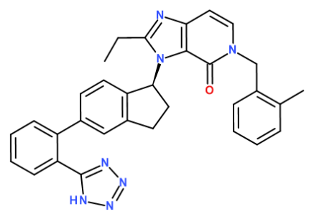 | 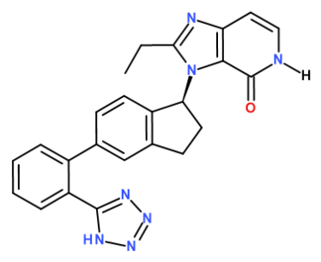 | 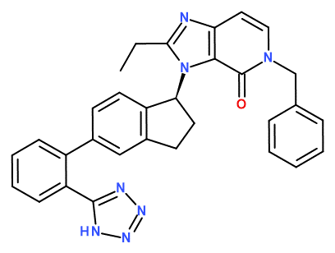
IP1 (IC₅₀ = 5.1 nM) | IP2 (IC₅₀ = 593 nM) | IP3 (IC₅₀ = 12.7 nM)
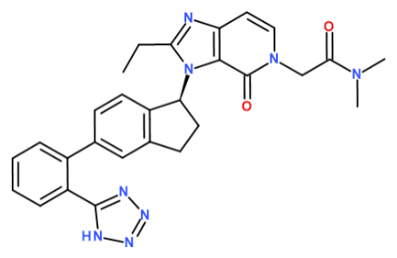 | 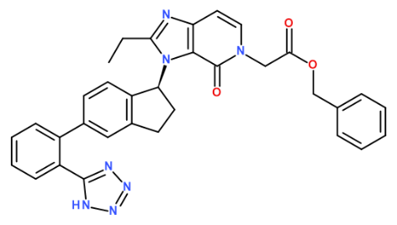 | 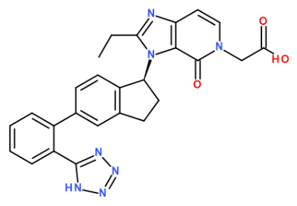
IP4 (IC₅₀ = 24.4 nM) | IP5 (IC₅₀ = 19.8 nM) | IP6 (IC₅₀ = 348 nM)
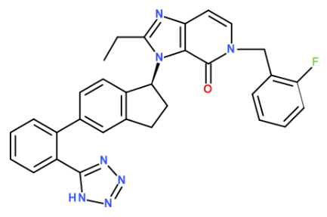 | 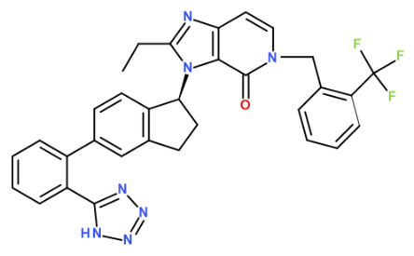 | 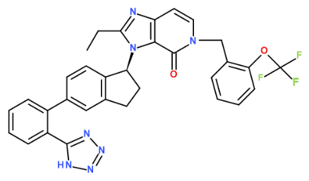
IP7 (IC₅₀ = 37.7 nM) | IP8 (IC₅₀ = 94.1 nM) | IP9 (IC₅₀ = 29.3 nM)
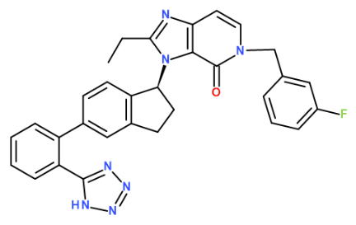 | 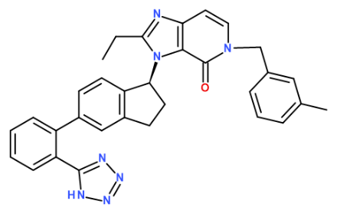 | 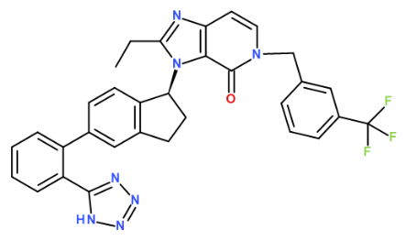
IP10 (IC₅₀ = 67.4 nM) | IP11 (IC₅₀ = 36.9 nM) | IP12 (IC₅₀ = 81.6 nM)
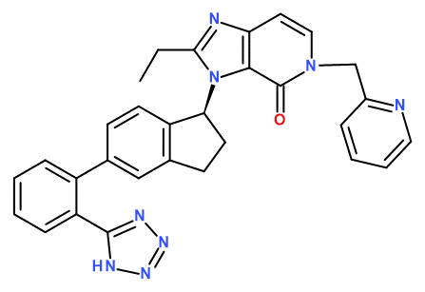 | 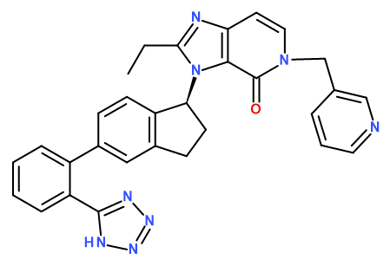 | 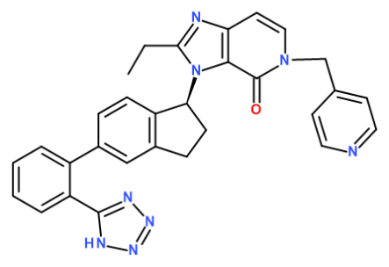
IP13 (IC₅₀ = 63.8 nM) | IP14 (IC₅₀ = 45.2 nM) | IP15 (IC₅₀ = 250 nM)
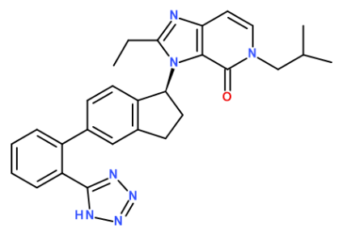 | 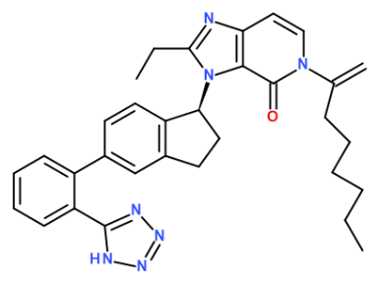 | 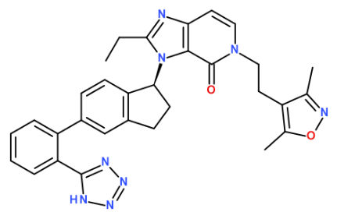
IP16 (IC₅₀ = 19.4 nM) | IP17 (IC₅₀ = 41 nM) | IP18 (IC₅₀ = 63.4 nM)
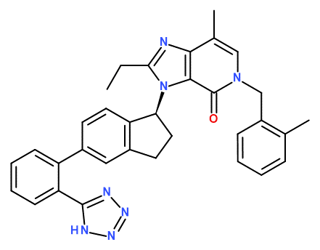
IP19 (IC₅₀ = 6.8 nM)

  - QSAR model
One-descriptor QSAR model: The 15 training-set (TS) and 4 validation-set (VS) complexes were generated through in situ modification of the refined angiotensin II type 1 receptor (AT1) crystal structure (PDB ID: 4HEE) [11], following the methodology described in the Methods section. The relative Gibbs free energy of complex formation (ΔΔG_com) was calculated for all 19 optimised AT1–inhibitor complexes. The corresponding energy components of ΔΔG_com were determined as defined in Equation (6) [15] and are summarised in Table 2 for both TS and VS imidazo[4.5-c]pyridin-4-one derivatives [11]. Experimental inhibitory activities (IC₅₀^exp) were transformed to pIC₅₀^exp values and correlated with the computed ΔΔG_com using linear regression analysis (Equation (1), Table 2). The resulting correlation supports the proposed active binding conformation of the inhibitors within the AT1 binding pocket and facilitated the definition of the AT1 inhibition pharmacophore (PH4).
To further investigate the binding affinity of the imidazo[4.5-c]pyridin-4-one (IP) derivatives toward AT1, the gas-phase complexation enthalpy (ΔΔH_MM) was initially calculated and correlated with experimental pIC₅₀^exp values. The statistical significance of the resulting linear relationship (Table 3, Equation A) highlights the predominant role of inhibitor–enzyme interactions as described by ΔΔH_MM, particularly when solvent effects and entropic penalties associated with binding are not considered. This model accounts for approximately 84% of the variance in pIC₅₀^exp, indicating that enthalpic contributions play a central role in determining ligand binding affinity.
Furthermore, a more comprehensive descriptor, the Gibbs free energy of AT1 complex formation, which incorporates enthalpic (ΔΔH_MM), entropic (ΔΔT S_vib), and solvation (ΔΔG_sol) contributions, was also evaluated (Table 3, Equation B). The relatively high coefficient of determination (R²) suggests that structural information derived from three-dimensional AT1–ligand complex models can reliably predict the inhibitory potency of novel IP analogues sharing a similar binding mode, as captured by QSAR Model B (Table 3).

Binding mode of Ips: The inhibitors (IPs) studied here belong to a new series of imidazo[4.5-c]pyridin-4-one derivatives as described in reference [4]. This skeleton is known for its ability to establish specific interactions (hydrogen bonds, π–π interactions) with protein active sites. In the case of the AT1 receptor, the 4-one function contributes significantly to ligand affinity and selectivity by stabilizing the ligand-receptor complex. Structural information on the binding mode was obtained through X-ray crystallographic analysis of the AT1 receptor (PDB identifier: 4HEE) in complex with one of the most potent inhibitors in this series.
Interaction Energy: Analysis of the interaction energies (ΔE_{int}) for the training set inhibitors highlighted the specific contributions of AT1 active site residues to the binding of IP analogs. Inhibitors categorized into three activity levels (high, moderate and low) were compared to pinpoint positions that may enhance binding affinity. However, the energetic contributions of the active site residues were found to be similar across all activity classes. No favorable substitutions of the R groups could be identified to enhance binding affinity. These results contrast with those previously reported for thymine-like AT1 inhibitors.
Table 2. Gibbs free energy of binding (ΔG_bind) and its energetic components for the training set AT1 inhibitors (IP1–IP15) and the validation set inhibitors (VIP16–VIP19) [11].
ª New id. | ^{g}${IC}_{50}^{exp}$  [nM] | ^{b} $M_{w}$[g/mol] | ^{c} $∆∆H_{MM}$  [g/mol] | ^{d}$∆∆G_{sol}$  [kca/mol] | ^{e}$∆∆T_{vib}$  [kca/mol] | ^{f}$∆∆G_{com}$  [kca/mol] | $${pIC}_{50}^{exp}$$
IP1 | 5.1 | 524 | 0.00 | 0.00 | 0.00 | 0.00 | 8.29
IP2 | 593 | 420 | 33.07 | -9.49 | -3.55 | 27.13 | 6.23
IP3 | 12.7 | 510 | 0.11 | -0.30 | -2.44 | 2.23 | 7.90
IP4 | 24.4 | 505 | 2.73 | 0.88 | -1.22 | 4.84 | 7.61
IP5 | 19.8 | 568 | 5.61 | 0.97 | -1.58 | 8.16 | 7.70
IP6 | 348 | 478 | 29.05 | -10.65 | -2.48 | 20.87 | 6.46
IP7 | 37.7 | 528 | 6.62 | -1.09 | -2.65 | 8.18 | 7.42
IP8 | 94.1 | 578 | 22.69 | -10.81 | -3.15 | 15.04 | 7.03
IP9 | 29.3 | 594 | 1.64 | 1.1 | -4.19 | 6.94 | 7.53
IP10 | 67.4 | 528 | 20.52 | -13.17 | -4.33 | 11.69 | 7.17
IP11 | 36.9 | 524 | 3.44 | -0.98 | -2.95 | 5.40 | 4.43
IP12 | 81.6 | 578 | 19.65 | -11.28 | -4.91 | 13.29 | 7.09
IP13 | 63.8 | 511 | 19.73 | -12.92 | -4.02 | 10.83 | 7.20
IP14 | 45.2 | 511 | 19.96 | -13.40 | -3.27 | 9.84 | 7.34
IP15 | 250 | 511 | 26.17 | -8.16 | -5.26 | 23.27 | 6.6

ª New  id. | ^{g}${IC}_{50}^{exp}$  [nM] | $${pIC}_{50}^{exp}$$  [nM] | ^{b} $M_{w}$  [g/mol] | ^{c} $∆∆H_{MM}$  [kca/mol] | ^{d}$∆∆G_{sol}$  [kca/mol] | ^{e}$∆∆T_{vib}$  [kca/mol] | ^{f}$∆∆G_{com}$  [kca/mol] | $${pIC}_{50}^{pre}$$ | ^{h}${{pIC}_{50}^{pre}/pIC}_{50}^{exp}$
VIP16 | 19.4 | 7.46 | 475 | 5.14 | -1.00 | 2.14 | 2.00 | 7.90 | 1.02
VIP17 | 41 | 7.47 | 530 | 12.97 | -2.33 | 5.16 | 5.48 | 7.66 | 1.04
VIP18 | 63.4 | 7.49 | 543 | 22.04 | -12.63 | -0.85 | 10.26 | 7.33 | 1.02
VIP19 | 6.8 | 8.45 | 524 | 0.36 | -1.28 | -0.78 | -0.13 | 8.04 | 0.98
ª for the chemical structures of the training set of inhibitors, refer to Table 2; ^{b} M_{w} denotes the molar mass of inhibitors; ^{c} ∆∆H_{MM} represent the relative enthalpic contribution to the GFE change associated with E-I complex formation, calculated by Molecular mechanics (MM); ∆∆H_{MM} ≈[E_{MM}{E-I_{x}} − E_{MM}{I_{x}}] − [E_{MM}{E-I_{ref}} − E_{MM}{I_{ref}}], where Iref denotes the reference inhibitor IP1; ^{d}∆∆G_{sol} represents the relative solvent effect’s contribution to the Gibbs Free Energy change of E-I complex formation: ∆∆G_{sol} = [G_{sol}{E-I_{x}} − G_{sol}{I_{x}}] − [G_{sol}{E-I_{ref}} − G_{sol}{I_{ref}}]; ^{e} ∆∆TS_{vib} represents the relative entropic contribution of the inhibitor to the Gibbs Free Energy of production of the E-I_{x} complex : ∆∆TS_{vib} = [TS_{vib}{I_{x}}E − TS_{vib}{I_{x}}] − [TS_{vib}{I_{ref}}E − TS_{vib}{I_{ref}}]; ^{f}∆∆G_{com} represents the overall relative Gibbs Free Energy change associated with the formation of the E-I_{x} complex : ∆∆G_{com} ≈∆∆H_{MM} + ∆∆G_{sol} − ∆∆TS_{vib}); ^{g} IC₅₀^{exp} denotes the experimental inhibitory concentration of AT1 referenced in [5] ; ^{h} the ratio of predicted to experimental half-maximal inhibition concentrations ${pIC}_{50}^{pre}$/${pIC}_{50}^{exp}$, where ${pIC}_{50}^{pre}$ = −log₁₀${IC}_{50}^{pre}$, was derived from calculated ∆∆G_{com} utilizing the regression equation for AT1 presented in Table 3, equation B).

Table 3. Analysis of calculated binding affinities $\left({∆∆G}_{com}\right)$, their enthalpy component ΔΔH_{MM} and experimental inhibitory concentrations ${pIC}_{50}^{exp}=-\log_{10}{IC}_{50}^{exp}$ of IPs towards AT1 [11]
Statistical of linear Regression | ${pIC}_{50}^{exp}$ = -0.0433$×{∆∆H}_{MM}$ + 7.8763 (A) | ${pIC}_{50}^{exp}$= -0.0687$×∆∆G$ + 8.035  (B)
Number of compound n | 15 | 15
Squared correlation coefficient | 0.84 | 0.94
LOO cross-validated Squared | 0.82 | 0.93
Standard error of regression $σ$ | 0.22 | 0.14
Statistical significance of regression | 67.04 | 204.5
Level of statistical significance $α$ | ˃95 | ˃95
Range of activities ${IC}_{50}^{exp}$ [nM] | 5.10-593 | 5.10-593
The statistical parameters reported in Table 3 confirm the validity of correlation Equations (A) and (B). In addition, the ratio ${pIC}_{50}^{pre}$p/${IC}_{50}^{exp}$ for the validation set is close to unity with the predicted $p{IC}_{50}^{pre}$ values estimated using correlation Equation (B) demonstrating the strong predictive performance of the complexation-based QSAR model (Table 2). Consequently, regression Equation (B) together with the calculated ∆∆G_{com} binding free energies can be reliably applied to predict the inhibitory potencies ${pIC}_{50}^{pre}$ of new IP analogs against AT1, provided that these compounds adopt the same binding mode as the training set inhibitors (IP1–IP19).

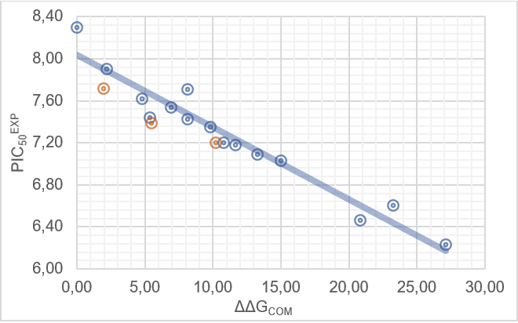
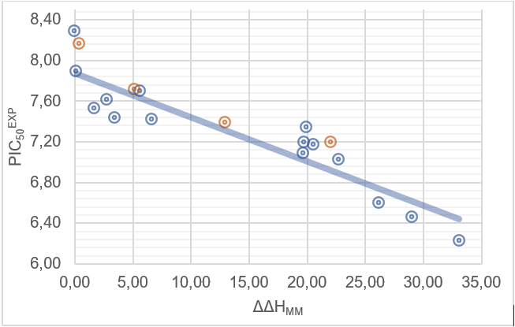

Figure 1. (Left) Graph of the correlation equation between ${pIC}_{50}^{exp}$ and the relative enthalpy contribution to GFE (∆∆H_{MM} [kcal.mol⁻¹]). (Right) A similar graph for the relative complexation Gibbs free energies of AT1-IP complex formation ∆∆G_{com} [kcal.mol⁻¹] from the training set [11]. Validation data points are shown in red.

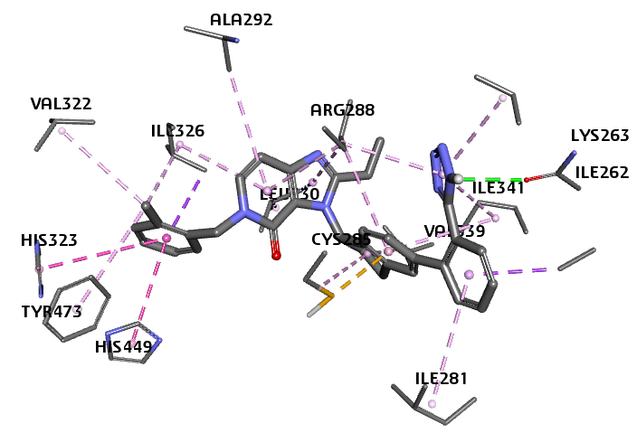
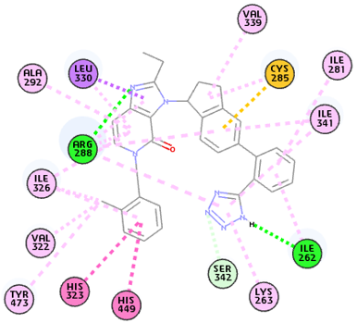
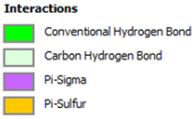

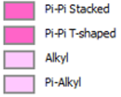

Figure 2. (Left) 2D interaction diagram of the most potent inhibitor IP1 in the AT1 active site. (Right) 3D representation of the binding mode of IP1 within the enzyme active site.
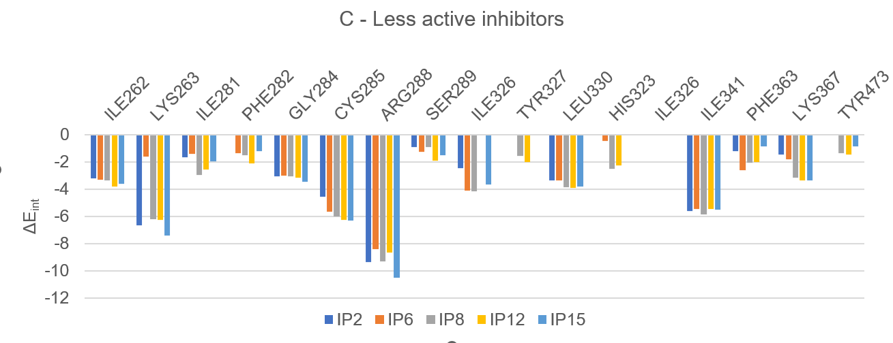
Figure 3. Intermolecular interaction energy in Molecular Mechanics. Details of residual contributions in [kcal.mol⁻¹]: (A: High) most active inhibitors, (B: Medium) moderately active inhibitors, (C: Low) less active inhibitors. Table 2 [11].
The energy interaction diagram (Figure 3) helps to understand the energy interactions between the various ligands (IPx) used to inhibit the AT1 receptor. Within the active site of the AT1 receptor (within a radius of 10 Å) are the residues Val 339, Cys 285, Ile 281, Ile 341, Ile 262, Ser 342, Lys 262, His 449, His 323, Tyr 473, Val 322, Ile 326, Arg 288, Ala 292 and Leu 330. The distribution of the interaction energy between the residues contributing to the active site of AT1 is divided into three classes: a first class of ligands exhibiting maximum biological activity, a second class of ligands exhibiting moderate biological activity, and a third class of ligands exhibiting the lowest biological activity (Figure 3). For all classes, the interaction energy per residue is highest for residues Arg 228, Ile 341 and Lys 263, and moderate for residues Lys 367, Leu 330, Cys 285 and Ile 262.

  - Generation and Validation of the 3D-QSAR Pharmacophore Model

A 3D-QSAR pharmacophore model for AT1 inhibition was constructed using the bioactive conformations of 15 inhibitors from the training set and subsequently validated with 4 compounds from the external validation set. The dataset covered a wide range of experimental inhibitory activities (5.1–593 nM), spanning nearly three orders of magnitude. Pharmacophore model generation was carried out through three successive stages: (i) the constructive phase, (ii) the subtractive phase and (iii) the optimization phase [16] following a methodology previously reported in the literature [16]. The generated hypotheses were assessed based on the accuracy of activity prediction derived from regression analysis and model complexity, using a simulated annealing optimization procedure. The ten best unique pharmacophore hypotheses were retained and characterized by five pharmacophoric features with their corresponding statistical parameters depicted in Table 4. Selection was guided by robust statistical criteria including a high correlation coefficient, low total cost and low root-mean-square deviation (RMSD). The cost difference (Δ = 564.33) calculated as the difference between the null cost (606.69) and the fixed cost (42.36) indicates a high probability (>90%) that the model reflects a genuine structure–activity correlation []. Hypothesis 1 (Hypo1) was further evaluated by mapping the most active compound (IP1) from the training set (Figure 4D), thereby illustrating the spatial arrangement and geometric features of the Hypo1 pharmacophore relevant to AT1 inhibition. The linear regression relating the experimental and predicted activities for Hypo1 is given by: ${pIC}_{50}^{exp}=0.9316 × {pIC}_{50}^{pre}+$0.497. This correlation illustrated in Figure 4E, was obtained for a dataset of 15 compounds and demonstrates excellent statistical performance (R² = 0.93, R²_{xv} = 0.92, F-test = 180, σ = 0.15, α > 95%). Collectively, these results confirm the robustness and predictive reliability of the PH4 pharmacophore model supporting its effective application in the virtual screening and design of new IP analogs.

Table 4. Pharmacophoric parameters of the ten PH4 hypotheses for AT1 inhibitors. validated by Cat-Scramble analysis (49 random trials. 98% confidence).
Hypothesis | RSMD ª | R² ^{b} | Total Cost ^{c} | Costs Difference ^{d} | Closest Random ^{e} | Features ^{f}
Hypo 1 | 1.352 | 0.97 | 56.5 | 550.2 | 92.7 | HYD_Al. HYD_Ar. HYD. R_Ar
Hypo 2 | 1.420 | 0.96 | 57.9 | 548.8 | 94.2 | HYD_Al . HYD_Ar. HYD. R_Ar
Hypo 3 | 1.650 | 0.95 | 64.6 | 542.1 | 95.9 | HYD_Al. HYD_Ar. HYD_Ar. R_Ar
Hypo 4 | 1.736 | 0.95 | 66.6 | 540.1 | 96.1 | HYD_Al. HYD. HYD. R_Ar
Hypo 5 | 1.880 | 0.94 | 72.1 | 534.6 | 113.8 | HYD_Al. HYD_Ar. R_Ar. R_Ar
Hypo 6 | 1.880 | 0.94 | 72.1 | 534.6 | 114.5 | HYD_Al. HYD. R_Ar. R_Ar
Hypo 7 | 2.140 | 0.92 | 80.1 | 526.5 | 114.9 | HYD_Al. HYD. R_Ar. R_Ar
Hypo 8 | 2.153 | 0.92 | 80.9 | 525.8 | 115.3 | HYD_Al. HYD. R_Ar. R_Ar
Hypo 9 | 2.205 | 0.91 | 82.6 | 524.0 | 115.8 | HYD_Al. HYD. R_Ar. R_Ar
Hypo 10 | 2.357 | 0.90 | 85.6 | 521.1 | 115.9 | HYD_Al. HYD_Ar. HYD. R_Ar
Fixed Cost | 0 | 0 | 42.36
Null Cost | 5.44 | 0 | 248.44
Configuration cost = 14.69; ª root mean squared deviation; ^{b} squared correlation coefficient; ^{c} overall cost parameter of PH4 pharmacophore; ^{d}cost differential between Null cost and hypothesis total cost; ^{e}minimum cost from 49 randomized runs at a specified confidence level of 98%. ^{f} HYD_Al (Hydrophobic Aliphatic); HYD (Hydrophobic); HYD_Ar (Hydrophobic Aromatic); R_Ar (Ring_Aromatic)

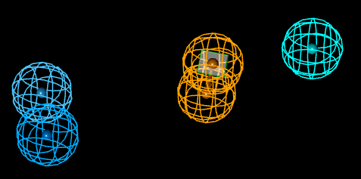
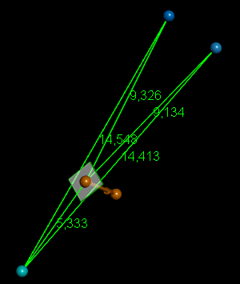
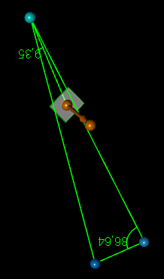
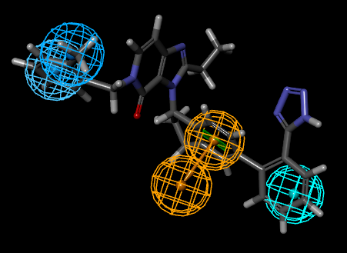
E
C
B
Aa
Da

Figure 4. (A) Features coordinates of centers, (B) Distances between centers, (C) angles between centers of pharmacophoric features, (D) mapping of pharmacophore of AT1 inhibitor with the most potent molecule IP1. Feature legend: HYD = Hydrophobic (cyan). HYD_Al = Hydrophobic Aliphatic (blue). R_Ar = Ring_Aromatic (yellow). (E) Correlation plot of experimental vs. predicted inhibitory activity.

  - Virtual Screening
In silico screening of virtual (combinatorial) libraries can effectively lead to hit identification as demonstrated in our previous studies on inhibitor design [,,,,,].
Virtual Library: A preliminary virtual library (VL) was constructed by systematic modification of the IP scaffold at the R₁ and R₂ positions as detailed in Table 5. During the enumeration process, the substituents listed in Table 5 were combinatorially attached to these two positions yielding a library size of: $R_{1}×R_{2}=38×38= 1444$ analogs. All generated compounds preserved the substitution pattern of the most potent reference inhibitor.
To construct this library, fragments were collected from chemical databases of commercially available compounds []. To optimize drug-like properties and streamline the compound library, a series of selection filters was employed including the Lipinski “Rule of Five” which excluded compounds with molecular weights exceeding 500 g/mol for oral administration [] and was further modified in this study to accommodate potential intravenous use. This filtering process yielded a more focused and pharmaceutically relevant library well suited for subsequent in-silico screening.
  - In silico Screening of Library of IPs
The targeted library of $1444$ analogs was then evaluated to identify molecular structures compatible with the 3D-PH4 Hypo1 pharmacophore model for AT1 inhibition. A total of 12 IP analogs met at least four pharmacophore characteristics. These top-ranked analogs (PH4 hits) were then subjected to selection based on the QSAR complexation model. The Gibbs free energy (ΔΔG) of AT1-IP complex formation, its components and the predicted negative logarithm of half-maximal inhibitory concentrations (${pIC}_{50}^{pre}$ ) obtained from correlation equation B (Table 3) are summarized in Table 6.

Table 5: R_groups proposed for the design of the virtual library of IPs analogues
Fragment number | F1 | F2 | F3 | F4 | F5
Fragments |  | 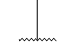
Fragment number | F6 | F7 | F8 | F9 | F10
Fragments
Fragment number | F11 | F12 | F13 | F14 | F15
Fragments
Fragment number | F16 | F17 | F18 | F19 | F20
Fragments
Fragment number | F21 | F22 | F23 | F24 | F25
Fragments
Fragment number | F26 | F27 | F28 | F29 | F30
Fragments
Fragment number | F31 | F32 | F33 | F34 | F35
Fragments
Fragment number | F36 | F37 | F38
Fragments
Table 6. GFE and their components for the 12 highest-ranked virtual IP analogs. The analog numbering links the index of each substituent R₁ and R₂ to the substituent numbers extracted from Table 6.
N⁰ | Analogs | ª$M_{w}$  [g/mol] | ^{b} $∆∆H_{MM}$  [g/mol] | ^{c}$∆∆G_{sol}$  [kca/mol] | ^{d} $∆∆{TS}_{vib}$  [kca/mol] | ^{e} $∆∆G_{com}$  [kca/mol] | ${IC}_{50}^{pre}$[pM] | ^{f}${pIC}_{50}^{pre}$
Ref. | IP1 (p12i) | 524 | 0.00 | 0.00 | 0.00 | 0.00 | 5100 | 8.29
1 | F1-F4 | 504.579 | -23.15 | -15.78 | -2.28 | -36.64 | 0.028 | 10.55
2 | F1-F5 | 520.587 | -24.55 | -15.32 | -3.48 | -36.39 | 0.030 | 10.53
3 | F4-F4 | 461.554 | -36.27 | 1.34 | -1.15 | -33.78 | 0.044 | 10.36
4 | F11-F5 | 507.58 | -34.11 | 1.94 | -1.45 | -30.72 | 0.071 | 10.15
5 | F8-F4 | 479.545 | -34.75 | 1.20 | -3.35 | -30.20 | 0.078 | 10.11
6 | F4-F1 | 504.579 | -33.62 | 1.82 | -2.52 | -29.28 | 0.089 | 10.05
7 | F4-F3 | 505.564 | -35.19 | 3.37 | -3.92 | -27.90 | 0.112 | 9.95
8 | F7-F6 | 502.606 | -27.46 | 0.57 | 0.30 | -27.19 | 0.126 | 9.90
9 | F6-F2 | 490.596 | -26.65 | 0.17 | 0.50 | -26.98 | 0.129 | 9.89
10 | F5-F9 | 506.552 | -28.04 | -0.77 | -1.98 | -26.83 | 0.132 | 9.88
11 | F5-F2 | 491.58 | -24.01 | -1.67 | 0.72 | -26.41 | 0.141 | 9.85
12 | F6-F10 | 504.622 | -25.38 | -0.39 | -0.05 | -25.73 | 0.158 | 9.80
ª Mw denotes molar mass of inhibitor; ^{b} ∆∆H_{MM} represents the relative enthalpic contribution to the Gibbs free energy (GFE) change of the AT1-IP complex formation ∆∆G_{com} (for further details, refer to the footnote of Table 2); ^{c} ∆∆G_{sol} indicates the relative solvation GFE contribution to ∆∆G_{com}; ^{d} ∆∆TS_{vib} is the relative (vibrational) entropic contribution to ∆∆G_{com}; ^{e} ∆∆G_{com} refers to the relative Gibbs free energy change associated with the formation of the enzyme–inhibitor AT1-IP complex: ∆∆G_{com} ≡ ∆∆H_{MM} + ∆∆G_{sol} − ∆∆TS_{vib}; ^{f} ${pIC}_{50}^{pre}$ denotes the predicted inhibition potency against AT1 derived from ∆∆G_{com} utilizing correlation Equation B, Table 3; ^{g} ${pIC}_{50}^{exp}$ ^{[11]} is provided for the reference inhibitor IP1.
Fig. 5. Frequency histograms of individual R-group occurrences within the 12 highest-ranked analogs mapping to three pharmacophoric features of the PH4 hypothesis Hypo1.
Table 7. Predicted ADME properties of selected lead analogs and reference antihypertensive agents using the QikProp module [].
Analogsª | #stars^{b} |  | M_{W} ^{c}  [g.mol⁻¹] |  | S_{mol} ^{d}  [Å²] |  | S_{molhfo} ^{e}  [Å²] |  | V_{mol} ^{f}  [Å³] |  | #RotB ^{g} |  | HB_{don} ^{h} |  | HB_{acc} ^{i} |  | logP_{o/w}^{j} |  | logS^{K}
F1-F4 | 2 | 504 |  | 816.9 |  | 154.9 |  | 1530.7 |  | 8 |  | 4 |  | 8.2 |  | 3.9 |  | -6.5
F1-F5 | 1 | 520 |  | 817.1 |  | 155.1 |  | 1542.3 |  | 9 |  | 5 |  | 8.9 |  | 3.4 |  | -6.0
F4-F4 | 2 | 461 |  | 769.4 |  | 155.4 |  | 1438.1 |  | 7 |  | 2 |  | 5.7 |  | 5.5 |  | -6.9
F11-F5 | 1 | 507 |  | 812.7 |  | 249.8 |  | 1535.1 |  | 9 |  | 3 |  | 7.2 |  | 5.0 |  | -6.7
F8-F4 | 2 | 479 |  | 778.0 |  | 155.8 |  | 1452.9 |  | 7 |  | 2 |  | 5.7 |  | 5.7 |  | -7.3
F4-F1 | 0 | 504 |  | 777.5 |  | 158.8 |  | 1493.9 |  | 8 |  | 4 |  | 8.2 |  | 3.9 |  | -5.8
IP1 | 3 | 524 |  | 880.2 |  | 262.1 |  | 1647.4 |  | 5 |  | 1 |  | 7.5 |  | 6.0 |  | -8.8
Valsartan | 0 | 435 |  | 751.4 |  | 308.6 |  | 1370.9 |  | 10 |  | 2 |  | 8.5 |  | 3.0 |  | -5.0
Asomex-2.5 | 0 | 409 |  | 679.9 |  | 388.0 |  | 1252.0 |  | 8 |  | 2 |  | 6.2 |  | 3.0 |  | -4.6
Amlodipine | 0 | 409 |  | 679.9 |  | 388.0 |  | 1252.0 |  | 8 |  | 2 |  | 6.2 |  | 3.0 |  | -4.6
Perindopril | 0 | 368 |  | 686.4 |  | 518.7 |  | 1233.4 |  | 8 |  | 2 |  | 8.5 |  | -0.3 |  | -1.7

Analogsª | logK_{hsa}^{l} | logB/B ^{m} | BIP caco^{n}  [nm.s⁻¹] | #metabº | ${IC}_{50}^{pre}$ [nM] | HOA^{q} | %HOA^{r}
F1-F4 | 0.7 | -2.4 | 60.7 | 4 | 0.028 | 1 | 68
F1-F5 | 0.4 | -2.6 | 45.0 | 5 | 0.030 | 2 | 63
F4-F4 | 1.0 | -1.1 | 726.0 | 3 | 0.044 | 1 | 100
F11-F5 | 0.9 | -1.6 | 336.6 | 5 | 0.071 | 1 | 88
F8-F4 | 1.1 | -0.9 | 736.0 | 3 | 0.078 | 1 | 100
F4-F1 | 0.6 | -1.9 | 144.0 | 4 | 0.089 | 3 | 76
IP1 | 1.4 | -1.3 | 456.0 | 5 | 5100 | 1 | 84
Valsartan | -0.2 | -2.2 | 25.9 | 3 |  | 2 | 70
Asomex-2.5 | 0.4 | -0.7 | 149.4 | 8 |  | 2 | 83
Amlodipine | 0.4 | -0.7 | 149.4 | 8 |  | 2 | 83
Perindopril | -0.5 | -1.2 | 11.1 | 4 |  | 2 | 44
ª designed IP analog as well as known antihypertensive agents Table 6; ^{b}drug likeness assessed using 24 physicochemical out of the 46 implemented QikProp. ver. 3.7 ( release 14), whose values fall outside the range observed for 95 % of known drugs; ^{c} the molecular mass measured in g.mol-1 with a range for 95% of drugs: 130 - 725 g.mol-1 [3]; ^{d} total solvent-accessible molecular surface is expressed in Å2 with a probe radius of 1.4 Å (range for 95% of drugs: 300 - 1000 Å2); ^{e}hydrophobic portion of the solvent-accessible molecular surface is also in Å2with a probe radius of 1.4 Å (range for 95% of drugs: 0 - 750 Å2); ^{f} total volume of molecule enclosed by solvent-accessible molecular surface is indicated in Å3 with a probe radius of 1.4 Å) (range for 95% of drugs: 500 - 2000 Å3); ^{g} number of non-trivial (not CX3) non-hindered (not alkene, amide, small ring) rotatable bonds is provided (range for 95% of drugs: 0 - 15); ^{h}estimated number of hydrogen bonds that the solute would donate to water molecules in an aqueous solution is included. Values represent averages derived from many configurations, allowing for non-integer values so they (range for 95% of drugs: 0.0 - 6.0) ; ^{i} estimated number of hydrogen bonds that the solute would accept from water molecules in an aqueous solution. Values represent averages derived from multiple configurations, allowing for non-integer values (range for 95% of drugs : 2.0 - 20.0); ^{j} denotes the logarithm of the partition coefficient between n-octanol and water phases (range for 95% of drugs : -2 - 6.5) ; ^{k} logarithm of predicted aqueous solubility logS, where S in mol·dm–3 indicates the concentration of the solute in a saturated solution at equilibrium with the crystalline solid (range for 95% of drugs: -6.0 - 0.5); ^{l} refers the logarithm of the predicted binding constant to human serum albumin (range for 95% of drugs: -1.5 - 1.5); m logarithm of predicted brain/blood partition coefficient (range for 95% of drugs: -3.0 - 1.2); ^{n} pertains to Caco-2 cell permeability (<25 poor, >500 high; ºexpected apparent Caco-2 cell membrane permeability in the Boehringer-Ingelheim scale is measured in nm s-1 (range for 95% of drugs: < 25 poor > 500 nm s-1 great); ^{p} predicted inhibition constants ${IC}_{50}^{pre}$ was estimated from calculated ∆∆G_{com} utilizing the regression Equation B presented in Table 3. ^{q} human oral absorption (1 = low. 2 = medium. 3 = high); ^{r} percentage of human oral absorption in gastrointestinal tract (80% = high). (*) in any column signifies that the descriptor value deviates from the ranges typical of 95% of recognized pharmaceuticals.

  - Novel IPs analogs
Analysis of the active conformation of IPs guided the rational design of the virtual library of analogs targeting the AT1 receptor. The choice of substituents at R₁ and R₂ was guided by the structural characteristics identified from the pharmacophore model (PH4). The analysis of the 12 best compounds reveals an even distribution of fragments. However, the F6 substituent appears as the most frequent at position R₁ (3 occurrences), while F2 is the most frequent at position R₂ (2 occurrences) suggesting comparable compatibility with the active site environment. This balanced predominance indicates favorable steric and electronic complementarity for all fragments likely to optimize ligand–receptor interactions and stabilize the active conformation. These findings validate the consistency of the pharmacophore model and offer a rational framework for prioritizing compounds for energy analysis and subsequent validation.
F1- F4, ${pIC}_{50}^{pre}=10.55$ | F1-F5, ${pIC}_{50}^{pre}=10.53$
F4-F4, ${pIC}_{50}^{pre}=10.36$ | F11-F5, ${pIC}_{50}^{pre}$=10.15

Fig. 6. The best IP Analogs with scaffold of AT1, the name is concatenation
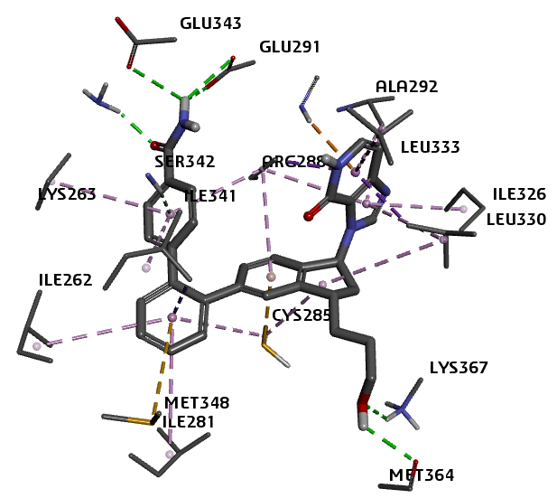  A | 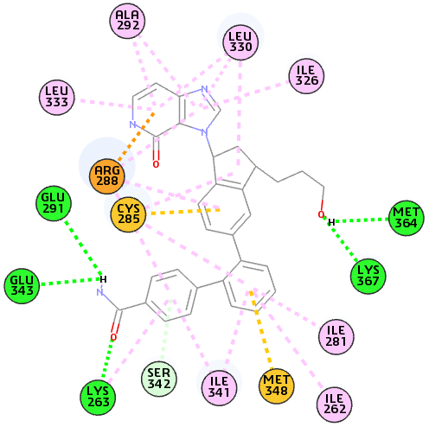  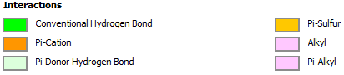  B
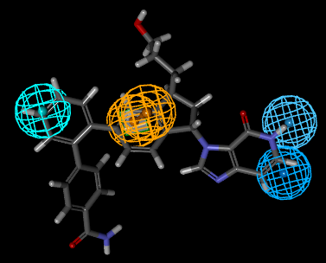  C | 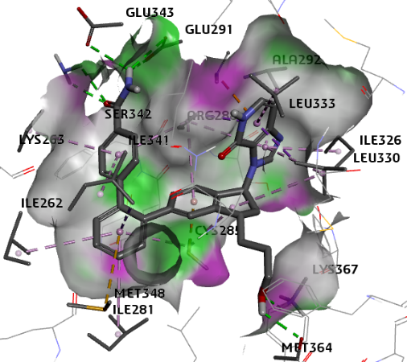  D
Fig. 7. (A) Close up of virtual hit F1- F4, the most active designed IP analog (${pIC}_{50}^{pre}=10.55$) at the active site of AT1, (B) 2D schematic interaction diagram of the best active designed IP analog F1- F4 at the active site of AT1, (C) Mapping of the IP F1- F4 to AT1 inhibition pharmacophore, (D) Surface of the active site of AT1 with bound best active designed IP analog. The surface of the binding site is color-coded based on residue hydrophobicity: red = hydrophobic, blue = hydrophilic, white = intermediate.

Fig. 8. Decomposition of the molecular mechanic inter-molecular interaction energy E_{int} into contributions from active site residues, measured in kcal.mol⁻¹: the four most effective unique developed IP analogs (color coding correspond to ligands indicated in the legend.

  - ADME profiles of designed
More investigation is still needed into the pharmacokinetic characteristics of AT1 inhibitors. As presented in Table 7, the ADME properties of our novel analogs were previously analyzed using the QikProp program based on Jorgensen’s method. The basic tenets of this strategy have already been discussed. Commercially available medications used to treat hypertension are contrasted with our best-performing analogs (Table 7).
This study used a combination of pharmacophoric modeling and a QSAR 3D approach to identify the structural factors governing the inhibitory activity of a series of analogs to the discovery of non-peptidic antagonists of the type 1 receptor of angiotensin II (AT1). The combination of these two approaches has made it possible to quantify the relationship between molecular properties and biological activity while also highlighting the pharmacophoric characteristics that are crucial to molecular recognition. In order to identify the major residues in the AT1 active site that contribute to ligand recognition, a comparative analysis of the distribution of enzyme–IP analog interaction energies were performed. This approach aimed to highlight the dominant residual contributions likely to explain the significant improvement in potency observed for the most active compound, IP1, as well as for the newly designed analogs (see Fig. 8). This figure shows that residues Gly284, Ser289, Leu330 and Lys337 interact strongly at the active site of the protein with the newly designed analogs compared to the most active reference ligand IP1 in the series [11].
The interaction energy diagram of the AT1–IPx complex provides additional information on the interactions between the ligands in the training set and the target protein. It highlights the individual energy contribution of each residue in the active site of AT1. The decomposition of interaction energy into residual contributions is an essential step in identifying the key residues involved in ligand recognition and stabilization as well as substituents that may improve the binding affinity of IP analogs to AT1 and consequently their inhibitory potential. The individual contributions of interaction energies were classified into three groups according to the activity level of the ligands in the training set: the most active ligands, the moderately active ligands and the least active ligands. A comparative analysis of the interacting energy contributions between these different groups (Figure 3) shows that the most active ligands exhibit the most favorable interactions with the active site residues. These results highlight certain key residues that play a decisive role in stabilizing the ligand-protein complex and increasing inhibitory potency. The top 4 best hit fit from the PH4 result were evaluated with the QSAR complexation model, equation B from Table 3 in order to predict their inhibitory activity (${IC}_{50}^{pre} )$.
4. CONCLUSION
We were guided by the structural details of the crystal structure of the AT1-IP1 complex when we built a feasible QSAR model of AT1 inhibition by imidazo[4.5-c]pyridin-4-one inhibitors. This model has made it possible to correlate the observed inhibiting powers with the free Gibbs energies of complex formation calculations. In addition to this QSAR model, we developed a pharmacophore PH4 model for IPs inhibitors based on a training set of 15 IPs and a validation set of 4 VIPs with known inhibitor activities. The analysis of the interactions between AT1 and IP at the level of the active site of the enzyme has led us to the idea of an initial virtual combinatorial library of new IP analogs with two substitutions on the molecular scaffold. Filtering the obtained library according to Lipinski’s Rule of five combined with prioritizing compounds based on their similarity to the PH4 pharmacophore model and ADME descriptors, allowed the identification of a subset of IP compounds with potential oral or intravenous bioavailability. Screening of this BV using the AT1 inhibition assay revealed 12 analogues. For each of these, inhibitory activity was calculated using the QSAR model. The best-designed analogues show predictive inhibitory activity at low concentrations, with the most active exhibiting inhibitory activity at 28 pm. These new analogues can be recommended for synthesis and biological evaluation to identify new antihypertensive molecules with a good pharmacokinetic profile that can be administered orally.The use of drugs to treat diseases requires prior theoretical and experimental studies. Our work has been confined primarily to the theoretical framework, given the novel method employed, which warrants further exploration as it provides significant predictive information for the design of new inhibitors. Based on our results, we can predict the synthesis of the most active inhibitors with a view to conducting a biological evaluation.

Abbreviations
2D : Two-dimensional
3D : Three-dimensional
ADME : Absorption, Distribution, Metabolism and Excretion
AT1 : Angiotensin II type 1
∆∆G_{com} : Relative complexation Gibbs free energy
GFE : Gibbs free energy
∆∆G_{sol} : Relative Solvation Gibbs free energy
HBA : Hydrogen bond Acceptor
HBD : Hydrogen bond Donor
H_{MM} : Enthalpy component of Gibbs free energy
HYD : Hydrophobic
HYDA : Hydrophobic Aliphatic
IC₅₀ : Half maximal inhibitory concentration
IP : Imidazo[4.5-c]pyridin-4-one inhibitors
IPx : Imidazo [4.5-c]pyridin-4-one inhibitors of the training set
VIPs : Imidazo[4.5-c]pyridin-4-one inhibitors of the validation set
MM : Molecular mechanics
MM-PB : Molecular mechanics–Poisson–Boltzmann
PDB : Protein Data Bank
PH4 : Pharmacophore
QSAR : Quantitative structure–activity relationships
RMSD : Root-mean square deviation
TS : Training set
VS : Validation set

COMPETING INTERESTS DISCLAIMER:
Authors have declared that they have no known competing financial interests OR non-financial interests OR personal relationships that could have appeared to influence the work reported in this paper.
Disclaimer (Artificial intelligence)

Author(s) hereby declare that NO generative AI technologies such as Large Language Models (ChatGPT, COPILOT, etc.) and text-to-image generators have been used during the writing or editing of this manuscript.

REFERENCES

. Preethi World Health Organization (WHO). Hypertension. Geneva: WHO; 2023.
. Casimiro-Garcia, A., Heemstra, R. J., Bigge, C. F., Chen, J., Ciske, F. A., Davis, J. A., Powell, N. A. (2013). Design, synthesis, and evaluation of imidazo [4, 5-c] pyridin-4-one derivatives with dual activity at angiotensin II type 1 receptor and peroxisome proliferator-activated receptor-γ. Bioorganic & medicinal chemistry letters, 23(3), 767-772.
. Insight-II and Discover Molecular Modeling and Simulation Package, version 2005 ; Accelrys : San Diego, CA, USA, 2005.
. Discovery Studio molecular modeling and simulation program, Version 2.5, Accelrys, Inc., San Diego, CA, 2009.
. Frecer, V.; Seneci, P.; Miertus, S. Computer-assisted combinatorial design of bicyclic thymidine analogs as inhibitors of Mycobacterium tuberculosis thymidine monophosphate kinase. J. Comput. Aidded Mol. Des. 2011, 25, 31–49.
. Niaré, A., Alex, A. Y. Z., Bernard, D. A. M.,Marius, K. S., Stéphane, D. S., Moise, K.A., Guy-Richard, K. M., Fagnidi, Y. K. H., &Doh, S. (2025). Study by molecular docking of the interactionsbetweendihydroorotate dehydrogenase and as eries of inhibitors of pyrrole derivatives for the treatment of malaria. Asian Journal of Chemical Sciences, 15(1), 92–110..
. Bieri, C., Esmel, A., Keita, M., Owono, L. C. O., Dali, B., Megnassan, E., Frecer, V. (2023). Structure-based design and pharmacophore-based virtual screening of combinatorial library of triclosan analogues active against enoyl-acyl carrier protein reductase of Plasmodium falciparum with favourable ADME profiles. International Journal of Molecular Sciences, 24(8), 6916.
. Soro I, N’Guessan H, Abou A, N’Guessan R K, Megnassan E. Conformational study of molecules in a biological environment, design of inhibitors of human aminopeptidase m1 implicated in cancer therapy. Universal Journal of Pharmaceutical Research.in our previous studies on the design of inhibitors. Universal J. of Pharm Research, 2023, 8(5) : 71-86.
. QikProp; Version 3.7, Release 14, X Schrödinger; LLC: New York, NY, USA, 2014.
. Kouassi, A. F., Kone, M., Keita, M., Esmel, A., Megnassan, E., N’Guessan, Y. T., Miertus, S. (2015). Computer-aided design of orally bioavailable pyrrolidine carboxamide inhibitors of enoyl-acyl carrier protein reductase of Mycobacterium tuberculosis with favorable pharmacokinetic profiles. International Journal of Molecular Sciences, 16(12), 29744-29771.
. Niaré, A., N’Guessan, A.-B., Djako, B. A. M.,Dembélé, G. S., Koné, M. G.-R., & Yéo, Y.(2024). QSAR, pharmacophore, andmolecular docking studies for the design of novel arylamide-derived inhibitors of Mycobacterium tuberculosis. ChemicalScience International Journal, 33(6), 212–224..
. Adama N, N’Guessan H, Dali B, Megnassan E. Computer-assisted design of hydroxamic acid derivatives inhibitors of M1 Metallo Aminopeptidase of Plasmodium falciparum with favorable pharmacokinetic profile. J Pharm Res Int, 2022: 21-44. doi: 10.9734/jpri/2022/v34i607271.
. Herbert J M. Dielectric continuum methods for quantum chemistry. WIREs Computational Molecular Science, 2022, 12(1) : 1519. https://doi.org/10.1002/wcms.1519
. Barber C, Heghes C, Johnston L. A framework to support the application of the OECD guidance documents on (Q) SAR model validation and prediction assessment for regulatory decisions. Computational Toxicology, 2024, 30 : 100305.
. N’Guessan H, Soro I, Keita M, Megnassan E. Design and In silico Screening of Combinatorial Library of New Herbicidal Analogs of Cycloalka [d] quinazoline2, 4dione− Benzoxazinones Inhibiting Protoporphyrinogen IX Oxidase. J Pharm Res Int, 2022, 34(56) : 42-61.
. N'Guessan H, Megnassan E. In silico design of phosphonic arginine and hydroxamic acid inhibitors of Plasmodium falciparum M17 leucyl aminopeptidase with favorable pharmacokinetic profile. J Drug Design Med Chem, 2017, 3(6) : 98-125. doi: 10.11648/j.jddmc.20170306.13.
. Keita M, Yaya Y, Yvon B M B, Esmel A E, Dali B, N’Guessan, H. Molecular and Thermodynamic Modeling of the Protein-Ligand Interaction. Application to Computer-Assisted Design of Anti-Competitive Inhibi-tors of Human Histone Deacetylase, 2021, 2 : 606-630. doi: 10.25177/JCCMM.5.2.RA.10763.
. Kone M, N’Guessan H, N'gouan A J, Megnassan E. Computer-aided design of new hydroxamic acid derivatives targeting the Plasmodium falciparum M17 Metallo-aminopeptidase with Favorable Pharmacokinetic Profile. Int. J. Pharm. Sci. Drug Res., 2023: 356‑375. doi: 10.25004/IJPSDR.2023.150317.
. Fofana, I., Dali, B., Koné, M., Sujova, K., Megnassan, E., Miertus, S., Frecer, V. (2025). In Silico Optimization of Inhibitors of the 3-Chymotrypsin-like Protease of SARS-CoV-2. Life, 16(1), 6.
. Bléhoué I C, Koné M, Esmel E A, Fofana I, Kéïta M, Megnassan E. Molecular modelling and virtual screening application to the computer-aided design of anticancer inhibitors with a favorable pharmacokinetic profile against e6 papillomavirus type 16. Universal Journal of Pharmaceutical Research.design of inhibitors. 2024
. Revillo Imbernon J, Jacquemard C, Bret G, Marcou G, Kellenberger E. Comprehensive analysis of commercial fragment libraries. RSC Medicinal Chemistry, 2022, 13(3) : 300–310. https://doi.org/10.1039/D1MD00363A ncbi.nlm.nih.gov+14
. Davis J M, Smith L R. Advances in computational approaches for estimating passive permeability in drug discovery. Membranes, 2023, 13(11) : 851. https://doi.org/10.3390/membranes13110851
. QikProp 6.5, Release 139; Schrödinger LLC.: New York, NY, USA, 2019.

