Pediatric Nephrotic Syndrome with Patent Ductus Arteriosus and Mild Ascites: A rare Case Report

Abstract:
Nephrotic syndrome, a prevalent pediatric renal disorder, manifests with significant proteinuria, hypoalbuminemia, oedema, and hyperlipidemia. Complications associated with nephrotic syndrome include infections, ascites, and pleural effusion. Congenital cardiac anomalies, such as Patent Ductus Arteriosus (PDA), can further complicate the management of this condition. In this case report, we present a 2-year-old female patient presenting with generalised oedema, fever, and urinary symptoms. Upon diagnosis, the patient was found to have a first-episode nephrotic syndrome complicated by urinary tract infection, mild ascites, pleural effusion, and incidental PDA. Laboratory tests revealed substantial proteinuria and hypoalbuminemia, which were corroborated by imaging studies. Echocardiography revealed a small PDA with a left-to-right shunt. The patient’s condition improved significantly with the administration of corticosteroids, antibiotics, and supportive therapy. This case underscores the paramount importance of early diagnosis, prompt treatment, and multidisciplinary management in pediatric nephrotic syndrome, particularly when comorbidities are present.

Keywords: Nephrotic syndrome; Pediatric; Patent ductus arteriosus; Ascites; Pleural effusion; Proteinuria; Urinary tract infection

Introduction:
Nephrotic syndrome is a significant pediatric renal disorder characterised by heavy proteinuria, hypoalbuminemia, edema, and hyperlipidemia. It is one of the most prevalent chronic kidney conditions in children, particularly affecting those between the ages of 2 and 6. The majority of cases are attributed to minimal change disease, which demonstrates a favourable response to corticosteroid therapy.¹ The global incidence of nephrotic syndrome ranges from 1 to 7 per 100,000 children annually, with a relatively higher burden reported in developing countries.² The underlying pathophysiology involves increased permeability of the glomerular filtration barrier, leading to excessive urinary protein loss. This results in decreased plasma oncotic pressure and subsequent fluid accumulation in interstitial and third spaces. Clinically, edema typically manifests as periorbital puffiness and may progress to generalised oedema, ascites, and pleural effusion in severe cases.³ Children with nephrotic syndrome are particularly susceptible to infections due to urinary loss of immunoglobulins and complement proteins. Among these, urinary tract infections are commonly encountered and may precipitate disease onset or relapse.⁴ PDA is a congenital cardiac anomaly characterised by persistent communication between the aorta and pulmonary artery. While small PDAs are often asymptomatic, they may influence fluid dynamics in conditions associated with volume overload.⁵ In this context, we report a case of a 2-year-old child presenting with nephrotic syndrome associated with urinary tract infection, mild ascites, pleural effusion, and incidental PDA, emphasising the importance of comprehensive evaluation and multidisciplinary care.

Case Presentation:
A two-year-old female child was brought to the pediatric department with complaints of swelling of the eyes for two months and swelling of the hands, abdomen, and lower limbs for one week. The swelling was initially noticed around the eyes, particularly in the morning, and gradually progressed to involve the entire body. The child also had a history of fever five days prior to admission and a burning sensation during micturition for two days. There was no history of decreased urine output, hematuria, vomiting, or respiratory distress. The antenatal history was uneventful, and the child was born at term via normal vaginal delivery with a birth weight of approximately 2.7 kg. The postnatal period was significant for NICU admission due to decreased activity, after which the child recovered. Immunisation status was appropriate for age. A prior echocardiographic evaluation had revealed a small Patent Ductus Arteriosus of approximately 2 mm with a left-to-right shunt. On examination, the child appeared unwell with generalised oedema. Vital signs revealed a heart rate of 138 beats per minute, respiratory rate of 24 cycles per minute, blood pressure of 110/64 mmHg, and oxygen saturation ranging between 95% and 99%. Abdominal examination revealed distension with shifting dullness suggestive of ascites, while other systemic examinations were unremarkable.

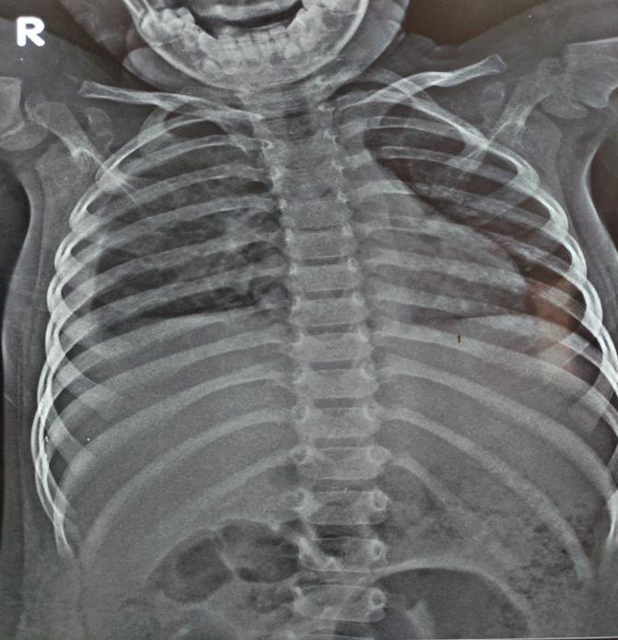
Fig 1: Periorbital Puffiness Fig 2: Mild abdominal distension with
Swelling umbilicus
Investigations:
Laboratory evaluation revealed significant proteinuria, with urine albumin measuring 3+ and the presence of pus cells (3–4 per high-power field) and bacteria, indicating a concurrent urinary tract infection. The haemoglobin level was 10.8 g/dL, suggesting mild anaemia, while the total leukocyte count was elevated, indicating an ongoing infection. Serum albumin levels were reduced, consistent with nephrotic syndrome, and lipid levels were elevated. Ultrasonography of the abdomen showed mild ascites and bulky kidneys. Chest radiography revealed pleural effusion. Two-dimensional echocardiography confirmed the presence of a small Patent Ductus Arteriosus of approximately 2 mm with a left-to-right shunt and preserved biventricular function.

Therapeutic intervention:
Oral prednisolone was initiated as the initial treatment for nephrotic syndrome. Intravenous ceftriaxone was administered to address the urinary tract infection. Furosemide was administered to alleviate oedema, and supportive management encompassed fluid and salt restriction. The child underwent meticulous monitoring of urine output, daily weight, and vital parameters. The Patent Ductus Arteriosus was managed conservatively due to its diminutive size and the absence of substantial hemodynamic repercussions. The patient exhibited gradual improvement, characterised by a reduction in oedema and stabilisation of the clinical condition.

Discussion:
Nephrotic syndrome in children is predominantly observed between the ages of 2 and 6 years, with minimal change disease accounting for approximately 80-90% of cases^{. 6} The present case involves a 2-year-old female child, which aligns with the typical age distribution reported in pediatric nephrotic syndrome. The classical presentation of periorbital oedema progressing to generalised oedema (anasarca) observed in this case corresponds to the findings of a previous study ⁷which described oedema as the earliest and most prominent clinical feature attributed to hypoalbuminemia and reduced plasma oncotic pressure. The patient’s initial periorbital swelling, which was more pronounced in the morning, followed by progression to limb and abdominal oedema, strongly supports this typical clinical pattern. In the present case, the child also developed mild ascites and pleural effusion, which are recognised complications of severe hypoalbuminemia. According to KDIGO ⁸ guidelines, fluid accumulation in third spaces such as the peritoneal and pleural cavities occurs due to decreased intravascular oncotic pressure and sodium retention. Similar findings were reported by Bagga and Srivastava ⁹ who noted that ascites and pleural effusion are common in moderate to severe cases of nephrotic syndrome. The ultrasonography and chest X-ray findings in this patient, confirming ascites and pleural effusion, are therefore consistent with established literature. The presence of a urinary tract infection (UTI) in this patient is clinically significant. Infections are among the most common complications of nephrotic syndrome due to urinary loss of immunoglobulins and complement factors.¹⁰ It was reported that UTI is frequently observed in children with nephrotic syndrome and may act as a triggering factor for disease onset or relapse. In this case, the child presented with burning micturition and laboratory evidence of pus cells and bacteria in urine, confirming UTI. This finding is consistent with previous studies emphasizing the need for early identification and treatment of infections to prevent complications. An interesting aspect of this case is the coexistence of PDA. While PDA is a relatively common congenital heart defect, its association with nephrotic syndrome is not frequently reported. The echocardiographic finding of a small PDA (~2 mm) with left-to-right shunt in this patient is consistent with the description by Schneider and Moore ^{11,} who noted that small PDAs are often hemodynamically insignificant and may remain asymptomatic. However, in nephrotic syndrome, fluid overload can potentially increase cardiac workload. In this case, despite the presence of oedema and fluid accumulation, the PDA did not result in significant cardiovascular compromise, supporting the conservative management approach adopted. The laboratory findings in this case, including heavy proteinuria (3+), hypoalbuminemia, and hyperlipidemia, are characteristic of nephrotic syndrome and align with diagnostic criteria outlined by KDIGO.⁸ The presence of mild anaemia and leukocytosis further supports the concurrent infection. These findings are consistent with previous observations, which emphasized the importance of laboratory evaluation in confirming diagnosis and identifying complications.¹² The patient showed improvement with corticosteroid therapy, which remains the cornerstone of treatment in pediatric nephrotic syndrome. In accordance with the International Study of Kidney Disease in Children (ISKDC), approximately 90% of children diagnosed with minimal change disease exhibit a favourable response to steroid therapy. The favourable response observed in this case further substantiates the likelihood of steroid-sensitive nephrotic syndrome. In summary, the findings in this case align with previously published literature regarding the clinical presentation, complications, and management of pediatric nephrotic syndrome. However, the concurrent presence of PDA introduces a unique dimension, emphasising the significance of comprehensive evaluation and multidisciplinary care.

Conclusion:
This case exemplifies a classical presentation of pediatric nephrotic syndrome, characterised by complications such as urinary tract infection, ascites, and pleural effusion, in addition to an incidental patent ductus arteriosus (PDA). The findings underscore the systemic nature of the disease and the heightened risk of infection. The child exhibited a favourable response to corticosteroids, antibiotics, and supportive care, suggesting steroid-sensitive nephrotic syndrome with a promising prognosis. Early diagnosis, prompt management, and multidisciplinary care are paramount, while regular follow-up is crucial for monitoring relapse and effectively managing associated comorbidities.

ETHICAL APPROVAL: Ethical approval was taken as per international standards from the concerned authority.

Consent
As per international standards, parental written consent has been collected and preserved by the author(s).

Disclaimer (Artificial intelligence)
Author(s) hereby declare that NO generative AI technologies such as Large Language Models (ChatGPT, COPILOT, etc.) and text-to-image generators have been used during the writing or editing of this manuscript.

Reference:
- Trautmann A, Schnaidt S, Lipska-Ziętkiewicz BS, Bodria M, Ozaltin F, Emma F, et al. Long-Term outcome of Steroid-Resistant nephrotic syndrome in children. Journal of the American Society of Nephrology. 2017;28(10):3055–65.
- Noone DG, Iijima K, Parekh R. Idiopathic nephrotic syndrome in children. The Lancet. 2018;392(10141):61–74.
- Sanjad SA, Ulinski T, Aoun B. Nephrotic syndrome in children. Frontiers in Pediatrics. 2021;9:803923.
- Sinha A, Bagga A. Nephrotic syndrome. The Indian Journal of Pediatrics. 2012;79(8):1045–55.
- Gillam-Krakauer M, Mahajan K. Patent ductus arteriosus. StatPearls - NCBI Bookshelf. 2023. Available from: https://www.ncbi.nlm.nih.gov/books/NBK430758/
- Alenazi SA. Incidence and Pathological Patterns of Nephrotic Syndrome among Infants and Children: A Systematic Review. Cureus. 2024;16(4):e58331.
- Eddy AA, Symons JM. Nephrotic syndrome in childhood. The Lancet. 2003;362(9384):629–39.
- Kidney Disease: Improving Global Outcomes (KDIGO) Glomerular Diseases Work Group. KDIGO 2021 clinical practice guideline for the management of glomerular diseases. 2021. Accessed on 5 apr 2026. Available from: https://kdigo.org/wp-content/uploads/2017/02/KDIGO-Glomerular-Diseases-Guideline-2021-English.pdf
- Bagga A, Mantan M. Nephrotic syndrome in children. Indian J Med Res. 2005 Jul;122(1):13-28. PMID: 16106086.
- Tapia C, Bashir K. Nephrotic syndrome. StatPearls - NCBI Bookshelf. 2023. Accessed on 6 apr 2026. Available from: https://www.ncbi.nlm.nih.gov/books/NBK470444/
- Schneider DJ, Moore JW. Patent ductus arteriosus. Circulation. 2006;114(17):1873–82.
- Gipson DS, Massengill SF, Yao L, Nagaraj S, Smoyer WE, Mahan JD, et al. Management of childhood onset nephrotic Syndrome. Pediatrics. 2009;124(2):747–57.

