EVALUATION OF IN-VITRO ANTI-ULCER POTENTIAL OF AERIAL PARTS OF
CROSSANDRA INFUNDIBULIFORMIS LINN

ABSTRACT:

There are several factors that may induce ulcers in human beings such as stress, chronic use of anti-inflammatory drugs, etc. Though in most cases, the etiology of ulcer is unknown, it has generally accepted that it is the result of an imbalance between aggressive factors and maintenance of the mucosal integrity through the endogenous defence mechanism. To evaluate the anti-ulcer activity of Crossandra infundibuliformis linn extract using an In-vitro experimental study. This study examined the potential of ethanol extract of Crossandra infundibuliformis to block H+/K+ ATPase in order to determine whether they may be utilized to cure ulcers. It involved evaluating the acid-neutralizing capacity of different concentrations of extracts with a standard antacid. The extract significantly reduced acid neutralizing capacity to 25 at a concentration of 500 μg/ml as compared to 45 with standard Aluminium hydroxide + Magnesium hydroxide (50 mg/ml).While in H+ /K+ - ATPase inhibition activity, the extract showed maximum percentage inhibition of 71.76% at the concentration 500μg as compared to 90.66% with standard Omeprazole. The results of this study suggest that Crossandra infundibuliformis ethanol extract contains substances that can block enzymes and neutralize acids, making it a better treatment for digestive issues.

KEY WORDS: Anti-Ulcer activity, in-vitro analysis, H+ /K+ - ATPase inhibition activity, Acid Neutralizing Capacity, Crossandra infundibuliformis,

INTRODUCTION

An ulcer is a break or erosion in the mucosal lining of any part of the body, which can occur in the digestive tract, skin, or other organs. In the context of gastrointestinal (GI) health, the most common ulcers are peptic ulcers, which are open sores that develop on the inner lining of the stomach or the duodenum (the first part of the small intestine).^{[1, 2]} Ulcers in this region are a significant health concern due to their prevalence and potential to cause severe complications if left untreated.

Ulcers form as a result of an imbalance between the aggressive factors, such as gastric acid and digestive enzymes, and the protective mechanisms that safeguard the stomach lining. The stomach and duodenum are normally protected by a layer of mucus and bicarbonate that neutralize stomach acids, preventing them from damaging the tissues. However, various factors, including infection, stress, and the use of nonsteroidal anti-inflammatory drugs (NSAIDs), can disrupt this balance and lead to the development of ulcers. ^{[3]}

Ulcers are characterized by pain, inflammation, and tissue damage at the site of erosion. They can be acute or chronic, and in severe cases, they may lead to bleeding, perforation, or obstruction in the digestive tract, making them potentially life-threatening.

- Types of Ulcers

There are several types of ulcers, each classified based on their location, underlying causes, and severity. The following are the most common types of ulcers:

- Peptic Ulcers

Peptic ulcers are the most prevalent form of ulcers and refer to ulcers that occur in the stomach (gastric ulcers) or the duodenum (duodenal ulcers). Peptic ulcers are caused by the erosion of the mucosal lining due to an imbalance between the stomach’s acidic environment and the natural protective barriers of the stomach and duodenum.

  - Gastric Ulcers: These ulcers occur in the stomach lining and are primarily associated with the Helicobacter pylori (H. pylori) bacterial infection or long-term use of NSAIDs. Gastric ulcers are often characterized by burning pain in the stomach, especially after eating, and can lead to complications such as bleeding or perforation. ^{[4, 5]}

  - Duodenal Ulcers: These ulcers form in the duodenum and are the most common type of peptic ulcer. They are often related to H. pylori infection, excess acid production, or NSAID usage. The pain from duodenal ulcers is typically relieved by eating, and they may cause recurrent discomfort if untreated. The incidence of duodenal ulcers has decreased in recent decades due to the widespread use of antibiotics to treat H. pylori. ^{[6, 7]}

Peptic ulcers, in general, can be triggered or exacerbated by factors such as smoking, excessive alcohol consumption, high caffeine intake, and stress.
Figure 1. Illustration of Stomach Ulcer
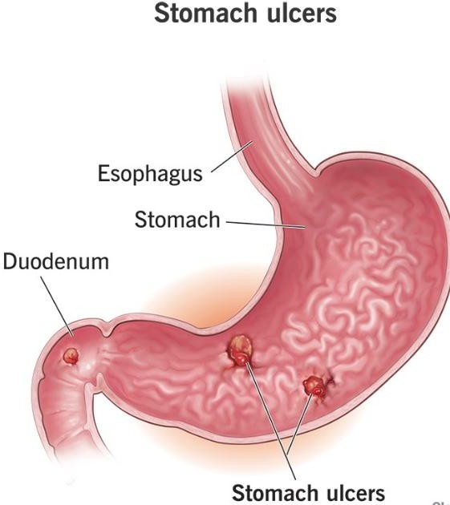

- Stress Ulcers

Stress ulcers are another type of peptic ulcer that typically develops after physical stress or trauma to the body, such as severe burns, head injuries, major surgeries, or prolonged illness. These ulcers usually form in the stomach, and while they are similar to peptic ulcers in terms of their location and symptoms, stress ulcers are primarily related to physiological stress rather than lifestyle factors like diet and bacterial infections. ^{[8-10]}

Stress ulcers are common in critically ill patients who have been subjected to significant trauma. The ulcers tend to form rapidly and can lead to gastrointestinal bleeding or perforation if not treated promptly. For this reason, stress ulcer prophylaxis is often administered to high-risk patients in hospitals. ^{[8-10]}

- Esophageal Ulcers

Esophageal ulcers develop in the esophagus, the tube that connects the mouth to the stomach. They are less common than peptic ulcers but can cause severe discomfort, particularly with swallowing. The primary cause of esophageal ulcers is gastroesophageal reflux disease (GERD), a condition where stomach acid and bile flow back into the esophagus, damaging the esophageal lining. This chronic acid reflux can erode the mucosal barrier of the esophagus, leading to the formation of ulcers. ^{[11-12]}

In addition to GERD, esophageal ulcers can be caused by infections (such as viral or fungal infections), swallowing toxic substances, or as a result of medical conditions like Crohn's disease. Patients with esophageal ulcers typically experience painful swallowing (odynophagia), chest pain, and heartburn. ^{[11-12]}

- Canker Sores (Aphthous Ulcers)

Unlike peptic ulcers, canker sores are small, shallow ulcers that occur in the mucous membranes of the mouth, such as the inner cheeks, lips, or the base of the gums. These ulcers are not caused by infection but may be linked to immune system dysfunction, hormonal changes, stress, and nutrient deficiencies (especially vitamin B12, folic acid, or iron). ^{[13, 14]}

Canker sores typically present as painful, round or oval sores with a white or yellowish center and a red border. They tend to resolve on their own within one to two weeks but can recur periodically. While they are not as serious as peptic ulcers, canker sores can cause significant discomfort and disrupt normal eating and speaking. ^{[13, 14]}
^{Figure 2.} Canker sores
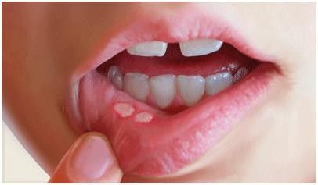

- Complications of Ulcers

Ulcers, when left untreated or inadequately managed, can lead to a range of serious and potentially life-threatening complications. The severity of these complications can vary based on the location of the ulcer, the underlying causes, the patient's overall health, and the timeliness of treatment. While many ulcers can be managed effectively with medication, lifestyle changes, and in some cases, surgical intervention, certain complications can arise that require urgent medical

- Role of Traditional Medicine in Ulcer Treatment:

Traditional medicine, which encompasses the use of plants, herbs, and natural substances, has been used for centuries across various cultures to treat a wide range of ailments, including ulcers. In recent years, there has been a growing interest in understanding the potential of traditional remedies in managing peptic ulcers, especially in cases where conventional treatments may have limitations or cause undesirable side effects. Traditional medicine often emphasizes holistic approaches, focusing on natural healing processes and overall well-being. Below, we explore the role of traditional medicine in ulcer treatment, including the therapeutic properties of plant-based remedies, their mechanisms of action, and their potential benefits and drawbacks. ^{[15]}
- Crossandra infundibuliformis:

Crossandra Infundibuliformis plant is very well known for its therapeutics benefits in Indian systems of medicine including Ayurveda and Siddha and in other forms of traditional medicine worldwide for the treatment of several ailments. It observed that many traditional utilities of Crossandra Infundibuliformis got their authentication when it is tested using different disease-based pharmacological models taking various extracts of roots, leaves, and stem as test samples.
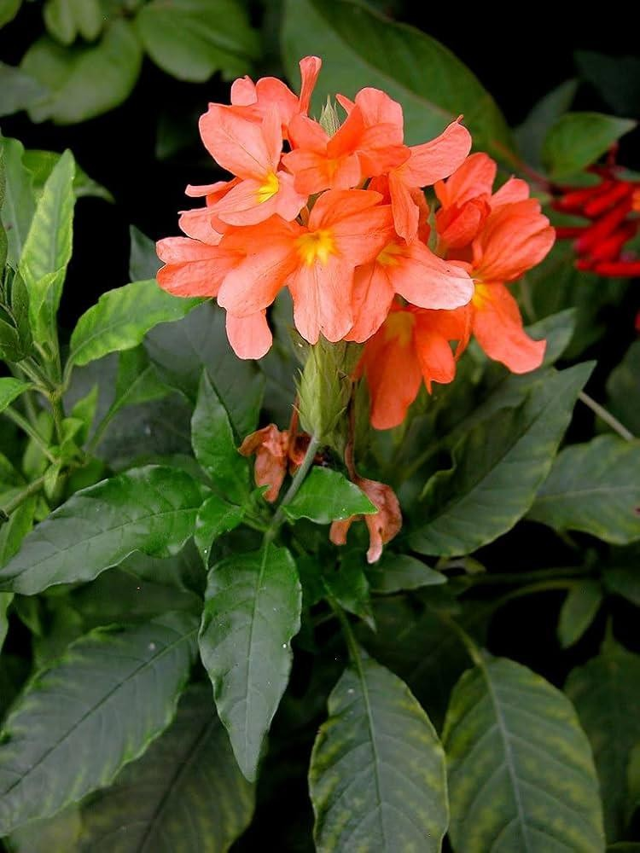
Leaf extracts of Crossandra infundibuliformis have aphrodisiac, anti-inflammatory and analgesic effect. The leaf extracts shown wound healing, antibacterial, antioxidant, antisolar, and larvicidal properties. This plant’s therapeutic properties make it useful for treating a variety of diseases.

Figure 3. Crossandra infundibuliformis linn
THERAPEUTIC USES:
Crossandra infundibuliformis ethanolic extract was used for various therapeutiuc purpose, Antimicrobial activity - leaves of Crossandra infundibuliformis, Wound healing activity by Crossandra infundibuliformis floral extract shown remarkable wound healing potential, The hepatoprotective activity was shown by extract of dried leave ,Aphrodisiac Activity leaves revealed the presence of alkaloids and saponins, The ethanol extract of Crossandra infundibuliformis shown antibacterial activity against all six pathogenic micro organism, Anticancer activity-The ethanolic extract of the leaves of Crossandra infundibuliformis was studied, Methanol and chloroform extract of Crossandra infundibuliformis shows substantial antioxidant activity in the majority of method examined. The antioxidant activity of methanol and chloroform extract of Crossandra infundibuliformis was ideal when total phenol and flavonoid levels were taken to account. The results of the investigation shows that methanol and chloroform extract of Crossandra infundibuliformis infundibuliformis could serve as a source of natural antioxidant

MATERIALS AND METHODS
Plant material:
The aerial parts of Crossandra infundibuliformis (L.) were collected from the local area of Komarapalayam in the month of May 2025, Namakkal District, Tamilnadu, India. The plant material was authenticated by Dr. P. RADHA; Research officer (Botany) Sci II, I/C; Siddha Medicinal Plants Garden / Mettur Dam, Tamilnadu - 636401 .and a voucher specimen{C0205250021} was submitted at the SSM College of Pharmacy, Erode (638312) Tamilnadu, India.
Extraction of plant:
Extraction by soxhlet apparatus the extraction procedure for the isolation of crude drug from plants has been practiced for a long time. This apparatus mainly consists of three parts, a round bottom flask in which the solvent has taken, the main jar in which the material from which the compounds to been extracted has kept loaded, and a condenser in which condensation of vapours of solvents takes place. Approximately 30 g of the powder of plant material from which the extract has to take into packed into Soxhlet main jar. The solvent is poured in the round bottom flask and extract condensation under reduced pressure, and a controlled temperature of 60-80 degree celcius has set to boil through the regulated heating mantle.The vapour of the solvent pass-through drive tubes enters the condenser through the main jar and gets condensed where there is a continuous flow of water in the condenser.The condensed solvent falls back on packed material in the main jar before collecting in a jar itself. The collection and extraction of material take place simultaneously in the main jar, as seen by the coloring of the solvent as a compound of material gets dissolved in the solvent. Thus, the crude plant material extract has been obtained, and it usually takes 7-8 h to complete an extraction. The solvent has evaporated, and finally, it yields green extract; this has been stored in the refrigerator for further usage

PRELIMINARY PHYTO CHEMICAL ANALYSIS TEST
The aerial parts of Crossandra infundibuliformis (L.) was subjected to systematic Phyto chemical screening by successively extracting with ethanol and the extracts were subjected for Phyto chemical investigation by qualitative chemical identification tests.
- Detection of alkaloids:
Dragendorff Test: 1-2 ml of Dragendorff's reagent was added to a few ml of the
extract. A reddish- brown or creamy white precipitate indicated the presence of alkaloids, while the absence of such precipitate indicated a negative result.
Mayer’s Test: 1ml of the extract was added with 1 ml of Mayer’s reagent. White yellow colour precipitate indicates the presence of alkaloids
- Detection of cardiac glycosides:

Keller-Killani Test: 1ml of filtrate was mixed with 1.5 ml of glacial acetic acid, 1 drop of 5% ferric chloride, and concentrated H2SO4 (added along the side of the test tube). A blue- colored solution in the acetic acid layer indicated the presence of cardiac glycosides.
- Detection of proteins:

Ninhydrin Test: 2mL of filtrate was mixed with 2 drops of Ninhydrin solution. A purple-coloured solution indicated the presence of amino acids.
Biuret Test: 1 ml of the extract was treated with 4% NaOH and few drops of CuSO4 Solution. Formation of purple violet colour indicates the presence of proteins.

- Detection of flavonoids:

Lead Acetate Test: 1mL of plant extract was added to a few drops of 10% lead acetate solution. A yellow precipitate indicated the presence of flavonoids.
Ferric Chloride Test: A few drops of 10% ferric chloride solution were added to an aqueous extract. A green precipitate indicated the presence of flavonoids.
- Detection of phenolic compounds:

Iodine Test: 1mL of extract was mixed with a few drops of diluted iodine solution. A transient red color indicated the presence of Phenolic compound

- Detection of tannins:

Braymer's Test: 1mL of extract was mixed with 3mL of distilled water, followed by 3 drops of 10% ferric chloride solution. A blue-green color indicated the presence of tannins.
Gelatin Test: 1 ml of extract was added with 1% gelatin solution containing 10% sodium chloride. Formation of white precipitate indicates the presence of tannins.
- Detection of phytosterols:

Salkowski's Test: The extract was mixed with a few drops of concentrated H2SO4, shaken well, and allowed to stand. A red color in the lower layer indicated the presence of phytosterol.
- Detection of carboxylic acids:

Effervescence Test: 1mL of plant extract was mixed with 1 ml of sodium bicarbonate solution. The appearance of effervescence indicated the presence of carboxylic acids. ^{[ 15,16,17]}
- Test for carbohydrates:
Fehling's test 0.5ml of Fehling's A was added to 0.5ml of Fehling's B solution 0.5ml of Fehling's B solution and to this mixture; 2ml of EECC was added. The mixture was heated in boiling water for 5-10 minutes
Benedict's test 0.5ml of extract is taken in a test tube and to this: 0.5ml of benedict's was added. The mixture was boiled for 5 minutes
Molisch's test 3ml of extract was taken in a test tube and to this few drop of naphthol solution was added test tube was shaken and conc. HSO4 was added from the walls

EVALUATION OF ANTI ULCER ACTIVITY
- In-vitro anti-ulcer activity by H+/K+ - ATPase Inhibition Activity:

- Preparation of H+/K+ - ATPase Enzyme

To prepare H+/K+ - ATPase enzyme sample the fresh goat stomach has purchased from the local slaughterhouse, the gastric mucosa of the fundus was cut-off and opened, the inner layer of the stomach has scrapped out for the parietal cell. The parietal cell obtained from the stomach has homogenized in 16mM Tris buffer with PH of 7.4, which has 10% Triton X-100 and centrifuged at 6000 rpm for 10mins after centrifuged the supernatant solution has used for the H+/K+- ATPase inhibition Protein content are used to find out according to Bradford's method were BSA are used for standard.
- Assessment of H+/K+ ATPase inhibition

Per-incubated for 60 min at 37 ºC for the reaction mixture of the sample containing 0.1ml of enzyme extract (300μg) and sample with different concentration (500, 250, 100, 50 and 10μgml). The reaction was initiated by adding 2mM MgCl2 (200μL) and 10mM KCl (200μL). After 30 min of incubation at 37 ºC the reaction was stopped by 4.5% ammonium molybdate, and 60% perchloric acid was added and centrifuged at 2000rpm for 10 min, and in spectrophotometrically inorganic phosphate was released and measured at 660nm. Briefly, at 10 min at room temperature, 1ml of supernatant 4ml of Millipore water, 1ml of 2.5% of ammonium molybdate, 0.4ml of ANSA was added. At 660nm inorganic phosphate, absorbance has been measured at various doses of the extract; the enzyme activity has been calculated as micromoles of Pi released per hour. Results were compared with the known anti-ulcer PPA inhibitor Omeprazole (100μg/ml) and expressed as Mean
± SEM 16 % enzyme inhibition has calculated using the below formula. ^{[18]}

Percentage of inhibition = [Activity (control) - Activity (test)/Activity (control)] × 100.

EVALUATION OF ANTI ULCER ACTIVITY
  - In-vitro anti-ulcer activity by Acid Neutralizing Capacity

The acid neutralizing capacity value for solution of Sample mixture using different concentration (500, 250, 100, 50 and 10 µg/ml) was compared with the standard antacid Aluminium hydroxide + Magnesium hydroxide (50 mg/ml). To the 5 ml quantity of this mixture, water was added to make up the total volume 70 ml and then mixed for one minute. There after 30 ml of 1.0 N HCl was added into standard and test preparation and stirred for 15 minutes, drops of phenophthalein solution was added and mixed. The excess HCl was immediately titrated with 0.5 N Sodium hydroxide solution drop wise until a pink color is attained. ^{[19]}
The moles of acid neutralized is calculated by,

Moles of acid neutralized = (vol. of HCl ×Normality of HCl) - (vol. Of NaOH × Normality of NaOH)
Acid neutralizing capacity (ANC) per gram of antacid = moles of HCl neutralized/ Grams of Antacid or Extract

RESULT AND DISCUSSION:

The Plant extract was done by Soxhlet extraction method using ethanol as solvent. Obtained plant extract was green viscous, semi solid in nature. The Percentage yield value of the extract was 29.24%.

PRELIMINARY PHYTOCHEMICAL TEST RESULT:

Preliminary phytochemical test of the ethanolic extracts revealed the presence and absence of different primary and secondary metabolites. Tannins, phytosteroids, flavonoids, glycosides, saponin, protein are present in the ethanolic extract of crossandra infundibuliformis

FIGURE 4. Phytochemical test
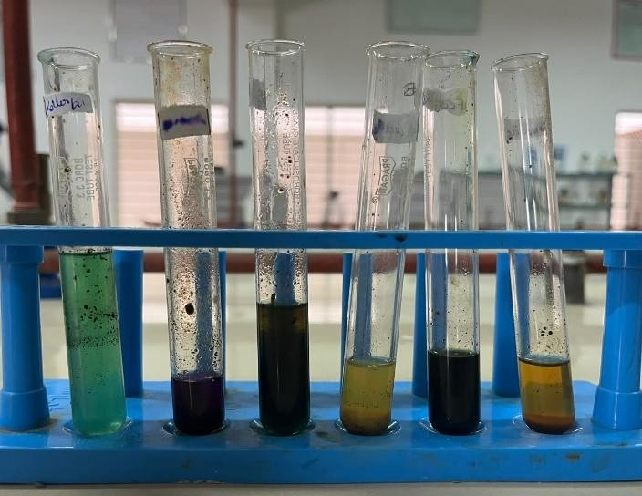
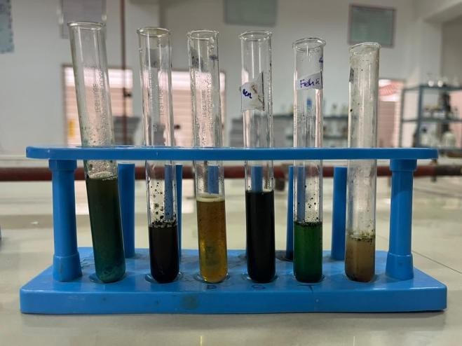

S.No. | Name of the  Sample | Phytochemical  compound | Result
1. | Ethanolic extract of Crossandra infundibuliformis linn aerial parts | Resins | _
2. |  | Carboxylic acid | _
3. |  | Tannins | +
4. |  | Steroids | +
5. |  | Flavonoid | +
6. |  | Carbohydrates | _
7. |  | Glycosides | +
8. |  | Saponification | +
9. |  | Protein | +
10. |  | Phenol | _
11. |  | Alkaloids | +
TABLE 1. Phytochemical compound of Crossandra infundibuliformis Linn

The results revealed the presence of medically active compounds in the plant extract. Preliminary Phyto chemical studies confirmed the purity of the drug. The Phyto chemical investigation of the extract showed that the presence of Alkaloids, Flavonoids, Phenolic Compounds and Phytosterol.

IN-VITRO ANTI-ULCER ACTIVITY BY H+/K+ - ATPase INHIBITION ACTIVITY REPORT:

TABLE 2. OD Value at 660 nm for Different Concentrations of Tested Samples
S. No | Tested sample  concentration (μg /ml) | OD Value at 660 nm (in triplicates)
1. | Control | 1.628 | 1.663 | 1.637
2. | 500 μg/ml | 0.474 | 0.462 | 0.455
3. | 250 μg/ml | 0.510 | 0.555 | 0.547
4. | 100 μg/ml | 0.576 | 0.558 | 0.566
5. | 50 μg/ml | 0.732 | 0.742 | 0.788
6. | 10 μg/ml | 0.946 | 0.973 | 0.982
7. | Omeprazole (100μg/ml)  (Standard) | 0.150 | 0.152 | 0.158

The optical density (OD) values at 660 nm were measured for various concentrations of the tested sample, providing valuable insight into the interaction between the sample and the assay medium. The OD values at this wavelength are typically indicative of the sample’s absorption properties, which, in the context of enzyme inhibition assays, can be used to gauge changes in enzyme activity or the presence of bioactive components in the sample. The results show a clear trend: as the concentration of the tested sample increases, the OD values decrease.

FIGURE 5. OD Value at 660 nm for Different Concentrations of Tested Samples

Percentage of Inhibition of H+/K+-ATPase Enzyme

The percentage inhibition of the H+/K+-ATPase enzyme by various concentrations of the tested sample is detailed in Table 4. This enzyme plays a crucial role in gastric acid secretion, making it a primary target for anti-ulcer drugs. In this study, a dose-dependent inhibition was observed, where increasing concentrations of the sample led to higher percentages of enzyme inhibition.

TABLE 3. Percentage of Inhibition of H+/K+-ATPase Enzyme

S. No | Tested sample concentration (μg/ml) | Percentage of inhibition (in triplicates) |  |  | Mean value (%)
1. | Omeprazole(100μg/  ml) | 90.8648 | 90.743 | 90.3776 | 90.6618
2. | 500 μg/ml | 71.1328 | 71.8636 | 72.2899 | 71.7621
3. | 250 μg/ml | 68.9403 | 66.1998 | 66.687 | 67.2757
4. | 100 μg/ml | 64.9208 | 66.0171 | 65.5298 | 65.4892
5. | 50 μg/ml | 55.4202 | 54.8112 | 52.0097 | 54.0804
6. | 10 μg/ml | 42.3873 | 40.743 | 40.1949 | 41.1084

FIGURE 6. Percentage of Inhibition of H+/K+-ATPase Enzyme

At the highest concentration (500 μg/ml), the sample exhibited about 71.76%, inhibition of the H+/K+-ATPase enzyme, which is quite significant. As the concentration of the sample decreased, the inhibition also decreased, with the 250 μg/ml concentration showing 67.27%, and the 100 μg/ml concentration showing 65.48%, inhibition. Even at the lowest tested concentration (10 μg/ml), the sample still managed to inhibit the enzyme by 41.10%, indicating that the sample has considerable activity, even at lower doses.

When compared to Omeprazole, a standard proton pump inhibitor, which exhibited 90.66% inhibition, the tested sample showed a moderate level of inhibition, but still demonstrated a promising effect. Omeprazole works by irreversibly binding to the H+/K+-ATPase enzyme, blocking the final step in gastric acid secretion. While the tested sample did not achieve the same level of inhibition, the dose-dependent response suggests that it may have similar mechanisms of action, possibly by binding to the enzyme and reducing its activity, or by modulating other factors involved in gastric acid secretion.

IC50 Value of Tested Sample

The IC50 value of the tested sample was determined to be 57.14 μg/ml, which represents the concentration required to inhibit 50% of H+/K+-ATPase enzyme activity. The IC50 value is a standard measure of the potency of an inhibitor, with lower values indicating more potent activity. In this case, the IC50 value of 57.14 μg/ml suggests that the sample has moderate inhibitory activity when compared to well-established proton pump inhibitors like Omeprazole, which typically exhibits a lower IC50
TABLE 4. IC50 Value of Tested Sample
log(inhibitor) vs. normalized response -- Variable slope
Best-fit values
LogIC50 |  | 1.757
HillSlope |  | -1.985
IC50 |  | 57.14
Std. Error
LogIC50 |  | 0.02684
HillSlope |  | 0.2691
95% Confidence Intervals
LogIC50 |  | 1.699 to 1.815
HillSlope |  | -2.567 to -1.404
IC50 |  | 50.00 to 65.30
Goodness of Fit
Degrees of Freedom |  | 13
R square |  | 0.9734
Absolute Sum of Squares |  | 524.3
Sy.x |  | 6.350
Number of points
Analyzed | 3 | 15

The relatively higher IC50 value compared to Omeprazole indicates that further optimization of the extract might be needed to enhance its potency. Additionally, the specific active compounds responsible for the inhibition of H+/K+-ATPase remain to be fully identified and characterized. Further studies could involve isolating and testing individual bioactive compounds to better understand their contribution to the observed enzyme inhibition and to identify potential candidates for drug development

Figure7: Well plate of H+/K+-ATPase Enzyme assay

While the IC50 value of the sample indicates a moderate level of potency, it still reflects promising potential for its use in the treatment of acid-related disorders, such as gastric ulcers. The moderate IC50 value could suggest that the sample contains bioactive compounds capable of interacting with the enzyme or other molecules involved in the acid secretion process. This result sets a benchmark for the sample's potency and offers a point of comparison for other natural or synthetic compounds with similar therapeutic applications.

The relatively higher IC50 value compared to Omeprazole indicates that further optimization of the extract might be needed to enhance its potency. Additionally, the specific active compounds responsible for the inhibition of H+/K+-ATPase remain to be fully identified and characterized. Further studies could involve isolating and testing individual bioactive compounds to better understand their contribution to the observed enzyme inhibition and to identify potential candidates for drug development

IN-VITRO ANTI-ULCER ACTIVITY BY ACID NEUTRALIZING CAPACITY METHOD:

The acid neutralizing capacity (ANC) of crossandra infundibuliformis linn was evaluated by comparing the acid-neutralizing ability of different concentrations (500 µg/ml, 250 µg/ml, 100 µg/ml, 50 µg/ml, and 10 µg/ml) to the standard antacid mixture of Aluminium hydroxide + Magnesium hydroxide (50 mg/ml). The ANC value provides insight into the ability of a substance to neutralize excess gastric acid
TABLE 5. Acid neutralizing capacity
S. No. | Name of the Sample | Concentration (µg/ml) | Reading on Burette (mL) | Moles of Acid Neutralized | Acid Neutralizing Capacity (ANC) / Antacid (g)
1 | Test sample | 500 µg/ml | 3.5 | 1.25 | 25
2 | Test sample | 250 µg/ml | 3.7 | 1.15 | 23
3 | Test sample | 100 µg/ml | 4 | 1.05 | 21
4 | Test sample | 50 µg/ml | 4.2 | 0.85 | 17
5 | Test sample | 10 µg/ml | 5 | 0.55 | 11
6 | Control (Aluminium hydroxide + Magnesium hydroxide) | 50 mg/ml | 1.5 | 2.25 | 45
FIGURE 8. Acid neutaralizing capacity

Different dose of ethanolic extracts from lower to higher concentration had been prepared to evaluate the effect. Aluminium hydroxide + Magnesium hydroxide was found to be more effective in anti-ulcer activity(antacid), so it is taken as standard drug. The Anti-ulcer activity is done by acid neutralizing capacity method. The result indicates that the concentration of extract increased, the acid neutralizing capacity also increased. The result demonstrating its potential of anti-ulcer activity as compared with standard drug (aluminium hydroxide + Magnesium hydroxide 50µg/ml). The extract has an anti-ulcer activity as compared to control but the extract has less potency as compared with standard drug

At lower concentrations (100 μg/ml, 50 μg/ml, and 10 μg/ml), there was a decrease in the ANC value, but it remained notable, suggesting that crossandra infundibuliformis still retains a moderate ability to neutralize acid. The gradual decline in ANC with decreasing concentration aligns with the expectation that a higher quantity of the active compounds in the sample is required to effectively neutralize a larger amount of acid. This suggests that the bioactive components responsible for the acid-neutralizing action are dose-dependent, and higher concentrations are more efficient in neutralizing excess HCl.
- This is an Short Research Article

SUMMARY & CONCLUSION:
- Crossandra infundibuliformis linn aerial parts were extracted using Soxhlet extraction with ethanol, a well-established technique for obtaining plant extracts ensuring efficient extraction of bioactive compounds from the plant material.
- Preliminary phytochemical screening revealed the presence of compounds such Tannins, steroids, flavonoids, glycosides, saponin, protein are present in the ethanolic extract of crossandra infundibuliformis These compounds are known for their antioxidant, anti- inflammatory, and gastroprotective effects.
- The inhibition of the H+/K+-ATPase enzyme was assessed by measuring the percentage of enzyme inhibition at different concentrations of the extract. A clear dose-dependent inhibition was observed, with higher concentrations leading to greater enzyme inhibition.
- The inhibition of H+/K+-ATPase suggests that the extract may act through direct interaction with the enzyme or other associated proteins involved in gastric acid production. This mechanism is crucial for reducing gastric acidity and promoting ulcer healing.
- The acid neutralizing capacity of the extract was determined by titrating with sodium hydroxide. The crossandra infundibuliformis extract demonstrated significant ANC, particularly at higher concentrations (500 μg/ml and 250 μg/ml), comparable to the standard antacid Aluminium hydroxide + Magnesium hydroxide.
- The ability of crossandra infundibuliformis linn aerial parts to restore the gastric mucosal barrier is crucial for its anti-ulcer effects. By promoting mucus secretion and reducing acid secretion, the extract helps protect the stomach lining from acid-induced damage
- Future research should focus on isolating the specific compounds responsible for the observed effects, as well as investigating their mechanisms of action at the molecular level. Clinical trials will be necessary to evaluate the extract’s efficacy and safety in human subjects before it can be recommended for therapeutic use.

COMPETING INTERESTS DISCLAIMER:
Authors have declared that they have no known competing financial interests OR non-financial interests OR personal relationships that could have appeared to influence the work reported in this paper.

Disclaimer (Artificial intelligence)

Author(s) hereby declare that NO generative AI technologies such as Large Language Models (ChatGPT, COPILOT, etc.) and text-to-image generators have been used during the writing or editing of this manuscript.

REFERENCES:
- Khan AH, Dar MA, Mir MA. Gastric ulcer: an overview. International Journal of Current Research in Physiology and Pharmacology. 2023 Apr 11:1-7.
- Jaiswal F, Rai AK, Wal P, Wal A, Singh SP. Peptic ulcer: a review on etiology, pathogenesis and treatment. Asian Journal of Pharmaceutical Education and Research. 2021;10(4):1.
- RaviKKumar VR, Rathi S, Singh S, Patel B, Singh S, Chaturvedi K, Sharma B. A comprehensive review on ulcer and their treatment. Zhongguo Ying Yong Sheng Li Xue Za Zhi. 2023 Dec 21;39:e20230006.
- Wallace JL. Recent advances in gastric ulcer therapeutics. Current Opinion in Pharmacology. 2005 Dec 1;5(6):573-7.
- Gear MW, Truelove SC, Whitehead R. Gastric ulcer and gastritis. Gut. 1971 Aug 1;12(8):639-45.
- Mille M, Engelhardt T, Stier A. Bleeding duodenal ulcer: strategies in high-risk ulcers. Visceral Medicine. 2021 Feb 10;37(1):52-62.
- Shiotani A, Graham DY. Pathogenesis and therapy of gastric and duodenal ulcer disease. Medical Clinics. 2002 Nov 1;86(6):1447-66.
- Haglund U. Stress ulcers. Scandinavian Journal of Gastroenterology. 1990 Jan 1;25(sup175):27-33.
- Barletta JF, Bruno JJ, Buckley MS, Cook DJ. Stress ulcer prophylaxis. Critical care medicine. 2016 Jul 1;44(7):1395-405.
- Moody FG, Cheung LY. Stress ulcers: their pathogenesis, diagnosis, and treatment. The Surgical Clinics of North America. 1976 Dec 1;56(6):1469-78.
- Dağ MS, Öztürk ZA, Akın İ, Tutar E, Çıkman Ö, Gülşen MT. Drug-induced esophageal ulcers: case series and the review of the literature. Turkish Journal of Gastroenterology. 2014;25(2):180-4.
- Wilcox CM, Schwartz DA, Clark WS. Esophageal ulceration in human immunodeficiency virus infection: causes, response to therapy, and long-term outcome. Annals of internal medicine. 1995 Jul 15;123(2):143-9.
- Messadi DV, Younai F. Aphthous ulcers. Dermatologic therapy. 2010 May;23(3):281-90.
- McBride DR. Management of aphthous ulcers. American family physician. 2000 Jul 1;62(1):149-54.
- Kuna L, Jakab J, Smolic R, Raguz-Lucic N, Vcev A, Smolic M. Peptic ulcer disease: a brief review of conventional therapy and herbal treatment options. Journal of clinical medicine. 2019 Feb 3;8(2):179.
- Kota BP, Teoh AW, Roufogalis BD. Pharmacology of traditional herbal medicines and their active principles used in the treatment of peptic ulcer, diarrhoea and inflammatory bowel disease. New Adv Basic Clin Gastroenterol. 2012 Apr 18;14:297-310.
- Borra SK, Lagisetty RK, Mallela GR. Anti-ulcer effect of Aloe vera in non-steroidal anti-inflammatory drug induced peptic ulcers in rats. African Journal of Pharmacy and Pharmacology. 2011 Oct 29;5(16):1867-71.
- Reyes-Chilpa R, Baggio CH, Alavez-Solano D, Estrada-Muñiz E, Kauffman FC, Sanchez RI, Mesia-Vela S. Inhibition of gastric H+, K+-ATPase activity by flavonoids, coumarins and xanthones isolated from Mexican medicinal plants. Journal of ethnopharmacology. 2006 Apr 21;105(1-2):167-72.
- Devhare LD, Gokhale N. Acid neutralizing capacity and antimicrobial potential of selected solvent extract from various indigenous plants. Journal of Advanced Scientific Research. 2021 Nov 30;12(04):175-9.
- Roy AJ, Maut C, Gogoi HK, Ahmed SI, Kashyap A. A review on herbal drugs used in the treatment of peptic ulcer. Current Drug Discovery Technologies. 2023 May 1;20(3):4-15.
- Vasantha, G., Bhargavi, D., Yashodha, A., Roy, N. S., & Shaik, S. A. (n.d.). A plant review on Crossandra infundibuliformis. Anvesak, UGC Care Group 1 Journal. Department of Pharmacology, Vignan Institute of Pharmaceutical Technology, Duvvada, Visakhapatnam.

- Vadivel, E., & Panwal, S. V. (2016). In vitro anticancer and insecticidal activity of Crossandra infundibuliformis. Journal of Chemical and Pharmaceutical Research, 8(5), 260–264.http://www.jocpr.com

- Sharmilla, N., & Gomathi, N. (2011). Antibacterial, antioxidant activity and phytochemical studies of Crossandra infundibuliformis leaf extracts. International Journal of Phytomedicine, 3, 151–156.http://www.ajournals.org/index.php/ijpm/index

- Selvakumar, S. (2015). Preliminary phytochemical analysis of aerial parts of Crossandra infundibuliformis. Journal of Chemical and Pharmaceutical Research, 7(12), 784–787.http://www.jocpr.com

- 140 Sajeena, C. H., Kalliyath, M. D., P., M. N., Shabeeb, M., Mufe edha, K. P., Salih, K. T. M., Baboo, R. V. C., & Sirajudheen, M. K. (2024). A review on Crossandra infundibuliformis. World Journal of Pharmaceutical Research, 13(12), 547–559.https://doi.org/10.20959/wjpr202412-32870.

- Silen W, Merhav A, Simson JN. The pathophysiology of stress ulcer disease. World journal of surgery. 1981 Mar;5(2):165-72.
- Richardson CT. Pathogenetic factors in peptic ulcer disease. The American Journal of Medicine. 1985 Aug 30;79(2):1-7.
- Margolis DJ, Knauss J, Bilker W, Baumgarten M. Medical conditions as risk factors for pressure ulcers in an outpatient setting. Age and ageing. 2003 May 1;32(3):259-64.
- Yandrapu H, Sarosiek J. Protective factors of the gastric and duodenal mucosa: an overview. Current gastroenterology reports. 2015 Jun;17(6):24.

