CASE REPORT
SUCCESSFUL NON-OPERATIVE MANAGEMENT OF SPONTANEOUS SPLENIC RUPTURE WITH HEMOPERITONEUM IN PLASMODIUM VIVAX MALARIA: A CASE REPORT FROM CENTRAL INDIA
ABSTRACT
Background: Plasmodium vivax malaria, traditionally considered benign, is now increasingly recognized as a cause of severe and life-threatening complications. Among these, spontaneous splenic rupture (SSR) is a rare but critical emergency associated with significant morbidity and potential mortality if not promptly managed.
Aims: To report a case of spontaneous splenic rupture (SSR) secondary to Plasmodium vivax malaria managed successfully with Non-Operative Management (NOM), and to highlight the viability of splenic salvage in hemodynamically responsive patients.
Presentation of Case: A 28-year-old male from Central India presented with a 6-day history of high-grade fever, chills, and acute left upper quadrant abdominal pain. Clinical examination revealed hypotension (80/60 mmHg), tachycardia (110 bpm), pallor, and icterus. Diagnostic evaluation confirmed P. vivax mono-infection. CECT abdomen revealed massive splenomegaly with subcapsular hematomas and hemoperitoneum. The patient showed rapid physiological response to crystalloid resuscitation, permitting a trial of NOM.
Discussion: The patient was managed conservatively in the ICU with intravenous artesunate followed by oral primaquine. Hemodynamic stability was maintained without blood transfusions despite a hemoglobin nadir of 8.0 g/dL. Following 12 days of strict monitoring, the patient was discharged with complete clinical recovery and radiological resolution confirmed at 6-week follow-up.
Conclusion: This case demonstrates that P. vivax malaria can cause spontaneous splenic rupture even in the absence of trauma. Hemodynamically unstable patients who respond well to initial fluid resuscitation can be successfully managed conservatively, preserving immunological function and avoiding the morbidity of splenectomy.
Keywords: Plasmodium vivax, Malaria, Splenic Hematoma, Spontaneous Splenic Rupture, Hemoperitoneum, Conservative Management.
1. INTRODUCTION
Historically, Plasmodium vivax was characterized as "benign tertian malaria", distinct from the lethal trajectory of Plasmodium falciparum. However, contemporary evidence has dismantled this dichotomy, identifying P. vivax as a significant cause of severe morbidity, including Spontaneous Splenic Rupture (SSR). While SSR is a rare entity, estimated to occur in less than 1-2% of malaria cases, it represents a catastrophic emergency often underreported in resource-limited settings where autopsies are infrequent (Kassam et al., 2020).
Epidemiologically, a paradox exists: while P. falciparum causes more deaths globally, P. vivax is disproportionately responsible for splenic rupture. This predisposition is attributed to rapid, massive splenomegaly induced by the infection and chronic architectural remodeling caused by recurrent relapses (Jiménez et al., 2007). The pathophysiology follows a "three-stage" mechanism: initial hyperplastic congestion, formation of subcapsular hematomas due to micro-infarcts, and final capsular breach precipitated by trivial increases in intra-abdominal pressure (Ali and Abdallah, 2013).
Management paradigms have shifted from mandatory splenectomy to "Splenic Salvage." The historical imperative to operate has been challenged by the success of Non-Operative Management (NOM). A landmark review of the Khartoum experience cited a 71% success rate for NOM in malarial rupture, provided the patient is hemodynamically stable or responsive to resuscitation (Rasheed et al., 2012). Preserving the spleen is now prioritized to prevent Overwhelming Post-Splenectomy Infection (OPSI), a condition caused by encapsulated bacteria that carries a mortality rate of up to 50-70% in asplenic individuals (Stern et al., 2025). This report describes the successful NOM of a patient with P. vivax malaria complicated by a splenic hematoma and hemoperitoneum, emphasizing good hemodynamic response to fluid resuscitation as a decisive clinical parameter for conservative management.
2. PRESENTATION OF CASE
A 28-year-old male from Khandwa, Madhya Pradesh, India, presented to the Emergency Department with a 6-day history of fever with chills and rigors, followed by acute abdominal pain in the left upper quadrant. He reported multiple episodes of non-bilious vomiting. There was no history of trauma. The patient initially received treatment at a district hospital where he was managed with broad-spectrum antibiotics for presumed sepsis, with non-resolution of symptoms and worsening abdominal pain prompting referral to our center.
On physical examination, the patient was conscious but anxious, with pallor and icterus. He presented with hypotension (Blood Pressure: 80/60 mmHg) and tachycardia (Pulse: 110 bpm). Abdominal examination revealed diffuse tenderness, most marked in the left hypochondrium, without generalized guarding or rigidity. An immediate fluid challenge with crystalloids was administered; re-evaluation showed a hemodynamic response, with BP stabilizing to 98/68 mmHg and pulse settling to 92 bpm within 2 hours.
Laboratory investigations including peripheral blood smear (thick and thin) showed rings, trophozoites, and schizonts consistent with P. vivax; rapid antigen tests were confirmatory for Plasmodium vivax mono-infection. The initial hemogram showed anaemia (Haemoglobin: 11 g/dL) and thrombocytopenia (Platelets: 79,000/µL). Biochemical profile indicated malaria-associated hepatitis and haemolysis (Total Bilirubin: 4.45 mg/dL, Indirect Bilirubin: 3.79 mg/dL, elevated SGOT) with preserved renal function (Creatinine: 0.97 mg/dL). A summary of laboratory parameters throughout the admission is presented in Table 1.
Ultrasonography (USG) revealed hepatosplenomegaly with mild to moderate free fluid with fine moving internal echoes in the pelvis and perisplenic regions, suggestive of hemoperitoneum. Contrast-Enhanced Computed Tomography (CECT) abdomen confirmed a massively enlarged spleen (Splenic Index: 930) with a subcapsular hematoma and a localized hyperdense pelvic collection measuring approximately 70 cc (Figure 1). Importantly, there was no active contrast blush to suggest ongoing arterial bleeding. Had it been traumatic, on comparison to American Association for Splenic Trauma (AAST) scale (2018 revision), this equates to Grade III (ruptured subcapsular hematoma, hemoperitoneum without vascular injury/active bleed) (Gaillard F et al.; 2026). Hepatomegaly (17.5 cm) was also noted.
The patient was admitted to the Intensive Care Unit (ICU). Initial empirical broad-spectrum antibiotics were administered to cover potential sepsis pending diagnostic confirmation. Upon confirmed malaria diagnosis, antimalarial therapy was initiated with intravenous artesunate (2.4 mg/kg), followed by oral consolidation therapy. Oral primaquine was administered for radical cure following G6PD status assessment. Judicious intravenous fluid therapy was maintained to ensure Mean Arterial Pressure (MAP) > 65 mmHg. Daily coagulation profile remained in normal limits (aPTT within reference range) (ibonuf MAM et al.; 2025).
Despite a decline in haemoglobin to a nadir of 8.0 g/dL on Day 11, blood transfusion was withheld as the patient remained clinically asymptomatic at rest, avoiding transfusion-related risks. The patient remained hemodynamically stable throughout the hospital stay. Abdominal pain and distension gradually subsided. Haematological recovery occurred by day 11 with platelets recovering to 199,000/µL and haemoglobin stabilizing at 8.0 g/dL. Serum bilirubin normalized (1.63 mg/dL) as haemolysis resolved. The patient was discharged on day 12 with strict instructions to avoid strenuous activity and contact sports for 8 weeks to prevent delayed rupture. Follow-up after 6 weeks confirmed complete clinical recovery with resolution of hemoperitoneum and splenic hematoma on repeat imaging.
Parameter (Normal Range) | Day 1 | Day 4 | Day 8 | Day 10 | Day 11 | Interpretation
Heamoglobin (13.0-17.0 g/dl) | 11 | 10.2 | 8.2 | 8.3 | 8 | Significant decline; stabilized
Platelet (15.-450 x 10³/µL) | 79 | 80 | 100 | 148 | 199 | Recovery from thrombocytopenia
WBC (4.0–11.0 × 10³/µL) | 4.67 | 6.63 | 3.84 | 3.67 | 3.8 | Persistent mild leukopenia
Serum Bilirubin Total (0.1–1.2 mg/dL) | 4.45 | 4.48 | 2.01 | 1.88 | 1.63 | Resolving hyperbilirubinemia
Bilirubin direct, serum (up to 0.3) | 0 | 0.52 | 0 | 0 | 0
Bilirubin indirect, serum (0.2-1.0) | 3.79 | 2.91 | 1.26 | 1.29 | 1.13 | Malaria induced hemolysis
Delta bilirubin, serum (0.0-0.2) | 0.67 | 1.05 | 0.76 | 0.59 | 0.5
AST (5–40 U/L) | 45 | 83 | 49 | - | 37 | Mild hepatic involvement
ALT (5–40 U/L) | 46 | 35 | 34 | - | 49 | Mild hepatic involvement
Serum Creatinine (0.7–1.3 mg/dL) | 0.97 | 1.64 | 0.72 | 0.71 | - | Normal renal function
Table 1. Laboratory parameters over the course of hospital admission.
Abbreviations: WBC, White Blood Cell; AST, Aspartate Aminotransferase; ALT, Alanine Aminotransferase

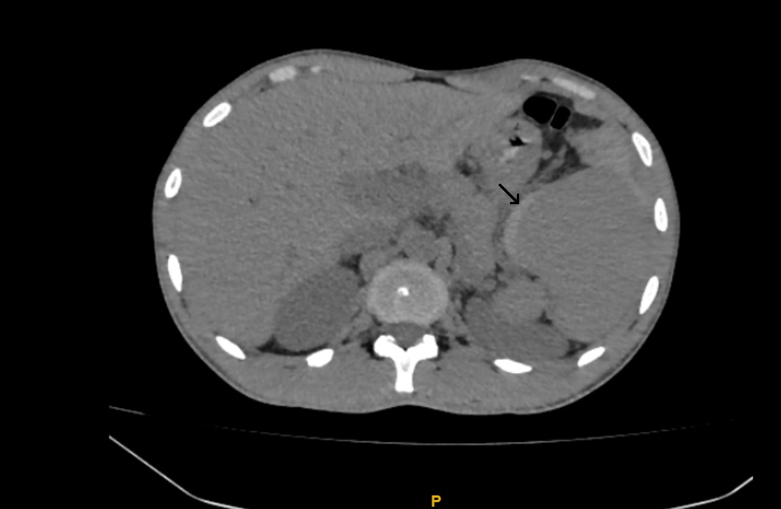
Fig. 1. CECT Abdomen, Transverse Section showing the spleen with a semilunar hyper-density indicating a subcapsular hematoma (Arrowhead). Note the absence of active contrast extravasation, confirming no ongoing arterial hemorrhage.
3. DISCUSSION
Splenic complications in malaria caused by P. vivax are rare yet potentially fatal (Kim et al., 2014). SSR occurs due to congestion of the spleen with parasitized erythrocytes, leading to infarction, hematoma formation, and subsequent capsular rupture (Kim et al., 2014; Alani et al., 2021). This case was notable for the absence of antecedent trauma and its presentation with classic clinical features: acute abdominal pain, progressive anemia, and imaging confirmation of splenic pathology.
The decision for NOM was anchored in the patient's physiological response to initial resuscitation. Despite a large subcapsular hematoma, the absence of active contrast extravasation on CECT and the patient's hemodynamic stability permitted splenic conservation. This aligns with the growing consensus that NOM is appropriate in hemodynamically responsive patients, with splenectomy reserved for those with uncontrollable hemorrhage or deteriorating clinical status. A review of the Khartoum experience reported a 71% NOM success rate in malarial splenic rupture, validating the conservative approach adopted in this case (Rasheed et al., 2012).
Preserving the spleen is of particular importance in malaria-endemic regions such as Central India. The spleen is a key immunological organ responsible for filtering parasitized erythrocytes and generating specific antibody responses against Plasmodium species and encapsulated bacteria. Splenectomy predisposes patients to OPSI, which carries a mortality rate of 50-70% and mandates lifelong antibiotic prophylaxis and vaccination (Stern et al., 2025). Therefore, every effort should be made to preserve splenic function, especially in young patients from endemic areas.
The biochemical profile in this case, reflecting malaria-associated hepatitis and haemolysis, also warrants discussion. Prospective data in malaria patients demonstrate that liver enzymes and bilirubin are frequently deranged at presentation but tend to normalize following effective antimalarial treatment, indicating predominantly reversible, infection-related hepatic dysfunction (Megabiaw et al., 2022). The normalization of bilirubin levels observed in this patient by day 12 is consistent with this pattern.
Judicious use of imaging and serial clinical assessment was critical for guiding management decisions. The absence of a contrast blush on CECT was a key reassuring finding that validated the NOM strategy. Clinicians should maintain serial monitoring for at least 8-12 weeks following discharge, as delayed splenic rupture, though rare, has been reported in the literature.

4. Clinical Significance
This case is indication of malaria-endemic regions like central India, where > 50 % of cases Malaria accounts for P. vivax. (Singh R et al.; 2023) and due to lack in number of imaging access spontaneous splenic rupture remain an Underdiagnosed complication of P. vivax (Khan MD et al.; 2022, ibonuf MAM et al.; 2025). The treatment plan for NOM rather than splenectomy was based on:
(1) rapid hemodynamic response to crystalloids (BP from 80/60 to 98/68 mmHg in 2 hours); (Rasheed A et el.; 2012)
(2) CECT absence of active contrast blush/extravasation; (Gaillard F et al.; 2026)
(3) no ongoing transfusion need despite Hb 8.0 g/dL; (Singh R et al.; 2023) and
(4) stable serial labs/APTT. (ibonuf MAM et al.; 2025)
In this case report, surgery was considered as second line due to 71 % success rate of SSR (Rasheed A et al.; 2012) and opsi risks (Stern BA et al.; 2025). Moving with NOM as treatment plan had an advantage of splenic preservation for immunity against Plasmodium, decrease in morbidity (infection, thrombosis). Also, it avoided risks of transfusion and favorable outcome of shorter stay (12 days) (Odeh A et al.; 2021).
Since the initial instability was quickly overcome, this technique did not differ from guidelines (e.g., AAST for stable patients) (Gaillard F et al., 2026). This is consistent with the Khartoum series (Rasheed A et al., 2012) and recent experiences in endemic regions (Khan MD et al.; 2022, Singh R et al.; 2023). ICU monitoring, broad spectrum antibiotics, coagulation panel, sepsis markers, and angioembolization/surgery on standby for blush or deterioration were all part of the preparation for complications (ibonuf MAM et al.; 2025). Although there was no DIC or sepsis, the intervention thresholds were MAP <65 mmHg or Hb <7 g/dL.
Biochemical abnormalities included modest direct elevation in hepatic enzymes due to congestion, reversed after artesunate therapy, and indirect hyperbilirubinemia (3.79 mg/dL Day 1) from P. vivax RBC haemolysis (Megabiaw F et al., 2022). A bigger splenic hematoma would have changed therapy towards surgical intervention. As for AAST Grade III splenic injury similar to our case, NOM was appropriate (Gaillard F et al., 2026, Odeh A et al., 2021).

5. CONCLUSION
This case demonstrates that P. vivax malaria can cause spontaneous splenic rupture even in the absence of trauma, and that hemodynamically unstable patients who respond promptly to initial fluid resuscitation can be successfully managed with conservative protocols. Clinicians in malaria-endemic regions should maintain high clinical suspicion for splenic complications in cases presenting with acute abdomen, anaemia, and jaundice. Conservative management in hemodynamically responsive patients allows splenic preservation, thereby maintaining immunological integrity and avoiding the long-term morbidity associated with splenectomy, provided close clinical monitoring and access to timely surgical intervention remain available.

Disclaimer (Artificial intelligence)

Author(s) hereby declares that no generative AI technologies were used for content creation, data analysis, or medical interpretation in this manuscript. AI tools were used solely for grammar improvement, language correction, and reference formatting assistance.
Ethical Approval:

As per international standards or university standards written ethical approval has been collected and preserved by the author(s).
Consent
As per international standards or university standards, patient(s) written consent has been collected and preserved by the author(s).

REFERENCES
- Kassam N, Furalle R, Meena E, Fatma A. Case Report: Sudden Splenic Rupture in a Plasmodium falciparum-Infected Patient. Int J Gen Med 2020; 13: 691-695.
- Jiménez BC, Navarro M, Huerga H, López-Vélez R. Spontaneous Splenic Rupture due to Plasmodium vivax in a Traveler: Case Report and Review. J Travel Med 2007; 14: 188-191.
- Ali AA, Abdallah TM. The clinical range and management of spontaneous rupture of the pathological malarial spleen (SRPMS): A short case series from Sudan. MalariaWorld J 2013; 4: 1-6.
- Rasheed A, Layden J, Guiver M, Warhurst DC. Non-operative management of malarial splenic rupture: the Khartoum experience and an international review. Int Surg 2012; 97: 215-220.
- Stern BA, O'Malley B, Majeed A, Grodsky M. From ER to Mortality in 48 Hours: A Fatal Case of Overwhelming Post-Splenectomy Infection. Medicine Forum 2025; 26: 31-35.
- Kim KM, Bae BK, Lee SB. Spontaneous splenic rupture in Plasmodium vivax malaria. Ann Surg Treat Res 2014; 87: 44-46.
- Alani AM, Kolleri JJ, Al Ekeer A, Ibrahim ZAA. Spontaneous splenic rupture in malaria patients: two case reports. Cureus 2021; 13: e20344.
- Megabiaw F, Eshetu T, Kassahun Z, Aemero M. Liver enzymes and lipid profile of malaria patients before and after antimalarial drug treatment at Dembia Primary Hospital and Teda Health Center, Northwest, Ethiopia. Res Rep Trop Med 2022; 13: 11-23.
- Gaillard F, Sharma R, Knipe H, et al. AAST spleen injury scale. Reference article, Radiopaedia.org (Accessed on 17 Mar 2026)
- Khan MA, Raza S, Ahmed S. Spontaneous Splenic Rupture in Plasmodium Vivax Malaria. Pak Armed Forces Med J 2022;72(3):1024-1027.
- Singh R, Kumar A, Sharma V. A Rare Twist: Spleen Rupture in Plasmodium vivax Malaria. Cureus 2023;15(11):e48372.
- Ibnouf MAM, et al. Predictor of Spontaneous Rupture of Malarial Spleen. Sudan J Med Sci 2025;20(1):45-52.
- Odeh A, et al. Spontaneous Splenic Rupture as a Complication of Malaria. Travel Med Infect Dis 2021;44:102123.

