Review Article

Medicinal Significance of Pyracantha crenulata: Insights into Botany, Phytochemistry, and Pharmacology

Abstract
Background: Pyracantha crenulata (Roxb.) M. Roem. is an evergreen shrub also called as Himalayan firethorn, belongs tofamily Rosaceae inherent in the Himalayan areas of India, China and Nepal. Various parts of the plant have long been used in traditional medicine for the treatment of infections, inflammation, metabolic disorders and cardiovascular diseases. Due to its diverse pharmacological potential and rich phytochemical profile, it has gained increasing scientific attention in recent years. Although research on Pyracantha crenulata has progressed significantly, systematic studies on its biological activities remain relatively limited.
Aim: The present review aims to provide a comprehensive overview of the botanical characteristics, phytochemical composition, and experimentally validated pharmacological properties of Pyracantha crenulata.
Methods: This review is based on published literature retrieved from scientific databases like PubMed, Scopus, Web of Science and Google Scholar. It provides an in-depth assessment of the botanical features, phytochemistry and pharmacological activities of the plant.
Results: The biological activities of Pyracantha crenulata are mainly ascribed to the presence of flavonoids, phenolic acids, triterpenoids, sterols, glycosides and essential micronutrients, in accordance with phytochemical analyses. Various extracts have demonstrated significant antioxidant, cardioprotective, anti-inflammatory, antibacterial, antidiabetic, hepatoprotective and neuroprotective activities in research studies.
Conclusion: This review compiles and critically analyzes the available scientific evidence, highlighting the therapeutic potential of Pyracantha crenulata and providing a valuable reference for future research in pharmacognosy and natural product-based drug discovery.

Keywords: Pyracantha crenulata, Himalayan firethorn, phytochemistry, medicinal plants

1. Introduction
Pyracantha crenulata, often called Ghingharu or Himalayan firethorn, is the perennial evergreen shrub native to Kumaon region in Uttarakhand (Singh et al., 2018; Kewlani et al., 2023). It belongs to Rosaceae family and is identified by its prickly branches and groups of magnificent, small white flowers that are followed by vibrant red berries (Osmaton 1927). The plant is found in many countries which include India, China and Japan where it has been used to treat wide range of diseases. Due to its ample number of biological resources and ethnobotanical significance in traditional medicine, the plant has captivated a lot of attention (Joshi et al., 2023).
Pyracantha crenulata has been assessed for various phytochemicals to study its possible remedial uses. The plant is rich in essential oils and contains a variety of secondary metabolites which includes triterpenoids and diterpenoids such labdanes, abietanes and ent-kauranes (Kumar et al., 2026). These phytochemicals have anti-inflammatory, antioxidant, antibacterial and anticancer activities (Singh et al., 2020). Pyracantha crenulata is used four both culinary and therapeutic purposes in Southeast Asian countries (Sati, 2017). The flowers of Pyracantha have one ovary and twenty stamens which makes them hermaphrodite. Indian Hawthorn or Ghingharu are common names for this prickly, perennial evergreen shrub (Brandis, 1921; Kewlani et al., 2023). Pyracantha is a good soil binder used to stabilize deteriorated slope areas. That is vulnerable to landslides (Gamble, 1972). In Garhwal folk and traditional medicine, the fruit of this plant has been used to cure significant diseased conditions such as diabetes, hypertension, blood pressure, and circulatory disorders particularly angina (Spectrum, 2010; Kewlani et al., 2023). The fruit is used to cure burns, heart failure, myocardial debility and Buerger's disease. It is also an appetizer, cardiotonic, diuretic, vasodilator, and sedative. Old age individuals eat the fruit to feel refreshed and to ease body and joint discomfort. Yogurt and fruit powder are used to treat bloody dysentery (Chauhan, 1999; Khare, 2004; Khare, 2007; Pade et al., 2007; Saklani et al., 2011; Saklani and Chandra, 2014). The leaves are used to make herbal teas, sunburn treatments, and face creams because of their anti-inflammatory, immunomodulatory, and antioxidant properties(Simoons, 1990). The plant is seeded as an ornamental and makes a great hedge (Dimitri, 2009). It contains calcium, potassium, protein, carbs, lipids, fibers, vitamin C, vitamin A, vitamin B, vitamin B2, vitamin B12, and vitamin E (Negi et al., 2009). The majority of Pyracantha species contain bio-flavonoids that are very helpful in treating heart and blood circulation problems (Peschel et al., 2008). The antioxidants present in plant lessen the harm caused by free radicals. Up to the 18th century, this herb was used medicinally to treat respiratory disorders and circulatory system disorders. Increasing blood flow to the coronary heart muscle and repairing the regular heartbeat are considered in ayurvedic medicine. This has an effect due to bioflavonoid content of fruits. The fruit and flowers of plants are thought to have a minor heart-tonic effect in other medical systems (Osmaston, 1926; Tiwari et al., 2020; Sultana et al., 2017; Kewlani et al., 2023). Additionally, because of its diuretic, depurative, tonic, antirheumatic, cardiotonic, hypoglycemic, hypotensive, anti-inflammatory and lithontripic qualities(Guglani et al., 2022), it is said to be helpful in treating a variety of conditions in Ayurvedic medicine, including hepatic, stomach, and skin disorders (Himalay, 1999; Fern, 2008; Otsuka et al., 1981; Singh et al., 2018). Despite its widespread use, further research is required to elucidate the mechanisms underlying the medicinal properties of Pyracantha crenulata and to explore its potential applications in modern medicine (Pandey et al., 2024). Although research on Pyracantha crenulata has progressed significantly, systematic studies on its biological activities remain relatively limited. The present review aims to provide a comprehensive understanding of Pyracantha crenulata by summarizing its phytochemical and pharmacological properties.
2. Methodology
2.1Source and Search Strategy
An extensive literature survey was conducted to collect relevant data on Pyracantha crenulata published up to the year 2025. Scientific articles were retrieved from electronic databases such as PubMed, Google Scholar and ScienceDirect. The search strategy included keywords such as Pyracantha crenulata, Himalayan firethorn, Ghingharu, pharmacognosy, phytochemistry, pharmacology and traditional uses. Relevant peer-reviewed research articles, review papers, books and ethnomedicinal reports published in the English language were screened. Chemical structures were drawn using ChemDraw in accordance with journal guidelines.
2.2Inclusion and Exclusion Criteria
The present review includes all relevant scientific literature on Pyracantha crenulata published up to 2025. Studies related to its pharmacognostic, phytochemical, pharmacological and traditional uses reported in peer-reviewed journals, books and other authenticated English language sources were considered. Publications concerning other species of the genus Pyracantha without specific reference to Pyracantha crenulata were excluded. Studies with insufficient scientific evidence, unclear methodology, duplicate data or those unrelated to the medicinal relevance of the plant were also excluded.
3. Botanical and Geographical distribution
Pyracantha crenulata is a perennial shrub found in China and the Himalayas, ranging from Sutlaj to Bhutan at elevations of 800–2500 meters (Khare, 2004; Khare, 2007, Pande et al., 2007; Saklani et al., 2011; Saklani and Chandra, 2014). In Uttarakhand, it grows between 1000 and 2600 nm. It is extensively distributed in the districts of Nainital, Chamoli, Uttarkashi, Tehri, Almora, Bageshwar, Champawat, and Pithoragarh (Saklani and Chandra, 2012; Saklani and Chandra, 2014). It is a significant plant in the Himalayan foothills and can be found at an altitude between 1600 and 2500 meters in Uttarakhand, Himachal Pradesh, the northern eastern state of India and Nepal (Brandis, 1921; Kewlani et al., 2023). Figure 1
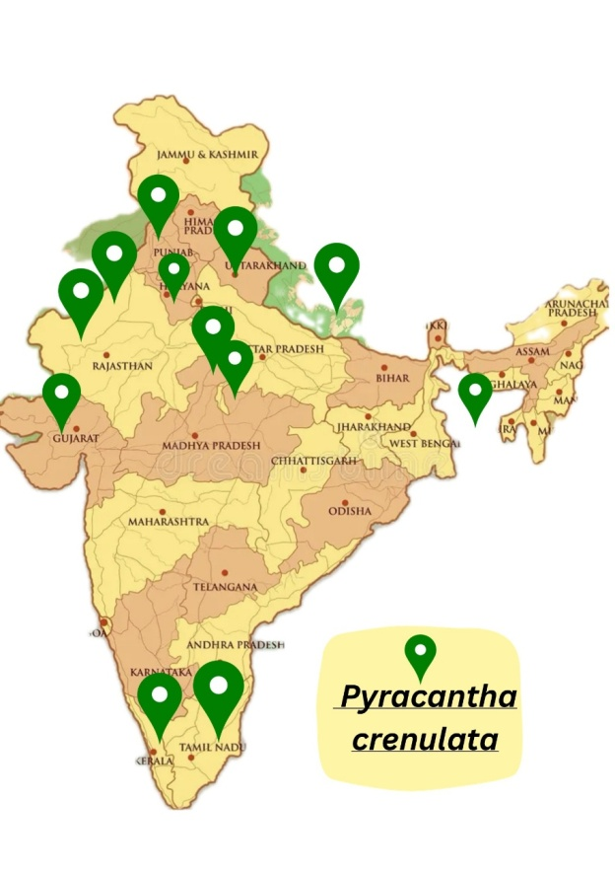
Figure 1: Geographical distribution map of Pyracanths crenulatain India
3.1Synonyms: Pyracantha crenulata (D. Don) M. Roem.: Mespilus crenulata D. Don; Crataegus crenulata (D. Don) Roxb.; Cotoneaster crenulatus (D. Don) K. Koch
3.2Local Names: Nepali: Ghangaru, Gangaru, Kaathgedi; Sherpa: Mharu; Gurung: Bhonpujo, Chento, Rishinpojo; Tamang: Chhernekanda; Magar: Ghangaru; Hindi: Ghingaru (Manandhar 2002). English: Nepalese White Thorn, Fire thorn, Nepalese fire thorn, Himalayan fire thorn (Manandhar 2002); Pashto: Khrasharavo (Ahmad and Pieroni 2016)
3.3Plant Profile (Chauhan, 1999; Feng et al., 2021)
Botanical name: Pyracantha crenulate (D,Don) M. Roemer
Common name: Nepalese firethom
Local name: Ghingaru
Kingdom: Plantae
Phylum: Streptophyta
Class: Equisetopsida
Subclass: Magnoliidae
Order: Rosales
Family: Rosaceae
Genus: Pyracantha
Species: Pyracantha crenulata
3.4 Botanical Features
Pyracantha crenulata is an attractive evergreen shrub valued for its distinctive botanical characteristics. Understanding its morphology and botanical features is essential for its identification and utilization in both natural and cultivated environments.
Morphology: Pyracantha crenulata is an evergreen shrub typically growing to a height of 1.5–3 m, with numerous branches. Its dense, upright growth habit forms a compact thicket covered with glossy leaves. The common name “firethorn” is derived from the sharp prickles that often adorn the branches, providing protection against herbivores (Bhatta et al., 2021).
Leaves: One of the distinctive features of Pyracantha crenulata is its foliage. The leaves are lustrous, leathery, and dark green, providing an attractive background for the plant’s flowers and berries. They are generally elliptical to ovate in shape and measure about 2–5 cm in length. A key characteristic of the leaves is their finely serrated margins, giving them a crenulated appearance, which is reflected in the species name “crenulata” (Bhatta et al., 2021).
Flowers: Pyracantha crenulata produces numerous small, white flowers arranged in clusters known as corymbs during the spring. These flowers, borne at the apices of the branches, attract pollinators such as bees and butterflies. Their pleasant fragrance and characteristic five-petaled structure enhance the plant’s ornamental value (Bhatta et al., 2021).
Fruits: The ornamental appeal of Pyracantha crenulata is enhanced by the abundance of colorful berries produced after flowering. Depending on the climate and cultivar, the berries are initially green and gradually mature to red or orange. These fruits persist on the plant throughout winter, creating a striking contrast with the dark green leaves and serving as a food source for birds and other wildlife (Bhatta et al., 2021).
Root System: Pyracantha crenulata has a fibrous root system that helps anchor the plant in a variety of soil types and provides stability against soil erosion. When cultivated in gardens or landscapes, sufficient space should be provided for root development, although the root system is generally non-invasive (Bhatta et al., 2021).
Thorns: The plant bears sharp thorns along its branches which are among its most noticeable protective features. These thorns protect the plant from damage and deter grazing animals. Although they contribute to the plant’s resilience and adaptability, they may pose challenges during pruning and maintenance (Bhatta et al., 2021).
Broadly, botanical characteristics of Pyracantha crenulate support its horticultural potential, ecological value, and beautiful appeal. It is a useful inclusion to gardens, parks because of its heavy foliage, prominent blossoms, vibrant berries and robust growth habit, which increase the landscape with beauty and utility both (Jaiswal et al., 2024). Figure 2

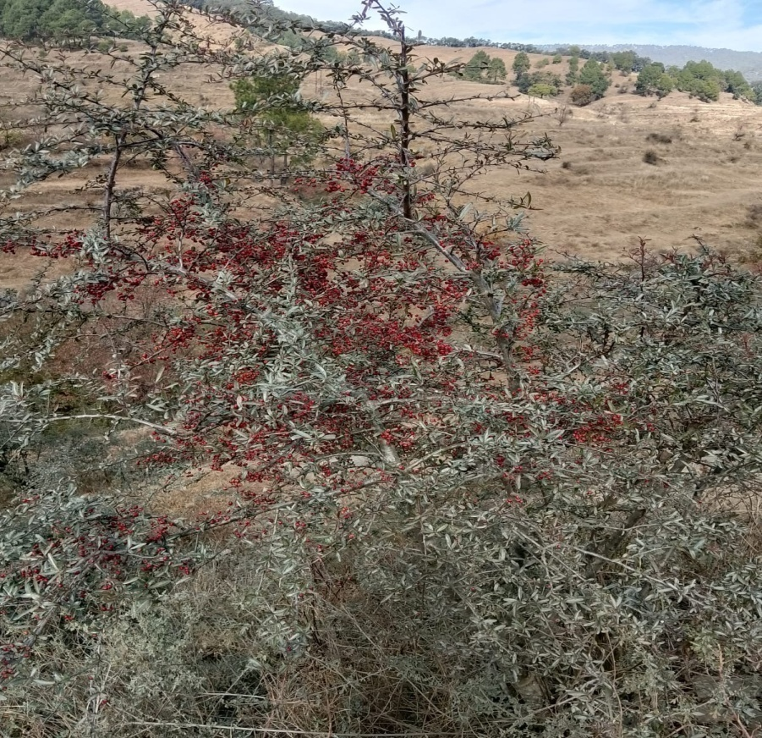
Figure 2: Pyracantha crenulata in its habitat
4. Chemical constituents
All medicinal herbs are rich in various crucial chemical compounds. The studies done previously have found that Pyracantha crenulata is high in calcium, potassium, carbohydrates, protein, lipids, fibers, vitamin C, vitamin A, vitamin B, vitamin B2, vitamin B12, vitamin E, and some species are high in bioflavonoids (Negi et al., 2009; Peschel et al., 2008).
As per previous research, Pyracantha crenulata has a number of chemical compounds that contribute to its healing qualities. It consists of flavonoids, phenolic chemicals, saponins and triterpenoids (Arya, 2024). Flavonoids are well known for their antioxidant properties, which give the plantthe capacity to fight off oxidative stress and neutralize free radicals (Beigmohamadi, Rahmani, 2011). Moreover, phenolic compounds also have antioxidant qualities, which may increase the therapeutic potential of the plant (Rashidi et al., 2020). Various compounds such as vitexin, leucocyanidin, leucoanthocyanidin, flavonoids, flavonol, kaempferol, glycoside, quercetin, beta-sitosteroland oligomeric saponins were found in plant (Kumar et al., 2026). Anti-inflammatory and antioxidant qualities of triterpenoids like ursolic and oleanolic acid, will possibly contribute to the curative effects of the plant (Peschel et al., 2008). Many biological activities such as antibacterial and anti-inflammatory effects have been demonstrated for saponins. A quantitative biochemical study of the leaf extract of Pyracantha crenulata revealed notable amounts of fiber, protein, carbohydrates, ascorbic acid, and other physicochemical characteristics. Phytochemical studies have also validated the presence of medicinally important constituents such as phenols, alkaloids, saponins, glycosides and tannins (Guglani et al., 2022).The floral components also produce chemicals such as tyramine, O-methoxyphenyl ethylamine, and phenyl ethylamine. Chlorogenic acid and 2-phenylchromones are other components, and pyracrenic acid has been extracted from the bark. The main fatty acids in the seed oil are linoleic, oleic, and palmitic acids (Nayik and Gull, 2020; Chauhan and Banerjee, 2025). Chemical compounds and their structure are well drawn in figure 3.
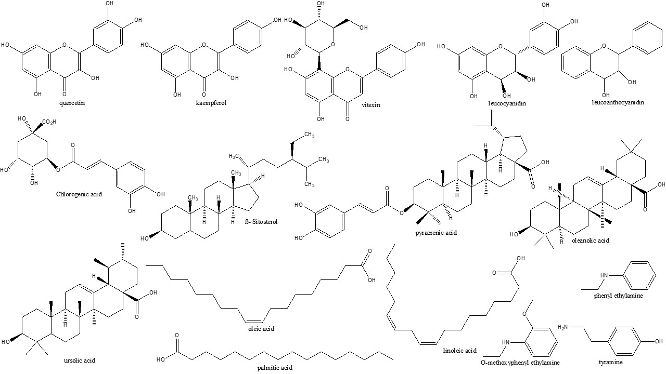
Figure 3: Chemical structures of constituents present in Pyracantha crenulata
5. Uses
Leaves are used in the preparation of sunburn creams, herbal teas, and lotions. The wood is utilized for making agricultural implements, walking sticks and inexpensive household items. The bark has been traditionally used to manage severe menstrual bleeding (Janakiram et al., 2019). The stem bark is also reported to be beneficial in the treatment of fever, particularly malaria. The berries contain antioxidants that may reduce damage caused by free radicals. Baths prepared from root decoctions are traditionally used to alleviate physical discomfort (Janakiram et al., 2019; Gudzenko et al., 2013; Kumar et al., 2016; Bahuguna et al., 2009). Topical application of bark extract is reported to protect the skin against frostbite and sunburn. The fruit juice has been reported to exhibit hypoglycemic effects when used in the management of diabetes (Andrade-Cetto and Heinrich, 2005).
5.1Local Handicraft and Other Uses
Infar-western provinces of Nepal, branches are used to agricultural tools and as walking sticks (Giretho). Branches are used to make fuelwood (Manandhar 2002). The plant is grown as ornamentals for its eye-catching fruits and makes a great hedge (Polunin and Stainton 1984; Manandhar 2002; Sharma et al., 2003; Pendry 2011; Shrestha et al., 2018).
6. Pharmacological Activities
The plant Pyracantha crenulata has long been utilized in herbal therapy to treat a variety of illnesses. Based on reports, it has hepatoprotective, anti-inflammatory, anti-urolithic, anti-microbial and antioxidant properties (Alsayari et al., 2018). These actions inferred that Pyracantha crenulata may be utilized in the therapy of ailments related with oxidative stress, inflammation, tissue necrosis, digestion and health of the liver. Minerals, protein, vitamins, β-carotene, amino acids and other phenolic compounds are also present in the plant (Janakiram et al., 2019). To entirely understand the exact mode of action and potential, more scientific research is needed (Gudzenko et al., 2013).
6.1Anti-urolithogenic Activity
Urolithiasis also referred to as urinary stone disease, is a recurrent and multifactorial disorder affecting individuals across all age groups. The curative qualities Pyracantha crenulata may offer a solution to this problem. Recently, anti-urolithic prospective of plant has drawn added attention from researchers. It is one of the many plants that have historically been used to treat urolithiasis, in accordance with ethnobotanical research. In line with research, treating calculogenic rats with Pyracantha crenulata juice of fruit and alcoholic extracts (250 mg/kg b.w., p.o.) had both therapeutic and preventive effects, notably reducing the increased deposition of stone-forming component in the kidneys. This implies that the fruit may have a cytoprotective impact, better kidney function, lessen the precipitation of calcium oxalate and assist prevent the development of urinary stones (Kumar et al., 2016). Anti-urolithic properties of plant are due to saponin-rich components of the plant (Bahuguna et al., 2009).
6.2Anti-inflammatory Activity
Chemicals such as phenolic compounds, flavonoids and triterpenoids present in Pyracantha crenulata fruits have been correspond to the biological actions of the plant. The anti-inflammatory potential may be due to the strong antioxidant capacity of these chemical compounds. The antioxidant and anti-inflammatory potential of extracts of this plant have been additionally supported by studies showing their capability to scavange free radicals and lessenlipid peroxidation (Joshi and Madhu, 2020). A novel compound Pyracrenic acid found in the bark was found to have granulation suppressive properties (Otsuka et al., 1981). Bioflavonoids, which are found in plant have been manifested in clinical trials to decrease cholesterol levels in person with heart disease. In addition, the leaves of plant demonstrated potent immunomodulatory and anti-inflammatory potential (Saxena et.al.,2025).
6.3Anti-hypertensive Properties
The bioactive components responsible for the cardioprotective potential of the plant include flavonoids and oligomeric proanthocyanidins. Standardized extracts from various Crataegus species consist of these compounds and are used in the management of moderate cardiac disorders (Tassell et al., 2010).
6.5Antimicrobial Activity
A previous study focused on assessing the in vitro antimicrobial activity of the wild edible fruit of Pyracantha crenulata. Antimicrobial properties were evaluated using the disc diffusion method against ten bacterial strains and three fungal strains. The ethanolic fruit extract exhibited significant activity with inhibition zones of 18 mm, 17 mm, and 15 mm against Shigella flexneri, Escherichia coli, and Streptococcus pyogenes respectively, which are associated with foodborne illnesses. The fruits were found to be rich in nutrients such as crude protein, fiber, and carbohydrates as well as non-nutritional phytoconstituents including phenolics, saponins and flavonoids (Saklani and Chandra, 2014). The plant demonstrates notable antibacterial and antifungal properties particularly against Gram-positive bacteria and pathogenic Candida species. These activities may be attributed to the presence of various bioactive compounds such as phenolic compounds, flavonoids, and terpenoids (Saklani and Chandra, 2014).
6.6Analgesic Activity
The analgesic activity of hydroethanolic extracts from the leaves and fruits of Pyracantha crenulata has been evaluated in rodents using various nociceptive models including the formalin-induced rat paw licking test, tail immersion test, tail flick test and Eddy’s hot plate model. To further elucidate the underlying mechanisms, molecular docking and molecular dynamics studies were performed. The results demonstrated that Pyracantha crenulata leaf and fruit extracts significantly reduced pain across all nociceptive models tested, suggesting involvement of both central and peripheral pain pathways. The extracts exhibited analgesic efficacy comparable to that of diclofenac used as the standard reference drug in the study. Molecular studies revealed that gallic acid identified in the leaf extract by HPTLC analysis, interacts with μ-opioid and cyclooxygenase-2 (COX-2) receptors indicating a possible mechanism of action. These findings support the traditional use of this plant for pain relief. Overall, the analgesic potential of Pyracantha crenulata extracts may be attributed to their modulatory effects on COX-2 and μ-opioid receptors providing a scientific basis for its ethnopharmacological application (Tewari et al., 2024).
6.7Anti-cancer Activity
Extracts of Pyracantha crenulata have been reported to inhibit the proliferation of various cancer cell lines. Using the MTT assay, silver nanoparticles synthesized from the aqueous leaf extract demonstrated anticancer activity against liver cancer (Hep-2) cell lines (Gupta et al., 2023). The plant has also been reported to induce apoptosis in cancer cells, leading to programmed cell death. Bioactive constituents such as proanthocyanidins, phenolic compounds, polysaccharides, and dietary fibers are believed to contribute to its antitumor properties.
6.8Antidiabetic Activity
Computational studies suggest that the antidiabetic potential of Pyracantha crenulata is attributed to its rich phytochemical profile with several compounds exhibiting higher docking scores against diabetes-related targets compared to some conventional drugs. Molecular docking analysis indicates that multiple constituents may act as potential inhibitors of diabetes-associated proteins such as IUOK (Arya, 2024). Furthermore, studies have demonstrated that the ethanolic fruit extract of Pyracantha crenulata ameliorates hyperglycemia possibly through the release of bioactive compounds, thereby supporting its traditional use as a natural hypoglycemic agent (Dumka et al., 2025).
6.9Antioxidant Activity
In recent years, the antioxidant properties of Pyracantha crenulata have attracted considerable attention from researchers. The plant’s ability to scavenge free radicals and protect against oxidative stress has been investigated in various studies. Using 2,2-azinobis (3-ethylbenzothiazoline-6-sulfonic acid) and 1,1-diphenyl-2-picrylhydrazyl assays, the leaf and fruit extracts of Pyracantha crenulata have demonstrated significant antioxidant activity with IC₅₀ values of 10.61 μg/mL and 12.73 μg/mL, respectively. Phytochemical analysis revealed notable amounts of total phenolics (128.78 mg/g), tannins (385.15 mg/g), and flavonoids (22.81 mg/g). These results suggest that the antioxidant activity may be attributed to the high content of phenolics, tannins and flavonoids, particularly in the lyophilized leaf extract (Guglani et al., 2022). One study reported the isolation of six phytoconstituents (Cc-1 to Cc-6) from Pyracantha crenulata which were evaluated for in vitro antioxidant activity using the DPPH radical scavenging assay. The results demonstrated notable antioxidant potential with compound Cc-4 exhibiting the highest activity (IC₅₀ = 15.734 μg/mL), followed by Cc-2, Cc-1 and Cc-5 (Kumar et al., 2026). The summarized pharmacological activities of various parts of the plant are presented in Table 1.
Table 1: Summary of Pharmacological activity of different parts of the plant Pyracantha crenulata
Pharmacological activity | Dose/concentration | Plant part/ extract | Experimental models | Observation | Ref.
Analgesic | - | Leaves and fruits/hydroethanolic extract | Wistar rats; tail immersion, tail flick, hot plate, formalin tests | Reduced nociception comparable to diclofenac; modulation of receptors | Tewari et al., 2024).
Antioxidant | IC₅₀/EC₅₀: ABTS (0.029mg/mL), DPPH (0.047mg/mL), and FRAP (0.025mg/mL) | Leaves/ alcoholic extract | In vitro assays | High radical scavenging and reducing activity | Guglani et al., 2021
Antioxidant | IC₅₀ value: approx. 15.7-71.6μg/mL | Leaves/isolated compounds | In vitro DPPH assay | Compounds showed antioxidant effects | Kumar et al., 2024
Antidiabetic | IC₅₀ value 44.79 µg/ml at 100 µg/ml in the α-amylase inhibitory assay and 30.09 µg/ml at 100 µg/ml in the α-glucosidase inhibitory assay | Fruit/ ethanolic extract | In vitro enzyme inhibition | Inhibition of digestive enzymes | Dumka et al., 2025
Antiurolithogenic | 250 mg/kg b.w.p.o | Fruit/ juice and alcoholic extract | Albino rats; ethylene glycol induced urolithiasis | Reduction in calcium oxalate precipitation, improved kidney function | Bahuguna et al., 2009
Antibacterial and Antifungal | 10 mg/ml and 50 mg/ml | Fruit/ethanolic extract | In vitro disc diffusion against bacterial and fungal strains | Zones of inhibition (18, 17, 15 mm) against bacteria and fungi | Saklani and Chandra, 2014
Antimicrobial and anticancer (nanoparticles) | Various in vitro doses | Leaves/ gold nanoparticles of aqueous extract | AuNPs evaluated on microbial cultures and cancer models | Bacterial inhibition zones and reduced cancer cell proliferation | Gupta et al., 2025

7. Future Perspectives
Pyracantha crenulata is a Himalayan shrub with significant ethnomedicinal importance and a wide range of pharmacological properties supported by preliminary scientific studies. Despite promising findings, several research gaps remain to be addressed. Future studies should focus on well designed clinical trials to validate its therapeutic efficacy and safety in humans. In addition, detailed investigations into the molecular mechanisms of action and identification of particular bioactive compounds are necessary to better understand its pharmacological potential. Standardization of extraction methods, dosage and formulation strategies are also required to ensure reproducibility and consistency across studies. Furthermore, comprehensive toxicological and pharmacokinetic evaluations are essential for its safe therapeutic application. The influence of geographical variation on phytochemical composition should also be explored. Pyracantha crenulata holds potential for development into functional foods, herbal formulations and nutraceuticals. However, its successful commercialization will depend on the implementation of sustainable harvesting practices, quality control measures and regulatory compliance. Involvement of local communities in cultivation and processing may further support socio-economic development while preserving traditional knowledge. Overall, a multidisciplinary and systematic research approach is required to bridge the gap between traditional use and modern therapeutic application.
8. Limitation
The current research on Pyracantha crenulata is associated with several limitations. Most studies are limited to in vitro and animal models with a lack of well-designed clinical studies in humans restricting its direct therapeutic application. There is also variation in plant parts, extraction methods and experimental conditions leading to inconsistent results. Additionally, phytochemical standardization is insufficient and the exact active constituents responsible for its biological activities are not fully identified. The molecular mechanisms of action remain inadequately explored. Moreover, there is a lack of detailed toxicity, safety and pharmacokinetic studies including long-term evaluation and herb–drug interaction data. These gaps highlight the need for more systematic, standardized and clinically oriented research to validate its medicinal potential.
8. Conclusion
With a growing number of scientific evidence and traditional use, Pyracantha crenulata is emerging as a noteworthy medicinal plant with substantial therapeutic importance. The present review provides a clear basis for the recognition of plant and pharmacognostic assessment by putting together the information that is currently accessible on its botanical features, geographical regions and ethnomedicinal significance. Pyracantha crenulata is a rich source of bioactive compounds, such as flavonoids, phenolic acids, triterpenoids, sterols and glycosidic chemicals which are strongly related to its mentioned biological activity, according to phytochemical exploration. Several of its traditional claims have been validated by pharmacological studies that have shown a wide range of actions including antioxidant, cardioprotective, anti-inflammatory, antibacterial, antidiabetic, hepatoprotective and neuroprotective properties. Nevertheless, the majority of recent research is restricted to preclinical and in vitro models, with differences in plant parts utilized, extraction techniques, and experimental models. Therefore, systematic phytochemical standardization, the discovery of active principles, molecular mechanisms of action, and thorough safety evaluations should be the main targets of future study. Overall, this study highlights plant’s potential as a useful candidate in natural product-based drug discovery and underlines the need of more well-planned research to fully recognize its pharmacological and therapeutic benefits.
Conflict of interest
The authors declare that they have no competing interests.
AI Disclosure Statement
The authors hereby declare that no generative or assistive artificial intelligence tools, including but not limited to those used for text generation, data analysis, image creation, or manuscript preparation, were utilized at any stage during the development of this manuscript. All content was created solely by the authors.

References
Ahmad K, Pieroni A. Folk knowledge of wild food plants among the tribal communities of Thakht-e-Sulaiman Hills, North-West Pakistan. J EthnobiolEthnomed. 2016;12:17.
Alsayari A, Ghazwani M, Almaghaslah D, Alhamhoom Y, Louis J, Altohami J, et al. Potential analgesic and diuretic activity of Crataegusoxyacantha Linn. Res J Pharm Technol. 2018; 11(6):2476-82.
Andrade-Cetto A, Heinrich M. Mexican plants with hypoglycaemic effect used in the treatment of diabetes. Journal of ethnopharmacology. 2005;99(3):325-48.
Arya GC. A systematic study of Pyracantha crenulata phytoconstituents for their anti-diabetic activity using computational techniques. Curr Anal Chem. 2024;20(5):318-34.
Bahuguna YM, Rawat MS, Juyal V, Gusain K. Evaluation of Pyracantha crenulata Roem for antiurolithogenic activity in albino rats. Afr J Urol. 2009; 15(3):159-66.
Beigmohamadi M, Rahmani F. Genetic variation in hawthorn (Crataegus spp.) using RAPD markers. Afr J Biotechnol. 2011; 10(37):7131-5.
Bhatta GD, Kunwar RM, Bussmann RW. Pyracantha crenulata (D. Don) M. Roem. Rosaceae. InEthnobotany of the Himalayas, 2021; pp. 1-5. Cham: Springer International Publishing.
Brandis D, Indian Trees: an account of trees, shrubs, woody climber, bamboos & palms, indigenous or commonly cultivated in the British Indian empire. Constable & Company, Ltd., London,1921; p 294, 1921.
Chauhan A, Banerjee R. Evaluation of traditional uses, phytochemical constituents, therapeutic uses and prospects of Pyracantha genus: a systematic review. Nat Prod Res. 2025; 39(4):922-34.
Chauhan NS. Medicinal and aromatic plants of Himachal Pradesh. New Delhi: Indus Publishing; 1999.
Dimitri MJ, Enciclopedia de Agricultura y Jardinería, Ed. ACME, Buenos Aires, 1: 433-435;1972
Dumka H, Ram V, Tangri P. Phytochemical profiling and evaluation of in-vitro antidiabetic effects of Pyracantha crenulata (D. Don) M. Roem. fruit extracts. Journal of Applied Pharmaceutical Research. 2025;13(5):299-308.
Feng HZ, Wei SJ, Wang LY, Chen SF, Fan Q, Liao WB. A taxonomic revision of the Pyracantha crenulata complex (Rosaceae, Maleae). Phytotaxa.2021; 478 (2): 239–252.
Gamble JS. A manual of Indian timbers: an account of the growth, distribution, and uses of the trees and shrubs of India and Ceylon, with descriptions of their wood-structure. Bishen Singh Mahindra Pal Singh Publication, Dehra Dun.,1972.
Gudzenko A. Development and validation of an RP-HPLC method for the simultaneous determination of vitexin-2″-O-rhamnoside and hyperoside in leaves and flowers of hawthorn. World J Pharm Res. 2013; 2(5):1270-86.
Guglani A, Pandey HK, Arya RK, Gaddam B. The nutritional profile, phytochemical investigation and in vitro antioxidant activity of the leaves extract of Pyracantha crenulata collected from the middle hill climatic conditions of the Western Himalayas. Indian J Pharm Sci. 2022; 84(1):182-8.
Guglani A, Rajeshwar K.K. Arya, H.K. Pandey, Singh AK, Bisht D.Variation in Antioxidant Activity and Phyto-Constituents in Different Parts of Pyracantha crenulata Collected from Middle Hill Climatic Condition of Western Himalayas. Nat. Volatiles & Essent. Oils, 2021; 8(4): 12455-12468.
Gupta S, Jasrotia S, Jugran S, Syal S, Godbole V, Pallavi A, Kandwal A, Purohit R Purohit MC. Biosynthesis and characterization of gold nanoparticles using Pyracantha crenulata leaves and evaluation of its antimicrobial and anticancer activities. International Journal of Environmental Sciences,2025; 11:(23s): 2098-2114.
Gupta S, Jasrotia S, Kandwal A, Rawat R, Purohit MC. Green synthesis of silver nitrate nanoparticles using leaves of Pyracantha crenulata and its anticancer activity on liver cancer. Journal of Mountain Research, 2023; 18(2):273-283.
Jaiswal J, Upadhyaya K, Arya V. Pyracantha crenulata: A Review of Its Botanical Features, Ecological Significance, And Horticultural Potential. nt. J. of Pharm. Sci., 2024, Vol 2, Issue 7, 1387-1396.
Janakiram T, Safeena SA, Prasad KV. Status of indigenous ornamental plants in India. New Delhi: Indian Council of Agricultural Research, Krishi Anusandhan Bhavan, Pusa; 2019.
Joshi RK, Laurindo LF, Barbalho SM. Chemical components and bioactivities of Pyracantha crenulata (D. Don) wild and cultivated from Uttarakhand, India: a review. Am J Essent Oils Nat Prod. 2023; 11(1):34-7.
Joshi SK, Madhu BA. Phenological attributes of Pyracantha crenulata—a high-value multipurpose shrub of the Himalaya. Not Sci Biol. 2020; 12(1):30-41.
Kewlani P, Negi VS, Bhatt ID, Rawal RS. Pyracantha crenulata (Roxb. Ex D. Don) M. Roem. InHimalayan Fruits and Berries 2023 Jan 1 (pp. 319-330). Academic Press.
Khare CP. Indian Herbal Remedies: Rational Western Therapy, Ayurvedic and Other Traditional Usage, Botany, Springer-Verlag Berlin Heidelberg, 163;2004.
Khare CP. Indian Medicinal Plants: An Illustrated Dictionary. Springer-Verlag New York, 176; 2007.
Kumar A, Parveen M, Ali Khan A, Nami SA, Murad Ghalib R, Malik A, Alam M. Phytochemical investigation and spectral characterization of isolated compounds from Pyracantha crenulata (D. Don) M. Roem (syn. Crataegus crenulata Roxb) leaves: evaluation of antioxidant activity and molecular docking analysis. Natural Product Research. 2026 Feb 16;40(4):960-9.
Kumar A, Parveen M, Khan AA, Nami SAA, Raza Ghalib M, Malik A, Alam M. Phytochemical investigation and spectral characterization of isolated compounds from Pyracantha crenulata (D. Don) M. Roem (syn. Crataegus crenulata Roxb) leaves: evaluation of antioxidant activity and molecular docking analysis. Nat Prod Res. 2024 Oct 7:1-10.
Kumar BN, Wadud A, Jahan N, Sofi G, Bano H, Makbul SA, et al. Antilithiatic effect of Peucedanumgrande C.B. Clarke in chemically induced urolithiasis in rats. J Ethnopharmacol. 2016; 194:1122-9.
Manandhar NP. Plants and people of Nepal. Portland: Timber Press; 2002.
Nayik GA, Gull A, editors. Antioxidants in fruits: properties and health benefits. Berlin: Springer; 2020. p. 201-25.
Negi PS, Singh R, Bhakuni DS, Ahmed Z. Crataegus: A multipurpose plant of Himalayan Hills. Technical pamphlet, DIBER (DRDO) Haldwani, 2009
Osmaston AE. A forest flora for Kumaon. Periodical Experts Book Agency, Delhi.1926
Otsuka H, Fujioka S, Komiya T, Goto M, Hiramatsu Y, Fujimura H. Studies on anti-inflammatory agents. V. A new anti-inflammatory constituent of Pyracantha crenulata Roem. Chem Pharm Bull (Tokyo). 1981; 29(11):3099-104.
Pande PC, Tiwari L, Pande HC. Ethnoveterinary plants of Uttaranchal-A review. Indian Journal of Traditional Knowledge 6 (3): 444-458;2007
Pandey M, Joshi S, Sharma S. Total importance value of medicinal plants in Jaunpur Range, Garhwal Himalaya, Uttarakhand. Ann Plant Soil Res. 2024; 26(2):311-6.
Peschel W, Bohr C, Plescher A. Variability of total flavonoides in Crataegus: Factor evaluation for the monitored production of industrial starting material. Fitoterapia. 2008;79:6–20
Polunin O, Stainton A. Flowers of the Himalaya. New Delhi: Oxford University Press; 1984.
Rashidi H, Tahmasebi W, Khalili M, Ahmadi R. Simultaneous effect of one-month Crataegus supplementation and rehabilitation program on cardiac contractile strength, blood pressure, heart rate, and functional capacity of patients with heart failure. J Basic Clin Pathophysiol. 2020; 8(2):28-36.
Saklani S, Chandra S, Mishra AP. Evaluation of antioxidant activity, quantitative estimation of phenols, anthocyanins and flavonoids of wild edible fruits of Garhwal Himalaya. J Pharm Res. 2011; 4(11):4083-6.
Saklani S, Chandra S, Mishra AP. Evaluation of nutritional profile, medicinal value and qualitative estimation in different parts of Pyrus pashia, Ficus palmate and Pyracantha crenulata. J Global Trends Pharmaceutical Sci. 2 (3): 350-354; 2011.
Saklani S, Chandra S, Preliminary phytochemical evaluation of Garhwal Himalaya wild edible fruit Pyracantha crenulata, Journal of Pharmacy Research, 5(6), 3434-3436;May-2012.
Saklani S, Chandra S. In vitro antimicrobial activity, nutritional value, antinutritional value and phytochemical screening of Pyracantha crenulata fruit. Int J Pharm Sci Rev Res. 2014; 26(1):1-5.
Sati DC. Pharmacognostical and phytochemical screening of leaf and fruit extract of Pyracantha crenulata. Journal of Pharmacognosy and Phytochemistry. 2017;6(5):2563-8.
Saxena P, Kothiyal P, Ratan P. On review of phytochemical and pharmacological aspects of Pyracantha crenulata. Journal of Natural Remedies,2025; 25(7), 1521–1531.
Sharma I, Joshi N, Roy B, Shrestha R. Flora of Royal Botanical Garden (Phanerogams). Godawari: Department of Plant Resources, Royal Botanical Garden; 2003. p. 62.
Shrestha KK, Bhattarai S, Bhandari P. Handbook of flowering plants of Nepal (Volume 1. gymnosperms and angiosperms: Cycadaceae – Betulaceae). Jodhpur: Scientific Publishers; 2018.
Simoons FJ. Food in China: A Cultural and Historical Inquiry, CRC Press, New Delhi, 259;1990
Singh A, Rana S, Singh R. Wild and cultivated vegetables of the Indian Himalaya and their use as vegetables and in traditional medicine. Int J Veg Sci. 2020; 26(4):385-407.
Singh R, Negi PS, Dwivedi SK. Indian hawthorn (Pyracantha crenulata). InNew Age Herbals: Resource, Quality and Pharmacognosy 2018 Apr 18 (pp. 135-149). Singapore: Springer Singapore.
Spectrum, Science Reporter, Himalaya Red Berry- Wonder Heart Tonic, 2010; 16-18.
Sultana S, Ali M, Mir SR. Cinnamic acid and lanostenoic acid derivatives from the leaves of Pyracantha crenulata (D. Don) M. Roem. J. Pharm. Biol. Sci. 2017.; 5, 91.
Tassell MC, Kingston R, Gilroy D, Lehane M, Furey A. Hawthorn (Crataegus spp.) in the treatment of cardiovascular disease. Pharmacogn Rev. 2010; 4(7):32-41.
Tewari D, Bawari S, Sah AN, Sharma H, Joshi BC, Gupta P, et al. Himalayan Pyracantha crenulata (D. Don) M. Roem. Leaf and fruit extracts alleviate algesia through COX-2 and mu-opioid receptor-mediated pathways. J Ethnopharmacol. 2024; 318:117004.
Tiwari D, Sah AN, Bawari S, Bussmann RW. Ethnobotanical investigations on plants used in folk medicine by native people of Kumaun Himalayan Region of India. Ethnobotany Research and Applications. 2020 Jul 24;20:1-35.

