Original Research Article

Effect of Coconut Shell Size Variation on the Physical and Mechanical Properties of Concrete

ABSTRACT

Concrete is the second most used material in the world after water. Approximately ten billion tons of concrete are produced every year. It is expected that the demand for concrete will continue to increase in the future. Due to the huge amount of concrete produced daily which consumes natural resources and has negative effects on the environment, it has become necessary to minimize environmental effects per ton. This research investigates the use of coconut shells as a substitute for coarse aggregates in concrete, specifically looking at how this substitution affects the physical and mechanical of the concrete characteristics. In this study, crushed coconut shell aggregates of different sizes:12.5-9.5mm, 19-12.5mm, 25-19mm, and 37.5-25 mm, were utilized for concrete, making up 10% by weight of the overall coarse aggregate. The aggregate impact value of the coconut shells was determined according to IS 2386 (Part IV). The physical and mechanical properties were determined according to British Standards. The study found that concrete containing 12.5 – 9.5mm coconut shells sizes exhibited superior performance in terms of compressive and tensile strengths, compared to 37.5 – 25mm coconut shells. The 28th-day compressive strength of the crushed coconut shell concrete ranged between 12.81 N/mm² and 13.40 N/mm², while the tensile strength ranged from 1.01 N/mm² to 1.25 N/mm². Water absorption varied between 4.577% and 5.542%, and density ranged from 2128.33 kg/m³ to 2165.33 kg/m³. Notably, 12.5 – 9.5mm crushed coconut shells offered improved workability, density, and strength, making them suitable for lightweight concrete applications. Coconut shell concrete is a feasible alternative to conventional aggregates, particularly for sustainable construction practices. Physical and mechanical properties of concrete partially replaced with coconut shell size variation at different percentages on a large scale are recommended for future research.

Keywords: Aggregate Impact Value, Coconut shells, Compressive Strength, Density, Split Tensile Strength, Water Absorption

1. INTRODUCTION

One of the most used building materials on earth is concrete. The manufacturing of the premier civil engineering construction material (concrete) involves the consumption of ingredients such as water, cement, fine aggregate, and coarse aggregate and admixture(s) (Yerramala & Ramachandrudu, 2012). While water and cement act as binders, fine and coarse aggregates provide structural strength, with variations in granule size and shape (de Brito & Kurda, 2021).

One crucial component of concrete is the coarse aggregate (Buertey et al., 2016), which has historically been available quantitatively and qualitatively for construction works (Kalyanapu et al., 2015; Wahab & Appiah-Kubi, 2024). Aggregate collected from the earth for concrete is a however a non-renewable natural material. Concerns have therefore been raised about the depletion of high-quality natural aggregates and the environmental damage posed by the extensive mining of these aggregates. Considering the increasing demand for concrete for varied uses due to increasing population, there is the high tendency for the shortage of these raw materials (aggregates) in the coming years (Herring et al., 2021). As a concern, the increasing demand for concrete has resulted in increasing unit cost price in the local market. It is therefore of greater concern to research into new alternatives for concrete aggregate (Olsson et al., 2023). With the evolution of preen housing and sustainable construction technologies, this above issue has even become more critical.

Improving concrete production under the green housing and sustainable development agenda began to gather momentum following the 1987 Brundtland report on “Our Common Future”, and the 1992 UN Conference on Environment and Development (UNCED), also known as the Earth Summit. In line with the above agenda, it has become very necessary to replace some proportions of aggregates that has been used over the years and gradually depleting in construction with some industrial or bio-waste products that are normally disposed and even cause nuisance as well as threat to lives (Kaur & Kaur, 2012).

Transporting crushed aggregates over long distances can be costly, making local alternatives like river stones more viable in certain areas (Steven et al., 2002). As rapid urbanization has created shortages of traditional building materials (Arora et al., 2023), concrete technology is shifting toward sustainable alternatives to reduce dependence on natural resources (Sujatha & Balakrishnan, 2021). Irham et al. (2024) found that even though concrete made with coconut and palm kernel shells has lower compressive strength than conventional concrete, using this material can also reduce concrete costs by 30% and 42%, respectively.

To make concrete more affordable and eco-friendlier, researchers are exploring the use of waste materials like wood chips, plastic waste, snail shells, palm kernel shells, coconut shells and broken bricks as replacements for coarse aggregates (Murthi et al., 2020). Coconut shells are appropriate for lightweight concrete applications because of their low density (Shyam & Jain, 2023; Aziz et al., 2022; Algaifi et al., 2022). Compared to regular concrete, adding coconut shell aggregates typically causes a decrease in compressive strength, according to Gunasekaran et al. (2017). A potential alternative is a coconut shell, an agricultural waste product with similar chemical properties to wood. Coconut shells are durable, non-biodegradable, and could substitute natural aggregates in concrete production, potentially retaining many of concrete’s original properties (Alireza, 2025; Verma & Shrivastava, 2019).

In this regard, coarse aggregate (granite stones) can be replaced with agro-waste products like coconut shells (Algaifi et al., 2022). However, scientific works to ascertain the physical and mechanical properties of concrete made with coarse aggregate replaced with coconut shells, such as aggregate impact value, water absorption, density, compressive strength and split tensile strength, are essential but have not yet been fully studied. This study therefore aims to investigate the physical and mechanical properties of concrete made with aggregates replaced with coconut shells with variations in the shell sizes.

2. MATERIALS AND METHODS

2.1 Materials
The study made use of various materials, including sand, coconut shells, crushed granite stones, and cement.

2.1.1 Sand
The Sand was sourced from Kumasi in the Ashanti region of Ghana, and it was ensured to be free of organic matter by collecting it from 300mm below the surface.

2.1.2 Granite Stones
Crushed granite stones, sized between 12mm and 16mm, were obtained from Aboaso in the Ashanti region. The crushed granite stones of sizes that passed through 14mm sieve and retained on 12.5mm sieve (after sieve analysis) was used for the study.

2.1.3 Coconut shells
The coconut shells as shown in Figure 1, were procured from Roman Hill, Kumasi in the Ashanti Region, Ghana. These shells were from the west coast tall coconut variety, commonly found along Ghana’s coast. They were air-dried for 14 days to remove moisture before being manually crushed and sieved to different size variations.

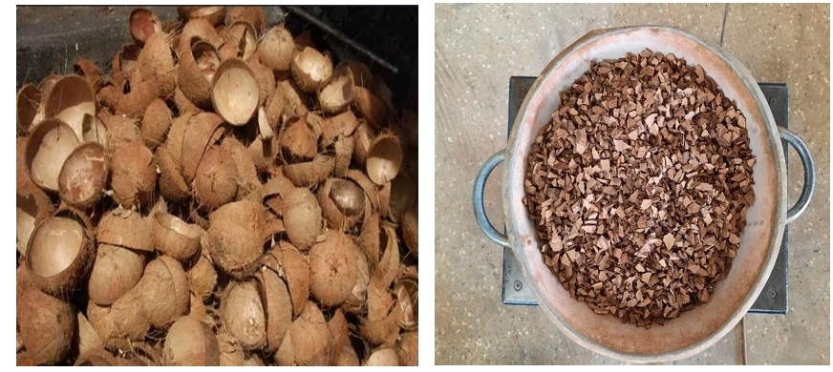
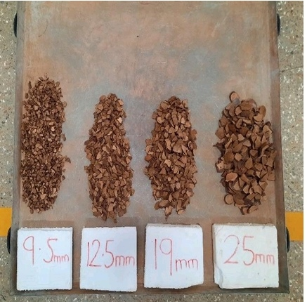
b
a

Fig. 1. Uncrushed coconut shell (a) and crushed coconut shells (b)

2.1.4 Cement
Ordinary Portland cement made in Ghana by CIMAF Ghana Cement Factory with a grade of 42.5R which confirms BS EN 197-1:2011 was used for the study.

2.2 Methods

The coconut shells (CS) were manually crushed with a maul hummer into smaller sizes and sieved. The materials were batched by weight and mixed mechanically. In the mixtures, 10% of the crushed coconut shell aggregate was used to partially replace the crushed granite stones (coarse aggregate), with various crushed coconut shell (CCS) size ranges: 12.5 - 9.5 mm, 19 - 12.5 mm, 25 - 19 mm, and 37.5 - 25 mm, as illustrated in Fig. 1b. The specimens were then mechanically moulded and cured by sun-drying for 28 days, following the procedures specified in BS EN 12390-2:2019.

2.2.1 Mixing and Casting

Ten percent (10%) by weight of coarse aggregates (crushed granite) were replaced by the crushed and sieved sizes of coconut shells, that retained on the following sieves (37.5mm - 25mm, 25mm - 19mm, 19mm - 12.5mm and 12.5mm - 9.5mm). A concrete mix ratio of 1:2:4 was used with a water-cement ratio of 0.5 (0.769kg). The coconut shells were pre-soaked 24hrs before being used in the mixing of the concrete (Figure 2a). Shells were collected separately and mixed separately with pit sand and crushed granite stones. In line with BS EN 12620:2002, the concrete constituents were batched and mixed using the mechanical mix machine accordingly (Figure 2b). The materials were mixed thoroughly until a uniform mixture was obtained.
Cubes of 100mm x 100mm x100mm dimensions were cast for the determination of compressive strength and 100mm x 200mm cylinders were cast for the determination of split tensile strength of the concrete.

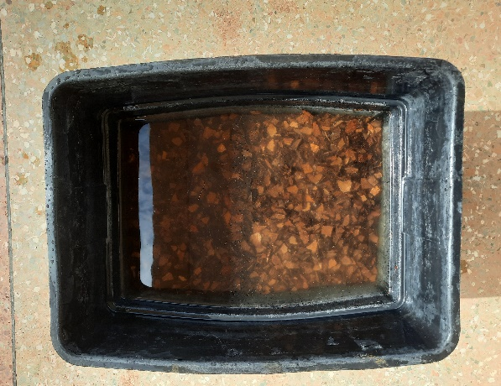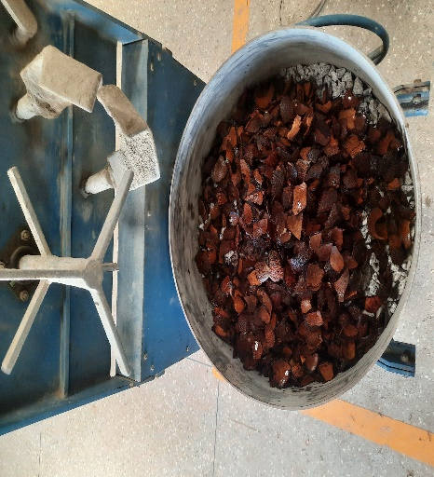
a
b
Fig. 2. Pre-soaking of coconut shell (a) and mixing of coconut shell aggregate concrete (b)

2.2.2 Curing

Specimens were cured by total immersion in potable water (Figure 3) from Ghana Water Company for 28 days by BS EN 12390-2:2019. The water is tested with the evidence of being organic free.

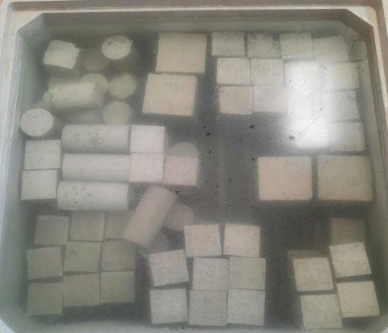

Figure 3 Curing of specimens in a tank

Fig. 3. Curing of specimens in a water tank

2.2.3 Testing Procedure

The aggregate impact value of coconut shells (CS) was determined using IS: 2386 (Part IV) as a guide. BS EN 12350-2:2019 served as a reference for conducting the slump value test on coconut aggregate concrete to assess the workability of CS concrete. The physical properties (water absorption and density) and mechanical properties (compressive strength and splitting tensile strength) of the specimens were evaluated after curing. The water absorption of the 28-day cured specimens was determined following BS EN 1881-122:2011+A1:2020. The density of the specimens after 28 days of curing was determined following the guidelines of BS EN 12390-7:2019. The compressive strength of the specimens after 7, 14, 21, and 28 days of curing was determined using BS EN 12390-3:2019 as a reference. The splitting tensile strength of the specimens was determined on days 7, 14, 21, and 28 of curing using BS EN 12390-6:2023 as a guide.

2.2.4 Data Analysis

The data from the study were analysed using Microsoft Excel v.15 and Sigma Plot. To present the data, tables and charts were utilized, incorporating descriptive and inferential statistics. A one-way ANOVA analysis was performed on the compressive strength and split tensile strength of the construct to ascertain if there are statistically significant differences between the specimens. Moreover, correlation and regression analyses were conducted to establish the relationship between the specimens.

3. results and discussion

3.1 Results Aggregate Impact Value of Coconut Shells (CS)

Table 1. Results of Aggregate Impact Value of Coconut Shells (CS)

Test | Coconut shell
Average Aggregate Impact Value | 6.80%

The data presented in Table 1 illustrates the results of aggregate impact tests performed on coconut shell (CS) aggregates. The results indicate that the average aggregate Impact Value of the CS was 6.80%. According to Alireza et al. (2025), aggregate impact value of CS ranges between 3.12 – 8.55%. The average aggregate impact value obtained suggests that coconut shell aggregates possess significant strength within the aggregate classification. It signifies that CS aggregates have the necessary toughness to withstand disintegration resulting from sudden impacts or shocks. This finding aligns with a study conducted by Herring et al. (2021), which reported an aggregate impact value of 8.14% for coconut shells, further underscoring the robust nature of the material.

3.2 Results of Slump Test (Workability)

Table 2. Results of Slump Test
Slump (mm)
Test | Control | 12.5 - 9.5mm Replacement | 19 - 12.5 Replacement | 25 - 19mm Replacement | 37.5 - 25mm Replacement
Slump | 59.3 | 56.7 | 55.3 | 31.0 | 24.0

The results presented in Table 2 illustrate the outcomes of the slump test conducted on CS concrete with varying CCS sizes: 12.5 - 9.5mm, 19 - 12.5mm, 25 - 19mm, and 37.5 - 25mm. The data in Table 2 reveals that concrete containing larger CCS sizes exhibits low to very low workability in dry mixes. Conversely, concrete made with smaller CCS sizes demonstrates medium workability. Furthermore, there is a clear trend indicating that the workability of the concrete decreases as the size of the coconut aggregates increases. Specifically, mixtures with medium workability were obtained from 12.5 - 9.5 mm and 19 - 12.5 mm, while mixes with low and very low workability were obtained from 25 - 19 mm and 37.5 - 25 mm. Notably, the type of slump observed in this test was a true slump.
These results align with the findings of Irham (2024), who reported a slight increase in the slump value when 10% coconut shell replacement was used as coarse aggregate in the concrete mix. This observation suggests that the increase in slump value may be attributed to different sizes of coconut shells sieving through a 10mm sieve, as well as the 10mm coarse aggregate (stone) sizes used in the mix. Additionally, Reddy et al. (2014) documented a higher slump value with 25% coconut shell replacement and 5% fly ash replacement of cement, indicating that the addition of fly ash in the mix may enhance the workability of coconut shell concrete. Furthermore, Herring et al. (2021) also found that the workability of fresh concrete decreases as the CSP concentration rises, which contrasts with the density.

3.3 Results of Water Absorption Test

Table 3. Results of Water Absorption Test

Water Absorption (%)
Curing days | Control | 12.5 - 9.5mm Replacement | 19 - 12.5 Replacement | 25 - 19mm Replacement | 37.5 - 25mm Replacement
28 | 3.155 | 5.542 | 4.821 | 4.718 | 4.577
The water absorption test results of specimens cured for 28 days in Table 3 demonstrate that the water absorption of CS concrete specimens decreases as the size of the crushed coconut shells increases. Specimens with smaller crushed coconut shell sizes exhibited higher water absorption rates compared to those with larger sizes. However, this difference does not significantly impact the concrete's strength. The decrease in water absorption with larger coconut shell sizes may be attributed to the greater surface area of the shells compared to the smaller sizes. These findings align with Ealias et al. (2014), who reported water absorption within the range of 6.43% to 4.6%. The study indicates that smaller shell sizes, with more surface area, absorb more water compared to larger sizes. These results also correlate with Herring et al. (2021), who observed that smaller particle sizes of coconut shells in concrete occupy more spaces, leading to increased surface area and higher water absorption. However, this conflicts with Kalyanapu et al. (2015), who reported a reduction in water absorption of 2.43%, possibly due to the size of coconut shells and the concrete mix design. Gunasekaran et al. (2011) discovered that coconut shells have a high-water absorption capacity due to their porous structure, ranging from 20% to 24% by weight. The study suggests that this high absorption rate requires adjustments in the water-cement ratio to maintain the concrete’s workability and strength. Aziz et al. (2022) investigated the replacement of aggregates in concrete with coconut shells in order to produce lightweight concrete, and recorded 18% reduction in shrinkage, with 50% replacement of cement with bagasse ash.

3.4 Results of Density Test

Table 4. Results of Density Test
Density (kg/m³)
Curing days | Control | 12.5 - 9.5mm  Replacement | 19 - 12.5mm  replacement | 25 - 19mm  replacement | 37.5 - 25mm  replacement
28 | 2302.67 | 2165.33 | 2161.00 | 2131.33 | 2128.33

The results of specimens cured for 28 days presented in Table 4 illustrate the density test conducted on the specimens following a 28-day curing period. It was observed that the density of the specimens utilizing crushed coconut shell aggregate decreased as the size of the crushed coconut shell aggregate increased in the mixes. This indicates that smaller crushed coconut shell sizes tend to yield higher density, although the control group exhibited the optimum density. This discovery aligns with a study by Shrikant (2017), which documented a density of 2242 kg/mᶟ when 10% crushed coconut shell was used as a replacement for coarse aggregate in the concrete mix. Additionally, these findings are consistent with the research by Irham et al. (2024), which reported a density of 2180 kg/mᶟ in a 10% coconut shell concrete mix. Furthermore, a study conducted by Yusuf et al. (2021) also affirms that the density of coconut shell concrete decreases with an increase in the proportion of coconut shells used.

3.5 Results of Compressive Strength Test

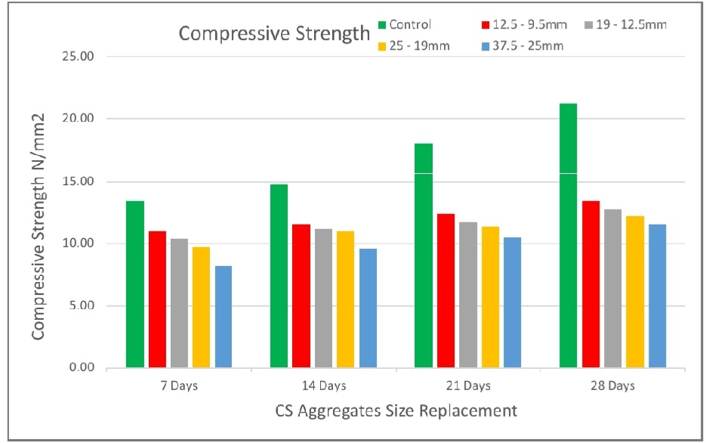
Fig. 4. Compressive Strength test results

In Figure 4, the outcomes from CCS concrete specimens at 7, 14, 21 and 28 curing days are presented. The results revealed that the average compressive strength of the specimens increased with longer curing periods, with the control group exhibiting the highest strength. The research demonstrated that as the sizes of crushed coconut shells in the mixes increased, the compressive strength of the concrete decreased, indicating that smaller crushed coconut shell sizes resulted in higher compressive strength compared to larger sizes. This is attributed to the larger surface area of the larger coconut shells. Osei (2013) reported that as the substitution percentage in concrete increased, its density and compressive strength reduced.

Yusuf et al. (2021) and Herring et al. (2021) concluded that the compressive strength and tensile splitting strength of coconut shell concrete decrease as the proportion of coconut shells increases, which is consistent with the findings of this study. Patel et al. (2015) also documented an increase in compressive strength of 18.14N/mm² for 7 days, 21.05 N/mm² for 14 days, and 27.58N/mm² for 28 days. The increase may be due to the addition of coir fibre at high temperatures to enhance strength, but it was also concluded that as the various sizes of the 10% coconut shell replaced in concrete increase, compressive strength decreases. Elias et al. (2014) reported similar results of 8.92N/mm² for 7 days, 12.43N/mm² for 14 days, and 14.82N/mm² for 28 days. The decrease in compressive strength might be attributed to the addition of fly ash and coir fibres to the coconut shell concrete mixes.

3.5.1 One-way -ANOVA analysis of the compressive strength
Table 5. Descriptive and one-way-ANOVA for compressive strength

Descriptive statistics
Treatment Name | N |  | Missing |  | Mean |  | Std Dev |  | SEM
0% | 3 |  | 0 |  | 21.24 |  | 0.0529 |  | 0.0306
9.5mm | 3 |  | 0 |  | 12.433 |  | 0.777 |  | 0.448
12.5mm | 3 |  | 0 |  | 12.807 |  | 0.095 |  | 0.0549
19mm | 3 |  | 0 |  | 13.333 |  | 1.069 |  | 0.617
25mm | 3 |  | 0 |  | 11.53 |  | 1.447 |  | 0.836
One Way ANOVA
Source of Variation |  | DF |  | SS |  | MS |  | F | P
Between Subjects |  | 2 |  | 4.016 |  | 2.008
Between Treatments |  | 4 |  | 187.442 |  | 46.86 |  | 101.59 | <0.001
Residual |  | 8 |  | 3.69 |  | 0.461
Total |  | 14 |  | 195.148 |  | 13.939

Table 6. Pairwise comparisons between P-values

Comparison | Diff of Means | T | P | P<0.050
0% vs. 25mm | 9.71 | 17.51 | <0.001 | Yes
0% vs. 9.5mm | 8.807 | 15.881 | <0.001 | Yes
0% vs. 12.5mm | 8.433 | 15.208 | <0.001 | Yes
0% vs. 19mm | 7.907 | 14.258 | <0.001 | Yes
19mm vs. 25mm | 1.803 | 3.252 | 0.068 | No
12.5mm vs. 25mm | 1.277 | 2.302 | 0.227 | No
9.5mm vs. 25mm | 0.903 | 1.629 | 0.458 | No
19mm vs. 9.5mm | 0.9 | 1.623 | 0.371 | No
19mm vs. 12.5mm | 0.527 | 0.95 | 0.603 | No
12.5mm vs. 9.5mm | 0.373 | 0.673 | 0.52 | No

An Analysis of Variance (ANOVA) was conducted at a significance level of 5% to examine any significant differences in the compressive strength of the specimens, as depicted in Table 5. The investigation indicated that the mean values between the treatment groups do not show statistically significant differences at a 5% significance level, indicating that the difference may be attributed to random sampling variability. The test resulted in a P-value of less than 0.050, indicating that there is no statistically significant variation in the compressive strength of the specimens. However, the multiple comparison analysis (Table 6) indicated a notable difference between the control group and the replacement of crushed coconut shell aggregates at various sizes, suggesting that the crushed coconut shell aggregate had a significant impact on the compressive strength of the specimens at P<0.001.

3.6 Results of Split Tensile Strength Test

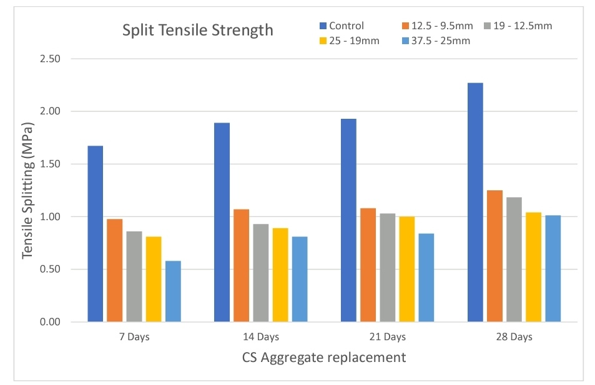
Fig. 5. Split Tensile Strength test results

The results presented in Figure 5 illustrate the split tensile strength test conducted on CS concrete specimens cured for 7, 14, 21 and 28 days, respectively. The results indicate that the average split tensile strength of the CS specimens increased with longer curing periods, with the control group demonstrating the highest strength. The study also revealed that larger sizes of coconut shells in the mixes led to a decrease in the concrete's split tensile strength, suggesting that smaller coconut shell sizes exhibit higher tensile strength due to their increased surface area. Similar trends were observed in the compressive strength.

Ealias et al. (2014) observed a split tensile strength increase of 1.43 N/mm² at 7 days, 1.89 N/mm² at 14 days, and 2.15 N/mm² at 28 days, attributing the strength increase to the addition of coir fibres and fly ash to the coconut shell concrete mix. Chakravarthy et al. (2017) reported a split tensile strength increase of 3.07 N/mm² at 28 days, which they attributed to the addition of steel fibres to the mixes. Furthermore, Herring et al. (2021) reported split tensile strength increases at 28 days of 2.4 N/mm² for 5mm - 14mm particle size replacement and 2.8 N/mm² for 5mm - 20mm, attributing the strength increase to the concrete mix ratio of 1:1.9:2.7. Both Yusuf et al. (2021) and Herring et al. (2021) concluded that the tensile splitting strength of coconut shell concrete decreases with an increase in the proportion of coconut shells. Sanchaya et al. (2022) conducted research on concrete by replacing 10% of the aggregates with CS and partially replacing cement with rice husk ash (RHA) at levels of 5%, 10%, 15%, 20%, and 25%. The tensile strength ranged from 2.05 to 2.55 N/mm², while Aziz et al. (2022) reported that the 28-day splitting tensile strength of the concretes containing CS, with bagasse ash, ranged from 3.31 to 3.89 N/mm².

Table 7. Descriptive and one-way ANOVA for split tensile strength

Descriptive statistics
Treatment Name |  | N | Missing |  | Mean | Std Dev |  | SEM
0% |  | 3 | 0 |  | 2.267 | 0.0577 |  | 0.0333
9.5mm |  | 3 | 0 |  | 1.1 | 0.0361 |  | 0.0208
12.5mm |  | 3 | 0 |  | 1.18 | 0.0265 |  | 0.0153
19mm |  | 3 | 0 |  | 1.047 | 0.146 |  | 0.0841
25mm |  | 3 | 0 |  | 1.013 | 0.0737 |  | 0.0426
One Way ANOVA
Source of Variation | DF |  | SS | MS |  |  | F |  | P
Between Subjects | 2 |  | 0.0178 | 0.00889
Between Treatments | 4 |  | 3.399 | 0.85 |  |  | 147.048 |  | <0.001
Residual | 8 |  | 0.0462 | 0.00578
Total | 14 |  | 3.463 | 0.247

Table 8. Pairwise comparisons between P-values

Comparison | Diff of Means | T | P | P<0.050
0% vs. 25mm | 1.253 | 20.193 | <0.001 | Yes
0% vs. 19mm | 1.22 | 19.656 | <0.001 | Yes
0% vs. 9.5mm | 1.167 | 18.797 | <0.001 | Yes
0% vs. 12.5mm | 1.087 | 17.508 | <0.001 | Yes
12.5mm vs. 25mm | 0.167 | 2.685 | 0.155 | No
12.5mm vs. 19mm | 0.133 | 2.148 | 0.281 | No
9.5mm vs. 25mm | 0.0867 | 1.396 | 0.591 | No
12.5mm vs. 9.5mm | 0.08 | 1.289 | 0.55 | No
9.5mm vs. 19mm | 0.0533 | 0.859 | 0.658 | No
19mm vs. 25mm | 0.0333 | 0.537 | 0.606 | No

An ANOVA was conducted at a 5% significance level to examine potential differences in the split tensile strength of concrete made with granite and coconut shell aggregates, as shown in Table 7. The findings revealed that the mean differences between the treatment groups were not statistically significant enough to dismiss the possibility that these differences were due to random sampling variation at the 5% significance level. The test results indicated no significant difference in the tensile strength of the specimens (P < 0.050). However, a multiple comparison analysis (Table 8) identified a significant difference between the coconut shell aggregate replacements and the control group, implying that the coconut shell aggregates influenced the specimens' tensile strength (P < 0.001).

3.7 Relationship between compressive and tensile strength
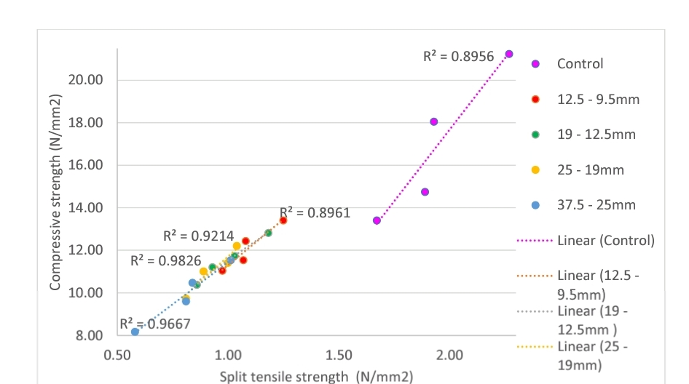

Fig. 6. Relationship between compressive and tensile strength

In Figure 6, the graph illustrates the connection between compressive strength and tensile strength. The test results indicate a strong positive linear correlation between the compressive strength and tensile strength of concrete when crushed coconut shells are used to partially replace coarse aggregate. The coefficient of determinant (R²) was highest at 0.9826 for the 19 – 12.5mm size of coconut shells, indicating a substantial increase in both the tensile and compressive strengths of the specimens. Following this, R² values of 0.9667, 0.9214, and 0.8961 were observed for the 37.5 – 25mm, 25 – 19mm, and 12.5 – 9.5mm crushed coconut shells concrete specimens, respectively. This suggests that compressive strength serves as a reliable predictor of the tensile strength of concrete made with crushed coconut shells as aggregate.

4. Conclusion

The study highlights the potential of using crushed coconut shells (CCS) as a partial replacement for coarse aggregates in concrete. The findings suggest that smaller crushed coconut shell sizes (12.5-9.5mm) resulted in concrete with superior mechanical and physical properties compared to larger sizes. These concrete mixes exhibited good workability, appropriate density, and improved compressive and tensile strength, making them suitable for lightweight construction applications. Although the incorporation of coconut shells reduces the overall strength of concrete compared to traditional aggregates, the material still meets acceptable standards, particularly for non-load-bearing structures. Additionally, utilizing coconut shells offers an environmentally friendly solution by reducing waste and lessening reliance on natural resources.

Disclaimer (Artificial intelligence)

Author(s) hereby declare that NO generative AI technologies such as Large Language Models (ChatGPT, COPILOT, etc.) and text-to-image generators have been used during the writing or editing of this manuscript.

References

Arora, R., Kumar. S., Dixit. S., Tipu. R. K., Kaul. P., Chauhan. S., Raju. Y. K., Nijhawan. G., & Haindavi., P. (2023). “Parametric Investigation of Coconut Shell as Partial Replacement of Coarse Aggregates in Sustainable Concrete”. WoC 430, 01180.

Algaifi, H. A., Shahidan, S., Zuki, S. S. M., Ibrahim, M. H. W., Huseien, G. F., & Rahim, M. A. (2022). Mechanical properties of coconut shell-based concrete: experimental and optimisation modelling. Environmental Science and Pollution Research, 29(14), 21140-21155.

Alireza, J.P., Payam, S., Ünal, M.T., & Zainah, I. (2025). Mechanical Properties of Coconut Shell Lightweight Aggregate Concrete: A Comprehensive Review, Advances in Civil Engineering, 2025, 7816362, 34 pages. https://doi.org/10.1155/adce/7816362

Aziz, W., Aslam, M., Ejaz, M. F., Ali, M. J., Ahmad, R., Raza, M. W. U. H., & Khan, A. (2022). Mechanical properties, drying shrinkage and structural performance of coconut shell lightweight concrete. Structures, Vol. 35, pp. 26-35.

British Standard BS EN 197-1. (2011). Cement - Composition, specifications and conformity criteria for common cements. British Standards Institution. London.

British Standard BS EN 12390-2. (2019). Testing hardened concrete - Making and curing specimens for strength tests. British Standards Institution. London

British Standard BS EN 12620. (2002). Aggregates for concrete. British Standards Institution. London

British Standard BS EN 12350-2. (2019). Testing fresh concrete - Slump test. British Standards Institution. London

British Standard BS EN 1881-122. (2020). Testing concrete - Method for determination of water absorption. British Standards Institution. London

British Standard BS EN 12390-7. (2019). Testing hardened concrete - Density of hardened concrete. British Standards Institution. London

British Standard BS EN 12390-3. (2019). Testing hardened concrete - Compressive strength of test specimens. British Standards Institution. London

British Standard BS EN 12390-6. (2023). Testing hardened concrete - Tensile splitting strength of test specimens. British Standards Institution. London

Brundtland Report (1987). “Our Common Future”, and the 1992 UN Conference on Environment and Development (UNCED).

Buertey, J. T., Atsrim, F., & Ofei, W. S. (2016). “An examination of the physiomechanical properties of rock lump and aggregates in three leading quarry sites near Accra”. American Journal of Civil Engineering, 4(6), 264-275.

de Brito, J., & Kurda, R. (2021). The past and future of sustainable concrete: A critical review and new strategies on cement-based materials. Journal of Cleaner Production, 281, 123558.

Gunasekaran, K., Prakash, C., Annadurai, R., & Satyanarayanan, K. S. (2017). “Augmentation of mechanical and bond strength of coconut shell concrete using quarry dust. European Journal of Environmental and Civil Engineering. 21(5) 629-640.

Herring, T. C., Thuo, J. N., & Nyomboi, T. (2021). Influence of coconut shell grades as partial replacement of coarse aggregates on concrete properties, 8(11), 13-23.

IS 2386-4. (1963). Methods of test for aggregates for concrete, Part 4: Mechanical properties. Bureau of Indian Standards (BIS). India.

Kalyanapu, V. R., Swaroop, A. H. L., Kodanda, P. R., Bharath, C. N. (2015). “Study on strength properties of coconut shell concrete”. 6(3), pp.42-61.

Kaur, M. & Kaur, M. (2012), “A review on the utilization of coconut shell as coarse aggregates in mass concrete”, Int. J. Appl. Eng. Res., 7(11), 7-9.

Olsson, J. A., Miller, S. A. & Alexander, M. G. (2023). “Near-term pathways for decarbonizing global concrete production”. Doi.org/10.1038/s41467-023-40302-0.

Osei, D.Y. (2013). Experimental Assessment on Coconut Shells as Aggregate in Concrete. International Journal of Engineering Science Invention. (2013) 2, no. 5, 7–11.
Sanchaya M., Harikaran, M., Cheran, K., Varoon, M., Jayaprakash, P., & Navin, G. (2022). Experimental Investigation on Rice Husk Ash and Coconut Shell Used in Building Materials. Materials Today: Proceedings, 68, 1697–1702.

Shyam, S. K., & Jain, S. K. (2023). “A study on the implementation of coconut shell as a coarse aggregate in concrete – An Overview”, 10, IJERT Journal, 2395 – 0072.

Stephen, R.S., Gerry, G, C., Virmani, Y, P., Glen, E, S., Robert, G, K. (2002). Electrochemical chloride extraction: Influence on Treatment. DOT, F 1700.7 (8 - 72).

Verma, S. K., & Shrivastava, S. (2019, September). Use of coconut shell as partial substitution of coarse aggregate experimental analysis. In AIP Conference Proceedings (Vol. 2158, No. 1). AIP Publishing.

Irham, M. Z. M. A., Nurizaty, Z., Nadiah, S., Majedu, K. A., & Kado, B. (2024). “Mechanical Properties of Concrete Containing Coconut Shell as Coarse Aggregate Replacement”. Volume 3, 69 – 80.

Sujatha, A., & Balakrishnan, S. D. (2023). Properties of high-strength lightweight concrete incorporating crushed shells as coarse aggregate. Materials today. 2214 – 7853.

Murthy, A., A., Pukazhendhi, D., M., Vishnuvardhan, S., Saravanan, S. (2020). Performance of concrete beams reinforced with GFRP bars under monotonic loading. 27(3): 1274 – 1288.

Wahab, A., & Appiah-Kubi, E. (2024). Characterization of Pulverized Palm Kernel Shells Block. (JET), 15(1).

Yerramala, A. & Ramachandrudu, C. (2012). Properties of concrete with coconut shells as aggregate replacement. IJE, 1(6).

