Comparative Infrared and Mineralogical Analyses of Clay Deposits in Enugwu-Agidi and Mbaukwu Areas of Anambra State, Nigeria

Abstract
The industrial potential of Nigerian clay deposits remains a critical frontier for economic diversification. This study presents a preliminary mineralogical and geochemical characterization of clay deposits from Enugwu-agidi and Mbaukwu in Anambra State, Nigeria. Representative clay samples were collected, processed, and analyzed using FTIR, X-ray diffraction (XRD) and X-ray fluorescence (XRF) techniques. FTIR analysis showed characteristic absorption bands typical of aluminosilicate minerals, particularly within kaolinite–illite–smectite systems, with minor contributions from quartz and adsorbed water. XRD analysis reveals that both clay samples are predominantly composed of kaolinite, illite, and quartz, with minor occurrences of feldspar and hematite. XRF results indicate high concentrations of SiO₂ (~53 wt.%) and Al₂O₃ (~30 wt.%), confirming their aluminosilicate nature. Geochemical indices, including silica–alumina ratios (>1.7) and Chemical Index of Alteration (CIA) values (90–93%), indicate significant weathering and the presence of free silica. Ternary diagram evaluation (SiO₂–Al₂O₃–Fe₂O₃) further indicates that the clays fall within the compositional range suitable for ceramic and refractory applications. Comparative analysis shows that Enugwu-agidi clay is relatively purer and more suitable for high-grade ceramic applications, while Mbaukwu clay contains slightly higher impurities. Variations in mineral and chemical composition between the two deposits reflect differences in weathering intensity and parent rock composition which influence their suitability for industrial applications such as ceramics, refractories and building materials. The findings provide valuable insight into the industrial potential and geochemical characteristics of the studied clay deposits.
Keywords: Clay minerals, XRD, XRF, kaolinite, ternary diagram, quartz

Introduction
Clay materials are among the most abundant and versatile natural resources widely utilized in a broad range of industrial applications including ceramics, construction, pharmaceuticals, refractories, paper, paints, and drilling fluids [1-2]. Clay structure is made up of layered silicates mineral mainly composed of silicon, aluminium, oxygen and hydroxyl groups. These layers form sheet-like structures such as silica tetrahedral sheet and alumina octahedral sheet. The arrangement of these sheets determines the type of clay mineral. It can be 1:1 layer structure or 2:1 layer structure giving it either T:O or T:O:T respectively which gives clay it’s unique properties such as plasticity, swelling, adsorption and ion exchange ability [3] as illustrated below; 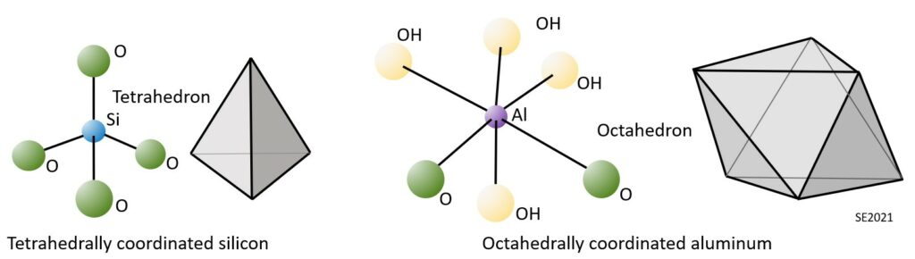Figure 1: Representations of the Silica Tetrahedra and Aluminum Octahedra That Combine to Form Clay Minerals.
An important feature of clay minerals results from the characteristics of their bonding. The tetrahedra and octahedra are strongly bonded to each other within the sheets, but the sheets are only weakly bonded one to another. The sheets that make up a clay mineral grain have a tendency to slide with respect to each other, and the result is that clay mineral masses tend to be soft and plastic, and not very strong. Their suitability for applications and properties depends largely on their mineralogical composition and chemical characteristics which determines their plasticity, strength, and thermal behavior. Consequently, detailed characterization of clay deposits is essential for determining their industrial potential and optimizing their utilization.
Nigeria is endowed with significant clay deposits distributed across various geological formations, particularly within the Anambra Basin and adjoining regions. Among these, the Mbaukwu and Enugwu-Agidi clay deposits in southeastern Nigeria have attracted increasing attention due to their accessibility and potential economic value. The clays in these areas are products of weathering and sedimentation processes [4], influenced by environmental and geological factors such as rainfall, temperature, and parent rock composition. Despite this, comprehensive comparative studies evaluating their mineralogical and geochemical properties remain limited.
Mineralogical characterization, typically conducted using X-ray diffraction (XRD), provides insight into the crystalline phases present in clays, such as kaolinite, illite, smectite, and quartz. These mineral phases directly influence key properties such as plasticity, thermal stability, shrinkage behavior, and firing characteristics. Complementarily, geochemical analysis, often performed using X-ray fluorescence (XRF), reveals the elemental composition of the clays, including major oxides such as SiO₂, Al₂O₃, Fe₂O₃, and trace elements, which are critical in assessing their suitability for specific industrial applications.
Comparative analysis of different clay deposits enables the identification of variations in mineral composition and chemical makeup that may affect performance in industrial processes. For instance, high kaolinite content is desirable for ceramic and refractory applications, while elevated iron oxide content may limit suitability for whiteware production but enhance use in pigments or construction materials [5-6].
This study therefore aims to carry out a comparative mineralogical and geochemical characterization of Mbaukwu and Enugwu-Agidi clays using XRD and XRF techniques. By systematically evaluating their compositional and structural differences, the study seeks to determine their potential industrial applications and provide a scientific basis for their effective exploitation.
Materials and Methods

Picture Map of Study Area
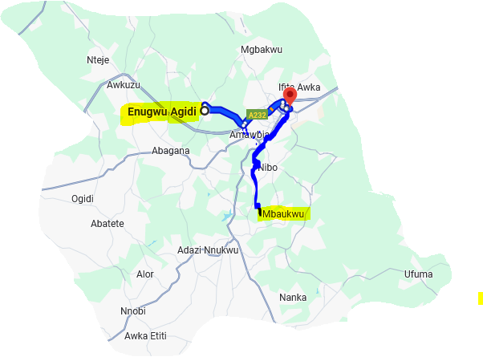

Sample Collection and Preparation
Clay samples were collected from Mbaukwu and Enugwu-Agidi in Anambra State, Nigeria. At each site, five (5) samples were obtained from different points to represent spatial variability within the deposit, giving a total of ten (10) composite samples for the study. Sampling was conducted from a depth of 0.5–1.5 m, after removing the organic topsoil layer to expose the true clay horizon. The samples from each respective location were air-dried, crushed, sieved to obtain uniform particle sizes and homogenized thoroughly by manual mixing. Organic matter and impurities were removed prior to analysis to ensure accuracy of results.

IR Spectroscopic Analysis of Enugwu-agidi and Mbaukwu clays.
The clay samples were analyzed using a Buck Scientific Model 530 FTIR spectrophotometer over the spectral range of 4000–600 cm⁻¹ to identify functional groups and infer mineralogical composition (Figure 1). Infrared spectroscopy is widely applied for the qualitative and semi-quantitative characterization of clay minerals due to its sensitivity to hydroxyl, silicate, and water-related vibrations [7-8].

Mineralogical Analysis (XRD)
X-ray diffraction analysis was carried out using X-ray diffractometer (Rigaku D/Max-lllC), to identify the mineral phases present in the clay samples. The powdered samples were scanned over a range of 2θ angles (typically 5°–70°) using Cu-Kα radiation set at 40kV and 20mA. The diffraction patterns obtained were matched with standard reference patterns (JCPDS database) to identify the mineral phases.

Geochemical Analysis (XRF)
X-ray fluorescence analysis was carried out using X-ray fluorescence spectrometer (Philip PW 1210, TEFA ORTEC automatic) to determine the elemental composition of the samples. The method is based on the interaction between incident high-energy X-rays and the atoms within a sample, leading to the emission of characteristic secondary (fluorescent) X-rays. The powdered samples were scanned using Cu-Kα radiation set at 45kV and 35mA with wavelength cuka 1 and 2[A^{O}] 1.440 – 1.450. Major oxides such as SiO₂, Al₂O₃, Fe₂O₃, CaO, MgO, Na₂O, and K₂O were quantified. The results were expressed in percentage composition. The Chemical Index of Alteration (CIA) was calculated using:
CIA = [Al₂O₃ / (Al₂O₃ + CaO + Na₂O + K₂O)] × 100
Silica–alumina ratios were also computed to assess mineralogical composition.

Ternary Diagram Analysis
Ternary diagrams (SiO₂–Al₂O₃–Fe₂O₃) were constructed using normalized oxide percentages obtained from XRF results. This geochemical tool was used to evaluate compositional relationships and classify the clay materials based on their industrial suitability.

Results and Discussion

Figure 2: Spectral analysis of Enugwu-agidi and Mbaukwu clays
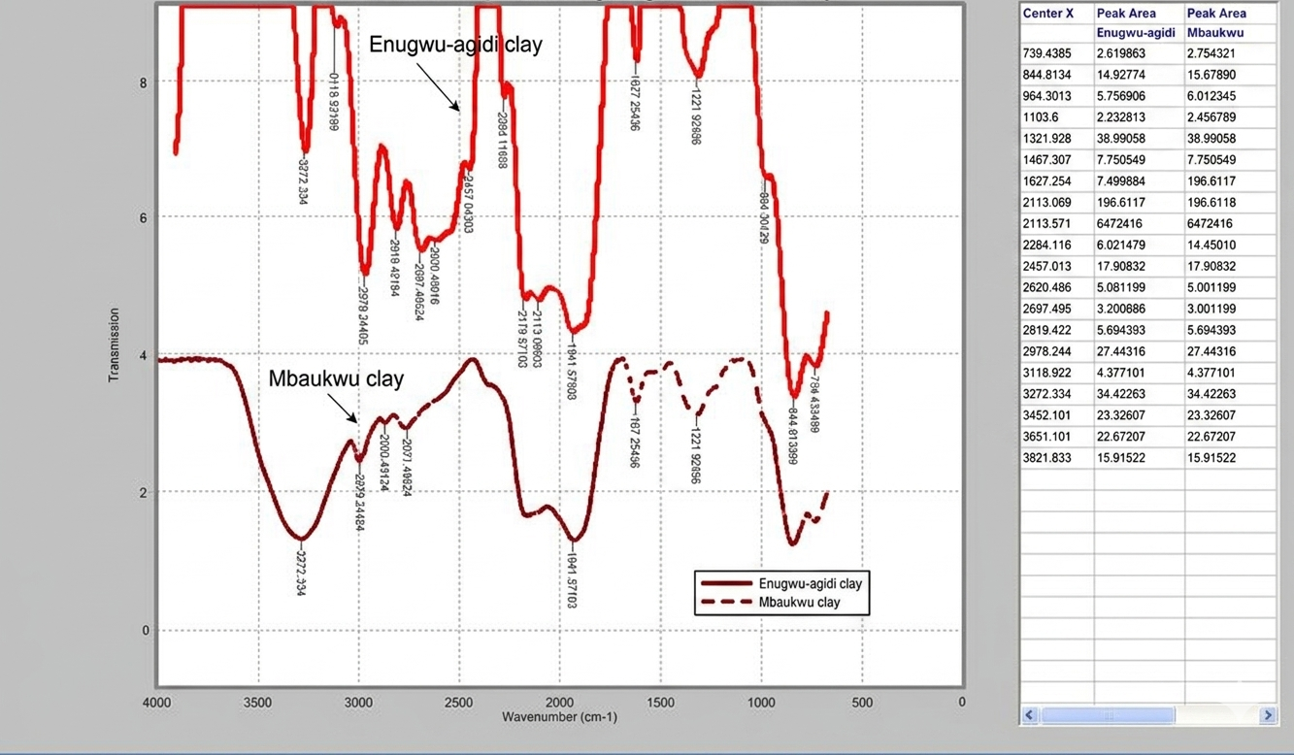
The FTIR spectra of both Enugwu-Agidi and Mbaukwu clays display characteristic absorption bands typical of aluminosilicate minerals, particularly within kaolinite–illite–smectite systems, with minor contributions from quartz and adsorbed water. The general similarity in band positions suggests comparable mineralogical frameworks, consistent with findings that IR spectra can reliably indicate clay mineral groups based on vibrational fingerprints [9].
A broad absorption band observed in the region ~3452–3621 cm⁻¹ is assigned to O–H stretching vibrations of structural hydroxyl groups and adsorbed water molecules. The presence of multiple peaks within this region reflects contributions from both inner hydroxyls and hydrogen-bonded water. Such features are typical of kaolinite and smectitic clays, where hydrogen bonding and interlayer water influence band broadening [8]. The broader and more intense band observed in the Mbaukwu sample suggests increased hydrogen bonding and moisture content, indicating higher surface activity or lower crystallinity.
The band near ~1630 cm⁻¹ corresponds to H–O–H bending vibrations of physically adsorbed or interlayer water, a common feature in hydrated phyllosilicates [7]. The persistence of this band in both samples confirms the presence of structural or adsorbed water, which plays a critical role in adsorption and cation exchange processes.
Strong absorption bands within the range ~1000–1100 cm⁻¹ are attributed to Si–O–Si and Si–O–Al stretching vibrations, which dominate aluminosilicate frameworks. These bands are diagnostic of silicate mineral structures and are widely used in identifying clay mineral assemblages [8,10]. The band near ~915–950 cm⁻¹, assigned to Al–Al–OH bending vibrations, is characteristic of kaolinite, supporting its presence in both samples.
Additional bands near ~780–800 cm⁻¹ are attributed to Si–O vibrations in quartz, indicating the presence of free silica as an impurity phase. This observation is consistent with typical mineralogical compositions of natural clays and aligns with XRD-based identification of quartz in similar systems [10]. Weak bands observed around ~460–540 cm⁻¹ correspond to Si–O bending vibrations, further confirming the silicate lattice structure.
A comparative analysis (Table 1) shows that both clays exhibit similar absorption features, indicating dominance of aluminosilicate minerals, likely within the kaolinite–illite group. However, differences in peak intensity and sharpness are evident. The Mbaukwu clay displays broader and more intense O–H stretching bands (~3450–3270 cm⁻¹), suggesting higher hydration levels and possible structural disorder. In contrast, the sharper peaks observed in the Enugwu-Agidi clay indicate relatively higher crystallinity.

Table 1: IR Spectral Band Assignments for Enugwu-Agidi and Mbaukwu Clays
Observed Wavenumber (cm⁻¹) | Enugwu-Agidi | Mbaukwu | Assigned Vibration | Mineral/Group
3695–3620 | Present | Present (broader) | O–H stretching | Kaolinite (inner OH)
3450–3200 | Moderate | Strong | H-bonded O–H stretch | Adsorbed water
~1630 | Clear | Clear | H–O–H bending | Interlayer water
1100–1000 | Strong | Strong | Si–O stretching | Aluminosilicate
~915–950 | Present | Present | Al–Al–OH bending | Kaolinite
800–780 | Present | Present | Si–O (quartz) | Quartz
~540–470 | Weak | Weak | Si–O bending | Silicates

These spectral variations are significant, as they influence the physicochemical properties of the clays. Increased hydration and structural disorder, as observed in Mbaukwu clay, are often associated with enhanced adsorption capacity and reactivity, whereas higher crystallinity, as seen in Enugwu-Agidi clay, may favor applications in ceramics and structural materials [11].
Overall, the FTIR results confirm that both clay samples share similar mineralogical compositions but differ in structural order and hydration characteristics, which may impact their industrial and environmental applications.

Mineralogical Composition
The X-ray diffraction patterns of Enugwu-Agidi and Mbaukwu clay samples (Figure 3) reveal the presence of both clay and non-clay mineral phases. The Mbaukwu pattern is vertically offset for clarity.
Figure 3: X-ray diffraction patterns of Enugu-Agidi and Mbaukwu clay samples.
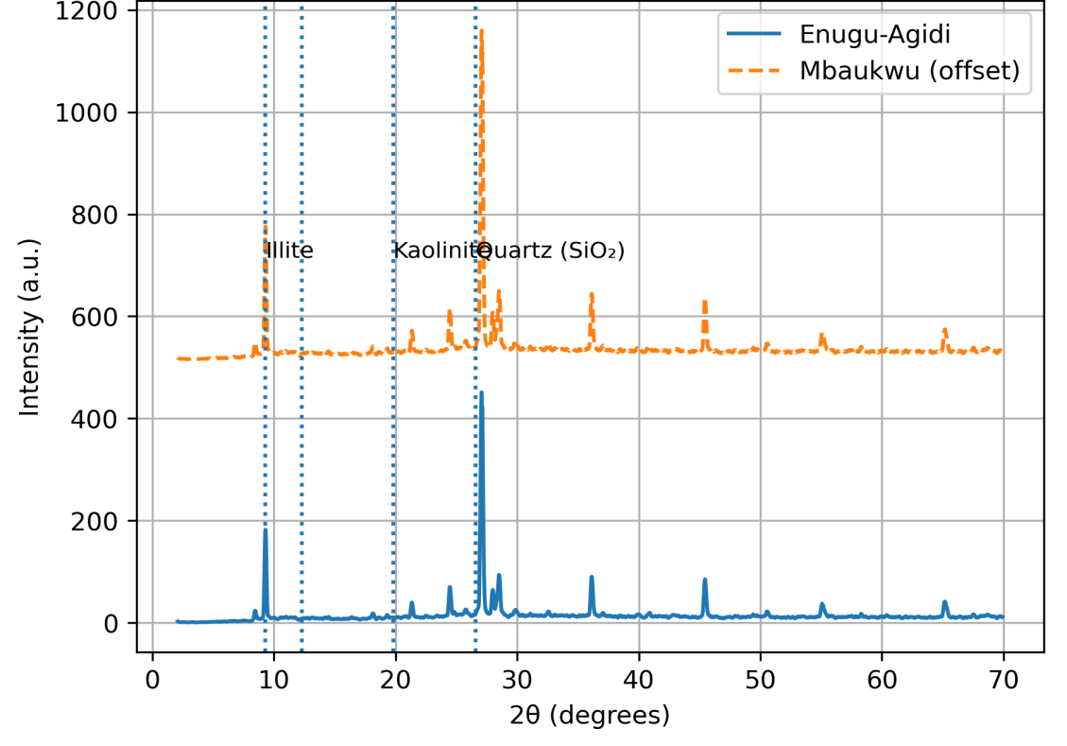
A dominant diffraction peak at approximately 9.3° (2θ), corresponding to a basal spacing of ~10 Å, is characteristic of illite, indicating that it is the principal clay mineral in both samples. Secondary reflections observed around 19–20° (2θ) are attributed to kaolinite, confirming its presence as a subordinate clay phase. The relatively lower intensity of these peaks suggests that kaolinite occured in smaller proportions compared to illite. A very strong and sharp peak at approximately 26.6° (2θ) corresponds to quartz (SiO₂), indicating a significant amount of crystalline silica. The high intensity and narrow width of this peak suggest a well-crystallized quartz phase. Comparatively, both samples exhibited similar mineralogical compositions, although the Mbaukwu clay showed slightly higher peak intensities, indicating a relatively higher mineral concentration or crystallinity. Overall, the mineral assemblage [3, 12] of illite–kaolinite–quartz suggests that the clays were typical of weathered aluminosilicate deposits and may be suitable for ceramic and industrial applications. The interplanar spacing (d-spacing) values were calculated using Bragg’s law:
nλ = 2d sinθ, Where λ = 1.5406 Å (Cu Kα radiation) and n = 1, as seen in table 2.
Table 2: XRD Peak Positions and Calculated d-spacing for Enugu-Agidi and Mbaukwu Clays
Sample | 2θ (°) | θ (°) | d-spacing (Å) | Assigned Mineral
Enugu-Agidi | 9.30 | 4.65 | 9.50 – 10.00 | Illite
Enugu-Agidi | 19.80 | 9.90 | 4.48 | Kaolinite
Enugu-Agidi | 26.60 | 13.30 | 3.34 | Quartz
Mbaukwu | 9.30 | 4.65 | 9.50 – 10.00 | Illite
Mbaukwu | 19.80 | 9.90 | 4.48 | Kaolinite
Mbaukwu | 26.60 | 13.30 | 3.34 | Quartz

The calculated d-spacing values for both Enugu-Agidi and Mbaukwu clay samples were interpreted by comparison with standard diffraction data from the ICDD Powder Diffraction File (PDF) database. A basal reflection observed at d ≈ 9.50–10.00 Å (2θ ≈ 9.30°) in both samples is characteristic of illite (JCPDS PDF 26-0911). This peak represents the (001) plane of illite and confirms the presence of a non-expanding clay mineral formed under moderate weathering conditions. The reflection at d ≈ 4.48 Å (2θ ≈ 19.80°) corresponds to kaolinite (JCPDS PDF 14-0164). Although the most diagnostic kaolinite peak typically occurs at ~7.15 Å, the presence of this secondary reflection supports the occurrence of kaolinitic clay minerals, indicating advanced chemical weathering and leaching processes. A very strong and sharp peak at d ≈ 3.34 Å (2θ ≈ 26.60°) is attributed to quartz (JCPDS PDF 46-1045). This peak is highly diagnostic and indicated a significant proportion of free silica in both clay deposits, suggesting incomplete weathering of parent rock materials.

Geochemical Composition
The major oxide compositions of Enugwu-agidi and Mbaukwu clay samples are presented in Table 3.
Table 3: Major Oxide Compositions of Clay Samples (wt%)
Clay sample location (%) | SiO₂ | AI₂O₃ | Fe₂O₃ | MnO | CaO | P₂O₅ | K₂O | TiO₂ | MgO | Na₂O | LOI
Enugwu-agidi | 53.1 | 30.61 | 3.97 | 0.04 | 1.36 | 0.02 | 0.48 | 1.22 | 0.91 | 0.33 | 6.2
Mbaukwu | 53.8 | 30.7 | 4.17 | 0.06 | 1.76 | 0.02 | 0.73 | 1.34 | 4.35 | 0.81 | 6.8
Both samples were dominated by SiO₂ (53.10–53.80 wt.%) and Al₂O₃ (30.61–30.70 wt.%), indicating that they were predominantly aluminosilicate in nature, consistent with kaolinitic clay systems reported in similar Nigerian deposits [5-6]. Mbaukwu clay displayed slightly higher Al₂O₃ content, which is beneficial for high-temperature applications. The high alumina content is characteristic of kaolinitic clays, while the silica content suggests the presence of free quartz.
The Fe₂O₃ content ranges from 3.97 to 4.17 wt.%, indicating moderate iron enrichment, likely due to the presence of hematite or goethite, which must have imparted reddish coloration to the clays. Minor oxides such as CaO, K₂O, Na₂O, and MgO occured in low concentrations, suggesting limited amounts of feldspars and other accessory minerals that can act as fluxing agents during firing.
The TiO₂ content (~1.2–1.34 wt.%) suggests the presence of titanium-bearing minerals such as anatase or rutile, which are typical of highly weathered tropical soils while the Loss on Ignition (LOI) values reflect the presence of structurally bound water and organic matter, mainly associated with clay minerals such as kaolinite.

Calculated Geochemical Parameters

(a) Silica–Alumina Ratio is calculated using SiO₂/Al₂O₃ for each clay sample in table 4.

Table 4: Silica–Alumina Ratio
Sample | SiO₂ | Al₂O₃ | Value
Enugwu-agidi | 53.1 | 30.61 | 1.73
Mbaukwu | 53.8 | 30.70 | 1.75

The silica–alumina ratios for Enugwu-agidi (1.73) and Mbaukwu (1.75) are higher than the theoretical value for pure kaolinite (~1.18), indicating the presence of excess silica in the form of quartz.

(b) Chemical Index of Alteration (CIA) is calculated using CIA = Al₂O₃/ Al₂O₃+CaO+Na₂O+K₂O ×100 for each clay sample in table 5,

Table 5: Chemical Index of Alteration
Sample | Al₂O₃ | CaO | Na₂O | K₂O | CIA (%)
Enugwu-agidi | 30.61 | 1.36 | 0.33 | 0.48 | 93.4
Mbaukwu | 30.70 | 1.76 | 0.81 | 0.73 | 90.3
The Chemical Index of Alteration (CIA) values were very high, ranging from 90.3 to 93.4%. These results align with previous studies on highly weathered clays within the Anambra Basin [4]. These values indicate intense chemical weathering and significant leaching of mobile cations (Ca²⁺, Na⁺, and K⁺), consistent with tropical weathering conditions [12].

Ternary Diagram Analysis (SiO₂–Al₂O₃–Fe₂O₃)
Ternary diagrams were used to evaluate the compositional distribution of the clay samples and their industrial relevance as seen in figure 4.
Figure 4: Ternary diagram of SiO₂–Al₂O₃–Fe₂O₃ for Enugu-Agidi and Mbaukwu clay samples.
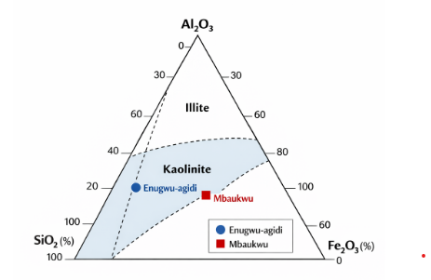
The SiO₂–Al₂O₃–Fe₂O₃ ternary plot shows that both samples cluster near the SiO₂–Al₂O₃ axis, indicating low iron content and dominance of aluminosilicate phases. This compositional field is consistent with kaolinite-rich clays with minor quartz and iron oxide impurities. The Enugwu-Agidi clay plots closer to the Al₂O₃ apex, indicating higher kaolinite content and greater suitability for ceramic and refractory applications. In contrast, the Mbaukwu clay plots toward the SiO₂-rich region, reflecting higher quartz content and lower plasticity. Both samples fall within the typical compositional field of kaolinitic clays used in ceramic production, although Mbaukwu clay may require beneficiation to reduce excess silica.

Comparison with Standard Industrial Clay Specifications
The chemical compositions of the studied clays were compared with standard industrial requirements for ceramic and refractory materials.
Table 6: Comparison with Standard Industrial Clay Specifications
Parameter | Enugu-Agidi | Mbaukwu | Standard Ceramic Clay
SiO₂ (%) | 53.10 | 53.80 | 45–60
Al₂O₃ (%) | 30.63 | 30.70 | 20–35
Fe₂O₃ (%) | 3.97 | 4.17 | <10
LOI (%) | 6.20 | 6.80 | 5–15
The comparison showed that both clay deposits meet the general requirements for ceramic raw materials. Enugu-Agidi clay, with higher alumina content, is more suitable for high-quality ceramic and refractory products. Mbaukwu clay, due to its higher iron content, is suitable for bricks, tiles, and construction materials requiring dimensional stability and thermal resistance. Enugwu-agidi clay exhibits slightly lower Fe₂O₃ and higher CIA values, suggesting a higher degree of weathering and greater mineralogical purity compared to Mbaukwu clay. In contrast, Mbaukwu clay showed slightly higher concentrations of Fe₂O₃, TiO₂, and MgO, indicating a more heterogeneous composition with additional mineral phases.

Industrial Implications
The high alumina content and low alkali concentrations suggest that both clays are suitable for ceramic and refractory applications. However, the relatively lower impurity levels in Enugwu-agidi clay make it more suitable for high-quality ceramic production. Blending of the two clays could also be explored to optimize properties for specific industrial uses.

4 Conclusion
The integrated XRD and XRF analyses reveal that the studied clays are predominantly kaolinite-rich with minor quartz and accessory minerals. Geochemical indices indicate intense weathering and confirm their suitability for industrial applications, particularly in ceramics and refractory materials. Enugwu-agidi clay exhibits superior quality compared to Mbaukwu clay. These findings provide a scientific basis for the effective utilization and industrial development of these clay resources.

Disclaimer (Artificial intelligence)

Author(s) hereby declare that NO generative AI technologies such as Large Language Models (ChatGPT, COPILOT, etc.) and text-to-image generators have been used during the writing or editing of this manuscript.

References

- Belghazdis, M., & Hachem, E. K. (2022). Clay and clay minerals: A detailed review. International Journal of Recent Technology and Applied Science, 4(2), 54–75.
- Kalendová, A., Kupková, J., Urbášková, M., & Merinská, D. (2024). Application of clays in nanocomposites and ceramics. Minerals, 14(1), 93. https://doi.org/10.3390/min14010093
- Warr, L. N. (2022). Earth’s clay mineral inventory and its climate interaction. Earth-Science Reviews, 234, 104198.
- Ezealaji, I., Akudinobi, B. E. B., & Lar, U. A. (2023). Assessment of mineralogical and heavy metal constituents of geophagic clays in parts of Anambra State, Nigeria. Journal of Basic Physical Research, 11(1), 77–89.
- Adeniyi, A. G., Iwuozor, K. O., & Emenike, E. C. (2023). Material development potential of Nigeria’s kaolin. Chemistry Africa, 6(4), 1709–1725.
- Nnameme, F. O., Onuegbu, T. U., Agbo, S. C., & Okwute, E. S. (2020). Characterization of local clay from Anambra State, Nigeria for ceramic applications. Asian Journal of Chemical Sciences, 8(2), 1–10.
- Lavine, B., Almirall, J., Muehlethaler, C., Neumann, C., & Workman Jr, J. (2020). Criteria for comparing infrared spectra–A review of the forensic and analytical chemistry literature. Forensic Chemistry, 18, 100224.
- Vahur, S., Kiudorv, L., Somelar, P., Cayme, J. M., Retrato, M. D. C., Remigio, R. J., ... & Leito, I. (2021). Quantitative mineralogical analysis of clay-containing materials using ATR-FT-IR spectroscopy with PLS method. Analytical and bioanalytical chemistry, 413(26), 6535-6550.
- Dubrovkin, J. (2022). Spectral Databases. Brief Review.
- Susantoro, T. M., Saepuloh, A., Agustin, F., Wikantika, K., & Harsolumakso, A. H. (2020). Clay mineral alteration in oil and gas fields: integrated analyses of surface expression, soil spectra, and X-ray diffraction data. Canadian Journal of Remote Sensing, 46(2), 237-251.
- Villabona-Estupiñan, S., Rojas-Ruiz, F. A., Pinto-Camargo, J. L., Manrique, E. J., & Orrego-Ruiz, J. A. (2020). Characterization of Petroleum Compounds Adsorbed on Solids by Infrared Spectroscopy and Mass Spectrometry. Energy & Fuels, 34(5), 5317-5330.
- Wilson, M. (2004). Weathering of primary rock-forming minerals. Clay Mineralogy, 39(3), 233–266.

