Original Research Article

Numerical Investigation Of The Performance Of Talc Filled Epoxy Composites For Cookware Insulation Application

ABSTRACT
Thermal insulation plays a vital role in domestic cookware by limiting heat transfer to external components such as handles, thereby improving user safety. This study dives into the thermal performance of talc/epoxy composites that have been exposed to various post-curing temperatures and comparing their insulation abilities to traditional Bakelite. In total, 40 composite specimens were put to the test in this research. These composites were made using different talc particle sizes and cured at temperatures ranging from 50°C to 150°C.
To evaluate the thermal behavior of both the composites and Bakelite, a computational fluid dynamics approach was employed using ANSYS Fluent to simulate heating in a domestic pot with a consistent aspect ratio (H/D = 0.52625). the post cured composites and Bakelite were simulated as handles of the domestic pot.
The results showed that composites cured at 100°C provided the best insulation performance, significantly outperforming Bakelite. At lower curing temperatures, incomplete cross-linking limited thermal resistance, while higher temperatures led to degradation. A grid independence study confirmed the reliability of the numerical model.
Among the 40 specimens tested, the 2E (106 µm- 5% fiberglass, 15% Talc and 80% epoxy) composite post cured at 125°C demonstrated the highest insulation capability, achieving approximately 30°C of heat reduction at the pot handles compared to Bakelite's 24.4°C.
These findings reveal that talc/epoxy composites can be effective alternatives to traditional insulating materials for domestic uses like cookware, particularly when processed under optimal curing conditions.
Keywords: ANSYS Fluent, Epoxy Composites, Insulation, Bakelite, Curing Temperature, Computational

1. INTRODUCTION
Effective thermal insulation is essential in household cookware to reduce heat transfer from the cooking medium to external surfaces, particularly handles, thereby ensuring safe handling and improved energy efficiency. César (2023) (Madhulika & Ramazan, 2013) Traditional insulating materials like Bakelite have been popular because of their electrical insulating properties and decent thermal resistance (Sajjad & Mohammed, 2012). However, their performance is limited under varying long term thermal conditions (Ahmed et al.,2025, Rybakiewicz, 2020), necessitating the development of improved insulating materials.
Lately, polymer matrix composites, particularly those based on epoxy, have been getting a lot of attention. They offer fantastic dielectric strength, chemical resistance, and adjustable thermal properties. Epoxy resins naturally have low thermal conductivity, making them a great choice for insulation (Israa & Riyam, 2021). Their performance can be tailored by incorporating particulate fillers, which influence internal heat transfer mechanism to boost thermal stability and structural integrity (Nemlen et al., 2026, Zhang 2023, Siti et al., 2022).
Epoxy composites are commonly used for electrical and thermal insulation because they effectively resist heat flow while maintaining their structural strength according to, (Rashid et al., 2023, Jian et al., 2020). When fillers are added to epoxy matrices, they can change how heat transfers by either disrupting or enhancing thermal conduction pathways, depending on the type, size, and distribution of the fillers. (Girish et al., 2025, Zelibe et al., 2021, Agrawal et al., 2021)
Previous researches have shown that adding fillers can significantly impact the thermal conductivity, dielectric properties, and mechanical performance of epoxy systems (Rahima et al., 2015, Yan-Chun et al., 2024, Zhang, 2023). While many studies focus on improving thermal conductivity for heat dissipation, insulation applications like cookware need materials that control or reduce heat transfer. This really emphasizes the need to optimize composite formulations specifically for insulation purposes.
Processing parameters such as curing temperature, in particular, affects cross-link density and interfacial bonding Carbas et al., (2014). At low curing temperatures, incomplete cross-linking leads to weak interfacial bonding and the presence of micro-voids, which can reduce insulation performance. Moderately higher curing temperatures generally improve thermal stability and mechanical strength, but excessive curing may induce residual stresses that affect insulation performance. (Zelibe et al., 2026, Sambayi & Heyns, 2023)
Recent studies have further emphasized the importance of thermal stability in determining the performance of polymer-based composites under varying processing and service conditions (Rahimli et al., 2025, Nicolas et al., 2016). Rahimli et al., (2025) investigated polystyrene–zinc oxide nanocomposites and reported that the incorporation of inorganic fillers significantly enhances thermal stability by restricting polymer chain mobility and improving interfacial interactions. Their findings demonstrate that well-dispersed fillers can act as thermal barriers, reducing heat transfer and improving dielectric and thermal performance. This behavior is particularly relevant to epoxy-based systems, where the addition of fillers such as talc and fiberglass can similarly influence thermal transport by modifying the internal microstructure and limiting conductive pathways.
Additionally, the crystallization behavior of polymer composites plays a critical role in determining their thermal and dielectric properties (Ramazanov & Rahimli, 2020, Xu et al., 2021, Zaki & Salih, 2021). (Ramazanov & Rahimli, 2020) demonstrated that the temperature–time mode of crystallization significantly affects the structural ordering and phase distribution in PVC/TiO₂ nanocomposites. Their research showed that carefully controlled thermal processing can lead to better crystallinity and stronger interfacial bonding, which in turn enhances thermal resistance and dielectric performance. Conversely, non-optimal temperature conditions may result in structural defects, poor crystallization, and reduced material performance.
Numerical modeling techniques, especially Computational Fluid Dynamics (CFD) and Finite Element Analysis (FEA), have become crucial for assessing the thermal performance of composite materials, as highlighted by (Udebuani et al., 2021, Wenkai et al., 2018). These methods enable us to simulate heat transfer behavior in controlled settings, which significantly cuts down on the need for extensive experimental trials.
CFD simulations have been widely used to analyze temperature distribution, heat flux, and insulation efficiency in domestic systems (Adewumi et al., 2021, Zlatko et al., 2012, Hassan et al., 2019). When these numerical models are validated with experimental data, they can reliably predict how composites behave under different thermal loads and geometrical configurations, according to (Ayberk et al., 2025, Agarwal et al., 2022).
In cookware applications, numerical investigations allow us to assess how heat transfers from the fluid to the handles and other parts of the cookware, as discussed by (Adewumi et al., 2021, Wang et al., 2022), This enables a direct comparison of insulating materials like Bakelite and various composite alternatives.
Despite the rising interest in filled epoxy composites, there’s a noticeable lack of studies specifically targeting talc-filled epoxy composites for insulation in domestic cookware. Most existing research tends to focus on enhancing thermal conductivity for heat dissipation rather than insulation performance, (Hongwei et al., 2025, Wang et al., 2022). Moreover, there are few studies that combine numerical simulation with experimental validation to evaluate insulation performance in real-world domestic systems.
Therefore, this study focuses on the numerical investigation of heat transfer in a domestic pot system using talc-filled epoxy composites as insulating materials. The analysis will be carried out under consistent geometric conditions and varying curing temperatures, with comparisons made to traditional Bakelite.
It also provides insight into the development of cost-effective and efficient insulating materials for domestic cookware ultimately contributing to better thermal management, enhanced user safety. and energy efficiency in household applications.
- METHODOLOGY
2.1 Materials and Composite Preparation
In carrying out this project, epoxy resin was used as matrix material, while fibre glass and talc were used as filler for the production of the thermoset composite. For the purpose of this experiment, Talc was sieved into average particle sizes of 75 µm and 106 µm using a mechanical sieve. The fiber glass was cut into short pieces of approximately equal length, with an aspect ratio of 0.08. The mold was coated in Poly Vinyl Alcohol (mold release agent) and left to dry before pouring the resin mixture.
Figures showing the talc filled epoxy composites after being fabricated and cured after 24 hours and post cured at elevated temperature levels
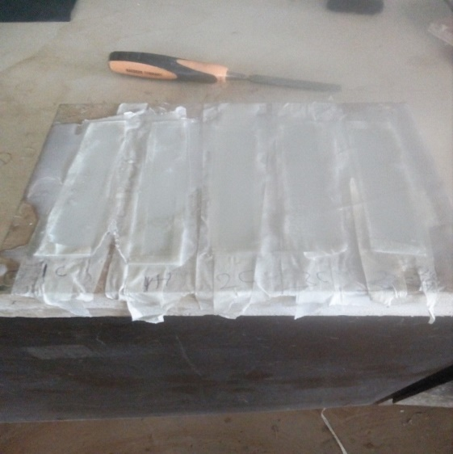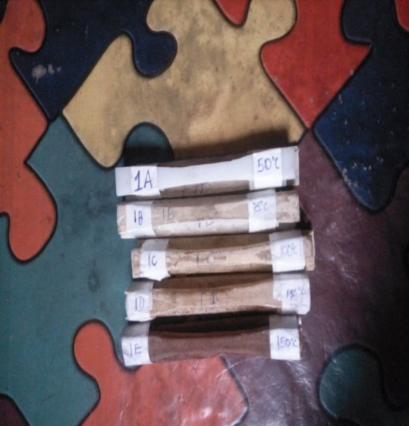
Fig 1: Cure sample after 24 hours Fig 2. Post Cured Samples

Tables 2 to 4 below show the test sample fabricated by Omotinuola et al., (2017) which were considered in the numerical investigations carried out in this study.
Table 1: Loading of specimen for 75 microns’ filler size
Particle | Epoxy (%) | Fiber glass (%) | Particle (%) | designation
75 microns  (1) | 100 | 0 | 0 | A
75 microns  (1) | 90 | 5 | 5 | B
75 microns  (1) | 80 | 10 | 10 | C
75 microns  (1) | 80 | 15 | 5 | D
75 microns  (1) | 80 | 5 | 15 | E

Table 2: Loading of specimen for 106 microns’ filler size
Particle | Epoxy (%) | Fiber glass (%) | Particle (%) | designation
106 microns  (2) | 100 | 0 | 0 | A
106 microns  (2) | 90 | 5 | 5 | B
106 microns  (2) | 80 | 10 | 10 | C
106 microns  (2) | 80 | 15 | 5 | D
106 microns  (2) | 80 | 5 | 15 | E

Table 3: Post cured temperature with constant holding time
S/No. | Curing tempt (ºC) | Holding time (min)
1 | 50 | 120
2 | 75 | 120
3 | 100 | 120
4 | 125 | 120
5 | 150 | 120

2.2 Overview of the pot used for modelling
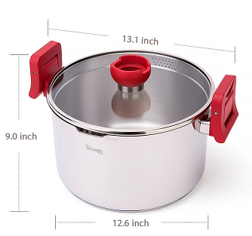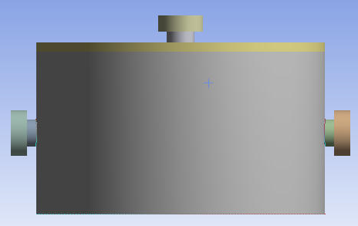
Fig 3; Geometry to be used Model pot Fig 4; Modelled pot using ANSYS CFD solver

The ANSYS design modeller was used to draw the physical model of the pot in Fig 4 and the mesh geometry of the pot was used for the numerical investigation. The top handle and side handles of the pot are modelled as insulators with Bakelite and fibreglass/talc filled composites thermo-physical properties inputted into the CFD solver and results calculated. The simulated pot has aspect ratio of 0.5625 i.e ); Height of pot H = 18cm; Diameter of pot = 32cm, therefore, the ratio of the height of pot to its diameter= 18cm/32cm = 0.5625.

2.3 Validation of the CFD code
The validation of this work, is carried out by a simple experiment of measuring the maximum temperature of fluid (water) after it is heated in a pot with a specified heat flux of 2MW and a measuring thermometer. The result gotten from this simple experiment is compared with the numerical result gotten from the ANSYS platform using the same parameters. Both validations were run for a time of 10 minutes (600 time steps on the CFD solver). The temperature of the fluid after heating for 10 minutes was recorded to be 78°C on the thermometer.
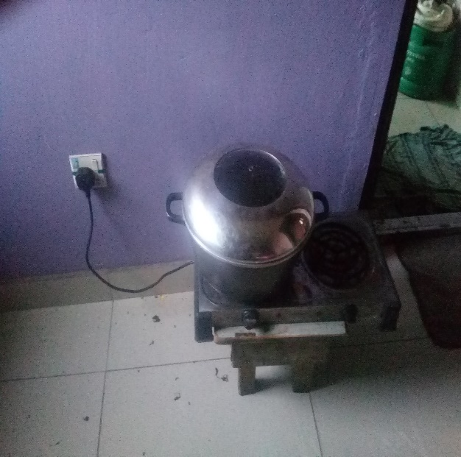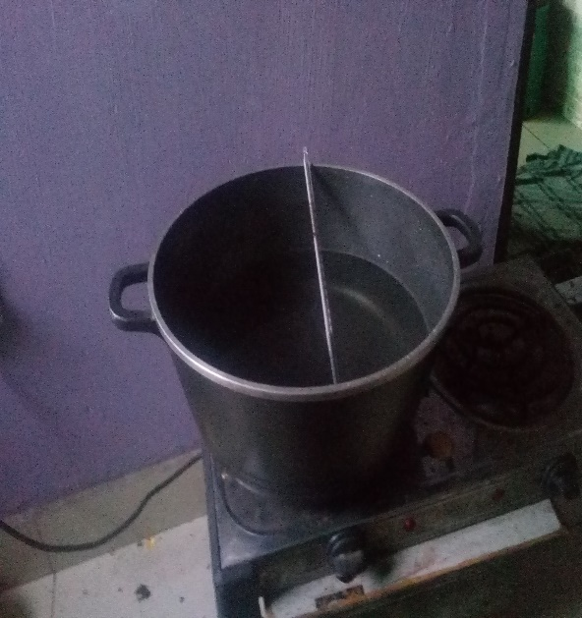
- (b)
Figure 5: Experimental procedures (a) heating of fluid (b) measurement of heated fluid

2.4 Grid Refinement Test
For the numerical validation, a grid refinement test was carried out which is applied to select a mesh size with negligible changes in temperature difference ∆T is obtained.

Table 4: Grid Refinement Study
Number of Elements | Maximum Water Temperature (°C) | % Change
45,320 | 77.42 | –
65,658 | 78.18 | 0.98%
98,745 | 78.51 | 0.42%

A mesh size of 65 658 elements was selected after running the CFD code for a time step of 600. This is because the maximum temperature of water obtained was 78.18°C which was in good agreement with the experimental value already obtained (when compared to other mesh sizes from the grid test), with a percentage difference of 0.23%. Therefore, the mesh elements were selected as the optimal grid for subsequent simulations.

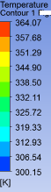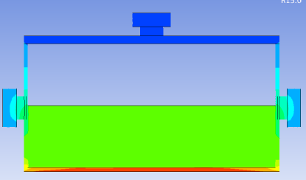
Figure 6: Pot after 10 minutes of heating from the CFD solver

The validation done above allows us to carry out the investigation of this study. Bakelite and the Fibreglass talc filled composites were modelled as handles of the pot on CFD solver. They served as insulators, and their maximum temperature was monitored as the temperature of the fluid(water) increased due to the heat flux applied. The size of the pot retains the same measurements we used in the validation of this work. The body of the pot is modelled as stainless steel with properties of stainless steel imputed i.e. thermal conductivity, specific heat capacity and density. The fluid is modelled as water which is half-filled with a volume of 7239.168cm³. The cover of the pot is modelled as glass. The Boundary conditions applied are:
• Heat flux: 2 MW/m²
• No-slip wall condition
• Initial temperature: 0°C

- RESULTS AND DISCUSSION

In this chapter, the thermos-physical measurement of the post cured composites displayed in table 5 and the results gotten after inputting these measured values into ANSYS fluent for simulation, and comparison with existing material in use (Bakelite) are discussed. The numbers 1 and 2 represent the particle filler sizes used in the composite formulation which are 75µm and 106µm. The composite loading types from tables 1 and 2 are;
B- (5% fiberglass, 5% Talc, 90% Epoxy)
C- (10% fiberglass, 10% Talc, 80% Epoxy)
D - (15% fiberglass, 5% Talc, 80% Epoxy)
E - (5% fiberglass, 15% Talc, 80% Epoxy)

3.1 Physical measurement of composites
The table below shows the thermo-physical properties of fibre-glass talc filled epoxy determined experimentally using a KD2 pro thermal properties analyser, while the thermos-physical properties of Bakelite from (www.wikipedia.com/Bakelite). These property values are inputted into the fluent solver

Table 5: Thermo-physical properties of post cured fibreglass talc epoxy filled composites
Post cured temperature | Composite size & loading | Thermal Conductivity (K) | Specific Heat Capacity (C) | Thermal Diffusivity (D) | Density(ρ)
(°C) |  | k (W/m·K) | Cp (kJ/kg·K) | α (mm²/s) | ρ (g/cm³)
50 | 1E | 0.343 | 1.105 | 0.310 | 1.001314
 | 1C | 0.192 | 0.429 | 0.449 | 0.996776
 | 2B | 0.112 | 0.164 | 0.679 | 1.005783
 | 2D | 0.064 | 0.189 | 0.341 | 0.993033
 | 1B | 3.800 | 1.087 | 3.497 | 1.001679
 | 1D | 0.160 | 0.469 | 0.341 | 1.000444
 | 2C | 0.276 | 0.683 | 0.404 | 1.000246
 | 2E | 0.491 | 2.191 | 0.224 | 1.00044
75 | 2E | 0.179 | 0.607 | 0.295 | 0.999637
 | 1E | 0.313 | 0.800 | 0.391 | 1.000639
 | 2C | 0.171 | 0.804 | 0.213 | 0.998528
 | 1D | 1.913 | 2.911 | 0.657 | 1.000247
 | 2B | 0.589 | 3.098 | 0.190 | 1.000646
 | 1B | 0.282 | 0.834 | 0.338 | 1.000383
 | 2D | 1.578 | 1.543 | 1.023 | 0.99969
 | 1C | 0.958 | 0.387 | 2.475 | 1.000183
100 | 2C | 0.311 | 0.801 | 0.389 | 0.99811
 | 1D | 0.660 | 1.676 | 0.394 | 0.999479
 | 1C | 1.618 | 2.596 | 0.623 | 1.000428
 | 1E | 0.145 | 0.306 | 0.473 | 1.00181
 | 2E | 0.066 | 0.604 | 0.109 | 1.002491
 | 2D | 0.163 | 0.465 | 0.351 | 0.998683
 | 1B | 0.578 | 2.387 | 0.242 | 1.000599
 | 2B | 0.479 | 0.811 | 0.590 | 1.001066
125 | 1C | 0.718 | 0.633 | 1.135 | 0.999367
 | 1A | 0.217 | 0.592 | 0.366 | 1.001514
 | 1E | 0.246 | 0.403 | 0.611 | 0.999054
 | 2D | 0.231 | 0.395 | 0.585 | 0.999675
 | 2B | 1.037 | 0.720 | 1.440 | 1.000193
 | 2E | 0.964 | 2.654 | 0.364 | 0.997872
 | 1B | 0.187 | 0.696 | 0.269 | 0.998804
 | 2C | 0.529 | 2.136 | 0.248 | 0.998626
150 | 1E | 0.277 | 1.065 | 0.260 | 1.000361
 | 2B | 0.613 | 3.068 | 0.200 | 0.999022
 | 2C | 0.571 | 0.455 | 1.254 | 1.000754
 | 2D | 0.338 | 1.343 | 0.251 | 1.002691
 | 2E | 1.082 | 0.855 | 1.266 | 0.999603
 | 1B | 0.219 | 0.325 | 0.673 | 1.001257
 | 1C  1D | 0.150  0.083 | 0.358  0.834 | 0.418  0.100 | 1.002379  0.995204

For reference the thermo-physical properties of Bakelite used as the existing material in this study is given as
Table 6: Thermo-physical properties of Bakelite and fibreglass
Material | k (W/m·K) Cp (Kj/kg/k) α (mm²/s) ρ (g/cm³)
Bakelite | 0.200 0.920 0.2 1.360
Fiberglass | 0.035 0.805 0.3 2.600

3.2 Governing Equations
Heat transfer from the hot water to the composite is modelled as a free convection problem. The governing non-linear partial differential equations for fluid flow and heat transfer is shown in Equations (1) to (3). These equations are solved using a ANSYS Fluent computational fluid dynamics tool which employs the finite volume method and results obtained are presented in this section. The fluid is assumed to be a Newtonian incompressible fluid with temperature dependent properties.
$∇.V=0$ (1)
$p\left(\frac{∂V}{∂t}+V.∇V\right)=-∇p+μ∇^{2}V$ (2)
$pc_{p }\left(\frac{∂T}{∂t}+V. ∇T\right)=k∇^{2}T$ (3)

3.3 Numerical results for composites cured at 50˚C
Table 7 shows a comparison between the numerical results obtained for maximum temperature of Bakelite handles to the composites handles after they are subjected to heating at 600 time steps while Figure 7 shows the temperature distribution in the water, pot and handles.
Table 7: insulation values of Bakelite against Composites at 50°C post cured temperature
 |  |  |  | Insulation Values
 | Tw max | LH | RH | Tw max-LH | Tw max-RH | TOTAL
Bakelite | 65.12829 | 40.73306 | 40.98348 | 24.39523 | 24.14481 | 48.54004
1B | 66.73113 | 41.04531 | 41.11276 | 25.68582 | 25.61837 | 51.30419
1C | 65.5668 | 41.71835 | 41.85037 | 23.84845 | 23.71643 | 47.56488
1D | 63.45638 | 41.52795 | 41.89895 | 21.92843 | 21.55743 | 43.48586
1E | 63.01235 | 41.03063 | 41.37448 | 21.98172 | 21.63787 | 43.61959
2B | 63.28604 | 42.13998 | 42.52215 | 21.14606 | 20.76389 | 41.90995
2C | 64.42855 | 41.39175 | 41.83358 | 23.0368 | 22.59497 | 45.63177
2D | 64.47628 | 41.86352 | 42.06405 | 22.61276 | 22.41223 | 45.02499
2E | 64.38479 | 40.36874 | 40.65386 | 24.01605 | 23.73093 | 47.74698

At 50°C, the composites demonstrated a fair level of insulation performance, with Bakelite coming out on top among all the composites, except for the 1B (75 Micron sized) composite. However, when we compare this to the performance at higher curing temperatures, it falls a bit short. This can be attributed to the epoxy matrix not curing completely at these lower temperatures. This observation aligns with previous studies which report that low curing temperatures produce poorly cross-linked polymer networks with higher defect densities and reduced thermal resistance (Carbas et al., 2014, Zelibe et al., 2026). At 50°C, the cross-linking reaction doesn’t fully take shape, leading to weaker bonds between the talc particles and the epoxy matrix. This results in more thermal pathways due to tiny voids and defects, which ultimately lowers the material's resistance to heat flow. At low curing temperatures, filler–matrix bonding is insufficient, preventing the formation of effective phonon-scattering interfaces. Studies show that the efficiency of fillers strongly depends on their dispersion and interfacial bonding within the epoxy matrix (Girish et al., 2025). So, while the 1B composite does have a slight edge over Bakelite, the difference isn’t all that significant because of the less-than-ideal microstructure. The 1B composite achieved the best results, with the maximum water temperature reaching 66.73°C and the maximum handle temperatures at LS 41.04°C and RS 41.11°C. It insulated around 25.6°C.
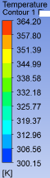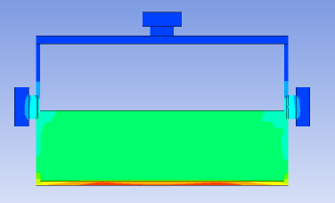
(a)
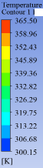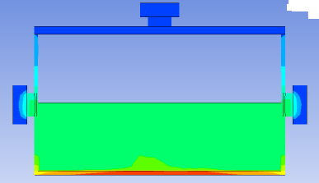
(b)
Figure 7: Temperature contours (a) Bakelite (b) 2E composite
3.4 Numerical results for composites cured at 75˚C
Table 8 shows a comparison between the numerical results obtained for maximum temperature of Bakelite handles to the composites handles after they are subjected to heating at 600 time steps while Figure 8 shows the temperature distribution in the water, pot and handles.
Table 8: insulation values of Bakelite against Composites at 50°C post cured temperature
 |  |  |  | INSULATION
 | Tw max | LH | RH | Tw max-LH | Tw mx-RH | TOTAL
Bakelite | 65.12829 | 40.73306 | 40.98348 | 24.39523 | 24.14481 | 48.54004
2E | 63.36547 | 41.40606 | 41.79318 | 21.95941 | 21.57229 | 43.5317
1E | 62.10253 | 41.36144 | 41.53716 | 20.74109 | 20.56537 | 41.30646
2C | 64.65453 | 41.1097 | 41.39974 | 23.54483 | 23.25479 | 46.79962
1D | 64.53057 | 39.02834 | 39.20327 | 25.50223 | 25.3273 | 50.82953
2B | 65.39587 | 39.81045 | 40.0856 | 25.58542 | 25.31027 | 50.89569
1B | 65.69247 | 41.25894 | 41.50649 | 24.43353 | 24.18598 | 48.61951
2D | 64.85183 | 40.12206 | 40.63513 | 24.72977 | 24.2167 | 48.94647
1C | 63.90481 | 42.37744 | 42.61718 | 21.52737 | 21.28763 | 42.815

When the temperature rises to 75°C, we notice a marked improvement in insulation performance across most of the composite samples. The temperature difference (TW–LH and TW–RH) is greater than what we saw at 50°C, indicating that these materials are more effective at resisting heat transfer. This improvement is due to a higher cross-link density in the epoxy matrix. Carbas et al., (2014). As the curing temperature increases, the polymer network becomes more interconnected, enhancing the adhesion between the particles and the matrix while also reducing pathways for thermal conductivity. his agrees with findings that thermal and mechanical properties of epoxy systems improve with increasing degree of cross-linking (Wan et al., 2021). Compared to Bakelite, several of the composites showed better insulation performance, suggesting they start to reveal their thermal advantages at this curing temperature. It can be seen that composites designated 1D (maximum temperature of water 64.53°C, LS 39.03°C and RS 39.20°C), 2B (maximum temperature of water 65.4°C, LS 39.81°C and RS 40.08°C), 1B (maximum temperature of water 65.69°C, LH 24.43°C and RH 24.18°C) and 2D (maximum temperature of water 64.85°C, LS 40.12°C and RS 40.63°C) all performed better than Bakelite which is the existing material in use. The composite 2B was the best performing composite having insulated about 25.6°C for this cured temperature.
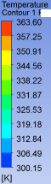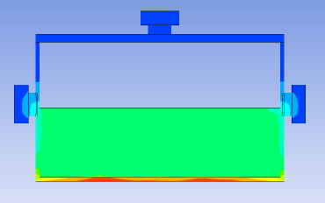
(a)
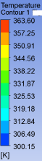
(b)
Figure 8: Temperature contours (a) Bakelite (b) 2B

3.5 Numerical results for composites cured at 100˚C
Fiber-glass talc filled epoxy composites cured at 100°C is compared with Bakelite and the results determined numerically with the CFD solver.
Table 9: insulation values of Bakelite against Composites at 100°C post cured temperature
 |  |  |  | INSULATION
 | Tw max | LH | RH | Tw max-LH | Tw mx-RH | TOTAL
Bakelite | 75.12829 | 40.73306 | 40.98348 | 34.39523 | 34.14481 | 68.54004
2C | 73.67422 | 41.25948 | 41.46459 | 32.41474 | 32.20963 | 64.62437
1D | 76.0567 | 40.52303 | 40.60827 | 35.53367 | 35.44843 | 70.9821
1C | 76.64776 | 39.41116 | 39.69909 | 37.2366 | 36.94867 | 74.18527
1E | 75.55132 | 41.96047 | 42.06082 | 33.59085 | 33.4905 | 67.08135
2E | 75.33212 | 40.89013 | 40.97433 | 34.44199 | 34.35779 | 68.79978
2D | 73.24883 | 41.63445 | 41.89251 | 31.61438 | 31.35632 | 62.9707
1B | 74.5989 | 40.23974 | 40.34683 | 34.35916 | 34.25207 | 68.61123
2B | 74.42233 | 41.30557 | 41.6239 | 33.11676 | 32.79843 | 65.91519

At 100°C, the composites showed their best insulation performance, with the largest temperature differences noted across all curing conditions. This can be attributed to maximum cross-link density and optimal microstructural integrity. Many of the composites outshone Bakelite at this temperature, particularly the smaller particle fillers of 75 µm, labeled by 1B, 1C, 1D and 1E. The composite 1D insulated 25.5°C (${Tw}_{max}$= 66.06°C, LS = 40.5°C, RS= 40.6°C); composite 1C insulated 27.24°C (${Tw}_{max}$= 66.65°C, LS = 39.41°C, RS = 39.70°C); and the composite 1E insulated 23.55°C (${Tw}_{max}$= 65.55, LS = 42°C, RS = 42.06°C). Research has shown that that smaller or well-dispersed filler particles create more interfaces, increasing phonon scattering and reducing thermal conductivity Zelibe et al., (2021). Conversely, poorly distributed fillers may form conductive pathways. Research indicates that filler size, distribution, and loading significantly control thermal transport in epoxy composites (Girish et al., 2025; Zhang, 2023). The impressive performance at 100°C can be linked to the optimal curing of the epoxy matrix, leading to:
- Maximum cross-link density
- Strong interfacial bonding
- Reduced micro-void content
- Improved thermal stability
These elements work together to enhance phonon scattering within the composite, which helps lower thermal conductivity and boost insulation. Plus, the improved structural integrity achieved at this curing temperature plays a key role in minimizing internal defects, further reducing heat transfer to the handle area.
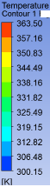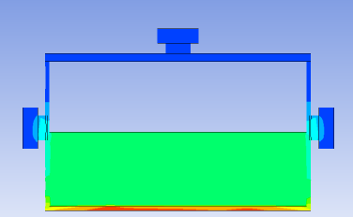
(a)
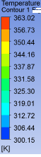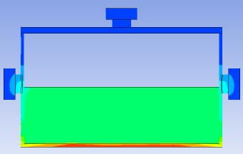
(b)
Figure 9: Temperature contours (a) Bakelite (b) 1C

3.6 Numerical results for composites cured at 125˚C
Table 10 shows a comparison between the numerical results obtained for maximum temperature of Bakelite handles to the composites handles cured at 125°C after they are subjected to heating at 600 time steps (10 minutes), while Figure 10 shows the temperature distribution in the water, pot and handles.
Table 10: insulation values of Bakelite against Composites at 125°C post cured temperature
 |  |  |  | INSULATION
 | Tw max | LH | RH | Tw max-LH | Tw mx-RH | TOTAL
Bakelite | 75.12829 | 40.73306 | 40.98348 | 34.39523 | 34.14481 | 68.54004
1C | 74.60095 | 41.68493 | 41.73788 | 32.91602 | 32.86307 | 65.77909
1D | 74.10842 | 41.71642 | 42.16912 | 32.392 | 31.9393 | 64.3313
1E | 74.10842 | 41.71642 | 42.16912 | 32.392 | 31.9393 | 64.3313
2D | 73.11041 | 41.76025 | 42.02404 | 31.35016 | 31.08637 | 62.43653
2B | 76.62863 | 41.46374 | 41.72854 | 35.16489 | 34.90009 | 70.06498
2E | 80.06466 | 39.84796 | 40.12383 | 40.2167 | 39.94083 | 80.15753
1B | 74.13641 | 41.34506 | 41.51428 | 32.79135 | 32.62213 | 65.41348
2C | 73.21859 | 40.21649 | 40.69576 | 33.0021 | 32.52283 | 65.52493

At 125°C, a slight decline in insulation performance is observed compared to 100°C, although several composites still outperform Bakelite. This reduction can be attributed to the beginning of thermal degradation effects within the epoxy matrix. Higher curing temperatures can lead to:
- Micro cracks
- Residual thermal stresses
- Localized defects

Similar observations have been made where high-temperature curing results in structural defects that negatively impact thermal performance (Zelibe et al., 2026, Sambayi & Heyns, 2023). These structural flaws create extra pathways for heat transfer, which in turn reduces insulation efficiency. Nevertheless, the composites still hold their ground against Bakelite, suggesting that the degradation effects are not yet dominant.

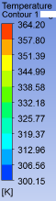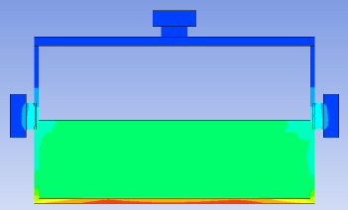
(a)
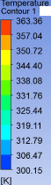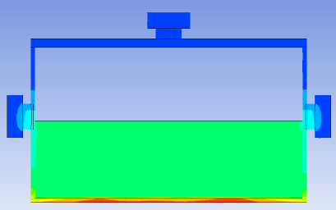
(b)
Figure 10: temperature contours (a) Bakelite (b) 2E

3.7 Numerical results for composites cured at 150˚C

Table 11: insulation values of Bakelite against Composites at 150°C post cured temperature
 |  |  |  | INSULATION
 | Tw max | LH | RH | Tw max-LH | Tw mx-RH | TOTAL
Bakelite | 75.12829 | 40.73306 | 40.98348 | 34.39523 | 34.14481 | 68.54004
1E | 74.14047 | 40.98293 | 41.24935 | 33.15754 | 32.89112 | 66.04866
2B | 72.93203 | 39.84097 | 40.25787 | 33.09106 | 32.67416 | 65.76522
2C | 76.06716 | 41.89254 | 42.41265 | 34.17462 | 33.65451 | 67.82913
2D | 74.64459 | 40.85226 | 41.04922 | 33.79233 | 33.59537 | 67.3877
2E | 75.56283 | 41.15612 | 41.51492 | 34.40671 | 34.04791 | 68.45462
1B | 75.4356 | 41.94598 | 42.16415 | 33.48962 | 33.27145 | 66.76107
1C | 73.2481 | 41.63949 | 41.9295 | 31.60861 | 31.3186 | 62.92721
1D | 76.12933 | 40.68859 | 40.8774 | 35.44074 | 35.25193 | 70.69267

At 150°C, a more pronounced reduction in insulation performance is observed. Several composites performed comparably to or worse than Bakelite under this condition. The decline in performance is primarily due to over-curing and thermal degradation of the epoxy matrix. Literature reports that thermal degradation and excessive filler loading or curing can introduce porosity and defects that significantly reduce thermal resistance (Yan-Chun et al., 2024, Zelibe et al., 2026, Sambayi & Heyns, 2023)). At elevated temperatures:
- Polymer chains become excessively rigid
- Microstructural damage increases
- Interfacial bonding may deteriorate
These effects reduce the material’s ability to resist heat transfer, thereby diminishing insulation performance. As a result, the advantage of the composites over Bakelite is significantly reduced at this curing temperature.The composite 1D is selected as the best performing composite since it insulated about 25.4° (${Tw}_{max}$= 66.13°C, LS= 40.69°C and RS= 40.88°C), which is more than what Bakelite produced,
3.8 Overall Comparative Analysis at Constant Aspect Ratio of the simulated Pot
The results across all curing temperatures indicate that post-curing temperature and filler characteristics are critical factors influencing insulation performance. These findings align with existing literature that highlights how the thermal performance of epoxy composites is influenced by factors like filler size, dispersion, crystallisation, and the evolution of microstructure during curing (Girish et al., 2025, Zelibe et al., 2026, Rahimli et al., 2025, Ramazanov & Rahimli, 2020). Results obtained show that;
- At low temperatures (50°C): incomplete curing → poor performance
- At moderate temperatures (75°C): improved cross-linking → better performance
- At optimal temperature (100°C): maximum insulation performance
- At high temperatures (125–150°C): degradation → reduced performance

The best-performing composites were consistently observed at 100°C curing temperature, indicating that this condition provides the optimal balance between structural integrity and thermal resistance.

- CONCLUSION
The thermal performance of talc-reinforced epoxy composites has been evaluated within a simulated domestic pot at a constant geometric aspect ratio (H/D = 0.52625). The results confirm that curing conditions and composite formulations significantly influence the material’s ability to resist heat transfer.
The composites showed their best insulation performance at post cured temperatures of (75°C 100°C), where we recorded the largest temperature differences between the fluid and the handle surfaces and more composites outperforming Bakelite. This impressive performance is due to the creation of a well-cross-linked polymer network, which improves the bonding between the epoxy matrix and the filler particles, effectively lowering thermal conductivity and minimizing heat transfer.
At lower curing temperatures 50°C, the insulation performance of the composites dropped because of incomplete curing. This led to weak adhesion between the particles and the matrix, resulting in more pathways for phonon scattering. Consequently, this increased the effective thermal conductivity and decreased resistance to heat flow.
Conversely, at higher curing temperatures (125–150°C), we noticed a decline in insulation performance. This drop can be linked to thermal degradation issues like micro-crack formation, residual stresses, and structural flaws within the epoxy matrix. These imperfections create extra pathways for heat transfer, which raises thermal diffusivity and diminishes insulation effectiveness.
Comparative analysis with Bakelite show that the fabricated composites outperformed traditional materials at optimal curing conditions, proving their potential for thermal insulation in everyday cookware. From this investigation, the 2E composite cured at 125°C demonstrated the highest overall temperature reduction among the tested samples. having insulated about 30°C of heat compared to Bakelite with 24.4°C.
In summary, this study highlights that the post-curing temperature is a crucial factor influencing the thermal insulation performance of epoxy composites. The findings provide a basis for optimizing composite processing conditions for improved thermal management applications.
LIMITATIONS
The numerical model developed in this study provides valuable insight into the thermal performance of talc-filled epoxy composites; however, it is based on several simplifying assumptions that may affect its accuracy.
- The composites were modeled as homogeneous materials with uniformly distributed fillers, whereas real systems often exhibit non-uniform dispersion, agglomeration, and interfacial imperfections.
- The use of idealized boundary conditions and simplified geometry further limits representation of real-world conditions
- The model overlooks important microstructural details like variations in particle size, the orientation of fillers, and the thermal resistance at the interfaces, all of which influence heat transfer behavior.
Consequently, while the results are useful for comparative analysis and trend evaluation, caution should be exercised when extending the findings to real-world applications without further experimental validation and advanced multi-physics modeling.
Disclaimer (Artificial intelligence)
Author(s) hereby declare that NO generative AI technologies such as Large Language Models (ChatGPT, COPILOT, etc.) and text-to-image generators have been used during the writing or editing of this manuscript.

REFERENCES
Adewumi, O.O., Onitiri, M.A., Olusanya, A.H., & Adeyi, O.T. 2021. "Numerical and experimental investigations of the performance of fiber-glass/talc epoxy composites insulated water heater." Bayero Journal of Engineering And Technology (BJET) VOL.16 No.1 PP 23-30.
Agarwal, Pankaj., Mukesh, Kumar., Mahavir, Choudhary., Ankush, Sharma., & Amar, Patnaik.,. 2022. "Experimental and Numerical Analysis of Mechanical, Thermal and Thermomechanical Properties of Hybrid Glass/Metal Fiber Reinforced Epoxy Composites." Fibers and Polymers 23: 1342–1365. doi:doi.org/10.1007/s12221-022-4760-5.
Agrawal, Nidhi., Thakur O.P., & Anjani, K. Singh.,. 2021. "Role of shape, size and concentration of filler particles on filler matrix interface: A mathematical analysis." Material Today 44 (1): 890-894. doi:doi.org/10.1016/j.matpr.2020.10.793.
Ahmed, Jehanzaib., Nazia, S. Abbas., Muhammad, Amin., Sara, Hasan., Arooj, Anwaar., Ahmad, S. Saleemi., Nimra, Adil., & Amna, Liaqat.,. 2025. "Investigation of Thermal Stability of Bakelite by Isoconversional Thermal Analysis." Conclusions in Engineering 1 (2). doi:doi.org/10.71107/13q71h11.
Ayberk, Salim Mayil., and Cisil, Timuralp.,. 2025. "Numerical and Experimental Analysis of Cooling System Performance in Induction Hobs: A Comparison of Heatsink Designs." Applied Sciences 15 (11): 59-95.
Carbas, R. J. C., Marques, E. A. S., DaSilva, L. F. M., & Lopes, A. M.,. 2014. "Effect of Cure Temperature on the Glass Transition Temperature and Mechanical Properties of Epoxy Adhesives." The Journal of Adhesion 104-119, DOI: 10.1080/00218464.2013.779559.
César, Pérez Morelos.,. 2023. "Heat Insulation Materials for Energy Efficiency and Cost Reduction." NUTEC.
Girish, S., Vinay, M.S., Bavan, D. et al.,. 2025. "Evaluation of thermal properties of epoxy composites filled by nanofiller materials." Discover Applied Sciences 7 (1269). doi:https://doi.org/10.1007/s42452-025-07550-9.
Hassan, Karkaba., Charbel, Habchi., & Ahmad, al Takash.,. 2019. "Numerical Analysis of Different Indoor Heating Methods." 2019 Fourth International Conference on Advances in Computational Tools for Engineering Applications (ACTEA). Beirut, Lebanon: Institute of Electrical and Electronics Engineers (IEEE). doi:10.1109/ACTEA.2019.8851075.
Hongwei, Yang., Zongyi, Deng., Minxian, Shi., & Zhixiong, Huang.,. 2025. "High-Thermal-Conductivity Graphene/Epoxy Resin Composites: A Review of Reinforcement Mechanisms, Structural Regulation and Application Challenges." Polymers 17 (17): 2342 DOI: 10.3390/polym17172342.
Israa, F Ghazi., and Riyam, I Jaddan.,. 2021. "Thermal Conductivity Characterization of Epoxy Based Composites Reinforced with Date Palm Waste Particles." Journal of Physics: Conference Series. Babylon, Iraq.
Jian, Quan Liang., Wei, Sun., Hong, Da Zhang., & Lei Lei, Zhao.,. 2020. "A Study of Electrical and Mechanical Properties of Epoxy Resin Insulating Materials under Low Temperature." Key Engineering Materials 90-97. doi: 10.4028/www.scientific.net/KEM.842.90.
Madhulika, Srikanth., and Ramazan, Asmatulu.,. 2013. "Nanotechnology Safety in the Construction and Infrastructure Industries." (Elsevier) 99-113.
Nemlen, S. Yuyoh., Yakum, R. Nafu., & Tsi, E. Angwafo.,. 2026. "Thermal Insulation Properties and Stability of Hybrid Epoxy Composites Reinforced With Palm Kernel Shell and Bilinga (Nauclea diderrichii) Sawdust." Edited by Mohammad Rezwan Habib. Advances in Material Science and Engineering. doi:doi.org/10.1155/amse/9636839.
Nicolas, Horny., Yempab, Kanake., Mihai, Chirtoc., and Lan, Tighzert.,. 2016. "Optimization of thermal and mechanical properties of bio-polymer based nanocomposites." Polymer Degradation and Stability 127: 105-112. doi:https://doi.org/10.1016/j.polymdegradstab.2016.01.006.
Omotinuola, S. L., Onitiri, M. A., & Akinlabi, E.,. 2017. "Compressive Properties of Post Cured Talc/Fiber Glass Filled Epoxy Composites." ASME Proceedings.
Rahima, Nasrin., A. H. Bhuiyan., and M. A. Gafur.,. 2015. "Influence of Talc Filler Content on the Mechanical and DC Electrical Behavior of Compression Molded Isotactic Polypropylene Composites." International Journal of Composite Materials. 5 (6): 155-161. doi:doi:10.5923/j.cmaterials.20150506.03.
Rahimli, A., Huseynova, A., and Jafarov, M.,. 2025. "Insights into dielectric and thermal properties of polystyrene-zinc oxide nanocomposites: A multifaceted characterization approach." Journal of Thermoplastic Composite Materials 38 (4): 1542–1556. doi:doi.org/10.1177/08927057241274265.
Ramazanov, M.A. and Rahimli, A.M.,. 2020. "The effect of the temperature-time mode of crystallization on the photoluminescence and dielectric properties of PVC/TiO₂ nanocomposites." Integrated Ferroelectrics 212 (1): 61–67. doi:doi.org/10.1080/10584587.2020.1819035.
Rashid, Dallaev., Tatiana, Pisarenko., Nikola, Papež., Petr, Sadovský., & Vladimír Holcman.,. 2023. "A Brief Overview on Epoxies in Electronics: Properties, Applications, and Modifications." Polymers 15 (19): 3964. doi:doi: 10.3390/polym15193964.
Rybakiewicz, L., and Sokolowsk. D.,. 2020. "Tests of thermal insulation properties of bakelite." Journal of Physics:Conference Series 1507 062013. IOP Publishing. doi:10.1088/1742-6596/1507/6/062013.
Sajjad, Azeem., and Muhammad, Zain-ul-Abdein.,. 2012. "Investigation of thermal conductivity enhancement in bakelite–graphite particulate filled polymeric composite." International Journal of Engineering Science 52: 30-40. doi:https://doi.org/10.1016/j.ijengsci.2011.12.002.
Sambayi, Pmk., & Heyns, PS.,. 2023. "Effects of multiple post cure cycles on properties of composite carbon fibre and epoxy materials." Journal of Composite Materials- Volume 57, Issue 15 2467-2481.
Siti, S. Samsudin., Hassan, A. Alshahrani., Mariatti, Jaafar.,. 2022. "Physical, Thermal Transport, and Compressive Properties of Epoxy Composite Filled with Graphitic- and Ceramic-Based Thermally Conductive Nanofillers." Polymer 14 (5): 10-14. doi:doi.org/10.3390/polym14051014.
Udebuani, O. P., Onitiri, M. A., and Adewumi, O. O.,. 2021. "experimental and numerical heat transfer coefficient of fiber-glass/talc-filled epoxy composites." Journal of Engineering, Science, and Technology (AJEST) (APWEN) 5 (2): 18-32.
Wan, Xiao., Baris, Demir,, Meng, An., Tiffany R. Walsh., and Nuo, Yang.,. 2021. "Thermal Conductivities and Mechanical Properties of Epoxy Resin as a Function of the Degree of Cross-linking." International Journal of Heat and Mass Transfer 180: 121-821. doi:doi.org/10.1016/j.ijheatmasstransfer.2021.121821.
Wang, Jianyou., Wei, Zhang., Tao, Yang., Yunzu, Yu., Chuang, Liu & Bin, Li.,. 2022. "Numerical and experimental investigation on heat transfer enhancement by adding fins on the pot in a domestic gas stove." Energy 239 (Part E): 122-439. doi:https://doi.org/10.1016/j.energy.2021.122439.
Wenkai, Xiao., Xian, Zhai., Pengfen, Ma., TaoTao, Fan., & Xiaotuo, LI.,. 2018. "Numerical study on the thermal behavior of graphene nanoplatelets/epoxy composites." Results in Physics 9: 673-679. doi:https://doi.org/10.1016/j.rinp.2018.01.060.
Xu, Lu.,Wei, Deng., Jindong, Wei., Yuhui, Wan., Lin, Zhang ., Li, Jin., et al.,. 2021. "Crystallization behaviors and related dielectric properties of semicrystalline matrix in polymer-ceramic nanocomposites." Composites Part B: Engineering 224: 109-195. doi:https://doi.org/10.1016/j.compositesb.2021.109195.
Yan-Chun, Li., Na, Chu., Fan-Long, Jin., & Seong-Ju, Park.,. 2024. "Recent advances in improvement of thermal conductivity of epoxy-based nanocomposites through addition of fillers." Polymers 313 (6). doi:10.1016/j.polymer.2024.127678.
Zaki, N. S., and Salih, T. W.,. 2021. "The Effect of Crystallinity on the Thermal Conductivity of Polymers." Journal of Engineering and Sustainable Development 25 (s): 25-32. doi:search.emarefa.net/detail/BIM-1273109.
Zelibe, C. G., Onitiri, M. A., and Adewumi, O. O.,. 2021. "Influence Of Filler Material On The Thermal Properties Of Post-Cured Epoxy Resin Composite." APWEN Journal of Engineering, Science, and Technology 5 (2): 33-43.
Zelibe, G. Christian., M. A. Onitiri., and O. O. Adewumi. 2026. "Influence of Post Curing Temperature on the Thermal Properties of Fiber-Glass/Talc Filled Epoxy Composites." NIPES Journal Of Materials Engineering, Structures and Computation 5 (1): 38-48.
Zhang, Jiacheng.,. 2023. "Enhanced Thermal Conductivity and Dielectric Properties of Epoxy Composites with Fluorinated Graphene Nanofillers." Nanomaterials 13 (16): 2322. doi:doi.org/10.3390/nano13162322.
Zlatko, Rek., Mitja, Rudolf., & Iztok, Zun.,. 2012. "Application of CFD Simulation in the Development of a New Generation Heating Oven." Strojniški vestnik - Journal of Mechanical Engineering 58 (2): 134-144. doi:https://doi.org/10.5545/sv-jme.2011.163.

NOMENCLATURE
°C | Cured temperature (Celsius)
C_{p} | Specific Heat Capacity
k | Thermal conductivity of fibre glass/ talc composites
K | Kelvin
LH | Left handle of pot geometry
RH | Right handle of pot geometry
$${Tw}_{max}$$ | Maximum temperature of water
q | heat transfer rate
α | Thermal Diffusivity

