Review Article

DENIM-JEANS POST-CONSUMER WASTE FEEDSTOCKS IMPACT: A REVIEW

ABSTRACT

Background: Climate change and renewable processes, solutions and their products and materials evolved in this chain have been discussed since the past decade. The international pressure to adapt the countries industrial environmental to more sustainable practices have taken place in many areas around the world. Post-consumer textile waste has emerged as a significant environmental challenge due to increasing disposal rates and the complexity of fiber blends, dyes, and finishing agents. At the same time, the packaging sector is seeking renewable and recycled fiber sources to reduce reliance on virgin materials. Although textile waste contains valuable cellulosic and polymeric fibers, challenges remain in feedstock heterogeneity, contaminant removal, and achieving consistent material performance after reprocessing.
Aims: Design a review article based on hypothesis-driven research exploring processing strategies to convert textile waste into functional fiber feedstocks for new application processes carrying out sensitive analysis and Monte Carlo simulations focused on the impact category Global Warming.
Study Design: Review article presenting the actual scenario for post-consumer textile waste and preliminary results for a life cycle analysis of a denim-jeans production.
Place and Duration of Study: Department of Chemical Engineering, SUNY College of Environmental Science and Forestry, Syracuse, New York, USA from October 2025 to April 2026.
Results: Jeans-Denim waste stream incorporation in new process and products, physico-Chemical transformation of waste stream into new intermediates to produce replace or add new functionalities into the existent fabrics or to incorporate the design of new materials is a sustainable solution. This evolution reflects how environmental responsibility has emerged as a critical competitive advantage, reshaping production processes to minimize ecological footprints while simultaneously meeting rising consumer expectations. Although this great market and predictions, cutting waste from jeans production contributes to about 10 to 15 % of the waste generated. This waste is recycled mainly by unravelling and shredding it back to fibers.
Conclusions: From the major contributors for the denim production the steps that easily affect and influence are the mass of cotton itself inputted for the jeans production and the fraction of fabric wasted accordingly the feasibility analysis. These preliminary findings contribute to precisely input the life cycle analysis considering broad impacts beyond carbon dioxide and safe hazardous for new applications considering their feasibility from this raw material. Mass cotton and Fraction of textile wasted are the most significative parameters that have great effect on sensitivity analysis means they present a bigger range of variation and could interfere in a major part of the supply chain and their emissions.

Key-words: Denim, Jeans, Textile, Waste, Post-consumer, Life cycle analysis.

1. INTRODUCTION

Denim waste presents a significant challenge due to its structural complexity and limited recyclability, with over 80% reportedly incinerated or disposed of in landfills (Li et al., 2025). The utilisation of such waste as a raw material source is further constrained by the vast volume of cotton waste generated annually—exceeding 100 million tonnes and accounting for approximately 35–40% of global textile waste (Wang et al., 2023). Addressing this issue represents a substantial societal benefit and forms a key motivation for the present research proposal. In this context, the denim industry plays a critical role in influencing progress towards the achievement of the United Nations Sustainable Development Goals (SDGs) by 2030. The effective valorisation of denim waste streams underscores the broader environmental and socio-economic implications of sustainable resource utilisation within the textile sector.
Figure 1 shows the estimated at US$80-87 billion denim market in 2024, projected to grow to US$105-122 billion by 2033, exhibiting a CAGR (Compound Annual Growth Rate) of 3.5-6% [25,34]. The study covers several segments and provides an in-depth examination of the influential trends and dynamics impacting market growth. The cotton denim sector is experiencing significant momentum, driven primarily by the global push toward sustainable manufacturing practices adopted by industry leaders and supported by government environmental initiatives. A notable recent development is the increasing adoption of water-saving and eco-friendly technologies in cotton denim production; documented in official textile industry updates, this trend underscores a pivotal shift in production priorities across key cotton denim manufacturing regions. This evolution reflects how environmental responsibility has emerged as a critical competitive advantage, reshaping production processes to minimize ecological footprints while simultaneously meeting rising consumer expectations [25].

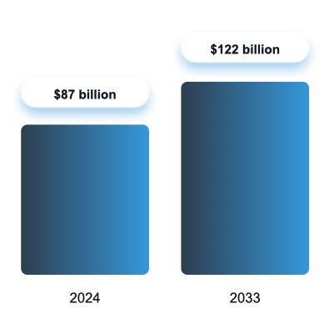  A | 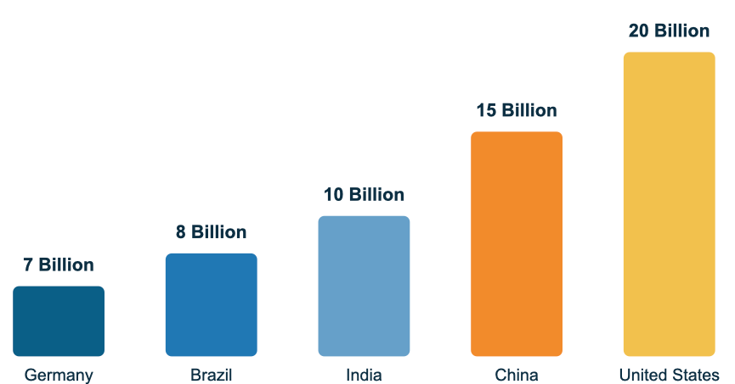  B

Figure 1. Cotton denim market size and forecasts from 2024 to 2033 (A) and their market share in the top 5 countries worldwide (B) [34].

Post-consumer denim garments that satisfy textile processing standards can be mechanically disintegrated to generate regenerated fibres, which may be reintroduced into the textile production cycle. In contrast, fibres lacking adequate spinnability can be subjected to chemical conversion into microcrystalline cellulose, a high-value product with diverse industrial applications. This integrated approach facilitates the comprehensive recycling of discarded denim garments of varying quality, while minimising the economic costs and environmental burdens typically associated with conventional chemical depolymerisation and landfill disposal [44].
Despite the substantial market potential and favourable projections, waste generated during denim garment manufacturing—particularly from cutting processes—accounts for approximately 10–15% of total production waste. Such waste is commonly recycled through mechanical processes, including unravelling and shredding into fibres, which is relatively straightforward due to the homogeneous composition of the material. However, post-consumer denim waste presents greater recycling challenges. Variations in colour, fibre composition, and the presence of non-textile components such as zippers, buttons, and labels complicate processing and limit recyclability. These challenges are particularly evident in major markets, including the United States, which ranks among the leading countries in denim consumption and waste generation within this category [26].

2. CRADLE TO GATE COTTON PRODUCTION

Post-consumer textile waste has emerged as a significant environmental challenge due to increasing disposal rates and the complexity of fiber blends, dyes, and finishing agents. At the same time, the packaging sector is seeking renewable and recycled fiber sources to reduce reliance on virgin materials. Although textile waste contains valuable cellulosic and polymeric fibers, challenges remain in feedstock heterogeneity, contaminant removal, and achieving consistent material performance after reprocessing. Figure 2 shows the cradle to gate cotton production and manufacture chain that will be evaluated focusing on the Total Organic Residues (TROI) and in the Total Residues from Fabric (TRFF).

Figure 2. Cradle to gate cotton production and manufacture chain. Illustration adapted from Levi Strauss & Co (2026) [24].

Considering this industry and the major impacts of this wastes stream we could highlight 3 sustainability principles as industrial possible side-chain products derivates: (1) Waste stream incorporation in new process and products; (2) Physico-Chemical transformation of waste stream into new intermediates to produce replace or add new functionalities into the existent package; (3) Reduction of excess or expensive components in new packaging design. The final products designed as packaging will apply the transformed raw material replacing completely or partially fossil components in the final package. The cogeneration of this application throughout the waste streams from this manufacture chain could also contribute for the cost’s reductions of the cotton production and management and finally for the fabric waste stream disposal. These broader impacts are strongest linked to increasing of the safety conditions for waste handling and thus guarantee the better hazardous conditions contributing for the quality of the work environmental.

3. FROM COTTON FIBER TO YARN MANUFACTURE

Cotton has historically constituted a fundamental raw material within the fashion industry, owing to its inherent softness, breathability, and favourable dyeing properties, which render it suitable for applications ranging from basic apparel to high-end garments [12]. Despite its widespread utilisation, cotton waste generation remains substantial, exceeding 100 million tonnes annually and accounting for approximately 35–40% of global textile waste. Notably, less than 30% of this waste is currently recycled [40]. Following harvest, seed cotton is collected from the harvester and compacted into modules for temporary storage prior to transportation to ginning facilities. At the gin, the cotton undergoes drying to reduce moisture content, followed by cleaning processes to remove extraneous materials. Subsequently, the cotton is conveyed to gin stands, where rotating circular saws separate the lint from the seeds. The extracted lint is then compressed into bales for storage and eventual transport to textile mills for further processing [1]. After scouring and the removal of impurities, cotton consists of approximately 99% cellulose. Structurally, cellulose is composed of long chains of glucose units linked by β-1,4-glycosidic bonds, forming repeating anhydro-β-cellobiose units. These polymer chains are stabilised by extensive hydrogen bonding between hydroxyl groups on adjacent molecules, particularly within highly ordered crystalline regions of the fibre. Each repeating unit contains three reactive hydroxyl groups (at C2, C3, and C6 positions), comprising one primary and two secondary alcohol groups. These functional groups are chemically active and participate in substitution reactions during fibre modification, as well as in dyeing and finishing processes involving crosslinking. Additionally, the hydroxyl groups serve as primary sites for water sorption, with water molecules being strongly associated through hydrogen bonding interactions [8].
In compositional terms, cotton fibres consist of approximately 90% cellulose, with the remaining fraction comprising minor constituents such as waxes, pectins, and proteins, as illustrated in Figure 3.

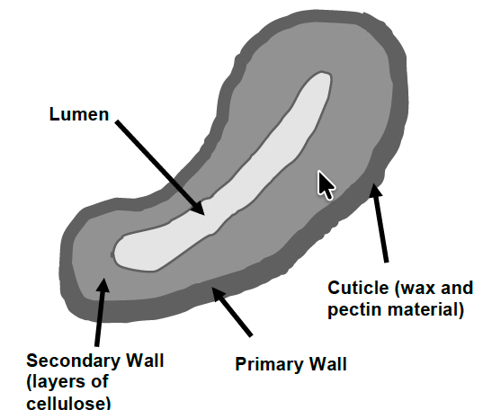

Figure 3. Cross-sectional view of a cotton fiber [9].

The cellulose in cotton fibers is a linear polymer made up of repeating units of glucose molecules, with each unit connected by beta 1 - 4 glycosidic bonds [18]. Figure 5 shows the structure and morphology of cotton fibers and in Fig.4A the multi-layered structure of cotton divided into two main parts: the cuticle layer and the inner fiber. The cuticle layer is a thin layer of wax and pectin that surrounds the fiber and protects it from damage. The inner fiber is made up of the cellulose chains arranged in a helical structure that runs along the length of the fiber [18,23]. Cotton fibers are typically long and fine, with a high degree of strength and elongation. The length of cotton fiber can range between ½ inch to 2 inches. The length and fineness of cotton fibers can vary depending on the variety of cotton, with longer and finer fibers generally being associated with higher quality cotton. It is because of this reason that PIMA and Egyptian cotton is considered high quality cotton. Cotton fibers are also highly absorbent, which makes them suitable for use in a wide range of textile products. Additionally, cotton fibers have a natural luster that gives them a soft, luxurious appearance [18].

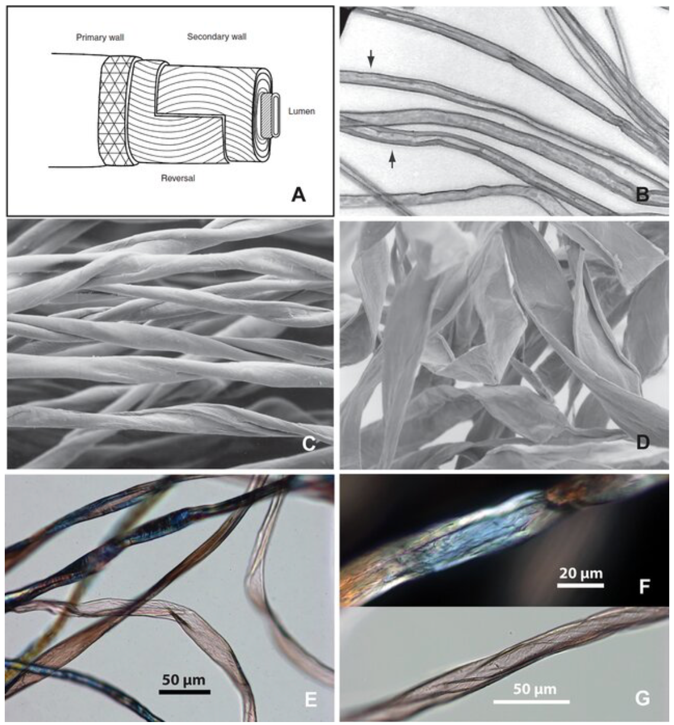 | Figure 4. Structure and morphology of cotton fibers. (A) Multi-layered structure of cotton fiber; (B) mature fibers before dried, appear as long cylinders with thick cell walls (arrows); (C) Dried mature fibers twisted and flattened, showing the convolutions of the fibers; (D) Dried immature fibers form thin, flattened ribbons, and exhibit abrupt bends and flat twists; (E) cotton fibers showing different morphology in one sample, comparable to B-D; (F) cotton fiber showing relatively smooth surface; (G) cotton fiber showing oblique networking [23].

Contemporary alternatives to natural cotton fibres include sustainable man-made polymers, which are produced using analogous fibre-forming techniques. The fundamental process of polymer fibre formation, commonly referred to as spinning, involves converting the polymer into a fluid state and extruding it through fine apertures in a spinneret to produce continuous filaments. The specific spinning method employed depends on the nature of the polymer, such as derivatised cellulose or synthetic polymers. Commonly utilised techniques include melt spinning, wet spinning, dry spinning, emulsion spinning, and gel spinning.
Following extrusion, the resulting filaments are subjected to drawing or stretching processes to reduce their diameter and enhance tensile strength through increased molecular orientation along the fibre axis. The filaments are subsequently collected for further processing. Polymer fibres may be utilised either as monofilaments or, more commonly, as multifilament yarns, which consist of multiple filaments twisted together or produced simultaneously using multiple spinnerets. These multifilament yarns are characterised by parameters such as overall yarn size, number of filaments, and individual filament dimensions [9]. Despite the development of these alternatives, natural cotton fibres remain well established within the textile industry. Upon arrival at textile mills in bale form, cotton undergoes a series of processing stages. Carding represents a critical initial step, during which fibres are disentangled, aligned, and further cleaned before being condensed into a continuous web of overlapping fibres. This is followed by the roving process, which refines the carded material into a finer strand, known as roving, with a slight imparted to improve cohesion [36]. The roved fibres are subsequently spun into yarn. Yarn count, an important parameter in textile production, denotes the fineness or thickness of yarn and is typically expressed as mass per unit length, commonly measured in tex (grams per kilometre of yarn) [36].
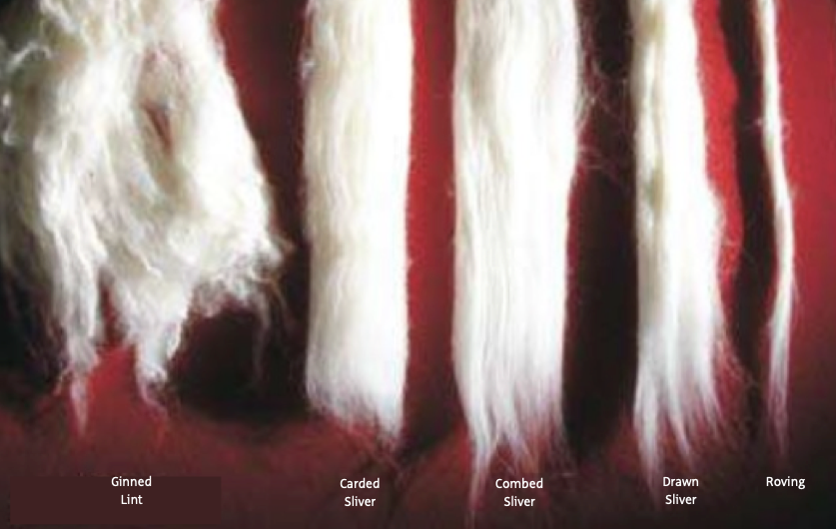

Figure 5. Cotton at various stages of processing. Ginned lint: Ginned lint is the raw state of the fiber following removal of seed and foreign matter during the ginning process. Carding: aligns and further cleans the fibers before condensing them into a single, continuous strand of overlapping fibers. Combing: removes the final proportion of short fibers, neps and other impurities and the output is known as "combed sliver", which then goes through the drawing process. The waste from combing is called “noil” or “comber waste”. Combed yarns are usually finer, stronger, smoother and more uniform than carded yarns. Drawing: fibers are blended, straightened and the number of fibers in the sliver reduced to achieve the desired linear density and to improve uniformity. Roving: condenses the carded cotton into a finer strand, known as "roving", with a small amount of twist added [36].

Therefore, the feasibility of closed-loop recycling of textiles, or fiber-to-fiber recycling, is directly dependent on efficient and traceable collection, identification and sorting of materials. Controlling the color and material composition of post-consumer textiles is one of the greatest challenges of mechanical fiber-to-fiber recycling; see [15,22,39]. The other great challenge is related to the quality of mechanically recycled (MR) fibers. Mechanically recycled cotton is often referred to as possessing a “lower quality”, which is why it is often blended with other fibers, especially longer, virgin fibers [22,39] to facilitate easier spinning. In the shredding process, the fiber is exposed to mechanical forces that shorten the fiber, contributing to a high short fiber content (SFC) [5,7,30] and causing Epping [4], characteristics that affect both the spinnability and overall quality of yarn. It is advised to use 20–30% of recycled fibers in yarns for fabric production [22,33].

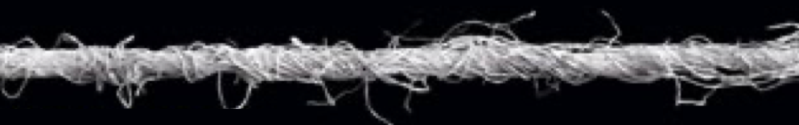 A
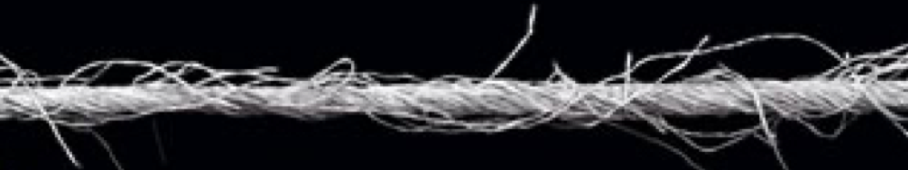 B
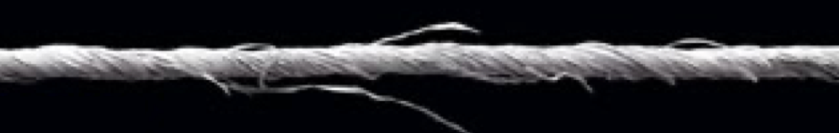 C

Figure 6. Cotton Yarn in different stages of their manufacturing processes. A. After rotor - or open end - spinning produces less regular, weaker yarns, that have a harsher feel to them than ring spun yarns; B and C. After ring spinning produces higher quality yarns, one exemption in C their compacted structure [36].

Denim is among the most widely used items of apparel since it suits people of all ages, all seasons, and all occasions, resulting in denim becoming a popular fashion item [28]. Nevertheless, the production of denim evolves several steps that could rapidly affect the environmental. The production of blue denim often involves the use of indigo as the primary colorant in the dying process. Although it is often considered that indigo has poor quality vat dyes, it is widely used in the denim industry because of the worn-out appearance that it gives to the denim fabric. Figure 7 shows the chemistry of indigo dyeing
comprises an oxidation−reduction reaction. Then, the proposed breakthrough application could also contribute for the elimination of denim-dye related waste streams.

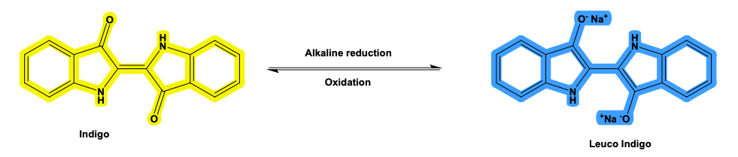

Figure 7. Oxidation-reduction reaction of indigo [28].

Considering this industry and made-denim-fiber materials, incorporate the Total Organic Residues (TROI) and in the Total Residues from Fabric (TRFF) from this manufacture chain into the design of new oriented products became the central rationale in many industrial partnershiops focusing in 3 main hypothesis described as: (1) Purity-level of natural cotton or their derivatized-species from denim jeans waste stream presents higher alfa-cellulose content; (2) Top-down deconstruction process for waste components (TDDC) will act increasing physico-chemoenzimatic accessibility, throughout fiber swelling, followed by alfa-cellulose content exposition finally to (3) Consolidate a pool of re-manufactured waste fibers in solid; semi-solid and aqueous reactional media for design new products or re-insertion onto the denim fabrication.

4. LIFE CYCLE ANALYSIS (LCA)

4.1 LCA ASSUMPTIONS

In this study, we used a practitioner's perspective was applied to propose a foreground from cradle to gate diagram for life cycle analysis for a blue jeans pair as illustrated in Figure 8, accordingly Damasio, Renato (2025) using an available confidential sourced-database for step-by-step jeans-denim production. The TRACI 2.1 was chosen to use as method provided by EPA [17, 38] to calculate the total GWP (Global Warming Potential) of 1 pair of blue jeans compared with baseline scenario in kgCO2/pair of blue jeans. Global warming (KgCO2eq) was calculated for the desired conditions according to ISO 14040 and ISO 14044 [20, 21]. Also, sensibility analysis and Monte Carlo simulations was carried out. For the sensibility analysis a tax of 20 % were considered to calculate minimum and maximum values. Considering Monte Carlo simulations 5000 runs was adopted after incorporation into TRACI 2.1 model. The OpenLCA was used to perform part of the Life Cycle Assessment (LCA). The software openLCA Nexus is linked with the open source, and freely available, openLCA LCA software [14]. The cradle to gate, analysis and additional sensitivity analysis was carried out in excel considering the generated data.

4.2 A DENIN-JEANS PAIR LCA CASE STUDY

Figure 8 shows a proposed diagram for life cycle analysis from cradle to gate for a blue jeans pair made from cotton. The foreground process are the preliminary result from cradle to gate evaluation taking in consideration the 7 major steps from cotton to denim production and their related activities as described as operational and secondary units linked to the main units (Cotton cultivation / Cotton ginning in the field / Cotton transportation from the field to the mill / Yarns production / Yarn weaving / Textile refining / Finished jeans and transportation from mill to store) for an one jean pair. Many of these operations result in inputs and outputs of emissions and generation of side-chain waste streams from the field to the end-user.

Thus, considering this production and the achievement of the UN sustainable development goals (SDG) by 2030, was significantly influenced by the denim industry [37]. For example, SDG6 for example is impacted by the denim industry’s large-scale discharge of contaminated water that contains toxic materials, dyes, and other additives. The manufacture of denim produces higher GHG emissions and is a crucial industry for the climate change described in SDG13. Also, the issue of marine/rivers pollution as well as the emission of microfibers and microplastics into the environment due to home washing is addressed by SDG14. Additionally, cotton farming has a significant worldwide impact on soil quality and emphasizes for SDG15 [28]. Thus, considering this comprehensive industry and their background processes, Figure 8 presents an anticipation of foreground diagram for life cycle analysis from cradle to gate and Figure 10 their sensitivity analysis.

Figure 8. Proposed diagram for life cycle analysis from cradle to gate for a blue jeans pair.

Figure 9 shows considering the main units quantitatively proposed in the LCA from cradle to gate for a blue jeans pair in Figure 8. The biggest contributions from the higher to lower percentage are: Textile refining (50%); Cultivation and ginning (23%); Yarns fibers production (19%); Weaving (5%); Brass production (2%); Transportation to store (1%) and the last Transportation to mill (0%). Exemplified in Figure 10, the highest fraction that involves textile refining, 50 % of this contribution percentage are linked to the denim process toward the total GWP (Global Warming Potential) of 1 pair of blue jeans in kgCO2/pair of blue jeans. It is important emphasizes that this single step of cotton processing operation and their technical description could be divided in the following activities: after being received in bales format in the mill, cotton follow their processing since carding; aligns, and further cleans the fibers before condensing them into a single, continuous strand of overlapping fibers; until roving that’s condenses the carded cotton into a finer strand, known as "roving", with a small amount of twist added [36].

Figure 9. Contribution percentage of each main unit in the denim process toward the total GWP (Global Warming Potential) of 1 pair of blue jeans in kgCO2/pair of blue jeans.

Accordingly Figure 10, the contribution of each process toward the total GWP (Global Warming Potential) of 1 pair of blue jeans compared with baseline scenario in kgCO2/pair of blue jeans. From the major contributors for the denim production the steps that easily affect and influence are the mass of cotton itself inputted for the jeans production and the fraction of fabric wasted accordingly the feasibility analysis. These preliminary findings contribute to precisely input the life cycle analysis considering broad impacts beyond carbon dioxide and safe hazardous for new applications considering their feasibility from this raw material. Mass cotton and Fraction of textile wasted are the most significative parameters that have great effect on sensitivity analysis means they present a bigger range of variation and could interfere in a major part of the supply chain and their emissions. Mass button and Mass rivets as parts probable already manufactured present a very small range of variation not interfering in the sensitivity analysis for the entire system. This evidence could be supported throughout the emissions in kgCO₂/pair of blue jeans linked to each main step: Mass cotton (3.668); Fraction of textile wasted (3.238); Distance field to mill (0.218); Distance factory store (0.168); Mass zipper (0.128); Mass rivets (0.008) and Mass button (0.002).

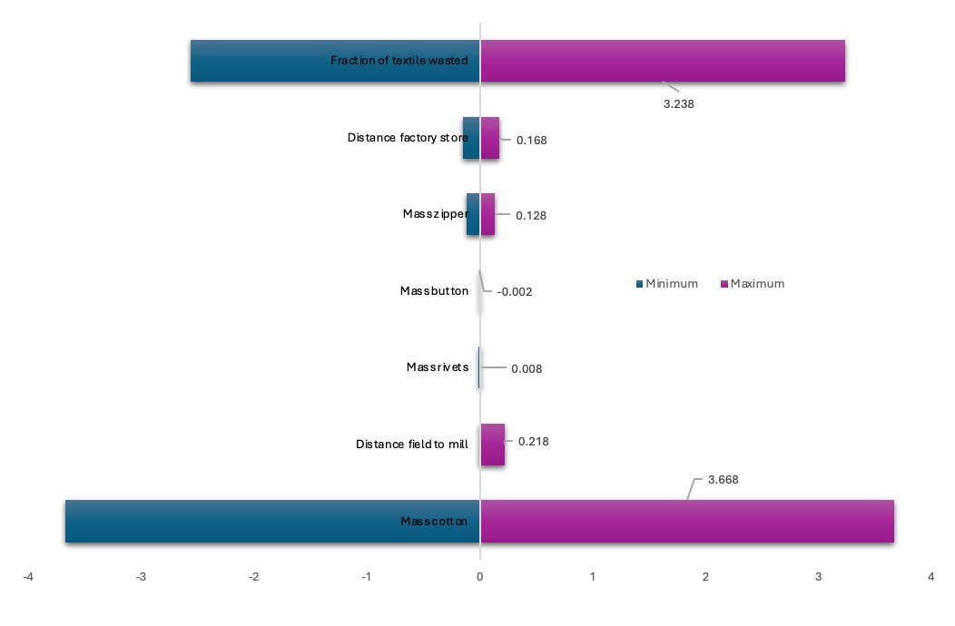
Figure 10. Sensitivity analysis accordingly contribution of each process toward the total GWP (Global Warming Potential) of 1 pair of blue jeans compared with baseline scenario in kgCO2/pair of blue jeans.

5. MONTE CARLO SIMULATION

The Monte Carlo method, also known as statistical simulation method, is a very precise method of numerical calculation guided by probability statistical theory. It uses random numbers (or more commonly pseudo-random numbers) to solve many calculation problems [10, 41, 42]. This uncertainty analysis was adopted, and Figure 11 shows the Monte Carlo histogram for global warming environmental impact category considering 1 pair of jeans in kg.CO2eq. Monte Carlo method can randomly sample the values of uncertain variables based on probabilistic analysis, and combine with the pre-determined impact assessment method to simulate, so as to obtain statistically significant environmental impact evaluation results, which can reflect the influence of uncertain factors more accurately [21].

Figure 11. Monte Carlo histograms for global warming environmental impact category considering 1 pair of denim-jeans in kg.CO2eq.

Monte Carlo histograms show visually how the data population are behaving accordingly the assumptions, input parameters and method for calculation used, TRACI 2.1 applying 5000 simulations. 25.124 of kgCO2/eq are the mean of the emissions for this cradle to gate case considering all 5000 simulations in a range of 19.22 to 32.31 of kgCO2/eq for 1 pair of jeans, exhibiting a normal-shape curve with 2.719 of Standard Deviation.

6. CONCLUSION AND FUTURE OUTLOOK

The challenge of use as source of raw material over 100 million tons of cotton waste produced annually, representing 35 - 40% of global textile waste accordingly Wang, et al. (2023) is one of the greatest’s societal gains in this study as sad. Post-consumer textile waste has emerged as a significant environmental challenge due to increasing disposal rates and the complexity of fiber blends, dyes, and finishing agents. At the same time, the packaging sector is seeking renewable and recycled fiber sources to reduce reliance on virgin materials. Jeans-Denim waste stream incorporation in new process and products, physico-Chemical transformation of waste stream into new intermediates to produce replace or add new functionalities into the existent fabrics or to incorporate the design of new materials is a sustainable solution. This evolution reflects how environmental responsibility has emerged as a critical competitive advantage, reshaping production processes to minimize ecological footprints while simultaneously meeting rising consumer expectations. Although this great market and predictions, cutting waste from jeans production contributes to about 10 to 15 % of the waste generated. This waste is recycled mainly by unravelling and shredding it back to fibers. From the major contributors for the denim production the steps that easily affect and influence are the mass of cotton itself inputted for the jeans production and the fraction of fabric wasted accordingly the feasibility analysis. These preliminary findings contribute to precisely input the life cycle analysis considering broad impacts beyond carbon dioxide and safe hazardous for new applications considering their feasibility from this raw material. Mass cotton and Fraction of textile wasted are the most significative parameters that have great effect on sensitivity analysis means they present a bigger range of variation and could interfere in a major part of the supply chain and their emissions. Due to the lack of a comprehensive and systematic recycling method, post-consumer waste denim, like other textiles, is disposed of by incineration and landfill accordingly Wang et al (2023) and Li et al. (2025), resulting in huge amounts of environmental pollution and resource waste. Thus, contributing to increase the pressure to design new processes applying biorefinery strategies to incorporate the physico-chemical transformed waste-intermediates into new niches of application to become into new products.
Disclaimer (Artificial intelligence)

Author(s) hereby declare that no generative ai technologies such as large language models (chatgpt, copilot, etc.) And text-to-image generators have been used during the writing or editing of this manuscript.

Competing interests

Author have declared that no competing interests exist.

7. REFERENCES

1. American Cotton Producers. Cotton: From Field to Fabric. Memphis, TN: National Cotton Council of America; [publication year unknown]. Accessed March 20, 2026. https://www.cotton.org/pubs/cottoncounts/fieldtofabric/upload/cotton-from-field-to-fabric-129k-pdf.pdf
2. ASTM International. Standard Test Method for Moisture in Cotton by Oven-Drying ASTM D2495-07(2024).
3. ASTM International. Standard Test Method for Drop Test of Loaded Containers by Free Fall ASTM D5276-19 (2023).
4. Arafat, Y.; Uddin, A.J. Recycled fibers from pre- and post-consumer textile waste as blend constituents in manufacturing 100%cotton yarns in ring spinning: A sustainable and eco-friendly approach. Heliyon 2022, 8, e11275. [CrossRef] [PubMed]
5. Aronsson, J.; Persson, A. Tearing of post-consumer cotton T-shirts and jeans of varying degree of wear. J. Eng. Fiber Fabr. 2020, 15,1–9. [CrossRef]
6. ASTM International. Standard Terminology for Cotton Fibers. ASTM D7139. 2005.
7. Badara, O.; Rämö, V.; Rissanen, M.; Tehrani-Bagha, A. Mechanically recycled textile fibers in carded and needle-punchednon-wovens: Implications on processability, structure, and performance. Text. Res. J. 2024, 95, 1617–1636. [CrossRef]
8. Cotton Incorporated. Cotton Morphology and Chemistry. Cotton Incorporated website. Accessed March 20, 2026. https://www.cottoninc.com/quality-products/nonwovens/cotton-fiber-tech-guide/cotton-morphology-and-chemistry/
9. Cotton Incorporated. Cotton Fiber: Structure, Properties, and Processing. CottonWorks; 2017. Accessed March 20, 2026. https://www.cottonworks.com/wp-content/uploads/2017/11/Fibers_Booklet_edited-1.pdf
10. Damásio, Renato. (2025). Comparison of Environmental Impact of Hydrogen Production via Gasification and Electrolysis Using Life Cycle Assessment. Journal of Materials Science Research and Reviews. 8. 989-1006. 10.9734/jmsrr/2025/v8i4454.
11. Dias, Felipe da Cruz. Uso do software Image J para analise quantitativa de imagens de microestruturas de materiais/ Felipe da Cruz Dias. São José dos Campos: INPE, 2008. 145p. (INPE-15330-TDI/1370)
12. EcoAya. Plant‑Based Fibers: How Organic Cotton and Sustainable Fibers Transform Textile Waste. EcoAya website. Published 2023 (estimated). Accessed March 20, 2026. https://ecoaya.com/blogs/sustainability/plant-based-fibers-how-organic-cotton-and-sustainable-fibers-transform-textile-waste*
13. Ferreira, T. and Rasband, W. Image J User Guide – Revised edition IJ 1.46r. https://imagej.net/ij/docs/index.html; [23-02-2024]
14. GreenDelta. (2025). openLCA Nexus. https://nexus.openlca.org/
15. Heikkilä, P.; Heikkilä, J.; Kamppuri, T.; Keskisaari, A.; Määttänen, M.; Saarimäki, E.; Heikinheimo, L.; Koivula, A.; Rintala, N.;Harlin, A. Technologies and Model for Sustainable Textile Recycling. VTT Technical Research Centre of Finland. VTT ResearchReport VTT-R-00941-22. 2024. Available online: https://cris.vtt.fi/en/publications/technologies-and-model-for-sustainable-textile-recycling (accessed on 27 June 2025)
16. Hutten IM. Introduction to nonwoven filter media. In: Hutten IM, ed. Handbook of Nonwoven Filter Media. Butterworth-Heinemann; 2007:1-28. doi:10.1016/B978-185617441-1/50016-0.
17. Henderson, A. D., Niblick, B., Golden, H. E., & Bare, J. C. (2021). Modeling spatially resolved characterization factors for eutrophication potential in life cycle assessment. International Journal of Life Cycle Assessment, 26, 1832–1846.
https://doi.org/10.1007/s11367-021-01956-4
18. Irfan M. Cotton Fibers: Review of Structure, Properties, Types and Uses. Sootter website. Published 2023* (approx.). Accessed March 20, 2026. https://sootter.com/blog/cotton-fibers-review-of-structure-properties-types-and-uses/
19. ISO International Standard for Textiles – Quantitative chemical analysis – Part 1: general principles of testing (2020-06).
20. International Organization for Standardization. (2006a). ISO 14040: Environmental management—Life cycle assessment—Principles and framework.
https://www.iso.org/standard/37456.html
21. International Organization for Standardization. (2006b). ISO 14044: Environmental management—Life cycle assessment—Requirements and guidelines.
https://www.iso.org/standard/38498.html
22. Kärkkäinen, Ella & Kamppuri, Taina & Heikinheimo, Lea & Silva, Carla & Gomes, Joana. (2025). Characterisation of Fibre Mechanical Recycled Cotton Denim Fibres and the Effects of Their Properties on Yarns and Knits. Recycling. 10. 177. 10.3390/recycling10050177.
23. Liu, Li & Levin, Maureece & Klimscha, Florian & Rosenberg, Danny. (2022). The earliest cotton fibers and Pan-regional contacts in the Near East. Frontiers in Plant Science. 13. 10.3389/fpls.2022.1045554.
24. Levi Strauss & Co. The Life Cycle of a Jean: Understanding the Environmental Impact of a Pair of Levi’s® 501® Jeans. Levi Strauss & Co.; 2015. Accessed March 17, 2026. https://www.levistrauss.com/wp-content/uploads/2015/03/Full-LCA-Results-Deck-FINAL.pdf
25. Market Research Intellect. Global Cotton Denim Market Size and Forecast. Market Research Intellect. https://www.marketresearchintellect.com/de/product/global-cotton-denim-market-size-and-forecast/. Accessed March 19, 2026.
26. Market Research Intellect. Global Cotton Denim Market Size and Forecast. Market Research Intellect. https://www.marketresearchintellect.com/de/product/global-cotton-denim-market-size-and-forecast/. Accessed March 19, 2026.
27. PerkinElmer Frontier, FTIT, NIR and FIR Spectroscopy. 009431_01 Printed in the UK, https://resources.perkinelmer.com/lab-solutions/resources/docs/bro_frontierftir.pdf, (Accessed November 09, 2024).
28. Periyasamy AP, Periyasami S. Critical Review on Sustainability in Denim: A Step toward Sustainable Production and Consumption of Denim. ACS Omega. 2023 Jan 13;8(5):4472-4490. doi: 10.1021/acsomega.2c06374. PMID: 36777581; PMCID: PMC9909807.
29. RK Print Coat Instruments. K Control Coater. RK Print; 2024. Accessed March 1, 2026. https://www.rkprint.com/wp-content/uploads/2024/10/RK-K-Control-Coater.pdf.
30. Rabbi, K.F.; Banna, B.U.; Mia, R.; Islam, M.R.; Hasan, M.M. Utilization of post-consumer waste for sustainable denim manufactur-ing. Case Stud. Chem. Environ. Eng. 2023, 8, 100415. [CrossRef]
31. Riemens, J.; Lemieux, A.-A.; Lamouri, S.; Garnier, L. A Delphi-Régnier Study Addressing the Challenges of Textile Recycling inEurope for the Fashion and Apparel Industry. Sustainability 2021, 13, 11700. [CrossRef]
32. Ragauskas, A., Research Work Instructions for FTIR. Laboratorial procedure.
33.Sari, B.; Uzumcu, M.B.; Ozsahin, K. Analysing the effect of mechanically recycled cotton fibres from pre-consumer wastes onmechanical and fastness properties of knitted fabrics. Int. J. Cloth. Sci. Tech. 2025, 37, 663–678. [CrossRef]
34. Strategic Revenue Insights. Denim Jeans Market. Strategic Revenue Insights.
https://www.strategicrevenueinsights.com/industry/denim-jeans-market.
Accessed March 19, 2026.
35. SCAN standard for Wood chips for pulp production - Size distribution SCAN-CM 40:01 (2021).
36. Textile Exchange; Kering. Organic cotton: a fiber classification guide. Textile Exchange; 2017. Accessed March 21, 2026. https://textileexchange.org/app/uploads/2021/04/00_OrganicCottonFiberClassification_Guide2017_FINALforpublishing.pdf
37.United Nations. Sustainable Development Goals. United Nations. https://sdgs.un.org/goals. Accessed March 19, 2026.
38. U.S. Environmental Protection Agency. (2024). Tool for the reduction and assessment of chemicals and other environmental impacts (TRACI).
https://www.epa.gov/chemical-research/tool-reduction-and-assessment-chemicals-and-other-environmental-impacts-traci
39. van Duijn, H.; Carrone, N.P.; Bakowska, O.; Huang, Q. Sorting for Circularity Europe: An Evaluation and CommercialAssessment of Textile Waste Across Europe. Published September 2022. Available online: https://www.fashionforgood.com/case-study/sorting-for-circularity-europe-an-evaluation-and-commercial-assessment-of-textile-waste-across-europe/ (accessed on 27 June 2025).
40. Wang, Chan & Su, Jinhui & Liu, Taoyuan & Ge, Shengbo & Zhang, Hui & Naushad, Mu & Lam, Su & Ng, Hui Suan & Sonne, Christian & Fan, Wei. (2023). A sustainable strategy to transform cotton waste into renewable cellulose fiber self-reinforcing composite paper. Journal of Cleaner Production. 429. 139567. 10.1016/j.jclepro.2023.139567.
41. Sun, Shouheng & Ertz, Myriam. (2020). Life cycle assessment and Monte Carlo
simulation to evaluate the environmental impact of promoting LNG vehicles. MethodsX. 7. 101046. 10.1016/j.mex.2020.101046.
42. R.Y. Rubinstein , D.P. Kroese , Simulation and the Monte Carlo Method, 10, John Wiley & Sons, 2016.
43. Abuadala, A.; Dincer, I. A review on biomass-based hydrogen production and potential applications. Int. J. Energy Res. 2012, 36, 415–455. [CrossRef]
44. Li Z, Zhang M, Li F, Shi S, Wang S, Gao C, Li Y. Recycling of waste denim: A stepwise utilisation strategy for clean decolourisation, opening and degradation. Waste Manag. 2025;198:12‑20. doi:10.1016/j.wasman.2025.02.037.

