Room Temperature Synthesis of Zinc Pyromellitate Complex and Its Application as a Precursor for Nano-ZnO Formation
Abstract
Nano-sized ZnO was synthesized using a tetranuclear Zn(II) pyromellitate salt with the general formula [Zn₄(H₂B4C)_{2.5}(OH)₃(H₂O)₅] as a precursor. The precursor was synthesized under room temperature precipitation technique using zinc acetate dihydrate and 1,2,4,5-benzenetetracarboxylic acid in a molar ratio of 2:1 in water-methanol mixture (1;1 v/v) at the natural pH of the reaction mixture. The composition of the complex was determined by the elemental analysis (EA), Fourier Transform Infra-red Spectroscopy (FT-IR), Scanning Electron Microscopy (SEM), Powder X-ray Diffraction (PXRD), Braunauer-Emmett-Teller (BET) Analysis and Thermogravimetry (TG) Analysis, The end product of the thermal decomposition of the precursor at 400 °C and 800 °C is the ZnO, confirmed by XRD. The effect of calcination temperature on the prepared ZnO showed that the crystallite size of the nano-ZnO increases from 16 nm at 400 °C to and 23 nm at 500 ºC respectively.
Keywords: Thermal decomposition, room-temperature precipitation method, nano-ZnO,

Introduction

Recently, there has been a new class of materials called metallic nanoparticles which have found applications in medicine, pharmaceuticals, food engineering, pollution control, cosmetic materials, and agriculture. A vast number of nanoparticles with amazing properties are produced via physical, chemical and biological procedures. [1, 2]
Benzenecarboxylates such 1,2,4,5-benzenetetracarboxylic acid (H₄B4C) are of special interest owing to their use as precussors in the synthesis of ZnO nanoparticles. This is due to their ability to form O – 3D structures [3] It is comprised of four carboxyl groups capable of completely or partially deprotonate to give rich coordinated nodes. It can also act as a hydrogen-bond donor and acceptor depending on the number of deprotonation [4]. The transition metal oxides such as ZnO, TiO₂, NiO etc exhibit unique electrical, optical and mechanical properties. Based on size and shape, they exhibit wide applications and can exist as rods, sheets, belts and wires [5, 6].
Nanophase materials due to their distinctive surface effect, macroscopic quantum tunnelling and volume effect, can be applied to the fields of electricity, optics, catalysis, mechanics, explosives and as combustion [7]. One of such is ZnO; a low cost, eco-friendly[8] and efficient conductor[5], possesses a wide-band-gap (3.37 eV) and a large exciton binding energy of 60 meV semiconductor [9], a potential candidate in biomedical applications[10] such as anti-cancer, anti-inflammatory, biosensing, also applied as an additives in commercial and additive products like lubricants, pigments, glass, ointments, fire retardants, solid state batteries[11]. Research has shown that several methods exist for the synthesis of nano-ZnO, these are vapor transport, liquid phase, precipitation, solgel, hydrothermal, mechanochemical and thermal decomposition. The thermal decomposition method is the most sought after among these methods because it is simple, requires no solvent and is efficient for the preparation of ZnO nanoparticles [12, 13, 14]. In this paper, the latter procedure using pyromellitate salt as the precursor is adopted, and to the best of our knowledge, this has not been reported.
2. Materials and Methods

2.1. Materials and Physical Measurements
All chemical reagents used were purchased from Sigma Aldrich and used as received without further purification. The metal salts, zinc acetate dihydrate (219.51g/mol, 99%) and the methanol 99.8 % purity used as a solvent are an Analar grade.
Elemental analyses for C and H were performed on Elementar Analysensysteme varioMICRO V1.6.2 GmbH analysis system. The percentage amount of the zinc was determined using a Perkin-Elmer Analyst200 Atomic Absorption. FTIR spectra was obtained within the range of 4000 – 500 cm⁻¹ using a Perkin-Elmer Spectrum 100FT-IR with ATR attachment. The powder X-ray powder diffraction data was recorded on a Bruker D8 Discover X-ray powder diffractometer equipped with a proportional counter, using Cu-Kα radiation (λ=1.5405 Ǻ, nickel filter). Data collection were in the range 2θ = 5 - 65˚, scanning at 0.5˚ min⁻¹ with a filter time- constant of 1.1s per step and a divergent slit width of 0.6 mm. SEM imaging was carried out using a Vega TESCAN TS 5136LM microscope operated at 20 kV, at a working distance of 20 mm. Samples were coated with gold before imaging to prevent charge building up on the surface. Thermogravimetry analysis data was obtained using a Perkin-Elmer TG-4000 (Pyris Version 4.01 Software fitted with ±1% instrumental error) as customized by the manufacturer in an air atmosphere in the temperature range of 25-700 ºC with a heating rate 100 ºC min⁻¹ and constant gas flow rate of 19.8 mLmin⁻¹. N₂ adsorption properties were measured on a Micromeritics ASAP 2020 HD analyzer. Control of the cryogenic temperature of 77 K was achieved using liquid nitrogen. Prior to measurement, degassing was carried out at 90 ºC for four days.
2.2 Synthesis of [Zn₄(H₂B4C)(H₂O)_{2.5}(OH)₃(H₂O₅]·10H₂O
A mixture of Zn(CH₃CO₂)₂ˑ2H₂O (0.4390 g, 2.0 mmol), H₄B4C (0.2542 g, 1.0 mmol) and 20 ml of MeOH/H₂O (50:50 v/v) was stirred for 30 minutes at ambient temperature. The resulting solution was allowed to stand for 12hrs, filtered and washed with methanol, followed by drying in air to obtain a white microcrystalline powder of the complex.
2.3 Preparation of nano-ZnO
The complex [Zn₄(H₂B4C)(H₂O)_{2.5}(OH)₃(H₂O₅]·10H₂O was calcined at 400 ºC, and 800 ºC for 1.5 hr, to obtain the nano-ZnO. This is followed by studying the effect of the calcination temperature on the nano-ZnO properties using SEM, IR and XRD.

3. Results and discussion
3.1. Composition and Property of the Complex
The Calc. Expt (%) analysis of the title complex are in good agreement: C, 23.92 (24.74); H, 3.53(24.74); Zn, 23.21(23.47). Although a single crystal of this complex could not be obtained, the results of elemental analysis, thermal analysis and FTIR spectra showed the composition to be [Zn₄(H₂B4C)_{2.5}(OH)₃(H₂O₅]·10H₂O (M_{r} =1213.15). At room temperature, this complex is fairly stable.
The powder X-ray diffraction pattern of the complex is shown in Figure 1. The pattern has a low baseline but strong diffraction peak indicating a good crystalline state. This is similar to the reported structure of [Zn₂(btca)H₂O)₄][13]. The X-ray diffraction patterns for this complex accounts for seventeen reflections. The calculated inter-planar d-spacing have been calculated using the Bragg‘s equation: nλ = 2dsin θ, together with relative intensities for the most intense peak. The unit cell calculations for cubic symmetry from the all-essential peaks yielding h k l (Miller indices) unit cell parameter values (Appendix 1) were carried out using PANalytical XPert HighScore 3.0 software. These Miller indices have been compared with the calculated ones and found to be in good agreement

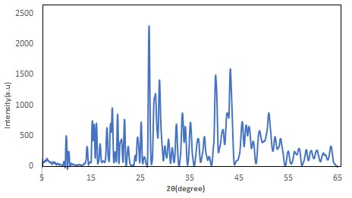
Figure 1. Powder X-ray diffraction pattern of the precusor, [Zn₄(H₂B4C)_{2.5}(OH)₃(H₂O₅]·10H₂O.

3.3 FTIR Spectroscopy Analysis
The FTIR spectra of the ligand and the complex are shown in Fig. 2. The first band of interest in the IR spectrum of this compound is the νO-H. This band which appeared between 3007–2871 cm⁻¹ in the ligand shifted to a higher wavenumber (3448 -3157 cm⁻¹) in the complex. The sensitivity to hydrogen bonding (intra and inter) is indicated by the broadness of the band and may be said to be loosely bound to the metal ions through a hydrogen bond [14]. The evidence of complex formation was obtained by comparing the infrared spectra for the free ligand and the complex. The carbonyl region offers information on the type of coordination which exists between the metal and the carboxylic acid group of the ligand. In the complex, a shift of the asymmetric stretching vibration frequency ν_{as}COO from higher wavenumber (1694 cm⁻¹) in the free ligand) to lower wavenumber, 1549 cm⁻¹ is observed in this complex. While the symmetric vibration frequency ν_{sy}COO shifts from 1264 cm⁻¹ to higher wavenumber 1374 cm⁻¹ suggesting coordination of the carbonyl oxygen to the metal. The observed splitting of the ν_{as}COO band has been attributed to many causes e.g. two coordination modes, polymer–dimer equilibrium or coupling between neighbouring carboxylate groups. The splitting difference ∆ν, between the asymmetric and symmetric stretch in this complex is 192 cm⁻¹. This value which is larger than the corresponding value in Na₄B4C (95 cm⁻¹), indicates that the carboxylate groups behave as monodentate ligand[15].

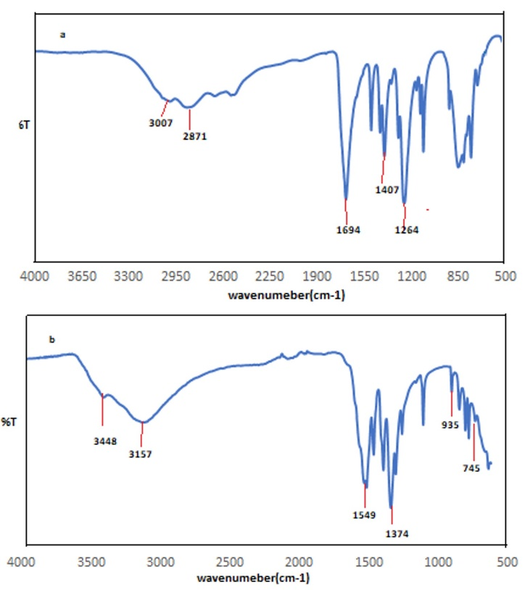
Figure 2. FTIR Spectrum of a) H₄B4C, b) [Zn₄(H₂B₄C)_{2.5}(OH)₃(H₂O)₅]·10H₂O
3.4 Thermogravimetry Analysis
The thermogravimetric and differential thermogravimetry (TGA-DTG) curves of the thermal decomposition for the studied complex is shown in Figure 3. A three-step loss with the second step occurring as a two-stage loss was observed. The first weight loss of 15.01% (calculated 14.84%) between 41 -105 ºC is due to the loss of 10H₂O molecules. The second weight loss of 8.74 % (calculated 8.82%) is a two-step loss (shoulder (i) in TG curve) between 105-175 ºC, attributed to the loss of coordinated 5H₂O molecules and an OH respectively. The third weight loss of 2.91%

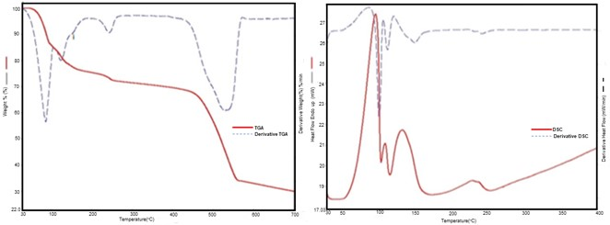
Figure 3.TGA-Derivative TGA and the corresponding DSC/ Derivative DSC for
Zn₄(H₂B4C)_{2.5}(OH)₃(H₂O)₅]·10H₂O
(calculated 2.89%) is a loss of coordinated 2OH⁻ groups (likely lost as H₂O) between 212 ºC – 261 ºC. This high temperature of dehydration indicates that the water molecules are coordinated ones. The remaining material is stable up to 437 °C beyond which it decomposes with a final weight loss of 38.92% (calculated 39.59%) which is assigned to the decarboxylation of the ligand structure leaving 33.84% (calculated 33.77%) residue in the form of amorphous carbon and ZnO. The residual XRPD pattern confirmed the formation of ZnO. The TGA thermogram of this compound is comparable to the compound reported by Anirban and Susanta, 2015[16].

The proposed reactions of decomposition are illustrated below and it is in good agreement with the observed mass losses.
Its DSC and derivative DSC revealed four endotherm peaks in the temperature range of 40-250 ºC. The enthalpy change (ΔH) associated with the first mass loss in the TGA (dehydration step) in the temperature range 41-105 ºC is 337 Jg⁻¹ (associated energy 408 kJmol⁻¹). With this energy, it suggests that 10H₂O molecules were removed. Upon calculation, each water molecule requires 40.8 kJmol⁻¹ to be removed from the structure. When this is compared to the enthalpy of vaporization of water at 100 °C (kJmol⁻¹) it indicates that the water was held to the structure by a weak hydrogen bond.

3.5. Nitrogen Gas Adsorption Properties

To examine the porous nature of the complex, N₂ adsorption-desorption characteristics of the desolvated compound was investigated at 77 K, and its isotherm is as presented in Figure 4. This complex show typical Type III mesoporous isotherm as defined by IUPAC classification scheme [17] and with characteristic hysteresis of adsorption and desorption. The BET surface area; 5.151 m²g⁻¹, Langmuir Surface area; 5.387 m-²g⁻¹ pore volume; 0.012 cm³g⁻¹, and pore size; 39.6 nm obtained from the nitrogen adsorption data, are far smaller than those reported in the literature. The mesoporous material is typical of pore size 2 - 50 nm. This type of isotherm revealed only surface adsorption, which suggested that N₂ molecules cannot diffuse into the pores of this complex at 77 K. It also suggests that the coordinated H₂O molecules play important role in the stability of the complex.

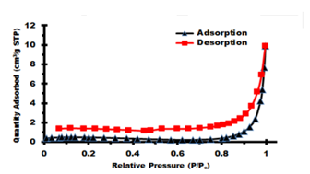

Figure 4: Nitrogen adsorption/desorption of [Zn₄(H₂B4C)_{2.5}(OH)₃(H₂O)₅]·10H₂O

3.6 Nano-Zn-O Particle size and Morphology
The nano-ZnO was prepared by using the complex [Zn₄(H₂B4C)_{2.5}(OH)₃(H₂O₅]·10H₂O as precursor through the thermal decomposition reaction. The reaction involved calcining the complex at 400 ºC, and 800 ºC for 1.5hr. The powder XRD patterns of the products obtained are shown in Figure 5. The diffractograms show prominent peaks at 2θ = 31.79º, 34.5 º, 36.26º, 47.73º, 56.67º, 62.83º, 67.51º, 67.93º, 69.20º, 3.47º and 77.29º which correspond to the diffraction planes 100, 002, 101,102, 110, 103, 200, 112, 201, 004 and 202 respectively. These diffraction peaks are in agreement with the JCPDS card (No.36-1451) [18] and can be indexed as hexagonal wurtzite
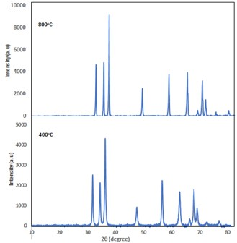
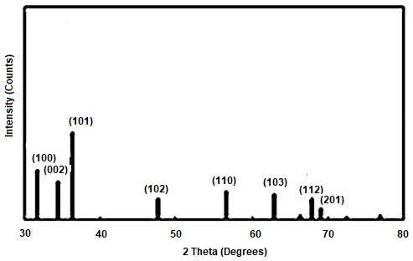
JCPDS (36-1451)

Figure 5: Powder X-ray Diffraction of calcined [Zn₄(H₂B4C)_{2.5}(OH)₃(H₂O)₅]·10H₂O at different Temperature.

structure of ZnO (a = 3.3249 Å, c =5.206 Å). The intensity and sharpness of the peaks are observed to increase with calcining temperature showing increased crystallinity, this characteristic has been reported in the literature[19].The broadening of the diffraction peaks for the nano-ZnO obtained at 400 ºC indicates that the crystallite size were smaller than those obtained 500 ºC, this is in agreement with characteristic of nano-size particles [20]. This statement also agrees with the values obtained for the average crystallite size of the nano-ZnO product (16 nm and 23 nm for 400 ºC and 500 ºC respectively) estimated using the Debye Scherrer Eq. 1 below. Diffraction peaks due to impurities were not observed confirming the purity of the synthesized product.

D = $\frac{0.89λ}{βcosθ}$
where D is the crystallite size,
λ = 1.5418Ǻ for CuKα,
β is the half maximum peak width and
θ is the diffraction angle in degrees.
The SEM images of the precursor a, nano-ZnO (b) and FT-IR (c) spectrum of the nano-ZnO are shown in Figure 6. The SEM image of the precursor showed a well dispersed homogenous shape and size of plate-like structures while b show an agglomerate of the plate-like structure, with the particlesize of the nano-ZnO smaller than that of the precursor.
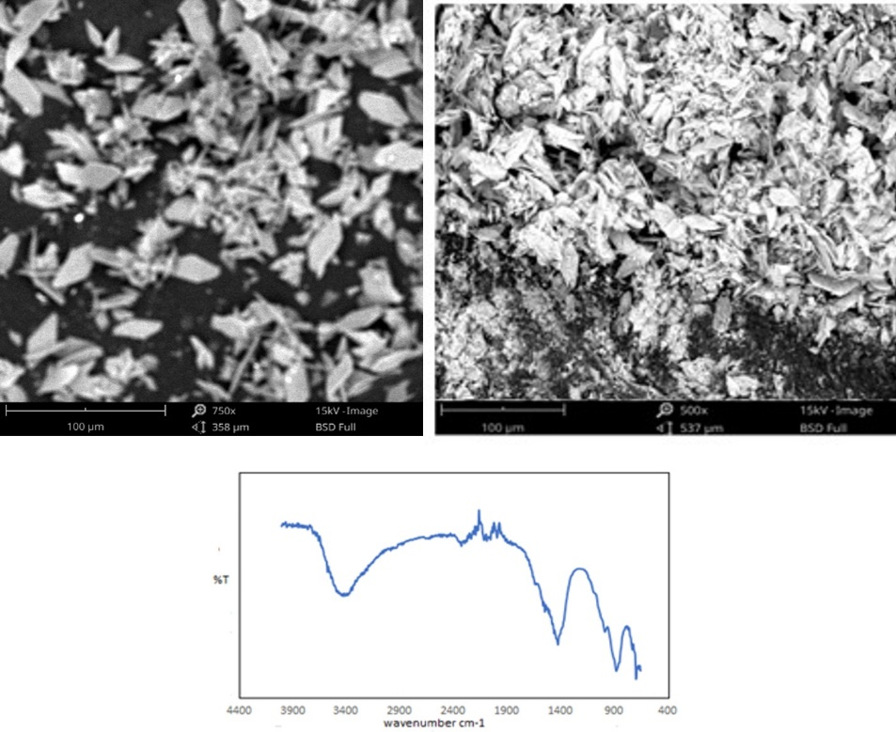
c
b
a

Figure 6. SEM images of (a and b) and FT-IT (c) Spectrum of nano-ZnO

- Conclusions.

The synthesis of zinc nanoparticles have been achieved through a simple, cheap and eco-friendly method which involves the calcination at 400 ºC and 800 ºC of the zinc pyromellitate salt. The confirmation of the successful formation of zinc nanoparticles was achieved by Powder XRD, SEM, and IR. The result showed that the nano particles formed at 400 ºC contained smaller crystallite size particles than those obtained at higher temperature. It also proves that the thermal decomposition procedure is suitable for production of some other nanostructures which can be used as a photocatalyst, sensor and other functional materials. .

Acknowledgement: The authors would like to thank the entire personnels of the Nanotechnoloogy Innovation Centre (NIC) in the Department of Chemistry, Rhodes University South Africa for helping out with the Elemental, BET, PXRD analysis of the compound.

Competing Interest: The Authors declared that no competing interest exist.

Author Contributions: Bukunola K. Oguntade synthesized the complex, analyzed, interpreted and prepare the manuscript. Gareth M. Watkins supervised the experiment and reviewed the first draft.

Disclaimer (Artificial intelligence)
Author(s) hereby declare that NO generative AI technologies such as Large Language Models (ChatGPT, COPILOT, etc.) and text-to-image generators have been used during the writing or editing of this manuscript.

References
- Crisan M. C; Theodoara M.; Lucian, M. (2022). Copper Nanoparticles: Synthesis and Characterization, Physiology, Toxicity and Antimicrobial Applications. Appl. Sci. 12(1), 141. https://doi.org/10.3390/app12010141
- Mekuye, B. Abera, B. (2023) Nanomaterials: An overview of synthesis, classification, characterization, and applications. Nano Select., 4, 486. https://doi.org/10.1002/nano.202300038
- Radovanović L. Zdravković1, J. D., Simović B. Ž., Radovanović Z., Mihajlovsk K., Dramićanin M. D., and Jelena Rogan J. (2020). Zinc oxide nanoparticles prepared by thermal decomposition of zinc benzenepolycarboxylato precursors: Photoluminescent, photocatalytic and antimicrobial properties. Serb. Chem. Soc. 85 (11) 1475–1488. https://doi.org/10.2298/JSC200629048R
- Shi, Q., Cao, R., Sun, D., Hong, M., Liang, Y. (2001). Solvothermal syntheses and crystal structures of two metal coordination polymers with double-chain structures. Polyhedron 20(28), 3287-3293. https://doi.org/10.1016/s0277-5387901)00945-7
- Mohan, S.: Vellakkat, M.; Aravi, A. Reka U. (2020). Hydrothermal synthesis and characterization of Zinc Oxide nanoparticles of various shapes under different reaction conditions. Nano Express 1, 030028. https://doi.org/10.1088/2632-959X/abc813.
- Hayat, K.; Gondal, M. A; Khaled, M. M.; Ahmed, S. Shemsi. A. M. (2011). Nano ZnO synthesis by modified sol gel method and its application in heterogeneous photocatalytic removal of phenol from water, Applied Catalysis A: General, 393, (1–2),
122-129. https://doi.org/10.1016/j.apcata.2010.11.032.
- Chavali, M.S., Nikolova, M.P. (2019), Metal oxide nanoparticles and their applications in nanotechnology. SN Appl. Sci. 1, 607. https://doi.org/10.1007/s42452-019-0592-3.
- Haq, U. I.; Nadhman A. N.; Ullah A.; Mustafa I.; Yasinzai, G. A. M.; Khan, I (2017} Synthesis approaches of ZnO nanoparticles. The dilemma of ecotoxicity 8510342
- Sangari, N. U.; Chitra Devi, S. C. (2013) Synthesis and characterization of nano ZnO rods via microwave assisted chemical precipitation method, Journal of Solid State Chemistry, Volume 197, 483-488. https://doi.org/10.1016/j.jssc.2012.08.011.
- Islam, F., Shohag, S., Uddin, M. J., Islam, M. R., Nafady, M. H., Akter, A., Mitra, S., Roy, A., Emran, T. B., Cavalu, S. (2022). Exploring the Journey of Zinc Oxide Nanoparticles (ZnO-NPs) toward Biomedical Applications. Materials, 15(6), 2160. https://doi.org/10.3390/ma15062160
- Zhou, X.-Q., Hayat, Z., Zhang, D.-D., Li, M.-Y., Hu, S., Wu, Q., Cao, Y.-F., & Yuan, Y. (2023). Zinc Oxide Nanoparticles: Synthesis, Characterization, Modification, and Applications in Food and Agriculture. Processes, 11(4), 1193. https://doi.org/10.3390/pr11041193
- Khalaji, A. D. (2019). Preparation and Characterization of ZnO Nanoparticles via Thermal Decomposition from Zinc(II) Schiff Base Complex as New Precursor. Chemical Methodologies 3(5), 635-643. https://doi.org/10.33945/SAMI/CHEMM.2019.5.6.
- Yang, R., Wang, M., Liu, T., Zhong, G. (2018). Room Temperature Solid State Synthesis, Characterization, and Application of a Zinc Complex with Pyromellitic Acid. Crystal, 8(2),56. https://doi.org/10.3390/cryst8020056
- Tai, X.-S.; Meng, Q.-G.; Liu, L.-L. (2016). Synthesis, crystal structure, and cytotoxic activity of a novel eight-coordinated dinuclear Ca(II)-Schiff base complex. Crystals, 6, 109. https://doi.org/10.3390/cryst6090109
- Deacon, G. B., Phillips, R. J. (1980). Relationships between the Carbon-Oxygen Stretching frequencies of Carboxylato complexes and the type of Carboxylate Coordination. Coordination Chemistry Reviews, 33,227-250. https://doi.org/10.1016/S0010.8545(00)80455-5
- Anirban K., and Susanta H., (2015). Synthesis, supramolecular structure and thermal study of a new dinuclear zinc(II) complex derived from benzene-1,2,45-tetracarboxylic acid. Z. Kristallogr. 230(3): 185–191. 185-191. https://doi.org/ 10.1515/zkri-2014-1812
- IUPAC. (1985). Reporting physisorption data for gas/ solid systems with special reference to the determination of surface area and porosity. Pure & Appl. Chem, 57(4), 603-619.
- Khalaji, A. D. (2019). Preparation and Characterization of ZnO Nanoparticles via Thermal Decomposition from Zinc(II) Schiff Base Complex as New Precursor. Chemical Methodologies 3(5), 635-643. https://doi.org/10.33945/SAMI/CHEMM.2019.5.6.
- Zelekew, O. A.; Aragaw, S. G.; Sabir, F. K.; Andoshe, D. M.;
Duma, A. D.; Dong-Hau Kuo D. H; Xiaoyun Chen, X.; Temesgen D. Desissa, T. D.;
Tesfamariam, B. B.; Feyisa, G. B; Hairus Abdullah, H. Eneyew Tilahun Bekele, E. T.; and
Aga, F. G. (2021). Green synthesis of Co-doped ZnO via the accumulation of cobalt ion
onto Eichhornia crassipes plant tissue and the photocatalytic
degradation efficiency under visible light. Mater. Res. Express 8, 025010 https://doi.org/10.1088/2053-1591/abe2d6
- Natheer B. Mahmood, Farqad R. Saeed, Kadhim R. Gbashi, Um-Salama Mahmood (2022). Synthesis and characterization of zinc oxide nanoparticles via oxalate co-precipitation method, Materials Letters: X, 13, 100126, https://doi.org/10.1016/j.mlblux.2022.100126.

APPENDIX 1
Table 1. Powder indexing result of [Zn₄(H₂B4C)_{2.5}(OH)₃(H₂O)₅]·10H₂O
Peak  No. | 2θ [°] | θ [°] | Sinθ | sin²θ | 1000sin²θ | 1000sin²θ /CF  h²+k²+l² hkl |  | d spacing  obs cal
1 | 13.8030 | 6.9020 | 0.1202 | 0.0144 | 14.440 | 1.00 | 100 | 6.4105 | 6.3409
2 | 15.7110 | 7.8560 | 0.1367 | 0.0187 | 18.680 | 1.2936 | 100 | 5.6359 | 5.5981
3 | 17.0920 | 8.5460 | 0.1486 | 0.0220 | 22.080 | 1.5291 | 110 | 5.1837 | 5.1833
4 | 19.3950 | 9.6970 | 0.1684 | 0.0283 | 28.370 | 1.9647 | 110 | 4.5730 | 4.5384
5 | 23.5540 | 11.7770 | 0.2041 | 0.0417 | 41.660 | 2.8850 | 111 | 3.7740 | 3.7418
6 | 25.1670 | 12.5830 | 0.2179 | 0.0475 | 47.460 | 3.2867 | 111 | 3.5357 | 3.5269
7 | 26.7090 | 13.3540 | 0.2309 | 0.0534 | 53.350 | 3.6946 | 200 | 3.3350 | 3.3239
8 | 27.5730 | 13.7870 | 0.2383 | 0.0568 | 56.790 | 3.9328 | 200 | 3.2324 | 3.2424
9 | 29.1810 | 14.5910 | 0.2519 | 0.0635 | 63.460 | 4.3947 | 200 | 3.0578 | 3.0507
10 | 31.0170 | 15.5080 | 0.2674 | 0.0715 | 71.490 | 4.9508 | 210 | 2.8809 | 2.8988
11 | 32.7290 | 16.3650 | 0.2818 | 0.0794 | 79.380 | 5.4972 | 210 | 2.7339 | 2.7866
12 | 33.4300 | 16.7150 | 0.2876 | 0.0827 | 82.720 | 5.7285 | 211 | 2.6783 | 2.6678
13 | 35.1920 | 17.5960 | 0.3023 | 0.0914 | 91.390 | 6.3289 | 211 | 2.5481 | 2.5249
14 | 36.7100 | 18.3550 | 0.3149 | 0.0992 | 99.170 | 6.8677 | 7 | 2.4461 | 2.4403
15 | 38.5790 | 19.2900 | 0.3304 | 0.1091 | 109.130 | 7.5575 | 220 | 2.3318 | 2.3326
16 | 40.9590 | 20.4790 | 0.3499 | 0.1224 | 122.410 | 8.4772 | 221 | 2.2017 | 2.1936
17 | 43.2740 | 21.6370 | 0.3687 | 0.1359 | 135.960 | 9.4155 | 221 | 2.0891 | 2.0891

