Original Research Article

Comparative Evaluation of Pine Oil and Vernonia amygdalina Extract as Frothers in the Froth Flotation of Duguri Galena for Lead Oxide Production

ABSTRACT

The demand for eco-friendly reagents in minerals flotation is rising. Conventional frothers, while effective for flotation processes, are synthetic, raising environmental and sustainability concerns. Green frothers act as eco-friendly substitutes, reducing ecological impacts and improving biodegradability without compromising flotation performance. This study investigated the froth flotation of Duguri lead ore (Bauchi State, Nigeria) using conventional (pine oil) and non-conventional (Vernonia amygdalina extract) frothers to produce lead oxide concentrate suitable for pyrometallurgical extraction of lead metal. The sample underwent comminution and homogenization, followed by random sampling and particle size analysis. A grindability test was performed, and subsequent froth flotation experiments were conducted to concentrate the valuable lead mineral. The elemental composition of the ore sample was analyzed using Energy Dispersive X-ray fluorescence (ED-XRF), the morphological structure using Scanning Electron Microscope - equipped with Energy Dispersive Spectroscopy (SEM-EDS), and the mineral composition identified using X-ray Diffraction (XRD). The liberation size of the ore was determined to be within the range of -180+125 µm, with a work index of 22.20 kWh/t and a comminution energy of 3.76 kWh. The froth flotation method significantly increased the PbO grade. Pine oil achieved optimal results in the -125+90 µm size range, while Vernonia amygdalina extract performed better in the -63 µm fraction, yielding higher PbO grade, recovery, concentration ratio, enrichment ratio, and separation efficiency. Consequently, both frothers produced 60-65% PbO concentrates, suitable for pyrometallurgical extraction of lead metal. Therefore, Vernonia amygdalina extract emerges as a more efficient alternative frother to pine oil in the froth flotation of Duguri lead ore, offering an eco-friendly option, that reduces reliance on synthetic reagents while maintaining or improving metallurgical performance.

Keywords: Lead ore; Work index; Froth flotation; Pine oil; Vernonia amygdalina extract

1. INTRODUCTION

The Nigerian Federal Government has prioritized the exploitation of strategic minerals such as iron ore, coal, gold, lead, zinc, bitumen, limestone and barites. Mining of these minerals is economical due to their wide availability in both high-quality and large quantities (Olade, 2019). The Duguri lead ore deposit in Bauchi State is an example of such a deposit. Notably, Nigeria also holds considerable lead deposits across several other states, including Anambra, Ebonyi, Plateau, Cross River, Imo, Kano, Enugu, Abuja, and Taraba, where the ore predominantly occurs in the form of lead-zinc deposits (Ahmed et al., 2017). With such deposits, the mining and minerals sector has the potential to contribute significantly to Nigeria’s Gross Domestic Product (GDP). Therefore, providing information on the characteristics and processing route of Duguri lead ore is necessary to support its exploration, development, and exploitation for economic gain.

Lead (Pb) is a bluish-grey metal exhibiting a relatively soft and malleable nature. It is a versatile and widely utilized metal globally, thanks to its unique combination of properties such as high density, excellent resistance to chemical corrosion and low melting point (Collin et al., 2022). The primary ore mineral of lead is galena (PbS), usually found in association with barytes and sphalerite (ZnS). Lead is used in several applications, including the manufacture of car batteries, ammunition, pigments, lifting weights, solders, cable sheathing, lead crystal glass and radiation protection (Boldyrev, 2018; May et al., 2018). These diverse applications of lead are a testament to its importance in modern technology and infrastructure. However, it is important to note that lead is also a toxic metal, and its use requires proper handling, safety precautions and environmental considerations to minimize its potential risks and impacts (Chowdhury et al., 2022; Kim et al., 2021).

In recent years, the growing recognition of finer liberation sizes for minerals, including lead, has prompted researchers to explore alternative methods for enriching valuable minerals associated with ore bodies. As a result, while most gravity methods are unsuitable for finely disseminated ore bodies and certain ore types such as sulphides, the flotation method has emerged as a preferred approach for selectively separating valuable minerals from the gangue. Several researchers have beneficiated lead ore mineral via the froth flotation method. Mütevellioğlu & Yekeler (2019) floated oxide carbonate Pb-Zn ore containing 9.05% Pb and 11.97% Zn using reagents such as CMC, Na2S, and AERO promotor. Flotation in six stages using 350 g/t KAX, 275 g/t AERO 407, 7500 g/t Na2S, and 1000 g/t CMC achieved 70.93% Pb concentration with a recovery of 71.56%. Similarly, Wei et al. (2021) achieved an increase in Pb grade to 52.73% from 43.37% in the crude ore by applying a new flotation approach involving a low-alkaline and non-desliming process, at a pH of 9. This approach was deemed effective for improving lead and zinc recoveries, while lowering production cost and reducing environmental pollution. Other related works by Zhang & Chen (2021) achieved 65.16% lead and 87.81% silver recovery in a laboratory floatation set-up, compared to industrial closed-circuit testing flotation, which attained a 67.71% total lead recovery, and an 87.64% total silver recovery yield, while Ramezani & Kamran Haghighi (2025) floated lead using potassium amyl xanthate (PAX), zinc sulfate, and sodium cyanide. A lead concentrate having 21.5% lead with a recovery of 61.17% was obtained, with 45.34% zinc and 26.765 iron recoveries, under the optimal conditions of 800 g/ton PAX, 250 g/ton zinc sulfate, and 50 g/ton sodium cyanide at a pH of 9.5.

Although flotation remains the most widely employed beneficiation technique for the recovery of valuable minerals—particularly sulphide ores and certain non-sulphide ores such as oxides and phosphates—its environmental implications present notable sustainability challenges. These concerns arise primarily from its high energy requirements, reliance on petrochemical-based reagents, and substantial water consumption. Recent research has increasingly focused on the development and application of environmentally benign frothers derived from renewable resources and industrial waste streams. Such alternatives include plant-derived glycosides, polymer–surfactant blends, biosurfactants, and esters (Nazoori et al., 2025). These green frothers have demonstrated the capacity to enhance froth formation and stability, regulate bubble size distribution, and improve flotation selectivity when compared with conventional reagents (Nazoori et al., 2025). This study, therefore, employed the use of conventional (pine oil) and non-conventional (Vernonia amygdalina extract) as frothers in the froth flotation of Duguri lead ore. The bitter leaf extract has been used alternatively to minimize the cost of reagents used in concentrating the lead mineral, with the aim to reduce the overall cost of producing lead mineral, promote the rural economy and contribute meaningfully to Nigeria’s GDP.

2. MATERIALS AND METHOD

2.1 Materials and chemical reagents

The samples used in this study were Duguri lead ore and the reference ore (quartz from the overburden), obtained from a mine site in Duguri town (coordinates: Latitude 9°39ʹ11ʺN, and Longitude 10°44ʹ48ʺE), Alkaleri Local Government Area, Bauchi State, Nigeria. All laboratory-grade reagents used for froth flotation of the lead ore included sodium hydroxide/hydrochloric acid (pH regulator), zinc sulphate (depressant), copper sulphate (activator), potassium ethyl xanthate (collector), pine oil and Vernonia amygdalina extract (frothers). Fig. 1 shows the location of the study area.
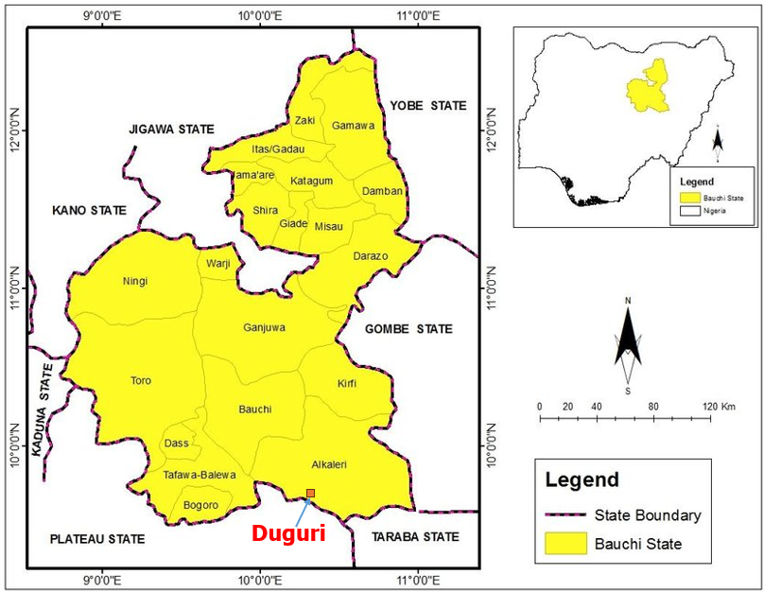

Fig. 1. Location of Duguri in Alkaleri Local Government Area, Bauchi State, Nigeria (Udeh et al., 2020)

2.2 Method

The method employed included sample collection, chemical and mineralogical characterization of the lead ore, particle size analysis, work index determination and froth flotation.

2.2.1 Sample collection

Fifty kilograms (50 kg) of lead ore (test) sample and 10 kg of quartz (reference ore) were collected from a mine site in Duguri town. The samples were collected from 10 different pits (500 m apart) dug at dimensions of 1.5 m by 1.5 m and 3.0 m deep. About 5 kg was collected from each pit using the random sampling method.

2.2.2 Sample preparation

Sample preparation involved comminution processes, including crushing and grinding. Boulder-sized materials exceeding 200 mm were initially reduced using a sledgehammer to particle sizes of approximately 50–100 mm. Samples collected from the ten pits were thoroughly mixed to ensure homogenisation, after which a representative 10 kg portion was obtained through random sampling for subsequent analysis. The material was further reduced in size using a laboratory jaw crusher (Denver D12) to approximately 5 mm, followed by pulverisation with a Fritsch pulveriser. Thereafter, sieve analysis was conducted to determine particle size distribution. Sampling for characterisation was performed using the cone and quartering method, complemented by random sampling techniques to ensure the representativeness of the final sample.

2.2.3 Particle size analysis

Particle size analysis was conducted according to procedures outlined by Alabi et al. (2016) & Owino et al. (2026). After pulverization, 100 g of the prepared lead ore sample was placed into a series of sieves organized in a pattern that varied in size according to the square root of 2 (√2). The mesh sizes for the sieves used were 1000 µm, 710 µm, 500 µm, 355 µm, 250 µm, 180 µm, 125 µm, 90 µm, and 63 µm. A pan was tightly fitted underneath the bottom sieve to collect the smallest particles, while a lid was placed on the top sieve to prevent any sample from escaping throughout the process. The set of sieves was agitated using a Denver automated sieve shaker (MY-2014 model) for 30 minutes. The resulting fraction of material collected on each sieve was weighed and recorded.

2.2.4 Work index determination

The work index was computed using the modified Bond’s method based on the Gaudin Schumann equation and following the procedures outlined by Bwala et al. (2021). The work index of the test ore was determined by conducting the sieve analyses of the feed to the ball mill for the test ore, the product out of the ball mill for the test ore, the feed to the ball mill for the reference ore and the product out of the ball mill for the reference ore. The size of the reference ore, quartz (known as the overburden layer), was reduced using the jaw crusher, and the resulting product was further crushed and ground using a ball mill. Likewise, the test ore was crushed and ground. A total of 100 g of both the test and reference ores were separately loaded into a series of sieves and agitated on an automated sieve shaker for 30 minutes. The respective fractions of the test and reference ores were weighed and recorded.

2.2.5 Froth flotation process

500 g of ground sample of the lead ore (100% passing 250 µm sieve size) was charged into a Denver (D-12) froth flotation cell, followed by the addition of 2000 ml of water. This was thoroughly mixed to form a slurry of ratio 1:4. The slurry was agitated using an impeller at a speed of 1700 rpm for 1 minute, after which, the pH was checked (initially at 10.2) and adjusted to 9.0 using dilute hydrochloric acid. The slurry was agitated for another 1 minute, and then the depressant, zinc sulphate (100 g/t), was added. The resulting slurry was further agitated for 1 minute, and 10 g/t copper sulphate (activator) was added. After agitating the slurry for another 1 minute, the collector, 20 g/t potassium ethyl xanthate, was added. The slurry was thoroughly agitated for another 1 minute, and 2 droplets of pine oil (frother) were added, and air was introduced into the slurry by opening the air valve. Froth was formed, skimmed, and collected.500 ml of water was used for the wash-down of lead oxide from the lead ore for more froth formation. After 1 minute of agitation, air was again introduced to recover more froth. The froth and the depressed products were allowed to settle for 24 hours and then decanted, filtered and dried. Representative samples were collected for chemical analysis. This procedure was repeated for sieve sizes of 180 µm, 125 µm, 90 µm and 63 µm and the replication was done using Vernonia amygdalina (bitter leaf) extract as the frother.

2.3 Characterization

Energy-dispersive X-ray fluorescence spectroscopy (EDS-XRFS) was employed to determine the chemical composition of the ore sample. A 20 g portion of the pulverised lead ore was sieved through a 250 µm mesh screen and subsequently mixed with a binder in a ratio of 5.0 g of sample to 1.0 g of cellulose flakes. The binder was then compressed into pellets using a pelletising machine at 10–15 tons/in² and stored in a desiccator prior to analysis. The PANalytical Minipal 7 ED-XRF instrument was switched on and allowed to stabilise at an operating temperature of 20°C for two hours. Selected elements of interest were analysed using appropriate software, and the results were recorded.
X-ray diffraction (XRD) analysis was conducted using a PANalytical X’Pert Pro powder diffractometer equipped with an X’Celerator detector, as well as variable divergence and receiving slits. Diffraction measurements were carried out using Fe-filtered Co-Kα radiation. Phase identification was performed using X’Pert HighScore Plus software. The receiving slit was set at 0.040°, and data were collected over a 2θ range of 5–70° with a counting time of 1.5 seconds per step. Temperature-dependent XRD measurements were obtained using an Anton Paar HTK 16 heating chamber fitted with a platinum heating strip. Both qualitative and quantitative results were presented graphically, and the Rietveld refinement method was applied to determine the relative proportions of the various phases in terms of weight percentages (Gbadamosi et al., 2021).
Furthermore, an ultra-high-resolution field emission scanning electron microscope (UHR-FEGSEM), coupled with energy-dispersive spectroscopy (EDS), was utilised to examine the morphology and microstructure of the pulverised lead ore sample. Particle images were acquired using a secondary electron detector.

3. RESULTS AND DISCUSSION
3.1 Mineralogical Characterization
Drawing from the previous work, Munyao et al. (2024), the chemical composition of the crude lead ore, as depicted in Table 1 showed the presence of lead oxide (PbO) at 36.83%, with the existence of other oxides such as SiO₂ (45.82%), Fe₂O₃ (8.29%), ZnO (9.66%), Al₂O₃ (3.41%), TiO₂ (1.07%) and WO₃ (0.31%). Evidently, the ore meets the 1-10% Pb standard required to mine lead ore deposits, but requires beneficiation to upgrade it 60-65% content suitable for pyrometallurgical extraction of lead metal (Yunana et al., 2015). The XRD analysis identified the main mineral present in the ore as galena (47.0%), with the presence of other minerals including cerussite (19.0%), quartz (18.8%) and gratonite (15.0%).
Table 1. Chemical composition of the crude Duguri lead ore
Component | PbO | SiO₂ | Fe₂O₃ | ZnO | Al₂O₃ | TiO₂ | WO₃
Chemical composition (%) | 36.83 | 45.82 | 8.29 | 9.66 | 3.41 | 1.07 | 0.31

The morphology of the ore, as shown by the SEM micrograph in Fig. 2, revealed the characteristic cubical and octahedral crystals (Nasymov et al., 2019), indicating a coarse-grained ore and a smooth surface with a fine-grained texture, suggesting quartz or silicate mineralization. The ore has limited porosity, consistent with Galena’s dense nature. Additionally, the minerals present in the present in the ore are coarsely dispersed within the matrix of the ore, which facilitates easier liberation during comminution processes. The elemental constituents consisted of Pb, Si, C and O.
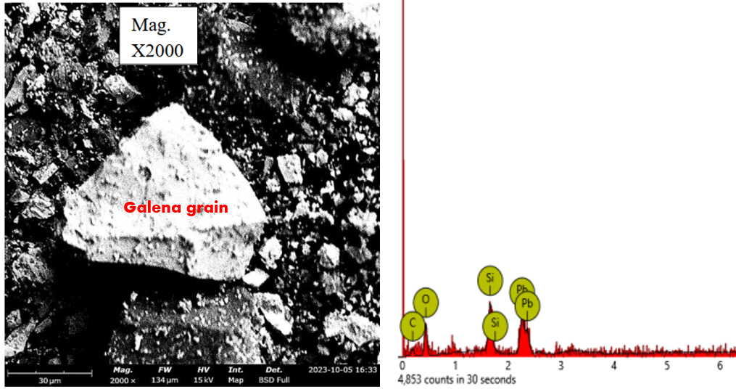
Fig. 2. The morphology of Duguri lead ore (Munyao et al., 2024)
3.2 Particle Size Analysis
The sieve analysis result for the crude lead ore is presented in Table 2. The cumulative % weight retained and passing curves for the crude lead ore, shown in Fig. 3, depict the point of intersection at 125 µm, meaning that the theoretical liberation size for the ore is in the sieve size range of -180+125 µm. The actual liberation size, as shown in Table 2, indicates the liberation size is also at -180+125 µm, with the highest PbO content of 38.88%. The liberation size is defined as the size at which the mineral of interest is fully liberated from the gangue (Rerani et al., 2024).
Table 2. Sieve analysis result for the crude lead ore
Sieve size Range (µm) | Sieve size (µm) | Weight Retained (g) | Weight Retained (%) | Cumulative Weight Retained (%) | Cumulative Weight Passing (%) | Grade of PbO (%)
1000 | 1000 | 5.40 | 5.49 | 5.49 | 94.51 | 34.88
-1000 + 710 | 710 | 0.20 | 0.20 | 5.69 | 94.31 | 31.89
-710 + 500 | 500 | 10.40 | 10.59 | 16.28 | 83.72 | 31.35
-500 + 355 | 355 | 14.29 | 14.54 | 30.82 | 69.18 | 33.52
-355 + 250 | 250 | 1.09 | 1.11 | 31.93 | 68.07 | 34.02
-250 + 180 | 180 | 7.71 | 7.85 | 39.78 | 60.22 | 34.52
-180 + 125 | 125 | 9.11 | 9.27 | 49.05 | 50.95 | 38.88
-125 + 90 | 90 | 10.96 | 11.16 | 60.21 | 39.79 | 36.10
-90 + 63 | 63 | 9.60 | 9.77 | 69.98 | 30.02 | 35.90
-63 | -63 (pan) | 29.50 | 30.02 | 100 | 0 | 37.01
 |  | 98.25 | 100

Fig. 3. Cumulative % weight retained and passing for the crude lead ore at varying sieve sizes
3.3 Work Index Determination
The work index of the test ore (Galena) was determined by conducting the sieve analyses of the feed to the ball mill, and the product out of the ball mill for the test ore, the feed to the ball mill and the product out of the ball mill for the reference ore. The results of the experiments carried out are presented in Tables 3-6.
Table 3. Sieve analysis results for the feed to the ball mill for test ore
Sieve size Range (µm) | Sieve size (µm) | Weight Retained (g) | Weight Retained (%) | Cumulative Weight Retained (%) | Cumulative Weight Passing (%)
1000 | 1000 | 7.19 | 7.39 | 7.39 | 92.61
-1000 + 710 | 710 | 0.17 | 0.18 | 7.57 | 92.43
-710 + 500 | 500 | 10.58 | 10.89 | 18.46 | 81.54
-500 + 355 | 355 | 13.75 | 14.15 | 32.61 | 67.40
-355 + 250 | 250 | 1.61 | 1.65 | 34.26 | 65.74
-250 + 180 | 180 | 7.16 | 7.37 | 41.63 | 58.38
-180 + 125 | 125 | 9.14 | 9.41 | 51.03 | 48.97
-125 + 90 | 90 | 10.45 | 10.75 | 61.78 | 38.22
-90 + 63 | 63 | 9.59 | 9.87 | 71.65 | 28.35
-63 | -63 (pan) | 27.55 | 28.35 | 100 | 0.00
 |  | 97.19 | 100

Table 4. Sieve analysis results for the product out of the ball mill for test ore
Sieve size Range (µm) | Sieve size (µm) | Weight Retained (g) | Weight Retained (%) | Cumulative Weight Retained (%) | Cumulative Weight Passing (%)
1000 | 1000 | 0.00 | 0.00 | 0.00 | 100
-1000 + 710 | 710 | 0.02 | 0.02 | 0.02 | 99.98
-710 + 500 | 500 | 1.80 | 1.88 | 1.90 | 98.10
-500 + 355 | 355 | 10.14 | 10.60 | 12.51 | 87.49
-355 + 250 | 250 | 8.07 | 8.44 | 20.94 | 79.06
-250 + 180 | 180 | 12.34 | 12.90 | 33.85 | 66.15
-180 + 125 | 125 | 12.89 | 13.48 | 47.32 | 52.68
-125 + 90 | 90 | 14.33 | 14.98 | 62.31 | 37.69
-90 + 63 | 63 | 16.41 | 17.16 | 79.46 | 20.54
-63 | -63 (pan) | 19.64 | 20.54 | 100 | 0.00
 |  | 95.64 | 100

Table 5. Sieve analysis results for the feed to the ball mill for reference ore
Sieve size Range (µm) | Sieve size (µm) | Weight Retained (g) | Weight Retained (%) | Cumulative Weight Retained (%) | Cumulative Weight Passing (%)
1000 | 1000 | 7.89 | 8.30 | 8.30 | 91.71
-1000 + 710 | 710 | 0.25 | 0.26 | 8.55 | 91.45
-710 + 500 | 500 | 18.86 | 19.82 | 28.37 | 71.63
-500 + 355 | 355 | 23.13 | 24.30 | 52.67 | 47.33
-355 + 250 | 250 | 12.09 | 12.71 | 65.38 | 34.62
-250 + 180 | 180 | 9.78 | 10.28 | 75.66 | 24.34
-180 + 125 | 125 | 7.27 | 7.64 | 83.29 | 16.71
-125 + 90 | 90 | 6.01 | 6.31 | 89.61 | 10.39
-90 + 63 | 63 | 3.85 | 4.04 | 93.65 | 6.35
-63 | -63 (pan) | 6.04 | 6.35 | 100 | 0.00
 |  | 95.13 | 100

Table 6. Sieve analysis results for the product out of the ball mill for reference ore
Sieve size Range (µm) | Sieve size (µm) | Weight Retained (g) | Weight Retained (%) | Cumulative Weight Retained (%) | Cumulative Weight Passing (%)
1000 | 1000 | 0.00 | 0.00 | 0.00 | 100
-1000 + 710 | 710 | 0.02 | 0.02 | 0.02 | 99.98
-710 + 500 | 500 | 0.76 | 0.78 | 0.79 | 99.21
-500 + 355 | 355 | 2.46 | 2.51 | 3.31 | 96.69
-355 + 250 | 250 | 10.71 | 10.96 | 14.26 | 85.74
-250 + 180 | 180 | 14.59 | 14.93 | 29.19 | 70.81
-180 + 125 | 125 | 23.17 | 23.71 | 52.90 | 47.10
-125 + 90 | 90 | 12.47 | 12.76 | 65.66 | 34.34
-90 + 63 | 63 | 17.79 | 18.20 | 83.87 | 16.13
-63 | -63 (pan) | 15.77 | 16.13 | 100 | 0.00
 |  | 97.72 | 100

Using the Gaudin Schumann Expression (Wills & Finch, 2015; Alabi et al., 2015) as shown in equations 1, 2 and 3, the feed particle size (F_{t}) of the test ore at 80% passing, product particle size (P_{t}) of the test ore at 80% passing, the feed particle size (F_{r}) of the reference ore at 80% passing and the product particle size (P_{r}) of the reference ore at 80% passing were computed as shown in Table 7.
P(X) = 100[$X/{K]}$^{α} (1)
α = $\frac{{Log P(X}_{2})-Log P(X_{1})}{Log\left(X_{2}\right)-Log(X_{1})}$ (2)
${Size}_{2}$ = $\frac{{(Percentage passing {size}_{2})}^{2}}{{(Percentage passing {size}_{1})}^{2}} × {Size}_{1}$ (3)
Table 7. Computed sieve mesh size values with 80% of particle size passing
Component | F_{t} | P_{t} | F_{r} | P_{r}
Sieve size (µm) | 481.29 | 255.98 | 623.68 | 217.65

Using Bond’s equation (Wills & Finch, 2015; Alabi et al., 2015) as presented in equation 4, the work index of the test ore was computed.
$W_{r}$ = $W_{t}=$ $W_{ir}\left[\frac{10}{√P_{r}} -\frac{10}{\sqrt{F_{r}}}\right]$ $=W_{it}\left[\frac{10}{\sqrt{P_{t}}}-\frac{10}{\sqrt{F_{t}}}\right]$ (4)
Hence,
$W_{it}$ = $W_{ir}\left[\frac{10}{√P_{r}} -\frac{10}{\sqrt{F_{r}}}\right]$ $÷\left[\frac{10}{\sqrt{P_{t}}}-\frac{10}{\sqrt{F_{t}}}\right]$ (5)
Where, W_{it} = work index of test ore
W_{ir} = work index of the reference ore
Recalling that the work index (W_{ir}) of the reference ore (quartz) is 13.57 kWh/t (Alabi et al., 2015; Allen, 2017), the work index of the test ore (W_{it}) was computed as shown.
W_{it} = $13.57\left[\left(\frac{10}{√217.65} -\frac{10}{\sqrt{623.68}}\right) ÷ \left(\frac{10}{\sqrt{255.98}}-\frac{10}{\sqrt{481.29}}\right)\right]$ = 22.20 kWh/t
The calculated value falls within the range for the standard work index of Galena (7 to 26 kWh/t) (Alabi et al., 2015). The work index was used to calculate the energy required for grinding Duguri galena to its liberation size using equation 4 (Wills & Finch, 2015).
W_{r} = W_{t} = 3.76 kWh
3.4 Froth Flotation
The results of the froth flotation process (concentrate weights) using pine oil and Vernonia amygdalina extract as frothers is presented in Fig. 4.
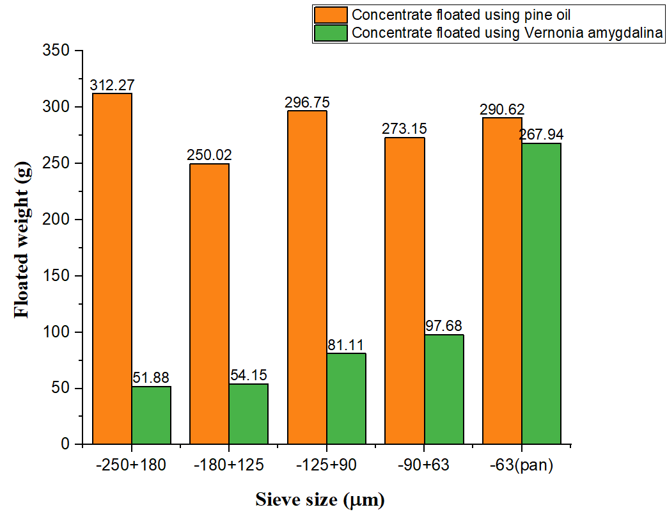
Fig. 4. Floated concentrate weights using pine oil and Vernonia amygdalina extract as frothers at varied sieve sizes
Lead oxide concentrate was recovered as froth in both cases. This indicates a successful separation of the mineral of interest (PbO) from the gangue. When pine oil was used as a frother, a near uniform froth formation was observed, while froth formation was observed to increase with decreasing particle size when Vernonia amygdalina extract was used. The result of chemical analysis of the concentrate and tailings obtained for both frothers are presented in Tables 8 and 9.
Table 8. Chemical composition of the froth floatation process at varied sieve sizes using pine oil as the frother
Mineral  Constituent  (%) | Sieve size (µm)
Mineral  Constituent  (%) | -250+180 |  | -180+125 |  | -125+90 |  | -90+63 |  | -63
Mineral  Constituent  (%) | Conc. | Tails | Conc. | Tails | Conc. | Tails | Conc. | Tails | Conc. | Tails
Al₂O₃ | 3.41 | 3.30 | 3.32 | 3.22 | 3.49 | 2.92 | 2.86 | 2.86 | 2.71 | 2.78
SiO₂ | 19.42 | 42.41 | 16.12 | 46.32 | 7.32 | 52.2 | 12.46 | 43.81 | 13.27 | 47.69
TiO₂ | 1.07 | 1.06 | 0.08 | 0.06 | 0.17 | 0.10 | 0.13 | 0.09 | 0.16 | 0.11
ZnO | 9.96 | 3.46 | 9.89 | 2.36 | 8.14 | 1.96 | 10.94 | 1.83 | 8.76 | 0.96
Fe₂O₃ | 6.43 | 3.93 | 5.41 | 3.33 | 3.01 | 2.06 | 5.12 | 4.03 | 5.96 | 3.92
PbO | 46.14 | 31.71 | 52.81 | 27.88 | 62.89 | 7.92 | 51.45 | 21.37 | 56.42 | 23.57
WO₃ | 0.32 | 0.31 | 0.25 | 0.25 | 0.20 | 0.23 | 0.24 | 0.24 | 0.26 | 0.26

Table 9. Chemical composition of the froth floatation process at varied sieve sizes using Vernonia amygdalina extract as the frother
Mineral  Constituent  (%) | Sieve size (µm)
Mineral  Constituent  (%) | -250+180 |  | -180+125 |  | -125+90 |  | -90+63 |  | -63
Mineral  Constituent  (%) | Conc. | Tails | Conc. | Tails | Conc. | Tails | Conc. | Tails | Conc. | Tails
Al₂O₃ | 3.11 | 3.21 | 3.02 | 3.03 | 3.19 | 3.23 | 2.90 | 2.17 | 2.07 | 2.41
SiO₂ | 34.15 | 37.11 | 27.73 | 39.93 | 14.22 | 48.61 | 17.41 | 41.71 | 19.27 | 39.32
TiO₂ | 1.08 | 1.07 | 0.08 | 0.07 | 0.13 | 0.10 | 0.09 | 0.12 | 0.11 | 0.08
ZnO | 8.46 | 2.51 | 8.26 | 3.47 | 8.09 | 0.99 | 8.96 | 1.64 | 9.97 | 1.86
Fe₂O₃ | 7.92 | 5.39 | 8.41 | 5.01 | 4.81 | 6.01 | 6.73 | 6.33 | 6.93 | 7.98
PbO | 39.43 | 29.83 | 48.88 | 27.90 | 82.19 | 10.89 | 69.94 | 26.12 | 65.24 | 14.14
WO₃ | 0.33 | 0.31 | 0.25 | 0.23 | 0.22 | 0.19 | 0.24 | 0.30 | 0.26 | 0.24

When pine oil was used as the frother, the highest lead oxide (PbO) concentrate grade of 62.89% was obtained in the -125+90 µm sieve size range, while the lowest grade was attained in the -250+180 µm size fraction. In comparison, with Vernonia amygdalina extract as the frother, the highest grade of PbO concentrate (82.19%) was achieved in the sieve size of -125+90 µm, and the lowest grade (39.43%) was attained in the -250+180 µm size fraction. The recovery of PbO for both frothers is presented in Tables 10 and 11. Using pine oil, the highest recovery of 93.84% was achieved at a PbO grade of 62.89% in the -125+90 µm size fraction, with a concentration ratio of 1.82 and an enrichment ratio of 1.71. The lowest recovery (70.26%) was obtained in the sieve size range of -250+180 µm. For Vernonia amygdalina extract, the highest recovery of 94.92% was obtained at a PbO grade of 65.24% in the -63 µm fraction with a concentration ratio of 1.87 and an enrichment ratio of 1.77, whereas the lowest recovery (11.11%) was attained in the -250+180 µm fraction.
Table 10. Metallurgical accounting for froth flotation using pine oil as the frother
Sieve size (µm) | Feed weight, F (g) | Feed grade, f (%) | Concentrate weight, C (g) | Concentrate grade, c (%) | Recovery (Cc/Ff)$×$100 (%) | Conc. Ratio, F/C | Enrich. Ratio, c/f
-250+180 | 500 | 36.83 | 312.27 | 46.15 | 78.26 | 1.60 | 1.25
-180+125 | 500 | 36.83 | 250.02 | 52.81 | 71.70 | 2.00 | 1.43
-125+90 | 500 | 36.83 | 274.75 | 62.89 | 93.84 | 1.82 | 1.71
-90+63 | 500 | 36.83 | 273.15 | 51.45 | 76.33 | 1.83 | 1.40
-63(pan) | 500 | 36.83 | 290.62 | 56.42 | 89.05 | 1.72 | 1.53

Table 11. Metallurgical accounting for froth flotation using Vernonia amygdalina extract as the frother
Sieve size (µm) | Feed weight, F (g) | Feed grade, f (%) | Concentrate weight, C (g) | Concentrate grade, c (%) | Recovery (Cc/Ff)$×$100 (%) | Conc. Ratio, F/C | Enrich. Ratio, c/f
-250+180 | 500 | 36.83 | 51.88 | 39.43 | 11.11 | 9.64 | 1.07
-180+125 | 500 | 36.83 | 54.15 | 48.88 | 14.37 | 9.23 | 1.33
-125+90 | 500 | 36.83 | 81.11 | 82.19 | 36.20 | 6.16 | 2.23
-90+63 | 500 | 36.83 | 97.68 | 69.94 | 37.10 | 5.12 | 1.90
-63(pan) | 500 | 36.83 | 267.94 | 65.24 | 94.92 | 1.87 | 1.77

The grade of lead oxide concentrate obtained, with the highest recovery, when both pine oil and Vernonia amygdalina extract were used as frothers, is suitable for use as a charge in the furnace for lead metal production. According to Yunana (2015), a grade of 60-65% of PbO concentrate is required for the pyrometallurgical extraction of lead metal. The Vernonia amygdalina extract has proven to be a sustainable alternative frother for flotation of lead ore. As reported by Pawliszak et al. (2024) & Nuorivaara et al. (2020), green frothers play a critical role in flotation by producing smaller bubbles and stabilized froth, which efficiently enhances mineral separation. This occurs through the creation of surface tension gradients at the air-water interface, which promotes bubble formation and stability. Nazoori et al. (2025) reiterated that green frothers can match or even surpass conventional reagents as they develop stable froths having lower entrainment levels compared to conventional frothers, hence resulting in good metal recoveries and grades. Vernonia amygdalina extract have of an amphiphilic structure, which enabled it to function effectively as a frother in the flotation of the lead ore. They consist of saponin (Alara et al., 2019; Fordos et al., 2025), which are amphiphilic with a hydrophobic sugar chain that help form stable foam. The amphiphilic arrangement reduces surface tension by stabilizing the interface, thereby, preventing bubble coalescence to enable the formation of smaller, stable bubbles (Nazoori et al., 2025). Additionally, as reported by Pan et al. (2025) the Vernonia amygdalina extract was able to promote the formation of many small bubbles, through coalescence suppression, which increased the total bubble surface area for particle attachment. A fine bubble population enhances the recovery of fine mineral particles. The use of Vernonia amygdalina extract as a frother in the flotation of galena, contributes significantly to green metallurgy towards sustainable mineral processing. Similar technologies that are being employed in froth floatation of minerals include the use of biosurfactants. Simões et al. (2024) stated that biosurfactants exhibit hydrophobic properties derived from long-chain fatty acids, which promotes selective adsorption (through physical/chemical interactions with mineral surfaces), resulting in enhanced recovery of target minerals. Jiang et al. (2025) in a view to replace the use of dichromate (K₂Cr₂O₇) in flotation separation of chalcopyrite and galena, due to its high toxicity, synthesized a green polymer depressant (poly (acrylamide-N-thiourea maleic acid), which exhibited a stronger depressing capability achieving an effective Cu-Pb separation, and proving it can serve as an environmentally friendly alternative in flotation separation of Cu and Pb. Feng et al. (2026) also employed the use of glutathione (a naturally produced antioxidant) for flotation separation of galena and talc. Glutathione selectively acted on galena, depressing it and reducing its floatability. From the separation efficiency as shown in Table 12, the highest separation efficiency, 77.10%, was obtained when Vernonia amygdalina extract was used as the frother, in the -63 µm sieve size, while that of pine oil as the frother was 74.17% achieved in the -125+90 µm size fraction.
Table 12. Separation efficiency using pine oil and Vernonia amygdalina extract as frothers
Sieve size  range (µm) | Recovery of metal in concentrate, Rm (%) |  | Recovery of metal in gangue, Rg (%) |  | Separation efficiency, (Rm-Rg) (%)
 | Pine oil | Vernonia amygdalina extract | Pine oil | Vernonia amygdalina extract | Pine oil | Vernonia amygdalina extract
-250+180 | 78.26 | 11.11 | 31.51 | 72.58 | 46.75 | 61.47
-180+125 | 71.70 | 14.37 | 37.84 | 67.49 | 33.86 | 53.12
-125+90 | 93.84 | 36.20 | 19.67 | 24.77 | 74.17 | 11.43
-90+63 | 76.33 | 37.10 | 26.24 | 57.05 | 50.09 | 19.95
-63(pan) | 89.05 | 94.92 | 26.65 | 17.82 | 62.40 | 77.10

4. CONCLUSION
This research successfully carried out a comparative evaluation of conventional (pine oil) and non-conventional (Vernonia amygdalina extract) as frothers for the flotation of Duguri lead ore, to produce enhanced lead oxide concentrate suitable for pyrometallurgical extraction of lead metal. The crude ore was characterized as containing a PbO content of 36.827%, and having minerals present as galena (47%), cerussite (19%), quartz (18.8%) and gratonite (15%). The liberation size was established at -180+125 μm sieve size fraction and the work index determined to be 22.20 kWh/t, with a grinding energy of 3.76 kWh. The comparative froth flotation experiments demonstrated that both pine oil and Vernonia amygdalina extract, are suitable frothers for the flotation of lead ore, with the pine oil yielding a PbO concentrate grade of 62.89% with a recovery of 93.84%, achieving a concentration ratio of 1.82 and an enrichment ratio of 1.71 in the -125+90 μm sieve size fraction. This performance translated to a separation efficiency of 74.17%. In contrast, Vernonia amygdalina extract produced a higher PbO grade of 65.24% and a recovery of 94.92%, with a concentration ratio of 1.87, an enrichment ratio of 1.77 and a higher separation efficiency of 77.10%, achieved in the -63 μm sieve size. Overall, the research has established that Vernonia amygdalina extract can be used as a frother in place of pine oil to successfully beneficiate Duguri lead ore. By achieving higher PbO grade, recovery, and efficiency, Vernonia amygdalina extract presents an opportunity for sustainable mineral processing, reducing reliance on synthetic reagents and aligning with global trends toward green metallurgy.
DATA AVAILABILITY
All data are available within the article.
Conflict of Interest Disclaimer
Conflict of Interest: No conflict of interest is declared by the authors.
Disclaimer (Artificial intelligence)
Author(s) hereby declare that NO generative AI technologies such as Large Language Models (ChatGPT, COPILOT, etc.) and text-to-image generators have been used during the writing or editing of this manuscript.

REFERENCES

Ahmed, H. A., Girei, M. B., Ibrahim, A. O., Vincent, V. I., Habib, M., Jakada, H., & Zhu, Y. (2017). Solid mineral deposits of Nigeria: Potentials, challenges, and prospects. In Conference Proceedings of Society of Economic Geologists, Beijing, 1-2.

Alabi, O. O., Yaro, S. A., Dungka, G. T., Asuke, F., & Dauda, E. T. (2015). Determination of work index of Gyel-Bukuru columbite ore in Plateau State, Nigeria. Journal of Minerals and Materials Characterization and Engineering, 3(1), 194-203.

Alara, O. R., Abdurahman, N. H., Ukaegbu, C. I., & Kabbashi, N. A. (2019). Extraction and characterization of bioactive compounds in Vernonia amygdalina leaf ethanolic extract comparing Soxhlet and microwave-assisted extraction techniques. Journal of Taibah university for science, 13(1), 414-422. https://doi.org/10.1080/16583655.2019.1582460.

Allen, M. A. (2017). A Study on work index evaluation of Ishiagu galena ore Ebonyi State, Nigeria. American Journal of Engineering Research, 106-111.

Boldyrev, M. (2018). Lead: properties, history, and applications. Wiki Journal of Science, 1(2), 1-23. https://doi.org/10.15347/wjs/2018.007.

Bwala, M. D., Abdulfattah, F., Oladunni, O. A., & Adewuyi, B. O. (2021). Determination of work index of Filin Kokuwa gold deposit in Toro Local Government, Bauchi State Nigeria. Nigerian Journal of Technology, 40(3), 387-392. http://doi.org/10.4314/njt.v40i3.5.

Chowdhury, I. R., Chowdhury, S., Mazumder, M. A. J., & Al-Ahmed, A. (2022). Removal of lead ions (Pb2⁺) from water and wastewater: a review on the low-cost adsorbents. Applied Water Science, 12(8), 185. https://doi.org/10.1007/s13201-022-01703-6.

Collin, M. S., Venkatraman, S. K., Vijayakumar, N., Kanimozhi, V., Arbaaz, S. M., Stacey, R. S., & Swamiappan, S. (2022). Bioaccumulation of lead (Pb) and its effects on human: A review. Journal of Hazardous Materials Advances, 7, 100094. https://doi.org/10.1016/j.hazadv.2022.100094.

Feng, M., Jin, Y., Xie, H., Wei, Z., Ma, Y., Jiang, T., & Liu, D. (2026). A Green and Efficient Strategy: Unraveling the Role of Glutathione in the Flotation Separation of Galena and Talc. Langmuir. https://doi.org/10.1021/acs.langmuir.6c00058

Fordos, S., Amin, S., Abid, N., Pasha, I., Khan, M. K. I., Amin, A., & Abdi, G. (2025). Saponins: Advances in extraction techniques, functional properties, and industrial applications. Applied Food Research, 5(2), 101146. https://doi.org/10.1016/j.afres.2025.101146.

Gbadamosi, Y. E., Alabi, O. O., & Borode, J. O. (2021). Assessing the grindability behavior of Anka (Zamfara State, Nigeria) manganese ore towards effective manganese mineral liberation. Journal of Engineering Research and Reports, 21(1), 68-73. Et al

Jiang, X., Sun, S., Luo, A., Meng, Y., Zhang, X., & Chen, J. (2025). Green effective separation of chalcopyrite and galena with a polymer surfactant: Synthesis performances and adsorption mechanism. Separation and Purification Technology, 361, 131446. https://doi.org/10.1016/j.seppur.2025.131446

Kim, W. J., Seo, S., Lee, S. I., Kim, D. W., & Kim, M. J. (2021). A study on pyro-hydrometallurgical process for selective recovery of Pb, Sn and Sb from lead dross. Journal of Hazardous Materials, 417, 126071. https://doi.org/10.1016/j.jhazmat.2021.126071.

May, G. J., Davidson, A., & Monahov, B. (2018). Lead batteries for utility energy storage: A review. Journal of energy storage, 15, 145-157. https://doi.org/10.1016/j.est.2017.11.008.

Munyao, H., Alabi, O., Aramide, F., & Gbadamosi, Y. (2024). Chemical and mineralogical characterization of Duguri galena (Bauchi State, Nigeria). Chemistry, 4(1), 1-9.

Mütevellioğlu, N. A., & Yekeler, M. (2019). Beneficiation of oxidized lead-zinc ores by flotation using different chemicals and test conditions. Journal of Mining Science, 55(2), 327-332. https://doi.org/10.1134/S1062739119025623.

Nasymov, G., Gaibullaeva, Z., Ay, N., & Smirnova, A. (2019). Chemical, morphological, and kinetic study of lead extraction from the Koni Mansur polymetallic deposit. Hydrometallurgy, 183, 159-165. https://doi.org/10.1016/j.hydromet.2018.11.012.

Nazoori, A. Z., Rezai, B., Abdolahzadeh, A., & Allahkarami, E. (2025). Green frothers and modern characterization tools: Toward sustainable flotation performance. Chemical Engineering Journal Advances, 100860. https://doi.org/10.1016/j.ceja.2025.100860.

Nuorivaara, T., & Serna-Guerrero, R. (2020). Amphiphilic cellulose and surfactant mixtures as green frothers in mineral flotation. 2. Flotation of chalcopyrite and Cu-containing tailings. Colloids and Surfaces A: Physicochemical and Engineering Aspects, 603, 125298. https://doi.org/10.1016/j.colsurfa.2020.125298.

Olade, M. A. (2019). Solid mineral deposits and mining in Nigeria: a sector in transitional change. Achievers Journal of Scientific Research, 2(1), 1-16.

Owino, B. O., Alabi, O. O., Aramide, F. O., & Folorunso, D. O. (2026). Characterization, liberation size determination and processing of Toro (Bauchi State, Nigeria) zircon sand for zirconia production. Mining, Metallurgy & Exploration, 1-12. https://doi.org/10.1007/s42461-025-01454-3.

Oyelola, A. O., Abdu, D. A., Victor, A. D., Magnus, I. T., Bosan, B. M., & Oyebode, A. B. (2016). Extraction of a low-grade zinc ore using gravity and froth flotation methods. Journal of Applied Science & Environmental Management, 20(4), 903. http://doi.org/10.4314/jasem.v20i4.1.

Pan, G., Gao, Z., Zhu, H., Yin, J., Shi, Q., & Zhang, Y. (2025). Effect of non‐ionic frothers on bubble characteristics in flotation: a review. Journal of Chemical Technology & Biotechnology, 100(3), 493-507. https://doi.org/10.1002/jctb.7777.

Pawliszak, P., Bradshaw-Hajek, B. H., Skinner, W., Beattie, D. A., & Krasowska, M. (2024). Frothers in flotation: A review of performance and function in the context of chemical classification. Minerals Engineering, 207, 108567. https://doi.org/10.1016/j.mineng.2023.108567.

Ramezani, H., & Kamran Haghighi, H. (2025). An innovative process for lead upgrade from Kaldo smelting slag of lead ores: characterization and flotation. Scientific Reports, 15(1), 31423. https://doi.org/10.1038/s41598-025-17360-z.

Rerani, V. P., Mabowa, H. M., & Wagner, N. J. (2024). Characterization of rare earth element-bearing mineral phases present in South African coal ash using Mineral Liberation analysis. Fuel, 368, 131661. https://doi.org/10.1016/j.fuel.2024.131661.

Simões, C. R., da Silva, M. W. P., de Souza, R. F. M., Hacha, R. R., Merma, A. G., Torem, M. L., & Silvas, F. P. C. (2024). Biosurfactants: an overview of their properties, production, and application in mineral flotation. Resources, 13(6), 81. https://doi.org/10.3390/resources13060081

Udeh, E. L., Nnachi, S. U., & Ikpe, E. (2020). Evaluating trends and characteristics of climatic variables (rainfall and temperature) at Bauchi weather station, Nigeria,” Gombe Journal of Geography and Environmental Studies, 1(3) 487-503. https://doi.org/10.13140/RG.2.2.16155.28963.

Wei, Q., Dong, L., Qin, W., Jiao, F., Qi, Z., Feng, C., & Xiao, S. (2021). Efficient flotation recovery of lead and zinc from refractory lead-zinc ores under low alkaline conditions. Geochemistry, 81(4), 125769. https://doi.org/10.1016/j.chemer.2021.125769.

Wills, B. A., & Finch, J. (2015). Wills' mineral processing technology: an introduction to the practical aspects of ore treatment and mineral recovery. Butterworth-heinemann.

Yunana, M. B., Yaro, S. A., & Thomas, D. G. (2015). Characterization of Zurak lead-zinc ore using X-ray florescence (XRF) spectrometry and X-ray diffraction (XRD). Nigeria Journal of Engineering, 22(1), 9-14.

Zhang, Y., & Chen, J. (2021). Sulfidizing behavior of complex lead-silver Ore: A flotation study. Minerals, 11(4), 434. https://doi.org/10.3390/min11040434.

