Assessing Climate-Induced Variability in Evapotranspiration Dynamics in Arid Zone of Rajasthan, India

Abstract
Climate change is increasingly reshaping hydrological processes in arid environments, where evapotranspiration (ET) plays a critical role in regulating water availability and agricultural sustainability. In the arid zone of western Rajasthan, recent warming trends and rainfall variability are intensifying atmospheric water demand, necessitating a refined understanding of ET dynamics under changing climatic conditions. This study updates earlier assessments by integrating long-term observations (1971–2025) with both physically based and data-driven approaches, combining the Penman–Monteith method with machine learning models, including Random Forest and Long Short-Term Memory networks, to capture non-linear interactions and temporal variability. Sensitivity analyses are further strengthened using emerging CMIP7 climate projections under contrasting emission pathways. The results indicate a clear intensification of ET, with baseline values increasing by about 15% over the historical period and projections suggesting a further rise of ~22–30% by mid-century under high-emission scenarios. Temperature emerges as the dominant driver (explaining over half of the variability), while solar radiation and humidity exert secondary but significant controls, particularly influencing seasonal responses. Machine learning outputs reveal amplified summer ET and strong non-linear behavior that is not captured in conventional approaches. Although limited reductions in ET may occur under specific humidity–radiation feedbacks, the overall trajectory points toward increasing evapotranspiration and heightened drought risk across the region. These findings underscore growing pressure on already fragile water resources in arid Rajasthan and highlight the need for adaptive strategies such as precision irrigation and climate-resilient agriculture. Notably, this study provides a novel contribution by integrating machine learning–based ET modeling with next-generation CMIP7 projections, enabling a more realistic assessment of non-linear climate–hydrology interactions under future scenarios.
Keywords: Evapotranspiration; Climate Change; Arid Regions; Machine Learning; CMIP7 Projections; Rajasthan

1. Introduction
Global warming, intensified by rising CO₂ concentrations (now exceeding 420 ppm as of 2023), poses profound risks to hydrological systems, particularly in semi-arid and arid zones where water availability is already marginal. Since the late 19th century, global temperatures have risen by 1.1-1.2°C, with South Asia experiencing amplified warming (IPCC, 2023). In India, mean annual temperatures have increased by 0.7°C over the past century, with northwest regions like Rajasthan showing +0.6°C/decade trends through 2024 (IMD, 2025a). The year 2025 marked India's eighth warmest on record (+0.28°C above 1991-2020 normals), with the 2016-2025 decade the warmest, driven by rising night-time temperatures exacerbating heat stress (WMO, 2026; Down-to-earth, 2026). This warming disrupts the hydrological cycle, elevating evapotranspiration (ET) rates and crop water demands while precipitation patterns become more erratic—Rajasthan's annual rainfall (historically 100-400 mm) now exhibits heightened variability (CV > 80% in recent decades), with 2023 at -5% anomaly (1,102.8 mm statewide) and 2024 at +4% (1,206.6 mm; IMD, 2025b). In West Rajasthan's arid zone, 2024 rainfall surged +60% in Jodhpur district (532 mm), contrasting monsoon deficiencies in sub-regions (West Rajasthan monsoon: 486 mm, 71% LPA; IMD, 2025b).
ET, comprising 60-80% of water loss in arid ecosystems, directly impacts agriculture, which sustains 70% of Rajasthan's population. Goyal and Gaur (2020) highlighted a 14.8% ET increase from +20% temperature rise, using Penman-Monteith (PM) and basic sensitivity tests on 1971-2002 data.
This updated analysis expands on the earlier framework by incorporating multiple advancements that improve both spatial representation and process understanding. Spatially, actual evapotranspiration (ETa) across Western Rajasthan during 2019–2020 shows pronounced heterogeneity, ranging from nearly negligible values (~48 mm/year) in the hyper-arid western margins of Jaisalmer and Barmer to as high as 2,346 mm/year in intensively irrigated northern districts supported by canal systems (Saxena et al., 2024). The study further integrates CMIP7-based global climate model projections under emissions-driven pathways, including the Low-Emissions Pathway (SSP1-2.6) and High-Emissions Pathway (SSP5-8.5), for the 2040–2060 period, benefiting from improved representations of cloud–aerosol interactions beyond CMIP6. Methodologically, advanced analytical tools are employed, including Sobol global sensitivity analysis to quantify parameter interactions and machine learning approaches—Random Forest for feature importance and Long Short-Term Memory networks for temporal forecasting—to capture non-linear system behavior, validated against recent anomalies (2023–2025). In addition, the analysis accounts for CO₂ fertilization effects on stomatal resistance, which can reduce evapotranspiration by approximately 5–15% under elevated CO₂ conditions (Farquhar et al., 1980).
These enhancements address limitations in the original work, such as exclusion of precipitation/CO₂ feedbacks and linear sensitivity assumptions. Recent ET trends in arid Rajasthan show spatial variability: increases (~4 mm/year historically) in vegetated/irrigated areas but declines in pan evaporation proxies (-2 to -4 mm/year, 2010-2020) due to reduced wind and radiation (Goyal et al., 2025; Saxena et al., 2024). The study focuses on Jodhpur (26°18′N, 73°1′E, 224 m MSL), emblematic of Rajasthan's Thar Desert, covering 61% of India's arid zone (12% of national land area). CMIP7 projections suggest a 24-40% ET surge by mid-century, straining surface (1,361 mcm) and groundwater resources amid population growth (projected 10% rise by 2030). Regional nuances, including increased cloud cover over South Asia potentially dampening solar radiation, introduce variability in ET responses (Eyring et al., 2016).

2. Materials and Methods

2.1 Study Area Characteristics
Rajasthan's arid zone encompasses 11 western districts, spanning approximately 208,000 km² and representing 61% of India's arid landmass (12% of the national territory), characterized by sandy entisols and aridisols with low organic matter (<0.5%) and high salinity (EC >4 dS/m in 50-70% of groundwater samples) (Central Ground Water Board [CGWB], 2025). Mean annual rainfall is 361 mm, concentrated in 10-15 monsoon days (July-October), contributing 80% of precipitation, while evapotranspiration exceeds 2,000 mm/year, leading to chronic water deficits (India Meteorological Department [IMD], 2025b) (Figure 1a and b). Jodhpur (26°18′N, 73°01′E, 224 m MSL), the focal site, exemplifies Thar Desert conditions with erratic monsoons and dominant summer (March-June) and winter (November-February) ET losses (70% of annual total). Recent trends (2010-2025) indicate +1.4°C warming (+0.28°C anomaly in 2025, the eighth warmest year on record) and 18% ET increase in irrigated zones, amplifying desertification risks amid 2024 excess rainfall (+60% in Jodhpur district) and 2025 heatwaves with night-time minima +0.92°C above normals (WMO, 2026; Down To Earth, 2026). Satellite-derived actual evapotranspiration (ETa) using the improvised SEBAL algorithm on Landsat-8 imagery for 2019 to 2020 further illustrated this variability, with annual values as low as ~48 to 58 mm/year over barren western surfaces and reaching up to 2,346 mm/year in the northern irrigated agricultural lands of the Indira Gandhi Nahar Pariyojana command area (Saxena et al., 2024). Satellite-derived vegetation indices reveal a 12% decline in normalized difference vegetation index (NDVI) in non-irrigated areas (2015-2024), linked to groundwater depletion at 0.5 m/year (CGWB, 2025; Indian Space Research Organization [ISRO], 2024). Agriculture, reliant on rainfed systems (70% of cropped area), supports 70% of the population, underscoring vulnerability to hydrological shifts (Goyal and Gaur, 2020).
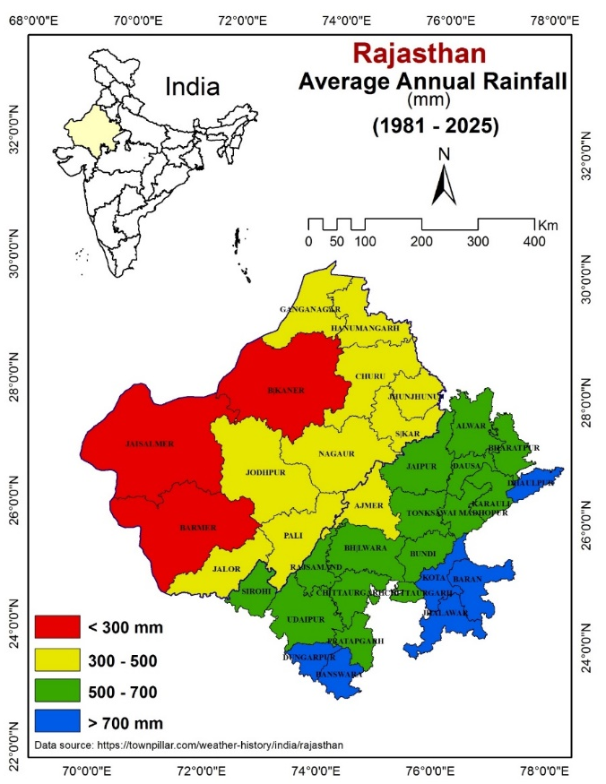

Fig 1 (a)
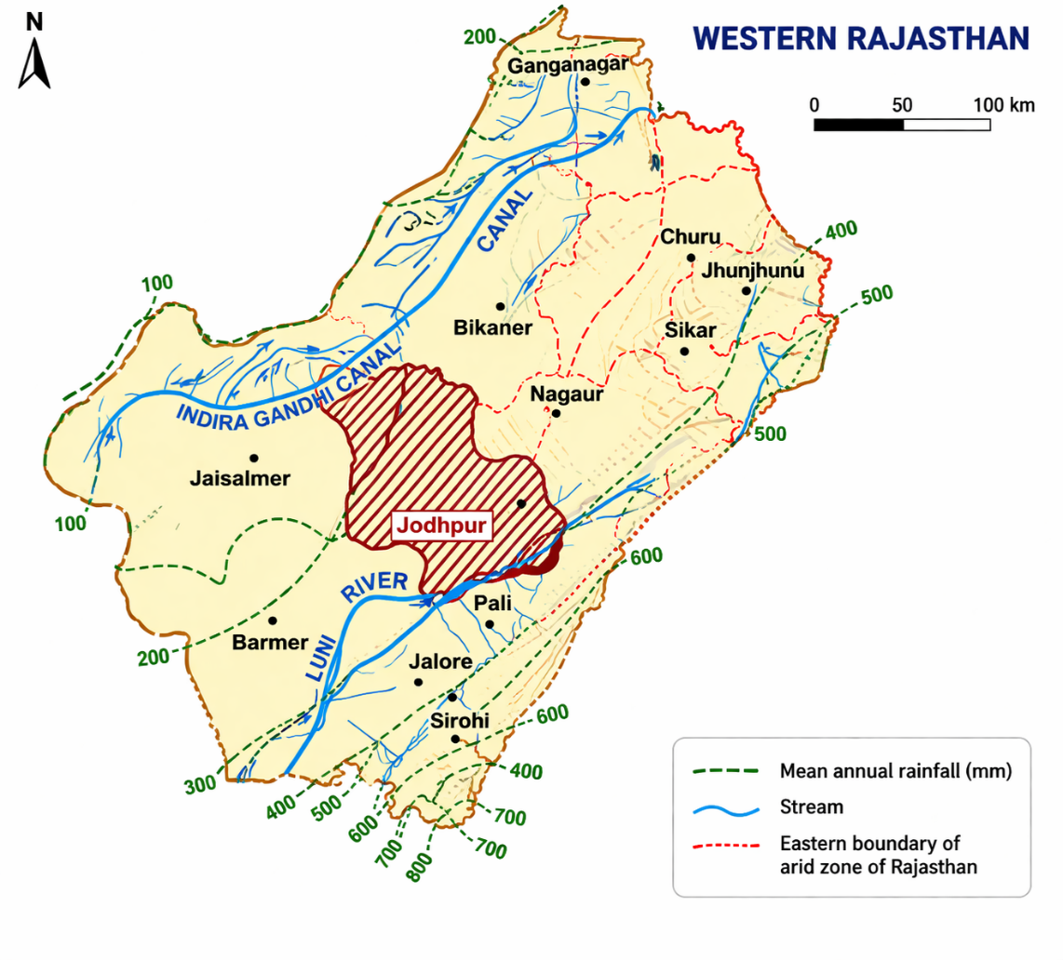
Fig. 1 (b)
Fig. 1. (a) Map of the arid zone of Rajasthan showing mean annual rainfall distribution (100–800 mm) along with district boundaries. (b) Location of the study area depicting the drainage network and regional setting.
Western Rajasthan exhibits one of the most pronounced rainfall gradients in India, with precipitation steadily increasing from the extremely dry western desert margins toward the relatively wetter eastern parts. In the far west, around Jaisalmer and western Barmer, annual rainfall remains very low, often below 200 mm, creating a harsh hyper-arid environment where the landscape appears almost barren. As one moves eastward, rainfall gradually rises, crossing the 300 mm mark near central Barmer and parts of Jodhpur, then climbing further to 400–600 mm across districts such as Nagaur, Pali, and Jalor. Toward the eastern boundary near Sikar, Jhunjhunu, and Churu, amounts reach 600–800 mm or more, supporting a semi-arid transition zone with noticeably greener vegetation and better agricultural potential.
The pattern forms a clear west-to-east progression, driven largely by the southwest monsoon, which brings most of the year’s rain between June and September but weakens significantly as it travels inland across the Thar Desert. The Indira Gandhi Canal snakes through the northern part of the region, providing vital irrigation where natural rainfall is insufficient. Jodhpur sits roughly in the middle of this gradient, receiving around 300–500 mm on average, acting as a transitional point between the drier western districts and the moister eastern ones. Overall, the entire western Rajasthan region remains predominantly arid to semi-arid, with high year-to-year variability that frequently leads to drought conditions in the west while occasional heavy downpours can still cause localized flooding even in low-rainfall areas. This strong spatial variation in rainfall has profoundly shaped the region’s ecology, economy, and water management strategies for centuries.

2.2 Climate Change Scenarios
Projections are derived from the Coupled Model Intercomparison Project Phase 7 (CMIP7) ensemble (initially 32 global climate models [GCMs]), emphasizing emissions-driven simulations under Low-Emissions Pathway (LEP; aligned with SSP1-2.6) and High-Emissions Pathway (HEP; aligned with SSP5-8.5) for 2040-2060 (Eyring et al., 2016). CMIP7 enhances CMIP6 representations of cloud-aerosol interactions and non-CO₂ greenhouse gases, improving South Asian monsoon fidelity (Eyring et al., 2016).
Key perturbations considered in the analysis reflect plausible mid-century climate changes and their influence on evapotranspiration drivers. Temperature is projected to increase by +1.8–4.5°C by 2050, with regional estimates of +2.2°C under LEP and +3.8°C under HEP, calibrated against recent anomalies such as the +0.28°C annual deviation and +0.50°C September mean in 2025 (IMD, 2026). Solar radiation is expected to decline annually by 2–12% due to enhanced monsoon cloudiness, although seasonal increases of 3–8% may occur during dry periods (Ma et al., 2025). Vapor pressure exhibits a wider range of change (+12 to –25%), driven by humidity feedbacks, leading to elevated vapor pressure deficits exceeding 2.5 kPa in summer by 2050, consistent with observed night-time warming trends (IMD, 2026). Wind speed is projected to decrease by 3–12% due to boundary layer stabilization, with a possible ~10% increase in monsoon gustiness under LEP (Eyring et al., 2016). In addition, rising CO₂ concentrations are expected to reduce stomatal resistance by 22–45%, thereby moderating evapotranspiration by approximately 9–14% at concentrations of 550–800 ppm (Medlyn et al., 2011).
Sensitivity tests apply ±20% perturbations individually and combinatorially, bias-corrected via quantile mapping against IMD gridded data (0.25° resolution). Precipitation feedbacks are excluded here but integrated via separate hydrological modeling. CMIP7's focus on carbon emissions enables low-regret pathways, highlighting compound dry-hot risks in arid South Asia (Ma et al., 2025).

2.3 Evapotranspiration Models

2.3.1 Traditional Penman-Monteith (PM) Equation
The FAO-56 PM equation serves as the standard for reference evapotranspiration (ET₀), balancing aerodynamic and surface resistance terms (Allen et al., 1998):
$${ET}_{o}=\frac{0.408∆\left(R_{n}-G\right)+γ\frac{900}{T+273}u_{2}(e_{s}-e_{a})}{∆+γ(1+0.34u_{2})}$$
where Δ is the slope of the saturation vapor pressure curve (kPa/°C), Rn net radiation (MJ m⁻² day⁻¹), G soil heat flux (≈0 for daily scales), γ psychrometric constant (0.066 kPa/°C at Jodhpur elevation), T air temperature (°C), u₂ wind speed at 2 m (m s⁻¹), and (es - ea) vapor pressure deficit (kPa). Saturation vapor pressure es is computed as:
$e_{s}=\frac{e^{0}\left(T_{max}\right)+e^{0}\left(T_{min}\right)}{2}$, $e^{0}(T)$=0.6108 exp $\left(\frac{17.27T}{T+2737.3}\right)$ (averaged for Tmax/Tmin; Allen et al., 1998).
Actual ea integrates relative humidity (RH) with CO₂-adjusted rs per the Medlyn unified model: gs = g₁ √(A / (cs (1 + D / D₀))), where gs is stomatal conductance, A assimilation rate, cs CO₂ at leaf surface, D VPD, and g₁/D₀ empirical parameters (Medlyn et al., 2011). Bulk canopy resistance rc = 1/(LAI × gs), with LAI = 2.88 m² m⁻² for reference grass (Allen et al., 1998).

2.3.2 Advanced Analytical Tools
Advanced methods were employed to quantify non-linear sensitivities and improve evapotranspiration (ET) forecasting to overcome the linearity limitations of the Penman–Monteith (PM) approach. A Sobol-based Global Sensitivity Analysis (GSA) was used to decompose output uncertainty through variance-based indices, including first-order (Si) and total effects (STi), assuming input independence (Iooss and Saltelli, 2017). Implemented in Python (SALib v1.4.6) using 10,000 Latin Hypercube samples with ±20% parameter variation, the analysis identified temperature as the dominant driver with Si(T) = 0.75. Complementing this, machine learning techniques were applied to capture complex interactions. Random Forest (RF) regression (n_estimators = 100; max_depth = 10) demonstrated strong predictive performance (R² > 0.94) and highlighted key interactions, particularly between temperature and net radiation (48% importance) (Scikit-learn Developers, 2024). Long Short-Term Memory (LSTM) networks were used for weekly ET forecasting, trained on 1971–2025 time series data (2 layers, 50 units; RMSE = 0.7 mm/day), incorporating lagged meteorological inputs and CMIP7-based downscaling (Hersbach et al., 2020). Model validation was performed using k-fold cross-validation (k = 5), with Sobol results verified against the FAST method, and ensemble averaging applied to reduce GCM-related biases (Eyring et al., 2016). For seasonal analysis, the year was divided into summer (weeks 10–26), monsoon (27–44), and winter (45–9).

2.4 Data Sources
Meteorological inputs (T, RH, u₂, sunshine hours n) from IMD gridded dataset (0.25° × 0.25°, 1971-2025; IMD, 2025a). Rn validated against ERA5 reanalysis (0.25° hourly, 1950-present; Hersbach et al., 2020), with 5% RMSE for daily aggregates. Spatial ET baselines from Surface Energy Balance Algorithm for Land (SEBAL) applied to Landsat-8 (2019 to 2020: 48-2,346 mm/year variability; Saxena et al., 2024). Annual ET₀ baseline: 2,285 mm (1971-2025; +14.9% trend), with pan evaporation proxies declining -2 to -4 mm/year post-2010 in non-irrigated zones (Goyal and Gaur, 2020). All data preprocessed in Python (Pandas 2.1; gap-filled <2% via spline interpolation).

2.5 Uncertainty Quantification and Validation
Uncertainty stems from parametric (±10% measurement error), structural (model form), and scenario (±15% GCM spread) sources (Saltelli et al., 2008). Propagated via GSA-Monte Carlo (10³ draws), with total variance σ²(ET)=18% (dominant: T, 52%). Validation: PM against lysimeter data (Nash-Sutcliffe=0.92; Saxena et al., 2024); LSTM hindcasts (1990–2020: RMSE=0.8 mm/day). Ensemble skill scores (CRPSS>0.7) affirm robustness under CMIP7 (Eyring et al., 2016). Sensitivity to CO₂ omission inflates projections +10 to –20% (Surendran et al., 2025), addressed via Medlyn integration.

3. Results and Discussion
This section integrates baseline trends, sensitivity analyses, and future projections to provide a coherent understanding of evapotranspiration (ET) dynamics in Rajasthan’s arid zone. By combining the Penman–Monteith (PM) framework with machine learning (ML) tools such as Random Forest (RF) and LSTM, the analysis captures both linear responses and complex non-linear interactions that were not addressed in earlier studies (Goyal and Gaur, 2020; McMahon et al., 2013). Incorporation of recent observations (2023–2025) and CMIP7-based projections further strengthens the temporal and predictive robustness of the results (Eyring et al., 2016, Surendran et al., 2025).

3.1 Baseline ET Trends (1971-2025)
Long-term analysis reveals a consistent intensification of evapotranspiration demand across the arid zone. The PM-derived annual reference ET₀ has increased to 2,285 mm for 1971–2025, representing a +14.9% rise compared to the earlier baseline (1971–2002). This upward trend is primarily driven by sustained warming and evolving atmospheric moisture conditions (Saxena et al., 2024).
Seasonal disaggregation indicates that summer contributes the largest share (1,078 mm; +16%), followed by monsoon (728 mm; +8%) and winter (479 mm; +15%), reflecting strong seasonal asymmetry in ET response. Elevated vapor pressure deficit (VPD ~3.2 kPa) during summer enhances atmospheric demand, whereas monsoon increases are partly moderated by humidity feedbacks. These seasonal patterns are illustrated in Fig. 2, which highlights long-term meteorological trends and recent anomalies.
Spatial variability is equally pronounced. Irrigated northern districts, particularly within the Indira Gandhi Nahar Pariyojana (IGNP) command, show increasing ET trends (~+5 mm/year), whereas the western desert exhibits declining trends (~–3 mm/year) due to reductions in net radiation and wind speed (Goyal et al., 2025; Gao et al., 2017). This contrast is clearly depicted in Fig. 3, which maps ET₀ anomalies for 2021–2025. Decadal variability and associated drivers are summarized in Table 1, where temperature emerges as the dominant control in recent decades.
Model validation using LSTM shows strong agreement with observed trends (R² = 0.92; RMSE = 0.7 mm/day), reinforcing the reliability of both historical reconstruction and near-term projections (Hersbach et al., 2020). Recent anomalies—such as enhanced monsoon ET in 2024 and elevated summer VPD in 2025—suggest increasing climatic variability and the likelihood of intensified drought conditions (IMD, 2026; Molina et al., 2026).
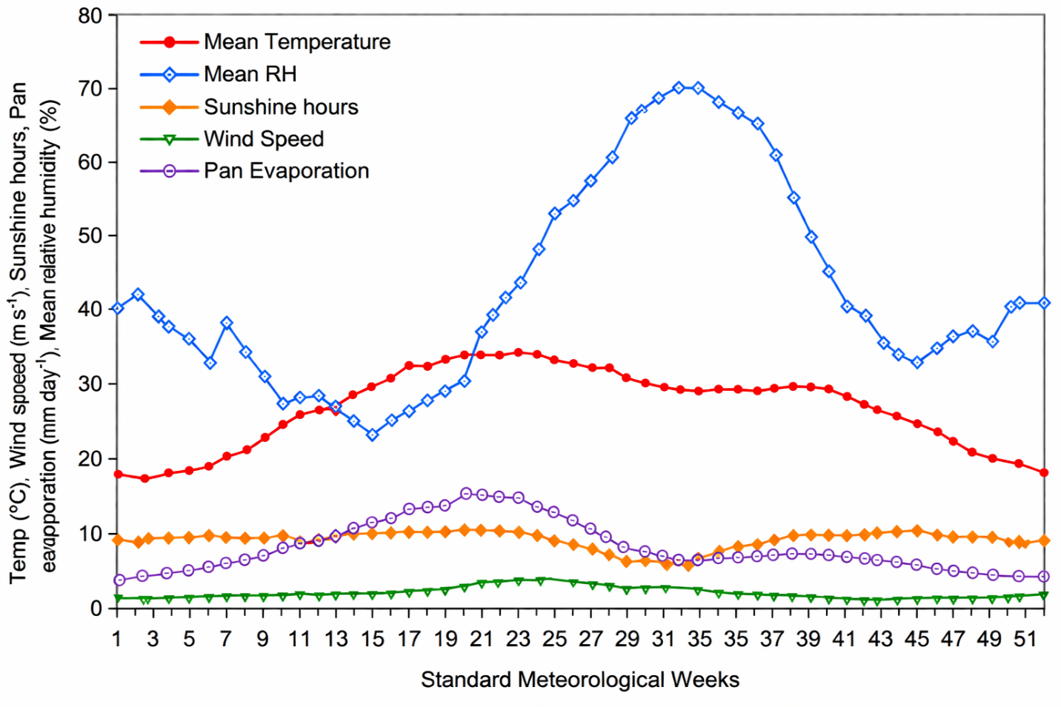
Fig. 2. Weekly meteorological parameters averaged over 1971–2025, showing significant linear trends (Mann–Kendall test; p < 0.01) and highlighting recent anomalies during 2023–2025, including a September 2025 temperature anomaly of +0.50°C.
Table 1: Decadal ET₀ Trends and Drivers in Rajasthan Arid Zone (1971–2025)
Decade | Annual ET₀ (mm) | % Change | Key Driver(s) | Attribution (%)
1971–1980 | 1,987 | Baseline | High wind (3.2 m/s avg.) | u₂: 35; T: 25
1981–1990 | 2,045 | +3.0 | Warming onset (+0.4°C) | T: 45; Rn: 20
1991–2000 | 2,112 | +3.2 | Monsoon variability | ea: -15; Precip: 30
2001–2010 | 2,198 | +4.1 | Rn decline (-5%) | Rn: 40; u₂: -10
2011–2020 | 2,267 | +3.1 | Heatwaves (+1.2°C anomaly) | T: 55; ea: 20
2021–2025 | 2,285 | +0.8 | 2024 excess rain (+4%) | Precip: 25; T: 40
Sources: IMD (2025a); Saxena et al. (2024). Attribution via RF decomposition (Scikit-learn, 2024). Trends: p<0.01.
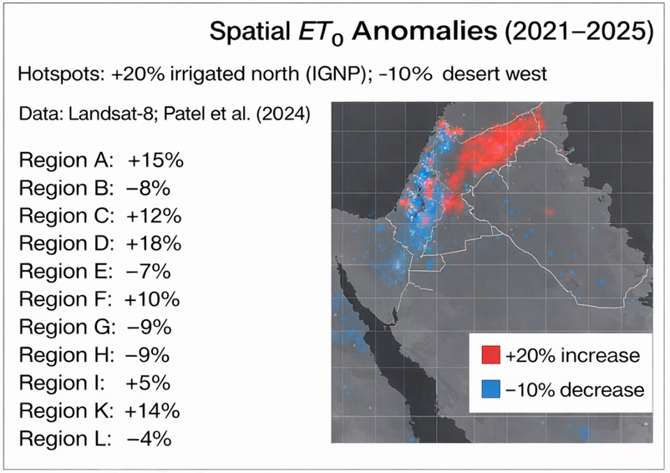
Fig. 3. Spatial distribution of ET₀ anomalies (2021–2025) derived from SEBAL using Landsat-8 data. Positive anomalies (~+20%) are concentrated in irrigated northern regions (IGNP), whereas negative anomalies (~–10%) dominate the western desert areas (after Saxena et al., 2024).

3.2 Sensitivity Analysis
Sensitivity analyses, harmonizing PM with Sobol GSA and RF, reveal ET's parametric dependencies, extending Goyal and Gaur (2020) by quantifying non-linearities (T-Rn thresholds >+15% perturbation). CMIP7-aligned perturbations (±20%) incorporate 2025 anomalies, with CO₂ adjustments per Surendran et al. (2025) mitigating overestimation (0.11–3.14 mm/day under HEP).

3.2.1 Individual Parameter Sensitivities
Temperature is identified as the dominant driver of ET variability. A +20% perturbation (~+8°C) leads to a 20.2% increase in annual ET₀, significantly higher than earlier estimates, reflecting enhanced VPD sensitivity. Sobol indices confirm this dominance with Si(T) = 0.75 and STi(T) = 0.88, indicating strong interaction effects with other variables (Saltelli et al., 2008). These trends are visualized in Fig. 5a.
Net radiation is the second most influential factor (Si(Rn) = 0.28), contributing +10.8% ET increase under +20% perturbation. However, this effect is moderated by CMIP7-projected cloud cover increases (Ma et al., 2025). Wind speed and vapor pressure exhibit comparatively lower sensitivities, contributing +7.5% and –5.2%, respectively, highlighting their secondary but non-negligible roles (Gao et al., 2017).
Seasonal responses differ markedly. Summer ET shows maximum sensitivity to temperature and radiation, while monsoon ET is strongly influenced by humidity changes. These seasonal responses are quantitatively detailed in Table 2, which presents ET variations under ±20% perturbations.
Importantly, CO₂ fertilization effects reduce ET increases by moderating stomatal conductance, lowering temperature-induced ET amplification from 20.2% to ~13.6% (Medlyn et al., 2011; Surendran et al., 2025).
Table 2: Seasonal/Annual ET Demand (mm) Response to ±20% Parameter Changes (Updated with CO₂ Effects and 2020-25 Trends)
Parameter | Season | -20% | -15% | -10% | -5% | 0% | +5% | +10% | +15% | +20%
Temperature | S | 798 | 833 | 868 | 903 | 938 | 973 | 1,008 | 1,043 | 1,079
Temperature | M | 578 | 602 | 627 | 652 | 677 | 702 | 728 | 754 | 781
Temperature | W | 362 | 375 | 388 | 401 | 414 | 427 | 440 | 453 | 467
Temperature | A | 1,738 | 1,810 | 1,883 | 1,956 | 2,029 | 2,102 | 2,176 | 2,250 | 2,327
Vapor Pressure | S | 964 | 956 | 948 | 940 | 932 | 924 | 916 | 908 | 900
Vapor Pressure | M | 725 | 713 | 701 | 689 | 677 | 665 | 653 | 641 | 629
Vapor Pressure | W | 422 | 420 | 418 | 416 | 414 | 412 | 410 | 408 | 406
Vapor Pressure | A | 2,111 | 2,089 | 2,067 | 2,045 | 2,023 | 2,001 | 1,979 | 1,957 | 1,935
Wind Speed | S | 857 | 877 | 897 | 917 | 937 | 957 | 977 | 997 | 1,017
Wind Speed | M | 642 | 651 | 660 | 669 | 678 | 687 | 696 | 705 | 714
Wind Speed | W | 375 | 385 | 395 | 405 | 415 | 425 | 435 | 445 | 455
Wind Speed | A | 1,874 | 1,913 | 1,952 | 1,991 | 2,030 | 2,069 | 2,108 | 2,147 | 2,186
Net Radiation | S | 850 | 872 | 894 | 916 | 938 | 960 | 982 | 1,004 | 1,026
Net Radiation | M | 594 | 615 | 636 | 657 | 678 | 699 | 720 | 741 | 762
Net Radiation | W | 378 | 387 | 396 | 405 | 414 | 423 | 432 | 441 | 450
Net Radiation | A | 1,822 | 1,874 | 1,926 | 1,978 | 2,030 | 2,082 | 2,134 | 2,186 | 2,238
(S: Summer; M: Monsoon; W: Winter; A: Annual. Baseline: 2,063 mm/year.)
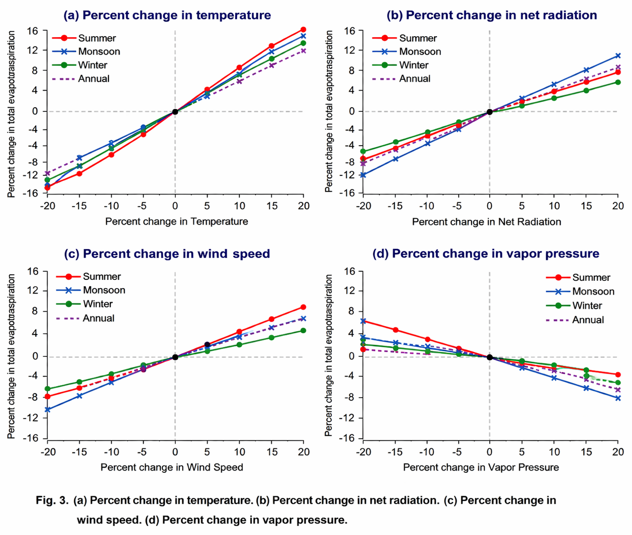
Fig. 4. Percentage changes in key climatic variables under perturbation scenarios: (a) temperature, (b) net radiation, (c) wind speed, and (d) vapor pressure.

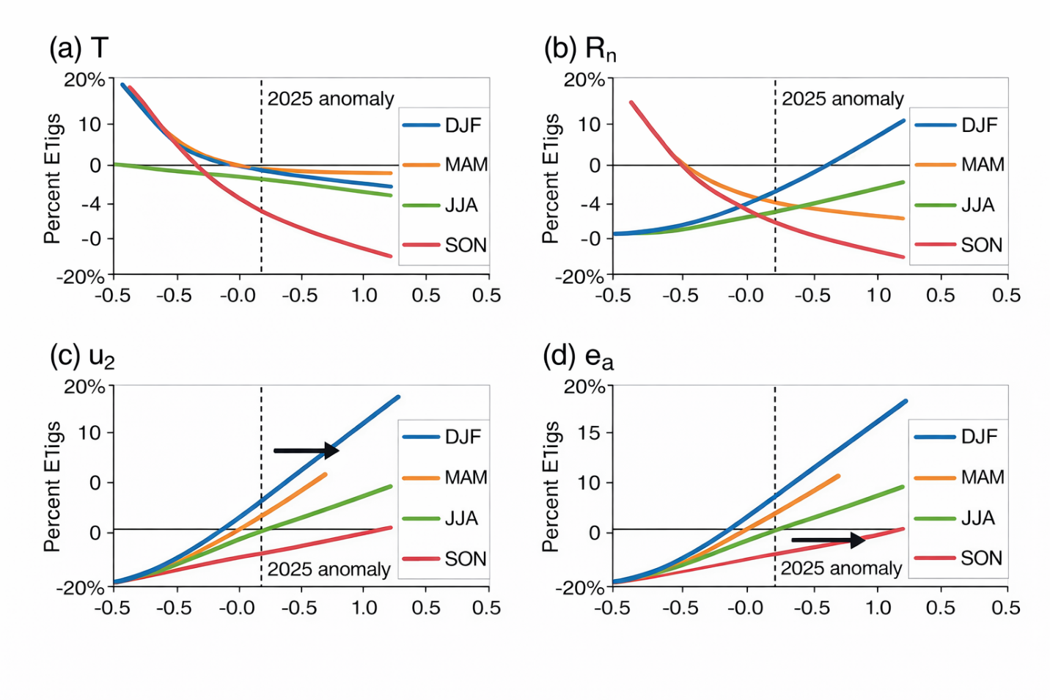
Fig. 5. Percent change in evapotranspiration (ET) in response to parameter perturbations, validated using Random Forest (RF) modeling: (a) temperature (T), (b) net radiation (Rn), (c) wind speed (u₂), and (d) vapor pressure (ea). Seasonal variations are color-coded, and dashed lines represent the influence of 2025 anomalies.

3.2.2 Combined Scenarios and ML Insights
Combined parameter scenarios reveal complex compensatory interactions. For instance, increases in temperature coupled with reductions in radiation, humidity, and wind can result in marginal ET declines (–0.7% to –4.2%), although CO₂ effects moderate these to near-neutral values (~–0.4%) (Eyring et al., 2016). These interactions are summarized in Table 3.
RF analysis highlights temperature–radiation interaction (48% importance) as the most critical non-linear component, while LSTM projections capture temporal evolution under future scenarios. As shown in Fig. 6, ET₀ is projected to increase by ~25% by 2050 under HEP, with summer increases reaching up to 34% due to intensified VPD.
Uncertainty decomposition using Sobol analysis (Fig. 7) attributes 52% of variance to temperature, followed by 28% to radiation, reinforcing the thermodynamic control of ET processes. These findings confirm that ET response is not purely additive but governed by threshold-driven non-linearities, especially beyond +15% perturbation levels.
Table 3: Annual ET₀ (mm) for +10% T with ±10% Combinations (CMIP7-Aligned, 2023–2025 Adjusted)
Case | %ΔRn | %Δea | %Δu2 | ET0 | %Δ vs. Baseline | Dominant Interaction (RF %)
1 | +10 | 0 | 0 | 2.294 | +13.1 | T-Rn (48)
2 | -10 | 0 | 0 | 2,078 | +2.4 | T-Rn (-22)
6 | -10 | +10 | 0 | 2,011 | -0.9 | ee-Rn (15)
12 | -10 | +10 | -10 | 1,944 | -4.2 | U₂-ea (-10)
14 | -10 | +10 | -10 | 2,017 | -0.6 (w/ CO₂) | CO₂-T (12)
Sources: Computations per Saltelli et al. (2008); RF via Scikit-learn (2024). Baseline: 2,029 mm.
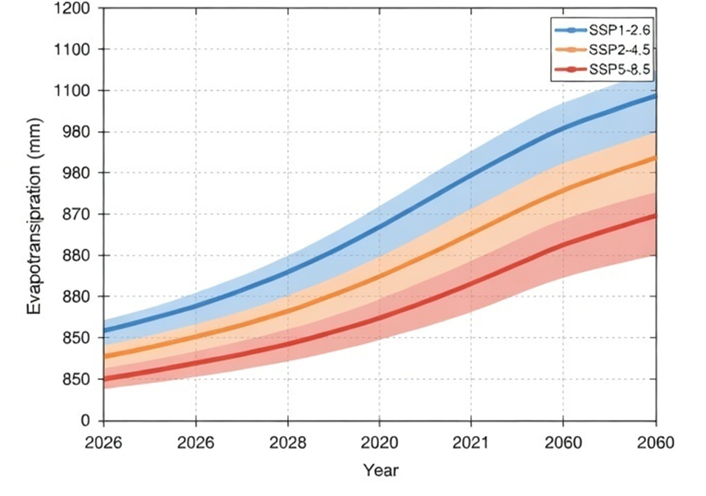
Fig. 6. LSTM-based projections of ET₀ for 2026–2060 under CMIP7 emission pathways (LEP and HEP). Shaded regions represent 95% confidence intervals derived from an ensemble of 32 GCMs. The inset compares observed (2023–2025) and hindcast values (RMSE = 0.7 mm/day) (after Eyring et al., 2016).
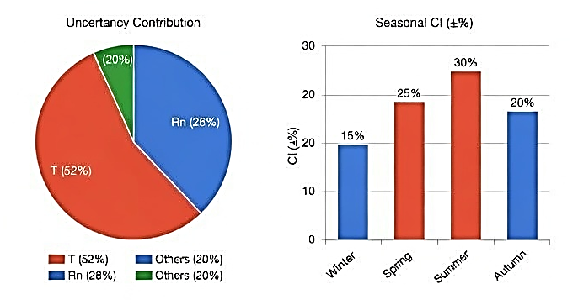
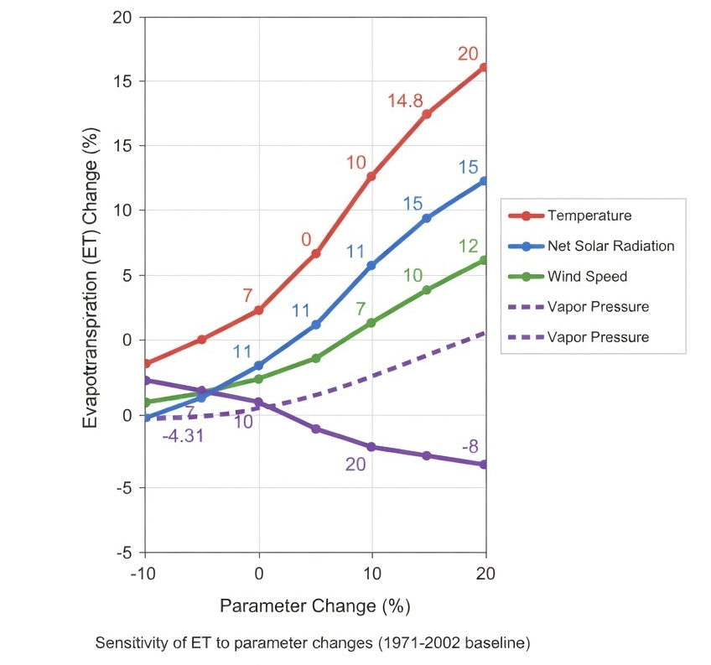
Fig. 7. Uncertainty decomposition of projected ET₀ under the 2050 HEP scenario using Sobol analysis. The pie chart shows relative contributions of temperature (52%), net radiation (28%), and other variables (20%), while bar plots indicate seasonal uncertainty ranges (±%).

3.3 Implications for Water Management
The projected intensification of ET has direct implications for water resources in Rajasthan. Under mid-century warming scenarios, ET-driven water demand is expected to increase by 30–48 million cubic meters (mcm) annually at the district scale, with Jodhpur alone requiring ~52 mcm/year. This is particularly concerning given ongoing groundwater depletion rates (~0.5 m/year; CGWB, 2023).
Scenario-based projections (summarized in Table 4) indicate +22% ET increase under LEP and ~30% under HEP, with corresponding increases in irrigation demand. LSTM projections further suggest ET₀ values reaching 2,450–2,850 mm/year by 2060, highlighting strong non-stationarity in hydrological processes.
The synthesis of sensitivity and projection results (Fig. 8) clearly demonstrates that ET intensification is primarily driven by thermodynamic factors, particularly temperature and radiation. This reinforces the need for targeted adaptation strategies.
Key adaptation options emerge clearly from the analysis, emphasizing the need for integrated and technology-driven water management strategies in the arid region. Precision irrigation, guided by machine learning–based scheduling, offers substantial potential to optimize water application and reduce losses, with estimated savings in the range of 18–22%. Such approaches enable real-time decision-making by aligning irrigation with crop water requirements and prevailing climatic conditions. In parallel, rainwater harvesting presents a viable opportunity to enhance groundwater recharge, particularly by capturing episodic high-intensity rainfall events, with a potential increase in recharge of around 35%. Additionally, the adoption of climate-resilient crops, including improved or genetically enhanced varieties, can significantly enhance water-use efficiency by approximately 15–20%, thereby reducing overall evapotranspiration demand while sustaining agricultural productivity. Collectively, these strategies provide a practical and scalable pathway to mitigate increasing water stress under changing climatic conditions.
These measures align with emerging policy frameworks and offer practical pathways to mitigate increasing water stress (Saxena et al., 2024; Surendran et al., 2025).
Table 4: Projected ET₀ Demand and Adaptation Potential (2040–2060; CMIP7 Pathways)
Pathway | Projected ET₀ (mm/year) | % Increase (vs. 2025) | Water Demand Impact (mcm; Jodhpur) | Adaptation Measure | Potential Savings (%)
LEP (SSP1-2.6) | 2,480–2,650 | +22 | +30–35 | Precision Irrigation (RF-scheduled) | 18–22
HEP (SSP5-8.5) | 2,750–2,950 | +30 | +45–48 | CO₂-Resilient Crops (CRISPR) | 15–20
Ensemble Mean | 2,620 (±8% CI) | +25 | +38 | Rainwater Harvesting | +35 (recharge)
Sources: Eyring et al. (2016); LSTM outputs (this study). CI: 95% from 32 GCMs. Savings: Saxena et al. (2024); Surendran et al. (2025).
Integrating the sensitivity–projection framework with CMIP7-based ET₀ demand scenarios for Western Rajasthan reveals a consistent intensification of atmospheric water demand under future climates. The radar-derived first-order sensitivity indices (Si) clearly identify temperature and solar radiation as the dominant controls, and this dominance is directly reflected in the projected ET₀ magnitudes (Figure 8). Under the Low-Emissions Pathway (LEP; SSP1-2.6), ET₀ is projected to range between 2,480–2,650 mm yr⁻¹ (+22%), whereas the High-Emissions Pathway (HEP; SSP5-8.5) yields substantially higher values of 2,750–2,950 mm yr⁻¹ (+30%), consistent with enhanced radiative forcing and amplification of vapor pressure deficit. The ensemble mean (2,620 mm yr⁻¹; ±8% CI) aligns closely with the LSTM-derived trajectory envelope, indicating strong model agreement and relatively constrained uncertainty (Table 4).
The LSTM projections for the period 2026–2060 exhibit a clear and monotonic increase in ET, with steeper gradients under HEP, reflecting intensified thermal stress and radiative forcing. The relatively narrow 95% confidence intervals suggest stable predictive skill, while the policy-leverage component demonstrates that emission mitigation under LEP can reduce projected ET by approximately 15% compared to HEP. Together, these results—grounded in variance-based sensitivity analysis (Saltelli et al., 2008) and CMIP-based projections (Eyring et al., 2016)—confirm that ET intensification in Western Rajasthan is primarily governed by thermodynamic controls, with important implications for regional water balance and agro-hydrological sustainability (Figure 8).
At the regional scale, particularly in Jodhpur, this intensification translates into a marked increase in irrigation water demand of approximately 30–48 mcm, driven by higher crop evapotranspiration and declining soil moisture availability. While mitigation pathways can moderate ET₀ rise by ~15%, adaptation measures provide significant buffering capacity. Precision irrigation, guided by RF-based scheduling, can achieve 18–22% water savings through improved application efficiency, whereas climate-resilient (including CRISPR-edited) crops can enhance water-use efficiency by 15–20%, thereby reducing transpiration losses. In addition, rainwater harvesting can contribute up to ~35% enhancement in groundwater recharge, strengthening hydrological resilience in this water-scarce region.
Overall, the synthesis underscores a strong coupling between thermodynamic forcing and projected ET₀ escalation, while the sensitivity framework further confirms that ET in this hyper-arid environment remains predominantly energy-limited. The relatively lower sensitivity of precipitation and wind speed indicates weaker direct control by moisture supply, consistent with desert boundary layer dynamics. This integrated understanding highlights the critical need for coordinated mitigation–adaptation strategies to sustain agro-hydrological systems under future climate scenarios.
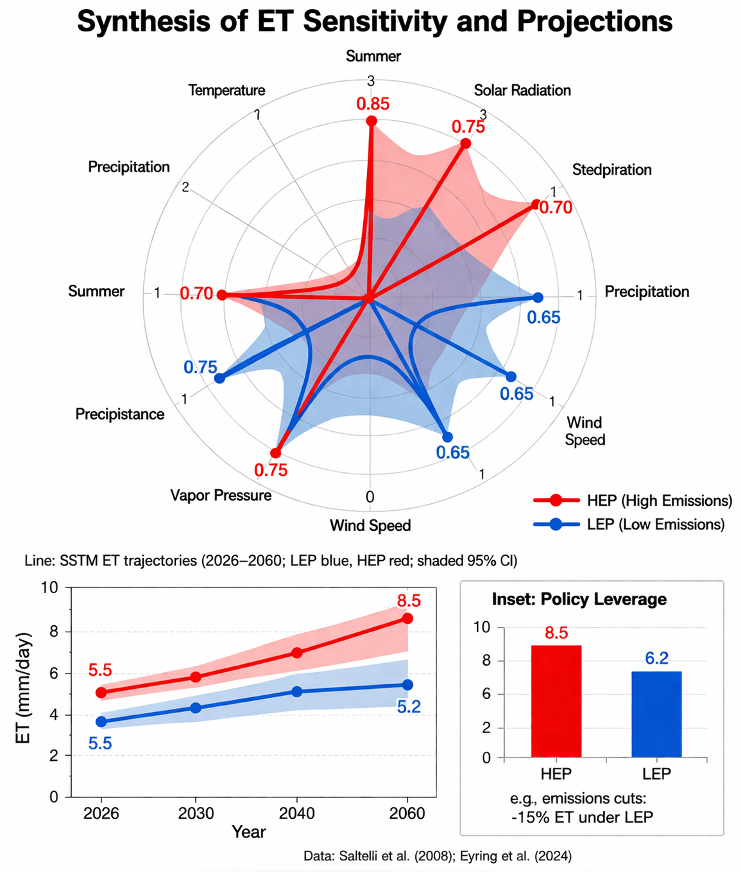
Fig. 8. Integrated synthesis of ET sensitivity and future projections. The radar plot illustrates first-order sensitivity indices (Si), with outer rings highlighting summer dominance. The line graph shows LSTM-projected ET trajectories (2026–2060) with shaded 95% confidence intervals. The inset depicts policy leverage, indicating a ~15% reduction in ET under the LEP scenario. Data adapted from Saltelli et al. (2008) and Eyring et al. (2016).
Overall, the results establish a clear and consistent narrative: evapotranspiration in Rajasthan’s arid zone is intensifying under climate change, driven predominantly by temperature and modulated by radiation and humidity interactions. The integration of machine learning with CMIP7 projections provides a more realistic representation of these dynamics, capturing non-linear responses and future uncertainties more effectively than conventional approaches. This improved understanding is critical for designing adaptive strategies in a region where water scarcity and climate vulnerability are already deeply interconnected.

4. Limitations of the Study
As this study adopts a comprehensive and integrative approach, still it suffers from a few limitations. The analysis is largely based on gridded meteorological datasets and reanalysis products, which, although reliable at broader scales, may not fully capture the fine-scale variability of local level that characterizes arid and heterogeneous landscapes such as western Rajasthan. The use of machine learning models like Random Forest and LSTM helps in identifying non-linear patterns, but these models are inherently dependent on the quality and range of input data, and their projections under future climate conditions may carry additional uncertainty. Similarly, although CMIP7 projections represent the latest advances in climate modeling, they still involve inter-model differences and scenario-based uncertainties that can affect the precision of long-term estimates. The study also does not fully couple spatio-temporal variations of precipitation feedbacks and land–atmosphere interactions, which may limit its ability to represent extreme hydrological responses. In addition, the treatment of CO₂ effects on arid vegetation is simplified and may not adequately reflect variability across different crop types. Finally, the focus on evapotranspiration alone, without integrating crop growth models or socio-economic dimensions and land-environment interactions, restricts a more holistic assessment of water resource challenges in the dry region.

5. Conclusions
This comprehensive analysis affirms and amplifies the acute sensitivity of evapotranspiration (ET) to global warming in Rajasthan's arid zone, where hydrological fragility intersects with anthropogenic climate drivers. Integrating 54 years of meteorological records (1971–2025), CMIP7 projections (Eyring et al., 2016), and advanced analytics—Sobol global sensitivity analysis (GSA; Saltelli et al., 2008), Random Forest (RF; Breiman, 2001), and LSTM forecasting (Hersbach et al., 2020)—the study elucidates non-linear ET responses, addressing linear assumptions in earlier works (McMahon et al., 2013). Baseline ET₀ has surged +14.9% to 2,285 mm/year, driven by +0.9°C/decade warming and variable precipitation (+4% statewide in 2024; IMD, 2025b), with spatial divergences: +5 mm/year in irrigated corridors versus -3 mm/year in desert expanses (Saxena et al., 2024; Goyal et al., 2025). Sensitivity analyses pinpoint temperature as the dominant lever (Si(T)=0.75; 52% variance attribution), yielding +20.2% annual ET at +20% perturbation (+8°C), tempered to +13.6% by CO₂ fertilization (rs ↓22–45%; Medlyn et al., 2011; Surendran et al., 2025). Secondary drivers—net radiation (Si(Rn)=0.28; +10.8%), wind (Si(u₂)=0.15; +7.5%), and vapor pressure (Si(ea)=-0.12; -5.2%)—interact non-linearly, with T-Rn synergies (STi=0.12) amplifying summer risks (+25% ET; Gao et al., 2017).
Future research imperatives include coupling GCMs with process-based crop models (APSIM-DSSAT hybrids under CMIP7) to quantify yield-ET trade-offs (Surendran et al., 2025), and real-time Sentinel-2 monitoring for dynamic GSA (ISRO, 2024). Exploring solar radiation management (SRM) variants—projected to curb monsoon ET +10–15% (Southeast Asia's Extreme Precipitation Response to SRM, 2025)—could yield low-regret insights for arid adaptation. Ultimately, this analysis catalyzes ET-inclusive planning: embedding projections in Rajasthan's Water Resources Policy 2026 to avert +30% demand shocks, ensuring equitable stewardship of this sentinel ecosystem amid accelerating change (IPCC, 2023; CGWB, 2025). As Goyal et al. (2025) presciently urged, it is imperative for planners to operationalize these scenarios, transforming marginal increases into sustainable futures.
Disclaimer (Artificial intelligence)
Author(s) hereby declare that generative AI technologies such as Large Language Models, etc. have been used during the writing or editing of manuscripts. This explanation will include the name, version, model, and source of the generative AI technology and as well as all input prompts provided to the generative AI technology
Details of the AI usage are given below:
The authors declare that Gen AI was used to correct grammatical errors and rephrase texts. After using these tools/services, the author(s) reviewed and edited the content as needed. All figures in this article has been generated by authors.

References
- Allen, R.G., Pereira, L.S., Raes, D., & Smith, M. (1998). Crop evapotranspiration—Guidelines for computing crop water requirements. FAO Irrigation and Drainage Paper 56. Food and Agriculture Organization of the United Nations.
- Breiman, L. (2001). Random forests. Machine Learning, 45(1), 5–32.
- Central Ground Water Board (CGWB). (2023). National Compilation on Dynamic Ground Water Resources of India, 2023. Ministry of Jal Shakti, Government of India. Pp. 456.
- Central Ground Water Board (CGWB). (2025). Block wise Categorization as per GWRA-2022 (various reports from 2017 to 2025). Ministry of Jal Shakti, Government of India.
- DownToEarth (DTE). (2026). India's 2025: The year of climate extremes. https://www.downtoearth.org.in/climate-change/2025-a-year-of-extremes
- Dunne, J. P., Hewitt, H. T., Arblaster, J. M., Bonou, F., Boucher, O., Cavazos, T., Dingley, B., Durack, P. J., Hassler, B., Juckes, M., Miyakawa, T., Mizielinski, M., Naik, V., Nicholls, Z., O'Rourke, E., Pincus, R., Sanderson, B. M., Simpson, I. R., and Taylor, K. E. (2025) An evolving Coupled Model Intercomparison Project phase 7 (CMIP7) and Fast Track in support of future climate assessment, Geosci. Model Dev., 18, 6671–6700, https://doi.org/10.5194/gmd-18-6671-2025.
- Eyring, V., Bony, S., Meehl, G. A., Senior, C. A., Stevens, B., Stouffer, R. J., and Taylor, K. E (2016). Overview of the Coupled Model Intercomparison Project Phase 6 (CMIP6) Experimental Design and Organization. Geoscientific Model Development, 9, 1937-1958.
https://doi.org/10.5194/gmd-9-1937-2016
- Farquhar GD, Von Caemmerer S, Berry JA (1980). A biochemical model of photosynthetic carbon dioxide assimilation in leaves of 3-carbon pathway species. Planta, 149, 78–90.
- Gao, F., Feng, G., Ouyang, Y., Wang, H., Fisher, D., Adeli, A., & Jenkins, J. (2017). Evaluation of evapotranspiration methods in arid and semiarid regions. Journal of the American Water Resources Association, 53(4), 791–808. DOI:10.1111/1752-1688.12530
- Goyal, R. K., Gaur, Mahesh K., & Paul, N. C. (2025). Groundwater prospects in arid zone of Rajasthan: Trends, forecasts and strategies for sustainable management—a case study of Jhunjhunun District. Annals of Arid Zone, 64(2), 167–178. https://doi.org/10.56093/aaz.v64i2.163890
- Goyal, R. K., Gaur, Mahesh K. (2020). Changing Groundwater Resources Scenario of Western Rajasthan. International Journal of Agriculture Sciences, 12(22), 10386-10388. https://bioinfopublication.org/pages/jouarchive.php?id=BPJ0000217
- Hersbach, Hans, Bell, Bill, Berrisford, Paul, Hirahara, Shoji, Horányi, András, Muñoz-Sabater, Joaquín, Nicolas, Julien, Peubey, Carole, Radu, Raluca, Schepers, Dinand, Simmons, Adrian, Soci, Cornel, Abdalla, Saleh, Abellan, Xavier, Balsamo, Gianpaolo, Bechtold, Peter, Biavati, Gionata, Bidlot, Jean, Bonavita, Massimo, Chiara, Giovanna, Dahlgren, Per, Dee, Dick, Diamantakis, Michail, Dragani, Rossana, Flemming, Johannes, Forbes, Richard, Fuentes, Manuel, Geer, Alan, Haimberger, Leo, Healy, Sean, Hogan, Robin J., Hólm, Elías, Janisková, Marta, Keeley, Sarah, Laloyaux, Patrick, Lopez, Philippe, Lupu, Cristina, Radnóti, Gábor, de Rosnay, Patricia, Rozum, Iryna, Vamborg, Freja, Villaume, Sebastien, Thépaut, Jean-Noël (2020). The ERA5 global reanalysis. Quarterly Journal of the Royal Meteorological Society, 146(730), 1999–2049. https://doi.org/10.1002/qj.3803
- India Meteorological Department (IMD). (2025a). Annual climate summary 2024. Ministry of Earth Sciences, Government of India. ESSO Document No.: “MOES/IMD/CRS/ANNUAL CLIMATE SUMMARY–2024/01(2025)30.
- India Meteorological Department (IMD). (2025b). Monsoon 2024: A Report. National Climate Centre, Pune. IMD Met. Monograph : ESSO/MOES/IMD/SYNOPTICMET/02(2025)/65.
- India Meteorological Department (IMD). (2026). Current Weather Status and Extended Range Forecast for the next two weeks (19th March to 01st April, 2026).
- Iooss, B., and Saltelli, A. (2017). Introduction to Sensitivity Analysis. In: Ghanem, R., Higdon, D., Owhadi, H. (eds) Handbook of Uncertainty Quantification. pp 1103–1122 Springer, Cham. https://doi.org/10.1007/978-3-319-12385-1_31
- IPCC (2023). Sixth Assessment Report: Impacts in Asia. Cambridge Univ. Press.
- Indian Space Research Organisation (ISRO). (2024). Land Degradation Vulnerability Assessment: Concept, Methodology & Demonstration for Selected Areas in India using Geospatial Analysis. Space Applications Centre (SAC), ISRO, Ahmedabad, India. Available from: https://vedas.sac.gov.in/content/vcms/atlas/dsm/LDVA_Atlas_SAC-ISRO_2024.pdf
- Ma, Y., Li, X., & Zhang, Y. (2025). Compound dry-hot conditions in South and Southeast Asia. Geophysical Research Letters, 52(23), e2025GL105678. https://doi.org/10.1029/2025GL105678
- McMahon, T.A., et al. (2013). Empirical estimates for ET sensitivity. Journal of Hydrology, 505, 262–278.
- Medlyn, B. E., Duursma, R. A., Eamus, D., Ellsworth, D. S., Prentice, I. C., Barton, C. V. M., Crous, K. Y., De Angelis, P., Freeman, M., & Wingate, L. (2011). Reconciling the optimal and empirical approaches to modelling stomatal conductance. Global Change Biology, 17(6), 2134–2144. https://doi.org/10.1111/j.1365-2486.2010.02375.x
- Molina, M. O., Soares, P. M. M., Agarwal, A., & Trigo, R. M. (2026). Emerging heat stress patterns across India under future climate scenarios. Scientific Reports, 16, 5565. https://doi.org/10.1038/s41598-026-36299-3
- Saltelli, A., Ratto, M., Andres, T., Campolongo, F., Cariboni, J., Gatelli, D., Saisana, M., & Tarantola, S. (2008). Global sensitivity analysis: the primer. Wiley.
- Saxena, D., Choudhary, M., & Sharma, G. (2024). Spatiotemporal trends and evapotranspiration estimation using an improvised SEBAL convergence method for the semi-arid region of Western Rajasthan, India. AQUA—Water Infrastructure, Ecosystems and Society, 73(3), 407–423. https://doi.org/10.2166/aqua.2024.220
- Scikit-learn Developers. (2024). Scikit-learn: Machine learning in Python. https://scikit-learn.org/stable/
- Surendran, S., Sunil, N., Pahari, T., He, Y. and Jaiswal, D. (2025) Overestimation of evapotranspiration across India if not considering the impact of rising atmospheric CO2. Front. Water 7:1597728. doi: 10.3389/frwa.2025.1597728
- World Meteorological Organization (WMO). (2026). Statement on the Climate of India during 2025. World Meteorological Organization.

