Environmental and Socioeconomic Implications of Wetland Dynamics in Bamenda III Sub Division, North West Region, Cameroon

ABSTRACT
Uncontrolled urban population growth in Bamenda III Sub-Division, coupled with the human activities has led to escalating wetland degradation which manifests in the form of reclamation, settlement and construction with consequence on wetland ecosystem services. This study sought to examine the socio-economic and environmental implications of wetland dynamics in Bamenda III subdivision. The research employed a mixed-methods approach, integrating spatial analysis of Landsat imagery (2007-2025) to quantify land use change. One hundred and fifty - three (153) questionnaires were administered to the population around wetland areas. This was complimented by interviews with the following municipal and community stakeholders. Data was analyzed using descriptive statistical techniques such as frequencies, percentages and averages with the aid of Microsoft Office (2016) and Statistical Package for Social Sciences (SPSS) version 20. Data was presented using maps, tables, bar graphs, histograms and pie charts and shape files were displayed in ArcGIS 10.8. Secondary data sources were also consulted to complement the primary sources. Results revealed that while majority of the population (35.71%) in the SE Zone of Bamenda III are faced with land use conflicts linked to wetland dynamics, those of the NW Zone are characterized by displacement and poverty (7.40%). Pollution and loss of water resources have the highest percentage of 33.33% in the NW Zone of Bamenda III and 7.41% attested to increased flooding. The study therefore recommends that the Bamenda III council should adopt effective land use and zoning control measures to ameliorate the impact of land use change and wetland impacts in the study area. The council should work with the traditional authorities to ensure the protection and sustainable management of the wetlands. The population of Bamenda III should be involved in decisions concerning wetland management and be sensitized on their importance.
Key words: Wetland dynamics, degradation, reclamation, environmental implications

Introduction
Wetlands, among the most productive and biologically diverse ecosystems on Earth, function as critical ecotones linking terrestrial and aquatic environments and occupy a central role within global ecological systems (Reddy et al., 2022). They comprise a wide range of water bodies, including marshes, fens, and peatlands, and are recognised for their substantial ecological value (Kundu et al., 2024). Wetlands are defined as areas of the land surface that are either permanently or seasonally inundated with water. According to the Ramsar Convention (1997), wetlands are areas of marsh, fen, peatland or water, whether natural or artificial, permanent or temporary, with water that is static or flowing, fresh, brackish or salt, including areas of marine water, the depth of which at low tide does not exceed 6 meters. The Convention on Wetlands is of International Importance, especially as it is the only global convention that is related to and recognizes the value of wetlands and their resources. Wetlands, although occupying only a limited proportion of the Earth’s surface, deliver a disproportionately high level of ecosystem services (Zhu et al., 2022). Their distinctive hydrological, edaphic, and biogeochemical properties enable them to perform multiple ecological functions, including the regulation of regional hydrological cycles, carbon sequestration and transformation as significant carbon sinks, the conservation of biodiversity, and the enhancement of surface water quality (Cohen et al., 2016; Marton et al., 2015). Collectively, these functions contribute to the maintenance of global ecological balance while simultaneously providing vital natural resources and environmental protection essential for the sustainability of human societies (McLaughlin et al., 2014).
Wetlands are widely regarded as among the most ecologically diverse environments, supporting a wide range of flora and fauna (Ramsar, 2017). Human survival is closely linked to the services provided by wetlands, which rank among the most productive ecosystems globally and deliver numerous beneficial ecosystem functions (Kamble et al., 2012). However, under the combined pressures of global climate change and intensifying anthropogenic activities, wetlands are increasingly subjected to significant challenges, including areal reduction and functional degradation, thereby threatening ecological security and human well-being (Kundu et al., 2024). In particular, activities such as agricultural expansion, urbanisation, and infrastructure development have disrupted and fragmented the natural connectivity of wetland systems. Moreover, rapid socio-economic growth, urban development, and large-scale engineering interventions—including dam construction, river channel modification, reservoir development, and regulated water discharge—have imposed substantial pressures on diverse wetland types, further exacerbating their ecological vulnerability. According to Mironga, (2005) wetland losses over the world are directly the result of economic activities carried out by man through the influence of human population growth. However, several well-established drivers influence wetland dynamics, including the direct loss of wetlands through drainage and conversion to agricultural land, as well as indirect losses resulting from water abstraction from rivers and streams for irrigation. Additionally, dam construction for water storage contributes to reductions in wetland extent and functionality, while alterations in hydrological regimes associated with water storage can lead to the disappearance of seasonal wetlands. Furthermore, pollution arising from anthropogenic waste inputs represents a significant factor contributing to wetland degradation.
Wetland loss and degradation result in a marked decline in ecosystem services, including provisioning, regulating, cultural, and supporting functions. Anthropogenic pressures—such as land-use change, agricultural expansion, industrial development, urban growth, and rapid population increase—constitute major drivers of wetland degradation globally (Kuchara et al., 2023). Wetlands worldwide are increasingly threatened by both direct and indirect human activities. Direct impacts primarily involve various forms of land-use change (Alavaisha, 2020), which alter water quality and quantity, intensify pollution, and modify species composition, thereby accelerating wetland loss and degradation. The consequences of wetland degradation are substantial, encompassing economic losses, biodiversity decline, adverse effects on wildlife, deterioration of water quality, increased risks of flooding and erosion, elevated carbon emissions, and broader climatic implications (Nimusima, 2019). Furthermore, wetland loss exacerbates erosion and sedimentation processes, contributing to habitat destruction (Nyandwi and Ndikubwimana, 2024).

Urban wetlands, in particular, are experiencing severe degradation, characterised by increased pollution and a reduction in spatial extent. Their biodiversity is significantly compromised, with biological invasions often resulting in the displacement or disappearance of native species (Pengfei et al., 2018). Urbanisation and city development impose multiple pressures on wetlands, including: (i) direct habitat loss through land reclamation and dredging; (ii) alterations to hydrological regimes due to the construction of barriers; (iii) contamination from wastewater, solid waste, and agrochemicals; and (iv) biodiversity loss driven by the introduction of invasive alien species (Ramsar, 1971).

In the context of Cameroon, wetlands continue to be widely perceived as wastelands, particularly in association with rapid population growth, urbanisation, and land-use change (Mbanga and Dingha, 2022). This perception has led to extensive wetland conversion, pollution, and encroachment, while management interventions remain fragmented and insufficiently inclusive (Asangwe, 2009; Gwan and Kimengsi, 2020). Coastal wetland hazards are increasingly evident in rapidly urbanising areas such as Limbe, Tiko, and Douala, where environmental challenges are becoming more pronounced (Asangwe, 2009). Similarly, in the peri-urban zones of Bamenda III Municipality, intensified land-use dynamics have resulted in a notable decline in agricultural land alongside a substantial expansion of built-up areas, with an annual change rate of approximately 52.6%, thereby driving significant wetland encroachment (Kimengsi et al., 2017). Bamenda III Sub Division is one of the areas in Bamenda that has been experiencing rapid population growth over time. The wetlands in Bamenda III are the most affected environmental resource as the area in the past years has been exposed to serious wetland reclamation, destruction of wetland services such as raffia palms and water resources. Bamenda III Sub Division comprises of two areas, Nkwen and Ndzah. Areas such as Ntasin, Below Foncha, Mulang, Mile 4 bridge-wetland area, Ntefinki, Mbelem depression are some of the areas witnessing wetland dynamics from human influence and natural causes. These are areas of permanent and temporal flooding which are experiencing rapid urbanization over time (Bamenda III Council, 2023). The socio-economic and environmental implications of wetland dynamics are numerous as the wetlands continue to change over time. It is against this background that the present study sought to investigate the environmental and socioeconomic implications of wetland dynamics in Bamenda III Sub Division.
- Study Area
Bamenda III Sub-Division is located in Mezam Division of the North West Region of Cameroon, lying between latitudes 6°15′00″N and 6°25′00″N and longitudes 10°02′00″E and 10°15′00″E of the Greenwich Meridian. The subdivision occupies a strategic geographical position as the gateway linking Bamenda to the neighboring divisions of Boyo, Ngoketunjia, Bui, and Donga-Mantung. It shares boundaries to the West with Tubah Sub-Divisional Council, to the North with Bamenda I, to the East with Bamenda II, and to the South with Bafut Sub-Divisional Council. This situation places it at the center of significant socioeconomic interactions within the Bamenda Metropolitan Area. The subdivision covers a total surface area of approximately 67.9 km² and has a population estimated at 268111 inhabitants (Bamenda III Council, 2023) making it one of the most densely populated and urbanized subdivision in Mezam Division.
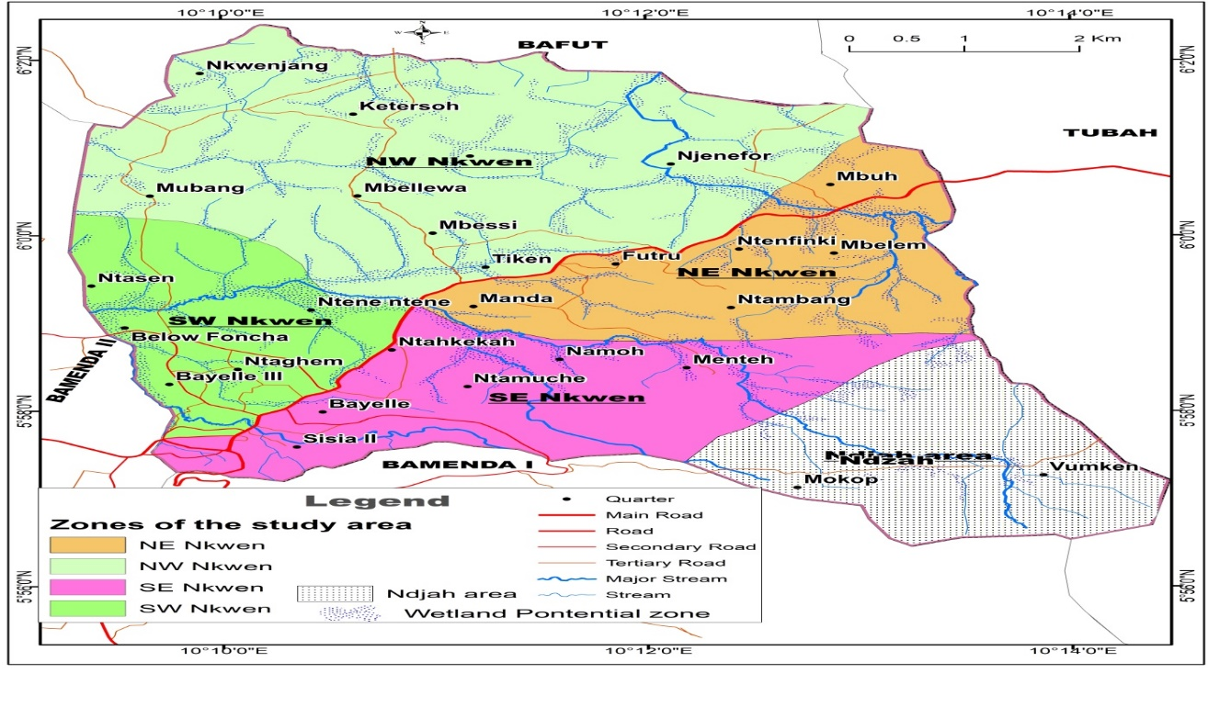
Figure: 1 Location of Bamenda III Sub Division
Source: Geo - Database of Cameroon 2024, NIS Yaounde
Administratively, Bamenda III is made up of two autonomous villages Nkwen and Ndzah with Nkwen being the largest and most urbanized. Nkwen alone consists of 46 quarters, while Ndzah comprises 9 quarters, summing up to 55 quarters in the municipality (Bamenda III Council, 2023). Nkwen hosts key urban centers, business districts, and major road networks, while Ndzah retains a more rural and agrarian outlook, creating a blend of urban and rural dynamics within the subdivision.
- Methodology
The research design was a mixed method design composed of the explanatory and descriptive methods. The opinion of the population was sampled with the use of direct questionnaires administered in a stratified sampling technique. The study area population is estimated at 26811 inhabitants (Bamenda III Council, 2023). The targeted population were those living and has constructed on and around wetland sites and were accessible at the time the researcher was in the field during the administration of questionnaires. The study area was stratified into four geographical zones being South West (SW) Nkwen, South East (SE) Nkwen, North West (NW) Nkwen and North East (NE) Nkwen in the Bamenda III Sub Division. These four areas have different population size and different topographic orientation which explain the spatial wetland dynamics over time. The study therefore targeted landowners, house owners, land occupants (tenants), wetland exploiters (farmers, business persons), council authorities and traditional authorities. A total of one hundred and fifty three (153) questionnaires were administered in the four geographical zones. The questionnaires were administered randomly in a stratified sampling technique. The stratified sampling technique was used to group the population of Bamenda III into four zones being South West (SW) Bamenda III, South East (SE) Bamenda III, North West (NW) Bamenda III and North East (NE) Bamenda III. The use of simple random sampling technique was to ensure that each member of the targeted population has equal chance of being chosen to respond to the questionnaire. (Table 1). Interviews were conducted with traditional authorities, council authorities, and land surveyors at the Regional Delegation of Lands and Surveys. (Table 2)
Table 1. Questionnaires Distribution
Demarcated wetland zones | Target Population | Number Administered | Percentage
North West (NW) Bamenda III | 9365 | 46 | 30
North East (NE) Bamenda III | 3714 | 32 | 21
South West (SW) Bamenda III | 5465 | 35 | 23
South East (SE) Bamenda III | 8267 | 40 | 26
 | 26811 | 153 | 100
Table 2. Persons Interviewed
Persons Interviewed | Date | Duration | Key Issues Discussed
Fon of Nkwen, Quarter Heads of Manda, Njengang, Ntahmuche, Bayelle | 12/11/2025 | 15mins (each) | - Awareness of wetland importance.  - Motives of allocation of wetlands for construction  - the gradual disappearance of wetlands and its effects on water supply
- First Deputy Mayor  - Chief of the Technical service in the council | 15/11/2025 | 15mins (each) | - issuing of building permits  - check of urbanization on wetland sites  - Changes that have taken place so far on wetlands
- Chief of service; Regional Delegation of lands and surveys | 21/11/2025 | 15mins (each) | - effects on wetlands  - what are the changes in wetlands over the years?  - are there areas years back that were wetlands and not in present day  - management strategies in place to avoid loss of wetlands  - management challenges
Source: Field work (2025)
Data was analyzed using descriptive statistical techniques such as frequencies, percentages and averages. Spatial analysis of Landsat imagery (2007-2025) was also integrated to quantify land use change. The images were processed with to portray the spatio-temporal dynamics (changes in landuse over time). The Images were imported into Erdas Imagine, 2013 where preprocessing (layer-stacking and image enhancement) was done and the images were imported into Arcgis 10.8. Interactive Supervised image Classification was adopted for the processing of the image to generate a raster format depicting the designed landcover/land uses. This analysis provided a comprehensive understanding of the environmental and socioeconomic implications of wetland dynamics. This was possible with the application of Microsoft Office (2016) and Statistical Package for Social Sciences (SPSS) version 20. Data was presented using maps, tables, bar graphs, histograms and pie charts and shape files were displayed in ArcGIS 10.8. Secondary data sources were also consulted to complement the primary sources from the field.
4.0. Results

4.1. Socio-economic implications of wetland dynamics in Bamenda III Sub Division
Wetland dynamics have been viewed as the transformation of the wetlands to other land uses mainly for socio-economic sustenance. The encroachment into wetlands by rapid population growth is only considered in a positive perspective tilted towards self-benefits. Nevertheless, the wetland dynamics showed socio-economic impacts of the population especially through the negative responses from the urbanite whose livelihoods equally depend on wetland resources. Loss of livelihood resource, land use conflict, decline in agricultural space, loss of good sources of water supply, displacement and increase poverty were some of the identified socio-economic implications of wetland dynamics in the Bamenda III Sub Division (Table 3).
Table 3: Socio-economic implications of wetland dynamics in the different zones within Bamenda III Sub Division.
Socio-economic Implication of wetland dynamics | Wetland zones in Bamenda III Sub Division
Socio-economic Implication of wetland dynamics | SW Bamenda  III | SE Bamenda III | NW Bamenda III | NE Bamenda III
Loss of livelihood resource | 22.22 | 17.86 | 29.63 | 22.22
Land use conflict | 29.62 | 35.71 | 33.33 | 25.0
Decline agricultural space | 24.08 | 14.28 | 18.51 | 16.66
Loss of good water sources | 16.67 | 21.43 | 11.11 | 27.78
Displacement/ Poverty | 7.41 | 10.71 | 7.40 | 8.33
Population % | 100 | 100 | 100 | 100
Source: Fieldwork, (2025)
Considering the socio-economic implication, majority of the population (29.63%) held that loss of livelihood resource is the main implication affecting the population which is in the NW Bamenda III zone. The NE and SW parts of Bamenda III revealed a corresponding 22.22%. A lower percentage of the population (17.86%) in the SE viewed that loss of livelihood resource is a less likely effect to wetland dynamics. The results showed that wetland is an important resource for livelihood sustenance. Wetlands provide services to the population such as agricultural land, water resources, vegetal as well as animals’ species and habitats. Consequently, wetland dynamics result in loss of these vital livelihood resources needed by the urban population. Land use conflict was equally identified as one of the socio-economic implications associated with wetland dynamics. In the SW part of Bamenda III, 29.62% of the population opined that land use conflict is an implication to wetland dynamics. Majority of the population (35.71%) in the SE Bamenda III held that they have been faced with land use conflicts while 33.33% and 25.0% held the same view in the NW and NE Bamenda III. The findings also revealed the declining agricultural space as one of the outstanding socio-economic implications of wetland dynamics in Bamenda III.The results showed that 24.08% of the population in the SW part of Bamenda III faced declining agricultural space over time while in the SE area, 14.28% held the same view. In the same light, 18.51% of the population observed declining agricultural space in the NW Bamenda III while 16.66% in the NE part of Bamenda III experienced declining agricultural space associated to wetland dynamics.

Loss of good water sources is equally one of the socio-economic implications of wetland dynamics in Bamenda III. Findings revealed that in the SW of Bamenda III, 16.67% attested that they have lost their good water sources while 21.43% of the population in the SE equally held the same opinion. 27.78% of the population in the NE part of Bamenda III and 11.11% in the NW respectively held that they have lost their good sources of water supply because of changes in wetland. Wetland provides clean and purified water resources which are good for drinking. However, the continuous wetland reclamation, transformation and conversion into other land uses have rendered some of these water sources unfit for drinking. Some of the water sources have been buried underground while other wetlands have been transformed into wasteland or dump sites. This only goes a long way to pollute the water sources through constant infiltration of pollutants into the underground water system. The study viewed displacement and poverty as socio-economic implications to the population within the wetland areas of Bamenda III Sub Division. Wetlands are prone to flooding, and this sometimes results in collapse of buildings, destruction of property and loss of lives. Findings revealed that displacement and poverty as socio-economic implication to the population had the least with the following percentages: 10.71% in the SE of Bamenda III, 8.33% in the NE, 7.41% in the SW and 7.40% in the NW of Bamenda III. This is so because the population held that though affected by flood incidence, they usually prefer resilient measures to displacement to avoid inconveniences.

4.1.2. Land use changes and implications on wetland dynamics in Bamenda III Sub Division
Findings revealed that most of the wetland areas have been reclaimed and most of the raffia palms cut and replaced by settlement, farmland and others like buildup areas for economic purposes and waste dumpsites just to name a few (Table 4).
Table 4. Land use change and wetland dynamics in Bamenda III between 2007 and 2025
Landuse (km²) | 2007 | 2016 | 2025
Wetlands | 10.23 | 9.18 | 8.29
Settlement | 9.02 | 14.61 | 17.91
Farmland | 21.71 | 20.68 | 21.98
Others | 25.32 | 21.81 | 66.28
Total (km²) | 66.28 | 66.28 | 66.28
Source: Landsat 7 (February, 2007, January 2016 & Landsat 8 (February, 2025) USGS Earth Explorer
The results show the effect of land use changes on wetland areas in Bamenda III for three years 2007, 2017, and 2025. In 2007 wetlands occupied surface area of 10.23km² which reduced to 9.18km² in 2016, and 8.29km² in 2025. The decline in wetlands is because of the encroachment of settlement as population and farmland increases. The analysis indicates settlement evolution in Bamenda III wetland areas between 2007 and 2025 as the highest. The evolution of built up areas for settlements showed that in 2007, it covered 9.02km², 2016 it increased to 14.61km² and in 2025 it occupied an area of 17.91km². Farmlands between 2007 and 2025 revealed an insignificant increase from 21.71km² to 21.98km2.
The continuous destruction of wetland vegetation is an indication of wetland dynamics as attested by the population of Bamenda III Sub Division. The majority of the population opined that increase population growth and increase housing construction in Bamenda III Sub Division remains the main indicator of wetland dynamics as indicated by land use change maps between 2007 and 2025 (Figure 2).

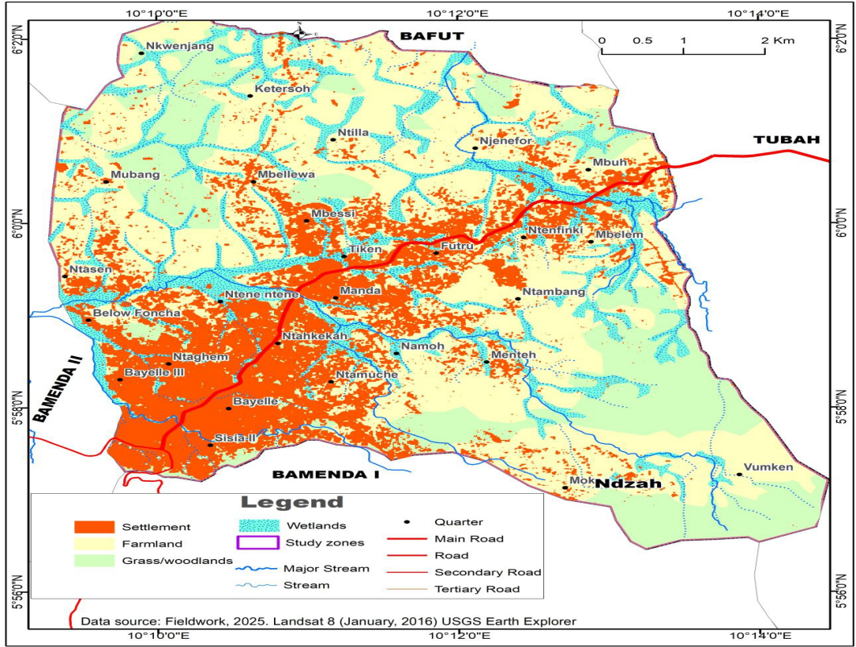
Figure 2.(a )Settlement and wetland situation Bamenda III, 2007

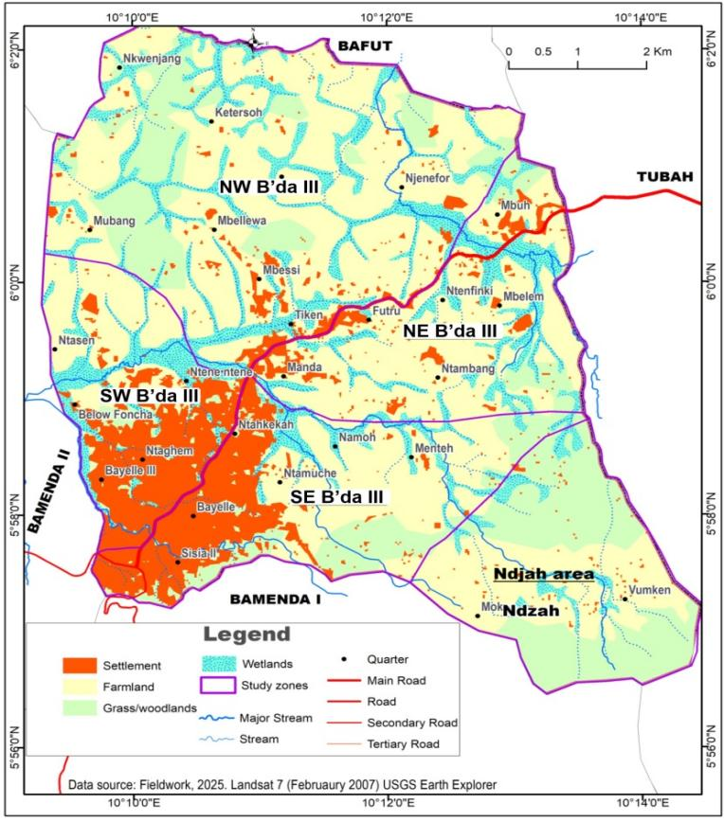

Figure 2.(b): Settlement and wetland situation in Bamenda III in 2016

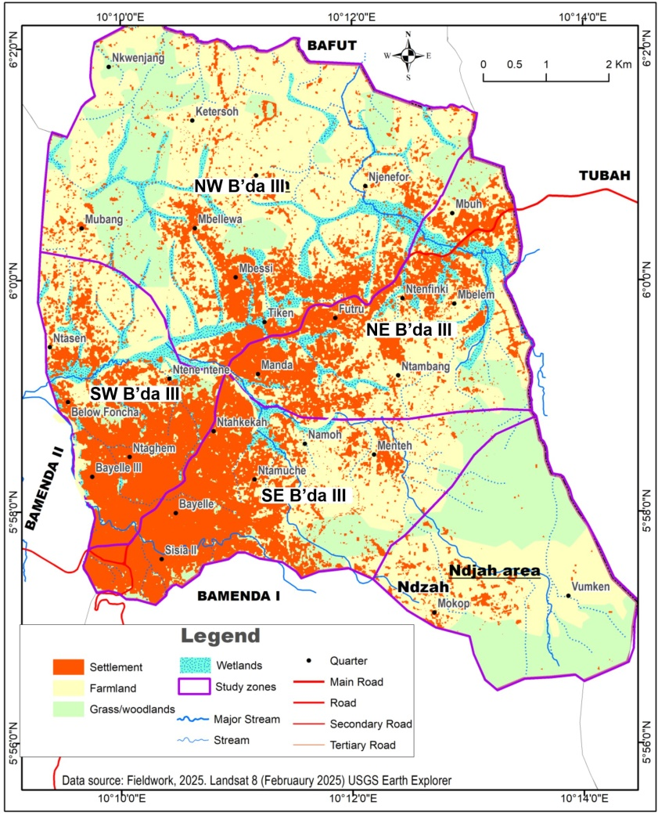

Figure 2 (c) settlement and wetland situation Bamenda III, 2025
Source: Field Work
The spatial encroachment of settlement, farmlands and other land have resulted in a reduction or complete disappearance of some of the wetlands in Bamenda III Sub Division. In 2007 settlement and farmlands occupied a small area as compared to 2025 where the population has increased causing settlement and farmlands to continue encroaching into wetlands which was opined by the population as cheaper to purchase thereby reducing them. Settlement evolution could widely be noted in the field while at the same rate, wetlands are retreating and disappearing in some areas.

4.2. Environmental implications of wetland dynamics in Bamenda III Sub Division
Wetland dynamics causes environmental implications especially in areas characterized by uncontrolled human activities. Most of the wetlands in the Bamenda III Sub Division are altered by human interference through waste disposal, wetland reclamation and construction processes, increase flooding, Pollution and loss of water resources (Table 5).
Table 5: Environmental implications of wetland dynamics
Environmental implication of wetland dynamics | Wetlands Zones in Bamenda III Sub Division
Environmental implication of wetland dynamics | SW Bamenda III | SE Bamenda III | NW Bamenda III | NE Bamenda III
Waste disposal on wetland | 14.81 | 10.71 | 25.92 | 13.89
Construction | 31.48 | 25.0 | 22.22 | 16.67
Wetland reclamation | 12.96 | 21.43 | 11.11 | 19.44
Increase flooding | 18.52 | 14.28 | 7.41 | 22.22
Pollution and loss of water resources | 22.22 | 28.57 | 33.33 | 27.78
Population % | 100 | 100 | 100 | 100
Source: Fieldwork, (2025)
The results showed that in the SW Bamenda III particularly in Ntasin, Below Foncha and around Government Technical High School 14.81% of the population revealed that they have witnessed waste disposal on wetland which constitutes an environmental impact as they perceive the bad odour. In the NW of Bamenda III the highest population of 25.92% attested to waste disposal in wetlands while in the NE and SE zone 13.89% and 10.71% attested to waste disposal in wetlands. The population held that waste disposal is also leading to water pollution and contamination as there are frequent hospitalizations from waterborne diseases and malaria.
Findings revealed that the population of the SW of Bamenda III attested to the highest environmental implication being construction work taking place with 31.48%, followed by SE with 25.0%, NW with 22.22% and NE of Bamenda III with 16.67%. They said it is visible through the loss of wetland vegetation, raffia palm and shrubs from rapid deforestation or reclamation of wetlands for agriculture and settlement areas to accommodate the increasing population. Results for land reclamation as an environmental implication were as follows; 11.11% for the NW of Bamenda III, SW 12.96%, NE 19.44%, and the SE recorded the highest percentage of 21.43%. The population also attested to increase flooding as an environmental implication with the highest percentage of 22.22% recorded in the NE followed by 18.52% in the SW, 14.28% in the SE and 7.41% the lowest in the NW. Pollution and loss of water resources was also opined by the population as an environmental implications of wetland dynamics in Bamenda III with the highest majority of 33.33% in the NW, 28.57% in the SE, 27.785% in the NE and 22.22 in the SW. The population observed that waste disposal in wetland areas by the increasing population is leading to pollution and loss to water resources, increase flooding, loss of biodiversity which are environmental implications affecting the population in the wetland areas.
Field investigation equally presents some of the environmental risk implications associated with wetlands dynamics as health implications within Bamenda III Sub Division. Finding revealed that most wetlands have been turned into dump sites which do not offer good environmental conditions to the urban population. Figure 3 presents some of the sampled characteristic implications of waste disposal on wetlands.

Figure 3: Environmental and health implications of waste disposal on wetlands
Source: Fieldwork, (2025)

The results showed that 31.5% of the population opined that waste dumping in wetland areas of Bamenda III constitute a breeding site for mosquitoes. The decomposition and the nature of the waste only become favorable and breeding ground mosquitoes which cause malaria which makes the population thereby affecting their output at work. The population confirmed regular hospital visit for treatment of malaria and other health related diseases associated with poor waste disposal on wetlands. Findings also showed that 25.2% of the population held that waste disposal on wetland produces unpleasant smell to the urban populace especially when the waste undergoes decomposition. However, 20.5% of the population was of the view that waste dumping on wetland equally causes decrease in water quality with concomitant health effects such as skin infections, diarrhoea and typhoid fever. This is explained by the fact that the leachate from the wastes infiltrate to pollute the underground water system or contaminate the surface water drainage. 13.8% and 9.0% of the population held that waste disposal on wetland blocks stream flow channel and reduce natural buffer respectively. The blockage of stream channels further accelerates flooding with other socio-economic and environmental implications within the Bamenda III neighborhoods.
Discussion
Majority of the wetland areas in Bamenda III Sub Division have been reclaimed and most of the raffia palms cut and replaced by settlement, farmland and others like built up areas for economic purposes and waste dumpsites just to name a few. The results show the effect of land use changes on wetland areas in Bamenda III for three years 2007, 2017, and 2025. In 2007 wetlands occupied surface area of 10.23km² which reduced to 9.18km² in 2017, and 8.29km² in 2025. The decline in wetlands is because of the encroachment of settlement as population and farmland increases. Most of the population opined that increase population growth and increase housing construction in Bamenda III Sub Division remains the main indicator of wetland dynamics as indicated by land use change maps between 2007 and 2025.

Most of the wetlands in the Bamenda III Sub Division are altered by human interference through waste disposal, wetland reclamation and construction processes, increase flooding, Pollution and loss of water resources. The population observed that waste disposal in wetland areas by the increasing population is leading to pollution and loss of water resources, increase flooding, loss of biodiversity which are environmental implications affecting the population in and around the wetland areas. Results indicated that waste disposal is also leading to water pollution and contamination as there are frequent hospitalizations from waterborne diseases and malaria.Wetland dynamics showed socio-economic impacts of the population especially through the responses from the urbanite whose livelihoods equally depend on wetland resources. Loss of livelihood resource, land use conflict, decline in agricultural space, loss of good sources of water supply, displacement and increase poverty were some of the identified socio-economic implications of wetland dynamics in the Bamenda III Sub Division.

These results are like those of Mironga, 2005 who opined that wetland losses over the world are directly the result of economic activities carried out by man through the influence of human population growth. However, some of the established influence of wetlands dynamics is due to draining and conversion of wetlands to agricultural land, and pollution from anthropogenic wastes. These findings are also consistent with those of Alavaisha (2020), who reported that direct human activities involve various forms of land-use change that contribute to wetland degradation and loss through alterations in water quality and quantity, increased pollution levels, and changes in species composition. Nevertheless, in Cameroon, ongoing population growth associated with rapid urbanisation and shifting land-use patterns continues to reinforce the perception of wetlands as wastelands. This has resulted in widespread conversion and pollution of wetland ecosystems (Mbanga & Dingha, 2022). The findings of the present study are also consistent with those of Kimengsi et al. (2017), who observed that peri-urban areas of the Bamenda III Municipality have undergone notable land-use transformations characterised by a proliferation of competing land uses. This has led to a substantial decline in agricultural land, alongside a corresponding expansion of built-up areas, with an annual change rate of 52.6%. Such dynamics have significantly contributed to the encroachment and invasion of wetland ecosystems. Bamenda III Sub Division is one of the areas in Bamenda that has been experiencing rapid population growth over time. Previous studies have been carried out on wetlands in Bamenda III but non examined the socio economic and environmental impacts on wetland dynamics with results of destruction of wetland services such as raffia palms and water resources, loss of livelihood resource, land use conflict, loss of good sources of water supply, displacement and increase poverty, increase flooding, waste disposal which is leading to water pollution and contamination as there are frequent hospitalizations from waterborne diseases and malaria as some of the socio-economic and environmental implications of wetland dynamics in the Bamenda III Sub Division.
Human activities have continued to cause the loss of wetlands and their persistent degradation in Bamenda III sub division. Wetland dynamics have been viewed as the transformation of the wetlands to other land uses mainly for socio-economic sustenance. The encroachment into wetlands by rapid population growth has resulted in wetland dynamics and their implications in Bamenda III like loss of livelihood resources, land use conflict, decline in agricultural space, loss of good sources of water supply, displacement and increase poverty. The degradation and reduction in wetlands also resulted in environmental implications, especially in areas characterized by uncontrolled human activities. Most of the wetlands in the Bamenda III Sub Division are altered by human interference through waste disposal, wetland reclamation for farming and construction processes which have resulted in increased flooding, pollution and loss of water resources. These environmental implications are leading to health challenges which the population is facing. These findings are consistent with those reported by Barman (2021), who indicated that urban development has resulted in the loss of more than 60% of wetlands. Urbanisation exerts significant pressure on wetland ecosystems by facilitating their conversion into alternative economic uses, including construction, mining, and quarrying activities. Similar studies by Oyedepo & Oluyege, (2024), held that wetland conservation has gained increased attention due to the alarming rate at which these ecosystems are being degraded by anthropogenic activities, particularly urbanization, land reclamation, and infrastructure development. In recent decades, societal advancement and the rapid expansion of modern industry have intensified environmental pressures, particularly in relation to land reclamation, water pollution, and excessive deforestation. These challenges are especially pronounced in urban wetlands. With the continued acceleration of urbanisation, a substantial number of wetlands have been lost (Tana et al., 2013). Comparable findings have been reported by Bouahim et al. (2015), who demonstrated that intensified human activities over the past century have led to significant wetland loss and a marked reduction in the extent of remaining wetland areas. This decline has, in turn, resulted in substantial losses of natural habitats. The results revealed a consistent decline in wetland coverage, with a corresponding rise in population density and encroachment in lowlying areas. Wetland zones at lower elevations showed greater susceptibility to conversion, often replaced by built-up or agricultural land (Oluwaseun et al., 2025). These findings are consistent with those reported by Ajibola et al. (2016), who observed that wetland reclamation and degradation are further exacerbated by the decline in the economic well-being of communities residing in affected areas. The reclamation and conversion of wetlands result in the destruction of vital livelihood resources for local populations. Notably, wetlands provide favourable conditions for agriculture and traditional farming practices, which constitute key sources of sustenance for many communities. Consequently, their conversion leads to the loss of primary livelihood opportunities, often resulting in severe economic hardship. Despite these implications, wetlands in Cameroon continue to be perceived as wastelands, largely due to population growth, rapid urbanisation, and changing land-use patterns (Mbanga & Dingha, 2022). This perception has contributed to widespread encroachment, degradation, and loss of wetland ecosystems. Moreover, management interventions have remained fragmented and insufficiently inclusive, further undermining conservation efforts (Asangwe, 2009; Akhere & Kimengsi, 2020).
Conclusion
This study addresses the critical problem of escalating wetland degradation and loss in Bamenda III Sub-Division, Cameroon, driven by rapid and uncontrolled urban population growth, which manifests in illegal land reclamation, housing construction on fragile lands, and the consequent loss of ecosystem services. Wetland dynamics causes environmental implications especially in areas characterized by uncontrolled human activities where waste disposal in wetland areas leads to pollution and loss to water resources, increase flooding, loss of biodiversity which are environmental implications affecting the population around the wetland areas. The blockage of stream channels by waste further accelerates flooding with other socio-economic and environmental implications within the Bamenda III neighborhoods. It causes the disappearance of water sources, contamination of water sources, blockage of waterways and exposes the population of Bamenda III to health risk. However, the continuous wetland reclamation, transformation and conversion into other land uses have resulted in the reduction in agricultural space which has led to increase flood risk, loss of fertile land, reduced water regulation and urban food insecurity. The study therefore recommends as follows; the council should adopt effective land use and zoning control measures to ameliorate the impact of land use change and wetland impacts in the study area. The council should establish a governance system and a legal framework specific to wetlands management in Bamenda III Sub Division. The council should work hand in gloves with the traditional authorities to ensure the protection and sustainable management of the wetlands. The population should be involved in decision making in wetland management and be educated on the importance of wetlands. The traditional authorities should ensure effective preservation and monitor the reclamation of wetlands in the different quarters of Bamenda III Sub Division.

Disclaimer (Artificial intelligence)

Author(s) hereby declare that NO generative AI technologies such as Large Language Models (ChatGPT, COPILOT, etc.) and text-to-image generators have been used during the writing or editing of this manuscript.

References
- Adekola, O., Mitchell, R., (2018); Wetlands as livelihood sources: Economic and social perspectives. Journal of Ecological Economics, (145), 165–174. https://doi.org/10.1016/j.ecolecon.2017.09.002
- Adhikari, B., Khatri-Chhetri, A., Shrestha, P., (2019); Socio-economic factors influencing community use of natural resources in rural landscapes. Journal of Rural Studies, (68), 134–145. https://doi.org/10.1016/j.jrurstud.2019.03.001
- Ajibola, M. O., Adeleke, A. M., & Ogungbemi, O. A. (2016); An assessment of wetland loss in Lagos Metropolis, Nigeria. Development Country Studies, 6(7), 225–275.
- Akhere, S. G., Kimengsi, J. N., (2020); Urban expansion and the dynamics of farmers’ livelihoods: evidence from Bamenda, Cameroon. Journal of Sustainability 12:5788
- Alavaisha, E., (2020); Agricultural expansion impacts on wetland ecosystem services from Kilombero Valleynia, Tanza, Dissertations in Physical Geography, ISSN 2003-2358; 7, Stockholm: Department of Physical Geography, Stockholm University , 2020. , p. 49. Stockholm University, Faculty of Science, Department of Physical Geography.ORCID iD: 0000-0001-5259-3301
- Asangwe, K. C., (2009); Monitoring wetlands deterioration in the Cameroon coastal lowlands: implications for management. Journal of Proc Earth Planet Sci (1),1010–1015
- Barman, A., Ramakar, J., (2021); Traditional stormwater management system in watershed of wetland, astudy and overview of “Dong” systems in wetland fringe villages of Assam, Hydro 2020 International, 5th International Conference on Hydraulics, Water Resources and Coastal Engineering, National Institute of Technology Rourkela, Odisha, India, March 26-28, 2021
- Bouahim, S., Rhazi, L., Amami, B., Sahib, N., Rhazi, M., Waterkeyn, A., Zouahri, A., Mesleard, F., & Grillas, P. (2015); Combining vulnerability analysis and perceptions of ecosystem services in sensitive landscapes: A case from western Moroccan temporary wetlands. Journal for Nature Conservation, 27, 1–9.
- Bensch, G., Kavanagh, M., Tadesse, D., (2021); Socio-economic determinants of resource dependency in African wetlands. Journal of Land Use Policy, (103), 105–118. https://doi.org/10.1016/j.landusepol.2020.105118
- Byaruhanga, J., Mwanga, S., Nsubuga, F., (2019); Integrating local knowledge into wetland management for sustainable livelihoods. Journal of Wetlands Ecology and Management, 27(4), 345–360. https://doi.org/10.1007/s11273-019-09687-5
- Bwenge, M., Byaruhanga, J., Mugisha, A., (2021); Community participation and wetland governance in Uganda. African Journal of Environmental Studies, 12(3), 45–62.
- Casagrande, D.G., (1997); The human component of urban wetland restoration. Restor. Urban Salt Marsh: Interdiscip. Approach , (100), 136–150.
- Chakraborty, S.K.; Sanyal, P.; Ray, R. (2023); Pollution, environmental perturbation and consequent loss of wetlands. In Wetlands Ecology: Eco-Biological Uniqueness of a Ramsar Site (East Kolkata Wetlands, India); Springer: Singapore, pp. 521–582.
- Cohen, M. J., Creed, I. F., Alexander, L., Basu, N. B., Calhoun, A. J. K., Craft, C., D’Amico, E., (2016); Do geographically isolated wetlands influence landscape functions? Journal of Proc. Natl. Acad. Sci. USA (113), 1978–1986.
- Dingha, C. B., Mbanga, L. A., (2023); Institutions and approaches for wetland management in Bamenda, North West Region of Cameroon. Cameroon. Celebrating ten years of restless rest in landmark research and human resource development: festschrift for Professor Emeritus Cornelius Mbifung Lambi. Conference Proceedings Vol. II: Development and Environmental Sustainability. The University of Bamenda Printing Press, Bamenda Cameroon, pp 15–31.

Guofeng, Z., Yuwei, L., Lei, W., Liyuan, S., Kailiang, Z., ( 2023); The isotopes of precipitation have climate change signal in arid Central Asia. Journal of Global and Planetary Change (225), 104103
- Kamble, S., Rashinkar, G., Kumbhar, A., Salunkhe, R., (2012); Ecosystems WETLANDS WELL-BEING: AND HUMAN AND WATER. In Green Chemistry Letters and Reviews (5) 1. https://doi.org/10.1080/17518253.2011.584217

- Kimengsi, J. N., Balgah, S. N., Achia, S. N., (2017); Peri-urban `land use dynamics and development implication in Bamenda III municipality of Cameroon. Sustainability in Environment, 2(3), 273-288
- Khan, A. A., Arshad, S., (2014); Wetlands of Pakistan : Distribution, Degradation and Management. Pakistan Geographical Review, 69(1), 28–45.
- Kometa, S., Kimengsi, J. N., Petiangma, D., Urban development and its implications on wetland ecosystem services in Ndop. Journal of Environ. Manag. Sustain. Dev., (7) 12141.
- Kuchara, V., Charan, R., Mankad, A., & Solanki, H., (2023); Wetland Degradation and Loss Due To the Expansion of Anthropogenic Activities. Journal of International Association of Biologicals and Computational Digest, 2(2), 41–47. https://doi.org/10.56588/iabcd.v2i2.191
- Kundu, S., Narendra, Kumar, R., Susanta, M., (2024); Unravelling blue landscape fragmentation effects on ecosystem services in urban agglomerations Journal of Sustainable Cities and Society, (102), 105192.
- Kundu, S., Kundu, B., Rana, N. K., Mahato, S., (2024); Wetland degradation and its impacts on livelihoods and sustainable development goals. Journal Sustainable Production Consumption, (48), 419–434.
- Lejissa, L. T., Environment, E., (2020); Comparative Economic Analysis of Three Competing Land Use Types In Southern Ethiopia : Tools for Informed Decision. Making on Land Use Choices Comparative Economic Analysis of Three Competing Land Use Types in South Ethiopia : Tools for Informed Decision.
- Marton, J. M., Creed, I. F., Lewis, D. B., Lane, C.R., Basu, N.B., (2015); Geographically Isolated Wetlands are Important Biogeochemical Reactors on the Landscape. Journal of Bioscience, (65), 408–418.
- Mbanga, L. A., & Babila, C. D. (2022); Wetland dynamics, trends and environmental implications: Comparative study in Bamenda II and III Municipalities, North West Region, Cameroon. Journal of Geography, (45):1–14 doi: 10.26650/JGEOG2022-980928
- McLaughlin, D.L., Kaplan, D.A., Cohen, M. J., (2014); A significant nexus: Geographically isolated wetlands influence landscape hydrology. Journal of Water Resour. Res, (50), 7153–7166.
- Mironga, J. M. (2005); Effect of farming practices on wetlands of Kisii District, Kenya. Applied Ecology and Environmental Research, 3(2), 81–91.
- Mitchell, S. A. The status of wetlands, threats and the predicted effect of global climate change: the situation in Sub-Saharan Africa. Journal of Aquat. Sci. (75), 95–112.
- Nimusima, (2019)., Rwanda Environment and Climate Change Analysis. 1–26
- Nyandwi, O., Ndikubwimana I., (2024); The Effects of Wetland Degradation on Ecological Species journal of International Journal of Innovative Science and Research Technology, 9(4) 2456-2165
- Oluwaseun, I., Feyisetan, M., Oladunjoye, E., Olamide, O., (2025); Spatiotemporal Assessment of Wetland Ecosystem: Integrating Terrain and Population Dynamics for Sustainable Planning, International Journal of Multidisciplinary Research and Growth Evaluation 3(6) :(2582-7138)
- Oyedepo, J. A., Oluyege, D. E., (2024); Spatiotemporal assessment of wetlands and land reclaim activities in Eastern Lagos State Nigeria. Niger Journal of Technol. 43(3):577– 86. https://doi.org/10.4314/njt.v43i3.21
- Pengfei. Y, Xiaoying, H, Yifei C., (2018); Analysis on Ecological Protection of Urban Wetland journal of Natural Resources Conservation and Research 1(1) DOI: 10.24294/nrcr.v1i1.226
- Pieter, T.J.J., Jason, T.H., Valerie, J.M., Andrew, R. B., Katherine L.D. R., (2013); Urbanization and wetland communities: Applying metacommunity theory to understand the local and landscape effects. Journal of Applied Ecology, (50), 34-42.
- Ramsar Convention Bureau (1997), The Ramsar Convention Manual: A Guide to the Convention on Wetlands Ramsar, Iran, 2nd Edition, Ramsar Convention Bureau, Gland, Switzerland.
- Ramsar, P. (1971); The Ramsar Convention Manual: A guide to the Convention on Wetlands (Ramsar, Iran, ) Ramsar Convention Secretariat. online: https://aquadocs.org/handle/1834/330
- Ramsar. (2018)., Global Wetland Outlook: State of the World’s Wetlands and their Services to People. Global Wetland Outlook.Gland Switzerland : Ramsar Convention secretariat., 84. https://www.globalwetlandoutlook.ramsar.org/outlook
- Ramsar. (2017); Ramsar Management Plan Status Report. https://www.gov.je/SiteCollectionDocuments /Government and administration/R Ramsar management plan status report 2017 20190805
- Reddy, K. R., DeLaune, R. D., Inglett, P.W., (2022); Biogeochemistry of Wetlands: Science and Applications; CRC Press: Boca Raton, FL, USA,
- Russi, D., Ten Brink, P., Farmer, A., Bandura, T., Coates, D., Forster, J., Kumar, R., Davidson, N. (2013); The Economics of Ecosystems and Biodiversity for Water and Wetlands: A final Consultation Draft. IEEP, London and Brussels; Ramsar Secretaria, 119
- Saunders, M. J., Kansiime, F. Jones, M. B., (2012); Agricultural encroachment: implications for carbon sequestration in tropical African wetlands. Journal of Glob. Chang. Biol. (18), 1312–1321.
- Sofoluwe, N. A., Tijani, A. A., Baruwa, O. I., (2011); Farmers’ Perception and Adaptation To Climate Change in Osun State, Nigeria. African Journal of Agricultural Research, 6(20), 4789–4794.
- Susanta, M., Geetanjali, P., Joshi, P.K., (2023); Damming effects on hydrological abundance and eco-hydrological alteration in upstream wetlands of Eastern Himalaya, Journal of Cleaner Production, (418) 138089
- Tana, G., Letu, H., Cheng, Z., & Tateishi, R. (2013). Wetlands mapping in North America by decision rule classification using MODIS and ancillary data. IEEE Journal of Selected Topics in Applied Earth Observations and Remote Sensing, 6(6), 2391–2401.
- Tiner, R.W., (2003), Geographically isolated wetlands of the United States. Journal of Wetlands ,(23), 494–516.
- Thomas, V., (2017); Climate Change and Natural Disasters: Transforming Economies and Policies for a Sustainable Future. In Climate Change and Natural Disasters: Transforming Economies and Policies for a Sustainable Future. https://doi.org/10.4324/ 9781315081045
- Uluocha, N. O., Okeke, I. C. (2004); Implications of Wetlands Degradation for Water Resources Management: Lessons from Nigeria. journal, Geography 61(2), 151–154. Https://Doi.Org/10.1007/S10708-004-2868-3

