Street Vending and Public Space Governance in Bamenda City, Cameroon: Survival Strategies and Urban Planning Challenges

ABSTRACT
The nexus between rapid urbanisation and persistent economic hardship has intensified the use of public spaces for informal commercial activities in many Cameroonian cities. In Bamenda City, street vending has emerged as a crucial survival strategy for a large fraction of the urban population, particularly amid rising unemployment and declining formal economic opportunities. Notwithstanding its importance for livelihoods, street vending continues to generate recurring conflicts related to space use, urban planning, sanitation, traffic congestion, and municipal governance. This study examines the major challenges faced by street vendors in their daily use of public spaces and explores feasible strategies supporting livelihood sustainability and economic growth within these spaces. Both quantitative and qualitative research approaches were employed, involving field observation, interviews with vendors, and consultation with the main resource persons. Both quantitative and qualitative research approaches were employed, involving field observation, interviews with vendors, and consultation with key informants. Data were analysed using descriptive, qualitative, and spatial techniques. The study identifies major challenges, including spatial congestion, inadequate infrastructure, insecurity, weak regulatory enforcement, and limited participation of vendors in urban planning processes within market arenas. Findings further reveal the existence of a wide range of socio-economic activities (with street vending constituting 38.6%), serving as livelihood strategies for vendors. However, the continued marginalisation of informal economic activities within Bamenda City's governance frameworks exacerbates tension and undermines effective public space management. The study argues that inclusive urban planning, the creation of designated vending zones, improved market infrastructure, participatory governance, and a balanced regulatory framework are essential for harmonising vendor activities with broader urban development goals. By integrating informal economic actors into city planning in a manner that upholds the Afro-Endogenous development approach, Bamenda City can enhance social inclusion, urban functionality, and strengthen the resilience and adaptability of local economic growth. Such measures are essential for fostering social stability, economic resilience, and the harmonious use of public spaces.
Keywords: Vendors, public space, strategies, Afro-endogenous, Bamenda City, Cameroon

I. INTRODUCTION
Throughout urban history, public spaces have represented important elements in urban configuration. They are known to provide residents with well-being, resilience, and inclusion. Every community needs such places, where all feel welcome and where all can "enjoy being part of the great congress of humanity". Beyond this, public spaces play a critical role in shaping urban development, serving not only as physical spaces for recreation and interaction but also as arenas for social, political, and economic expression (Ntakana et al., 2025). Street vending, whilst sometimes spontaneous and unplanned, serves a crucial role in the urban fabric. Globally, there has been a surge of interest in understanding the dynamics of informal street vending, motivated by a desire to alleviate economic inequalities (Musa et al., 2024).
Substantial literature indicates that, in most cities with sufficient public spaces, there are well-maintained, safe, and attractive places to live and work in, and most streets are multifunctional areas for social interaction, economic exchange, and cultural expression among a wide diversity of participants (Assako, 2012; UN-Habitat, 2017). It is also argued that the inability of cities to generate enough employment opportunities has contributed to widespread informality. Half of the global urban workforce is informally employed, more so in the global South (UN-Habitat, 2017).
Still on this point, public spaces in European cities and villages are common places for information exchange, important events (such as processions, celebrations, and festivals), markets, and genuine face-to-face encounters outside the virtual world (Grunskis & Mankus, 2013).
Even though rapid urbanisation characterises many African cities, they exhibit public space patterns of a more Afro-endogenous character, compounded by the enormous challenges of coping with soaring urbanisation. Furthermore, the Politics of Governing African Urban Spaces (2018) argues for inclusive definitions that go beyond tranquil parks, focusing on multifunctional spaces that support mobility, commerce, social exchange, youth activities, and cultural life, in contrast to the European context.
In many African contexts, public space is not merely a physical location but a site of ongoing negotiation. Scholars argue that street vending signifies an assertion of the "right to the city" by marginalised populations who are often excluded from formal economic structures (Brown et al., 2023). Furthermore, many African urban scholars view public space as a lived, socially constructed, and economically functional area shaped by informality, survival strategies, and everyday negotiations between citizens and the state. Mabogunje (1968, 1993) initially observed that in African cities, streets, markets, and open spaces develop beyond their planned functions to become vital platforms for livelihoods and social interaction, especially for low-income urban residents. This idea is expanded upon by Simone (2004), who describes African public spaces as fluid and improvised environments where networks of survival, informal economies, and social relations are enacted in ways that challenge formal planning logic.
Forms of urban informality, ranging from informal settlements to street vending and informal transport, remain a key challenge for those engaged in exploring and shaping public spaces, particularly in Global South cities (Kamalipour et al., 2025). Pieterse (2008) further situates public space within the framework of citizenship and contestation, arguing that these spaces reveal the tensions between governance structures and the urban poor's right to the city. Similarly, Watson (2009) critiques conventional urban planning for failing to recognise the "stubborn realities" of informality that define how public spaces are actually used in African cities. Myers (2011) reinforces this argument by calling for an "African urbanism" that rethinks public space through the lenses of colonial legacies, poverty, and informal practices rather than imported Western ideals. Rather than viewing street vending as a sign of planning failure, Crossa et al. (2021) argue that informality is a central mechanism in the production of public space. Anthropological contributions deepen this understanding. De Boeck and Plissart (2004) illustrate how residents of Kinshasa culturally reinterpret streets and open areas as symbolic and socially negotiated spaces, whilst Olivier de Sardan (2005) and Alain Marie (1997) emphasise public space as an arena of everyday negotiation, individual agency, and informal governance.
Collectively, these scholars present public space in African cities as a livelihood space, a contested political terrain, a socially negotiated environment, and a reflection of resilience in the face of economic hardship and governance limitations. Recent scholarship reinforces this perspective by showing that informal vending is shaped not only by livelihood precarity but also by the quality of governance arrangements, procedural fairness, and the degree of tolerance extended by municipal authorities. Studies from Nigeria and Zimbabwe show that formal and informal governance structures often coexist in regulating vendors, while harassment, exclusionary enforcement, and weak institutional coordination continue to undermine livelihoods (Adeosun et al., 2023; Chakunda, 2023). Related work on African cities further indicates that traders’ trust in local government depends strongly on reciprocity and fair treatment, suggesting that inclusive governance is central to effective public-space management (Resnick & Sivasubramanian, 2023). More recent spatial research also demonstrates that street vending follows identifiable urban logics tied to mobility, transport interdependencies, street edges, and in-between spaces, implying that planning responses should move beyond blanket eviction toward adaptive and spatially sensitive regulation (Dovey & Recio, 2024; Liu et al., 2025; Ngo Kien Thinh et al., 2025). In addition, evidence from midsized and informal-settlement contexts suggests that informality in secondary cities deserves more focused analysis, because governance and infrastructure constraints there differ in important ways from those of major metropolitan centres (Essien & Jesse, 2024; Ono, 2025). Urban street food vending is one of the most conspicuous economic activities on the streets of most cities in Sub-Saharan Africa, yet it remains largely informal (Mutandwa et al., 2025).
In Cameroon, public space is a key enabler of economic development in cities. Recent work from Cameroon further shows that urban planning outcomes in secondary cities are closely shaped by land-use conflict, participatory planning needs, and inclusive livability concerns, reinforcing the need to analyse how public-space governance affects informal livelihoods in Bamenda (Kimengsi & Awah, 2021; Kuma, 2025). Streets, pavements, markets, squares, and parks are accessible, safe, and inclusive elements of basic infrastructure that support the economic vibrancy and growth of cities (Yemmafouo, 2018).
Formal urban planning approaches in Cameroonian cities are largely driven by ideals of order, aesthetics, and modernity, often implemented through urban beautification and redevelopment programmes. These approaches prioritise regulated land uses, fixed infrastructure, and visually "clean" cityscapes, which tend to redefine public spaces as zones for circulation, leisure, or formal commerce (Assako, 2012). He further holds that informal practices such as street vending, which rely on flexibility, proximity to pedestrian flows, and affordability, are frequently labelled as illegal, disorderly, or incompatible with planned urban functions. Accordingly, vendors are displaced from strategic public spaces, marginalised in planning decisions, and forced into precarious or peripheral locations, highlighting how formal planning frameworks often exclude informal livelihoods despite their central role in urban life. This raises the problem of an Afro-Indigenous conceptualisation of urban public space. This conceptualisation is particularly relevant to Bamenda City, where street vending and informal activities in public spaces are not merely violations of urban order but essential survival mechanisms and expressions of citizens' adaptation to socio-economic realities. The marginalisation of these informal economic activities within Bamenda City's governance frameworks exacerbates tension and undermines effective public space management.
2-Problem statement
The management of urban public space is characterised by inherent complexity, serving as a contested arena where diverse stakeholder interests intersect. While substantial literature has examined street vending in Africa’s primary metropolises, the governance of public space in secondary cities such as Bamenda, Cameroon, remains critically under-researched. In Bamenda city, public spaces are often characterised by inconsistency: they are simultaneously unregulated and underutilised, failing to meet the needs of a rapidly evolving population. Although these spaces are intended to function as democratic platforms for social interaction and as vital socio-economic engines for the urban poor, a profound legal-spatial rift persists. While the state defines these spaces as administrative assets, vendors transform them into essential marketplaces and social hubs for survival.
This study observes that the current public space governance in Bamenda city lacks effective coordination and inclusive collaboration. The absence of clear regulatory frameworks, combined with limited financial resources and uneven enforcement, appears to have weakened coordination in the management of public space. Consequently, existing regulatory arrangements appear to constrain vendors’ access to public space and contribute to insecurity in their spatial tenure. Furthermore, the systematic disregard for Afro-endogenous design and local norms has disrupted the functional dynamics of these spaces. This neglect often leads to the displacement of occupants under restrictive "temporary occupation" policies, which exacerbate socio-spatial exclusion, erode social trust, and hinder collective action.
Ultimately, these governance lapses limit the capacity of municipal authorities to address the socio-economic vulnerabilities of street vendors. This paper, therefore, investigates: What are the primary challenges faced by street vendors in the use of public space in Bamenda city? How do these vendors negotiate and adapt to rigid urban governance structures in Bamenda? What inclusive planning strategies can bridge the gap between formal management and the survival needs of the urban poor in Bamenda city?
By exploring these dynamics, this research seeks to move beyond reactive management towards a responsive, inclusive, and Afro-endogenous model of public space governance in Bamenda City.
II-STUDY AREA AND METHODS

2.1. Study Area
Bamenda is the administrative seat of Mezam Division, the Regional Headquarters of the North West Region, and the largest town in the North West Region. Bamenda City covers a surface area of approximately 37.560 km². It comprises seven Sub-Divisional Councils and has a population of approximately 800,000 inhabitants (Kimengsi & Fogwe, 2017). Figure 1 depicts a map of Bamenda City in Cameroon.
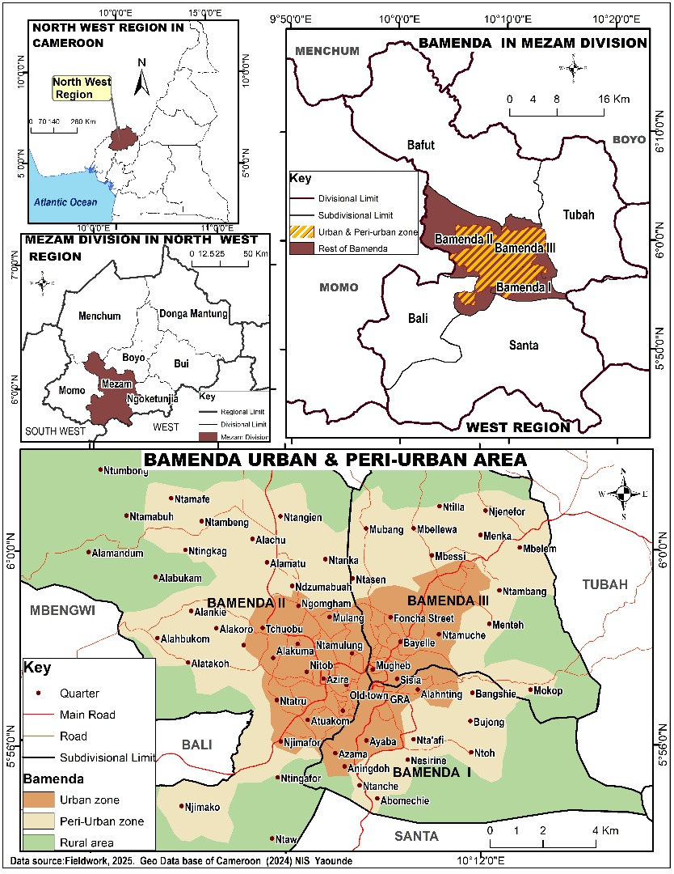
Figure 1: Location of Bamenda City in the North West Region of Cameroon
Bamenda City is a cosmopolitan city, and one of the bedrocks of Cameroonian politics, with a very strong traditional setup and extremely powerful Fons and Fondoms. Although the population is cosmopolitan, the majority are local ethnic groups, which include the Bamendakwe, Nsongwa, Chomba, Mbattu, and Nkwen, who primarily practise subsistence farming.

2.2. Methods
This study adopted a mixed-methods research design to examine the relationship between street vending and public space governance in Bamenda City. The paper findings span from 2023 to 2025 to ensure the evolution of some field realities through observation. The variation in fieldwork dates reflects a multi-phase data collection strategy designed to capture temporal shifts in vendors' activities within the three-year study period (2023-2025). Initial data (2023) established baseline conditions, while subsequent iterations (2024-2025) allowed for the validation of findings and the integration of the most recent spatial updates. The use of both quantitative and qualitative approaches made it possible to capture, on the one hand, the spatial and socio-economic characteristics of street vending and, on the other hand, the institutional and governance dimensions shaping vendors’ access to and use of public space. The approach was appropriate because the subject under investigation involves both measurable patterns of public-space use and context-dependent experiences of regulation, negotiation, and survival. The quantitative component was based on a questionnaire survey administered to 170 street vendors operating in selected public spaces across Bamenda I, Bamenda II, and Bamenda III municipalities. Respondents were selected through systematic random sampling at predetermined vending locations. At each site, the estimated number of vendors present was first established, after which a sampling interval (k) was calculated by dividing the estimated vendor population by the target sample for that location. A random starting point was then chosen, and every kth eligible vendor was approached for participation until the required quota for the site was attained. For example, in Ntarikon, an estimated population of 130 vendors and a target sample of 26 yielded a sampling interval of 5, such that every fifth vendor was selected. This procedure was repeated across all sampled locations to obtain the final survey sample.
The qualitative component consisted of purposive key informant interviews with institutional actors directly involved in urban management, land administration, and local governance in Bamenda City. Interview participants included the Regional Delegate of Housing and Urban Development, the Regional Delegate of State Property, Surveys and Land Tenure for the North West Region, the Mayor of the Bamenda City Council, the Director of Paco-vita, and municipal authorities from Bamenda I, II, and III councils. These participants were selected because of their direct knowledge of planning regulation, land tenure administration, enforcement practices, and the management of public space. Their perspectives complemented the vendor survey by providing insight into the regulatory and institutional context within which informal vending occurs. The spatial distribution of these various sampling points and institutional sites is indicated in Figure 2.
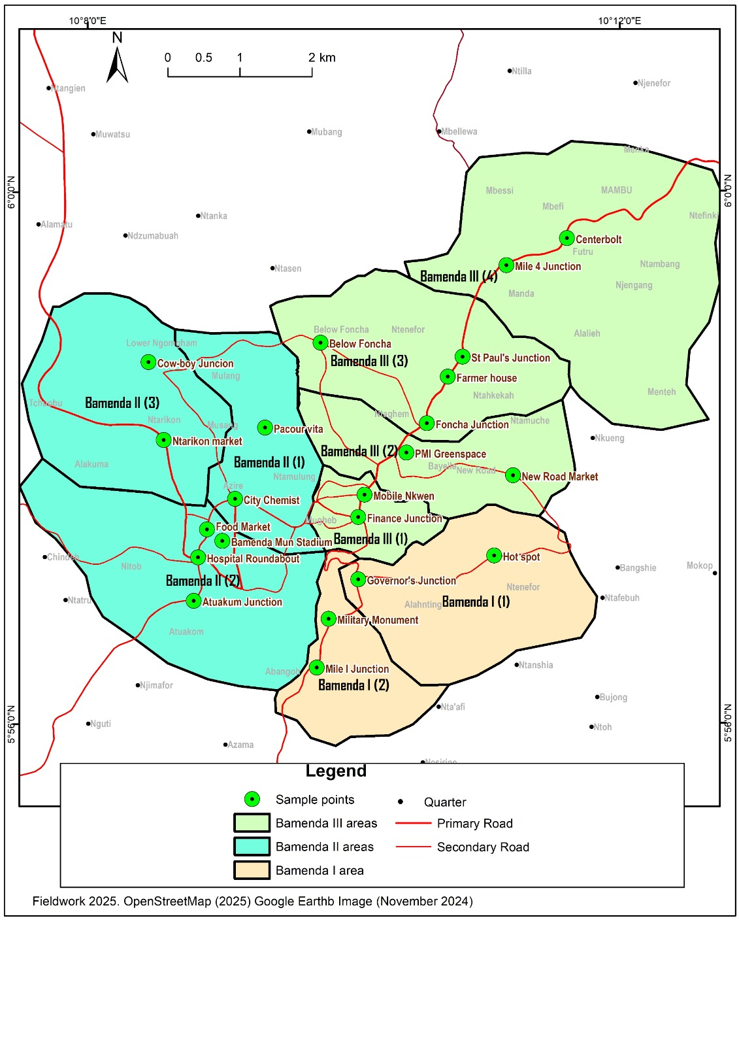
Figure 2. Diagrammatic Representation of Sampled Points in the Study Area
Figure 2 presents a spatial analysis of sampling points across the three subdivisions of Bamenda (I, II, and III). The map splits the city into three primary-coloured zones, representing different municipal councils as indicated in the key.
To strengthen the validity of the findings, the study employed triangulation through the combination of questionnaire data, key informant interviews, field observation, mapping, and documentary review. Repeated site visits were conducted to observe patterns of occupation, congestion, circulation, and vendor activity in different parts of the city. Secondary information was drawn from relevant academic literature and official municipal materials relating to urban planning and vendor regulation. This combination of sources improved the credibility of the analysis by allowing evidence from one source to be checked against that from others.
Both quantitative and qualitative techniques were used in data analysis. Quantitative data from the questionnaire survey were organised and analysed using descriptive statistics, including frequencies and percentages, and were presented in tables, charts, and maps. The manuscript also indicates the use of inferential analysis, including correlation analysis, to examine the relationship between street vending and public space governance. Qualitative data from interviews and field observations were analysed using content and thematic analysis, with emphasis on recurring issues related to livelihood strategies, spatial access, regulation, infrastructure, and governance challenges. Spatial and cartographic data were processed to produce maps illustrating sampled points and public-space types across the study area. For data processing and presentation, the study used SPSS version 20, Microsoft Excel, and ArcGIS 10.3.
The methodology was designed to generate a broad understanding of how vendors use and negotiate public space in Bamenda City, while also identifying the institutional constraints and planning challenges that shape these practices. Through the integration of survey evidence, interviews, field observation, and spatial analysis, the study provides an empirically grounded account of the governance of informal economic activity in urban public space.

III. RESULTS AND DISCUSSIONS

3.1. Spatial Distribution of Public Spaces in Bamenda City
The study area comprised public spaces structured into three categories: formal (officially designed), informal (unofficial), and semi-public (privately owned but publicly accessible) spaces. The informal types, which are the primary focus of this study, encompass roadsides, sports fields, market areas, green spaces, car parks, clandestine motor stops, and streets. These spaces are spread across the three municipalities of Bamenda City, each serving distinct social and economic functions and involving different actors. Figure 3 presents a visual representation of the proportion of various public space typologies in Bamenda City.

Figure 3: Types of public spaces in Bamenda City
Figure 3 reveals that markets, as informal spaces accounting for 25%, dominate public spaces in terms of socio-economic activity, whilst clandestine motor stop areas, streets, and roads are the least frequented by such activities. This highlights the diversity of public spaces in Bamenda, each characterised by distinct functions and spatial configurations. It is within these spaces that street vending emerges as an iconic example of an economic opportunity for the urban working poor one that presents a management challenge to city governments, notably regarding whether and how to regulate access to public space for informal livelihoods. This is consistent with the findings of Sourav et al., (2023), who posited that streets, pathways, and nearby leftover spaces in developing countries often serve as significant public places where vendors earn a living. Figure 4 illustrates a spatial overview of the public spaces where street vendors primarily operate in the study area.
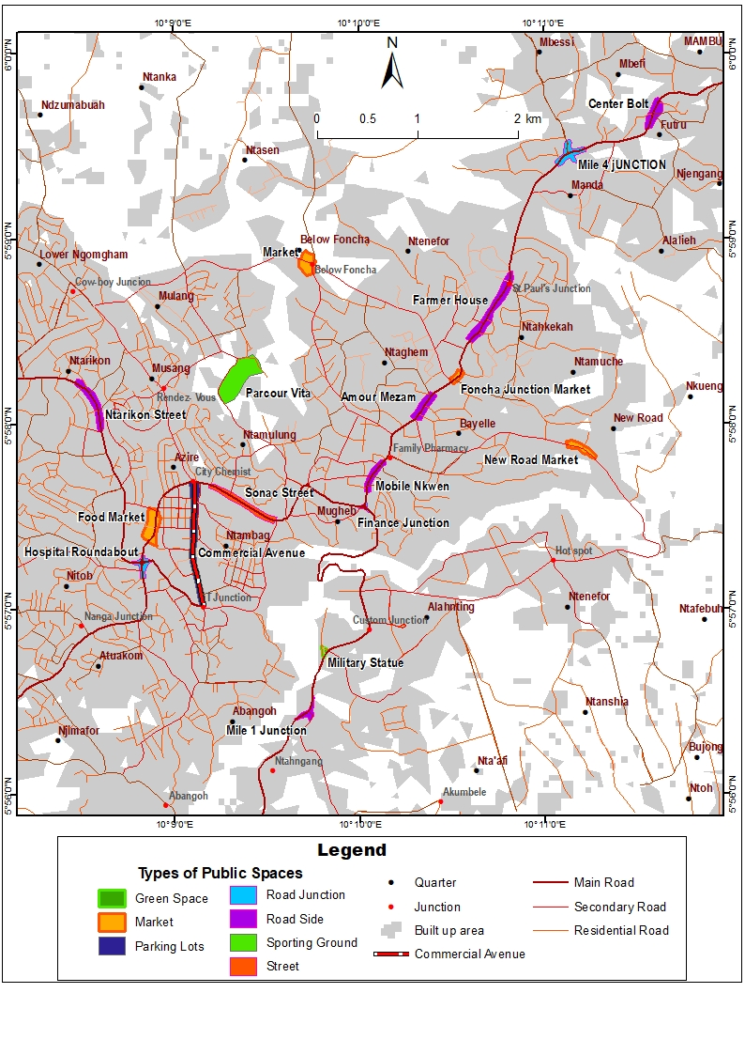
Figure 4: Spatial view of public space types in Bamenda City
Source: Fieldwork ,2024
As illustrated in Figure 4, the majority of public spaces in the study area are concentrated within the Bamenda II and Bamenda III Municipalities. In contrast, Bamenda I Municipality is predominantly characterised by well-planned residential neighbourhoods and administrative and government facilities, with comparatively fewer active public spaces. The map clearly highlights the main categories of public spaces across the study area, including roadside vending zones, market yards, informal motor parks, streets, road junctions, and sporting grounds frequented by vendors. The typology and spatial distribution of public spaces in the study area reveal a city shaped by numerous economic corridors and extensive informal spatial practices. This case study diverges from the works of Adegunloye et al., (2022) and Irene (2021), who pointed out that public spaces connect one part of the city to another and must relate to the physical elements of the city that shape its image, and that there is a positive relationship between public spaces and the city's image.

3.2. Vendors’ activities in public spaces in Bamenda City
Bamenda City is endowed with a myriad of socio-economic activities spread across urban open public spaces. These activities vary in terms of space, actors, and tenure arrangements. The most common activities in these spaces are those practised by street vendors, which is one of the main preoccupations of this study. Vending activity, as a specific spatial phenomenon in the study area, is observed to be a major form of livelihood for many people engaged in the informal economy. This gives rise to an almost daily pattern of informal traders moving from one location to another, eventually cycling back to the same place once the attention of the municipal police is directed elsewhere. Figure 5 illustrates the various economic activities carried out by street vendors in the study area.
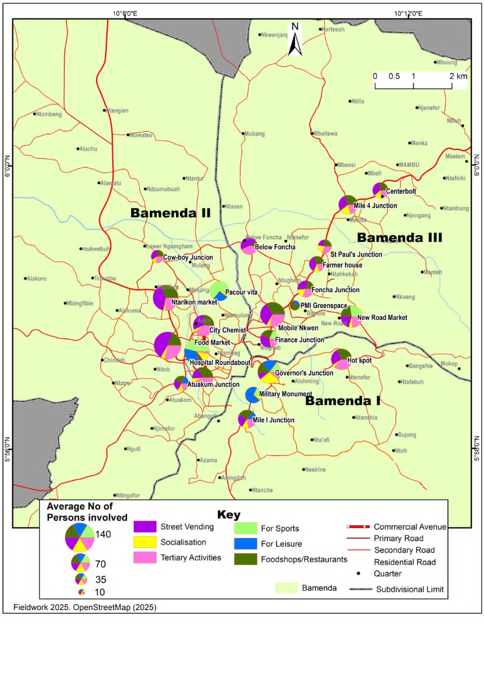
Figure 5. Economic activities in the Bamenda City Public spaces
Figure 5 illustrates the various economic activities within public spaces in Bamenda. Field evidence indicates that street vending (or hawking) is the primary activity, accounting for 38.6% of public space usage, whilst other activities are less frequent. It was observed that the occupation of most of these areas is authorised by municipal authorities through temporary occupation permits. Figure 6 displays examples of street vending and the arrangement of goods for sale along Commercial Avenue in Bamenda.

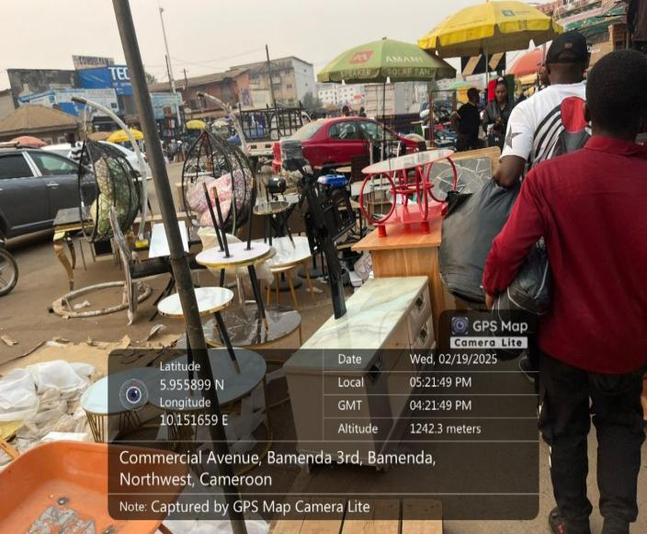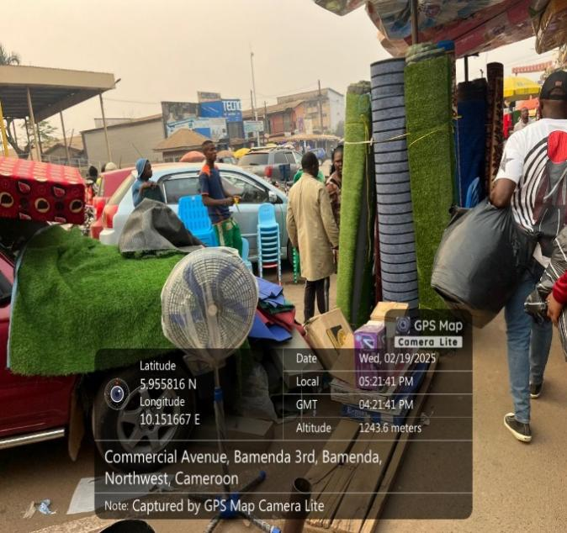
Figure 6: Sample of vendors’ occupation at Commercial Avenue in Bamenda City
Source: Fieldwork, 2024
The photograph above vividly illustrates public space occupation along Commercial Avenue in Bamenda City. The proliferation of hawking in urban areas such as Bamenda, coupled with the constant movement and displacement of goods for sale, underscores the important role that informal economic activities play within the urban fabric. Far from being marginal or peripheral, street vending reflects a dynamic and adaptive form of commerce that meets the immediate needs of urban residents. The visibility of goods displayed on streets, pavements, and public squares signals not only economic vitality but also the social and cultural integration of informal trade within the cityscape, as well as Afro-indigenous practices. The study argues that the persistence and ubiquity of street vending suggest it holds substantial economic and social value for the Bamenda urban community values that warrant significantly greater development and policy integration. Despite its challenges, street vending provides livelihoods for vendors, access to affordable goods for consumers, and contributes to the vibrancy and functionality of public spaces. This prominence within the urban environment challenges prevailing perceptions of informality as chaotic or undesirable, instead highlighting it as a critical component of urban life that supports mobility, sustenance, and social interaction in Bamenda City and beyond.
As underscored by Peimani et al. (2024), public spaces in Global South cities generally involve informal actors and activities competing for access, use, and visibility, with street vending being one of the most prevalent forms of urban informality. However, despite the crucial role of street vendors in the informal economic sector, they often face little dignity and tolerance from authorities, as is the case in Bamenda City. Field findings also revealed the demographic characteristics of street vending in the study area, bringing into focus a range of varied metrics with corresponding values as indicated in Table 1.
Table 1: Street Vending Demographic Characteristics in Bamenda City
Metric | Estimated figure
Gender Participation | 60% to 68% of street vendors are women.
Primary Age Group | The majority fall between 28 and 43 years old.
Daily Income | Often, less than 500 FCFA for the most vulnerable.
Education Level | High prevalence of low formal education; many have not completed primary school.
Marital Status | A mix of young wives, widows, and single mothers seeking family sustenance.
Hotspots | Main market, Food market, Nkwen market, Ntarikon market and major road stretches
Source: Field work, 2024
Table 1 shows that street vending is a cornerstone of the informal economy in the study area, with women making up approximately 60% to 68% of the workforce. Recent instability in Bamenda appears to have increased reliance on informal livelihood activities among some vulnerable groups, including women and displaced youth. This is consistent with the findings of Abagissa (2020), who showed that most traders in Yeka sub-city came from outside Addis Ababa in search of employment, and that street vending proliferated as a way of life and a coping mechanism adopted by economically underprivileged segments of society. It was also revealed that the factors contributing to high levels of street vending were complex and varied, including the absence of opportunities in the formal sector and cultural habituation. This study argues that, unless managed effectively, street vending will have a negative impact on traffic movement, encroachment into public space, and unfair competition within the formal business sector.

3.3. Reasons for Street Vending Activities in Bamenda City
Urban public spaces serve as critical arenas for social interaction, economic activity, and cultural expression in cities across Africa (Ntakana et al., 2025). In Bamenda, the capital of the North West Region of Cameroon, these spaces are not only centres of movement and gathering but also primary sites for informal economic activity, particularly street vending. The occupation of public spaces by vendors is shaped by multiple interrelated factors, including proximity to consumers, perceived security, employment opportunities, affordability, environmental conditions, family and social ties, and the availability of essential amenities.
Street vending in Bamenda City reflects both economic necessity and urban spatial dynamics. For many individuals excluded from formal employment, public spaces provide accessible and low-cost opportunities to earn a livelihood. The strategic positioning of vendors in areas with high foot traffic, near social gathering points, and in spaces with basic amenities allows them to maximise sales whilst responding to the needs of the urban population. Furthermore, public spaces function as communal hubs where social, cultural, and economic activities converge, highlighting the complex relationship between urban planning, social behaviour, and informal economies.
Understanding the motivations behind vendors' use of public spaces in the study area is crucial for urban policy and planning. It not only illuminates the economic strategies of urban dwellers but also provides insights into how Bamenda City can accommodate informal activities without unduly compromising order and public welfare. This study explores the following driving factors proximity, security, employment, affordability, cleanliness, family gatherings, and amenities to provide a comprehensive analysis of why vendors occupy public spaces in Bamenda City. Table 2 captures a quantitative analysis of the various reasons that motivate vendors to use public open spaces in the study area.
Table 2: Reasons for Public Space Use by Vendors in Bamenda City
Reasons | Percentage
Proximity | 9,5%
Amenities available | 2,3%
Security | 15,3%
Cleanliness | 3,6%
Accessibility | 10,8%
Family gatherings | 1,8%
Income generation | 46,2%
Affordability | 10,4%
Total | 100 %
Source: Fieldwork, 2024

3.4. Temporal Patterns of Vendors’ Use of Public Spaces in Bamenda City
The use of public spaces by vendors in Bamenda City is not static but follows distinct temporal patterns influenced by human behaviour, economic considerations, climatic conditions, and security realities. Vendors strategically align their activities with periods of peak customer presence to maximise sales whilst minimising risks and physical strain, as indicated in Table 3. Understanding these temporal dynamics is crucial, as it highlights how vendors adapt to daily urban rhythms, the distribution of public spaces, and surrounding infrastructure.
Moreover, the interaction between temporal patterns and spatial accessibility that is, how far vendors and residents are from public spaces creates a complex set of behaviours that shape the functionality, congestion, and vibrancy of urban areas (Ntakana et al., 2025). The findings suggest that, by analysing these patterns, stakeholders can better design urban policies, regulations, and public space management strategies that support informal livelihoods whilst maintaining order, accessibility, and safety in the city. Table 3 summarises the temporal patterns and spatial accessibility of vendor activities in Bamenda City.
Table 3: Temporal patterns of Street vendors’ use of public spaces in Bamenda City
Time of Day | Vendor Activity Level | Characteristics / Observations | Drivers / Influencing Factors | Examples / Locations
Morning (6:00 Am – 10:00 Am) | Highest activity | Peak customer traffic; vendors sell breakfast items, farm produce, snacks, newspapers, and mobile credit; early operation to avoid municipal enforcement | High foot traffic from commuters; freshness of perishable goods; favorable climate; avoiding officials | Central core areas: City Chemist, Finance Junction, Mobile Nkwen, PMI Neighborhood
Afternoon (12:00 Pm – 2:00 Pm) | Moderate activity | Surge in food vending for lunch; buyers who missed morning errands; activity declines after peak | Worker lunch breaks; residual shopping needs; midday heat in the dry season discourages prolonged vending | Areas near markets and workplaces
Evening (After 5:00 Pm) | Lower activity | Streets are less crowded; vendors leave before dark; security and transport limitations reduce presence | Security concerns (socio-political instability), reduced transportation, and exhaustion | Peripheral areas and markets with security risks
Whole Day (All-day vending) | Limited/rotational activity | Physically exhausting; some vendors operate in shifts or rotations; restricted by municipal regulations | Lack of shelter/sanitation; need for rest; legal restrictions; rotational space-sharing | Front of main markets: Ntarinkon Market, Food Market, Mobile Nkwen
Sources: Field work,2024

3.6. Street vendors in the face of challenges in Bamenda City
In the specific context of Bamenda, public space management is further complicated by the diverse array of informal economic actors, including market stallholders, street hawkers, fuel sellers, and food vendors. These actors play a vital role in the local economy by ensuring the steady provision of goods and services, creating employment opportunities, and supporting food distribution, particularly for low-income households. Despite these contributions, the informal sector operates within a framework of challenges that affect both vendors and the broader urban environment. Principal issues include insecurity and crime, overcrowding of streets and marketplaces, traffic congestion, poor sanitation, inaccessibility of main urban spaces, high rents and taxes, and instances of illegal occupation of public areas.
The daily experiences of street vendors in Bamenda City reveal a dynamic tension: they are indispensable to the city's economic and social life, yet their activities often clash with urban planning goals and regulatory frameworks. Figure 6 illustrates the range of challenges confronting street vendors in Bamenda, highlighting the need for nuanced policies that integrate informal livelihoods into sustainable urban development strategies. Addressing these challenges requires a balanced approach that safeguards public order, ensures accessibility and sanitation, and simultaneously supports the informal economy that sustains a significant portion of the city's population. Figure 7 illustrates the main challenges faced by vendors in open public spaces.

Figure 7: Challenges faced by street vendors in public spaces in Bamenda City
Source: Fieldwork, 2024
From Figure 7, it is evident that public spaces in the study area face numerous and diverse challenges. These challenges arise from multiple triggers and have varying impacts on both vendors operating within these spaces and the surrounding urban environment. This situation reflects broader urban issues highlighted by Jude et al., (2017), who argued that cities worldwide are increasingly confronted with the "triple threats" of informal vending activities, congestion, and environmental degradation. In Bamenda City, the intensified use of public spaces for street vending remains a particularly pressing concern.
Whilst street vending constitutes a vital component of the urban informal economy, its unregulated expansion disrupts normal mobility, urban aesthetics, and the functionality of public spaces. Street vending around major markets, in particular, has become a contentious issue for urban policymakers, economists, planners, designers, and local councils. It can contribute to traffic congestion, litter, and grime; however, these challenges are not solely caused by vendors. Pedestrian movement, vehicular traffic, inadequate enforcement, and insufficient municipal sanitation services also play significant roles in shaping the urban environment.
Moreover, many street vendors comply with municipal regulations by paying operating fees and local taxes, even though most earn incomes below the threshold for personal or corporate taxation. This underscores the economic contribution of vendors to the city despite the challenges associated with informal operations.
Given the aforementioned challenges and their impacts in the study area, this study argues that there is a pressing need for balanced and inclusive urban planning that not only supports the economic survival of street vendors but also promotes the orderly, sustainable, and safe use of public spaces, ensuring that informal livelihoods and urban functionality coexist harmoniously.

4. Strategies for street vendors’ survival in public spaces in Bamenda City
Vendors in Bamenda City, operating in the highly contested environment of poorly regulated public spaces, employ a range of proactive and reactive survival strategies. Based on field inquiries, 85% of operators rely on highly mobile infrastructure, such as wheelbarrows and baskets, to disappear within seconds during municipal police raids at locations such as Commercial Avenue, Food Market, and Mobile Nkwen. Field investigations also reveal that, in high-density junctions such as the Hospital Roundabout and Finance Junction, vendors tap into massive pedestrian flows, often settling near formal businesses to capture a 70% overlap in customer bases. This spatial encroachment is balanced by extreme temporal flexibility, with approximately 60% of vendors shifting to "shadow hours," operating late at night or in the very early morning to serve clandestine bus stops (travelling to towns such as Bafoussam, Dschang, Mbouda, Yaounde, and Douala) and commuters whilst avoiding the daytime scrutiny of the municipal police. Some vendors reported making unofficial payments during enforcement encounters in an effort to reduce the risk of eviction, harassment, or confiscation of goods. To manage the lack of formal infrastructure, 70% of vendors have established a "subterranean" logistics network, paying small fees to store products overnight in the backyards of trusted neighbours rather than transporting them daily. Furthermore, to hedge against enforcement targeting specific commodities, over 55% of vendors have diversified their inventory, often pairing perishable food items with high-turnover electronics or phone credit. Ultimately, these strategies transform Bamenda's public spaces into a living laboratory of informal urban planning, where economic necessity consistently outpaces formal regulation. Table 4 portrays street vendors' survival strategies in the study area.
Table 4: Street Vendors' Survival Strategies in Bamenda City
Strategy Category | Specific Tactic/Variable | Prevalence (%) | Primary Risk Mitigated | Key Locations Affected
Spatial Mobility | Use of mobile infrastructure (wheelbarrows, baskets) | 85 | Asset Confiscation | Commercial Avenue, Mobile Nkwen
Spatial Selection | Anchoring near formal businesses/junctions | 70 | Low Sales Volume | Hospital Roundabout, Finance Junction
Temporal Shift | Night/Early morning operations (Off-peak) | 60 | Municipal Raids | Amour Mezam, Mobile Nkwen and finance junction Clandestine Bus Stops
Logistics | Informal overnight storage with neighbours/shops | 70 | Theft and Transport Costs | Ntarikon Market, Food Market
Economic Hedging | Product diversification (Food and Electronics) | 55 | Market Volatility | Main Road Junctions
Informal Governance | Unofficial payments during enforcement encounters | 45 | Eviction/Harassment | Highly Contested Centers
Source: Fieldwork,2025
The data reveal that spatial mobility (85%) is the most critical survival determinant, indicating that a vendor's ability to retreat physically is more important than the profitability of their location. Furthermore, the high reliance on informal storage (70%) suggests a deeply integrated community network that compensates for the city's lack of formal infrastructure. The 45% engagement in informal payments highlights a significant "shadow tax" that reduces the net profit of the informal sector but provides a necessary, albeit fragile, layer of workspace stability. This is consistent with the observation of Simone (2004), who describes African public spaces as fluid and improvised environments where networks of survival, informal economies, and social relations are enacted in ways that challenge formal planning logic.

5-Theoretical Contributions
This study is grounded in the theory of Urban informality, specifically as articulated by Roy (2005), which posits that informality is not a marginal sector of the economy but a "state of exception" produced by the legal and planning apparatus itself. In Bamenda city, this theory illuminates the legal-spatial rift where municipal "temporary occupation" policies simultaneously extract revenue from street vendors while denying them permanent legitimacy.
Complementing this is the Right to the City framework of Harvey (2008), which argues that urban inhabitants have a moral claim to participate in the production of urban space. By applying this to a secondary African city, the research transitions from a Western-centric view of public space as a recreational amenity to an Afro-endogenous perspective, where space is a co-produced, multi-functional infrastructure for the economic survival of the street vendors. These theoretical lenses allow the study to interpret the daily spatial negotiations of Bamenda’s street vendors not as "disorder," but as a sophisticated claim to urban citizenship and spatial justice.

IV. CONCLUSION
This study examined the relationship between street vending and public space governance in Bamenda City, Cameroon. The findings show that public spaces in Bamenda serve important economic and social functions, particularly for low-income urban residents who rely on informal trading as a source of livelihood. Street vending was found to be one of the most visible and significant activities within these spaces, reflecting both limited formal employment opportunities and the practical importance of accessible trading locations. The study also shows that public spaces in Bamenda I, II, and III municipalities vary in their distribution, accessibility, and functionality, with many affected by inadequate infrastructure, congestion, sanitation challenges, and weak regulatory coordination.
The evidence further suggests that vendors’ continued use of public space is shaped by a combination of economic necessity, proximity to customers, temporal flexibility, and adaptation to regulatory pressures. At the same time, the study indicates that current approaches to public-space management do not sufficiently accommodate the realities of informal livelihoods. As a result, tensions often emerge between urban order, accessibility, and the survival strategies of vendors. These findings suggest that the challenges associated with street vending are linked not only to vendor practices themselves, but also to broader limitations in urban planning, infrastructure provision, and governance arrangements.
Overall, the study supports the need for more inclusive and participatory approaches to public-space governance in Bamenda City. Measures such as improved market infrastructure, clearer and more consistent regulation, designated vending areas, and stronger engagement between municipal authorities, planners, and vendors’ associations may help reduce conflict while supporting livelihoods. A more balanced planning approach would improve the functionality and accessibility of public spaces while recognizing the role of informal economic activities in the urban economy. In this way, Bamenda City can better promote social inclusion, economic resilience, and more effective management of shared urban space.
Limitations and Future Research
This study provides useful insight into street vending and public space governance in Bamenda City, but the limitations should be acknowledged. First, the analysis is based on a relatively modest sample of 170 vendors and a limited number of institutional informants, which may not capture the full diversity of experiences across all public-space users. Second, although the study adopts a mixed-methods approach, most findings are primarily descriptive, limiting the strength of causal claims about governance and livelihood outcomes. Third, the cross-sectional design reflects conditions during the study period only and may not adequately capture seasonal, political, or economic changes affecting vending practices over time. Future research should therefore employ longitudinal designs, expand the sample to include consumers and formal business actors, and compare Bamenda with other secondary African cities. More rigorous spatial and inferential analyses would also strengthen understanding of how governance arrangements shape informal urban livelihoods.
Consent
As per international standards or university standards, respondents’ written consents have been collected and preserved by the author(s).

Disclaimer (Artificial intelligence)
Author(s) hereby declares that NO generative AI technologies such as Large Language Models (ChatGPT, COPILOT, etc.) and text-to-image generators have been used during the writing or editing of this manuscript.

REFERENCES
- Abagissa Jemal (2020). Street Businesses in Addis Ababa: Causes, Consequences, and Administrative Interventions. Journal of Governance and Development Vol. 16. Issue 1
- Adegunloye O.O.1, Folorunso C.O.2, Taiwo, A.A.3, and Adegbehingbe (2022). Nexus between Public Spaces and City Image: A Case Study of Akure, Nigeria. Covenant Journal of Research in the Built Environment (CJRBE) Vol. 10 No. 1, June, 2022SSN: p. 2384-5724e.2384-5716
- Alobwede d’Epie, C. (1998). Bending the stems of the bushes: Pidgin English in Cameroon. English Today, 14(1), 20–26.
- Assako, R. J. A. (2012). À propos de l’opération d’embellissement de Yaoundé, capitale d’Afrique centrale. Les Cahiers d’Outre-Mer, 259, 371–393. https://doi.org/10.4000/com.6652
- Brown, A., Msoka, C., and Dankoco, I. (2023). A right to the city: Informal vendors and public space in African municipalities. Routledge
- Budi, R. N. (2021). Cameroonian Women in the Informal Petrol Trade: The Case of Bamenda City Council Area, 1980-2017. African Studies Quarterly, 20(2), 23-42.
- Crossa, V., & Ward, P. M. (2021). Informality and the production of public space: Critiques and possibilities. Urban Studies, 58(11), 2201–2216. https://doi.org/10.1177/00420980211018318
- Grunskis, J., and Mankus, J. (2013). Research on the Importance of Public Spaces in Modern European Cities. Procedia Engineering, 57, 356–361.
- Harvey, D. (2008). The right to the city. New Left Review, (53), 23–40.
- Kamalipour, H., & Peimani, N. (2025). Public space and informal urbanism in the Global South. In J. Dolley, K. Hardy, & T. Matthews (Eds.), Public Space and the Sustainable Development Goals (pp. 105-114). Cheltenham: Edward Elgar Publishing. https://doi.org/10.4337/9781035322411.00014
- Irene Doosuur Mngutyo. (2021) Interrogating Access to Public Space for Peace, Security and Development of African Cities. Urban and Regional Planning. Vol. 6, No. 1, 2021, pp. 26-40. doi: 10.11648/j.urp.20210601.13
- Jude Ndzifon Kimengsi and Zephania. (2017). Urban Green Development Planning Opportunities and Challenges in Sub-Saharan Africa: Lessons from Bamenda City, International Journal of Global Sustainability, ISSN 1937-7924 2017, Vol. 1, No.1
- Mabogunje, A. L. (1993). Perspective on urban land and urban management policies in Sub-Saharan Africa. Washington, DC: World Bank.
- Mabogunje, A.L (1968). Public space in African cities often evolves beyond its planned purpose into a livelihood arena for urban residents
- Marie, A. (1997). La ville africaine et ses mutations. Paris: L’Harmattan.
- Musa Adamu Eya, Gobi Krishna Sinniah , Muhammad Zaly Shah, Abdullahi Hashim. (2024). Factors Influencing Community Participation in Street Vending Business on Urban Road Corridors: A Disposition of Economic Theories and Land Use Models. international journal of research and innovation in applied science (ijrias). ISSN No. 2454-6194 | DOI: 10.51584/IJRIAS |Volume X Issue VII
- Mutandwa E, Saidi PT and Baraka Munyaka JC. (2025). Assessing the Contribution of Urban Street Food Vending to Incomes in Harare and Surrounding Areas: A Fuzzy Numbers Approach [version 1] VeriXiv 2025, 2:317 https://doi.org/10.12688/verixiv.1754.1
- Myers, G. A. (2011). African cities: Alternative visions of urban theory and practice. London: Zed Books.
- Ntakana, K., Mbanga, S., and Mosiea, T. (2025). Urban public space development: themes and trends in the urban planning rhetoric. Frontiers in Built Environment, 01. DOI: 10.3389/fbuil.. 2025.1456638
- Olivier de Sardan, J.-P. (2005). Anthropologie et développement: Essais en socio-anthropologie du changement social. Paris: Karthala.
- Peimani, N., and Kamalipour, H. (2024). Informal public space: Exploring street vending in Tehran. Journal of Urbanism: International Research on Placemaking and Urban Sustainability. https://doi.org/10.1080/17549175.2024.2348792
- Pieterse, E. (2008). Cityness in the African city: Re-imagining urban life. Urban Studies, 45(3), 556–570.
- Plissart, R. (2004). Kinshasa: The imaginary city. Brussels: Fonds Mercator
- Simo Bobda, A. (2001). English in the Cameroon territory: Its development and education. Peter Lang.
- Roy, A. (2005). Urban informality: Toward an epistemology of planning. Journal of the American Planning Association, 71(2), 147–158. https://doi.org/10.1080/01944360508976689
- Sourav Zaman1 and Nafia Nawreen Ahmed (2023). The Impact of Street Vendors on Social Sustainability of Public Places: The Case of Khulna City in Bangladesh, Department of Architecture, Northern University of Business and Technology, ISVS e-journal, Vol. 10, Issue 3.
- Street Hawking and Urban Disorder in Bamenda II Subdivision, Northwest Region of Cameroon. (2025). Research Guru.
- UN-HABITAT (2017). Improving Public Space Worldwide Over: Hanoi, Vietnam © Love Strandell/Katla Studios
- Watson, V. (2009). The planned city sweeps the poor away: Urban planning and 21st century African cities. Progress in Planning, 72(3), 151–193
- Yemmafouo, A. (2018). Street Vending Power Relationships and Governance of Public Spaces in Bafoussam, West Cameroon. Current Urban Studies, 6, 611-629. https://doi.org/10.4236/cus.2018.64032
- Adeosun, K. P., Oosterveer, P., & Greene, M. (2023). Informal ready-to-eat food vending governance in urban Nigeria: Formal and informal lenses guiding the practice. PLOS ONE, 18(7), e0288499. https://doi.org/10.1371/journal.pone.0288499
- Chakunda, V. (2023). A “war against livelihoods”: Contestations over the government of Zimbabwe’s response to street vending in selected cities. City, Culture and Society, 34, 100536. https://doi.org/10.1016/j.ccs.2023.100536
- Resnick, D., & Sivasubramanian, B. (2023). Political trust and informal traders in African cities. The Journal of Modern African Studies, 61(3), 389–412. https://doi.org/10.1017/S0022278X23000125
- Dovey, K., & Recio, R. B. (2024). Inventraset assemblages: The spatial logic of informal street vending, transport and settlement. Urban Studies, 61(12), 2265–2289. https://doi.org/10.1177/00420980231223060
- Essien, E., & Jesse, E. E. (2024). Urban informality in Nigeria: A midsized city perspective. Environment, Development and Sustainability. https://doi.org/10.1007/s10668-024-05647-6
- Liu, Y., Liu, Y., Chen, X., Lin, C., & Zhou, Z. (2025). Balancing spatial logic and governance objectives for street vending: An optimizing model for dynamic formalization zones. Cities, 160, 105819. https://doi.org/10.1016/j.cities.2025.105819
- Ngo Kien Thinh, Peimani, N., & Kamalipour, H. (2025). Forms and spatiality of street vending in informal settlements: The case of in-between spaces in Hanoi. Cities, 160, 105870. https://doi.org/10.1016/j.cities.2025.105870
- Ono, H. (2025). Public space and social diversity in Nairobi’s informal settlements. Japan Architectural Review. Journal of Architecture and Planning, Volume 85 Number 778, pages 2695–2702. https://doi.org/10.1002/2475-8876.70062
- Kimengsi, J. N., & Awah, Y. L. (2021). Diagnosing the urban expansion-land conflict nexus in Bamenda II, Cameroon. Journal of Geography, Environment and Earth Science International, 25(7), 36–46. https://doi.org/10.9734/jgeesi/2021/v25i730297
- Kuma, C. J. (2025). Applying livable city method to address urban poverty in Bafoussam, Cameroon: A participatory framework for inclusive planning. Journal of Geography, Environment and Earth Science International, 29(7), 1–14. https://doi.org/10.9734/jgeesi/2025/v29i7914

