Socioeconomic Status as a Predictor of Career Risk-Taking Behaviour Among Secondary School Students in West Bengal, India

ABSTRACT

Career choices are not merely decisions about the future, but reflections of how individuals perceive risk, opportunity, and possibility. This study examines the predictive role of socioeconomic status (SES) in shaping career risk-taking behaviour among secondary school students in West Bengal, India. Using a quantitative descriptive survey design, data were collected from 212 students through multistage sampling and analysed using descriptive and inferential statistics, including correlation, Chi-square, ANOVA, and multiple regression analyses. The findings indicate that a majority of students (74.5%) exhibit a moderate level of career risk-taking behaviour (M = 116.66, SD = 20.51). Inferential results reveal no statistically significant relationship between SES and career risk-taking behaviour (r = -0.035, p > 0.05), and no significant association across income groups (χ²(6) = 2.760, p = 0.838). Further, ANOVA results show no significant group differences (F(3,208) = 0.871, p = 0.457), while regression analysis confirms that SES and demographic variables do not significantly predict career risk-taking behaviour (R² = 0.010, p = 0.568). These findings challenge the conventional assumption of socioeconomic determinism, indicating that career risk-taking behaviour is largely independent of SES and may be influenced more by psychological and contextual factors. The study contributes empirical evidence from the Indian context and highlights the need for multidimensional approaches in career development and policy frameworks.

KEYWORDS | Socioeconomic Status (SES), Career Risk-Taking Behaviour, Secondary School Students, Career Decision-Making, West Bengal

- Introduction
Career development during adolescence represents a critical phase in which individuals begin to formulate aspirations, evaluate opportunities, and make decisions that shape their future trajectories. Within this context, career risk-taking behaviour—defined as the propensity to pursue uncertain or non-conventional career pathways—has gained increasing attention in contemporary career research. The evolving global labour market, characterised by technological disruption and shifting occupational demands, requires greater adaptability and risk orientation among young individuals (World Economic Forum, 2020). Socioeconomic status (SES), typically operationalised through indicators such as family income, parental education, and occupational background, has long been regarded as a key determinant of educational and career outcomes. Empirical evidence suggests that students from higher SES backgrounds benefit from greater access to resources, career information, and social capital, facilitating more exploratory and risk-oriented career behaviours (OECD, 2018; UNESCO, 2019). Conversely, students from lower SES contexts are often associated with constrained opportunities and a preference for stable career choices, reflecting structural limitations (Bourdieu, 1986).
However, recent theoretical developments challenge this deterministic perspective. Social Cognitive Career Theory emphasises the role of self-efficacy, outcome expectations, and personal goals in shaping career-related decisions (Lent, Brown, & Hackett, 1994). Similarly, Bandura’s concept of self-efficacy highlights the role of individual agency in navigating career pathways beyond structural constraints (Bandura, 1997). These perspectives suggest that career risk-taking behaviour may not be solely determined by socioeconomic conditions. In addition, social and institutional factors such as parental expectations, peer influence, and educational environments significantly shape students’ career orientations (Eccles, 2009). Variables such as gender and academic stream further influence aspirations and perceived opportunities (Eccles & Wigfield, 2002). Moreover, the diversification of career pathways, including entrepreneurship and interdisciplinary professions, has transformed traditional notions of career stability and risk (Government of India, 2020; NITI Aayog, 2021). Despite these developments, empirical research examining the relationship between socioeconomic status and career risk-taking behaviour remains limited, particularly within the Indian secondary school context. Existing studies have primarily focused on academic achievement and access to education, with limited attention to behavioural dimensions of career decision-making (Tilak, 2002; Kingdon, 2007). This gap is especially relevant in regions such as West Bengal, where socioeconomic diversity and educational variation provide a meaningful context for investigation.
The present study addresses this gap by examining whether socioeconomic status functions as a predictor of career risk-taking behaviour among secondary school students in West Bengal. Using a quantitative design and multiple statistical techniques—including correlation, chi-square, ANOVA, and regression—the study provides a comprehensive analysis of both relational and predictive dimensions. The findings indicate that socioeconomic status does not have a statistically significant relationship with career risk-taking behaviour, thereby challenging conventional assumptions of economic determinism. These findings contribute to the broader discourse by suggesting that career risk-taking behaviour is more strongly influenced by psychological and contextual factors than by socioeconomic status alone. The study therefore underscores the need for a multidimensional approach to career guidance and educational policy, emphasising motivation, exposure, and institutional support.
- Review of related literature
Contemporary research in career development increasingly emphasises the interaction between structural, psychological, and contextual determinants of career behaviour. Socioeconomic status (SES) has traditionally been viewed as a significant predictor of educational and occupational outcomes; however, recent studies present a more nuanced understanding of its role.
Empirical evidence suggests that SES influences access to educational resources, career information, and social capital, thereby shaping students’ aspirations and opportunities. For instance, research highlights that students from higher socioeconomic backgrounds tend to demonstrate greater academic confidence and broader career exploration (OECD, 2018; OECD, 2022). Similarly, global reports indicate that socioeconomic disparities continue to affect educational participation and career readiness (UNESCO, 2019; UNESCO, 2023). Despite this, recent theoretical and empirical advancements challenge the deterministic role of SES. Social Cognitive Career Theory posits that career behaviour is significantly shaped by self-efficacy, outcome expectations, and personal goals rather than solely by structural factors (Lent et al., 2017; Lent & Brown, 2021). These findings suggest that individuals can exercise agency in career decision-making, thereby reducing the direct influence of socioeconomic constraints.
In the Indian context, recent policy and research developments indicate a shift toward diversified career pathways. The implementation of the National Education Policy 2020 emphasises flexibility, skill development, and interdisciplinary learning, thereby redefining traditional career trajectories. Similarly, national-level reports highlight the growing importance of innovation, entrepreneurship, and emerging occupations in shaping youth career behaviour (NITI Aayog, 2021).
Further research underscores the importance of psychological and contextual variables in influencing career risk-taking behaviour. Studies building on Bandura’s framework demonstrate that self-efficacy plays a crucial role in determining individuals’ willingness to engage in uncertain career pathways (Bandura, 2012). Additionally, expectancy-value models suggest that students’ aspirations are shaped by motivational beliefs, parental expectations, and social environments (Eccles & Wigfield, 2020).
Recent empirical studies (2018–2024) indicate that adolescents tend to exhibit moderate levels of career risk-taking behaviour, reflecting a balance between aspiration and security. These behaviours are often influenced by exposure to career information, institutional support, and peer interactions rather than purely by socioeconomic background.
Moreover, global labour market transformations have reinforced the importance of adaptability and risk orientation. Reports highlight that future employment landscapes will require individuals to navigate uncertainty, innovation, and continuous skill development (World Economic Forum, 2020; World Economic Forum, 2023).
However, despite these developments, there remains a significant gap in the literature concerning the direct relationship between socioeconomic status and career risk-taking behaviour, particularly within the Indian secondary school context. Existing research has largely focused on academic achievement and access to education, with limited attention to behavioural dimensions of career decision-making. Therefore, the present study addresses this gap by examining whether socioeconomic status functions as a predictor of career risk-taking behaviour among secondary school students in West Bengal. By integrating multiple statistical techniques and focusing on behavioural outcomes, the study contributes to the existing literature and provides context-specific insights relevant to both theory and practice.

- Rationale of the study
Career risk-taking behaviour represents a critical yet underexplored dimension of adolescent career development, particularly within rapidly transforming socio-economic and labour market contexts. While socioeconomic status (SES) has traditionally been conceptualised as a key structural determinant influencing educational and career outcomes, its role in shaping behavioural orientations—such as the willingness to engage in uncertain or non-conventional career pathways—remains theoretically ambiguous and empirically under-investigated. Existing literature tends to emphasise the influence of SES on access, opportunity, and academic achievement, with comparatively limited attention to behavioural constructs such as career risk-taking. This gap is particularly evident within the Indian secondary education context, where socio-economic diversity coexists with evolving career landscapes. Moreover, concerns raised regarding conceptual clarity necessitate a more precise operationalisation of career risk-taking behaviour as a measurable construct within career development research.
In response to these limitations, the present study is designed to systematically examine the predictive role of SES in relation to career risk-taking behaviour among secondary school students in West Bengal. The study explicitly integrates demographic variables and employs multiple statistical techniques—including correlation, chi-square, ANOVA, and regression—to ensure methodological robustness and analytical depth. This multi-analytical approach enables a comprehensive evaluation of both relational and predictive dimensions, addressing prior concerns regarding insufficient analytical justification.Furthermore, the study contributes to the theoretical discourse by critically examining the assumption of socioeconomic determinism in career development. By empirically investigating whether SES significantly influences career risk-taking behaviour, the research provides evidence that may either reinforce or challenge prevailing theoretical frameworks. Overall, the study offers a conceptually grounded and methodologically rigorous contribution to the field by clarifying the relationship between socioeconomic status and career risk-taking behaviour. The findings have significant implications for career guidance practices, educational planning, and policy formulation, particularly in contexts characterised by socio-economic heterogeneity and increasing diversification of career pathways.
- Research Objectives

- To assess the levels of career risk-taking behaviour among secondary school students.
- To analyse the distribution of students based on demographic variables such as gender, academic stream, type of school, and monthly family income.
- To determine the association between socioeconomic status and levels of career risk-taking behaviour.
- To compare career risk-taking behaviour across different socioeconomic (income) groups.
- To examine the influence of demographic variables (gender, type of school, and academic stream) on career risk-taking behaviour.
- To analyse the predictive role of socioeconomic status and demographic variables on career risk-taking behaviour.
- To assess the accuracy and explanatory power of the regression model in predicting career risk-taking behaviour.

- Methodology of the Study

Method | The method used in the present study is a descriptive survey method and quantitative in nature
Sample | The sample of the study comprised 212 secondary School Students from different districts of West Bengal. Among them, 90 were male, and 122 were female, representing a balanced distribution of gender within the sample.
Tool Used | Data were collected using a questionnaire ware developed to measure Career Risk-Taking Behaviour (CRTB) to measure the level of Career Risk-Taking Behaviour Among Secondary School Students in West Bengal.
Sampling Technique | Multistage sampling is used for data collection from various schools in different districts of West Bengal.
Statistical Techniques Used | To ensure analytical rigour and address the research objectives comprehensively, the Descriptive, Pearson Correlation, Chi-square Test, One-way ANOVA, and Multiple Regression Analysis statistical techniques were employed
Ethical Considerations | Ethical standards were strictly maintained throughout the study. Informed consent was obtained from participants, and confidentiality of responses was ensured. Participation was voluntary, and data were used solely for academic purposes.

- Results and Discussion

Following analysis presents the distribution and relationship of career risk-taking behaviour across different socioeconomic groups based on monthly family income. The data are analysed using descriptive and inferential statistics to examine patterns and variations in students’ career risk orientation.

  - To assess the levels of career risk-taking behaviour among secondary school students. Distribution of Students Based on Levels of Career Risk-Taking Behaviour.
Table 1: Distribution of Students Based on Levels of Career Risk-Taking Behaviour
CRTB_Level
 |  | Frequency | Percent | Valid Percent | Cumulative Percent
Valid | Low Career Risk-Taking Behaviour | 28 | 13.2 | 13.2 | 13.2
Valid | Moderate Career Risk-Taking Behaviour | 158 | 74.5 | 74.5 | 87.7
Valid | High Career Risk-Taking Behaviour | 26 | 12.3 | 12.3 | 100.0
Valid | Total | 212 | 100.0 | 100.0
Table 1 presents the distribution of secondary school students according to their levels of career risk-taking behaviour. The findings indicate that a substantial majority of students (74.5%) fall within the moderate level category, suggesting a balanced orientation toward career decision-making, where students exhibit cautious yet exploratory tendencies. A smaller proportion of students (13.2%) demonstrates low career risk-taking behaviour, indicating a preference for safer and more secure career options. Similarly, only 12.3% of students fall under the high-risk-taking category, reflecting a relatively limited inclination toward highly uncertain or unconventional career paths. Overall, the distribution reveals that most students tend to adopt a moderate approach to career risk, highlighting a tendency toward equilibrium between risk and stability in career-related decisions. This pattern suggests that extreme risk orientations-either low or high—are less prevalent among the study population.

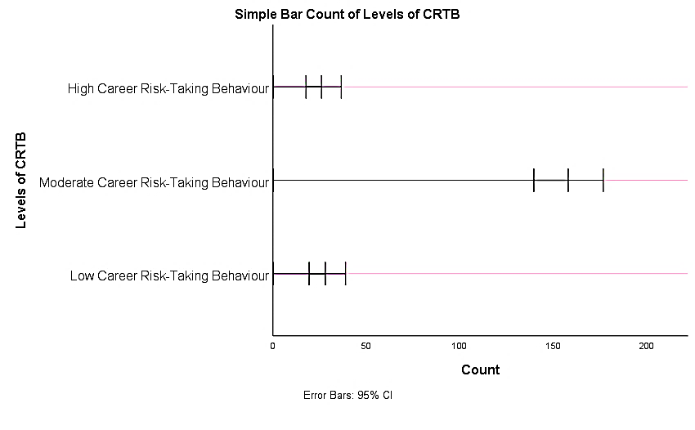
Figure 1: Bar Chart Showing Levels of Career Risk-Taking Behaviour
Figure 1 illustrates the distribution of students across different levels of career risk-taking behaviour. It is evident from the bar chart that the majority of students (74.5%) fall under the moderate level of career risk-taking behaviour, as indicated by the tallest bar. In contrast, a smaller proportion of students exhibit low (13.2%) and high (12.3%) levels of career risk-taking behaviour, represented by comparatively shorter bars. This pattern suggests that most students adopt a balanced approach toward career decisions, showing a moderate willingness to take risks while still considering stability. Only a limited number of students are either highly risk-averse or highly risk-oriented in their career choices.

  - To analyse the distribution of students based on demographic variables such as gender, academic stream, type of school, and monthly family income.
Table 2: Distribution of Students Based on Gender
Gender of the Students
 |  | Frequency | Percent | Valid Percent | Cumulative Percent
Valid | Male | 90 | 42.5 | 42.5 | 42.5
Valid | Female | 122 | 57.5 | 57.5 | 100.0
Valid | Total | 212 | 100.0 | 100.0

Table 2 The gender distribution indicates a slight predominance of female students (57.5%) over male students (42.5%) within the sample. However, the difference is not substantial, suggesting a reasonably balanced representation of both genders, thereby ensuring that gender-based comparisons in subsequent analyses are not significantly biased.

Table 3: Distribution of Students Based on Academic Stream
Stream of the student
 |  | Frequency | Percent | Valid Percent | Cumulative Percent
Valid | Science | 67 | 31.6 | 31.6 | 31.6
Valid | Arts | 69 | 32.5 | 32.5 | 64.2
Valid | Commerce | 76 | 35.8 | 35.8 | 100.0
Valid | Total | 212 | 100.0 | 100.0

Table 3 distribution of students across different academic streams reveals that 67 students (31.6%) belonged to the Science stream, 69 students (32.5%) were from the Arts stream, and 76 students (35.8%) were from the Commerce stream. This indicates a relatively balanced representation of students across all three streams, with a slightly higher proportion from the Commerce stream.
Table 4: Distribution of Students Based on Type of School
Type of School
 |  | Frequency | Percent | Valid Percent | Cumulative Percent
Valid | Government School | 175 | 82.5 | 82.5 | 82.5
Valid | Government Aided School | 37 | 17.5 | 17.5 | 100.0
Valid | Total | 212 | 100.0 | 100.0

Table 4 distribution based on type of school shows that the majority of students, 175 (82.5%), were from Government schools, while 37 students (17.5%) were from Government-aided schools. This indicates that most respondents in the study were enrolled in Government schools.
Table 5: Distribution of Students Based on Monthly Family Income (Socioeconomic Status)
Monthly Family Income
 |  | Frequency | Percent | Valid Percent | Cumulative Percent
Valid | 10000 Below | 69 | 32.5 | 32.5 | 32.5
Valid | 10000-20000 | 134 | 63.2 | 63.2 | 95.8
Valid | 20000-30000 | 8 | 3.8 | 3.8 | 99.5
Valid | 30000 Above | 1 | .5 | .5 | 100.0
Valid | Total | 212 | 100.0 | 100.0

Table 5 presents the descriptive statistics of career risk-taking behaviour among secondary school students. The total sample consisted of 211 students. The scores ranged from 35 to 175, with a mean score of 116.66 and a standard deviation of 20.51. This indicates a moderate level of career risk-taking behaviour among the students, with some variability in responses. students based on monthly family income indicates that 69 students (32.5%) belonged to families earning below ₹10,000 per month. The majority of students, 134 (63.2%), fell within the ₹10,000–₹20,000 income group. A smaller proportion, 8 students (3.8%), belonged to the ₹20,000–₹30,000 category, while only 1 student (0.5%) reported a family income above ₹30,000. This suggests that most students in the sample belong to lower and middle-socioeconomic backgrounds.
Table 6: Monthly Family Income * Levels of Career Risk-Taking Behaviour Crosstabulation
Monthly Family Income * Levels of Career Risk-Taking Behaviour Crosstabulation
Count
 |  | Levels of Career Risk-Taking Behaviour |  |  | Total
 |  | Low Career Risk-Taking Behaviour | Moderate Career Risk-Taking Behaviour | High Career Risk-Taking Behaviour | Total
Monthly Family  Income | 10000 Below | 10 | 50 | 9 | 69
Monthly Family  Income | 10000-20000 | 18 | 101 | 15 | 134
Monthly Family  Income | 20000-30000 | 0 | 6 | 2 | 8
Monthly Family  Income | 30000 Above | 0 | 1 | 0 | 1
Total |  | 28 | 158 | 26 | 212
Table 6 The cross-tabulation reveals a consistent pattern across all income groups, with the majority of students exhibiting a moderate level of career risk-taking behaviour. The absence of a clear increasing or decreasing trend across income categories indicates that career risk-taking behaviour does not vary systematically with socioeconomic status. This uniform distribution suggests that income level has minimal influence on students’ risk orientation in career decision-making.

  - To determine the association between socioeconomic status and levels of career risk-taking behaviour.
Table 7: Chi-Square Tests
Chi-Square Tests
 | Value | df | Asymptotic Significance (2-sided)
Pearson Chi-Square | 2.760ª | 6 | .838
Likelihood Ratio | 3.816 | 6 | .702
Linear-by-Linear Association | .361 | 1 | .548
N of Valid Cases | 212
a. 5 cells (41.7%) have expected count less than 5. The minimum expected count is .12.
Table 7 The Chi-square analysis confirms that there is no statistically significant association between monthly family income and levels of career risk-taking behaviour (χ² = 2.760, p = 0.838). Since the p-value exceeds the threshold of 0.05, the null hypothesis is retained. This indicates that socioeconomic status is not significantly related to career risk-taking behaviour, reinforcing the findings from the cross-tabulation analysis.

  - To compare career risk-taking behaviour across different socioeconomic (income) groups.

Table 8: One-Way ANOVA of Career Risk-Taking Behaviour by Socioeconomic Status
ANOVA
CRT_Behaviour Scale
 | Sum of Squares | df | Mean Square | F | Sig.
Between Groups | 1097.714 | 3 | 365.905 | .871 | .457
Within Groups | 87358.791 | 208 | 419.994
Total | 88456.505 | 211
Table 8 one-way ANOVA was conducted to examine whether there are significant differences in career risk-taking behaviour among students across different income groups. The results indicated that there is no statistically significant difference in career risk-taking behaviour based on monthly family income, F(3, 208) = 0.871, p = 0.457 (p > 0.05). This suggests that students from different socioeconomic backgrounds do not differ significantly in their levels of career risk-taking behaviour. Therefore, socioeconomic status, as measured by monthly family income, does not have a significant impact on students’ career risk-taking behaviour.
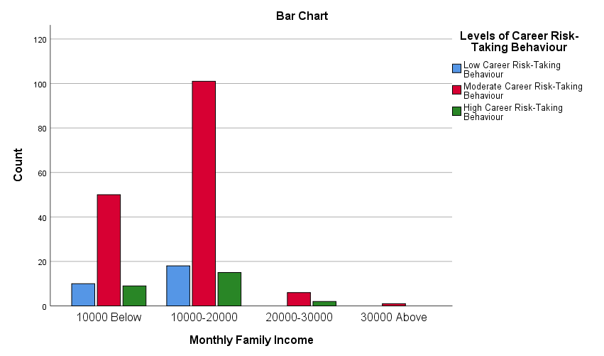
Figure 2: Bar Chart Showing Distribution of Career Risk-Taking Behaviour Across Monthly Family Income Groups
Figure 2 bar chart illustrates the distribution of career risk-taking behaviour across different monthly family income groups. It is evident that the majority of students belong to the ₹10,000–₹20,000 income group, where a large proportion exhibit a moderate level of career risk-taking behaviour. A similar moderate pattern is observed in the below ₹10,000 group, though with comparatively lower counts. In the higher income groups (₹20,000–₹30,000 and above ₹30,000), the number of students is considerably smaller, but the trend of moderate risk-taking behaviour remains consistent. The low and high risk-taking categories are minimal across all income groups.

  - To examine the influence of demographic variables (gender, type of school, and academic stream) on career risk-taking behaviour.
Table 9: Gender and Levels of Career Risk-Taking Behaviour among Secondary School Students
Gender of the Students * Levels of Career Risk-Taking Behaviour Crosstabulation
 |  | Levels of Career Risk-Taking Behaviour |  |  | Total
 |  | Low Career Risk-Taking Behaviour | Moderate Career Risk-Taking Behaviour | High Career Risk-Taking Behaviour | Total
Gender of the Students | Male | 11 | 65 | 14 | 90
Gender of the Students | Male | 12.2% | 72.2% | 15.6% | 100.0%
Gender of the Students | Female | 17 | 93 | 12 | 122
Gender of the Students | Female | 13.9% | 76.2% | 9.8% | 100.0%
Total |  | 28 | 158 | 26 | 212
 |  | 13.2% | 74.5% | 12.3% | 100.0%

Table 9 indicates that among male students, 72.2% exhibit moderate, 12.2% low, and 15.6% high career risk-taking behaviour. Similarly, among female students, 76.2% show moderate, 13.9% low, and 9.8% high levels. Overall, the majority of students (74.5%) fall under the moderate category.

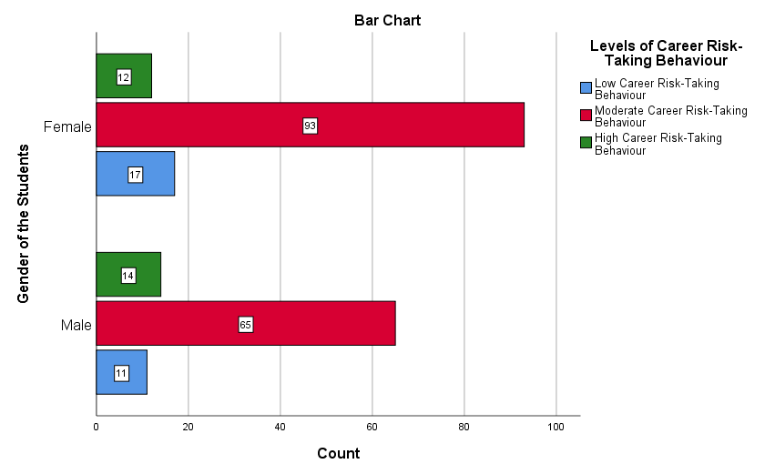
Figure 3: Bar Chart Showing Gender Differences in Levels of Career Risk-Taking Behaviour
Figure 3 The bar chart illustrates the distribution of career risk-taking behaviour across gender. It is evident that both male and female students predominantly exhibit a moderate level of career risk-taking behaviour, with females (93) slightly higher than males (65). In terms of low risk-taking behaviour, females (17) are slightly higher than males (11), whereas for high risk-taking behaviour, males (14) slightly exceed females (12).
Table 10: Type of School * Levels of Career Risk-Taking Behaviour Crosstabulation
Type of School * Levels of Career Risk-Taking Behaviour Crosstabulation
Count
 |  | Levels of Career Risk-Taking Behaviour |  |  | Total
 |  | Low Career Risk-Taking Behaviour | Moderate Career Risk-Taking Behaviour | High Career Risk-Taking Behaviour | Total
Type of School | Government School | 23 | 132 | 20 | 175
Type of School | Government Aided School | 5 | 26 | 6 | 37
Total |  | 28 | 158 | 26 | 212
Table 10 presents the distribution of students’ levels of career risk-taking behaviour with respect to the type of school. Among students studying in government schools, 23 exhibit low, 132 moderate, and 20 high levels of career risk-taking behaviour. In comparison, among students from government-aided schools, 5 fall under low, 26 under moderate, and 6 under high levels of career risk-taking behaviour. It is observed that in both categories of schools, the majority of students demonstrate a moderate level of career risk-taking behaviour. The distribution pattern across government and government-aided schools appears to be relatively similar, with only minor variations in the proportion of students across different levels
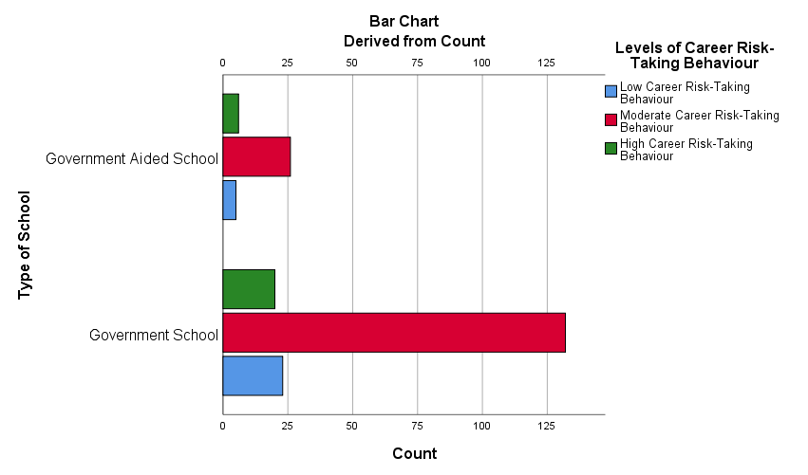
Figure 4: Bar Chart Showing Distribution of Career Risk-Taking Behaviour Across Types of School
Figure 4 bar chart shows the distribution of career risk-taking behaviour across types of school. It is evident that students from both government and government-aided schools predominantly exhibit a moderate level of career risk-taking behaviour, with a notably higher number in government schools due to larger sample representation. A smaller proportion of students in both school types fall under low and high risk-taking categories, with slightly higher counts observed in government schools.
Table 11: Distribution of Career Risk-Taking Behaviour Across Academic Stream
Stream of the student * Levels of Career Risk-Taking Behaviour Crosstabulation
Count
 |  | Levels of Career Risk-Taking Behaviour |  |  | Total
 |  | Low Career Risk-Taking Behaviour | Moderate Career Risk-Taking Behaviour | High Career Risk-Taking Behaviour | Total
Stream of the student | Science | 8 | 52 | 7 | 67
Stream of the student | Arts | 7 | 51 | 11 | 69
Stream of the student | Commerce | 13 | 55 | 8 | 76
Total |  | 28 | 158 | 26 | 212
Table 11 presents the distribution of students’ levels of career risk-taking behaviour across different academic streams. Among students from the Science stream, 8 exhibit low, 52 moderate, and 7 high levels of career risk-taking behaviour. In the Arts stream, 7 students fall under low, 51 under moderate, and 11 under high levels. Similarly, among Commerce students, 13 exhibit low, 55 moderate, and 8 high levels of career risk-taking behaviour. It is evident that across all three academic streams, the majority of students demonstrate a moderate level of career risk-taking behaviour. Although slight variations are observed in the distribution of low and high levels among the streams, the overall pattern remains consistent. These findings indicate that the academic stream of the students does not substantially influence their level of career risk-taking behaviour, as similar trends are observed across Science, Arts, and Commerce groups.
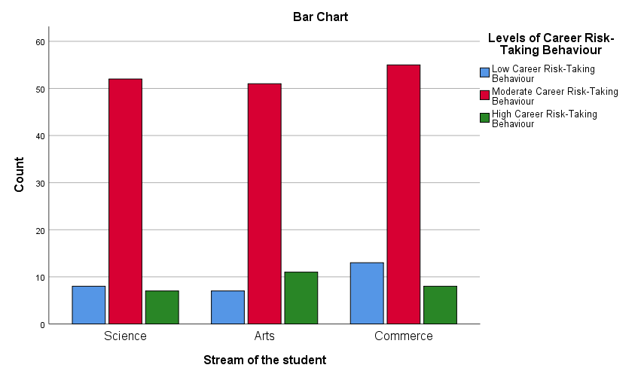
Figure 5: Bar Chart Showing Distribution of Career Risk-Taking Behaviour Across Academic Stream
In Figure 5 Distribution of career risk-taking behaviour across different academic streams. It is evident that students from all streams-Science, Arts, and Commerce-predominantly exhibit a moderate level of career risk-taking behaviour, with Commerce students showing a slightly higher count. The low and high risk-taking categories are comparatively smaller across all streams, with minor variations. Arts students show a slightly higher tendency toward high risk-taking behaviour, while Commerce students have relatively higher representation in the low category.
  - To analyse the predictive role of socioeconomic status and demographic variables on career risk-taking behaviour.
Table 12: Summary of Multiple Regression Analysis Predicting Career Risk-Taking Behaviour
Model Summary^{b}
Model | R | R Square | Adjusted R Square | Std. Error of the Estimate | Change Statistics
 |  |  |  |  | R Square Change | F Change | df1 | df2 | Sig. F Change
1 | .098ª | .010 | -.005 | 20.52233 | .010 | .676 | 3 | 208 | .568
a. Predictors: (Constant), Gender of the Students, Type of School, Monthly Family Income
b. Dependent Variable: CRT_Behaviour Scale
Table 12 Model summary indicates that the multiple correlation coefficient (R) is 0.098, suggesting a very weak relationship between the independent variables (monthly family income, gender, and type of school) and career risk-taking behaviour. The coefficient of determination (R²) is 0.010, which indicates that only 1.0% of the variance in career risk-taking behaviour is explained by the predictor variables. The adjusted R² value (-0.005) further confirms that the model has very low explanatory power.
Table 13: ANOVA for Multiple Regression Analysis Predicting Career Risk-Taking Behaviour
ANOVAª
Model |  | Sum of Squares | df | Mean Square | F | Sig.
1 | Regression | 853.945 | 3 | 284.648 | .676 | .568^{b}
1 | Residual | 87602.559 | 208 | 421.166
1 | Total | 88456.505 | 211
a. Dependent Variable: CRT_Behaviour Scale
b. Predictors: (Constant), Gender of the Students, Type of School, Monthly Family Income
Table 13 ANOVA results show that the overall regression model is not statistically significant, F(3, 208) = 0.676, p = 0.568 (p > 0.05). This indicates that the set of independent variables does not significantly predict career risk-taking behaviour. Therefore, the regression model is not a good fit for the data.
Table 14: Regression Coefficients for Predicting Career Risk-Taking Behaviour
Coefficientsª
Model |  | Unstandardized Coefficients |  | Standardized Coefficients | t | Sig.
 |  | B | Std. Error | Beta | t | Sig.
1 | (Constant) | 125.813 | 7.657 |  | 16.432 | .000
1 | Monthly Family Income | -1.148 | 2.559 | -.031 | -.449 | .654
1 | Type of School | -1.168 | 3.721 | -.022 | -.314 | .754
1 | Gender of the Students | -3.717 | 2.855 | -.090 | -1.302 | .194
a. Dependent Variable: CRT_Behaviour Scale
Table 14 Regression coefficients indicate that none of the independent variables significantly predict career risk-taking behaviour. Monthly family income (β = -0.031, p = 0.654), type of school (β = -0.022, p = 0.754), and gender (β = -0.090, p = 0.194) all have non-significant p-values (p > 0.05). This suggests that changes in socioeconomic status, school type, or gender do not significantly influence students’ career risk-taking behaviour.

  - To assess the accuracy and explanatory power of the regression model in predicting career risk-taking behaviour.
Table 15: Residuals Statistics for Multiple Regression Model
Residuals Statisticsª
 | Minimum | Maximum | Mean | Std. Deviation | N
Predicted Value | 112.5984 | 119.7800 | 116.6085 | 2.01175 | 212
Residual | -84.78002 | 58.93679 | .00000 | 20.37592 | 212
Std. Predicted Value | -1.993 | 1.577 | .000 | 1.000 | 212
Std. Residual | -4.131 | 2.872 | .000 | .993 | 212
a. Dependent Variable: CRT_Behaviour Scale
Table 15 residuals statistics provide information about the accuracy and distribution of the predicted values in the regression model. The predicted values of career risk-taking behaviour range from 112.60 to 119.78, with a mean of 116.61 and a standard deviation of 2.01, indicating a relatively narrow spread of predicted scores. The residual values range from -84.78 to 58.94, with a mean of 0.00 and a standard deviation of 20.38. The mean residual of zero suggests that the model does not systematically overestimate or underestimate the dependent variable. However, the wide range of residuals indicates substantial variability between observed and predicted values.
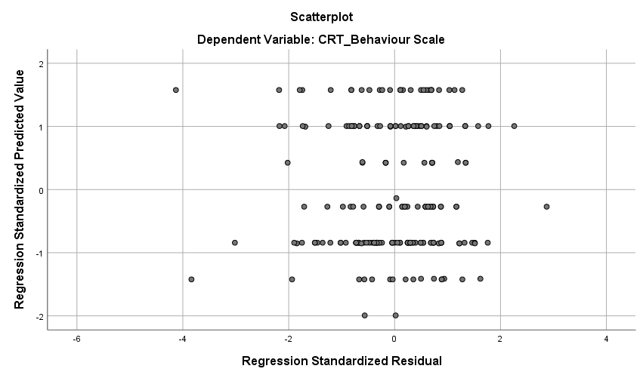
Figure 6: Scatterplot of Standardised Residuals vs Standardised Predicted Values
Figure 6 shows a lack of a distinct pattern in the scatterplot suggests that the independent variables included in the model do not adequately explain variations in career risk-taking behaviour. This supports the non-significant findings obtained from regression analysis and highlights the limited role of socioeconomic and demographic factors in predicting the outcome variable.

- Summary and Conclusion

The findings of the study reveal a clear and consistent pattern in the distribution and determinants of career risk-taking behaviour among secondary school students. The predominance of a moderate level of career risk-taking behaviour (74.5%) suggests that most students adopt a balanced approach toward career decision-making, indicating a tendency to weigh both risk and stability rather than exhibit extreme orientations. This pattern reflects a cautious yet adaptive behavioural tendency, which may be shaped by broader socio-cultural and educational influences.
Analysis of demographic characteristics indicates a relatively balanced representation across gender and academic streams, with a larger proportion of students belonging to government schools and lower to middle socioeconomic backgrounds. However, despite this variation, the distribution of career risk-taking behaviour remains largely consistent across groups, suggesting that demographic factors do not substantially differentiate students’ risk orientation.
Importantly, inferential analyses provide strong evidence against the assumed influence of socioeconomic status on career risk-taking behaviour. The Chi-square test indicates no significant association between SES and levels of career risk-taking behaviour (p > 0.05), while the one-way ANOVA further confirms the absence of significant differences across income groups. These findings suggest that students from different socioeconomic backgrounds exhibit comparable behavioural patterns in relation to career risk.
Similarly, cross-tabulation analyses across demographic variables such as type of school and academic stream reveal a uniform pattern, with the majority of students in all categories demonstrating moderate levels of career risk-taking behaviour. This consistency reinforces the notion that these variables exert minimal influence on the behavioural outcome.
The multiple regression analysis provides further analytical depth by examining the predictive capacity of SES and demographic variables. The results indicate that these variables do not significantly predict career risk-taking behaviour (R² = 0.010, p > 0.05), highlighting the extremely low explanatory power of the model. This suggests that only a negligible proportion of variance in career risk-taking behaviour can be attributed to socioeconomic and demographic factors.
Moreover, residual analysis and scatterplot examination reveal a lack of systematic pattern, indicating weak model fit and reinforcing the limited predictive relevance of the selected variables. The presence of variability and outliers further suggests that unmeasured factors may play a more substantial role in shaping career risk-taking behaviour.
Overall, the findings challenge the conventional assumption of socioeconomic determinism in career development. The consistent absence of significant relationships across multiple statistical techniques-correlation, chi-square, ANOVA, and regression-indicates that career risk-taking behaviour is largely independent of socioeconomic status. Instead, the results point toward the likely influence of psychological, social, and contextual factors, such as self-efficacy, motivation, exposure, and institutional support, which may better explain variations in career-related risk behaviour.

The study challenges the deterministic view of socioeconomic status and emphasises the need for a multidimensional perspective in understanding career development. It highlights that factors such as personal interests, self-efficacy, parental guidance, peer influence, and educational exposure may play a more crucial role in shaping students’ career-related decisions.
In conclusion, the study contributes to the existing literature by providing empirical evidence that career risk-taking behaviour among adolescents is largely independent of socioeconomic status, thereby offering important implications for educational policy, career guidance, and future research.

Limitations of the Study
Despite its analytical rigour, the study is limited by its confined sample, simplified SES measure, and cross-sectional design, which restricts broader generalisation and causal interpretation.

Acknowledgement
The author thanks all participants and school authorities for their support in data collection.

Ethical Approval:

As per international standards or university standards written ethical approval has been collected and preserved by the author(s).

Consent
As per international standards or university standards, Participants’ written consent has been collected and preserved by the author(s).
Disclaimer (Artificial intelligence)
Author(s) hereby declare that NO generative AI technologies such as Large Language Models (ChatGPT, COPILOT, etc.) and text-to-image generators have been used during the writing or editing of this manuscript.

Reference:
- Bandura, A. (1997). Self-efficacy: The exercise of control. W. H. Freeman.
- Bandura, A. (2012). On the functional properties of perceived self-efficacy revisited. Journal of Management, 38(1), 9–44. https://doi.org/10.1177/0149206311410606
- Bourdieu, P. (1986). The forms of capital. In J. Richardson (Ed.), Handbook of theory and research for the sociology of education (pp. 241–258). Greenwood.
- Eccles, J. S. (2009). Who am I and what am I going to do with my life? Personal and collective identities as motivators of action. Child Development, 80(3), 682–692. https://doi.org/10.1111/j.1467-8624.2009.01342.x
- Eccles, J. S., & Wigfield, A. (2002). Motivational beliefs, values, and goals. Annual Review of Psychology, 53, 109–132. https://doi.org/10.1146/annurev.psych.53.100901.135153
- Eccles, J. S., & Wigfield, A. (2020). From expectancy-value theory to situated expectancy-value theory: A developmental perspective on motivation. Contemporary Educational Psychology, 61, 101859. https://doi.org/10.1016/j.cedpsych.2020.101859
- Government of India. (2020). National Education Policy 2020. https://www.education.gov.in
- Kingdon, G. G. (2007). The progress of school education in India. World Development, 35(10), 1681–1695. https://doi.org/10.1016/j.worlddev.2006.10.008
- Lent, R. W., Brown, S. D., & Hackett, G. (1994). Toward a unifying social cognitive theory of career and academic interest. Psychological Review, 101(2), 326–348. https://doi.org/10.1037/0033-295X.101.2.326
- Lent, R. W., Brown, S. D., & Hackett, G. (2017). Social cognitive career theory: Empirical and practical implications. Journal of Career Assessment, 25(1), 4–18. https://doi.org/10.1177/1069072716658780
- Lent, R. W., & Brown, S. D. (2021). Career development and counseling: Putting theory and research to work (3rd ed.). Wiley.
- NITI Aayog. (2021). National strategy for artificial intelligence. https://www.niti.gov.in
- Organisation for Economic Co-operation and Development (OECD). (2018). Education at a glance 2018: OECD indicators. https://www.oecd.org/education/education-at-a-glance/
- Organisation for Economic Co-operation and Development (OECD). (2022). Education at a glance 2022: OECD indicators. https://www.oecd.org/education/education-at-a-glance/
- Tilak, J. B. G. (2002). Determinants of household expenditure on education in rural India. Economic and Political Weekly, 37(6), 540–551.
- UNESCO. (2019). Global education monitoring report. https://en.unesco.org/themes/education
- UNESCO. (2023). Global education monitoring report 2023. https://www.unesco.org/en/education
- World Economic Forum. (2020). The future of jobs report 2020. https://www.weforum.org/reports/the-future-of-jobs-report-2020
- World Economic Forum. (2023). The future of jobs report 2023. https://www.weforum.org/reports/the-future-of-jobs-report-2023

