The Digital Reset: Cultivating Digital Discipline and Inner Balance
Abstract:
The world is becoming increasingly interconnected by technology, leading to digital addiction with adverse effects (cognitive impairment, sleep disruptions, and workplace productivity) that have been amplified. Therefore, digital wellness is being emphasized, which describes a mindful, measured, and deliberate attitude toward our relationship with digital technologies. Digital wellness is not intended to pull us away from disconnections; it aims for healthy interactions that build psychological resilience, emotional regulation, and physical health. The fundamental backing of digital wellness is self-regulation. Users take preventative measures like screen-time or app-based restrictions, tech-free zones and digital detoxes. While many users want to reduce their smartphone or other digital device usage, changing behaviour is often a challenging task to achieve. While the landscape of popular digital wellness tools and apps in this space has exploded to aid in this, evidence-based research exploring their efficacy is very limited, and the onus for implementation most often falls on an individual’s ability to push through and avoid temptation from the reclamation of one’s attention that awaits us digitally. This paper provides that definition, and through it, awareness is raised of the significance of digital hygiene as a means for both personal well-being and environmental conservation. The review aims to combine ideas and perspectives from existing literature on psychology, public health, education, and technology use to develop an overarching understanding of digital discipline and inner balance.
Keywords: Digital hygiene, digital addiction, digital detox, mental health, environmental sustainability, screen time management.

1. Introduction
Technology has been influencing all aspects of life. The pervasive media provide many benefits and challenges, meaning that connectivity comes with a lot of information alongside opportunities, alongside fears of digital addiction and its widespread impact (Przybylski and Weinstein, 2017; Twenge and Campbell, 2018). Digital devices are deeply integrated into our life influencing every aspect of life; therefore, practising digital hygiene through mindfulness practices can be really helpful to communicate better, learn, and relax. We now have technology cynicism: smartphones, computers and gadgets of all kinds hold us hostage to prolonged screen time, which is closely associated with decreased productivity, sleep issues and worse cognitive function, three major impediments to reaching our highest self. However, excessive usage can be detrimental due to negative outcomes like digital fatigue, reduced attention, disturbed sleep and social isolation. Digital wellness is a unique tool that is the intentional and conscious use of digital technology to improve the physical, emotional and psychological well-being (Beetham, 2016). Given these hurdles, the needs and practices of Digital Wellness (DW) are becoming clearer and gaining traction. More importantly, digital health is not only personal but also a global dimension. And how we make, use and discard digital technology from the growing piles of e-waste to energy-guzzling data centres, affects our environment for the worse (Belkhir and Elmeligi, 2018; Hertlein et al., 2021).
Digital Wellness connects health to the larger issue of environmental sustainability through the use of applications, tracking devices, and behavioural interventions that build on technology itself, thereby enabling balanced use of technology and paving the way towards stress reduction, an essential element for achieving a smooth work-life balance. This review examines the paradoxical terrain that digital wellness occupies, situated between promoting better habits, increasing productivity, and fostering more sustainable engagement with technology itself. The role of Digital Wellness (DW) has developed as a crucial counterpoint to various challenges posed by excessive technology use. Digital wellness describes the practice of leveraging the benefits of digital tools while limiting their downsides, such as burnout, anxiety, and social disconnection (Figure 1) (Kushlev and Leitao, 2020).

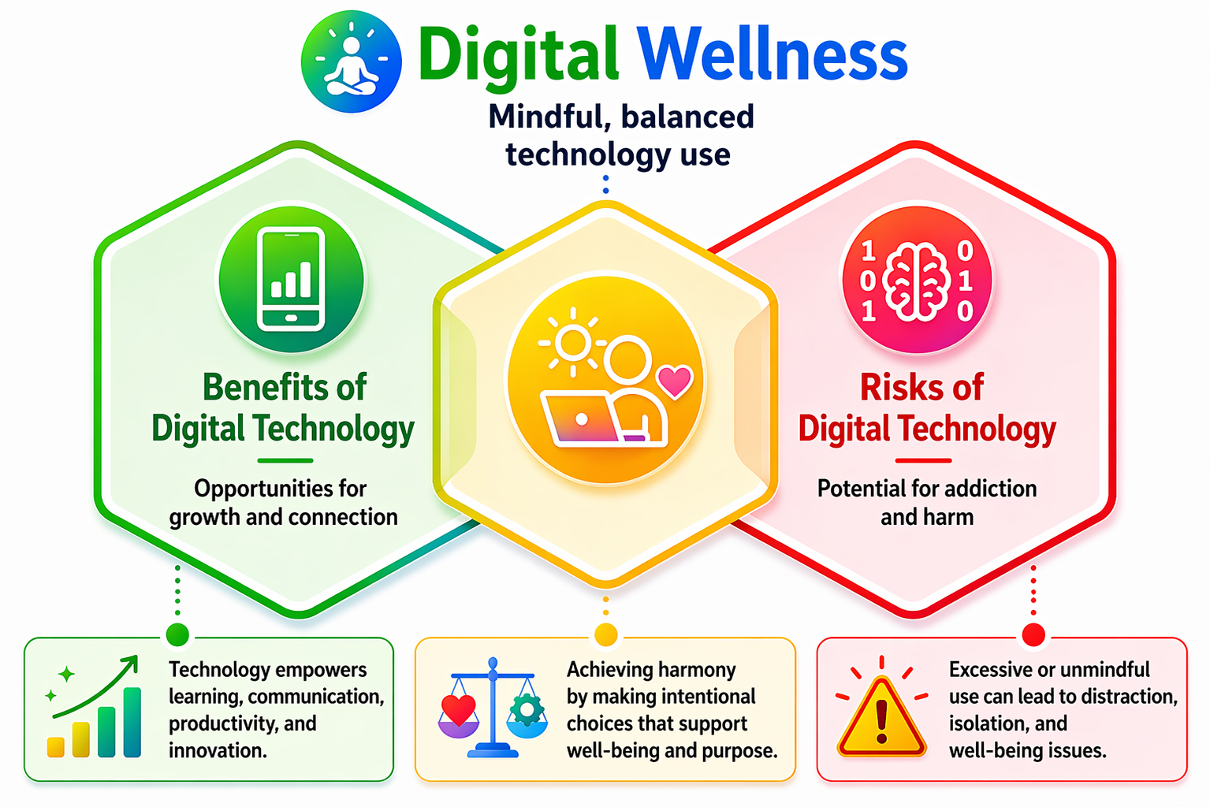
Figure 1. Balancing Digital Benefits and Risk (Kushley and Leitao, 2020)
What is Digital Wellness?
Digital wellness refers to the intentional and conscious development of self-consciousness in addition to creating appropriate uses for technology, such as limiting activities and reducing the bad side effects. With the unquenchable thirst for technology pervading almost every aspect of life, the deliberate development of self-awareness along with engaging in healthy technology practices will be core to reducing the adverse effects caused by excess digital engagement and thus embodying what it means to live well in a world filled with devices (Chaudhary and Sharma, 2022). This idea has the potential to ensure that how you use technology aligns with what you value most in your life, personally, professionally, and societally, a process that can effectively turn technology from a source of distraction into a tool for self-improvement. Digital wellness is to focus in the presence of distractions and to have control (Mark et al., 2017), facilitating deeper connections with meaningful offline events (Uhls et al., 2014), engaging in weekly physical activity, and often possessing outdoor experiences, which rejuvenate body and mind (Rosen et al., 2016), while balancing technology use with other keeping psychological chronic fatigue at bay or sustaining digital citizenship within parts of life which ends up being an ethical issue in responsibility.
Regular commitment to the domain of digital wellness can lead to better mental health, higher productivity, and stronger relationships while allowing for a life that is more balanced and satisfying. Building mindful tech habits into our daily lives will better arm us against the onslaught of cognitive overload, emotional exhaustion and sedentary behaviours whilst enabling us to carve opportunities for reflection, creativity and intentional engagement in the personal and professional sphere. Accordingly, digital wellness stands as an empowering and preventative way to manoeuvre an ever-more technology-driven environment (Figure 2) (Kushlev et al., 2016a).

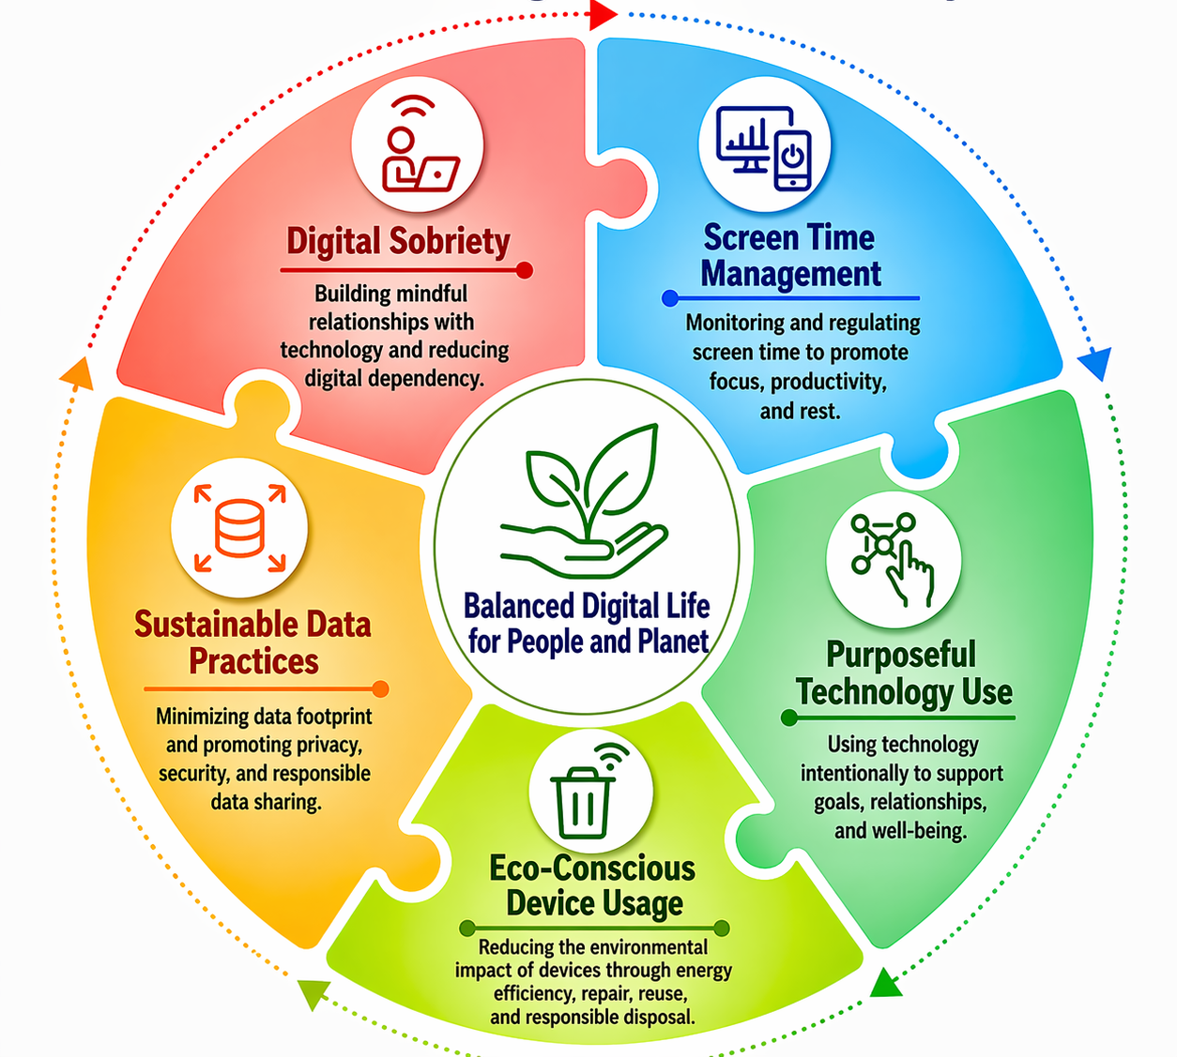

Figure 2. Components of Digital Hygiene for Wellbeing and Sustainability
(Kushlev et al., 2016)

2. 2. Methodology
Comprehensive coverage of the literature was achieved by systematically searching all major scientific and interdisciplinary databases: PubMed, Scopus, Web of Science, Google Scholar, and ScienceDirect. A systematic search strategy was employed based on the keywords of “digital hygiene”, “digital addiction,” “digital detox”, “mental health”, “environmental sustainability” and screen time management. Boolean operators (AND, OR) and suitable filters, such as publication date, article type, and language, were used to narrow the search results. In order to reflect the multiple perspectives on the topic, both peer-reviewed research articles and review papers were reviewed. Moreover, credible organisations and journals were referenced to include recent trends and practical effects. The literature obtained was then screened and assessed for relevance, quality, and compatibility with the review objectives to ensure an unbiased synthesis of current knowledge in the field.
33. Methods for deliberate engagement and sustainable health
Mindful and sustainable tech practices are critical for both individual and planetary health. In this age of digital interaction, implementing some structured strategies can help to minimize the downsides of too much screen time while improving productivity and quality of life.
a. Managing Screen Time
Daily limitations on the use of entertainment and social media applications have been repeatedly proven to reduce digital distractions and mental fatigue and mitigate information overload (Panova and Carbonell, 2018). Digital well-being dashboards or screen time trackers are invaluable feedback mechanisms that help users achieve greater self-regulation in their screen-use habits. The 20-20-20 rule is an ergonomic technique to relieve digital eye strain, in which a person looks at something about 20 feet away from the device every 20 minutes for at least 20 seconds (Sheppard and Wolffsohn, 2018). These scientifically driven interventions are crucial in trying to balance the scales between better online and better offline, all the while promoting productivity and well-being. Equally, if not more importantly, are the environmental and behavioural changes, such as creating tech-free areas in the home and imposing digital curfews (especially in the hours before bedtime) to foster restorative sleep and encourage mental clarity (Christensen et al., 2016).
Such practices are the most impactful for kids who have shown a gradual shift from playing outside and moving their bodies to leading more sedentary lifestyles that centre around screen consumption and entertainment. This significant change has been linked to a decrease in physical activity, an increase in stress levels as well as weakening of familial bonds. This negative turn, along with the persistence of social distancing precautions, can be countered by encouraging outdoor sports, unstructured play and hobbies that require a mind-based approach to tasks; strengthening social ties in this manner will yield holistic developmental benefits across all ages (Figure 3) (Tremblay et al., 2011).

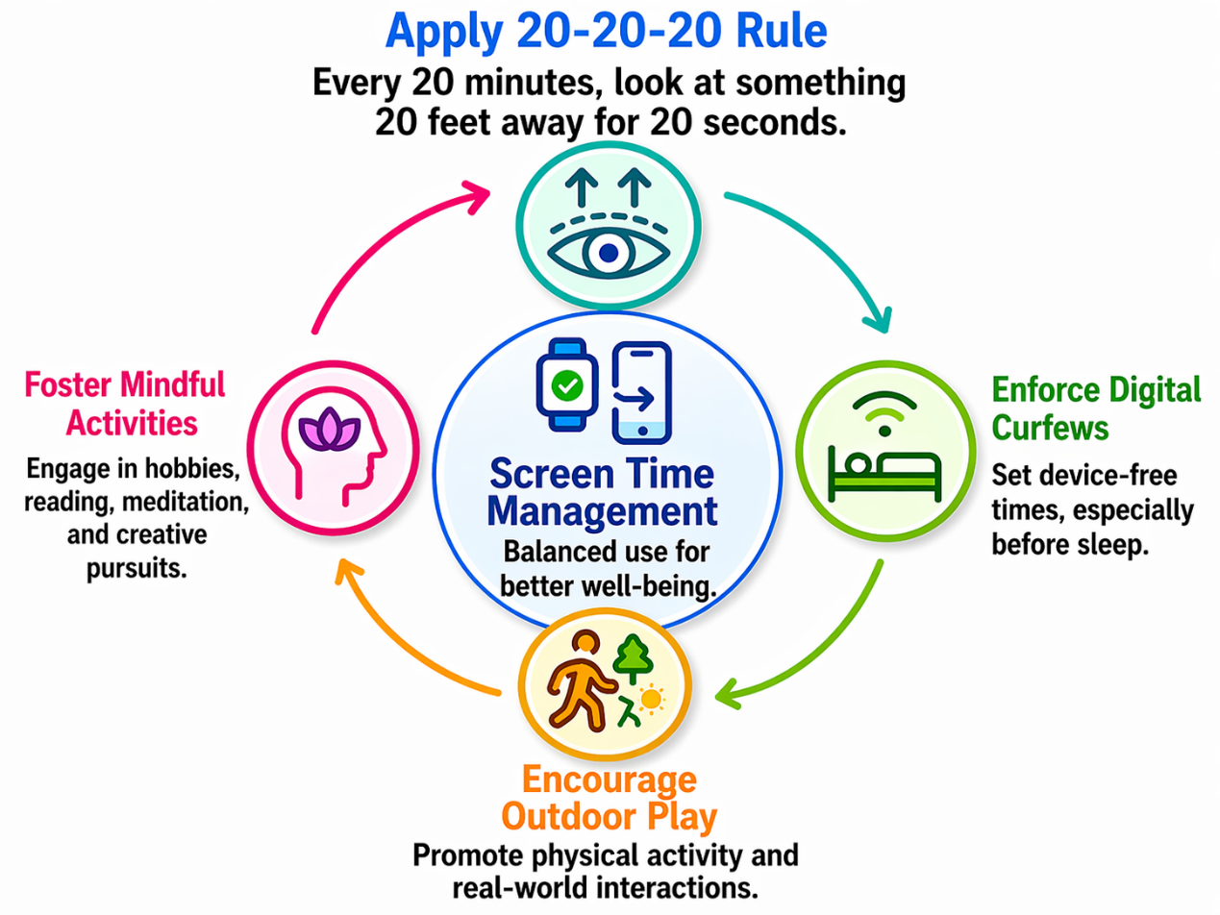
Figure 3. Cycle of Healthy Screen Time Management (Tremblay et al., 2011)

b. Purposeful Technology Use
Intentional engagement with technology emphasizes digital tools as resources for creativity, learning and relationships with a person performs; people should be interested in developing passive (Kushlev and Leitao 2020) consumption patterns. For younger age children, various ways of introducing engaging sessions can be introduced through diversion apps for educational structures and ability builders, like MyHome-work for keeping academics organized, Seesaw for interactive learning, or nature- and tech-exploration apps that merge the two worlds of nerdy curiosity. These habits foster that calling, leadership and cognitive risk-taking while reducing the dangers of the death of genuine interaction through mindless scrolling and constant exposure to non-value-added material. Guiding users in setting concrete aims before engaging with devices, digital mindfulness is supposed to soothe context to ensure that online activity is consistent with your values, priorities, and goals for well-being (Throuvala et al., 2019). This allows individuals to audit their goals, communication vectors, and work-life dichotomies within the context of their digital behaviours (Gergen, 2009) as they purposely choose technologies that support introspection, productivity and reflection. Combined, these approaches transform technology from a distracting force into an intentional ally for personal growth and overall well-being.

c. Intentionally Using Devices in a Green Environment
Technology has a massive environmental footprint, and several ways of using it sustainably are essential (Balde et al., 2017). Using energy-efficient devices/tools and turning off unused electronic devices can help reduce energy use in this system (Belkhir and Elmeligi, 2018). In addition, the responsible recycling of end-of-life devices protects harmful substances from leaking into the environment and supports material recovery (Forti et al., 2020). More generally, industry-level initiatives such as Green IT and green nanotechnology reduce the carbon footprint of the digital age. Such techniques involve innovations such as energy-efficient servers, green materials and the design of software to reduce power consumption by data centres (Zhou et al., 2021). By integrating individual behavioural changes and system-level technological developments, we could massively reduce the environmental costs of the digital age.
d. Sustainable Data Practices
Data centres, powering the infrastructure of our digital universe and often requiring immense electricity at a high baseline level, culminating in power levels comparable to small cities (Jones 2018), have large constant data transfer rates feeding powerful cooling systems and active server life that together result in an outsized portion of this energy expenditure. People can help reduce this footprint by measures such as deleting unused files, apps and backups (Corcoran 2019). Moreover, choosing cloud service providers based on their use of renewable energy sources makes it possible to reduce carbon emissions associated with data hosting (Cook et al., 2017). This balance between individual-level digital hygiene and systemic green data practices allows society to attack one of the most energy-demanding aspects of our digital infrastructure, whilst continuing to reap the benefits well connected technology has brought. Therefore, by avoiding large file transfers and unnecessary streaming, better usage practices can be planned effectively (Aslan et al., 2018).
e. Digital Cleanness
Intentional practice of maintaining an organised and mindful digital environment can help reduce excessive screen usage, bring down digital clutter, and enable purposeful technology usage. Unregulated digital usage, long screen time, and excessive notifications can lead to reduced attention, stress and cognitive overload (Mark et al., 2018; Montag and Walla, 2016). Therefore, adopting a digital routine that regulates actions by decluttering notes, files, and limiting essential device use contributes to improvement in emotional well-being through healthier behavioural patterns (Duke and Montag, 2017; Kushlev et al., 2016a). Mindful digital practices can reduce energy demands, thereby minimising unnecessary data usage and contributing to personal well-being (Jones, 2018).
Research says that digital cleanness can be beneficial by enhancing emotional regulation and cognitive efficiency through intentional engagement with digital environments. Therefore, it is very important to reduce constant digital multitasking, which can cause mental fatigue, impair memory, and reduce productivity (Ophir et al., 2009; Rosen et al., 2013). Practices such as managing screen time, disengaging, and consuming content mindfully on digital platforms can restore and improve cognitive function. Moreover, excessive digital usage has been linked with poor sleep quality and anxiety and depression; therefore, reducing digital engagement can help adolescents and adults with good sleep and better performance (Exelmans and Van den Bulck, 2016; Twenge et al., 2018). Therefore, digital cleanness can support mental clarity, further contributing significantly to psychological flexibility and holistic/overall well-being.
4. Integrative Approaches for Stress Reduction
A holistic framework to alleviate the psychological and physiological toll that results from excessive digital exposure, integrative approaches for stress reduction. These strategies combine behavioural solutions with mind–body interventions (eg, mindfulness, breathing techniques, Emotional Freedom Techniques [EFT], structured digital detox practices) to support self-regulation and emotional resilience. Through the multifactorial approach that these interventions adopt, they aim at mitigating compulsive screen use through targeting cognitive and neurobiological pathways essential in maintaining attention and mental equilibrium. Mindfulness, controlled breathing, and techniques such as EFT are associated with lower stress biomarkers and provide emotional regulation support along with reducing anxiety-related symptoms (Ullagaddi, 2026).
In addition, new integrative modalities such as colour and light based therapies present additional non-invasive methods of stress modulation. Such methods impact neurobiological circuits, including limbic nerve pathways, hypothalamus and autonomic nervous system – regulating emotional behaviour and controlling the body clock and hormonal involvements. It is evidenced that exposure to certain colours and wavelengths of light can lower stress levels, create more stable mood states and elevate cognitive performance via both modulation of psychological perception as well as physiological reactions. These therapies based on both traditional healing systems and updated neuroscience are beneficial during stress or emotional dysregulation due to digital overexposure (Kumarasinghe et al., 2026).
Furthermore, integrative neurowellness strategies based on lifestyle modification, nutritional support and behavioral therapies may promote adaptive coping and resilience to digital stressors. Functional foods and antioxidant-rich interventions play a crucial role in reducing oxidative stress, thereby complementing neuroprotection strategies and strengthening the link between mental well-being and physiological functioning. Softer digital detox practices further allow users to meander through online distractions, which can also help readjust reward pathways that have been overstimulated, and subsequently allowing for greater focus—helping mitigate for cognitive fatigue. Applied together, these integrative interventions delay behavioural maladaptation while lessening acute stress reactivity and can be dubbed sustainable health practices for digital wellness (Figure 4) (Ullagaddi, 2026).
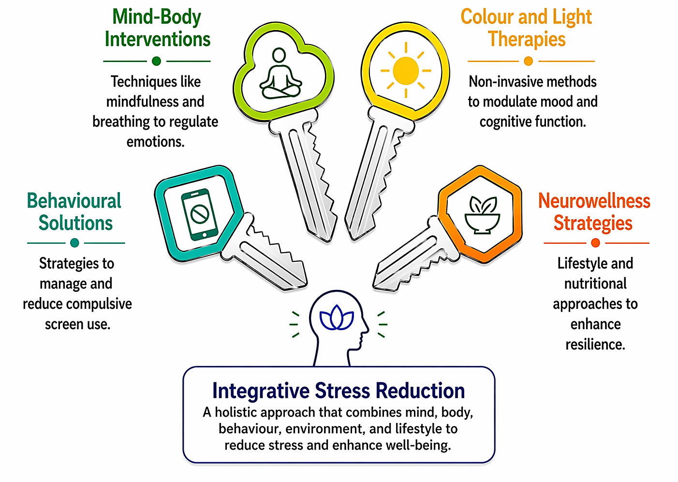
Figure 4. Integrative Approaches to Stress Reduction (Ullagaddi, 2026)

5. Digital Wellness Tools and Interventions
Digital wellness tool renaissance also reflects a new awareness that we need to rein in technology use. These tools vary from built-in smartphone features, such as tracking screen time and limiting app usage, to dedicated applications created for improving focus and managing digital distractions (Chisholm and Hartman-Caverly, 2022; Palalas and Doran, 2023). Digital detox applications and focus-enhancing tools rely on behavioural design principles that are intended to reduce exposure and help with productivity. Example-based methods, some which are guided by cognitive behavioral therapy (CBT) to help users identify excess use triggers and replace them with better coping strategies (Specker Sullivan and Reiner, 2021). Although initial changes to usage behaviour are often observed, long-term adherence is frequently constrained by user fatigue, burnout and low levels of intrinsic motivation (Babu and Joseph 2025; Wilcockson et al., 2019). Additionally, we should consider the long-term sustainability and conceptual coherence of the paradox of using digital tools to overcome digital dependency. Recent studies have shown that digital wellness tools work best with behaviour- and education-related techniques (Figure 5).
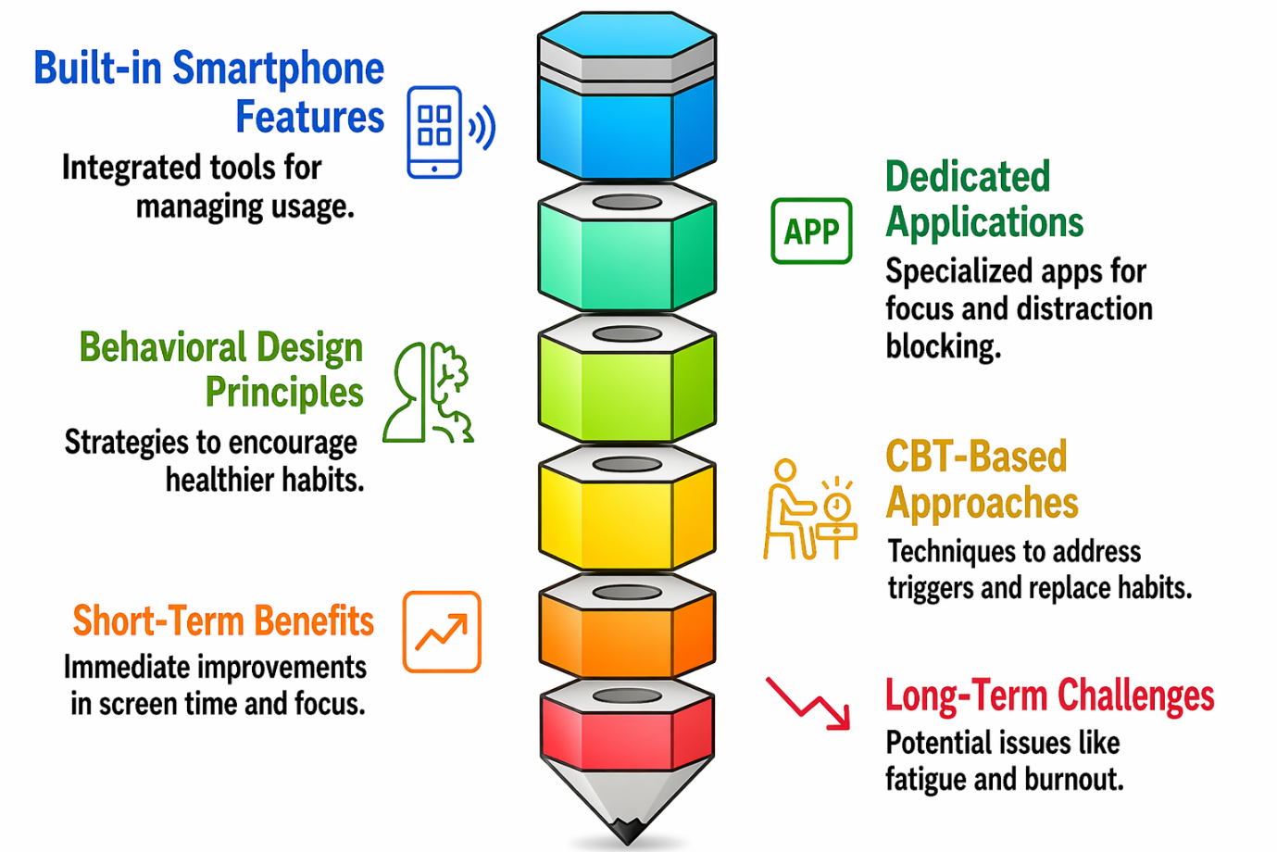
Figure 5. Framework for Digital Well-Being (Ullagaddi, 2026)

Therefore, digital literacy programs and application monitoring can work together to better support users' awareness while motivating them towards enduring behavioural change (Figure 5) (Palalas and Doran, 2023; Ribble, 2015).
6. Public Health and Education Digital Wellness
Digital wellness has been advanced largely by the public health and education sectors, which have equipped young leaders with the skills to harness digital environments responsibly. Therefore, integrating digital wellness programs into various educational frameworks helps students learn self-regulation, protect their mental well-being, and foster respectful online communities (Livingstone et al., 2017; OECD, 2021). At a broader level, digital health innovations such as telemonitoring and e-health platforms have demonstrated significant potential to improve patient outcomes, accessibility, and healthcare efficiency (WHO, 2019). These also raise concerns about waste generation, energy consumption, and environmental footprint. There is a need to implement a “green by design” approach in digital health, ensuring that technological progress aligns with sustainability principles while preserving clinical efficacy and economic viability (Bree et al., 2000).

Schools and universities play a crucial role in fostering appropriate digital conduct and digital wellbeing from very young ages. Given that cognitive, social and behavioural habits develop mostly through the engagement of students in educational institutions, incorporating digital hygiene principles into formal education could prove to be an effective long-term solution. There is an immediate need to have structured modules about safe use of technology, screen-time management, cyber-ethics and mental well-being in schools and instigate self-regulation and critical awareness among learners (Rible, 2015). Specifically, universities could repurpose this framework by integrating digital wellness into cross-disciplinary curricula in areas such as public health, psychology, and environmental sustainability. These initiatives not only improve academic outcomes but also equip students to navigate the increasingly complex digital ecosystems that they encounter in their personal and professional lives.
Today, the designing of a digital hygiene curriculum is gaining recognition as a preventive strategy to combat the dangers related to excessive engagement with digital. These lessons may include mindful technology use, digital detox techniques, online safety and the effect of digital decimation on the climate. Research indicates that educational interventions integrating conscious use with structured methods, screen-free periods, mindfulness tracking, and face-to-face bonding opportunities are more effective at achieving long-term success, even when the primary aim is to change behaviour (Palalas and Doran, 2023). Moreover, strategies such as experiential learning through workshops and peer-to-peer discussions, or Internet-unplugging-based initiatives, may further promote better habit formation and adherence.
However, policy-level national to global steps are critical in providing the systems of support and standardizing digital wellness behavior. New initiatives emerging in India under frameworks such as the NEP have focused on holistic development, so extending this approach to digital well-being and responsible use of technology will be a welcome addition. Guidelines regarding screen time for children, digital literacy campaigns and awareness programs can be effective to combat rising epidemic of digital addiction. At the international level, there is growing recognition among organizations and governments of the need for regulation that embeds ethical design in technology, enhances data privacy, and improves consumer well-being (Floridi, 2014). Public health policies may additionally promote digital wellness via the consideration of it as a preventive healthcare answer that specifically focuses on the mental fitness issues because of large screen-use. Thus, to strike a balance between the benefits and distortions of technology, it is crucial that efforts be coordinated among educators, policymakers, health professionals, and technology developers. Integrating digital hygiene into education systems and reinforcing it with policy interventions can help move societies towards a sustainable and health-oriented digital future.

7. Challenges and Future Directions
Digital wellness poses several challenges that extend beyond public health, influencing education, technology, individual behaviour, and environmental sustainability. The overuse of digital gadgets arises from addictive behaviours, perpetual connectivity, shortened attention, and impaired emotional and mental well-being (Montag and Walla 2016; Rosen et al. 2013). While this raises awareness, many issues constrain progress on these fronts of digital wellness. Among these challenges, perhaps the most fundamental is the omnipresent reality of persuasive technology in which digital arenas that expand reach are intentionally designed to facilitate engagement and rewarding content (Alter, 2017). The problem of user compliance is another outstanding challenge; the vast majority of digital wellness solutions rely on self-regulation and monitoring, which can be exceptionally challenging in environments overflowing with digital stimuli. The progression of digital assets and the capacity to foster well-being are also influenced by socioeconomic and cultural factors, underscoring the need for inclusion (Chaudhary and Sharma 2022).
The increasing focus on digital wellness is great, but some limitations prevent it from being used consistently and effectively. Based on what we learned from previous work exploring neurowellness and behavioural interventions, frequent dependence on digital tools often causes cognitive overload, shortened attention spans and emotional dysregulation, which undermine wellbeing intentions. Socio-behavioural issues such as the stickiness of habits, immediate gratification, and poor self-regulation with digital make it even more difficult to follow digital hygiene. Likewise, gaps in digital competencies and accessibility shape the fair application of digital well-being interventions. At the environmental level, rising digital consumption also leads to increased electricity use and e-waste, which pose sustainability issues (Figure 5) (Ullagaddi, 2026).
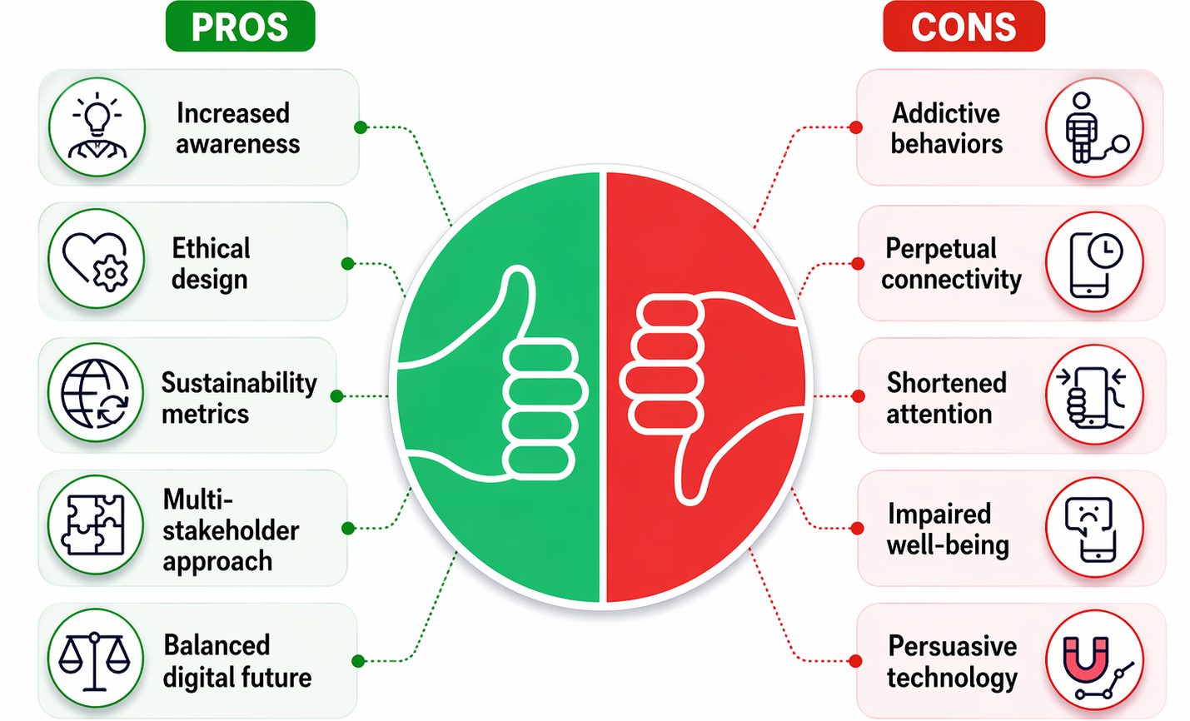
Figure 6. Benefits and Risks of Digital Wellness (Ullagaddi, 2026)
The interconnectedness of these challenges underscores the need for integrative, research-backed solutions that combine behavioural change, mindful tech use, and sustainability to achieve long-lasting digital health. Future research should prioritize longitudinal studies that evaluate the long-term impact of digital wellness interventions. Furthermore, there is a growing demand to investigate cross-disciplinary solutions that combine psychology with public health, environmental science, and technology design. Emerging interventions that promote ethical and humane technology design argue for systems that prioritise user wellbeing over engagement metrics (Floridi, 2014). By embedding sustainability metrics into digital wellness frameworks, we will make these much more relevant to the challenges posed by global environmental issues. Promoting digital wellness from all corners involves a multi-stakeholder approach by individuals, educators, policymakers, and industry leaders. Interest in exploring the connection between technological innovation and human values and ecological sustainability could lead to a more balanced digital future

8. Conclusion
Excessive digital engagement has been associated with several detrimental effects viz., poor work performance, disturbed sleep patterns and low cognitive function, preventing people from performing at their best. Digital wellness has become an essential guideline that promotes a healthy interaction through digital gadgets without interrupting mental and physical well-being and environmental sustainability. The interconnection between human well-being and environmental sustainability is more relevant today. Whether innovations are done with the ethics of sustainability (in itself based on foundation principles) will be an important factor that will ensure the extraordinary progress in digital technology doesn't come at the cost of our planet's health and vitality. These innumerable examples, alongside an infinite number of other representations of simple yet purposeful actions, provide people with the opportunity to live healthier lives that help them find personal growth and lead to a drastically lower digital carbon footprint. The more we explore this hypothesis, the more obvious it becomes that digital wellness is a crucial step towards our personal well-being and ultimately a more eco-friendly post-carbon society. By intentionally making our online decisions in accordance with our fundamental beliefs and ethics, we become architects of a future where tech enables us to live fuller lives without sacrificing the quality of human connection while also preserving a more sustainable planet for those who come after.
9. Disclaimer (Artificial intelligence)
The author(s) hereby declare that no generative artificial intelligence technologies, including Large Language Models (e.g., ChatGPT, Copilot), were utilized in the writing or editing of this manuscript. Napkin AI was used exclusively to generate images based on the article's contextual content.

Acknowledgements:
The authors extend sincere gratitude to Sadguru Sri Madhusudan Sai, Chancellor of Sri Sathya Sai University for Human Excellence (SSSUHE), and Bhagavan Sri Sathya Sai Baba for the guidance and inspiration.

References
Alter, A. (2017). Irresistible: The rise of addictive technology and the business of keeping us hooked. Penguin Press.
Aslan, J., Mayers, K., Koomey, J. G., and France, C. (2018). Electricity intensity of internet data transmission: Untangling the estimates. Journal of Industrial Ecology, 22(4), 785–798. https://doi.org/10.1111/jiec.12630
Babu, A., and Joseph, A. P. (2025). Digital wellness or digital dependency? a critical examination of mental health apps and their implications. Frontiers in Psychiatry, 16, 1581779.
Balde, C. P., Forti, V., Gray, V., Kuehr, R., and Stegmann, P. (2017). The global e-waste monitor 2017: Quantities, flows, and resources. United Nations University.
Beetham, H. (2016). Digital capability framework. Jisc. https://www.jisc.ac.uk
Belkhir, L., and Elmeligi, A. (2018). Assessing ICT global emissions footprint: Trends to 2040 and recommendations. Journal of Cleaner Production, 177, 448–463. https://doi.org/10.1016/j.jclepro.2017.12.239
Chaudhary, R., and Sharma, M. (2022). Digital wellness: Concept, components, and practices. Journal of Technology and Society, 14(2), 45–53.
Chisholm, A., and Hartman-Caverly, S. (2022). Privacy literacy: From doomscrolling to digital wellness. portal: Libraries and the Academy, 22(1), 53-79.
Christensen, M. A., Bettencourt, L., Kaye, L., Moturu, S. T., Nguyen, K. T., Olgin, J. E., ... and Marcus, G. M. (2016). Direct measurements of smartphone screen-time: Relationships with demographics and sleep. PloS One, 11(11), e0165331. https://doi.org/10.1371/journal.pone.0165331
Cook, G., Van Horn, J., and Matthews, H. S. (2017). Clicking clean: Who is winning the race to build a green internet? Greenpeace International.
Corcoran, P. (2019). Energy efficiency of cloud computing: Technologies and trends. Computer, 52(8), 28–36. https://doi.org/10.1109/MC.2019.2921234
Duke, É., and Montag, C. (2017). Smartphone addiction, daily interruptions and self-reported productivity. Addictive Behaviors Reports, 6, 90–95.
Exelmans, L., and Van den Bulck, J. (2016). Bedtime mobile phone use and sleep in adults. Social Science and Medicine, 148, 93–101.
Floridi, L. (2014). The ethics of information. Oxford University Press.
Forti, V., Baldé, C. P., Kuehr, R., and Bel, G. (2020). The global e-waste monitor 2020: Quantities, flows and the circular economy potential. United Nations University.
Frick, N. R., Matthes, J., and Birkner, T. (2021). Digital detox: An analysis of digital abstinence in the context of environmental sustainability. Sustainability, 13(5), 2780. https://doi.org/10.3390/su13052780
Gergen, K. J. (2009). Relational being: Beyond self and community. Oxford University Press.
González, R., León, A., and Ordóñez, C. (2020). Digital mindfulness: Reducing stress and improving well-being through intentional technology use. Computers in Human Behavior Reports, 2, 100024. https://doi.org/10.1016/j.chbr.2020.100024
Government of India. (2020). National Education Policy (NEP) 2020. Ministry of Education, Government of India.
Greenhalgh, T., Wherton, J., Papoutsi, C., Lynch, J., and Hughes, G. (2017). Beyond adoption: A new framework for theorizing and evaluating non adoption, abandonment, and challenges to the scale-up, spread, and sustainability of health and care technologies. Journal of Medical Internet Research, 19(11), e367. https://doi.org/10.2196/jmir.8775
Harwood, J., Dooley, J. J., Scott, A. J., and Joiner, R. (2014). Constantly connected – The effects of smart-devices on mental health. Computers in Human Behavior, 34, 267–272. https://doi.org/10.1016/j.chb.2014.02.006
Hayama, Y., and Desai, H. (2025). Digital Wellbeing. In Digital Futures in Human-Computer Interaction (pp. 224-242). CRC Press.
Hertlein, K. M., Blumer, M. L., and Smith, J. M. (2021). Digital wellness: A framework for digital media use in couples and families. Journal of Family Theory and Review, 13(4), 442–457. https://doi.org/10.1111/jftr.12427
Jones, N. (2018). How to stop data centres from gobbling up the world’s electricity. Nature, 561(7722), 163–166. https://doi.org/10.1038/d41586-018-06610-y
Jr Rogayan, D. V., and Dollete, L. F. (2025). Gearing up for the era of digital wellness: challenges and opportunities. Journal of Public Health, 47(1), e140-e141.

Kickbusch, I., Piselli, D., Agrawal, A., Balicer, R., Banner, O., Adelhardt, M., and Capobianco, E. (2021). The Lancet and Financial Times Commission on governing health futures 2030: Growing up in a digital world. The Lancet, 398(10312), 1727–1776.

Kumarasinghe, W. S., Jayanthi, K., and Ullagaddi, R. (2026). Therapeutic applications of colour and light: Bridging holistic practices and modern healthcare. International Journal of Advanced Signal and Image Sciences, 12(3s), 483–498.
Kushlev, K., and Leitao, M. R. (2020). Smartphones and well-being. Current Opinion in Psychology, 36, 72–77.
Kushlev, K., and Leitao, M. R. (2020). The effects of smartphones on well-being: Theoretical integration and research agenda. Current Opinion in Psychology, 36, 72–77. https://doi.org/10.1016/j.copsyc.2020.04.001
Kushlev, K., Dwyer, R., and Dunn, E. W. (2016). The social price of constant connectivity: Smartphones impose subtle costs on well-being. Current Directions in Psychological Science, 25(6), 515–521. https://doi.org/10.1177/0963721416663193
Kushlev, K., Proulx, J., and Dunn, E. W. (2016a). Silence your phones: Smartphone notifications increase inattention and hyperactivity symptoms. Proceedings of the 2016 CHI Conference on Human Factors in Computing Systems, 1011–1020.

Livingstone, S., Mascheroni, G., and Staksrud, E. (2017). European research on children’s internet use: Assessing the past and anticipating the future. New Media and Society, 20(3), 1103–1122.
Mark, G., Gudith, D., and Klocke, U. (2017). The cost of interrupted work: More speed and stress. Proceedings of the SIGCHI Conference on Human Factors in Computing Systems, 107–110. https://doi.org/10.1145/3025453.3026021
Montag, C., and Walla, P. (2016). Carpe diem instead of losing your social mind: Beyond digital addiction and why we all suffer from digital overuse. Cogent Psychology, 3(1), 1157281.

OECD. (2021). 21st-century readers: Developing literacy skills in a digital world. Organisation for Economic Co-operation and Development.

Ophir, E., Nass, C., and Wagner, A. D. (2009). Cognitive control in media multitaskers. Proceedings of the National Academy of Sciences, 106(37), 15583–15587.
Palalas, A., and Doran, M. (2023). Digital wellness framework for online learning. Canadian Journal of Learning and Technology, 49(3), 1-25.
Panova, T., and Carbonell, X. (2018). Is smartphone addiction really an addiction? Journal of Behavioral Addictions, 7(2), 252–259. https://doi.org/10.1556/2006.7.2018.49
Péréa, C., Gérard, J., and de Benedittis, J. (2023). Digital sobriety: From awareness of the negative impacts of IT usages to degrowth technology at work. Technological Forecasting and Social Change, 194, 122670.
Przybylski, A. K., and Weinstein, N. (2017). Digital screen time limits and young children's psychological well-being: Evidence from a population-based study. Child Development, 90(1), e56–e65. https://doi.org/10.1111/cdev.13007
Ribble, M. (2015). Digital citizenship in schools: Nine elements all students should know (3rd ed.). International Society for Technology in Education.
Rosen, L. D., Carrier, L. M., and Cheever, N. A. (2016). The association of technology-related anxiety and stress with sleep, academic performance, and self-regulation. Stress and Health, 32(5), 533–541. https://doi.org/10.1002/smi.2631
Rosen, L. D., Lim, A. F., Felt, J., Carrier, L. M., Cheever, N. A., Lara-Ruiz, J. M., Mendoza, J. S., and Rokkum, J. (2013). Media and technology use predicts ill-being among children, preteens and teenagers independent of the negative health impacts of exercise and eating habits. Computers in Human Behavior, 29(3), 1243–1250.
Sheppard, A. L., and Wolffsohn, J. S. (2018). Digital eye strain: Prevalence, measurement and amelioration. BMJ Open Ophthalmology, 3(1), e000146. https://doi.org/10.1136/bmjophth-2018-000146
Specker Sullivan, L., and Reiner, P. (2021). Digital wellness and persuasive technologies. Philosophy and Technology, 34(3), 413-424.
Throuvala, M. A., Griffiths, M. D., Rennoldson, M., and Kuss, D. J. (2019). Motivational processes and dysfunctional mechanisms of social media use among adolescents: A qualitative focus group study. Computers in Human Behavior, 93, 164–175. https://doi.org/10.1016/j.chb.2018.12.012.
Tremblay, M. S., et al. (2011). Systematic review of sedentary behaviour and health indicators in school-aged children and youth. International Journal of Behavioral Nutrition and Physical Activity, 8, 98. https://doi.org/10.1186/1479-5868-8-98
Twenge, J. M., and Campbell, W. K. (2018). Screen time and psychological well-being. Preventive Medicine Reports, 12, 271–283.
Twenge, J. M., Joiner, T. E., Rogers, M. L., and Martin, G. N. (2018). Increases in depressive symptoms, suicide-related outcomes, and suicide rates among U.S. adolescents after 2010 and links to increased new media screen time. Clinical Psychological Science, 6(1), 3–17.

Ullagaddi, R. (2026). Emotional Freedom Techniques (EFT) and Dopamine Detox: A Neurobehavioral Tool for Stress Management. Awareness – Newer Horizons in Human Excellence, 3(1), 39–52.
Uhls, Y. T., et al. (2014). Five days at outdoor education camp without screens improves preteen skills with nonverbal emotion cues. Computers in Human Behavior, 39, 387–392. https://doi.org/10.1016/j.chb.2014.05.036
van Bree, R., et al. (2020). Environmental impact of telemonitoring in chronic disease care: A comparative life-cycle assessment. Journal of Medical Internet Research, 22(11), e18575. https://doi.org/10.2196/18575
van Dijk, J. (2020). The digital divide. Cambridge: Polity Press.
Wilcockson, T. D. W., Osborne, A. M., and Ellis, D. A. (2019). Digital detox: The effect of smartphone abstinence on mood, anxiety, and craving. Journal of Behavioral Addictions, 8(3), 437–447.
World Health Organization (WHO). (2019). WHO guideline: Recommendations on digital interventions for health system strengthening.
Zhou, Y., Chen, M., and Li, Q. (2021). Green nanotechnology: Concepts, benefits, and challenges. Journal of Cleaner Production, 278, 123805. https://doi.org/10.1016/j.jclepro.2020.123805.

