Implementation of the Safety Management pillars, Following Behavioral Safety Aspects Resulting in Increased Safety Belief and Values in the Pharmaceutical Industry
ABSTRACT:
Safety management pillars, which play an important role in the pharmaceutical industry, the various precautions for handling the solvents and chemicals, which are flammable, irritant, corrosive, oxidizer and environmental impact when exposed to the abnormal condition have been presented. In this scenario it is very much important that the appropriate behavioral concepts are followed to get the desired output with the highest safety standards in the occupational environment, which leads to the narrowing down the unsafe acts, conditions and near misses in the working environment. By implementing the safety management pillar, adopting the behavioral based safety concept by the safety leadership team will result in more behavioral based safety (BBS) interactions. All the concepts of the safety implications, which are followed in the pharmaceutical industry is directly related to the subconscious minds, so people are trained in handling the normal and abnormal situation in the pharmaceutical industry, in this regard we have dedicated fire marshals and the emergency response team members to tackle the emergency situation. In order to strengthen the mindset of the individuals we have conducted mock drills, so that highest safety beliefs and values are maintained in the occupational environment. The paper briefly discusses on the practical aspects of the safety in the hazardous chemical industry like pharmaceutical industry, there is very less published combined information regarding safety management pillars, various behavioral aspects leading to the increased belief and values. Further In this paper we have tried to give an qualitative view picture of the how the different elements of the safety management pillars leading to increased safety beliefs and values have been adopted in the working environment.
Key words – Safety management pillar, behavioral base safety, safety leadership team, mock drill and safety beliefs and values.

1. INTRODUCTION
The hazardous chemical handling industries such as pharmaceutical, petrochemical, polymer and other flammable and toxic substances handling industries are involved in handling the dangerous chemicals and solvents should have a greater exposure and experience (Austad et al., 2011), which are achieved by providing suitable training for their employee and contractors. Wang et al. (2022) & Schwan et al. (2025) reported that only well-trained people are to be involved in handling of the critical reactions such as hydrogenation and chlorination. The need of the day is the trained people who are involved in dangerous activities should have their belief and the values of the assigned task (Meyer et al., 2019). The physiology of handling the chemical reactions is not according to the safety aspects and not following the batch management record (BMR), which leads to the accidents and explosions (Alazzam et al., 2023). Min et al. (2020) has informed that vital that a systematic behavioral aspect to be followed in order to avoid the various incidents / accidents in the hazardous chemical handling industries. The various behaviors-based safety (BBS) of the employees and the contractors are a challenging task (Rashid et al., 2023), which are in the form of belief and the values are to be combined with BBS interactions, which are carried out by the safety leadership team (SLT) (Cooper, 2015). SLT are the head of the department (HOD), where one the SLT of the department will be involved in talking to the shop floor people of the other department. It will help us identifying the various unsafe act, unsafe conditions and Near misses in the organization, it is the need of the day that people are to be trained for identifying and recording the unsafe conditions and activities, so that safe practices can be followed in the hazardous chemical handling industry, which increases the moral beliefs and values of the organization.
The SLT of BBS with their beliefs and their values are not only grateful in maintaining the leading indicators but also it helps identifying the lagging indicators (Pawłowska, 2015), which will help us to reducing the unsafe acts, conditions and near misses in the organization such a new concept is developing in the countries like India. Basically, the safety management of the hazardous handling industry is based on the safety management pillar (SMP) approach. Waring (2019) has described that there are five pillars in the occupational health and safety in a context of authoritarian socio-political climates, where there is no much published information about the SMP, which are related to the pharmaceutical industry. We have introduced six SMP for the pharmaceutical industry, where all the Environment, Health and Safety (EHS) policies are covered, employees are involved, training conducted, Hazard identification and risk assessment (HIRA), measure evaluate and can narrow the risk by having proper belief and values in the occupational environment (Figure.1). We can say that by implementing the SMP and BBS will result in the higher belief and values, which is given in Figure. 2. Meyer et al. (2019) has informed that having no belief in the safety behaviors will result in the lesser concentration in the work environment resulting in incidents / accidents and lesser productivity, so we have given highest preference for the beliefs and values in the working environment.
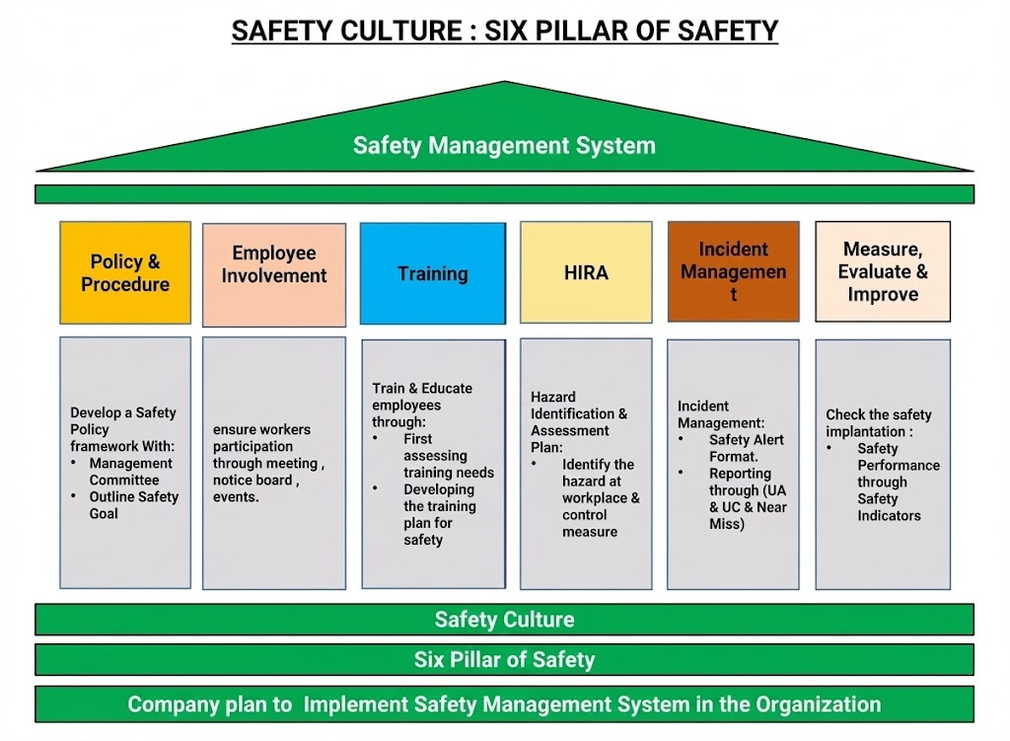
Figue. 1. Six Management pillars applied in the Pharamcytical indsutry
Our occupants in the pharmaceutical industry are well trained on the various aspects of the following the SMP. By applying the BBS concept leading to the higher belief and values among the workers in the occupational environment leading to the safe work practices in the organization (Carra et al., 2024; Scott Geller & Robinson, 2015). There are more than five hundred and eighty
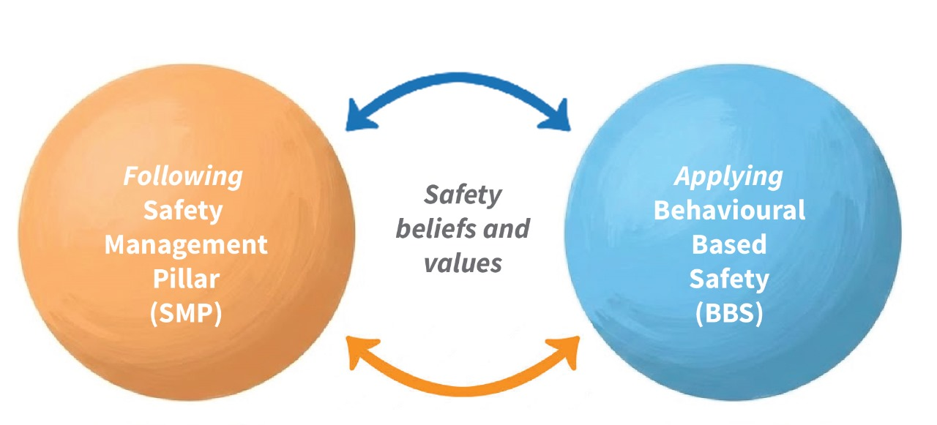
Figure. 2. Safety management pillar (SMP) and behavioral based safety (BBS) will result in the higher belief and values
employees working in the various blocks such as raw material storage area, production blocks, finished goods, Effluent Treatment Plant, Maintenance department. Electrical department and environment health and safety department.
In this paper we have explained how a pharmaceutical industry helps in managing the safety of the workers in the occupational environment. This is an over view of the beliefs and values, which are prevailed among the occupants working in the hazardous chemical handling industry. We will explain the new concept advantages of the following the SMP and BBS leading to achieving the good safety practices and culture in the organization.
2. MATERIAL AND METHODS
Qualitative aspects of the occupants working in the pharmaceutical industry has been carried out in order to know the important of the following of the SMP and drastic changes, which have led for the Applying of the BBS concept, a practical concept for achieving the inherency thoughts among the occupants leading to the increased safety belief and value has been presented. The qualitative approach which gives insights of the highest safety culture prevailing in the organization, both in case of normal as well as abnormal circumstances,

3. RESULTS AND DISCUSSION
The safety beliefs and the values first begin with the Environmental health and safety (EHS) policy. It is common to all our sites, the EHS policy is committed by the management for achieving goal zero. The objective of the EHS policy is to achieve goal zero includes, striving towards achieving zero accidents, zero unsafe act, conditions, near misses, zero non legal compliance, committed towards the safety training to our employees and contractors. Smirniakova et al. (2021) has informed that many countries, which includes Russia are also involved in participant in the Vision Zero campaign, founded by the International Social Security Association (ISSA) and the Institution of Occupational Safety and Health (IOSH) has successfully implemented the occupational safety management systems formation in JSC “SUEK-Kuzbass. Bhusnure et al. (2018) discussed on Chemical hazards and safety management in pharmaceutical industry but there is no information of the EHS policy commitment and their objectives. Our objectives of the EHS policy are achieved by implementing the guidelines for achieving goal zero by having different types of committees such as risk committee, safety committee, process safety management (PSM) committee, Energy management committee, environmental and occupational health center committee. Our achievements in the EHS policy are implementing hazard and operability (HAZOP) studies for all our manufacturing products, hazard identification and risk analysis (HIRA) is carried out for all the activities, which are carried out in the various blocks, ensuring the PPE compliance as per PPE matrix, EHS policy is displayed in all the blocks in both English and the local language and people are trained for its commitment, which are achieved by their vision, safety belief and values. Adikwu et al. (2023) have described that many of the multinational companies (MNC) will have a common policy but these diversified frame work may vary based on the country and its cultural attitude in the occupational environment of the safety, health and hygiene, so it has to undergo various challenges to stabilize. Further there is no much published information available for the various ways of implementation and achieving of the EHS policy for the pharmaceutical industry leading to its belief and values among the occupants.
Secondly the safety beliefs and values begin during the induction period in the organization. In the year of 2024-2025 there were around 35 new recruits who were inducted as employees and they were initially trained for the safety aspects and brief explanation of the safety procedures to be followed in the occupational environmental has been explained, which has resulted in the increased safety practices. The importance of Personal protection equipment (PPE) matrix has been explained to have an awareness for the different type of PPE to be worn in the various activities in the working environment. The PPE matrix is given in the Figure. 3,
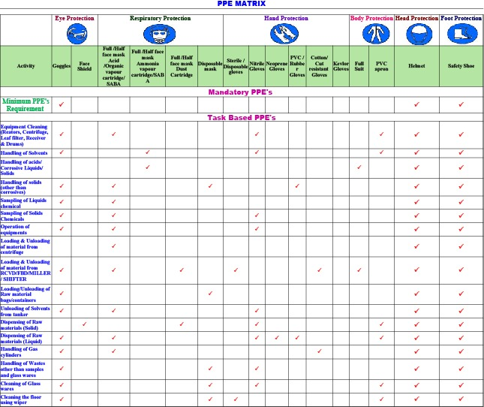
Figure. 3. Overview of Personal Protective Equipment (PPE) matrix
These increases the moral beliefs and values of the new recruits, thus following the highest safety culture in the organization. Such type of similar refresher safety training has been given to all our employees and contractors in order to have an inbuilt safety culture leading to the increased safety beliefs and the values in the organization. Pai et al. (2016) have discussed about the personal training on negative impact on the yield and its quality wise of the pharmaceutical industry in the city of Mangalore, India; technicians in the Kenyan country have provided safety training for improving the safety culture of the pharmaceutical industry has been reported by Miring (2024) but it does not cover any induction training for the hazardous chemical handling industry; similarly Dunn et al. (2020) have stressed the importance of the process safety training of the pharmaceutical industry, which includes rate of high energy reaction and usage of alternate solvents for handling the risky circumstances, There is no much published information about the safety induction training, which are provided for the new recruits and its impact of the subconscious mind of the pharmaceutical industry, which leads to the highest belief and its values. Ong et al. (2016) reported that behaviors and the beliefs are inter related to each other, which increases the effectiveness in teaching, thus increase the knowledge and remembrance in subconscious mind. There is very less published information is available for the safety and beliefs, which are prevailing in the pharmaceutical industry.
The emergency siren patterns have been explained to the new recruiters, the signal patterns, which are given in the Figure. 4, which has increased the importance of siren during and emergency situation (Agarwal et al., 2018) but it has not covered the number of sirens raised for creating the
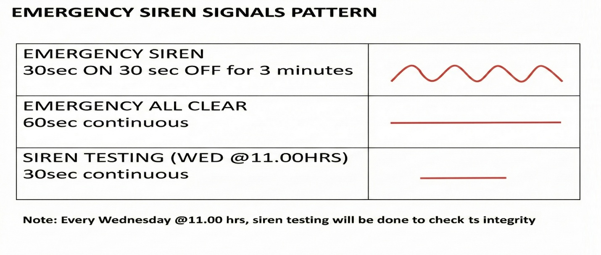
Figure, 4, Emergency siren – Weekly testing patters for its integrity
awareness among the employees for an emergency situation but we have stressed the importance usage of the siren are practiced once in a week on Wednesday, its timing of the siren and the importance is given in the Figure. 4. We have explained the importance of the wind socks during an emergency situation; its details are given in the Figure. 5, the awareness programs have been conducted to the new recruits and during the tool box talk to the existing employees. The wind socks, which shows the wind direction of the air flow, it is recommended to move towards the upward direction and reach the safe assembly point in case of an emergency situation (Figure. 5). Ramabrahmam et al. (2016) in his case study for handling an emergency situation, have stressed the importance of the wind socks during the leakage of the toxic gas from the ammonia gas
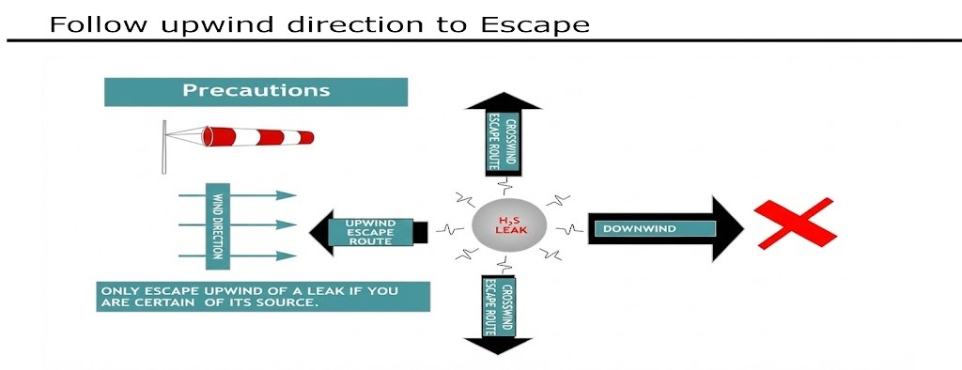

Figure. 5. The importance of the wind socks directions
terminal. Basic evacuation plan and in case of an emergency has been explained to the new recruiters, which is given in the Figure 6, which is marked in yellow colour. Lindell et al. (2018) have stressed the importance of the emergency response plan by using various models in the
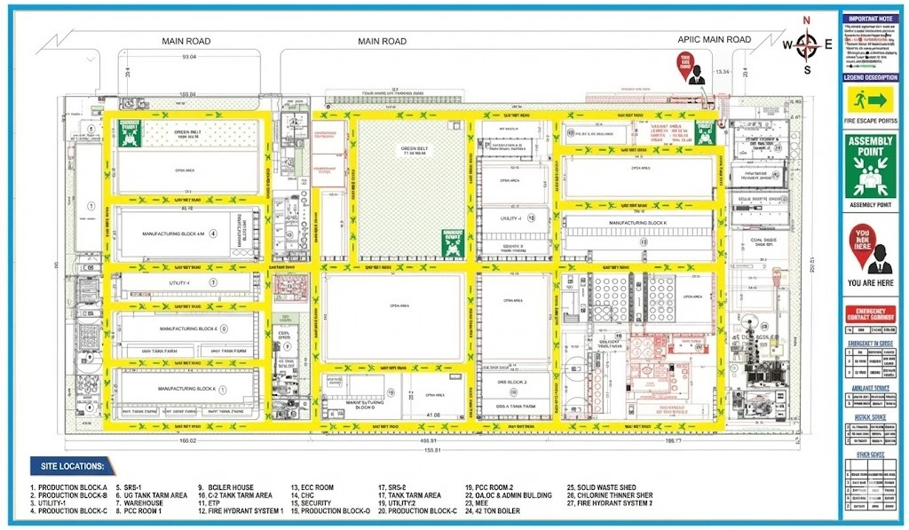
Figure.6. over view of the Evacuation plan in the company premises reaching to the assembly point
hazardous area but they have not covered the evacuation procedures; Many of the other authors such as Cvetković (2024), Ashar et al. (2019); Sheeba et al. (2019) have informed various disaster pans and its rescue, Practices of tsunami evacuation planning in Padang, Indonesia and various models for evacuating the building in case of an fire emergency but there is less published importance of the practical evacuation in the pharmaceutical industry by using emergency escape routes.
The various types of extinguishers to be used in case of an emergency has been explained during the induction training, Further the importance of the pass method has been explained, so that new recruiters can also be involved in the handling of an emergency situation. During the induction period itself we are committed in giving safety training to the new recruits for tackling an emergency situation like fire, which will result in the strong formation of the emergency response team (ERT) with the existing members in the organization. The importance of the Pass method is explained in Figure. 7 and the various type of the extinguishers have been explained during the induction training as well as to the existing employees, these has increased the safety belief and values for handling an emergency situation. We do have a firefighting marshal and its guards in the organization, as they are involved in the handling of the fire pump house auto operations of the Jockey, hydrant and diesel pump in the organization. Nolan (2017) has explained the various designs for usage of the emergency firefighting equipment’s for the hazardous chemical handling industry. Recently Golwalkar & Kumar (2022) has informed that various pumps, which are used in the fire pump house acts as a heart function in tackling the emergency situation of the chemical industry.
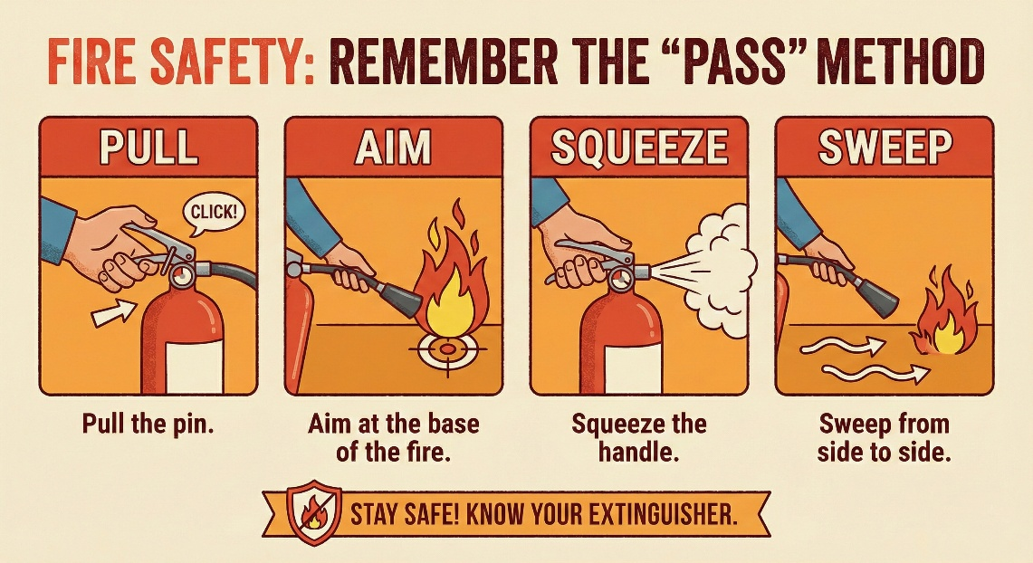
Figure. 7. The importance of the PASS method
All the fire Marshalls along with the other ERT team members have undergone external practical training with the help of district fire officer of Puducherry. During the period we have discussed the various techniques, which are to be used for lifting an injured person during the handling of the emergency situation. Born et al. (2021); Andriani et al. (2017) has discussed the various rules, adoption in handling an emergency situation like fire during the abnormal operations but there is no discussion on the various teams involved in the mock drill / during any of the emergency operations for the pharmaceutical industry in India. With the help of various teams, we have conducted mock drills, block wise as well as entire site evacuation for handling an emergency situation on 11th November 2025 (Figure. 8). Meghana et al. (2021) has discussed about the emergency and response team members are involved in tackling the emergency situation

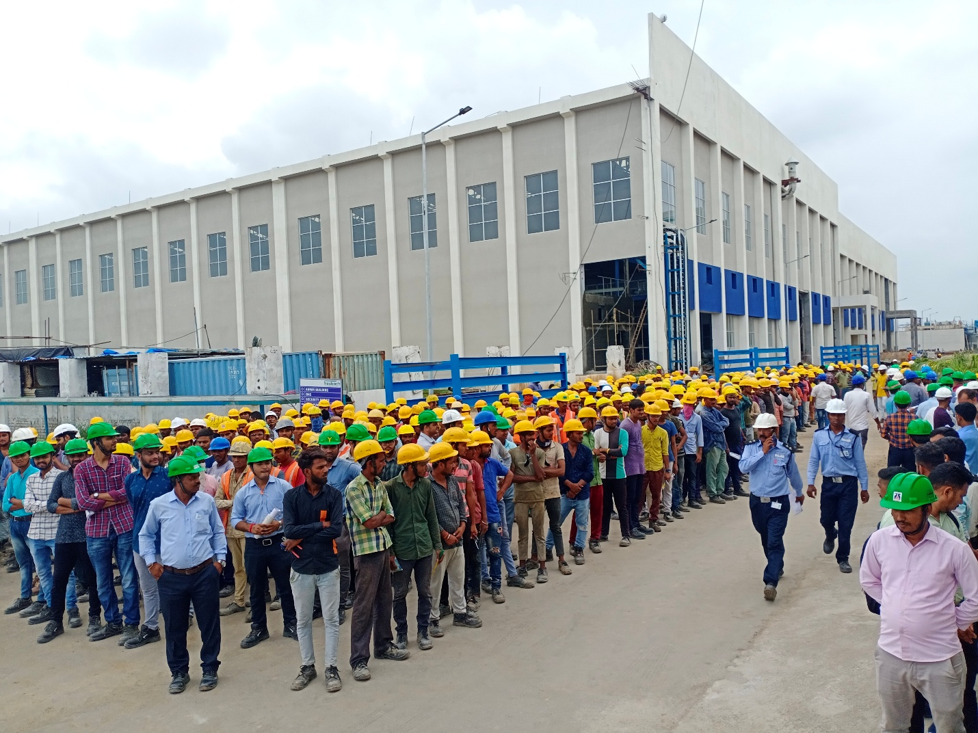
Figure. 8. Entire site evacuation mock drill, where occupants are standing in the assembly point
in pharmaceutical industry during COVID – 19 circumstances but there is very less published information available for the various teams, which are involved in tackling the emergency situation. Our various teams, which are involved in the mock drills are communication team, firefighting team, first aid and rescue, Liaison team and leak arresting team. All these teams will be reporting to the incident controller and he will be reporting same to the site main controller during the mock drill and in case any emergency arises. The extinguishing concept during the mock drill are practiced for handling emergency (Figure. 9), such type of practicing the mock drill

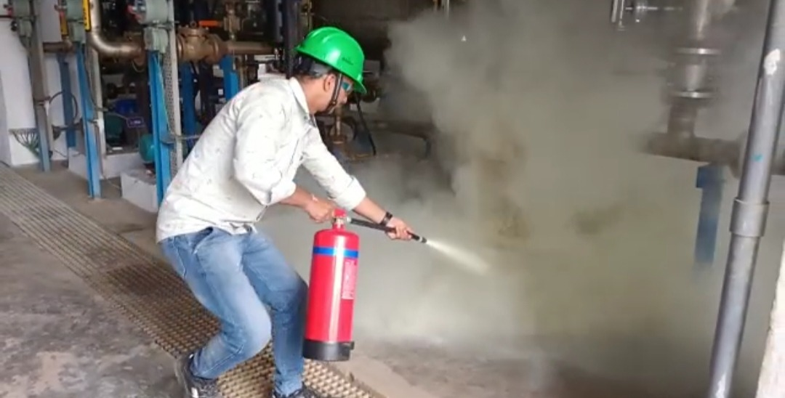
Figure. 9. Extinguishing the fire during the mock drill
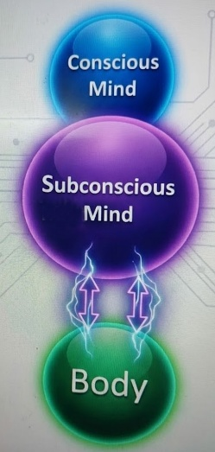
will help us in easily handling an emergency situation and results in the increase in the safety belief and their values for handling an emergency situation, increases the functional ability and thinking during an emergency situation like fire or explosion. The belief and values of the occupants have increased after indulging the mock drill activities for tackling the emergency situation. The safety beliefs and knowledge are more than an emotional feeling. All the belief and values, which are there in the human body are directly related to the subconscious mind (Figure. 10).

Figure. 10. Beliefs and values are directly linked to the subconscious and conscious mind
All the BBS interactions of the SLT with the other department focus has increased the usage of the PPE compliance by 97.7 %, identifying the unsafe acts and its conditions and narrow down the unsafe acts and conditions in the manufacturing blocks by 78 %. Further we have reduced 85 % near misses. Skowron-Grabowska & Sobociński (2018) have stressed the advantages of the BBS system further he has informed that inappropriate trainer involved in the activity will give a negative effect. We have hired a BBS specialist for conducting programs which has resulted in the successful implementation of the BBS interaction and survey. The BBS interactions and survey have resulted in increased safety belief and values for meeting the safety compliance, diligence, independent ownership and safety. We have conducted a campaign for identifying the near misses in the month of February 2025, we have followed universal tracker for the near misses and further introduced the near miss boxes in each of the department. The camping over view of the near miss campaign and the various boxes for collecting the near miss complaints are in the Figure. 11.
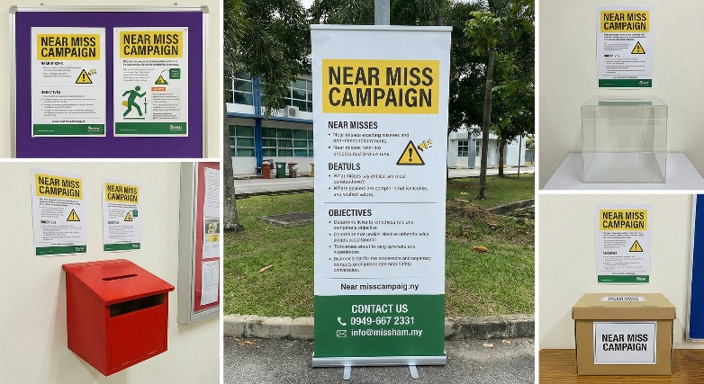
Figure. 11. Near Miss campaign to spread the awareness among the employees
Highest care to be taken for handling and storage of the chemicals and solvents in storage tanks. We have taken license for storing the Class A and B flammable solvents from petroleum explosive safety organization (PESO). We have provided nitrogen blanketing for all our liquid chemicals and solvents storage tanks, similarly Ding et al. (2020) have reported that during the risk assessment, it was observed nitrogen blanketing is the highest control to cut the oxygen in the solvent storage tanks. It has been ensured that earth rite system is in place while unloading of the solvents from the road tankers to the storage tanks so that we can avoid the static accumulation. All the executives in the stores and the various blocks were trained for handling the chemicals and solvents, so that they keep all the safety instructions in the subconscious mind, so that highest safety culture is maintained for handling of the chemicals and the solvents. Each of the chemical storage tanks are supported with the dyke wall and double earthing has been provide to the storage tanks to avoid static, Flame arrestor cum breather valve has been provided for the chemical storage tanks. Mora et al. 2018 has stressed the importance of the various devices, which are used to the solvent storage tanks. The day storage tanks, where the chemicals or solvents are stored will have overview display board of safety data sheet (SDS) for each of the chemical. All the storage tanks are labelled as per hazard information management system (HIMS). Such type safety labels of HIMS on the storage tanks will increase the awareness of handling the chemicals, it displays the suitable PPE to be worn while handling of the chemicals or solvents thus practicing the highest safety beliefs and values during the working environment. We can say that the behavioral aspects with respect to safety are crucial for handling the flammable, corrosive, irritant and carcinogenic chemicals or solvents, which results in increase in safety Knowledge and highest practices for handling the organic solvents as reported by Hasylin et al. (2022). The behavioral aspects is a daily practice (Kunc et al., 2020), which are to be followed while handling the chemicals in the pharmaceutical industry, so it is very much necessary that all the safety aspects go to the subconscious mind without fail, so safety is a continuous improvement process (Amyotte et al., 2019)
In this paper we have covered the importance of the six SMP and we have stressed the importance of the safety aspects of handling the emergency situation, practicing the mock drill and conducting various different types of training based on the requirement and need of the safety training, identifying the unsafe act and its conditions, so that we can avoid the incidents / accidents in the pharmaceutical industry, stressing the importance for conducting the near miss campaigns and educating the occupants, so that we can avoid the near misses in the working environment, the importance of the BBS interactions with the SLT and we have given an overview of the important safety precautions to be taken while handling the deadly chemicals and solvents. It is very well understood that all the activities require the inherent thoughts in the subconscioCC]0’]0’us mind for all the above activities which are handled in the pharmaceutical industry. Highest beliefs and values are mandatory for all the workers working in the occupational environment for having an incident / free environment.
4. CONCLUSION:
The implementation of the safety management pillars, practicing the appropriate behavioral aspects and giving the appropriate training based on needs and requirement of the people working in various blocks. All the Behavioral based safety aspects are well trained by the safety leadership team for identifying the unsafe conditions and unsafe acts in the various blocks, ultimately, we have narrowed down and reduced the unsafe act and conditions in the organization leading to the highest beliefs and values. Near miss campaign has been conducted for identifying the near misses. we have discussed about the various teams, which are involved in handling the emergency situation. Further we have trained the emergency team members along with the fire marshals for handling the real time circumstances, which has resulted in the safety beliefs and values. Further we have stressed the importance of the safety precautions and conditions, which are required for storage of the deadly chemicals and solvents. Over all we have committed to our EHS policy for achieving the various goals and objectives. Safety is a continuous improvement, based on the change in the chemical, process equipment, the hazard may increase. We can say that changes in safety is based on hazardous criticality of the reaction, so safety is continuous improvement process in the pharma industry.

COMPETING INTERESTS DISCLAIMER:
Authors have declared that they have no known competing financial interests OR non-financial interests OR personal relationships that could have appeared to influence the work reported in this paper.
Disclaimer (Artificial intelligence)
Author(s) hereby declare that NO generative AI technologies such as Large Language Models (ChatGPT, COPILOT, etc.) and text-to-image generators have been used during the writing or editing of this manuscript.

5. REFERENCES
- Adikwu, F. E., Ozobu, C. O., Odujobi, O. L. A. D. I. P. O., Onyekwe, F. O., & Nwulu, E. O. (2023). Advances in EHS compliance: A conceptual model for standardizing health, safety, and hygiene programs across multinational corporations. Journal Name Not Provided.
https://www.researchgate.net/profile/Engr-Oladipo-Odujobi/publication/388996769_Advances_in_EHS_Compliance_A_Conceptual_Model_for_Standardizing_Health_Safety_and_Hygiene_Programs_Across_Multinational_Corporations/links/67af3f1196e7fb48b9c34b2e/Advances-in-EHS-Compliance-A-Conceptual-Model-for-Standardizing-Health-Safety-and-Hygiene-Programs-Across-Multinational-Corporations.pdf
- Agarwal, P., Goyal, A., & Vaishnav, R. (2018). Chemical hazards in pharmaceutical industry: An overview. Asian J. Pharm. Clin. Res, 11(2).
- Alazzam, A. M., Alrubaye, M. W., Goldsmith, J. A., & Gorgey, A. S. (2023). Trends in measuring BMR and RMR after spinal cord injury: a comprehensive review. British Journal of Nutrition, 130(10), 1720-1731.
https://doi.org/10.1017/S0007114523000831
- Ashar, F., Amaratunga, D., Sridarran, P., & Haigh, R. (2019). Practices of tsunami evacuation planning in Padang, Indonesia. In Coastal Management (pp. 399-433). Academic Press.
https://doi.org/10.1016/B978-0-12-810473-6.00019-4
- Andriani, P., Ali, A., & Mastrogiorgio, M. (2017). Measuring exaptation and its impact on innovation, search, and problem solving. Organization Science, 28(2), 320-338.
https://doi.org/10.1287/orsc.2017.1116
- Amyotte, P. R., Khan, F. I., & Irvine, Y. (2019). Continuous Improvement in Process Safety Education. CET Journal-Chemical Engineering Transactions, 77.
https://openurl.ebsco.com/EPDB%3Agcd%3A5%3A34348309/detailv2?sid=ebsco%3Aplink%3Ascholar&id=ebsco%3Agcd%3A139266467&crl=c&link_origin=scholar.google.com
- Austad, K. E., Avorn, J., & Kesselheim, A. S. (2011). Medical students' exposure to and attitudes about the pharmaceutical industry: a systematic review. PLoS medicine, 8(5), e1001037.
https://doi.org/10.1371/journal.pmed.1001037
- Bhusnure, O. G., Dongare, R. B., Gholve, S. B., & Giram, P. S. (2018). Chemical hazards and safety management in pharmaceutical industry. Journal of Pharmacy Research, 12(3), 357-369.
- Born, E., & Lehner, J. M. (2022). Variants of drill as preparations for responding to surprising events. Journal of Management Development, 41(2), 118-129.
https://doi.org/10.1108/JMD-11-2021-0310
- Carra, S., Bottani, E., Vignali, G., Madonna, M., & Monica, L. (2024). Implementation of behavior-based safety in the workplace: A review of conceptual and empirical literature. Sustainability, 16(23), 10195.
https://doi.org/10.3390/su162310195
- Cooper, D. (2015). Effective safety leadership: Understanding types & styles that improve safety performance. Professional Safety, 60(02), 49-53.
https://onepetro.org/PS/article-abstract/60/02/49/33312/Effective-Safety-Leadership-Understanding-Types
- Cvetković, V. (2024). Essential Tactics for Disaster Protection and Rescue. Scientific-Professional Society for Disaster Risk Management, Belgrade.
- Ding, L., Khan, F., & Ji, J. (2020). Risk-based safety measure allocation to prevent and mitigate storage fire hazards. Process safety and environmental protection, 135, 282-29
https://doi.org/10.1016/j.psep.2020.01.008
- Dunn, A. L., Payne, A., Clark, P. R., McKay, C., Williams, G. D., Wheelhouse, K., ... & Shilcrat, S. (2020). Process safety in the pharmaceutical industry: a selection of illustrative case studies. Journal of Chemical Education, 98(1), 175-182.
https://doi.org/10.1021/acs.jchemed.0c00115
- Golwalkar, K. R., & Kumar, R. (2022). Practical guidelines for the chemical industry. Berlin: Springer.
https://link.springer.com/book/10.1007/978-3-030-96581-5
- Hasylin, H., Abdul-Mumin, K. H., Pg-Hj-Ismail, P. K., Trivedi, A., & Win, K. N. (2022). Knowledge and Practice of Health and Safety in Handling Organic Solvents among Automobile Industry Workers in Brunei Darussalam.
https://www.preprints.org/frontend/manuscript/1d36ebe3df76ac0904a5cb9d281c33a9/download_pub
- Kunc, M., Harper, P., & Katsikopoulos, K. (2020). A review of implementation of behavioural aspects in the application of OR in healthcare. Journal of the Operational Research Society, 71(7), 1055-1072.
https://www.tandfonline.com/doi/abs/10.1080/01605682.2018.1489355
- Lindell, M. K., Murray-Tuite, P., Wolshon, B., & Baker, E. J. (2018). Large-scale evacuation: The analysis, modeling, and management of emergency relocation from hazardous areas. CRC Press.
https://doi.org/10.4324/9781315119045
- Meghana, A., Aparna, Y., Chandra, S. M., & Sanjeev, S. (2021). Emergency preparedness and response (EP&R) by pharmacy professionals in India: Lessons from the COVID-19 pandemic and the way forward. Research in Social and Administrative Pharmacy, 17(1), 2018-2022.
https://doi.org/10.1016/j.sapharm.2020.04.028
- Meyer, J. M., Kirk, A., Arch, J. J., Kelly, P. J., & Deacon, B. J. (2019). Beliefs about safety behaviours in the prediction of safety behaviour use. Behavioural and Cognitive Psychotherapy, 47(6), 631-644.
https://doi.org/10.1017/S1352465819000298
- Min, Y., Yexiang, F., Weilin, T., & Jiajie, Z. (2020). Study on safety behavior planning theory and control strategies for coal chemical workers. Safety science, 128, 104726.
https://doi.org/10.1016/j.ssci.2020.104726
- Miring’u, J., Gatebe, E., & Karanja, B. (2024). Assessment of the Influence of Safety Training on the Technicians Safety Culture in the Pharmaceutical Manufacturing Industries in Kenya. Journal of Health and Environmental Research, 10(4), 134-148.
- Mora, j., Sibaja, j., Umaña, w., Piedra, G., & Molina, O. (2018). safety equipment for storage and handling. safety and security engineering vii, 174, 345.
https://books.google.co.in/books?hl=en&lr=&id=AoBIDwAAQBAJ&oi=fnd&pg=PA345&dq=safety+for+solvent+handling&ots=toW5XnpFKN&sig=qWJQYMVE-ny3n-2ptue8HtoUBkk&redir_esc=y#v=onepage&q=safety%20for%20solvent%20handling&f=false
- Nolan, D. P. (2017). Fire pump arrangements at industrial facilities. Gulf Professional Publishing.
https://books.google.co.in/books?hl=en&lr=&id=cEQQ5-wadbUC&oi=fnd&pg=PP1&dq=fire+marshal+for+operation+of+the+fire+pump+house+in+hazardous+chemical+industry+&ots=M0IY-OTyMg&sig=Nk-EnXiA_0X0xx6B9u_nppIET70&redir_esc=y#v=onepage&q&f=false
- Ong, C. C., Dodds, A., & Nestel, D. (2016). Beliefs and values about intra-operative teaching and learning: a case study of surgical teachers and trainees. Advances in Health Sciences Education, 21(3), 587-607.
https://link.springer.com/article/10.1007/s10459-015-9654-5
- Pai, D. R., Kamath, K., Subramanyam, E. V., & Shabaraya, A. R. (2016). Personnel training for pharmaceutical industry. International Journal of Pharmaceutical Quality Assurance, 7(03), 55-61.
- Pawłowska, Z. (2015). Using lagging and leading indicators for the evaluation of occupational safety and health performance in industry. International journal of occupational safety and ergonomics, 21(3), 284-290.
https://doi.org/10.1080/10803548.2015.1081769
- Ramabrahmam, B. V., Sreenivasulu, B., & Mallikarjunan, M. M. (1996). Model on-site emergency plan. Case study: toxic gas release from an ammonia storage terminal. Journal of loss prevention in the process industries, 9(4), 259-265.
https://doi.org/10.1016/0950-4230(96)00016-2
- Rashid, M. I., Athar, M., Noor, F., & Hussain, A. (2023). Behavior-based safety program for process industries. International journal of occupational safety and ergonomics, 29(4), 1440-1450.
https://doi.org/10.1080/10803548.2022.2135282
- Schwan, J., Kleoff, M., Dreyhsig, G. H., Voßnacker, P., Fiedler, T., Rosental, M., & Riedel, S. (2025). Rethinking Chlorine: Essential Chemical or Replaceable Risk?. ChemSusChem, 2402697.
https://doi.org/10.1002/cssc.202402697
- Scott Geller, E., & Robinson, Z. J. (2015). Behavior‐based approaches to occupational safety. The Wiley Blackwell handbook of the psychology of occupational safety and workplace health, 299-326.
https://doi.org/10.1002/9781118979013.ch14
- Sheeba, A. A., & Jayaparvathy, R. (2019). Performance modeling of an intelligent emergency evacuation system in buildings on accidental fire occurrence. Safety science, 112, 196-205.
https://doi.org/10.1016/j.ssci.2018.10.027
- Skowron-Grabowska, B., & Sobociński, M. (2018). Behavior based safety (BBS)-advantages and criticism. Production engineering archives, 20, 12-15.
- Smirniakova, V., Smirniakov, V., Almosova, Y., & Kargopolova, A. (2021). Vision zero” concept as a tool for the effective occupational safety management system formation in JSC “SUEK-kuzbass. Sustainability, 13(11), 6335.
https://doi.org/10.3390/su13116335
- Wang, X., Zhang, C., & Gao, W. (2022). Risk assessment of hydrogen leakage in diesel hydrogenation process. International Journal of Hydrogen Energy, 47(10), 6955-6964.
https://doi.org/10.1016/j.ijhydene.2021.12.027
- Waring, A. (2019). The five pillars of occupational safety & health in a context of authoritarian socio-political climates. Safety science, 117, 152-163.
https://doi.org/10.1016/j.ssci.2019.04.008

