Original Research Article
MODELING AND SIMULATION OF A PV–BATTERY INTEGRATED BIDIRECTIONAL DC–DC CONVERTER FOR EV APPLICATIONS

ABSTRACT

The integration of photovoltaic (PV) systems with battery storage is crucial for enhancing the efficiency and reliability of electric vehicle (EV) energy systems. Modeling and simulation of a bidirectional DC–DC converter enable effective power flow management and optimization under varying operating conditions. This paper proposes a solar photovoltaic (PV) and battery integrated multi-port DC–DC converter for efficient energy management in electric vehicle (EV) applications. The work addresses the challenge of inefficient energy utilization and high battery stress in conventional EV systems. The system employs a non-isolated dual-input dual-output (DIDO) converter that integrates renewable solar energy with battery storage to ensure continuous and reliable power supply. The converter is capable of operating in both buck and boost modes, enabling effective voltage regulation under varying input and load conditions. It also supports bidirectional power flow, facilitating battery charging, discharging, and regenerative braking. A Proportional–Integral–Derivative (PID) controller is implemented to maintain a stable output voltage and improve dynamic performance by adjusting the duty cycle of switching devices. The research hypothesis is that integrating PV with battery storage through a bidirectional converter improves overall system efficiency compared to standalone battery systems.The system operates in multiple modes, including PV-to-load, PV-to-battery, battery-to-load, and combined operation, ensuring optimal utilization of available energy sources. This approach reduces battery stress, enhances system efficiency, and improves overall reliability. Simulation and hardware implementations are carried out to validate the performance of the proposed system. The system achieves an efficiency of approximately 92–94% under varying operating conditions. The results demonstrate stable voltage output, efficient power sharing, and high efficiency, making the system a promising solution for sustainable and next-generation electric vehicle applications.

Keywords: Solar Photovoltaic (PV), Electric Vehicles (EV), Multi-Port DC–DC Converter, Bidirectional Power Flow, Battery Energy Storage, PID Controller, Power Management, Renewable Energy Integration, PWM Control, Energy Efficiency.
- INTRODUCTION

The increasing demand for sustainable and eco-friendly transportation has led to rapid advancements in electric vehicle (EV) technology. Conventional vehicles powered by fossil fuels contribute significantly to environmental pollution and global warming, creating a need for cleaner alternatives. Electric vehicles offer a promising solution by reducing emissions and improving energy efficiency. However, their performance is largely dependent on efficient energy management systems. In most EVs, batteries serve as the primary energy source. Although batteries provide reliable energy storage, they face several limitations such as high stress during peak power demand, limited lifespan, long charging time, and reduced efficiency under dynamic operating conditions. These challenges highlight the need for integrating alternative energy sources to enhance system performance and reliability.

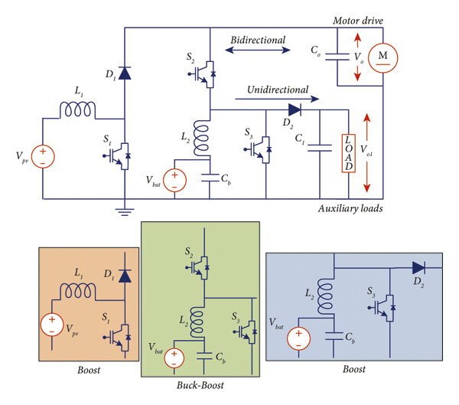

Figure 1. Four-Port Bidirectional DC–DC Converter for EV

The figure 1 represents a multi-port bidirectional DC–DC converter designed for electric vehicle (EV) applications, integrating a solar PV source and a battery. The PV source is connected through an inductor L₁​, diode D₁​, and switch S₁​, forming a boost converter that steps up the PV voltage. The battery is connected through another inductor L₂​, capacitor C_{b}​, and switches S₂​ and S₃​, enabling buck–boost operation. This configuration allows bidirectional power flow between the battery and the motor drive, supporting both charging and discharging modes. The motor load is supplied through an output capacitor C_{o}​, which helps in maintaining a stable voltage. Additionally, an auxiliary load is connected through diode D₂​ and capacitor C₁​, ensuring regulated power supply for secondary loads. The converter operates in different modes such as PV-to-load, PV-to-battery, battery-to-load, and combined operation depending on energy availability and demand. The bidirectional feature is particularly useful for regenerative braking, where energy from the motor is fed back to the battery. Overall, the circuit ensures efficient energy management, voltage regulation, and improved performance of the EV system.

Solar photovoltaic (PV) energy has emerged as a viable renewable energy source for EV applications due to its abundance, sustainability, and environmental benefits. However, the intermittent nature of solar energy requires an efficient energy management system to ensure continuous power supply. Integrating PV systems with battery storage can address these issues by enabling energy sharing and improving overall efficiency. To effectively manage multiple energy sources, multi-port DC–DC converters have gained significant attention. These converters allow integration of PV, battery, and load within a single system, reducing complexity and improving efficiency. Additionally, bidirectional power flow capability enables regenerative braking and energy recovery, further enhancing system performance.

To ensure stable operation under varying conditions, advanced control strategies such as Proportional–Integral–Derivative (PID) control are employed. The PID controller regulates the output voltage by adjusting the duty cycle of the converter, thereby improving dynamic response and system stability. In this paper, a solar PV and battery integrated multi-port DC–DC converter is proposed for EV applications. The system aims to achieve efficient energy management, reduced battery stress, and improved overall performance. Simulation and hardware validation are carried out to demonstrate the effectiveness of the proposed approach.
- LITERATURE SURVEY
Recent advancements in DC–DC converter technologies have focused on improving efficiency, reliability, and integration of renewable energy sources for electric vehicle (EV) applications. A comprehensive review in [1] highlights the development of traditional, bidirectional, and multi-port converter topologies, emphasizing their importance in managing multiple energy sources such as photovoltaic (PV) systems and batteries.
High-efficiency converter designs have been widely explored in recent studies. The work in [2] demonstrates a thermally optimized converter achieving an efficiency of up to 98.8%, while [3] presents a high-gain coupled-inductor-based converter suitable for low-voltage renewable applications. Similarly, high step-up and cost-effective converter designs for PV systems are discussed in [4] and [5], which focus on improving voltage gain and reducing system complexity.
In EV applications, DC–DC converters play a crucial role in energy management and voltage regulation. The study in [6] provides a detailed analysis of converter topologies for EV systems, highlighting the need for bidirectional power flow to support battery charging, discharging, and regenerative braking. Additionally, [7] reviews converter technologies for sustainable electro mobility, emphasizing the integration of renewable energy sources.
Control strategies are equally important for maintaining system stability and performance [8]. Conventional controllers such as Proportional (P), Proportional–Integral (PI), and Proportional–Integral–Derivative (PID) are widely used due to their simplicity and effectiveness in DC–DC converter applications [19]. More advanced techniques, including fuzzy logic control, model predictive control (MPC), and artificial intelligence (AI)-based approaches, have also been explored to improve dynamic response and adaptability under varying operating conditions [20], [21]. Despite these developments, most existing converter designs suffer from increased complexity, higher component count, and implementation cost [22].
Furthermore, many reported multi-port and bidirectional converters focus on high-performance optimization using advanced control strategies, which limits their suitability for simple and practical applications [23]. Therefore, there is a need for a simplified, cost-effective multi-port DC–DC converter with basic control techniques that can efficiently integrate PV and battery systems while ensuring reliable bidirectional power flow. In this context, the present work proposes a PV–battery integrated bidirectional DC–DC converter with reduced component count and PID-based control, aiming to provide a practical and easily implementable solution suitable for foundational and real-time EV applications.
3. MODELLING AND SIMULATION OF MULTI-PORT DC–DC CONVERTER FOR EV APPLICATIONS
The integration of renewable energy sources with electric vehicles (EVs) has become essential for achieving sustainable and efficient transportation systems. Among various renewable sources, solar photovoltaic (PV) energy is widely preferred due to its availability and environmental benefits. However, the intermittent nature of solar energy and the dynamic operating conditions of EVs require an efficient energy management system. To address these challenges, a multi-port DC–DC converter integrated with PV and battery sources is proposed and analysed through simulation [9-12].
Simulation plays a vital role in validating system performance before hardware implementation. In this work, the proposed system is modelled using MATLAB/Simulink to analyse its behaviour under different operating conditions. The simulation helps in understanding voltage regulation, power flow management, and dynamic response of the system.
The system consists of a solar PV source, battery energy storage, multi-port DC–DC converter, control system, and DC motor load. The converter enables efficient power transfer between multiple sources and the load, while also supporting bidirectional power flow for applications such as regenerative braking. The integration of these components ensures continuous power supply and improved system reliability [13-18].
A Proportional–Integral–Derivative (PID) controller is employed to regulate the output voltage and maintain system stability. The controller adjusts the duty cycle of switching devices based on the error between reference and actual output voltage. This improves dynamic response, reduces steady-state error, and ensures efficient operation under varying conditions.
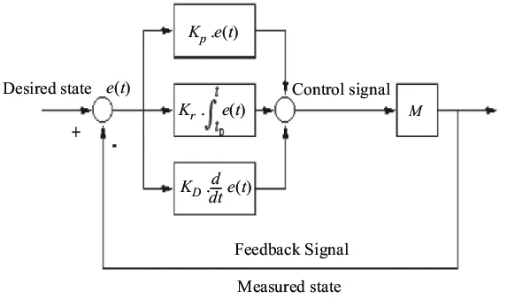
Figure 2 . Closed-Loop PID Control System Block Diagram
The figure 2 shows the block diagram of a Proportional–Integral–Derivative (PID) controller used in a closed-loop control system. The desired output (reference signal) is compared with the measured output to generate an error signal e(t). This error is processed through three components: proportional, integral, and derivative. The proportional term K_{p} provides an immediate response proportional to the error, improving system responsiveness. The integral term K_{i} accumulates the error over time and eliminates steady-state error. The derivative term K_{d} predicts future error based on its rate of change, improving system stability and reducing overshoot. The outputs of these three components are summed to produce the control signal, which is applied to the system or plant (M). The system output is continuously fed back and compared with the reference input, forming a closed-loop system. This feedback mechanism ensures accurate output tracking, improved dynamic response, and stable operation under varying conditions.
The simulation model also includes key parameters such as inductors, capacitors, switching frequency, and duty cycle to represent real-time system behaviour. Various operating modes such as PV-to-load, battery-to-load, and combined operation are analysed to evaluate system performance.
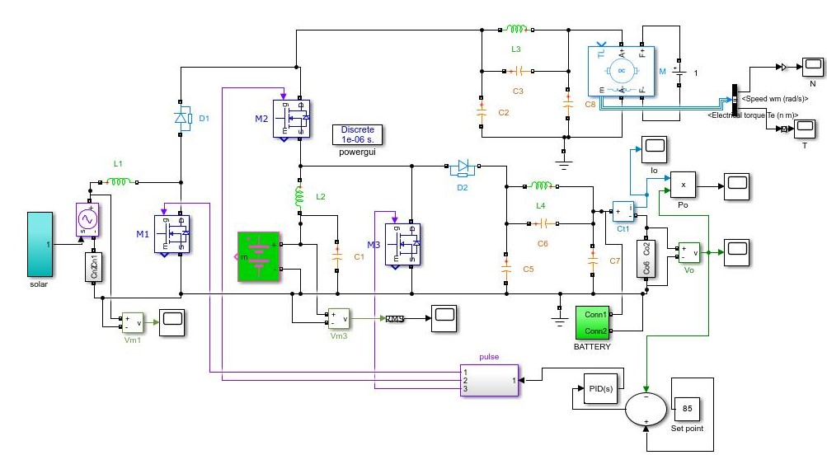
Figure 3. Simulink Model of PV–Battery Based DC–DC Converter with PID-Controlled Motor Drive
The proposed work figure 3 Simulink model represents a solar PV and battery integrated multi-port DC–DC converter system designed for electric vehicle (EV) applications. The solar panel acts as the primary renewable energy source, supplying power through an inductor and switching devices (M1, M2), forming a boost converter stage. The battery is connected as an auxiliary energy storage source, which can either supply power to the load or get charged depending on operating conditions. The multi-port converter, consisting of inductors (L1, L2, L3, L4), capacitors (C1–C8), diodes (D1, D2), and switches (M1, M2, M3), enables bidirectional power flow and supports both buck and boost operations. The output is connected to a DC motor load, where parameters such as speed and torque are measured. A PID controller is used to regulate the output voltage by comparing it with a reference set point and adjusting the duty cycle of the switching pulses through PWM generation. The system operates in different modes such as PV-to-load, battery-to-load, and combined operation, ensuring efficient energy management. Overall, the model demonstrates stable voltage regulation, efficient power sharing, and improved performance under varying input and load conditions.
Figure 4(a) shows the time response of motor speed, illustrating important dynamic characteristics such as rise time, overshoot, and settling time. Initially, the motor speed increases rapidly from zero and reaches the desired value, indicating a fast rise time. A slight overshoot is observed before the speed settles at the steady-state value, demonstrating the effect of system dynamics and controller action. The steady and smooth settling indicates good stability and effective control performance.
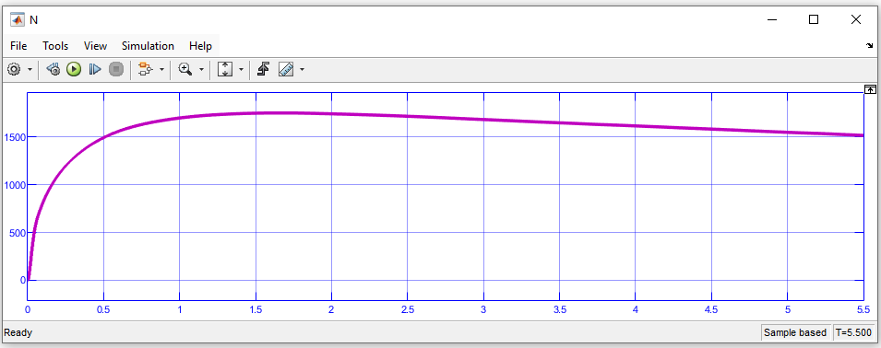
Figure 4(a) Time Response of Motor Speed Showing Rise Time, Overshoot, and Settling Behavior
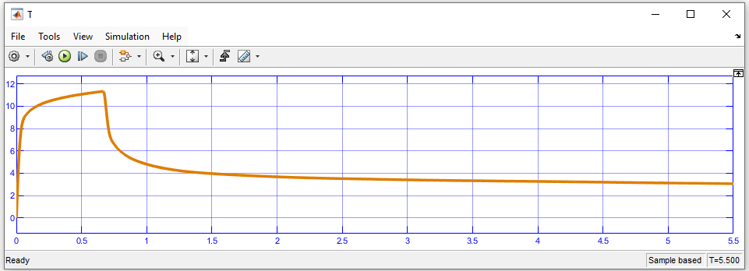
Figure 4(b) Time Response of Electromagnetic Torque Showing Transient and Steady-State Behaviour
Figure 4(b) represents the time response of electromagnetic torque. At the starting condition, the torque is high to overcome inertia and load requirements. As the motor speed increases, the torque gradually decreases and stabilizes at a steady-state value. The transient behaviour shows a quick response with minimal oscillations, indicating efficient control and proper energy utilization. Together, both graphs confirm that the system achieves stable operation with good dynamic and steady-state performance.
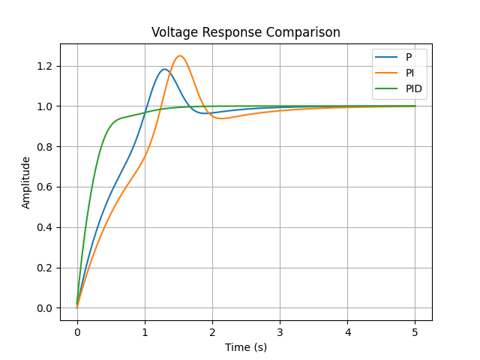
Figure 5. Performance Analysis of P, PI, and PID Controllers Based on Voltage Response
Figure 5 shows the performance analysis of P, PI, and PID controllers based on voltage response. The proportional (P) controller provides a fast response but results in steady-state error and noticeable oscillations. The PI controller eliminates steady-state error but introduces overshoot and slower settling time. The PID controller combines the advantages of both P and PI controllers, providing fast response, minimal overshoot, and zero steady-state error. Hence, PID control offers better voltage regulation and improved system stability compared to P and PI controllers. The PV source represents a solar panel whose output is interfaced to the converter through a boost stage for voltage regulation [24]
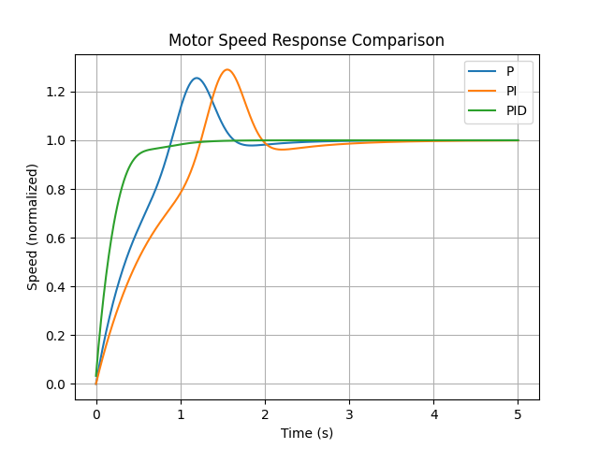
Figure 6.Time Response Analysis of Motor Speed Using P, PI, and PID Controllers
Figure 6 illustrates the time response of motor speed using P, PI, and PID controllers. The P controller shows faster rise time but suffers from oscillations and steady-state error. The PI controller improves accuracy by eliminating steady-state error but has higher overshoot and longer settling time. The PID controller provides the best performance with smooth response, reduced overshoot, faster settling time, and accurate tracking of the desired speed. Overall, the PID controller ensures superior dynamic and steady-state performance for motor speed control.
4. Experimental Setup of PV–Battery Integrated Converter Driving a DC Motor
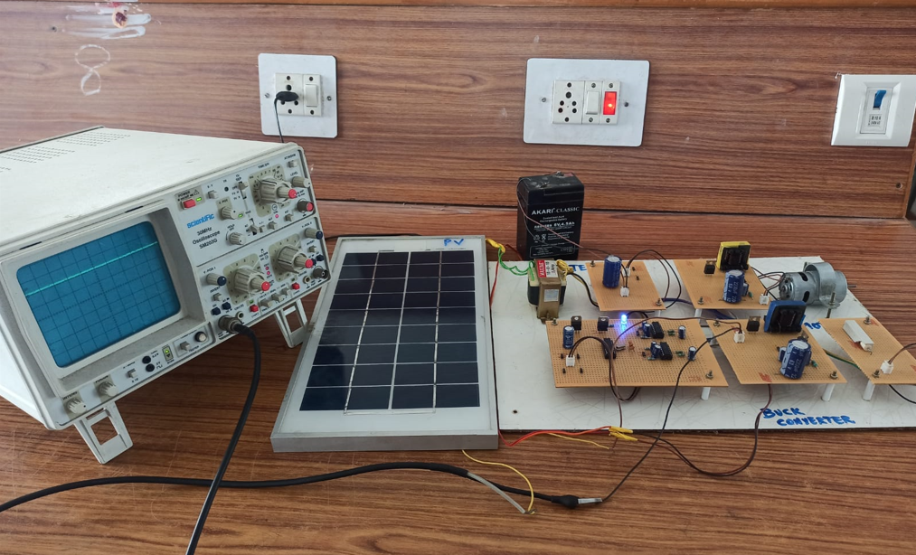
Figure 7. Experimental Setup of PV–Battery Integrated Converter Driving a DC Motor
The experimental setup demonstrates the practical implementation of a solar PV and battery integrated DC–DC converter system for electric vehicle (EV) applications as shown in figure 7. It consists of a solar panel, battery, converter circuits, control section, DC motor load, and measurement instruments. The setup is designed to validate the performance of the proposed system under real-time operating conditions. The solar panel acts as the primary renewable energy source. It converts sunlight into electrical energy and supplies DC power to the converter circuit. The PV output is variable depending on light intensity, which makes voltage regulation necessary. The battery is used as an energy storage device. It stores excess energy generated by the PV panel and supplies power to the load during low or no solar conditions. This ensures continuous operation and improves system reliability.
The converter circuit is implemented using hardware components such as inductors, capacitors, diodes, and MOSFET switches mounted on PCB boards. It performs both buck and boost operations to regulate voltage and maintain a constant output. The converter also enables power flow between PV, battery, and load efficiently. The control circuit generates PWM signals to control the switching devices in the converter. By adjusting the duty cycle, the output voltage is regulated. This ensures proper energy management and stable system operation. A DC motor is connected as the load to represent an EV drive system. The motor converts electrical energy into mechanical energy. Its performance is analysed in terms of speed and torque under different operating conditions.

A Cathode Ray Oscilloscope (CRO) is used to observe voltage waveforms, switching signals, and output characteristics. It helps in analysing system performance, waveform quality, and stability of the converter.
The proposed PV–battery integrated DC–DC converter system operates in different modes depending on the availability of solar energy and load requirements. These modes ensure efficient energy utilization and continuous power supply.
The system operates in different modes such as: PV to Load Mode, PV to Battery Charging Mode, Battery to Load Mode and Combined Operation Mode. These modes ensure efficient utilization of available energy sources.
1. PV to Load Mode
In this mode, the solar PV panel directly supplies power to the load (DC motor). This occurs when sufficient solar energy is available. The battery remains idle or lightly loaded, reducing stress on it and improving its lifespan.
2. PV to Battery Charging Mode
When the PV panel generates excess power beyond the load requirement, the additional energy is used to charge the battery. This ensures efficient utilization of solar energy and prevents energy wastage. It also prepares the system for operation during low solar conditions.
3. Battery to Load Mode
In this mode, the battery supplies power to the load when solar energy is insufficient or unavailable (e.g., during night or cloudy conditions). This ensures uninterrupted operation of the system.
4. Combined Operation Mode
During high load demand conditions, both the PV panel and battery work together to supply power to the load. This mode helps in handling peak power requirements efficiently and reduces excessive load on a single source.
The experimental setup verifies the practical feasibility of the proposed system. The results show stable output voltage, proper power sharing, and efficient operation. The system demonstrates good dynamic response and reliable performance under varying conditions. Overall, the hardware setup successfully validates the design of the PV–battery integrated converter system. It confirms efficient energy management, reduced dependency on a single source, and suitability for EV applications.
5. Conclusion
The proposed solar PV and battery integrated multi-port DC–DC converter system offers an efficient and reliable solution for energy management in electric vehicle (EV) applications. By integrating renewable solar energy with battery storage, the system reduces dependency on a single energy source and improves overall efficiency. The converter operates effectively in both buck and boost modes and supports bidirectional power flow, enabling features such as battery charging and regenerative braking. The implementation of a PID controller ensures stable output voltage, fast dynamic response, and minimal steady-state error. Simulation and hardware results demonstrate stable performance, efficient power sharing, and improved system reliability. Overall, the proposed system enhances energy utilization, reduces battery stress, and contributes to the development of sustainable EV technology. The proposed system can be further improved by incorporating advanced control strategies such as fuzzy logic control, artificial intelligence (AI), or model predictive control for better accuracy and adaptability. Integration of additional energy storage devices like super capacitors can enhance power handling capability and reduce battery degradation. The system can also be extended to high-power EV applications and real-time vehicle implementation. Furthermore, the inclusion of maximum power point tracking (MPPT) techniques can improve solar energy utilization. Future work may also focus on optimizing converter design to reduce size, cost, and losses, as well as integrating the system with smart grids and vehicle-to-grid (V2G) technologies for enhanced energy management.
COMPETING INTERESTS DISCLAIMER:
Authors have declared that they have no known competing financial interests OR non-financial interests OR personal relationships that could have appeared to influence the work reported in this paper.
Disclaimer (Artificial intelligence)

Author(s) hereby declare that NO generative AI technologies such as Large Language Models (ChatGPT, COPILOT, etc.) and text-to-image generators have been used during the writing or editing of this manuscript.

References:
- Mosallam, H. A., & Badran, E. A. (2026).A systematic review of DC–DC converter technologies: Traditional, bidirectional, and impedance-source topologies. Discover Electronics, 3, Article 16. https://doi.org/10.1007/s44291-026-00168-0
- Zhang, Z. (2026).A 98.8%-efficiency, thermally optimized 48 V-to-12 V DC–DC converter for high-power data centers. Frontiers in Electronics, 7, Article 1697781. https://doi.org/10.3389/felec.2026.1697781
- Hosseini, S. J. A., Hasanpour, S., Shahgholian, G., & others. (2025).A new ultra-high voltage gain DC/DC converter based on coupled-inductor. Scientific Reports, 15, Article 5330. https://doi.org/10.1038/s41598-025-90093-1
- Sharma, P., Hasanpour, S., & Kumar, R. (2024).Ultra-high voltage gain achieved with quadratic DC/DC converter design. Scientific Reports, 14, Article 23384. https://doi.org/10.1038/s41598-024-73984-7
- Baskaran, J., Naghapushanam, M., Ganapathy, M., Meena, P., Meena, V. P., Azar, A. T., & Hameed, I. A. (2024).Cost-effective high-gain DC–DC converter for photovoltaic applications. Frontiers in Energy Research, 12, Article 1400651. https://doi.org/10.3389/fenrg.2024.1400651
- Ramya, D., & Umadevi, K. (2024).A complete review on DC–DC converter topologies for energy sustainable electromobility. Journal of Environmental Nanotechnology, 13(3), 161–170. https://doi.org/10.13074/jent.2024.09.242714
- Thulasiraman, N., Viswanathan, L., & Sriramalakshmi, P. (2024).Review of DC–DC boost converter derived topologies for renewable energy applications. International Journal of Power Electronics and Drive Systems, 15(2), 947–957.
- Wang, X. (2023).Comprehensive analysis of DC/DC converters for electric vehicle applications: Topologies and future perspectives. Highlights in Science, Engineering and Technology, 76, 346–357. https://doi.org/10.54097/7rmk9c11
- Martínez-Vera, E., Bañuelos-Sánchez, P., & Etcheverry, G. (2023).Comparative examination of control strategies in DC–DC converters. Journal of Intelligent Systems and Control, 2(2), 82–98. https://doi.org/10.56578/jisc020203
- Dhineshkumar, K., Vengadachalam, N., Muthusamy, S., & Khan, B. (2025).Integrated MPPT and bidirectional DC–DC converter with reduced switch multilevel inverters for electric vehicle applications. Scientific Reports, 15, Article 25053. https://doi.org/10.1038/s41598-025-08700-0
- Alghamdi, A., et al. (2025).Battery charger based on high step-down DC–DC converter for light electric vehicle charging applications. Arabian Journal for Science and Engineering. https://doi.org/10.1007/s13369-025-10312-9
- Singh, A. R., Suresh, K., Parimalasundar, E., Kumar, B. H., & Bajaj, M. (2024).A high-efficiency poly-input boost DC–DC converter for energy storage and electric vehicle applications. Scientific Reports, 14, Article 18176. https://doi.org/10.1038/s41598-024-69254-1
- Waheed, A., Rehman, S. U., Alsaif, F., Rauf, S., & Hossain, I. (2024).Hybrid multimodule DC–DC converters accelerated by wide bandgap devices for electric vehicle systems. Scientific Reports, 14, Article 4746. https://doi.org/10.1038/s41598-024-55426-6
- Natarajan, S., & Singaravel, R. M. (2024).Solar PV powered DC charger for electric vehicles with reconfigurable power electronic interface. International Journal of Green Energy. https://doi.org/10.1080/15435075.2024.2417244
- Khan, M. R., Mishra, B., & Shrivastava, R. (2024).Adaptive bidirectional DC–DC converter for solar PV-enabled electric vehicle charging systems. Journal of Electrical Systems. https://doi.org/10.52783/jes.7997
- Bogaraj, T., Jose, P. S., Natarajan, A., & Karthikeyan, S. (2024).
A DC–DC converter for electric vehicle application. Majlesi Journal of Electrical Engineering, 18(4), 1–10. https://doi.org/10.57647/j.mjee.2024.1804.51
- Akhtar, M. F., Raihan, S. R. S., Rahim, N. A., Akhtar, M. N., & Abu Bakar, E. (2023).
Recent developments in DC–DC converter topologies for light electric vehicle charging: A critical review. Applied Sciences, 13(3), 1676. https://doi.org/10.3390/app13031676
- Zhou, K., Wu, Y., Wu, X., Sun, Y., Teng, D., & Liu, Y. (2023).
Research and development review of power converter topologies and control technology for EV fast-charging systems. Electronics, 12(7), 1581. https://doi.org/10.3390/electronics12071581
- Martínez-Vera, E., Bañuelos-Sánchez, P., & Etcheverry, G. (2023). Comparative examination of control strategies in DC–DC converters. Journal of Intelligent Systems and Control, 2(2), 82–98. https://doi.org/10.56578/jisc020203
- Sahoo, A. K., et al. (2022). A review of control strategies for DC–DC converters in renewable energy systems. Renewable and Sustainable Energy Reviews, 159, 112145. https://doi.org/10.1016/j.rser.2022.112145
- Wang, X. (2023). Comprehensive analysis of DC/DC converters for electric vehicle applications: Topologies and future perspectives. Highlights in Science, Engineering and Technology, 76, 346–357. https://doi.org/10.54097/7rmk9c11
- Akhtar, M. F., Raihan, S. R. S., Rahim, N. A., Akhtar, M. N., & Abu Bakar, E. (2023). Recent developments in DC–DC converter topologies for light electric vehicle charging: A critical review. Applied Sciences, 13(3), 1676. https://doi.org/10.3390/app13031676
- Waheed, A., Rehman, S. U., Alsaif, F., Rauf, S., & Hossain, I. (2024). Hybrid multimodule DC–DC converters accelerated by wide bandgap devices for electric vehicle systems. Scientific Reports, 14, 4746. https://doi.org/10.1038/s41598-024-55426-6
- Khan, M. A., Zeb, K., Sathishkumar, P., Busarello, T. D. C., Ahmad, I., Kim, H. J., & Kim, H. J. (2021). A novel bidirectional DC–DC converter for electric vehicles with renewable energy integration. IEEE Access, 9, 58857–58868. https://doi.org/10.1109/ACCESS.2021.3074581

