Original Research Article

ATTENTION-DRIVEN DIAGNOSIS: Enhancing Chicken Disease Prediction from Fecal Imagery

.
ABSTRACT

BACKGROUND: Poultry farming is essential for food security, but traditional disease detection is inefficient, making AI-driven CNN models a powerful solution for accurate and automated diagnosis.
Aims: This study aims to develop and evaluate an enhanced deep learning-based framework for the automated classification of poultry diseases using fecal images to address the limitations of traditional manual inspection.
Study Design: The research utilizes a comparative experimental design, evaluating two distinct deep learning architectures; ResNet50 and Vision Transformer (ViT) on a multiclass dataset.
Methodology: A dataset of 8,067 annotated fecal images representing four classes (Coccidiosis, Healthy, Newcastle Disease, and Salmonella) was partitioned using a stratified 80/20 split. Both models were initialized with pretrained ImageNet weights and subjected to selective fine-tuning (unfreezing the last two layers of ResNet50 and the last two encoder blocks of ViT) alongside data augmentation and 5-fold cross-validation.
Results: The Vision Transformer (ViT) outperformed the ResNet50 model, achieving a state-of-the-art accuracy of 96.16% and a macro F1-score of 0.96, compared to 94.49% accuracy and a 0.94 F1-score for ResNet50. Notably, ViT showed superior performance in detecting Newcastle Disease (NCD), increasing recall to 0.91, a 6% improvement over ResNet50.
Conclusion: The results demonstrate that while traditional CNNs like ResNet50 provide strong baselines, transformer-based architectures excel at capturing global contextual relationships, making them more robust for accurate real-time poultry disease diagnostics.
Our code is available on https://github.com/NedumCares/Chicken-Disease-Prediction.

Keywords: Vision Transformer (ViT); ResNet50; Poultry Disease Classification; Fecal Image Analysis; Deep Learning; Avian Health Monitoring; Precision Agriculture; Newcastle Disease.

1. INTRODUCTION
Poultry farming is a vital component of the global agricultural sector, contributing significantly to food security, employment, and economic sustainability. The increasing demand for poultry products has led to intensified production systems, which, while efficient, also increase the risk of disease outbreaks among birds. These diseases such as coccidiosis, salmonella, and Newcastle disease can result in severe economic losses, high mortality rates, and reduced productivity if not detected early [1][2].
Traditional diagnostic approaches rely heavily on manual inspection and veterinary expertise, which are often time-consuming, labor-intensive, and prone to human error. In many cases, delayed diagnosis leads to widespread infection before intervention can occur. Studies have shown that conventional methods are not suitable for continuous monitoring in modern, large-scale poultry systems, further emphasizing the need for automated solutions [3][4]. With the rapid advancement of artificial intelligence, deep learning techniques particularly convolutional neural networks (CNNs) have emerged as powerful tools for image-based disease detection. These models are capable of automatically extracting complex features from images and have demonstrated high accuracy in medical and agricultural applications. Recent research confirms that CNN-based models can achieve a good accuracy in poultry disease prediction tasks, highlighting their effectiveness in real-world scenarios[2].
The integration of transfer learning, transformer-based architectures, and explainable AI techniques has enhanced the robustness and interpretability of these systems. For example, Vision Transformers and explainability methods such as Integrated Gradients have been introduced to improve transparency in model decisions[5]. Also, hybrid frameworks combining multiple pretrained CNN models have been proposed to balance computational efficiency and classification performance[6].
Despite these advancements, several challenges remain, including data imbalance, limited availability of labeled datasets, lack of generalization across diverse farm environments, and insufficient model interpretability. Therefore, there is a need for more robust and efficient deep learning models that can address these limitations while maintaining high accuracy.
The primary contributions of this study are threefold:
- We propose a fine-tuned Vision Transformer (ViT-B/16) framework that achieves a state-of-the-art accuracy of 96.16%, effectively surpassing the 'performance ceiling' of 94% observed in recent CNN-based literature.
- We provide a rigorous comparative analysis between local feature-based models (ResNet50) and global attention-based models (ViT), demonstrating that self-attention is critical for resolving the high visual similarity between Newcastle Disease and Salmonella symptoms.
- We introduce a selective fine-tuning strategy and an optimized training pipeline that ensures high recall (0.91) even for underrepresented disease classes, providing a more balanced diagnostic tool than previous custom architectures like ChicNetV6
.

2. RELATED WORK

The application of deep learning in poultry disease detection has gained significant attention in recent years, with various studies exploring different architectures, datasets, and optimization techniques.
Early work by Mbelwa et al. [7] introduced a CNN-based framework for detecting chicken diseases using fecal images, demonstrating that image-based approaches can effectively replace traditional diagnostic methods. Their findings showed that deep learning models can automatically learn discriminative features from visual data, enabling accurate disease classification. Machuve et al.[8] further expanded this domain by providing a comprehensive analysis of deep learning models for poultry disease diagnosis. Their study highlighted the importance of dataset quality, preprocessing, and model selection in achieving reliable performance, while also emphasizing the role of AI in improving agricultural decision-making.
Gourisaria et al. [9] proposed a multiclass classification system using deep learning techniques, demonstrating the effectiveness of CNN architectures in identifying multiple poultry diseases simultaneously. Their work confirmed that automated classification systems can significantly enhance diagnostic efficiency compared to manual methods. Similarly, Srivastava and Pandey[10] developed a deep learning-based framework capable of distinguishing between healthy and diseased poultry using image data. Their results showed high classification accuracy, reinforcing the reliability of CNN-based approaches in poultry health monitoring.
To address dataset imbalance, Ahsan and Ariatmanto[11] employed the InceptionV3 architecture with transfer learning techniques. Their study demonstrated that handling class imbalance improves model generalization and performance, particularly in real-world datasets where certain disease classes are underrepresented. In another study, Vandana and Yadav [12] utilized the EfficientNetB7 model to classify chicken diseases based on fecal images. Their approach highlighted the importance of using advanced architectures to capture fine-grained features, leading to improved detection accuracy. Al Qatrawi and Abu-Naser [13] focused on optimizing deep learning models for chicken disease classification, emphasizing the role of feature extraction and hyperparameter tuning in improving predictive performance.
More recent studies have explored hybrid and optimized frameworks. For instance, a feature-based transfer learning approach evaluated multiple pretrained CNN models, including DenseNet, MobileNet, and ResNet, to improve classification accuracy while maintaining computational efficiency[6]. Similarly, Dhungana et al. [3] proposed an integrated deep learning system for poultry disease detection using manure images, demonstrating the feasibility of continuous monitoring systems in modern poultry farming. Also, Joseph[14] developed an automated poultry disease detection system using CNNs, emphasizing the importance of real-time monitoring and early diagnosis in improving farm productivity.
Recently, Luong and Nguyen [5] introduced a Vision Transformer-based model combined with Integrated Gradients for explainability. Their work addressed one of the major limitations of deep learning models lack of interpretability by providing insights into how models make predictions.
Despite these advancements, several limitations persist across existing studies. Many models struggle with small and imbalanced datasets, lack robustness across different environmental conditions, and provide limited interpretability. These gaps highlight the need for improved models that are not only accurate but also generalizable.

3. material and methods

An overview of the proposed methodology is presented in Figure 1. The workflow begins with data acquisition, followed by dataset splitting and data augmentation to enhance data diversity. Subsequently, appropriate model architectures are selected, and a well-defined training strategy is employed. Finally, the models are evaluated using relevant performance metrics to assess their effectiveness.

DATASET
Unfreeze last 2 trainable layers
Unfreeze the last two blocks
Vision Transformer
Training Dataset
Model Evaluation
ResNET50
Data Augmentation
Testing Dataset
Cross Validation

Figure 1: Overview of our methodology
3.1 DATASET
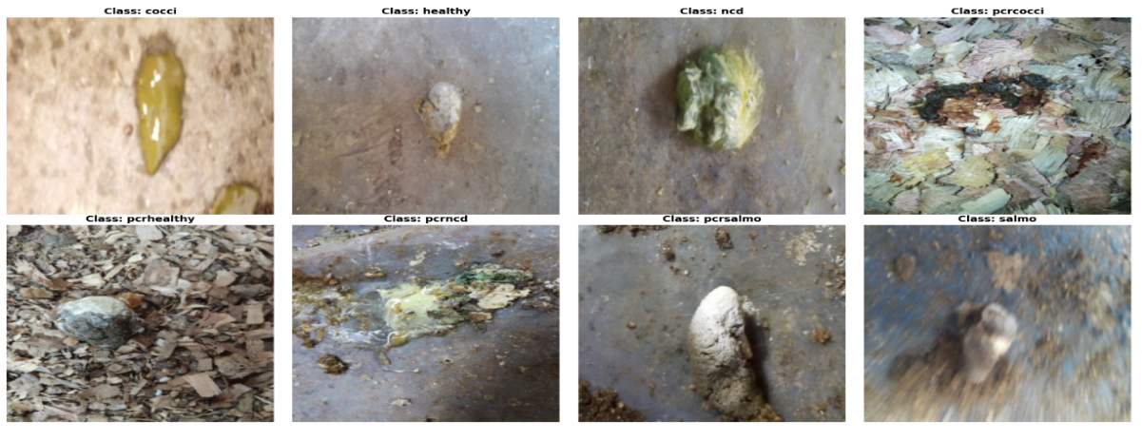
This study utilizes a publicly available poultry disease dataset consisting of annotated fecal images for disease diagnosis. The dataset was originally collected to support small- to medium-scale poultry farmers in disease identification and management. The dataset comprises a total of 8,067 images of poultry fecal matter, captured in real farm environments across the Arusha and Kilimanjaro regions of Tanzania between September 2020 and February 2021. Image acquisition was performed using mobile phones through the Open Data Kit (ODK) application, ensuring a diverse and realistic representation of field conditions, including variations in lighting, background, and image quality[15]. The sample of the images are shown in Figure 2.

Figure 2: Sample Images from the dataset
The dataset is categorized into four distinct classes representing common poultry health conditions: Coccidiosis, Healthy, Newcastle Disease, Salmonella and it’s statistics are shown in Table 1.
Table 1: Image Distribution of each class
Class | Number of Images
Salmonella | 2625
Coccidiosis | 2476
Healthy | 2404
Newcastle Disease | 562
Total | 8067
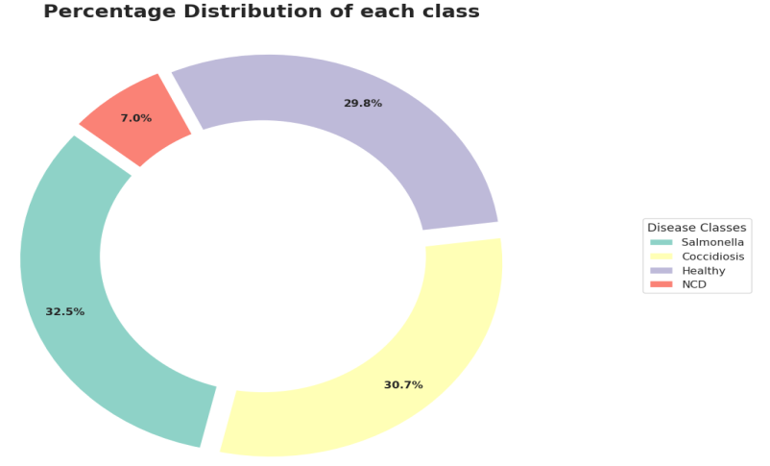
Salmonella constitutes the largest portion of the dataset, with 2,625 images representing approximately 32.5% of the total samples, while Newcastle Disease is the least represented class, with 562 images accounting for about 7%, as illustrated in Figure 3.

Figure 3: Percentage Distribution of each class

3.2 DATASET SPLIT

The dataset was partitioned into 80% training and 20% testing sets using a stratified sampling approach, as illustrated in Figure 4. This ensured that each class was proportionally represented in both subsets, with 80% of samples from each class allocated to the training set and the remaining 20% to the testing set. As a result, the training set comprises 6,452 images, while the testing set contains 1,615 images.

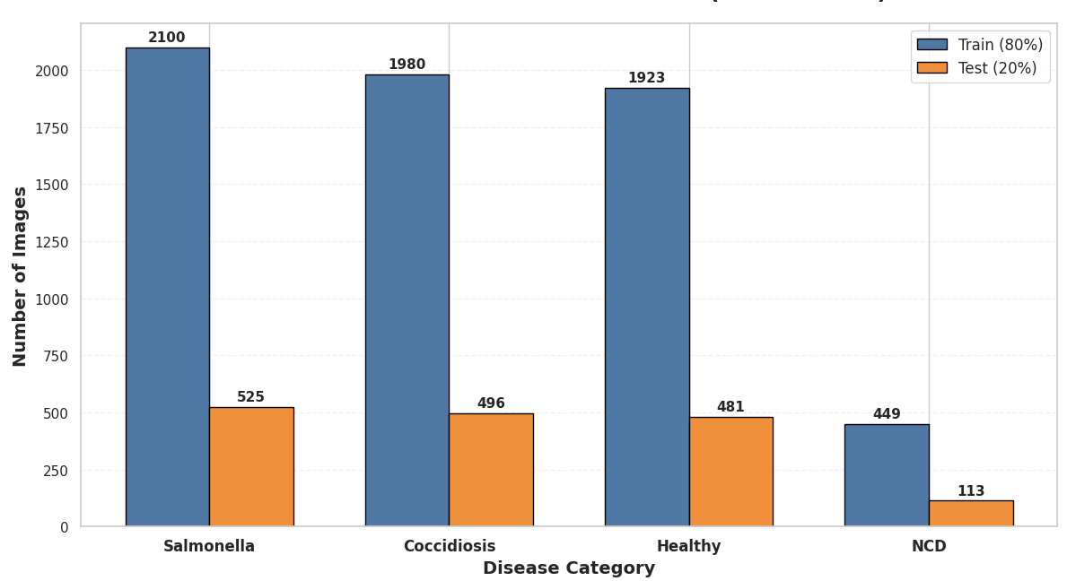

Fig4: Stratified Dataset Split per Class

3.3 DATA AUGMENTATION
To improve model generalization and mitigate overfitting, data augmentation techniques were applied to the training dataset using the PyTorch torchvision.transforms module. These transformations were designed to artificially increase the diversity of the training data by introducing realistic variations in the input images.
First, all images were resized to a fixed dimension of 224 × 224 pixels, ensuring compatibility with standard deep learning architectures and enabling efficient batch processing. During training, a series of stochastic augmentation techniques were applied, including random horizontal flipping with a probability of 0.5 and random rotation within a range of ±15 degrees. These transformations help the model become invariant to orientation and spatial variations commonly encountered in real-world data. Color jittering was employed to introduce variations in brightness and contrast (±20%), thereby improving the model’s robustness to changes in lighting conditions during image acquisition. This is particularly important given that the dataset was collected in uncontrolled farm environments using mobile devices.
After augmentation, images were converted to tensors and normalized using the ImageNet mean and standard deviation values ([0.485, 0.456, 0.406] and [0.229, 0.224, 0.225], respectively). This normalization step ensures that the input data distribution aligns with pretrained models, facilitating faster convergence and improved performance. For the validation dataset, only resizing and normalization were applied, without augmentation, to ensure that model evaluation was performed on unaltered data and reflects true generalization performance.
3.4 MODEL SELECTION
In this study, two state-of-the-art deep learning architectures; ResNet50 and Vision Transformer (ViT) were selected for poultry disease classification. These models were chosen due to their demonstrated effectiveness in image classification tasks and their complementary strengths in feature representation. While convolutional neural networks (CNNs) such as ResNet50 are highly effective at capturing local spatial features, transformer-based models such as ViT excel at modeling global contextual relationships within images [16][17].
The architectural designs of the selected models are presented in Figure 5 (ResNet50) and Figure 6 (Vision Transformer).

3.4.1 RESNET50
ResNet50 is a deep convolutional neural network based on residual learning, which was introduced to address the degradation problem associated with increasing network depth. It is a 50-layer variant of the Residual Network (ResNet) architecture, a deep convolutional neural network (CNN) designed to address the challenges of training very deep models. It comprises 48 convolutional layers, along with one max-pooling layer and one average-pooling layer, as illustrated in Fig. 5. Despite its depth, the model contains over 23 million trainable parameters, enabling it to learn highly discriminative and complex feature representations [18].
The residual learning mechanism allows the network to learn complex mappings by focusing on the difference between input and output features, rather than attempting to learn the transformation directly. This significantly enhances the model’s ability to extract hierarchical features such as edges, textures, and high-level patterns from images. The effectiveness of ResNet-based architectures in image classification tasks has been widely validated across multiple domains, including medical and agricultural applications[16]

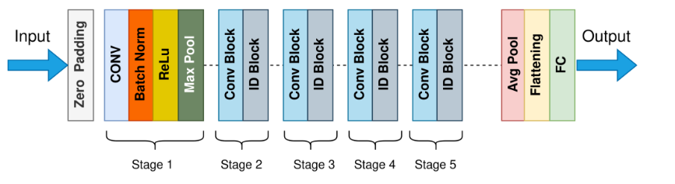

Fig 5: RESNET Architecture

3.4.2 VISION TRANSFORMER
The Vision Transformer (ViT) represents a novel approach to image classification by applying transformer architectures originally designed for natural language processing to visual data. Instead of using convolutional operations, ViT divides an image into fixed-size patches, which are flattened and linearly embedded into a sequence of tokens. These tokens are then processed using transformer encoders with multi-head self-attention mechanisms[17].

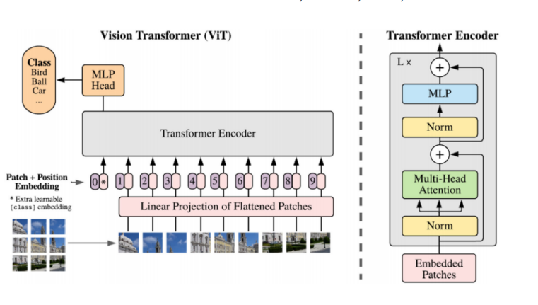

Fig 6: Vision Transformer Architecture
The self-attention mechanism enables the model to capture global dependencies by assigning varying levels of importance to different regions of the image. Positional encodings are incorporated to preserve spatial relationships between patches, allowing the model to maintain structural information [19].
3.5 TRAINING STRATEGY
A robust training strategy was adopted using 5-fold cross-validation, transfer learning, and selective fine-tuning, implemented in PyTorch. The dataset was partitioned into five folds using a shuffled split with a fixed random seed (42) to ensure reproducibility. In each iteration, four folds were used for training while one fold was reserved for validation, providing a reliable and unbiased estimate of model performance.
Both ResNet50 and Vision Transformer (ViT-B/16) were initialized with pretrained ImageNet weights. Initially, all layers were frozen to retain learned feature representations, and the final classification layers were replaced to match the four target classes. To further enhance performance, selective fine-tuning was applied by unfreezing the last two layers of ResNet50 and the last two encoder blocks of the Vision Transformer, enabling the models to adapt high-level features to the poultry disease dataset while preserving low-level pretrained representations.
Training was conducted for 20 epochs per fold using a mini-batch size of 32, with data loaded via PyTorch DataLoader, where training batches were shuffled to enhance learning. The models were optimized using the Adam optimizer with a learning rate of 1 × 10⁻⁴, and the Cross-Entropy Loss function was employed for the multi-class classification task.

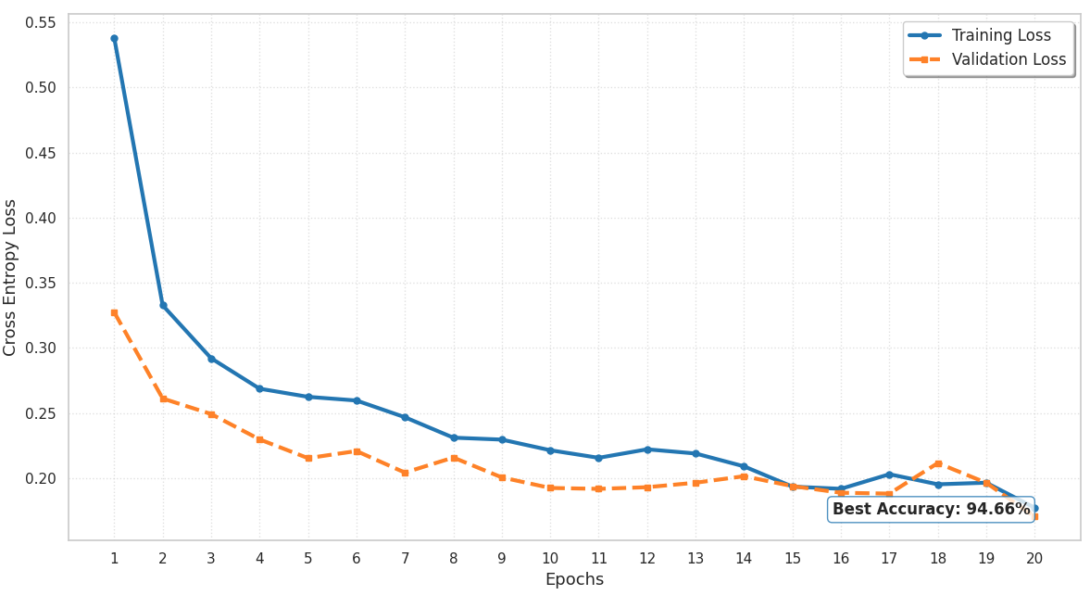

Fig 7: Learning Curve for the best performing fold in ResNET50
During each epoch, the models were trained on the training subset and evaluated on the validation subset. Key performance metrics, including training loss, validation loss, and validation accuracy, were recorded for each fold. To ensure optimal model selection, a checkpointing strategy was implemented, where the model achieving the highest validation accuracy across all folds was saved. The learning curve corresponding to the best-performing fold (achieved in Fold 2-epoch 20) during the training of ResNet50 is presented in Figure 7, while the learning curve for the best-performing fold(achieved in Fold 1-epoch 20) during the training of the Vision Transformer (ViT) is illustrated in Figure 8.
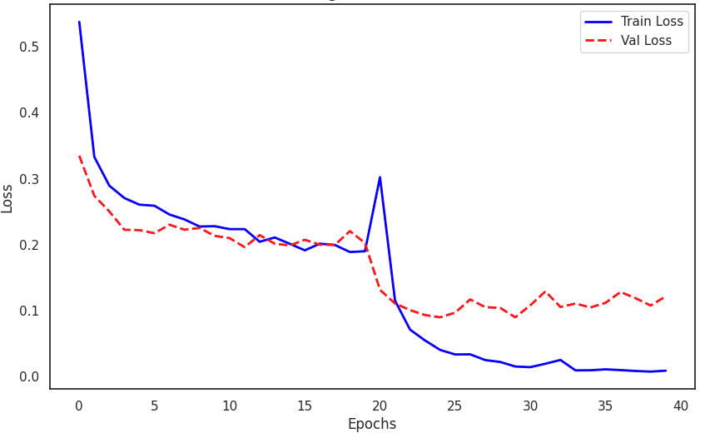

Fig 8: Learning Curve for the best performing Fold in VIT
All experiments were conducted using GPU acceleration (NVIDIA T4 ×2) on the Kaggle platform, enabling efficient training of deep architectures.

3.6 EVALUATION METRICS
This study evaluated model performance using five primary metrics: Accuracy, Precision, Recall, F1 Score, and the Confusion Matrix. The definitions and mathematical formulations of these metrics are summarized in Table 2. All of them are based on four fundamental classification outcomes: True Positives (TP), False Positives (FP), True Negatives (TN), and False Negatives (FN). A True Positive indicates a correctly identified positive instance, whereas a False Positive occurs when a negative sample is incorrectly labeled as positive. In contrast, a True Negative represents a correctly classified negative case, while a False Negative refers to a positive instance that the model fails to detect, mistakenly classifying it as negative instead[20].

Table 2: Evaluation Metrics and it’s equation
SN | Metrics | Equation
1 | Accuracy | (TP+TN)/(TP+TN+FP+FN)
2 | Precision | TP/(TP+FP)
3 | Recall | TP/(TP+FN)
4 | F1-Score | (2*(Precision*Recall)/(Precision+Recall)
5 | Confusion Metrics

4. results and discussion

4.1 OVERALL PERFORMANCE ANALYSIS
The performance of the ResNet50 and Vision Transformer (ViT) models was evaluated on a multiclass poultry disease dataset. The results, summarized in Table 3, show that both models achieved high classification performance, with ViT outperforming ResNet50 across all evaluation metrics.
Table 3: Performance of our proposed models
Model | Accuracy | F1-Score | Recall | Precision
FalanfaResNet | 94.49% | 0.94 | 0.94 | 0.94
FalanfaVIT | 96.16% | 0.96 | 0.95 | 0.96

As presented in Table 3, the Vision Transformer achieved an accuracy of 96.16%, compared to 94.49% for ResNet50. Similarly, ViT recorded higher values in F1-score (0.96 vs. 0.94), precision (0.96 vs. 0.94), and recall (0.95 vs. 0.94).
This consistent improvement across all metrics indicates that ViT provides a more balanced and reliable classification performance. Unlike accuracy alone, the F1-score reflects the trade-off between precision and recall, suggesting that ViT is better at minimizing both false positives and false negatives.
The superior performance of ViT can be attributed to its self-attention mechanism, which captures global dependencies within images. In contrast, ResNet50 relies on convolutional operations that primarily extract local features, which may limit its ability to distinguish visually similar disease patterns.
4.2 CONFUSION MATRIX ANALYSIS

The confusion matrices shown in Figure 9 (ResNet50) and Figure 10 (ViT) provide a detailed class-wise evaluation of model performance.
From Figure 9, ResNet50 demonstrates strong classification capability across most classes, particularly for Healthy and Salmonella samples. However, the model shows noticeable confusion in distinguishing Newcastle Disease (NCD) from other disease classes. This is reflected in its relatively lower recall of 0.85 for NCD, indicating that some infected samples are misclassified.

This limitation arises because CNN-based models like ResNet50 focus on localized texture patterns, which may not be sufficiently distinctive for diseases with subtle visual differences.

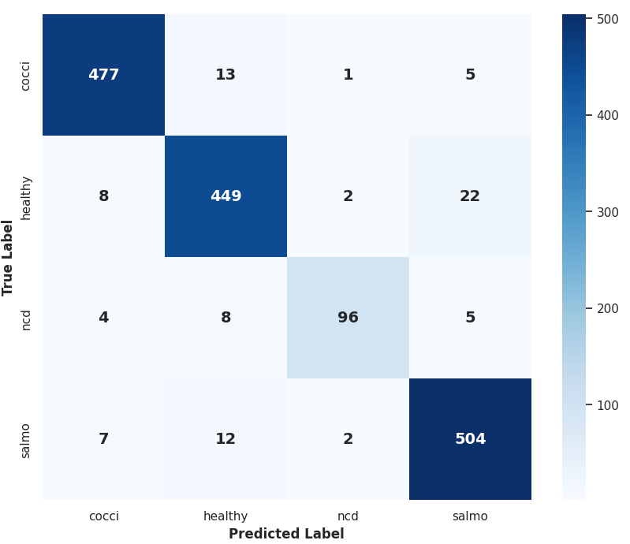

Fig 9: Confusion Matrix for ResNet50
In contrast, Figure 10 shows that the ViT model significantly reduces misclassification across all classes. The improvement is especially evident in the Newcastle Disease category, where recall increases to 0.91. This represents a 6% improvement over ResNet50.
The enhanced performance of ViT is due to its ability to model long-range dependencies and analyze the entire image context simultaneously. This allows it to better capture complex and distributed visual cues associated with disease symptoms.

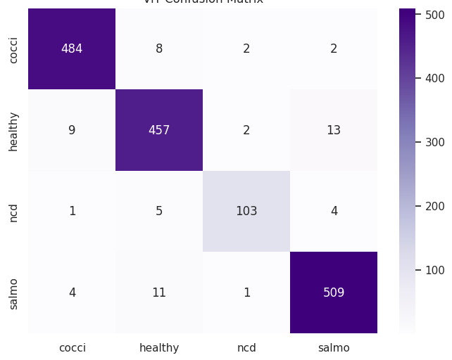

Fig 10: Confusion Matrix for VIT

As shown earlier in Table 1 and Figure 3, the dataset is imbalanced, with Newcastle Disease representing only about 7% of the total samples. Such imbalance typically leads to poor model performance on minority classes.
Despite this challenge, the ViT model demonstrates strong robustness by achieving higher recall for the minority class. This suggests that the model is less biased toward majority classes and can generalize better in real-world scenarios where disease occurrence is unevenly distributed. The use of data augmentation and stratified sampling also contributed to mitigating the effects of class imbalance, ensuring that all classes were adequately represented during training.

4.3 LEARNING CURVE
The learning curves presented in Figure 7 (ResNet50) and Figure 8 (ViT) illustrate the training and validation performance over epochs.
For ResNet50, the training and validation curves converge steadily, indicating stable learning. However, a slight gap between training and validation performance suggests mild overfitting.
In contrast, the ViT learning curve shows faster convergence and better alignment between training and validation metrics. This indicates improved generalization and a more efficient learning process. The use of transfer learning and selective fine-tuning played a crucial role in stabilizing training and preventing overfitting, particularly for the deeper ViT architecture.

4.4 COMPARISON WITH EXISTING MODELS

When compared with existing models such as InceptionV3 and ChicNetV6 (Table 4), the proposed FalanafaViT model achieves the highest overall performance.
Table 4: Chicken Disease Classification Comparison
Source | Model | Accuracy | F1-Score | Recall | Precision
Our study | FalanfaResNet | 94.49% | 0.94 | 0.94 | 0.94
Our study | FalanfaVIT | 96.16% | 0.96 | 0.95 | 0.96
Ahsan et. al[11] | InceptionV3 | 94.49% | 0.74 | 0.83 | 0.88
Gourisaria et al[9] | ChicNetV6 | 94.46% | 0.79 | 0.85 | 0.91

Although some prior models report similar accuracy levels (~94%), their F1-scores are significantly lower, indicating poor balance across classes. For example, ChicNetV6 achieves an F1-score of 0.79, which is substantially lower than the 0.96 achieved by ViT in this study.
High accuracy alone is not sufficient for a reliable diagnostic system, as models may perform well on dominant classes while failing on critical minority classes. Therefore, balanced metrics like F1-score and recall are essential. The results also suggest that traditional CNN-based models tend to plateau around 94% accuracy, likely due to their focus on local features. In contrast, the Vision Transformer (ViT) surpasses this limit by capturing global contextual relationships, making it more effective for complex image classification tasks.

The improved performance of ViT has important practical implications, including more accurate detection of diseases especially minority classes like Newcastle Disease reduced misdiagnosis, and suitability for real-time automated monitoring. Overall, transformer-based models are better suited for precision agriculture, where detecting subtle visual differences is crucial.
5. Conclusion

This study demonstrates the high effectiveness of deep learning, specifically the Vision Transformer (ViT) and ResNet50, in the automated classification of poultry diseases from fecal images. Our findings reveal that the ViT model significantly outperforms traditional CNN-based architectures, achieving a peak accuracy of 96.16% and a balanced F1-score of 0.96. Through comparative analysis, it was observed that the self-attention mechanism in ViT is more adept at capturing global contextual features, which led to a 6% improvement in detecting the challenging Newcastle Disease (NCD) class compared to ResNet50. Furthermore, our models demonstrated superior balance across metrics (F1-score) when compared to established benchmarks in literature, such as ChicNetV6 and InceptionV3. In conclusion, the transition from convolutional to transformer-based architectures provides a more reliable and scalable solution for early disease detection in the poultry industry, potentially reducing economic losses and improving farm management through accurate, automated diagnostics.

6. LIMITATIONS AND FUTURE RESEARCH DIRECTIONS
6.1 Limitations
Dataset Constraints
While this study utilized 8,067 annotated fecal images, the dataset was collected exclusively from the Arusha and Kilimanjaro regions of Tanzania over a six-month period. This geographic and temporal restriction limits the generalizability of the trained models to poultry farms in other climatic regions, breeds, or production systems. Furthermore, the significant class imbalance with Newcastle Disease representing only approximately 7% of total samples (562 images) compared to Salmonella at 32.5% (2,625 images) poses an inherent challenge. Although stratified sampling and data augmentation were applied to mitigate this, the minority class remains underrepresented, and the risk of residual bias in model predictions cannot be fully eliminated with augmentation alone. More sophisticated resampling strategies such as SMOTE or class-conditional generative augmentation were not explored in this work.
Scope of Disease Classes
The classification framework is restricted to four disease categories: Coccidiosis, Healthy, Newcastle Disease, and Salmonella. In practice, poultry farms encounter a broader spectrum of conditions, including Avian Influenza, Infectious Bronchitis, Marek's Disease, and nutritional deficiencies, many of which may produce visually similar fecal presentations. The model's inability to distinguish these additional classes limits its deployment readiness in real clinical or farm settings.
Model Interpretability
Although ViT's self-attention mechanism inherently provides some degree of spatial attention weighting, this study did not formally integrate explainability methods such as Integrated Gradients, GradCAM, or attention rollout visualization. Without such tools, veterinarians and farm operators cannot verify which image regions drove a particular prediction, reducing the trust and transparency required for responsible AI-assisted diagnosis.

Computational Requirements
The Vision Transformer (ViT-B/16), while achieving superior accuracy, is computationally heavier than CNN-based alternatives. Training required dual NVIDIA T4 GPU acceleration on the Kaggle platform. This hardware dependency may restrict real-world deployment in resource-constrained environments, particularly among the small- to medium-scale poultry farmers the dataset was originally designed to support.
6.2 Future Research Directions

Expanding and Diversifying the Dataset

Future studies should aim to compile larger, more geographically diverse datasets spanning multiple countries, farm scales, poultry breeds, and seasons. Collaboration with agricultural institutions and veterinary bodies across Sub-Saharan Africa, Southeast Asia, and other high-density poultry production regions would contribute to models with stronger cross-environment generalizability. In parallel, federated learning approaches could enable multi-farm data aggregation while preserving data privacy, without requiring centralized data collection.

Addressing Class Imbalance with Generative Methods

Beyond standard augmentation, future work should investigate the use of Generative Adversarial Networks (GANs) or Diffusion Models to synthesize realistic minority-class fecal images, particularly for Newcastle Disease. Such synthetic data generation could substantially enrich underrepresented classes and reduce diagnostic bias without requiring additional data collection.

Expanding Disease Coverage

The classification framework should be extended to cover a broader range of poultry diseases, including Avian Influenza, Infectious Bursal Disease (Gumboro), and Marek's Disease. This would require curating multi-disease annotated datasets and potentially redesigning the classification head to accommodate hierarchical or open-set recognition scenarios, where the model can flag unfamiliar disease presentations rather than forcing them into known categories.

COMPETING INTERESTS DISCLAIMER:
Authors have declared that they have no known competing financial interests OR non-financial interests OR personal relationships that could have appeared to influence the work reported in this paper.
Disclaimer (Artificial intelligence)
Author(s) hereby declare that NO generative AI technologies such as Large Language Models (ChatGPT, COPILOT, etc.) and text-to-image generators have been used during the writing or editing of this manuscript.

References

[1] Srivastava, K., & Pandey, P. (2023). Deep learning based classification of poultry disease. International Journal of Automation and Smart Technology, 13(1), 2439-2439.

[2] Babatunde, A. O., Oladipo, I. D., Ajagbe, S. A., Akanmu, M. A., Akinpelu, S. A., Bankale, M. I., ... & Mudali, P. (2025). Analysis of deep learning algorithm for predicting poultry diseases. Discover Data, 3(1), 44.

[3] Dhungana, A., Yang, X., Paneru, B., Dahal, S., Lu, G., & Chai, L. (2025). An Integrated Deep Learning Approach for Poultry Disease Detection and Classification Based on Analysis of Chicken Manure Images. AgriEngineering, 7(9), 278.

[4] Barsagade, A. G., Ajalkar, D., & Rumale, A. S. (2024). Mathematical formulation of deep learning model for poultry disease classification using efficientnet-b3 cnn model. Communications on Applied Nonlinear Analysis, 31(2s), 470-484.

[5] Luong, H. H., & Nguyen, T. M. (2024). Improving Chicken Disease Classification Based on Vision Transformer and Combine with Integrated Gradients Explanation. International Journal of Advanced Computer Science & Applications, 15(4).

[6] Luo, Y., Chen, Y., & Majeed, A. P. A. (2025). Optimizing poultry disease classification: A feature-based transfer learning approach. Smart Agricultural Technology, 10, 100856.

[7] Mbelwa, H., Mbelwa, J., & Machuve, D. (2021). Deep convolutional neural network for chicken diseases detection. International Journal of Advanced Computer Science and Applications, 12(2).

[8] Machuve, D., Nwankwo, E., Mduma, N., & Mbelwa, J. (2022). Poultry diseases diagnostics models using deep learning. Frontiers in Artificial Intelligence, 5, 733345.

[9] Gourisaria, M. K., Arora, A., Bilgaiyan, S., & Sahni, M. (2023, May). Chicken disease multiclass classification using deep learning. In Proceedings of International Conference on Information Technology and Applications: ICITA 2022 (pp. 225-238). Singapore: Springer Nature Singapore.

[10] Srivastava, K., & Pandey, P. (2023). Deep learning based classification of poultry disease. International Journal of Automation and Smart Technology, 13(1), 2439-2439.

[11] Ahsan, M. S., & Ariatmanto, D. (2023). Chicken disease classification based on inception v3 algorithm for data imbalance. Sinkron: jurnal dan penelitian teknik informatika, 7(3), 1875-1882.

[12] Vandana, K. K. Y., & Yadav, S. P. (2024). Chicken diseases detection and classification based on fecal images using efficientnetb7 model. Evergreen, 11(1), 314-330.

[13] Al Qatrawi, M., & Abu-Naser, S. S. (2024). Classification of chicken diseases using deep learning.

[14] Joseph, S. (2023). Automating poultry disease detection using deep learning. Journal of Soft Computing Paradigm, 5(4), 378-389.

[15] https://www.kaggle.com/datasets/allandclive/chicken-disease-1

[16] He, K., Zhang, X., Ren, S., & Sun, J. (2016). Deep residual learning for image recognition. In Proceedings of the IEEE conference on computer vision and pattern recognition (pp. 770-778).

[17] Dosovitskiy, A., Beyer, L., Kolesnikov, A., Weissenborn, D., Zhai, X., Unterthiner, T., ... & Houlsby, N. (2020). An image is worth 16x16 words: Transformers for image recognition at scale. arXiv preprint arXiv:2010.11929.

[18] Mbonu, C. E., Anigbogu, K., Asogwa, D., & Belonwu, T. (2025). An explorative analysis of svm classifier and resnet50 architecture on african food classification. arXiv preprint arXiv:2505.13923.

[19] Amangeldi, A., Taigonyrov, A., Jawad, M. H., & Mbonu, C. E. (2025). CNN and ViT efficiency study on tiny ImageNet and DermaMNIST datasets. arXiv preprint arXiv:2505.08259.

[20] Onyedinma, E. G., Asogwa, D. C., Belonwu, T. S., & Mbonu, C. E. (2025). A Multi-Algorithmic Approach to Stroke Risk Prediction Using Machine Learning. Journal of Engineering Research and Reports, 27(7), 247-259.

