A Novel Bandwidth Maximization-Based Approach to Call Admission Control for Real-Time Application in 3GPP LTE Networks

ABSTRACT
The continuous growth in the number of users of various communication networks, either wired or wireless, Real-Time (RT) or Non Real-Time (NRT); available network resources are always limited and so not enough for more request in addition to already existing calls. This goes on to leave so many call requests being rejected, dropped or delayed and so on thereby degrading the Quality of Service (QoS) experienced by users. Intensive effort to solve the problem of limited network resources have been done although with a common deficiency of time and bandwidth wastage in the existing Call Admission Control (CAC) schemes. This study proposes a novel model of call admission control schemes for real-time applications in 3rd Generation Partnership Program (3GPP) long term evolution (LTE) networks known as Bandwidth Maximization (BWM) CAC scheme, carried out with the aid of MATLAB R2020a, HP ProBook 6550b series, and LTE Network Data Logs amongst other materials. The performance of the proposed CAC scheme along various network parameters such as Bandwidth utilization, Blocking probability, Forced call termination and Handoff Call Dropping Probability (HCDP) were realized with the following as results: Blocking probability; 0%; Bandwidth Utilization; 76%; Forced Call termination; 2%; HCDP; 0.04%. The study concludes that the BWM-CAC scheme offers a more reliable and efficient solution for improving network performance in LTE systems Researchers recommend integration of Artificial Intelligence (AI) and Machine Learning (ML) in CAC mechanisms.
Keywords: Call Admission Control (CAC) scheme, Quality of Service (QoS), 3GPP LTE, bandwidth utilization, blocking probability, MATLAB
1. INTRODUCTION
Back in the days when children use to play call games, where the top of two empty tins of small metal containers are tied to a wire of over one meter long and without shouting, they both can hear each other speak through the open end of the metal containers in an analog to analog communication system. In light of this, the first telephones were connected directly in pairs from one customer’s office or residence to the other (Defense, 2017). This in no distant time became inconvenient as users want to communicate with others whom they are not directly connected to and so this system was then replaced by a manually operated centrally located switchboards which was initially manually operated by an attendant popularly known as the switchboard attendant (Bo, 2002). When a customer makes a call across, the attendant asks for possible destination and makes the connection while also dropping their headphones to complete the connection. Longer distance calls especially within a region or country were made possible through other switchboard stations. Until the 1970s, most telephones in customers residence or offices were permanently wired to the telephone line and so to allow more portability, the inside wiring was terminated to give rise to installation of jacks in various locations so that when a customer wants to dial a number, the exchange center examines the dialed telephone number and makes the proper connection. Most exchanges in the world are interconnected through a larger switching systems which forms the public switched telephone network (PSTN) (Bo, 2002).
Wireless communication has enjoyed quite a significant growth in the past decade and its devices has so much become an important part of our being (Ahmad & Habibi, 2013). The number of users using the wireless cellular networks are ever increasing today compared to the past decade and in our daily life, wireless devices have become an integral part of it; but the bandwidth to contain it all is limited due to heavy traffic and constant demands by customers (Raja & Louis, 2021; Ahmad & Habibi, 2013). During congestion period of the network bandwidth, resource availability begins to fluctuate thereby affecting its quality of Service, which brings about the mandatory need for call admission control scheme to manage the scarce resource (Emmadi & Venkatesh, 2014).
The primary objective of this study is to develop a mathematical model and analytical framework for the design and evaluation of a novel Call Admission Control (CAC) scheme, termed Bandwidth Maximization CAC (BWM-CAC), for real-time applications in Long Term Evolution networks. The study further aims to simulate the proposed CAC scheme for voice and video services under real-time traffic conditions, taking into account key network performance metrics such as latency, throughput, and bandwidth utilization over time. In addition, this research seeks to assess the effectiveness of the proposed scheme in optimizing resource allocation and utilization while maintaining stable network performance under varying traffic loads. Particular emphasis is placed on minimizing call blocking probability, reducing forced call termination, and ensuring reliable connectivity for delay-sensitive applications. The outcomes of this study are intended to contribute to the efficient design and operation of LTE networks deployed by service providers. By enhancing resource management strategies, the proposed BWM-CAC scheme is expected to improve overall system throughput, reduce network congestion, and deliver improved Quality of Service (QoS), thereby enhancing user experience and maximizing the utilization of limited network resources.
Call Admission Control (CAC) is therefore a scheme which manages oversubscription to a network and with respect to this research work which is heterogeneous in nature for both real and Non-Real-Time calls. The practical steps for call admission is as thus; Request initiation, resource measurement (i.e. required by incoming call and network availability), admission decision (i.e. to accept or to reject), (as shown in the flowchart of this model CAC, handoff calls are prioritized over new call and so special arrangements are made for them) and lastly in the process, final decisions are made with regards accepting or rejecting after the checks (Mamman, 2021). A practical challenge faced by CAC schemes is in trying to balance high network utilization as well as maintaining a good QoS.
Furthermore, the research through its Mathematical modeling, simulations analysis can enable researchers or companies easily note which CAC scheme is preferable for their plans with respect to the various metrics of call blocking, throughput, Bandwidth utilization, forced call termination and Handoff Call Dropping probability (HCDP). The findings herein has the capacity to serve as a reference for further studies especially with inclinations to Fifth Generation (5G) and Artificial Intelligence (AI) enabled CAC schemes.
2.0 LITERATURE
2.1 Quality of Service (QoS)
The performance level of a service offered by a network provider to its customers or users is known as its Quality of Service (Reddy et al., 2006), it is an internetworking issue which describes a networks capability to provide a quality service, to manage traffic and to reduce packet loss and delays using a set of techniques and mechanisms that ensures the performance of the network to deliver good and predictable service according to already stated conditions to an application program (Muayad, 2018). To give better services, QoS deals with the following parameters as its guiding attributes, these includes reliability or packet loss, delay or latency, jitter and bandwith (Reddy et al., 2006; Ghaderi & Boutaba, 2006; Muayad, 2018; Felisac, 2021). The overall quality of the network connection depends on these four and they also often influence one another, because a change in one impacts the other which in the long run affects the entire network (Kentik, 2024). A service or network provider after accepting a service request has to make sure that the requirements (as per agreement) needed for its smooth execution to the end is available. For a reliable delivery of data packets, a reliable and high quality of service is required. Some of the techniques required to achieve this includes scheduling, admission control, traffic shaping and resource control (Bhanu, 2021; Brainkart, 2024).
To manage discarded packets to maintain high CAC, the researcher suggests that rather than getting discarded and lost, they can be sent back to the classifier in the case of priority queuing or weighted fair queuing for reclassifications and back to the sender from that point for FIFO queuing for resending. All these is in a bit to save more time; because rather than waiting on feedback and resend request from the receiver, the sender gets that notification from within the sending process thereby making necessary amends even before the intended recipient becomes aware. To manage priority method without having too much delay for lower priority, the researcher suggests that time for processing should be rationed between a more prioritized package and others. For instance, a ratio of 3:1 can be applied so that after 3 priority package has been processed, 1 less priority package can be processed so as to manage the disadvantage of this method.
2.2 Call Admission Control (CAC) Schemes
In recent times, the number of users of wireless cellular networks are on the increase and when compared to the resources needed for smooth flow such as bandwidth, it is found to be limited (Hou, Yang & Papavassiliou, 2002). Therefore, it becomes paramount that efficient use of available resources is ensured, because it can lead to voice quality degradation when too many calls are active at a point in time on a link whose bandwidth is oversubscribed (Cisco, 2024). To avoid congestion in any type of networks the mechanism of the CAC is used (Belghith, Mohamed & Obaidat, 2016; Lei et al., 2008), depending on the system, CAC limits the number of connections in the system when needed. Just like with the uncertainty principle from the Nobel laureate Werner Heisenberg in 1972, the bandwidth and QoS requirements cannot be simultaneously satisfied at the same time. CAC decreases network overcrowding effects by regulating and managing the amount of new call request into the wireless network. It also goes on to balance the rate of call dropping and call blocking (Ahmed, 2005; Wang et al., 2011). CAC plays an important role in ensuring a good QoS for an existing call and for incoming call (Nadembega, Hafid & Taleb, 2014; Tarek & Nidal, 2009). To ensure continuity of service even while the user is in motion, calls are handed over to other Base Stations (BS) or cells, however, if in the new BS or cells there isn’t enough bandwidth or support to continue the call it gets dropped. The probability of a handoff failure is named call dropping probability (Fang & Zhang, 2002).
From the user or customer point of view, dropping an existing call due to inadequate resource is much more exasperating than blocking new calls. To preserve the ultimate satisfaction of a user in progress, BWM-CAC deals separately, handoff calls and new call request and higher value is placed on a user in progress than a new incoming call. According to Khabazian, Kubbar and Hassanein, (2012) and Zhang et al. (2001), the reservation schemes of bandwidth is used to safeguard handoff calls. In denying a request for a new call by a BS is another way of reducing call dropping effects, but it also invariably increases call blocking probability (Yilmaz & Chen, 2009) a dilemma network provider have to balance off.
The existing CAC scheme proposed by previous researchers suffers from bandwidth and time wastage. For example Hassanein et al. (2006) worked on QoS-aware Call Admission Control (QA-CAC) scheme, where existing RT & NRT calls are degraded to admit any call request. However, their approach allocates maximum BW for both RT and NRT calls. Wang and Qui (2013) worked on Multi-Service Call Admission Control (MS-CAC), where the BW is divided into four sub-channels: NRT, RT, VoIP and Video calls and RT calls having a bad channel has a preemptive right over the channel of the NRT. This, cause a disadvantage to the reserved channel for NRT calls. Also, reserved BW that may not be in use. Zarai et al. (2014) worked on Adaptive Call Admission Control (ACAC) with BW reservation, where existing RT calls are degraded to their minimum workable BW to admit NRT call request and New RT calls are out rightly rejected when BW is not enough. However, it admits RT calls with maximum allowed BW. Umar et al. (2021) worked on Enhanced Adaptive Call Admission Control (EA-CAC) with BW reservation, where existing NRT calls are first degraded to admit any call request. If not enough then RT calls are degraded and before RT calls are degraded a scouting check is made. However, the system admits RT and NRT with maximum allowed BW.
The proposed CAC “Bandwidth maximization” (BWM-CAC) is such that incoming calls are allotted the minimum amount of workable BW so that when a new call comes in, if there is enough BW to accommodate it, it is admitted immediately or otherwise rejected immediately; no need for the system to go round (like with highlighted and existing CACs) within itself in search of possible existing calls that were allotted maximum BW initially so as to degrade them and salvage some extra BW, which it now adds to available pool, then checks if it would be enough to admit the new call request. A process which takes time and wastes BW.
3. MATERIALS AND METHODS
3.1 Materials
The materials used for the study and their description are presented in Table1.
Table 1: List of Materials and Resources
S/N | Material | Description
1 | MATLAB R2020a | Software for mathematical modeling and simulation
2 | HP ProBook 6550b Series | Laptop used for simulations and data analysis
3 | LTE Network Data Logs | LTE Network Data Logs
4 | Performance Monitoring Tools | Tools for measuring network latency, jitter, packet loss, and bandwidth
5 | Network Simulation Framework | Framework for simulating LTE network scenarios

3.2 Methods
3.2.1 Modeling Parameters
To enhance the realism of the model CAC scheme, the variability of traffic across time and regions was incorporated to include low, moderate and peak traffic periods which represents regions such as Rural, suburban and urban respectively. The mathematical model captures the arrival processes, resource allocation, blocking probabilities, and utilization. In the arrival processes, both the New Calls (NC) and the Handoff Calls (HC) arrive according to Poisson processes. For NC, the call rate is mathematically represented as:
$λNC=\left.\begin{aligned}1 call/\min{(low traffic)} \\ 3 calls/\min{(moderate traffic)} \\ 8 calls/\min{(peak traffic)}\end{aligned}\right\}$ (1)
Which is consistent with typical cellular network.
While the HC, is mathematically represented as:
$λHC=1 Calls Per Minute$ (2)
Each call is classified as voice (70%) or video (30%). The bandwidth for each call type varies around a base value (voice: 0.45 ±20%, video: 1.25 ±20%). The Poisson process assumption reflects real-world randomness in user call behavior.
3.2.2 Resource Allocation
The total bandwidth is split into reserved (20 Mbps for HC) and general (80 Mbps for NC). The hand over calls (HC) can use both reserved bandwidths (in occasion of insufficient HC reserve) and the new calls (NC), the general reserve only. The availability of BW determines whether or not calls are accepted or blocked. Also, other features are as follows:
Holding Time: Calls have durations uniformly distributed between 15-45 minutes. So, the service time is a random variable T ~ Uniform (15-45).
Blocking Probability: For NC calls, if the sum of active NC calls' bandwidth exceeds the general pool, they're blocked. Similarly, for HC in the reserved pool and the general pool if any.
Utilization: The total bandwidth used over time, which would be the sum of all active calls' bandwidth at each minute.
The Erlang model assumes fixed bandwidth per call. Here, since bandwidth varies, the model is more complicated. Perhaps an approximation using the Erlang formula with effective bandwidth might be possible, but exact analytical solutions are difficult. Therefore, the simulation approach in the code is then the most appropriate. The study adopts the framework of LTE networks, where radio resources are allocated in terms of Resource Blocks (RBs). A system bandwidth of 100MHz was considered which corresponds to 500RBs. Depending on the service type, each call request consumes specific bandwidth and admission decision are made based on that.
3.2.3 Bandwidth Requirements
Each call type consumes a certain amount of bandwidth, assuming that the allocated bandwidth for a call is determined by multiplying a base value by a random factor X that is uniformly distributed between 0.8 and 1.2. That is,
$BW=Base value x X$ (3)
3.2.4 Expected Bandwidth per Call
For voice and video calls:
$E\left({BW}_{voice}\right)=\frac{{BW}_{voice} \left(min\right)+{BW}_{voice}(max) }{2}$ (4)
$E\left({BW}_{video}\right)=\frac{{BW}_{video} \left(min\right)+{BW}_{video}(max) }{2}$ (5)
Where: $E\left(BW\right)$ is the expected bandwidth for NC pool, $BW\left(min\right)$ is the minimum allocated bandwidth for calls and $BW(max)$ is the maximum allocated bandwidth for calls.
3.2.5 Calls Blocking Probability
Blocking probability measures the likelihood that a call is rejected due to insufficient available bandwidth. It reflects how efficiently the network handles call requests. The simulated parameters are:
General probability of call blocking $=\frac{Blocked calls}{Total arrival}$ (6)
For NC arrivals
$P_{b, NC}=\frac{Blocked NC Calls}{Total NC Arrivals }$ (7)
For HC arrivals
$P_{b, HC}=\frac{Blocked HC Calls}{Total HC Arrivals }$ (8)
Acceptance Probability: The acceptance probability is the ratio of accepted calls to total call arrivals.
$P_{b, NC}=\frac{Accepted NC Calls}{Total NC Arrivals }$ (9)
$P_{b, NC}=\frac{Accepted HC Calls}{Total HC Arrivals }$ (10)
3.2.6 Total Arrivals
This presents a detailed breakdown of the total number of call arrivals, accepted calls, and blocked calls during the simulation. The system handles two types of calls: NC and HC. The total number of call arrivals is the sum of both NC and HC arrivals over the simulation period. Similarly, the total number of accepted and blocked calls is computed based on the individual acceptance and blocking of NC and HC calls.
$Total Arrivals =Total NC Arrival+Total HC Arrivals$ (11)
3.2.7 Latency
This is a critical metric in networking, telecommunications, and computing, impacting the performance and user experience of real-time applications like video calls. Total latency for a call is represented mathematically as:
$L_{total}=L_{prop}+L_{trans}+L_{queue}+L_{proc}$ (12)
where $L_{prop}$ is the Propagation Delay, $L_{trans}$ is the Transmission Delay, $L_{queue}$ is the queuing process and $L_{proc}$ is the processing delay
$L_{prop} =\frac{Distnace }{Propagation Speed}x 1000 (ms)$ (13)
$L_{trans}=\frac{Packet Size }{Allocated Bandwidth}x 1000 (ms)$ (14)
3.2.8 Expected Bandwidth Utilization
Expected Bandwidth utilization measures the average bandwidth occupied by successful calls over the simulation period. It reflects how well the network resources are utilized.
For New Call (NC) Pool Utilization:
$U_{nc}=λ_{nc}\left(1-{Pb}_{nc}\right) x E\left[{BW}_{nc}\right] x E\left[T\right]$ (15)
For Handoff Call (HC) Pool Utilization:
$U_{hc}=λ_{hc}\left(1-{Pb}_{hc}\right) x E\left[{BW}_{hc}\right] x E\left[T\right]$ (16)
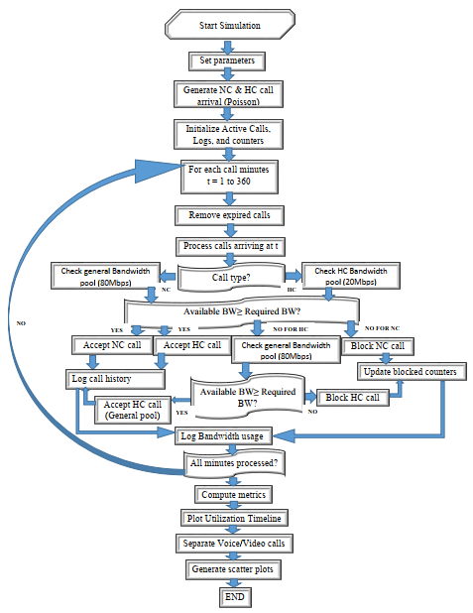
Fig. 1: Flowchart for Bandwidth Maximization CAC in LTE Networks
The CAC scheme also includes a mechanism for dynamically adjusting bandwidth allocation based on real-time traffic patterns. If HC traffic is low, unused reserved bandwidth can be temporarily released to support NC traffic, improving overall resource utilization. Similarly, if HC traffic increases, the system can reclaim the reserved bandwidth to accommodate the handoff requests. This dynamic allocation helps maximize network efficiency while maintaining a high QoS standard as well as maximizing the scarce commodity of BW and time as compared to previous CAC schemes.
4. RESULTS AND DISCUSSION
The expected bandwidth per call following equations (3) to (5), is presented in Table 2
Table 2: Expected bandwidth per call
Expected Bandwidth Per Call | Base Mbps | X | BW (min) Mbps | X | BW (max)
Voice Call | 0.45 | 0.8 | 0.36 | 1.2 | 0.54
Video Call | 1.25 | 0.8 | 1.00 | 1.2 | 1.50

Voice Call Bandwidth follows a uniform distribution between 0.36 Mbps and 0.54 Mbps. Video Call Bandwidth follows a uniform distribution between 1.0 Mbps and 1.5 Mbps.
These values reflect variations in call quality, codec efficiency, and network conditions. We choose X to vary between 0.8 and 1.2 to simulate a ±20% variation around the base bandwidth value. In other words, multiplying the base bandwidth by a factor uniformly drawn from [0.8 - 1.2] means that the allocated bandwidth for each call can be up to 20% lower or 20% higher than the base value. This models variability is due to changing network conditions, user behavior, and other uncertainties in real-life scenarios.
4.1 Simulation of Call Admission Control
Figure 2 shows the available bandwidth over time for a call admission control (CAC) simulation in a 3GPP LTE network. The simulation models how bandwidth is allocated and managed for two types of calls: new calls and handoff calls. The available bandwidth is divided into two separate pools:
- General Pool (Blue Line): This pool represents the bandwidth allocated for new calls originating within the network. New calls are admitted only if there is sufficient available bandwidth in the general pool.
- Handoff Pool (Red Line): This pool represents the bandwidth allocated for handoff calls — calls that are being transferred from neighboring cells. Handoff calls are given higher priority than new calls to prevent call drops.
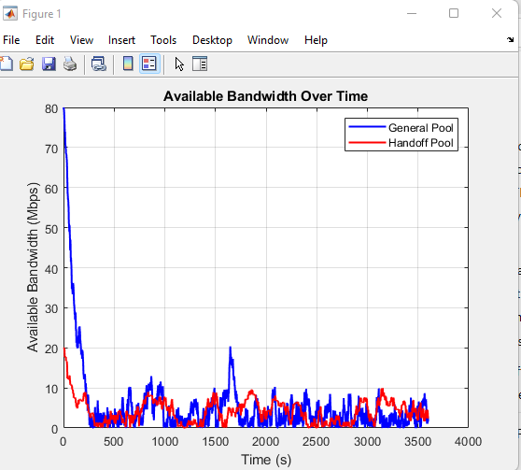
Figure 2: Available Bandwidth over time for the CAC Simulation in a 3GPP LTE Network
  - Performance Metrics
Quality of Service (QoS) refers to the overall performance of a telecommunications network, particularly in terms of how effective it handles call requests and maintains service quality. In this context, the key QoS metrics include blocking probability, acceptance probability, latency, jitter and packet loss. These metrics help evaluate the effectiveness of the proposed call admission control (CAC) scheme in managing network resources and ensuring user satisfaction.
Table 3: Mathematical Analysis for Blocked Vs Accepted Calls Probability (BWM-CAC)
Metric | NC | HC | Overall
Total Arrivals | 1129 | 363 | 1492
Accepted Calls | 1129 | 297 | 1426
Blocked Calls | 0 | 66 | 66
Block Probability | 0.0000(0%) | 0.1818(18.18%) | 0.0442(4.42 %)
Acceptance Probability | 1.0000(100%) | 0.8182(81.82%) | 0.9558(95.58%)
Blocked/Accepted Ratio | 0.0000 | 0.2222 | 0.0463
A high new call blocking probability indicates that the network is struggling to accommodate new users, while a high handoff call blocking probability suggests poor handoff management, leading to service drops. Maintaining a low handoff blocking probability is essential for providing seamless service continuity and improving user satisfaction. Figure 3 presents the proposed CAC scheme with regards blocking probabilities of NC and HC calls.
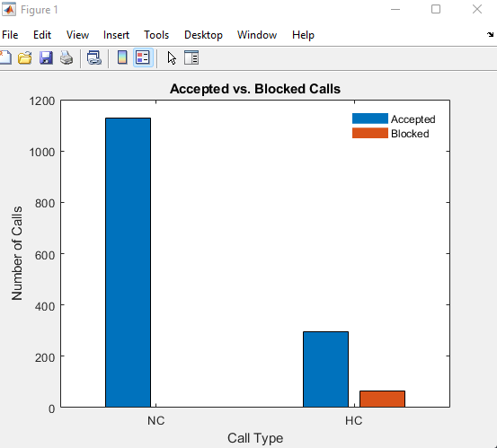
Figure 3: Analysis for Blocked Vs Accepted Calls Probability
Figure (3) presents a comparison of New Calls (NC) and Handoff Calls (HC) in terms of how many were accepted versus blocked. This highlights that the network effectively handles newest calls but struggles at times to accommodate handoff calls, resulting in a non-negligible HC blocking rate. Comparing this result with previous CAC schemes, the proposed CAC scheme in this study performed better in terms of Handoff Call Dropping probability (0.04%) and Forced call termination at 2% as compared to that of Zarai et al. (2014) and Hassanein et al. (2006). However, the results are similar in terms of new call blocking probability. Figures (4) and (5) presents a scatter plot graph indicating the intensity of service provided with regards video and voice call respectively, based on their duration and BW utilization with the aid of MATLAB code.
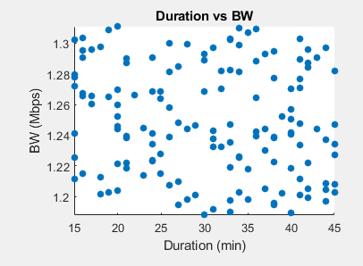
Figure 4: Video Call duration vs Bandwidth
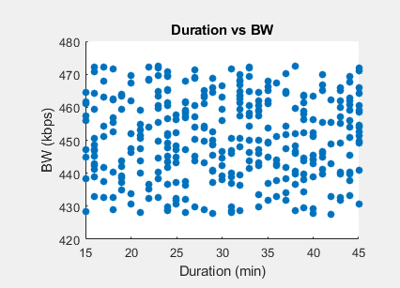
Figure 5: Voice Call Duration vs Bandwidth
Both Figures (4) and (5) freely presents a typical Nigerian caller who would fancy voice calls over video calls due to expensive data from network providers. Figure 4 presents a sparse scatter point as compared to Figure 5, indicating customer’s preference of voice call over video calls. Also, Figure 4 utilizes larger BW in Mbps as compared to that of the voice call seen in Kbps which goes to show that Video calls utilizes more of the BW than the voice calls. Overall, customers stay longer in voice calls as compared to video calls. However, bandwidth does not depend on the duration of calls rather, variations are due to channel and scheduling. This goes to show that long calls don’t automatically interpret the consumption of bandwidth per time. The graphs looks scattered or random, that is lacking in correlation is a good thing representing a real life situation, where CAC does not adapt bandwidth based on call duration and the quality of service are maintained independent of length of call time which directly aligns with Erlang-type loss systems. If there were to be a trend, it would signal unfair allocation of resources and the degradation of QoS for long calls.
4.3 Latency
It is not computed by a single formula in every scenario because it usually consists of several components. A common way to express latency is to sum all the delays as shown in eqn. (12).
L _{prop} = Propagation Delay
Using equation (13) where; Distance = 100km (100,000 m), Propagation Speed = 2 x 10⁸ ms,
Propagation Delay = 0.5 ms
Transmission Delay (L_{trans})
Using equation (14) and Packet size = 1000 bits, Transmission delay for voice is:
$L_{trans} =\frac{1000 }{0.45 x {10}^{6}}x 1000 (ms)$ = 2.22 ms
Transmission Delay for Video is given as:
$L_{trans}=\frac{1000 }{1.25 x {10}^{6}}x 1000 (ms)$ = 0.8 ms
Weighted Average Transmission Delay
$L_{trans}=\left(0.7 x 2.22\right)+\left(0.3 x 0.8\right)=1.79 ms$
Queuing Delay ($L_{queue})$
This was chosen randomly between 5 to 15 ms
$L_{queue} =\frac{5+15}{2}$ = 10 ms
Processing Delay (L _{proc})
This is placed at a constant value of 1ms.
Total Latency
$L_{total}=L_{prop}+L_{trans}+L_{queue}+L_{proc}=0.5 + 1.79 + 10 + 1=13.29 ms$
Figure 6 represents the measured average latency at each minute during the simulation. The simulation spans 360 minutes, reflecting a 6-hour test period in an LTE environment. Latency values typically range between 10 and 18 milliseconds, with occasional dips and spikes. Propagation delay is around 0.5 milliseconds, arising from signal travel over 100 km of fiber. Transmission delay depends on bandwidth allocation and packet size, averaging about 1.79 milliseconds. Queuing delay varies uniformly between 5 and 15 milliseconds, producing an expected value of 10 milliseconds. Processing delay is fixed at 1 millisecond, accounting for device-level packet handling. Summing these four components yields a theoretical total average of 13.29 milliseconds.
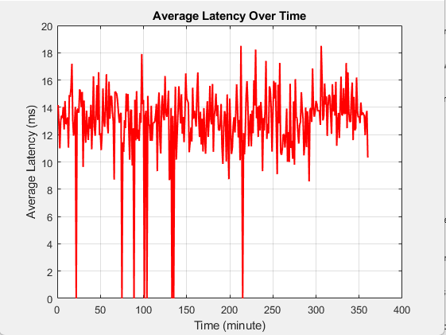
Figure 6: Average Latency over Time
Figure 6 shows that most measured values hover near this calculated range, confirming the model’s accuracy. Slight fluctuations occur due to changes in network load, which affect queue occupancy. Voice and video calls share bandwidth, but the network appears capable of handling both effectively. Real-time applications benefit from latency under 20 milliseconds, ensuring minimal audio or video lag. The queue delay contributes the largest portion, so traffic surges can push total latency briefly higher. Propagation delay remains stable, indicating the physical link distance does not change during the test. Transmission delay varies slightly based on the mix of voice and video calls at any given time. Processing delay remains constant, reflecting the fixed overhead of routing and switching operations. Overall, the network maintains relatively low latency, which supports quality voice and video communication. Frequent dips to near 10 milliseconds signal lighter traffic periods with less queuing. Spikes toward 18 milliseconds align with heavier load, when queues lengthen momentarily. The results validate that the LTE system can deliver consistent performance under typical usage patterns. Operators can use these insights to adjust bandwidth reservations for voice and video services. The obtained result from this research is well within the range as acceptable, according to ITU-T (2003), the acceptable one-way latency for real-time communication is <150ms. With regards CAC schemes like with the BWM-CAC, this requirement is indirectly enforced through the control of network load to maintain low queuing delays, typically within the range of 5 – 20ms which ensures an overall acceptable end-to-end delay for a good QoS; as also referenced by Nanda (2008).
4.4 Throughput and Bandwidth Utilization over Time
The total throughput, measured in megabits per second (Mbps), provides a direct indication of how much data was successfully moved across the network. Meanwhile, bandwidth utilization, expressed as a percentage, shows how effectively the available bandwidth is being used. By examining these two metrics, it becomes possible to gain insights into overall network performance and resource allocation, ultimately guiding resource provisioning and capacity planning efforts.
In this research, the total throughput is computed by summing the usage logs for both normal and high-capacity calls, resulting in a combined figure of 7,600 Mbps over a 360-minute simulation period. This quantity signifies the absolute amount of data transmitted throughout the entire duration. By dividing the total throughput by total bandwidth (100 Mbps) the resulting utilization is 76% within the given time period. Such a value implies that a substantial portion of the network’s available capacity is being employed, reflecting an efficient operational state for most usage scenarios. When throughput is high and utilization is also high, the network is making good use of its resources to transmit large volumes of data. If throughput remains high but utilization is notably lower, it may indicate that the network still has additional capacity that is not being fully harnessed. Conversely, low throughput paired with high utilization often points to congestion or mismanagement, since it suggests that bandwidth is fully occupied yet fails to deliver the expected level of data transfer. These insights underscore the importance of continuously monitoring both metrics to maintain a balanced and effective networking environment. Displaying throughput in Mbps and utilization as a percentage on the same axes Figure 7, network administrators can easily compare fluctuations in data transmission with the corresponding changes in capacity usage.
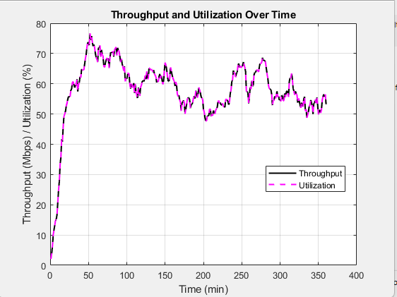
Figure 7: Throughput and Bandwidth Utilization over Time
Observing these trends across the 360-minute window helps identify peak usage periods, potential bottlenecks, and opportunities for scaling or optimization. Such visual representations are valuable for both diagnosing performance issues and planning for future network expansion. Overall, the comparison of total throughput and bandwidth utilization provides a holistic view of network performance, highlighting how efficiently the infrastructure is being leveraged. In this case, the alignment of 7,600 Mbps of throughput with a 76% utilization rate indicates a well-provisioned network that effectively meets demand without excessive idle capacity. Comparison between obtained result with already existing CAC schemes such as researched by Zarai et al. (2014) and Hassanein et al. (2006); the proposed CAC scheme fairs better with a bandwidth utilization of 76% compared to theirs at 68%. It is however found to be of same value when compared with the work of Umar et al. (2021).
4.5 Blocking Probability across Regions
The graph in figure 8 shows the bandwidth utilization across the three regions under consideration, while figure 8 shows the blocking probability for New Calls (NC) and Handoff calls (HC).
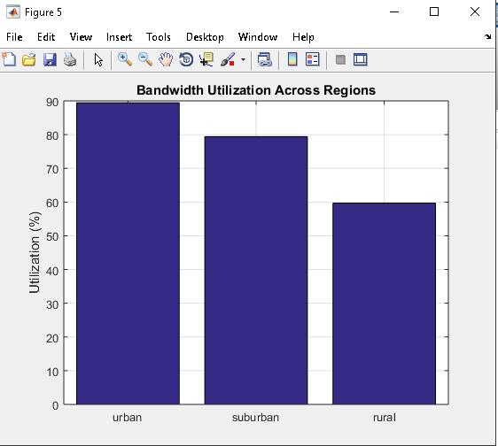
Figure 8: Bandwidth Utilization across Regions
Figure 8 compares the bandwidth utilization in percentage for Urban, Suburban and rural regions. It is observed that utilization is highest in the urban areas due to increased demand on traffic and the utilization decreases continuously as it comes down to the rural area. The results demonstrate that the proposed BWM-CAC scheme effectively and seamlessly adapts to the varying traffic conditions while also maintaining and efficient use of available network bandwidth.
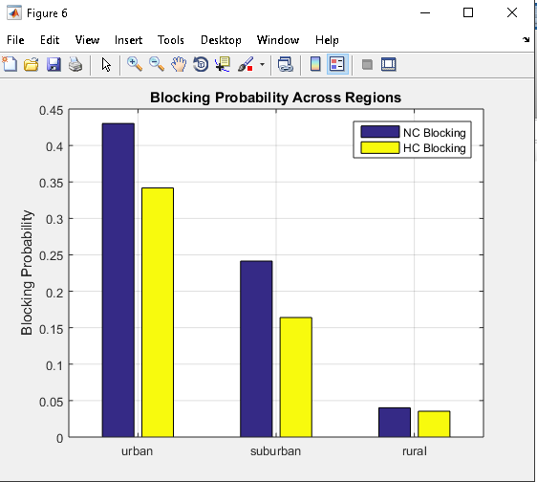
Figure 9: Blocking Probability across regions
Figure 9 demonstrates the blocking probabilities for NC and HC calls across all three regions. As expected and experienced in daily living, higher blocking occurs in urban environments due to increased traffic intensity. However as evident across all three regions, the HC blocking rate is lower compared to new calls which further confirms the dynamic reservation mechanism with priority to HC calls as mentioned in the theory and implemented in the proposed BWM-CAC scheme. This ensures continuity of ongoing call sessions which significantly reduces handoff dropping probability across the varying traffic conditions.

CONCLUSION
This research has systematically investigated the design, modeling, and performance evaluation of CAC schemes in LTE networks to address the challenges posed by real-time traffic demands. The study reveals that: Efficient CAC schemes significantly impact QoS performance, ensuring that ongoing calls maintain high-quality transmission without excessive blocking or dropping of new calls. Adaptive resource allocation mechanisms, such as Proportional Fair Scheduling and Maximum Throughput Scheduling, improve network performance by dynamically allocating resources based on real-time conditions. Overall, the findings demonstrate that an optimal CAC strategy should integrate adaptive resource management, QoS-aware scheduling, and traffic prediction techniques to meet the stringent requirements of LTE real-time applications all of which are embodied in the proposed BWM CAC scheme.

COMPETING INTERESTS DISCLAIMER:
Authors have declared that they have no known competing financial interests OR non-financial interests OR personal relationships that could have appeared to influence the work reported in this paper.

Disclaimer (Artificial intelligence)
Author(s) hereby declare that NO generative AI technologies such as Large Language Models (ChatGPT, COPILOT, etc.) and text-to-image generators have been used during the writing or editing of this manuscript.

REFERENCE
Ahmad, I. & Habibi, D. (2013). Improving Quality of Service in WiMAX Communication at Vehicular Speeds: A New Call Admission Control Solution. Wireless Communications and Mobile Computing, 13(5), 451-459.
Ahmed, M. H. (2005). Call Admission Control in Wireless Networks: A Comprehensive Survey. IEEE Commun. Surv. Tutorials, 7(1-4), 50-69.
Belghith, A., Mohamed, M. B. & Obaidat, M. S. (2016). Efficient Bandwidth Call Admission Control in 3GPP LTE Networks. In 2016 IEEE Global Communications Conference (GLOBECOM) (pp. 1- 6). IEEE.
Bhanu, P. (2021). What are the general Technique to Improve the Quality of Service? Message posted to tutorials point. Accessed on 21st January, 2024 from https://www.tutorialspoint.com/what-are-the- general-techniques-to-improve-the-quality-of-service.
Bo, L. (2002). Peer to peer: Collaboration and Sharing over the Internet. Addison-Wesley. USA. Page 15. ISBN 9780201767322.
Brainkart (2024). Techniques to Improve QoS. Accessed on 21st January, 2024 from https://www.brainkart.com/article/Techniques-to-Improve-QoS_13490/.
Cisco (2024). Call Admission Control Overview. Accessed on 31st Jan., 2024. Available at https://www.cisco.com/c/en/us/td/docs/voice_ip_comm/cucm/admin/11_5_1/sysConfig/11_5 _1_SU1/cucm_b_system-configuration-guide-1151su1/cucm_b_system-configuration-guide- 1151su1_chapter_011100.pdf.
Defense (2017). Sound-Powered Telephone Talkers Manual. Accessed on 27th September, 2023. Available at https://web.archive.org/web/20180514065758/https://media.defense.gov/2017/ Mar/16/2001717399/-1/-1/0/CIM_9430_1.PDF.
Emmadi, S. K. & Venkatesh, T. G. (2014). Call Admission Control Schemes in Cellular Networks: A Comparative Study. In 2014 11th International Joint Conference on Computer Science and Software Engineering (JCSSE) (pp. 188-193). IEEE.
Fang, Y. & Zhang, Y. (2002). Call Admission Control Schemes and Performance Analysis in Wireless Mobile Networks. IEEE Transactions on Vehicular Technology, 51(2), 371-382.
Felisac (2021). Bandwidth, Latency, Jitter, Packet loss. Message posted to Fibermall Accessed on 16th January, 2024 from https://www.fibermall.com/blog/bandwidth-latency-jitter- packet-loss.htm.
Ghaderi, M. & Boutaba, R. (2006). Call Admission Control in Mobile Cellular Networks: A Comprehensive Survey. Wireless Communications and Mobile Computing, 6(1), 69-93.
Hassanein, H., Oliver, A., Nasser, N. & Elmallah, E. (2006). QoS‐Aware Call Admission Control in Wideband CDMA wireless networks. International Journal of Communication Systems, 19(2), 185-203.
Hou, J., Yang, J. & Papavassiliou, S. (2002). Integration of Pricing with Call Admission Control to meet QoS Requirements in Cellular Networks. IEEE Transactions on parallel and distributed systems, 13(9), 898-910.
ITU-T (2003). One way transmission time. ITU-T Recommendation G.114. Accessed on 9th April, 2026 at https://www.itu.int/rec/t-rec-g.114-200305-i
Kentik (2024). Understanding Latency, Packet Loss and Jitter in Network Performance. Accessed on 16th Jan., 2024. Available at https://www.kentik.com/kentipedia/understanding-latency-packet- loss-and-jitter-in-networking/#:~:text=Latency%2C%20packet%20loss%2C%20and%20jitter%2 0are%20ritical%20network%20performance%20metrics,seamless%20and%20reliable%20user% 20experience.
Khabazian, M., Kubbar, O. & Hassanein, H. (2012, January). Call Admission Control with Resource Reservation for Multi-Service OFDM Networks. In 2012 International Conference on Computing, Networking and Communications (ICNC) (pp. 781-785) IEEE.
Lei, H., Yu, M., Zhao, A., Chang, Y. & Yang, D. (2008). Adaptive Connection Admission Control Algorithm for LTE Systems. In VTC Spring 2008-IEEE Vehicular Technology Conference (pp. 2336-2340). IEEE.
Mamman, M. (2021). Call admission control algorithm with efficient handoff for both 4G and 5G networks. International Journal of Wireless & Mobile Networks (IJWMN) Vol, 13.
Muayad, N. A. (2018). Quality of Service. A term paper submitted to department of Network College of IT, University of Babylon, Iraq (unpublished).
Nadembega, A., Hafid, A. & Taleb, T. (2014). Mobility-Prediction-Aware Bandwidth Reservation Scheme for Mobile Networks. IEEE Transactions on Vehicular Technology, 64(6), 2561-2576.
Nanda, P. (2008, December). Supporting QoS Guarantees Using Traffic Engineering and Policy Based Routing. In 2008 International Conference on Computer Science and Software Engineering (Vol. 3, pp. 137-142). IEEE.
Raja, S. K. S. & Louis, A. B. V. (2021). A Review of Call Admission Control Schemes in Wireless Cellular Networks. Wireless Personal Communications, 120(4), 3369-3388.
Reddy, T. B., Karthigeyan, I., Manoj, B. S. & Murthy, C. S. R. (2006). Quality of Service Provisioning in Ad Hoc Wireless Networks: A Survey of Issues and Solutions. Ad Hoc Networks, 4(1), 83-124.
Tarek, B. & Nidal, N. (2009). Efficient Call Admission Control Scheme for 4G Wireless Networks. Wireless Communications and Mobile Computing, 9(4), 489-499.
Umar, M. M., Mohammed, A., Roko, A., Tambuwal, A. Y. & Abdulazeez, A. (2021). Enhanced Adaptive Call Admission Control Scheme with Bandwidth Reservation for LTE networks. International Journal of Mobile Computing and Multimedia Communications (IJMCMC), 12(1), 23-42.
Wang, H., Ding, L., Liu, N., Pan, Z., Wu, P. & You, X. (2011). Minimum Rate Guaranteed Call Admission Control for Cumulative Rate Distribution Based Scheduling. IEEE Communications Letters, 15(11), 1181-1183.

Wang, J. & Qiu, Y. (2013). A New Call Admission Control Strategy for LTE Femtocell Networks. In 2nd International Conference on Advances in Computer Science and Engineering (CSE2013) (pp. 336-340). Atlantis Press.
Yilmaz, O. & Chen, R. (2009). Utilizing Call Admission Control for Pricing Optimization of Multiple Service Classes in Wireless Cellular Networks. Computer Communications, 32(2), 317- 323.
Zarai, F., Ali, K. B., Obaidat, M. S. & Kamoun, L. (2014). Adaptive Call Admission Control in 3GPP LTE Networks. International Journal of Communication Systems, 27(10), 1522-1534.
Zhang, T., Van Den Berg, E., Chennikara, J., Agrawal, P., Chen, J. C. & Kodama, T. (2001). Local Predictive Resource Reservation for Handoff in Multimedia Wireless IP Networks. IEEE Journal on Selected Areas in Communications, 19(10), 1931-1941.

