Development and field validation of a low-cost georeferenced datalogger for multiparameter soil sensing

ABSTRACT

Background: Monitoring soil properties such as moisture, temperature, electrical conductivity, pH, and nutrient availability is essential for agricultural management and environmental studies. However, many soil monitoring systems remain expensive or require complex instrumentation, limiting their accessibility for routine field measurements.
Methods: In this study, a low-cost georeferenced datalogger was developed using an Arduino Mega 2560 platform integrated with a multiparameter soil sensor capable of measuring soil moisture, temperature, electrical conductivity, pH, and estimated concentrations of nitrogen, phosphorus, and potassium. The system also incorporates a GPS module for geospatial positioning and a microSD module for data storage. Field validation tests were conducted under contrasting environmental conditions across several regions of central and eastern Mexico.
Results: The device was transported approximately 900 km under real road conditions and operated continuously without signal instability or hardware malfunction. A total of 35 measurement points were collected across tropical lowlands, coastal environments, and montane cloud forest ecosystems. The measured ranges of soil variables were consistent with values reported in previous studies, demonstrating the operational stability and functionality of the system.
Conclusion: The proposed system provides a reliable and portable solution for georeferenced soil monitoring. Its low-cost design, ease of operation, and stable performance under diverse environmental conditions highlight its potential as a practical tool for field measurements, environmental monitoring, and precision agriculture applications.

Keywords: soil monitoring, soil moisture, electrical conductivity, low-cost sensor, precision agriculture, georeferenced datalogger

1. INTRODUCTION

Soil properties such as moisture, temperature, pH, electrical conductivity, and nutrient availability play a fundamental role in agricultural productivity and ecosystem functioning. In tropical soils, strong weathering processes and high biological activity can generate substantial variability in soil chemical properties, including nitrogen, phosphorus, and potassium concentrations (Motavalli et al., 1995; Suárez et al., 2015; López et al., 2002; Villarreal-Núñez et al., 2017). Accurate field monitoring of these variables is therefore essential for understanding soil conditions and supporting agricultural management.
Despite these advances, many soil monitoring systems remain expensive or require specialized equipment, limiting their accessibility for routine field measurements. Therefore, the objective of this study was to develop and evaluate a low-cost georeferenced datalogger capable of measuring multiple soil variables, including soil moisture, temperature, electrical conductivity, pH, and estimated concentrations of nitrogen, phosphorus, and potassium, while automatically recording geographic coordinates and storing the measurements for subsequent spatial analysis.

2. materialS and methods

The device was developed at the Colegio de Postgraduados, Campus Montecillo. It is important to note that field measurements require the recording of several variables, such as the date and time of measurement, geographic location, and the value of the measured variable, among others. Therefore, in order to obtain at least the temporal and spatial information, the device was designed using a sensor capable of providing multiple soil variables that could be measured and georeferenced in the field.

Several sensors were evaluated, and the Soil Sensor CWT-NPK was selected because it can measure soil temperature, soil moisture, electrical conductivity, pH, nitrogen, phosphorus, and potassium. It should be noted that, regarding the NPK measurements, the manufacturer indicates that a general rapid detection method is used (Estudiez, 2025), which may introduce certain measurement errors.

Once the sensor was selected, a device capable of reading the sensor data, acquiring geographic location information, and storing the collected data on a microSD card was developed so that the information could later be downloaded to a computer for analysis. To accomplish this, the device was developed through the following stages: selection of sensors and electronic components, connection of integrated circuits using an Arduino board, programming of the Arduino board, design and fabrication of the enclosure, field testing, and GPS validation.

2.1 Selection of sensors and electronic components

The system architecture was centered on an ATmega2560-based microcontroller (Arduino Mega 2560), which coordinated data acquisition, processing, and storage. The primary sensing unit was a CWT-NPK multiparameter soil sensor capable of measuring soil temperature, moisture, electrical conductivity (EC), pH, and estimated concentrations of nitrogen, phosphorus, and potassium.
Peripheral modules included a NEO-8M GPS module for geospatial positioning, a DS1302 real-time clock (RTC) module for timestamping measurements, and a microSD interface (MLMSD™) for local data storage. The sensor communication was performed through an RS-485 to TTL converter module (MAX485).
To facilitate field operation, the device incorporated a 3.5-inch Thincol™ touchscreen complemented with three normally open metal push-buttons used for menu navigation and measurement triggering.
Power was supplied using a dual-source configuration consisting of a 12 VDC rechargeable lithium-ion battery (2000 mAh) dedicated to the soil sensor and a 5000 mAh power bank (Steren™, model MOV-1058) used to power the control and data acquisition circuits.

2.2 Connection of integrated circuits using an Arduino board

To connect the electronic circuits, the measurement strategy was first defined. The system was designed to request data from the sensor only when a measurement is required. Therefore, the sensor is not continuously powered and is activated only at the moment when a measurement is performed. It is also important to note that the device was designed to be easy to use under field conditions. In many cases, touch screens cannot be easily operated due to soil or moisture on the user’s hands. For this reason, physical buttons were incorporated into the device. Two buttons allow navigation between menu screens, and an additional button triggers the measurement process. When this button is pressed, the system performs a complete measurement cycle in which the soil sensor is read, the GPS coordinates are obtained, and the results are stored on the microSD memory card.

All electronic modules remain continuously connected to the 5 V and GND lines while the device is operating. However, the CWT-NPK sensor remains disconnected from the +5 V supply and is powered only during the moment of data acquisition, while its remaining connections stay permanently connected. Power to the sensor is controlled using a relay module connected to a digital output pin of the Arduino board (D33). When the relay is activated, the circuit is closed and +5 V is supplied to the sensor. To connect the CWT-NPK sensor to the Arduino Mega 2560 board, the sensor was first connected to an RS-485 to TTL converter module, which was then connected to the Arduino board (Fig. 1). The physical control buttons were connected to the Arduino digital pins D39 (left), D41 (right), and D43 (enter).

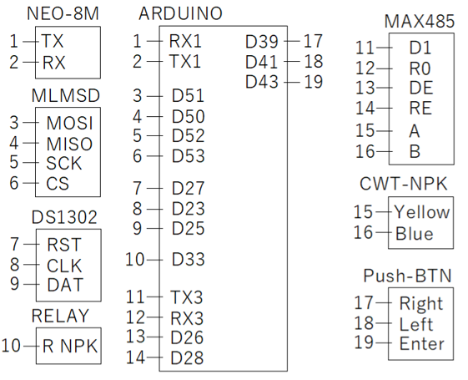

Fig. 1. Connection diagram of the MicroSD memory module (MLMSD), GPS module (NEO-8M), real-time clock module (DS1302), relay module (RELAY), RS-485 to TTL converter module (MAX485), soil sensor (CWT-NPK), and normally open metal push-buttons (Push-BTN) connected to the Arduino Mega 2560 board.

2.3 Programming of the Arduino board

The Arduino-based system was programmed using a modular software architecture to ensure robustness, ease of use, and scalability. The code was organized into independent functional blocks, including sensor data acquisition, geographic position retrieval, user interface management, and data storage on a microSD card.

System operation was designed around a single-action input. When the user presses the physical button, the device sequentially triggers soil variable measurement, GPS position acquisition, data validation, and data logging. This approach minimizes user interaction and reduces potential errors during field measurements.

The complete program consists of 1,840 lines of code, of which approximately 300 lines correspond to internal system processes, while 1,540 lines are dedicated to the user–device interface, highlighting the emphasis placed on usability and real-time interaction.

The software architecture was designed as a finite-state machine (FSM), consisting of two main processes: monitoring and data logging, and real-time user interaction, the latter of which required a greater proportion of the code.

2.4 Design and fabrication of the enclosure.
The device enclosure was designed using AutoCADTM 2007 and fabricated through additive manufacturing using a 3D printer (Creality Ender 3 V2). The enclosure components were printed using PLA filament (1.75 mm diameter) with a layer height of 0.2 mm. The design process incorporated multiple independent components to ensure proper accommodation of all electronic modules, including the Arduino board, touchscreen display, push buttons, RS-485 sensor interface, power supply, and data storage module (Fig. 2).
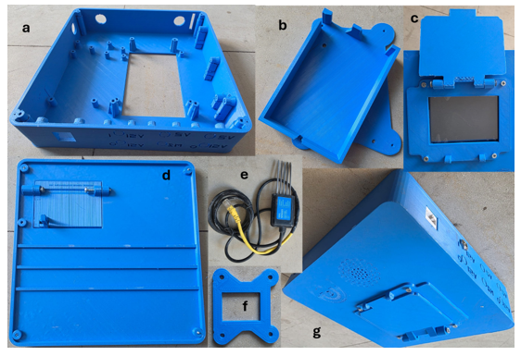
Fig. 2. 3D-printed enclosure components of the device including the main enclosure (a), internal Arduino support structure (b), front cover and touchscreen frame (c), rear cover of the enclosure (d), RJ45 connector adapter for the soil sensor (e), internal RJ45 female support structure (f), and the fully assembled device (g).
An iterative prototyping approach was employed to achieve precise fitting of external and internal components. For critical elements such as push buttons and connectors, test pieces containing only the required openings were first printed in a vertical orientation to verify dimensional accuracy. Minor geometric adjustments were applied until a tight and stable fit was achieved, after which the finalized geometry was integrated into the main enclosure.
To improve robustness and ease of connection, the original RS-485 soil sensor with exposed wires was adapted to a standardized RJ45 connector. A dedicated internal support was designed to securely house the RJ45 female connector, ensuring correct alignment, mechanical stability, and minimizing gaps that could allow the ingress of dust or small organisms.
Environmental considerations were also incorporated into the enclosure design. All openings were minimized and precisely adjusted to reduce the risk of dust, moisture, or insect intrusion, which could otherwise generate electrical noise or internal short circuits under field conditions. Internal components were positioned according to their functional roles, ensuring adequate separation and secure mounting.
The internal support structure was redesigned to accommodate a new power supply after the original battery model became unavailable. The updated support allows the battery, Arduino board, and touchscreen display to be mounted on opposite sides of the same structural element without interfering with mounting screws or access points. Additional adjustments were made to the display mounting height to prevent mechanical interference with the touchscreen interface.
The main enclosure includes engraved visual indicators and arrows to guide user interaction with the buttons, as well as optional internal supports and ports for future integration of motorized irrigation control systems. The microSD module was positioned in an externally accessible location, allowing data retrieval without full disassembly of the device. The final enclosure achieved a compact configuration with minimal unused internal space while maintaining accessibility and structural integrity.

2.5 Field testing

Field tests were conducted to evaluate the operational stability of the device during transport and under contrasting environmental conditions. The datalogger was transported by road across several regions of Mexico to verify the mechanical robustness of the electronic components and the stability of the system during travel.
Measurements were subsequently performed in warm and humid lowland regions (Tepetitla–Huejutla, Hidalgo, and Martínez de la Torre, Veracruz), a coastal environment (Costa Esmeralda, Veracruz), and a montane cloud forest (Zacapoaxtla, Puebla). These sites represent a wide range of temperature, humidity, and soil texture conditions.
At each location, measurements were taken directly in soil. Additional measurements were carried out in surface water bodies, including rivers and coastal seawater, in order to verify sensor response under fully submerged conditions and to evaluate the robustness of the sensing electrodes under stress-testing conditions.
In total, 35 measurement points were collected across all environments. Despite the strong contrasts in temperature and moisture among sites, the sensor and data acquisition system operated without interruption or signal instability, indicating that environmental variations did not adversely affect device performance during field operation.

2.6 GPS validation
The operation of the GPS module was evaluated in experimental plots located at the Colegio de Postgraduados, Campus Montecillo. A total of 104 points were sampled. In several cases, multiple measurements were collected at the same location in order to verify the correct operation and consistency of the device, including GPS positioning, sensor response, and data storage.
After data collection, contour maps were generated solely for visualization purposes. Spatial interpolation was performed to demonstrate the capability of the proposed datalogger to integrate georeferenced measurements with post-processing workflows. These interpolated surfaces are not intended to represent the true spatial variability of the study site; rather, they illustrate the operational functionality and data integrity of the system.
Spatial interpolation of the measured variables was performed in R using the akima package (Akima, 1978). The interp() function was used to generate a regular grid from the georeferenced measurements using Akima's interpolation method. Contour maps were subsequently generated using the contour() function in base R to visualize the spatial distribution of the variables.

3. results and discussion

The assembled device is shown in Fig. 3. This figure presents lateral views of the system together with the internal configuration of the device, where the main electronic components can be observed, including the relay module, GPS module, portable power supply, and the sensor connection system.
The green button corresponds to the main system control, which automatically performs the sensor reading, GPS position acquisition, and data storage on the microSD card with a single press. Additionally, the yellow buttons are used to navigate between the different menu screens of the interface.
Fig. 3 also illustrates that the enclosure was designed to securely integrate all electronic components while maintaining easy access to the control buttons and external connectors. The internal layout demonstrates the compact integration of the electronic modules within the enclosure.

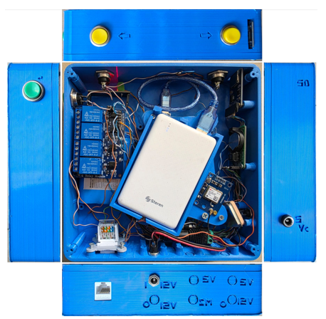

Fig. 3. Assembled device showing the lateral views and internal arrangement of the electronic components, including the GPS module, relay system, portable power supply, and internal wiring.

To evaluate the operational stability of the system under real transport and field-use conditions, the device was transported from Montecillo, Texcoco (State of Mexico), to the community of Tlalchiyahualica, Hidalgo, traveling approximately 264 km by road. During the journey, the equipment was exposed to vibrations caused by road irregularities, including potholes, speed bumps, and sections under repair.
Subsequently, measurements were carried out at different locations within the study area, including measurements in river water and in nearby soils. The regional climate corresponds to a warm subhumid climate typical of the Huasteca region (INEGI, 2026). Fig. 4 presents representative examples of the measurement sites together with the values recorded by the system.

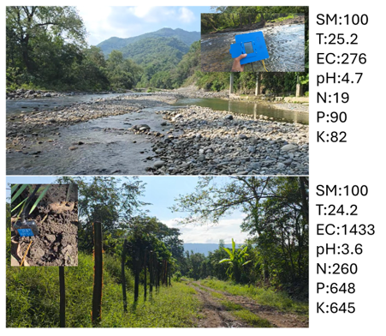

Fig. 4. Field measurement sites in Hidalgo, Mexico, where the upper image shows measurements conducted in the river of the community of Tlalchiyahualica and the lower image corresponds to soil measurements performed in Tepetitla, recording at both sites soil moisture (SM, %), temperature (T, °C), electrical conductivity (EC, µS/cm), pH, and estimated concentrations of nitrogen (N), phosphorus (P), and potassium (K, mg kg⁻¹).

Subsequently, the device was transported from the community of Tlalchiyahualica, Hidalgo, to the coastal region of Costa Esmeralda, Veracruz, traveling approximately 245 km by road. During the trip, the equipment was exposed to vibrations and varying road conditions, including segments with sharp curves, potholes, and some unpaved sections. Once at the site, measurements were conducted in two contrasting environments: moist sand near the shoreline and soil covered by vegetation in an area close to the coast. These locations allowed the evaluation of system performance under coastal environmental conditions characterized by high humidity and sandy soils. According to the climatic classification maps of Mexico, the study area corresponds to a warm semi-humid climate (INEGI, 2026). The results obtained at both measurement points are shown in Fig. 5.

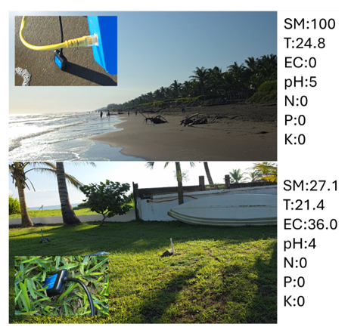

Fig. 5. Measurement sites during the field test conducted in the Costa Esmeralda region, Veracruz, Mexico, where the upper panel shows measurements performed in moist sand near the shoreline and the lower panel corresponds to measurements carried out in soil covered by vegetation, recording at both sites soil moisture (SM, %), temperature (T, °C), electrical conductivity (EC, µS/cm), pH, and estimated concentrations of nitrogen (N), phosphorus (P), and potassium (K) (mg kg⁻¹).

Subsequently, the device was transported from the Costa Esmeralda region to the ejido Manantiales, located in the municipality of Martínez de la Torre, Veracruz, traveling approximately 59 km by road. During the trip, the equipment continued to be exposed to typical transport conditions along rural roads, including curves and minor surface irregularities. Once at the site, measurements were conducted in two representative crops of the local agricultural area, specifically in soil associated with a lemon tree and in a bean crop. Access to the plots was granted by the landowners, allowing the evaluation of system performance under real agricultural management conditions. The study area is characterized by a warm semi-humid climate according to the climatic classification maps of Mexico (INEGI, 2026). The results obtained for both crops are shown in Fig. 6.

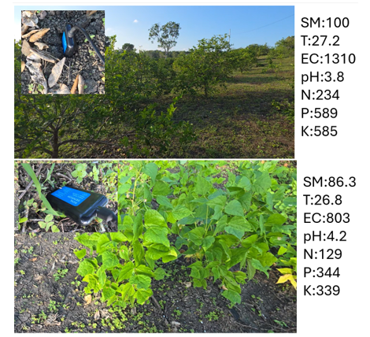

Fig. 6. Measurement sites during the field test conducted in the ejido Manantiales, municipality of Martínez de la Torre, Veracruz, Mexico, where the upper panel shows measurements performed in soil associated with a lemon crop and the lower panel corresponds to measurements conducted in a bean crop, recording at both sites soil moisture (SM, %), temperature (T, °C), electrical conductivity (EC, µS/cm), pH, and estimated concentrations of nitrogen (N), phosphorus (P), and potassium (K) (mg kg⁻¹).

Subsequently, the device was transported from the ejido Manantiales in Martínez de la Torre, Veracruz, to the community of Xalcticpac, located in the municipality of Zacapoaxtla, Puebla, traveling approximately 114 km by road. The route included mountainous roads with sharp curves and multiple terrain irregularities, representing an additional condition for evaluating the operational stability of the system during transport. Once at the site, measurements were conducted in two nearby rivers of the region, the Itzinioca River and the Texpilco (Ayohualolt) River, both located within a montane cloud forest environment. These measurements allowed the evaluation of system response in fluvial environments under conditions of low temperature and high environmental humidity. According to the climatic classification maps of Mexico, the study area corresponds to a temperate humid climate (INEGI, 2026). The values obtained at both locations are presented in Fig. 7.
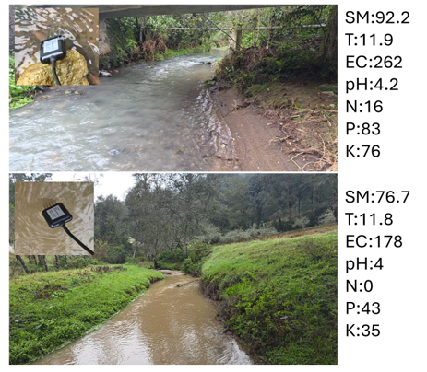

Fig. 7. Riverine field tests conducted in Xalcticpac, Zacapoaxtla, Puebla, Mexico, showing comparative measurements obtained from the Itzinioca River (upper panel) and the Texpilco (Ayohualolt) River (lower panel), including soil moisture (SM, %), temperature (T, °C), electrical conductivity (EC, µS cm⁻¹), pH, and estimated concentrations of nitrogen (N), phosphorus (P), and potassium (K) (mg kg⁻¹), where SM values correspond to the sensor response under fully submerged conditions.

To assess system behavior in montane soils under different land uses, measurements were performed at two sites in Xalcticpac, municipality of Zacapoaxtla, Puebla. One site corresponded to a forested area located along a forest road near the community, while the second site was an agricultural soil cultivated with pea crops in the mountainous sector locally known as “El Gran Poder de Dios”. These locations provided contrasting vegetation covers and environmental conditions typical of a temperate humid montane cloud forest ecosystem (INEGI, 2026). Comparative results are presented in Fig. 8.

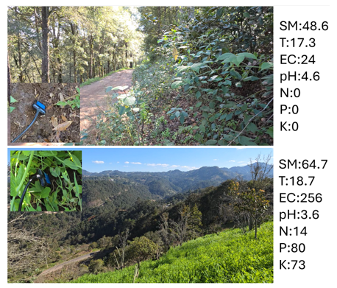

Fig. 8. Comparative soil measurements conducted in Xalcticpac, Zacapoaxtla, Puebla, Mexico, showing data from a forested site along a forest road near the community (upper panel) and an agricultural pea-crop site located in the mountainous sector known as “El Gran Poder de Dios” (lower panel), including soil moisture (SM, %), temperature (T, °C), electrical conductivity (EC, µS cm⁻¹), pH, and estimated concentrations of nitrogen (N), phosphorus (P), and potassium (K) (mg kg⁻¹).

To provide a concise overview of the ranges of soil variables recorded during the field validation campaign, a summary of the measured values is presented in Table 1.

Table 1. Summary of soil variable ranges measured during field validation
Variable | Minimum value | Maximum value
Soil moisture (%)  Soil temperature (°C)  Electrical conductivity (mS cm⁻¹) | 0  11.8  0 | 100  27.2  1.43
Soil pH | 3.6 | 5.0
Nitrogen (mg kg⁻¹) | 0 | 260
Phosphorus (mg kg⁻¹) | 0 | 648
Potassium (mg kg⁻¹) | 0 | 645

To evaluate the operational and mechanical durability of the system during field validation, the device was transported across several regions of central and eastern Mexico, including Montecillo (State of Mexico), Tlalchiyahualica (Hidalgo), Costa Esmeralda and Martínez de la Torre (Veracruz), and Zacapoaxtla (Puebla), covering an approximate total distance of 909 km by road, including a 227 km return segment from Zacapoaxtla to the initial site in Montecillo. Throughout the transit, the device was exposed to diverse road conditions, including highways, winding mountainous roads, speed bumps, and sections with irregular pavement, simulating the physical stresses encountered during large-scale field campaigns. The complete route followed during the field validation tests is shown in Fig. 9.

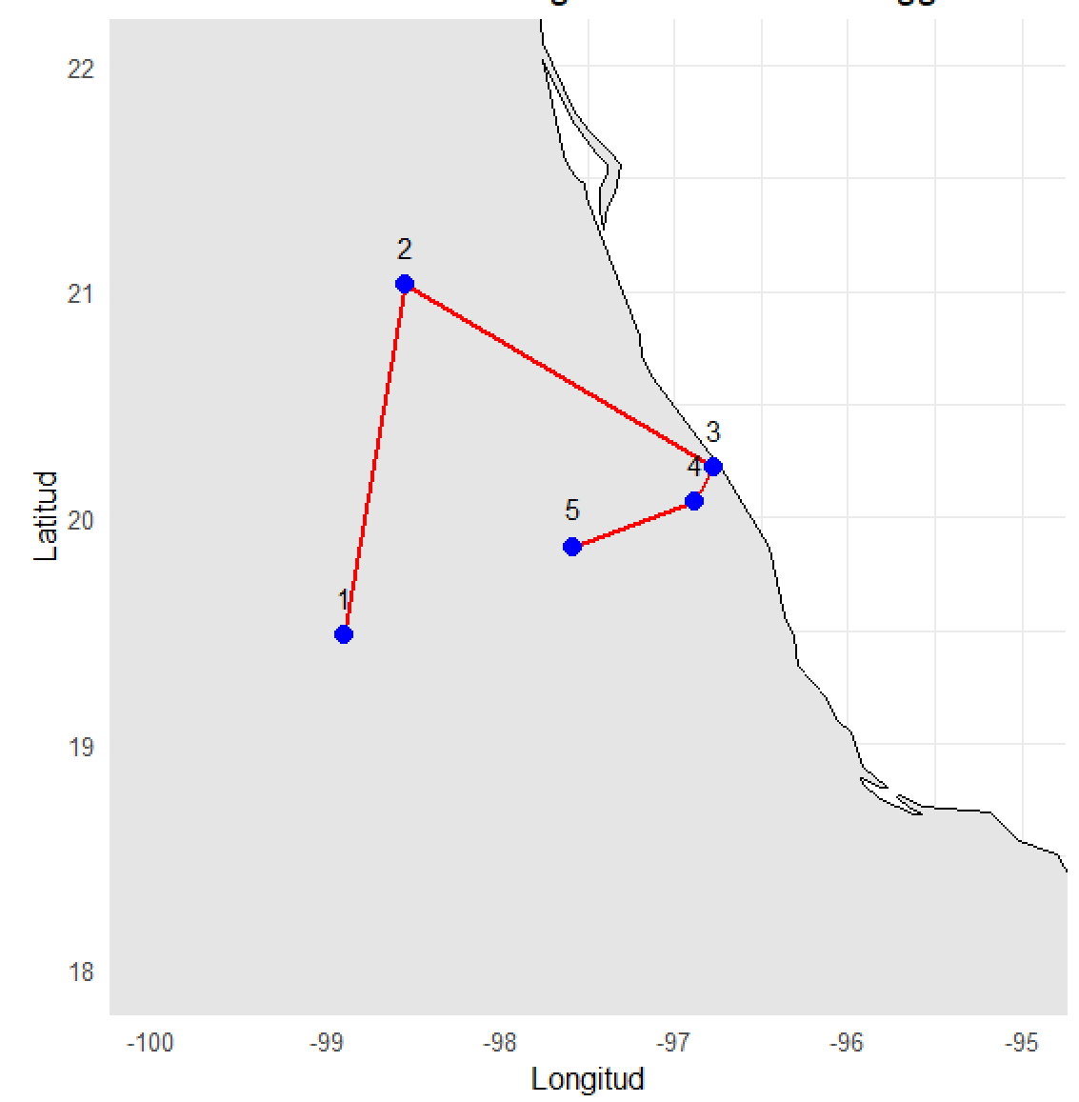
Fig. 9. Geospatial distribution of the field validation sites and transport route of the georeferenced datalogger in central and eastern Mexico, where numbered markers indicate the sampling and testing locations: (1) Montecillo, State of Mexico; (2) Tlalchiyahualica, Hidalgo; (3) Costa Esmeralda, Veracruz; (4) Martínez de la Torre, Veracruz; and (5) Zacapoaxtla, Puebla, while the red line represents the approximately 909 km route traversed during the field validation campaign.

Following the regional field validation campaign, a localized assessment was conducted at the Colegio de Postgraduados, Campus Montecillo, to evaluate the spatial consistency and repeatability of the GPS module. Measurements were recorded across different soil surface conditions, including recently irrigated areas, dry surfaces, and soils presenting superficial crusting with residual subsurface moisture. Multiple readings were captured at identical stationary positions to verify the stability of the geographic coordinates and sensor responses during repeated measurements. The spatial distribution of these sampling points is illustrated in Fig. 10.

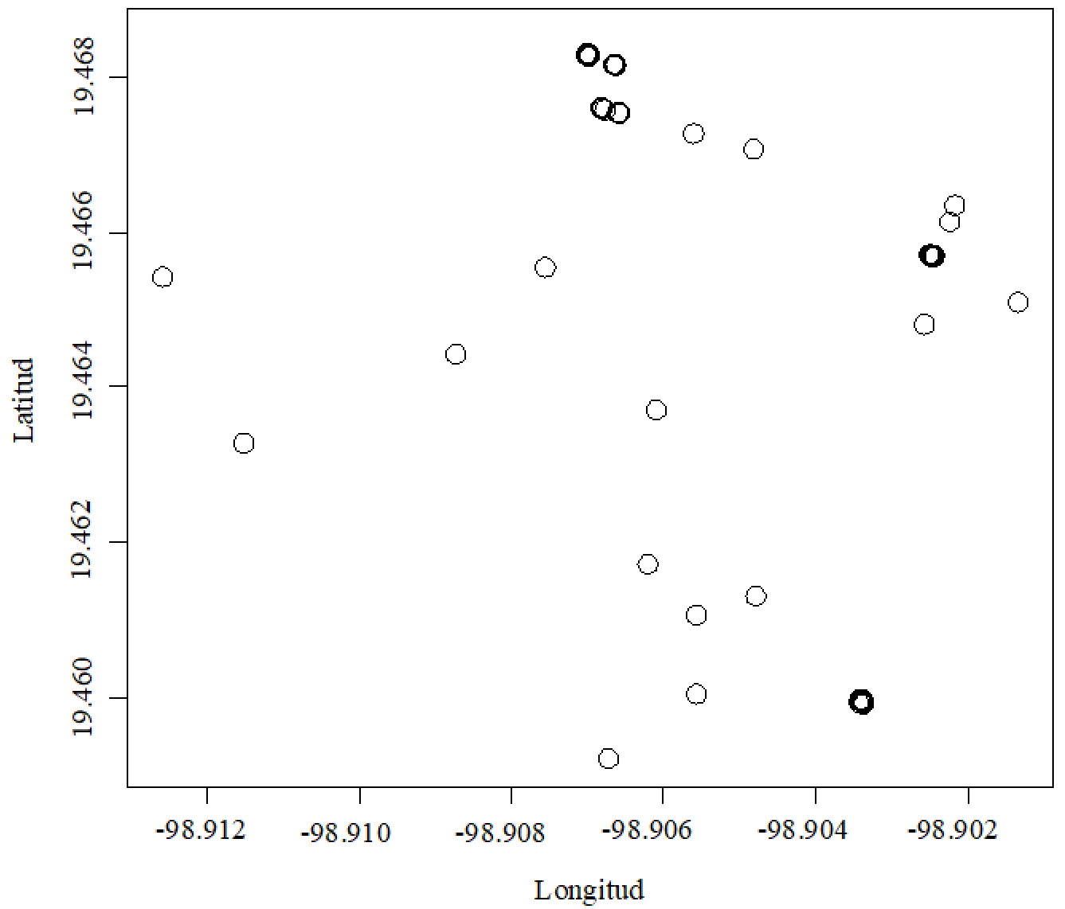
Fig. 10. Campus-scale spatial distribution of validation points at Colegio de Postgraduados, Campus Montecillo (Mexico), where each circle represents a measurement obtained with the proposed datalogger and overlapping markers indicate locations of repeated sampling used to verify GPS positional consistency and sensor stability under different soil moisture conditions.

Geospatial Post-Processing and Surface Interpolation. The georeferenced sampling points (Fig. 10) were used to demonstrate the spatial post-processing capabilities of the developed datalogger. By integrating recorded geographic coordinates with sensor data, illustrative contour maps were generated for soil moisture and electrical conductivity (Fig. 11). Spatial interpolation was performed in R using Akima’s bivariate quintic method, which enables the construction of continuous surfaces from discrete field measurements. These interpolated surfaces are intended for demonstration of data integration and system functionality rather than a definitive characterization of the study area's spatial variability.
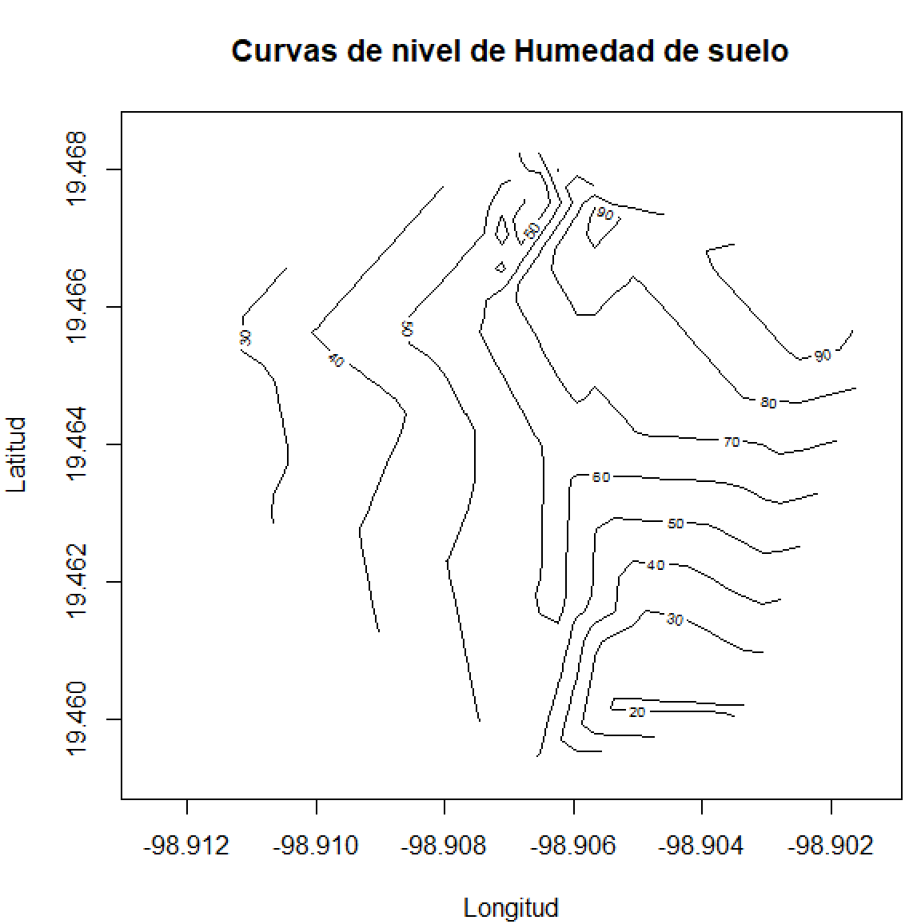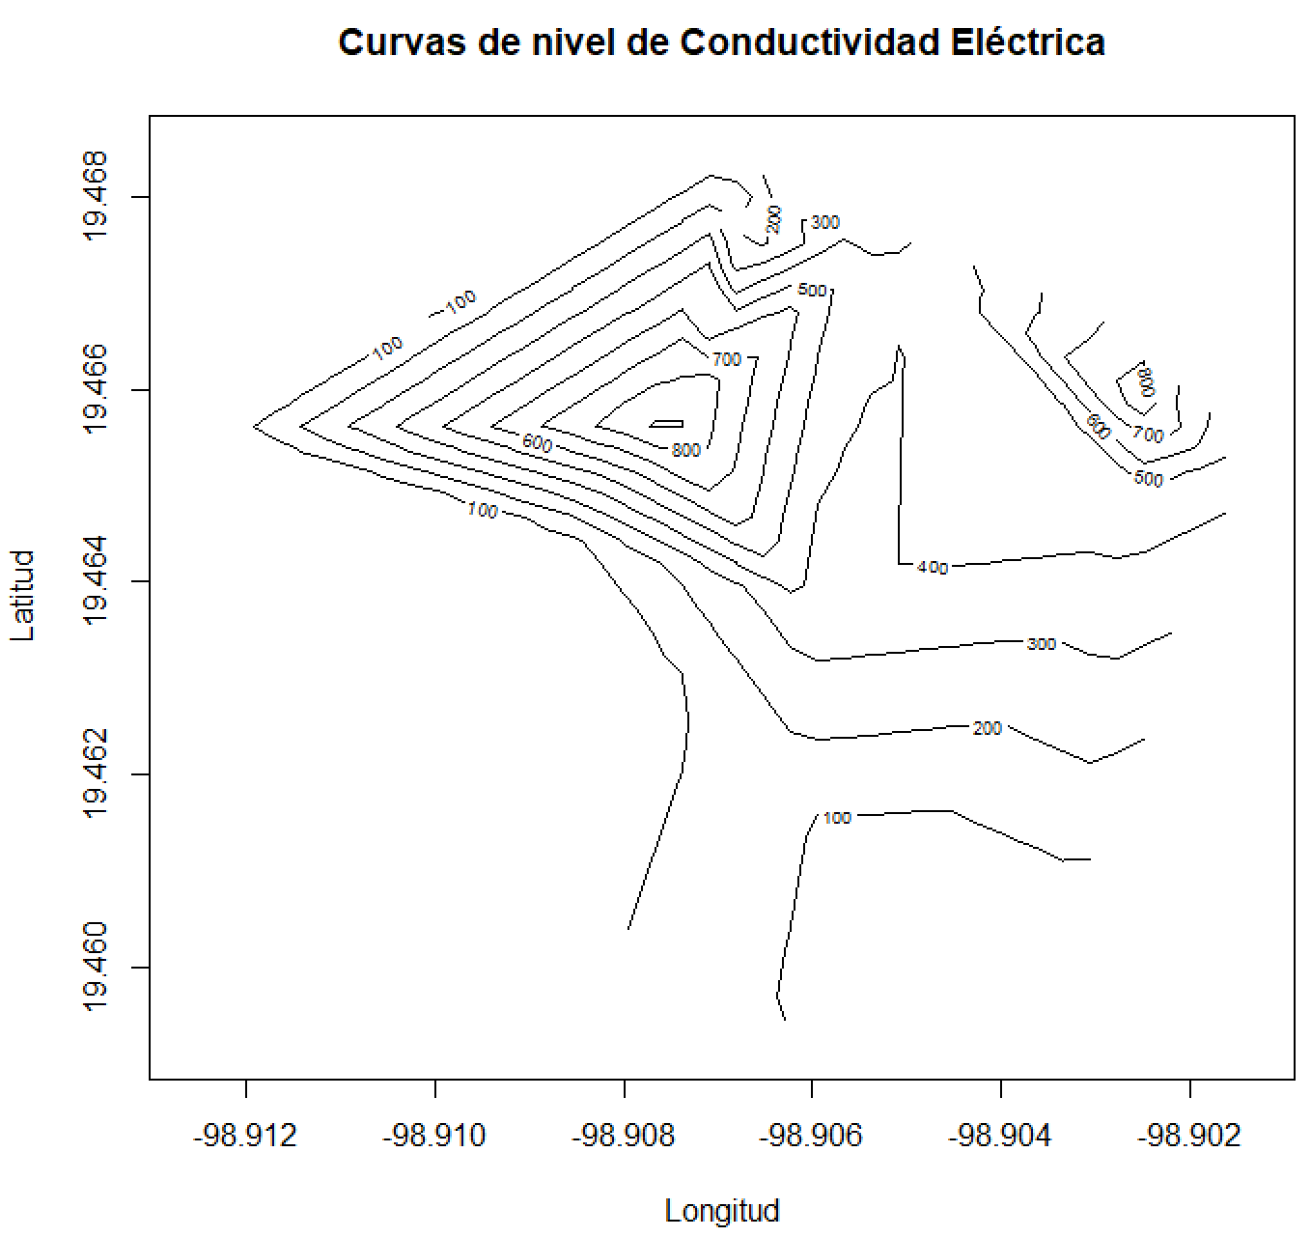
Fig. 11. Demonstrative contour map of soil moisture (Left) and electrical conductivity (right) generated from georeferenced measurements collected within the Colegio de Postgraduados campus using Akima interpolation in R.

Previous studies have reported soil nitrogen contents ranging from approximately 40 to more than 200 mg N kg⁻¹ depending on soil properties and environmental conditions (Suárez et al., 2015). This wide range illustrates the natural variability of nitrogen availability in soils and is consistent with the values detected by the proposed sensing system (0–234 mg kg⁻¹).
Phosphorus concentrations estimated by the sensing system ranged from 0 to 648 mg kg⁻¹ across the evaluated locations. Although these measurements correspond to indirect estimates rather than laboratory-determined phosphorus fractions, their magnitude is comparable to values reported for tropical soils. For example, López et al. (2002) reported residual phosphorus concentrations reaching 293 mg kg⁻¹ in Ultisols and 230 mg kg⁻¹ in Oxisols in highly weathered soils. Similarly, Villarreal-Núñez et al. (2017) reported total phosphorus contents ranging from 165 to 764 mg kg⁻¹ in soils from Panama. These results suggest that the phosphorus levels detected by the sensor fall within ranges reported in the literature for tropical soils, although differences may arise due to the analytical methods used and the specific phosphorus fractions quantified.
Potassium concentrations estimated by the sensing system ranged from 0 to 645 mg kg⁻¹ across the evaluated sites. Although these values correspond to indirect sensor-based estimates, they fall within the magnitude reported for tropical soils. For instance, Molina et al. (1986) reported potassium concentrations ranging from 45 to 620 mg kg⁻¹ for exchangeable K and up to 704 mg kg⁻¹ when extracted with HNO₃ in Andepts soils of Costa Rica. Additionally, previous studies have emphasized that the interpretation of potassium availability in soils should consider clay content, since clay minerals can influence potassium retention and availability in the soil matrix (Solórzano et al., 2021). This observation is consistent with the conditions found in the Huejutla sampling site, where the soils presented a clayey texture. Soil texture at the sampling locations was determined in the field using the USDA soil texture-by-feel method (USDA-NRCS, 2022).
It should be noted that the NPK measurements obtained with the sensor are based on a rapid detection method derived from soil electrical conductivity rather than direct chemical analysis. According to the manufacturer specifications, the sensor estimates nitrogen, phosphorus and potassium concentrations indirectly using empirical relationships with soil electrical properties (Estudiez, 2025). Therefore, the reported nutrient values should be interpreted as indicative measurements useful for monitoring trends and spatial variability rather than precise laboratory determinations. The relationship between nutrients and electrical conductivity has been used in practical applications such as real-time fertilization (Dou et al., 2026), the evaluation of the effects of different basal fertilizers including inorganic, organic, and compost fertilizers (Vyavahare et al., 2023), and the analysis of factors influencing soil EC sensor values by monitoring electrical conductivity under different soil organic matter and water contents (Kim and Park, 2024).

Soil electrical conductivity is commonly used as an indicator of the concentration of soluble ions present in the soil solution and is therefore related to nutrient availability and soil salinity (Dennis & Scott, 2003; Rhoades et al., 2012). Electrical conductivity values measured by the sensing system ranged from 0 to approximately 1.43 mS cm⁻¹ across the evaluated sites, indicating low electrical conductivity levels compared with the salinity thresholds reported by Rhoades et al. (1999), who classified soils with low salinity as those presenting electrical conductivity values below 2 dS m⁻¹.
Soil temperature recorded during the measurements ranged from approximately 11.8 to 27.2 °C across the evaluated sites. These measurements were conducted to verify that the device could operate under different temperature conditions. This range is consistent with the study of Kelley et al. (2025), who evaluated the response of soil moisture sensors within a temperature range of 4 to 14 °C, demonstrating that temperature can influence sensor readings and may require calibration adjustments. Temperature is an important factor when measuring soil moisture, as Zhu et al. (2019) reported temperature effects on soil moisture measurements using FDR and TDR sensors. Therefore, temperature influence could represent an area of opportunity for further calibration of the sensor evaluated in this study.
Soil pH values recorded during the measurements ranged from approximately 3.6 to 5.0 across the evaluated sites, indicating acidic soil conditions. These values are consistent with those reported for tropical soils. For example, Motavalli et al. (1995) reported initial soil pH values ranging from 3.9 to 6.7 in tropical forest soils.
The sensing system was subjected to extensive field validation across multiple locations in central and eastern Mexico. During the field campaign, the device was transported approximately 900 km between sampling sites under real road conditions. Despite the exposure to vibrations, varying terrain conditions, and contrasting environmental environments, the system operated continuously without signal instability or hardware malfunction, demonstrating the robustness of the proposed datalogger for field applications.
Overall, the results indicate that the proposed georeferenced datalogger is capable of acquiring soil variables under diverse environmental conditions, including tropical lowlands, coastal environments, and montane cloud forest regions. The consistency of the measurements and the stability of the system during long-distance field deployment demonstrate its potential as a practical tool for georeferenced soil monitoring and precision agriculture applications.

Recent advances in precision agriculture have promoted the development of sensor-based monitoring systems capable of providing real-time information on soil and environmental conditions. Several studies have reported the use of low-cost sensing platforms and IoT-based systems to monitor agricultural variables such as soil moisture, temperature, and other environmental parameters in field conditions (Rajani et al., 2023; Kalaivani et al., 2025). These systems often integrate user-friendly interfaces or dashboards that allow visualization of measurements and historical records, facilitating practical decision-making in agricultural management (Aditya et al., 2024). Furthermore, sensor-based monitoring technologies provide real-time data that support more efficient agricultural practices, including optimized irrigation and fertilization strategies (Mansoor et al., 2025). Early developments in precision agriculture also emphasized the importance of rapidly obtaining spatially distributed soil information through mobile or on-the-go sensing systems (Adamchuk et al., 2004). In this context, the device proposed in the present study contributes to these efforts by integrating the measurement of multiple soil variables—including soil moisture, temperature, electrical conductivity, pH, and estimated nutrient concentrations—with georeferenced data acquisition in a portable and low-cost system. Such developments support the transition toward more efficient and technology-assisted agricultural management systems (Soussi et al., 2024).

Limitations of the study. The NPK measurements provided by the sensor are indirect estimations based on electrical conductivity relationships rather than direct laboratory analysis. Therefore, the values reported in this study should be interpreted as indicative measurements useful for monitoring spatial trends rather than precise nutrient concentrations.

4. Conclusion

The georeferenced datalogger developed in this study demonstrated reliable operation for the simultaneous measurement and storage of multiple soil variables, including soil moisture, temperature, electrical conductivity, pH, and estimated concentrations of nitrogen, phosphorus, and potassium. The integration of a GPS module and microSD data storage allowed the automatic recording of georeferenced measurements through a simple user interface designed for field conditions.
Field validation tests conducted across several regions of central and eastern Mexico, covering approximately 900 km of transportation under real road conditions, confirmed the mechanical robustness and operational stability of the device. The system operated consistently under contrasting environmental conditions, including tropical lowlands, coastal environments, and montane cloud forest ecosystems.
The ranges of soil variables detected by the sensing system were consistent with values reported in previous studies for tropical and agricultural soils, supporting the potential applicability of the device for rapid field assessments. Although the nutrient measurements provided by the sensor are indirect estimates derived from electrical conductivity relationships rather than laboratory determinations, the results indicate that the system can effectively capture spatial trends and variability in soil properties.
Ultimately, the proposed device represents a cost-effective, portable, and durable tool for georeferenced soil monitoring. Its modular architecture offers potential applications in precision agricultural management, environmental monitoring, and large-scale soil surveys, particularly in resource-limited regions where high-resolution spatial data can support sustainable land management.

COMPETING INTERESTS DISCLAIMER:
Authors have declared that they have no known competing financial interests OR non-financial interests OR personal relationships that could have appeared to influence the work reported in this paper.
Disclaimer (Artificial intelligence)
The authors declare that generative AI tools were used only for language editing and grammar improvement. All scientific content, analysis, and interpretations were developed and verified by the authors.

References

Motavalli, P. P., Palm, C. A., Parton, W. J., Elliott, E. T., & Frey, S. D. (1995). Soil pH and organic C dynamics in tropical forest soils: Evidence from laboratory and simulation studies. Soil Biology and Biochemistry, 27(12), 1589–1599.
Suárez, G., Campos, A., & Cruz, L. (2015). Soil carbon and nitrogen dynamics in dry tropical coastal ecosystems. Tropical and Subtropical Agroecosystems, 18(3), 347–361.
López, C. F., Vázquez, S., & Dalurzo, H. C. (2002). Phosphorus forms in highly weathered soils of the southern Misiones province. Ciencias del Suelo, 20, 81–87.
Villarreal-Núñez, J. E., Jaramillo, S., & Villalaz-Pérez, J. A. (2017). Phosphorus forms in soils of Panama. Ciencia Agropecuaria, 26, 97–111.
Estudiez, B. (2025). SOIL-MB-NPKPHCTH-S soil sensor: N, P, K, pH, EC, temperature and humidity sensor with RS-485 Modbus RTU (Datasheet, pp. 1–45). Slicetex Electronics.
Akima, H. (1978). A method of bivariate interpolation and smooth surface fitting for irregularly distributed data points. ACM Transactions on Mathematical Software, 4(2), 148–159.
INEGI. (2026). Climatology. National Institute of Statistics and Geography. https://www.inegi.org.mx/temas/climatologia/
Molina, E., Bertsch, F., Cordero, A., & Alvarado, A. (1986). Potassium in Andepts of Costa Rica. I. Forms on the ground. CATIE. https://repositorio.catie.ac.cr/handle/11554/11691
Solórzano, P. R., Torres, S. J., & García, J. (2021). Potassium availability and its relationship with clay content in Venezuelan soils. Journal of the Faculty of Agronomy, 47(1), 15–23.
USDA-NRCS. (2022). Soil texture and structure: Soil health guide. United States Department of Agriculture, Natural Resources Conservation Service.
Dou, H., Hu, L., Zhang, Y., Zhai, C., Li, S., & Chen, L. (2026). Precision variable-rate fertilizer application method based on real-time field soil electrical conductivity sensing. Computers and Electronics in Agriculture, 241, 111267.
Vyavahare, G. D., Lee, Y., Seok, Y. J., Kim, H. N., Sung, J., & Park, J. H. (2023). Monitoring of soil nutrient levels by an EC sensor during spring onion (Allium fistulosum) cultivation. Agronomy, 13(8), 2156.
Kim, H. N., & Park, J. H. (2024). Monitoring of soil EC for the prediction of soil nutrient regime under different soil water and organic matter contents. Applied Biological Chemistry, 67(1), 1.
Dennis, C., & Scott, L. (2003). Application of soil electrical conductivity to precision agriculture. Agronomy Journal, 95, 455–471.
Rhoades, J. D., Kandiah, A., & Mashali, A. M. (2012). The use of saline waters for crop production (FAO Irrigation and Drainage Paper 48). Food and Agriculture Organization of the United Nations.
Rhoades, J. D., Corwin, D. L., & Lesch, S. M. (1999). Geospatial measurements of soil electrical conductivity to assess soil salinity and diffuse salt loading from irrigation. Geophysical Monograph, 108, 197–216.
Kelley, B., Ali, N., & Dong, Y. (2025). Methods to correct temperature-induced changes of soil moisture sensors to improve accuracy. MethodsX, 14, 103100.
Zhu, Y., Irmak, S., Jhala, A. J., Vuran, M. C., & Diotto, A. (2019). Time-domain and frequency-domain reflectometry type soil moisture sensor performance and soil temperature effects. Applied Engineering in Agriculture, 35(2), 117–134.
Rajani, P. K., Deshpande, G., Goswami, M., Kolhe, J., Khandagale, V., Mujumdar, M., & Singh, B. B. (2023). IoT-Based Low-Cost Soil Moisture and Soil Temperature Monitoring System. SSRG International Journal of Electrical and Electronics Engineering, 10(10), 66-74.
Kalaivani, T. S., Kamireddy, T., & Govindakumar, S. (2025). IoT-Enabled Soil and Crop Monitoring System Using Low-Cost Smart Sensors for Precision Agriculture. Engineering Proceedings, 118(1), 77.
Aditya, B. R., Hernawati, E., Gunawan, T., & Aji, P. (2024). Design an Agricultural Soil and Environment Monitoring System Based on IoT. Pertanika Journal of Science & Technology, 32(6).
Mansoor, S., Iqbal, S., Popescu, S. M., Kim, S. L., Chung, Y. S., & Baek, J. H. (2025). Integration of smart sensors and IOT in precision agriculture: trends, challenges and future prospectives. Frontiers in Plant Science, 16, 1587869.
Adamchuk, V. I., Hummel, J. W., Morgan, M. T., & Upadhyaya, S. K. (2004). On-the-go soil sensors for precision agriculture. Computers and electronics in agriculture, 44(1), 71-91.
Soussi, A., Zero, E., Sacile, R., Trinchero, D., & Fossa, M. (2024). Smart sensors and smart data for precision agriculture: a review. Sensors, 24(8), 2647.

