Numerical Investigation of Thermal and Hydraulic Performance for Grid-Type Earth-to-Air Heat Exchangers: A Comparative Study of U-Type and Z-Type Configurations

Keywords:  Earth-to-air heat exchanger; Grid-type EAHE; CFD simulation; Greenhouse ventilation; Flow uniformity; Pressure loss; Thermal effectiveness. | Abstract  Heating and cooling needs in greenhouses constitute a significant portion of total energy use, and therefore the adoption of passive and renewable approaches is important. Earth-to-air heat exchangers (EAHEs) exploit the relatively constant subsurface temperature to precondition ventilation air and may provide a sustainable option for greenhouse applications. Although grid-type configurations are particularly relevant to systems that require relatively large airflow rates, most previous studies have discussed isolated performance indicators under different geometrical and operating conditions, which makes fair comparison difficult. This study presents a numerical comparison of two grid-type EAHE configurations, Z-type and U-type, under identical geometric and operating conditions using four dimensionless performance parameters: thermal effectiveness ε, total pressure-loss coefficient K, airflow division uniformity coefficient Ω, and overall performance factor η* (defined as the ratio of heat-transfer rate to pumping power). The results show that the U-type layout improves flow distribution and reduces hydraulic losses. Ω increased from 0.79 to 0.87 for the U-type, while it decreased from 0.73 to 0.64 for the Z-type, resulting in a 38% improvement at high flow rates. Total pressure losses decreased by more than 28%, resulting in a corresponding reduction in fan-power demand. The thermal performance remained relatively similar, with ε differences ranging from 1% to 2%. However, η* was consistently higher for the U-type arrangement, exceeding the Z-type by more than 40% at the highest Reynolds number. Overall, the results suggest that the U-type EAHE provides the more favorable thermal–hydraulic performance for passive, energy-efficient greenhouse ventilation under the investigated conditions.

Introduction

One of the main challenges today is the high energy demand associated with greenhouse heating and cooling, which has increased interest in the use of renewable energy sources. Geothermal energy represents an important category of renewable energy that can be applied in power generation as well as in heating and cooling systems. Interest in sustainable and passive technologies has therefore continued to grow. Earth-to-air heat exchangers have emerged as promising solutions in ventilation and air-conditioning systems because they can utilize the relatively stable soil temperature at a specific depth (3–4 m) to improve the condition of incoming air. By exchanging heat between the air and the ground, the system can provide cooling during summer and heating during winter. Among the diverse design layouts, the grid-pipe configuration is particularly important. In this arrangement, a header pipe is installed at both the entrance and the exit so that ambient air is distributed through several buried parallel pipes and then collected before being supplied to the indoor space, as shown in Figure 1. This configuration is suitable for applications that require a relatively large amount of preconditioned air. Given this importance, several previous studies have investigated grid-type EAHE arrangements from different perspectives, such as heat transfer, effectiveness, the effect of pipe diameter and number, and airflow distribution patterns in the network.
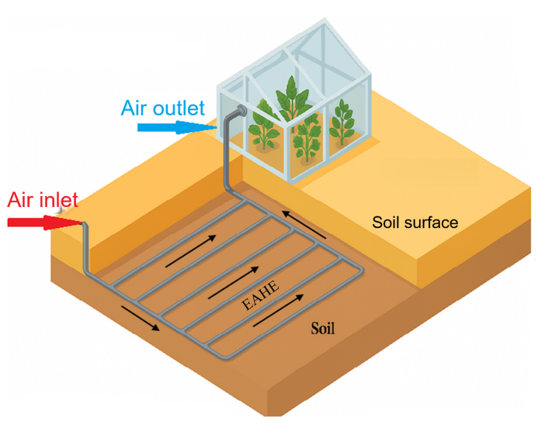
Figure 1: Schematic of EAHE system.

Previous studies have extensively investigated the design and performance of Earth-to-Air Heat Exchanger (EAHE) systems, with particular emphasis on grid-type configurations and their thermo-hydraulic behavior under various operating conditions.
Badescu and Isvoranu [1] created a mathematical approach in the evaluation of different grid geometries and airflow paths and showed that Z-paths can be more thermally efficient than U-paths. Whereas, Amanowicz and Wojtkowiak [2] carried out an experiment on the hydraulic and flow distribution characteristics of grid designs. The analysis showed that alterations of air supply scheme including transition of Z-type to U-type can be successfully used to enhance uniformity of airflow and reduction of pressure loss, which is 9 per cent better heating transfer performance as compared to the conventional Z-type design. The relevance of the effect of the geometric parameters and airflow distribution on overall performance was proven by the subsequent analyses. Ahmed et al [3] numerical and experimental analysis of a grid EAHE system was performed in a hot-humid climate with major consideration to the length of pipes, their diameter, and the flow rate as some of the factors that influence the cooling potential. Amanowicz and Wojtkowiak [4, 5] motivated further research by them which demonstrated the influence of non-uniform airflow in grid pipes. Their results showed that under static pressure imbalance in pipes it is possible to achieve variation in the flow distribution which is up to five times, thereby increasing the overall pressure losses and reducing thermal efficiency. Amanowicz [6] in CFD and simulated models showed that modification of air supply configuration between Z-type and U-type leads to a reduction of total pressure losses by 6-36% and enhancement of flow uniformity by 11-80%. A number of applied studies have provided significant information with regards to the functioning of EAHE systems under a variety of environmental conditions. Sakhri et al. [7] conducted experiments in dry Algerian conditions, but demonstrating the high level of heating and cooling efficiency of the system in various seasons. Mushtaq and Muter [8] focused on the benefits of grid arrangement in poultry houses in Nasiriyah, and Ahmad and Prakash [9] experimented to identify the effects of pipe diameter and velocity on effectiveness, and Mohammed et al. [10] modeled alternative EAHE systems in Iraq, which validated that multi-pipe systems have high potential as a cooling system. Recently, Eman Hummood et al. [11] carried out a numerical experiment whereby computational fluid dynamics was used to find out the impacts of the disturbed soil thickness on the effectiveness of Earth-to-Air Heat Exchangers (EAHE) when the length of the pipes was varied and lengthened with varying flow velocities in Nasiriya, in southern Iraq. The results revealed that there were at least changes in the flow velocity or pipe length in determining the temperature of the wall at the 1D to 6D levels in low velocities. This stability is associated with the effect of the temperature around the growing layer of soil on its growing thickness. Sofyan et al. [12] applied Ansys Fluent to measure the cooling performance of EAHE systems in parallel and series configurations. Their results showed that losses of pressure in parallel systems were about six times less than those in series systems. It was found that parallel systems were more efficient by approximately 15 percent than series systems even though the latter produced air at much lower temperatures than the former.
Recently, further studies have continued to expand EAHE research in directions relevant to the present work. Qi et al. [13] investigated the optimization of a multi-pipe EAHE system for greenhouse applications and highlighted the importance of operating and design parameters in determining greenhouse thermal performance. El-Said [14] examined the thermal–hydraulic characteristics of EAHE systems with different buried-pipe layouts and confirmed that exchanger configuration can significantly influence the balance between heat-transfer benefit and flow resistance. In addition, Allali et al. [15] evaluated the greenhouse microclimatic performance of an EAHE-based conditioning system relative to another passive thermal-storage option and reported that EAHE systems can provide useful temperature moderation under greenhouse operating conditions. Ali et al. [16] also presented a recent comparative assessment of EAHE performance under contrasting climatic conditions and emphasized the importance of site-specific conditions in determining system effectiveness. These recent developments further support the need for controlled comparative studies in which alternative grid layouts are evaluated under identical geometric and operating conditions.
Although previous studies have improved the understanding of grid-type EAHE systems, direct comparison between alternative layouts remains difficult because many published results were obtained under different geometrical, thermal, and operating conditions, and often emphasized either thermal or hydraulic performance separately. In addition, relatively few studies have provided a controlled comparison between U-type and Z-type grid layouts for greenhouse ventilation using a unified set of dimensionless performance indicators.

To address this gap, the present paper provides a CFD-based comparative assessment of two grid-type EAHE layouts, Z-type and U-type, under identical geometric and operating conditions. The comparison is intended to isolate the effect of the flow path alone, since both layouts have the same pipe number, pipe diameter, buried length, and burial depth. Four dimensionless indicators form the basis of the investigation: thermal effectiveness (ε), total pressure-loss coefficient (K), airflow uniformity coefficient (Ω), and overall performance factor (η*). Taken together, these indicators provide a standardized framework for a fair thermal–hydraulic comparison between the two layouts. This paper reports only the numerical comparative part of the study; no experimental results are presented here.

Problem Description

The model studied in this paper is a 3D grid-pipe earth-to-air heat exchanger system used for greenhouse cooling, investigated in two layouts: U-type and Z-type. The geometry was selected to represent a practical small-greenhouse application under Nasiriyah conditions while maintaining the same pipe material, diameter, branch length, spacing, and burial depth in both layouts so that only the effect of the flow path is examined. The EAHE was modeled using PVC pipes that are 3 mm thick. Both structures are designed as a buried grid at a depth of 3.5 m, where it is composed of six parallel pipes with a 1 m interval between them, a diameter of 0.1016 m, and a length of 6.93 m. All six pipes are joined by two main pipes having a diameter of 0.1016 meters and a length of 5.7 m.

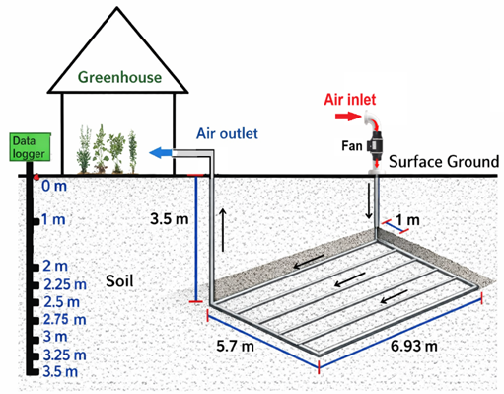
Figure 2: Schematic of EAHE system with greenhouse.
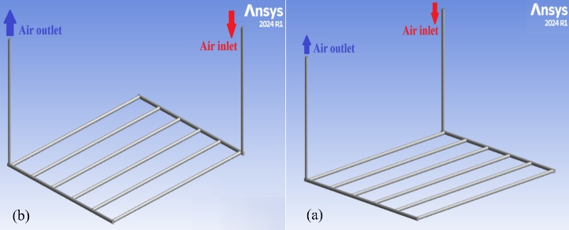
Figure 3: Geometric models of the EAHE: (a) U-type and (b) Z-type.
Disturbed soil
The soil layer in the vicinity of the EAHE pipe is affected by heat transfer, and this region is referred to as the thermally disturbed soil illustrated in Figure 4.
There is no universal formula to calculate the thickness of the thermally disturbed soil layer [17], as it strongly depends on soil thermal properties, climatic conditions, and operational parameters of the EAHE system, several researches suggested that the thickness of disturbed soil should be equivalent to the radius of the pipe (δ = R₁) [18, 19], twice the pipe diameter [20] and four times the pipe diameter [21].
In this study, the disturbed soil domain radius (R₂) was taken to be twice the outer radius of the pipe (R₂ = δ + R₁) [19].
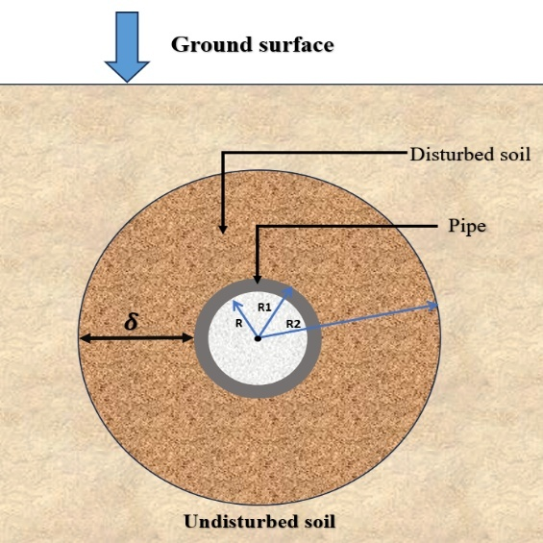
Figure 4: The cross-sectional schematic of the EAHE pipe depicts the thickness of the disturbed soil layer.
Mathematical Model

In order to simplify the analytical formulation and ensure the problem's tractability, the mathematical model was constructed based on certain simplifying assumptions [22, 23]:
1-The system operates under steady-state conditions.
2-The flow velocity is uniform and constant throughout the domain.
3-The soil exhibits consistent physical characteristics and remains of a homogenous.
4-The airflow is described as subsonic (M<0.3), letting its treatment as an incompressible fluid with assumed constant thermal conductivity, density, and specific heat capacity.
5-Perfect thermal contact exists between the pipe wall and the surrounding soil.
6-A turbulent flow regime (Re > 4000) is observed inside the pipe, and the corresponding turbulent correlations are applied.

Governing equations and boundary conditions

This analysis employed the following equations of heat transfer and fluid flow [11, 24]:
Continuity equation:
$div \overline{V}$ = 0 (1)
Momentum equations:
x-dir.
$\frac{∂\overline{u}}{∂t}+div \left(\overline{u} \overline{V}\right)+ div\left(\overline{uˈ Vˈ}\right)= - \frac{1}{ρ} \frac{∂\overline{p}}{∂\overline{x}}+ ν div \left(grad \left(\overline{u}\right)\right)$ (2)
y-dir.
$\frac{∂\overline{v}}{∂t}+div \left(\overline{v} \overline{V}\right)+ div\left(\overline{vˈ Vˈ}\right)= - \frac{1}{ρ} \frac{∂\overline{p}}{∂\overline{y}}+ ν div \left(grad \left(\overline{v}\right)\right)$ (3)
z-dir.
$\frac{∂\overline{w}}{∂t}+div \left(\overline{w} \overline{V}\right)+ div\left(\overline{wˈ Vˈ}\right)= - \frac{1}{ρ} \frac{∂\overline{p}}{∂\overline{w}}+ ν div \left(grad \left(\overline{w}\right)\right)$ (4)
Energy equation:
$\frac{∂U\tilde{T}}{∂x}+ \frac{∂V\tilde{T}}{∂y}+ \frac{∂W\tilde{T}}{∂z}=\frac{k}{ρ cp} \left(\frac{∂}{∂x} \left(\frac{∂\tilde{T}}{∂x}\right)+ \frac{∂}{∂y} \left(\frac{∂\tilde{T}}{∂y}\right)+ \frac{∂}{∂z} \left(\frac{∂\tilde{T}}{∂z}\right)\right)$ (5)
The effectiveness of earth to air heat exchanger can be defined as [5]:
$ε=\frac{T_{i}-T_{o}}{T_{i}-T_{s}}$ (6)
Where Ts refers to the undisturbed soil temperature, which is assumed to be equal to the temperature of the pipe wall [26].
The overall performance factor (η*) is employed to evaluate the overall performance of the EAHE system. It is defined here as the ratio of the heat-transfer rate between air and soil to the necessary air pumping power [19, 27]. Since both quantities are expressed in watts, η* is dimensionless and directly reflects the balance between thermal benefit and hydraulic penalty.
$η^{*}= \frac{Q_{EAHE}}{P.P}$ (7)
The heating and cooling potential of EAHE system has been determined using the following equation. [10]:
$Q_{EAHE}=\dot{m }C_{P} \left( T_{i}-T_{o}\right)$ (8)
P.P: is the pumping power, as computed by Eq. (9) [11]:
$P.P=\dot{V}{ ∆P}_{tot}$ (9)
$\dot{V}=\frac{\dot{m}}{ρ}$ (10)
Pressure drop denotes a difference in total pressure between the inlet and outlet sections of the EAHE pipes:
${∆P}_{tot}=P_{i}-P_{o}$ (11)
The total pressure loss coefficient (K) is a nondimensional value which is used to represent the degree of resistance of flow experienced in a system. It develops a correlation between the total pressure drop and dynamic pressure of the moving fluid. The coefficient is used as a basic measure in the evaluation of system configurations, the establishment of energy dissipation, and substantiation of power needs of fans in ventilation systems and heat exchange systems. The coefficient is calculated using Eq. (12) [6]:
$K=\frac{2 .{ ∆P}_{tot}}{ρ.{ v}^{2}}$ (12)
Flow uniformity coefficient (Ω) is a non-dimensional value that characterizes the evenness of the total volumetric flow distribution across the parallel pipes. This study relates flow maldistribution to system performance by analyzing grid-pipe EAHE layouts with the same number of parallel pipes under identical conditions. The ideal equal share, denoted by Ω = 1, signifies a perfectly uniform distribution, while Ω < 1 reflects growing maldistribution. The formulation adopted in Eq. (13) follows [24] and was selected because it directly compares the branch flow rates with the mean branch flow rate, which makes it suitable for comparing layouts of the same exchanger size.
$Ω=1-\frac{1}{{\dot{V}}_{a}} .\sqrt{\frac{\sum_{i=1}^{n}{{({\dot{V}}_{i}-{\dot{V}}_{a})}^{2}}}{n(n-1)}}$ (13)
Boundary conditions:
The following boundary conditions have been utilized to complete the model:
Inlet boundary condition:
At the inlet of the EAHE pipe, constant velocity values of 3, 5, 7, 9, 11, 13, 15, and 17 m/s were prescribed to represent a wide operating range from low to high airflow rates. This range was selected to show the thermal-hydraulic trade-off over practical operating conditions and to include the upper design point required for the greenhouse application considered in this study. The inlet dry-bulb temperature (T_{i}) was defined for turbulent-flow conditions. A constant inlet temperature of 50°C was imposed as a representative summer design condition for Nasiriyah, southern Iraq.
Outlet boundary conditions:
At the outlet, the relative pressure was considered zero atmospheric pressure.
Wall:
The horizontal part of the EAHE pipes is subjected to a constant soil-temperature boundary condition, as demonstrated in Figure 2. The wall temperature was prescribed as T_{s} = 26.1°C, representing a site-specific undisturbed-soil temperature at a depth of 3.5 m reported in our previously published work [29]. The two vertical segments were assumed to be adiabatic to simplify the numerical solution. Since the temperature changes along these two sections occur in opposite directions, their overall effect on the outlet air temperature is expected to be small compared with the horizontal buried section, where the surrounding soil temperature remains relatively stable. This assumption has been widely adopted in previous EAHE numerical studies [7], [17].

Numerical Solution:

The finite-volume approach was used to solve the governing equations and boundary conditions numerically. Computational Fluid Dynamics (CFD) was employed to solve the three-dimensional Navier–Stokes equations and to simulate the development of the airflow.
Computational Fluid Dynamics (CFD) modeling:

The primary purpose of using Computational Fluid Dynamics (CFD) in the present work is to predict the airflow and heat-transfer behavior inside the EAHE pipes under the specified boundary conditions [29]. ANSYS Fluent 2024 R1 software was used to conduct the CFD analysis. To simulate turbulent flow, the realizable k–ε turbulence model with enhanced wall treatment was adopted because it provides stable and reliable predictions for turbulent internal flows in ducts and manifolded pipe systems and has been used successfully in comparable EAHE studies [5, 6, 11]. The energy equation was solved because heat transfer was included in the computational model. CFD modeling also makes it possible to determine the main airflow characteristics at multiple locations within the EAHE system through the numerical mesh. The convergence criterion for the momentum and energy equations was set to 1 × 10⁻⁶.

Mesh independence test:

A mesh independence test was conducted as part of the mesh sensitivity analysis to ensure that the numerical results are not influenced by the mesh resolution. Four progressively refined meshes were examined. The selected Mesh 3 contained approximately 4.23 × 10⁶ elements. The final mesh quality was acceptable, with a maximum skewness of 0.757 and a minimum orthogonal quality of 0.243. Figure 5 presents the outlet-air temperature profile for the tested meshes. The change in outlet temperature from Mesh 3 to Mesh 4 was negligible (ΔT_{o} ≈ 0.0004 K), which indicates grid-independent results. Therefore, Mesh 3 was selected as a practical compromise between solution accuracy and computational cost. Table 1 summarizes the tested meshes, their element counts, and the predicted EAHE outlet-air temperature 𝑇_{𝑜}.
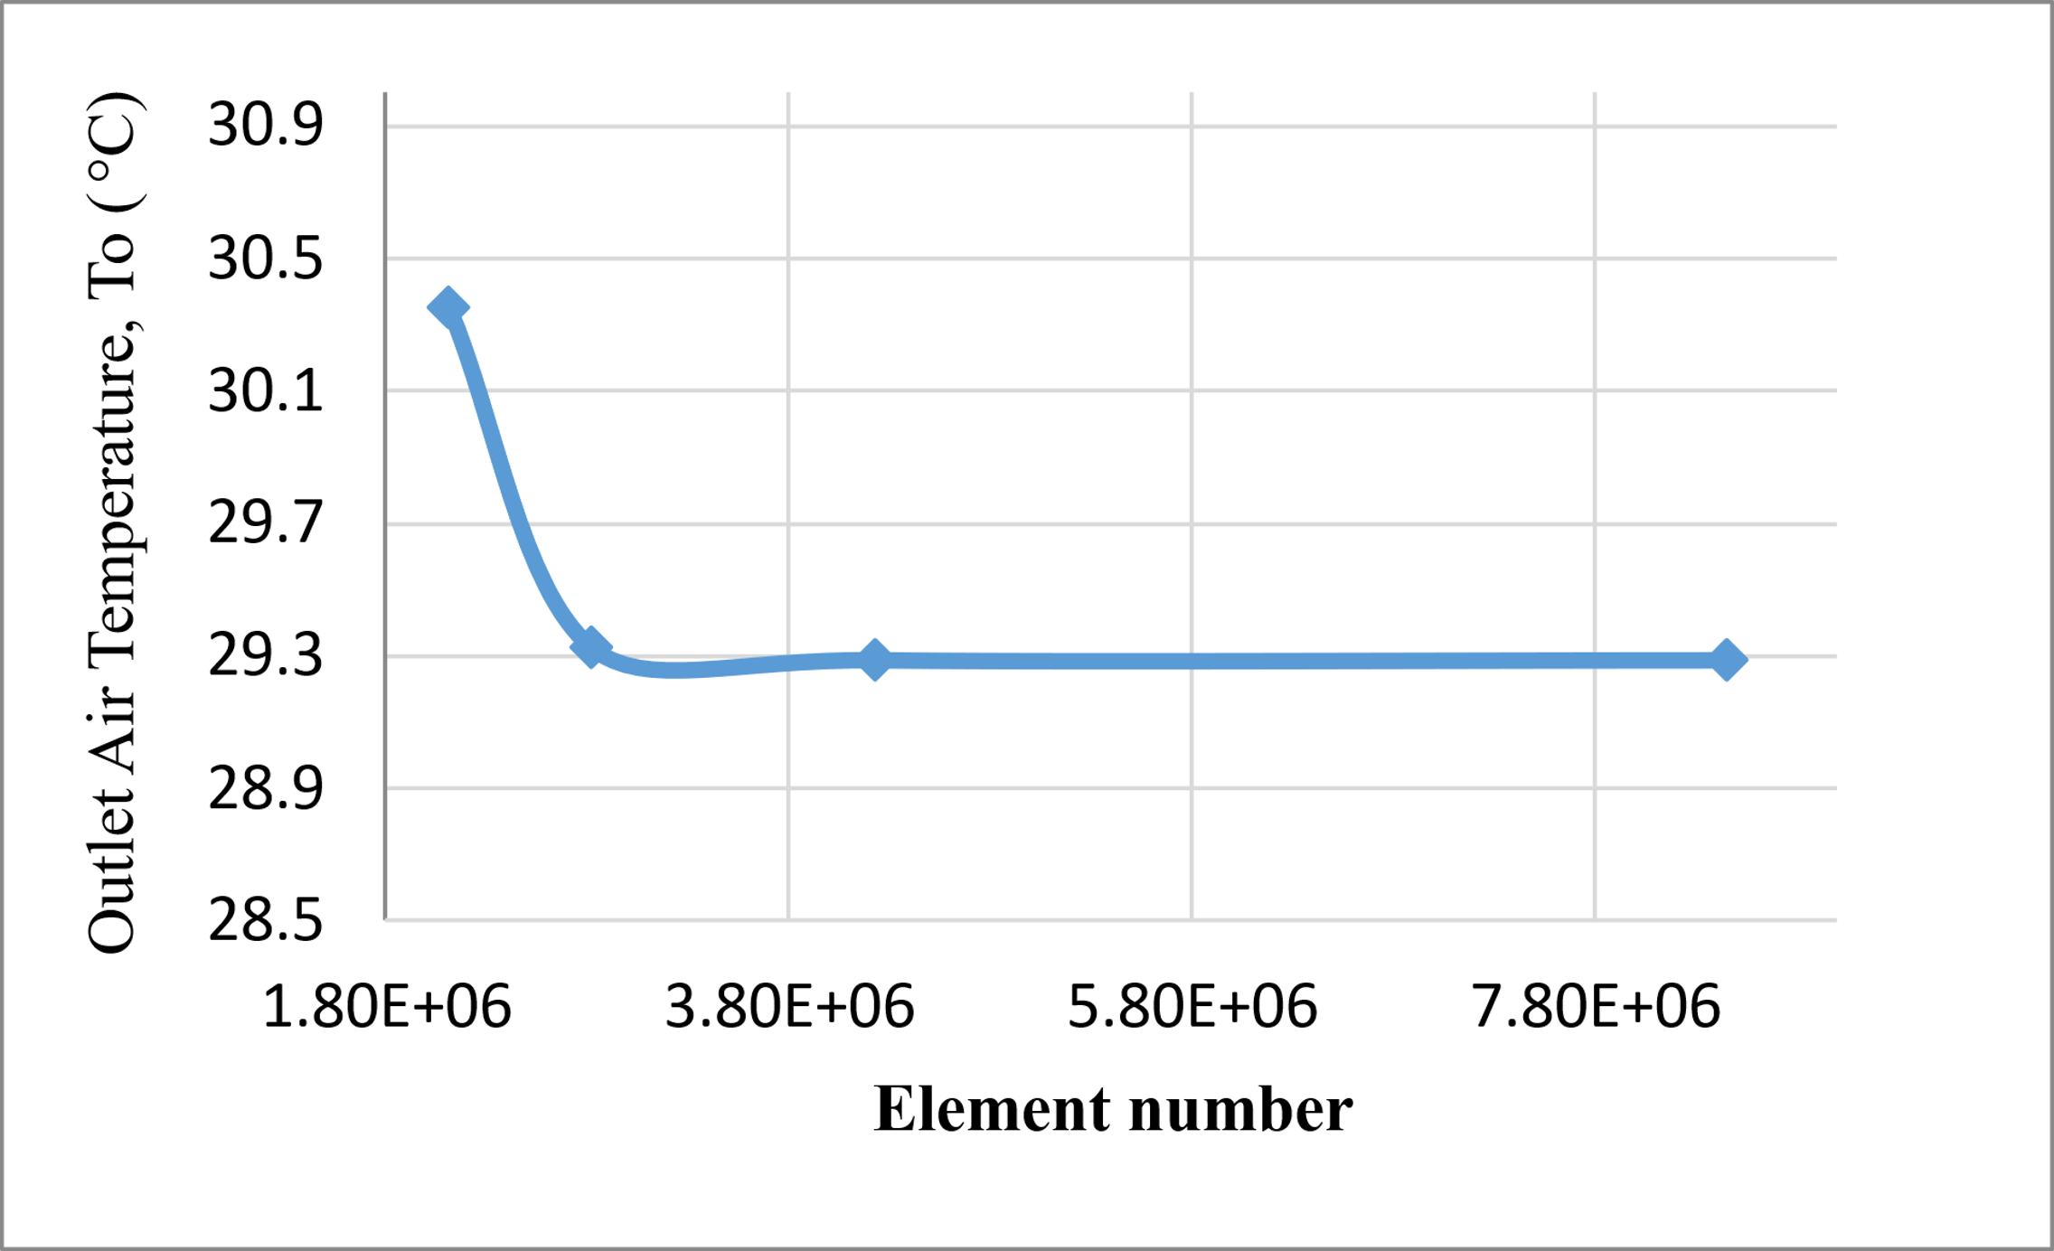 | Table 1: Mesh-independence test.  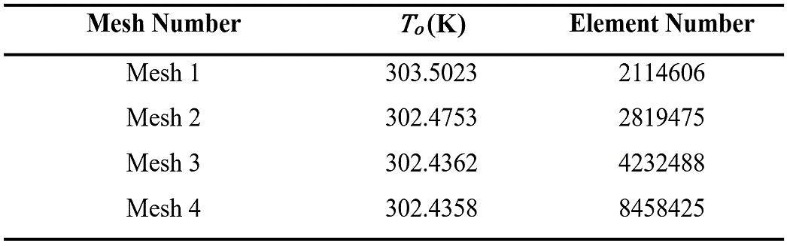
Figure 5: Effect of the element number on the outlet air temperature of the EAHE.

Results and discussion:

To verify the developed numerical model, the benchmark case reported in [30] was reproduced under the same geometry and operating conditions. The EAHE system described in [30] consists of a pipe with a diameter of 0.1016 m, a length of 11.88 m, and a burial depth of 3.5 m. Air was driven through the pipe at a constant velocity of 4.52 m/s, with inlet temperatures ranging from 33°C to 52°C, while the pipe surface temperature was maintained equal to the undisturbed soil temperature of 30°C. Figure 6 compares the simulation results of the present model with the published numerical and experimental data reported in [30] for the relationship between inlet and outlet air temperatures. The figure shows excellent agreement between the current model and the reference data, with average errors of 3.03% and 0.08%, respectively. These small deviations indicate that the current numerical model is implemented correctly and is sufficiently accurate for the reference thermal case. Although the verification benchmark is thermal in nature, the airflow-distribution and pressure-loss trends predicted in the present study are also in line with previously reported investigations of multi-pipe EAHE flow performance [2], [4], [5], [6].
The numerical simulations were conducted under the climatic conditions of Nasiriyah, southern Iraq, assuming constant thermal and physical properties of air and soil, as listed in Table 2.

Table 2: The thermophysical properties of air and soil [17].

Material | Density  (kg/m³) | Specific heat (J/kg. °C) | Thermal conductivity (W/m. °C)
Air | 1.225 | 1007 | 0.0242
Saturated soil | 2000 | 880 | 1.4
PVC | 1380 | 900 | 0.16

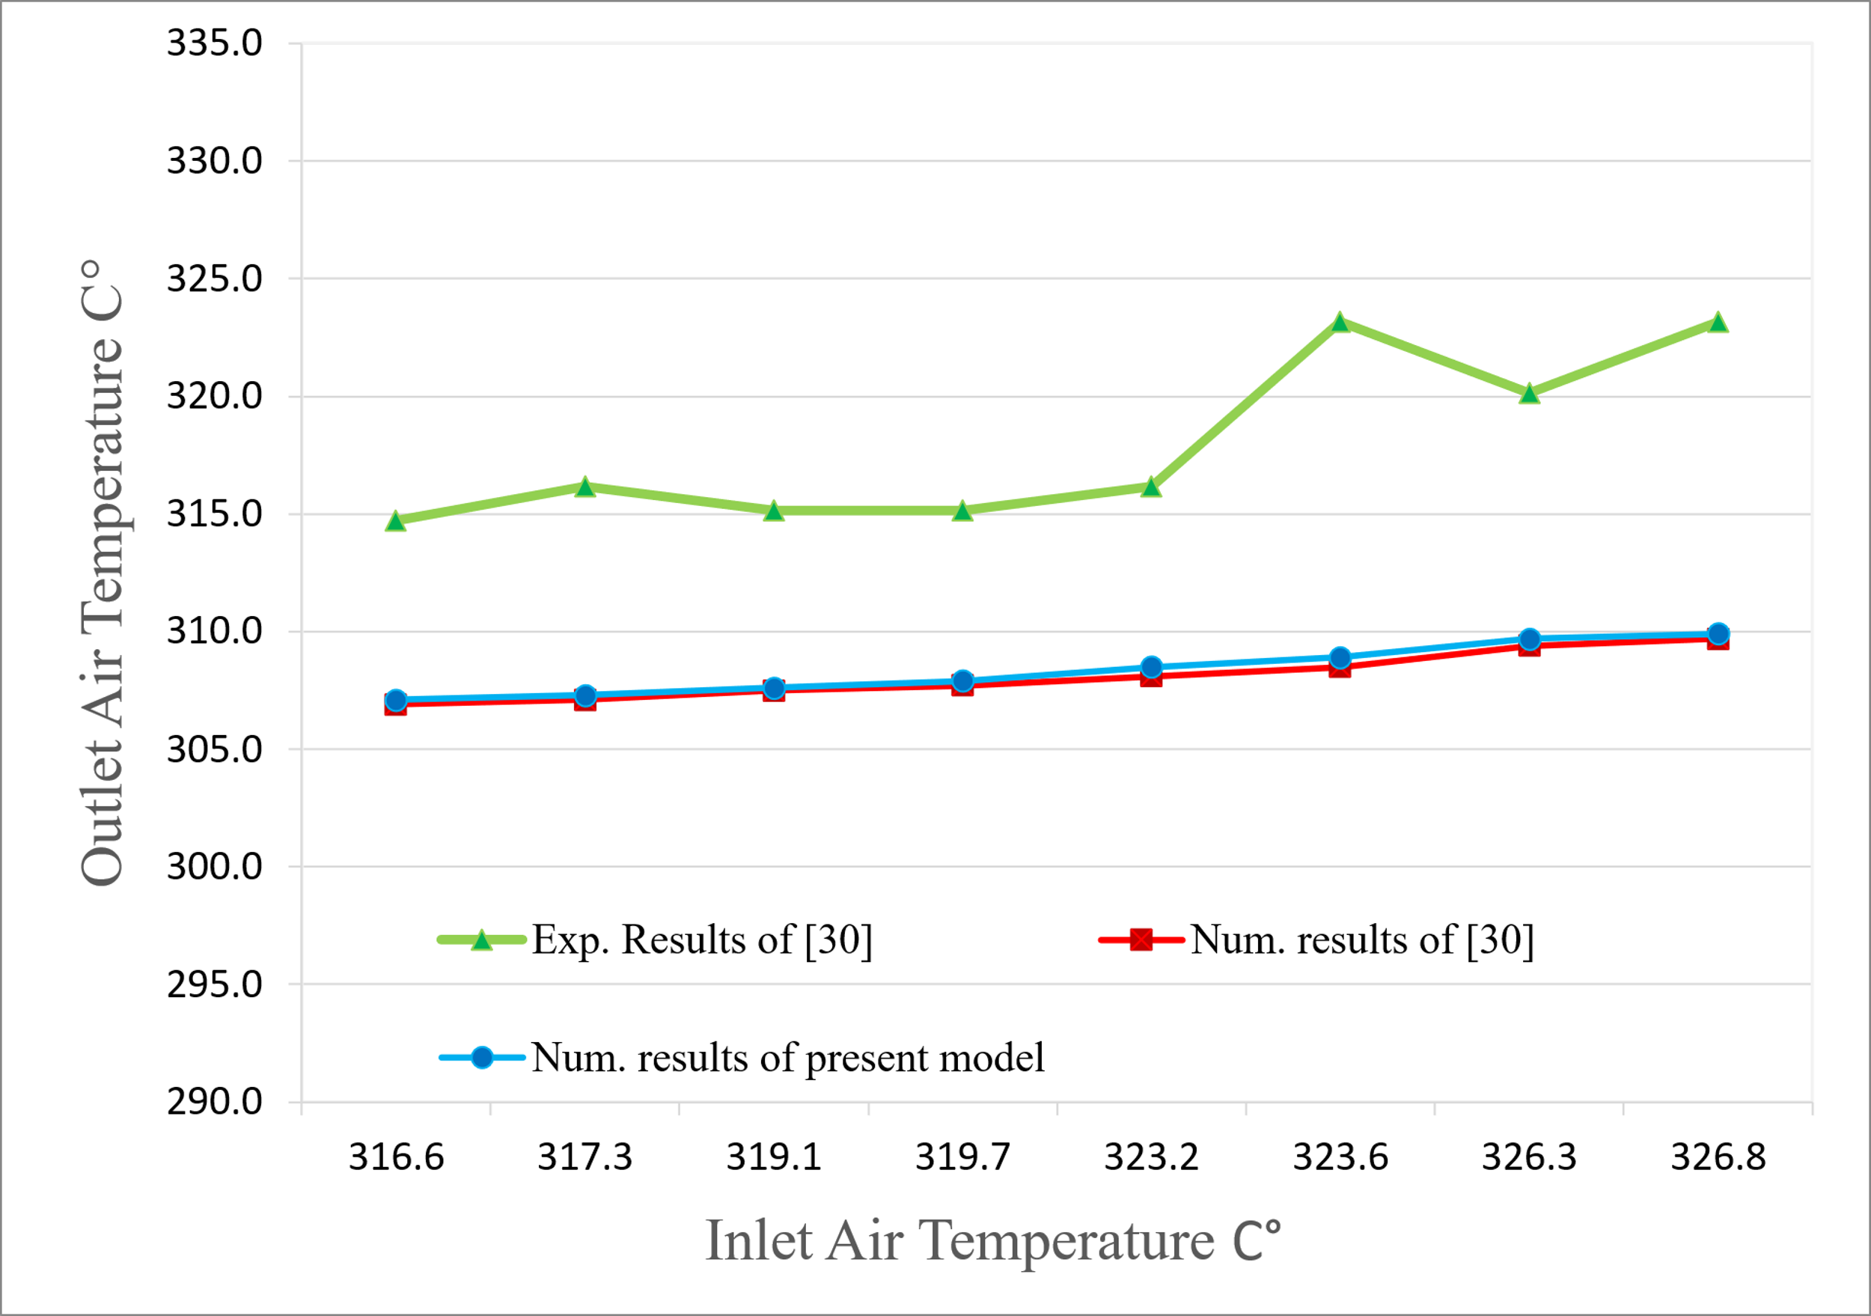

Figure 6: Variation of outlet air temperature with inlet air temperature as a comparison between the present model and the numerical and experimental results reported in [30].
Hydraulic Performance:
In Figure 7, the velocity distribution across the parallel pipes shows a gradual variation, which indicates that the airflow differences among the pipes are not excessive. This behavior can be attributed to frictional pressure losses along the pipe walls and changes in flow direction within the grid.
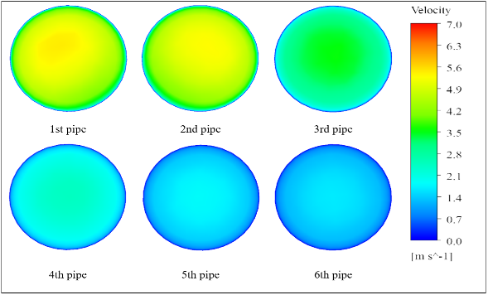

Figure 7: Velocity contours on the YZ cross-sectional plane at the mid-length of parallel pipes in the U-type EAHE parallel pipes.
Figure 8 indicates a non-uniform velocity distribution across the pipes. The first four pipes show relatively low and stable velocities, whereas the fifth pipe and especially the sixth pipe carry higher flow rates. This behavior results from the Z-type flow arrangement, in which the pressure field directs more airflow toward the terminal pipes with lower hydraulic resistance.
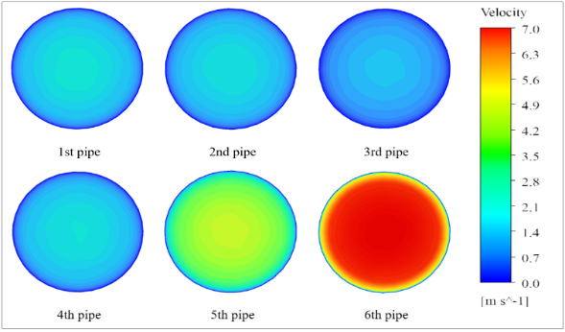

Figure 8: Velocity contours on the YZ cross-sectional plane at the mid-length of parallel pipes in the Z-type EAHE parallel pipes.
In Figure 9, the velocity distribution along the pipes is more uniform. The gradual transition from inlet to outlet indicates a progressive reduction in velocity from the 1st to the 6th pipe, mainly because of energy dissipation and wall-friction losses along the flow path. This pattern suggests that the U-type layout distributes the airflow more evenly and therefore reduces maldistribution.
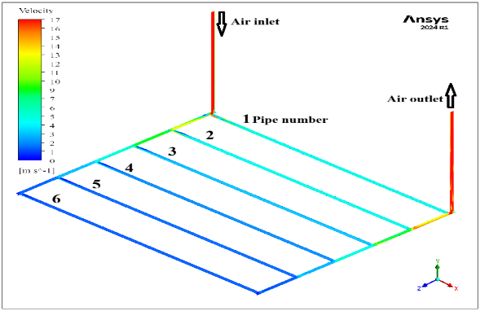
Figure 9: Velocity contour distribution on the XZ longitudinal plane, illustrating the airflow behavior within the U-type EAHE parallel pipes.
Figure 10 shows clear non-uniformity in the velocity distribution. Higher velocities appear in the last pipe near the outlet, whereas the remaining pipes carry lower flow rates. This behavior reflects the Z-type configuration, in which the airflow tends to follow the path of lower hydraulic resistance. As a result, the Z-type layout exhibits stronger flow maldistribution than the U-type.

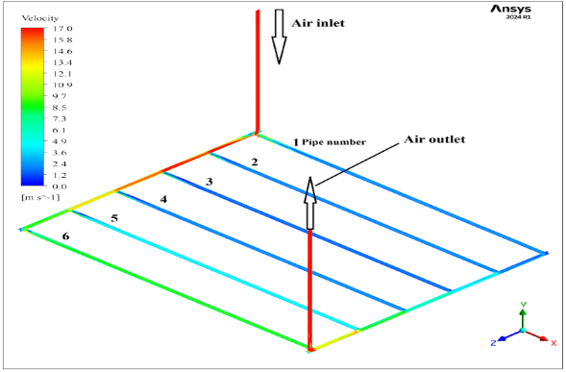
Figure 10: Velocity contour distribution on the XZ longitudinal plane, illustrating the airflow behavior within the Z-type EAHE parallel pipes.
Figure 11 shows that, in the U-type configuration, the pressure is distributed more evenly along the pipes, leading to a more balanced flow pattern. The pressure decreases gradually from the inlet to the outlet, and the relatively uniform pressure drop across the parallel pipes supports a similar airflow pattern throughout the system.
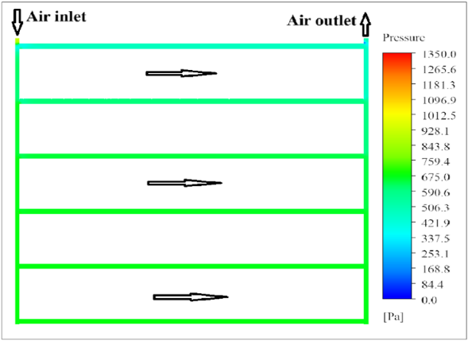
Figure 11: Static pressure distribution on the longitudinal plane located along the pipe axis of the 6-pipe EAHE in the U-type configuration.
Figure 12 shows that the highest pressure occurs near the inlet in the Z-type configuration and then decreases along the flow path, with the largest drop appearing near the outlet of the last pipe. Because this last pipe offers lower hydraulic resistance, it carries more airflow than the others. This pressure pattern explains the non-uniform flow distribution observed in the Z-type layout.
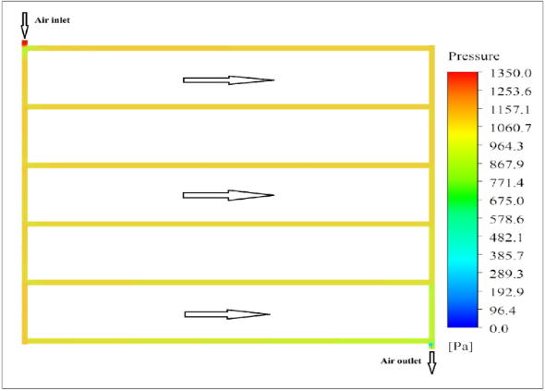

Figure 12: Static pressure distribution on the longitudinal plane located along the pipe axis of the 6-pipe EAHE in the Z-type configuration.
Figure 13 shows that the airflow distribution differs considerably between the Z-type and U-type layouts. In the Z-type configuration, airflow is concentrated toward the last pipes of the grid, particularly the 6th pipe, where the flow rate reaches 225.8 m³/h. This trend reflects the progressive reduction in hydraulic resistance along the flow direction and results in pronounced maldistribution. By contrast, the U-type layout shows a more balanced distribution, with the highest flow rate in the 1st pipe (124.8 m³/h) followed by a gradual decrease toward the final pipe. This more even distribution is favorable from both hydraulic and thermal viewpoints.
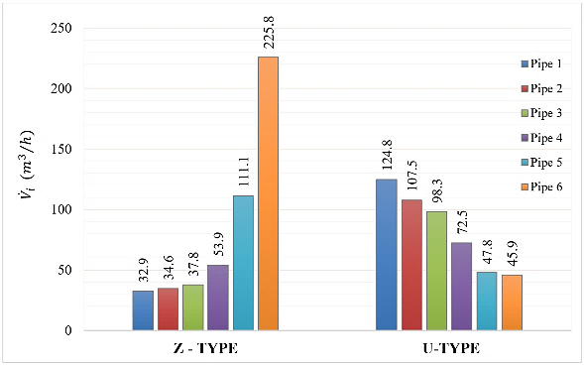

Figure 13: Comparison of airflow division between Z-type and U-type EAHE layouts.
Figure 14 illustrates the variation of the airflow uniformity coefficient Ω with Reynolds number for the U-type and Z-type EAHE systems. For the U-type layout, Ω increases from about 0.79 at Re = 1.9 × 10⁴ to about 0.87 at Re = 10.8 × 10⁴, indicating that this arrangement maintains good airflow distribution even at higher flow rates. By contrast, Ω for the Z-type decreases steadily from about 0.73 to 0.64 over the same Reynolds-number range, showing that airflow uniformity deteriorates as velocity increases. This trend can be attributed to the stronger pressure gradient that drives more air toward the pipes located near the inlet and outlet sections. The green curve shows that the percentage improvement of the U-type relative to the Z-type rises from about 15 percent at low Reynolds numbers to nearly 38 percent at the highest tested value. This indicates that the U-type layout offers a clear advantage in airflow distribution, especially under high-flow conditions. The improvement in Ω was evaluated using Eq. (14):
$∆Ω \% = \left|\frac{Ω_{ U}-{Ω }_{Z}}{{Ω }_{Z}}\right| ×100$ (14)
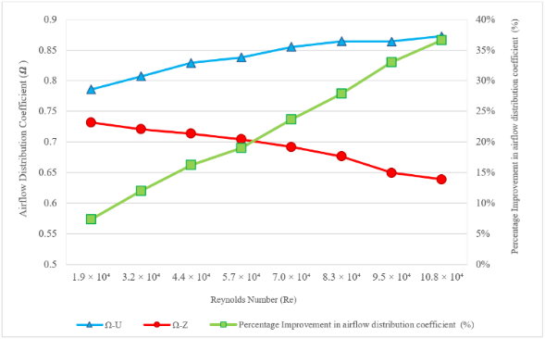

Figure 14: Comparison of the variation of the airflow distribution coefficient (Ω) with the Reynolds number for U- and Z-type configurations and the percentage improvement between Z- and U-type EAHE configurations.
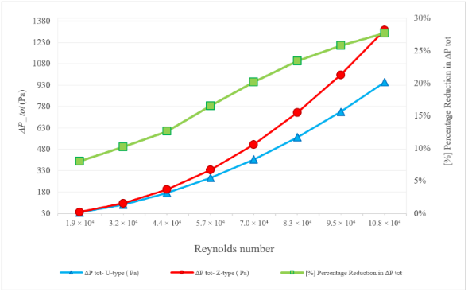

Figure 15: Comparison of total pressure losses and its percentage reduction between Z-type and U-type EAHE configurations at different Reynolds numbers.
Figure 15 illustrates the total pressure loss for the Z-type and U-type EAHE setups at different Reynolds numbers and also shows the relative reduction in total pressure loss (ΔPₜₒₜ %). The Z-type loses roughly 1300 Pa of pressure at the highest Reynolds number, whereas the U-type loses about 940 Pa. As the flow rate increases, the difference between the two layouts becomes more evident because frictional effects and flow-path resistance are greater in the Z-type configuration. The green curve indicates that the relative reduction in total pressure loss exceeds 28% at the highest flow rate, as calculated by Eq. (15):
${ΔP}_{tot} \% = \left|\frac{\left({{ΔP}_{tot},}_{U}- {{ΔP}_{tot},}_{Z}\right)}{{{ΔP}_{tot},}_{Z}}\right|× 100$ (15)
These results indicate that the U-type configuration has a hydraulic advantage because it consistently produces lower pressure losses over the investigated operating range. This advantage becomes more important at high Reynolds numbers, where pressure loss has a stronger effect on system performance and fan-power demand.
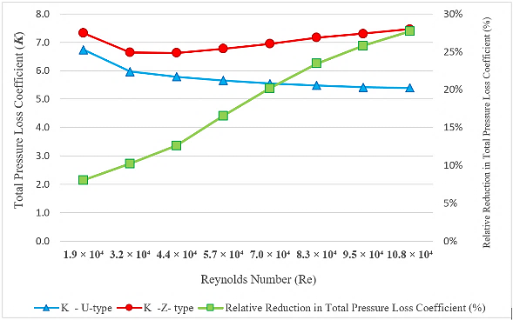

Figure 16: Comparison of the total pressure losses coefficient (K) and its relative reduction with Reynolds number between Z-type and U-type EAHE configurations.
Figure 16 shows that the Z-type always has a higher total pressure-loss coefficient (K) than the U-type over the investigated Reynolds-number range, indicating greater flow resistance. The K value of the Z-type ranges from 6.8 to 7.5, whereas that of the U-type ranges from 5.2 to 5.8, which confirms the hydraulic benefit of the U-type. The relative reduction in K increases with Reynolds number and reaches approximately 30 percent at the highest flow rate. Equation (16) was used to compute this relative reduction:
$∆K \% = \left|\frac{K_{ U}-K_{ Z}}{K_{Z}}\right| ×100$ (16)
The comparison of the results reveals that the U-type design offers more diffuse airflow distribution and lower hydraulic losses, especially at high Reynolds numbers, and therefore performs more favorably from a hydraulic standpoint.
As shown in Figure 17, the fan power in both designs rises with Reynolds number because higher flow rates lead to larger pressure losses. The Z-type structure always requires more fan power than the U-type structure. The green curve shows that the relative reduction in fan power consumption (ΔP.P %) increases from about 7 percent at low Reynolds numbers to about 28 percent at the highest tested case. Eq. (17) was used to calculate this relative reduction:
$∆P.P \% = \left|\frac{{P.P}_{ U}-{P.P}_{ Z}}{{P.P}_{ Z}}\right| ×100$ (17)
This trend indicates that the U-type layout is more energy-efficient than the Z-type, particularly as airflow rate and frictional effects increase. This difference is mainly due to the lower total pressure loss and more even airflow distribution achieved by the U-type system.
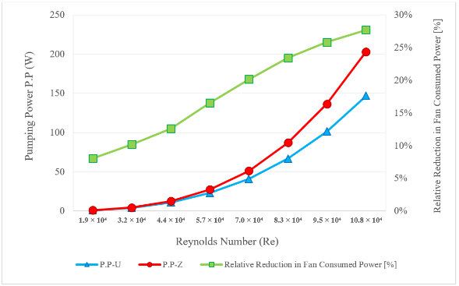

Figure 17: Comparison of fan power consumption and its relative reduction between U-type and Z-type EAHE configurations across different Reynolds numbers.
Thermal Performance:
Figure 18 shows that the temperature distribution in the U-type configuration is gradual and relatively uniform along the pipes. The first three pipes remain at slightly higher temperatures, while the remaining pipes show lower temperatures, as indicated by the transition from yellow-green to blue. This pattern reflects a more balanced airflow distribution and, consequently, a more uniform heat-transfer process along the parallel pipes.
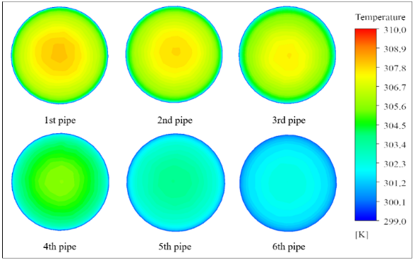

Figure 18: Temperature contour distribution on the YZ plane at the mid-length of the parallel pipes of the U-type EAHE.
Figure 19 shows a less uniform temperature distribution in the Z-type configuration. The pipes farther along the flow path, especially the 5th and 6th pipes, remain at higher temperatures, as indicated by the yellow and orange regions. Compared with the U-type arrangement, this behavior suggests a less even thermal distribution, which is consistent with the stronger airflow maldistribution in the Z-type layout.
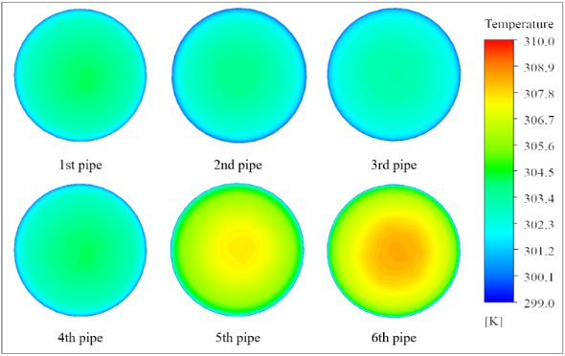

Figure 19: Temperature contour distribution on the YZ plane at the mid-length of the parallel pipes of the Z-type EAHE.
Figure 20 shows that the temperature in the U-type configuration decreases gradually and semi-uniformly from the inlet to the outlet along each pipe. The transition from warm colors near the entrance to cooler colors near the exit indicates a relatively even heat-transfer pattern along the parallel pipes, which is consistent with the more balanced airflow distribution.
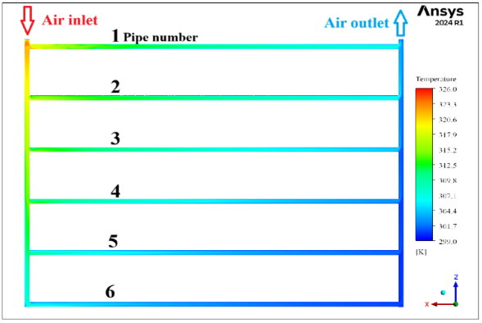
Figure 20: Temperature distribution on the longitudinal plane passing through the pipe axis of the 6-pipe EAHE in the U-type configuration.
Figure 21 shows that the Z-type configuration has a less uniform temperature profile. The temperature remains relatively high near the inlet region and decreases more sharply toward the end of the flow path. The persistence of warmer regions in the last pipes suggests that a larger portion of the airflow passes through these pipes, which reduces cooling effectiveness in the others. Overall, this pattern indicates that the U-type structure provides a more uniform temperature reduction and more balanced heat transfer than the Z-type.
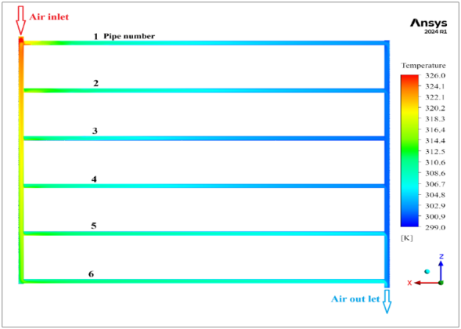

Figure 21: Temperature distribution on the longitudinal plane passing through the pipe axis of the 6-pipe EAHE in the Z-type configuration.
Figure 22 shows the outlet air temperature (Tₒ) variation of both U-type and Z-type EAHE setups at various Reynolds numbers and the relative temperature drop between the two arrangements. The figure indicates that the outlet air temperature rises as Reynolds number increases in both setups. The increased flow velocity decreases the air residence time in the pipes and therefore reduces heat transfer with the surrounding soil. Within the investigated range, the U-type layout presents a slightly lower outlet temperature than the Z-type, with a relative change (ΔTₒ %) between 1% and 2%, as shown by the green curve and calculated using Eq. (18):
$∆T_{o} \% = \left|\frac{{T_{o},}_{U}-{T_{o},}_{Z}}{{T_{o},}_{Z}}\right| ×100$ (18)
Although this difference is modest, it indicates that the U-type layout promotes more uniform airflow and slightly more effective heat transfer along the parallel pipes.
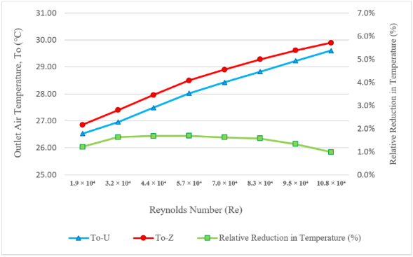
Figure 22: Comparison of outlet air temperature and its relative reduction percentage between U-type and Z-type EAHE configurations at different Reynolds numbers.
Figure 23 presents the variation of effectiveness (ε) for the U-type and Z-type EAHE systems with Reynolds number and the percentage change (Δε %) observed between the two layouts. The effectiveness of both systems decreases gradually as Reynolds number increases. This decrease is mainly caused by the reduction in air residence time at higher flow rates, which weakens the heat exchange between the air and the surrounding soil. Over the whole range, the U-type layout remains slightly superior to the Z-type and shows a relative improvement of about 1% to 2%, as calculated using Eq. (19):
$∆ε \% = \left|\frac{ε_{ U}-ε_{ Z}}{{ε }_{Z}}\right| ×100$ (19)
Although the thermal difference is small, it consistently indicates that the U-type layout provides slightly better heat-transfer performance because of its more uniform airflow distribution. When this thermal behavior is considered together with the significantly lower pressure losses, the U-type layout appears more favorable overall, especially at high Reynolds numbers.
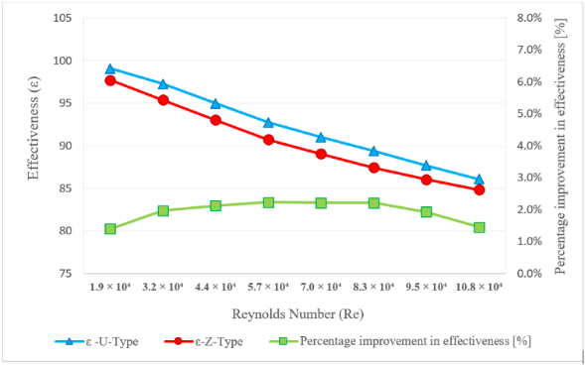
Figure 23: Comparison of effectiveness (ε) between U-type and Z-type EAHE systems and its percentage improvement in effectiveness with Reynolds number.

Figure 24 shows how the heat-transfer rate (Q_{EAHE}) varies with Reynolds number in both the U-type and Z-type configurations. The higher the Reynolds number, the higher the heat-transfer rate in both layouts. This is due to increased flow velocity, which enhances convective heat transfer by increasing turbulence and weakening the thermal boundary layer along the pipe walls. The U-type geometry consistently shows a slightly higher heat-transfer rate than the Z-type, and the relative enhancement (∆Q _{EAHE} %) is approximately 1–2, as shown by Eq. (20):
$∆Q_{EAHE} \% = \left|\frac{{Q }_{U}-{Q }_{Z}}{Q_{Z}}\right| ×100$ (20)
This minor difference suggests that the two systems possess similar cooling potentials, although the U-type retains a small thermal benefit because of its more homogeneous flow distribution. When this is considered together with the lower pressure loss, the U-type design shows a better overall thermal–hydraulic balance than the Z-type.
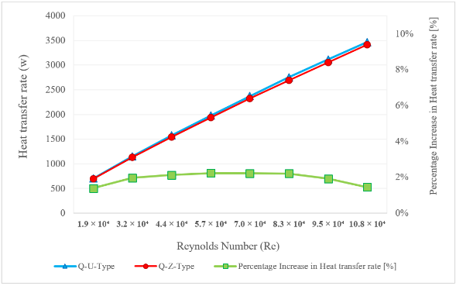

Figure 24: Comparison of heat transfer rates (Q _{EAHE}) for U-type and Z-type EAHE configurations and its percentage increase in heat transfer rate with Reynolds number.
Overall Thermal-Hydraulic Performance:
After examining the hydraulic and thermal behaviors separately, the overall thermal-hydraulic performance offers a more integrated comparison between the two layouts.
Figure 25 demonstrates how the overall performance factor (η*) varies for the U-type and Z-type EAHE configurations at different Reynolds numbers. A decreasing trend is observed as Reynolds number increases because the rise in pumping power becomes greater than the corresponding increase in heat-transfer rate. Nevertheless, the U-type always shows larger η* values, indicating better combined thermal-hydraulic behavior. Since both layouts use the same pipe material, diameter, and total buried length, this improvement is achieved without additional buried-pipe cost and is reflected directly in lower fan-power demand. Relative improvement (Δη*%), which is determined by Eq. (21):
$∆η^{*} \% = \left|\frac{{η^{*}}_{U}-{η^{*}}_{Z}}{{η^{*}}_{Z}}\right| ×100$ (21)
The relative enhancement rises from approximately 20 percent at low Reynolds numbers to more than 40 percent at the highest tested value, indicating that the U-type layout offers better overall thermal-hydraulic performance under the investigated conditions.
Although the benchmark used for verification is thermal in nature, the predicted airflow-distribution patterns and pressure-loss trends obtained in the present study are also consistent with previously reported investigations of multi-pipe EAHE flow performance [2], [4], [5], [6].
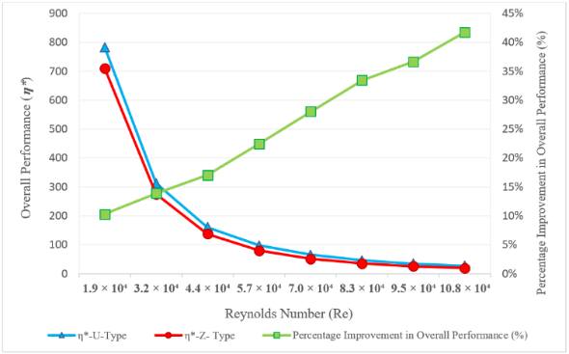

Figure 25: Comparison of the overall performance factor (η*) and its percentage improvement between U-type and Z-type EAHE configurations under various Reynolds numbers.

Limitations of the Present Study:
The present results should be interpreted in light of several modelling limitations. The simulations were performed under steady-state conditions with constant thermophysical properties. The surrounding soil was represented through a prescribed constant-temperature boundary rather than a transient coupled soil domain, and moisture transfer and condensation effects were not considered. In addition, the conclusions are limited to the investigated geometry, burial depth, disturbed-soil thickness assumption, and inlet-velocity range. Therefore, the superiority of the U-type layout should be understood as applying to the present conditions and should not be generalized directly to all greenhouse sizes, operating scenarios, or site conditions without further study.

Conclusions:
A quantitative comparison was carried out for two grid-type Earth-to-Air Heat Exchanger (EAHE) layouts, U-type and Z-type, under identical geometrical and operating conditions to evaluate their cooling performance. The major conclusions are the following:
- The U-type layout provided a more even distribution of airflow, velocity, and pressure throughout the grid. The airflow uniformity coefficient (Ω) improved by almost 38 percent at higher Reynolds numbers relative to the Z-type layout, indicating more stable flow distribution.
- The U-type system showed a clear reduction in hydraulic resistance, with total pressure loss more than 28 percent lower than that of the Z-type. This resulted in a corresponding reduction in fan-power demand and therefore improved hydraulic efficiency.
- The thermal characteristics of the two systems were nearly identical, and the thermal performance of both systems varied by 1–2 percent in thermal effectiveness (ε) and outlet air temperature. The U-type layout showed a slight thermal advantage because of its more uniform airflow distribution along the pipes.
- In terms of overall performance, the U-type configuration consistently produced higher values of the overall performance indicator (η*) than the Z-type by over 40 percent at the maximum Reynolds number. This indicates that the U-type layout provides a more favorable balance between thermal benefit and hydraulic penalty under the investigated conditions.
- Overall, the U-type EAHE showed better combined thermal-hydraulic performance than the Z-type within the investigated range of conditions, combining reduced energy consumption with more uniform airflow and consistent cooling. It may therefore be regarded as the more favorable grid configuration for passive, energy-efficient greenhouse ventilation, particularly under high-flow conditions.
The above conclusions should be interpreted in light of the modelling limitations stated in the preceding subsection.

Nomenclature
$$C_{P}$$ | Specific heat (J\kg. K)‎ | $${\dot{V}}_{i}$$ | Volumetric flow rate in each pipe (m³/h)‎
d | Inner diameter of the pipe (m) | Z | Axial coordinate (m)‎
EAHE | Earth to Air Heat Exchanger | $${ΔP}_{tot}$$ | Total pressure loss (Pa)‎
$$g$$ | Body force (gravity) (m/s²) | Greek symbols
K | Total pressure loss coefficient | $$δ$$ | Thickness of disturbed soil (m)
k | Air thermal conductivity (W/m·K) | $$ε$$ | Effectiveness
$$\dot{m}$$ | Mass flow rate (kg/s)‎ | η* | Overall performance factor (-)
n | Number of parallel pipes | θ | Angular coordinate (rad)
P.P | Pumping power (W) | $$ν$$ | Kinematic viscosity (μ/ρ) (m²/s)
$$p$$ | Pressure (Pa) | ρ | Density (kg/m3)‎
Q | Heat transfer rate (W)‎ | $$Φ$$ | Viscous dissipation (W/m³)
R₁ | Outer radius of the pipe (m) | $$Ω$$ | Airflow uniformity coefficient
R₂ | Radius of the disturbed soil domain (m) | Subscripts
r | Radial coordinate (m) | i | Inlet
T | Temperature (K) ‎ | o | Outlet
$$v$$ | Velocity (m/s) | s | Undisturbed soil
$$\dot{V}$$ | Volumetric flow rate (m³/h)‎ | U | Refers to U-type EAHE configuration
$${\dot{V}}_{a}$$ | Average volumetric flow rate in parallel pipes (m³/h)‎ | Z | Refers to Z-type EAHE configuration

COMPETING INTERESTS DISCLAIMER:
Authors have declared that they have no known competing financial interests OR non-financial interests OR personal relationships that could have appeared to influence the work reported in this paper.
Disclaimer (Artificial intelligence)
Author(s) hereby declare that NO generative AI technologies such as Large Language Models (ChatGPT, COPILOT, etc.) and text-to-image generators have been used during the writing or editing of this manuscript.

Disclaimer (Artificial intelligence)

Author(s) hereby declare that NO generative AI technologies such as Large Language Models (ChatGPT, COPILOT, etc.) and text-to-image generators have been used during the writing or editing of this manuscript.

References

[1] V. Badescu and D. Isvoranu, "Pneumatic and thermal design procedure and analysis of earth-to-air heat exchangers of registry type," Applied Energy, vol. 88, no. 4, pp. 1266-1280, 2011, doi: 10.1016/j.apenergy.2010.10.019.
[2] Ł. Amanowicz and J. Wojtkowiak, "An effect of flow nonuniformity in earth-to-air multi-pipe heat exchangers (EAHEs) on their thermal performance," in Proc. XIII Int. Conf. Air & Heat-Water & Energy, Wroclaw-Kudowa, Poland, Jun. 2011, vol. I, pp. 23-28.
[3] S. F. Ahmed, M. T. O. Amanullah, M. M. K. Khan, M. G. Rasul, and N. M. S. Hassan, "Parametric study on thermal performance of horizontal earth pipe cooling system in summer," Energy Conversion and Management, vol. 114, pp. 324-337, 2016, doi: 10.1016/j.enconman.2016.01.061.
[4] Ł. Amanowicz and J. Wojtkowiak, "Experimental investigation and CFD simulation of multi-pipe earth-to-air heat exchangers (EAHEs) flow performance," in E3S Web of Conferences, vol. 22, Art. no. 00002, 2017, doi: 10.1051/e3sconf/20172200002.
[5] Ł. Amanowicz and J. Wojtkowiak, "Validation of CFD model for simulation of multi-pipe earth-to-air heat exchangers (EAHEs) flow performance," Thermal Science and Engineering Progress, vol. 5, pp. 44-49, 2018, doi: 10.1016/j.tsep.2017.10.018.
[6] Ł. Amanowicz, "Influence of geometrical parameters on the flow characteristics of multi-pipe earth-to-air heat exchangers: Experimental and CFD investigations," Applied Energy, vol. 226, pp. 849-861, 2018, doi: 10.1016/j.apenergy.2018.05.096.
[7] N. Sakhri et al., "Experimental study of an earth-to-air heat exchanger coupled to the solar chimney for heating and cooling applications in arid regions," Journal of Thermal Analysis and Calorimetry, vol. 145, no. 6, pp. 3349-3358, 2021, doi: 10.1007/s10973-020-09867-6.
[8] M. I. Hasan and M. Muter, "Study the effects of configuration and design parameters on the performance of earth-to-air heat exchanger used in poultry houses," Basrah Journal for Engineering Sciences, vol. 21, no. 1, pp. 1-9, 2021.
[9] S. N. Ahmad and O. Prakash, "Thermal performance evaluation of an earth-to-air heat exchanger for the heating mode applications using an experimental test rig," Archives of Thermodynamics, vol. 43, no. 1, pp. 185-207, 2022, doi: 10.24425/ather.2022.140931.
[10] M. H. Ali, Z. Kurjak, and J. Beke, "Investigation of earth air heat exchangers functioning in arid locations using Matlab/Simulink," Renewable Energy, vol. 209, pp. 632-643, 2023, doi: 10.1016/j.renene.2023.04.042.
[11] E. Hummood, M. I. Hasan, and G. Abd, "Investigating the effects of disturbed soil thickness on the performance of earth-air heat exchanger," International Journal of Heat and Technology, vol. 42, no. 3, pp. 1101-1110, 2024, doi: 10.18280/ijht.420337.
[12] S. E. Sofyan, T. M. I. Riayatsyah, Khairil, E. Hu, A. Tamlicha, T. M. R. Pahlefi, and H. B. Aditiya, "Computational fluid dynamic simulation of earth air heat exchanger: A thermal performance comparison between series and parallel arrangements," Results in Engineering, vol. 24, Art. no. 102932, 2024, doi: 10.1016/j.rineng.2024.102932.
[13] D. Qi, Q. Liu, C. Zhao, S. Li, B. Song, and A. Li, "Optimizing the thermal environment of greenhouse with multi-pipe earth-to-air heat exchanger system using the Taguchi method," Applied Thermal Engineering, vol. 242, Art. no. 122469, 2024, doi: 10.1016/j.applthermaleng.2024.122469.
[14] E. M. S. El-Said, "Thermal-hydraulic characteristics of an earth air heat exchanger: An experimental analysis," Energy, vol. 313, Art. no. 133766, 2024, doi: 10.1016/j.energy.2024.133766.
[15] F. E. Allali, H. Fatnassi, H. Demrati, A. Wifaya, and A. Aharoune, "Performance assessment of sustainable cooling strategies in Canarian greenhouses: Evaluating earth-to-air heat exchanger and rock-bed systems," Case Studies in Thermal Engineering, vol. 72, Art. no. 106402, 2025, doi: 10.1016/j.csite.2025.106402.
[16] M. H. Ali, A. M. A. Alshibil, M. Almadhhachi, M. H. Machi, P. Vig, I. Farkas, and Z. Kurjak, "Comparative modeling and performance analysis of earth-air heat exchangers in hot-arid and cold-continental climates: A case study of Baghdad and Gothenburg," Energy Conversion and Management: X, vol. 27, Art. no. 101205, 2025, doi: 10.1016/j.ecmx.2025.101205.
[17] M. I. Hasan and E. K. Jabbar, "Fabricating and testing of the ground coupled air conditioner for residential applications in Iraqi weather," Energy, vol. 216, Art. no. 119256, 2021, doi: 10.1016/j.energy.2020.119256.
[18] F. Al-Ajmi, D. L. Loveday, and V. I. Hanby, "The cooling potential of earth-air heat exchangers for domestic buildings in a desert climate," Building and Environment, vol. 41, no. 3, pp. 235-244, 2006, doi: 10.1016/j.buildenv.2005.01.027.
[19] D. Ronge, V. Kadam, S. Shende, P. Kate, V. Waghmare, and O. Patil, "Design of an earth air heat exchanger system for space cooling in hot and dry climate of Pandharpur, India," Aegaeum Journal, vol. 8, no. 6, pp. 1594-1602, 2020.
[20] C. Gauthier, M. Lacroix, and H. Bernier, "Numerical simulation of soil heat exchanger-storage systems for greenhouses," Solar Energy, vol. 60, no. 6, pp. 333-346, 1997, doi: 10.1016/S0038-092X(97)00022-4.
[21] R. Misra, V. Bansal, and A. Agarwal, "Investigation of thermal performance of EATHE system under intermittent operation: A CFD approach," International Journal of Engineering Technology, Management and Applied Sciences, vol. 4, no. 4, pp. 340-349, Apr. 2016.
[22] M. I. Hasan and S. W. Noori, "Numerical investigation of earth to air heat exchanger for cooling and heating applications," in Proc. 3rd Int. Scientific Conference, Mar. 14-15, pp. 1-10, 2018.
[23] F. Niu, Y. Yu, D. H. Yu, and H. R. Li, "Heat and mass transfer performance analysis and cooling capacity prediction of earth to air heat exchanger," Applied Energy, vol. 137, pp. 211-221, 2015, doi: 10.1016/j.apenergy.2014.10.008.
[24] G. Gan, "Simulation of dynamic interactions of the earth-air heat exchanger with soil and atmosphere for preheating of ventilation air," Applied Energy, vol. 158, pp. 118-132, 2015, doi: 10.1016/j.apenergy.2015.08.081.
[25] A. Hegazy and S. Z. Mohamed, "Unlocking geothermal energy for sustainable greenhouse farming in arid regions: A remote-sensed assessment in Egypt's New Delta," Scientific Reports, vol. 13, no. 1, 2023, doi: 10.1038/s41598-023-48667-4.
[26] M. I. Hasan and S. W. Noori, "Evaluating the influence of some design and environmental parameters on the performance of earth to air heat exchanger," Journal of Engineering and Sustainable Development, vol. 22, no. 2, pp. 10-29, 2018, doi: 10.31272/jeasd.2018.2.2.
[27] Ł. Amanowicz and J. Wojtkowiak, "Thermal performance of multi-pipe earth-to-air heat exchangers considering the non-uniform distribution of air between parallel pipes," Geothermics, vol. 88, Art. no. 101896, 2020, doi: 10.1016/j.geothermics.2020.101896.
[28] S. H. Hammadi and A. H. Mohammed, "Application of earth tube heat exchanger and solar chimney for natural cooling system in Basrah city," Basrah Journal for Engineering Sciences, vol. 14, no. 2, pp. 23-32, 2014.
[29] H. L. Thamer and M. I. Hasan, "Experimental testing of earth to air heat exchanger for air conditioning of greenhouse in hot climate regions," International Journal of Computational Methods and Experimental Measurements, vol. 13, no. 4, pp. 908-927, 2025, doi: 10.56578/ijcmem130412.
[30] E. A. H. Alshamry, "Investigation of air cooling in Nassiriya oil field using geothermal heat exchangers," M.S. thesis, Dept. Mechanical Engineering, University of Thi-Qar, Thi-Qar, Iraq, 2024.

