Commentaries / Opinion Articles

Innovation and Optimization of Construction Technology for Large-Diameter Extra-Long Reverse Circulation Rotary Bored Piles and Engineering Application

Abstract：In the construction of large-diameter extra-long pile foundations, technical challenges such as inadequate geological adaptability, cumbersome borehole quality control, and low reliability of pile integrity have long restricted project progress and quality. Taking the main tower pile foundation project of a newly built bridge as the research focus, this study carries out a detailed field study on the key construction technologies of φ2.0 m × 95 m reverse circulation rotary bored piles. By integrating the complex stratum characteristics of the project site—encompassing miscellaneous fill, silty clay, silty fine sand, and argillaceous sandstone—an integrated and optimized full-process construction system is developed, layered adaptive core process parameters are defined, and a targeted quality and safety control framework tailored to complex geological conditions is established. Field tests and comprehensive detection methods are employed to validate the effectiveness of the proposed technologies. The results demonstrate that the optimized construction technology effectively resolves bore-forming issues in high collapse-risk strata. All 28 engineering piles achieve 100% integrity and meet Class I pile standards. The vertical compressive bearing capacity of single piles substantially exceeds the design value. These research findings have effectively supported the successful completion of the project and offer practical technical references and engineering demonstrations for the construction of similar large-diameter extra-long pile foundations in alluvial-pluvial plain areas with complex geological conditions.
Keywords: reverse circulation rotary drilling; large-diameter extra-long piles; complex strata; construction technology optimization; pile foundation quality control; pile-tip post grouting

1 Introduction
With the development of large-scale, deep-water, and super high-rise configurations, large-diameter extra-long pile foundations have become indispensable in key engineering projects such as long-span bridges and super high-rise buildings, due to their high bearing capacity, small deformation, and good stability^{[1-3]}. Reverse circulation rotary bored pile technology, as a mainstream construction method for such foundations, has high borehole-forming efficiency, thorough hole wall slag removal, thin pile-tip sediment, and minimal disturbance to surrounding strata, and is widely used in various complex geological engineering scenarios^{[4,5]}. Nevertheless, when this technology is applied to penetrate deep composite strata consisting of loose fill, soft plastic silt, silty fine sand, and weathered argillaceous sandstone, it is prone to engineering defects including borehole collapse, diameter shrinkage, reinforcement cage deviation and floating, as well as concrete segregation within the pile body. These issues not only severely hinder the construction quality and safety of pile foundations but also exert a direct adverse impact on the bearing performance and long-term stability of the entire foundation structure^{[6]}.
The 29# main tower pile foundation of the newly built bridge comprises 28 friction-type reverse circulation rotary bored piles with a design specification of φ2.0 m × 95 m, each featuring a designed vertical reaction force of 17700 kN. The pile shafts are required to traverse multiple complex strata, such as miscellaneous fill, silty clay, silty fine sand, and argillaceous sandstone, leading to prominent construction challenges, including high borehole collapse risk, strict requirements for reinforcement cage hoisting, and complex control of underwater concrete pouring. In response to these engineering predicaments, this study, drawing on practical engineering experience, undertakes in-depth research on the optimization of key construction technologies, the establishment of quality and safety control systems, and the verification of construction effects for the project’s large-diameter extra-long reverse circulation rotary bored piles. It summarizes innovative construction methods and core process parameters suitable for the complex geology of alluvial-pluvial plains, and enriches the technical system of reverse circulation rotary drilling for extra-long friction piles under complex geological conditions and provides practical technical references for similar projects.

2 Engineering Overview

2.1 Engineering Background
The main bridge of the project is a concrete single-pylon cable-stayed bridge with a span arrangement of 35 m + 81 m + 135 m. The main tower foundation adopts an integral reinforced concrete bearing platform, beneath which 28 large-diameter extra-long reverse circulation rotary bored piles are arranged to serve as the load-bearing foundation for the main tower (Figure 1). The designed elevation of the pile top is 21.5 m, the designed elevation of the pile tip is -73.5 m, and the effective pile length is 95 m. Classified as a friction pile foundation, it primarily bears the load of the upper structure through the lateral frictional resistance between the pile shaft and the surrounding soil, imposing high demands on the construction quality and bearing capacity of individual piles.
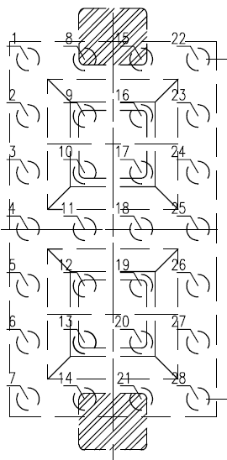
Figure 1 Layout Plan of Pile Positions for the Main Tower Pile Foundation

2.2 Geological and Hydrogeological Conditions
The bridge site is situated in an alluvial-pluvial plain area, characterized by a stable regional geological structure with no adverse geological features such as faults or folds within the exploration scope. The strata within the exploration depth exhibit a horizontal layered distribution from top to bottom. The artificial fill layer (Qᵐˡ) ranges from 0.7 to 5.8 m in thickness, predominantly composed of silty clay and plain fill, with local inclusions of crushed stones and brick slag, featuring a loose structure, low bearing capacity, and poor overall stability. The Holocene lacustrine-alluvial layer (Q₄ᵃˡ) has a thickness of 10 to 55 m, encompassing silt, silty clay, silt-containing silty clay, and silty fine sand; among these, the silty clay is in a plastic to soft plastic state, while the silty fine sand is slightly dense to medium dense, with poor gradation yet good uniformity, rendering it a high-risk stratum prone to borehole collapse and diameter shrinkage during construction. The Tertiary layer (E) is dominated by argillaceous sandstone, divided into highly weathered and moderately weathered layers; the highly weathered argillaceous sandstone is fragmented with poor integrity, classified as extremely soft rock, whereas the moderately weathered argillaceous sandstone exhibits developed joint fissures but relatively intact rock mass, serving as the main bearing stratum for the pile tip.
The project site is endowed with abundant groundwater, with groundwater types within the exploration depth including perched water, phreatic water, confined pore water, and bedrock fissure water. Phreatic water is mainly stored in the silty fine sand layer, with an aquifer thickness of 2 to 5 m; confined pore water is buried at a depth of 15.9 to 16.5 m, boasting a large water yield and high water pressure. Test results indicate that both surface water and groundwater at the site exhibit slight corrosivity to concrete and steel bars, and the site environment category is classified as Class II in accordance with relevant specifications.

2.3 Key Construction Difficulties
Integrating the project’s engineering geological and hydrogeological conditions as well as design requirements, the key challenges in constructing large-diameter extra-long reverse circulation rotary bored piles are concentrated in four aspects. Firstly, there is a high risk in borehole quality control: the pile shafts pass through multiple unfavorable strata such as loose fill, soft plastic clay, and silty fine sand, where the borehole walls possess poor self-stability, making them susceptible to borehole collapse and diameter shrinkage during construction. Secondly, reinforcement cage construction presents significant difficulties: a single reinforcement cage measures 95 m in length and weighs approximately 12.8 t, which is prone to deformation, deviation, and floating during segmented fabrication and hoisting, necessitating high safety standards and installation accuracy for hoisting operations. Thirdly, underwater concrete pouring requires strict control: each pile requires the pouring of approximately 83.6 m³ of C30 underwater concrete, demanding continuous construction, as any interruption may result in pile breakage and mud interlayers within the pile body. Fourthly, pile tip sediment control is challenging: deep and complex strata coupled with a high groundwater level increase the difficulty of borehole cleaning, and excessive sediment thickness at the pile tip will substantially reduce the vertical bearing capacity of individual piles.

3 Optimized Construction Technology Scheme
To address the core construction challenges of this project, including high collapse risk, difficult reinforcement cage installation, complex sediment control, and high concrete pouring risk, an integrated and optimized construction technology system based on “stratum adaptation, process control, and effect guarantee” is established on the basis of traditional reverse circulation rotary drilling technology, combined with the physical and mechanical properties of composite strata in alluvial-pluvial plains. This system adheres to the principle of “process step-by-step control and quality step-by-step acceptance,” forming a complete construction workflow, as shown in Figure 2: surveying and setting out → site leveling and hardening → precise embedding of steel casing → high-performance slurry preparation and circulation treatment → accurate positioning of the drilling rig → layered adaptive borehole drilling → primary reverse circulation borehole cleaning → reinforcement cage fabrication and three-point hoisting installation → conduit pressure test and segmented placement → secondary airlift reverse circulation borehole cleaning → continuous underwater concrete pouring → pile-tip post grouting with acoustic detection pipes as grouting pipes → comprehensive detection and acceptance of pile foundations. Each process strictly implements the three-inspection system of self-inspection, mutual inspection, and special inspection, and the subsequent process can only commence after the prior one is deemed qualified, achieving closed-loop quality control throughout the entire pile foundation construction.
Figure 2. Technical Flowchart of the Optimized Construction Technology for Large-Diameter Bored Piles
To mitigate the risk of borehole collapse in shallow loose fill and water-rich silty fine sand layers, a large-diameter long steel casing is adopted as the primary protective measure, fabricated by rolling high-quality 10 mm-thick steel plates with an inner diameter of 2.2 m (20 cm larger than the pile diameter) and a total length of 6.5 m to ensure sufficient penetration into stable strata. The embedding depth is controlled at no less than 6 m with 30 cm exposed above the ground to maintain a stable slurry head, and a vibratory hammer is used for sinking while a total station provides real-time monitoring to keep verticality deviation ≤1% and center position deviation ≤5 cm; high-quality clay is symmetrically backfilled around the casing and compacted layer by layer to form a closed anti-seepage ring, with lifting lugs installed at the top for post-construction recovery. Complementing the steel casing, a self-developed high-performance composite slurry formula and closed circulation purification system^{[7]} is employed to achieve dynamic regulation of slurry performance and green disposal of drilling slag: the composite slurry, blended with bentonite, soda ash, and polyacrylamide (PHP), maintains basic indicators of density 1.05–1.10, viscosity 19–22 s, sand content ≤2%, and pH 7–9, while for high collapse-risk strata such as silty fine sand, the density and viscosity are appropriately increased to 1.06–1.10 and 18–28 s respectively to enhance wall protection and slag-carrying capabilities. Two standardized slurry pools (6 m × 24 m × 4 m) enclosed by 9 m Larsen steel sheet piles are arranged along the bearing platform, with HDPE anti-seepage membrane and clay paving the bottom for double anti-seepage treatment, and two ZX-250 desanders integrated into the circulation system for efficient slurry purification and slag-slurry separation; drilling slag is transported to designated sites via closed dump trucks, and waste slurry is discharged only after purification to ensure environmental friendliness.
For borehole drilling, a high-torque reverse circulation rotary rig is selected, with core parameters such as drilling pressure, rotation speed, and footage speed dynamically adjusted according to stratum characteristics^{[8]}: the loose artificial fill layer adopts low-gear, light-pressure, slow-speed drilling (0.8–1.0 MPa, 8–10 r/min, 1–2 m/h) to prevent deviation and collapse; silty clay and silt-containing silty clay layers use medium-gear, medium-speed drilling (1.0–1.2 MPa, 10–12 r/min, 3–5 m/h) with increased slurry discharge for timely slag removal; high-risk silty fine sand layers employ light-pressure, slow-speed, frequent-lifting drilling (0.6–0.8 MPa, 6–8 r/min, 1–2 m/h) to reduce disturbance and strengthen slurry protection; argillaceous sandstone layers adopt low-gear, high-torque, heavy-pressure drilling (1.2–1.5 MPa, 3–5 r/min, 0.5–1 m/h) to ensure effective diameter and rock penetration depth. During drilling, slurry performance is monitored every 2–10 m. Borehole diameter and verticality are inspected every 5–8 m using a full-diameter detector. After drilling is completed, full-hole ultrasonic detection is conducted to ensure inclination ≤1/100 and diameter no less than the design value.
To address deep-hole sediment cleaning in 95 m extra-long piles, a two-stage cleaning technology is adopted: primary reverse circulation cleaning is performed immediately after drilling by lifting the drill bit 10–20 cm from the pile tip for no less than 30 min until slurry sand content <2%, density 1.03–1.10, and viscosity 17–20 s; secondary airlift reverse circulation cleaning is conducted after reinforcement cage and conduit installation, with the conduit bottom lifted 30–40 cm from the pile tip, and sediment thickness is double-detected using a sediment box and detector, allowing underwater concrete pouring only when sediment thickness ≤15 cm and slurry indicators are qualified. For the 95 m extra-long reinforcement cage, factory precision fabrication and three-point balanced hoisting are employed: cages are roll-welded in professional factories with single-segment lengths of 9–12 m, HRB400 main reinforcement with ±10 mm spacing deviation, stirrups with ±20 mm spacing deviation, reinforcing hoops every 2 m (double-sided welding ≥5d) and φ28 threaded steel cross braces (one group every 2 m) to enhance anti-deformation capacity; a 65 t crawler crane with two main hoists and one auxiliary hoist is used for three-point lifting to ensure balanced stress, with vertical lifting, precise centering, and uniform lowering, segmented mechanical connections (adjacent joint spacing ≥35d, same-section joint rate ≤50%), and firm fixation to the steel casing using I14 I-steel to prevent floating during concrete pouring.
For large-volume (83.6 m³ per pile) underwater concrete pouring, strict process control and continuous material supply are implemented: C30 underwater anti-segregation concrete with slump 180–220 mm, initial setting time ≥4 h, and special admixtures is selected; φ300 mm × 10 mm rigid conduits undergo 100% water tightness and joint tensile testing (test pressure ≥1.3 times maximum hydrostatic pressure of 1580.8 kPa) before numbered segmented installation, with the bottom opening 30–40 cm from the borehole bottom; initial pouring volume is accurately calculated as 7.7 m³ using a 5 m³ large hopper and multi-vehicle continuous supply to ensure impact force, conduit burial depth is controlled at 2–6 m with concrete surface elevation measured every 4–6 m³ for timely adjustment, and a 1.0 m over-pouring height is reserved to ensure effective pile top quality. To enhance friction pile bearing capacity, acoustic detection pipes are used as grouting pipes for integrated technology^{[9]}, realizing dual functions of detection and grouting with reduced costs: P.O42.5 cement with water-cement ratio 0.5–0.7 and single-pile grouting volume 4.6–5.0 t (grouting coefficient αₚ=2.3–2.5) is used, grouting is performed 7–30 days post-pile formation at 6–12 MPa with small-flow, slow-grouting, and a three-cycle process (40%:40%:20%) is adopted, stopping when 80% of design volume is reached and average pressure in the last 5 min exceeds final pressure to ensure compactness^{[10,11]}.
Selected on-site construction photos of key processes are presented as follows.
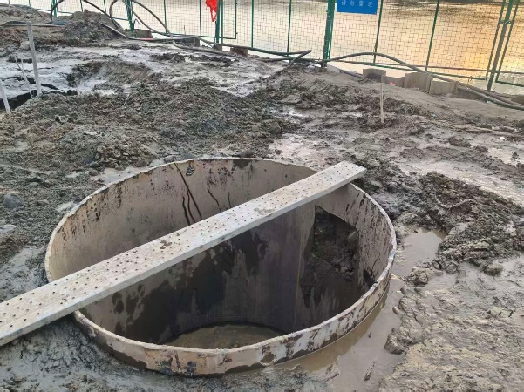 | 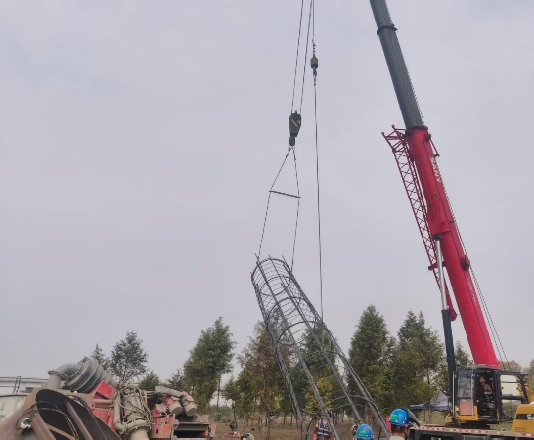
Figure 3. On-site view of completed steel casing installation for main tower pile foundation | Figure 4. On-site construction of three-point hoisting for segmented reinforcement cage of main tower pile foundation
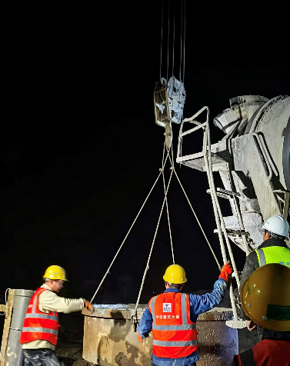 | 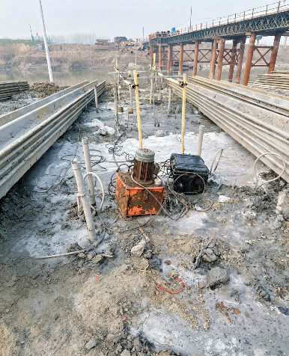
Figure 5. On-site construction of continuous underwater concrete pouring for main tower pile foundation | Figure 6. On-site vertical compressive static load test for single pile of main tower pile foundation

4 Quality and Safety Control System
A full-process, multi-level quality and safety control system is constructed, with process control as the core, key parameter monitoring as the means, and defect prevention as the goal, to ensure construction quality and on-site safety. In full-process quality control, precise borehole quality management includes pile position rechecking using GPS + total station (single-pile center deviation ≤ 50 mm, group pile ≤ 100 mm), full-hole ultrasonic detection of diameter and verticality (inclination ≤ 1/100, diameter not less than the design value), double detection of pile tip sediment thickness after secondary cleaning (≤ 15 cm), and real-time monitoring of slurry performance by a dedicated testing team, with immediate adjustments made if any parameters are unqualified. Comprehensive pile body quality control involves 100% re-inspection of reinforcement cage raw materials, individual inspection of fabrication accuracy (with deviations complying with specifications), on-site slump testing of concrete (unqualified batches are rejected), retention of no less than 4 groups of test blocks per pile (28-day strength ≥ C30), and strict control of pouring continuity to prevent pile breakage, mud interlayers, and segregation. Targeted quality defect prevention measures include: for borehole collapse, improving slurry indicators in high collapse-risk layers, ensuring the slurry head height, and advancing the embedding of steel casings; for slight collapse, supplementing slurry and drilling slowly; for severe collapse, backfilling with clay + gravel and re-drilling after stabilization. For diameter shrinkage, reducing the drilling speed, reaming, and optimizing the slurry in soft plastic layers and silty fine sand layers. For reinforcement cage deviation/floating, achieving precise centering, firm fixation, and controlling the initial pouring speed. For pile breakage, ensuring multi-point material supply, continuous pouring, and strictly controlling the conduit burial depth. For concrete segregation, strictly controlling the mix ratio and slump, optimizing admixtures, and controlling the falling height.
In systematic safety control, standardized safety protection measures include installing guardrails of no less than 1.2 m around slurry pools and borehole openings, posting warning signs, and providing night lighting; requiring certified operation for hoisting work with dedicated personnel on duty in the warning area; adopting a “three-level power distribution and two-level protection” mode for temporary electricity, with cables laid overhead or underground; implementing ventilation and dust reduction measures; and equipping complete labor protection equipment. Special emergency plans for hoisting injuries, mechanical injuries, electric shock, borehole collapse, and drowning are formulated, emergency teams are established, and emergency materials are fully prepared. Regular practical drills are conducted to continuously improve on-site emergency response capabilities.

5 Construction Effect Verification and Analysis
Comprehensive field tests are conducted on 28 pile foundations to verify the feasibility and effectiveness of the optimized technology. The quality and bearing capacity test results indicate that 100% of the piles are inspected using the sonic transmission method, all of which are classified as Class I piles, achieving a 100% qualification rate. Static load tests are conducted on 3 selected piles, and the maximum load reaches 35400 kN (twice the design value), with the bearing capacity significantly higher than the design requirements and minimal settlement, meeting the engineering design standards. The average 28-day strength of the concrete test blocks is 38.6 MPa with a dispersion coefficient of 3.2%, indicating stable and reliable quality of the pile body concrete. Construction efficiency analysis shows that the optimized construction technology shortens the average construction cycle per pile to 5 to 6 days compared with traditional processes, effectively meeting the overall project schedule requirements. Meanwhile, through closed slurry circulation and green drilling slag disposal technology, environmentally friendly construction is realized throughout the entire construction process, avoiding environmental pollution and achieving remarkable environmental benefits.

6 Key Conclusions and Innovations

6.1 Key Conclusions
The stratum-adaptive construction technology system effectively solves the difficult borehole-forming problems in complex high collapse-risk strata. By using precise steel casing embedding, layered adaptive drilling, and high-performance slurry regulation, the stability of the borehole wall and the control of sediment are ensured. The established full-process quality control system achieves the goal of 100% Class I piles, and the bearing capacity of the pile foundations meets and exceeds the design requirements, which ensures engineering safety. The integrated technology of acoustic detection pipes and grouting pipes not only improves the bearing capacity of the pile foundations but also effectively reduces construction costs and shortens the construction cycle, demonstrating favorable economic benefits. The optimized construction technology exhibits clear advantages including high efficiency, reliable quality, strong geological adaptability, and environmental friendliness. It should be noted that this technology is developed based on the specific geological conditions of the alluvial-pluvial plain; its applicability to other geological types requires further verification. The technology can be widely applied in similar engineering projects.

6.2 Core Innovations
A dynamic optimization system for drilling parameters in composite strata of alluvial-pluvial plains is established, dynamically adjusting core parameters such as drilling pressure and rotation speed according to the physical and mechanical properties of different strata, thereby solving the problems of borehole collapse and diameter shrinkage easily caused by fixed parameters. A high-performance composite slurry + closed circulation purification technology is developed, realizing the dual goals of precise regulation of slurry performance and green disposal of drilling slag through the compound slurry formula and closed circulation system. An innovative two-stage borehole cleaning technology is proposed, which stably controls the thickness of deep-hole sediment within 15 cm through the collaborative effect of primary reverse circulation cleaning and secondary airlift reverse circulation cleaning. A reinforcement technology of cross braces and three-point hoisting technology for extra-long reinforcement cages is developed, effectively resolving the problems of deformation, floating, and deviation during the fabrication and installation of extra-long reinforcement cages. An integrated technology of acoustic detection and grouting is constructed, realizing the organic integration of detection and grouting functions and achieving quality improvement and efficiency enhancement. A full-process quality and safety control system for pile foundations in complex geology is established, realizing precise control of the construction process and systematic safety management, and providing a complete technical reference for similar projects.

COMPETING INTERESTS DISCLAIMER:
Authors have declared that they have no known competing financial interests OR non-financial interests OR personal relationships that could have appeared to influence the work reported in this paper.
Disclaimer (Artificial intelligence)
Author(s) hereby declare that NO generative AI technologies such as Large Language Models (ChatGPT, COPILOT, etc.) and text-to-image generators have been used during the writing or editing of this manuscript.

References
[1] D, Y., Z, K., & L, W. (2024). Bearing performance of diaphragm wall pile combination foundation under vertical and horizontal loads. Journal of Engineering Research, 12(3), 340–350.
[2] Liang, H., Wang, Z., & Zhao, B. (2024). Investigation and numerical simulation study on the vertical bearing mechanism of large-diameter overlength piles in water-enriched soft soil areas. Applied Rheology, 34(1).
[3] Bai, X. Y., Liu, X. Y., Zhang, M. Y., Wang, Y. H., & Yan, N. (2020). Ultimate load tests on bearing behavior of large-diameter bored piles in weathered rock foundation. Advances in Civil Engineering, 2020.
[4] Li, K., Zhou, J., & Yu, P. (2026). Study on gas–solid particle dynamics and optimal drilling parameters in reverse circulation DTH drilling based on CFD and machine learning. Applied Sciences, 16(3), 1253.
[5] Cong, B. G., Jiang, J. F., & Wang, Z. G. (2023). Drilling technology for over 100-meter bored piles of the high-speed railway bridge across the Yellow River. Construction Technology, 52(13), 49–53+59.
[6] Liao, J., & Zhao, Q. (2015). Reverse circulation drilling technology with down-the-hole hammer. In Proceedings of the 13th National Symposium on Foundation Engineering (pp. 648–652). Chinese Hydraulic Engineering Society.
[7] Li, Z. W. (2022). Construction technology of special mud for super-long bored piles. China Science and Technology Information, (07), 44–45.
[8] Wang, T., & Han, X. L. (2025). Analysis on construction technology of bored piles in engineering with soft upper and hard lower strata. China Construction Metal Structure, 24(10), 43–45.
[9] Wang, W. Y., Liu, B. Y., & Li, H. (2017). Construction technology of post-grouting at pile tip and side for super-long bored piles. Construction Technology, 46(21), 117–119+124.
[10] Zhang, J., Zhao, C., & Wu, Y. (2023). Experimental study on post-grouting pile vertical bearing performance considering different grouting methods and parameters in cohesive soil. Applied Sciences, 13(22), 12175.
[11] Jin, R., Guo, F., & Xu, N. (2025). Laboratory model test study on bearing characteristics of super-long and large-diameter post-grouting piles in clay stratum. Buildings, 15(17), 3038.

