Numerical Investigation of the Structural Behavior of Ferrocement-Strengthened Reinforced Concrete Beams with Shear-Zone Openings

ABSTRACT:
The presence of openings in reinforced concrete (RC) beams significantly compromises their structural performance by inducing stress concentrations at opening corners, reducing stiffness, and increasing deformation. This study investigates the effectiveness of ferrocement — a thin cement mortar layer reinforced with a welded wire mesh — as a strengthening technique for RC beams containing square openings located in the shear zone. A nonlinear finite element model was developed using the ABAQUS program, employing the Concrete Damaged Plasticity (CDP) constitutive model for concrete and standard truss elements for steel reinforcement. The numerical model was validated against published experimental data, achieving 92% agreement in mid-span deflection at the ultimate load level. Following validation, six RC beam specimens with square openings of three different sizes relative to beam height — 0.25H, 0.5H, and 0.75H — were analyzed in both unstrengthened and ferrocement-strengthened configurations, alongside one solid reference beam with no openings, giving seven beams in total. Results demonstrate that ferrocement strengthening substantially improved structural performance across all opening sizes. For beams with 0.25H and 0.5H openings, mid-span deflection under a 150 kN applied load was reduced by approximately 64% and 62%, respectively, compared to the unstrengthened reference beam. For the largest opening (0.75H), where the unstrengthened beam sustained only 10 kN before failure, the ferrocement layer restored full load-bearing capacity to 150 kN, reducing deflection by 14% relative to the solid reference beam. Furthermore, maximum shear stress in all ferrocement-strengthened beams approached or exceeded that of the solid reference beam, confirming the effectiveness of the strengthening layer in restoring shear resistance lost due to the presence of openings.

Keywords: ferrocement, concrete beams, Abaqus program, finite element method, shear stress
- Introduction
Beams are linear structural elements that transfer loads from the slabs to the columns or walls they support. Determining the strength and stability of a load-bearing system depends on the contribution made by each element. Running conduits and pipes under beams requires an increased height on each floor, causing significant waste. Therefore, efforts are made to route these conduits and pipes through openings prepared in beams to reduce the floor height as much as possible. However, this change in the beam's cross-section will result in:
- Stress concentration at the corners of the openings.
- Reduced stiffness and increased deformation.
The practical implications of this challenge are far-reaching across multiple sectors of the construction industry. In residential and commercial building construction, mechanical, electrical, and plumbing (MEP) services — including water supply pipes, drainage systems, electrical conduits, ventilation ducts, and communication cables — routinely need to pass horizontally through floor beams. Routing these services beneath beams rather than through them would demand a greater floor-to-floor height, increasing material costs, structural dead loads, and the overall building height. In hospital and industrial facilities, where large-diameter pipes and ventilation systems are particularly common, this problem is even more acute. Beyond new construction, the issue is equally critical in structural rehabilitation: existing buildings often require upgraded service infrastructure, necessitating the introduction of new openings into beams that were originally designed as solid sections. In such cases, a low-cost, easily applicable strengthening method is essential to compensate for the structural capacity lost through the introduction of these openings. Ferrocement, requiring no heavy equipment for installation and adaptable to beams already in service, presents a particularly attractive solution in this rehabilitation context. Understanding the limits of its effectiveness across a range of opening sizes is therefore of direct practical value to structural engineers, contractors, and building rehabilitation specialists.
Openings can occupy a large or small space in the beam, depending on the required function and the desired geometric shape, which can be circular, rectangular, square, trapezoidal, triangular, or even irregular, among other shapes. Openings in beams offer significant benefits, as they reduce the weight and dimensions of the extensions passing through them, resulting in shorter actual lengths than if other paths were followed[1], Construction engineering today increasingly needs to reinforce existing structures to prevent their failure or to increase their capacity to withstand new functional loads that may be imposed on them. There are many methods used for reinforcement, including carbon fiber reinforcement, fiberglass reinforcement, and concrete reinforcement. Numerical studies have been conducted on strengthening reinforced concrete columns using a ferrocement layer, including one conducted by researcher Ali at Damascus University[2], who used the welded metal mesh shown in Figure 1.
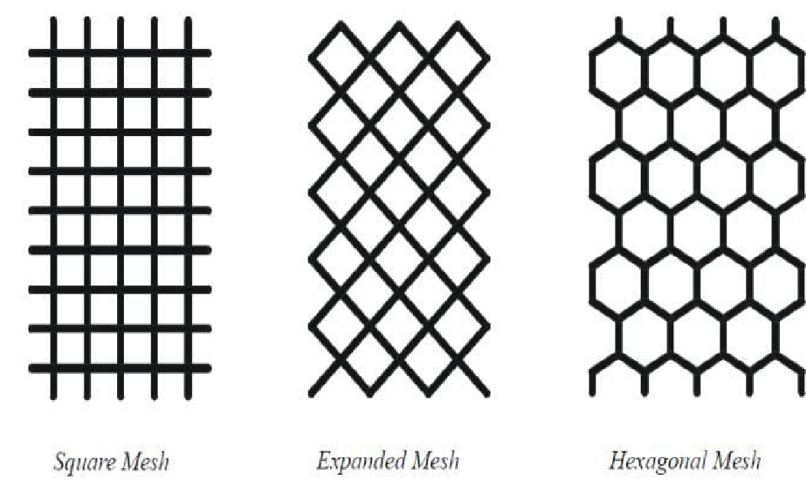
Figure 1: Types of metal networks within the Ferrocement layer.

In this research, we will strengthen concrete beams containing openings using cement mortar reinforced with a welded metal mesh (ferrocement). This method is useful for stopping cracks, helping the beam withstand greater external forces, and compensating for weaknesses caused by the presence of openings in the beam. Ferrocement is a commonly used type of reinforced concrete, consisting of a thin cement mortar layer reinforced with a relatively small-diameter reinforcing mesh. It is characterized by its low cost, as indicated by numerous studies, including those mentioned in the reference.
Despite the growing body of research on ferrocement as a strengthening technique for reinforced concrete elements, existing studies have predominantly focused on solid beams without openings, or on beams with openings strengthened using alternative methods such as steel plates or carbon fiber reinforced polymers (CFRP). To the authors' knowledge, no numerical study has systematically examined the combined effect of opening size variation and ferrocement strengthening on both mid-span deflection and shear stress distribution in RC beams simultaneously. Furthermore, the critical question of whether ferrocement can fully restore the structural performance of beams with large shear-zone openings — approaching or exceeding 0.75 times the beam height — remains unaddressed in the literature. The present study therefore aims to fill this gap by conducting a parametric numerical investigation using the ABAQUS finite element program, covering three opening size ratios and directly comparing strengthened and unstrengthened configurations against a solid reference beam.

Research Importance and Objectives:
- Given the need to use openings in concrete beams to ensure the passage of essential service supplies, thus reinforcing existing ones when necessary.
- To highlight the role of the ferrocement layer in strengthening beams and improving the behavior of their structural systems.
- To assess the suitability of ferrocement as a versatile strengthening method applicable to beams of varying cross-sectional geometries, thereby broadening its potential use in structural rehabilitation practice.
The objectives of this research are as follows:
- Study the strengthening of a beam containing openings reinforced with ferrocement.
- Study the effect of opening dimensions in strengthened beams on the behavior and load-carrying performance of reinforced concrete beams containing these openings, particularly in terms of mid-span deflection and maximum shear stress.
- Develop a computer model to simulate the behavior of concrete beams containing openings reinforced with ferrocement.
- LITERATURE REVIEW
In a study, Živkovic et al. (2024) conducted a test of (15) reinforced concrete beam samples measuring (250, 150, 3000) mm, where he used 4 models with a ferrocement strengthening process model with different sizes of wire meshes, and the process was verified using the finite element method (FEM), where the results for the models were good compared to the non-reinforced models.[3] Erfan et al. (2021) studied the behavior of reinforced concrete walls using various types of ferrocement. He used (10) wall models with dimensions of (1000, 1500, and 150) mm. The models were subjected to central and eccentric loads, and were examined experimentally and analyzed nonlinearly using the finite element method (FEM). The results were good for models made from ferrocement compounds. [4] Megarsa and Kenea (2022)[5] conducted an extensive analytical study of the shear strength performance of reinforced concrete beams using ferrocement. He simulated the models nonlinearly in the program (Abaqus 6.14). They used (15) models and two-point forces. The results showed that when forces were applied, the shear strength of beams reinforced with wire meshes was stronger than those without reinforcement. Soundararajan et al. (2022) [6] created (10) specimens of 1220, 100, and 150 mm in diameter using reinforced concrete reinforced with galvanized ferrocement at rates of 1.76% and 2.35%. The experimental results showed that ferrocement is effective and provides excellent reinforcement for reinforced concrete elements. Taha, et al. (2024)[7] evaluated and compared the torsional strength and torsional angle of different types of ferrocement compounds and measured them using linear and nonlinear analysis. The results showed that using Styrene Butadiene Rubber (SBR) as a bonding material is an effective method for maintaining the cohesion of reinforced concrete beams.
More recent studies have expanded the evidence base on reinforced concrete beams with web openings by combining experimental programs with validated finite-element models. Chen et al. (2023) showed that the shear behavior of beams with double openings is strongly influenced by opening location and loading position, while Elkafrawy et al. (2023) demonstrated numerically that pre-stressed Fe-SMA bars can substantially recover the lost shear capacity of beams with openings located in the shear zone. Cementitious and mesh-based strengthening systems have also received increasing attention: Hamoda et al. (2024a) reported that hybrid SHCC-mesh jackets markedly improved the shear strength, stiffness, and energy absorption of RC deep beams, and Hamoda et al. (2024b) showed that stainless-steel plate systems are effective for shear strengthening. For beams containing openings, Hamoda et al. (2025a) found that SHCC combined with glass-fiber mesh improved the structural behavior of deep beams with different opening shapes, whereas Hamoda et al. (2025b) reported that high-performance concrete mortars reinforced with steel wire mesh enhanced the shear performance of high-strength deep beams with openings. In addition, Tran et al. (2025) confirmed experimentally and numerically that ferrocement jacketing can significantly improve the behavior of retrofitted RC beams, and Hamoda et al. (2025c) extended the strengthening literature to circular openings subjected to torsion using NSM-GFRP and externally bonded CFRP systems.

- Research methodology and materials used:
This research adopts the analytical approach. A numerical model of reinforced concrete beams reinforced with ferrocement will be created using the ABAQUS finite element program. The model will be validated through calibration and simulation using available experimental studies. These beams will be analyzed under nonlinear static loading, and the maximum displacement at the center of the beam and the maximum shear stress on its cross-sections will be determined.
  - Working stage
    - Finite Element Model
The ABAQUS finite element program was used to fully simulate the reinforced concrete beam covered with a ferrocement layer, as shown in Figure 1.
Several analytical studies have examined strengthened reinforced concrete beams using simplified or reduced-order formulations. For example, Bouzid et al. (2023) developed analytical and three-dimensional numerical models to study the ultimate behavior of FRP-strengthened RC beams in flexure. Similarly, Aissa et al. (2023) proposed a predictive approach for evaluating interfacial stress distributions in RC beams strengthened with composite sheets, while Daouadji (2013) presented a theoretical analysis of interfacial stresses in damaged RC beams strengthened with bonded composite plates. These studies confirm that analytical or reduced-order approaches can be effective for predicting global structural response and interface behavior. However, the present study adopts a full three-dimensional ABAQUS finite-element model because its primary aim is to capture the local stress redistribution around square web openings and the ferrocement strengthening layer, rather than to formulate a reduced beam theory with a prescribed number of generalized unknowns.

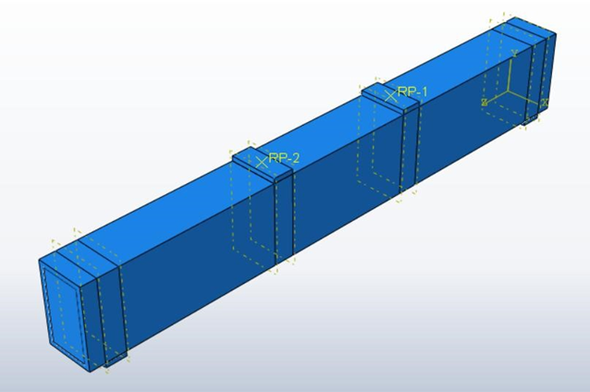
Figure 2: Model of a reinforced concrete beam fully reinforced with Ferrocement.
In our study, we have shown the same dimensions and parameters that were adopted in the reference.[8] Where the beam has a cross-section with dimensions (b*h = 150 * 300) mm, and a length of L = 2200 mm, reinforced with 3T12 main reinforcement, 2T10 suspension reinforcement, and ø8/200 mm transverse reinforcement, as shown in Figure 2. Figure (4 & 5) shows the details of the beam. The beam was fully strengthened with a 20 mm thick ferrocement layer on each side. The welded wire mesh embedded within the ferrocement layer had a wire diameter of 0.7 mm and a mesh aperture size of 12.5 × 12 mm, as shown in Figure 6. Each beam contained two square openings located in the shear spans. The center of each opening was positioned 300 mm from the adjacent support, and three opening sizes were considered: 75 × 75 mm, 150 × 150 mm, and 225 × 225 mm, corresponding to 0.25H, 0.5H, and 0.75H, respectively.
The original beam reinforcement consisted of three 12 mm bottom longitudinal bars, two 10 mm top bars, and 8 mm stirrups spaced at 200 mm along the beam length. In the opening region, no additional internal perimeter bars or diagonal bars were provided unless otherwise noted. Accordingly, the structural response in the vicinity of the openings was resisted by the remaining concrete web, the existing longitudinal and transverse reinforcement crossing the shear span, and, in the strengthened specimens, the external ferrocement layer.
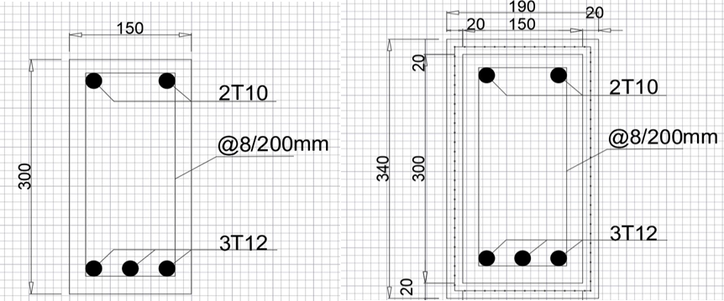
Figure 3: Cross-section details of the unreinforced beam. Figure 4: Cross-section details of the reinforced beam.
All the studied beams have simple support and are loaded with two identical forces, and the center of the opening is 300 mm away from the center of the support, as in Figure 3.
Loading protocol: All beams were analyzed under monotonic nonlinear static loading in a four-point bending configuration. Two equal vertical loads were applied symmetrically in the shear spans, while the beam ends were modeled as simple supports. A displacement-controlled loading history was imposed incrementally through the loading points, and the corresponding reaction forces were used to construct the load–deflection response. Mid-span deflection was recorded at the beam center throughout the analysis and was used to construct the load–deflection curves presented in the Results section.

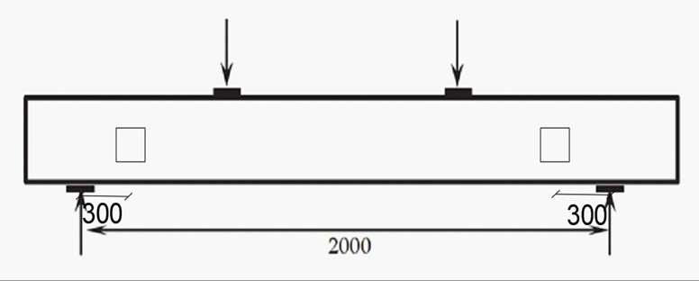
Figure 5: Reinforced concrete beam without support.

Figure (6) The reinforcement mesh used as support within the ferrocement layer[9]

    - Concrete Modeling
The C3D8 element was used to model the concrete. It is a solid element consisting of eight nodes, each with three degrees of freedom (three translations). It is from the group of three-stress elements with regular deformations and linear dimensions. Figure 7 shows the spatial element used, which is the same model used by the researcher.[10]
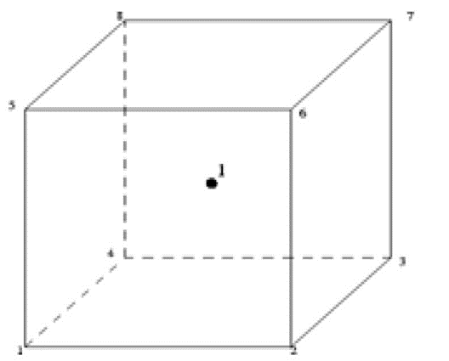
Figure (7) Element C3D8.
The Concrete Damaged Plasticity (CDP) model was used to characterize the inelastic behavior of concrete in tension and compression, or it can be used to represent the nonlinear behavior of concrete, considering the gradual decrease in elastic stiffness resulting from the occurrence of relative plastic straining in both tension and compression. Figures (8) and (9) show the stress-deformation diagram adopted for concrete in tension and compression.
The tensile and compressive constitutive laws assigned to the concrete were implemented within the Concrete Damaged Plasticity (CDP) model and calibrated to reproduce the benchmark response adopted for model verification. The input data included tensile stress–cracking strain behavior, compressive stress–inelastic strain behavior, and the associated tensile and compressive damage variables used in ABAQUS.

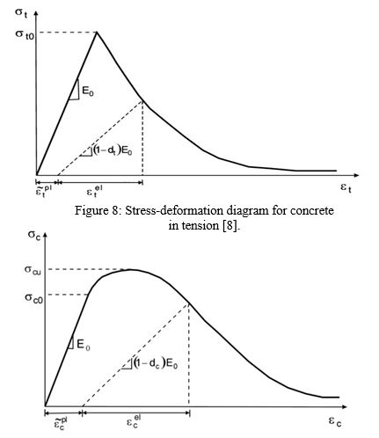
Figure (9) Stress-deformation diagram for concrete in compression[8]
    - Steel Reinforcing Modeling
The T3D2 element was used as the one used in the reference.[11] , which is a truss element consisting of two nodes, each node containing three degrees of freedom (3 translations), as Figure 10 [11] Shows the model of the T3D2 element.
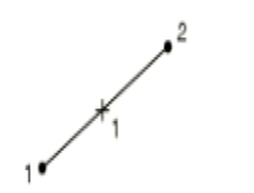
Figure (10) Element T3D2[10] .
To understand the behavior of steel and reinforcing bars, stress-strain diagrams used by researchers were utilized and incorporated into finite element models. Figure 11 shows a stress-strain diagram for reinforcing steel.
The same calibrated elastic–plastic constitutive law was assigned to the internal steel reinforcement in the numerical model. This material model was used for the longitudinal bars and transverse reinforcement to ensure consistency during model verification and parametric analysis.

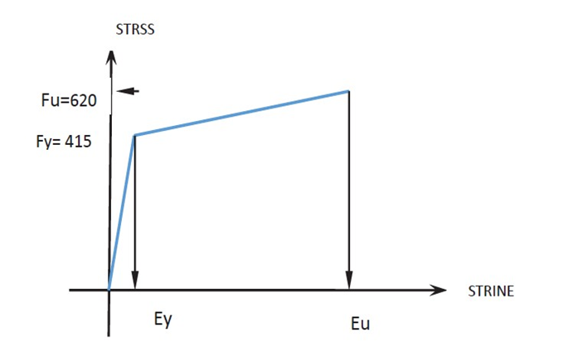
strain
stress
Figure 11: Stress-strain diagram for reinforcing steel[8]
    - Modeling the reinforcement network within the ferrocement layer
The reinforcement network is modeled using a uniaxial element with three degrees of freedom at each node, namely translations in the x, y, and z directions. It can withstand deformations and plasticity.
    - Study Parameters
We studied the effect of the dimensions of the square opening whose center is 300 mm away from the center of the support, where we changed the dimensions of the opening relative to the height of the beam (H), as this change included three values: (0.25*H, 0.5*H, 0.75*H)
    - Model Verification
We adopted the reinforced concrete beam model from the Studies[8], [11] And compared the transition obtained by the researcher at the center of the beam with the transition obtained using the ABAQUS program. The comparison showed good convergence in the results obtained, as the transition matched 92% at the ultimate strength of 150 KN, as shown in Figure 12. In the ABAQUS plot output used in the manuscript, the term ‘Transition’ refers to the vertical response at mid-span, i.e., the beam deflection.
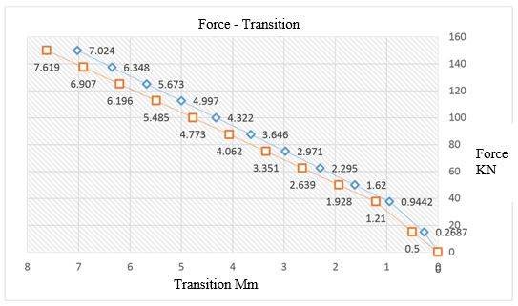 Figure (12) Force- Transition diagram for the beams in the reference study in red and modeling in blue on the ABAQUS program.
  - Results and discussions
All the studied beams contain two openings in the shear zone, where the dimensions of one opening were changed about the height of the beam shown in Table 1. The studied beams with or without reinforcement, the maximum Transition value, and the maximum shear stress.

Table 1: Details of the studied beam and their results.
Name of Beam | Opening Dimensions (mm) | Applied force (KN) | Transition (mm) | Maximum shear stress (MPa)
(A) Standard Sample | It does not contain any openings. | 150 | 7.024 | 2.46
(1-A) Unsupported Sample | 0.25*H=75 | 150 | 7.341 | 2.44
(2-A) Supported Sample | 0.25*H=75 | 150 | 2.551 | 2.53
(3-A) Unsupported Sample | 0.5*H=150 | 115 | 7.734 | 1.762
(4-A) Supported Sample | 0.5*H=150 | 150 | 2.691 | 2.51
(5-A) Unsupported Sample | 0.75*H=225 | 10 | 8.492 | 0.117
(6-A) Supported Sample | 0.75*H=225 | 150 | 6.047 | 2.517

The numerical results suggest that beam response was strongly influenced by opening size and strengthening condition. The unstrengthened beams exhibited a progressive reduction in load-carrying performance as the opening size increased, with the most severe deterioration observed for the beam with the 0.75H opening. In contrast, the ferrocement-strengthened beams showed improved stiffness and higher load-carrying capacity, indicating that the strengthening layer contributed to restoring structural performance and enhancing shear resistance around the opening region.

Figure 13 also shows a comparison of the force transition diagram for the beams (A-1), (A-2) and the standard sample.

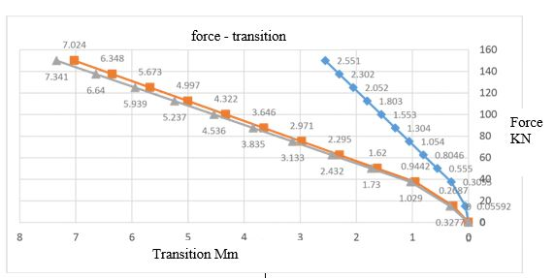

Figure (13) Force- Transition diagram for the beams (A-1, in gray), (A-2 in blue), and the standard sample in red.

We note from Figure 13) the force-transition diagram for the reinforced beam containing (2-A) holes, the standard sample (A), and the unreinforced beam containing (1-A) holes. The Transition at a force of 150 KN reached the following values: 2.551 mm, 7.024 mm, and 7.341 mm, respectively. We note that the difference between the values of beam (1-A) and the standard sample (A) was very small, not exceeding 5%. However, the Transition for beam (2-A) decreased by 64% compared to the standard sample. In other words, the Transition decreased by 65% in beam (2-A) compared to the Transition in beam (1-A). Figure (14) shows a comparison of the force-transition diagram for beams (3-A), (4-A), and the standard sample.

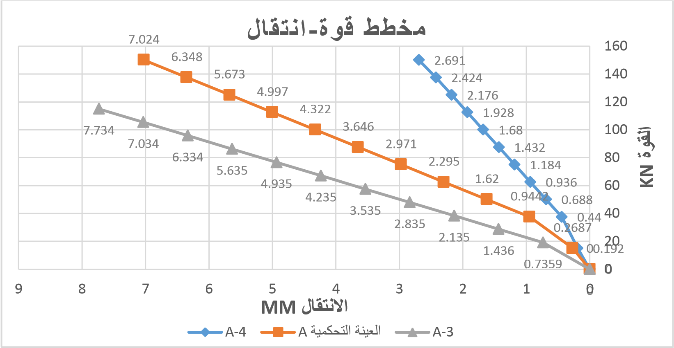
Transition Mm
Force KN
Force - Transition
Figure (14) Force- Transition diagram for beams (A-3, in gray), (A-4, in blue), and the standard sample in red.

Figure (14) shows that the displacement reached 2.691 mm for the reinforced beam (4-A) containing holes when the force reached 150 KN, while the Transition was 7.024 mm for the standard sample (A) for the same force. The Transition for the unreinforced beam (3-A) containing holes reached 7.734 mm for the force of 115 KN. The force applied to the beam (3-A) decreased by 23%, while the Transition increased by 10 % compared to the standard sample (A). Similarly, the Transition in the beam (4-A) decreased by 62% compared to the standard sample (A) and decreased by 65% compared to the beam (3-A). Figure 15 shows a comparison of the force-transition diagram for the beams (6-A), (5-A), and the standard sample.

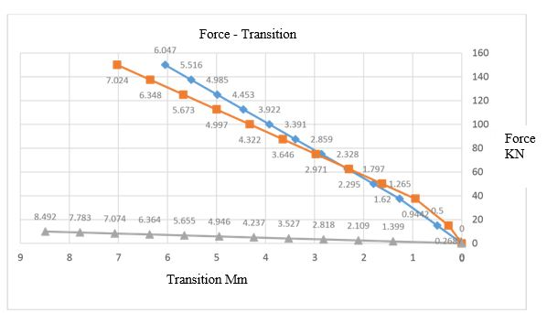
Figure (15) Force- Transition diagram for beams (A-5, in gray) (A-6, in blue) and the standard sample in red.
Transition MM
Force - transition

We also conclude from the diagram in Figure (15) that the value of the force applied to beam (5-A) decreased by 93%, and the Transition increased by 20% compared to the standard sample (A), while the Transition in beam (6-A) decreased by 14% compared to the standard sample (A), and by 29% compared to beam (5-A). It was observed that the Transition in beam (1-A) increased by 5% compared to that of the standard sample (A) at a Transition of 150 kN. The Transition in beam(3-A) increased by 11% compared to that of the standard sample (A) at a Transition of 115 kN. The Transition in beam (5-A) increased significantly at a strength much lower than that of the standard sample (A). This is due to the increased dimensions of the opening relative to the height of the beam without reinforcement. The Transition of reinforced beams (2-A) and (4-A) decreased significantly by 64% and 62%, respectively, compared to the standard sample (A) at a strength of 150 kN. The Transition of reinforced beam (6-A) decreased by 14% compared to the standard sample (A) at the same strength of 150 kN. The decrease in Transition in reinforced beams is due to the ferrocement layer. As for the maximum shear stress, we notice a relative increase in the reinforced beams (2-A) (4-A) (6-A), and (A) compared to the standard sample (A), due to the ferrocement layer, while we notice a relative decrease in its value in the unreinforced beams (1-A) (3-A) and a significant decrease in the unreinforced beam (5-A).
  - Conclusion and Recommendations
Based on the numerical investigation conducted in this study, it can be concluded that the presence of openings in the shear zone adversely affects the structural performance of reinforced concrete beams, particularly as the opening size increases relative to the beam depth. The finite-element results indicate that ferrocement strengthening improves the behavior of beams containing openings by reducing midspan displacement and enhancing shear resistance. For beams with relatively small openings equal to 0.25H, the effect of the opening on overall behavior was limited, whereas larger openings produced a more pronounced reduction in load-carrying performance in the unstrengthened specimens. In contrast, the strengthened beams exhibited improved structural response compared with their corresponding unstrengthened beams, confirming the beneficial contribution of the ferrocement layer. The results further show that the effectiveness of strengthening depends on opening size, with the greatest benefit observed in cases where the openings caused significant weakening of the original beam section. Overall, the study demonstrates that ferrocement jacketing is a practical strengthening technique for reinforced concrete beams with web openings under the loading and modeling conditions considered in this research.

In light of these findings, future studies are recommended to investigate the influence of different mesh types, mesh layers, and ferrocement thicknesses on beam performance. It is also recommended to examine other mortar and concrete strength levels, different opening shapes and locations, and additional loading conditions in order to develop a broader understanding of the structural efficiency of ferrocement-strengthened beams with openings.

Limitations and Future Research

First, the investigation was limited to a numerical finite-element analysis performed using ABAQUS, and model verification was conducted through comparison with previously published results rather than through an independent experimental program. Second, the scope of the parametric study was relatively restricted, as only seven beam models were considered, all with square openings located in the shear zone and with opening dimensions limited to 0.25H, 0.5H, and 0.75H. In addition, the analysis was confined to a single beam geometry, one ferrocement thickness, and one reinforcement configuration, which limits the generalizability of the conclusions. The study was also restricted to nonlinear static loading, without considering cyclic, fatigue, impact, or seismic loading conditions. Furthermore, the evaluation focused mainly on displacement and maximum shear stress, while other important response parameters, such as crack propagation, ductility, bond behavior, energy dissipation, and long-term durability, were not examined in detail.
Future research should therefore include comprehensive experimental validation, broader parametric analyses, different opening shapes and locations, alternative mesh arrangements, and varying mortar and concrete strengths. Additional studies should also investigate the long-term durability and serviceability performance of ferrocement-strengthened beams under practical loading and environmental conditions.

COMPETING INTERESTS DISCLAIMER:
Authors have declared that they have no known competing financial interests OR non-financial interests OR personal relationships that could have appeared to influence the work reported in this paper.

References
- [1] F. El Ame, J. N. Mwero, and C. K. Kabubo, “Openings Effect on the Performance of Reinforced Concrete Beams Loaded in Bending and Shear,” 2020. [Online]. Available: www.etasr.com
- [2] A. Al, H. Kikhia, and Y. Ali, “Retrofitting Of Reinforced Concrete Columns Using Locally Available Welded Wire Meshes (WWMs),” Dec. 2015.
- [3] D. Živković, P. Blagojević, D. Kukaras, R. Cvetković, and S. Ranković, “Comprehensive Analysis of Ferrocement-Strengthened Reinforced Concrete Beam,” Buildings, vol. 14, no. 4, Apr. 2024, doi: 10.3390/buildings14041082.
- [4] A. M. Erfan, R. M. Abd Elnaby, A. Elhawary, and T. A. El-Sayed, “Improving the compressive behavior of RC walls reinforced with ferrocement composites under centric and eccentric loading,” Case Studies in Construction Materials, vol. 14, Jun. 2021, doi: 10.1016/j.cscm.2021.e00541.
- [5] E. Megarsa and G. Kenea, “Numerical Investigation on Shear Performance of Reinforced Concrete Beam by Using Ferrocement Composite,” Math Probl Eng, vol. 2022, Feb. 2022, doi: 10.1155/2022/5984177.
- [6] M. Soundararajan, S. Balaji, J. Sridhar, and G. Ravindran, “Sustainable Retrofitting and Moment Evaluation of Damaged RC Beams Using Ferrocement Composites for Vulnerable Structures,” Sustainability (Switzerland), vol. 14, no. 15, Aug. 2022, doi: 10.3390/su14159220.
- [7] Roula Taha, Muneeb AL Allaf, and Ihssan Tarsha, “Experimental and Analytical Evaluation to Strengthened R.C Beams Using Ferrocement Under Torsion,” Steps For Civil, Constructions and Environmental Engineering, vol. 2, no. 3, pp. 9–17, Sep. 2024, doi: 10.61706/sccee1201121.
- [8] A. A. AL-Dhabyani and A. AL-Ansi, “Numerical Analysis for Reinforced Concrete Beams with Circular Openings in Flexural and Shear Zones Strengthened by Steel Plates,” Journal of Science and Technology, vol. 23, no. 2, pp. 31–48, Dec. 2018, doi: 10.20428/jst 23.2.2.
- [9] T. A. El-Sayed and A. M. Erfan, “shear strength of ferrocement composite box section concrete beams,” Constr Build Mater, vol. 172, pp. 608–617, May 2018, doi: 10.1016/j.conbuildmat.2018.03.273.
- [10] Ever J. Barbero, “Finite Element Analysis of Composite Materials Using Abaqus® Structural Health Monitoring Technologies and Next-Generation Smart Composite Structures Jayantha Ananda Epaarachchi and Gayan Chanaka Kahandawa, FRP Deck and Steel Girder Bridge Systems: Analysis and Design, 2023. doi: 10.1201/9781003108153.
- [11] J. Suresh and R. A. Prabhavathy, “Behaviour Of Steel Fibre Reinforced Concrete Beams With Duct Openings Strengthened By Steel Plates,” International Journal of Advanced Information Science and Technology (IJAIST), vol. 3, no. 8, pp. 53–61, Aug. 2014, doi: 10.15693/ijaist/2014.v3i8.53-61.

- Bouzid, H., Benferhat, R., & Daouadji, T. H. (2023). Ultimate behavior of RC beams strengthened in flexure using FRP material. Engineering Structures, 289, 116300. https://doi.org/10.1016/j.engstruct.2023.116300
- Aissa, B., Benferhat, R., & Daouadji, T. H. (2023). Predicting and analysis of interfacial stress distribution in RC beams strengthened with composite sheet using artificial neural network. Structural Engineering and Mechanics, 87(6), 517–527. https://doi.org/10.12989/sem.2023.87.6.517
- Daouadji, T. H. (2013). Analytical analysis of the interfacial stress in damaged reinforced concrete beams strengthened by bonded composite plates. Strength of Materials, 45, 587–597. https://doi.org/10.1007/s11223-013-9496-4
- Hamoda, A., Ghalla, M., Yehia, S. A., Ahmed, M., Abadel, A. A., Baktheer, A., & Shahin, R. I. (2024). Experimental and numerical investigations of the shear performance of reinforced concrete deep beams strengthened with hybrid SHCC-mesh. Case Studies in Construction Materials, 21, e03495. https://doi.org/10.1016/j.cscm.2024.e03495
- Hamoda, A., Yehia, S. A., Ahmed, M., Sennah, K., Abadel, A. A., & Shahin, R. I. (2024). Experimental and numerical investigation of shear strengthening of simply supported deep beams incorporating stainless steel plates. Buildings, 14(11), 3680. https://doi.org/10.3390/buildings14113680
- Hamoda, A., Shahin, R. I., Abadel, A. A., Sennah, K., Ahmed, M., & Yehia, S. A. (2025). Shear strengthening of normal concrete deep beams with openings using strain-hardening cementitious composites with glass fiber mesh. Structures, 71, 107994. https://doi.org/10.1016/j.istruc.2024.107994
- Hamoda, A., Emara, M., Ahmed, M., & Abadel, A. A. (2025). Shear strengthening of high-strength reinforced concrete deep beams with openings using high-performance concrete mortars. International Journal of Concrete Structures and Materials, 19, 70. https://doi.org/10.1186/s40069-025-00765-5
- Hamoda, A., Ahmed, M., Abadel, A. A., Sennah, K., Baktheer, A., & Yehia, S. A. (2025). Strengthening of reinforced concrete beams with circular openings under pure torsion using near-surface mounted GFRP and externally bonded CFRP. Case Studies in Construction Materials, 23, e05195. https://doi.org/10.1016/j.cscm.2025.e05195
- Chen, Z., Xu, R., Ling, Z., Liang, Y., Lu, S., & Qin, L. (2023). Experimental and numerical analysis of shear performance of reinforced concrete beams with double openings. Archives of Civil and Mechanical Engineering, 23, 195. https://doi.org/10.1007/s43452-023-00745-0
- Elkafrawy, M., Khalil, A., AlHamaydeh, M., Hawileh, R., & Abuzaid, W. (2023). Enhancing the shear capacity of RC beams with web openings in shear zones using pre-stressed Fe-SMA bars: Numerical study. Buildings, 13(6), 1505. https://doi.org/10.3390/buildings13061505
- Tran, T. T., Bui, L. V. H., Sirimontree, S., Nguyen, P. T., Stitmannaithum, B., & Thongchom, C. (2025). Experimental and numerical analyses of RC beams retrofitted with ferrocement. Results in Engineering, 27, 106939. https://doi.org/10.1016/j.rineng.2025.106939

