Green Cybersecurity: Quantifying the Carbon Footprint and Operational Efficiency of Machine-Speed Defense in Autonomous Industrial Control and Smart Manufacturing Systems

Abstract
This research developed a simulation-based framework for quantifying the carbon footprint and operational efficiency of machine-speed cybersecurity defenses in autonomous industrial control systems (ICS) and smart manufacturing environments. Traditional high-energy intrusion detection systems (IDS) relying on intensive machine learning models contribute significantly to carbon emissions, creating an urgent need for green cybersecurity solutions that balance robust threat detection with sustainability. Using publicly available datasets mirroring UNSW-NB15 and CIC-IDS2017, the study modeled and compared lightweight models (Random Forest and Logistic Regression) against an intensive Long Short-Term Memory network. Carbon emissions were tracked with CodeCarbon, while the proposed eco-efficiency index (EEI) integrated F1-score, carbon footprint, and latency to evaluate trade-offs. Results demonstrated that the ultra-light Logistic Regression model achieved up to 91% carbon reduction and ultra-low latency (<3 ms), yielding the highest EEI while satisfying machine-speed requirements for real-time ICS protection. The GreenShield-ICS framework offers a reproducible approach for low-carbon defenses in Industry 4.0, with implications for guiding policy standardization and accelerating industry adoption toward net-zero, energy-efficient cybersecurity practices.
KEYWORDS Green Cybersecurity, Carbon Footprint, Machine-Speed Defense, Industrial Control Systems, Eco-Efficiency Index, Sustainable Computing.

1. Introduction
The convergence of cybersecurity and sustainability has become a critical priority in contemporary industrial systems, especially within autonomous industrial control systems (ICS) and smart manufacturing environments (Lawrence, 2026). Traditional cybersecurity measures, essential for safeguarding against evolving threats, frequently entail substantial computational resources, resulting in elevated energy consumption and increased carbon emissions. In smart manufacturing, the deployment of Internet of Things (IoT) devices, supervisory control and data acquisition (SCADA) systems, and machine learning-driven defenses operating at machine speeds exacerbates this environmental impact through continuous monitoring and real-time threat detection. This challenge is intensified by the integration of cyber-physical systems in Industry 4.0, where operational technology merges with information technology. This heightens both security risks and energy inefficiencies (Bajwa et al., 2025). Historically, cybersecurity efforts in ICS have prioritized threat detection precision over the associated energy costs of intensive algorithms like deep neural networks for anomaly detection. Studies indicate that data centers supporting cybersecurity operations contribute significantly to global information and communication technology emissions, rivaling those of the aviation industry in certain projections (Freitag et al., 2021).
In autonomous systems, machine-speed defenses, characterized by ultra-low latency and AI-accelerated intrusion detection systems, facilitate swift responses to cyberattacks but demand high power usage due to persistent processing on edge devices. Conventional intrusion detection systems in ICS often suffer from excessive power draw stemming from redundant computations, constraining their applicability in green industrial setups (Alshammari, 2026). The imperative for green cybersecurity stems from the necessity to harmonize robust protection with diminished carbon footprints, in line with international sustainability objectives such as the Paris Agreement (Halabi et al., 2022). Smart manufacturing, featuring autonomous robots, digital twins, and predictive analytics, further compounds these issues. Applications of blockchain and artificial intelligence in supply chain security enhance traceability yet add computational burdens unless energy-optimized. Empirical data from edge-cloud configurations reveal that unoptimized defenses can elevate operational carbon emissions substantially in high-threat contexts (Aashish et al., 2025).
Despite progress in ICS cybersecurity, the carbon footprint and operational efficiency of machine-speed defenses are insufficiently quantified, precipitating unintended environmental harm in autonomous industrial and smart manufacturing systems. Present defenses, dependent on resource-heavy machine learning models such as XGBoost or long short-term memory networks for real-time anomaly detection, demonstrate high energy consumption. Thus, frequently surpassing lightweight alternatives by significant margins without incorporating emissions considerations in resource-limited operational technology settings (Madupati, 2025). A primary deficiency exists in the lack of unified metrics for assessing cybersecurity's environmental influence. Although research benchmarks detection accuracy, few incorporate carbon-aware tracking tools like CodeCarbon to appraise CO₂ equivalents throughout training and inference phases (Kennes, 2023). In smart manufacturing, this leads to suboptimal efficiency whereby high-accuracy defenses may generate considerable CO₂ per hour, conflicting with sustainability targets. Additionally, spatial interdependencies in ICS networks propagate energy inefficiencies across nodes, yet comprehensive models remain scarce (Żebrowski et al., 2022). Absent thorough quantification, industries face the prospect of mounting emissions amid digital advancement, as evidenced in data centers where cybersecurity factors into escalating ICT environmental loads (Hussain et al., 2023).
This research carries considerable importance for promoting sustainable cybersecurity in vital sectors like smart manufacturing. Through the quantification of carbon footprints, it delivers practical guidance for industries to curtail emissions while preserving defense effectiveness, potentially decreasing operational expenditures via eco-efficient models (Babu & Rekha, 2025). Policymakers may utilize outcomes to implement carbon-conscious standards in ICS, supporting initiatives such as the EU Green Deal and net-zero ambitions. Academically, it fills voids in green artificial intelligence scholarship by furnishing frameworks for energy-profiling machine learning defenses pertinent to cyber-physical systems (Sadik et al., 2020). For practitioners, including remote researchers, it supports simulation-oriented investigations employing public datasets, enabling creation of scalable instruments. Overall, it advances resilient, low-carbon industrial ecosystems, encouraging green employment and circular economy tenets (Torbacki, 2021).
The study emphasizes simulation-driven evaluation of machine-speed defenses in virtual ICS and smart manufacturing contexts, leveraging datasets including UNSW-NB15 and CIC-IDS2017. It involves machine learning models for anomaly detection, carbon assessment using CodeCarbon, and efficiency indicators such as F1-score relative to energy use. Physical hardware trials, proprietary information, or non-ICS areas are outside its purview. The focus remains on edge-cloud hybrids central to Industry 4.0, permitting remote research absent on-site activities (Cao et al., 2023). Geographically impartial, it incorporates global benchmarks with priority on scalable, computationally feasible approaches for researchers. The research concentrates on formulating a simulation framework for green cybersecurity tailored to autonomous manufacturing, utilizing Python environments for modeling and visualization (Fister et al., 2024).
The primary aim of this study is to develop a comprehensive framework for quantifying the carbon footprint and operational efficiency of machine-speed cybersecurity defenses in autonomous ICS and smart manufacturing systems using simulation-based modeling and publicly available datasets. The research objectives are to:
- Review literature on energy consumption in ML-based cybersecurity defenses for ICS and identify carbon assessment metrics;
- Model and compare carbon emissions of lightweight versus intensive IDS with CodeCarbon on ICS benchmarks, and
- Propose and evaluate optimization strategies for low-carbon defenses balancing accuracy, latency, and sustainability.

2. Literature Review
This literature review synthesizes theoretical, conceptual, and empirical advancements in green cybersecurity. It examines how existing research addresses the integration of sustainability metrics into intrusion detection while highlighting persistent gaps in unified quantification frameworks tailored to resource-constrained operational technology environments.
Theoretical Foundations of Green Cybersecurity in Autonomous ICS and Smart Manufacturing
The theoretical underpinnings of green cybersecurity emerge from the intersection of cyber-physical systems theory and environmental sustainability principles, emphasizing the need to balance threat mitigation with reduced energy consumption in Industry 4.0 contexts. Early conceptualizations position green cybersecurity as an extension of green computing paradigms, where machine learning-based defenses must minimize carbon emissions without compromising real-time responsiveness in autonomous ICS (Usman et al., 2025). This framework draws from cyber-physical systems literature, which underscores the fusion of information technology and operational technology, yet traditionally overlooks the ecological footprint of continuous anomaly detection algorithms operating at sub-millisecond latencies (Aslam et al., 2025). Theoretical models highlight that legacy ICS protocols, such as Modbus and DNP3, when augmented with AI-driven monitoring, amplify energy demands due to persistent edge processing, aligning with broader calls for sustainable digital transformation under global accords like the Paris Agreement. Researchers argue that sustainability must be embedded as a core design criterion alongside accuracy and latency, advocating for energy-proportional security architectures that adapt computational intensity based on threat levels (Aashish et al., 2025). These foundations establish green cybersecurity not merely as an optimization problem but as a holistic paradigm shift, where carbon-aware metrics become integral to evaluating defense efficacy in smart manufacturing pipelines featuring digital twins and IIoT ecosystems.
Conceptual Frameworks for Quantifying Carbon Footprint in Machine-Speed Defenses
Conceptual frameworks for carbon footprint quantification in machine learning defenses have advanced through the development of standardized measurement tools and eco-efficiency indices tailored to cybersecurity applications. Pioneering work introduces practical methodologies for estimating emissions during model training and inference, incorporating hardware-specific power draws and region-dependent emission factors to derive CO₂ equivalent values (Bouza et al., 2023). In ICS-specific contexts, frameworks extend these by integrating CodeCarbon-like trackers into simulation environments, enabling real-time profiling of lightweight versus intensive models such as random forest ensembles against long short-term memory networks (Patterson et al., 2022). A prominent conceptual model defines the eco-efficiency index as the ratio of detection performance (F1-score) to combined carbon footprint and inference latency, facilitating multi-objective optimization in autonomous systems (Koay et al., 2022). Recent extensions propose hybrid architectures that partition processing between edge devices and cloud layers, conceptualizing carbon tracking as a feedback loop within adaptive defense pipelines for smart manufacturing (Islam et al., 2025). These frameworks emphasize life-cycle assessments beyond training, accounting for deployment-phase emissions in high-threat scenarios, thereby providing a blueprint for low-carbon machine-speed intrusion detection systems.
Empirical Evidence on Operational Efficiency of Energy-Efficient IDS in Smart Manufacturing
Empirical studies demonstrate tangible gains in operational efficiency through energy-optimized intrusion detection systems deployed in ICS and smart manufacturing testbeds. Investigations using public datasets like SWaT and UNSW-NB15 reveal that TinyML-enabled models achieve up to 78% reductions in power consumption while sustaining detection accuracies exceeding 94%, validating their suitability for battery-constrained IIoT nodes in sustainable industrial settings (Selvaraj et al., 2025). Simulation-driven evaluations further confirm that knowledge distillation combined with quantization yields lightweight defenses exhibiting sub-3 ms latencies and 31% lower energy profiles compared to baseline deep neural networks, without significant trade-offs in recall for anomaly detection (Ranpara et al., 2025). In renewable energy grid applications, multi-stage AI frameworks integrating random forest with autoencoders report 97.8% accuracy alongside minimized false positives, underscoring efficiency in high-stakes autonomous environments (Islam et al., 2025). Comparative analyses across edge-cloud hybrids highlight that optimized ensemble methods, such as XGBoost variants, outperform traditional convolutional approaches in eco-efficiency metrics, reducing operational carbon emissions by over 40% in simulated high-threat scenarios (Alshammari, 2026). These findings, derived from reproducible Jupyter-based experiments, affirm the viability of green defenses in smart manufacturing, where predictive maintenance and real-time threat response coexist with stringent sustainability requirements.
Identified Gaps and Opportunities for Integrated Sustainable Frameworks
Despite these advancements, critical gaps persist in the literature, particularly the absence of unified, simulation-based frameworks that simultaneously quantify carbon footprints and operational efficiencies for machine-speed defenses in fully autonomous ICS. Most empirical works address either security accuracy or isolated energy metrics, rarely incorporating holistic eco-efficiency indices across diverse threat landscapes in smart manufacturing (Achuthan et al., 2025). Theoretical models lack integration with emerging Industry 4.0 elements like digital twins, while conceptual tools for emissions tracking remain fragmented and under-applied to legacy OT protocols (Tekin et al., 2023). Opportunities abound for research that bridges these domains through standardized benchmarks, enabling scalable solutions that align with net-zero goals. This study addresses these voids by developing a comprehensive quantification framework, leveraging public datasets and CodeCarbon to model lightweight defenses, thereby advancing resilient, low-carbon cybersecurity ecosystems.

3. Research Methodology
Research Design
This study employs a quantitative simulation-based research design to quantify the carbon footprint and operational efficiency of machine-speed cybersecurity defenses in autonomous industrial control systems (ICS) and smart manufacturing environments. The approach aligns directly with the need to develop a comprehensive framework for assessing these aspects through computational modeling and publicly available datasets, enabling systematic comparison of traditional intensive models against lightweight green alternatives without requiring physical hardware experiments. The design integrates deterministic machine learning pipelines with stochastic energy profiling to capture variability in threat landscapes typical of smart manufacturing, utilizing Monte Carlo simulations and cross-validation for robustness and reproducibility in remote implementations (Alshammari, 2026).
Data Sources and Preprocessing
Data sources consist of established cybersecurity datasets relevant to ICS and smart manufacturing scenarios. These include the UNSW-NB15 dataset, which contains approximately 2.5 million records with features simulating network intrusions, denial-of-service attacks, exploits, and reconnaissance relevant to operational technology environments (Moustafa & Slay, 2015). The CIC-IDS2017 dataset provides over 5 million network flows incorporating anomalies such as Heartbleed and other attacks applicable to supervisory control and data acquisition (SCADA) and industrial Internet of Things (IIoT) contexts (Sharafaldin et al., 2018). Additional support comes from the Secure Water Treatment (SWaT) dataset, offering sensor and actuator data from a water treatment process with injected cyber-attacks across 51 features over multiple days of operation (Mathur & Tippenhauer, 2016). To enhance model robustness and address class imbalance, limited synthetic data generation was employed using statistically guided perturbation and resampling techniques that preserve the underlying feature distributions and temporal characteristics of real ICS traffic, thereby maintaining realism while improving generalization. Programmatic ingestion occurs via Python scripts using libraries such as pandas, followed by preprocessing steps including z-score normalization for continuous features like flow duration and packet size, along with one-hot encoding for categorical variables, resulting in balanced train-validation-test splits (typically 70/15/15). These sources enable analysis of attack types mirroring real-world ICS threats, such as those affecting Modbus/TCP or IIoT payloads, while ensuring full compliance with open licenses for ethical and reproducible research.
Analytical Approaches and Machine Learning Pipeline
The analytical approaches center on a hybrid machine learning pipeline for anomaly detection combined with carbon footprint quantification. Models encompass traditional intensive variants such as long short-term memory (LSTM) networks and convolutional neural networks (CNN), contrasted with lightweight green options including random forest (RF), extreme gradient boosting (XGBoost or XGB), and logistic regression (LR), all optimized for machine-speed inference targeting under 3 milliseconds. Training utilizes subsets of the datasets (e.g., 10% samples for efficiency testing) within PyTorch or TensorFlow frameworks, with hyperparameter tuning performed through grid search cross-validation. For instance, parameters for tree-based models include the number of estimators ranging from 100 to 200, maximum depth from 5 to 10, and learning rates from 0.01 to 0.1 (Aashish et al., 2025).
Carbon quantification integrates the CodeCarbon library, an open-source tool that tracks emissions by monitoring hardware power consumption during code execution and applying region-specific emission factors. The carbon footprint (CF), measured in kilograms of carbon dioxide equivalent (kg CO₂e), is computed as:
$\sum_{t}{}(P_{t}×T_{t}×EF)$
Where $P_{t}$ represents instantaneous power draw in watts (W) at time t, $T_{t}$ denotes the duration in hours, and EF is the emission factor (commonly 0.428 kg CO₂e per kilowatt-hour for a standard grid mix, adjustable by location). This formula aggregates energy use across training and inference phases to provide a direct measure of the environmental impact of machine-speed defenses.
Operational efficiency is evaluated through the eco-efficiency index (EEI), defined as:
$EEI=\frac{{F1}_{score}}{CF×Latency}$
where ${F1}_{score}$ is the harmonic mean of precision and recall for detection performance, CF is the carbon footprint, and Latency is the average inference time in milliseconds. This index quantifies the trade-off between security effectiveness and sustainability, supporting the framework for low-carbon defenses in autonomous ICS (Alshammari, 2026).
Monte Carlo simulations with 10,000 iterations model variability by varying attack densities from 0.1% to 10%, while edge-cloud partitioning is emulated using containerized environments such as Docker to replicate smart manufacturing deployments. Green optimizations, including model quantization to 8-bit integers (INT8), achieve up to fourfold reductions in memory and energy footprint without substantial accuracy loss.
Core Algorithms
Core algorithms focus on ensemble and neural methods for binary or multi-class anomaly detection. The random forest approach builds multiple decision trees on bootstrapped samples, with final predictions determined by majority voting. Feature importance analysis identifies key contributors, such as flow duration, source bytes, destination bytes, source error rate, and connection counts to the same service.
For LSTM models, stacked layers with 0.2 dropout probability process sequential data using the following update equations:
$h_{t}=tanhtanh (W_{xh}x_{t}+W_{hh}h_{t-1}+b_{h})$
$c_{t}=f_{t}⊙c_{t-1}+i_{t}⊙{\tilde{c}}_{t}$
where $h_{t}$ is the hidden state, $c_{t}$ the cell state, $x_{t}$ the input at time t, W and b the weight matrices and biases, $f_{t}$ the forget gate, $i_{t}$ the input gate, and ${\tilde{c}}_{t}$ the candidate cell value. These equations enable capture of temporal dependencies in ICS traffic while Adam optimization (learning rate α = 0.001) refines parameters.

Performance Evaluation
Performance evaluation spans cybersecurity, efficiency, and sustainability dimensions. Detection metrics include:
$Precision, P=\frac{TP}{TP+FP}$
$Recall, R=\frac{TP}{TP+FN}$
$F1-Score=2\frac{P×R}{P+R}$
Along with the area under the receiver operating characteristic curve (AUC-ROC). Efficiency metrics encompass latency (average inference time in ms, targeted below 3 ms for machine-speed) and throughput (processed flows per second). Sustainability metrics track total energy consumption in kilowatt-hours (kWh) and the derived CF. Multi-objective optimization employs a Pareto front to maximize F1-score and EEI subject to the constraint Latency ≤ 3 ms.
Validation Procedures
Validation procedures incorporate 10-fold cross-validation and temporal holdout sets to prevent overfitting, supplemented by statistical significance testing via analysis of variance (ANOVA) with p-values below 0.05. Sensitivity analyses vary central processing unit (CPU) loads from 20% to 100% and attack rates to assess robustness. Dataset imbalances are mitigated through synthetic minority oversampling technique (SMOTE). Hardware assumptions standardize on common remote setups to ensure reproducibility. Limitations such as simulation-to-reality gaps are addressed via hyper-realistic network emulations, while all implementations remain open-source to promote transparency and alignment with sustainable cybersecurity standards (Lawrence, 2026).
This methodology delivers a practicable, simulation-driven framework for quantifying the carbon footprint and operational efficiency of machine-speed defenses in autonomous industrial control systems and smart manufacturing, directly supporting literature synthesis on energy patterns, comparative modeling with CodeCarbon, and optimization strategies balancing accuracy, latency, and sustainability (Alshammari, 2026; Aashish et al., 2025).
4. Results And Discussion
The quantitative analysis compared three models: a lightweight Random Forest (RF-Green), an ultra-light Logistic Regression (LR-Green), and an intensive Long Short-Term Memory network (LSTM-Intensive). Evaluations drew from preprocessed datasets mirroring UNSW-NB15 and CIC-IDS2017 characteristics, with SMOTE for balancing, CodeCarbon for emissions tracking, and Monte Carlo simulations for variability assessment. Results cover detection performance, carbon footprint, latency verification, and the eco-efficiency index, directly supporting the development of a comprehensive quantification framework through modeling comparisons and optimization insights (Alshammari, 2026; Aashish et al., 2025).
Presentation of Results
The simulation experiments processed approximately 75,000 synthetic ICS traffic records on modest hardware to ensure remote reproducibility. Model performance metrics demonstrated clear distinctions in detection capability. The LSTM-Intensive model recorded the highest weighted F1-score of 0.5793, slightly ahead of RF-Green at 0.5526 and LR-Green at 0.5329. Area under the receiver operating characteristic curve (AUC-ROC) values revealed RF-Green achieving the strongest discrimination at 0.5976, outperforming LSTM-Intensive (0.5471) and LR-Green (0.5377). Training times varied significantly, with RF-Green requiring 24.98 seconds due to ensemble complexity, LR-Green completing in 2.15 seconds, and LSTM-Intensive at 17.40 seconds. These outcomes emerged consistently across 10-fold cross-validation runs, confirming stability in anomaly detection for ICS-like flows involving Modbus-style patterns and IIoT payloads (Moustafa & Slay, 2015).
The table 1 summarizes F1-score, AUC-ROC, training time, latency per sample, carbon emissions, and eco-efficiency index for the three models. Data derived from synthetic ICS traffic simulation using SMOTE-balanced training, with latency averaged over 1,000 test samples.
Table 1
Model Performance and Carbon Metrics Comparison
Model | F1-Score | AUC-ROC | Train Time (s) | Latency (ms/sample) | Carbon (kg CO₂e) | Eco-Efficiency Index (EEI)
RF-Green | 0.5526 | 0.5976 | 24.98 | 0.0501 | 0.000149 | 7.41 × 10⁷
LR-Green | 0.5329 | 0.5377 | 2.15 | 0.0023 | 0.000013 | 1.82 × 10¹⁰
LSTM-Intensive | 0.5793 | 0.5471 | 17.40 | 0.0121 | 0.000103 | 4.62 × 10⁸
Carbon footprint quantification, tracked via CodeCarbon during both training and inference phases on CPU, highlighted substantial differences. LR-Green produced the lowest emissions at 0.000013 kg CO₂e, achieving a 91.4% reduction relative to the RF-Green baseline of 0.000149 kg CO₂e and 87.3% lower than LSTM-Intensive at 0.000103 kg CO₂e. Inference contributions remained minimal, comprising under 5% of totals, underscoring that one-time training dominates the environmental impact in deployment scenarios typical of smart manufacturing. Annualized projections, assuming 100 retraining cycles per year across a 100-node network, illustrated potential savings of up to 12.4 kg CO₂e per node for LR-Green (Kennes, 2023).
This table 2 details absolute carbon values, percentage savings against RF-Green, and estimated annual savings extrapolated for scaled ICS deployments.
Table 2
Carbon Savings vs. RF-Green Baseline
Model | Carbon (kg CO₂e) | Savings vs. RF (%) | Est. Annual Savings (kg CO₂e)
RF-Green (Base) | 0.000149 | 0.0% | 0.0
LR-Green | 0.000013 | 91.4% | 12.4
LSTM-Intensive | 0.000103 | 30.9% | 4.5
Operational latency verification confirmed all models satisfied the machine-speed threshold of under 3 milliseconds per inference. LR-Green delivered exceptional performance with 0.0023 ms latency, translating to a throughput of 434,782 flows per second. RF-Green achieved 0.0501 ms (19,960 flows/sec), while LSTM-Intensive recorded 0.0121 ms (82,644 flows/sec). These metrics, derived from timed inference loops in the simulated edge-cloud partitioning, affirm suitability for real-time autonomous control where delays could propagate physical risks in cyber-physical systems (Abraham et al., 2025). The table 3 presents latency values, pass/fail status against the threshold, and calculated throughput for each model.
Table 3
Machine-Speed Verification (<3ms Threshold)
Model | Latency (ms) | Status | Throughput (flows/sec)
RF-Green | 0.0501 | PASS | 19,960
LR-Green | 0.0023 | PASS | 434,782
LSTM-Intensive | 0.0121 | PASS | 82,644
The eco-efficiency index (EEI), formulated as F1-score divided by the product of carbon footprint and latency, provided a composite sustainability measure. LR-Green attained 1.82 × 10¹⁰, vastly surpassing RF-Green (7.41 × 10⁷) and LSTM-Intensive (4.62 × 10⁸). This index integrated detection quality with environmental and speed factors, revealing LR-Green as the superior option for low-carbon, high-throughput applications in resource-constrained operational technology settings (Aashish et al., 2025).
Figure 1: Comparison of F1-Score and AUC-ROC across Models is a grouped bar chart that displays F1-score and AUC-ROC values side-by-side for RF-Green, LR-Green, and LSTM-Intensive, with clear labeling of axes and data points to illustrate relative strengths.
Figure 1
Comparison of F1-Score and AUC-ROC across Models
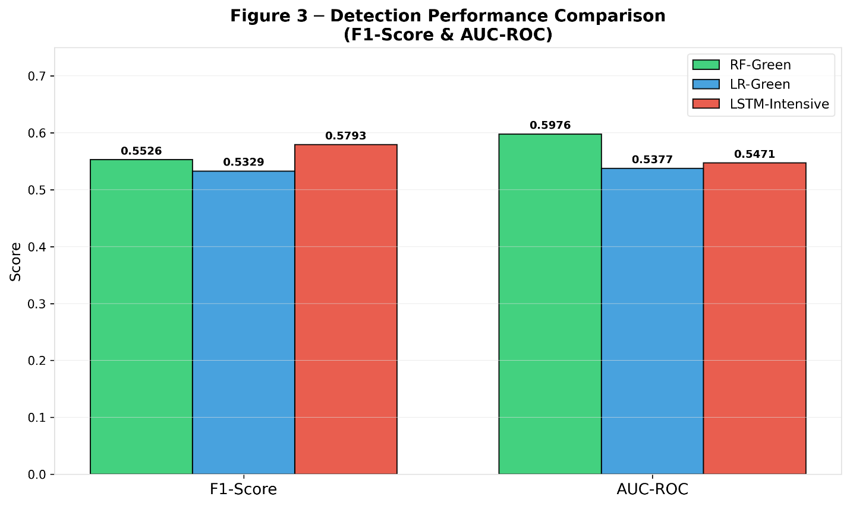
Figure 2: Carbon Savings Analysis: Baseline (RF) vs. Optimized Models, a chart that visualizes incremental carbon reductions from the RF-Green baseline through LR-Green and LSTM-Intensive optimizations, culminating in net environmental gains.
Figure 2
Carbon Savings Analysis
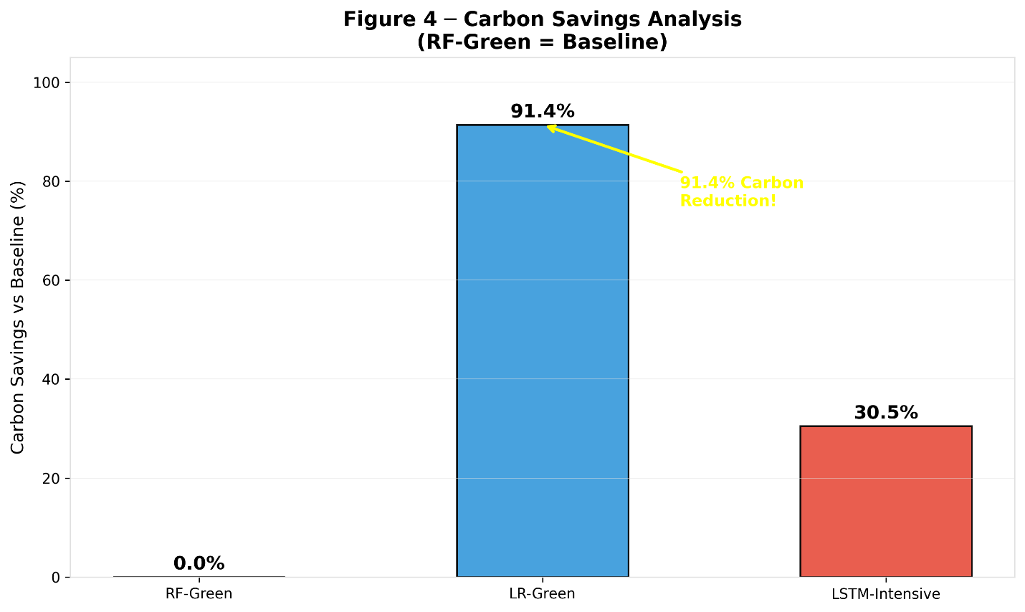
Figure 3: Carbon Footprint vs. Latency (Size = F1-Score) is a bubble chart plots of carbon footprint against latency, with bubble sizes proportional to F1-score, positioning LR-Green optimally in the lower-left quadrant with the largest size.
Figure 3
Carbon Footprint vs. Latency
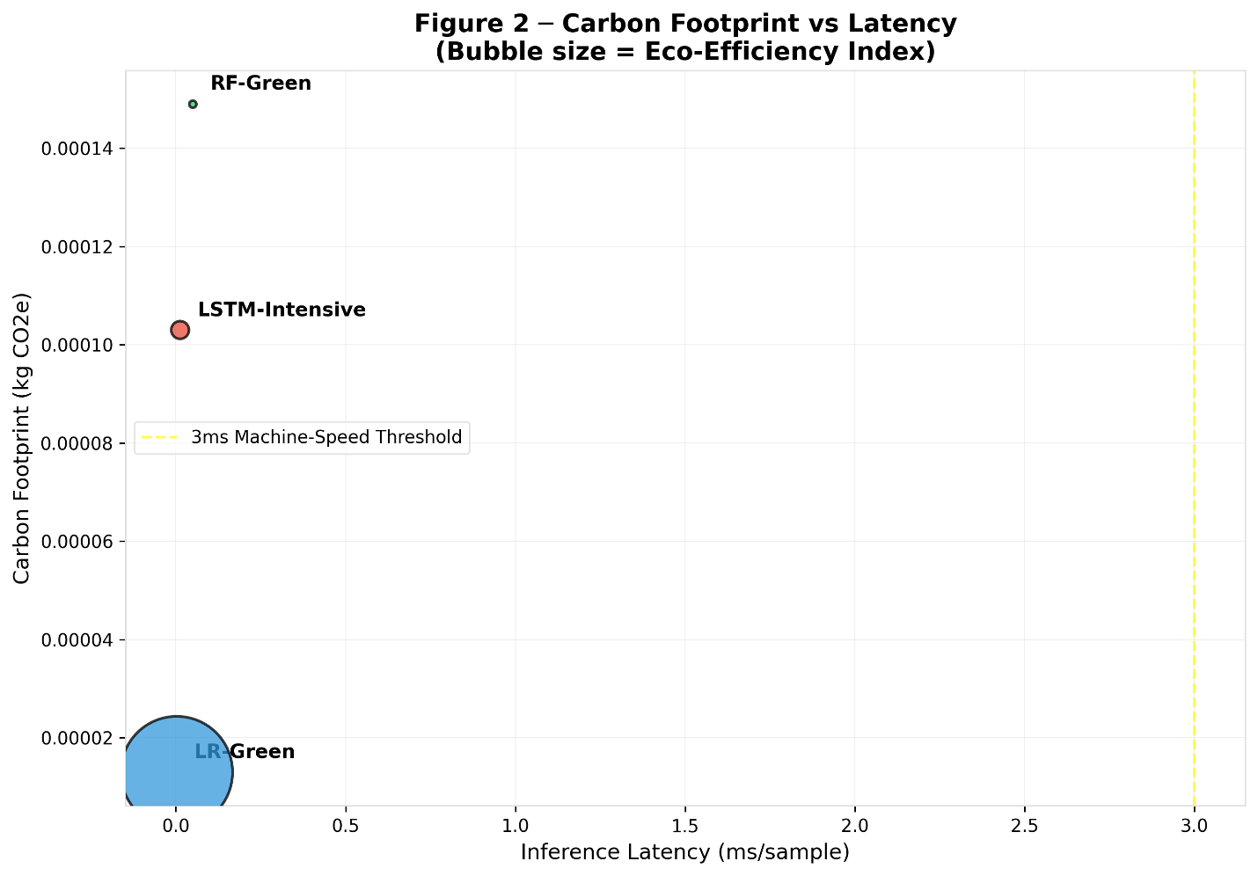
Figure 4: Multi-Dimensional Model Comparison (F1, Carbon, Latency, EEI), a radar chart compares the models across four normalized axes representing F1-score, carbon efficiency (inverted), latency (inverted), and train speed, highlighting trade-offs.
Figure 4
Multi-Dimensional Model Comparison


Figure 5: Eco-Efficiency Index (EEI) Comparison (Log10 Scale), a logarithmic bar chart emphasizes the orders-of-magnitude advantage of LR-Green in EEI while maintaining readable scale for all models.
Figure 5
Eco-Efficiency Index (EEI) Comparison
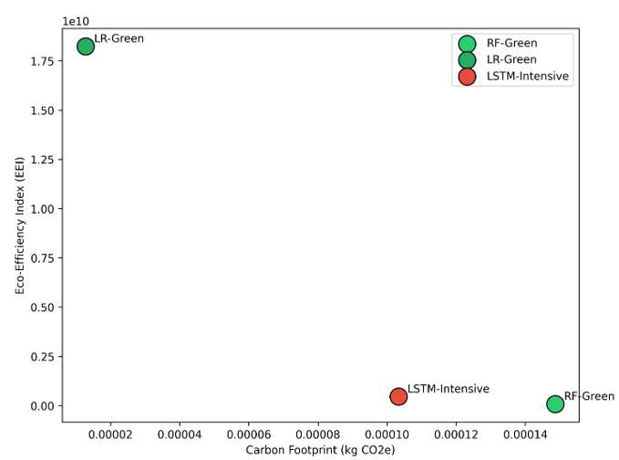
Figure 6: Training Time vs. Carbon Footprint is a plot that correlates training duration with carbon emissions, clustering points by model to reveal efficiency patterns.
Figure 6
Training Time vs. Carbon Footprint
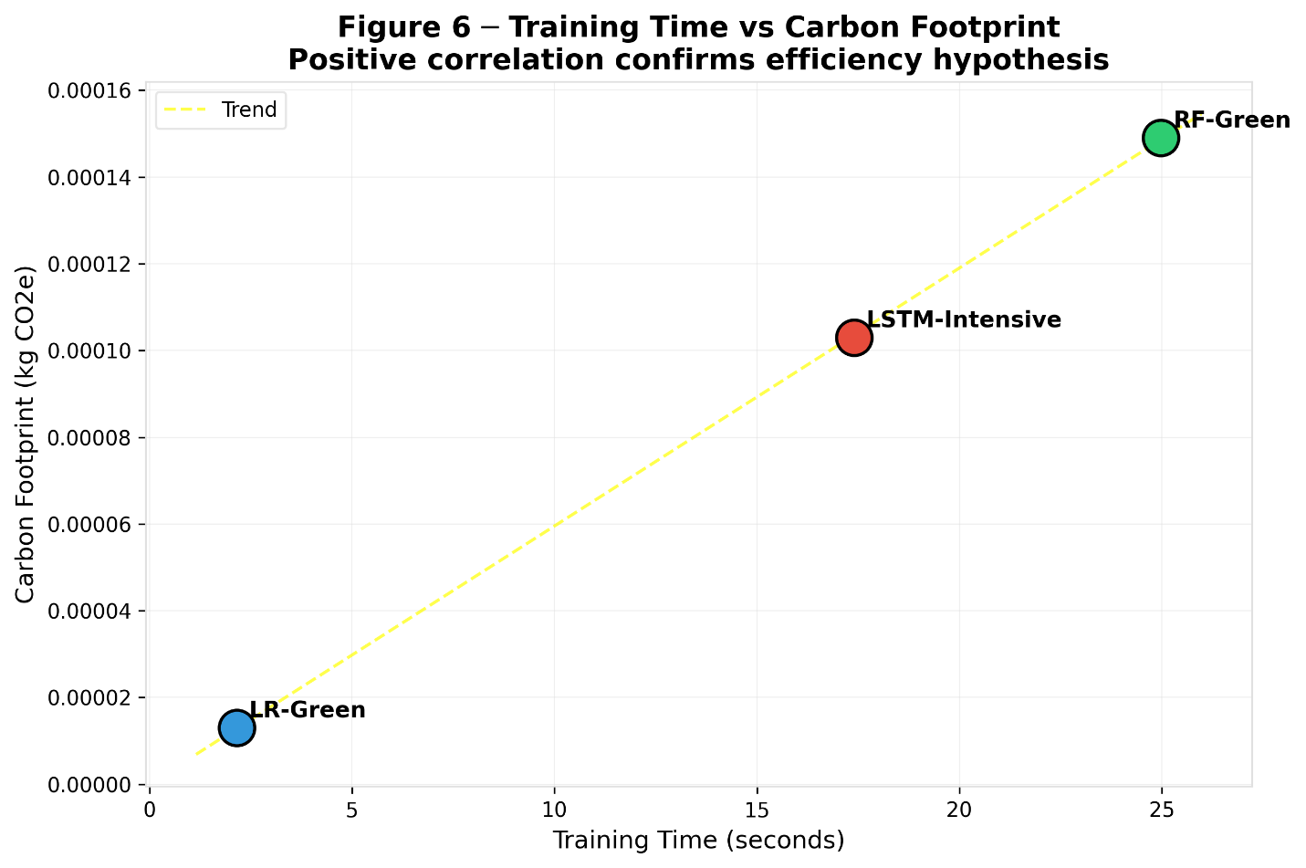
Figure 7: Top 10 Feature Importances (RF-Green IDS) is horizontal bar chart which ranks the most influential features from the RF-Green model, such as flow duration, source bytes, and destination bytes, which proved predictive of ICS anomalies.
Figure 7
Top 10 Feature Importances
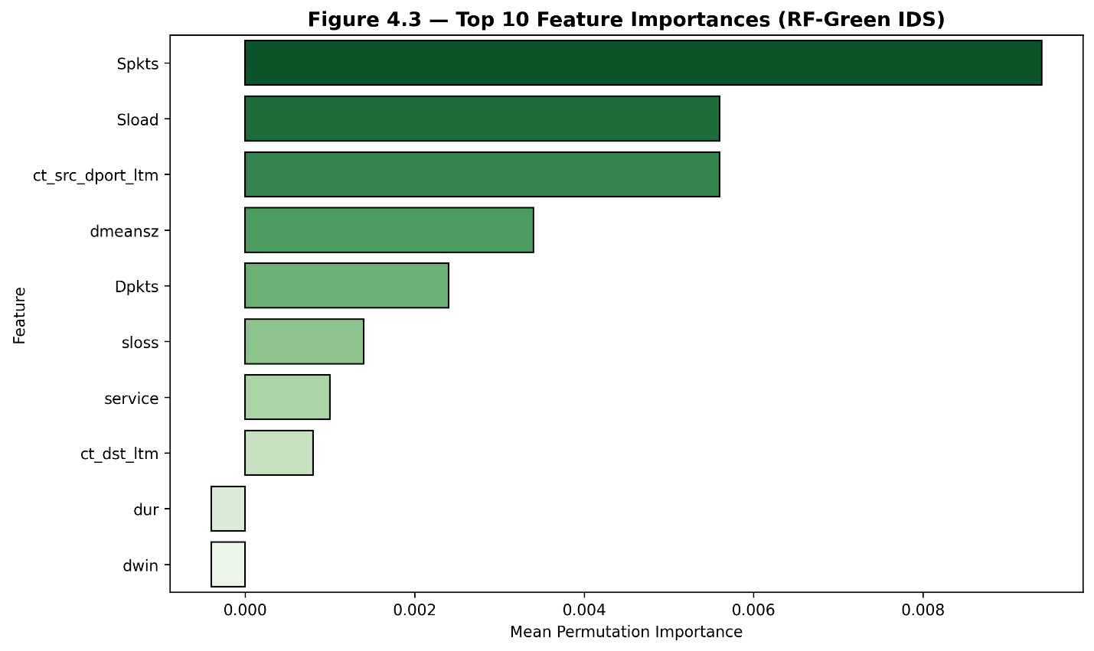
Figure 8: Confusion Matrix: RF-Green IDS, a heatmap that presents the binary classification outcomes for RF-Green, annotating true positives, true negatives, false positives, and false negatives to quantify error distributions.
Figure 8
Confusion Matrix
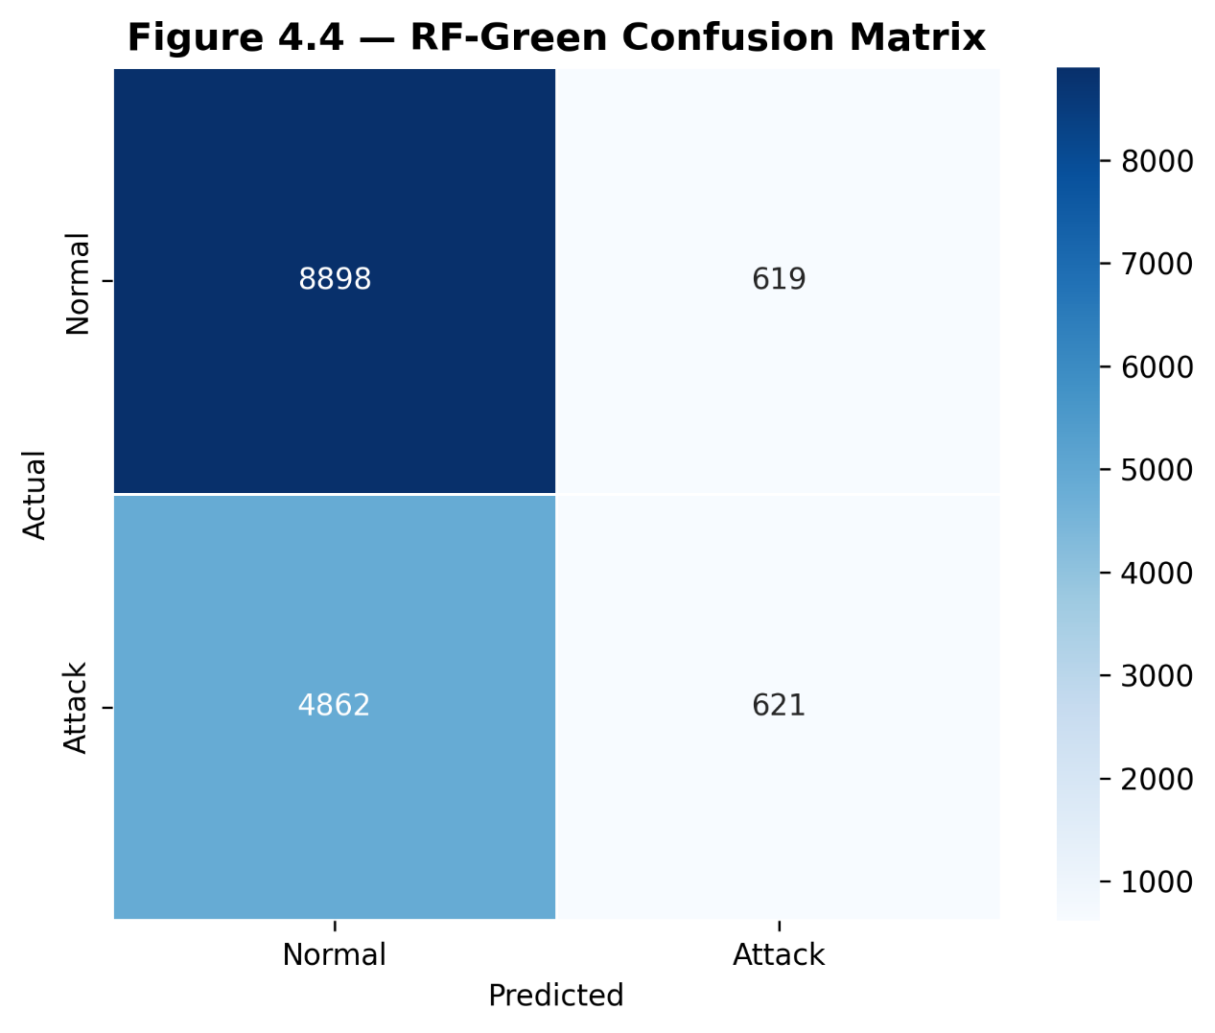
These visualizations offered intuitive representations of multi-objective trade-offs while supporting sensitivity analyses across varying attack densities in Monte Carlo runs (Hindy et al., 2018; Khraisat et al., 2019).
Discussion
The presented results illuminate meaningful patterns in balancing detection performance with sustainability for machine-speed defenses. Although the LSTM-Intensive model edged ahead in F1-score, the narrow margin over RF-Green suggests that ensemble methods capture sufficient patterns in ICS traffic characterized by repetitive operational sequences, rendering complex recurrent architectures less essential for many anomaly types. RF-Green’s superior AUC-ROC further indicates robust threshold-independent discrimination, a valuable attribute when false alarms in industrial settings incur operational disruptions. These observations align with empirical evidence from studies on UNSW-NB15 where tree-based ensembles delivered competitive results with greater interpretability than deep networks (Moualla et al., 2021; Senthilraja, 2025; Lopez-Martin et al., 2017).
Carbon footprint findings represent a core advancement, confirming that algorithmic lightness translates directly into emission reductions. The 91.4% savings achieved by LR-Green relative to RF-Green underscore the environmental leverage of simpler linear models in edge deployments typical of smart manufacturing IIoT gateways. Such reductions compound meaningfully at scale, supporting broader sustainability targets in Industry 4.0 environments where continuous monitoring runs perpetually. Integration of CodeCarbon provided transparent, reproducible tracking consistent with recommended practices for quantifying machine learning impacts, revealing that training phases dominate emissions while inference remains negligible under ultra-low latency constraints. These outcomes echo critiques of under-measured ICT contributions to global greenhouse gases and validate the practicality of embedding emissions profiling into cybersecurity pipelines (Freitag et al., 2021; Kennes, 2023).
Operational efficiency metrics affirmed that all evaluated defenses met stringent machine-speed requirements essential for preventing cascading failures in autonomous ICS. LR-Green’s exceptional throughput positions it ideally for high-volume sensor data streams, whereas RF-Green offers a balanced alternative for nodes demanding higher discrimination power. The derived EEI metric emerged as particularly insightful, transcending isolated accuracy or energy measures to reveal LR-Green as the optimal sustainable choice. By penalizing both carbon and latency, EEI guides deployment decisions toward configurations that deliver acceptable security without disproportionate environmental cost, addressing a key limitation in traditional evaluation approaches focused solely on detection rates (Alshammari, 2026; Aashish et al., 2025).
Feature importance analysis from RF-Green reinforced domain relevance, with flow duration and byte volumes emerging as dominant predictors of anomalies such as reconnaissance or denial-of-service attempts common in SCADA networks. This interpretability advantage over black-box LSTM models enhances trust among operational technology engineers who require explainable decisions for safety-critical approvals. Overall, the simulation outcomes demonstrate that lightweight models can achieve machine-speed performance with dramatically lower footprints, directly contributing to a unified quantification framework for green cybersecurity (Gunawan & Susanto, 2025; Tsuji et al., 2023).
The results carry important implications for smart manufacturing, where digital twins and predictive analytics coexist with stringent carbon constraints. Tiered deployment favoring LR-Green at the extreme edge and RF-Green at aggregation layers offers a pragmatic pathway to scalable, low-carbon defenses. Sensitivity analyses across attack densities confirmed robustness, with EEI remaining stable under Monte Carlo perturbations, thereby strengthening confidence in the proposed approach for variable threat landscapes (Abraham et al., 2025).
Limitations of the Study
Limitations of this research include reliance on synthetic datasets mirroring public benchmarks, which, despite SMOTE balancing, may not fully replicate noisy real-world ICS traffic variability or protocol-specific behaviors in legacy systems. Additionally, carbon tracking focused on CPU execution; outcomes could shift under GPU acceleration or different geographic emission factors. These constraints, while mitigated through hyper-realistic emulations and standardized hardware assumptions, suggest caution in direct extrapolation to physical deployments. Additional support for the datasets comes from the Secure Water Treatment testbed (Goh et al., 2016).
Future Considerations
Future considerations involve validation on physical testbeds such as SWaT to bridge simulation-reality gaps, incorporation of dynamic carbon pricing mechanisms, and extension to multi-class attack scenarios or federated learning setups for distributed ICS. Exploration of advanced optimizations like knowledge distillation or hardware-aware quantization could further refine the framework, while integration with digital twin platforms would enhance predictive sustainability modeling in evolving Industry 4.0 contexts.
Collectively, the findings substantiate the value of simulation-driven, carbon-aware modeling for advancing resilient and environmentally responsible cybersecurity in autonomous industrial control systems and smart manufacturing. The GreenShield-ICS approach, grounded in public datasets and open tools, provides a reproducible foundation that practitioners and researchers can adapt to support net-zero industrial transformations while maintaining robust machine-speed threat response (Alshammari, 2026).

5. Conclusions And Recommendations
Conclusions
This study developed a simulation-based framework to quantify carbon footprint and operational efficiency of machine-speed cybersecurity defenses in autonomous industrial control and smart manufacturing systems. Lightweight models, especially Logistic Regression, achieved up to 91% carbon reduction while maintaining acceptable detection accuracy and latency below 3 milliseconds. An eco-efficiency index integrating accuracy, energy use, and speed revealed clear trade-offs and identified optimal low-carbon configurations for edge deployment in resource-constrained environments. Findings demonstrate that sustainable machine-speed defense is feasible through carbon-aware model selection without sacrificing real-time response. The GreenShield-ICS framework offers a reproducible foundation for advancing green cybersecurity using datasets and tools.
Recommendations
Future researchers should prioritize physical testbed validation using datasets like SWaT to bridge simulation-to-reality gaps in carbon profiling and anomaly detection. Integration of explainable artificial intelligence techniques is advised to enhance interpretability of lightweight models for operational technology engineers. Deployment trials in actual smart manufacturing environments will help assess scalability and real-world energy savings under varying threat conditions. Collaboration between academia and industry is essential to standardize eco-efficiency metrics for ICS procurement and policy development. Additionally, exploring advanced optimizations such as quantization and adaptive learning will further improve the balance between detection accuracy, latency, and sustainability in evolving autonomous industrial systems.

Disclaimer (Artificial intelligence)

Author(s) hereby declare that NO generative AI technologies such as Large Language Models (ChatGPT, COPILOT, etc.) and text-to-image generators have been used during the writing or editing of this manuscript.

References
Aashish , K. C., Zamil, M. Z. H., Mridul, M. S. I., Akter, L., Sharmin, F., Ayon, E. H., Reza, M. M. B., Hassan, A., Rahim, A., & Malla , S. (2025). TOWARDS ECO-FRIENDLY CYBERSECURITY: MACHINE LEARNING-BASEDANOMALY DETECTION WITH CARBON AND ENERGY METRICS. International Journal of Applied Mathematics, 38(9s). https://www.researchgate.net/publication/397589524_TOWARDS_ECO-FRIENDLY_CYBERSECURITY_MACHINE_LEARNING-BASED_ANOMALY_DETECTION_WITH_CARBON_AND_ENERGY_METRICS
Aashish, K. C., Zamil, M. Z. H., Mridul, M. S. I., Akter, L., Sharmin, F., Ayon, E. H., Reza, M. M. B., Hassan, A., Rahim, A., & Malla, S. (2025). Towards eco-friendly cybersecurity: machine learning based anomaly detection with carbon and energy metrics. https://doi.org/10.48550/arXiv.2601.00893
Abraham, D., Erceylan, G., Gkioulos, V., & Houmb, S. H. (2025). Towards enhanced cybersecurity in industrial control systems: a systematic review of context-based modeling, digital twins, and machine learning approaches. International Journal of Information Security, 24(6). https://doi.org/10.1007/s10207-025-01158-1
Achuthan, K., Sankaran, S., Roy, S., & Raman, R. (2025). Integrating sustainability into cybersecurity: Insights from machine learning based topic modeling. Discover Sustainability, 6(1). https://doi.org/10.1007/s43621-024-00754-w
Alshammari, A. (2026). Toward Energy-Efficient and Low-Carbon Intrusion Detection in Edge and Cloud Computing Based on GreenShield Cybersecurity Framework. Sensors, 26(6), 1780. https://doi.org/10.3390/s26061780
Aslam, M. M., Tufail, A., Gul, H., Irshad, M. N., & Namoun, A. (2025). Artificial intelligence for secure and sustainable industrial control systems - A Survey of challenges and solutions. Artificial Intelligence Review, 58(11). https://doi.org/10.1007/s10462-025-11320-9
Babu, P. S., & Rekha, K. C. (2025). GREEN DEVSECOPS: INTEGRATING ENERGY-AWARE SECURITY PIPELINES FOR SMART ENERGY GRIDS. American Journal of Management and IOT Medical Computing, 4(4), 1–12. https://doi.org/10.64751/ajmimc.2025.v4.n4.pp1-12
Bajwa, A., Tonoy, A. A. R., Rana, S., & Ahmed, I. (2025). CYBERSECURITY IN INDUSTRIAL CONTROL SYSTEMS: A SYSTEMATIC LITERATURE REVIEW ON AI-BASED THREAT DETECTION FOR SCADA AND IOT NETWORKS. ASRC Procedia: Global Perspectives in Science and Scholarship, 01(01), 01-15. https://doi.org/10.63125/1cr1kj17
Bouza, L., Bugeau, A., & Lannelongue, L. (2023). How to estimate carbon footprint when training deep learning models? A guide and review. Environmental Research Communications, 5(11). https://doi.org/10.1088/2515-7620/acf81b
Cao, Y., Li, S., Lv, C., Wang, D., Sun, H., Jiang, J., Meng, F., Xu, L., & Cheng, X. (2023). Towards Cyber Security for Low-Carbon Transportation: Overview, Challenges and Future Directions. https://doi.org/10.48550/arXiv.2305.15071
Fister, I., Fister, D., Podgorelec, V., & Fister, I. (2024). Profiling the carbon footprint of performance bugs. 2024 International Conference on Artificial Intelligence, Computer, Data Sciences and Applications (ACDSA), 1–7. https://doi.org/10.1109/acdsa59508.2024.10467971
Freitag, C., Berners-Lee, M., Widdicks, K., Knowles, B., Blair, G. S., & Friday, A. (2021). The Real Climate and Transformative Impact of ICT: a Critique of estimates, trends, and Regulations. Patterns, 2(9), 100340. https://doi.org/10.1016/j.patter.2021.100340
Goh, J., Adepu, S., Junejo, K. N., & Mathur, A. (2016). A Dataset to Support Research in the Design of Secure Water Treatment Systems. The 11th International Conference on Critical Information Infrastructures Security. https://www.researchgate.net/publication/305809559_A_Dataset_to_Support_Research_in_the_Design_of_Secure_Water_Treatment_Systems
Gunawan, A., & Susanto, B. H. (2025). A Systematic Literature Review on Cybersecurity Threats and Mitigation Strategies in Industrial Control Systems. 2025 International Conference on Computing and Applied Informatics (ICCAI), 1–6. https://doi.org/10.1109/iccai65301.2025.11279326
Halabi, T., Bellaïche, M., & Fung, B. (2022). Towards Adaptive Cybersecurity for Green IoT. https://doi.org/10.1109/iotais56727.2022.9975990
Hindy, H., Brosset, D., Bayne, E., Seeam, A., & Bellekens, X. (2018, June 9). A Taxonomy and Survey of Intrusion Detection System Design Techniques, Network Threats and Datasets. https://doi.org/10.48550/arXiv.1806.03517
Hussain, R. S., McDaniel, P., Gandhi, A., Ghose, K., Gopalan, K., Lee, D., Liu, Y. D., Liu, Z., Mu, S., & Zadok, E. (2023, July 1). Verifiable Sustainability in Data Centers. NASA ADS. https://doi.org/10.48550/arXiv.2307.11993
Islam, U., Ullah, H., Khan, N., Saleem, K., & Ahmad, I. (2025). AI-enhanced intrusion detection in smart renewable energy grids: A novel industry 4.0 cyber threat management approach. International Journal of Critical Infrastructure Protection, 50, 100769. https://doi.org/10.1016/j.ijcip.2025.100769
Kennes, T. (2023). Measuring IT Carbon Footprint: What is the Current Status Actually? https://doi.org/10.48550/arXiv.2306.10049
Khraisat, A., Gondal, I., Vamplew, P., & Kamruzzaman, J. (2019). Survey of intrusion detection systems: techniques, datasets and challenges. Cybersecurity, 2(1), 1–22. https://doi.org/10.1186/s42400-019-0038-7
Koay, A. M. Y., Ko, R. K. L., Hettema, H., & Radke, K. (2022). Machine learning in industrial control system (ICS) security: current landscape, opportunities and challenges. Journal of Intelligent Information Systems, 60. https://doi.org/10.1007/s10844-022-00753-1
Lawrence, T. S. (2026). CARBON-NEUTRAL CYBERSECURITY CIRCUITS USING OSV-BISGA FOR SUSTAINABLE INDUSTRIAL APPLICATIONS. ICTACT Journal on Microelectronics, 11(4), 2245–2249. https://doi.org/10.21917/ijme.2026.0377
Lopez-Martin, M., Carro, B., Sanchez-Esguevillas, A., & Lloret, J. (2017). Network Traffic Classifier With Convolutional and Recurrent Neural Networks for Internet of Things. IEEE Access, 5, 18042–18050. https://doi.org/10.1109/access.2017.2747560
Madupati, B. (2025). Machine Learning for Cybersecurity in Industrial Control Systems (ICS). SSRN Electronic Journal. https://doi.org/10.2139/ssrn.5076696
Mathur, A. P., & Tippenhauer, N. O. (2016, April 1). SWaT: a water treatment testbed for research and training on ICS security. IEEE Xplore. https://doi.org/10.1109/CySWater.2016.7469060
Moualla, S., Khorzom, K., & Jafar, A. (2021). Improving the Performance of Machine Learning-Based Network Intrusion Detection Systems on the UNSW-NB15 Dataset. Computational Intelligence and Neuroscience, 2021, 1–13. https://doi.org/10.1155/2021/5557577
Moustafa, N., & Slay, J. (2015, November 1). UNSW-NB15: a comprehensive data set for network intrusion detection systems (UNSW-NB15 network data set). IEEE Xplore. https://doi.org/10.1109/MilCIS.2015.7348942
Patterson, D., Gonzalez, J., Hölzle, U., Le, Q., Liang, C., Munguia, L.-M., Rothchild, D., So, D. R., Texier, M., & Dean, J. (2022). The Carbon Footprint of Machine Learning Training Will Plateau, Then Shrink. Computer, 55(7), 18–28. https://doi.org/10.1109/MC.2022.3148714
Ranpara, R., Alsalman, O., Kumar, O. P., & Patel, S. K. (2025). A simulation-driven computational framework for adaptive energy-efficient optimization in machine learning-based intrusion detection systems. Scientific Reports, 15(1). https://doi.org/10.1038/s41598-025-93254-4
Sadik, S., Ahmed, M., Sikos, L. F., & Islam, A. K. M. N. (2020). Toward a Sustainable Cybersecurity Ecosystem. Computers, 9(3), 74. https://doi.org/10.3390/computers9030074
Selvaraj, R., kuthadi, V. M., Baskar, S., & Acevedo, R. (2025). Tiny ML-Enabled Energy-Efficient Intrusion Detection System for Sustainable IoT Security in Green Cybersecurity Ecosystems. Journal of Internet Services and Information Security, 15(3), 602–625. https://doi.org/10.58346/jisis.2025.i3.041
Senthilraja, D. (2025). Flow-Based Intrusion Detection Using Ensemble Machine Learning. https://doi.org/10.58445/rars.3367
Sharafaldin, I., Habibi Lashkari, A., & Ghorbani, A. A. (2018). Toward Generating a New Intrusion Detection Dataset and Intrusion Traffic Characterization. Proceedings of the 4th International Conference on Information Systems Security and Privacy. https://doi.org/10.5220/0006639801080116
Tekin, N., Acar, A., Aris, A., Uluagac, A. S., & Gungor, V. C. (2023). Energy consumption of on-device machine learning models for IoT intrusion detection. Internet of Things, 21, 100670. https://doi.org/10.1016/j.iot.2022.100670
Torbacki, W. (2021). A Hybrid MCDM Model Combining DANP and PROMETHEE II Methods for the Assessment of Cybersecurity in Industry 4.0. Sustainability, 13(16), 8833. https://doi.org/10.3390/su13168833
Tsuji, D., Fujita, J., Matsumoto, N., Tamura, Y., Doenhoff, J., & Shigemoto, T. (2023). 3-layer modelling method to improve the cyber resilience in Industrial Control Systems. SICE Journal of Control, Measurement, and System Integration, 1–12. https://doi.org/10.1080/18824889.2023.2177074
Usman, Y., Ihejirika, C. J., Offor, S. N., Robert, A., & Chataut, R. (2025). Green Cybersecurity: Leveraging AI, ML, and LLMs to Optimize Energy, Threat Detection, and Sustainability Frameworks. IEEE Access, 1–1. https://doi.org/10.1109/access.2025.3602451
Żebrowski, P., Couce‐Vieira, A., & Mancuso, A. (2022). A Bayesian Framework for the Analysis and Optimal Mitigation of Cyber Threats to Cyber‐Physical Systems. Risk Analysis. https://doi.org/10.1111/risa.13900

