Early Detection of Pneumonia Using Deep Learning on Chest Radiographic Images

Abstract - There are lots of diseases causing health issues for people, and among them, there is pneumonia which results in deaths of the patients. It is important to recognize symptoms since they cannot be prevented. Chest X-ray can be one of the tools for diagnosing the illness. At the same time, there are some issues concerning this method since it is quite time-consuming and subjective. In this paper, an alternative approach will be discussed, which involves diagnosing pneumonia by means of chest X-rays.
Approach Used and Experiments - In general, the technique suggested in this paper relates to techniques for automated diagnosis of pneumonia. The main principle of the proposed methodology is the use of DenseNet121 neural network and transfer learning. Some preprocessing procedures, including resizing, normalization, and augmentation, should be done before the actual work begins. As the source dataset, we have used images of chest X-rays of healthy people and those diagnosed with pneumonia. The efficiency of this technique is about 85%.
Keywords - Pneumonia Detection, Deep Learning, DenseNet121, Chest X-ray, Transfer Learning, Medical Image Classification, Artificial Intelligence, Healthcare Diagnostics.

INTRODUCTION
Description of Pneumonia - One of the many diseases that can cause inflammation in one's lungs owing to fluid retention within the lungs is called pneumonia. Some symptoms of this disease include constant coughing, having a fever, and shortness of breath. According to some studies conducted, pneumonia is among the illnesses associated with deaths caused by high mortality rates especially among those aged below five years, the elderly, and people whose immunity system has been compromised. For this reason, pneumonia is one of the ailments that have claimed many lives; hence it calls for serious measures in its treatment.
Chest X-Ray Technique in Diagnosing Pneumonia - The use of chest X-rays technique in diagnosing pneumonia has become very common all over the world. Some of the factors considered when carrying out chest X-rays include opacities, infiltration, and consolidation. Even though this is one of the methods used in diagnosing pneumonia, the difficulty that lies with this technique is its interpretation. What makes it difficult to interpret chest X-rays is that not only does one need to be very skillful to carry it out but also
interpreting is difficult. Besides, radiologists are not available in most rural areas or poor hospitals.
In recent times, AI has emerged as an innovative way of tackling the above-mentioned problems. There are several applications of AI technology in various healthcare environments. Out of all the AI technologies, there is a promising algorithm which may offer solutions to the problems related to medical images and that is deep learning. One of the algorithms that fall under deep learning is the Convolutional Neural Network (CNN). This algorithm is considered helpful due to the automatic learning capabilities in extracting features. It is thus highly recommended to apply CNN in analyzing medical images.
Another approach to obtaining deep learning is by using transfer learning, where models developed from the application of expert knowledge in one area are transferred to another area. It may be possible to apply the technique in medical image analysis because of the unavailability of training data. Transfer learning in the fine- tuning process of the pre-trained model of DenseNet121 will result in accurate and timely identification of pneumonia using less computing power.
Though there have been successes in the design of models for detecting pneumonia using deep learning algorithms, various issues must be considered. First, there are instances where researchers use small and unbalanced datasets that may hinder model performance. Moreover, there are deep learning models that lack interpretability, and therefore cannot be applied in health care applications. There is a need for models capable of predicting both diseases and their severity levels.
In regards to the above, this paper focuses on the creation of the automatic pneumonia diagnostic system based on machine learning techniques; specifically, pre-trained DenseNet121 model was used for designing the algorithm. There were many image processing techniques utilized in order to increase the efficiency of the designed algorithm, namely resizing, normalization, and data augmentation. Moreover, thanks to this research, the model was created which allows the users to automatically identify whether their chest x-ray images belong to one of the following categories – normal and pneumonia.
Besides, the developed application is equipped with friendly interface allowing users to upload their x-rays and get instant results concerning the likelihood of pneumonia development and its severity. It means that the proposed diagnostic system can serve as

an effective diagnostic tool that may prove to be useful in many medical establishments. Therefore, using such technologies will significantly help doctors in their work as they will be able to detect the illness timely.
To summarize, it should be noted that there is huge potential when it comes to diagnosing based on deep learning algorithms. The proposed method is once again evidence that AI techniques can prove to be highly beneficial in medicine.
In this study, a deep learning-based approach is proposed for automated pneumonia detection using chest X-ray images. The model employs transfer learning with a pre-trained DenseNet121 architecture to improve classification performance while reducing training time.
This study proposes and implements a deep learning-based system for pneumonia detection using DenseNet121 architecture. The proposed system aims to assist healthcare professionals by providing accurate, fast, and reliable pneumonia detection, thereby supporting early diagnosis and clinical decision-making.

PROBLEM STATEMENT
The diagnosis of pneumonia using chest X-ray images is considered to be a crucial but challenging task in the healthcare domain. As the number of patients is increasing, along with the scarcity of skilled professionals, there is a high probability of delaying the diagnosis of pneumonia. Moreover, the interpretation of the images is considered to be a complex task, which is always challenging to accomplish within a specific period of time. Therefore, the limitations of the existing pneumonia diagnosis methods need to be discussed, followed by the need to improve the existing system.
- Limitations of Manual Diagnosis
The manual diagnosis of pneumonia using chest X-ray images is considered to be a complex task, which is always associated with possible errors due to the limited skills of professionals.
- Challenges in Healthcare Environments
As the number of skilled professionals is limited in rural areas, along with the scarcity of time, the manual diagnosis of pneumonia using chest X-ray images is considered to be an inefficient process.
- Limitations of Traditional Methods
The existing machine learning models, which are considered to be shallow models, are not capable of accurately interpreting complex images.

LITERATURE SURVEY
Another great example of the application of artificial intelligence in the field of healthcare may be provided by the usage of deep learning models for recognizing the image in terms of medicine. Many studies have been conducted in order to introduce methods for the detection of various diseases using machine learning algorithms and deep learning models in medicine.
DenseNet is the name of the deep learning model that is based on 121 layers of the convolutional neural network
framework for the purpose of diagnosis of different kinds of diseases, including pneumonia using chest X-rays. It was developed by Rajpurkar et al. in 2017. The results achieved through the usage of this method were close to the results received in case of diagnosing the disease by a radiologist.
According to Kermany et al., there had been created a deep learning algorithm using the architecture of convolutional neural networks for the diagnosis of the presence of pneumonia using chest X-rays.
Stephen et al. (2019) have successfully utilized the convolutional neural network model for pneumonia diagnosis, achieving positive results and higher accuracy rates than those attainable using traditional machine learning models. It was mentioned that the data preprocessing stage plays a significant role in increasing the efficiency of the chosen model.
According to Li et al. (2020), transfer learning with pre- trained models such as ResNet and DenseNet is used to classify patients with pneumonia. As a result, it was concluded that the application of transfer learning leads to higher accuracy rates and faster training times, especially with limited samples.
Other directions that deserve attention in the current literature on the topic include visualization tools that can facilitate the interpretation of the model's decisions. For instance, the use of Gradient-weighted Class Activation Mapping is essential since it enables one to detect infected parts in chest x-ray images.
However, despite all these enhancements, there still exist several challenges as well. The cause of these issues can be attributed to the underdeveloped algorithms caused by the improper usage of an incomplete database during the algorithmic process. Additionally, one more issue is related to the absence of implementation of algorithms.
Differently from other methods, this article proposes the usage of Deep Learning along with DenseNet121 and Transfer Learning. Furthermore, it involves the execution of pre- processing steps and probabilistic and severity predictions.

PROPOSED METHODOLOGY
The proposed system outlines the process of how pneumonia can be detected with the help of images using various techniques of deep learning. The proposed system can be regarded as an accurate solution for the detection of pneumonia with images, considering the methodologies used in the proposed system. The proposed system can be divided into various phases, such as data collection, data preprocessing, etc.

Data Collection
The data set selected for this research work involves an X- ray image of the chest of the patient. The X-ray image has been taken from open-source medical databases. The two classes involved in the dataset are Normal and Pneumonia. These are images of different lung diseases used for the purpose of training and testing.
It is important to have the data set divided into three different sets for accurate training and validation of the model:
Training Data Set: This will be used for training the model

Validation Data Set: This will be used for tuning the model parameters and prevent overfitting of the model
Testing Data Set: It will be used for computing the performance of the trained model.

Data Preprocessing and Feature Engineering
Data pre-processing is one of the essential steps that will help improve the accuracy of the machine learning model by ensuring uniformity in the structure of all the inputs. The following pre-processing of data will be carried out:
Resizing of Images: This will involve resizing of all input images to 224x224 pixels in order to meet the input image size requirements of the DenseNet121 model.
Normalization: This will involve normalization in order to reduce all pixel values to range between 0 and 1.
Data Augmentation: Data augmentation will be done by rotating, flipping, and zooming of images.
The above pre-processing of data will improve the learning ability of the machine learning model.

Feature Extraction Using DenseNet121
Feature Extraction: The Deep Learning Model called DenseNet121 is chosen for extracting the features. This model is popular due to its dense network architecture. As there is dense network architecture in this model, the DenseNet121 model allows the usage of features from all previous layers. Thus, it allows efficient utilization of features and gradients.
These are the features that can be extracted using the DenseNet121 model on the chest X-rays:
  - Opacity in lungs
  - Infiltration
  - Texture shadow
The DenseNet121 model was pre-trained on the ImageNet data set.

Model Development and Training
To carry out training of the classifier based on DenseNet121 model, some changes have to be carried out with regard to the last layer of this particular network architecture. After that, one must start conducting the transfer learning process, meaning that during training all the layers will remain frozen.
This set of parameters will have to be used when training DenseNet121 model:
  - Loss function: binary cross entropy
  - Optimizer: adam optimizer
  - Activation function: sigmoid activation function Epochs: the training process will take place within several
epochs (usually from 10 to 20)
With the use of these procedures, it is possible to identify the pattern of pneumonia in the dataset.

Prediction and Classification
On the contrary, as far as the above statement is concerned, the following method of evaluating images would be adopted
that would follow a somewhat similar technique as adopted while preprocessing an image during training of artificial neural networks. In this context, it needs to be mentioned that the value generated through such an evaluation exercise will range between 0 and 1, thereby showing the presence of pneumonia.
Based on the above case, the threshold value that will be used in the evaluation of images will be 0.5.
P (Probability) ≥ 0.5 = Pneumonia P (Probability) < 0.5 = Normal

Decision Support System
The following information will be displayed on the output screen of the generated model using GUI:
  - Class – Normal / Pneumonia
  - Probability Value
  - Severity Level Based on Classification Results There could be three different severity levels including
low, medium, and high. The above details are very important for making the system user-friendly.

System Workflow
A typical process flow for the system is stated as follows:
- Input: Chest X-Ray image
- Preprocessing and Normalization
- Feature Extraction: DenseNet121
- Classification: Model training
- Output: Prediction along with confidence score and severity level of pneumonia
Such a process flow ensures effective processing and accurate detection of pneumonia.

MODEL ARCHITECTURE
For this research project, DenseNet121 deep learning model architecture will be used for designing the pneumonia detection system. The architecture of the model is made up of effective implementation of input image preprocessing, feature extraction, dimensionality reduction, and classification.
The input images of this pneumonia detection algorithm will be represented by X-ray images of the chest. As noted, there will be differences between images, especially in terms of their dimensions, resolution, formats, etc. To ensure that there will be homogeneity in the training data set, each input image will have to undergo processes such as image resizing into 224 x 224 pixels, pixel value normalization into 0-1 ranges, and rotation, horizontal flipping, and zooming of the images. The use of these methods ensures enhanced generalization and robustness of the deep learning model.
These processed images will then be passed to the feature extraction block that uses the architecture of DenseNet121. DenseNet121 architecture represents a deep convolutional neural network architecture that is distinguished by dense connections. That is, the dense connection of this network

means that all the layers of neurons of the network will be connected to each other.
The following stage after the feature extraction phase is where the feature maps are fed to the GAP layer. With the use of GAP, the spatial features are going to be minimized to get a feature vector in such a way that the number of training parameters will be minimized.
After the GAP layer, the features will be fed to the dense layers where the high-level features are going to be combined, hence getting predictions from them. The dense layers have a significant role in ensuring that there is segregation between the two classes, including Normal and Pneumonia.
The Sigmoid activation function is used in the output layer to predict the classes in a binary way. The Sigmoid activation function gives the probabilities ranging from 0 to 1 on pneumonia. The input image will be categorized as either Normal or Pneumonia if the probability score goes above 0.5.
Apart from making predictions, the model provides a measure of confidence in predicting the inputs. The relevance of the classifier is evident when classifications are made depending on the probability scores.
The proposed model is appropriate for real-time use since it is efficient, accurate, and user-friendly.
Figure 1: Model for real-time uses principle
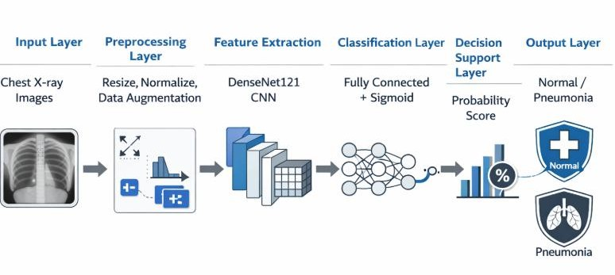

IMPLEMENTATION
Pneumonia detection using the proposed method has been done using programming languages such as python alongside machine learning packages like TensorFlow and Keras. In this regard, training has been done using the transfer learning approach and saving the created model in a serialized format (.h5) ensures future use of the model without the need for further training.
As discussed earlier, this system has been integrated with a web-based interface created with the help of Streamlit Framework. It has the capability to allow users to input chest X-rays in various file formats such as JPG and PNG files. On inputting the X-ray images, some preprocessing is done such as converting the image to the size of 224 × 224 pixels, normalization, and transforming the images to arrays.
After the preprocessing, the inputted X-rays are fed into the trained DenseNet121 model that predicts and provides the probability value. Using a set threshold value, 0.5, the system can then classify an input image as Normal or Pneumonia depending on the output probability.
Apart from predicting and classifying, the created application also provides a confidence score and indicates the degree of severity ranging from low, medium to high.
In this regard, the model has been created in a manner where it can provide predictions at real-time with minimum computational lag. Therefore, the users are provided with a quick analysis of the chest x-rays. Also, with the integration of the model and the Streamlit framework, it ensures that the system can be used in an interactive manner without facing any delays in getting prediction results.
The use of the pre-trained model, which is in this case DenseNet121, not only reduces the time required to train the model but reduces the computational overhead associated with the process but is capable of providing results.
Also, using Streamlit to create a web application makes the system more accessible, as it can run the system anywhere, even in a limited healthcare environment.
Also, one should note that the system has the ability to work with any input image as long as preprocessing is done.

RESULTS AND DISCUSSION
An evaluation was carried out for the proposed pneumonia classification model using the chest X-ray images from the test set. The proposed model was developed using the DenseNet121 with transfer learning, which was trained over several epochs to attain maximum performance.
From the evaluation, the proposed model attained an accuracy of 85.41%. The accuracy is a performance metric that measures the extent to which the model is able to classify the images correctly as either normal or having pneumonia. Other performance metrics were also used in the evaluation including the precision, recall, and F1-score. The precision and recall obtained from the model were 0.62 and 0.71 respectively, while the F1-score was 0.66.
Figure 2: Training and Validation Accuracy
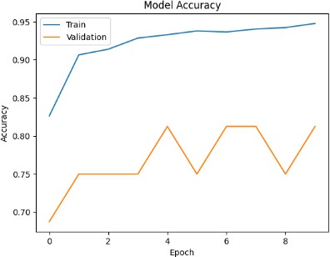
It illustrates the accuracy of training and validation during the process. It is clear that there is a consistent rise in the accuracy of training. However, there is fluctuation in the validation accuracy.
Figure 3: Training and Validation Loss

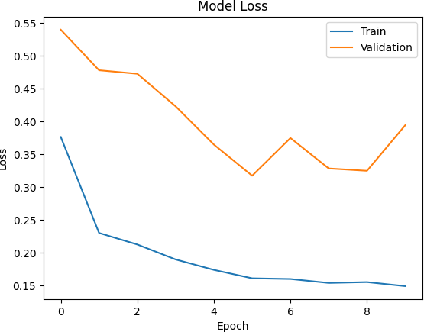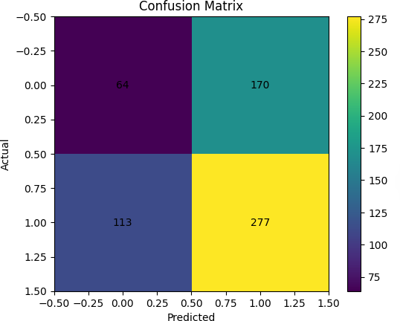

It depicts the training and validation loss plots. The loss value is decreasing steadily throughout training, indicating that the model is indeed learning something useful from the data.
Figure 4: Training Precision
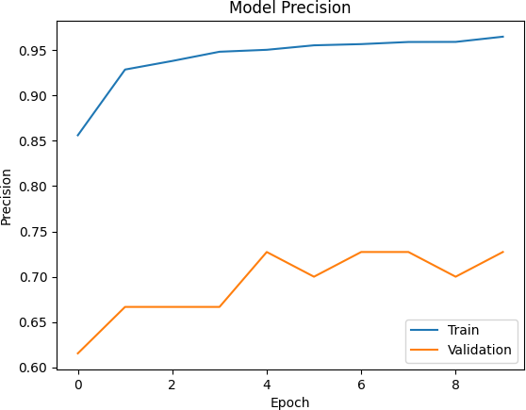
It shows the confusion matrix for the classifier. It gives a comprehensive insight into the performance of the classification process by providing the number of correct and wrong predictions of each class. The confusion matrix shows that the classifier can detect cases of pneumonia effectively despite some errors.

Figure 5: Confusion Matrix of Pneumonia Detection Model

It shows the performance measures of the algorithm, including accuracy, precision, recall, and F1 score. From the graph, one can tell that the recall is better than precision, which is advantageous in the detection of diseases such as pneumonia.
Figure 6: Performance Metrics of the Proposed Model

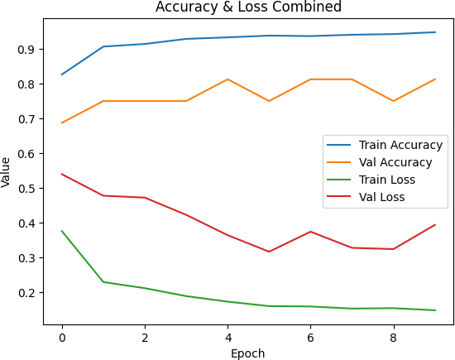
The algorithm is incorporated into the web application and this one was created using the Streamlit library. This way, people will have predictions about the presence of pneumonia or absence thereof depending on their x-rays published on the website. Several actions will be performed relative to the image including resizing (making sure that it will have 224×224 pixels), normalization, and transformation into the array for the use in the neural network as input data.
Additionally, there will be the following output provided:
- Probability of the presence of pneumonia in percentage;
- Probability of normal condition in percentage;
- Presence or absence of the disease;
- Progress bar demonstrating the level of accuracy of the prediction.
In particular, it should be noted that the algorithm will allow predicting the level of severity of the disease depending on the probability value:

High – when probability exceeds 0.8; Middle – probability equals 0.5-0.8;
Low – probability does not exceed 0.5 and there is no pneumonia.
Thus, one can conclude that the developed algorithm based on the method of deep learning makes it possible to achieve really high accuracy in detecting the presence of pneumonia in x-ray photos. On the other hand, several limitations still remain relevant, specifically related to the limited size of the training set, class imbalance, as well as image quality variability, that may influence the generalization power of the model.
In any case, the developed DenseNet121 model shows reliable performance in detecting pneumonia cases due to the ability of the method to learn highly abstract features like lung opacities and infiltrations. Finally, the developed solution is even more practical when integrated into a Streamlit application due to its real-time prediction capabilities.
Thus, it can be concluded that the developed automated pneumonia detection system demonstrates high efficiency and effectiveness in performing the necessary task. In the future, additional work might be focused on enhancing the current system through including additional data, improving generalization properties, as well as employing techniques related to explainable artificial intelligence.
To further evaluate the effectiveness of the proposed model, a comparison with existing deep learning models is presented in Table 1. The comparison includes commonly used architectures such as CNN, ResNet, and CheXNet.
Table 1: Comparison of Proposed Model with Existing Methods

Model | Accuracy(%)
CNN | 78.0
ResNet | 82.0
CheXNet | 84.5
Proposed DenseNet121 Model | 85.41

The results indicate that the proposed DenseNet121-based model achieves competitive performance compared to existing approaches, demonstrating its effectiveness in pneumonia detection.

CONCLUSION
In the current paper, a solution for automating the process of detecting pneumonia based on deep learning has been developed. Specifically, the model has been built based on DenseNet121 with a transfer learning approach to efficiently extract features necessary for classification of the image as either normal or pneumonia.
The model demonstrates the following performance indicators: the accuracy of 85.41% and such metrics as precision, 0.62; recall, 0.71; and F1-score, 0.66, thereby showing its efficiency in recognizing the images of patients having pneumonia. The indicators show that the model is
especially good at predicting the positive cases, which is important in a medical context.
Integration of the trained model with a web application developed using Streamlit ensures that it is possible to obtain predictions in a real-time manner by uploading X-ray images. Besides that, the application allows one to make predictions regarding the severity of pneumonia.
However, there are several disadvantages to this technique, such as the employment of a relatively small dataset, which may bring about certain difficulties with the generalization of the developed model. Class imbalance could also be one of the potential limitations of the proposed technique. Furthermore, the model does not involve a state-of- the-art explainable artificial intelligence approach, namely, Grad-CAM.
The presented deep learning model can be further enhanced in the future due to the employment of larger databases, application of modern approaches from the realm of deep learning, and incorporation of an explainable AI approach.
In general, the proposed medical imaging technique proves to be efficient thanks to the employment of a deep learning architecture and the capability of detecting pneumonia in its early stages.
Disclaimer (Artificial intelligence)
Author(s) hereby declare that NO generative AI technologies such as Large Language Models (ChatGPT, COPILOT, etc.) and text-to-image generators have been used during the writing or editing of this manuscript.

REFERENCES
- P. Rajpurkar, J. Irvin, K. Zhu, et al., “CheXNet: Radiologist-Level Pneumonia Detection on Chest X-Rays with Deep Learning,” arXiv preprint arXiv:1711.05225, 2017.
- G. Huang, Z. Liu, L. Van Der Maaten, and K. Q. Weinberger, “Densely Connected Convolutional Networks,” in Proceedings of the IEEE Conference on Computer Vision and Pattern Recognition (CVPR), 2017, pp. 4700–4708.
- World Health Organization (WHO), “Pneumonia Fact Sheet,” 2023. [Online]. Available: https://www.who.int
- K. He, X. Zhang, S. Ren, and J. Sun, “Deep Residual Learning for Image Recognition,” in Proceedings of the IEEE Conference on Computer Vision and Pattern Recognition (CVPR), 2016.
- D. Kermany, K. Zhang, and M. Goldbaum, “Labeled Optical Coherence Tomography (OCT) and Chest X-Ray Images for Classification,” Mendeley Data, 2018.
- S. Wang, Y. Zhou, Z. Liu, et al., “ChestX-ray8: Hospital-Scale Chest X-ray Database and Benchmarks on Weakly-Supervised Classification and Localization of Common Thorax Diseases,” in IEEE CVPR, 2017.
- I. Goodfellow, Y. Bengio, and A. Courville, Deep Learning, MIT Press, 2016.
- F. Chollet, “Keras: Deep Learning Library for Python,”
2015. [Online]. Available: https://keras.io
- M. Abadi et al., “TensorFlow: Large-Scale Machine
Learning on Heterogeneous Systems,” 2016. [Online].
Available: https://www.tensorflow.org
- A. Krizhevsky, I. Sutskever, and G. E. Hinton,
“ImageNet Classification with Deep Convolutional Neural

Networks,” in Advances in Neural Information Processing Systems (NeurIPS), 2012.
- S. R. Kalidindi, “Machine Learning in Medical Imaging: A Review,” Journal of Healthcare Engineering, 2020.
- J. Esteva, A. Kuprel, R. A. Novoa, et al., “Dermatologist-Level Classification of Skin Cancer with Deep Neural Networks,” Nature, vol. 542, no. 7639, pp. 115– 118, 2017.
- H. Greenspan, B. van Ginneken, and R. M. Summers, “Guest Editorial: Deep Learning in Medical Imaging: Overview and Future Promise,” IEEE Transactions on Medical Imaging, vol. 35, no. 5, pp. 1153–1159, 2016.
- S. Candemir and S. Antani, “A Review on Lung Boundary Detection in Chest X-rays,” International Journal of Computer Assisted Radiology and Surgery, 2019.
- J. Brownlee, “A Gentle Introduction to Transfer Learning for Deep Learning,” Machine Learning Mastery, 2019.
- T. Ozturk, M. Talo, E. A. Yildirim, U. B. Baloglu, O. Yildirim, and U. R. Acharya, “Automated detection of COVID-19 cases using deep neural networks with X-ray images,” Computers in Biology and Medicine, vol. 121, 2020.
- I. D. Apostolopoulos and T. A. Mpesiana, “COVID- 19: automatic detection from X-ray images utilizing transfer learning with convolutional neural networks,” Physical and Engineering Sciences in Medicine, vol. 43, no. 2, pp. 635– 640, 2020.
- M. E. H. Chowdhury, T. Rahman, A. Khandakar, et al., “Can AI help in screening Viral and COVID-19 pneumonia?,” IEEE Access, vol. 8, pp. 132665–132676, 2020.
- L. Brunese, F. Mercaldo, A. Reginelli, and A. Santone, “Explainable deep learning for pulmonary disease and COVID-19 detection from X-rays,” Computer Methods and Programs in Biomedicine, vol. 196, 2020.
- L. Li, L. Qin, Z. Xu, et al., “Artificial intelligence distinguishes COVID-19 from community acquired pneumonia on chest CT,” Radiology, 2020.
- C. Sitaula and M. B. Hossain, “Attention-based VGG-16 model for COVID-19 chest X-ray image classification,” Applied Intelligence, vol. 51, 2021.
- D. M. Ibrahim, N. M. Elshennawy, and A. M. Sarhan, “Deep-chest: Multi-classification deep learning model for diagnosing COVID-19, pneumonia, and lung cancer,” Computers in Biology and Medicine, 2021.
- T. Rahman, A. Khandakar, Y. Qiblawey, et al., “Exploring the effect of image enhancement techniques on COVID-19 detection using chest X-ray images,” Computers in Biology and Medicine, vol. 132, 2021.
- “Recent advances in deep learning for medical image analysis: A survey,” IEEE Access / Elsevier, 2023.
- “Deep learning-based pneumonia detection using chest X-ray images: Recent trends and future directions,” Springer / Elsevier, 2024–2025.
- S. Wang, B. Kang, J. Ma, et al., “A deep learning algorithm using CT images to screen for Corona Virus Disease (COVID-19),” European Radiology, vol. 31, pp. 6096–6104, 2021.
- H. Panwar, P. K. Gupta, M. K. Siddiqui, R. Morales- Menendez, and V. Singh, “Application of deep learning for fast detection of COVID-19 in X-rays using nCOVnet,” Chaos, Solitons & Fractals, vol. 138, 2020.
- A. Narin, C. Kaya, and Z. Pamuk, “Automatic detection of coronavirus disease (COVID-19) using X-ray images and deep convolutional neural networks,” Pattern Analysis and Applications, vol. 24, pp. 1207–1220, 2021.
- M. Loey, F. Smarandache, and N. E. M. Khalifa, “Within the lack of chest COVID-19 X-ray dataset: A novel detection model based on GAN and deep transfer learning,” Symmetry, vol. 12, no. 4, 2020.
- “Artificial Intelligence in Medical Imaging: Current Applications and Future Perspectives,” IEEE Transactions on Medical Imaging / Elsevier, 2025–2026.

